
Draw Guide 25.8

Chapter 6,
Editing Images
Creating vector graphics in LibreOffice

Copyright
Document copyright © for 2025 is held by the LibreOffice Documentation Team. Contributors are listed below. All trademarks in this guide belong to their legitimate owners. This document maybe distributed and/or modified under the terms of the GNU General Public License (https://www.gnu.org/licenses/gpl.html), version 3 or later, or the Creative Commons Attribution License (https://creativecommons.org/licenses/by/4.0/), version 4.0 or later.

Contributors

Contributors for this edition:
Peter Schofield

Contributors for previous editions:
Claire Wood
Elzett Kotze
Jean Hollis Weber
John A Smith
John Cleland
Martin Fox
Peter Schofield
Regina Henschel

Feedback
Please direct any comments or suggestions about this document to the Documentation Team Forum at https://community.documentfoundation.org/c/documentation/loguides/ (registration is required) or send email to: loguides@community.documentfoundation.org.
- Note
Everything sent to a mailing list, including email addresses, is publicly archived and cannot be deleted.

Publication date and software version
Published September 2025. Based on LibreOffice 25.8 Community.
Other versions of LibreOffice may differ in appearance and functionality.

Contents
Copyright 2
Contributors 2
Feedback 2
Publication date and software version 2
Introduction 5
Importing graphics and images 5
Inserting 5
Embedding 6
Linking 6
Editing links 7
Copying and pasting 8
Exporting images 8
Exporting ODG files 8
Exporting graphics or images 9
Formatting images 10
Naming images 11
Image toolbar 11
Cropping images 13
Quick cropping 14
Crop dialog 14
Exporting cropped images 16
Using Export dialog 16
Using Save 16
Compressing images 16
Image filters 17
Applying image filters 17
Image filters 17
No image filter 17
Invert filter 18
Smooth filter 18
Sharpen filter 18
Remove Noise filter 19
Solarization filter 19
Aging filter 20
Posterize filter 20
Pop Art filter 20
Charcoal Sketch filter 20
Relief filter 21
Mosaic filter 22
Replacing colors 22
Color Replacer dialog 22
Replacing colors 23
Replacing transparent areas 24
Conversion 24
Contour conversion 24
Polygon conversion 25
Conversion options and controls 25
Converting 25
Breaking 26
Splitting 27
Bitmap conversion 27

Introduction
Previous chapters in the Draw Guide provide information on vector graphics and the common types of vector graphics in use are as follows:
SVG (Scalable Vector Graphics)
An Extensible Markup Language (XML) based vector image format for two-dimensional graphics with support for interactivity and animation.
EPS (Encapsulated PostScript)
A PostScript document format usable as a graphics file format. EPS files are self contained, PostScript documents that describe an image or drawing and can be placed within another PostScript document.
AI (Adobe Illustrator)
A proprietary file format developed by Adobe Systems for representing single-page vector-based drawings in either the EPS or PDF formats.
However, Draw has several functions for handling raster graphics or bitmaps, for example photographs and scanned pictures. This includes import, export, and conversion from one graphic format to another graphic format. Draw can open the majority of graphic file formats using capabilities similar to raster graphics programs like Gimp or Adobe Photoshop. Raster graphics are generally images or pictures that use the following formats:
JPG/JPEG (Joint Photographic Experts Group)
JPEG is the most common image format on websites and most digital cameras produce JPEG images as default.
GIF (Graphics Interchange Format)
GIF is a bitmap image format that is popular because of its wide support and portability.
PNG (Portable Network Graphics)
PNG is a raster image format which supports lossless data compression and also background transparency.
TIF/TIFF (Tagged Image File Format)
TIFF is flexible, adaptable, and capable of storing image data in a lossless format.
BMP (BitMaP)
Also known as bitmap image file, which is a dot matrix data structure.

Importing graphics and images

Inserting
To import graphic or image files into a drawing, go to Insert > Image on the Menu bar to open the Insert Image dialog (Figure 1 below).
Draw contains import filters for the majority of graphic formats. If the file being imported uses a graphic format not compatible with LibreOffice import filters, it is recommended to use a free graphic conversion program to convert the file into a graphic format that Draw recognizes.
If Preview is selected, a preview of the file is shown on the right-hand side of the Insert Image dialog. This makes it easier to select the file required and makes sure that Draw can import the graphic file format used.
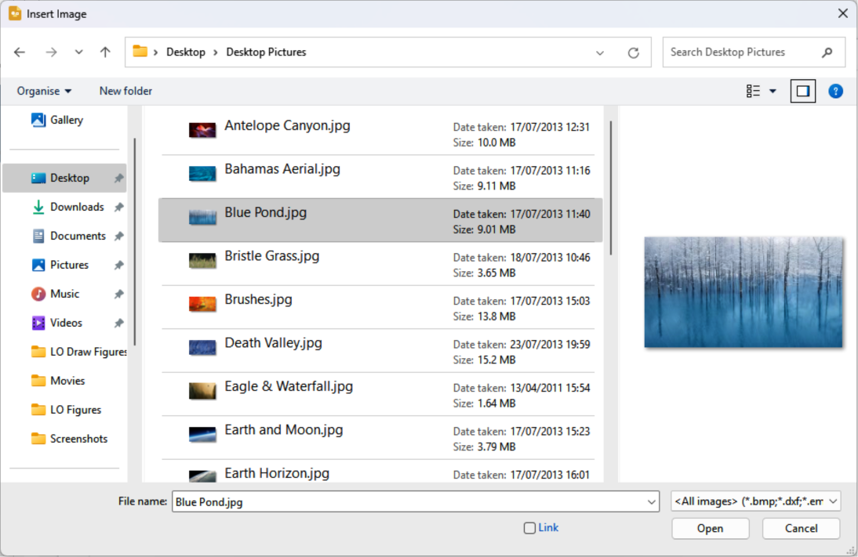
Figure 1: Insert Image dialog

Embedding
Embedding graphics into a drawing makes graphics a permanent part of the drawing. Any changes made to an embedded graphic only appear in a LibreOffice drawing where the graphic has been embedded. The original graphic file is not affected. Embedding is importing a graphic into a drawing using one of the following methods:
Insert Image dialog.
Copying and pasting.
Scanning a graphic.
Dragging and dropping between open files.
The main advantage of embedding graphics into a drawing is that a graphic is always available no matter what computer is used to open the drawing.
The main disadvantage of embedding graphics is that it creates large file sizes, which may create storage problems if there is limited storage capacity on the computer. Also, if the original graphic is altered, the embedded graphic is not updated each time the LibreOffice drawing is opened.
- Note
When a graphic is embedded into a LibreOffice drawing, make sure that Insert as Link is not selected in the Insert Image dialog.

Linking
Linking to an original graphic does not insert the graphic into a drawing, but creates a link to the location of an original graphic file. Each time a LibreOffice drawing is opened, any linked graphics are displayed in the drawing.
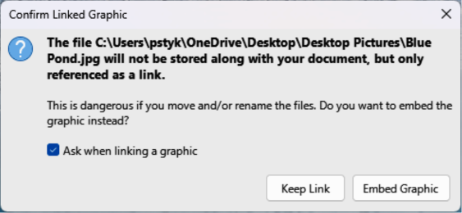
Figure 2: Confirm Linked Graphic dialog
The main advantage of linking graphic files is that if the original graphic file is altered or modified, opening a LibreOffice drawing automatically updates the linked graphic. Also the file size of a LibreOffice drawing is smaller and the original graphic is easily edited with specialized external applications.
The main disadvantage of linking graphics is that the link must be maintained between a LibreOffice drawing and the embedded graphic file for a link to work correctly. If the original drawing or graphic file is moved to another computer location, then any links must be updated to include the new location.
- Open the Insert Image dialog.
- Select Insert as Link in the Insert Image dialog.
- Select the required graphic or image file and click on Open to open the Confirm Linked Graphic dialog (Figure 2 above).
- Click on Keep Link to link the file and close the Confirm Linked Graphic dialog.
- If required, click on Embed Graphic to embed the file instead of linking the file. This also closes the Confirm Linked Graphic dialog.
- Note
When a graphic or image file is linked in a LibreOffice drawing, the file format of the linked graphic or image is not changed.

Editing links
- Go to Edit > External Links on the Menu bar to open the Edit Links dialog (Figure 3 below) and select the link to be edited.
- Click on Modify, Break Link, or Update as appropriate.
- Modify — allows changes to the selected link that is between the graphic file in the current drawing and the source file.
- Break Link — breaks the link between the selected linked graphic file and the current document. The graphic file version in the drawing becomes embedded into the drawing. A confirmation dialog opens asking if the link is to be broken. Click on Yes to confirm the breaking of the link.
- Update — updates the selected link so that the most recent version of the linked graphic file is displayed in the drawing.
- Click on Close to save the changes to the link and close the Edit Links dialog.
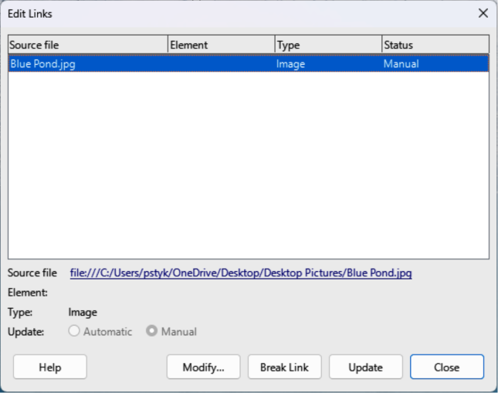
Figure 3: Edit Links dialog

Copying and pasting
Copying and pasting a graphic also embeds a graphic or image file into a LibreOffice drawing. A copied graphic can be an image already embedded in another document or drawing, or a graphic file such as a drawing, document, or photograph.
- After copying the graphic file, go to Edit > Paste Special > Paste Special on the Menu bar to open the Paste Special dialog.
- Select the required format for pasting the copied graphic into a LibreOffice drawing. Available formats for pasting depend on the type of file copied onto the clipboard.
- Click OK to paste the graphic file and close the Paste Special dialog.
- Note
When copying and pasting images into a LibreOffice drawing, respect the copyright and license of any file being copied.

Exporting images

Exporting ODG files
By default Draw saves drawings in the Open Document format ODG and some software programs are not compatible with the ODG format. To make drawings compatible with other software applications, an ODG file can be exported in several formats. The export procedure used depends on the computer setup and computer operating system being used. The following procedure is an example export procedure.
- Open the ODG file being exported.
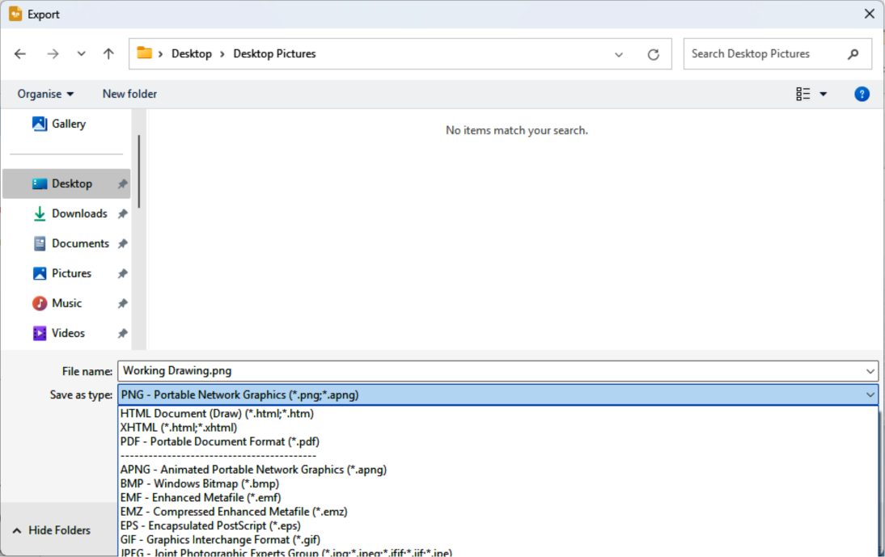
Figure 4: Example export dialog
- Go to File > Export on the Menu bar and open the Export dialog. An example export dialog is shown in Figure 4 above.
- Enter a filename for the exported file and navigate to the folder where the exported file is to be saved.
- Select the required file format from the options in the drop-down list.
- Click Export and the file is exported as a new file in the selected file format.
- Depending on the file format selected, another dialog may open allowing options to be selected for the export format.
- Depending on the additional dialog that may open, click on Export, Create, or OK and the file is exported as a new file in its new format.

Exporting graphics or images
Exporting individual graphics or images, or a group of graphics or images, from a drawing file is similar to exporting files. The following export procedure is an example. Actual procedure depends on computer operating system and computer setup.
- Open the ODG file that contains the graphic or images for export.
- In the ODG file, select the graphics or images for export.
- Go to File > Export on the Menu bar and open the Export dialog. An example export dialog is shown in Figure 4 above.
- Enter a filename for the exported file and navigate to the folder where the exported file is to be saved.
- Click on Selection in the Export dialog. Selecting may open an example options dialog as shown in Figure 5 below.
- Enter the required options in the options dialog and click OK to export the file to the selected destination. There is no confirmation of export.
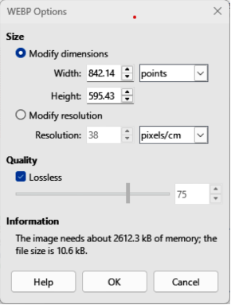
Figure 5: Example of Export Options dialog
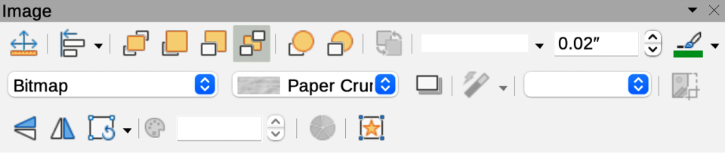
Figure 6: Image toolbar

Formatting images
Images (raster graphics) are edited and formatted to add or change filters and adjust the properties of color, lines, areas, and shadows using one of the following methods:
- Go to Format > Image on the Menu bar and use the tools in the sub-menu that opens.
- Use the tools on the Image toolbar (Figure 6 above).
- Use the tools available in the Image panel on the Properties deck of the Sidebar.
- Some raster graphics may have a text element. For more information on formatting text, see Chapter 9, Adding and Formatting Text.
- Note
Formatting changes to a graphic using LibreOffice tools only appear in the drawing where the graphic was modified. Original graphic file is not affected. Raster graphics included in a group behave like other objects when the properties of the group are edited and formatted.

Naming images
Draw names objects using the insertion order into a drawing, for example Shape 1, Shape 2, and so on. It is recommended to rename objects using a unique name. Names make objects and images easily identifiable in the Navigator.
- Select an image, then use one of the following methods to open the Name dialog and create a unique name for the selected image:
- Go to Format > Name on the Menu bar.
- Right-click on the image and select Name from the context menu.
- Enter a name in the Name text box in the Name dialog that opens and click OK.

Image toolbar
The Image toolbar (Figure 6 above) appears when an image or raster graphic object is selected. For more information on the Image toolbar and the available tools, see Appendix B, Toolbars. The tools listed below for the Image toolbar are an example only.
Position and Size (F4)
Opens the Position and Size dialog. See Chapter 3, Working with Objects for more information.
Align Objects
Opens a sub-toolbar giving access to alignment tools for aligning selected objects in relation to each other. See Chapter 5, Combining Multiple Objects for more information.
Bring to Front
Brings the selected object to the front of a group of objects (Ctrl+Shift++) (macOS ⌘+Shift++).
Bring Forward
Brings the selected object forward one step (Ctrl++) (macOS ⌘++).
Send Backward
Sends the selected object one step backward (Ctrl+–) (macOS ⌘+–).
Send to Back
Sends the selected object to the back of a group of objects (Ctrl+Shift+–) (macOS ⌘+Shift+–).
In Front of Object
Moves the selected object in front of another selected object.
Behind Object
Moves the selected object behind another selected object.
Reverse
Reverses the order of the selected objects. This tool is grayed out if only one object is selected.
Line Style
Opens a drop-down list with different line styles used for the outline of the border. See Chapter 4, Changing Object Attributes for more information.
Line Width
Used to change the width of a line. See Chapter 4, Changing Object Attributes for more information.
Line Color
Used to change the color of a line. See Chapter 4, Changing Object Attributes for more information.
Area Style/Filling
Used to change the type of filling used in a shape. See Chapter 4, Changing Object Attributes for more information.
Shadow
Sets the default shadow effect around the picture. The shadow attributes are adjusted using the Shadow panel in the Properties deck on the Sidebar. See Chapter 4, Changing Object Attributes for more information.
Filter
Opens the Image Filter toolbar which is described in “Image filters” on page 17.
Image Mode
Changes the display of the image from color to grayscale, black and white, or a watermark. This setting affects only the display and printing of the image; the original image file remains unchanged. The image mode setting can also be changed using Color mode in the Image panel in the Properties deck on the Sidebar (Figure 7 below).
Default
Image is displayed unaltered in color.
Grayscale
Image is displayed in 256 shades of gray.
Black/White
Image is displayed in black and white.
Watermark
Color, brightness, contrast, and gamma settings are reduced so that the image can be used as a watermark (background). The default settings for Watermark can be adjusted using the Color sub-toolbar (Figure 8 below).
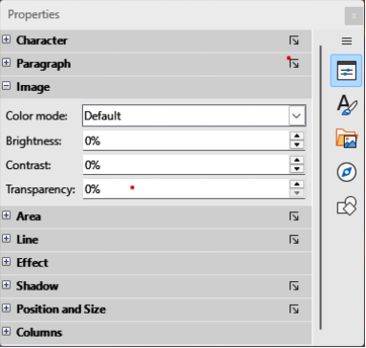
Figure 7: Image panel in Properties deck on Sidebar
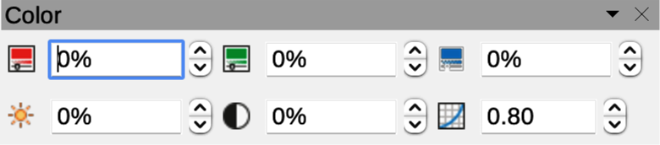
Figure 8: Color sub-toolbar
Crop Image
Crops or trims an image. When using this tool, crop marks appear around the image. Drag one or more of these marks to crop the image to the desired size. For more information on cropping, see “Cropping images” below.
Vertically
Flips the selected object vertically. See Chapter 4, Changing Object Attributes for more information.
Horizontally
Flips the selected object horizontally. See Chapter 4, Changing Object Attributes for more information.
Transformations
Opens the Transformations toolbar. See Chapter 4, Changing Object Attributes for more information.
Transparency
Adjusts the degree of transparency of the image between 0% (opaque) and 100% (fully transparent). The transparency setting can also be adjusted using the Image panel in the Properties deck on the Sidebar.
Color
Opens the Color sub-toolbar (Figure 8 above) to adjust the values of the RGB colors, brightness, contrast, and Gamma. These adjustments do not affect the original image, but the values are stored in LibreOffice Draw as a separate formatting set. The color settings can also be adjusted using the Image panel in the Properties deck on the Sidebar.
Red, Green, Blue
Select values between –100% (no color) to +100% (full intensity); 0% represents the original color value of the image.
Brightness
Select a value between –100% (totally black) and +100% (totally white).
Contrast
Select a value between –100% (minimum) and +100% (maximum).
Gamma
Affects the brightness of the middle color tones. Select a value between 0.10 (minimum) to 10 (maximum) Try adjusting this value if changing brightness or contrast does not give the required result.

Cropping images
Cropping is a method of hiding unwanted areas of an image or changing the size of an image in a drawing. Changes made when cropping an image only change the display of the image in a drawing and not the original image file.
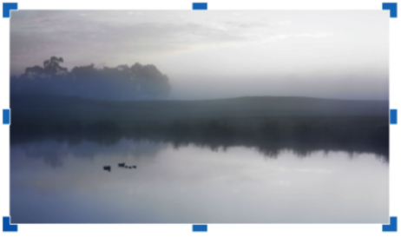
Figure 9: Example image in crop mode

Quick cropping
After selecting an image, it can be cropped quickly using one of the following methods:
- Click on Crop Image on the Standard or Image toolbar.
- Go to Format > Image > Crop on the Menu bar.
- Right-click on the image and select Crop from the context menu.
Selection handles appear around the selected image, as shown in the example in Figure 9 above. The image is cropped as follows:
- Top, bottom, left, and right selection handles crop the image in one direction only.
- Corner selection handles crop the image vertically and horizontally in two directions.
- To maintain the ratio between vertical and horizontal dimensions, hold down the Shift key while moving a selection handle.

Crop dialog
For more control and accuracy over the cropping functions, it is recommended to use the Crop dialog (Figure 10 below). Select an image and go to Format > Image > Crop Dialog on the Menu bar to open the Crop dialog.
Crop
Trim or scale the selected image, or add white space around the image.
Keep scale
Maintains the original scale of the image when cropping so that only the size of the image changes.
Keep image size
Maintains the image original size when cropping so that only the image scale changes. To reduce the image scale, select this option and enter negative values in the cropping boxes. To increase the image scale, enter positive values in the cropping boxes.
Left and Right
If Keep scale is selected, enter positive amount to trim the left or right edge of images, or negative amount to add white space to the left or right of images. If Keep image size is selected, enter a positive amount to increase image horizontal scale, or a negative amount to decrease image horizontal scale.
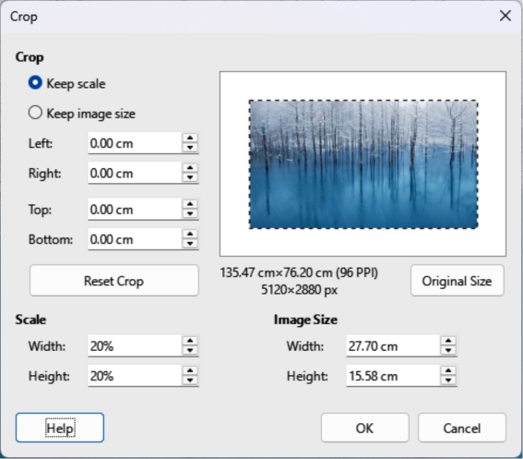
Figure 10: Crop dialog
Top and Bottom
If Keep scale is selected, enter a positive amount to trim the image top or bottom, or a negative amount to add white space above or below the image. If Keep image size is selected, enter a positive amount to increase the image vertical scale, or a negative amount to decrease the image vertical scale.
Scale
Used to change the image scale as it appears in a drawing.
Width
Enter a percentage value to change the image width.
Height
Enter a percentage value to change the image height.
Image Size
Used to change the image size.
Width
Enter a value for the image width.
Height
Enter a value for the image height.
Original Size
Original size of the image is displayed above the option. Clicking on this option and then clicking OK resets the selected image to its original size.
- Note
In the Crop dialog, the Width and Height are treated as independent values. Changing one without the other can result in significant distortion of the image and this may not be what is required.

Exporting cropped images
If a cropped image is to be used in another drawing, use one of the following methods after selecting the cropped image.

Using Export dialog
- Select the cropped image.
- Go to File > Export on the Menu bar to open the Export dialog.
- Navigate to the destination folder, then enter a filename.
- Click on Selection, then click on Export. See “Exporting images” on page 8 for more information.

Using Save
- Select the cropped image.
- Go to Format > Image > Save on the Menu bar or right click on the cropped image and select Save from the context menu.
- Click on Yes to save the modified image and open an Image Export dialog.
- Select the file format required, navigate to the destination folder, and enter a filename.
- Click on Save to save the cropped image.

Compressing images
If a large image is inserted into a drawing and resized to fit into the layout of the drawing, the complete full-size original image is stored in the drawing file. This preserves the original image, possibly resulting in a large file to store or send by mail.
If some loss of image quality can be accepted, the image can be compressed using the following procedure. This reduces the data volume while preserving the display in the page layout.
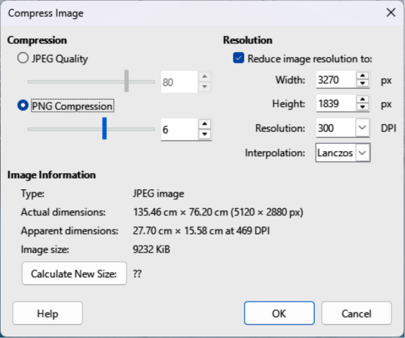
Figure 11: Compress Image dialog
- Open the Compress Image dialog (Figure 11 above) using one of the following methods:
- Right-click on the image and select Compress from the context menu.
- Go to Format > Image > Compress on the Menu bar.
- Select the type of compression and the resolution required.
- Click on Calculate New Size to update the image information when the Compression and Resolution settings are changed.
- When satisfied with the new settings, click OK to apply the settings.
- If the resulting image is not acceptable, use one of the following methods to undo the changes and select another compression setting.

Image filters
Draw has eleven filter effects that can be applied to selected images and these image filters can be combined. Filters always apply to the entire image and it is not possible to use filters on only part of the image.
- Notes
If an image is embedded into a drawing, any image filters are only applied directly to the embedded image and the original image file is not changed. Save the drawing to retain any filter effects applied to the embedded image in a drawing.
After a drawing is saved and closed, the effects of image filters become permanent. If image filter effects are not satisfactory, use Edit > Undo on the Menu bar to cancel the filter effects BEFORE saving the drawing.
When applying image filters to an image, the file size of the image must be taken into account. On large file sizes, there is a time lag between applying an image filter and the effect to become visible on the image.

Applying image filters
- Select an image to open the Image toolbar.
- Apply an image filter using one of the following methods:
- Click on Filter to open the Image Filter sub-toolbar (Figure 12 below), then select an image filter to apply.
- Go to Format > Image > Filter on the Menu bar and select an image filter from the context menu.

Image filters

No image filter
Figure 13 below is an example image with no image filters applied.
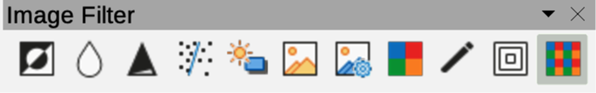
Figure 12: Image Filter sub-toolbar
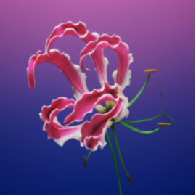
Figure 13: Example no filter applied
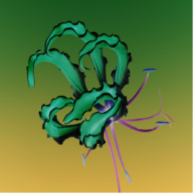
Figure 14: Example invert filter applied

Figure 15: Example smooth filter applied
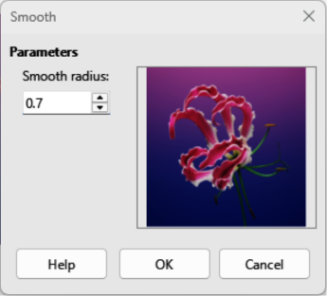
Figure 16: Smooth dialog

Invert filter
Inverts or reverses the color values of a color image (similar to a color negative), or the brightness values of a grayscale image. Apply the filter again to revert to the original graphic (Figure 14 above).

Smooth filter
Softens or blurs the image by applying a low pass filter. This reduces the contrast between neighboring pixels and produces a lack of sharpness making the image appear smoother. The effect of the smooth filter can be very subtle. Figure 15 above shows the effect of applying a Smooth radius of 15 to an image.
Selecting this filter opens the Smooth dialog (Figure 16 above) where the smooth radius parameter is set. The preview in the Smooth dialog shows the effect of applying the Smooth filter to an image.

Sharpen filter
Sharpens the image by applying a high pass filter, adjusting the contrast between neighboring pixels. The effect increases if the filter is applied several times making the colors appear faded, as shown by the example in Figure 17 below.
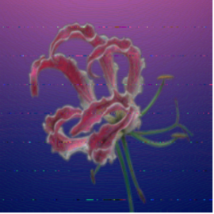
Figure 17: Example sharpen filter applied
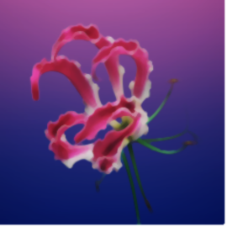
Figure 18: Example remove noise filter applied
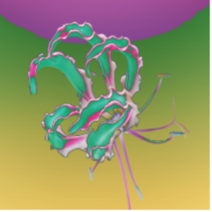
Figure 19: Example solarization filter applied
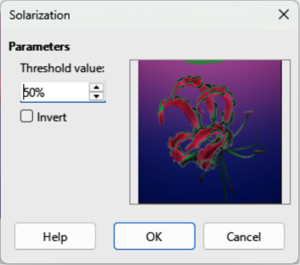
Figure 20: Solarization dialog

Remove Noise filter
Removes noise by applying a median filter comparing every pixel with its neighbor. It replaces any pixel with extreme values that deviate in color by a large amount from the mean value with a pixel that has a mean color value. The amount of picture information does not increase each time the filter is applied. However, there are fewer contrast changes resulting in an image that looks smoother and the effect is very subtle (Figure 18 above).

Solarization filter
Solarization refers to an effect that looks when there is too much light during photo development and the colors have become partly inverted. Dark areas appear light or light areas appear dark. In the digital world of photography, solarization creates a change or reversal of color, similar to the effect of the Invert image filter. Figure 19 above shows the effect of a Solarization filter applied using a Threshold value of 50%.
Selecting Solarization opens the Solarization dialog (Figure 20 above, where the degree of solarization (Threshold value) can be specified. Entering a Threshold value above 70% reverses the inversion effect on colors. Also, selecting Invert reverses the effect of the Solarization image filter, as shown in the preview box in Figure 20 above.
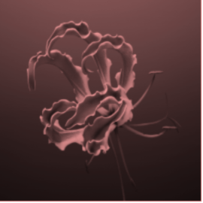
Figure 21: Example aging filter applied
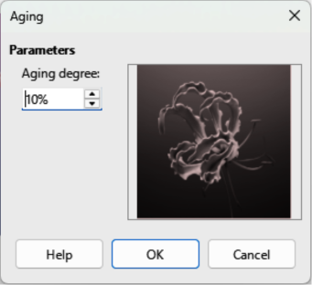
Figure 22: Aging dialog
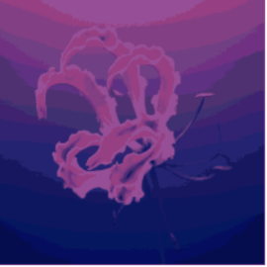
Figure 23: Example posterize filter applied
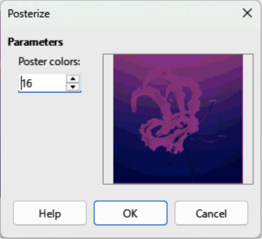
Figure 24: Posterize dialog

Aging filter
The Aging filter creates a look that resembles photographs developed in the early days of photography (Figure 21 above). All pixels are set to their gray values. The green and blue color channels are then reduced by the amount specified in Aging degree in the Aging dialog. Red color channel is not changed. Selecting the Aging filter opens the Aging dialog (Figure 22 above), where the Aging degree can be defined and create an old look for an image.

Posterize filter
Posterizing reduces the number of colors in an image. For example, a photograph will probably look like a painting when the number of colors is reduced (Figure 23 above). Selecting Posterize opens the Posterize dialog (Figure 24 above) where the number of Poster colors can be defined to produce the effect required.

Pop Art filter
Changes the colors of an image by converting the image to a pop-art format (Figure 25 below).

Charcoal Sketch filter
Displays an image as a charcoal sketch. The contours of the image are drawn in black and the original colors are suppressed (Figure 26 below).
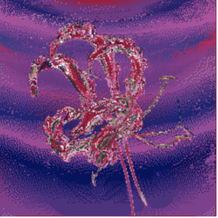
Figure 25: Example pop art filter applied
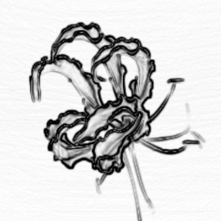
Figure 26: Example charcoal sketch filter applied
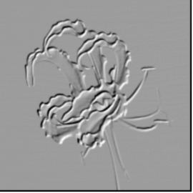
Figure 27: Example relief filter applied
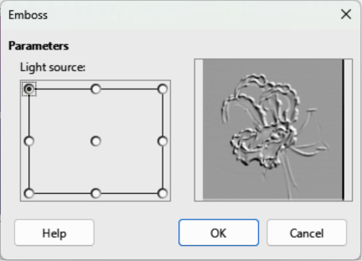
Figure 28: Emboss dialog
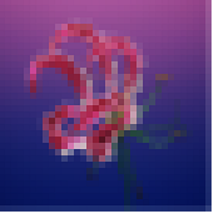
Figure 29: Example mosaic filter applied
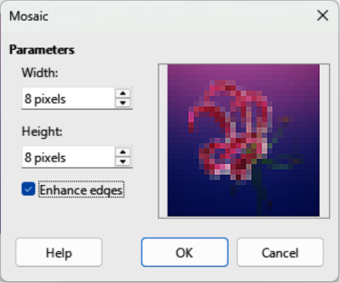
Figure 30: Mosaic dialog

Relief filter
Calculates the edges of an image in relief as if the image is illuminated by a light source (Figure 27 above). Selecting Relief opens the Emboss dialog (Figure 28 above) where the position of the Light source is selected producing shadows that differ in direction and magnitude.

Mosaic filter
The Mosaic filter joins groups of pixels and converts the pixels into rectangles of a single color creating an image that appears to be a mosaic (Figure 29 above). The larger the individual rectangles created, the fewer details in the mosaic graphic.
Selecting this image filter opens the Mosaic dialog (Figure 30 above), where the number of pixels for Width and Height of the tiles is set. Selecting Enhanced edges enhances the edges of each tile, creating a sharper definition.

Replacing colors
The Color Replacer is used to replace or change a color of an embedded image for another color, or to make a color transparent. Up to four colors can be replaced or changed at the same time. Areas of an image cannot be selected for editing as the Color Replacer only works on the whole of an image.
Selecting replacement colors can only be from the available color palettes in LibreOffice. Custom colors cannot be defined in the Color Replacer, but custom colors can be created before using the Color Replacer. For more information on creating custom colors, see Chapter 11, Advanced Draw Techniques.
- Note
The Color Replacer can only be used on embedded images. If the Color Replacer is used on a linked image, the following error message appears “This image is linked to a document. Do you want to unlink the image in order to edit it?”. Click on Yes to unlink and embed the graphic.

Color Replacer dialog
Pipette
Switches color selection on when selected.
Replace
Replaces selected source colors in a selected image with the colors specified in the Replace with boxes.
Colors
Lists the source colors and the replacement colors.
Source color
Select this checkbox to replace the current Source color with the color that specified in the Replace with box.
Tolerance
Set the tolerance for replacing a source color in a source image. To replace colors that are similar to the color selected, enter a low value. To replace a wider range of colors, enter a higher value.
Replace with
Lists the available color palettes and replacement colors.
Transparency
Replaces transparent areas in the selected image with the color selected.
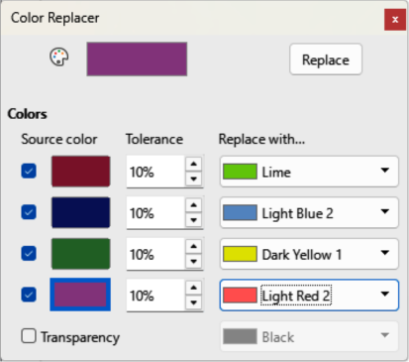
Figure 31: Color Replacer dialog

Replacing colors
- Note
Using the Color Replacer replaces all occurrences of a Source color that are in the selected image. Default selection of Transparent in the Replace with boxes removes selected color from an image creating transparent areas in a selected image.
- Select an embedded image.
- Go to Tools > Color Replacer on the Menu bar to open the Color Replacer dialog (Figure 31 above).
- Click on Pipette at the top of the Color Replacer dialog to activate the color selection mode.
- Move the cursor over the color to be replaced in the selected image.
- Click on the color and following happens. A maximum of four colors can be selected in an image.
- A preview of a selected color appears in the box next to Pipette each time a color is clicked on.
- Each selected color appears in a Source color preview box with a check mark.
- Enter the amount of tolerance required for replacing each selected color in the Tolerance boxes. The default selection is 10% tolerance.
- In Replace with and for each selected color, select a color palette from the drop-down list, then select the required color from the color palette. Transparent is the default selection.
- After selecting up to four colors for replacement, click Replace to replace the colors in the selected image. Examples of the original image and after color replacement are shown in Figures 32 below and 33 below.
- There is no preview of the effect. If the result is not satisfactory, select Edit > Undo: Image with transparency Color Replacer in the Menu bar and repeat the color replacement.
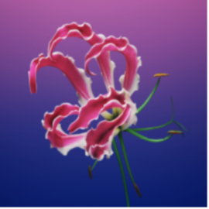
Figure 32: Example before replacing colors
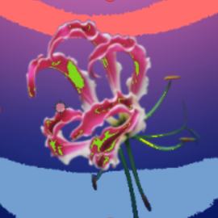
Figure 33: Example after replacing colors

Replacing transparent areas
- Go to Tools > Color Replacer on the Menu bar to open the Color Replacer dialog.
- Select an image with transparent areas.
- Select Transparency in the Color Replacer dialog so that a check mark appears next to Transparency.
- Select a color palette from the drop-down list next to Transparency, then select a color from the selected palette.
- Click on Replace and the transparent areas are filled with the selected color.
- There is no preview of the effect. If the result is not satisfactory, select Edit > Undo: Image with transparency Color Replacer in the Menu bar and repeat the transparency replacement.

Conversion

Contour conversion
Consider the following points before carrying out a contour conversion on an object:
- Contour conversion converts a selected object to a polygon, or a group of polygons, with four corner points.
- Converting an image to a contour, the converted image is set as a background graphic.
- If the conversion creates a group of polygons (for example, contour conversion of a text object). Enter a polygon group before selecting an individual polygon within a group. For more information on working with groups, see Chapter 5, Combining Multiple Objects.
- After converting an image to a contour, the object can no longer be edited normally. The converted image has to be edited using Edit > Points on the Menu bar to adjust its shape. For more information on editing points, see Chapter 3, Working with Objects.
- Any object editing must be completed before carrying out a contour conversion because any further editing is not possible on the converted object.
- No confirmation dialog is provided for a contour conversion.
A contour conversion is carried out as follows:
- Carry out all necessary editing on the object before converting to a contour.
- Make sure the object is selected.
- Convert the object to a contour using one of the following methods:
- Go to Shape > Convert > To Contour on the Menu bar.
- Right-click on an object and select Convert > To Contour from context menu.

Polygon conversion
Polygon conversion is used to convert a selected image into a group of polygons filled with color. The image is also converted to a vector graphic and can be resized with no loss of image quality or distortion of any text. After conversion, the graphic can be broken into groups of polygons and then split into individual polygons. Breaking and splitting allows editing or deletion of individual colors within the graphic.

Conversion options and controls
Number of colors
Enter the number of colors to be displayed in the converted image. LibreOffice generates a polygon for each occurrence of a color in the image. The range for the number of colors is between 8 and 32.
Point reduction
Removes color polygons that are smaller than the pixel value entered. The range for point reduction is between 0 and 32 pixels.
Fill holes
Fills blank areas in the graphic that can be created when applying a point reduction.
Tile size
Enter the size of the rectangle for the background fill. Tile sizes range between 8 and 128 pixels.
Source image
Preview of the original image.
Vectorized image
Preview of the converted image.
Preview
Creates a preview of the converted image in Vectorized image without applying any changes.
OK
Converts the image to a vector graphic consisting of polygons. The result is a metafile in SVM format (Star View Metafile) used by LibreOffice and allows transfer of the converted image to other LibreOffice documents.

Converting
- Select an image in a drawing.
- Convert the image into a polygon using one of the following methods and open the Convert to Polygon dialog (Figure 34 below).
- Go to Shape > Convert > To Polygon on the Menu bar.
- Right-click on an image and select Convert > To Polygon from context menu.
- Select Number of colors and Point reduction to be used in the conversion.
- Select Fill holes to prevent any blank areas appearing in the converted image.
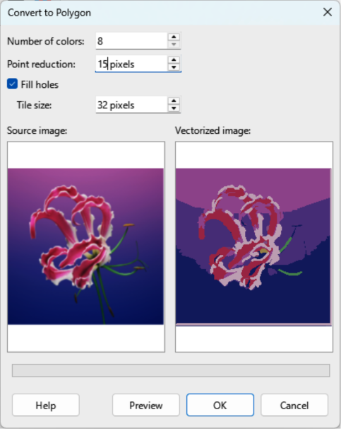
Figure 34: Convert to Polygon dialog
- Enter the number of pixels to use for Tile size.
- Click Preview to check how the converted graphic will look.
- Make any necessary changes to the settings and check the preview again.
- If the converted image meets the expected requirements, click OK to convert the image to a polygon and close the Convert to Polygon dialog.

Breaking
After converting an image to polygons, a vectorized image can be broken into groups of polygons. Each polygon group consists of one color and becomes an object that can be used in another drawing.
- Convert an image to polygons.
- Make sure the converted image is selected, then use one of the following methods to break the image into groups of polygons:
- Go to Shape > Break on the Menu bar.
- Right-click on the image and select Break from the context menu.
- Click on a color in the image and drag the group of polygons filled with that color out of the image to create a new image.
- Alternatively, press Delete and delete the color from the image.

Splitting
After converting an image to polygons and breaking the image into polygon groups, these polygon groups can be split into individual polygons.
- Convert an image to polygons.
- Break the image into groups of polygons.
- Select the image, then use one of the following methods to split the polygon groups into individual polygons:
- Go to Shape > Split on the Menu bar.
- Right-click on the image and select Shapes > Split from the context menu.
- Use the keyboard shortcut Ctrl+Alt+Shift+K (macOS ⌘+⌥+Shift+K).
- Select an individual polygon (or several polygons) in the image and drag the polygon from the image to create a new image in the drawing.
- Alternatively, press Delete to delete the selected polygon(s) from the image.

Bitmap conversion
All drawing objects placed into a LibreOffice drawing are vector graphics and these vector graphics can be converted to a bitmap (raster graphic) in PNG format. Any transparent areas in the original vector graphic are lost during conversion even though the PNG format used by Draw supports transparencies. Use one of the following methods to convert a vector graphic to a bitmap. There is no confirmation dialog is for a bitmap conversion.
- Go to Shape > Convert > To Bitmap on the Menu bar.
- Right-click on the graphic and select Convert > To Bitmap from the context menu.

