
Writer Guide 24.2

Chapter 6,
Formatting Pages: Advanced
Using columns, frames, tables, sections, and themes

Copyright
This document is Copyright © 2024 by the LibreOffice Documentation Team. Contributors are listed below. This document may be distributed and/or modified under the terms of either the GNU General Public License (https://www.gnu.org/licenses/gpl.html), version 3 or later, or the Creative Commons Attribution License (https://creativecommons.org/licenses/by/4.0/), version 4.0 or later. All trademarks within this guide belong to their legitimate owners.

Contributors
To this edition
Jean Hollis Weber
To previous editions
Jean Hollis Weber | Antonio Fernández | Kees Kriek
Felipe Viggiano | Bruce Byfield | Gillian Polack
Jamie Eby | John A Smith | Ron Faile Jr.
Jenna Sargent

Feedback
Please direct any comments or suggestions about this document to the Documentation Team Forum at https://community.documentfoundation.org/c/documentation/loguides/ (registration is required) or send an email to: loguides@community.documentfoundation.org.
- Note
Everything sent to a forum, including email addresses and any other personal information that is written in the message, is publicly archived and cannot be deleted. Emails sent to the forum are moderated.

Publication date and software version
Published February 2024. Based on LibreOffice 24.2 Community.
Other versions of LibreOffice may differ in appearance and functionality.

Using LibreOffice on macOS
Some keystrokes and menu items are different on macOS from those used in Windows and Linux. The table below gives some common substitutions used in this document. For a detailed list, see LibreOffice Help.
Windows or Linux | macOS equivalent | Effect
Tools > Options  menu selection | LibreOffice > Preferences | Access setup options
Right-click | Control+click or right-click depending on computer setup | Open a context menu
Ctrl (Control) | ⌘ (Command) | Used with other keys
Alt | ⌥ (Option) or Alt | Used with other keys
F11 | ⌘+T | Open Styles deck in Sidebar

Contents
Copyright 2
Contributors 2
Feedback 2
Publication date and software version 2
Using LibreOffice on macOS 2
Introduction 5
Choosing a layout method 5
Using columns to define the page layout 6
Formatting column width and spacing 6
Formatting separator lines 7
Distributing text across columns 7
Using frames for page layout 7
Creating a frame 8
Frame toolbar 8
Moving, resizing, and changing frame attributes 9
Anchoring frames 10
Linking frames 10
Using tables for page layout 12
Positioning information in headers or footers 12
Creating sideheads using tables 12
Using sections for page layout 14
Creating sections 15
Naming sections 15
Linking sections 16
Write-protecting sections 16
Password-protecting sections 16
Hiding sections 17
Formatting a section into columns 17
Indenting the section from margins 18
Changing the background of the section 18
Customizing footnotes and endnotes in a section 18
Editing and deleting sections 19
Editing section attributes 19
Editing the format of a section 20
Removing sections 20
Updating links 20
Removing links 21
Defining borders and backgrounds 21
Adding a border to a frame 22
Adding a color to the background area of a frame 22
Adding a gradient, pattern, or hatch to the background of a frame 23
Adding an image to the background of a page 23
Deleting a color, gradient, image, or other background 24
Adjusting the transparency of the background 24
Using document themes 25
Using page line-spacing for printing 26
To enable a page style for page line-spacing 26
To enable paragraph styles for page line-spacing 27
To enable paragraphs for page line-spacing 27

Introduction
Writer provides several ways to control page layouts. Chapter 5, Formatting Pages: Basics, described the use of page styles and some associated functions. This chapter covers the use of:
- Columns
- Frames
- Tables
- Sections
- Changing page orientation within a document
- Borders and backgrounds
- Using page line-spacing for printing
- Note
All pages in a Writer document are based on page styles. The other layout methods described in this chapter build upon the underlying page style.
- Tip
Page layout is usually easier if you select the options to show text, object, table, and section boundaries in Tools > Options > LibreOffice > Application Colors and the options for paragraph ends, tabs, breaks, and other items in Tools > Options > LibreOffice Writer > Formatting Aids.

Choosing a layout method
The best layout method depends on what the final document should look like, what sort of information will be in the document, and whether the document will be published in a fixed format (print, PDF) or a variable format (HTML, ePub) or more than one format. Here are some examples. The techniques mentioned are all described in this chapter.
- For a book similar to this user guide with one column of text, some figures without text beside them, and some other figures with descriptive text, use page styles for basic layout, and use tables to place figures beside descriptive text, where necessary.
- Use sections (with two or more columns) for an index or other document with two columns of text where the text continues from the left-hand column to the right-hand column and then to the next page, all in sequence. If the title of the document (on the first page) is full-page width, put it in a single-column section.
- For a newsletter with a complex layout, two or three columns on the page, and some articles that continue from one page to some place several pages later, use page styles for basic layout, then place articles in linked frames. If necessary, anchor graphics to fixed positions on the page.
- Tip
For a document to be published in HTML, EPUB, or another format that is not fixed, use minimal layout techniques. Some methods (columns, frames, wide tables) often do not export well to those formats.

Using columns to define the page layout
It is a good idea to define your basic page style (such as Default Page Style) with the most common layout to be used in your document, either single-column or multiple-column. You can then define extra page styles for pages with different numbers of columns.
- Note
If you wish to combine different numbers of columns on a single page, you must use sections, as described in “Using sections for page layout” on page 14.
To define the number of columns for a page style:
- Choose Format > Page Style on the Menu bar, or right-click on the page and choose Page Style in the context menu, or click the More Options button in the Format section of the Page deck on the Sidebar, to open the Page Style dialog. Go to the Columns tab (Figure 1).
- In the Settings section, choose the number of columns and specify any spacing between them and whether you want a vertical separator line to appear between the columns. Use one of Writer’s predefined column layouts or create a customized column layout. The preview on the right shows how the column layout will look.
- Click OK to save the changes.
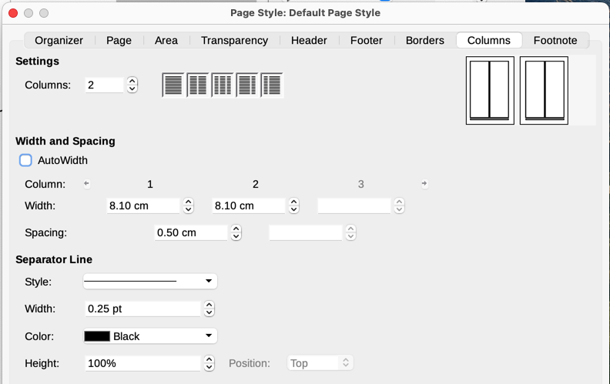
Figure 1: Defining the number of columns on a page

Formatting column width and spacing
Select AutoWidth in the Width and Spacing section to create columns of equal or preset width. To customize the width and spacing of the columns:
- In the Width and Spacing section, deselect the AutoWidth option.
- In the Width selection boxes, enter a width for each column.
- On the Spacing line, enter the amount of space between each pair of columns.
If more than three columns are specified, use the arrow buttons on the Column line to scroll among the columns.

Formatting separator lines
White space may be all that is needed between columns, but to create separator lines:
- Using the Style drop-down list, select the line style from the three styles available.
- Using the Width control, select the width of line to use, settable from 0.25pt to 9.0pt.
(1 point = 1/12 pica = 1/72 inch = 127/360 mm = 0.3527 mm.)
- Using the Height control, select the height of line required, as a percentage of the column height. You can choose from the supplied values or type in measurements.
- For a height less than 100%, use the Position drop-down list to select a vertical alignment for the separator lines. The vertical positioning options are Top, Centered, or Bottom.
- Select the line color from the Color drop-down list.

Distributing text across columns
As text is added to a column, the text flows from one column to the next. The last column may be shorter than the others.
To distribute text evenly, so that all the columns are approximately the same height, use a multi-column section instead; see “Formatting a section into columns” on page 17.
- Tip
Choose View > Formatting Marks (or press Ctrl+F10) to display end of paragraph markers (¶). Often, unexpected behavior of columns is due to extra paragraphs that are normally invisible but are taking up space.

Using frames for page layout
Frames can be very useful when producing newsletters or other layout-intensive documents. Frames can contain text, tables, multiple columns, pictures, and other objects. Use frames to:
- Position something in a particular place on a page, for example, a logo or a “stop press” news box in one corner of a page.
- Allow text on one page to continue on another page, somewhere more distant than the next one, by linking the content of one frame to another so the contents flow between them as you edit the text.
- Wrap text around an object, such as a photograph.
Because LibreOffice does not allow page styles with recurring frames (unless anchored in a header or footer), consider doing some quick sketches of the basic page layouts you need, indicating the approximate positions of different frames and their purposes. Keep the number of different page layouts as low as possible to avoid chaos in the design.
Pay special attention to the positioning of frames. A visually effective way to position a frame is to align its left margin with that of the paragraph above it. To do this, insert the frame in a blank paragraph of the same style as the paragraph above. Select Insert > Frame > Frame; in the Position section of the Type page of the Frame dialog (Figure 2 on page 8), select From Left in the Horizontal selection box to position the frame exactly where you want it.
Also, think about the type of wrap and the spacing between the frame and text. Instead of placing a frame close to the text, use the Wrap page to place some white space between them.
To format frames individually, or define and apply frame styles, see Chapter 9, Working with Styles.

Creating a frame
To create a frame, use one of these methods:
- Choose Insert > Frame > Frame to create an empty frame. The Frame dialog (Figure 2) opens. Set the frame’s characteristics at this stage or click OK and come back to customize it later.
- Select text and choose Insert > Frame > Frame to open the Frame dialog. Customize the frame (for example, to add space between the frame and the text) and click OK. The selected text is removed from the normal text flow and inserted into the frame.
- Choose Insert > Frame > Frame Interactively to quickly draw an empty frame. The mouse cursor changes shape. Click and drag the mouse to draw an empty frame. To customize the frame, right-click it and choose Properties in the context menu.
- Insert a formula or OLE object by selecting Insert > Object > [type of object]. The item is inserted and appears in a frame. To customize the frame, right-click it and choose Properties in the context menu.
To add content to a frame, first deselect the frame by clicking in an empty space somewhere else on the page. Then, click inside the frame to place the text cursor there. Now add content as you would on the main page. When you are done, deselect the frame.
- Note
The menu item Insert > Frame > Floating Frame is for use with HTML documents.
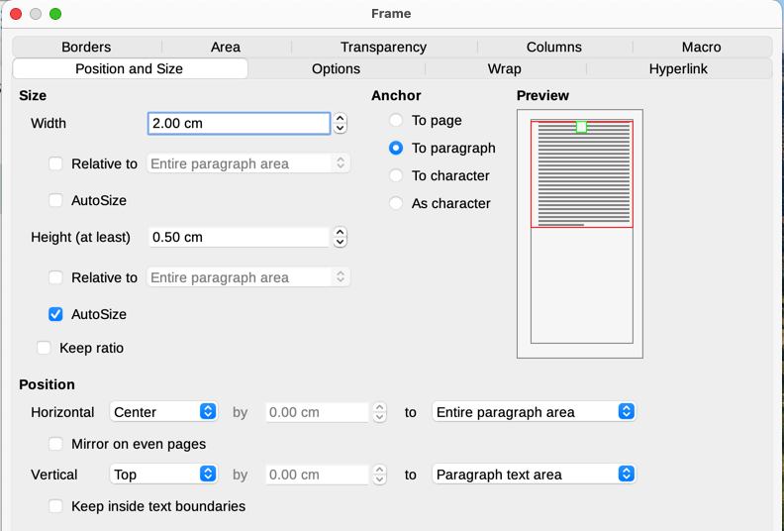
Figure 2: Frame dialog, Position and Size tab

Frame toolbar
When you create or select a frame, the Frame toolbar (Figure 3) is displayed. By default, it replaces the Formatting toolbar. You can also display it by using View > Toolbars > Frame.
1 Select anchor for object | 6 After | 11 Back One | 16 Border Style
2 None | 7 Through | 12 Send to Back | 17 Border Color
3 Parallel | 8 Align Objects | 13 To Foreground | 18 Background Color
4 Optimal | 9 Bring to Front | 14 To Background | 19 Link Frames
5 Before | 10 Forward One | 15 Borders | 20 Unlink Frames
Figure 3: The Frame toolbar

Moving, resizing, and changing frame attributes
When an object is added to Writer, it is automatically enclosed in a frame of a predetermined type. The frame sets how the object is placed on the page, as well as how it interacts with other elements in the document. You can edit the frame by modifying the frame style it uses or by manually formatting it when you add it to the document. Frame styles are discussed in Chapter 9, Working with Styles.
To change the size or location of a frame, first select the frame, then use either the mouse or the Frame dialog (Figure 2). Using the mouse is faster but less accurate.
- Tip
You might want to use the mouse for gross layout and the dialog for fine-tuning.
To re-size the frame manually, use any of these ways:
- Click on the green squares (sizing handles) and drag to the appropriate size.
- Add content to it (the frame will re-size automatically if, for example, you add a large picture to it).
- Go back to the Frame dialog and set the size and other characteristics.
To change the location of the frame using the mouse, drag and drop one of the edges or place the mouse pointer over an edge of the frame. The mouse pointer changes to a four-headed arrow when properly positioned for a drag-and-drop move.
To change the size of the frame, drag one of the sizing handles. Drag a handle on one of the sides to enlarge or reduce the text frame in one dimension only; drag a corner handle to enlarge or reduce it in both dimensions.
These resizing actions distort the proportions of the frame. Holding down the Shift key while dragging one of the handles makes the frame keep the same proportions.
To open the Frame dialog, select the frame, right-click, and choose Properties in the context menu.
To add or remove a frame’s border, click the relevant button on the Frame toolbar (Figure 3) to display some choices; or open the Frame dialog, go to the Borders page (Figure 4), and in the Line Arrangement section, select the first Preset (Set No Borders); or assign a borderless style to the frame; see Chapter 9, Working with Styles, for information on frame styles.
- Note
Do not confuse a frame’s border with the text boundaries that are made visible using the View menu (by selecting View > Text Boundaries).
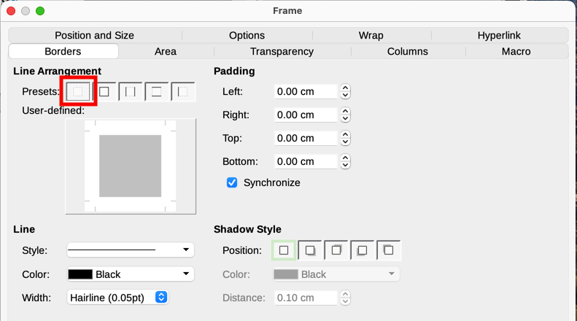
Figure 4: Removing the border from a frame

Anchoring frames
To anchor a frame, click on it, then right-click and point to Anchor, or click the Anchor button on the Frame toolbar and select the type of anchor, or open the Frame dialog to the Type tab.
To Page (available only on Frame dialog, not the toolbar or context menu)
The frame keeps the same position in relation to the page margins. It does not move as you add or delete text. This method is useful when the frame does not need to be visually associated with a particular piece of text. It is often used when producing newsletters or other documents that are very layout-intensive, or to center text vertically on a page.
The To Page anchor is deprecated. It is best to chose another type of anchor.
To Paragraph
The frame is associated with a paragraph and moves with the paragraph. It may be placed in the margin or another location. It is also used to center text on a page in documents which will be used in a master document (frames anchored to pages will disappear from the master document).
To Character
The frame is associated with a character but is not in the text sequence. It moves with the paragraph but may be placed in the margin or another location. This method is similar to anchoring to a paragraph.
As Character
The frame is placed in the document like any other character and, therefore, affects the height of the text line and the line break. The frame moves with the text as you add or delete text. This method is useful for adding a small icon in sequence in a sentence. It is also the best method for anchoring an image to an empty paragraph so it does not move around the page in unexpected ways.

Linking frames
You can link frames to each other even when they are on different pages of a document. The contents will automatically flow from one to the next. This technique is very useful when designing newsletters, where articles may need to be continued on a different page.
- Note
Text can only flow into a frame from one other frame, and flow on to one other frame. You can not link from a frame directly to more than one other frame.
To link one frame to another:
- Select the frame to be linked from.
- Click the Link Frames icon on the Frames toolbar.
- Click the next frame in the series (which must be empty).
When a linked frame is selected, any existing links are indicated by a faint connecting line (see Figure 5). To unlink frames, select the Unlink Frames icon on the Frames toolbar.
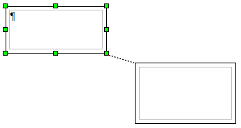
Figure 5: Linked frames
The height of a frame that is being linked from is fixed; you can change this height manually or by using the Position and Size tab on the Frame dialog, but it does not automatically adjust to the size of the contents (that is, the AutoHeight attribute is disabled). Only the last frame of a chain can adapt its height to the content.
The Wrap, Borders, Area, Columns, Transparency, and Macro pages of the Frame dialog are the same as those for frame styles. Refer to Chapter 9, Working with Styles, for details.
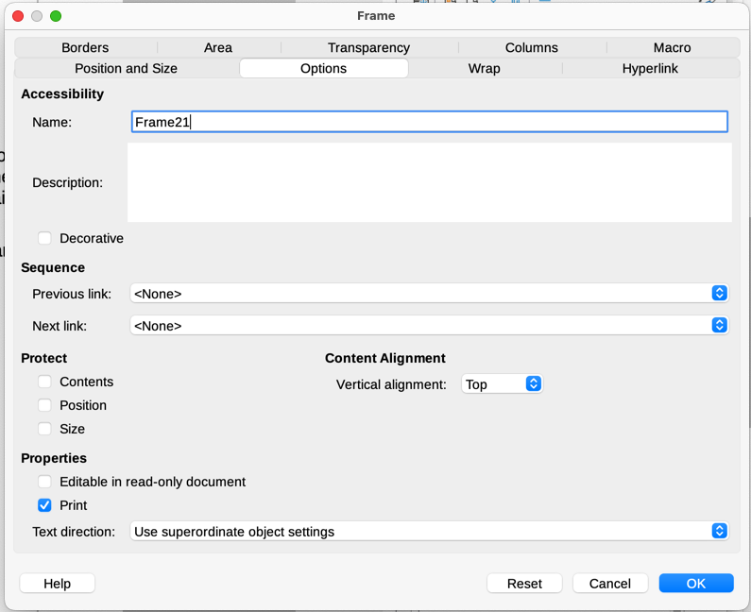
Figure 6: Options tab of the Frame dialog
The Options tab of the Frame dialog (Figure 6) shows the names of the selected frame and any frames it is linked to or from (Sequence). You can change this information here. On this tab, you can also select options to protect the contents, position, and size of the frame and provide accessibility information (Description). If the frame has no information content and is merely decorative, select the Decorative option.

Using tables for page layout
Writer’s tables can serve several purposes, such as holding data as you might see it in a spreadsheet, lining up material, and creating more complex page layouts. This topic describes how to achieve some common layouts by using tables. For information about using tables of data, see Chapter 13, Tables.

Positioning information in headers or footers
Instead of using tabs or frames, you can use a table in a header or footer to position different elements such as page number, document title, author, and so on. These elements are often inserted using fields, as described in Chapter 17, Fields.

Creating sideheads using tables
Sideheads and marginal notes are commonly used in documents such as resumes and computer user guides. The main body of the text is offset to leave white space (usually on the left-hand side) in which the sideheads or notes are placed. The first paragraph is aligned beside the sidehead, as in Figure 7.
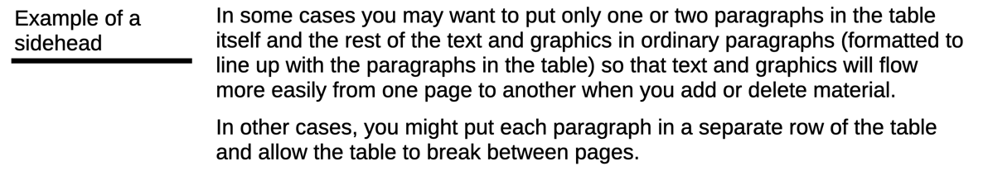
Figure 7: Example of a sidehead
- Note
Sideheads can also be created by placing text in a frame using the Marginalia frame style, as described in Chapter 9, Working with Styles.

Example
To create a table for use with a sidehead:
- Place the cursor where you want the table to appear and choose Table > Insert Table (Ctrl+F12).
- In the Insert Table dialog (Figure 8), define a two-column, one-row table with no heading. Choose None under Styles so the table will have no border. Click Insert.
- Right-click the table and choose Table Properties in the context menu. On the Columns tab of the Table Properties dialog (Figure 9), set the column widths.
- On the Table tab of the Table Properties dialog (Figure 10), in the Spacing section, make the Above and Below values the same as the Top and Bottom spacing you have defined for ordinary paragraphs of text. In the Properties section, optionally give this table a name. Click OK to save your settings.
- Tip
To check the top and bottom spacing for a paragraph: position the cursor in the paragraph and open the Properties deck on the Sidebar. In the Paragraph section, look under Spacing for the values.
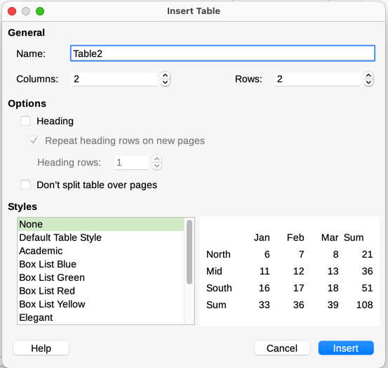
Figure 8: Defining a two-column borderless table with no heading
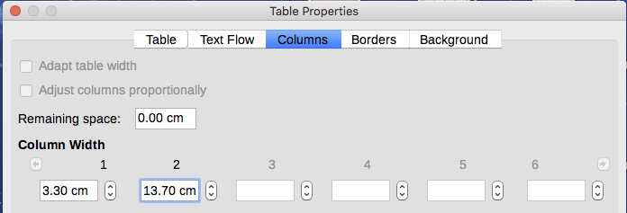
Figure 9: Defining a two-column table to line up with text offset at 3.3cm
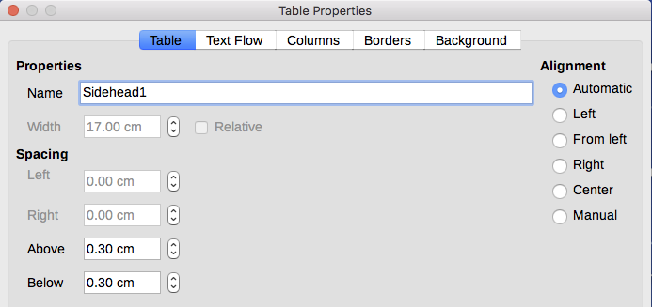
Figure 10: Defining the space above and below a table
To turn off number recognition so that Writer does not format numbers that should be plain text:
- Place the cursor in a table, and then select Table > Number Format on the Menu bar.
- On the Format Number dialog (Figure 11), make sure the Category is set to Text.
- Click OK.
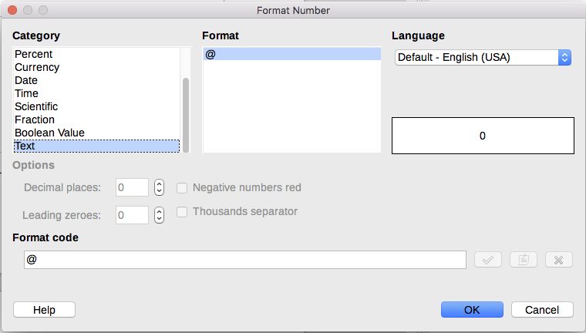
Figure 11: Setting number format to Text in a table
- Tip
If you use a table format often, consider saving it as a table style, using Table > AutoFormat Styles. See Chapter 13, Tables.

Using sections for page layout
A section is a block of text that has special attributes and formatting. Use sections to:
- Write-protect text.
- Hide text.
- Dynamically insert the contents of another document.
- Add columns, margin indents, a background color, or a background graphic to a portion of a document.
- Customize the footnotes and endnotes for a portion of a document.

Creating sections
To create a section:
- Place the cursor at the point in your document where you want to insert the new section. Or, select the text that you want to place in the new section.
- On the Menu bar, choose Insert > Section. The Insert Section dialog (Figure 12) opens.
- Choose settings for each page of the dialog as described below. Click Insert.
The Insert Section dialog has five tabs:
- Use the Section tab to set the section’s attributes.
- Use the Columns tab to format the section into columns.
- Use the Indents tab to set indents from the right and left margins of the section.
- Use the Area tab to add color or a graphic to the section’s background.
- Use the Footnotes/Endnotes tab to customize the section’s footnotes and endnotes.
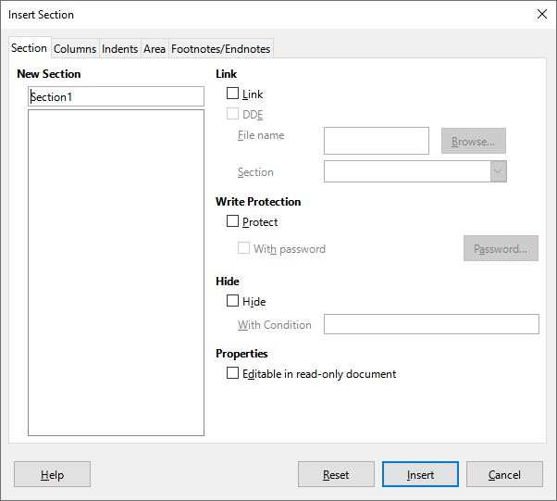
Figure 12: Inserting a section using the Insert Section dialog
At any time before closing the dialog, you can reset a tab other than the Section tab to its default settings by clicking the Reset button. If you wish to undo changes to the Section tab, you must do so manually.

Naming sections
Writer automatically enters a name for the section in the name box of the New Section list. To change the name, select it and type over it. The name is displayed in the Sections category of the Navigator window. Navigation is easier if you give your sections meaningful names.

Linking sections
You can insert the contents of another document into the section and then have Writer update it whenever the other document is updated.
- Note
If you want to insert only a part of the other document, be sure that part exists as a section in the document.
To link the section to another document, follow these steps:
- In the Link section of the dialog (Figure 13), select the Link option.
- Click the Browse button to the right of the File name field. The Insert dialog opens.
- Find and select the required document and click the Insert button. The name of the selected document appears in the File name field.
- To insert only a section of the selected document, select the desired section from the Section drop-down list.
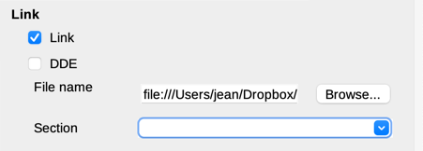
Figure 13: Linking sections
To update links automatically or manually, see “Updating links” on page 20.

Write-protecting sections
To write-protect the section so that its contents cannot be edited, select Protect in the Write protection area (Figure Chyba: Zdroj odkazu nenájdený).
- Note
Write-protection protects only the section’s contents, not its attributes or format.

Password-protecting sections
- Caution
Be very careful to remember or safely store the password, because it cannot be retrieved without advanced tools.
To prevent others from editing the section’s attributes or format, additionally protect the section with a password:
- Select Protect and With password.
- On the Enter Password dialog, type a password in the Password field and again in the Confirm field.
- Click OK.
Anyone who tries to edit the section’s attributes or format will be prompted to enter the password.

Hiding sections
You can hide the section so that it will not be displayed on the screen or printed. You can also specify conditions for hiding the section. For example, you can hide the section only from certain users. Hiding is very useful for creating a single source document containing students’ and teachers’ copies of a document such as a test.
- Note
You cannot hide a section if it is the only content on the page or if the section is in a header, footer, footnote, endnote, frame, or table cell.
To hide a section, select the Hide option in the Hide section of the dialog.
To hide the section only under certain conditions, enter the desired conditions in the With Condition field. The syntax and operators that you use to enter conditions are the same ones that you use to enter formulas. For syntax and a list of operators, see the Help and Chapter 17, Fields.
If the section is write-protected with a password, the password must be entered to hide or reveal the text.

Formatting a section into columns
You can give some parts of a page one column and other parts of the page two or more columns. For example, you might have a page-width headline over a three-column news story.
- Tip
You cannot select text on a multi-column formatted page and change it to a single column using this method. Instead, you need to define a single-column page style and then select the text you want to be in a two-column section on that page.
Use the Columns tab of the Insert Section dialog (Figure 14) to format the section into columns.
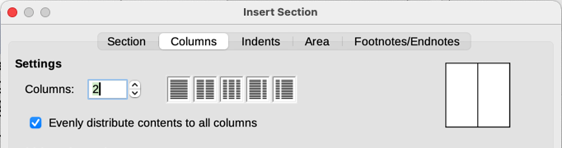
Figure 14: Choosing evenly distributed columns
As you add text to the section, the text flows from one column to the next. You can distribute text across the columns in one of two ways, as shown in Figure 15.
Evenly distribute contents to all columns
When this option is selected, Writer adjusts the length of the columns to the amount of text, so that all the columns are approximately the same length. As you add or delete text, the columns readjust.
When this option is not selected, Writer fills the columns newspaper-style: one column at a time, beginning with the first column. The last column may be shorter than the others.
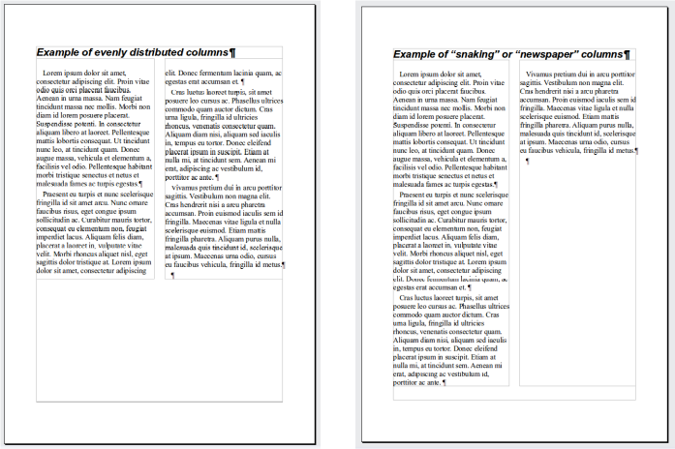
Figure 15: (Left) Evenly distributed columns; (Right) Newspaper-style columns

Indenting the section from margins
Use the Indents tab (Figure 16), to set indents from the right and left margins of the section.
Enter the desired left-margin indent in the Before section box. Enter the desired right-margin indent in the After section box. The preview box on the right-hand side of the tab shows you how the section will look with the indents applied.
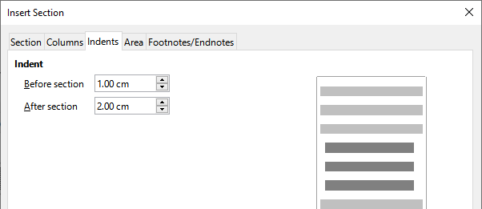
Figure 16: Indenting a section

Changing the background of the section
Use the Area tab to add color or an image to the background of the current section. This page is similar to the Area tabs for paragraphs, frames, tables, and other objects. For more information, refer to “Defining borders and backgrounds” on page 21 and the Draw Guide.

Customizing footnotes and endnotes in a section
Use the Footnotes/Endnotes page of the Insert Section dialog (Figure 17) to customize the current section’s footnotes and endnotes.
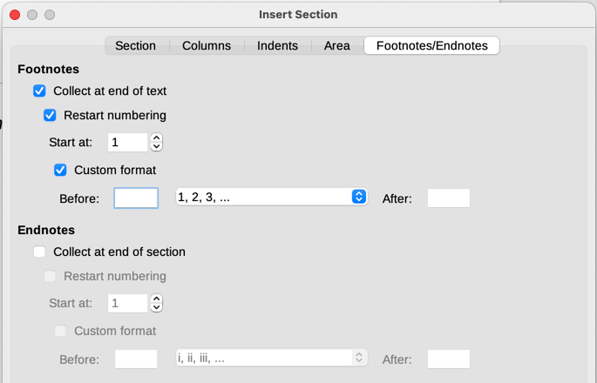
Figure 17: Setting footnotes and endnotes for sections

Customizing footnotes
To number the section’s footnotes separately from the other footnotes in the document, and format the numbering, follow these steps:
- In the Footnotes section of the page, make sure that Collect at end of text is selected.
- Select Restart numbering.
- To start the section’s footnotes at a number other than 1, enter the desired starting number in the Start at box.
- Select the Custom format option. In the drop-down list, select a numbering format for the footnotes.
To add text to the selected numbering format, use the Before and After boxes. For example, if you want the footnote numbers to be preceded by the word Note and followed by a colon, fill the Before and After boxes as shown in Figure 17.

Customizing endnotes
To have the section’s endnotes appear at the end of the section rather than at the end of the document, select the Collect at end of section option in the Endnotes area.
To number the current section’s endnotes separately from the other endnotes in the document, and format the numbering, apply the procedures described above to the Endnotes settings.

Editing and deleting sections
To edit a section, choose Format > Sections on the Menu bar, or go to Sections in the Navigator, right-click on the name of the section and select Edit in the context menu.
In the Edit Sections dialog (Figure 18), select the section to edit by clicking its name in the list.

Editing section attributes
To rename the selected section, type over its name in the Section name box.
On the Edit Sections dialog, you can also edit the selected section’s link, write-protect, and hide attributes. See “Linking sections” on page 16, “Write-protecting sections” on page 16, and “Hiding sections” on page 17.
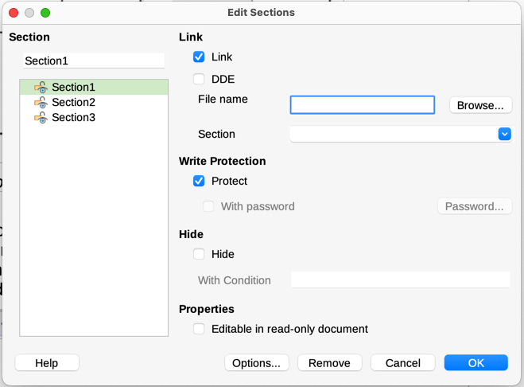
Figure 18: Edit Sections dialog

Editing the format of a section
To edit the format of the selected section, click the Options button.
The Options dialog has four tabs: Columns, Indents, Background, and Footnotes/Endnotes. These tabs are the same as those in the Insert Section dialog described earlier; the Background tab on the Options dialog corresponds to the Area tab in the Insert Section dialog.
To reset a tab to the conditions in place when the dialog opened, click the Reset button. To save the Options settings, click OK. You are returned to the Edit Sections dialog.

Removing sections
To remove the selected section, click the Remove button. This does not delete the contents of the section; the contents become part of the main document. If the contents were linked, they are now embedded.

Updating links
Writer can update linked sections automatically, and you can also update links manually. A protected section must first be unprotected before it can be updated.
To set Writer to update links automatically, or to turn off automatic updating:
- Choose Tools > Options > LibreOffice Writer > General. The dialog displays general text document settings.
- In the Update links when loading section of the dialog, select one of the options:
- Always Writer will update links automatically, without a prompt, when opening a document that contains links.
- On request Writer will display a prompt before updating links.
- Never Writer will not update links when opening a document.
- Click OK to save the settings.
To update a link manually:
- Open the document that contains the link.
- Choose Edit > External Links.
- The list in the Edit Links dialog (Figure 19) displays the names of all the files that are linked to the current document. Select the file that corresponds to the link to be updated.
- Click the Update button. The most recently saved contents of the linked file appear in the current document. To close the Edit Links dialog, click Close.

Removing links
To remove a link to a file and embed its contents, go to the Edit Links dialog, select the file that corresponds to the link you want to remove, and click the Break Link button. This action does not delete the text in the Section; it just breaks the link. If desired, the text must be removed manually.
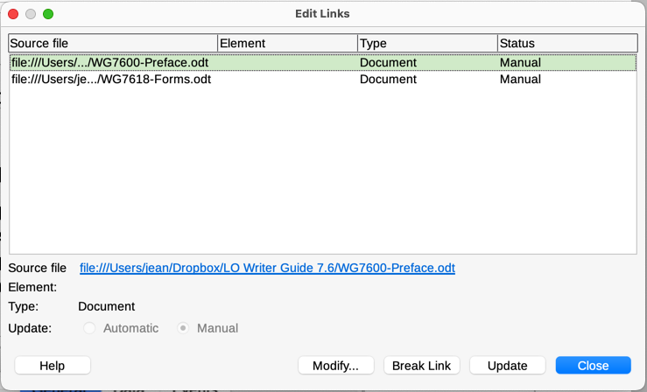
Figure 19: Edit Links dialog

Defining borders and backgrounds
Borders and backgrounds can be applied to many elements in Writer, including paragraphs, pages, frames, sections, page styles, paragraph styles, character styles, and frame styles. The dialog pages for borders and backgrounds are similar in each case. This topic includes some examples: a border and background for a frame and an image as background for a page.
- Tip
Page backgrounds can fill the entire page (sheet of paper) or only the area within the margins; make this selection on the Page tab of the Page Style dialog. Page borders surround only the area within the margins, including the header or footer if any exist. See Chapter 9, Working with Styles.
Tables, indexes, tables of contents, and bibliographies can also have borders and backgrounds, although the choices for background are limited to Color or Image.

Adding a border to a frame
You might want to set the frame off from the rest of the page by adding a border or background to the frame. To do this, select the frame, right-click, and choose Properties in the context menu. Select the Borders tab (Figure 20).
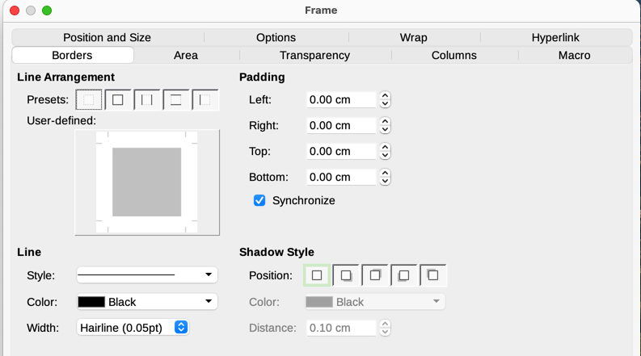
Figure 20: Frame dialog: Borders page
Borders have three components: where they go, what they look like, and how much space is left around them. Optionally they may also have a shadow property.
- Line Arrangement specifies where the borders go. Writer provides five default arrangements but you can click the line you want to customize in the User-defined area to get exactly what you want. Each line can be individually formatted.
- Line specifies what the border looks like: the style, width, and color. Each parameter has a number of attributes to choose from. The attributes selected will apply to those borders highlighted by a pair of black arrows in the User-defined thumbnail on the left side of the dialog.
- Padding specifies how much space to leave between the border and the contents of the element. Spaces can be specified to the left, right, top, and bottom. Select Synchronize to have the same spacing for all four sides.
- Shadow Style properties always apply to the whole element. A shadow has three components: where it is (Position), how far from the element it is cast (Distance), and what color it is.

Adding a color to the background area of a frame
To begin, select the frame, right-click, and choose Properties in the context menu. On the Frame dialog, select the Area tab (Figure 21), then choose Color. Select from the color grid or create a new color to use for this frame, and then click OK to apply it to the background.
- Tip
For selected words or other characters (right-click, Character > Character), the “background” is called highlighting. The only choices are Color or None.
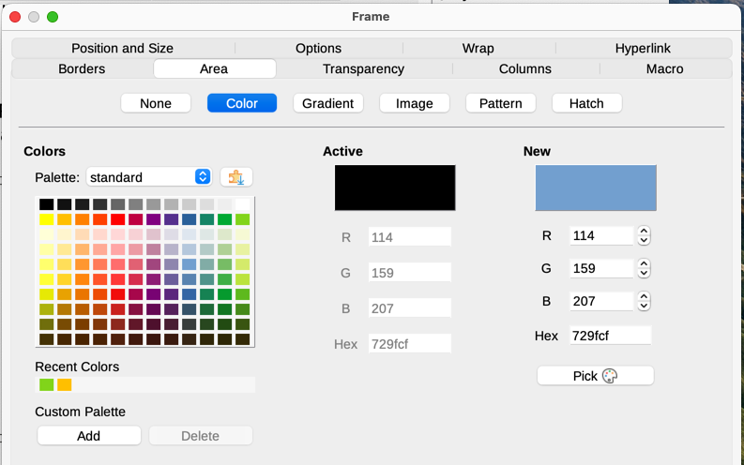
Figure 21: Frame dialog: Area page showing color choices

Adding a gradient, pattern, or hatch to the background of a frame
To add a gradient, pattern, or hatch to the background, choose the Area tab, then choose the required background type. The dialog now displays the options for that type, with an example in the preview pane to the right. Select the required design from the list or create a new design to use for this frame. Click OK to apply it to the background. See the Draw Guide for more about defining gradients, patterns, and hatching.

Adding an image to the background of a page
As an example, the first and last pages of the Writer Guide in PDF are images (cover art) applied as the background of those pages.
To add an image to the background of a page, right-click on the page and choose Page Style, go to the Area tab, and then choose Image (Figure 22). Choose one of the supplied images from the list on the left, or add your own.
To use a supplied image, select it from the thumbnails on the left.
- In the Options area, choose the placement for the image:
- Style – custom position/size, tiled, or stretched.
- Size – specify the width and height. Select Scale to stretch or shrink the image to fit the selected size.
- Position – select where the image is to be displayed.
- Click OK to apply the image to the background of the page.
To add or import an image:
- Click the Add/Import button. The Import dialog opens.
- Find the file you want and then click Open. The selected image now appears in the list of thumbnails on the left and in the preview box on the right of the Area tab.
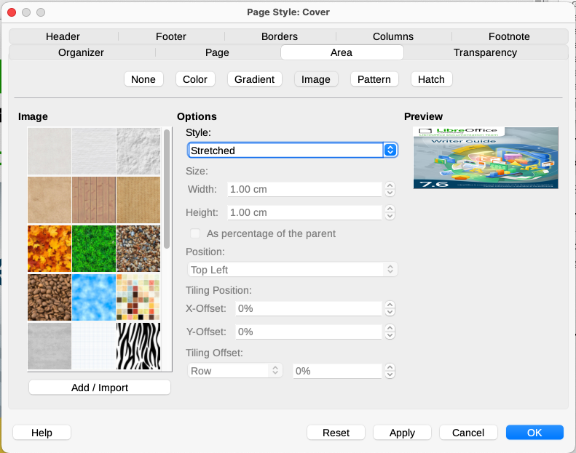
Figure 22: Page Style dialog: Area tab showing image choices

Deleting a color, gradient, image, or other background
To delete a background, select None near the top of the Area tab of the relevant dialog.

Adjusting the transparency of the background
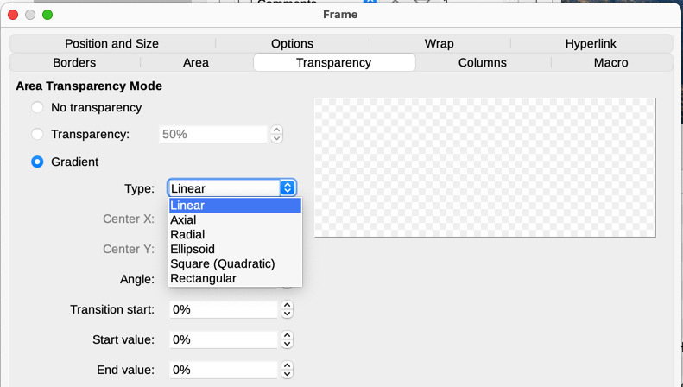
Figure 23: Transparency options
Transparency is useful for creating watermarks (a logo or text in the background of a page, typically showing the company name or a statement such as Draft) and making colors or images more pale (for more contrast with the text). Use the Transparency tab (Figure 23) to define the type of transparency. The choices are covered in detail in the Draw Guide.

Using document themes
Document themes collect various format selections into a set that can be applied and changed with two clicks. Theme colors have been implemented in LibreOffice 7.6; font and format settings are planned for a later release. This topic introduces the use of theme colors.
LibreOffice supplies several sets of theme colors, and you can define other sets (see Chapter 20, Customizing Writer). Theme colors have names like Dark 1, Light 1, Accent 1, and so on. They can be used in styles or applied manually.
To set up a document to use themes, choose colors for fonts, backgrounds, or objects from a Theme color palette (Figure 24), not an ordinary color palette. The first row of the palette contains the theme colors, with other rows containing modifications.
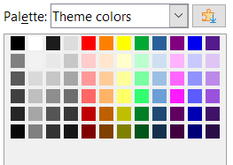
Figure 24: A palette of theme colors
To change the set of theme colors, choose Format > Theme on the Menu bar and select a different theme in the Theme dialog (Figure 25). Colors defined as theme colors change in the document. You need not change any style and need not change any object individually. Figure 26 shows an example.
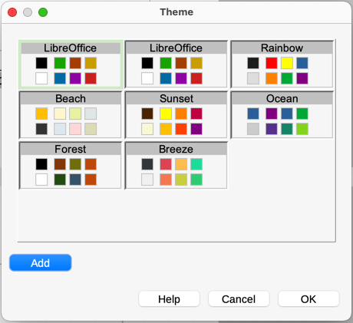
Figure 25: Theme dialog
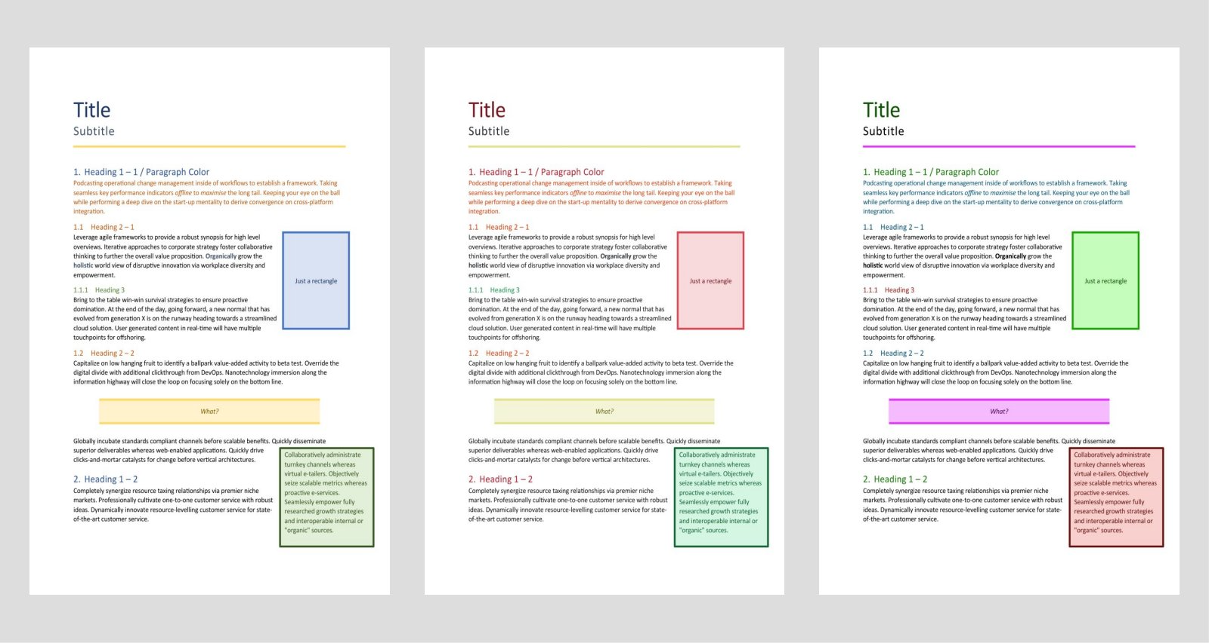
Figure 26: Example of changing a document's theme

Using page line-spacing for printing
Page line-spacing (also called Register-true) is particularly useful for printed documents that will have two pages set next to each other (for example, in a book or brochure), for multi-column layouts, and for documents intended for double-sided printing.
To use page line-spacing, you need to select options on the page styles and the paragraph styles or individual paragraphs to be included, because these options work together.

To enable a page style for page line-spacing
Each page style to be included in page line-spacing must be enabled separately. To do so:
- Open the Page Style dialog for the selected page style, using one of these methods:
- Right-click on any page using that style and select Page Style in the context menu.
- On any page using that style, go to Format > Page Style on the Menu bar.
- On the Sidebar, go to the Styles deck, select the Page Styles icon at the top, then right-click on the required page style and select Edit Style.
- On the Page tab, in the Layout Settings section, select the Use page line-spacing option, specify the Reference Style, and click OK.
- Note
The Reference Style sets an invisible vertical (typographical) grid, using the line distance specified in the style. All paragraphs that have Page line-spacing activated will use that line distance, aligning the bottom of a text line to the next grid line, regardless of font size or presence of graphics. Each line is thus the same height. Writer will align the base lines of text printed on adjacent columns, opposite pages, and both sides of a sheet of paper to this invisible grid.
All paragraphs with the selected Reference Style (or that inherit the Reference Style) will be activated automatically for Page line-spacing.

To enable paragraph styles for page line-spacing
- On the Styles deck of the Sidebar, right-click the Paragraph Style to enable, and choose Edit Style.
- In the Paragraph Style dialog, go to the Indents & Spacing tab.
- Select Activate page line-spacing to enable the paragraph style for page line-spacing. Deselect the option to exempt the paragraph style from page line-spacing. The option has no effect if Page line-spacing is disabled in the page style.

To enable paragraphs for page line-spacing
- Select all the paragraphs you want to enable, and then go to Format > Paragraph on the Menu bar.
- In the Paragraph dialog, go to the Indents & Spacing tab.
- Select Activate page line-spacing to enable the selected paragraphs for page line-spacing. Deselect the option to exempt the selected paragraphs from page line-spacing. The option has no effect if Page line-spacing is disabled in the page style.

