
Base Guide

Preface

Copyright
This document is Copyright © 2020 by the LibreOffice Documentation Team. Contributors are listed below. You may distribute it and/or modify it under the terms of either the GNU General Public License (http://www.gnu.org/licenses/gpl.html), version 3 or later, or the Creative Commons Attribution License (http://creativecommons.org/licenses/by/4.0/), version 4.0 or later.
All trademarks within this guide belong to their legitimate owners.

Contributors

To this edition
Pulkit Krishna | Dan Lewis

To previous editions
Pulkit Krishna | Jean Hollis Weber | Dan Lewis
Peter Scholfield

Feedback
Please direct any comments or suggestions about this document to the Documentation Team’s mailing list: documentation@global.libreoffice.org
- Note:
Everything you send to a mailing list, including your email address and any other personal information that is written in the message, is publicly archived and cannot be deleted.

Publication date and software version
Published May 2021. Based on LibreOffice 6.4.
Contents
Copyright 2
Contributors 2
To this edition 2
To previous editions 2
Feedback 2
Publication date and software version 2
Who is this book for? 4
What's in this book? 4
Sample databases 4
Where to get more help 5
Help system 5
Free online support 5
Paid support and training 6
What you see may be different 6
Illustrations 6
Icons 6
Using LibreOffice on macOS 6
What are all these things called? 6
Frequently asked questions 8

Who is this book for?
Anyone who wants to get up to speed quickly with LibreOffice Base will find this book valuable. Whether you have never worked with databases before, or have worked with them in a DBMS (Database Management System), or you are used to another database system from an office suite or a stand-alone database system such as MySQL, this book is for you. You may wish to first read Chapter 8, Getting Started with Base, in the Getting Started Guide.

What's in this book?
This book introduces Base, the database component of LibreOffice. Base uses the HSQLDB database engine to create database documents. It can access databases created by many database programs, including Microsoft Access, MySQL, Oracle, and PostgreSQL. Base includes additional functionality that allows you to create full data-driven applications.
- Note
A firebird embedded engine is also available. It is available in v6.4.1, v6.4.2 and v6.4.3 even without experimental mode. In v6.4.4, it has been moved back to experimental features due to the large number of bugs it had. Its use is deprecated. This guide is based on HSQLDB engine and gives a few example on Firebird. Please note that the Firebird engine is very good, it is its implementation in base which is full of bugs.
This book introduces the features and functions of Base, using a set of sample databases.
- Creating a database
- Accessing external databases
- Creating and using tables in relational databases
- Creating and using forms for data entry
- Using queries to bring together data from different tables, calculate results where necessary, and quickly filter a specific record from a mass of data
- Creating reports using the Report Builder
- Linking databases to other documents and external forms, including use in mail merge
- Filtering and searching data
- Using macros to prevent input errors, simplify tasks, and improve usability of forms
- Maintaining databases

Sample databases
A set of sample databases has been created to accompany this book. You can find them here:
https://wiki.documentfoundation.org/images/5/52/Sample-databases.zip
- Media_without_macros.odb
- Media_with_macros.odb
- Example_Sport.odb (Chapter 1, "Introduction to Base")
- Example_CSV_included.odb (Chapter 2, "Creating a Database")
- Example_jump_Cursor_Subform_Mainform.odb (Chapter 4, "Forms")
- Example_Report_conditional_Overlay_Graphics.odb (Chapter 6, "Reports")
- Example_Report_Bill.odb (Chapter 6, "Reports")
- Example_Report_Rows_Color_change_Columns.odb (Chapter 6, "Reports")
- Example_PDFForm_Import.odb (Chapter 7, "Linking to Databases")
- Example_Autotext_Searchmark_Spelling.odb (Chapter 8, "Database tasks")
- Example_Documents_Import_Export.odb (Chapter 8, "Database tasks")
- Example_Search_and_Filter.odb (Chapter 9, "Macros")
- Example_direct_Calculation_Form.odb (Chapter 9, "Macros")
- Example_Combobox_Listfield.odb (Chapter 9, "Macros")
- Example_serial_Number_Year.odb (Chapter 9, "Macros")
- Example_Database_Formletter_direct.odb (Chapter 9, "Macros")
- Example_Mail_File_activate.odb (Chapter 9, "Macros")
- Example_Dialogs.odb (Chapter 9, "Macros")

Where to get more help
This book, the other LibreOffice user guides, the built-in Help system, and user support systems assume that you are familiar with your computer and basic functions such as starting a program, opening and saving files.

Help system
LibreOffice comes with an extensive Help system. This is your first line of support for using LibreOffice. Windows and Linux users can choose to download and install the offline Help for use when not connected to the Internet; the offline Help is installed with the program on macOS.
To display the Help system, press F1 or select LibreOffice Help from the Help menu. If you do not have the offline help installed on your computer and you are connected to the Internet, your default browser will open the online Help pages on the LibreOffice website. The Help menu also includes links to other LibreOffice information and support facilities.
You can place the mouse pointer over any of the toolbar icons to see a small box (“tooltip”) with a brief explanation of the icon’s function. For a more detailed explanation, select Help > What's This? from the Menu bar and hold the pointer over the icon. In addition, you can choose whether to activate Extended Tips (using Tools > Options > LibreOffice > General).

Free online support
The LibreOffice community not only develops software, but provides free, volunteer-based support. In addition to the Help menu links above, there are other online community support options available, see the table below.
Free LibreOffice support
FAQs | Answers to frequently asked questions  https://wiki.documentfoundation.org/Faq
Mailing lists | Free community support is provided by a network of experienced users  https://www.libreoffice.org/get-help/mailing-lists/
Questions & Answers and  Knowledge Base | Free community assistance is provided in a Question & Answer formatted web service. Search similar topics or open a new one in  https://ask.libreoffice.org/en/questions  The service is available in several other languages; just replace /en/ with de, es, fr, ja, ko, nl, pt, tr, and many others in the web address above.
Native language support | The LibreOffice website in various languages  https://www.libreoffice.org/community/nlc/  Mailing lists for native languages  https://wiki.documentfoundation.org/Local_Mailing_Lists  Information about social networking  https://wiki.documentfoundation.org/Website/Web_Sites_services
Accessibility options | Information about available accessibility options  https://www.libreoffice.org/get-help/accessibility/
OpenOffice Forum | Another forum that provides support for LibreOffice, among other open source office suites https://forum.openoffice.org/en/forum/

Paid support and training
You can also pay for support through service contracts from a vendor or consulting firm specializing in LibreOffice. For information about certified professional support, see The Document Foundation’s website: https://www.documentfoundation.org/gethelp/support/

What you see may be different

Illustrations
LibreOffice runs on Windows, Linux, and macOS operating systems, each of which has several versions and can be customized by users (fonts, colors, themes, window managers). The illustrations in this guide were taken from a variety of operating systems. Therefore, some illustrations will not look exactly like what you see on your computer display.
Also, some of the dialogs may be differ because of the settings selected in LibreOffice. On some systems, you can either use dialogs from your computer’s operating system (default) or dialogs provided by LibreOffice. To change which dialogs are used, go to Tools > Options > LibreOffice > General and select or deselect the option Use LibreOffice dialogs.

Icons
The icons used to illustrate some of the many tools available in LibreOffice may differ from the ones used in this guide. The icons in this guide have been taken from a LibreOffice installation that has been set to display the Colibre set of icons.
To change the icon set used, go to Tools > Options > LibreOffice > View. In the Icon style section, choose from the drop-down list.

Using LibreOffice on macOS
Some keystrokes and menu items are different on macOS from those used in Windows and Linux. The table below gives some common substitutions for the instructions in this chapter. For a more detailed list, see the application Help.
Windows or Linux | macOS equivalent | Effect
Tools > Options | LibreOffice > Preferences | Access setup options
Right-click | Control+click and/or right-click depending on computer setup | Open a context menu
Ctrl (Control) | ⌘ (Command) | Used with other keys
F5 | Shift+ ⌘+F5 | Open the Navigator
F11 | ⌘+T | Open the Styles deck in the sidebar

What are all these things called?
The terms used in LibreOffice for most parts of the user interface (the parts of the program you see and use, in contrast to the behind-the-scenes code that actually makes it work) are the same as for most other programs.
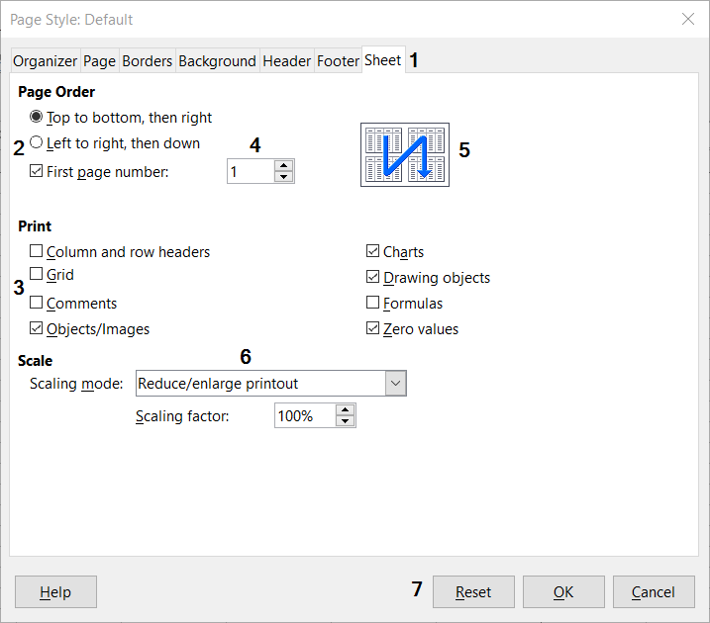Figure 1: Dialog (from Calc) showing common controls
- Tabbed page (not strictly speaking a control).
- Radio buttons (only one can be selected at a time).
- Checkbox (more than one can be selected at a time).
- Spin box (click the up and down arrows to change the number shown in the text box next to it, or type in the text box).
- Thumbnail or preview.
- Drop-down list from which to select an item.
- Push buttons.
A dialog is a special type of window. Its purpose is to inform you of something, or request input from you, or both. It provides controls for you to use to specify how to carry out an action. The technical names for common controls are shown in Figure 1. In most cases we do not use the technical terms in this book, but it is useful to know them because the Help and other sources of information often use them.
In most cases, you can interact only with the dialog (not the document itself) as long as the dialog remains open. When you close the dialog after use (usually, clicking OK or another button saves your changes and closes the dialog), then you can again work with the document.
Some dialogs can be left open as you work, so you can switch back and forth between the dialog and the document. An example of this type is the Find & Replace dialog.

Frequently asked questions
How is LibreOffice licensed?
LibreOffice is distributed under the Open Source Initiative (OSI) approved Mozilla Public License (MPL). See https://www.libreoffice.org/about-us/licenses/
It is based on code from Apache OpenOffice made available under the Apache License 2.0 but also includes software that differs from version to version under a variety of other Open Source licenses. New code is available under LGPL 3.0 and MPL 2.0.
May I distribute LibreOffice to anyone? May I sell it? May I use it in my business?
Yes.
How many computers may I install it on?
As many as you like.
Is LibreOffice available in my language?
LibreOffice has been translated (localized) into over 40 languages, so your language probably is supported. Additionally, there are over 70 spelling, hyphenation, and thesaurus dictionaries available for languages, and dialects that do not have a localized program interface. The dictionaries are available from the LibreOffice website at: www.libreoffice.org.
Why do I need Java to run LibreOffice? Is it written in Java?
LibreOffice is not written in Java; it is written in the C++ language. Java is one of several languages that can be used to extend the software. The Java JDK/JRE is only required for some features. The most notable one is the HSQLDB relational database engine.
How can I contribute to LibreOffice?
You can help with the development and user support of LibreOffice in many ways, and you do not need to be a programmer. To start, check out this webpage: https://www.libreoffice.org/community/get-involved/
May I distribute the PDF of this book, or print and sell copies?
Yes, as long as you meet the requirements of one of the licenses in the copyright statement at the beginning of this book. You do not have to request special permission. We request that you share with the project some of the profits you make from sales of books, in consideration of all the work we have put into producing them.
Donate to LibreOffice: https://www.libreoffice.org/donate/

