
Draw Guide

Chapter 1,
Introducing Draw

Copyright
This document is Copyright © 2021 by the LibreOffice Documentation Team. Contributors are listed below. You may distribute it and/or modify it under the terms of either the GNU General Public License (http://www.gnu.org/licenses/gpl.html), version 3 or later, or the Creative Commons Attribution License (http://creativecommons.org/licenses/by/4.0/), version 4.0 or later.
All trademarks within this guide belong to their legitimate owners.

Contributors
To this edition.
Peter Schofield | Regina Henschel | Elzett Kotze
To previous editions.
Martin Fox | John Cleland | Jean Hollis Weber
John A Smith | Peter Schofield | Vipul Gupta
Kees Kriek

Feedback
Please direct any comments or suggestions about this document to the Documentation Team mailing list: documentation@global.libreoffice.org
- Note
Everything sent to a mailing list, including your email address and any other personal information that is written in the message, is publicly archived and cannot be deleted.

Publication date and software version
Published May 2021. Based on LibreOffice 7.1.

Using LibreOffice on macOS
Some keystrokes and menu items are different on macOS from those used in Windows and Linux. Table 1 below gives some common substitutions for the instructions in this user guide. For a more detailed list, see the application Help.
Table 1: Using LibreOffice on macOS
Windows or Linux | macOS equivalent | Effect
Tools > Options  menu selection | LibreOffice > Preferences | Access setup options
Right-click | Ctrl+click and/or right-click depending on computer setup | Opens a context menu
Ctrl (Control) | ⌘ (Command) | Used with other keys
F11 | ⌘+T | Open the sidebar Styles deck

Contents
Copyright 2
Contributors 2
Feedback 2
Publication date and software version 2
Using LibreOffice on macOS 2
Introduction 4
Draw main window 4
Workspace 4
Pages pane 4
Layers bar 5
Sidebar 5
Rulers 6
Status bar 6
Toolbars 8
Adding and removing tools 9
Available toolsets 9
Docked and floating toolbars 10
Unlocking and locking toolbars 10
Customizing toolbars 10
Choosing and defining colors 11
Color palette 11
Specialized color palettes 11
Custom colors 12
Grid, snap, and help lines 12

Introduction
LibreOffice Draw is a vector graphics drawing program, although it can also perform some operations on raster graphics (pixels). Using Draw, a wide variety of graphical images can easily and quickly created.
Vector graphics store and display an image as an assembly of simple geometric elements such as lines, circles, and polygons, rather than a collection of pixels (points on the screen). Vector graphics allow for easier storage and scaling of the image.
Draw is fully integrated into the LibreOffice suite, and this simplifies exchanging graphics with all components of the suite. If an image is created in Draw, reusing it in a Writer document is relatively easy, for example, select and copy the drawing in Draw and then paste the image directly into a Writer document. Also, drawings can be worked on directly from within Writer or Impress, using a subset of the functions and tools from Draw.
The functionality of LibreOffice Draw is extensive. Draw was not designed to rival high-end graphics applications, but it possesses more functionality than the drawing tools that are generally integrated with the majority of office productivity suites.
A few examples of the drawing functions are: layer management, magnetic grid-point system, dimensions and measurement display, connectors for making organization charts, 3D functions that enable small three-dimensional drawings to be created (with texture and lighting effects), drawing and page-style integration, and Bézier curves.
This Draw Guide is not a course book to be worked through from beginning to end. Rather, it is a reference work in which can be browsed for guidance on particular topics.
This document describes only the functions associated with Draw. Some concepts, such as file management or the way the LibreOffice environment works, are mentioned only briefly and are covered in more detail in the Getting Started Guide.

Draw main window
The main components of the Draw main window are shown in Figure 1.

Workspace
The large area in the center of the Draw main window (Workspace) is where drawings are created. This drawing area can be surrounded with toolbars and information areas. The number and position of the visible tools vary with the task in hand and user preferences, therefore the Workspace displayed on another computer may look different from Figure 1.
The maximum size of a drawing page in LibreOffice Draw is limited by the computer setup and the page size that that can bet set and used in the printer connected to the computer.
By default, the Workspace consists of three layers (Layout, Controls and Dimension Lines) and the tabs for these default layers appear at the bottom of the Workspace. The default layers cannot be deleted or renamed, but layers can be added as and when necessary.

Pages pane
Drawings in Draw can be split over several pages. Multi-page drawings are used mainly for presentations. The Pages pane, on the left side of the Draw main window, gives an overview of the pages that created in a drawing. If the Pages pane is not visible, go to View on the Menu bar and select Page Pane. To make changes to the page order, drag and drop one or more pages.
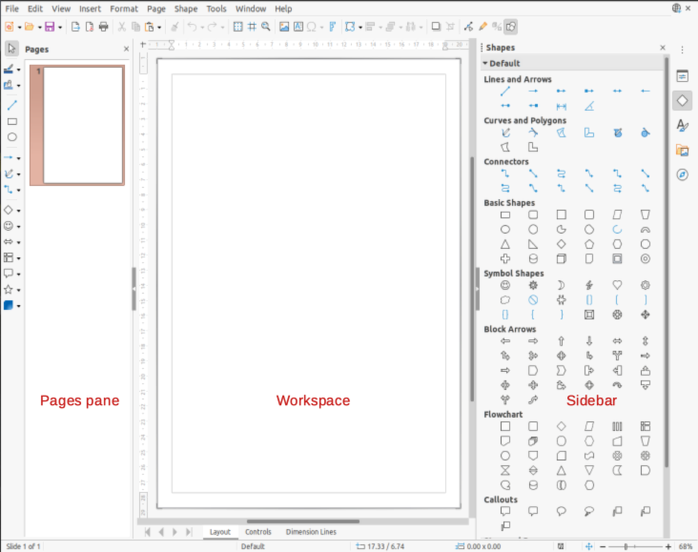Figure 1: Draw main window

Layers bar
A layer is a workspace where drawing elements and objects can be inserted. The Layers bar is located on the bottom of the Workplace and contains three default layers called Layout, Controls and Dimensions. For more information on layers, see Chapter 11, Advanced Draw Techniques.

Sidebar
The Sidebar has five main decks in Draw. To expand a deck, click on its icon or click on the small triangle ► in the section title bar and select a deck from the drop-down list. If the Sidebar is not visible, go to View > Sidebar on the Menu bar.
Properties
Contains sections for object properties, for example, Page, Character, Paragraph, Area, Effect, Shadow, Image, Line, and Position and Size. Available sections depends on the object selected.
Shapes
Provides quick selection of most items that are available on the Drawing toolbar: Lines and Arrows, Curves and Polygons, Connectors, Basic Shapes, Symbol Shapes, Block Arrows, Flowchart, Callouts, Stars and Banners, and 3D Objects.
Styles
Provides options to edit and apply Drawing Styles to objects within a drawing. When a style is edited or modified, the changes are automatically applied to all of the elements formatted using that style. In Draw, Presentation Styles are not available.
Gallery
From the Gallery deck, objects can be inserted into a drawing either as a copy or as a link. The Gallery is divided into categories: Arrows, BPMN (Business Process Model and Notation), Bullets, Diagrams, Flowchart, Icons, Network, Shapes, and Sounds. See Chapter 11, Advanced Draw Techniques for more information on using the Gallery.
Navigator
On the Navigator deck, pages and objects in a drawing can be quickly selected. It is recommended to give pages and objects in a drawing meaningful names so that they are easily identified when using the Navigator.

Rulers
Rulers are positioned on the upper and left-hand sides of the Workspace. If they are not visible, go to View > Rulers in the Menu bar. The rulers show the size of a selected object on the page using double lines (highlighted in Figure 2). Also, rulers can be used to manage object handles and guide lines when positioning objects.
The page margins in the drawing area are also represented on the rulers. Change the margins directly on the rulers by dragging them with the cursor. The margin areas are indicated by the grayed out area on the rulers as shown in Figure 2.
To change the measurement units of the rulers, right-click on a ruler and select the measurement unit from the drop down list, as shown in Figure 3 for the horizontal ruler. Measurement units for the horizontal and vertical rulers can be set to different measurement units.

Status bar
The Status Bar (Figure 4) is located at the bottom of the Workspace in all LibreOffice modules. To hide the Status Bar, go to View on the Menu bar and deselect Status Bar.
- Note
The measurement units shown on the Status Bar are set by going to Tools > Options > LibreOffice Draw > General on the Menu bar. These measurement units can be different to the measurement units set for the rulers.
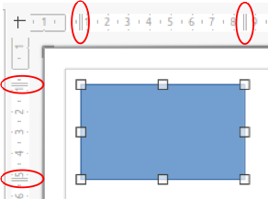Figure 2: Rulers showing object size
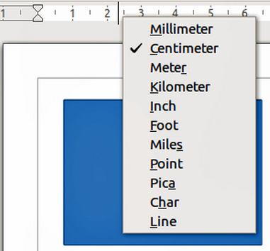Figure 3: Ruler measurement units
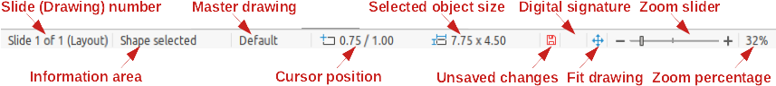Figure 4: Status bar
- Slide number – shows the number of the drawing pane that is selected.
- Information area – shows which action is being carried out, or object type selected.
- Cursor position and Object size – shows different information depending on whether objects are selected or not.
- When no object is selected, the position numbers show the current position (X and Y coordinates) of the mouse cursor.
- When an object is selected and being resized with the mouse, the object size numbers show the size of the object (width and height).
- If an object is selected, the position numbers shows the X and Y coordinates of the upper-left corner and the object size number pair displays the size of the object. These numbers do not relate to the object itself, but to the selection outline, which is the smallest possible rectangle that can contain the visible part or parts of the object; see Chapter 3, Working with Objects and Object Points for more information.
- When an object is selected, clicking in either of these areas opens the Position and Size dialog. See Chapter 4, Changing Object Attributes for more information.
- Unsaved changes – indicates that the file needs saving and the icon depends on computer setup. Clicking on this icon opens the Save as dialog if the file is new and has not been saved before. If the file has been saved before any changes, then clicking on this icon after any changes automatically saves the file.
- Digital signature – indicates if the document is digitally signed. The icon only appears if the drawing has a digital signature certificate. After the file has been saved, double-clicking on this icon opens the digital signatures dialog. See LibreOffice Help for more information on digital signature certificates.
- Fit drawing – resizes the drawing so that the whole drawing appears in the Workspace.
- Zoom slider and Zoom percentage – adjusts and indicates the zoom percentage of the Workspace displayed. Double-clicking on zoom percentage opens the Zoom & View Layout dialog.
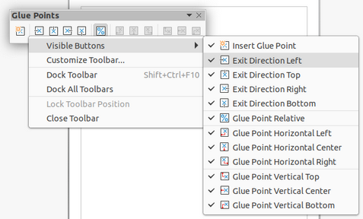Figure 5: Visible buttons on a toolbar

Toolbars
To display or hide the various Draw toolbars, go to View > Toolbars on the Menu bar and select from the drop down menu the toolbar required. For example, the Standard and Drawing toolbars are shown by default, but the Line and Filling, Text Formatting, and Options toolbars are not shown.
The appearance of the tool icons on toolbars depends on the computer operating system and the selection of icon style and size in Tools > Options > LibreOffice > View.
The tools available on a toolbar are indicated by a shaded outline around the tool icon or a check mark as shown by the example in Figure 5. For more information about working with toolbars, see the Getting Started Guide.
The four main toolbars used in Draw are as follows:
Standard toolbar
The Standard toolbar (Figure 6) is the same for all LibreOffice components and is not described in detail in this chapter. By default, it is locked into position at the top of the Draw main window.
Figure 6: Standard toolbar
Drawing toolbar
The Drawing toolbar (Figure 7) contains all the necessary functions for drawing various geometric and freehand shapes, and for organizing them in the drawing. By default, it is locked into position on the left of the Draw main window. It is described in detail in Chapter 2, Drawing Basic Shapes.
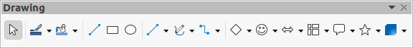Figure 7: Drawing toolbar
Line and Filling toolbar
The Line and Filling toolbar (Figure 8) is used to modify the main properties of a drawing object. The tools and pull-down lists vary according to the type of object selected. For example, to change the style of a line, click on the up and down arrows for Line Style and select the required style.
Figure 8: Line and Filling toolbar
The functions on the Line and Filling toolbar are used to change the color, style, and width of the line drawn, the fill color and style, and other properties of a selected object. If the selected object is a text frame, the Line and Filling toolbar is replaced by the Text Formatting toolbar. For more information, see Chapter, 4 Changing Object Attributes.
Text Formatting toolbar
The Text Formatting toolbar (Figure 9) is similar to the Formatting toolbar in Writer. It is only available when a text object has been selected in a drawing, replacing the Line and Filling toolbar. For more information, see Chapter, 4 Changing Object Attributes, and Chapter 9 Adding and Formatting Text.
Figure 9: Text Formatting toolbar

Adding and removing tools
The default set of tools on each toolbar can be modified using Visible Buttons. Add or remove a tool to or from a toolbar as follows:
- Either, right-click in an empty area on the toolbar, or click on the downward pointing triangle ▼ in the toolbar title and select Visible Buttons from the context menu.
- Click on a tool name to add or remove the tool to or from the toolbar.
- Note
When a tool is added to a toolbar, its position on the toolbar (from left to right) is the same as its position in the Visible Buttons context menu.

Available toolsets
Some tools on a toolbar have a downward pointing triangle ▼ to the right side of the tool icon. This indicates that the tool has additional tools available. Click on the downward pointing triangle ▼ to display the full set of tools (Figure 10).
This toolset can be turned into a floating toolbar. Click the area at the top of the toolset as shown in Figure 10, drag it across the screen to a convenient location and release the mouse button. To close a floating toolbar, click on the X on the right of the toolbar title.
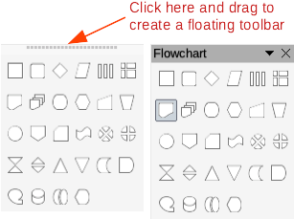Figure 10: Available tools and floating toolbar
- Note
When a toolset is made into a floating toolbar, the tool on the existing toolbar remains in the toolbar and always shows the last tool used. This means that the tool icon on a screen may differ from the tool icon shown in this guide.
- Tip
When double-clicking on a tool, the command corresponding to that tool becomes active and remains active. The tool command can be repeated as often as required. To exit from this mode, press the Esc key or click on another tool. Please note that this may not work for every tool on every toolbar.

Docked and floating toolbars
When Draw is opened, the Standard and Drawing toolbars, by default, are already locked and docked into their positions on the main Draw window. These toolbars can be undocked creating floating toolbars. To undock a toolbar and create a floating toolbar:
- Move the mouse cursor to the far left of the toolbar and over the toolbar handle (Figure 11). The cursor changes shape, normally a grabbing hand, depending on computer setup and operating system.
- Click and drag on the toolbar handle to move the toolbar until it becomes a floating toolbar. This floating toolbar capability is common to all components of LibreOffice.
To dock a floating toolbar, press and hold the Ctrl key, then double click on the title of the toolbar. The toolbar moves into available space at the top of the Draw main window.
An alternative method of docking a toolbar is to click in the toolbar title and drag the toolbar to the docked position that required. This can be the top, bottom or one of the sides of the Draw main window.
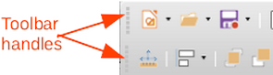Figure 11: Toolbar handles

Unlocking and locking toolbars
By default when Draw is opened, any docked toolbars are locked into position and have to be unlocked before they can become floating toolbars or repositioned on the Draw main window.
To unlock a toolbar, right-click in a blank area on the toolbar and deselect Lock Toolbar Position from the context menu. A toolbar handle, as shown in Figure 11, appears at the left end of the toolbar, indicating that the toolbar is unlocked and can be moved.
To lock a toolbar into position, dock the toolbar into position, then right-click in a blank area on the toolbar and select Lock Toolbar Position from the context menu. The toolbar handle disappears from the left end of the toolbar.

Customizing toolbars
You can customize Draw toolbars to add or remove commands to or from a toolbar. Also, customization allows you to create toolbars for specific purposes. Customizing toolbars is in addition to using “Adding and removing tools” above.
For more information when adding a new commands, modifying toolbars, or creating toolbars, see the Getting Started Guide.
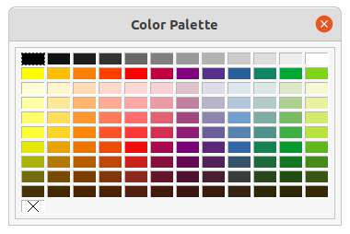Figure 12: Color Palette (Color Bar)

Choosing and defining colors

Color palette
The Color Palette (Figure 12) provides quick access to a standard set of colors to use for selected objects and text in a drawing.
- Go to View on the Menu bar and select Color Bar to open the Color Palette.
- Select an object or text where to change the color.
- Left click on the color required for the area fill or text and change the color of the object or text.
- Right click on the color required for the object or text box border and change the color of the border.
- Go to View on the Menu bar and deselect Color Bar to close the Color Palette.
- Note
The box with the X at the bottom left of the Color Palette corresponds to none (no color).
- Note
The colors available in the Color Palette depend on the color palette that had been previously used when changing color on an object. For example, Figure 12 shows the Standard color palette that had been used previously when changing color to an object using a properties dialog.

Specialized color palettes
In addition to the standard Color Palette, Draw has several specialized color palettes available, giving a greater choice of color: for example, chart-palettes, material, html, and so on. After selecting an object or text in a drawing, use one of the following to access the specialized color palettes.
- Area or fill color – Color page in the Area dialog, Fill Color on the Drawing or Line and Filling toolbar, or Fill in the Area section in the Properties deck on the Sidebar.
- Line color – Line page in the Line dialog, Line Color on the Drawing or Line and Filling toolbar, or Color in the Line section in the Properties deck on the Sidebar
- Text color – Font Color tool on the Text Formatting toolbar, or Font Color in the Character section in the Properties deck on the Sidebar.
For more information on selecting a color and a color palette for an object or text, see Chapter 4, Changing Object Attributes, Chapter 9, Adding and Formatting Text and Chapter 11, Advanced Draw Techniques.

Custom colors
In Draw, custom colors can be created using the Color Picker dialog, specific CMYK values, or specific RGB values to match the color schemes used in a company. For more detailed information on creating custom colors and color palettes, as well as more information on CMYK and RGB color schemes, refer to Chapter 11, Advanced Draw Techniques.

Grid, snap, and help lines
The grid and snap lines in Draw act as drawing aids and these can be turned on or off by clicking on Display Grid or Display Snap Guides on the Line and Filling or Options toolbars. The grid and snap lines are displayed only on the screen and are not shown on a printed drawing or when the drawing is used in another LibreOffice module. The color, spacing and resolution of the grid points can be individually chosen for each axis.
Help lines when moving objects can be displayed and these are turned on or off by clicking on Helplines While Moving on the Line and Filling or Options toolbars. Showing the position of the object while moving makes positioning the object much easier. If this function is activated, pairs of vertical and horizontal lines enclosing the object are shown while moving the object. These lines extend to the edges of the drawing area.
Draw also offers several snap functions to positioning of objects exactly in a drawing.
For more information on the grid, snap lines, snap functions, and help lines, see Chapter 3, Working with Objects and Object Points.

