
Draw Guide 25.8

Chapter 9,
Adding and Formatting Text

Copyright
Document copyright © for 2025 is held by the LibreOffice Documentation Team. Contributors are listed below. All trademarks in this guide belong to their legitimate owners. This document maybe distributed and/or modified under the terms of the GNU General Public License (https://www.gnu.org/licenses/gpl.html), version 3 or later, or the Creative Commons Attribution License (https://creativecommons.org/licenses/by/4.0/), version 4.0 or later.

Contributors

Contributors for this edition:
Peter Schofield

Contributors for previous editions:
Jean Hollis Weber
Low Song Chuan
Martin Saffron
Michele Zarri
Peter Schofield
Regina Henschel

Feedback
Please direct any comments or suggestions about this document to the Documentation Team Forum at https://community.documentfoundation.org/c/documentation/loguides/ (registration is required) or send email to: loguides@community.documentfoundation.org.
- Note
Everything sent to a mailing list, including email addresses, is publicly archived and cannot be deleted.

Publication date and software version
Published September 2025. Based on LibreOffice 25.8 Community.
Other versions of LibreOffice may differ in appearance and functionality.

Contents
Copyright 2
Contributors 2
Feedback 2
Publication date and software version 2
Introduction 5
Text mode 5
Activating text mode 5
Adding vertical text 5
Text toolbar 6
Text boxes 6
Creating text boxes 6
Text box borders 7
Line and Filling toolbar 7
Line dialog 8
Line panel in Sidebar 9
Moving text boxes 10
Resizing text boxes 10
Rotating text boxes 11
Formatting text boxes 12
Text box formatting options 12
Deleting text boxes 13
Text in objects 13
Adding text to objects 13
Text options for objects 14
Formatting text 15
Pasting text 16
Quick font resizing 16
Selecting text 16
Paragraph formatting 16
Direct formatting 16
Paragraph dialog 17
Paragraph panel in Sidebar 18
Character formatting 18
Direct formatting 18
Character dialog 19
Sidebar Character panel 20
Unordered or ordered lists 20
Creating lists 20
Adjusting list item level and position 21
Bullets and Numbering dialog 22
Text columns 23
Text boxes 23
Drawing objects 24
Text animation 25
Creating text animation 26
Text animation options 26
Text callouts 27
Creating text callouts 27
Editing text callouts 28
Text callout options 29
Tables in Draw 29
Inserting tables 30
Table dialog 30
Table grid 31
Table Design panel 31
Inserting table designs 31
Creating table designs 31
Table design options 32
Table formatting 32
Table toolbar 32
Menu bar 34
Table Properties dialog 35
Table position and size 38
Deleting tables 39
Whole table 39
Row or column 39
Cell contents 39
Using fields 40
Inserting fields 40
Field types 40
Using hyperlinks 41
Internet hyperlink 41
Mail hyperlink 41
Document hyperlink 43
New Document hyperlink 44
Further Settings 45
Editing text hyperlinks 45
Formatting hyperlinks 45
Image maps 45
Creating image maps 46
Image map tools 47
Fontwork 48
Creating Fontwork 48
Fontwork toolbar 49
Modifying Fontwork 50

Introduction
Text used in drawings is placed inside an object or text box. This chapter provides information on how to create, format, use, delete text, and information for various types of text that can be inserted into a drawing. Also, information is included on how to insert special forms of text such as ordered or unordered lists, tables, fields, hyperlinks, columns, and Fontwork.
- Note
When selecting text tools to add text to a drawing, Draw automatically switches to text mode. Also, the Text Formatting toolbar (Figure 1 below) automatically opens replacing the Line and Filling toolbar at the top of the drawing.

Text mode

Activating text mode
Before text is inserted into a drawing, text mode must be activated using one of the following methods.
- For horizontal text only, go to Insert > Text Box on the Menu bar, or use the keyboard shortcut F2.
- Click on Insert Text Box for horizontal text, or Insert Vertical Text for vertical text on the Drawing toolbar (Figure 2 below), or Text toolbar (Figure 3 below).

Adding vertical text
If Insert Vertical Text is NOT available on the Drawing toolbar (Figure 2 below), it is added to the toolbar as follows:
- Go to Tools > Options > Language Settings > Languages (macOS LibreOffice > Preferences > Language Settings > Languages) on the Menu bar to open the Languages page in the Options dialog.
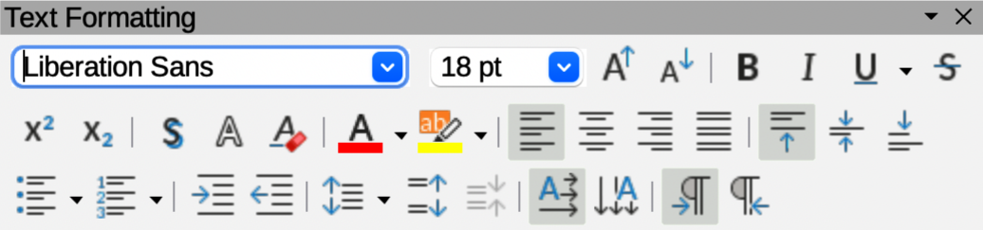
Figure 1: Text Formatting toolbar
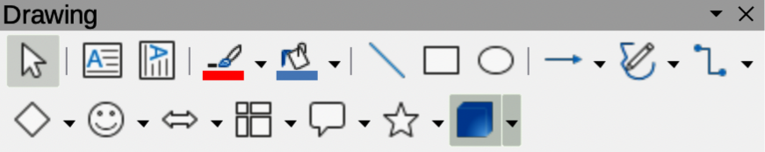
Figure 2: Drawing toolbar
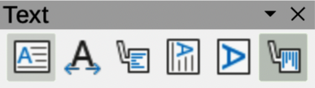
Figure 3: Text toolbar
- In Default Languages for Documents, select the option Asian and accept the default settings for this option.
- Click OK to close the Options dialog and save the changes.
- Right-click in an empty area on the Drawing toolbar, or the downward triangle ▼, and select Visible Buttons from the context menu.
- Select Vertical Text from the drop-down list of options to add Insert Vertical Text to the Drawing toolbar.

Text toolbar
It is recommended to have the Text toolbar (Figure 3 above) available in Draw when working with text. If the Text toolbar is not available, go to View > Toolbars on the Menu bar and select Text from the context menu to add it to the Draw workspace.

Text boxes

Creating text boxes
When text is added to a drawing, a text box is automatically created. By default, the text box either expands horizontally to accommodate a single line of horizontal text, or vertically to accommodate a single line of vertical text.
- Note
Text boxes are only for text and cannot contain illustrations, inline pictures, formulas, tables, or objects.
- Activate text mode in Draw for horizontal or vertical, see “Activating text mode” on page 5. The Text Formatting toolbar automatically opens, replacing the Line and Filling toolbar.
- Click at the approximate position in the drawing to insert the text box. A text box is created containing a flashing text cursor for the operating system and computer setup being used.
- Type or paste the text into the text box and the text box expands either horizontally or vertically to accommodate a single line of text. Also, the left corner of the Status Bar indicates text edit mode and the position of the text cursor (Figure 4 below).
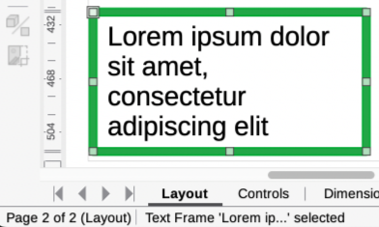
Figure 4: Example of text information on Status Bar
- To create multiple lines in the text box, use one of the following methods:
- Press the Enter key at the end of a line of text to create single line paragraphs inside the text box. The text box expands to accommodate more lines of text.
- For horizontal text, click and drag the text cursor horizontally creating a text box with the approximate width required. As the limits of the text box are reached, the text automatically word wraps inside the text box and increases text box height as more text lines are added.
- For vertical text, click and drag the text cursor vertically creating a text box with the approximate height required. As the limits of the text box are reached, the text automatically word wraps inside the text box and increases text box width as more text lines are added.
- Move, resize, rotate or format the text box as required. For more information, see the following sections and Chapter 3, Working with Objects.
- Format the text using the various tools on the Text Formatting toolbar. For more information on text formatting, see “Formatting text” on page 15.
- When adding and formatting text is completed, click outside the text box to save the changes and deselect the text box.

Text box borders
By default, when a text box is created, the borders of the text box are only displayed when the text box is selected. If necessary, use one of the following methods to create a visible border around the text box.

Line and Filling toolbar
- Click on a text box to select it and display the border indicating that the text box is in edit mode.
- If the Line and Filling toolbar is not visible, go to View > Toolbars > Line and Filling on the Menu bar to open the toolbar.
- In Line Style on the Line and Filling toolbar (Figure 5 below), select a line style from the options in the drop-down list.
- In Line Thickness on the Line and Filling toolbar, enter a line width for the text box border.
- In Line Color on the Line and Filling toolbar, select a color from one of the available color palettes, or create a custom color.
- Click outside the text box to exit edit mode and save the changes.
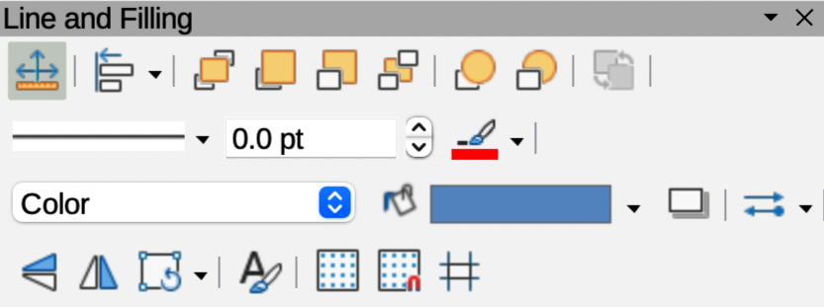
Figure 5: Line and Filling toolbar
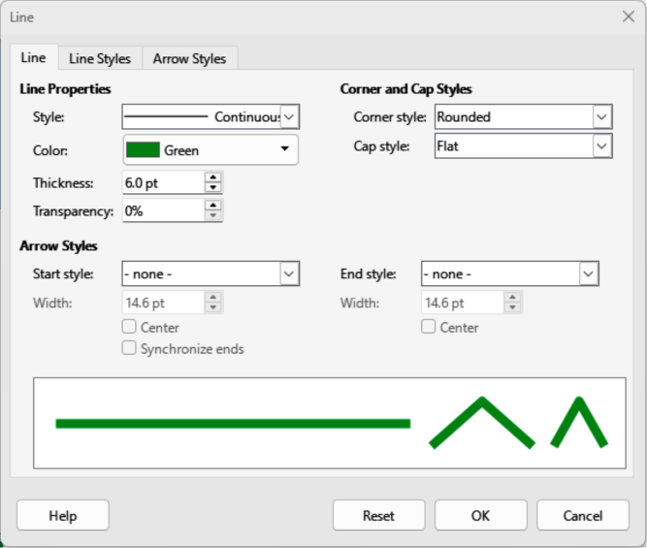
Figure 6: Line dialog — Line page — Text box border

Line dialog
- Click on a text box to select it and display the border indicating that the text box is in edit mode.
- Open the Line dialog (Figure 6 above) using one of the following methods:
- Right-click on the text box border and select Line from the context menu.
- Go to Format > Line on the Menu bar.
- Click on Line to open the Line page.
- Click on Line to open the Line page.
- In Style, select a line style from the drop-down list to use as a text box border.
- In Color, select a color for the line style from one of the available color palettes, or create a custom color.
- In Thickness, enter a width for the line style selected.
- In Transparency, enter a percentage value for the line style, if required.
- In Corner Style, select the type of corner style from the drop-down list.
- Click OK to save the changes and close the Line dialog, then click outside the text box to exit edit mode.
- Note
For a corner style to be clearly visible in a text box border, it is recommended to set the line thickness above 0.35cm, as shown by the example in Figure 7 below.
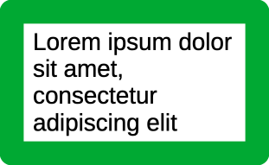
Figure 7: Example of using rounded corners on a text box
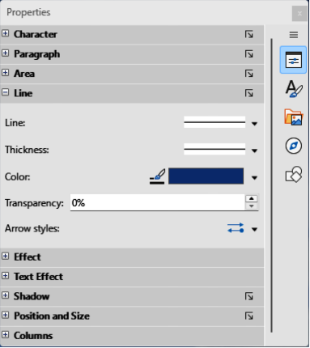
Figure 8: Line panel in Properties deck on Sidebar for Text Box

Line panel in Sidebar
- Click on a text box to select it and display the border indicating that the text box is in edit mode.
- In the Sidebar, click on Properties to open the Properties deck in the Sidebar, then click on Line to open the Line panel (Figure 8 above).
- In Line, select a line style from the drop-down list to use as a text box border.
- In Thickness, enter a width for the line style selected.
- In Color, select a color for the line style from one of the available color palettes, or create a custom color.
- In Transparency, enter a percentage value for the line style, if required.
- Click outside the text box to exit edit mode.

Moving text boxes
- Click on a text box to select it. The border is displayed indicating that the text box is in edit mode.
- Move the cursor over the border. The cursor changes shape to the move symbol for the computer setup (for example, a clenched hand).
- Click on the border and drag the text box to a new position in the drawing. A ghosted outline of the text box shows where it will be placed (Figure 9 below).
- Release the text box when it is in the required position.
- To accurately position a text box, use the Position and Size dialog, or the Position and Size panel in the Properties deck on the Sidebar. See Chapter 3, Working with Objects for more information.
- When the text box is in the required position, click outside the text box to save the changes and deselect the text box.

Resizing text boxes
- Click on a text box to select it and display the border indicating the text box is in edit mode.
- Move the cursor over one of the selection handles. The cursor changes shape to the resizing symbol for the computer setup (for example, a double-headed arrow). The selection handles are used to resize the text box as follows:
- Corner handles change the width and height of the text box simultaneously.
- Top and bottom selection handles change the height of the text box.
- Right and left selection handles change the width of the text box.
- Click and drag the border to a new position to resize the text box. A ghosted outline of the text box shows is displayed as the text box is resized (Figure 10 below).
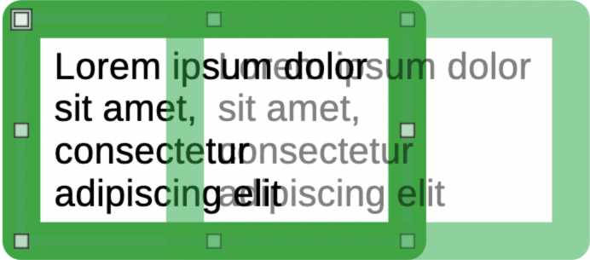
Figure 9: Example moving a text box
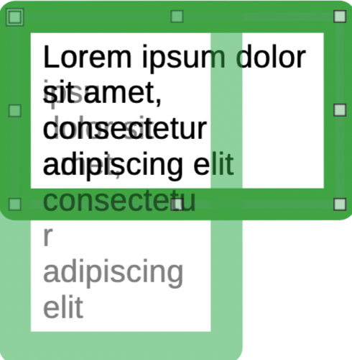
Figure 10: Example resizing a text box
- Release the text box when it reaches the required size.
- To accurately resize a text box, use the Position and Size dialog, or the Position and Size panel in the Properties deck on the Sidebar. See Chapter 3, Working with Objects for more information.
- When the text box is at the required size, click outside the text box to save the changes and deselect the text box.
- Note
When resizing a text box, press and hold the Shift key to maintain text box proportions, then click and drag a selection handle to resize. Release the cursor before releasing the Shift key.

Rotating text boxes
- Click on a text box to select it and display the border indicating that the text box is in edit mode.
- Click again on the text border and the selection handles change shape and color to indicate rotation mode. Also, a rotation point appears in the center of the text box.
- Click on a corner selection handle and drag to rotate the text box. A ghosted outline of the text box being rotated around the rotation point appears and the current angle of rotation is shown in the status bar (Figure 11 below).
- If required, click and drag the rotation point to a new position and change rotation angle of the text box. The rotation point can be positioned outside of the text box.
- Release the text box when it is at the required rotation angle.
- To accurately rotate a text box, use the Rotation page in Position and Size dialog, or the Position and Size panel in the Properties deck on the Sidebar. See Chapter 3, Working with Objects for more information.
- Note
When rotating a text box, the top, bottom, and side selection handles are visible, but not available for rotating a text box. Also, text boxes cannot be sheared, slanted, or flipped vertically/horizontally.
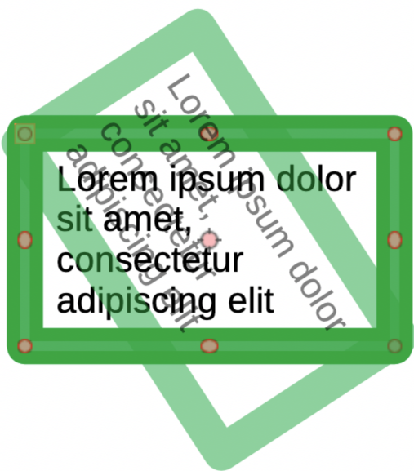
Figure 11: Example rotating a text box
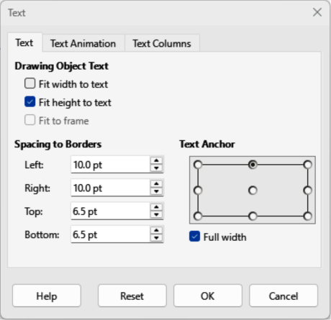
Figure 12: Text dialog — Text page — Drawing Object

Formatting text boxes
The formatting options available for area fill and box borders of text boxes are the same as other objects in a drawing. After formatting a text box to match the drawing requirements, the text attributes are formatted to make the text appear correctly inside the text box. See Chapter 3, Working with Objects for more information on formatting the area fill or borders of a text box.
- Select a text box and use one of the following methods to open the Text dialog for Drawing Object Text (Figure 12 above).
- Right-click on the text box and select Text Attributes from the context menu.
- Go to Format > Text Attributes on the Menu bar.
- Click on Text in the Text dialog to open the Text page and access to the formatting options.
- If required, click on Text Animation to open the Text Animation page to access options for animating the text. For more information on using text animation in a drawing, see “Text animation” on page 25.
- If required, click on Text Columns to open the Text Columns page to access options for creating columns in a text box. For more information on using text columns in a drawing, see “Text columns” on page 23.
- Click OK to save the changes to text attributes and close the Text dialog.
- Click in a blank space to deselect the text box and end the text editing mode.

Text box formatting options
Drawing Object Text
Fit width to text
Expands or reduces text box width to match the length of the text, if the text box is smaller or larger than the text. Can be used with Fit height to text to automatically adjust width and height of the text box to the text.
Fit height to text
Expands or reduces text box height to match the height of the text, if the text box is smaller or larger than the text. Can be used with Fit width to text to automatically adjust width and height of the text box to the text.
Fit to frame
Resizes text width and height to use the entire area of a text box without changing text box width or height. This option is not available if Fit width to text and/or Fit height to text options are selected.
Spacing to Borders
Specify the amount of space to create margins between text and the text box borders.
Text Anchor
Anchors the text to one of nine positions within a text box. The left and right anchor positions can only be selected when Full width is NOT selected. A text anchor only determines the position of the text within a text box and does not change the paragraph alignment of text inside a text box.
Full width
When selected, text box width expands to fit the longest paragraph of text inside a text box as a single line. When selected, only the top, middle or bottom center positions in Text Anchor can be used to anchor text inside a text box.

Deleting text boxes
- Click on the text box so that the selection handles are visible indicating that the text box is in edit mode.
- Press the Delete or Backspace key. The text box is deleted without any warning.

Text in objects
By default, an object is not dynamic when first created in Draw and does not behave like a text box. Any text placed inside a Draw object does not word wrap.
To keep text within the borders of an object, use paragraphs, line breaks, smaller text size, increasing object size, or a combination of all methods. Actual method method available depends on the type of object selected.
- Note
Text can be added to most objects. However, text cannot be added to 3D objects, or control elements such as buttons.

Adding text to objects
An example of adding text into an object is shown in Figure 13 below. The top object does not have the word wrap option applied and the bottom object has the word wrap option applied.
- Create an object in a drawing and make sure the object is selected.
- Enter text mode on the selected object using one of the following methods:
- Click on Insert Text Box for horizontal text, or Insert Vertical Text for vertical text on the Drawing or Text toolbar.
- For horizontal text, double-click on the selected object.
- For horizontal text, use the keyboard shortcut F2.
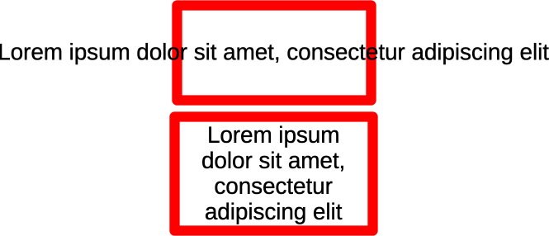
Figure 13: Example of text word wrap inside an object
- Type or paste text into the selected object.
- Format the text using the various tools on the Text Formatting toolbar, the panels in the Properties deck on the Sidebar, or the options in Format on the Menu bar. For more information on text formatting, see “Formatting text” on page 15.
- If the text goes outside the object borders, access text formatting options for a Draw object as follows:
- Double click on the text inside the selected object to select the text.
- Right click on the selected text and select Text Attributes to open the Text dialog for Drawing Object Text (Figure 12 on page 12).
- Format the text using the available options. For more information, see "Text options for objects" on page 14.
- If required, click on Text Animation to open the Text Animation page and access animation options for text. For more information on using text animation in a drawing, see “Text animation” on page 25.
- If required, click on Text Columns to open the Text Columns page and access options for creating columns inside an object. For more information on using text columns in a drawing, see “Text columns” on page 23.
- Note
The Text dialog for Custom Shape Text (Figure 14 below) is used to add text to objects and is similar to the Text dialog (Figure 12 on page 12).

Text options for objects
Custom Shape Text
Word wrap text in shape
Wraps text to fit inside an object. For example, if the width of an object is changed, then the height of the object either increases or decreases allowing for an increase or decrease in the number of text lines.
Resize shape to fit text
Resizes an object to fit the text that is being entered into the object. For example, if the object already contains one multi-line paragraph of text and this option is selected, then object width expands and height decreases until text is a single line.
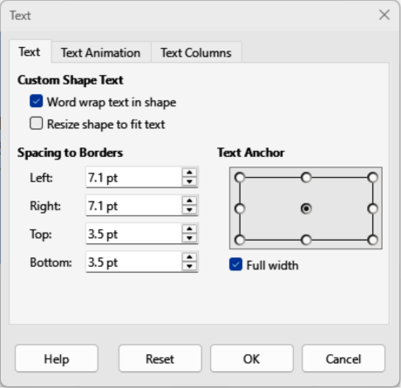
Figure 14: Text dialog — Text page
Spacing to Borders
Specify the amount of space to leave between the text and borders of an object.
Text Anchor
Anchors the text to one of nine positions within a text box. The left and right anchor positions can only be selected when Full width is not selected. A text anchor only determines the position of text within a text box and does not change the paragraph alignment of text inside an object.
Full width
When selected, object width expands to fit the longest paragraph of text inside an object as a single line. When selected, only the top, middle or bottom center positions in Text Anchor can be used to anchor text inside a text box.

Formatting text
Text formatting creates a more professional drawing without distracting elements. Text formatting tools are available on the Text Formatting toolbar and drop-down menus in Format on the Menu bar. For more information on text formatting, see the Writer Guide.
When several text boxes and/or objects in a drawing require the same text formatting, it is recommended to use drawing styles. For more information on using and creating styles, see Chapter 4, Changing Object Attributes.
- Note
Using Edit > Paste on the Menu bar, or the keyboard shortcut Ctrl+V (macOS ⌘+V) pastes copied text directly into a drawing creating an OLE object and DOES NOT create a Draw object. When creating text boxes, or adding text to Draw objects, it is recommended to paste text into Draw objects as unformatted text.

Pasting text
Pasting copied text from another object, drawing, or document into a text box or object, the copied text retains formatting from the source drawing or document. This copied text may not match text formatting already in use. It is recommended to paste text into a drawing as unformatted text, then apply formatting to match the text formatting already used in the target drawing.
- Copy and paste text as unformatted text into a drawing, or draw object using one of the following methods:
- Go to Edit > Paste Special > Paste Unformatted Text on the Menu bar.
- Go to Edit > Paste Special > Paste Special on the Menu bar to open the Paste Special dialog. Select Unformatted text and click OK to close the dialog.
- Use the keyboard shortcut Ctrl+Shift+V (macOS ⌘+Shift+V) and the Paste Special dialog opens. Select Unformatted text and click OK to close the dialog.
- Click on the triangle ▼ on the right of Paste on the Standard toolbar and select Unformatted text from the context menu.
- Format the pasted text to the drawing requirements, or apply a drawing style. Unformatted text is pasted into a text box at the cursor position, or inside a selected object and formatted to the default drawing style.

Quick font resizing
After selecting text, increasing or decreasing font size can be quickly carried out using the tools Increase Font Size (Ctrl+]) (macOS ⌘+]) and Decrease Font Size (Ctrl+[) (macOS ⌘+[) on the Text Formatting toolbar.
- Note
When using quick font resizing, any change in font size depends on the standard font sizes available for the font in use in the target drawing object.

Selecting text
Text must be selected before it can be formatted using one of the following methods. Any formatting changes apply only to the selected text.
- To format all the text in a text box or object, click once on the border of the text box or object to display the selection handles. Formatting changes then apply to all text in the text box or object.
- To format only part of the text, select text using one of the following methods:
- Click in the text and drag the cursor over the text to highlight the text.
- Double-click on text to select a complete word, or triple-click to select a paragraph.
- Click in the text, then press and hold the Shift key and use the arrow keys.

Paragraph formatting

Direct formatting
Direct or manual paragraph formatting is applied directly to selected paragraphs. This direct or manual formatting overrides any formatting that has been applied using paragraph formatting and drawing styles.
- Select the text (see “Selecting text” on page 16) and format using one of the following methods:
- Various formatting tools on the Text Formatting toolbar.
- Go to Format on the Menu bar and select a formatting option from the drop-down menu. Selecting a formatting option opens either a context menu, or dialog providing further formatting options to apply to the selected text.
- Use the options available in the Paragraph and Character dialogs.
- Use the options available in the Paragraph and Character panels in the Properties deck on the Sidebar.
- Click outside the text box, or object to deselect the text edit mode.

Paragraph dialog
- Click anywhere in the paragraph being formatted.
- Use one of the following methods to open the Paragraph dialog (Figure 15 below).
- Right-click on the selected text and select Paragraph from the context menu.
- Go to Format > Paragraph on the Menu bar.
- Use the various options on the tabbed pages of the Paragraph dialog to format the text.
- Click OK to save the changes and close the Paragraph dialog.
- Click outside the text box or object to deselect the text.
- Note
For information on the various text formatting options available in the pages of the Paragraph dialog, refer to the Writer Guide.
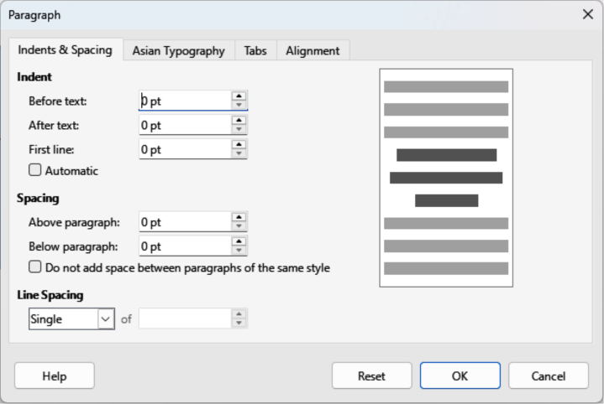
Figure 15: Paragraph dialog — Indents & Spacing page
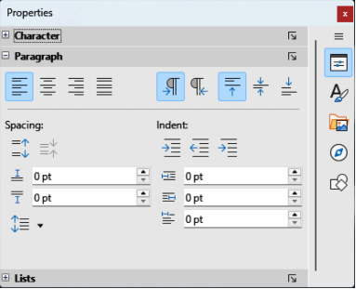
Figure 16: Paragraph panel in Properties deck on Sidebar

Paragraph panel in Sidebar
Use the Paragraph panel (Figure 16 above) in the Properties deck on the Sidebar to format paragraphs of text. Formatting options are limited, but similar in use to the formatting options available in the Paragraph dialog. Any formatting applied to a paragraph using the Paragraph panel is immediate.
- Click anywhere in the paragraph being formatted.
- On the Sidebar, click on Properties to open the Properties deck.
- If necessary, click on the expansion symbol on the left of the Paragraph title bar to open the Paragraph panel.
- Format the text using the various options available in the Paragraph panel.
- If necessary, click on More Options on the right of the title bar to open the Paragraph dialog to format text.
- Note
For information on the various formatting options available for text in the Paragraph panel on the Sidebar, refer to the Writer Guide.

Character formatting

Direct formatting
Direct or manual character formatting is applied directly to selected characters. This direct or manual formatting overrides any formatting that has been applied using character or paragraph formatting and drawing styles.
- Select the characters for formatting, see “Selecting text” on page 16 for more information.
- Format characters using one of the following methods.
- The various formatting tools on the Text Formatting toolbar. Formatting applied to characters is immediate.
- Go to Format on the Menu bar. Selecting a formatting option opens either a context menu or dialog where further formatting options are selected.
- Use the options available in the Character dialog. Clicking OK on the dialog applies the formatting changes.
- Use the options available in the Character panel in the Properties deck on the Sidebar. Formatting applied to characters is immediate.
- Click outside the text box or object to deselect the text.

Character dialog
- Select the characters for formatting and open the Character dialog (Figure 17 below) using one of the following methods:
- Right-click on the characters and select Character from the context menu.
- Go to Format > Character on the Menu bar.
- Use the options on the tabbed pages of the Character dialog to format selected characters.
- Click OK to apply the formatting changes and close the dialog.
- Click outside the text box or object to deselect the text.
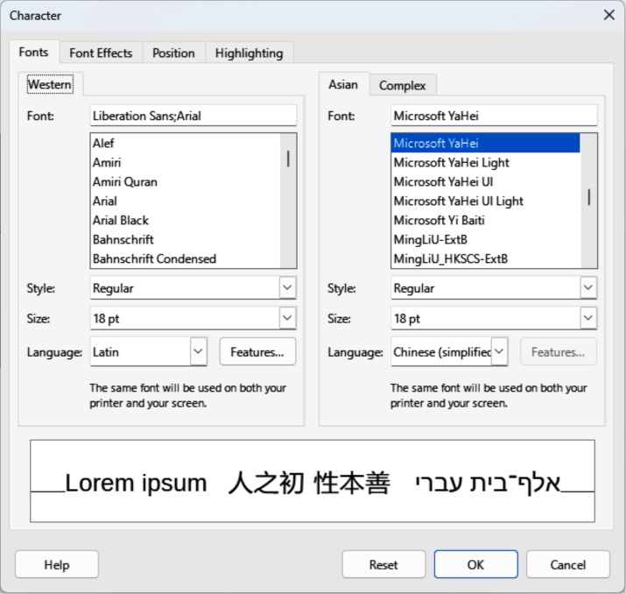
Figure 17: Character dialog — Fonts page
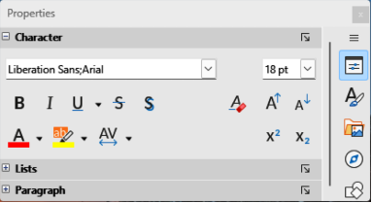
Figure 18: Character panel in Properties deck on Sidebar
- Notes
For information on the various formatting options available for characters in the pages of the Character dialog, refer to the Writer Guide.
For information on the various formatting options available for characters in the Character panel on the Sidebar, refer to the Writer Guide.

Sidebar Character panel
Use the Character panel (Figure 18 above) in the Properties deck on the Sidebar to format characters. Formatting options are limited, but similar in use to the formatting options available in the Character dialog. Any formatting applied to characters using the Character panel is immediate. Character formatting options are also available on the Text Formatting toolbar.
- Select a text box or object so that the selection handles on the border are displayed.
- On the Sidebar, click on Properties to open the Properties deck.
- Click on the expansion symbol on the left of the Character title bar to open the Character panel.
- Format the text using the tools in the Character panel.
- If necessary, click on More Options on the right of the title bar to open the Character dialog to format text.

Unordered or ordered lists
Unordered (bulleted) and ordered (numbered) lists can be created in text boxes and objects. When creating lists in objects, Draw objects are not dynamic and do not automatically expand as a list is created. Creating unordered or ordered lists in Draw is similar to Writer. For more information on unordered or ordered lists, see the Writer Guide.

Creating lists
Unordered or ordered lists are created in text boxes, or Draw objects as follows:
- Select all the required text for a list.
- Create a list using one of the following methods and default settings for lists:
- Click on Toggle Unordered List, or Toggle Ordered List on the Text Formatting toolbar.
- Click on Toggle Unordered List, or Toggle Ordered List in the Lists panel in the Properties deck on the Sidebar (Figure 19 below).
- Go to Format > Lists > Unordered List, or Ordered List on the Menu bar.
- To change the format of the list, click on the triangle ▼ on the right of the list icons and select a list style from the options available in the Bullets Library dialog (Figures 20 below), or More Numbers dialog (Figure 21 below).

Adjusting list item level and position
The level for each item in an unordered or ordered list is demoted or promoted within a list, or moved up or down in list order as follows:
- Click on a list item being demoted, promoted, or moved up or down.
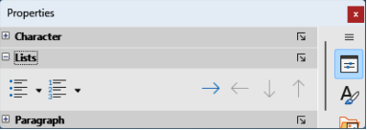
Figure 19: Lists panel in Properties deck on Sidebar
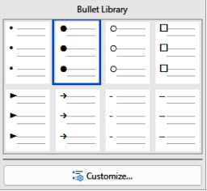
Figure 20: Bullet Library dialog for bullet lists
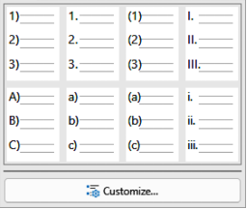
Figure 21: More Numbers dialog for numbered lists
- Demote a list item down one level at a time using one of the following methods:
- Use the Tab key.
- Go to Format > Lists > Demote on the Menu bar.
- Use Demote in the Lists panel in the Properties deck on the Sidebar.
- Promote a list item up one level at a time using one of the following methods:
- Use the key combination Shift+Tab.
- Go to Format > Lists > Promote on the Menu bar.
- Use Promote in the Lists panel in the Properties deck on the Sidebar.
- Change the position of a list item in the list order using one of the following methods:
- Go to Format > Lists > Move Up, or Move Down on the Menu bar.
- Use Move Up, or Move Down in the Lists panel in the Properties deck on the Sidebar.

Bullets and Numbering dialog
Use the Bullets and Numbering dialog (Figure 22 below) for more control over list formatting. Select text in a text box or object and open the dialog using one of the following methods:
- Go to Format > Bullets and Numbering on the Menu bar.
- Right-click on the selected text and select Bullets and Numbering from the context menu.
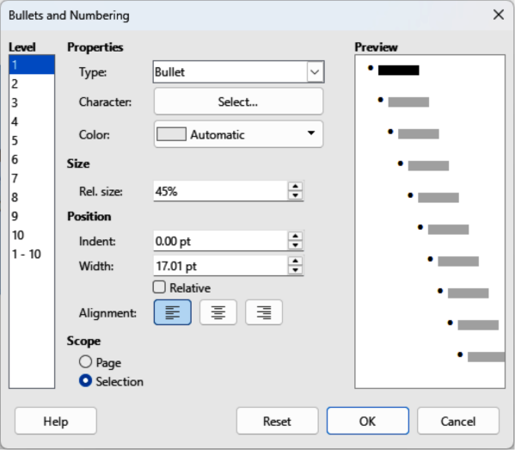
Figure 22: Bullets and Numbering dialog
- Click on More Options on the right side of Lists panel title bar in the Properties deck on the Sidebar.
- Click on More Bullets or More Numbering after clicking on the triangle ▼ on the right of Toggle Unordered List, or Toggle Ordered List on the Text Formatting toolbar, or in the Lists panel in the Properties deck on the Sidebar.
- Note
For more information on the options available in the Bullets and Numbering dialog for unordered or ordered lists, see the Writer Guide.

Text columns
Text in drawings can be formatted into columns inside text boxes and objects. Columns cannot be used on portions of text inside a text box or object. The whole of the text box, or object has to be used for columns. An example of text columns inside a Draw object is shown in Figure 23 below.
The type of columns used in Draw are continuous flow columns. When text reaches the bottom of a column, text automatically flows into the next column as more text is added.

Text boxes
- Click the border of a text box to select it so that the selection handles are displayed indicating that the text box is in edit mode.
- Open the options for text columns using one of the following methods:
- Right-click in the text box and select Text Attributes from the context menu to open the Text dialog, then click on the Text Columns tab to open the Text Columns page (Figure 24 below),
- Click on Columns in Properties on the Sidebar to open the Columns panel (Figure 25 below).
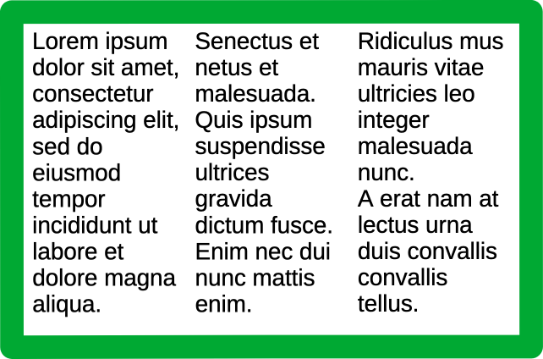
Figure 23: Example of text columns in a Draw object
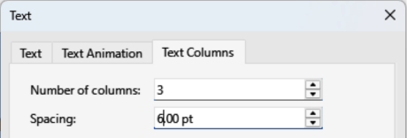
Figure 24: Text dialog — Text Columns page
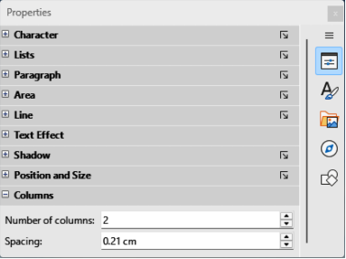
Figure 25: Columns panel in Properties deck on Sidebar
- Set the number of columns required in the Number of columns box and the required spacing between the columns in the Spacing box.
- Save the changes and deselect the text box using one of the following methods:
- For the Text dialog, click OK to save the changes and close the dialog, then click outside the text box to deselect it.
- For the Columns panel in the Properties deck on the Sidebar, click outside the text box to deselect it and save the changes.
- Note
Any text inside a text box, or drawing object automatically flows into column format when the changes are saved.

Drawing objects
- Click on an object to select it so that the selection handles are displayed indicating that the object is in edit mode.
- Double-click on the selected object to switch on text edit mode.
- Open the options for text columns using one of the following methods:
- Right-click in the text box and select Text Attributes from the context menu to open the Text dialog, then click on the Text Columns tab to open the Text Columns page (Figure 24 above),
- Click on Columns in Properties on the Sidebar to open the Columns panel (Figure 25 above).
- Set the number of columns required in the Number of columns box and the required spacing between the columns in the Spacing box.
- Save the changes and deselect the object using one of the following methods:
- For the Text dialog, click OK to save the changes and close the dialog, then click outside the object to deselect it.
- For the Columns panel in the Properties deck on the Sidebar, click outside the object to deselect it and save the changes.
- Double-click again on the object to switch on text edit mode.
- Type or use copy and paste to enter the required text. Any text entered appears in column format.
- If necessary, format the text to the drawing requirements.
- Click outside the object to deselect it and save the changes.

Text animation
- Note
Text animation is not recommended in a drawing unless the drawing is going to be displayed as part of a presentation. See the Impress Guide for more information on text animation.
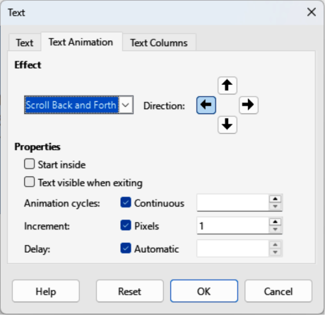
Figure 26: Text dialog — Text Animation page

Creating text animation
- Right-click on text in a text box, or drawing object and select Text Attributes from the context menu to open the Text dialog.
- Click on Text Animation to open the Text Animation page in the Text dialog (Figure 26 above).
- In Effect, select how the text appears during the text animation.
- In Direction, select which direction the text appears from during animation.
- In Properties, select Start inside for the text to be visible and inside the drawing object when applying the animation effect.
- In Properties, select Text visible when exiting for the text to remain visible after applying the animation effect.
- In Animation cycles, select either Continuous, or enter the number of animation cycles for the animated text.
- In Increment, select the increment value in Pixels for scrolling the text.
- In Delay, specify Automatic, or enter the time delay to wait before repeating the animation effect.
- Click OK to save the changes and close the Text dialog.

Text animation options
Effect
Select the animation effect from the drop-down list to apply to the text in the selected drawing object. To remove an animation effect, select No Effect.
Direction
Select a scrolling direction for the animated text.
Properties
Start inside
Text is visible and inside the drawing object when applying the animation effect.
Text visible when exiting
Text remains visible after applying the animation effect.
Animation cycles
Set the looping options for the animation effect.
Continuous
Plays the animation effect continuously. To specify the number of times to play the animation effect, deselect this check box, and enter the number of cycles in the Continuous box.
Increment
Specifies the increment value in the Pixels box for scrolling the text.
Delay
Specifies the amount of time before repeating the animation effect.
Automatic
LibreOffice automatically determines the amount of time before repeating the animation effect. To manually assign a delay period, unmark this check box, and then enter a time value in the Automatic box.
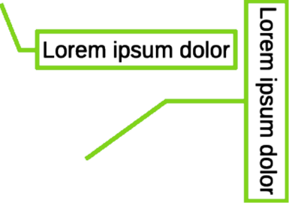
Figure 27: Examples of horizontal and vertical text callouts

Text callouts
A text callout is a short line of text connected by a line to highlight, or point out a feature in an illustration or drawing. Two types of text callouts (Figure 27 above) are available –– Callouts for horizontal text and Vertical Callouts for vertical text. Text callouts in Draw are a legacy from the earlier versions of LibreOffice and the tools are only available on the Text toolbar (Figure 3 on page 5).
- Note
Custom shape callouts can also be used by selecting Callout Shapes on the Drawing toolbar, or the Callouts panel in the Shapes deck on the Sidebar. Callout shapes have the same purpose as text callouts, but different options are available.

Creating text callouts
- Click on Callouts for horizontal text, or Vertical Callouts for vertical text on the Text toolbar (Figure 3 on page 5).
- Click in the drawing and drag the cursor to create the callout.
- Double click in the callout box to enter text mode.
- Type the required text, then click in a blank space in the drawing. The callout box adjusts its size horizontally and/or vertically to fit the text within the callout box.
- Select the callout and click on the selection handle at the end of the connector line, then drag the end of the connector line to the required position.
- With the callout still selected, click on the callout box and drag it to the required position.
- If required, with the callout still selected, click on a selection handle on the callout box to change the callout box width and height.
- Click in a blank space in the drawing to deselect the text callout and save the changes.
- Note
The Callout page in the Position and Size dialog is only available when a text callout has been selected. It is not available for Callout Shapes that are available on the Drawing toolbar, or the Callouts panel in the Shapes deck on the Sidebar.

Editing text callouts
- Double click in the callout box to enter text mode to edit and format the text. See “Formatting text” on page 15 for more information on text formatting.
- Click in a blank space on the drawing to save the changes to the text.
- Only select the text callout so that the selection handles are displayed.
- Make sure the text used in the text callout is NOT selected.
- Right click on a text callout and select an option from the context menu to change the attributes for position, size, line, and area of the text callout. For more information, see Chapter 3, Working with Objects, and Chapter 4, Changing Object Attributes.
- Click on the selection handle at the end of the connector line and drag it to change the position of the line end or the length of the connector line.
- Select the text callout and open the Position and Size dialog (Figure 28 below) using one of the following methods:
- Right-click on the selected callout and select Position and Size from the context menu.
- Go to Format > Position and Size on the Menu bar.
- Use the keyboard shortcut F4.
- Click Callout to open the formatting options available for text callouts.
- Select the style of text callout from Straight Line, Angled Line, or Angled Connector Line.
- In Spacing, enter the amount of space required between the end of the callout line and the callout box.
- In Extension, select from the available options how the callout line from extends the callout box.
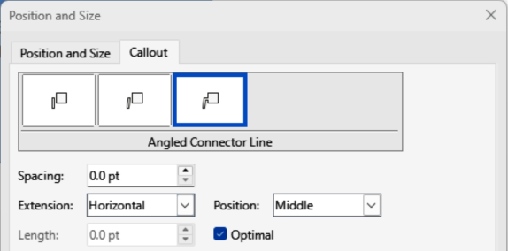
Figure 28: Position and Size dialog — Callout page
- If From top, or From left has been selected from the Extension drop-down list, enter a distance value in the By: box to create a space between the start point of the connector line and the callout box.
- If Horizontal, or Vertical has been selected from the Extension drop-down list, enter a position setting from the Position drop-down list to set the position of where the connector line is attached to the text callout box.
- In Length, enter the length of the callout line segment that extends from the callout box to the angle point of the connector line.
- Select Optimal to display the angle point in a connector line at an optimal distance from the callout box.
- Click in a blank space in the drawing to deselect the text callout and save the changes.

Text callout options
Callout Styles
Select the required callout style from the options available.
Spacing
Enter the amount of space required between the end of the callout line and the callout box.
Extension
Select where and how the callout line extends from the callout box.
Length
Enter the length of the callout line segment that extends from the callout box to the inflection point of the line.
Optimal
Select this option to display a single line in the optimum position.
- Note
The Length option is only available if Angled connector line is selected as the callout style and Optimal is not selected.

Tables in Draw
Tables provide information easily and quickly when used in a drawing. Tables can be added directly to a drawing eliminating the requirement to embed a Calc spreadsheet, or a Writer text table. However, it is recommended to embed a spreadsheet into a drawing, especially when greater functionality is required in the table. The tables provided by Draw do have a limited functionality.
- Notes
Tables are placed at the center of a drawing and cannot be placed into objects or shapes. Also, unlike text boxes and other objects, tables cannot be rotated, but can be repositioned.
When inserting tables into a drawing, the table is created using the default style with settings already applied. Currently these defaults are hard coded in LibreOffice. The table can be formatted to the drawing requirements after insertion.
If the Table toolbar is not visible, go to View > Toolbars > Table on the Menu bar. The Table toolbar is normally docked at the bottom of a Draw window.

Inserting tables

Table dialog
- Go to Insert > Table on the Menu bar to open the Insert Table dialog (Figure 29 below).
- Enter the number of rows and columns required.
- Click OK to insert the table in the center of a drawing and close the dialog.
- Move the table into position by clicking on the border and dragging it to its new position.
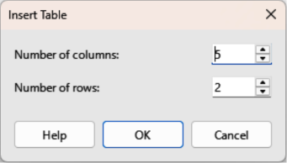
Figure 29: Insert Table dialog
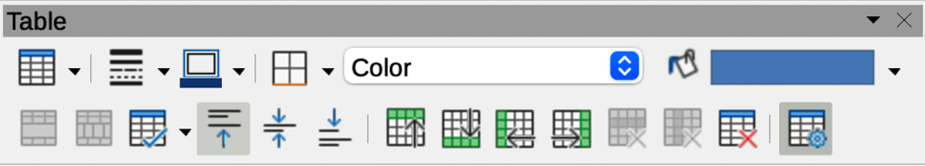
Figure 30: Table toolbar
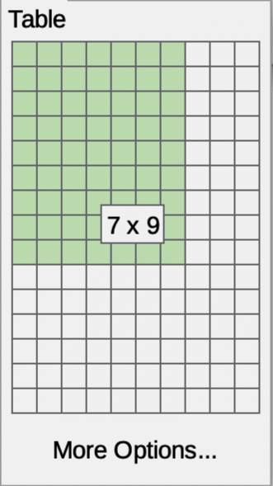
Figure 31: Table grid
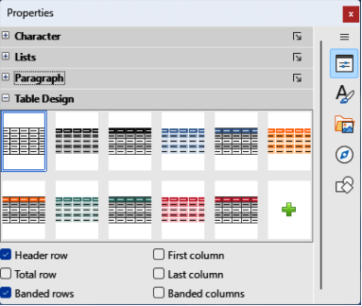
Figure 32: Table Design panel in Properties deck on Sidebar

Table grid
- Click on Table on the Table toolbar (Figure 30 above) to open the Table grid (Figure 31 above).
- Click and drag the cursor until the required number of columns and rows are selected,
- Click again to insert the table into the center of a drawing and close the Table grid.
- If necessary, click on More Options to open the Insert Table dialog to select the number of rows and columns required.
- Move the table into position by clicking on the border and dragging it to its new position.

Table Design panel
Several predefined table designs are provided in the Table Design panel in the Properties deck on the Sidebar (Figure 32 above). The Table Design panel is only available when a table is selected.

Inserting table designs
- Insert a table into a drawing or select a table in a drawing.
- Click on Table Design in the Properties deck on the Sidebar to open the Table Design panel.
- Select a design for the table from the available design options.
- Format the rows and columns using the available options in the Table Design panel.
- Alternatively, right click on the selected table design and select the format options for the rows and columns from the context menu.

Creating table designs
- Insert a table into a drawing, then select the new table.
- Click on Table Design in the Properties deck on the Sidebar to open the Table Design panel, or click on Table Design on the Table toolbar.
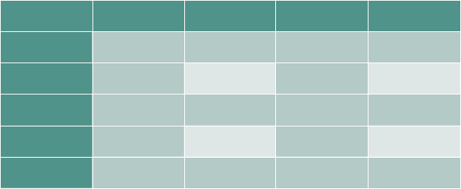
Figure 33: Example table with banded rows and columns
- Click on the plus sign in Table Design panel to create a new design.
- Make sure the new design is selected, then format the rows and columns from the available options listed below the Table Design panel.
- Alternatively, right click on the new table design and select the format options for the rows and columns from the context menu.

Table design options
Header row
Selected by default. The first row is normally a header row and is displayed with a different background from the rest of the table.
Total row
When selected, changes the background of the last row to make it stand out from other rows.
Banded rows
Selected by default. Alternate rows have different backgrounds making it easier to read data entered into the rows, as shown by the example in Figure 33 above.
First column
When selected, highlights the first column of the table using a darker background.
Last column
When selected, highlights the last column of the table using a darker background.
Banded columns
When selected, alternate columns are highlighted with dark and light colors.

Table formatting
Format a selected table using the tools and options available on the Table toolbar, by going to Format > Table on the Menu bar, or using the options available in the Table Properties dialog.

Table toolbar
The Table toolbar (Figure 30 on page 30) automatically opens when a table is selected providing tools for creating and formatting a table. The default docked position for the toolbar is at the bottom of the LibreOffice Draw Workspace.
Table
Inserts a new table in a drawing using the Insert Table dialog or the Table grid. See “Inserting tables” on page 30 for more information on inserting tables.
Border Style
Changes the line style of the borders of selected cells. Click on the triangle▼ next to Border Style to open a drop-down list and select from a range of predefined styles.
Border Color
Changes the color of the borders of selected cells. Click on the triangle▼ next to Border Color to access the available LibreOffice color palettes. Select a color from a range of predefined palettes or create a custom color.
Borders
Selects a predefined border configuration for the selected table, or cells. Click on the triangle▼ next to Borders to open a drop-down list to select a border configuration.
Area Style/Filling
Select the cells to be filled, then select the type of fill from the drop-down list: None, Color, Gradient, Hatching, Bitmap, Pattern, Use Slide Background.
Fill Color
Select a fill option from the drop-down menu. The fill options change to show the fillings available for each Area Style/Filling type.
Merge Cells
Merges the selected cells into one cell. Note that the contents of the merged cells are also merged. Alternatively, right-click on selected cells and select Merge Cells from the context menu.
Split Cells
Splits a selected cell into multiple cells either horizontally or vertically. Make sure the cursor is positioned on a cell, then click on Split Cells to open the Split Cells dialog (Figure 34 below).
In Split cells into, select the number of cells required when splitting a cell and whether to split the cell Horizontally or Vertically. If necessary, when splitting horizontally, select Into equal proportions to create cells of equal size. The contents of the split cell are kept in the original cell (left or top cell).
Optimize
Evenly distributes the selected rows and columns in a table either horizontally or vertically. Clicking on Optimize opens a pop-up toolbar which contains the following tools:
Minimal Row Height
Determines the minimal row height for selected rows. Minimal row height depends on the font size of the smallest character in the row.
Minimal Column Width
Defines the minimal column width for selected columns. Minimal column width depends on the shortest entry within a column.
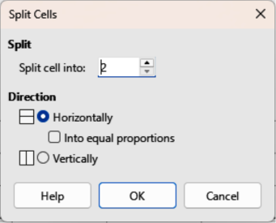
Figure 34: Split Cells dialog
Optimal Row Height
Determines the optimal row height for selected rows. Optimal row height depends on the font size of the largest character in the row.
Optimal Column Width
Defines the optimal column width for selected columns. Optimal column width depends on the longest entry within a column.
Distribute Rows Equally
Adjusts the height of the selected rows to match the height of the tallest row in the selection.
Distribute Columns Evenly
Adjusts the width of the selected columns to match the width of the widest column in the selection. The total width of the table cannot exceed the width of the page.
Align Top, Center Vertically, Align Bottom
Sets the vertical alignment of text in selected cells.
Insert Row Above, Insert Row Below
Click in a cell or cells to select rows and use these two tools to insert a row or rows above or below the selected rows. Alternatively, right-click on the selected rows and select Insert > Insert Row Above or Insert Row Below.
Insert Column Before, Insert Column After
Click in a cell or cells to select columns and use these two tools to insert a column or columns before or after the selected columns. Alternatively, right-click on the selected columns and select Insert > Insert Column Before or Insert Column After.
Delete Row, Delete Column, Delete Table
Click in a cell or cells to select rows or columns, then click on a tool to delete the selected rows or columns. To delete the whole table, place the cursor in a cell and select Delete Table. Alternatively, right-click on the selected cells and select Delete > Delete Row, or Delete Column, or Delete Table from the context menu.
Select Table, Select Column, Select Row
Select a table, column, or row if the same attributes are going to be applied to a table, column, or row.
Table Design
Clicking on this tool opens the Table Design panel in the Properties deck on the Sidebar. See “Table Design panel” on page 31 for more information.
Table Properties
Clicking on this tool opens the Table Properties dialog. Alternatively, right-click on the table and select Table Properties from the context menu.

Menu bar
Go to Format > Table on the Menu bar and select a formatting option from the submenu.
Minimal Row Height
Determines the minimal row height for selected rows. Minimal row height depends on the font size of the smallest character in the row.
Optimal Row Height
Determines the optimal row height for selected rows. Optimal row height depends on the font size of the largest character in the row.
Distribute Columns Evenly
Adjusts the width of the selected columns to match the width of the widest column in the selection. The total width of the table cannot exceed the width of the page.
Select Row
Selects the row or rows where cells have been selected in the table.
Insert Rows
Inserts rows in the table where cells have been selected in the table.
Delete Row
Deletes rows in the table where cells have been selected in the table.
Minimal Column Width
Defines the minimal column width for selected columns. Minimal column width depends on the shortest entry within a column.
Optimal Column Width
Defines the optimal column width for selected columns. Optimal column width depends on the longest entry within a column.
Distribute Columns Evenly
Adjusts the width of the selected columns to match the width of the widest column in the selection. The total width of the table cannot exceed the width of the page.
Select Column
Selects the column or columns where cells have been selected in the table.
Insert Columns
Inserts columns in the table where cells have been selected in the table.
Delete Column
Deletes columns in the table where cells have been selected in the table.
Merge Cells
Merges the selected cells into one cell. The contents of the merged cells are also merged. Alternatively, right-click on selected cells and select Merge Cells from the context menu.
Split Cells
Splits a selected cell into multiple cells either horizontally or vertically. Make sure that the cursor is positioned on the cell, then click on Split Cells to open the Split Cells dialog (Figure 34 on page 33). In Split cells into, select the number of cells required when splitting a cell and whether to split the cell Horizontally or Vertically. If necessary, when splitting horizontally, select Into equal proportions to create cells of equal size. The contents of the split cell are kept in the original cell (left or top cell).
Delete Table
To delete the whole table, place the cursor in a cell and select Delete Table. Alternatively, right-click on the selected cells and select Delete Table from the context menu.
Select…
Selects the whole table.
Properties…
Opens the Table Properties dialog.

Table Properties dialog
The Table Properties dialog has five tabbed pages that provide formatting options for Font, Font Effects, Borders, Background, and Shadow. Open the Table Properties dialog using one of the following methods:
- Right-click in a table and select Table Properties from the context menu.
- Go to Format > Table > Properties on the Menu bar.
- Click on Table Properties on the Table toolbar.
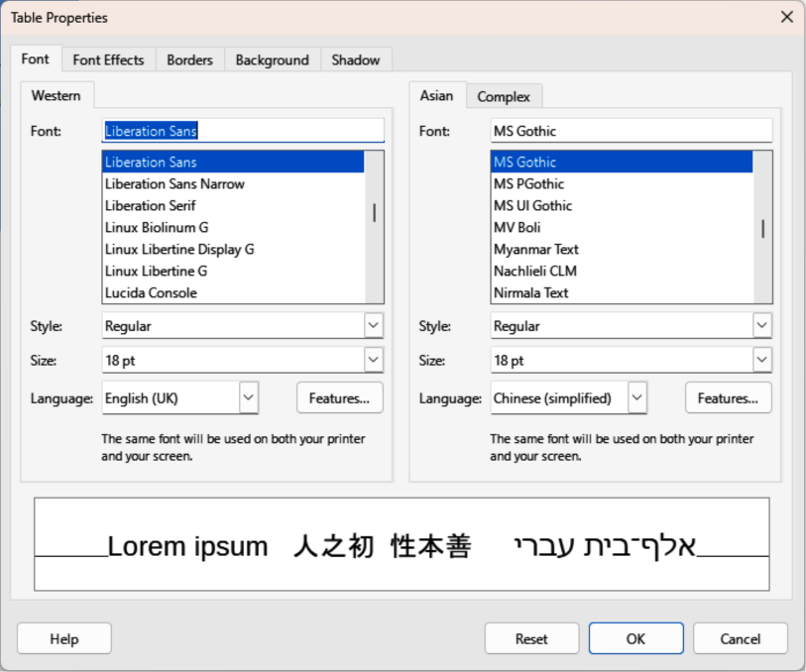
Figure 35: Table Properties dialog — Font page
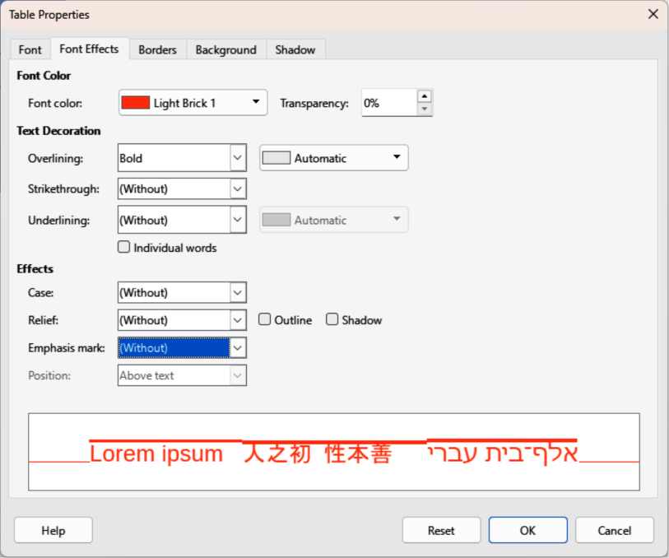
Figure 36: Table Properties dialog — Font Effects page
The formatting options on each dialog page are as follows:
Font
In Figure 35 above select the required Family, Style, Size, and Language for text in the table. A sample of the font selected is displayed in the preview box. See the Writer Guide for more information on fonts.
Font Effects
In Figure 36 above Select the required Font Color, Text Decoration, and Effects for the text in the table. A sample of the font effects applied to the text is displayed in the preview box. See the Writer Guide for more information on font effects.
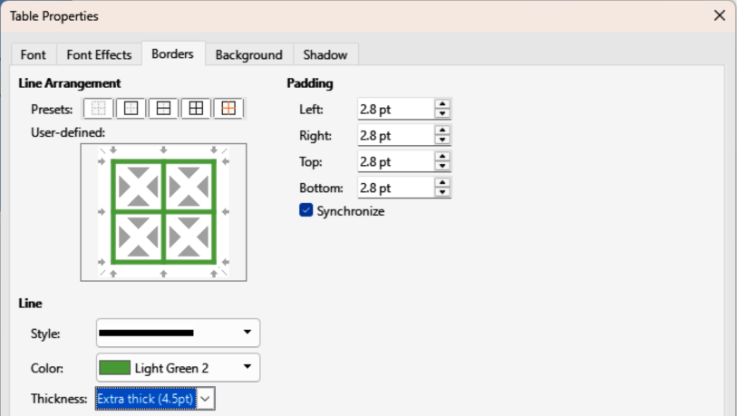
Figure 37: Table Properties dialog — Borders page
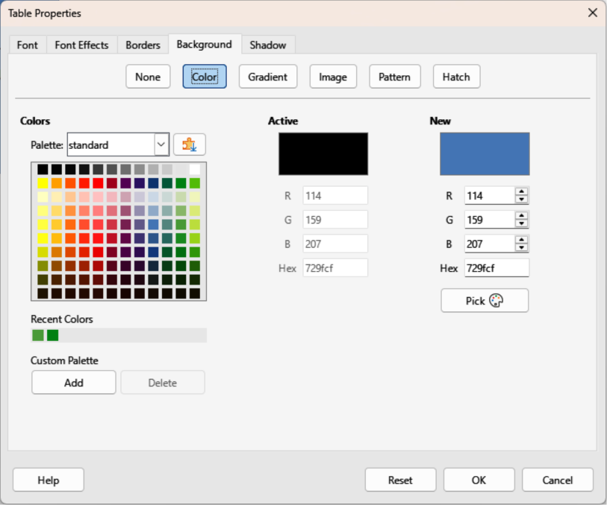
Figure 38: Table Properties dialog — Background
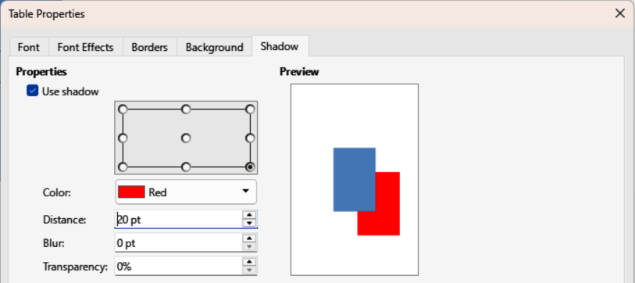
Figure 39: Table Properties dialog — Shadow page
Borders
In Figure 37 above select the required Line Arrangement, Line, and Padding for the table and cell borders. These options are similar to the tools Border Style, Border Color, and Borders on the Table toolbar. See Chapter 4, Changing Object Attributes for more information on the lines used for table and cell borders.
Background
In Figure 38 above select a background as the area fill for the table and/or selected cells. This dialog page provides the same functions as Area Style/Filling tools on the Table toolbar. See Chapter 4, Changing Object Attributes for more information on area style and filling used for table and cell backgrounds.
Shadow
In Figure 39 above a shadow can be added to the table. The options adjust the look and position of the shadow. See Chapter 4, Changing Object Attributes for more information on table shadows.

Table position and size
Tables are placed into boxes when created. This allows tables to be formatted as a Draw object. After selecting the table, use one of the following methods to change table position and size. See “Text boxes” on page 6 and Chapter 3, Working with Objects for more information positioning and resizing.
- Click on the table border and drag the table to a new position.
- Click and drag on a selection handle to change the table size.
- Open the Position and Size dialog and use the options available on the Position and Size page (Figure 40 below). The options available in the Rotation, and Slant & Corner Radius pages cannot be used for a table.
After selecting the table, use one of the following methods to open the Position and Size dialog:
- Right-click on the table and select Position and Size from the context menu.
- Go to Format > Position and Size on the Menu bar.
- Use the keyboard shortcut F4.
- Note
When the size of a table box is changed, the table and cell contents also increase or decrease in size to match the table box size.
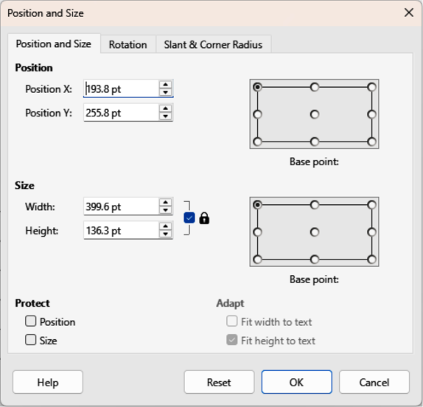
Figure 40: Position and Size dialog

Deleting tables

Whole table
Make sure the table is selected and the selection handles are visible on the table border, then delete the table using one of the following methods:
- Go to Format > Table > Delete Table on the Menu bar.
- Select Delete Table on the Table toolbar.
- Right-click on the table and select Delete > Delete Table from the context menu.

Row or column
Click in a table cell to delete the table row or column using one of the following methods. Make sure the table selection handles are NOT displayed.
- Go to Format > Table > Delete Row, or Delete Column on the Menu bar
- Select Delete Row, or Delete Column on the Table toolbar.
- Right-click and select Delete > Delete Row, or Delete Column from the context menu.

Cell contents
Delete cell contents in a table as follows:
- Select the cell or cells.
- Press the Delete, or Backspace key on the keyboard.

Using fields
Fields allow for the automatic insertion of text into a drawing and are used when creating templates and drawing masters. For more information on templates and master drawings, see Chapter 11, Advanced Drawing Techniques.

Inserting fields
When a field is created, a field text box is inserted into the center of a drawing and can be repositioned just like any other text box. See “Text boxes” on page 6 for more information.
- Go to Insert > Field on the Menu bar and select the type of field required.
- If required, position and resize the field text box.
- If required, format the text used for the field information. See “Formatting text” on page 15 for more information.

Field types
Date (fixed)
Inserts the current date into a drawing as a fixed field. The date is not automatically updated. Available date formats depend on the language setting in Tools > Options > Language Settings > Language (macOS LibreOffice > Preferences > Language Settings > Language). Right-click on the date field and select the required date format from the context menu.
Date (variable)
Inserts the current date into a drawing as a variable field. The date is automatically updated each time the file is opened. Available date formats depend on the language setting in Tools > Options > Language Settings > Language (macOS LibreOffice > Preferences > Language Settings > Language). Right-click on the date field and select the required date format from the context menu.
Time (fixed)
Inserts the current time into a drawing as a fixed field. The time is not automatically updated. Available time formats depend on the language setting in Tools > Options > Language Settings > Language (macOS LibreOffice > Preferences > Language Settings > Language). Right-click on the time field and select the required time format from the context menu.
Time (variable)
Inserts the current time into a drawing as a variable field. The time is automatically updated each time the file is opened. Available time formats depend on the language setting in Tools > Options > Language Settings > Language (macOS LibreOffice > Preferences > Language Settings > Language). Right-click on the time field and select the required time format from the context menu.
Author
Inserts the first and last names of the author of the drawing. This information is taken from values entered in the LibreOffice user data. To modify this information go to Tools > Options > LibreOffice > User Data (macOS LibreOffice > Preferences > LibreOffice > User Data).
Page Number
Inserts the page number into the current drawing. Alternatively, go to Insert > Page Number on the Menu bar. If a page number is to be added to every page in the drawing, go to View > Master on the Menu bar and insert the page number field.
Page Title
Inserts the page title. The default name is Page # if the page has not been renamed.
Page Count
Inserts the total number of pages in a drawing.
File Name
Inserts the name of the file used for the drawing. The file name only appears after the file has been saved.

Using hyperlinks
When inserting text that can be used as a hyperlink (for example, a website address or URL), Draw automatically formats it creating the hyperlink, and applies color and underlining. There are four types of hyperlinks and each hyperlink type requires a different procedure when inserting a hyperlink.
- Note
To prevent LibreOffice from automatically turning website addresses, or URLs into hyperlinks, go to Tools > AutoCorrect Options > Options on the Menu bar and deselect URL Recognition.
- Tip
To change the color of hyperlinks, go to Tools > Options > LibreOffice > Application Colors, scroll to Unvisited links and/or Visited links, select the checkboxes, then select new colors from the color palettes for the links and click OK. Note this color change changes the color for all hyperlinks across all LibreOffice modules.

Internet hyperlink
- Click in the text box at the required position for the hyperlink.
- Go to Insert > Hyperlink on the Menu bar, or use the keyboard shortcut Ctrl+K (macOS ⌘+K) to open the Hyperlink dialog.
- Select Internet to open the Internet page of the Hyperlink dialog (Figure 41 below).
- In Protocol, select either Web, or FTP.
- In the URL text box, enter the required web address for the hyperlink.
- In the Text box, enter a name for the hyperlink.
- If necessary, enter the details required for Further Settings. See “Further Settings” on page 45 for more information.
- Click Apply to insert the hyperlink and save the selections. If several hyperlinks are being created, click Apply after inserting each hyperlink.
- Click OK to close the Hyperlink dialog.

Mail hyperlink
- Click in the text box at the required position for the hyperlink.
- Go to Insert > Hyperlink on the Menu bar, or use the keyboard shortcut Ctrl+K (macOS ⌘+K) to open the Hyperlink dialog.
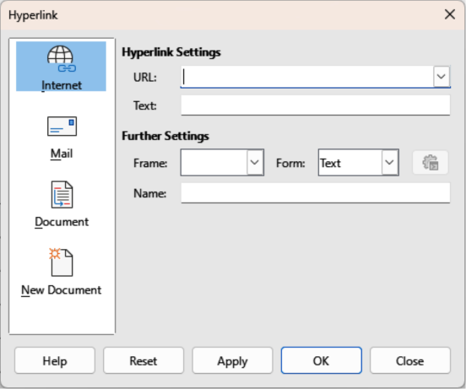
Figure 41: Hyperlink dialog — Internet page
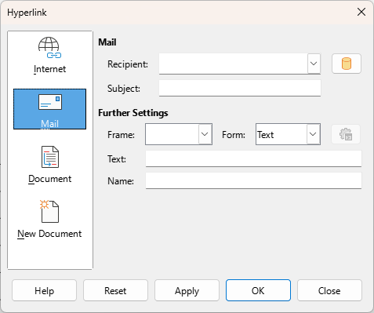
Figure 42: Hyperlink dialog — Mail page
- Select Mail to open the Mail page of the Hyperlink dialog (Figure 42 above).
- In Recipient text box, enter the email details of the recipient.
- In the Subject text box, enter a subject title.
- If required, click on Data Sources to open a data source browser, then drag the email receiver data field from the data source browser into the Recipient text box.
- If required, enter the details required for Further Settings. See “Further Settings” on page 45 for more information.
- Click Apply to insert the hyperlink and save the selections. If several hyperlinks are being created, click Apply after inserting each hyperlink.
- Click OK to close the Hyperlink dialog.

Document hyperlink
Creates a hyperlink to another document or to another place in a document, commonly referred to as a bookmark.
- Click in the text box at the required position for the hyperlink.
- Go to Insert > Hyperlink on the Menu bar, or use the keyboard shortcut Ctrl+K (macOS ⌘+K) to open the Hyperlink dialog.
- Select Document to open the Document page of the Hyperlink dialog (Figure 43 below).
- Note
Leave Path blank if the link is to a target in the same drawing.
- In the Path text box, enter the file path for the document.
- Alternatively, click on Open File to open a file browser and select the file as a target for the hyperlink.
- Optionally, to specify a target in a specific drawing, click on Target in Document to open a dialog to select a target. However, if the name of the target is known, enter in the Target text box.
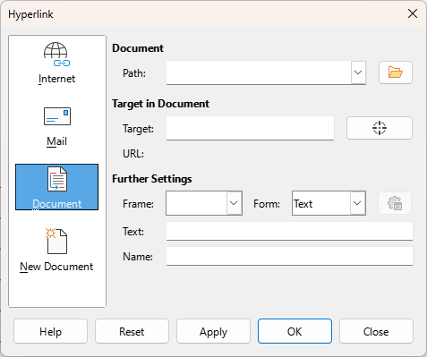
Figure 43: Hyperlink dialog — Document page
- If required, enter the details required for Further Settings. See “Further Settings” on page 45 for more information.
- Click Apply to insert the hyperlink and save the selections. If several hyperlinks are being created, click Apply after inserting each hyperlink.
- Click OK to close the Hyperlink dialog.

New Document hyperlink
Creates a new document and a hyperlink to the new document.
- Click in the text box at the required position for the hyperlink.
- Go to Insert > Hyperlink on the Menu bar, or use the keyboard shortcut Ctrl+K (macOS ⌘+K) to open the Hyperlink dialog.
- Select New Document to open the New Document page of the Hyperlink dialog (Figure 44 below).
- In New Document select Edit now to edit the newly created document immediately, or Edit later to only create the hyperlink.
- Select the type of document to create from the File type drop-down list.
- Click on Select Path to open a file browser and navigate to the folder where the new document is going to be saved
- Select the folder and click on Open. The selected folder appears in the File text box.
- If necessary, enter the details required for Further Settings. See “Further Settings” on page 45 for more information.
- Click Apply to insert the hyperlink and save the selections. If several hyperlinks are being created, click Apply after inserting each hyperlink.
- Click OK to close the Hyperlink dialog.
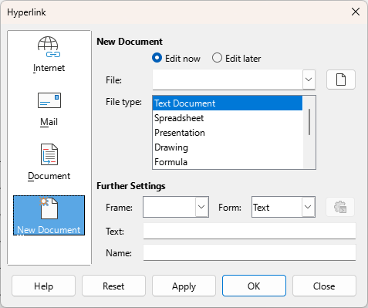
Figure 44: Hyperlink dialog — New Document page

Further Settings
The Further Settings section in the Hyperlink dialog is common to all hyperlink types, although some options are more relevant to specific types of links.
Frame
Enter a name for the frame in the Frame text box that the linked file opens in, or select a predefined frame from the list. If the Frame text box is empty, the linked file opens in the current browser window.
Form
Specifies whether the hyperlink is inserted as text, or as a button.
Text
Specifies the visible text, or button caption for the hyperlink.
Name
Applicable to HTML documents. It specifies the text added as a NAME attribute in the HTML code behind the hyperlink.

Editing text hyperlinks
- Select the hyperlink.
- Right-click on the hyperlink and select Edit Hyperlink from the context menu to open the Hyperlink dialog.
- Make editing changes using the available options.
- Click Apply to insert the hyperlink and save the selections. If several hyperlinks are being created, click Apply after inserting each hyperlink.
- Click OK to save the changes and close the Hyperlink dialog.
- Note
DO NOT click directly on the hyperlink text when editing or formatting hyperlinks. Clicking on the hyperlink text opens the hyperlink.

Formatting hyperlinks
A hyperlink is inserted in the centre of the current slide. To edit the text, the size of a hyperlink text box, or to reposition the hyperlink on the slide:
- Click and drag a selection marquee over the hyperlink text to display a text box border and selection handles.
- Right-click on the selected hyperlink and select the type of formatting required from the options available in the context menu.
- To reposition hyperlink, click and drag on the text border to move the hyperlink on the slide.
- Select Position and Size from the context menu, or use the F4 key to open the Position and Size dialog. Options can be selected to move the hyperlink, or resize the text box.

Image maps
An image map defines areas used as hotspots in images which are associated with a URL (web address or a file on the computer). Hotspots are the graphic equivalent of text hyperlinks. In Draw, clicking on a hotspot opens the linked page in the appropriate program (for example, default browser for HTML pages; Writer for ODT files; PDF viewer for PDF files).
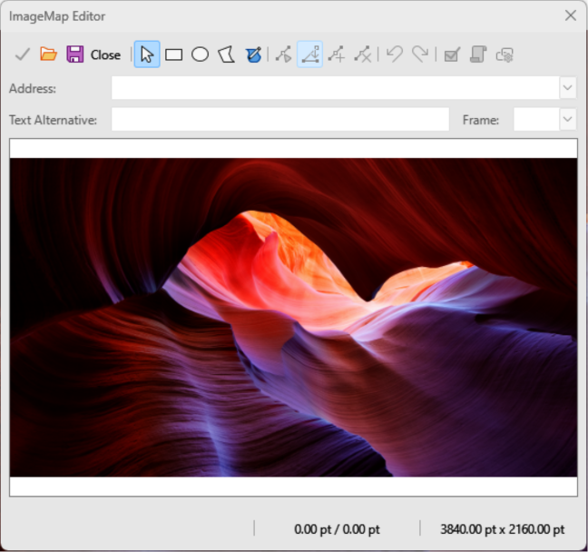
Figure 45: ImageMap Editor dialog
Hotspots can be created in various shapes, for example rectangles, ellipses, and polygons. Several hotspots can be included in the same image. When a hotspot is clicked on, the URL opens in a browser window or frame that has been specified. The text can also be specified as a hotspot name that appears when the cursor hovers over a hotspot.

Creating image maps
- Select an image in a drawing to use as a hotspot.
- Go to Tools > ImageMap on the Menu bar to open the ImageMap Editor dialog (Figure 45 above). The main part of the dialog shows the selected image where hotspots will be defined.
- Select the type of hotspot area required from the icons at the top of the ImageMap Editor dialog from the options Rectangle, Ellipse, Polygon, or Freeform Polygon.
- Create the hotspot area in the selected image.
- Enter the hyperlink address for the hotspot in the Address text box using the address format: file:///<path>/document_name#anchor_name.
- Click on Apply to apply the settings.
- Click on Save to save the image map to a file.
- Click on Close in the ImageMap Editor dialog.

Image map tools
Apply
Applies the changes.
Open
Loads an existing image map in the MAP-CERN, MAP-NCSA or SIP StarView file format.
Save
Saves the image map in the MAP-CERN, MAP-NCSA, or SIP StarView file format.
Select
Selects a hotspot in the image map for editing.
Rectangle, Ellipse, Polygon, Freeform Polygon
Creates a hotspot on the selected image in the shape selected.
Edit Points
Change the shape of the selected hotspot by editing anchor points.
Move Points
Moves individual anchor points of the selected hotspot.
Insert Points
Adds an anchor point at the selected point on the outline of the hotspot.
Delete Points
Deletes a selected anchor point.
Undo
Cancels the previous action.
Redo
Reapplies the previous cancelled action.
Active
Toggles the status of a selected hotspot between active and inactive.
Macro
Assign a macro that runs when the hotspot is clicked on.
Properties
Define the properties of the selected hotspot.
Address
Enter the URL for the file that opens when the selected hotspot is clicked on. The address format to be used: file:///<path>/document_name#anchor_name.
Text
Enter the text that is displayed when the cursor hovers over a hotspot. If no text is entered, the Address is displayed.
Frame
Enter the name of the target frame for the hotspot. Standard frame name can be selected from the drop-down list and used instead.
_blank
Opens in a new browser window.
_self
Default selection and opens in the current window.
_top
File opens in the topmost frame in the hierarchy.
_parent
File opens in the parent frame of the current frame. If there is no parent frame, the current frame is used.
Graphic view
Displays the image map so that the hotspots can be selected and edited.
- Note
The value _self for a target frame works on the majority of the occasions. It is not recommended to use the other values, if available, unless absolutely necessary.

Fontwork
Fontwork is used to create graphical text as objects in a drawing. Different settings for Fontwork (line, area, position, size, and more) are available to match the drawing requirements. Fontwork is also available in the Writer, Calc, and Impress modules in LibreOffice. However, there are small differences in the way that each LibreOffice module displays Fontwork.

Creating Fontwork
- Go to Insert > Fontwork on the Menu bar to open the Fontwork Gallery dialog (Figure 46 below) and select a Fontwork style from the dialog.
- Double click on the selected Fontwork, or select OK. This closes the Fontwork Gallery dialog and the selected Fontwork appears in the center of the drawing.
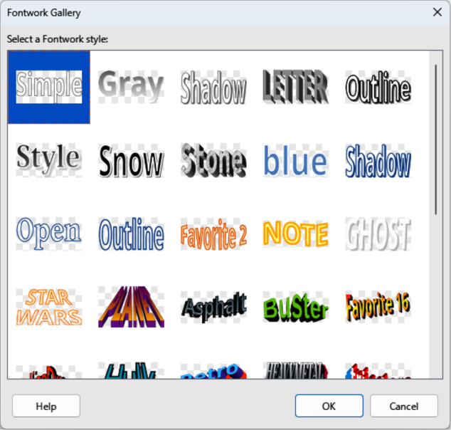
Figure 46: Fontwork Gallery dialog
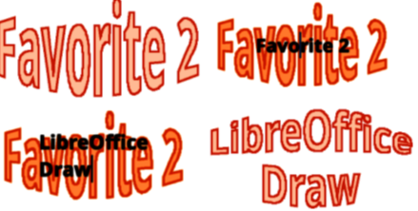
Figure 47: Example of creating Fontwork text
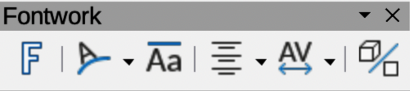
Figure 48: Fontwork toolbar
- Double-click on the Fontwork object to switch on editing mode. The example Fontwork text appears in the center of the image in text edit mode, as shown by the example in Figure 47 above.
- Highlight all of the text in edit mode to select it, then type in the required text to replace the highlighted text.
- Press the Esc key, or click outside the selected area to apply the new text and it appears as a Fontwork object in the center of the drawing.
- If necessary reposition and resize the Fontwork object to the drawing requirements. See Chapter 3, Working With Objects and Chapter 4, Changing Object Attributes for more information.

Fontwork toolbar
When a Fontwork object is selected, the Fontwork toolbar (Figure 48 above) opens on the Workspace. If the toolbar is not visible, go to View > Toolbars > Fontwork on the Menu bar.
The following tools are available for editing a Fontwork object.
Insert Fontwork Text
Opens the Fontwork Gallery dialog.
Fontwork Shape
Changes the shape of a selected Fontwork object. Click on the triangle▼next to Fontwork Shape on the Fontwork toolbar to open the Fontwork pop-up toolbar. Select a Fontwork shape for the available options. The Fontwork shapes are also available in the Fontwork Shape sub-toolbar (Figure 49 below).
Fontwork Same Letter Heights
Changes the height of characters in a selected Fontwork object. Toggles between normal height where the characters have different heights to where all characters have the same height.
Fontwork Alignment
Specifies the text alignment within the frame. Options available are Left Align, Center, Right Align, Word Justify, and Stretch Justify.
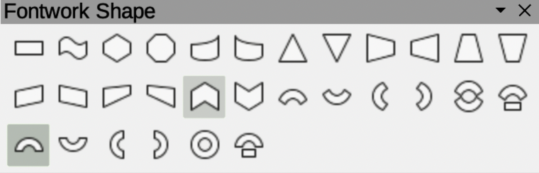
Figure 49: Fontwork Shape subtoolbar
Fontwork Character Spacing
Selects the spacing between characters and whether kerning pairs should be used. Options available are Very Tight, Tight, Normal, Loose, Very Loose, and Custom. For Custom spacing, input a percentage value: 100% is normal character spacing; less than 100% character spacing is tighter; more than 100% character spacing is looser.
Toggle Extrusion
Converts the Fontwork object into a 3D shape using extrusion. See Chapter 7, 3D Objects for more information.

Modifying Fontwork
A Fontwork object is treated like any other object in Draw. It can be resized, rotated, skewed, slanted, flipped, and so on. For more information on modifying a Fontwork object, see Chapter 3, Working With Objects, Chapter 4, Changing Object Attributes, and Chapter 5, Combining Multiple Objects.
- Fontwork consists of text, but only minimal text formatting options can be used with Fontwork text, for example font type, font size, Bold, or Italic.
- Some of Fontwork shapes can be modified and this is indicated by a dot appearing on a selected shape. For example, change angles of a trapezoid, or parallelogram basic shapes by moving the dot displayed when the selection handles are visible.

