
Draw Guide 25.8

Appendix B,
Toolbars

Copyright
Document copyright © for 2025 is held by the LibreOffice Documentation Team. Contributors are listed below. All trademarks in this guide belong to their legitimate owners. This document maybe distributed and/or modified under the terms of the GNU General Public License (https://www.gnu.org/licenses/gpl.html), version 3 or later, or the Creative Commons Attribution License (https://creativecommons.org/licenses/by/4.0/), version 4.0 or later.

Contributors

Contributors for this edition:
Peter Schofield

Contributors for previous editions:
Peter Schofield

Feedback
Please direct any comments or suggestions about this document to the Documentation Team Forum at https://community.documentfoundation.org/c/documentation/loguides/ (registration is required) or send email to: loguides@community.documentfoundation.org.
- Note
Everything sent to a mailing list, including email addresses, is publicly archived and cannot be deleted.

Publication date and software version
Published September 2025. Based on LibreOffice 25.8 Community.
Other versions of LibreOffice may differ in appearance and functionality.

Contents
Copyright 2
Contributors 2
Feedback 2
Publication date and software version 2
Introduction 5
Using toolbars 5
Displaying toolbars 5
Closing toolbars 5
Moving toolbars 5
Docked toolbars 5
Floating toolbars 6
Floating sub-toolbars 6
Docking floating toolbars 7
Locking toolbars 7
Docked toolbars 7
Locking toolbars and sub-toolbars 7
Editing toolbars 7
Adding tools 8
Removing tools 8
Customizing toolbars 8
Toolbars 8
3D-Objects 9
3D-Settings 9
Align Objects 10
Comments 10
Distribute Selection 10
Drawing 11
Edit Points 11
Find 11
Fontwork 12
Form Controls 12
Form Design 12
Form Navigation 13
Gluepoints 13
Image 14
Insert 14
Legacy Circles and Ovals 14
Legacy Rectangles 15
Line and Filling 15
Master View 15
Media Playback 16
Options 16
Redaction 16
Standard 17
Standard (Viewing Mode) 17
Table 17
Text 18
Text Formatting 18
Transformations 19
Zoom 19
Sub-toolbars 19
3D-Objects 19
Align Objects 19
Basic Shapes 20
Block Arrows 20
Callouts 20
Color 21
Connectors 21
Curves and Polygons 21
Distribute Selection 22
Flowchart 22
Fontwork Shape 22
Image Filter 23
Lines and Arrows 23
Position 23
Stars and Banners 24
Symbol Shapes 24

Introduction
Draw provides several toolbars for creating drawings. Each toolbar has a default set of tools when LibreOffice is installed on a computer. To improve the usability of a toolbar, additional tools can be added, see “Editing toolbars” on page 8 for more information.
- Note
The toolbar icons displayed in this user guide may differ from what is displayed on a computer screen. Toolbar icons depend on the computer operating system and how LibreOffice is set up. For more information on customizing LibreOffice and the toolbars, see the Getting Started Guide.

Using toolbars

Displaying toolbars
Two methods of opening toolbars in Draw are used, as follows:
- Go to View > Toolbars on the Menu bar. A sub-menu opens with an alphabetical list of toolbars available for creating drawings in Draw.
- Click on a toolbar name to display it and make it active. Active toolbars are indicated by highlighting or a check mark next to the toolbar name, depending on computer setup.

Closing toolbars
To close a toolbar, use one of the following methods:
- Go to View > Toolbars on the Menu bar and deselect the toolbar.
- Right-click in a blank area on a toolbar and select Close Toolbar from the context menu.
- Click on the X in the right corner of the title bar of a floating toolbar.

Moving toolbars

Docked toolbars
By default, some toolbars are docked into position in the Draw main window. The Standard toolbar is docked horizontally at the top and the Drawing toolbar is docked vertically at the left side. Docked toolbars can be undocked and moved into a new docked position in the main window, or left as a floating toolbar.
- Move the cursor over the small vertical handle at the left end of the toolbar, or horizontal handle at the top of a toolbar (highlighted in Figure 1 below). The cursor changes shape to the moving cursor used for the computer system and setup.
- Alternatively, right click on a docked toolbar and select Undock Toolbar from the context menu.
- Click and drag the toolbar to a new docked position, or leave as a floating toolbar. A hashed border appears around the toolbar indicating toolbar position as it is dragged.
- Release the toolbar when it is in the required position.
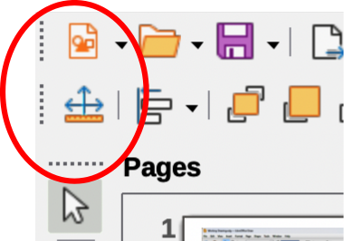
Figure 1: Example of toolbar moving handles
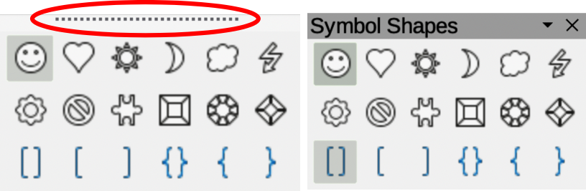
Figure 2: Example of creating floating sub-toolbars
- Note
If toolbar moving handles are not visible on a docked toolbar, then the toolbar is locked into position. A docked toolbar must be unlocked before it can be moved to a new position in the main window. See “Locking toolbars” on page 7 for more information.

Floating toolbars
To move a floating toolbar, click on the title bar and drag it to a new floating location. Release the toolbar when it is in the required position. A floating toolbar does not have to be positioned on the Draw main window for it to function.

Floating sub-toolbars
Some tools on a toolbar have a triangle ▼ to the right of the tool indicating that more tools are available on a sub-toolbar, for example Symbol Shapes on the Drawing toolbar. Sub-toolbars can be turned into floating toolbars and moved into a new position as follows:
- Move the cursor over the horizontal handle at the top of the sub-toolbar (highlighted in Figure 2 above). Cursor changes to a moving cursor used for computer system and setup.
- Click and drag the sub-toolbar to a new location creating a floating sub-toolbar.
- Release the sub-toolbar when the required position is reached.
- To close the floating sub-toolbar, right-click on the triangle ▼ in the sub-toolbar title bar and select Close Toolbar from the context menu.
- Alternatively, click on the X in the right corner of the title bar of a floating sub-toolbar

Docking floating toolbars
To dock a floating toolbar, use one of the following methods:
- Click on the title bar and drag it to a docking position at the top, bottom, left side, or right side of the main window. When the toolbar reaches its docking position, a hashed border appears at the docking position. Release the toolbar to dock it in the required position.
- Right-click on the toolbar and select Dock Toolbar from the context menu. The toolbar moves into a docked position. If the position is not suitable, move the toolbar to a new docked position.
- To dock all floating toolbars that are active, right-click on a toolbar and select Dock All Toolbars from the context menu.

Locking toolbars

Docked toolbars
When a toolbar has been docked into position, the toolbar can also be locked into position preventing the toolbar from becoming a floating toolbar.
- To lock a toolbar into a docked position, right-click in a blank area on the toolbar and select Lock Toolbar Position in the context menu. The small vertical or horizontal bar at the left end or top of the toolbar disappears indicating that the toolbar is locked.
- To unlock a toolbar, right-click in a blank area on the toolbar and click on Lock Toolbar Position in the context menu. A small vertical or horizontal bar appears at the left end or top of the toolbar indicating that the toolbar is unlocked. This bar also moves the toolbar.
- Notes
The Lock Toolbar Position is used for locking and unlocking toolbars is an on/off switch.
Some toolbars cannot be docked or locked into position. This is indicated by the options Dock Toolbar and/or Lock Toolbar Position being grayed out making both options unavailable.
Using the Lock Toolbars option affects all toolbars and sub-toolbars available in all LibreOffice modules.

Locking toolbars and sub-toolbars
To prevent all toolbars and sub-toolbars from becoming floating toolbars or sub-toolbars, they can be locked. Locked toolbars and sub-toolbars can be unlocked using the same method below. The Lock Toolbars option is used as a lock/unlock switch.
- Save the drawing that is open in Draw.
- Go to View > Toolbars on the Menu bar and select Lock Toolbars from the context menu.
- Select Restart Now in the Restart LibreOffice dialog that opens to activate the Lock Toolbars option.
- To unlock all toolbars and sub-toolbars so they can be repositioned, repeat Steps 1 thru 3. The Lock Toolbars option is an on/off switch.

Editing toolbars
When LibreOffice is installed on a computer, it includes a set of toolbars suitable for each LibreOffice module. Each toolbar has a default set of visible tools. Tools can be added or deleted, and toolbars can be customized.

Adding tools
- Right-click in a blank area on a toolbar, or click on the triangle ▼ on the right of the toolbar title bar.
- Select Visible Buttons from the context menu to display a list of available tools.
- Click on the tool required and the tool appears in the toolbar. The list of available tools closes automatically. A check mark next to the tool, or highlighting around the tool, indicates that the tool listed in Visible Buttons is already installed on the toolbar.
- Note
When adding tools using Visible Buttons, the tool is added to the toolbar at the same position as the tool appears in the Visible Buttons list. That is, the first tool in the list appears at the left end of the toolbar and the last tool in the list appears at the right end of the toolbar.

Removing tools
- Right-click in a blank area on a toolbar, or click on the triangle ▼ on the right of the toolbar title bar.
- Select Visible Buttons from the context menu to display a list of available tools.
- Click on a tool no longer required to deselect and it is removed from the toolbar. The highlighting or check mark is also removed. List of available tools closes automatically.

Customizing toolbars
Extra tools and commands that are not available in Visible Buttons can be added to a toolbar using customization (View > Toolbars > Customize on the Menu bar). Customization also allows the creation of new toolbars if a specific set of tools are required for a specific task. For information on customizing toolbars, see the Getting Started Guide.

Toolbars
- To open the default list of toolbars already installed in Draw, go to View > Toolbars on the Menu bar. An example of the default list of toolbars in Draw is shown in Figure 3 below.
- The number of tools visible on a toolbar depends on the computer setup and operating system being used to create a drawing.
- The tools displayed on toolbars displayed in this appendix are examples only. Actual tools displayed in a toolbar depend on computer setup, operating system and user preferences.
- The tools already installed on a toolbar are indicated in Visible Buttons either by the tool icon being highlighted or by a check mark. This indication depends on computer setup and computer operating system being used.
- On some toolbars, tool icons may have a triangle ▼ to the right of the icon. Click on this triangle ▼ to open a list of options, another toolbar, or a sub-toolbar.
- Some tools also have a keyboard shortcut for selecting the tool. For a full list of keyboard shortcuts available in Draw, see Appendix A, Keyboard Shortcuts.
- Each toolbar and sub-toolbar displayed in this appendix shows the full list of available tools for that toolbar or sub-toolbar.
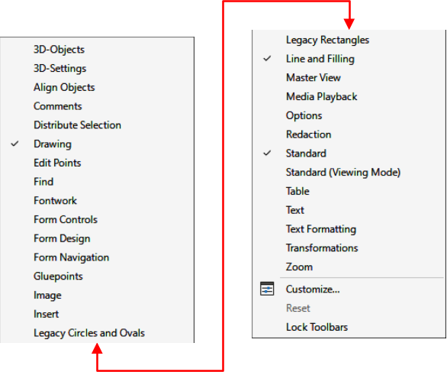
Figure 3: Example of default list of toolbars in Draw

3D-Objects
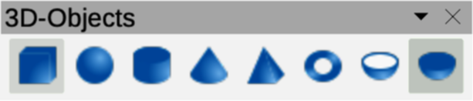
Figure 4: 3D-Objects toolbar
The 3D-Objects toolbar (Figure 4) provides the tools for creating 3D objects in a drawing. Go to View > Toolbars > 3D-Objects on the Menu bar. Alternatively, clicking on the triangle ▼ next to 3D-Objects on the Drawing toolbar opens a sub-toolbar providing access to the same 3D tools.
- Cube
- Sphere
- Cylinder
- Cone
- Pyramid
- Torus
- Shell
- Half Sphere

3D-Settings
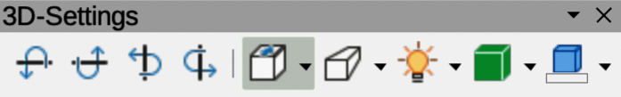
Figure 5: 3D-Settings toolbar

The tools on the 3D-Settings toolbar (Figure 5) are active when an object has been converted to 3D using Toggle Extrusion and the converted object is selected. For the following tools on the 3D-Settings toolbar click on the triangle ▼ on the right of the icon for access to more options.
- Toggle Extrusion
- Tilt Down
- Tilt Up
- Tilt Left
- Tilt Right
- Depth
- Direction
- Lighting
- Surface
- 3D Color

Align Objects
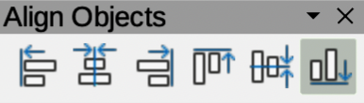
Figure 6: Align Objects toolbar
The Align Objects toolbar (Figure 6) provides tools for aligning several objects with each other in a drawing.
- Toggle Extrusion
- Tilt Down
- Tilt Up
- Tilt Left
- Tilt Right
- Depth
- Direction
- Lighting
- Surface
- 3D Color

Comments
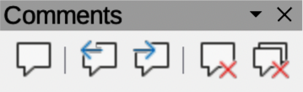
Figure 7: Comments toolbar
The Comments toolbar (Figure 7) provides tools for adding, deleting, editing and navigation of comments in a drawing. To use comments, it is recommended to add the name and initials of all users in Tools > Options > LibreOffice > User Data (macOS LibreOffice > Preferences > LibreOffice > User Data). Adding user names identifies comments that have been inserted.
- Comment
- Previous Comment
- Next Comment
- Delete Comment
- Delete All Comments

Distribute Selection
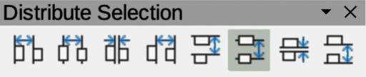
Figure 8: Distribute Selection toolbar
The Distribute Selection toolbar (Figure 8) provides tools to distribute three or more selected objects along a horizontal axis or vertical axis. Also, the spacing between objects can be evenly distributed horizontally and vertically.
- Distribute Horizontally Left
- Distribute Horizontally Center
- Distribute Horizontally Spacing
- Distribute Horizontally Right
- Distribute Vertically Top
- Distribute Vertically Center
- Distribute Vertically Spacing
- Distribute Vertically Bottom

Drawing
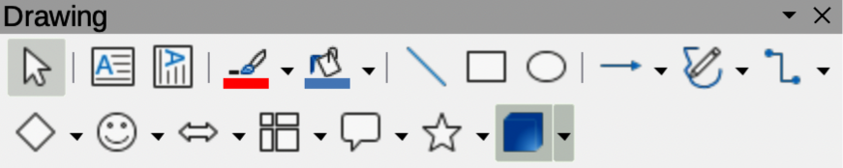
Figure 9: Drawing toolbar
The Drawing toolbar (Figure 9) provides the tools used to create graphic objects in a drawings. By default, this toolbar is docked on the left side of the Workspace. Some tool shapes on the Drawing toolbar change depending on the last tool that was previously selected and used. If required, click on the triangle ▼ to the right of a tool icon to open a pop-up toolbar for options.
- Select
- Zoom & Pan
- Zoom
- Text Box
- Vertical Text
- Insert Fontwork
- Line Color
- Fill Color
- Line
- Rectangle
- Ellipse
- Line Ends with Arrow
- Lines and Arrows
- Curves and Polygons
- Connectors
- Basic Shapes
- Symbol Shapes
- Block Arrows
- Flowchart
- Callouts
- Stars and Banners
- 3D Objects
- Position and Size
- Rotate
- Flip
- Align Objects
- Arrange
- Select at least three objects to distribute
- Shadow
- Crop Image
- Filter
- Points F8
- Show Gluepoint Function
- To Curve
- To Polygon
- To 3D
- T0 3D Rotation Object
- Toggle Extrusion
- Insert
- Controls

Edit Points
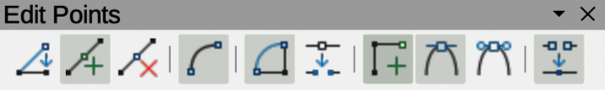
Figure 10: Edit Points toolbar
The Edit Points toolbar (Figure 10) provides tools for editing the points of a curve or polygon, or an object that has been converted to a curve or polygon. The toolbar only becomes active when an object is selected. Click on Edit Points on the Drawing or Standard toolbar, or use the keyboard shortcut F8 to open the toolbar.
- Edit Points
- Move Points
- Insert Points
- Delete Points
- Convert to Curve
- Close Bezier
- Split Curve
- Corner Point
- Smooth Transition
- Symmetric Transition
- Eliminate Points

Find
Figure 11: Find toolbar
The Find toolbar (Figure 11) opens by default and is docked in the bottom left corner of the LibreOffice Draw main window above the Status bar. This toolbar can be undocked from its default position and made into a floating toolbar.
- Close Find Bar
- Find Text
- Find Previous
- Find Next
- Find All
- Match Case
- Find and Replace

Fontwork
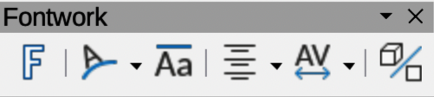
Figure 12: Fontwork toolbar
The Fontwork toolbar (Figure 12) is used to create graphical text objects in a slide and provide the tools for editing a graphical text object. This toolbar only becomes active when a Fontwork graphical text object has been selected on a drawing.
- Insert Fontwork Text
- Fontwork Shape
- Fontwork Same Letter Heights
- Fontwork Alignment
- Fontwork Character Spacing
- Toggle Extrusion

Form Controls
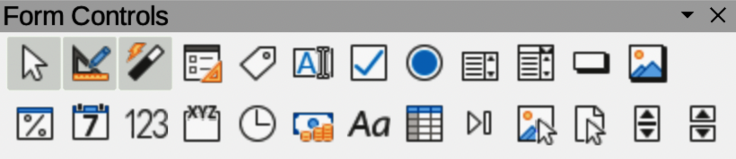
Figure 13: Form Controls toolbar
The Form Controls toolbar (Figure 13) provides the tools required to create an interactive form. This allows controls to be added to a form in a drawing. For example, a button that opens a document, drawing, spreadsheet, or slide.
- Select
- Design Mode
- Toggle Form Control Wizards
- Form Design
- Control Properties
- Form Properties
- Label
- Text Box
- Check Box
- Option Button
- List Box
- Combo Box
- Push Button
- Image Button
- Formatted Field
- Date Field
- Numerical Field
- Group Box
- Time Field
- Currency Field
- Pattern Field
- Table Control
- Navigation Bar
- Image Control
- File Selection
- Spin Button
- Scrollbar

Form Design
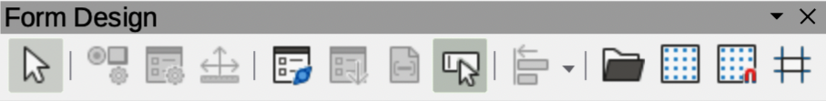
Figure 14: Form Design toolbar
The Form Design toolbar (Figure 14) opens a form in Design Mode so that it can be edited. Controls of the form cannot be activated, or its contents edited when in Design Mode. However, the position and size of the controls can be changed, properties edited, and controls added or deleted in Design Mode.
- Select
- Control Properties
- Form Properties
- Position and Size
- Form Navigator
- Activation Order
- Add Field
- Automatic Control Focus
- Bring to Front
- Send to Back
- Group
- Ungroup
- Enter Group
- Exit Group
- Align Objects
- Open in Design Mode
- Display Grid
- Snap to Grid
- Helplines While Moving

Form Navigation
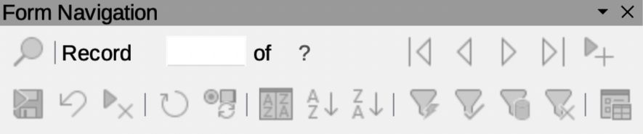
Figure 15: Form Navigation toolbar
The Form Navigation toolbar (Figure 15) provides tools to edit a database table or control data view. The toolbar is normally displayed at the bottom of a document that contains fields that are linked to a database. This toolbar is only active when forms are connected to a database, which is why an inactivate toolbar is shown in Figure 15.
The Form Navigation toolbar allows movement within records as well as inserting and deleting records. If data is saved in a form, the changes are transferred to the database. This toolbar also provides tools providing sort, filter, and search functions for data records.
- Find Record
- Record
- Absolute Record
- Text -> Record
- Total No. of Records
- First Record
- Previous Record
- Next Record
- Last Record
- New Record
- Save Record
- Undo: Data entry
- Delete Record
- Refresh
- Refresh Control
- Sort
- Sort Ascending
- Sort Descending
- AutoFilter
- Apply Filter
- Form-Based Filters
- Reset Filter/Sort
- Data source as Table

Gluepoints
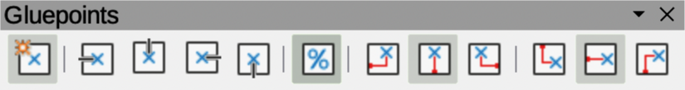
Figure 16: Gluepoints toolbar
The Gluepoints toolbar (Figure 16) provides tools to insert a gluepoint or modify the properties of a gluepoint. When a connector is attached, it uses a gluepoint. By default, LibreOffice automatically places a gluepoint at the center of each side of the bounding rectangle for every object created.
- Insert Glue Point
- Exit Direction Left
- Exit Direction Top
- Exit Direction Right
- Exit Direction Bottom
- Glue Point Relative
- Glue Point Horizontal Left
- Glue Point Horizontal Center
- Glue Point Horizontal Right
- Glue Point Vertical Top
- Glue Point Vertical Center
- Glue Point Vertical Bottom

Image
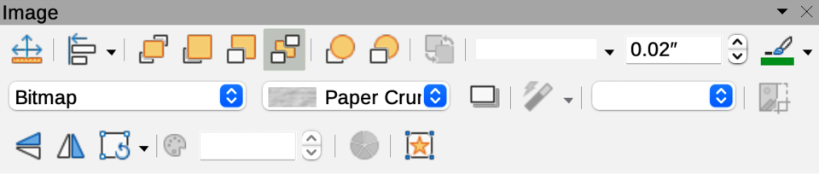
Figure 17: Image toolbar
The Image toolbar (Figure 17) provides tools to edit, modify, align, reposition and resize images. The toolbar only becomes active and available when an image is selected in a drawing. The Image toolbar automatically replaces the Line and Filling toolbar when it becomes active.
- Position and Size
- Align Objects
- Left
- Centered
- Right
- Top
- Center
- Bottom
- Arrange
- Bring to Front
- Bring Forward
- Send Backward
- Send to Back
- In Front of Object
- Behind Object
- Reverse
- Line Style
- Line Width
- Line Color
- Area Style/Filling
- Fill Color
- Shadow
- Filter
- Image Mode
- Crop
- Vertically
- Horizontally
- Transformations
- Transparency
- Color
- Line
- Area
- Animation
- Interaction

Insert
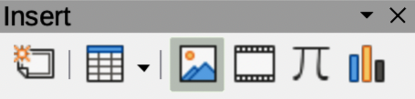
Figure 18: Insert toolbar
The Insert toolbar (Figure 18) provides tools for inserting objects into a drawing such as table, images, media, formulas, charts, and OLE objects.
- New Page
- Floating Frame
- Insert Page from File
- Table
- Image
- Insert Audio or Video
- Formula Object
- Chart
- OLE Object

Legacy Circles and Ovals
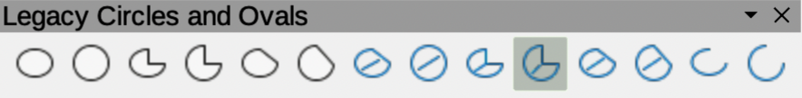
Figure 19: Legacy Circles and Ovals toolbar
The Legacy Circles and Ovals toolbar (Figure 19) provides tools to insert different types of circles and ovals into a drawing.
- Insert Ellipse
- Circle
- Ellipse Pie
- Circle Pie
- Ellipse Segment
- Circle Segment
- Ellipse, Unfilled
- Circle, Unfilled
- Ellipse Pie, Unfilled
- Circle Pie, Unfilled
- Ellipse Segment, Unfilled
- Circle Segment, Unfilled
- Arc
- Circle Arc

Legacy Rectangles
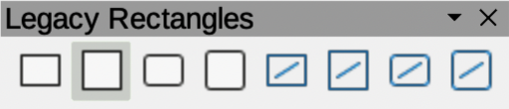
Figure 20: Legacy Rectangles toolbar
The Legacy Rectangles toolbar (Figure 20) provides tools to insert different types of rectangles and squares into a slide.
- Insert Rectangle
- Square
- Rectangle, Rounded
- Rounded Square
- Rectangle, Unfilled
- Square, Unfilled
- Rounded Rectangle, Unfilled
- Rounded Square, Unfilled

Line and Filling
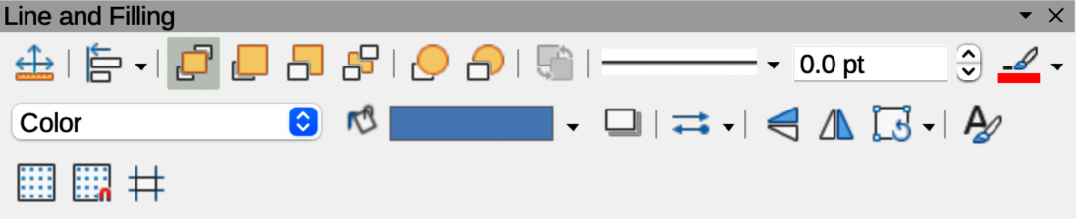
Figure 21: Line and Filling toolbar
The Line and Filling toolbar (Figure 21) provides tools and drop-down lists for editing lines, arrows, and object borders. The tools available depends on the type of object selected for editing.
- Position and Size
- Align Objects
- Left
- Centered
- Right
- Top
- Center
- Bottom
- Arrange
- Bring to Front
- Bring Forward
- Send Backward
- Send to Back
- In Front of Object
- Behind Object
- Reverse
- Line Style
- Line Width
- Line Color
- Area Style/Filling
- Fill Color
- Shadow
- Arrow Style
- Vertically
- Horizontally
- Transformations
- Line
- Area
- 3D Effects
- Image Map
- Animation
- Interaction
- Show the Styles Sidebar
- Display Grid
- Helplines While Moving

Master View
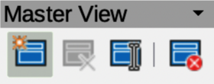
Figure 22: Master View toolbar
The Master View toolbar (Figure 22) provides tools for creating, renaming, deleting, and closing the master view. This toolbar is only active when Draw is in master view mode.
- New Master
- Rename Master
- Delete Master
- Close Master View

Media Playback
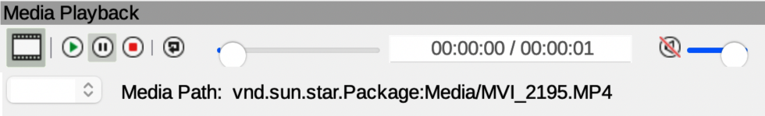
Figure 23: Media Playback toolbar
The Media Playback toolbar (Figure 23) provides the tools required to insert, view, play, and listen to audio and video files. The toolbar only becomes active when an audio or video file is selected. LibreOffice Draw supports many different media formats depending on the computer operating system being used.
- Insert Audio or Video
- Play
- Pause
- Stop
- Repeat
- Position
- Mute
- Volume
- View

Options
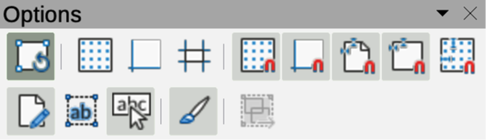
Figure 24: Options toolbar
The Options toolbar (Figure 24) provides tools for editing various settings for newly created presentations, for example how objects snap to the grid when being moved or resized.
- Rotation Mode after Clicking Object
- Display Grid
- Display Snap Guides
- Helplines While Moving
- Snap to Grid
- Snap to Snap Guides
- Snap to Page Margins
- Snap to Object Borders
- Snap to Object Points
- Allow Quick Editing
- Select Text Area Only
- Double-click to edit Text
- Modify Object with Attributes
- Exit All Groups

Redaction
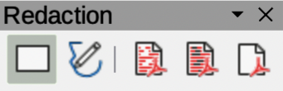
Figure 25: Redaction toolbar
The Redaction toolbar (Figure 25) is used to block portions of a drawing when protecting sensitive information. Redaction helps enterprises and organizations to comply with regulations on confidentiality or privacy.
When a redacted drawing is exported, any redacted portions are removed from a drawing and replaced by redaction blocks of pixels. This prevents any attempt in restoring or copying the original contents. A redacted drawing is often exported as PDF for publication or sharing.
- Rectangle
- Freeform
- Redacted Export (White)
- Redacted Export (Black)
- PDF

Standard
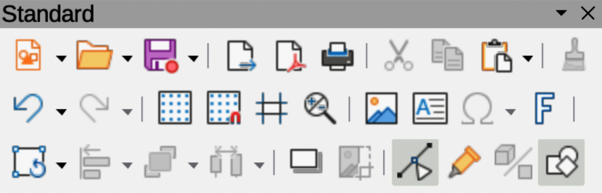
Figure 26: Standard toolbar
The Standard toolbar (Figure 26) is common to all LibreOffice components providing the most common tools used for creating and editing documents using LibreOffice. The Standard toolbar differs between LibreOffice components to allow for the toolsets required when creating different types of documents.
- Load URL
- New
- Templates
- Open
- Open Remote
- Save
- Save As
- Email
- Edit Mode
- Export Directly as PDF
- Print Directly
- Print
- Cut
- Copy
- Paste
- Clone Formatting
- Clear
- Undo
- Redo
- Find and Replace
- Spelling
- Auto Spellcheck
- Zoom & Pan
- Zoom
- Display Grid
- Helplines While Moving
- Display Views
- Views Tab Bar
- Format Slide
- Master Slide
- Start from First Slide
- Start from Current Slide
- Table
- Insert Image
- Insert Audio or Video
- Insert Chart
- Text Box
- Insert Special Characters
- Vertical Text
- Insert Fontwork Text
- Insert Hyperlink
- Show Draw Function
- Interaction
- LibreOffice Help
- What’s That

Standard (Viewing Mode)
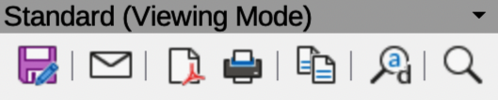
Figure 27: Standard (ViewingMode) toolbar
The Standard (Viewing Mode) toolbar (Figure 27) provides tools for saving, editing, and distributing a drawing.
- Save As
- Edit Mode
- Read Only Mode
- Email
- Export Directly as PDF
- EPUB
- Print Directly
- Print
- Copy
- Find and Replace
- Zoom

Table
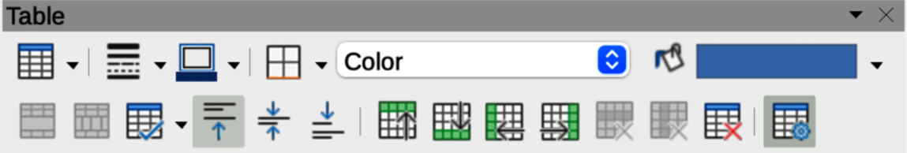
Figure 28: Table toolbar
The Table toolbar (Figure 28) provides tools and options to edit and format a table inserted into a drawing. This toolbar only becomes active when a table is selected.
- Table
- Border Style
- Border Color
- Borders (Shift to overwrite)
- Area Style/Filling
- Fill Color
- Merge Cells
- Split Cells
- Optimize
- Align Top
- Center Vertically
- Align Bottom
- Insert Row Above
- Insert Row Below
- Insert Column Before
- Insert Column After
- Delete Row
- Delete Column
- Delete Table
- Select Table
- Select Column
- Select Row
- Table Design
- Table Properties

Text
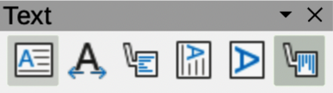
Figure 29: Text toolbar
The Text toolbar (Figure 29) provides tools to insert text boxes and callouts into a drawing.
- Insert Text Box
- Fit Text in Text Box Size
- Callouts
- Insert Vertical Text
- Fit Vertical Text to Frame
- Vertical Callouts

Text Formatting
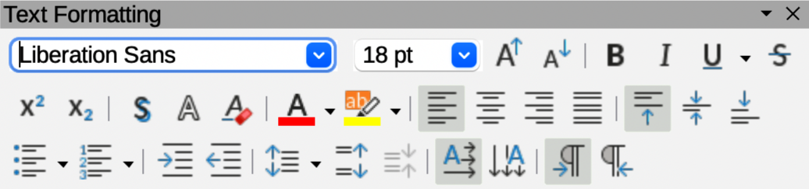
Figure 30: Text Formatting toolbar
The Text Formatting toolbar (Figure 30) provides tools for formatting text and alignment commands. This toolbar becomes active when text in a text box or graphic object has been selected and it automatically replaces the Line and Filling toolbar.
- Font Name
- Font Size
- Increase Font Size
- Decrease Font Size
- Bold
- Italic
- Underline
- Double Underline
- Strikethrough
- Overline
- Superscript
- Subscript
- Toggle Shadow
- Apply outline attribute to font
- Clear Direct Formatting
- lowercase
- UPPERCASE
- small capitals
- Font Color
- Character Highlighting Color
- Toggle Unordered List
- Toggle Ordered List
- Outline Format
- Align Left
- Align Center
- Align Right
- Justified
- Align Top
- Center Vertically
- Align Bottom
- Set Line Spacing
- Character Spacing
- Increase Paragraph Spacing
- Decrease Paragraph Spacing
- Text direction from left to right
- Text direction from top to bottom
- Left-To-Right
- Right-To-Left
- Select All
- Character
- Paragraph

Transformations
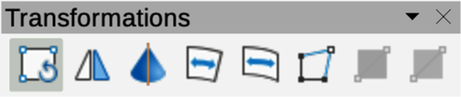
Figure 31: Transformations toolbar
The Transformations toolbar (Figure 31) provides tools to modify the shape, orientation, or fill of selected objects.
- Rotate
- Flip
- In 3D Rotation Object
- Set in Circle (perspective)
- Set to circle (slant)
- Distort
- Interactive transparency tool
- Interactive gradient tool

Zoom
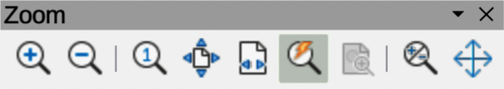
Figure 32: Zoom toolbar
The Zoom toolbar (Figure 32) provides tools to reduce or enlarge the screen display of the current drawing.
- Zoom In
- Zoom Out
- 100%
- Zoom Previous
- Zoom Next
- Entire Page
- Page Width
- Optimal View
- Object Zoom
- Zoom & Pan
- Shift

Sub-toolbars

3D-Objects
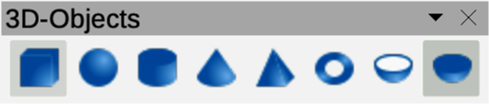
Figure 33: 3D-Objects sub-toolbar
Click on the triangle ▼ to the right of 3D-Objects on the Drawing toolbar to open the 3D-Objects sub-toolbar (Figure 33), then select a 3D object to add to a drawing. The 3D-Objects sub-toolbar is identical to the 3D-Objects toolbar available at View > Toolbars on the Menu bar.
- Cube
- Sphere
- Cylinder
- Cone
- Pyramid
- Torus
- Shell
- Half Sphere

Align Objects
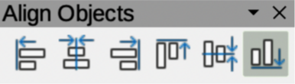
Figure 34: Align Objects sub-toolbar

To make a drawing look more professional, objects can be aligned with each other using one of the tools on the Align Objects sub-toolbar (Figure 34).
- Left
- Centered
- Right
- Top
- Center
- Bottom
- Left
- Centered
- Right
- Top
- Center
- Bottom

Basic Shapes
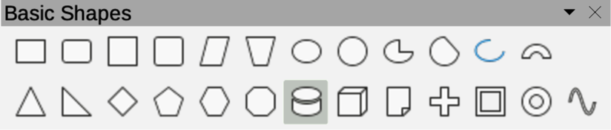Figure 35: Basic Shapes sub-toolbar
Click on the triangle ▼ to the right of Basic Shapes on the Drawing toolbar to open the Basic Shapes sub-toolbar (Figure 35), then select a basic shape to add to a drawing.
- Rectangle
- Rectangle, Rounded
- Square
- Square, Rounded
- Parallelogram
- Trapezoid
- Ellipse
- Circle
- Circle Pie
- Circle Segment
- Arc
- Block Arc
- Isosceles Triangle
- Right Triangle
- Diamond
- Regular Pentagon
- Hexagon
- Octagon
- Cylinder
- Cube
- Folded Corner
- Cross
- Frame
- Ring

Block Arrows
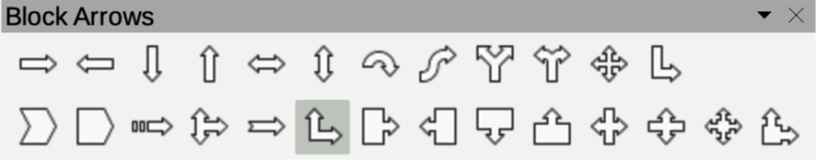
Figure 36: Block Arrows sub-toolbar
Click on the triangle ▼ to the right of Block Arrows on the Drawing toolbar to open the Block Arrows sub-toolbar (Figure 36), then select a block arrow to add to a drawing.
- Right Arrow
- Left Arrow
- Down Arrow
- Up Arrow
- Left and Right Arrow
- Up and Down Arrow
- Circular Arrow
- S-shaped Arrow
- Split Arrow
- Right or Left Arrow
- 4-way Arrow
- Corner Right Arrow
- Chevron
- Pentagon
- Striped Right Arrow
- Up, right and Down Arrow
- Notched Right Arrow
- Up and Right Arrow
- Right Arrow Callout
- Left Arrow Callout
- Down Arrow Callout
- Up Arrow Callout
- Left and Right Arrow Callout
- Up and Down Arrow Callout
- 4-way Arrow Callout
- Up and Right Arrow Callout

Callouts
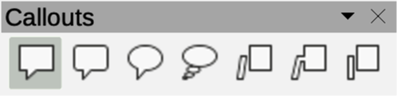
Figure 37: Callouts sub-toolbar
Click on the triangle ▼ to the right of Callouts on the Drawing toolbar to open the Callouts sub-toolbar (Figure 37), then select a callout to add to a drawing.
- Rectangular Callout
- Rounded Rectangular Callout
- Round Callout
- Cloud
- Line Callout 1
- Line Callout 2
- Line Callout 3

Color
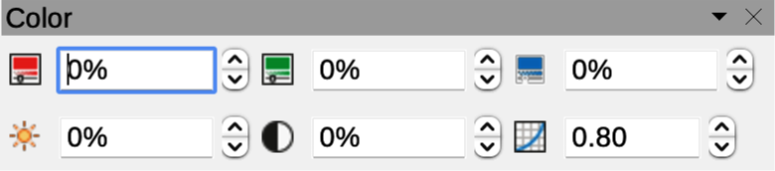
Figure 38: Color sub-toolbar
The Color sub-toolbar (Figure 38) provides tools to edit the color properties of a selected object. After selecting an object to open the Image toolbar, click on Color on the Image toolbar.
- Red
- Green
- Blue
- Brightness
- Contrast
- Gamma

Connectors
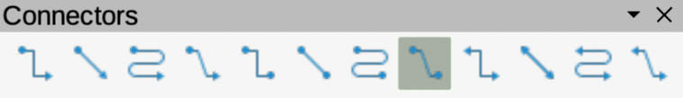
Figure 39: Connectors sub-toolbar
Click on the triangle ▼ to the right of Connectors on the Drawing toolbar to open the Connectors sub-toolbar (Figure 39), then select a connector to add to a drawing.
- Connector Ends with Arrow
- Straight Connector Ends with Arrow
- Curved Connector Ends with Arrow
- Line Connector Ends with Arrow
- Connector
- Straight Connector
- Curved Connector
- Line Connector
- Connector Starts with Arrow
- Straight Connector starts with Arrow
- Curved Connector Starts with Arrow
- Line Connector Starts Arrow
- Connector Ends with Circle
- Straight Connector Ends with Circle
- Curved Connector Ends with Circle
- Line Connector Ends with Circle
- Connector Starts with Circle
- Straight Connector starts with Circle
- Curved Connector Starts with Circle
- Line Connector Starts with Circle
- Connector with Circles
- Straight Connector with Circle
- Curved Connector with Circle
- Line Connector with Circle

Curves and Polygons
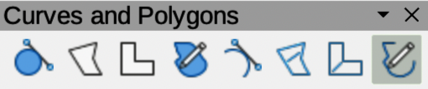
Figure 40: Curves and Polygons sub-toolbar
Click on the triangle ▼ to the right of Curves and Polygons on the Drawing toolbar to open the Curves and Polygons sub-toolbar (Figure 40), then select a curve or polygon to add to a drawing.
- Curve, Filled
- Polygon, Filled
- Polygon (45°), Filled
- Freeform Line, Filled
- Curve
- Polygon
- Polygon (45°)
- Freeform Line

Distribute Selection
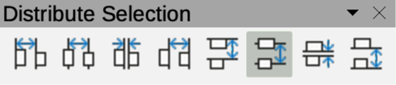
Figure 41: Distribute Selection sub-toolbar
Distributing objects allows three or more objects to be evenly spaced along a horizontal or vertical axis. Objects are distributed using the outermost objects as base points for spacing. The Distribute sub-toolbar is also available as a toolbar. Go to View > Toolbars > Distribute Selection on the Main menu bar.
- Distribute Horizontally Left
- Distribute Horizontally Center
- Distribute Horizontally Spacing
- Distribute Horizontally Right
- Distribute Vertically Top
- Distribute Vertically Center
- Distribute Vertically Spacing
- Distribute Vertically Bottom

Flowchart
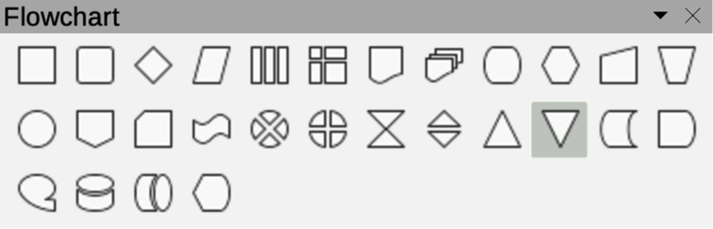
Figure 42: Flowchart sub-toolbar
Click on the triangle ▼ to the right of Flowchart on the Drawing toolbar to open the Flowchart sub-toolbar (Figure 42), then select a flowchart shape to add to a drawing.
- Flowchart: Process
- Flowchart: Alternate Process
- Flowchart: Decision
- Flowchart: Data
- Flowchart: Predefined Process
- Flowchart: Internal Storage
- Flowchart: Document
- Flowchart: Multidocument
- Flowchart: Terminator
- Flowchart: Preparation
- Flowchart: Manual Input
- Flowchart: Manual Operation
- Flowchart: Connector
- Flowchart: Off-page Connector
- Flowchart: Card
- Flowchart: Punched Tape
- Flowchart: Summing Junction
- Flowchart: Or
- Flowchart: Collate
- Flowchart: Sort
- Flowchart: Extract
- Flowchart: Merge
- Flowchart: Stored Data
- Flowchart: Delay
- Flowchart: Sequential Access
- Flowchart: Magnetic Disc
- Flowchart: Direct Access Storage
- Flowchart: Display

Fontwork Shape
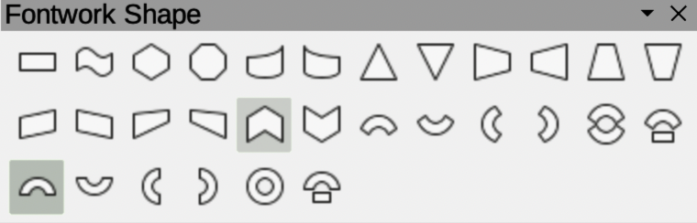
Figure 43: Fontwork Shape sub-toolbar
Clicking on the triangle ▼ to the right of Fontwork Shape on the Fontwork toolbar opens the Fontwork Shape sub-toolbar (Figure 43). Select the required shape to change how a Fontwork text shape appears in a drawing.
- Plain Text
- Wave
- Inflate
- Stop
- Curve Up
- Curve Down
- Triangle Up
- Triangle Down
- Fade Right
- Fade Left
- Fade Up
- Fade Down
- Slant Up
- Slant Down
- Fade Up and Right
- Fade Up and Left
- Chevron Up
- Chevron Down
- Arch Up (Curve)
- Arch Down (Curve)
- Arch Left (Curve)
- Arch Right (Curve)
- Circle (Curve)
- Open Circle (Curve)
- Arch Up (Pour)
- Arch Down (Pour)
- Arch Left (Pour)
- Arch Right (Pour)
- Circle (Pour)
- Open Circle (Pour)

Image Filter
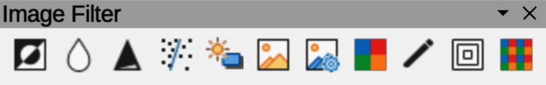
Figure 44: Image Filter sub-toolbar
Clicking on the triangle ▼ to the right of Filter on the Image toolbar opens the Image Filter sub-toolbar (Figure 44). Select the required filter to change how an image appears on the display.
- Invert
- Smooth
- Sharpen
- Remove Noise
- Solarization
- Aging
- Posterize
- Pop Art
- Charcoal Sketch
- Relief
- Mosaic

Lines and Arrows
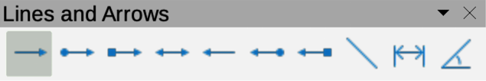
Figure 45: Lines and Arrows sub-toolbar
Click on the triangle ▼ to the right of Lines and Arrows on the Drawing toolbar to open the Lines and Arrows sub-toolbar (Figure 45), then select a line or arrow to add to a drawing.
- Line Ends with Arrow
- Line with Circle/Arrow
- Line with Square/Arrow
- Line with Arrows
- Line Starts with Arrow
- Line with Arrow/Circle
- Line with Arrow/Square
- Insert Line
- Dimension Line
- Line (45°)

Position
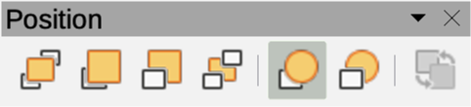
Figure 46: Position sub-toolbar
Click on the triangle ▼ to the right of Arrange on the Line and Filling toolbar to open the Position sub-toolbar (Figure 46), then select the position of a selected object in a drawing.
- Bring to Front
- Bring Forward
- Send Backward
- Send to Back
- In Front of Object
- Behind Object
- Reverse

Stars and Banners
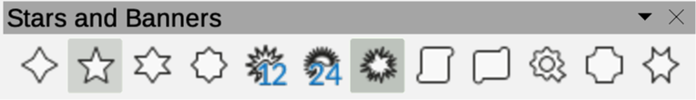
Figure 47: Stars and Banners sub-toolbar
Click on the triangle ▼ to the right of Stars and Banners on the Drawing toolbar to open the Stars and Banners sub-toolbar (Figure 47), then select a star or arrow to add to a drawing.
- 4-Point Star
- 5-Point Star
- 6-Point Star
- 8-Point Star
- 12-Point Star
- 24-Point Star
- Explosion
- Vertical Scroll
- Horizontal Scroll
- Signet
- Doorplate
- 6-Point Star, Concave

Symbol Shapes
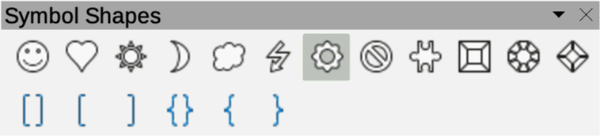
Figure 48: Symbol Shapes sub-toolbar
Click on the triangle ▼ to the right of Symbol Shapes on the Drawing toolbar to open the Symbol Shapes sub-toolbar (Figure 48), then select a symbol shape to add to a drawing.
- Smiley Face
- Heart
- Sun
- Moon
- Cloud
- Lightning Bolt
- Flower
- Prohibited
- Puzzle
- Square Bevel
- Octagon Bevel
- Diamond Bevel
- Double Bracket
- Left Bracket
- Right Bracket
- Double Brace
- Left Brace
- Right Brace

