
Writer Guide 24.2

Chapter 21,
User Interface Variants

Copyright
This document is Copyright © 2024 by the LibreOffice Documentation Team. Contributors are listed below. This document may be distributed and/or modified under the terms of either the GNU General Public License (https://www.gnu.org/licenses/gpl.html), version 3 or later, or the Creative Commons Attribution License (https://creativecommons.org/licenses/by/4.0/), version 4.0 or later. All trademarks within this guide belong to their legitimate owners.

Contributors
To this edition
Jean Hollis Weber
To previous editions
Jean Hollis Weber | Kees Kriek

Feedback
Please direct any comments or suggestions about this document to the Documentation Team Forum at https://community.documentfoundation.org/c/documentation/loguides/ (registration is required) or send an email to: loguides@community.documentfoundation.org.
- Note
Everything sent to a forum, including email addresses and any other personal information that is written in the message, is publicly archived and cannot be deleted. Emails sent to the forum are moderated.

Publication date and software version
Published February 2024. Based on LibreOffice 24.2 Community.
Other versions of LibreOffice may differ in appearance and functionality.

Using LibreOffice on macOS
Some keystrokes and menu items are different on macOS from those used in Windows and Linux. The table below gives some common substitutions used in this document. For a detailed list, see LibreOffice Help.
Windows or Linux | macOS equivalent | Effect
Tools > Options  menu selection | LibreOffice > Preferences | Access setup options
Right-click | Control+click or right-click depending on computer setup | Open a context menu
Ctrl (Control) | ⌘ (Command) | Used with other keys
Alt | ⌥ (Option) or Alt | Used with other keys
F11 | ⌘+T | Open Styles deck in Sidebar

Contents
Copyright 2
Contributors 2
Feedback 2
Publication date and software version 2
Using LibreOffice on macOS 2
Introduction 4
Selecting the user interface 4
Standard interfaces 4
Tabbed interface 5
Icon bar 5
Quick menu 6
Fixed tabs 6
File tab 6
Home tab 7
Insert tab 8
Layout tab 9
References tab 10
Review tab 11
View tab 12
Extension tab 12
Tools tab 13
Additional tabs 13
Draw tab 13
Image tab 14
Media tab 15
Object tab 16
Table tab 16
Tabbed Compact interface 17
Groupedbar Compact interface 17
Contextual Single interface 18

Introduction
By default, LibreOffice Writer’s commands are grouped in cascading menus and in toolbars filled with icons—the standard user interface described in Chapter 1, Introducing Writer. These menus and toolbars are described in the chapters that discuss the related tasks and functions.
In addition, Writer provides other user interface variants, displaying contextual groups of commands and contents. This chapter describes these user interface variants and provides a quick reference to the location of the tools and functions when using each of the variants.

Selecting the user interface
To select or switch between any of the user interfaces:
- Choose View > User Interface on the Menu bar.
- On the Select Your Preferred User Interface dialog (Figure 1), choose one of the variants on the left. An example of the variant is shown in the Preview box on the right, along with a short description.
- Choose the relevant button to apply this selection to all components of LibreOffice, or only to Writer. The Writer window changes to match the selection.
- Click Close to close the dialog.
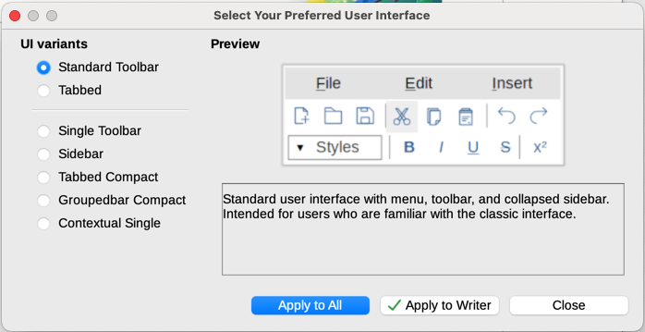
Figure 1: Selecting a user interface

Standard interfaces
Three of the user interface choices in Figure 1 are described in Chapter 1, Introducing Writer.
Standard Toolbar
Classic mode with two visible toolbars: standard and formatting. The sidebar shows only its tabs.
Single Toolbar
Only one toolbar with frequently used features. The sidebar shows only its Hide button.
Sidebar
The sidebar is fully opened and only one toolbar (Formatting) is showing.
The elements on each of the standard user interfaces can be modified using the View menu on the Menu bar.

Tabbed interface
The Tabbed interface (Figure 2) provides a familiar interface for users coming from proprietary office suites such as Microsoft Office. It includes a Menu bar, an Icon bar, a Tab bar, icons for the active tab, one or more tab-specific menus, and a Quick Menu. On Windows and Linux, the Menu bar can be hidden or displayed by clicking on the Menu Bar icon in the Icon bar (Figure 4).
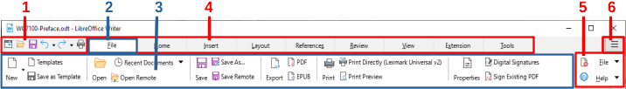
1 Icon bar 2 Active tab 3 Icons on active tab 4 Tabs 5 Tab menus 6 Quick menu
Figure 2: Tabbed Interface with Menu bar hidden
In Writer, this user interface variant includes nine fixed tabs and five additional tabs. Each tab displays a set of icons grouped by context. The context can change depending on the location of the cursor or the item selected. Each tab also includes one or more tab-specific drop-down menus at the right-hand end. The Quick Menu is the same for all tabs.
The Tabbed interface can be customized using the Notebookbar tab of the Customize dialog to show and hide the individual icons on the various tabs. See Chapter 20, Customizing Writer, for more information.
If the icons on a tab do not fit into the width of the Writer window, >> appears at the end of the row. Click it to display the other commands (Figure 3).
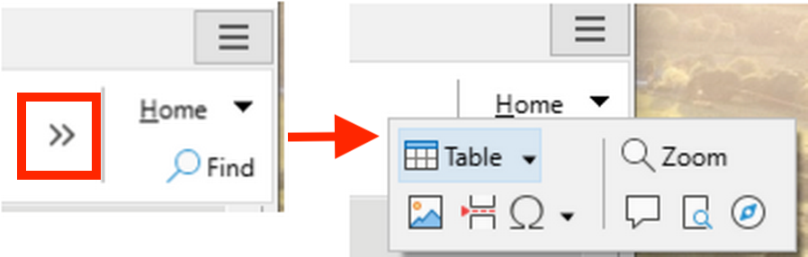
Figure 3: Displaying more commands on a tab

Icon bar
The icon bar (Figure 4) is located at the top left of the tabs.
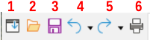
Figure 4: Icon bar
1 Menu bar – Show / Hide the menu bar.
2 Open (Ctrl+O) – Open a file browser and select the file to be opened.
3 Save (Ctrl+S) – Save the open file.
4 Undo (Ctrl+Z) – Undo the last action performed.
5 Redo (Ctrl+Y) – Redo the last undone action.
6 Print (Ctrl+P) – Open the Print dialog.

Quick menu
At the right-hand end of the tab bar is a Quick menu (Figure 5) containing some commonly used commands and links. Some of the Quick menu items have submenus, indicated by arrows on the right.
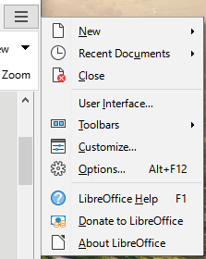
Figure 5: Tabbed Interface – Quick menu

Fixed tabs
The fixed tabs in Writer are File, Home, Insert, Layout, References, Review, View, Extension, and Tools. The tabs are described on the following pages. The illustrations show the left and right ends of the tabs separately so they are large enough to more easily see the commands.

File tab
The File tab (Figure 6) includes commands to create new documents; open, save, print, and close documents; manage templates; export to PDF and EPUB; display document properties; add a digital signature; and sign an existing PDF.
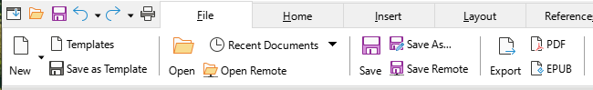
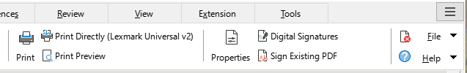
Figure 6: Tabbed Interface – File tab
The File tab has two menus (Figure 7): File and Help. The File menu contains the same commands as the icons on the tab. The Help menu provides links to a variety of resources.
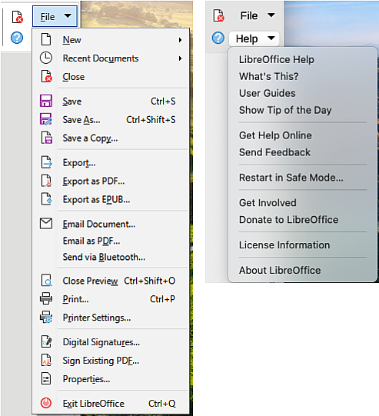
Figure 7: File tab menus

Home tab
The Home tab (Figure 8) includes commands to cut, copy, paste, and format text; insert common items (image, table, special characters, and page break); apply, update, and edit styles; and others.
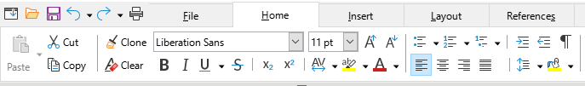
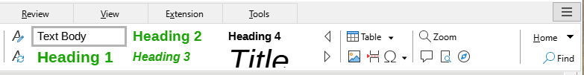
Figure 8: Tabbed Interface – Home tab
The Home menu (Figure 9) provides additional commands that are not on the tab.
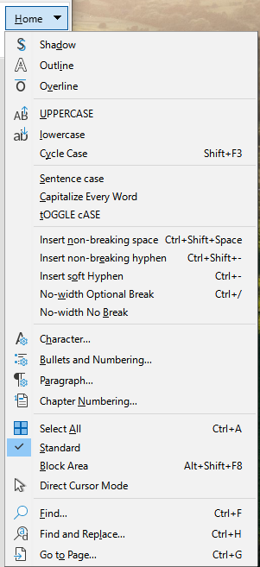
Figure 9: Home tab menu

Insert tab
The Insert tab (Figure 10) includes commands to insert many commonly used items.
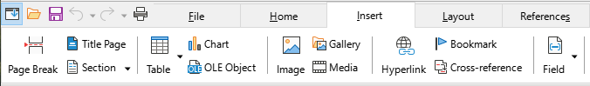
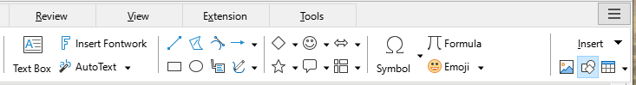
Figure 10: Tabbed Interface – Insert tab
The Insert menu (Figure 11) provides some of the same commands.
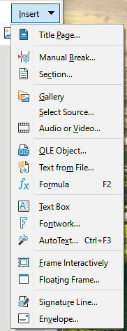
Figure 11: Insert tab menu

Layout tab
The Layout tab (Figure 12) provides commands for working on page layout.
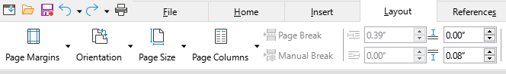
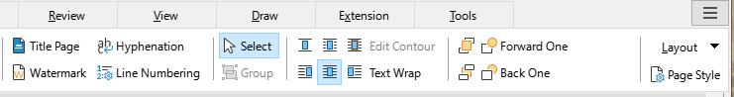
Figure 12: Tabbed Interface – Layout tab
The Layout menu (Figure 13) provides commands for a few of the same items.
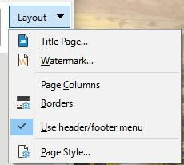
Figure 13: Layout tab menu

References tab
The References tab (Figure 14) provides commands for working with tables of contents, indexes, footnotes and endnotes, cross-references, bibliographies, and fields.
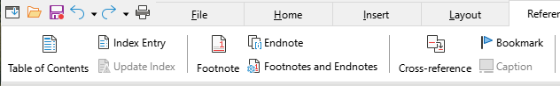
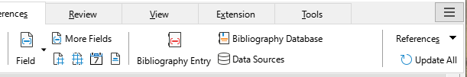
Figure 14: Tabbed Interface – References tab
The References menu (Figure 15) provides many of the same commands.
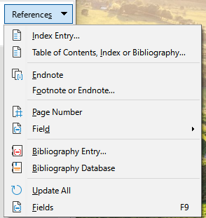
Figure 15: References tab menu

Review tab
The Review tab (Figure 16) assists in editing. It provides quick access to recording, showing, hiding, and managing changes.
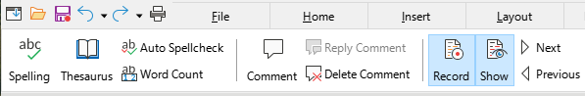
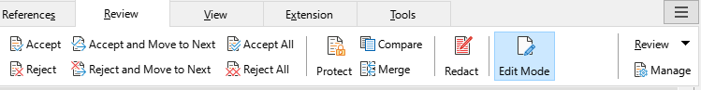
Figure 16: Tabbed Interface – Review tab
The Review menu (Figure 17) provides many of the same commands.
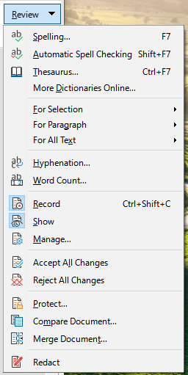
Figure 17: Review tab menu

View tab
The View tab (Figure 18) provides commands related to the display of a document on screen.
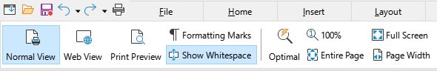
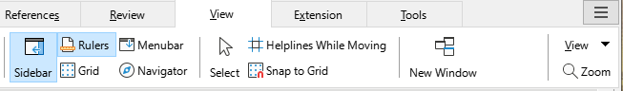
Figure 18: Tabbed Interface – View tab
The View menu (Figure 19) provides many of the same commands.
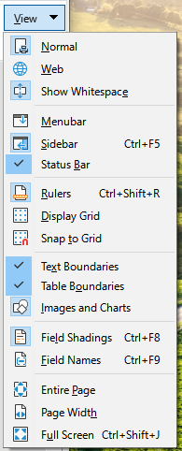
Figure 19: View tab menu

Extension tab
The Extension tab (Figure 20) contains only the menu for accessing the Extensions dialog.
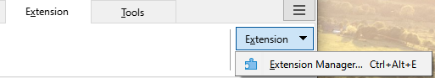
Figure 20: Tabbed Interface – Extension tab

Tools tab
The Tools tab (Figure 21) provides several tools for macros, mail merge, and form creation.
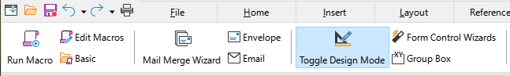
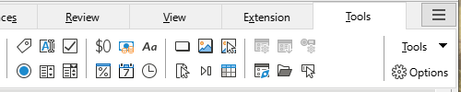
Figure 21: Tabbed Interface – Tools tab
The Tools menu (Figure 22) provides some of the same commands.
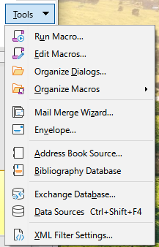
Figure 22: Tools tab menu

Additional tabs
Additional tabs appear when an item is selected; they are displayed between the View and Extension tabs. The additional tabs in Writer are Draw, Image, Media, Object, and Table.

Draw tab
The Draw tab (Figure 23) is displayed when a drawing object is selected. It provides commands for captioning and modifying the drawing object and for inserting and modifying Fontwork objects.
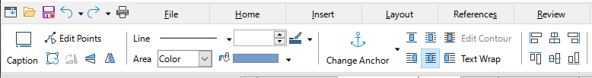
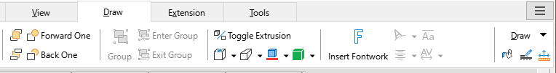
Figure 23: Tabbed Interface – Draw tab
The Draw menu (Figure 24) provides a subset of commands, which vary depending on the drawing object.
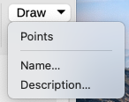
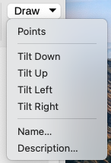
Figure 24: Draw tab menu examples

Image tab
The Image tab (Figure 25) provides commands for working with images, including captions, cropping, borders and area styles and colors, anchors, wrapping, positioning, and filtering.
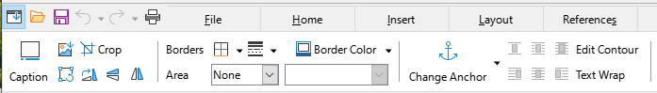
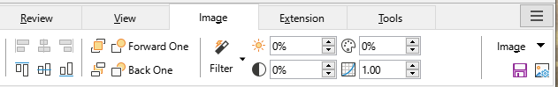
Figure 25: Tabbed Interface – Image tab
The Image menu (Figure 26) provides links to dialogs for working with images.
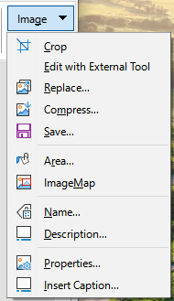
Figure 26: Image tab menu

Media tab
The Media tab (Figure 27) provides commands for positioning and running an audio or video file.
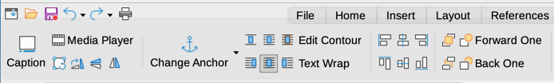
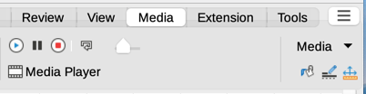
Figure 27: Tabbed Interface – Media tab
The Media menu (Figure 28) provides some of the same commands
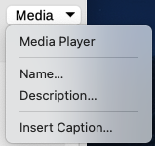
Figure 28: Media tab menu

Object tab
The Object tab (Figure 29) provides commands to position, resize, link, choose colors and borders for the selected object. The illustration shows the tab when a frame is selected.
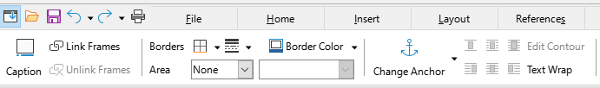
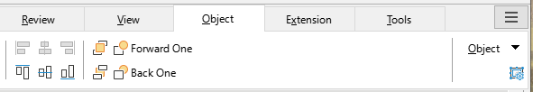
Figure 29: Tabbed Interface – Object tab
The Object menu (Figure 30) provides a few of the same commands. The illustration shows the menu when a frame is selected.
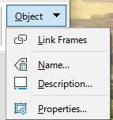
Figure 30: Object tab menu

Table tab
The Table tab (Figure 31) is opened when the cursor is in a table.
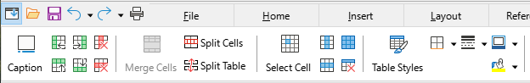
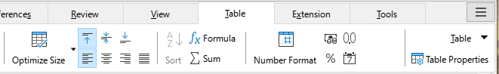
Figure 31: Tabbed Interface – Table tab
The Table menu (Figure 32) includes some commands not shown on the tab.
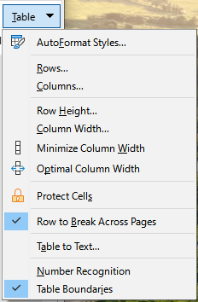
Figure 32: Table tab menu

Tabbed Compact interface
The Tabbed Compact interface has the same tabs as the Tabbed interface, but the commands on each tab are arranged in a single row of icons, many with drop-down menus of choices.
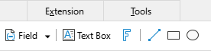
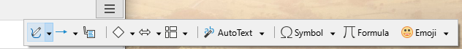
Figure 33: Tabbed Compact interface example: Insert tab

Groupedbar Compact interface
The Groupedbar Compact interface (Figure 34) is divided into groups that contain commands organized as sets of icons and menus.
Figure 34: Groupedbar Compact interface example
The Groupedbar menu (Figure 35) provides a subset of commands, including a convenient way to change the user interface.
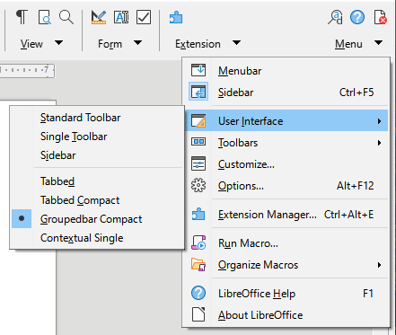
Figure 35: Groupedbar menu

Contextual Single interface
The Contextual Single interface displays a standard Menu bar and a single toolbar with context-dependent content.

