Copyright
This document is Copyright © 2023 by the LibreOffice Documentation Team. Contributors are listed below. You may distribute it and/or modify it under the terms of either the GNU General Public License (https://www.gnu.org/licenses/gpl.html), version 3 or later, or the Creative Commons Attribution License (https://creativecommons.org/licenses/by/4.0/), version 4.0 or later.
All trademarks within this guide belong to their legitimate owners.

Contributors
To this edition
Vítor Ferreira | Olivier Hallot
To previous editions
Rafael Lima | Olivier Hallot | Jean Hollis Weber
Roman Kuznetsov | Dave Barton | Regina Henschel
Peter Schofield | Hazel Russman | Laurent Balland-Poirier
Jean Hollis Weber | Daniel Carrera | Agnes Belzunce
T. J. Frazier | Peter Kupfer | Ian Laurenson
Janet M. Swisher | Michele Zarri | Florian Reisinger
Christian Kühl | Jochen Schiffers | Frédéric Parrenin
Gisbert Friege (Dmaths) | Bernard Siaud
LibreOffice 7.x Guide Series cover design by Rizal Mutaqin.

Feedback
Please direct any comments or suggestions about this document to the Documentation Team’s forum at https://community.documentfoundation.org/c/documentation/loguides/ (registration is required) or send an email to: loguides@community.documentfoundation.org.
- Note
Everything you send to a mailing list, including your email address and any other personal information that is written in the message, is publicly archived and cannot be deleted.

Publication date and software version
Published June 2024. Based on LibreOffice 7.3 Community.
Other versions of LibreOffice may differ in appearance and functionality.

Contents
Copyright 2
Preface 5
Who is this book for? 6
Where to get more help 6
What you see may be different 8
Using LibreOffice on macOS 8
What is new in LibreOffice Math 7.5 Community? 9
Chapter 1, Creating and Editing Formulas 10
Introduction 11
Getting started 11
Creating formulas 13
Editing formulas 18
Formula layout 18
Changing formula appearance 24
Formula library 32
Chapter 2, Formulas in Writer 34
Introduction 35
Automatic formula numbering 35
Anchoring formulas 36
Vertical alignment 37
Object spacing 38
Text mode 39
Background and borders 39
Quick insertion of formulas 41
Chapter 3, Formulas in Calc, Draw, and Impress 42
Introduction 43
Anchoring formulas 43
Formula object properties 43
Formulas in charts 44
Chemical formulas 45
Chapter 4, Customization 46
Introduction 47
Floating dialogs 47
Adding keyboard shortcuts 47
Catalog customization 50
Formula spacing 53
Scaling of code in the Formula Editor input window 53
Extensions 54
Chapter 5, Exporting and Importing 55
MathML format 56
Microsoft file formats 56
Appendix A, Commands Reference 57
Introduction 58
Unary/binary operator commands 58
Relation commands 59
Set operation commands 60
Functions 61
Operators 62
Attributes 64
Brackets 66
Formats 68
Others 69
Greek characters 70
Special characters 72
Reserved words 72


Math Guide 7.3

Preface

Who is this book for?
LibreOffice Math is a formula (equation) editor that is an integral part of LibreOffice. Anyone who wants to learn how to insert formulas and equations using Math will find this guide valuable.
In LibreOffice, formulas can be inserted as objects into Writer, Impress, Draw, and Calc documents. Regardless of the document type, formula objects are edited using LibreOffice Math.
If you want an introduction to all of the LibreOffice components, you might like to read the Getting Started Guide first.
- Note
LibreOffice Math is not capable of evaluating mathematical equations or performing calculations. For that purpose, you should use LibreOffice Calc; see the Calc Guide.

Where to get more help
This guide, the other LibreOffice user guides, the Help system, and user support systems assume that you are familiar with your computer and its operating system’s basic functions such as starting a program, opening and saving files.

Help system
LibreOffice comes with an extensive online Help system. This is your first line of support. Windows and Linux users can choose to download and install the Help for use when not connected to the Internet; the offline Help is installed with the program on macOS.
To display the Help system, press F1 or go to Help > LibreOffice Help on the Menu bar. If you do not have the offline help installed on your computer and you are connected to the Internet, your default browser will open the online Help pages on the LibreOffice website.
The Help menu also includes links to other LibreOffice information and support facilities. The options marked by a ‡ sign in the list below are only accessible if your computer is connected to the Internet.
- What's This? For quick tips when a toolbar is visible, place the mouse pointer over any of the icons to see a small box (“tooltip”) with a brief explanation of the icon’s function. For a more detailed explanation, select Help > What's This? and hold the pointer over the icon. In addition, you can choose whether to activate Extended Tips using Tools > Options > LibreOffice > General.
- User Guides ‡ Opens your default browser at the Documentation page of the LibreOffice website, https://documentation.libreoffice.org/en/english-documentation/. There you will find copies of user guides and other useful information.
- Show Tip of the Day Opens a small window with a random tip on how to use LibreOffice.
- Search Commands In Writer, Calc, Impress, and Draw (but not Base or Math), opens a window where you can type a few letters or the name of a Menu bar command, to quickly find where the command is located. Clicking on a command in the resulting list may open a relevant dialog or have other effects.
- Get Help Online ‡ Opens your default browser at the Ask LibreOffice forum of questions and answers from the LibreOffice community, https://ask.libreoffice.org/en/questions/.
- Send Feedback ‡ Opens your default browser at the Feedback page of the LibreOffice website, https://www.libreoffice.org/get-help/feedback/. From there you can report bugs, suggest new features and communicate with others in the LibreOffice community.
- Restart in Safe Mode Opens a dialog where you can restart LibreOffice and reset the software to its default settings.
- Get Involved ‡ Opens your default browser at the Get Involved page of the LibreOffice website, https://www.libreoffice.org/community/get-involved/. There you can choose a topic of interest to help improve the program.
- Donate to LibreOffice ‡ Opens your default browser at the Donation page of the LibreOffice website, https://donate.libreoffice.org/.
- License Information Outlines the licenses under which LibreOffice is made available.
- Check for Updates ‡ Opens a dialog and checks the LibreOffice website for updates to your version of the software.
- About LibreOffice Opens a dialog and displays information about the version of LibreOffice and the operating system you are using. This information will often be requested if you ask the community for help or assistance with the software. A button is provided to enable you to copy this information to the clipboard so that you can subsequently paste it into a forum post, an email, or a bug report. (On macOS, this item is under LibreOffice on the Menu bar.)

Other free online support
The LibreOffice community not only develops software, but provides free, volunteer-based support. In addition to the Help menu links above, other online community support options are available; see Table 1 and this web page: https://www.libreoffice.org/get-help/.
Table 1: Free support for LibreOffice users
Free LibreOffice support
FAQs | Answers to frequently asked questions  https://wiki.documentfoundation.org/Faq
Mailing lists | Free community support is provided by a network of experienced users  https://www.libreoffice.org/get-help/mailing-lists/
Forum | As in the mailing lists above, but through forum  https://community.documentfoundation.org/
Questions & Answers and  Knowledge Base | Free community assistance is provided in a Question & Answer format. Search similar topics or ask a new question in  https://ask.libreoffice.org/en/questions  The service is available in several other languages; just replace /en/ with de, es, fr, ja, ko, nl, pt, tr, and many others in the web address above.
Native language support | The LibreOffice website in various languages  https://www.libreoffice.org/community/nlc/  Mailing lists for native languages  https://wiki.documentfoundation.org/Local_Mailing_Lists  Information about social networking  https://wiki.documentfoundation.org/Website/Web_Sites_services
Accessibility options | Information about available accessibility options  https://www.libreoffice.org/get-help/accessibility/

Paid support and training
You can also pay for support through service contracts from a vendor or consulting firm specializing in LibreOffice. For information about certified professional support, see The Document Foundation’s website: https://www.documentfoundation.org/gethelp/support/.
For schools, educational and research institutions, and large organizations, see https://www.libreoffice.org/download/libreoffice-in-business/.

What you see may be different
LibreOffice runs on Windows, Linux, and macOS operating systems, each of which has several versions and can be customized by users (fonts, colors, themes, window managers).

Illustrations
The illustrations in this guide were taken from the Windows 10 operating system. Therefore, some illustrations will not look exactly like what you see on your computer display.
Also, some of the dialogs may be different because of the settings selected in LibreOffice. In some cases (mainly Open, Save, and Print dialogs), you can choose to use dialogs from your computer’s operating system or dialogs provided by LibreOffice. To change which dialogs are used, go to Tools > Options > LibreOffice > General (on Windows and Linux) or LibreOffice > Preferences > General (on macOS) and select or deselect the option Use LibreOffice dialogs.

Icons
The LibreOffice community has created icons for several icon sets: Breeze, Colibre, Elementary, Karasa Jaga, Sifr, and Sakapura; some are also available in a dark version. As a user, you can select your own preferred set. The icons in this guide have been taken from a LibreOffice installation that has been set to display the default set of icons. The icons you see for some of the many tools available in LibreOffice may differ from the ones used in this guide.
To change the icon set used, go to Tools > Options > LibreOffice > View. In the Icon style section, choose from the drop-down list.
- Notes
Some Linux distributions include LibreOffice as part of the installation and may not include all the icon sets mentioned above. You should be able to download other icon sets from the software repository for your Linux distribution if you wish to use them.
The Galaxy, Oxygen, and Tango icon sets are no longer included as part of the standard installation package. You can download and install them as extensions from https://extensions.libreoffice.org/en/extensions/.

Using LibreOffice on macOS
Some keystrokes and menu items are different on macOS from those used in Windows and Linux. The table below gives some common substitutions for the instructions in this book. For a more detailed list, see the application Help.
Windows or Linux | macOS equivalent | Effect
Tools > Options menu selection | LibreOffice > Preferences | Access setup options
Right-click | Control+click or right-click depending on computer setup | Open a context menu
Ctrl (Control) | ⌘ (Command) | Used with other keys
F11 | ⌘+T | Open the Styles deck in the Sidebar

What is new in LibreOffice Math 7.5 Community?
LibreOffice Math 7.5 Community includes many improvements not visible in the user interface, including support for MathML custom entities and html color support.
This user guide has been updated from Math Guide 7.2 It covers some of the new features in LibreOffice 7.3, 7.4 and 7.5 that are visible in the user interface, including:
- Elements pane from left side of Math's window was moved to Sidebar.
Math Guide 7.3

Chapter 1,
Creating and Editing Formulas

Introduction
Math is a formula editor included with LibreOffice that you can use to create or edit formulas (equations) in a symbolic form, within LibreOffice documents or as stand-alone objects. Example formulas are shown below:
or
The Formula Editor in Math uses a markup language to represent formulas. This markup language is designed to be easily read wherever possible. For example, a over b using markup language produces the fractionwhen used in a formula.

Getting started
Using the Formula Editor, you can create a formula as a separate file for a formula library or insert formulas directly into a document using LibreOffice Writer, Calc, Impress, or Draw.

Formulas as separate documents or files
To create a formula as a separate document or file, use one of the following methods to open an empty formula document in LibreOffice Math (Figure 1).
- On the Menu bar, go to File > New > Formula.
- On the Standard toolbar, click the triangle to the right of the New icon and select Formula.
- From the Start Center, click Math Formula.
- From within LibreOffice Math, use the keyboard shortcut Ctrl+N.
- You can also launch Math from the command line using libreoffice --math
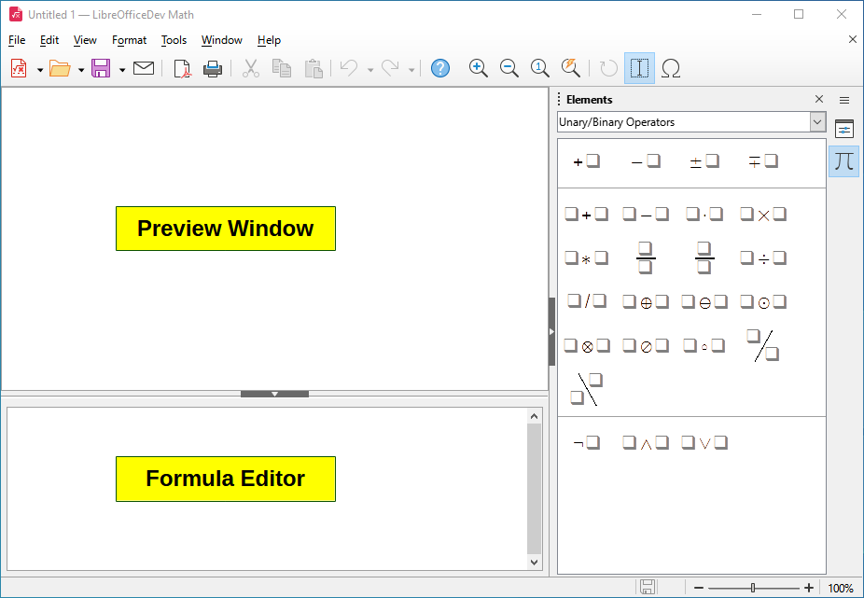
Figure 1: An empty formula document in Math
As the markup language in the Formula Editor is entered, the formula will appear in the Preview window during and after input of the markup language. The Elements panel on the sidebar to the right of the Preview window may also appear, if it has been selected in View on the Menu bar, as shown in Figure 4.
For more information on creating formulas, see “Creating formulas” on page 13.
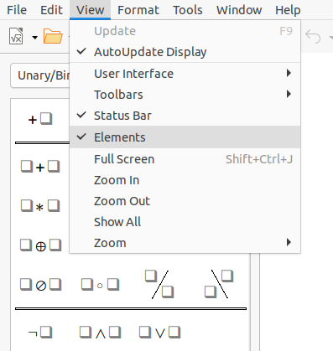
Figure 2: Enabling the Elements panel

Formulas in LibreOffice documents
To insert a formula into a LibreOffice document, open the document in Writer, Calc, Draw, or Impress. The LibreOffice component you are using affects how you position the cursor to insert the formula.
- In Writer, click in the paragraph where you want to insert the formula.
- In Calc, click in the spreadsheet cell where you want to insert the formula.
- In Draw and Impress, the formula is inserted into the center of the drawing or slide.
Then, go to Insert > Object > Formula Object on the Menu bar to open the Formula Editor. Alternatively, go to Insert > Object > OLE Object on the Menu bar to open the Insert OLE Object dialog, then select Create new, choose the Object Type “LibreOffice 7.3 Formula” and then click OK to open the Formula Editor.
The Elements panel to the right of the Preview window , if Elements has been selected in View on the Menu bar. For more information on creating formulas, see “Creating formulas” on page 13.
Figure 3 shows an example Writer document with the formula box selected ready for a formula to be entered or edited.
When you have completed entering the markup language for the formula, close the Formula Editor by pressing the Esc key or by clicking an area outside the formula in the document. Double-click on the formula object in the document to open the Formula Editor again so that you can edit the formula.
Formulas are inserted as OLE objects into documents. You can change how the object is placed within the document, as with any OLE object. For more information on OLE objects, see Chapter 2, Formulas in Writer, Chapter 3, Formulas in Calc, Draw, and Impress, and the user guides for Writer, Calc, Draw, and Impress.
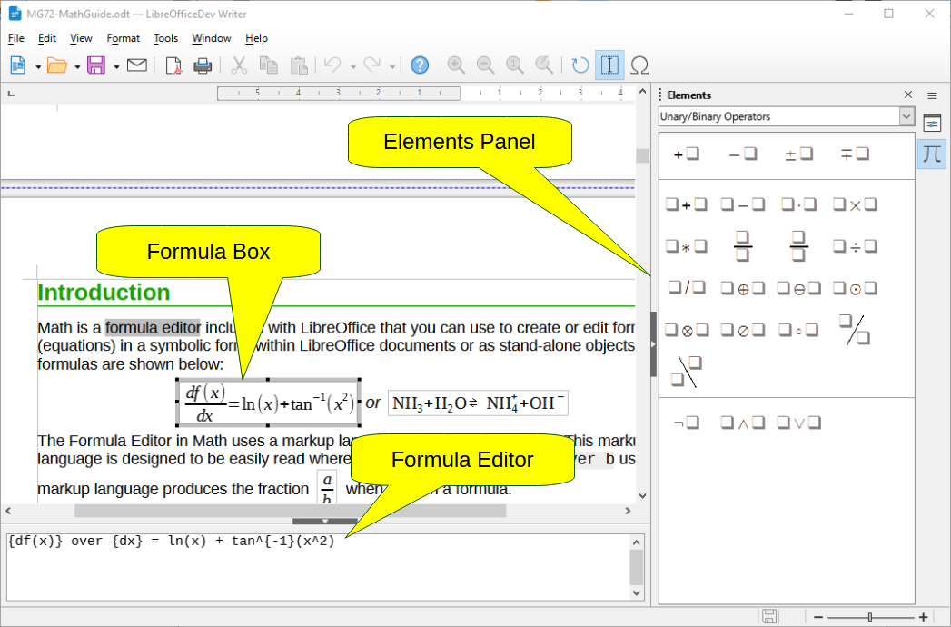
Figure 3: Formula in a Writer document
If you frequently insert formulas into documents, it is recommended to add the Formula button to the Standard toolbar or create a keyboard shortcut. See “Adding keyboard shortcuts” on page 48 for more information.

Creating formulas
You can create a formula using one of the following methods:
- In the Elements panel, select a category from the drop-down list, then a symbol.
- Right-click in the Formula Editor and select a category, then select a symbol in the context menu.
- Enter markup language directly in the Formula Editor.
- Note
Using the Elements panel or the context menus to create a formula provides a convenient way to learn the markup language used by LibreOffice Math.
- Tip
When using the Elements panel, it is recommended to have Extended Tips selected in the LibreOffice Options. This will help you identify the categories and symbols you can use in the formula. Go to Tools > Options > LibreOffice > General on the Menu bar and select Extended Tips in the Help section.

Elements Panel
The Elements panel (Figure 4) is a visual tool to help you create and edit formulas. It organizes mathematical symbols and operators using Categories in a drop-down list. The steps below describe how to enable the Elements panel and navigate its categories and symbols.
- Go to View > Elements on the Menu bar to open the Elements panel.
- Select the category you want to use in your formula from the drop-down list at the top of the Elements panel.
- Select the symbol you want to use in your formula in the Elements panel. The symbols that are available change according to the selected category.
- After choosing one of the symbols in the Elements panel, the Formula Editor will be updated with the Markup notation of the selected symbol.
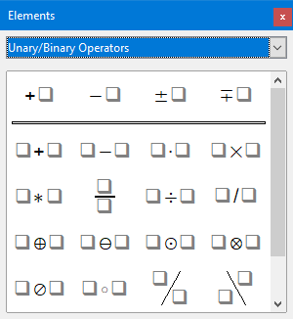
Figure 4: Elements panel as a floating dialog
- Note
The Elements panel can either be a floating dialog, as shown in Figure 4, or positioned to the left of the Formula Editor, as shown in Figure 1 and Figure 3.
- Tip
The Elements panel includes an Examples category which provides example formulas to use as a starting point for your formula or equation.

Context menu
The Formula Editor also provides a context menu to access categories and symbols when creating a formula. Right-click in the Formula Editor to open the context menu. Select a category and then select the markup example that you want to use in the sub-context menu. An example is shown in Figure 5.
- Note
The Elements panel and the context menu contain only the most common commands that are used in formulas. To insert other symbols and commands not listed in the Elements panel and context menu, you have to enter them manually using the markup language. For a complete list of commands and symbols available in Math, see Appendix A, Commands Reference.
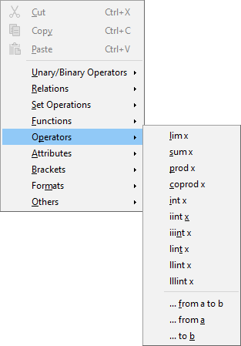
Figure 5: Context menu in Formula Editor

Markup language
Markup language is entered directly into the Formula Editor. For example, typing 5 times 4 into the Formula Editor creates the simple formula . If you are experienced in using markup language, it can be the quickest way to enter a formula. Table 2 shows some examples of using markup language to enter commands. For a full list of commands that can be used in the Formula Editor, see Appendix A, Commands Reference.
Table 2: Example commands using markup language
Display | Command | Display | Command
 | a = b |  | sqrt {a}
 | a^2 |  | a_n
 | int f(x) dx |  | sum a_n
 | a <= b |  | infinity
 | a times b |  | x cdot y

Greek characters

Using markup language
Greek characters are commonly used in formulas, but they cannot be entered into a formula using the Elements panel or the context menu. Use the English names of Greek characters in markup language when entering Greek characters into a formula. See Appendix A, Commands Reference for a list of characters that can be entered using markup language.
- For a lowercase Greek character, type a percentage % sign, then type the character name in lowercase using the English name. For example, typing %lambda creates the Greek character .
- For an UPPERCASE Greek character, type a percentage % sign, then type the character name in UPPERCASE using the English name. For example, typing %LAMBDA creates the Greek character .
- For an italic Greek character, type a percentage % sign followed by the i character, then the English name of the Greek character in lower or UPPER case. For example, typing %iTHETA creates the italic Greek character .

Symbols dialog
Greek characters can also be entered into a formula using the Symbols dialog.
- Make sure your cursor is in the correct position in the Formula Editor.
- Go to Tools > Symbols on the Menu bar, or click the Symbols icon in the Tools toolbar, to open the Symbols dialog (Figure 6)
- Select Greek in the Symbol set drop-down list. For italic characters, select iGreek in the drop-down list.
- Double-click the Greek character you want to insert, or select it and click Insert. When selected, the name of the character is shown below the symbol list.
- Click Close when you have finished entering Greek characters into your formula.
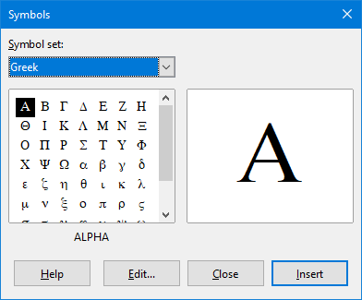
Figure 6: Symbols dialog

Formula examples

Example 1
The simple formula can be created using LibreOffice Math as follows:
- Make sure your cursor is flashing in the Formula Editor, then select the category Unary/Binary Operators and symbol Multiplication using one of the following methods:
- In the Elements panel, select Unary/Binary Operators from the drop-down list and then select the Multiplication icon .
- Right-click in the Formula Editor and select Unary/Binary Operators > a times b from the context menu.
- Using markup language, type 5 times 4 in the Formula Editor.
The first two methods place the formula text <?> times <?> in the Formula Editor and the symbol appears in the document. For the third method, using markup language in the Formula Editor places the formuladirectly into the document and there is no need to carry out the following steps.
- Select the first placeholder <?> before the word times in the Formula Editor and replace it with the character 5. The formula in your document updates automatically.
- Select the second placeholder <?> after the word times in the Formula Editor and replace it with the character 4. The formula in your document updates automatically.
- Tip
To move forward from one placeholder to the next placeholder in a formula, press the F4 key. To move backward from one placeholder to the previous placeholder in a formula, use the key combination Shift+F4.
- Note
If necessary, you can prevent a formula in a document from updating automatically. Go to View on the Menu bar and deselect AutoUpdate Display. To then manually update a formula, press the F9 key or select View > Update on the Menu bar.

Example 2
You want to enter the formula , where the value of pi is rounded to 5 decimal places. You know the name of the Greek character (pi), but do not know the markup associated with the Is Similar Or Equal symbol.
- Make sure your cursor is flashing in the Formula Editor.
- Enter %pi in the Formula Editor to enter the Greek character for pi (π).
- Select the category Relations and symbol Is Similar Or Equal using one of the following methods:
- In the Elements panel, select Relations in the drop-down list and then select the Is Similar Or Equal icon .
- Right-click in the Formula Editor and select Relations > a simeq b in the context menu.
- Delete the first placeholder <?> before the word simeq in the Formula Editor.
- Select the second placeholder <?> after the word simeq in the Formula Editor and replace it with the characters 3.14159. The formulanow appears in your document.

Editing formulas
How you edit a formula and switch into formula editing mode depends on whether the formula is in Math or another LibreOffice component.
- In Math, double-click on a formula element in the formula that appears in the Preview window to select the formula element in the Formula Editor, or directly select a formula element in the Formula Editor.
In Writer, Calc, Impress, or Draw, double-click on the formula, or right-click on the formula and select Edit in the context menu, to open the Formula Editor and enter editing mode. The cursor is positioned at the start of the formula in the Formula Editor.
- Note
If you cannot select a formula element using the cursor, click on the Formula Cursor icon in the Tools toolbar to activate the formula cursor.
- Select the formula element you want to change using one of the following methods:
- Click on the formula element in the Preview window, positioning the cursor at the beginning of the formula element in the Formula Editor, then select the formula element in the Formula Editor.
- Double-click on the formula element in the Preview window to select the formula element in the Formula Editor.
- Position the cursor in the Formula Editor at the formula element you want to edit, then select that formula element.
- Double-click directly on the formula element in the Formula Editor to select it.
- Make your changes to the formula element you have selected.
- Go to View > Update on the Menu bar, or press the F9 key, or click on the Update icon on the Tools toolbar to update the formula in the Preview window or your document.
- In Math, save your changes to the formula after editing.
In Writer, Calc, Impress, or Draw, click anywhere in the document away from the formula to leave editing mode, then save the document to save your changes to the formula.

Formula layout
This section provides some advice on how to lay out complex formulas in Math or in your LibreOffice document.

Using braces
LibreOffice Math knows nothing about order of operation within a formula. You need to use braces (curly brackets) to define the order of operations. The following examples show how braces can be used in a formula.
Example 1
2 over x + 1 gives the result
Math has recognized that the 2 before and the x after the over command as belonging to the fraction, and has represented them accordingly. If you want rather than to be the denominator, you must bracket them together using braces so that both will be placed there.
Inserting braces into 2 over {x + 1} gives the resultwhere is now the denominator.
Example 2
– 1 over 2 gives the result
Math has recognized the minus sign as a prefix for the 1 and has therefore placed it in the numerator of the fraction. If you wish to show that the whole fraction is negative, with the minus sign in front of the fraction, you must put the fraction in braces to signify to Math that the characters belong together.
Adding braces into the markup language – {1 over 2} gives the resultand the whole fraction is now negative.
Example 3
When braces are used in markup language, they define the layout of the formula and are not displayed or printed. If you want to use braces within a formula, use the commands lbrace and rbrace within the markup language.
x over {–x + 1} gives the result
Replace the braces using the commands lbrace and rbrace in the markup language. Write x over lbrace –x + 1 rbrace and the result is

Brackets (parentheses) and matrices
If you want to use a matrix in a formula, you have to use the matrix command. Below is a simple example of a 2 x 2 matrix.
matrix { a # b ## c # d }
In matrices, rows are separated by two hashes (##) and entries within each row are separated by one hash (#).
Normally, when you use brackets within a matrix, the brackets do not scale as the matrix increases in size. The example below shows an a formula where the parentheses do not scale to the size of the resulting matrix.
( matrix { a # b ## c # d } )
To overcome this problem, Math provides scalable brackets that grow in size to match the size of the matrix. The commands left( and right) have to be used to create scalable brackets around a matrix. The following example shows how to create a matrix with scalable parentheses.
left( matrix { a # b ## c # d } right)
Scalable brackets can also be used with any element of a formula, such as fraction, square root, and so on.
To create a matrix where some values are empty, you can use the grave accent (`) so that Math will put a small space in that position, as shown in the example below:
left( matrix { 1 # 2 # 3 ## 4 # ` # 6 } right)
- Tip
Use the commands left[ and right] to obtain square brackets. A list of all brackets available within Math can be found in Appendix A, Commands Reference.
- Tip
If you want all brackets to be scalable, go to Format > Spacing on the Menu bar to open the Spacing dialog. Click on Category, select Brackets from the drop-down list. and then select the option Scale all brackets.

Unpaired brackets
When using brackets in a formula, Math expects that for every opening bracket there will be a closing one. If you forget to add a closing bracket, Math places an inverted question mark next to where the closing bracket should have been placed. For example, lbrace a; b will result in because the right bracket rbrace is missing.
This inverted question mark disappears when all the brackets are paired. The previous example could be fixed to lbrace a; b rbrace, resulting in . However, there are cases where an unpaired bracket is necessary and for that you have the following options.

Non scalable brackets
A backslash \ is placed before a non scalable bracket to indicate that the subsequent character should not be regarded as a bracket, but rather as a literal character.
For example, the unpaired brackets in the formula [ a; b [ would result in an inverted question mark because Math expects that [ will be closed by ]. To fix the error, use the backslash and insert \ [ a; b \ [ into the Formula Editor to obtain as the result.

Scalable brackets
To create unpaired scalable brackets or braces in a formula, the markup commands left, right, and none can be used.
Example
The following formula uses the stack command to create a two-line formula and adds a bracket only to the right side of the stack.
abs x = left lbrace stack {x "for" x >= 0 # -x "for" x < 0} right none
This effect can be achieved by using the left lbrace command combined with the right none command. The first command indicates that the left bracket is a lbrace whereas the second command tells Math that the right bracket will be none, meaning that no bracket will be added to the right side of the formula.

Recognizing functions
In the basic installation of Math, Math outputs functions in normal characters and variables in italic characters. However, if Math fails to recognize a function, you can tell Math that you have just entered a function. Entering the markup command func before a function forces Math to recognize the following text as a function.
For a full list of functions within Math, see Appendix A, Commands Reference.
Some Math functions have to be followed by a number or a variable. If these are missing, Math places an inverted question mark where the missing number or variable should be. To remove the inverted question mark and correct the formula, you have to enter a number, a variable, or a pair of empty brackets as a placeholder.
- Tip
You can navigate through errors in a formula using the key F3 to move to the next error or the key combination Shift+F3 to move to the previous error.

Formulas over multiple lines
Suppose you want to create a formula that requires more than one line, for example. Your first reaction would be to press the Enter key. However, if you do that, the markup language in the Formula Editor goes to a new line, but the resulting formula does not have two lines. To add a new line to the formula you need to use the markup command newline.
Example
The examples below illustrate how the markup command newline can be used to add a new line to a formula. The first one simply adds an Enter to break the line in the markup language, which does not result in adding a new line. The second example uses the newline command, yielding a two-line formula.
Markup Language | Resulting Formula
x = 3
y = 1
x = 3 newline y = 1
It is not possible in Math to create multiple line formulas when a line ends with an equals sign and you want to continue the formula on a new line without completing the term on the right side of the equals sign. If you require a multiple line formula to have an equals sign at the end of a line without a term after the equals sign, then use empty quotes “” or empty braces {} or the space characters grave ` or tilde ˜.
By default, the alignment of a multiple line formula is center aligned. For more information on alignment using the equals sign, see “Aligning formulas using equals sign” on page 24.

Spacing within formulas
Spacing between the element in a formula is not set by using space characters in the markup language. To add spaces into a formula, use one of the following options:
- Grave ` to add a small space.
- Tilde ~ for a large space.
- Add space characters between quotes “ ”. These spaces will be considered as text.
Any spaces at the end of a line in the markup language are ignored by default. For more information, see “Formula spacing” on page 54.

Adding limits to summations and integrals
The sum and int commands, used for summations and integrals respectively, can take the parameters from and to if you want to set the lower and upper limits. The parameters from and to can be used singly or together as shown by the following examples. For more information on the sum and integral commands, see “Operators” on page 63.
Examples
Here are some examples of how to add upper and lower bounds to summations and integrals. Note that you can use brackets to explicitly define which parts of the formula correspond to the desired bounds.
Markup Language | Resulting Formula
sum from k = 1 to n a_k
sum to infinity 2^{-n}
sum from{ i=1 } to{ n } sum from{ j=1; i <> j } to{ m } x_ij
int from 0 to x f(t) dt
int_0^x f(t) dt
int from Re f

Writing derivatives
When writing derivatives, you have to tell Math that it is a fraction by using the over command. The over command is combined with the character d for a total derivative or the partial command for a partial derivative to achieve the effect of a derivative. Braces {} are used in each side of the elements to surround them and make the derivative as shown by the following examples.
Examples
Below are a few examples of how you can use Math to write derivatives:
Markup Language | Resulting Formula
{df} over {dx}
{partial f} over {partial y}
{partial^2 f} over {partial t^2}
- Note
To write function names with primes, as is normal in school notation, you must first add the symbols to the catalog. See “Catalog customization” on page 51 for more information.

Markup language characters as normal characters
Characters that are used as controls in markup language cannot be entered directly as normal characters. These characters are: %, {, }, &, |, _, ^ and ". For example, you cannot write 2% = 0.02 in markup language and expect the same characters to appear in your formula. To overcome this limitation in markup language, use one of the following methods:
- Use double quotes to mark that character as text, for example 2"%"= 0.02 will appear in your formula as. However, this method cannot be used for the double-quote character itself, see “Text in formulas” below.
- Add the character to the Math Catalog, for example the double quote character.
- Use commands, for example lbrace and rbrace give you literal braces .
- Note
The Special Characters dialog used by other LibreOffice components is not available in Math. If you regularly require special characters in Math, then it is recommended to add the characters to the Math Catalog. See “Catalog customization” on page 51 for more information.

Text in formulas
To include text in a formula, you have to enclose any text in double-quotes, for example x " for " x >= 0 in markup language will create the formula . All characters, except double quotes, can be used in text.
However, if you require double quotes in formula text, then you have to create your text with double quotes in LibreOffice Writer, then copy and paste the text into the Formula Editor as shown in Figure 7.

Figure 7: Example of double quotes in formula text
The font used for text in a formula will be the default font that has been set in the Fonts dialog. For more information on how to change fonts used in formulas, see “Changing formula appearance” on page 24.
By default, text alignment is left-justified in formulas. For more information on how to change text alignment, see “Adjusting formula alignment” on page 31.

Formatting text in formulas
Formatting commands are not interpreted within text used in formulas. If you want to use formatting commands within formula text, then you must break up the text using double quotes in the Formula Editor.
Example
Enter the following in the Formula Editor:
"In " color blue bold "isosceles" "triangles, the base angles are equal"
This markup creates the following text in a formula:
This example shows how to use the markup commands color and bold to format the word “isosceles”. Note that the commands are applied to the immediately subsequent text within double quotes. Hence, the formatting commands do not apply to the remainder of the text in the example because it is in a separate quote block.
The command color needs to be followed by the name of the desired color or to its RGB or hexadecimal value. Refer to “Attributes” on page 65 for a list of predefined color names.

Aligning formulas using equals sign
LibreOffice Math does not have a command for aligning formulas on a particular character. However, you can use a matrix to align formulas on a character and this character is normally the equals sign (=). In addition, you can use the markup commands alignr, alignl and alignc to set the alignment of each value inside the matrix to the right, left or center, respectively.
Example
The example below uses a matrix to align formulas on the equals sign. Notice how the alignment commands align the contents of each position in the matrix.
matrix{ alignr x+y # {}={} # alignl 2 ## alignr x # {}={} # alignl 2-y }
- Note
The empty braces each side of the equals sign are necessary because the equals sign is a binary operator and requires an expression on each side. You can use spaces, or ` or ~ characters each side of the equals sign, but braces are recommended as they are easier to see within the markup language.
You can reduce the spacing on each side of the equals sign if you change the inter-column spacing of the matrix. See “Adjusting formula spacing” on page 28 for more information.

Changing formula appearance
This section describes how to change the font or font size in a selected formula and how to change the default font or font size.
- Note
If you have already inserted formulas into your document and you change the default font or font size, only formulas inserted after the change in default font or font size will use the new default settings. You have to individually change the font or font size of formulas already inserted if you want these formulas to use the same font or font size as the default settings.
- Tip
The extension “Formatting of all Math formulas” allows you to change font name and font size for all or only for selected formulas in a document. You can download it and read the installation and usage instructions here: https://extensions.libreoffice.org/en/extensions/show/formatting-of-all-math-formulas

Formula font size

Current formula font size
To change the font size used for a formula already inserted in Math or another LibreOffice component:
- Click in the markup language in the Formula Editor.
- Go to Format > Font size on the Menu bar to open the Font Sizes dialog (Figure 8).
- Select a different font size using the Base size spinner or type a new font size in the Base Size box.
- Click OK to save your changes and close the dialog. An example result when you change font size is shown below.
Example
Default font size 12pt:
After font size change to 18pt:
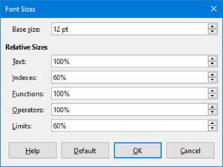
Figure 8: Font Sizes dialog

Default formula font size
To change the default font size used for all formulas in Math or another LibreOffice component:
- Before inserting any formulas in your document, go to Format > Font size on the Menu bar to open the Font Sizes dialog (Figure 8).
- Select a different font size using the Base size spinner or type a new font size in the Base Size box.
- Click Default and confirm your changes to the base size font. Any formulas created from this point on will use the new base size font for formulas.
- Click OK to save your changes and close the Font Sizes dialog.

Font size options
The Font Sizes dialog (Figure 8) specifies the font sizes for a formula. Select a base size and all elements of the formula will be scaled in relation to this base.
- Base size – all elements of a formula are proportionally scaled to the base size. To change the base size, select or type in the desired point (pt) size. You can also use other units of measure or other metrics, which are then automatically converted to points.
- Relative Sizes – in this section, you can determine the relative sizes for each type of element with reference to the base size.
- Text – select the size for text in a formula relative to the base size.
- Indexes – select the relative size for the indexes in a formula in proportion to the base size.
- Functions – select the relative size for names and other function elements in a formula in proportion to the base size.
- Operators – select the relative size of the mathematical operators in a formula in proportion to the base size.
- Limits – select the relative size for the limits in a formula in proportion to the base size. This is used to determine the size for commands as from and to used in summations and integrals.
- Default – click this button to save any changes as a default for all new formulas. A confirmation message appears before saving any changes.

Formula fonts

Current formula fonts
To change the fonts used for the current formula in Math or another LibreOffice component:
- Click in the markup language in the Formula Editor.
- Go to Format > Fonts on the Menu bar to open the Fonts dialog (Figure 9).
- Select a new font for each of the various options from the drop-down lists.
- If the font you want to use does not appear in the drop-down list, click Modify and select the option from the context menu to open a fonts dialog. Select the font you want to use and click OK to add it to the drop-down list for that option.
- Click OK to save your changes and close the Fonts dialog.

Default formula fonts
To change the default fonts used for all formulas in Math or another LibreOffice component:
- Before inserting any formulas in your document, go to Format > Fonts on the Menu bar to open the Fonts dialog (Figure 9).
- Select a new font for each the various options from the drop-down lists.
- If the font you want to use does not appear in the drop-down list, click Modify and select the option from the context menu to open a fonts dialog. Select the font you want to use and click OK to add it to the drop-down list for that option.
- Click Default and confirm your changes to the fonts. Any formulas created from this point on will use the new font for formulas.
- Click OK to save your changes and close the Fonts dialog.
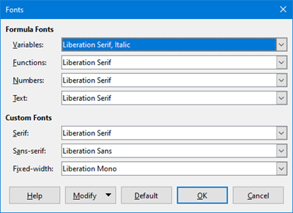
Figure 9: Fonts dialog

Formula font options
Defines the fonts that can be applied to formula elements.
- Formula Fonts – defines the fonts used for the variables, functions, numbers and inserted text that form the elements of a formula.
- Variables – selects the fonts for the variables in your formula. For example, in the formula x=SIN(y), x and y are variables and will reflect the assigned font.
- Functions – selects the fonts for names and properties of functions. For example, the functions in the formula x=SIN(y) are =SIN( ).
- Numbers – selects the fonts for the numbers in a formula.
- Text – defines the fonts for the text in a formula.
- Custom Fonts – this section of the Fonts dialog (Figure 9) defines fonts to format text components in a formula. The three basic fonts Serif, Sans-serif and Fixed-width are available. Other fonts can be added to each standard installed basic font using the Modify button. Every font installed on a computer system is available for use.
- Serif – specifies the font to be used for the font serif format. Serifs are the small "guides" that can be seen, for example, at the bottom of a capital A when the Times serif font is used. Using serifs is quite helpful since it guides the eye of a reader in a straight line and can speed up reading.
- Sans – specifies the font to be used for sans font formatting.
- Fixed – specifies the font to be used for fixed font formatting.
- Modify – click one of the options from the context menu to access the Fonts dialog, where the font and attributes can be defined for the respective formula and for custom fonts.
- Default – click this button to save any changes as a default for all new formulas. A confirmation message appears before saving any changes.
- Note
When a new font is selected for a formula, the old font remains in the list alongside the new one and can be selected again.
- Note
Variables should be written in italics, so make sure that the Italic option is selected. For the font you want to use. For all other elements, use the basic form of a font. The style can be easily altered in the formula itself by using the commands italic or bold to set these characteristics and nitalic or nbold to unset them.

Adjusting formula spacing
Use the Spacing dialog (Figure 10) to determine the spacing between formula elements. The spacing is specified as a percentage in relation to the defined base size for font sizes.
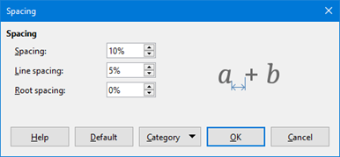
Figure 10: Spacing dialog

Current formula spacing
To change the spacing used for the current formula in Math or another LibreOffice component:
- Click in the markup language in the Formula Editor.
- Go to Format > Spacing on the Menu bar to open the Spacing dialog (Figure 10).
- Click Category and select one of the options from the drop-down list. The options in the Spacing dialog change according to the category selected.
- Enter new values for the spacing category and click OK.
- Check the result in your formula. If not to your satisfaction, repeat the above steps.

Default formula spacing
To change the default spacing used for all formulas in Math or another LibreOffice component:
- Before inserting any formulas in your document, go to Format > Spacing on the Menu bar to open the Spacing dialog (Figure 10).
- Click Category and select one of the options from the drop-down list. The options in the Spacing dialog change according to the category selected.
- Click Default and confirm your changes to the formula spacing. Any formulas created from this point on will use the new spacing for formulas.
- Click OK to save your changes and close the Spacing dialog.
- Note
If you have already inserted formulas into your document and you change the spacing, only formulas inserted after the change in spacing will use the new default settings. You have to individually change the spacing of formulas already inserted if you want these formulas to use the same spacing as the default settings.

Spacing options
Use Category in the Spacing dialog (Figure 10) to determine the formula element for which you would like to specify the spacing. The appearance of the dialog depends on the selected category. A preview window shows you which spacing is modified through the respective boxes.
- Category – click this button to select the category for which you want to change the spacing.
- Spacing – defines the spacing between variables and operators, between lines, and between root signs and radicals.
- Spacing – determines the spacing between variables and operators
- Line Spacing – determines the spacing between lines.
- Root Spacing – determines the spacing between the root sign and radicals.
- Indexes – defines the spacing for superscript and subscript indexes.
- Superscript – determines the spacing for superscript indexes.
- Subscript – determines the spacing for subscript indexes.
- Fractions – defines the spacing between the fraction bar and the numerator or denominator.
- Numerator – determines the spacing between the fraction bar and the numerator.
- Denominator – determines the spacing between the fraction bar and the denominator.
- Fraction Bars – defines the excess length and line weight of the fraction bar.
- Excess length – determines the excess length of the fraction line.
- Weight – determines the weight of the fraction line.
- Limits – defines the spacing between the sum symbol and the limit conditions.
- Upper limit – determines the spacing between the sum symbol and the upper limit.
- Lower limit – determines the spacing between the sum symbol and the lower limit.
- Brackets – defines the spacing between brackets and the content.
- Excess size (left/right) – determines the vertical distance between the upper edge of the contents and the upper end of the brackets.
- Spacing – determines the horizontal distance between the contents and the upper end of the brackets.
- Scale all brackets – scales all types of brackets. If you then enter ( a over b) in the Formula Editor, the brackets will surround the whole height of the argument. You normally achieve this effect by entering left ( a over b right ).
- Excess size – adjusts the percentage excess size. At 0% the brackets are set so that they surround the argument at the same height. The higher the entered value is, the larger the vertical gap between the contents of the brackets and the external border of the brackets. The field can only be used in combination with Scale all brackets.
- Matrices – defines the relative spacing for the elements in a matrix.
- Line spacing – determines the spacing between matrix elements in a row.
- Column spacing – determines the spacing between matrix elements in a column.
- Symbols – defines the spacing of symbols in relation to variables
- Primary height – defines the height of the symbols in relation to the baseline.
- Minimum spacing – determines the minimum distance between a symbol and variable.
- Operators – defines the spacing between operators and variables or numbers.
- Excess size – determines the height from the variable to the operator upper edge.
- Spacing – determines the horizontal distance between operators and variables.
- Borders – adds a border to a formula. This option is particularly useful if you want to integrate the formula into a text file in LibreOffice Writer by combining mathematical formulas and text inside the same paragraph.
- Left – the left border is positioned between the formula and background.
- Right – the right border is positioned between the formula and background.
- Top – the top border is positioned between the formula and background.
- Bottom – the bottom border is positioned between the formula and background.
- Preview Field – displays a preview of the current selection.
- Default – saves any changes as default settings for all new formulas. A security response will appear before saving these changes.
- Note
If you are adding Math formulas into a LibreOffice Writer document, you may notice spacing between the formula and the surrounding text even if you set all formula borders to zero. This is because Math formulas are OLE objects embedded into a frame that, by default, adds 0.2 cm to the left and right of the Math object.
You can remove that extra spacing in two ways. The first way is to edit the object properties by right-clicking the Math object and then going to Properties > Wrap and adjust the Spacing fields to the desired values. The second way is to modify the spacing options of the default Formula frame style or create a new style. To learn more on how to change the spacing of Math objects, refer to “Object spacing” on page 39. For more information on how to edit styles in general, refer to the Styles chapters in the Writer Guide.
Example
In the following example, Math objects are combined with text by removing all spacing both from the formula and the frame style surrounding it. Because spacing is set to zero, the spacing between text and formulas is achieved by simply adding a space character using the keyboard space bar.
“Let be a cost matrix and be a decision variable defined for origins and for destinations”.

Adjusting formula alignment
The alignment settings determine how formula elements located above one another are aligned horizontally relative to each other.
- Note
It is not possible to align formulas on a particular character and formula alignment does not apply to text elements. Text elements are always aligned to the left.

Current formula alignment
To change the alignment used for the current formula in Math or another LibreOffice component:
- Click in the markup language in the Formula Editor.
- Go to Format > Alignment on the Menu bar to open the Alignment dialog (Figure 11).
- Select either Left, Centered, or Right for horizontal alignment.
- Click OK and check the result in your formula. If not to your satisfaction, repeat the above steps.
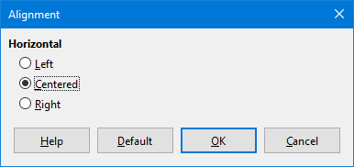
Figure 11: Alignment dialog
- Note
Regardless of the alignment option selected in the Alignment dialog, it is possible to align sections of a formula using the commands alignl, alignc and alignr. For example, they can be useful to align formulas in matrices. These commands also work for text elements.

Default formula alignment
To change the default alignment used for all formulas in Math or another LibreOffice component:
- Before inserting any formulas in your document, go to Format > Alignment on the Menu bar to open the Alignment dialog (Figure 11).
- Select either Left, Centered, or Right for horizontal alignment.
- Click Default and confirm your changes to the formula alignment. Any formulas created from this point on will use the new alignment for formulas.
- Click OK and check the result in your formula. If not to your satisfaction, repeat the above steps.
- Note
If you have already inserted formulas into a document and you change the formula alignment, only formulas inserted after the change in alignment will use the new default settings. You have to individually change the alignment of formulas already inserted if you want them to use the same alignment as the default settings.

Changing formula color
You can change the color of characters used in a formula using markup language: the command color followed by a color name, RGB value, or HTML hex value.
The color command only works on the formula element immediately after the color name, RGB value, or hex value. For example, entering the markup language color red 5 times 4 gives the result . Only the number 5 is colored red.
To change the color of the whole formula, you have to enclose the whole formula within brackets. For example, entering the markup language color red {5 times 4} gives the result.

Named colors
For information on the named colors available in Math, see “Attributes” on page 65. These colors are listed in the Attributes section of the Elements panel (Figure 4 on page 14).

RGB values
To use custom colors defined by RGB (Red, Green and Blue) values ranging from 0 to 255, use the color rgb R G B markup command, where R, G, and B correspond to the Red, Green, and Blue values of the desired color.
Example
In this example, the term “decision variable” uses the color defined by the RGB values 160, 82, 45.
"Let " x_ij " be a " color rgb 160 82 45 "decision variable " "in the problem under consideration"
Math will create the following output:

Hex values
Math now supports HTML colors, defined by a hex number. Use the color hex 000000 markup command, where 00000 is the corresponding hex number. For example, the command color hex FF0000 decision creates the output .

Background color
It is not possible to select a background color for formulas in LibreOffice Math. The background color for a formula is by default the same color as the document or frame that the formula has been inserted into. In LibreOffice Writer, you can use object properties to change the background color for a formula. For more information, see “Background and borders” on page 40.

Formula library
If you regularly insert the same formulas into your documents, you can create a formula library using formulas that you have created using the Formula Editor. Individual formulas can be saved as separate files using the ODF format for formulas (file type .odf), or in MathML format (file type .mml).
You can use either LibreOffice Math, Writer, Calc, Draw, or Impress to create formulas and build up your formula library.

Using Math
- Create a folder on your computer to contain your formulas and give the folder a memorable name, for example Formula Library.
- In LibreOffice, go to File > New > Formula on the Menu bar, or click on Math Formula in the Start Center to open LibreOffice Math and create your formula using the Formula Editor. See “Formulas as separate documents or files” on page 11 for more information.
- Go to File > Save As on the main Menu bar or use the keyboard shortcut Ctrl+Shift+S to open a Save As dialog.
- Navigate to the folder you have created for your formula library.
- Type a memorable name for your formula in the File name box.
- Select in the File type drop-down list either ODF Formula (.odf) or MathML 2.0 (.mml) as the file type for the formula.
- Click Save to save the formula and close the Save As dialog.
- Note
MathML 2.0 stands for Mathematical Markup Language (MathML) Version 2.0. MathML is an XML format that describes mathematical notation and enables the use of mathematics in the World Wide Web. If you want to learn more about the MathML format, visit its official website at https://www.w3.org/TR/MathML2/overview.html

Using Writer, Calc, Draw, or Impress
- Create a folder on your computer to contain your formulas and give the folder a memorable name, for example Formula Library.
- Open a document using Writer, Calc, Draw, or Impress.
- Go to Insert > Object > Formula Object on the Menu bar to open the Formula Editor and create a formula. See “Formulas in LibreOffice documents” on page 12 for more information.
- Right-click on the formula object and select Save Copy as in the context menu to open a Save As dialog.
- Navigate to the folder you have created for your formula library.
- Type a memorable name for your formula in the File name box.
- Select in the File type drop-down list either ODF Formula (.odf) or MathML 2.0 (.mml) as the file type for the formula.
- Click Save to save the formula and close the Save As dialog.

Using your formula library
You cannot insert a formula from your library into a document by dragging and dropping using the mouse, nor by using Insert > File on the Menu bar. You must insert a formula from your library into a document as an OLE object.
- Open your document in Writer, Calc, Draw, or Impress.
- Go to Insert > Object > OLE Object on the Menu bar to open the Insert OLE Object dialog.
- Select the option Create from file.
- Click Search to open your file browser dialog.
- Navigate to the folder you have created for your formula library.
- Select the formula you want to insert and click Open, or double-click on the formula you want to insert.
- Click OK to insert your formula as an OLE object in the document and close the OLE Object dialog.
Math Guide 7.3

Chapter 2,
Formulas in Writer

Introduction
When a formula is inserted into a document, LibreOffice Writer inserts the formula into a frame and treats the formula as an OLE object. Double-clicking on an inserted formula will open the Formula Editor in LibreOffice Math, allowing you to edit the formula. For more information on creating and editing formulas, please refer to Chapter 1, Creating and Editing Formulas.
This chapter explains what options you can change for each individual formula within a Writer document. Please refer to the chapters on styles in the Writer Guide for information on how to change the default settings for frame styles for OLE objects.

Automatic formula numbering
Automatic numbering of formulas for cross-reference purposes can only be carried out in LibreOffice Writer. The easiest way to add numbered formulas in sequence is to use the AutoText entry fn (for ‘formula numbered’).

Numbering
- Start a new line in your document.
- Type fn and then press the F3 key. A two column table with no borders is inserted into your document with the left column containing a sample formula and the right column containing a reference number, as shown below.
(1)
- Delete the sample formula and insert your formula as an object in the left column.
- Alternatively, you can first insert your formula into the document, then carry out Steps 1 and 2 above replacing the sample formula with your formula.

Cross-referencing
- Click in your document where you want the cross-reference to appear.
- Go to Insert > Cross-reference on the Menu bar to open the Fields dialog (Figure 12).
- Click on the Cross-references tab, then select Text in the Type section.
- In the Selection section, select the formula number you want to refer to.
- In the Insert reference to section, select Reference and click Insert.
- When you have finished creating cross-references, click Close to close the Fields dialog.
- Tip
To insert the cross-reference number without parentheses, select Numbering instead of Reference in the Insert reference to section.
- Note
If you want to use square parentheses instead of round ones, or if you want the cross-reference number to be separated from the formula by tabs instead of using a table, then refer to the Writer Guide.
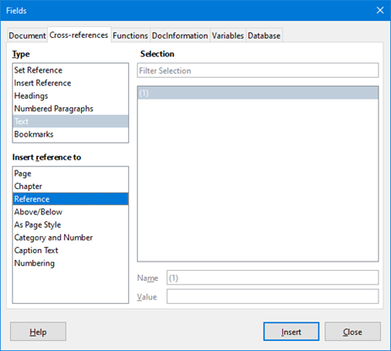
Figure 12: Fields Dialog – Cross-references tab

Anchoring formulas
A formula is treated as an object within Writer and its default anchoring is To character within a paragraph when it is inserted into a document. To change the anchoring of a formula object:
- Right-click on the selected formula object and select Anchor from the context menu.
- Select a new anchoring option from the context sub-menu. The anchoring positions available are To page, To paragraph, To character, or As character.
- Alternatively, right-click on the selected formula object and select Properties from the context menu, or go to Format > Frame and Object > Properties on the Menu bar to open the Object dialog (Figure 13).
- Make sure the Type tab is selected and select a new anchoring position from the Anchor section.
- Click OK to save your changes and close the Object dialog.
- Note
The anchoring options are not available in the Object dialog when you are making changes to the options available for frame styles. For more information on how to modify frame styles, please refer to the chapters on styles in the Writer Guide.
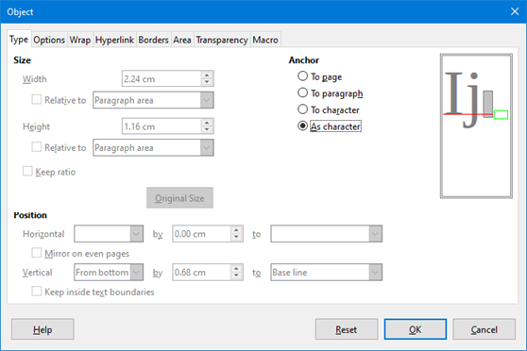
Figure 13: Object dialog – Type tab with Anchor options

Vertical alignment
The normal default setting for vertical alignment for formula objects is to use the text base line as a reference. This default setting can be changed by modifying the Formula frame style; see the chapters on styles in the Writer Guide for more information.
To change the vertical alignment position of an individual formula object (assuming that the As character anchoring option is selected):
- Right-click on the selected formula object and select Properties in the context menu, or go to Format > Frame and Object > Properties to open the Object dialog (Figure 13).
- Make sure the Type tab is selected and select a new alignment position in the drop-down list in the Position section. The vertical alignment options available are Top, Bottom, Center, or From bottom.
- If necessary, type in the text box a plus or minus value for vertical alignment. This option is only available if From bottom vertical alignment has been selected.
- Select the type of text alignment from the drop-down list in the Position section. The text alignment options available are Base line, Character, and Row.
- Click OK to save your changes and close the Object dialog.
- Note
If the Position section in the Object dialog is grayed out and not available, then go to Tools > Options > LibreOffice Writer > Formatting Aids and uncheck the option Math baseline alignment. This setting is stored with the document and applies to all formulas within it. Any new documents created will also use this setting for Math baseline alignment.

Object spacing
A formula object, when inserted into a Writer document, has spacing on each side of the object. The default value used for spacing is set within the frame style for formula objects and can be changed by modifying the Formula frame style. See the chapters on styles in the Writer Guide for more information.
To individually adjust the spacing for each formula object within your document:
- Create your formula in your Writer document.
- Right-click on your selected formula object and select Properties in the context menu, or go to Format > Frame and Object > Properties to open the Object dialog.
- Click on the Wrap tab to open the Wrap page in the Object dialog (Figure 14).
- In the Spacing section, enter the spacing value for Left, Right, Top, and Bottom spacing.
- Click OK to save your changes and close the Object dialog.
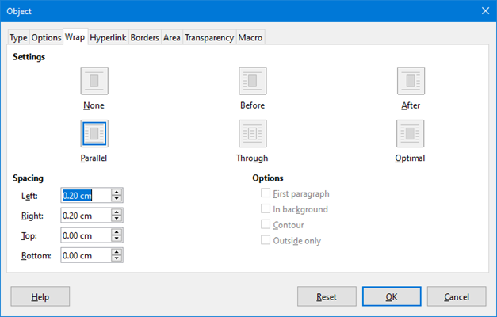
Figure 14: Object dialog – Wrap tab
- Note
Object wrapping options will be grayed out if the object is anchored As Character. To enable all wrapping options, you need to anchor the object To Page, To Paragraph, or To Character. To change the anchor settings, right-click the formula object and use the Anchor context menu to select the desired option.

Text mode
In large formulas placed within a line of text, the formula elements can often be higher than the text height. Therefore, to make large formulas easier to read, it is recommended to always insert large formulas into a separate paragraph of their own so that it is separated from text.
However, if it is necessary to place a large formula within a line of text, double-click on the formula to open the Formula Editor and then go to Format > Text Mode on the Menu bar. The Formula Editor will try to shrink the formula to fit the text height. The numerators and denominators of fractions are shrunk, and the limits of integrals and sums are placed beside the integral/sum sign, as shown in the following example.
Example
A formula in a separate paragraph:

and the same formula embedded into a line of text using text mode format:

Background and borders
The default setting for background (area fill) and borders for formula objects is set by the Formula frame style. To change the default setting for the Formula frame style, refer to the chapters on styles in the Writer Guide. However, for individual formulas in your document, you can change the background and borders.
- Note
The size of the frame that a formula is placed in when inserted into a document cannot be changed. The frame size for a formula object depends on the setting of the formula font size. See “Formula font size” on page 25 for more information.
Below is an example of a formula using background color and borders.

Note that the background color and border properties are part of the Math OLE object and hence cannot be defined using markup language.

Backgrounds
- In your document, select the formula where you want to change the background.
- Right-click on the formula and select Properties from the context menu, or go to Format > Frame and Object > Properties on the Menu bar to open the object dialog.
- Click on the Area tab and use the buttons at the top to select the type of fill you want to use for your formula (Figure 15).
- Select the options you want to use for your formula background. The options change depending on the type of fill selected.
- Click OK to save your changes and close the Object dialog.
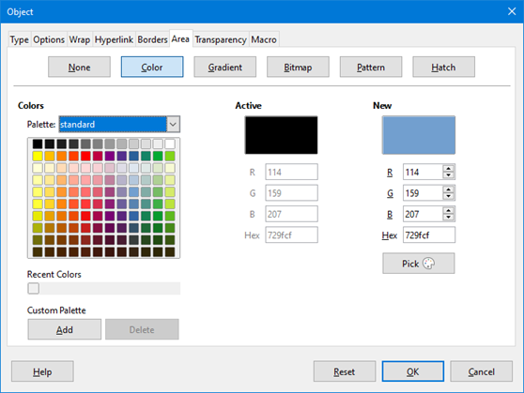
Figure 15: Object dialog – Area tab

Borders
- In your document, select the formula where you want to change the borders.
- Right-click on the formula and select Properties from the context menu, or go to Format > Frame and Object > Properties on the Menu bar to open the object dialog.
- Click on the Borders tab and select the options you want to use for your formula borders (Figure 16). Click OK to save your changes and close the Object dialog.
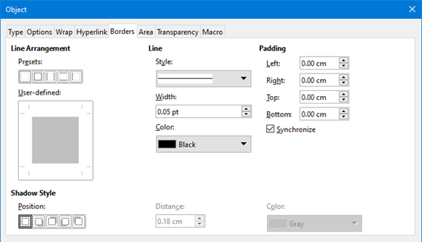
Figure 16: Object dialog – Borders tab

Quick insertion of formulas
If you know the markup language for your formula, you can quickly insert it into your Writer document without opening the Formula Editor:
- Enter the formula markup language into your document at the position where you want the formula to be placed.
- Select the markup language.
- Go to Insert > Object on the Menu bar and select Formula Object to create a formula from the selected markup language.
- Alternatively you can use the key combination Ctrl + Insert to open the Insert OLE Object dialog and then select Formula.

Math Guide 7.3

Chapter 3,
Formulas in Calc, Draw, and Impress

Introduction
In Calc, Draw, and Impress, formulas are inserted as OLE objects without any background (area fill) or borders. See Chapter 1, Creating and Editing Formulas for more information on inserting formulas into a LibreOffice component.
Each formula object is inserted into a spreadsheet, drawing, or slide as follows:
- In Calc, formulas are inserted into a selected cell in a spreadsheet with no style assigned to the formula object.
- In Draw and Impress, formulas are inserted into a central position on your drawing or slide and, by default, are assigned the drawing object style Object with no fill and no line. For more information on how to modify or assign drawing object styles, see the Draw Guide or the Impress Guide.

Anchoring formulas

Calc
A formula object can be anchored into a spreadsheet as To Page (default setting), or as To Cell. To change the anchoring type of formulas in a Calc spreadsheet:
- Select the formula object in the spreadsheet.
- Right-click on the formula and select Anchor > To Page or To Cell in the context menu.
- Alternatively, go to Format > Anchor on the Menu bar and select To Page or To Cell.
- Tip
If you insert a formula into a Calc spreadsheet and it appears out of scale, you can fix it by right-clicking the formula object and then selecting the Original Size option in the context menu.

Draw and Impress
When a formula is inserted into a drawing or slide, it is inserted as a floating OLE object and is not anchored to any particular position in the drawing or slide.

Formula object properties
Formula objects in Calc, Draw, and Impress can be modified just like any other object that has been placed in a spreadsheet, drawing, or presentation, with the exception of formula object size and changing the format of any text within a formula. For more information on how to change object properties, see the Calc Guide, Draw Guide and Impress Guide. For more information on formula object size and formatting formula text, see Chapter 1, Creating and Editing Formulas.
The following points will help you select which dialog to use if you want to change the properties of formula objects.
- For formula backgrounds, use the various options in the tabs of the Area dialog.
- For formula borders, use the various options in the Line dialog. Note that formula borders are separate from cell borders in a Calc spreadsheet.
- To accurately re-position a formula object, use the various options in tabs of the Position and Size dialog.
- In Draw and Impress, you can arrange, align, group, flip, convert, break, combine, and edit points of formula objects.
- You cannot change the text attributes of a formula object. The text used in a formula is set when you create the formula in the Formula Editor.
- Formula object size is set by the formula font size when the formula is created in the Formula Editor. The formula object size is protected in the Position and Size dialog, but this can be deselected if you wish. However, this is not recommended as resizing a formula object using the Position and Size dialog could lead to distortion of the formula making it difficult to read.

Formulas in charts
A chart in a Calc spreadsheet is itself an OLE object, therefore, you cannot use the Formula Editor to create and insert a formula directly into a chart. However, you can create both the Chart and Math objects separately and later copy and paste the Math formula into the Chart object:
- Create the chart using LibreOffice Calc. For a complete reference on how to create charts, see Chapter 3 in the Calc Guide.
- Click at any cell in your spreadsheet so that the Chart is no longer selected.
- Insert a Math Formula object by clicking Insert > Object > Formula.
- Type the desired formula into the Formula Editor.
- After editing the formula, select the Math Formula object and press Ctrl+C to copy the Formula object to the clipboard.
- Double-click the chart object to start editing the chart and press Ctrl+V to paste the Formula object into the chart.
- Now you can position the object anywhere you want inside the chart.
Figure 17 shows an example of a Calc chart with a Math Formula object inside it, which in this example is the function.
Figure 17: Calc chart with a Math object inside it
To change the formula, you must repeat the whole process of creating, copying, and pasting the Formula object into the chart.

Chemical formulas
The primary purpose of Math is to create mathematical formulas, but it can also be used to write chemical formulas. However, in chemical formulas, the chemical symbols are normally written in uppercase using non-italic characters. The following table shows some examples of chemical formulas.
Construction | Example | Markup Language
Molecules |  | H_2 SO_4
Isotopes |  | U lsub 92 lsup 238
Ions | or | SO_4^{2-{}} or SO_4^{2"-"}
To create chemical formulas using Math, change the font used for variables to a non-italic font. For more information on how to change fonts in a formula, see “Formula fonts” on page 26.
For reversible reactions in chemical formulas, there is no symbol for a double arrow in Math. If you have a font available with correct symbols for use in chemical formulas, then you can add these symbols to the Catalog. See “Catalog customization” on page 51 for more information on how to add symbols to the Catalog.
Math Guide 7.3

Chapter 4,
Customization

Introduction
This chapter explains how you can customize LibreOffice Math to suit the way you create formulas for use in LibreOffice documents. Also, refer to Chapter 14, Customizing LibreOffice, in the Getting Started Guide for more general information on how to customize LibreOffice.

Floating dialogs
The Formula Editor and Elements panel can cover a large part of your document. To help create more space and/or allow you to move either the Formula Editor or Elements panel out of the way, you can turn both of them into floating dialogs.
- Position the cursor on the frame.
- Hold down the Ctrl key and double-click. This turns the Formula Editor into the Commands dialog (Figure 18) and the Elements panel into the Elements dialog (Figure 19).
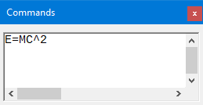
Figure 18: Commands dialog
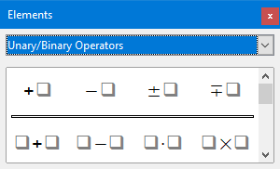
Figure 19: Elements panel
To return the Commands dialog and Elements dialog to their default positions:
- Position the cursor on the frame of the dialog, NOT the title bar at the top of the dialog.
- Hold down the Ctrl key and double-click.

Adding keyboard shortcuts
You can add keyboard shortcuts to LibreOffice to make creating documents much easier and to match your workflow. Below is an example of how to add a keyboard shortcut for inserting a Math formula into a LibreOffice document.
- Caution
When selecting new keyboard shortcuts, make sure that you do not select a shortcut that is already in use by LibreOffice or your computer system.

Example keyboard shortcut
- Go to Tools > Customize on the Menu bar to open the Customize dialog (Figure 20).
- Click on the Keyboard tab to access the options available for adding keyboard shortcuts.
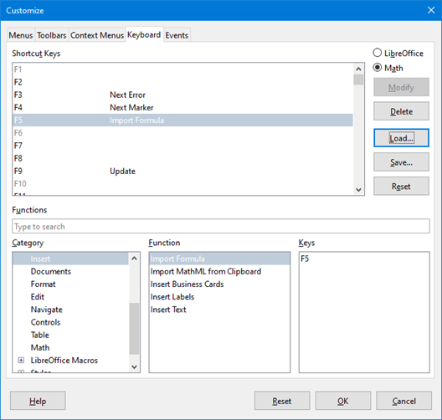
Figure 20: Customize dialog – Keyboard tab
- Select the level of the new keyboard shortcut.
- Select LibreOffice if you want the new keyboard shortcut to be set for all components of LibreOffice.
- Select Math if you want the new keyboard shortcut to be set for Math only.
- In the Category list, select Insert.
- In the Function list, select Import Formula.
- In the Shortcut Keys list, select the key or keyboard combination that you want to use for your new keyboard shortcut.
- Click Modify and your keyboard shortcut will appear in the Keys list.
- If necessary, continue to add keyboard shortcuts using the above steps.
- Click OK to save your keyboard shortcuts and close the Customize dialog.
- Tip
If you frequently add formulas into Writer documents, you can set a shortcut to quickly create Math Formulas. This can be done by following the steps described above to assign a shortcut to the function Formula in the category Insert.
Be aware that there are two Formula commands available in the Customize dialog in Writer and, although they have the same name, they correspond to different LibreOffice commands. As shown in Figure 21, the first Formula command is used to insert a calculated field in Writer, whereas the second Formula command is the one used to insert new Math objects.
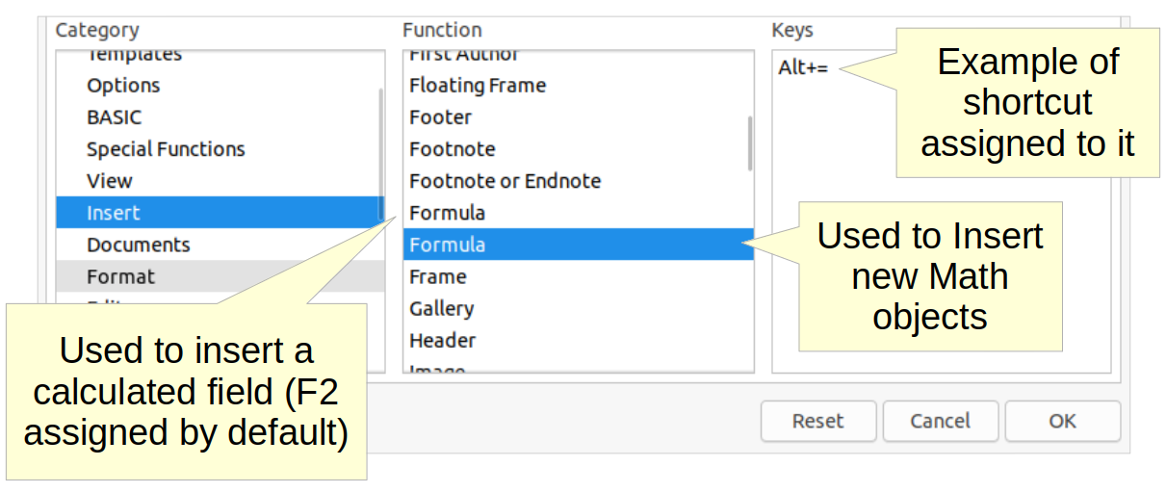
Figure 21: Assigning a shortcut to insert new Math objects in Writer

Keyboard customize options
The options for customizing keyboard shortcuts are as follows:
- LibreOffice – displays shortcut keys that are common to all LibreOffice components.
- Math, Writer, Calc, Draw, or Impress – displays the keyboard shortcuts for the open and current LibreOffice component.
- Shortcut Keys – lists the shortcut keys and the associated commands. To assign or modify the shortcut key for the command selected in the Function list, click a shortcut in this list, and then click Modify.
- Functions – type function name in the text field for search it in Function list.
- Function – lists the function categories and the LibreOffice functions that you can assign shortcut keys to.
- Category – lists the available function categories.
- Function – select a function that you want to assign a shortcut key to, select a key combination in the Shortcut Keys list, and then click Modify. If the selected function already has a shortcut key, it is displayed in the Keys list.
- Keys – displays the shortcut keys that are assigned to the selected function.
- Modify – assigns the key combination selected in the Shortcut Keys list to the command selected in the Function list.
- Delete – deletes the selected element or elements without requiring confirmation.
- Load – replaces the shortcut key configuration with one that was previously saved.
- Save – saves the current shortcut key configuration, so that you can load it later.
- Reset – resets modified values back to the default values.

Catalog customization
If you regularly use a symbol that is not available in Math, you can add it to the Symbols dialog (Figure 22) by using the Edit Symbols dialog (Figure 23).
You can add symbols to a symbol set, edit symbol sets, or modify symbol notations. You can also define new symbol sets, assign names to symbols, or modify existing symbol sets.

Adding symbols
- Go to Tools > Symbols on the Menu bar or click on the Symbols icon on the Tools toolbar to open the Symbols dialog (Figure 22).
- Click the Edit button to open Edit Symbols dialog (Figure 23).
- Select a font in the Font drop-down list.
- Select a symbol character that you want to add in the preview box. You may have to scroll down in the preview box to locate the symbol you want to use. The small right preview box displays the new symbol.
- In the Symbol box, type a memorable name for the symbol you are adding.
- In the Symbol set box, select a symbol set in the drop-down list to add your new symbol to, or type a new name to create a new symbol set for your new symbol.
- If required, select a font style from the Style drop-down list – Standard, Italic, Bold, or Bold Italic.
- Click Add, then click OK to close the Edit Symbols dialog. The new symbol and, if created, new symbol set are now available for use.
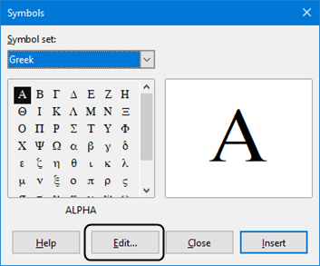
Figure 22: Symbol dialog
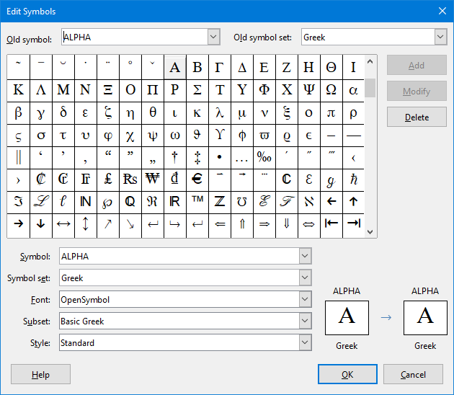
Figure 23: Edit Symbols dialog
- Note
When a new symbol is added to the catalog, you can type a percentage sign (%) followed by the new name into the markup language in the Formula Editor and your new symbol will appear in the formula. Remember that symbol names are case sensitive, for example, %prime is a different symbol to %Prime.
- Note
There are numerous free fonts available that contain several symbols if you cannot find a symbol to use in the fonts already installed on your computer. For example, the STIX font was developed specially for writing mathematical and technical texts. Also, the DejaVu and Lucida fonts have a wide range of symbols.
- Note
By default, only those user-defined symbols that actually occur in the document are stored with it. Sometimes it is useful to embed all the user-defined symbols, so that when the document is transferred to another computer it can be edited by another person. Go to Tools > Options > LibreOffice Math > Settings on the Menu bar and uncheck Embed only used symbols (smaller file size) in the Miscellaneous Options setion.

Editing symbols

Modifying symbol names
To change the name of a symbol:
- In the Edit Symbols dialog (Figure 23), select the symbol name you want to change from the Old symbol drop-down list. The symbol appears in the left preview pane at the bottom of the dialog.
- Type a new name for the symbol in the Symbol text box, or select a new name in the Symbol drop-down list. The new symbol name appears above the right preview pane at the bottom of the Edit Symbols dialog.
- Click Modify and the symbol name is changed.
- Click OK to close the Edit Symbols dialog.

Moving symbols
To move a symbol from one symbol set to another:
- In the Edit Symbols dialog (Figure 23), in the Old symbol set drop-down list, select the symbol set where the symbol you want to move is located.
- Select the symbol name you want move in the Old symbol drop-down list. The symbol appears in the left preview pane at the bottom of the Edit Symbols dialog.
- In the Symbol set drop-down list, select the symbol set that you want to move the symbol to. The new symbol set name appears below the right preview pane at the bottom of the Edit Symbols dialog.
- Click Modify and the symbol is moved to the new symbol set.
- Click OK to close the Edit Symbols dialog.

Deleting symbols
To delete a symbol from a symbol set:
- In the Edit Symbols dialog (Figure 23), in the Old symbol set drop-down list, select the symbol set from which you want to delete the symbol.
- Select the symbol name you want to delete in the Old symbol drop-down list. The symbol appears in the left preview pane at the bottom of the Edit Symbols dialog (Figure 23).
- Click Delete and the symbol is deleted from the symbol set without any confirmation.
- Click OK to close the Edit Symbols dialog.
- Note
The only way you can delete a symbol set is by deleting all of the symbols in that set. When you delete the last symbol from a set, the set is also deleted.

Options for editing symbols
The fields in the Edit Symbols dialog (Figure 23) are as follows:
- Old symbol – select the name of the current symbol. The symbol, the name of the symbol, and the set that the symbol belongs to are displayed in the left preview pane at the bottom of the dialog.
- Old symbol set – this list box contains the name of the current symbol set. You can also select a different symbol set using this list box.
- Symbol – lists the names for the symbols in the current symbol set. Select a name from the list or type a name for a newly added symbol.
- Symbol set – this list box contains the names of all existing symbol sets. You can modify a symbol set or create a new one.
- Font – displays the name of the current font and enables you to select a different font.
- Subset – if you selected a non-symbol font in the Font list box, you can select a Unicode subset in which to place your new or edited symbol. When a subset has been selected, all symbols belonging to this subset of the current symbol set are displayed in the Symbol list.
- Style – the current style of font is displayed. You can change the font style by selecting one from the list box.
- Add – click this button to add the symbol shown in the right preview window to the current symbol set. It will be saved under the name displayed in the Symbol list. You must specify a name under Symbol or Symbol set to be able to use the Add button. Names cannot be used more than once.
- Modify – click this button to replace the name of the symbol shown in the left preview window (the old name is displayed in the Old symbol list) with the new name you have entered in the Symbol list.
- Delete – click this button to remove the symbol shown in the left preview window from the current symbol set. There will be confirmation of deletion. Deleting the last remaining symbol of a symbol set also deletes the symbol set.
- Cancel – click this button at any time to close the dialog without saving any of the changes.

Formula spacing
The grave accent (`) inserts an additional small space and the tilde (~) inserts an additional large space into formulas. However, in the basic installation of LibreOffice, these symbols are ignored when they occur at the end of a formula. If you are working with running text in a formula, it may be necessary to include spacing at the end of formulas as well. This customization is only required when you are working with a Math document and is not required when you are inserting a formula into another LibreOffice component.
To add spacing at the end of formula in Math, go to Tools > Options > LibreOffice Math > Settings on the Menu bar and uncheck Ignore ~ and ` at the end of the line in the Miscellaneous Options section.
- Note
To customize LibreOffice Math settings, you need to start LibreOffice Math and then navigate to Tools > Options > LibreOffice Math > Settings.

Scaling of code in the Formula Editor input window
By default, the code in the Formula Editor input window (Figure 1) is scaled to 100%. You can change the scaling factor by going to Tools > Options > LibreOffice Math > Settings on the Menu bar and changing the percent in the Scaling code input window box in the Miscellaneous Options section. For example, if you change the scaling to 150%, the code in the input window will appear larger. This setting affects the Formula Editor in all LibreOfice components. However, the LibreOffice Math section in the Options dialog can only be accessed from within the Math component. It is not available when you are editing a formula in a LibreOffice document.

Extensions
If you create formulas frequently in your documents, you can customize LibreOffice by adding extensions that are designed to help you create formulas. Extensions are easily installed using the Extension Manager. For more information on how to install extensions, see Chapter 14, Customizing LibreOffice, in the Getting Started Guide.
A commonly used extension is Formatting of All Math Formulas. It allows you to format all Math formulas in a Writer, Calc, Draw, or Impress document. With it you can change the font names and font sizes of all formulas in the document. For more information on this extension, go to https://extensions.libreoffice.org/en/extensions/show/formatting-of-all-math-formulas.
Math Guide 7.3

Chapter 5,
Exporting and Importing

MathML format
In addition to exporting documents as PDFs, as described in the Getting Started Guide, LibreOffice offers the possibility of exporting formulas in the MathML format. This allows you or another person to insert formulas into documents that were created in other software, for example, Microsoft Office or an internet browser.
- Note
Some internet browsers do not fully support the MathML format and your formula may not display correctly.
If you are working on a Math document, go to File > Save as on the Menu bar or use the keyboard combination Ctrl+Shift+S to open the Save as dialog. Select MathML from the list of available file formats in File type to save your formula as MathML.
If you are working in another LibreOffice component, right-click on the formula object and select Save copy as from the context menu to open the Save as dialog. Select MathML from the list of available file formats in File type to save your formula object as MathML.
In Math you can also import MathML formulas. Use Tools > Import MathML from clipboard on the Menu bar.

Microsoft file formats
To control how formulas in Microsoft format are imported and exported using LibreOffice, go to Tools > Options > Load/Save > Microsoft Office on the Menu bar and select or deselect the options for MathType to LibreOffice Math or reverse.
- [L]: Load and convert the object
- [S]: Convert and save the object

[L]: Load and convert the object
Select this option if Microsoft OLE objects are to be converted into the specified LibreOffice OLE objects when a Microsoft document is opened in LibreOffice. For formulas, any embedded MathType objects must not exceed the MathType 3.1 specifications to be successfully loaded and converted. Information on MathType format can be found at https://docs.wiris.com/en/mathtype/office_tools/microsoft_office.
If a document containing OMML formulas has been saved in .docx format and then converted to the older .doc format, then any OMML objects are converted into graphics, which will be displayed in LibreOffice as graphics.

[S]: Convert and save the object
Select this option if LibreOffice OLE objects are to be converted and saved in Microsoft file format. LibreOffice converts any formulas into a format that can be read and modified by Microsoft Equation Editor and MathType.
When this option is not selected, the formula is treated as an OLE object on conversion into a .doc format and remains linked to LibreOffice. A double-click on the object in Microsoft Office will attempt to launch LibreOffice.
Math Guide 7.3

Appendix A,
Commands Reference

Introduction
This appendix lists the operators and commands that are available for use in the Formula Editor when you are creating formulas.
The more common operators and commands can be entered by clicking on the appropriate icon in the Elements panel. Where there is no icon displayed in the following tables for the Elements panel, then you have to enter the operator or command into the Formula Editor using markup language.
- Note
In the markup language shown in the following tables, you have to replace the place holder <?> with the value you want to use in your formulas.

Unary/binary operator commands
To access the icons used for entering markup language for unary/binary operator commands into the Formula Editor, select Unary/Binary Operators from the drop-down list at the top of the Elements panel.
Table 3: Unary/binary commands
Operation | Markup language | Example formula
Plus | +
Minus | -
Plus/minus | +- or plusminus
Minus/plus | -+ or minusplus
Addition | <?> + <?>
Subtraction | <?> - <?>
Multiplication (Dot) | <?> cdot <?>
Multiplication | <?> times <?>
Multiplication (*) | <?> * <?>
Division (Fraction) | {<?>} over {<?>}
Frac (Fraction) | frac {<?>} {<?>}
Division | <?> div <?>
Division (Slash) | <?> / <?> or <?> slash <?>
Division (Wideslash) | {<?>} wideslash {<?>}
Division (Counter Wideslash) | <?> widebslash <?>
Concatenate | <?> circ <?>
Boolean NOT | neg <?>
Boolean AND | <?> and <?> or <?> & <?>
Boolean OR | <?> or <?>
Backslash | <?> bslash <?>
Slash in circle | <?> odivide <?>
Small multiply symbol in circle | <?> odot <?>
Subtract symbol in circle | <?> ominus <?>
Add symbol in circle | <?> oplus <?>
Multiply symbol in circle | <?> otimes <?>
User defined binary operator | <?> boper ????? <?>
User defined unary operator | uoper ????? <?>

Relation commands
To access the icons used for entering markup language for relations commands into the Formula Editor, select Relations from the drop-down list at the top of the Elements panel.
Table 4: Relation commands
Operation | Markup language | Example formula
Is equal | <?> = <?>
Is not equal | <?> <> <?> or <?> neq <?>
Is less than | <?> < <?> or <?> lt <?>
Is less than or equal to | <?> <= <?>
Is less than or equal to | <?> leslant <?>
Is greater than | <?> > <?> or <?> gt <?>
Is greater than or equal to | <?> >= <?>
Is greater than or equal to | <?> geslant <?>
Is much less than | <?> << <?> or <?> ll <?>
Is much greater than | <?> >> <?> or <?> gg <?>
Is approximately equal | <?> approx <?>
Is similar to | <?> sim <?>
Is similar to or equal | <?> simeq <?>
Is congruent to | <?> equiv <?>
Is proportional to | <?> prop <?>
Is parallel to | <?> parallel <?>
Is orthogonal to | <?> ortho <?>
Divides | <?> divides <?>
Does not divide | <?> ndivides <?>
Toward | <?> toward <?>
Double arrow left | <?> dlarrow <?>
Double arrow left and right | <?> dlrarrow <?>
Double arrow right | <?> drarrow <?>
Precedes | <?> prec <?>
Succeeds | <?> succ <?>
Precedes or equal to | <?> preccurlyeq <?>
Succeeds or equal to | <?> succcurlyeq <?>
Precedes or equivalent to | <?> precsim <?>
Succeeds or equivalent to | <?> succsim <?>
Not precedes | <?> nprec <?>
Not succeeds | <?> nsucc <?>
Definition | <?> def <?>
Corresponding symbol image of | <?> transl <?>
Corresponding symbol original of | <?> transr <?>

Set operation commands
To access the icons used for entering markup language for set operation commands into the Formula Editor, select Set Operations from the drop-down list at the top of the Elements panel.
Table 5: Set operation commands
Operation | Markup language | Example formula
Is in | <?> in <?>
Is not in | <?> notin <?>
Owns | <?> owns <?> or <?> ni <?>
Intersection | <?> intersection <?>
Union | <?> union <?>
Difference | <?> setminus <?> or  <?> bslash <?>
Quotient set (slash) between characters | <?> slash <?>
Subset | <?> subset <?>
Subset or equal to | <?> subseteq <?>
Superset | <?> supset <?>
Superset or equal to | <?> supseteq <?>
Not subset | <?> nsubset <?>
Not subset or equal to | <?> nsubseteq <?>
Not superset | <?> nsupset <?>
Not superset or equal to | <?> nsupseteq <?>
Empty set | emptyset
Aleph (cardinal numbers) | aleph
Natural numbers set | setN
Integers set | setZ
Set of rational numbers | setQ
Real numbers set | setR
Complex numbers set | setC

Functions
To access the icons used for entering markup language for function commands into the Formula Editor, select Functions from the drop-down list at the top of the Elements panel.
Table 6: Function commands
Operation | Markup language | Example formula
Absolute value | abs{<?>}
Factorial | fact{<?>}
Square root | sqrt{<?>}
Nth root | nroot{<?>}{<?>}
Power | <?>^{<?>}
Natural exponential function | func e^{<?>}
Natural logarithm | ln(<?>)
Exponential function | exp(<?>)
Logarithm | log(<?>)
Sine | sin(<?>)
Cosine | cos(<?>)
Tangent | tan(<?>)
Cotangent | cot(<?>)
Hyperbolic sine | sinh(<?>)
Hyperbolic cosine | cosh(<?>)
Hyperbolic tangent | tanh(<?>)
Hyperbolic cotangent | coth(<?>)
Inverse sine or arcsine | arcsin(<?>)
Inverse cosine or arccosine | arccos(<?>)
Inverse tangent or arctangent | arctan(<?>)
Inverse cotangent or arccotangent | arccot(<?>)
Inverse or area hyperbolic sine | arsinh(<?>)
Inverse or area hyperbolic cosine | arcosh(<?>)
Inverse or area hyperbolic tangent | artanh(<?>)
Inverse or area hyperbolic cotangent | arcoth(<?>)
Back epsilon | backepsilon
Subscript | <?> sub <?>

Operators
To access the icons used for entering markup language for operator commands into the Formula Editor, select Operators from the drop-down list at the top of the Elements panel.
Table 7: Operator commands
Operation | Markup language | Example formula
Limes | lim <?>
Limes subscript bottom | lim from{<?>} <?>
Limes superscript top | lim to{<?>} <?>
Limes sup/sub script | lim from{<?>} to{<?>} <?>
Limes inferior | liminf <?>
Limes superior | limsup <?>
Sum | sum <?>
Sum subscript bottom | sum from{<?>} <?>
Sum superscript top | sum to{<?>} <?>
Sum sup/sub script | sum from{<?>} to{<?>} <?>
Product | prod <?>
Product subscript bottom | prod from{<?>} <?>
Product superscript top | prod to{<?>} <?>
Product sup/sub script | prod from{<?>} to{<?>} <?>
Coproduct | coprod <?>
Coproduct subscript bottom | coprod from{<?>} <?>
Coproduct superscript top | coprod to{<?>} <?>
Coproduct sup/sub script | coprod from{<?>} to{<?>} <?>
Integral | int <?>
Integral subscript bottom | int from{<?>} <?>
Integral superscript top | int to{<?>} <?>
Integral sup/sub script | int from{<?>} to{<?>} <?>
Double integral | iint <?>
Double integral subscript bottom | iint from{<?>} <?>
Double integral superscript top | iint to{<?>} <?>
Double integral sup/sub script | iint from{<?>} to{<?>} <?>
Triple integral | iiint <?>
Triple integral subscript bottom | iiint from{<?>} <?>
Triple integral superscript top | iiint to{<?>} <?>
Triple integral sup/sub script | iiint from{<?>} to{<?>}  <?>
Curve integral | lint <?>
Curve integral subscript bottom | lint from{<?>} <?>
Curve integral superscript top | lint to{<?>} <?>
Curve integral sup/sub script | lint from{<?>} to{<?>} <?>
Double curve integral | llint <?>
Double curve integral subscript bottom | llint from{<?>} <?>
Double curve integral superscript top | llint to{<?>} <?>
Double curve integral sup/sub script | llint from{<?>} to{<?>}  <?>
Triple curve integral | lllint <?>
Triple curve integral subscript bottom | lllint from{<?>} <?>
Triple curve integral superscript top | lllint to{<?>} <?>
Triple curve integral sup/sub script | lllint from{<?>} to{<?>} <?>
- Note
For customized operators, use the command oper followed by your custom operator. For example, entering oper OP from 0 to 1 A will give the formula.

Attributes
To access the icons used for entering markup language for attribute commands into the Formula Editor, select Attributes from the drop-down list at the top of the Elements panel, or click the Attributes icon in the Elements dialog.
Table 8: Attribute commands
Operation | Markup language | Example formula
Acute accent | acute <?>
Grave accent | grave <?>
Breve | breve <?>
Circle | circle <?>
Dot | dot <?>
Double dot | ddot <?>
Triple dot | dddot <?>
Line above | bar <?>
Vector arrow | vec <?>
Harpoon | harpoon <?>
Tilde | tilde <?>
Circumflex | hat <?>
Reverse circumflex | check <?>
Large vector arrow | widevec {<?>}
Large harpoon | wideharpoon <?>
Large tilde | widetilde {<?>}
Large circumflex | widehat {<?>}
Line over | overline {<?>}
Line below | underline {<?>}
Line through | overstrike {<?>}
Transparent (blank placeholder to create space) | phantom {<?>}
Bold font | bold <?>
Not bold font | nbold <?>
Italic font | ital <?> or italic <?>
Not italic font | nitalic <?>
Resize | size <?> {<?>}
Change font | font <?> {<?>}
Color black | color black {<?>}
Color blue | color blue {<?>}
Color green | color green {<?>}
Color red | color red {<?>}
Color cyan | color cyan {<?>}
Color aqua (same as cyan) | color aqua {<?>}
Color magenta | color magenta {<?>}
Color fuchsia (same as magenta | Color fuchsia {<?>}
Color yellow | color yellow {<?>}
Color gray | color gray {<?>}
Color lime | color lime {<?>}
Color maroon | color maroon {<?>}
Color navy | color navy {<?>}
Color olive | color olive {<?>}
Color purple | color purple {<?>}
Color silver | color silver {<?>}
Color teal | color teal {<?>}
RGB colors | color rgb R G B {<?>}
Hexadecimal colors | color hex 000000 {<?>}
Color coral | color coral {<?>}
Color midnight | color midnightblue {<?>}
Color crimson | color crimson {<?>}
Color violet | color violet {<?>}
Color orange | color orange {<?>}
Color orangered | color orangered {<?>}
Color seagreen | color seagreen {<?>}
Color indigo | color indigo {<?>}
Color hotpink | color hotpink {<?>}
Color lavender | color lavender {<?>}
- Note
The font command changes the font type. The first placeholder is replaced with the name of the font and the second placeholder is replaced with your formula values or text. The default fonts are Serif, Sans, or Fixed. If you have added custom fonts to Math (see “Formula fonts” on page 26), then you can replace the first placeholder with the custom font name.

Brackets
To access the icons used for entering markup language for bracket commands into the Formula Editor, select Brackets from the drop-down list at the top of the Elements panel.
Table 9: Bracket commands
Operation | Markup language | Example formula
Group brackets (not displayed in formula) | {<?>}
Round brackets | (<?>)
Left round bracket only | \(<?>
Right round bracket only | <?>\)
Square brackets | [<?>]
Left square bracket only | \[<?>
Right square bracket only | <?>\]
Double square brackets | ldbracket <?> rdbracket
Left double square bracket only | \ldbracket <?>
Right double square bracket only | <?> \rdbracket
Braces | lbrace <?> rbrace
Left brace only | \lbrace <?>
Right brace only | <?> \rbrace
Angle brackets | langle <?> rangle
Left angle bracket only | \langle <?>
Right angle bracket only | <?> \rangle
Operator brackets | langle <?> mline <?> rangle
Ceiling (upper half square brackets) | lceil <?> rceil
Left ceiling only | \lceil <?>
Right ceiling only | <?> \rceil
Floor (lower half square brackets) | lfloor <?> rfloor
Left floor only | \lfloor <?>
Right floor only | <?> \rfloor
Single lines | lline <?> rline
Left single line only | \lline <?>
Right single line only | <?> \rline
Double lines | ldline <?> rdline
Left double line only | \ldline <?>
Right double line only | <?> \rdline
Scalable round brackets | left ( <?> right )
Scalable left round bracket only | left ( <?> right none
Scalable right round bracket only | left none <?> right )
Scalable square brackets | left [ <?> right ]
Scalable left square bracket only | left [ <?> right none
Scalable right square bracket only | left none <?> right ]
Scalable double square brackets | left ldbracket <?> right rdbracket
Scalable left double square bracket only | left ldbracket <?> right none
Scalable right double square bracket only | left none <?> right rdbracket
Scalable braces | left lbrace <?> right rbrace
Scalable left brace only | left lbrace {<?>} right none
Scalable right brace only | left none {<?>} right rbrace
Scalable angle brackets | left langle <?> right rangle
Scalable left angle bracket only | left langle {<?>} right none
Scalable right angle bracket only | left none {<?>} right rangle
Scalable operator brackets | left langle <?> mline <?> right none
Scalable left operator bracket | left langle <?> mline <?> right none
Scalable right operator bracket | left none <?> mline <?> right rangle
Scalable ceiling (upper half square brackets) | left lceil <?> right rceil
Scalable left ceiling | left lceil <?> right none
Scalable right ceiling | left none <?> right rceil
Scalable floor (lower half square brackets) | left lfloor <?> right rfloor
Scalable left floor | left lfloor <?> right none
Scalable right floor | left none <?> right rfloor
Scalable single lines | left lline <?> right rline
Scalable left single line | left lline <?> right none
Scalable right single line | left none <?> right rline
Scalable double lines | left ldline <?> right rdline
Scalable left double line | left ldline <?> right none
Scalable right double line | left none <?> right rdline
Scalable top brace | {<?>} overbrace {<?>}
Scalable bottom brace | {<?>} underbrace {<?>}

Formats
To access the icons used for entering markup language for format commands into the Formula Editor, select Formats from the drop-down list at the top of the Elements panel.
Table 10: Format commands
Operation | Markup language | Example formula
Power (superscript right) | <?>^{<?>} or <?>sup{<?>} or  <?>rsup{<?>}
Subscript right | <?>_{<?>} or <?>sub{<?>} or  <?>rsub{<?>}
Superscript left | <?>lsup{<?>}
Subscript left | <?>lsub{<?>}
Superscript center | <?>csup{<?>}
Subscript center | <?>csub{<?>}
New line | newline
Small gap | `
Blank or large gap | ~
No space (suppresses space between elements) | nospace {<?>}
Align left | alignl <?>
Align center | alignc <?>
Align right | alignr <?>
Vertical stack (2 elements) | binom{<?>}{<?>}
Vertical stack (more than 2 elements) | stack{<?> # <?> # <?>}
Matrix stack | matrix{<?> # <?> ## <?> # <?>}
- Note
By default, text characters are aligned to the center in a formula. Use the alignl and alignr commands to align text characters in a formula to the left or right when a formula has more than one line. You can also use the align commands in conjunction with the stack commands to align multi-line formulas on a specific formula element, for example, the equals sign (=).

Others
To access the icons used for entering markup language for other commands into the Formula Editor, select Others from the drop-down list at the top of the Elements panel, or click the Others icon in the Elements dialog.
Table 11: Other commands
Operation | Markup language | Example formula
Placeholder | <?>
Infinity | infinity or infty
Partial derivative or set margin | partial
Nabla vector operator | nabla
Existential quantifier, there is at least one | exists
Existential quantifier, there does not exist | notexists
Universal quantifier, for all | forall
H-bar constant | hbar
Lambda bar | lambdabar
Real part of a complex number | re
Imaginary part of a complex number | im
Weierstrass p function | wp
Laplace transformation | laplace
Left arrow | leftarrow
Right arrow | rightarrow
Up arrow | uparrow
Down arrow | downarrow
Ellipsis | dotslow
Math axis ellipsis | dotsaxis
Vertical ellipsis | dotsvert
Upward diagonal ellipsis | dotsup or dotsdiag
Downward diagonal ellipsis | dotsdown
Back epsilon | backepsilon

Greek characters
Greek characters are normally entered into a formula using the Symbols dialog (see “Greek characters” on page 15 for more information). However, if you know the name of the Greek character, you can type a percentage sign (%) followed by the name of the Greek character into the Formula Editor.
For uppercase Greek characters, type the name using uppercase characters, for example %BETA (see Table 12 for a full list of uppercase Greek characters). For lowercase Greek characters, type the name using lowercase characters, for example %beta (see Table 13 for a full list of lowercase Greek characters)
Italic Greek characters can also be entered into a formula by typing the character i after the percentage sign (%) and before the name of the Greek character, for example, %iPI for uppercase and %ipi for lowercase . See Table 14 for a full list of italic uppercase Greek characters and Table 15 for a full list of italic lowercase Greek characters.
- Note
In localized versions of LibreOffice, the names of Greek characters are also localized. If a document is not localized to the same language, then the names of Greek characters in the following tables may not work correctly. If this happens, you can use the Symbols dialog to select the required Greek character. When selected in the Symbols dialog, the name of the Greek character is displayed at the bottom of the Symbols dialog in the correct language. See “Greek characters” on page 15 for more information on Greek characters and the Symbols dialog.
Table 12: Uppercase Greek characters
%ALPHA |  | %BETA |  | %GAMMA |  | %DELTA
%EPSILON |  | %ZETA |  | %ETA |  | %THETA
%IOTA |  | %KAPPA |  | %LAMBDA |  | %MU
%NU |  | %XI |  | %OMICRON |  | %PI
%RHO |  | %SIGMA |  | %TAU |  | %UPSILON
%PHI |  | %CHI |  | %PSI |  | %OMEGA
Table 13: Lowercase Greek characters
%alpha |  | %beta |  | %gamma |  | %delta
%varepsilon |  | %zeta |  | %eta |  | %theta
%iota |  | %kappa |  | %lambda |  | %mu
%nu |  | %xi |  | %omicron |  | %pi
%rho |  | %varsigma |  | %sigma |  | %tau
%upsilon |  | %varphi |  | %chi |  | %psi
%omega |  | %vartheta |  | %phi |  | %varpi
%varrho |  | %epsilon
Table 14: Uppercase italic Greek characters
%iALPHA |  | %iBETA |  | %iGAMMA |  | %iDELTA
%iEPSILON |  | %iZETA |  | %iETA |  | %iTHETA
%iIOTA |  | %iKAPPA |  | %iLAMBDA |  | %iMU
%iNU |  | %iXI |  | %iOMICRON |  | %iPI
%iRHO |  | %iSIGMA |  | %iTAU |  | %iUPSILON
%iPHI |  | %iCHI |  | %iPSI |  | %iOMEGA
Table 15: Lowercase italic Greek characters
%ialpha |  | %ibeta |  | %igamma |  | %idelta
%ivarepsilon |  | %izeta |  | %ieta |  | %itheta
%iiota |  | %ikappa |  | %ilambda |  | %imu
%inu |  | %ixi |  | %iomicron |  | %ipi
%irho |  | %ivarsigma |  | %isigma |  | %itau
%iupsilon |  | %ivarphi |  | %ichi |  | %ipsi
%iomega |  | %ivartheta |  | %iphi |  | %ivarpi
%ivarrho |  | %iepsilon

Special characters
Special characters are normally entered into a formula using the Symbols dialog (see “Symbols dialog” on page 16 and “Catalog customization” on page 51 for more information). However, if you know the name of the special character, you can type a percentage sign (%) followed by the name of the special character into the Formula Editor. Table 16 Shows the full list of special characters that are available in LibreOffice.
- Note
In localized versions of LibreOffice, the names of special characters are also localized. If a document is not localized to the same language, then the names of special characters in the following table may not work correctly. If this happens, you can use the Symbols dialog to select the required special character. When selected in the Symbols dialog, the name of the special character is displayed at the bottom of the Symbols dialog in the correct language.
Table 16: Special characters
%perthousand |  | %tendto
%noelement |  | %infinite
%angle |  | %and
%or |  | %notequal
%identical |  | %strictlylessthan
%strictlygreaterthan

Reserved words
A reserved word is a word that is used by LibreOffice as a command in the Math markup language and it cannot be used as a variable name or entered into a formula as text. However, if you want to use a reserved word as text in a formula then you must place the reserved word between double quotes.
For example, consider that you want to use the word “purple” in a formula and you do not want the formula elements to be changed to the color purple. If you simply type A purple B in the Formula Editor, the resulting formula is, which is incorrect and the error is shown by the inverted question mark. To correct this error, type A "purple" B in the Formula Editor using double quotes each side of the word purple and the resulting correct formula is .
If you want the word “purple” written in italic, as you would normally have with variables, you can type A italic{ "purple" } B in the formula editor, which will result in .
The reserved words used in Math are listed in the above tables for commands in markup language.

Math Guide

Using the formula editor
About this book:
Math is a simple formula editor that lets you lay out and display mathematical, chemical, electrical, or scientific formulas quickly in standard written notation.
It is most commonly used in Writer for text documents, but it can also be used with other types of documents or stand-alone.
If you have never used LibreOffice before, or you want an introduction to all of its components, you might like to read the Getting Started Guide first.
About the authors:
This book was written by volunteers from the LibreOffice community. Profits from the sales of the printed edition are used to benefit the community.
A PDF version of this book can be downloaded free from:
https://documentation.libreoffice.org/en/
About LibreOffice:
LibreOffice is the free, libre, and open source personal productivity suite from The Documentation Foundation. It runs on Windows, macOS, and GNU/Linux. Support and documentation is free from a large, dedicated community of users, contributors, and developers.
Get involved as a volunteer and work in many areas: development, quality assurance, documentation, translation, user support, and more.
Download LibreOffice for free from:
https://libreoffice.org/downloads/
For commercial use:
Work with certified LibreOffice professionals for any business needs, from deployment or conversion from other office suits, staff training, or custom development needs.
Information on professional support services at:
https://www.libreoffice.org/get-help/professional-support/

