
Getting Started Guide 7.3

Appendix A
Keyboard Shortcuts
Using LibreOffice without a mouse

Copyright
This document is Copyright © 2022 by the LibreOffice Documentation Team. Contributors are listed below. This document maybe distributed and/or modified under the terms of either the GNU General Public License (https://www.gnu.org/licenses/gpl.html), version 3 or later, or the Creative Commons Attribution License (https://creativecommons.org/licenses/by/4.0/), version 4.0 or later.
All trademarks within this guide belong to their legitimate owners.

Contributors
To this edition
Peter Schofield | Kees Kriek | Jean Hollis Weber
To previous editions
Jean Hollis Weber | Rafael Lima | Kees Kriek
Olivier Hallot | Steve Fanning | Ron Faile Jr.
John A Smith

Feedback
Please direct any comments or suggestions about this document to the Documentation Team’s mailing list: documentation@global.libreoffice.org
- Note
Everything sent to a mailing list, including email addresses and any other personal information that is written in the message, is publicly archived and cannot be deleted.

Publication date and software version
Published February 2022. Based on LibreOffice 7.3 Community.
Other versions of LibreOffice may differ in appearance and functionality.

Contents
Copyright 2
Contributors 2
Feedback 2
Publication date and software version 2
Introduction 4
Assistive tools in LibreOffice 5
Information for macOS users 6
Keyboard shortcuts 6
Using keyboard shortcuts 6
Opening menus and menu items 7
Accessing menu commands 7
Accessing toolbar commands 8
Navigation and selection 8
Controlling dialogs 9
Controlling documents and windows 10
Editing or formatting documents 10
Sidebar keyboard shortcuts 11
General 11
Gallery 12
Database table keyboard shortcuts 12
Controlling macros 12
Entering Unicode numbers 13
Defining keyboard shortcuts 13
Further reading 13

Introduction
LibreOffice can be used without requiring a pointing device, such as a mouse or trackball, by using the keyboard shortcuts that are available in LibreOffice. Tasks as varied and complex as docking and un-docking toolbars and windows, or changing the size or position of objects, can all be accomplished using keyboard shortcuts. Although LibreOffice has an extensive set of keyboard shortcuts, each LibreOffice module has keyboard shortcuts that are specific to that module.
This appendix lists some of the more common keyboard shortcuts that apply to multiple components of LibreOffice. For shortcuts specific to Writer, Calc, Impress, Draw, Math, or Base, refer to the relevant user guide or search the LibreOffice Help.
To assist the user with identification of useful keyboard shortcuts, shortcuts are indicated by text next to menu items and as tooltips for some tools on the toolbars. In Writer, for example, some commonly used keyboard shortcuts are as follows:
- The menu item File > Open includes text indicating that Ctrl+O (macOS ⌘+O) is a keyboard shortcut.
- The Align Left tool in the Formatting toolbar has a tooltip indicating that Ctrl+L (macOS ⌘+L) is a keyboard shortcut.
LibreOffice provides further information about the keys used and the available keyboard shortcuts in the list presented on the Keyboard tab of the Customize dialog for Linux/Windows (Figure 1) or macOS (Figure 2).
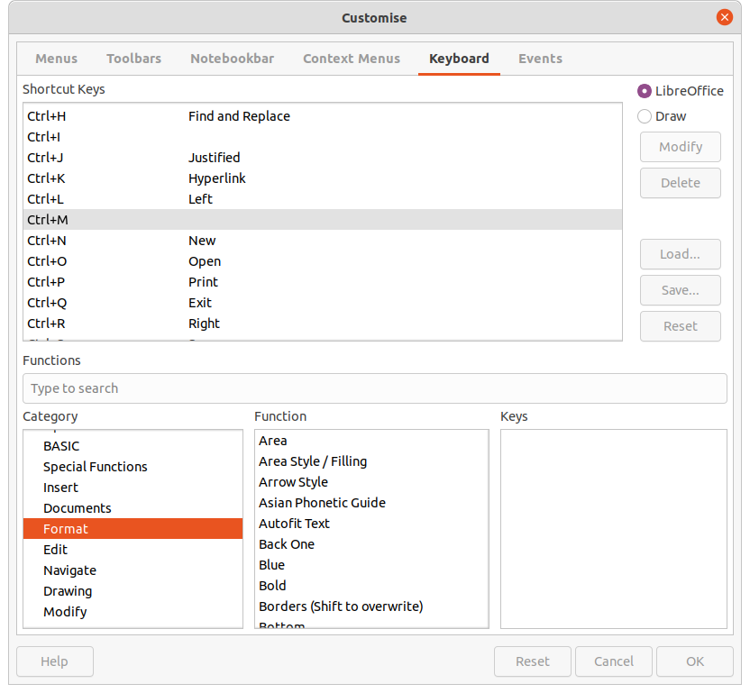Figure 1: Customize dialog – Keyboard tab for Linux (Windows is similar)
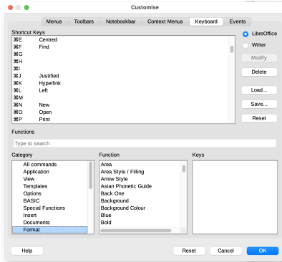Figure 2: Customize dialog – Keyboard tab in macOS
- Note
Some keyboard shortcuts listed may not be available if the operating system uses the same shortcuts for other tasks. To resolve any conflicts, assign different keys to these shortcuts by reconfiguring either LibreOffice (see Chapter 14, Customizing LibreOffice) or the operating system (see operating system documentation or help).

Assistive tools in LibreOffice
In addition to keyboard shortcuts, LibreOffice supports some assistive technology tools like screen magnification software, screen readers, and on-screen keyboards. Please note that except for the Windows platform, accessibility support relies on Java technology for communications with assistive technology tools. This means that the first program startup may take a few seconds longer, because the Java runtime environment has to be started as well.
A current list of supported assistive tools can be found on the Wiki at https://wiki.documentfoundation.org/Accessibility.

Information for macOS users
Some keystrokes and menu items are different in macOS than those used in Windows or Linux. Table 1 gives the common substitutions that are used in a LibreOffice document. For a more detailed list, see LibreOffice Help.
Table 1: macOS equivalent keystrokes
Windows or Linux | macOS equivalent | Effect
Tools > Options  menu selection | LibreOffice > Preferences | Access setup options
Right-click | Control+click or right-click depending on computer setup | Open a context menu
Ctrl (Control) | ⌘ (Command) | Used with other keys
Alt | ⌥ (Option) or Alt, depending on keyboard | Used with other keys
F11 | ⌘+T | Open Styles deck in Sidebar
- Note
Actual keys available on a macOS keyboard depend on the type of keyboard being used. For example, a macOS laptop keyboard may not have a Delete key, but a macOS keyboard with a numeric keypad does have a Delete key.
- Note
Some keyboard shortcuts are not available for computers using macOS. This is indicated in the following tables by a blank cell.

Keyboard shortcuts
- Note
Some of the shortcut keys may be assigned to the computer operating system and are not available for LibreOffice. Either assign different keys in LibreOffice using Tools > Customize > Keyboard on the Menu bar, or in the computer operating system. For more information, see Chapter 14, Customizing LibreOffice or the documentation/help for the computer operating system.

Using keyboard shortcuts
LibreOffice functions can easily be used by using keyboard shortcuts. For example, the Ctrl+O (macOS ⌘+O) keyboard shortcut is shown next to Open in the File menu on the Menu bar. To use this keyboard shortcut, press and hold down the Ctrl (macOS ⌘) key and then press the O key. Release both keys together after the dialog box opens.

Opening menus and menu items
Table 2: Keys for opening menus and menu items
Windows  Linux | macOS | Effect
Alt+<?>  Windows only |  | Opens a menu where <?> is an underlined character of the menu being opened. For example, Alt+F opens the File menu.  When a menu is opened, there may be submenu items with underlined characters. Press the underlined character directly to carry out the action or option.  Where two menu items have the same underlined character, press the character key again to move to the next menu item.  Menu items that have no underlined character have to be clicked on directly.
Esc | Esc | Closes an open menu.
F6 |  | Repeatedly pressing F6 switches the focus through the following objects:  - Menu bar  - Every toolbar from top to bottom and from left to right  - Every free window from left to right  - Document
 | F6 | Repeatedly pressing F6 switches the focus through the following objects:  - Each toolbar from top to bottom and from left to right  - Sidebar  - Document
Shift+F6 | Shift+F6 | Switches focus through objects in the opposite direction.
Ctrl+F6 | ⌘+F6 | Switches the focus to the document.
F10 |  | Switches focus to the Menu bar and back.

Accessing menu commands
- Press Alt or F6 or F10 to select the first item on the Menu bar (normally the File menu). In macOS, selection is the first tool on the Standard toolbar.
- Press the right or left arrow to move the selection right or left.
- Press the Home key (macOS Fn+left arrow) or End key (macOS Fn+right arrow) to move menu selection to the first or last item on the Menu bar.
- Press the down or up arrow to move the selection down or up the list of menu commands.
- If necessary, press the right arrow to open any submenus on the selected menu. Submenus are indicated by a triangle ► next to the name of the selected menu.
- If necessary, press the down or up arrow to move the selection down or up the list of submenu commands.
- If necessary, press the left arrow to close a submenu.
- Press Enter to run the selected menu or submenu command.

Accessing toolbar commands
- Press F6 repeatedly until the first icon on a toolbar is selected.
- On a horizontal toolbar, press the right or left arrows to move tool selection to the right or left.
- On a vertical toolbar, press the up or down arrows to move tool selection upward or downward.
- Press the Home key (macOS Fn+left arrow) or End key (macOS Fn+right arrow) to move tool selection to the first or last tool on a toolbar.
- Press Enter to action the selected tool on the toolbar.
- To insert an object into a drawing or presentation after selecting the required object on the Drawing toolbar, use the key combination Ctrl+Enter (macOS ⌘+Enter) to insert the object in the center of the drawing page or slide.
- Note
If a tool on a toolbar has an editable text field, for example Load URL or Line Width, the Tab or Shift+Tab keys are then used to move the selection right or left onto the next tool on the toolbar.

Navigation and selection
Navigate through a document and make selections using the keyboard is as follows:
- To move the cursor, use one of the keys or key combinations given in the following table.
- To select any text while moving the cursor, hold down the Shift key as the cursor is moved.
- To select a word, position the cursor in the word and double-click.
- To select a sentence, position the cursor in the sentence and triple-click.
- To select a paragraph, position the cursor in the paragraph and click four times.
- To select all of the text or objects in a document, use Ctrl+A (macOS ⌘+A).
- Use Ctrl+Del (macOS ⌘+Delete) to delete everything from the cursor position to the end of the word.
Table 3: Keys for navigation and selection
Windows  Linux | macOS | Effect
Left Arrow | Left Arrow  Ctrl+B | Moves the cursor one character to the left.
Right Arrow | Right Arrow  Ctrl+F | Moves the cursor one character to the right.
Ctrl+Left Arrow | ⌥+Left Arrow | Moves the cursor one word to the left.
Ctrl+Right Arrow | ⌥+Right Arrow | Moves the cursor one word to the right.
Up Arrow | Up Arrow  Ctrl+P | Moves the cursor up one line.
Down Arrow | Down Arrow  Ctrl+N | Moves the cursor down one line.
Ctrl+Up or Down Arrow | ⌥+Up or Down Arrow | Moves the cursor up or down to the beginning of the previous or next paragraph.
Home | Fn+Left arrow  Ctrl+A | Moves the cursor to the beginning of the current line.
Ctrl+Home | ⌘+Up Arrow | Moves the cursor to the beginning of the document.
End | Fn+Right arrow  Ctrl+E | Moves the cursor to the end of the current line.
Ctrl+End | ⌘+Down Arrow | Moves the cursor to the end of the document.
Page Up | Fn+Up Arrow | Scrolls up one page.
Ctrl+Page Up | ⌘+Fn+Up Arrow | Moves the cursor to the header.
Page Down | Fn+Down Arrow | Scrolls down one page.
Ctrl+Page Down | ⌘+Fn+Down Arrow | Moves the cursor to the footer.

Controlling dialogs
When opening any dialog, one element (for example button, option field, entry in a list box, or checkbox) is highlighted indicating that the element has focus on it. How the element is highlighted depends on the operating system and how the computer is setup.
Table 4: Keys for controlling dialogs
Shortcut Keys | Result
Enter | Activates selected button.  When no button is selected, Enter is equivalent to clicking OK.
Esc | Closes dialog without saving any changes made while the dialog was open.  Esc is also equivalent to clicking Cancel.  When a drop-down list is open and selected, Esc closes the list.
Spacebar | Checks or clears an empty checkbox.
Up or Down arrow | Moves focus up and down a list.  Increases or decreases value of a variable.  Moves focus vertically within a section of dialog.
Left or Right arrow | Moves focus horizontally within a section of a dialog.
Tab | Advances focus to the next section or element of a dialog.
Shift+Tab | Returns focus to the previous section or element in a dialog.
Alt+Down arrow  (macOS ⌥+Down arrow) | Shows items in a drop-down list.

Controlling documents and windows
Table 5: Keys for controlling documents and windows
Windows  Linux | macOS | Effect
Ctrl+O | ⌘+O | Opens the Open dialog to select and open a document.
Ctrl+S | ⌘+S | Saves the current document. If the document is a previously unsaved file, the shortcut opens the Save As dialog.
Ctrl+N | ⌘+N | Creates a new document.
Shift+Ctrl+N | ⌘+Shift+N | Opens the Templates dialog.
Ctrl+P | ⌘+P | Opens the Print dialog to print the document.
Ctrl+F | ⌘+F | Opens the Find toolbar.
Ctrl+H | ⌥+⌘+F | Opens the Find and Replace dialog.
Ctrl+Shift+F |  | Searches for the last entered search term.
Ctrl+Shift+J |  | Toggles the view between full-screen mode and normal mode in Writer or Calc.
Ctrl+Shift+R | ⌘+Shift+R | Opens and closes the rulers.
F1 | F1 | Opens the LibreOffice Help contents in your default browser. If the local Help package is not installed, LibreOffice opens the online Help located at https://help.libreoffice.org.
Shift+F1 | Shift+F1 | Turns the cursor into a What’s This? question mark. Shows the tip for an item underneath the cursor. The shortcut does not work with the online help.
Shift+F2 | Shift+F2 | Turns on Extended Tips for the currently selected command, icon or control. The shortcut does not work with the online help.
Ctrl+Shift+F10 | ⌘+Shift+F10 | Docks and undocks floating toolbars, Sidebar and Navigator.
Ctrl+F4 or Alt+F4 | ⌘+F4 | Closes the current document. Closes LibreOffice when the last open document is closed.
Ctrl+Q | ⌘+Q | Exits LibreOffice.

Editing or formatting documents
Table 6: Keys for editing or formatting documents
Windows  Linux | macOS | Effect
Enter | Enter | When an OLE object is selected, activates the software used to create the OLE object.  When a drawing object is selected, activates text mode.
Ctrl+X | ⌘+X | Cuts selected text or objects from a document and places them in the clipboard.
Ctrl+C | ⌘+C | Copies selected text or objects and places them in the clipboard.
Ctrl+V | ⌘+V | Places text or objects from the clipboard that have copied or cut into the document.
Ctrl+Alt+Shift+V | ⌘+⌥+Shift+V | Pastes unformatted text from the clipboard. The text is pasted using the format that exists at the insertion point.
Ctrl+Shift+V | ⌘+Shift+V | Opens the Paste Special dialog.
Ctrl+A | ⌘+A | Selects all text and objects in a document.
Ctrl+Z | ⌘+Z | Undoes last action.
Ctrl+Y | ⌘+Y | Redoes last action.
Ctrl+Shift+Y | ⌘+Shift+Y | Repeats last command.
Ctrl+I | ⌘+I | Applies the Italic attribute to selected characters and text.
Ctrl+B | ⌘+B | Applies the Bold attribute to selected characters and text.
Ctrl+U | ⌘+U | Applies the Underline attribute to selected characters and text.
Ctrl+M | ⌘+M | Removes direct formatting from selected text or objects. This command is also available in Format > Clear Direct Formatting in the Menu bar.

Sidebar keyboard shortcuts

General
Table 7: General keyboard shortcuts for the Sidebar
Windows  Linux | macOS | Effect
Tab | Tab | Moves the focus in the Sidebar.
Shift+Tab | Shift+Tab | Moves the focus in the reverse direction in the Sidebar.
Shift+F10 | Shift+F10 | Opens a context menu for the selected element in the Sidebar.
Home | Fn+Left Arrow | Moves focus to first entry.
End | Fn+Right Arrow | Moves focus to last entry.
Up or Down Arrow | Up or Down Arrow | Moves the selection up or down and opens the panels in the selected deck.
Right Arrow | Right Arrow | Opens any sub-elements in the selected element.
Left Arrow | Left Arrow | Closes any sub-elements in the selected element.
Ctrl+Enter | ⌘+Enter | Opens the Properties dialog for the selected element.

Gallery
Table 8: Keyboard shortcuts for Gallery in Sidebar
Windows  Linux | macOS | Effect
Ctrl+R |  | Opens the Enter Title dialog. Only themes added to LibreOffice can be renamed. Themes installed with LibreOffice cannot be renamed.
Ctrl+D | ⌘+D | Deletes themes that have been added to LibreOffice. Themes installed with LibreOffice cannot be deleted.
Insert |  | Inserts a new theme into the Gallery and opens the Insert of New Theme dialog.
Ctrl+Shift+Insert | ⌘+Shift+Insert | Inserts the selected object as a linked object into the current document.
Ctrl+I | Ctrl+I | Inserts a copy of the selected object into the current document.
Ctrl+P  Spacebar  Enter | Ctrl+P  Spacebar  Enter | Switches between a view of a list of object previews and a selected object.

Database table keyboard shortcuts
Table 9: Keyboard shortcuts for database tables
Windows  Linux | macOS | Effect
Ctrl+Shift+F4 | ⌘+Shift+F4 | Opens and closes a database table in a document for editing.
Spacebar | Spacebar | Toggles row selection, except when the row is in edit mode.
Ctrl+Spacebar | ⌘+Spacebar | Toggles row selection.
Shift+Spacebar | Shift+Spacebar | Selects the current column.
Ctrl+Page Up | ⌘+⌥ + Fn+ Up Arrow | Moves the cursor to the first row.
Ctrl+Page Down | ⌘+⌥ + Fn+ Down Arrow | Moves the cursor to the last row.

Controlling macros
Table 10: Keys for controlling macros
Windows  Linux | macOS | Effect
Ctrl+* (multiplication sign on number pad only) | ⌘+* (multiplication sign on number pad only) | Runs a macro field.
Shift+Ctrl+Q | ⌘+Ctrl+Q | Stops a running macro.
- Note
For more information on macros, see Chapter 13, Getting Started with Macros.

Entering Unicode numbers
Each character in LibreOffice can be entered into a document by typing its Unicode hexadecimal number and then pressing Ctrl+Alt+X (mac OS ⌘+⌥+X). For example, to enter the copyright sign into text, type U+00A9 followed immediately by Ctrl+Alt+X (mac OS ⌘+⌥+X) and the copyright sign © appears at the cursor position in the text.
- Note
Unicode hexadecimal numbers in the range U+0000 to U+0020 are not converted into characters using the conversion shortcut Ctrl+Alt+X (mac OS ⌘+⌥+X).

Defining keyboard shortcuts
In addition to using the built-in keyboard shortcuts listed in this Appendix, custom keyboard shortcuts can be defined. For more information, see Chapter 14, Customizing LibreOffice.
To check if a keyboard shortcut is is already in use, open the Keyboard page in the Customize dialog and scroll though the listed keyboard shortcuts. Go to Tools > Customize on the Menu bar to open the Customize dialog.

Further reading
For help with keyboard shortcuts, or using LibreOffice with a keyboard only, search the application Help using the keywords “shortcut keys” or “accessibility”.

