
Draw Guide 7.4

Preface
Drawing Vector Graphics in LibreOffice

Copyright
This document is Copyright © 2023 by the LibreOffice Documentation Team. Contributors are listed below. This document maybe distributed and/or modified under the terms of either the GNU General Public License (https://www.gnu.org/licenses/gpl.html), version 3 or later, or the Creative Commons Attribution License (https://creativecommons.org/licenses/by/4.0/), version 4.0 or later. All trademarks within this guide belong to their legitimate owners.

Contributors
Contributors for this edition:
Peter Schofield

Contributors for previous editions:
Elzett Kotze
Jean Hollis Weber
Peter Schofield
Rachel Kartch

Feedback
Please direct any comments or suggestions about this document to the Documentation Team mailing list: loguides@community.documentfoundation.org.
- Note
Everything sent to a mailing list, including email addresses and any other personal information that is written in the message, is publicly archived and cannot be deleted.

Publication date and software version
Published January 2023. Based on LibreOffice 7.4 Community.
Other versions of LibreOffice may differ in appearance and functionality.

Contents
Copyright 2
Contributors 2
Feedback 2
Publication date and software version 2
Who is this user guide for? 4
What is in this user guide? 4
Minimum requirements for using LibreOffice 4
How to get LibreOffice 4
Installing LibreOffice 4
Setting up and customizing LibreOffice 4
Extensions and add-ons 5
Where to get more help 5
Help system 5
Other free online support 6
Paid support and training 7
What you see may be different 7
Illustrations 7
Icons 8
Using LibreOffice on macOS 9
Who wrote this user guide? 9
Frequently asked questions 9
What is new in LibreOffice 7.4? 10

Who is this user guide for?
Anyone who wants to quickly acquire knowledge on LibreOffice Draw and is new to drawing software, or may be familiar with another office suite, will find this user guide very useful.
LibreOffice is an open-source office productivity software suite containing capabilities for word processing, spreadsheets, presentations, graphics, databases, and formula editing. LibreOffice Draw is the vector graphics drawing application for LibreOffice where a wide variety of graphical images can be easily and quickly created.

What is in this user guide?
This user guide introduces the main features of LibreOffice Draw. Although Draw is a vector graphics drawing tool, it can also perform some operations on raster graphics (pixels) such as photographs.
A few examples of the drawing functions are: layer management, snap functions and grid-point system, dimensions and measurement display, connectors for making organization charts, 3D functions that enable small 3D drawings to be created (with texture and lighting effects), drawing and page-style integration, and Bézier curves.

Minimum requirements for using LibreOffice
For a detailed list of requirements and operating systems supported, see the LibreOffice website, https://www.libreoffice.org/get-help/system-requirements/.

How to get LibreOffice
Versions of LibreOffice for Windows, Linux, and macOS are freely available and can be downloaded from https://www.libreoffice.org/download. Linux users will also find LibreOffice included free in many of the latest distributions.
Portable and other versions of LibreOffice are listed on the download page. Linux, Vanilla, and other versions may differ in a few features from the descriptions in this user guide.

Installing LibreOffice
Information on installing and setting up LibreOffice on the various supported operating systems is given here: https://www.libreoffice.org/get-help/install-howto/.

Setting up and customizing LibreOffice
To change the default settings (options) in LibreOffice to match the required preferences, go to Tools > Options on the Menu bar (LibreOffice > Preferences in macOS).
- Tip
Some settings are intended for power users and programmers. If it is difficult to understand what an option does, LibreOffice recommends leaving the option on its default setting unless instructions in this user guide recommend changing the setting.
Settings are described in LibreOffice Help and the Getting Started Guide. These two sources provide information on how to customize menus, toolbars, and keyboard shortcuts in LibreOffice Draw, add new menus and toolbars, and assign macros to events.

Extensions and add-ons
Functionality can be added to LibreOffice with extensions and add-ons. Several extensions are installed with the program and other extensions from the official extensions repository, https://extensions.libreoffice.org/ or from other sources. See the Getting Started Guide for more information on installing extensions and add-ons.

Where to get more help
This user guide and other LibreOffice user guides, the built-in Help system, and user support systems assume that users are familiar with computers and basic functions such as starting a program, opening and saving files.

Help system
LibreOffice comes with an extensive Help system and this can be used as the first line of support. Windows and Linux users can choose to download and install the offline Help for use when not connected to the Internet. Offline Help is installed with the MacOS version of LibreOffice.
To display the LibreOffice Help, press F1 or go to Help > LibreOffice Help on the Menu bar. If the offline help is not installed on a computer, but connected to the Internet, a dialog opens giving the option to Read Help Online. Select this option and the default web browser opens at the LibreOffice online help pages in the LibreOffice website.
The Help menu also includes links to other LibreOffice information and support facilities.
What's This?
For quick tips when a toolbar is visible, place the cursor over any of the tool icons to see a small tooltip box with a brief explanation of the tool function. Also Extended Tips can be activated by going to Tools > Options > LibreOffice > General on the Menu bar. Extended Tips provide a brief description about tools and commands. To display an extended tip, use the keyboard Shift+F1, then point to a tool or command.
User Guides
Opens the default browser at the Documentation page of the LibreOffice website https://documentation.libreoffice.org/en/english-documentation/. This page gives access to the LibreOffice User Guides and other useful information that can be opened in the default browser. Also, the User Guides are available in PDF format as a free download or to buy as printed copies.
Show Tip of the Day
Opens a small window with a random tip on how to use LibreOffice.
Search Commands
Opens a window where typing a few letters, or the name of a Menu bar command, for example, quickly finds where the command is located. Clicking on a command in the resulting list may open a relevant dialog or have other effects.
Get Help Online
Opens the default browser at the Ask LibreOffice forum of questions and answers from the LibreOffice community, https://ask.libreoffice.org/en/questions/.
Send Feedback
Opens the default browser at the Feedback page of the LibreOffice website https://www.libreoffice.org/get-help/feedback/. From this page, bugs can be reported, new features suggested and communicated with other users in the LibreOffice community.
Restart in Safe Mode
Opens a dialog window giving options to restart LibreOffice and reset the software to its default settings. Restarting in safe mode also provides an opportunity to restore LibreOffice from a backup.
Get Involved
Opens the default browser at the Get Involved page of the LibreOffice website, https://www.libreoffice.org/community/get-involved/. Choose a topic of interest to help improve the program.
Donate to LibreOffice
Opens the default browser at the Donation page of the LibreOffice website, https://donate.libreoffice.org/ providing an opportunity to make a donation to support LibreOffice.
License Information
Outlines the licenses under which LibreOffice is made available.
Check for Updates
Opens a dialog and checks the LibreOffice website for updates to version of the software. The dialog provides an opportunity to download and install any updates to LibreOffice.
About LibreOffice
Opens a dialog and displays information about the version of LibreOffice and the operating system being used. This information is often requested if the community is asked for help or assistance with the software (on macOS, this option is found under LibreOffice on the Menu bar).

Other free online support
The LibreOffice community not only develops software, but provides free, volunteer-based support. See Table 1 and the web page https://www.libreoffice.org/get-help/. For comprehensive online support from the community, look at mailing lists and the Ask LibreOffice website, https://ask.libreoffice.org/en/questions/. Other user websites also offer free tips and tutorials.
Table 1: Free support for LibreOffice users
Free LibreOffice support
FAQs | Answers to frequently asked questions  https://wiki.documentfoundation.org/Faq
Mailing lists | Free community support is provided by a network of experienced users  https://www.libreoffice.org/get-help/mailing-lists/
Questions & Answers and  Knowledge Base | Free community assistance is provided in a Question & Answer formatted web service. Search similar topics or open a new one in  https://ask.libreoffice.org/en/questions  The service is available in several other languages; just replace /en/ with de, es, fr, ja, ko, nl, pt, tr, and many others in the web address above.
Native language support | The LibreOffice website in various languages  https://www.libreoffice.org/community/nlc/  Mailing lists for native languages  https://wiki.documentfoundation.org/Local_Mailing_Lists  Information about social networking  https://wiki.documentfoundation.org/Website/Web_Sites_services
Accessibility options | Information about available accessibility options. https://www.libreoffice.org/get-help/accessibility/
OpenOffice Forum | Another forum that provides support for LibreOffice, among other open source office suites. https://forum.openoffice.org/en/forum/

Paid support and training
Support and training is available through service contracts from a vendor or consulting firm specializing in LibreOffice. For information about certified professional support, see The Document Foundation website: https://www.documentfoundation.org/gethelp/support/.

What you see may be different

Illustrations
LibreOffice runs on Windows, Linux, and macOS operating systems, each of which has several versions and can be customized by users (fonts, colors, themes, window managers). The illustrations in this guide were taken from a variety of computers and operating systems. Therefore, some illustrations will not look exactly like what is seen on a computer display.
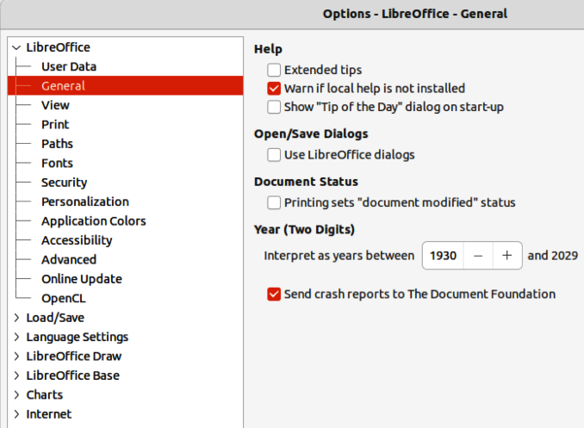
Figure 1: Options LibreOffice General dialog
Also, some of the dialogs may differ because of the settings selected in LibreOffice. Either use dialogs from the computer system (default) or dialogs provided by LibreOffice.
To change to using LibreOffice dialogs:
- On Linux and Windows operating systems, go to Tools > Options > LibreOffice > General on the Menu bar to open the dialog for general options.
- On a Mac operating system, go to LibreOffice > Preferences > LibreOffice > General on the Menu bar to open the dialog for general options.
- Select Use LibreOffice dialogs in Open/Save dialogs to display the LibreOffice dialogs on a computer display, as shown in Figure 1.
- Click OK to save the settings and close the dialog.

Icons
The LibreOffice community has created icons for several icon sets, including Breeze, Colibre, Elementary, Sifr, and Tango. Each user can select a preferred set. The icons used to illustrate some of the many tools available in LibreOffice may differ from the ones used in this guide. The icons in this user guide have been taken from a LibreOffice installation that has been set to display the Colibre set of icons.
Change the icon set used in a LibreOffice installation as follows:
- On Linux and Windows operating systems, go to Tools > Options > LibreOffice > View on the Menu bar to open the dialog for view options.
- On a Mac operating system, go to LibreOffice > Preferences > LibreOffice > View on the Menu bar to open the dialog for view options.
- In Icon Style select Colibre (SVG) from the options available in the drop down list as shown in Figure 2.
- In Icon Size, select Small from the drop down lists for Toolbar, Notebookbar and Sidebar, as shown in Figure 2.
- Click OK to save the settings and close the dialog.
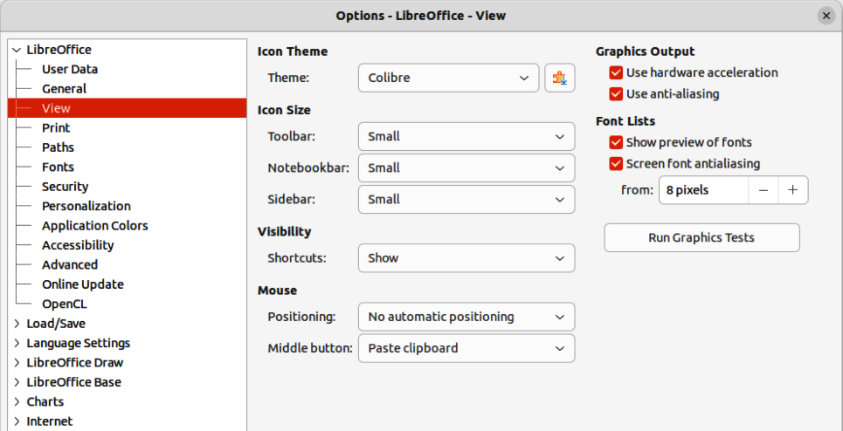
Figure 2: Options LibreOffice View dialog
- Note
Some Linux operating systems, for example Ubuntu, include LibreOffice as part of the installation and may not include the Colibre icon set. This icon set can be downloaded from the software repository for the Linux operating system being used.

Using LibreOffice on macOS
Some keystrokes and menu items are different on macOS from those used in Windows and Linux. Table 2 below gives some common substitutions for the instructions in this user guide. For a more detailed list, see the application help.
Table 2: Example of macOS keyboard shortcuts
Windows or Linux | macOS equivalent | Effect
Tools > Options on Menu bar | LibreOffice > Preferences on Menu bar | Access to setup options
Right-click | Ctrl+click and/or right-click depending on computer setup | Opens a context menu
Ctrl or Control | ⌘ and/or Cmd or Command, depending on keyboard | Used with other keys
Alt | ⌥ and/or Alt or Option depending on keyboard | Used with other keys

Who wrote this user guide?
This user guide was written by volunteers from the LibreOffice community. Profits from sales of the printed edition will be used to benefit the community.

Frequently asked questions
How is LibreOffice licensed?
LibreOffice is distributed under the Open Source Initiative (OSI) approved Mozilla Public License (MPL). See https://www.libreoffice.org/about-us/licenses/. It is based on code from Apache OpenOffice made available under the Apache License 2.0 but also includes software that differs from version to version under a variety of other Open Source licenses. New code is available under LGPL 3.0 and MPL 2.0.
May I distribute LibreOffice to anyone?
Yes.
May I sell it?
Yes.
May I use it in my business?
Yes.
How many computers may I install it on?
As many as you like.
Is LibreOffice available in my language?
LibreOffice has been translated (localized) into over 40 languages, so your language probably is supported. Additionally, there are over 70 spelling, hyphenation, and thesaurus dictionaries available for languages, and dialects that do not have a localized program interface. The dictionaries are available from the LibreOffice website at: www.libreoffice.org.
How can you make it for free?
LibreOffice is developed and maintained by volunteers and has the backing of several organizations.
I am writing a software application. May I use programming code from LibreOffice in my program?
You may, within the parameters set in the MPL and/or LGPL. Read the licenses: https://www.mozilla.org/MPL/2.0/.
Why do I need Java to run LibreOffice? Is it written in Java?
LibreOffice is not written in Java; it is written in the C++ language. Java is one of several languages that can be used to extend the software. The Java JDK/JRE is only required for some features. The most notable one is the HSQLDB relational database engine.
Java is available at no cost. More information and download links to the appropriate edition for your operating system can be found at: https://java.com/en/download/manual.jsp
- Note
If the LibreOffice features that require Java are to be used, it is important that the correct 32-bit or 64-bit edition matches the installed version of LibreOffice. For more information, see the Getting Started Guide. If Java is not to be used, nearly all of the LibreOffice features can still be used.
How can I contribute to LibreOffice?
You can help with the development and user support of LibreOffice in many ways, and you do not need to be a programmer. To start, check out this webpage: https://www.libreoffice.org/community/get-involved/
May I distribute the PDF of this user guide, or print and sell copies?
Yes, as long as requirements are met for one of the licenses in the copyright statement at the beginning of this user guide. There is no need to request special permission. LibreOffice request that you share with the project some of the profits you make from sales of user guides, in consideration of all the work we have put into producing them.
Donate to LibreOffice: https://www.libreoffice.org/donate/

What is new in LibreOffice 7.4?
The LibreOffice 7.4 Release Notes are available at this link https://wiki.documentfoundation.org/ReleaseNotes/7.4
Also at this link, the release notes for earlier versions of LibreOffice are located giving more information on the features that are included in LibreOffice.

