
Draw Guide 7.4

Chapter 3,
Working with Objects

Copyright
This document is Copyright © 2023 by the LibreOffice Documentation Team. Contributors are listed below. This document maybe distributed and/or modified under the terms of either the GNU General Public License (https://www.gnu.org/licenses/gpl.html), version 3 or later, or the Creative Commons Attribution License (https://creativecommons.org/licenses/by/4.0/), version 4.0 or later. All trademarks within this guide belong to their legitimate owners.

Contributors
Contributors for this edition:
Peter Schofield

Contributors for previous editions:
Claire Wood
Dave Barton
Elzett Kotze
Jean Hollis Weber
John A Smith
Kees Kriek
Martin Fox
Peter Schofield

Feedback
Please direct any comments or suggestions about this document to the Documentation Team mailing list: loguides@community.documentfoundation.org.
- Note
Everything sent to a mailing list, including email addresses and any other personal information that is written in the message, is publicly archived and cannot be deleted.

Publication date and software version
Published January 2023. Based on LibreOffice 7.4 Community.
Other versions of LibreOffice may differ in appearance and functionality.

Using LibreOffice on macOS
Some keystrokes and menu items are different on macOS from those used in Windows and Linux. The table below gives some common substitutions used in this document. For a detailed list, see LibreOffice Help.
Windows or Linux | macOS equivalent | Effect
Tools > Options  menu selection | LibreOffice > Preferences | Access setup options
Right-click | Control+click, Ctrl+click, or right-click depending on computer setup | Open a context menu
Ctrl or Control | ⌘ and/or Cmd or Command, depending on keyboard | Used with other keys
Alt | ⌥ and/or Alt or Option depending on keyboard | Used with other keys
F11 | ⌘+T | Open the Styles deck in the Sidebar

Contents
Copyright 2
Contributors 2
Feedback 2
Publication date and software version 2
Using LibreOffice on macOS 2
Introduction 5
Selecting objects 5
Direct selection 5
Selection by framing 5
Selecting hidden objects 5
Arranging objects 6
Positioning and adjusting objects 6
Using zoom 6
Status bar 7
Zoom & View Layout dialog 7
Zoom toolbar 8
Moving and adjusting object size 9
Moving objects 9
Adjusting object size 10
Modifying arcs 10
Rotating and slanting objects 10
Rotating objects 10
Slanting objects 11
Setting exact position, size, rotation and slant 12
Position and Size 14
Rotating objects 15
Slant and corner radius 16
Using grid and snap functions 17
Configuring grid and snap functions 17
Snap to grid 19
Using Snap to Grid 19
Displaying grid 19
Changing color of grid points 19
Snap points and lines 19
Inserting snap points and snap lines 20
Displaying snap points and lines 21
Editing snap points and lines 21
Deleting snap points and lines 22
Configuring snap range 22
Using Helplines 22
Changing object shape 23
Regular shapes 23
Basic shapes 23
Symbol Shapes 24
Block Arrows 25
Callouts 26
Stars and Banners 26
Curves and polygons 27
Bézier curves 27
Converting objects to curve or polygon 27
Editing points 27
Point types 28
Tangents 29
Symmetric transition 30
Smooth transition 30
Corner point 30
Points 31
Moving points 31
Inserting points 32
Deleting points 32
Eliminating points 33
Converting curves or lines 33
Splitting objects 34
Closing objects 34
Distorting objects 35

Introduction
This chapter looks at the tools and functions to modify existing drawings. All of the functions apply to a selected object or a group of selected objects, which can be distinguished by selection handles on a rectangular frame that is large enough to contain the object. Where several objects are selected, the frame around the objects corresponds to the smallest rectangle that can contain all of the objects. This frame is called the selection rectangle.
- Note
The color and shape of the selection handles changes depending on the tool and function that has been selected to change the object properties. The color of the selection handles also depends on the computer operating system and how the computer has been set up.

Selecting objects

Direct selection
The easiest way to select an object is to click directly on it. For objects that are not filled, click on the object border to select it. To select more than one object, hold the Shift key down while clicking on objects. To deselect an object, move the cursor into a blank space and click.

Selection by framing
Several objects can be selected at once by clicking and dragging the cursor around the objects drawing a selection rectangle around the objects. Only objects that lie entirely within this selection rectangle are selected. To select multiple objects by framing, Select on the Drawing toolbar must be active, as shown in Figure 1.
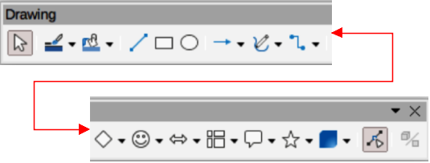
Figure 1: Drawing toolbar

Selecting hidden objects
If objects are located behind others and not visible, they can still be selected. When a hidden object is selected, its selection handles appear through the objects covering it.
- Windows, Mac or Linux — press the Tab key to select and cycle through the selection of objects in a drawing, stopping at the hidden object to select it. To cycle through the objects in reverse order, press Shift+Tab.
- Windows or Mac only — select the object in front of a hidden object, then press the Alt key (macOS ⌥) and click to select the hidden object. If there are several hidden objects, keep holding down the Alt key (macOS ⌥) and clicking until the object required is reached. To cycle through the objects in reverse order, hold down the Alt+Shift keys (macOS ⌥+Shift) and click.

Arranging objects
In a complex drawing, several objects may be stacked on top of one another. This stacking order can be rearranged by moving an object forward or backward using one of the following methods:
- Select an object, go to Shape > Arrange on the Menu bar, or right-click on the object and select Arrange from the drop down menu, then select one of the following options:
- Bring to Front (Ctrl+Shift++) (macOS ⌘+Shift++)
- Bring Forward (Ctrl++) (macOS ⌘++)
- Send Backward (Ctrl+–) (macOS ⌘+–)
- Send to Back (Ctrl+Shift+–) (macOS ⌘+Shift+–)
- In Front of Object
- Behind Object
- Select an object, then select one of the Arrange tools at the left end of the Line and Filling toolbar (Figure 2). When the cursor hovers over a tool, its function is indicated.
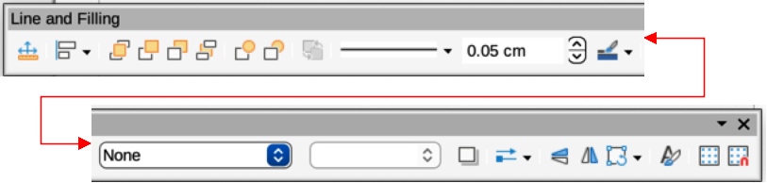
Figure 2: Line and Filling toolbar

Positioning and adjusting objects

Using zoom
To help in the positioning and adjustment of objects, Draw has a zoom function that reduces or enlarges the screen display of the current drawing. For example, zoom in to position objects on a drawing with greater accuracy; zoom out to see the complete drawing. Zooming is controlled using the Status Bar, Zoom & View Layout dialog, or Zoom toolbar.
- Note
Zooming is handled differently in Linux operating systems. Drawings saved with 100% zoom factor in Windows or macOS are displayed at a larger zoom factor in Linux.
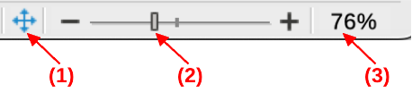
Figure 3: Status Bar zoom controls
- Fit slide to current window
- Zoom slide control
- Zoom percentage
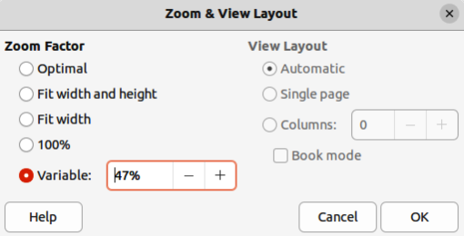
Figure 4: Zoom & View Layout dialog

Status bar
The zoom controls are located on the right side of the Status Bar (Figure 3) and these controls give quick and easy access to zooming. Use one of the following methods to change the zoom factor:
- Fit slide to current window – fits the drawing to the open window.
- Zoom Out — minus sign (–) on the zoom slide control reduces the zoom factor.
- Zoom In — plus sign (+) on the zoom slide control increases the zoom factor.
- Click and drag the zoom slide control to increase or decrease the zoom factor.
- Right-click on the zoom percentage number and select a zoom option from the context menu that opens.

Zoom & View Layout dialog
The Zoom & View Layout dialog (Figure 4) is opened using one of the following methods:
- Click on the zoom percentage number in the Status Bar.
- Go to View > Zoom > Zoom on the Menu bar.
The Zoom & View Layout dialog provides the following options to control how a drawing is viewed on a display.
Zoom Factor
Sets the zoom factor at which to display the current document and all documents of the same type that are subsequently opened.
Optimal
Resizes the display to fit the width of the text in the document.
Fit width and height
Displays the entire page on the screen.
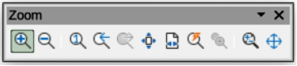
Figure 5: Zoom toolbar
Fit width
Displays the complete width of the document page. The top and bottom edges of the page may not be visible.
100%
Displays the document at its actual size.
Variable
Enter a percentage in the box for the zoom factor to display the document.
View Layout
Used to set the view layout and is not available for drawings. View layout is normally used in text documents to see the effects of different layout settings.

Zoom toolbar
Go to View > Toolbars > Zoom on the Menu bar to open the Zoom toolbar (Figure 5). The tools available on this toolbar, from left to right, are as follows:
Zoom In
Displays the drawing at two times its current size each time the tool is selected.
Zoom Out
Displays the drawing at half its current size each time the tool is selected.
100%
Displays the drawing at its actual size.
Zoom Previous
Returns the display of the drawing to the previous zoom factor applied.
Zoom Next
Undo the action of the previous zoom command.
Entire Page
Displays the whole drawing in the Workspace.
Page Width
Displays the complete width of the drawing. The top and bottom edges of the slide may not be visible.
Optimal
Resizes the display to include all of the objects on the slide.
Object Zoom
Resizes the display to fit the selected object(s).
Zoom & Pan
Zooms in for each click. Ctrl+click (macOS ⌘+click) zooms out for each click. Shift+click allows panning of the drawing.
Shift
Moves the drawing within the Workspace. Place the cursor on the drawing and drag to move the drawing.

Moving and adjusting object size
When moving an object or changing its size, check the left-hand area of the Status Bar at the bottom of the Workspace (Figure 6). From left to right, this area shows that a shape is selected, its position on the drawing in X/Y coordinates and dimensions of the object. The measurement units are those selected in Tools > Options > LibreOffice Draw > General (macOS Preferences > LibreOffice > LibreOffice Draw > General).

Moving objects
To move an object (or a group of objects), select it, then click and drag within the object borders. During movement, a ghost image of the object appears to help with repositioning, as shown in Figure 7. When the object reaches its new location, release the cursor.
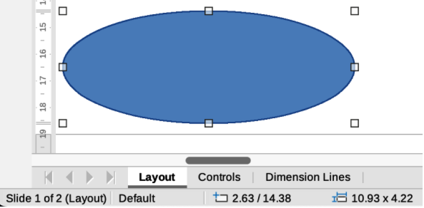
Figure 6: Left end of Status Bar with object selected
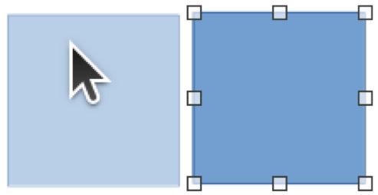
Figure 7: Example of moving objects
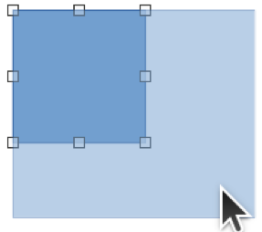
Figure 8: Example of adjusting objects

Adjusting object size
To change the size of a selected object (or a group of selected objects), move the cursor to one of the selection handles. The cursor changes shape to indicate the direction of movement for that selection handle.
Click and drag the selection handle to change object size. The results depend on which selection handle is used. To resize an object along one axis, use a side, top, or bottom handle. To resize along both axes, use a corner handle.
As the object size changes, a ghosted outline of the object appears, as shown in Figure 8. When the desired size of the object is reached, release the cursor.
- Note
Pressing and holding the Shift key while resizing an object. changes the size symmetrically keeping the aspect ratio of width to height the same. This Shift key behavior works on all selection handles.

Modifying arcs
The size of an arc can be changed by adjusting the positions of the start and end points of an arc. The selection handle at the start point of an arc is larger than the end point of an arc.
Select an arc, then right click on the arc and select Points from the drop down menu or press the F8 key. Two handles appear at the start and end of the arc, as shown in Figure 9.
Click and drag on one of the start or end handle to change the shape of the arc. Release the cursor when the desired arc shape is reached.

Rotating and slanting objects

Rotating objects
To rotate an object (or a group of objects), select the object, then go to rotation mode using one of the following methods.
- Select an object so that the selection handles are displayed.
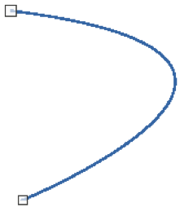
Figure 9: Example of modifying arcs
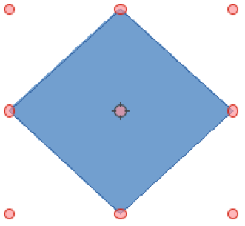
Figure 10: Object in rotation mode
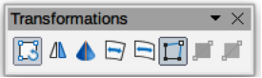
Figure 11: Transformations toolbar
- Use one of the following methods to switch to rotation mode. The selection handles change shape and color and a center of rotation indicator appears in the center of the object, as shown in Figure 10.
- Click again on a selected object.
- Click on the triangle ▼ on the right of Transformations on the Line and Filling toolbar and select Rotate from the pop up menu.
- Go to View > Toolbars > Transformations on the Menu bar to open the Transformations toolbar (Figure 11) and select Rotate.
- Move the cursor over a corner selection handle and the cursor changes shape to indicate rotation mode.
- Click on and drag the corner selection handle to rotate the object. Release the cursor when the desired object rotation is reached.
- Notes
The rotation center is normally located at the center of an object. To change the position of the rotation center, click and drag the rotation center until it is at the desired position. This rotation center can even be outside of the object.
Rotation works in a slightly different way for 3D objects because it occurs in a three dimensional space and not in a single plane. See Chapter 7, Working with 3D Objects for more information.

Slanting objects
The axis used for slanting an object is the object edge directly opposite the midpoint handle being used to slant the object. This axis stays fixed in location while the other sides of the object move in relation to it as the selection handle is dragged. In Figure12 the selection handle at the bottom of the object has been used to slant the object..
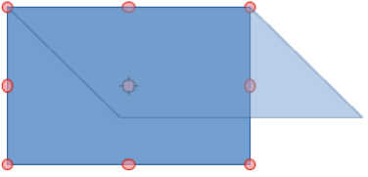
Figure 12: Example of slanting objects
- Select or click on an object and use one of the following methods to switch to rotation mode. The selection handles change shape and color and a center of rotation indicator appears in the center of the object.
- Click again on a selected object.
- Click on the triangle ▼ on the right of Transformations on the Line and Filling toolbar and select Rotate from the pop up menu.
- Go to View > Toolbars > Transformations on the Menu bar to open the Transformations toolbar and select Rotate.
- Move the cursor over a selection handle at the midpoint of the top, bottom, left or right sides of the object and the cursor changes shape to indicate slanting direction.
- Click and drag the selection handle to slant the object. Release the cursor when the desired object slant is reached. A ghosted outline of the object being slanted appears and the current angle of slanting is shown in the Status Bar.
- Note
Press and hold the Shift key while rotating or slanting an object, movement is restricted to 15°. This is the default behavior of the Shift key. However, if When creating or moving objects has been selected in Tools > Options > LibreOffice Draw > Grid (macOS LibreOffice > Preferences > LibreOffice Draw > Grid), the action of the Shift key is reversed and rotation or slanting is restricted to 15° of movement unless the Shift key is pressed.

Setting exact position, size, rotation and slant
Using the cursor to position and resize objects is not exact. If greater accuracy is required to position and size an object, it is recommended to use the Position and Size dialog (Figure 13), or the Position and Size panel (Figure 14) in the Properties deck on the Sidebar.
- To open the Position and Size dialog, select the object and use one of the following methods:
- Go to Format > Position and Size on the Menu bar.
- Right-click on the object and select Position and Size from the context menu.
- Use the keyboard shortcut F4.
- To open the Position and Size panel in the Properties deck on the Sidebar, select the object, then click on Properties on the Sidebar and click on the chevron > on the Position and Size title bar to open the panel.
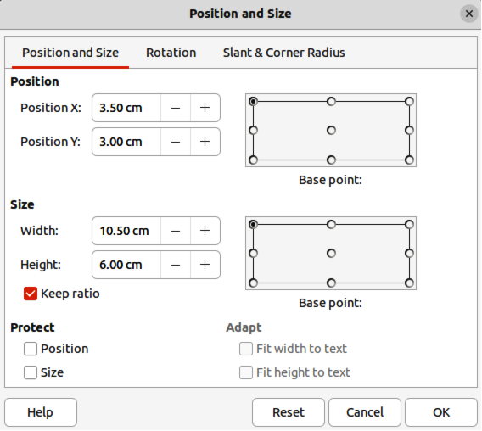
Figure 13: Position and Size dialog
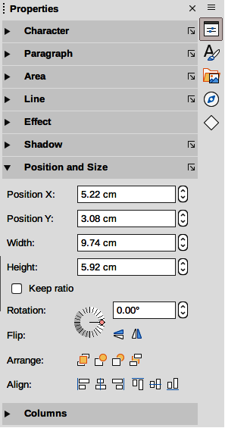
Figure 14: Position and Size panel in Properties deck on Sidebar

Position and Size
Position
Specify the location of the selected object on the page. The units of measurement used for X//Y coordinates and the width and height of the object are set by going to Tools > Options > LibreOffice Draw > General (macOS LibreOffice > Preferences > LibreOffice Draw > General).
Position X
Enter the horizontal distance required to move the object relative to the base point selected in the grid.
Position Y
Enter the vertical distance required to move the object relative to the base point selected in the grid.
Base point
Select a base point in the grid and then enter the amount required to shift the object relative to the base point that is selected in the Position Y and Position X boxes. The base points correspond to the selection handles on an object. This option is only available in the Position and Size dialog.
Size
Specify the amount required to resize the selected object with respect to the selected base point.
Width
Enter a width for the selected object.
Height
Enter a height for the selected object.
Keep ratio
Maintains proportions when resizing the selected object.
Base point
Select a base point in the grid, and then enter the new size dimensions for the selected object in the Width and Height boxes. This option is only available in the Position and Size dialog.
Protect
This option is only available in the Position and Size dialog.
Position
Prevents changes to the position or the size of the selected object.
Size
Prevents resizing of the object.
Adapt
Specifies, if the size of a text box should be adjusted to fit the size of entered text. This option is only available in the Position and Size dialog for text boxes.
Fit width to text
Expands the width of the object to the width of the text, if the object is smaller than the text.
Fit height to text
Expands the height of the object to the height of the text, if the object is smaller than the text.
- Note
The default location of the base points for position and size is the upper left corner of the drawing area. This base point can be temporarily changed to make positioning or dimensioning simpler by clicking on a position corresponding to the location of the base point required. This change in base point is only valid for single use and the base point is reset to the standard position of top left corner when the Position and Size dialog is closed.

Rotating objects
To accurately rotate an object, click on the Rotation tab of the Position and Size dialog to open the Rotation page (Figure 15). The options available allow the rotation angle and the location of the pivot point to be defined. Alternatively, use the available options for rotation in the Position and Size panel in the Properties deck on the Sidebar.
Pivot Point
The selected object is rotated around a specified pivot point and is only available in the Position and Size dialog. The default position for the pivot point is at the center of the object. The pivot point can be moved from its default central position by changing the setting for Position X and/or Position Y, or selecting a position in Default settings.
Position X
Enter horizontal distance from the left edge of the page to change the position of the pivot point.
Position Y
Enter vertical distance from the top edge of the page to change the position of the pivot point.
Default settings
Select the position of the pivot point. Default position is the center of the object. Changing the pivot point is valid for single use only and is reset to the default central position when the Position and Size dialog is closed.
Rotation Angle
Specify the number of degrees required to rotate the selected object. This option is only available in the Position and Size dialog.
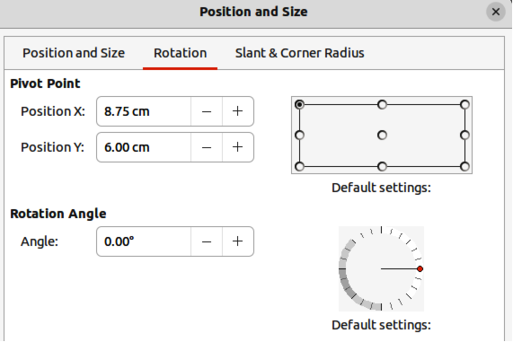
Figure 15: Position and Size dialog - Rotation page
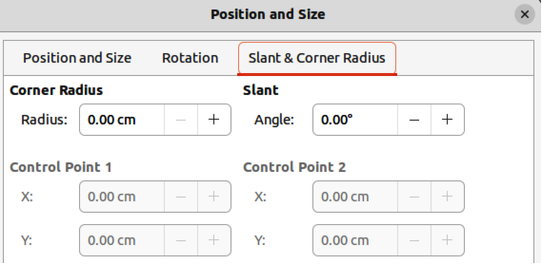
Figure 16: Position and Size dialog - Slant & Corner Radius page
Angle
Enter the number of degrees that required to rotate the selected object.
Default settings
Click on the indicator to rotate the object. The number of degrees rotated is shown in the Angle box.

Slant and corner radius
To accurately set the corner radius or slant angle of an object, click on the Slant & Corner Radius tab of the Position and Size dialog (Figure 16). Options for slant and corner radius are only available in the Position and Size dialog.
Corner Radius
This option is only available for the corners of a rectangular or square object that has been created using the Legacy Rectangles toolbar. This toolbar is optional and is opened by going to View > Toolbars > Legacy Rectangles on the Menu bar. If this option is grayed out, the corner radius cannot set.
Radius
Enter the radius of the circle that is to be used to round corners. The larger the value for corner radius set, the rounder corners of a rectangle or square become.
Slant
Slants the selected object along the bottom edge of the object.
Angle
Enter the angle of the slant axis. The slant angle relates to how much an object inclines or slants from its normal vertical position on a drawing.
Control Point 1/Control Point 2
These control points are special handles or dots that are available on some shapes and are used to change the properties of a shape. If these options are grayed out, then the shape does not have a special handle and coordinates cannot be set.
Enter a value to set the X and Y coordinates of the special handle in relation to the top left corner of the shape. The example shown in Figure 17 shows the change in shape after adjusting the X coordinate of Control Point 1 of the special handle.
- Note
For more information on this special handle used for control points, see “Changing object shape” on page 23.
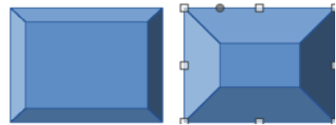
Figure 17: Example of Corner Point adjustment
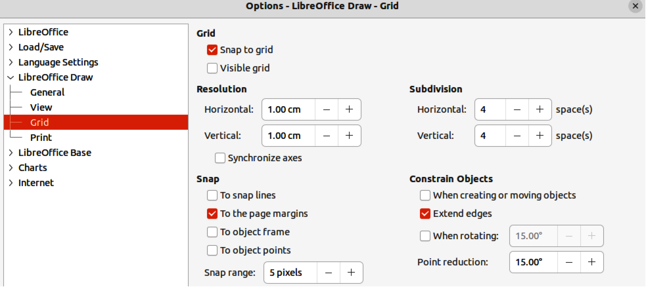
Figure 18: Options LibreOffice Draw dialog - Grid page
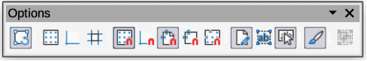
Figure 19: Options toolbar

Using grid and snap functions
Objects can be positioned accurately and consistently using the grid and snap functions available in Draw. To make it easier to use the grid and snap functions, it is recommended to use the highest practical zoom value for a drawing. Two different functions can be used at the same time. For example, snapping to a guide line and the page edge. However, it is recommended to activate only those snap functions that are necessary.

Configuring grid and snap functions
To configure the grid and snap functions in a drawing, go to Tools > Options > LibreOffice Draw > Grid (macOS LibreOffice > Preferences > LibreOffice Draw > Grid) on the Menu bar to display the Grid dialog (Figure 18). The grid and snap functions can also be displayed and switched on or off using this dialog, right-clicking on a drawing and selecting options in the context menu, or using the tools on the Options toolbar (Figure 19). If the Options toolbar is not open, go to View > Toolbars > Options on the Menu bar.
Grid
Specifies the settings for the configurable grid in a drawing and helps to determine the exact position of objects. Also, this grid can be set in line with the magnetic snap grid. If the snap grid is activated, but want to move or create individual objects without snap positions, keep the Shift key pressed to deactivate this function.
Snap to grid
Specifies whether to move frames, drawing elements, and controls only between grid points. To change the status of the snap grip only for the current action, drag an object while holding down the Ctrl key (macOS ⌘).
Visible grid
Specifies whether to display the grid.
Resolution
Horizontal
Defines the unit of measure for the spacing between grid points on the X-axis.
Vertical
Defines the grid points spacing in the desired unit of measurement on the Y-axis.
Synchronize axes
Specifies whether to change the current grid settings symmetrically. The resolution and subdivision for the X and Y axes remain the same.
Subdivision
Horizontal
Specify the number of intermediate spaces between grid points on the X-axis.
Vertical
Specify the number of intermediate spaces between grid points on the Y-axis.
Snap
To snap lines
Snaps the edge of a dragged object to the nearest snap line when the click is released. This setting can also be defined using Snap to Snap Guides on the Options toolbar.
To the page margins
Specifies whether to align the contour of the graphic object to the nearest page margin. The cursor or a contour line of the graphics object must be in the snap range. This function can also be accessed using Snap to Page Margins in the Options toolbar.
To object frame
Specifies whether to align the contour of the graphic object to the border of the nearest graphic object. The cursor or a contour line of the graphics object must be in the snap range. This function can also be accessed with Snap to Object Border in the Options toolbar.
To object points
Specifies whether to align the contour of the graphic object to the points of the nearest graphic object. This only applies if the cursor or a contour line of the graphics object is in the snap range. This function can also be accessed with Snap to Object Points in the Options toolbar.
Snap range
Defines the snap distance between the cursor and the object contour. Snaps to a snap point if the cursor is closer than the distance selected.
Constrain Objects
When creating or moving objects
Specifies that graphic objects are restricted vertically, horizontally or diagonally (45°) when creating or moving them. This setting can be temporarily deactivated by pressing the Shift key.
Extend edges
Specifies that a square is created based on the longer side of a rectangle when the Shift key is pressed before releasing the click. This also applies to an ellipse (a circle is created based on the longest diameter of the ellipse). When Extend edges is not selected, a square or a circle is created based on the shorter side or diameter.
When rotating
Specifies that graphic objects can only be rotated within the rotation angle that is selected. To rotate an object outside the defined angle, press the Shift key when rotating. Release the key when the desired rotation angle is reached.
Point reduction
Defines the angle for point reduction. When working with polygons, this maybe useful in reducing the editing points.

Snap to grid

Using Snap to Grid
Using Snap to Grid moves an object exactly onto a grid point in a drawing. This function can be switched on and off using one of the following methods:
- Go to View > Snap Guides > Snap to Grid on the Menu bar.
- Right-click on a drawing and select Snap Guides > Snap to Grid from the context menu.
- Click on Snap to Grid on the Options toolbar.

Displaying grid
Displaying or turning off the grid in a drawing is done using one of the following methods:
- Go to View > Grid and Helplines > Display Grid on the Menu bar.
- Click on Display Grid on the Options toolbar.
- Right-click on a drawing and select Grid and Helplines > Display Grid from the context menu.
- Select Visible grid in the Options LibreOffice Draw Grid dialog.

Changing color of grid points
By default and depending on the display and computer setup, the grid points are gray and are not always easy to see. To change the color of the grid points, go to Tools > Options > LibreOffice > Application Colors (macOS LibreOffice > Preferences > LibreOffice > Application Colors) to open the Application Colors dialog (Figure 20). In Drawing/Presentation, select a more suitable color for the grid from the drop-down list.

Snap points and lines
Unlike the grid, snap lines and snap points can be inserted when to position an object to a specific position on a drawing. Snap lines can either be horizontally or vertically and appear as dashed lines. Snap points appear as small crosses with dashed lines. Snap points and snap lines do not appear in printed output.
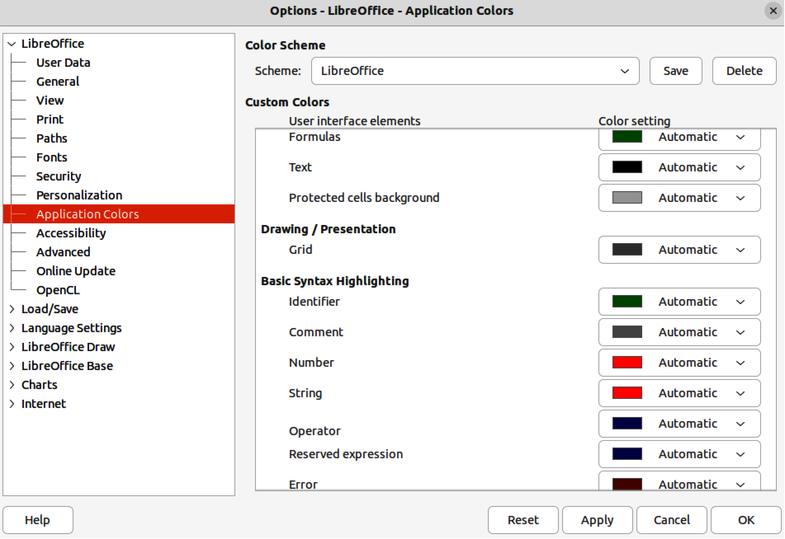
Figure 20: Options LibreOffice dialog - Application Colors page
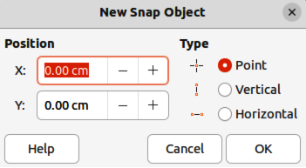
Figure 21: New Snap Object dialog

Inserting snap points and snap lines
To insert a snap point or snap line, go to Insert > Snap Guide on the Menu bar to open the New Snap Object dialog (Figure 21).
Position
Sets the position of a selected snap point or line relative to the top left corner of the page.
X:
Enter the amount of space required between the snap point or line and the left edge of the page.
Y:
Enter the amount of space required between the snap point or line and the top edge of the page.
Type
Specifies the type of snap object being inserted.
Point
Inserts a snap point.
Vertical
Inserts a vertical snap line.
Horizontal
Inserts a horizontal snap line.

Displaying snap points and lines
Displaying or turning off snap points and lines in a drawing can be done using one of these methods:
- Go to View > Snap Guides > Display Snap Guides on the Menu bar.
- Click on Display Snap Guides in the Options toolbar.
- Right-click on a drawing and select Snap Guides > Display Snap Guides from the context menu.

Editing snap points and lines
To edit a snap point, right-click on the snap point and select Edit Snap Point from the context menu to open the Edit Snap Point dialog (Figure 22). Enter new X and Y coordinate settings for the snap point and click OK. Alternatively, click and drag a snap point to a new position on a drawing.
To edit a snap line, right-click on the snap line and select Edit Snap Line from the context menu to open the Edit Snap Line dialog (Figure 23). Enter a new X coordinate setting for vertical snap lines or a new Y coordinate setting for horizontal snap lines and click OK. Alternatively, click and drag a snap line to a new position on a drawing.
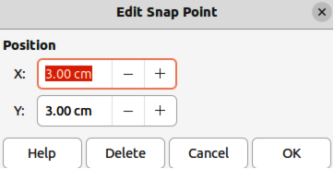
Figure 22: Edit Snap Point dialog
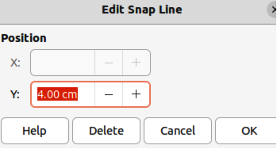
Figure 23: Edit Snap Line dialog

Deleting snap points and lines
To delete a snap point, drag it back to a ruler or right-click on the snap point and select Delete Snap Point from the context menu.
To delete a snap line, drag it back to the ruler or right-click on the snap line and select Delete Snap Line from the context menu.

Configuring snap range
To configure the snap range of when an object snaps to position
- Go to Tools > Options > LibreOffice Draw > Grid (macOS LibreOffice > Preferences > LibreOffice Draw > Grid) on the Menu bar to open the Options LibreOffice Grid dialog.
- Enter the number of pixels to set the proximity of when the object will snap into position in the Snap range box. The default setting is 5 pixels.
- Click OK to set the new snap range and close the dialog.

Using Helplines
Helplines are a function in Draw to help in positioning of objects. Helplines can be displayed while the object is being moved. They extend from the edges of the object to the rulers at the top and left side of a drawing and do not have a snap function (Figure 24).
To use guide lines, go to Tools > Options > LibreOffice Draw > View (macOS LibreOffice > Preferences > LibreOffice Draw > View) on the Menu bar to open the Options LibreOffice Draw View dialog (Figure 25) and select Helplines when moving option or click Helplines While Moving in the Options toolbar.
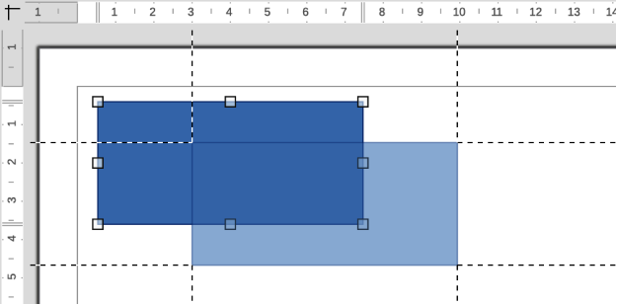
Figure 24: Example of Helplines While Moving
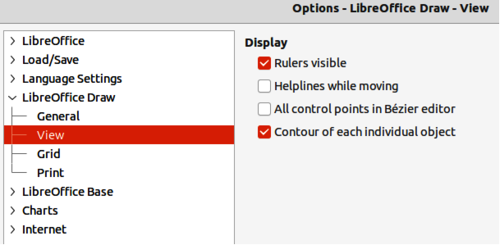
Figure 25: Options LibreOffice Draw dialog - View page

Changing object shape

Regular shapes
When drawing certain regular shapes, one or more dots (special handles) are displayed in a different color to the selection handles when an object is selected. When the cursor hovers over one of these dots, it changes shape. Clicking and dragging on these dots modifies the shape of the object. For example, increasing corner radius of a rounded rectangle or square, changes the angles of an arc, and so on. These dots perform different functions according to the shape selected.
- Note
Regular shapes can also be changed after conversion to a curve or polygon and editing the points. See “Curves and polygons” on page 27 and “Editing points” on page 27 for more information.

Basic shapes
Refer to Figure 26, from left to right, to identify the following shapes with adjustment dots.
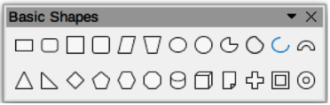
Figure 26: Basic Shapes sub-toolbar
Rectangle, Rounded
Changes the radius of the curve that replaces the angled corners of a rectangle or square.
Square, Rounded
Changes the radius of the curve that replaces the angled corners of a rectangle or square.
Parallelogram
Changes the internal angles between the sides.
Trapezoid
Changes the internal angles between the sides.
Circle Pie
Changes the size of the filled sector.
Block Arc
Changes both internal diameter and size of the filled area.
Isosceles Triangle
Changes the shape and type of the triangle.
Hexagon
Changes the internal angles between the sides.
Octagon
Changes the internal angles between the sides.
Cylinder
Changes the perspective.
Cube
Changes the perspective.
Folded Corner
Changes the size of the folded corner.
Cross
Changes the thickness of the four arms of the cross.
Frame
Changes the thickness of the frame.
Ring
Changes the internal diameter of the ring.

Symbol Shapes
Refer to Figure 27, from left to right, to identify the following shapes with adjustment dots.
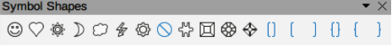
Figure 27: Symbol Shapes sub-toolbar
Smiley Face
Changes the smile on the face.
Heart
Changes the shape of the symbol.
Sun
Changes the shape of the symbol.
Moon
Changes the shape of the symbol.
Prohibited
Changes the thickness of the ring and the diagonal bar.
Square Bevel
Changes the thickness of the bevel.
Octagon Bevel
Changes the thickness of the bevel.
Diamond Bevel
Changes the thickness of the bevel.
Double Bracket
Changes the curvature of the bracket.
Left Bracket
Changes the curvature of the bracket.
Right Bracket
Changes the curvature of the bracket.
Double Brace
Changes the curvature of the bracket.
Left Brace
Changes the curvature of the brace and the position of the point.
Right Brace
Changes the curvature of the brace and the position of the point.

Block Arrows
Refer to Figure 28, from left to right, to identify the following shapes with adjustment dots.
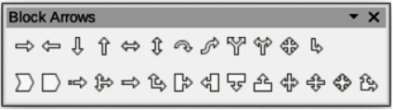
Figure 28: Block Arrows sub-toolbar
Right Arrow
Changes the shape and thickness of the arrow.
Left Arrow
Changes the shape and thickness of the arrow.
Down Arrow
Changes the shape and thickness of the arrow.
Up Arrow
Changes the shape and thickness of the arrow.
Left and Right Arrow
Changes the shape and thickness of the arrow.
Up and Down Arrow
Changes the shape and thickness of the arrow.
Circular Arrow
Changes the shape and thickness of the arrow.
4-way Arrow
Changes the shape and thickness of the arrow.
Chevron
Changes the angle between the sides and the shape.
Pentagon
Changes the angle between the sides and the shape.
Striped Right Arrow
Changes the shape and thickness of the arrow.
Up, Right and Down Arrow
Changes the shape and thickness of the arrow.
Notched Right Arrow
Changes the shape and thickness of the arrow.
Up and Right Arrow
Changes the shape and thickness of the arrow.
Right Arrow Callout
Changes the shape and thickness of the callout.
Left Arrow Callout
Changes the shape and thickness of the callout.
Down Arrow Callout
Changes the shape and thickness of the callout.
Up Arrow Callout
Changes the shape and thickness of the callout.
Left and Right Arrow Callout
Changes the shape and thickness of the callout.
Up and Down Arrow Callout
Changes the shape and thickness of the callout.
4-way Arrow Callout
Changes the shape and thickness of the callout.
Up and Right Arrow Callout
Changes the shape and thickness of the callout.

Callouts
For all callouts (Figure 29) use the adjustment dots to change the length, position and angle of the pointer.
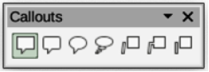
Figure 29: Callouts sub-toolbar

Stars and Banners
Refer to Figure 30, from left to right, to identify the following shapes with adjustment dots.
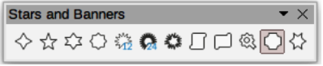
Figure 30: Stars and Banners sub-toolbar
4-Point Star
Changes the thickness and shape of the star points.
8-Point Star
Changes the thickness and shape of the star points.
24-Point Star
Changes the thickness and shape of the star points.
Vertical Scroll
Changes the width and shape of the scroll.
Horizontal Scroll
Changes the width and shape of the scroll.
Doorplate
Changes the inward curvature of the corners.

Curves and polygons

Bézier curves
The editing of curves and polygons depends on the mathematics of Bézier curves. Explaining Bézier curves goes beyond this scope of this chapter. See Chapter 11, Advanced Draw Techniques for more information on drawing and manipulating Bézier curves.
Editing a Bézier curve consists in principle of moving points or tangents passing through these points. Each tangent has one control point at each end and a junction point where it meets the curve. The relative angle and distance between control points determine the shape of the curve. Figure 31 shows what happens to a basic square and changing only one point on the square.

Converting objects to curve or polygon
When changing the shape of an object and before modifying the points on an object, it must be converted to a curve or a polygon. Depending on what kind of shape and effect required to produce using one of the following methods to create a curve or a polygon:
- After selecting an object, go to Shape > Convert on the Menu bar and select either To Curve or To Polygon.
- Right click on an object and select Convert > To Curve or To Polygon from the context menu.

Editing points
Many different shapes can be created by moving either the point itself, or one or both of the round handle points at either end of the tangent, as shown in Figure 31. Points can be added, deleted, or points type changed using tools available on the Edit Points toolbar (Figure 32).
After converting a shape to a curve or polygon, object points are edited as follows:
- Select the object and switch to points editing mode using one of the following methods.
- Go to Edit > Points on the Menu bar.
- Click on the Points tool on the Standard toolbar.
- Right click on the converted object and select Points from the context menu.
- Use the keyboard shortcut F8.
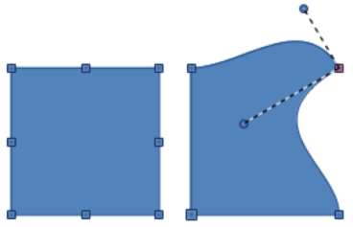
Figure 31: Example of creating different shapes by changing tangent points
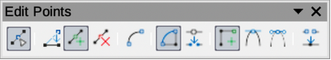
Figure 32: Edit Points toolbar
- Note
After switching to points editing mode, the selection handles become points. The number of points may increase or reduce in number. This change in number depends on the shape of the object and is normal behavior.
- Click on an object point to change the object shape. The Edits Points toolbar opens and the tools become active when a point is selected. Tangents also appear attached to the selected point.
- Use the various tools on the Edit Points toolbar to add, delete, or change the point type.
- Click on and drag the point to move the point and change the object shape.
- If the selected object is a curve, click on and drag the round points at the end of a tangent to make further changes to the object shape.
- When satisfied with the shape, click outside of the object to cancel points editing mode and close the Edit Points toolbar.

Point types
The available tools on the Edit Points toolbar depend on the object and type of object point that has been selected.
Move Points
Activates a mode allowing movement of points. Click, hold and drag the selected point to another location. The object border follows the movement on both sides of the selected point to the next point on each side of the selected point.
Insert Points
Activates the insert mode and allows points to be inserted. Points can also be moved. A point is inserted onto the selected object each time there is a click made and the object changes shape to include the new point into the border of the object. The inserted point is a smooth point.
Delete Points
Used to delete points from the selected object. Select Delete Points and then click on a point to delete it. To delete several points, hold down the Shift key as each point is selected for deletion, then click on Delete Points.
Convert To Curve
Converts a curve into a straight line or a straight line into a curve. If a single point is selected, the curve before the point will be converted. If two points are selected, the curve between both points will be converted. If more than two points are selected and each time this icon is clicked, a different portion of the curve will be converted. If necessary, round points are converted into corner points and corner points are converted into round points.
If a section of the curve is a straight line, the end points of the line have a maximum of one control point each. They cannot be modified to round points unless the straight line is converted back to a curve.
Close Bézier
Closes a curve. A curve is closed by connecting the last point with the first point, indicated by an enlarged square.
Split Curve
Select the point or points where the curve will be split, then click on Split Curve.
Corner Point
Converts the selected point or points into corner points. Corner points have two movable control points, which are independent from each other. A curved line, therefore, does not go straight through a corner point, but forms a corner.
To create a corner point, a smooth or a symmetrical point must be inserted first and then converted to a corner point by clicking on Corner Point.
Smooth Transition
Converts a corner point or symmetrical point into a smooth point. Both control points of the corner point are aligned in parallel, and can only be moved simultaneously. The control points may differentiate in length, allowing variation in the degree of curvature.
Symmetric Transition
Converts a corner point or a smooth point into a symmetrical point. Both control points of the corner point are aligned in parallel and have the same length. They can only be moved simultaneously and the degree of curvature is the same in both directions.
Eliminate Points
Marks selected points for deletion. This happens if the point is located on a straight line. If converting a curve or a polygon using Convert to Curve into a straight line or alter a curve using the cursor so that a point lies on the straight line, the selected point is removed. The angle from which the point reduction is to take place is 15° by default.

Tangents
Before using tangents on an object, the object must be converted to a curve. Tangents are only used on curves. If an object has been converted to a polygon and a tangent is added, the object is automatically converted to a curve.
- Note
The angle that a tangent relates to an object shape can be changed by clicking on one of the tangent control points at the end of a tangent and moving it with the cursor. As the tangent angle is changed, the shape of the object changes in response.
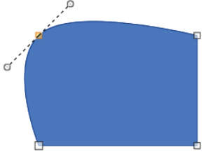Figure 33: Example of symmetric transition

Symmetric transition
Symmetric transition converts a corner point or a smooth point into a symmetrical point. The tangents have the same length and are aligned in a straight line, as shown in Figure 33. The tangents can only be moved simultaneously and the degree of curvature is the same in both directions.
- Convert the object to a curve or polygon.
- Switch the selected object into editing points mode and open the Edit Points toolbar.
- Select the point to be changed to a symmetrical point.
- Click on Symmetric Transition in the Edit Points toolbar. The straight line on each side of the symmetric transition point is converted to a curve.
- Click and drag one of the tangent control handles to change the curvature and shape of the object. Any change to one tangent is carried over symmetrically to the other tangent.

Smooth transition
Smooth transition converts a corner point or symmetrical point into a smooth point. The tangents are aligned in a straight line and can only be moved simultaneously. The tangents can have different lengths with the curvature controlled by the longest tangent being the largest curvature, as shown in Figure 34.
- Convert the object to a curve or polygon.
- Switch the selected object into editing points mode and open the Edit Points toolbar.
- Select the point to be changed to a symmetrical point.
- Click on Smooth Transition on the Edit Points toolbar.
- Click and drag one of the tangent control handles to change the shape of the object. This creates an asymmetric tangent with the largest curvature on the tangent longest side.
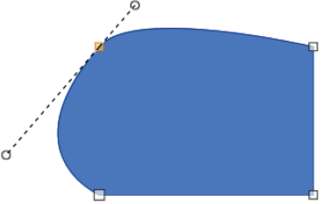
Figure 34: Example of smooth transition

Corner point
Converts a selected point or points into corner points. Corner points have two movable control points, which are independent from each other. It is possible to independently change the angle on each side of a tangent using the central point of the tangent as a corner point, as shown in Figure 35.
- Convert the object to a curve or polygon.
- Switch the selected object into editing points mode and open the Edit Points toolbar.
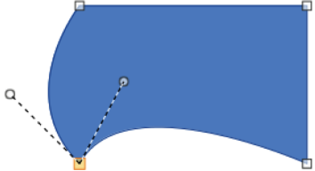
Figure 35: Example of corner point
- Select the point to be changed to a symmetrical point.
- Click on Corner Point on the Edit Points toolbar.
- Click and drag the end of one of the tangents to change its angle. Each tangent can be moved independently to create spikes and troughs in an object shape.

Points

Moving points
When moving points, the object border on both sides of the point follows the movement of the point changing the object shape.
- Convert the object to a curve or a polygon.
- Switch the selected object into editing points mode and open the Edit Points toolbar.
- Select the point to be changed to a symmetrical point.
- Click on Move Points on the Edit Points toolbar.
- Place the cursor on the selected point, then click and drag the point to create a new shape. Figure 36 illustrates how a different shape can be created from a circle by dragging the left hand side point to the left.
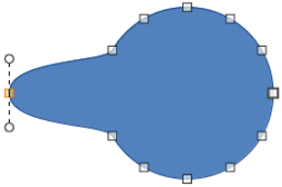
Figure 36: Example of moving points
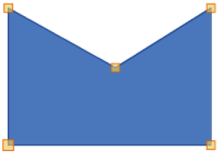
Figure 37: Example of inserting points

Inserting points
A point is inserted onto the selected object each time there is a click. Clicking inside the border of the object, the object changes shape to include the new point into the border of the object, as shown in Figure 37. The inserted point is a smooth point.
Points can also be moved in insert point mode. Hover the cursor over the point until it changes shape, then click and drag the point to change the object shape.
- Convert the object to a curve or a polygon.
- Switch the selected object into editing points mode and open the Edit Points toolbar.
- Click on Insert Points on the Edit Points toolbar.
- Click on the object border to insert a point at the required position on the border.
- Alternatively, click inside the object border to insert a point. The object automatically changes shape to include the new point into the object border.

Deleting points
Figure 38 shows what happens when three points on the left were deleted from a circle. The left image is a the full circle and the right image is where three points have been deleted creating a new shape.
- Convert the object to a curve or a polygon.
- Switch the selected object into editing points mode and open the Edit Points toolbar.
- To delete a single point, proceed as follows
- Select the point for deletion.
- Click on Delete Points on the Edit Points toolbar.
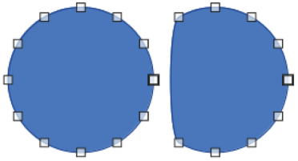
Figure 38: Example of deleting points
- To delete several points at the same time, proceed as follows:
- Hold down the Shift key.
- Select all the points for deletion.
- Click on Delete Points on the Edit Points toolbar.

Eliminating points
The Eliminate Points tool on the Edit Points toolbar only functions on lines with multiple points. These lines are created when a curve is converted to a line using the Convert to Curve tool. An example of creating a straight line and eliminating points is shown in Figure 39.
- Convert the curve to a curve or a polygon.
- Switch the curve into editing points mode and open the Edit Points toolbar.
- Select the curve with multiple points and convert to a line, see “Converting curves or lines” below.
- Select the point or points on the line for elimination. The selected point is emphasized.
- Select the Eliminate Points tool on the Edit Points toolbar.
- Accurately position the cursor over the selected point, then click and drag the selected point. As the cursor is dragged, a dotted line forms between the neighboring points.
- When this dotted line appears to be a straight line between the neighboring points, release the click. The selected point is eliminated and a straight line now exists between the neighboring points.

Converting curves or lines
Curves and lines are easily converted using the Convert to Curve tool on the Edit Points toolbar. When a curve is converted to a line, a straight line is created between selected points on a curve. When a line is converted to a curve, a curve is created between selected points on a line. An example of converting a curve to a line is shown in Figure 39.
- Convert the object to a curve or a polygon.
- Switch the object into editing points mode and open the Edit Points toolbar.
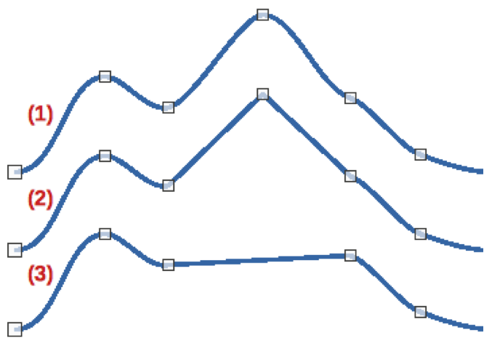
Figure 39: Example of converting a curve into a line
- Curve with points displayed.
- Sections between points converted to line.
- Point deleted to create a line section.
- Select the points for converting from curve to line or from line to curve.
- Click on Convert to Curve on the Edit Points toolbar. Between the selected points, a curve is converted into a line or a line is converted into a curve.
- Delete one of the points on the converted line to create a straight line.

Splitting objects
- Convert the object to a curve or a polygon.
- Switch the object into editing points mode and open the Edit Points toolbar.
- Select the point or points on the object where it is to be split. Keep the Shift key pressed down when selecting more than one point.
- Click on Split Curve on the Edit Points toolbar to split or cut the object border at the selected point. If the object is filled, it will be emptied because the object border is no longer closed, as shown in Figure 40.
- Deselect the object, then drag the cut segment and move it away from the original object.
- Note
The point where the object was split is now larger than the remaining points visible on the object.

Closing objects
- Select an open object (Figure 41).
- Switch the object into editing points mode and open the Edit Points toolbar.
- Select a point where the object has been split. Note that the start point of an object is larger than the other points visible on the object.
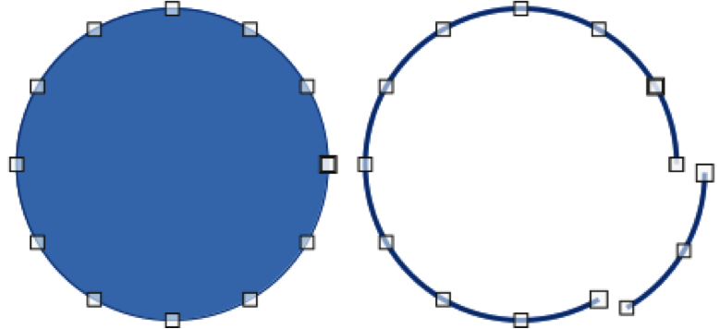
Figure 40: Example of splitting objects
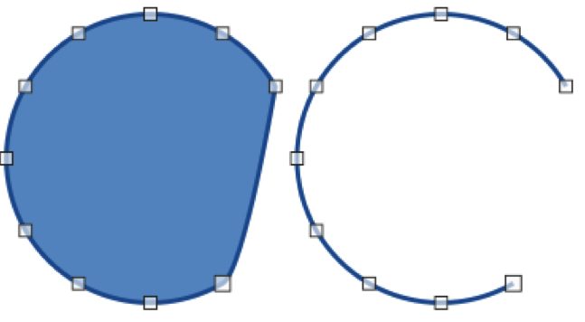
Figure 41: Example of closing objects
- Click on Close Bézier in the Edit Points toolbar to close the object. If the open object was originally a closed and filled object, then the original color fills the object when it is closed.

Distorting objects
- Select the object and switch into editing points mode to display the points on the object. This also opens the Edit Points toolbar.
- Select one of the points on the object and drag it to a new position to distort the object (Figure 42).
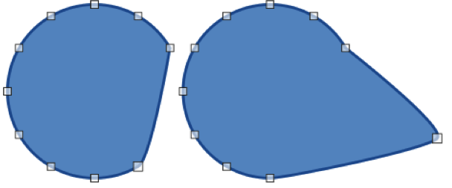
Figure 42: Example of distorting objects

Bézier curves were invented by Pierre Bézier, who developed the technique in the 1960s and while as an engineer with the Renault car manufacturer. The technology was intended to make modeling the surface of vehicles easier.

