
Draw Guide 7.4

Chapter 9,
Adding and Formatting Text

Copyright
This document is Copyright © 2023 by the LibreOffice Documentation Team. Contributors are listed below. This document maybe distributed and/or modified under the terms of either the GNU General Public License (https://www.gnu.org/licenses/gpl.html), version 3 or later, or the Creative Commons Attribution License (https://creativecommons.org/licenses/by/4.0/), version 4.0 or later. All trademarks within this guide belong to their legitimate owners.

Contributors
Contributors for this edition:
Peter Schofield

Contributors for previous editions:
Jean Hollis Weber
Low Song Chuan
Martin Saffron
Michele Zarri
Peter Schofield
Regina Henschel

Feedback
Please direct any comments or suggestions about this document to the Documentation Team mailing list: loguides@community.documentfoundation.org.
- Note
Everything sent to a mailing list, including email addresses and any other personal information that is written in the message, is publicly archived and cannot be deleted.

Publication date and software version
Published January 2023. Based on LibreOffice 7.4 Community.
Other versions of LibreOffice may differ in appearance and functionality.

Using LibreOffice on macOS
Some keystrokes and menu items are different on macOS from those used in Windows and Linux. The table below gives some common substitutions used in this document. For a detailed list, see LibreOffice Help.
Windows or Linux | macOS equivalent | Effect
Tools > Options  menu selection | LibreOffice > Preferences | Access setup options
Right-click | Control+click, Ctrl+click, or right-click depending on computer setup | Open a context menu
Ctrl or Control | ⌘ and/or Cmd or Command, depending on keyboard | Used with other keys
Alt | ⌥ and/or Alt or Option depending on keyboard | Used with other keys
F11 | ⌘+T | Open the Styles deck in the Sidebar

Contents
Copyright 2
Contributors 2
Feedback 2
Publication date and software version 2
Using LibreOffice on macOS 2
Introduction 5
Text mode 5
Adding vertical text 5
Text toolbar 6
Text boxes 6
Creating text boxes 6
Text box borders 7
Line and Filling toolbar 7
Line dialog 7
Line panel in Sidebar 9
Moving text boxes 9
Resizing text boxes 10
Rotating text boxes 11
Formatting text boxes 11
Text box formatting options 12
Deleting text boxes 13
Text in Draw objects 13
Adding text to objects 13
Text options for objects 14
Pasting text 15
Formatting text 16
Quick font resizing 16
Selecting text 16
Paragraph formatting 16
Direct formatting 16
Paragraph dialog 17
Paragraph panel in Sidebar 17
Character formatting 18
Direct formatting 18
Character dialog 19
Sidebar Character panel 19
Unordered or ordered lists 20
Creating lists 20
Adjusting list item level and position 22
Bullets and Numbering dialog 22
Text columns 23
Text boxes 23
Drawing objects 24
Text animation 25
Creating text animation 25
Text animation options 26
Text callouts 26
Creating text callouts 27
Editing text callouts 27
Text callout options 29
Tables in Draw 29
Inserting tables 29
Table dialog 29
Table grid 29
Table Design panel 30
Table formatting 31
Table toolbar 31
Menu bar 34
Table Properties dialog 35
Table position and size 38
Deleting tables 39
Whole table 39
Row or column 39
Cell contents 39
Using fields 39
Inserting fields 39
Field types 40
Using hyperlinks 41
Internet hyperlink 41
Mail hyperlink 42
Document hyperlink 43
New Document hyperlink 44
Further Settings 44
Editing text hyperlinks 45
Formatting hyperlinks 45
Image maps 45
Creating image maps 46
Image map tools 46
Fontwork 48
Creating Fontwork 48
Fontwork toolbar 49
Modifying Fontwork 50

Introduction
When text is used in drawings, it is placed inside an object or text box. This chapter describes how to create, format, use, and delete text. It also discusses the various types of text that can be inserted into a drawing. Finally, it provides information on how to insert special forms of text such as numbered or bulleted lists, tables, fields, hyperlinks, columns, and Fontwork.

Text mode
Before any text can be typed in a drawing, text mode has to be activated using one of the following methods. The Text Formatting toolbar (Figure 1) automatically opens when in text mode replacing the Line and Filling toolbar.
- For horizontal text only, go to Insert > Text Box on the Menu bar.
- For horizontal text only, use the keyboard shortcut F2.
- Click on Insert Text Box for horizontal text, or Insert Vertical Text for vertical text on the Drawing toolbar (Figure 2).

Adding vertical text
If Insert Vertical Text is not visible on the Drawing toolbar, it can be added to the toolbar as follows:
- Go to Tools > Options > Language Settings > Languages (macOS LibreOffice > Preferences > Language Settings > Languages) on the Menu bar to open the Languages page in the Options dialog.
- In Default Languages for Documents, select the option Asian. Accept the default settings for this option.
- Click OK to close the Options dialog and save the changes.
- Right-click in an empty area on the Drawing toolbar and select Visible Buttons from the context menu.
- Select Vertical Text from the drop-down list of options to add Insert Vertical Text to the Drawing toolbar.
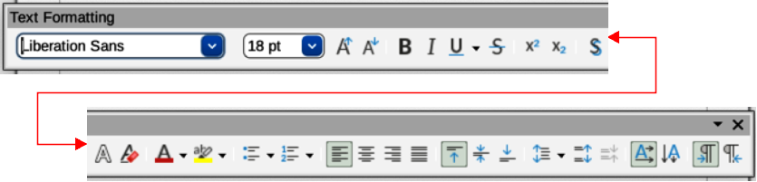
Figure 1: Text Formatting toolbar
Figure 2: Drawing toolbar with text tools highlighted
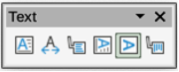
Figure 3: Text toolbar

Text toolbar
To make it easier when working with text, it is recommended to have the Text toolbar (Figure 3) available in Draw. If the Text toolbar is not available, go to View > Toolbars on the Menu bar and select Text from the context menu to add it to the available toolbars. The tools available on the Text toolbar, from left to right, are as follows:
Insert Text Box (F2)
Fit Text in Textbox Size
Callouts
Insert Vertical Text
Fit Vertical Text to Frame
Vertical Callouts

Text boxes

Creating text boxes
When text is added to a drawing, a text box is automatically created to contain the text. By default, the text box either expands horizontally to accommodate a single line of horizontal text, or vertically to accommodate a single line of vertical text.
- Note
Text boxes are only for text and cannot contain illustrations, inline pictures, formulas, tables or shapes.
- Activate text mode, see “Text mode” on page 5.
- Click at the approximate position in the drawing to insert the text box. A text box is created containing a flashing text cursor for the computer system and setup being used.
- For horizontal text, click on Insert Text Box, or for vertical text, click on Insert Vertical Text on the Drawing, or Text toolbars. The Text Formatting toolbar automatically opens, replacing the Line and Filling toolbar.
- Type or paste the text into the text box and the text box expands either horizontally or vertically to accommodate a single line of text. Also, the left corner of the Status Bar indicates text edit mode and the position of the text cursor (Figure 4).
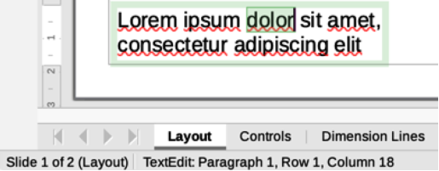
Figure 4: Text information on Status Bar
- To create multiple lines in the text box, use one of the following methods:
- Use the Enter key to create single line paragraphs inside the text box. The text box expands to accommodate more lines of text.
- Before typing text, click and drag the text cursor creating a text box with the approximate dimensions required. As the limits of the text box are reached, the text automatically word wraps inside the text box and the text box expands as it fills.
- Move, resize, rotate or format the text box as required. For more information, see the following sections and Chapter 3, Working with Objects.
- Format the text using the various tools on the Text Formatting toolbar, the various panels in the Properties deck on the Sidebar, or the various options in Format on the Menu bar. For more information on text formatting, see “Formatting text” on page 16.
- When text insertion and formatting is complete, click outside the text box to save the changes and deselect the text box.

Text box borders
By default, when a text box is created, the borders of the text box are only displayed when the text box is selected. If necessary, use one of the following methods to create a visible border around the text box.

Line and Filling toolbar
- Click on a text box to select it so that the border is displayed indicating that the text box is in edit mode.
- In Line Style on the Line and Filling toolbar (Figure 5), select a line style from the drop-down list for use as a text box border. If the Line and Filling toolbar is not visible, go to View > Toolbars > Line and Filling on the Menu bar.
- In Line Width on the Line and Filling toolbar, enter a width for the line style selected for the text box border.
- In Line Color on the Line and Filling toolbar, select a color from one of the available color palettes, or create a custom color.
- Click outside the text box to exit edit mode.

Line dialog
- Click on a text box to select it so that the border is displayed indicating that the text box is in edit mode.
- Open the Line dialog (Figure 6) using one of the following methods:
- Right-click on the text box border and select Line from the context menu.
- Go to Format > Line on the Menu bar.
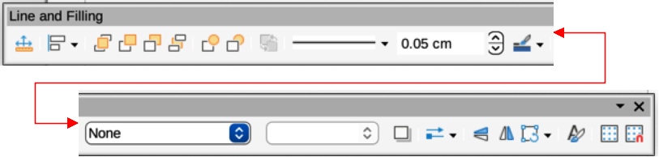
Figure 5: Line and Filling toolbar
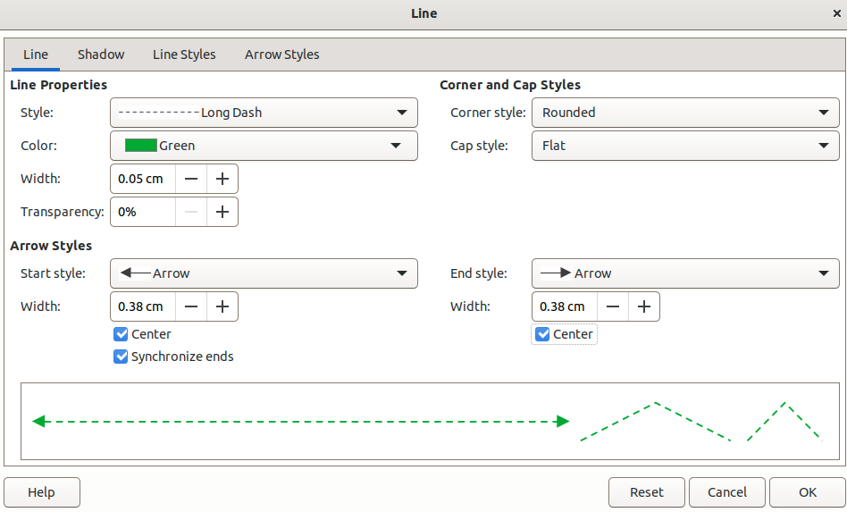
Figure 6: Line dialog — Line page
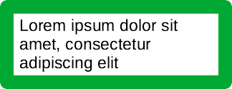
Figure 7: Example of using rounded corners
- Click on Line to open the Line page.
- In Style, select a line style from the drop-down list to use as a text box border.
- In Color, select a color for the line style from one of the available color palettes, or create a custom color.
- In Width, enter a width for the line style selected.
- If necessary, in Transparency and enter a percentage value for the line style.
- If necessary, in Corner Style, select the type of corner style from the options in the drop-down list.
- Click OK to save the changes and close the Line dialog.
- Click outside the text box to exit edit mode.
- Note
For a corner style to be clearly visible in a text box border, it is recommended to set the line width at a thickness above 0.35cm, as shown by the example in Figure 7.
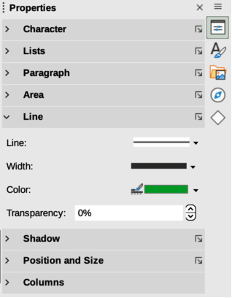
Figure 8: Line panel in Properties deck on Sidebar

Line panel in Sidebar
- Click on a text box to select it so that the border is displayed indicating that the text box is in edit mode.
- In the Sidebar, click on Properties to open the Properties deck in the Sidebar, then click on Line to open the Line panel (Figure 8).
- In Line, select a line style from the drop-down list to use as a text box border.
- In Width, enter a width for the line style selected.
- In Color, select a color for the line style from one of the available color palettes, or create a custom color.
- In Transparency, if necessary, enter a percentage value for the line style.
- Click outside the text box to exit edit mode.

Moving text boxes
- Click on the text in a text box to activate the text mode and the text box border is displayed.
- Move the cursor over the border. The cursor changes shape to the move symbol for the computer setup (for example, a clenched hand).
- Click on the border and drag the text box to a new position in the drawing. A ghosted outline of the text box shows where it will be placed (Figure 9).
- Release the cursor when the text box is in the required position.
- To accurately position a text box, use the Position and Size dialog, or the Position and Size panel in the Properties deck on the Sidebar. See Chapter 3, Working with Objects for more information.
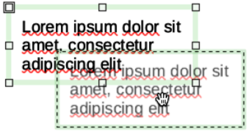
Figure 9: Example of moving a text box
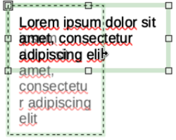
Figure 10: Example of resizing a text box
- When the text box is in the required position, click outside the text box to save the changes and deselect the text box.

Resizing text boxes
- Click on the text in a text box to activate text mode and a text box border is displayed.
- Move the cursor over one of the selection handles. The cursor changes shape to the resizing symbol for the computer setup (for example, a double-headed arrow). The selection handles are used to resize the text box as follows:
- Corner handles change the width and height of the text box simultaneously.
- Top and bottom selection handles change the height of the text box.
- Right and left selection handles change the width of the text box.
- Click and drag the border to a new position to resize the text box. A ghosted outline of the text box shows is displayed as the text box is resized (Figure 10).
- Release the cursor when the text box reaches the desired size.
- To accurately resize a text box, use the Position and Size dialog, or the Position and Size panel in the Properties deck on the Sidebar. See Chapter 3, Working with Objects for more information.
- When the text box is at the required size, click outside the text box to save the changes and deselect the text box.
- Notes
Press and hold the Shift key to maintain text box proportions, then click and drag a selection handle to resize. Release the cursor before releasing the Shift key.
When in rotation mode, the top, bottom, and side selection handles, though visible, are not available for use for rotating a text box. Also, text boxes cannot be sheared, slanted, or flipped vertically/horizontally.
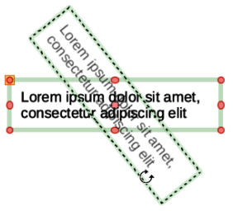
Figure 11: Example of rotating a text box

Rotating text boxes
- Click on the text in a text box to activate text mode and a text box border is displayed.
- Click on the text box border so that the selection handles are visible indicating that the text box is now in edit mode.
- Click again on the text border and the selection handles change shape and color.
- Click on a corner selection handle and drag to rotate the text box. A ghosted outline of the text box being rotated appears and the current angle of rotation is shown in the status bar (Figure 11).
- Release the cursor when the text box is at the desired rotation angle.
- To accurately rotate a text box, use the Rotation page in Position and Size dialog, or the Position and Size panel in the Properties deck on the Sidebar. See Chapter 3, Working with Objects for more information.

Formatting text boxes
Text boxes can be treated just like other basic shapes in a drawing when formatting the area fill or borders of a box. See Chapter 3, Working with Objects for more information on formatting the area fill or borders of a text box.
After formatting text to match the drawing requirements, format a text box as follows so that text appears correctly inside a text box:
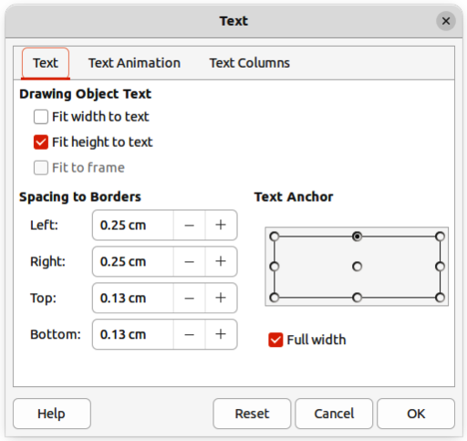
Figure 12: Text dialog — Text page
- Select a text box and use one of the following methods to open the Text dialog (Figure 12).
- Right-click on the text box and select Text Attributes from the context menu.
- Go to Format > Text Attributes on the Menu bar.
- Click on Text in the Text dialog to open the Text page and access to the formatting options.
- If required, click on Text Animation to open the Text Animation page to access options for animating the text. For more information on using text animation in a drawing, see “Text animation” on page 25.
- If required, click on Text Columns to open the Text Columns page to access the options for creating columns in a text box. For more information on using text columns in a drawing, see “Text columns” on page 23.
- Click OK to save the changes to text attributes and close the Text dialog.
- Move the cursor away from the text box, then click to end the text mode.

Text box formatting options
Drawing Object Text
Fit width to text
Expands or contracts the width of the text box to the length of the text, if the text box is smaller or larger than the text. Can be used with Fit height to text to automatically adjust width and height of the text box to the text.
Fit height to text
Expands or contract the height of the text box to the height of the text, if the text box is smaller or larger than the text. Can be used with Fit width to text to automatically adjust width and height of the text box to the text.
Fit to frame
Resizes (distorts) the text to fit the entire area of the text box, but does not change the width or height of the text box. This option is not available if Fit width to text and/or Fit height to text options are selected.
Spacing to Borders
Specify the amount of space to leave between the text and the borders of the text box.
Text Anchor
Anchors the text to one of nine positions within the text box. The left and right anchor positions can only be selected when Full width is not selected. A text anchor only determines the position of the text within the text box and does not change the paragraph alignment of the text inside the text box.
Full width
When selected, the text box width expands to fit the longest paragraph of text inside the text box as a single line. When selected, only the top, middle or bottom center positions in Text Anchor can be used to anchor the text inside the text box.

Deleting text boxes
- Click on the text box so that the selection handles are visible indicating that the text box is in edit mode.
- Press the Delete or Backspace key. The text box is deleted without any warning.

Text in Draw objects
- Note
Text can be added to most Draw objects. However, text cannot be added to 3D objects, or control elements, for example buttons.
By default, an object is not dynamic when it is first created in Draw and does not behave like a text box. By default, text does not word wrap inside an object. To keep text within the borders of an object, use word wrap, paragraphs, line breaks, smaller text size, increasing object size, or a combination of all methods. Actual method method available depends on the type of Draw object selected.

Adding text to objects
An example of adding text into a Draw object is shown in Figure 13. The left object does not have the word wrap option applied and the right object has the word wrap option applied.
- Create an object in a drawing and make sure the object is selected with the selection handles displayed.
- Enter text mode on the selected object using one of the following methods:
- Click on Insert Text Box for horizontal text, or Insert Vertical Text for vertical text on the Drawing or Text toolbar.
- For horizontal text, double-click on the selected object.
- For horizontal text, use the keyboard shortcut F2.
- For vertical text, double-click on the selected object and click on Insert Vertical Text on the Drawing or Text toolbar.
- Type or paste text into the selected object.
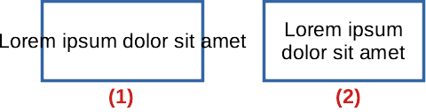
Figure 13: Example of object text word wrap
- No word wrap
- Word wrap to shape applied
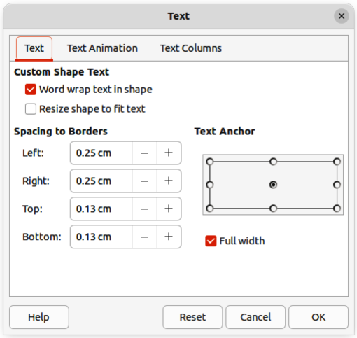
Figure 14: Text dialog for Draw objectsText page
- Format the text using the various tools on the Text Formatting toolbar, the panels in the Properties deck on the Sidebar, or the options in Format on the Menu bar. For more information on text formatting, see “Formatting text” on page 16.
- If the text goes outside the object borders, click on Text in the Text dialog to open the Text page (Figure 14) to access the text formatting options for a Draw object.
- If required, click on Text Animation to open the Text Animation page to access options for animating the text. For more information on using text animation in a drawing, see “Text animation” on page 25.
- If required, click on Text Columns to open the Text Columns page to access the options for creating columns in a text box. For more information on using text columns in a drawing, see “Text columns” on page 23.

Text options for objects
Custom Shape Text
Word wrap text in shape
Wraps the text so that it fits inside the object. For example, if the width of the object is changed, then the height of the object either increases or decreases to accommodate the increase or decrease in the number of lines of text.
Resize shape to fit text
Resizes the object to fit the text that is being entered into the object. For example, if the object already contains one multi-line paragraph of text and this option is selected, then the object width expands and the height decreases until the text is a single line of text.
Spacing to Borders
Specify the amount of space to leave between the text and the borders of the object.
Text Anchor
Anchors the text to one of nine positions within the text box. The left and right anchor positions can only be selected when Full width is not selected. A text anchor only determines the position of the text within the text box and does not change the paragraph alignment of the text inside the object.
Full width
When selected, the object width expands to fit the longest paragraph of text inside the object as a single line. When selected, only the top, middle or bottom center positions in Text Anchor can be used to anchor the text inside the text box.

Pasting text
Text may be inserted into a text box or object by copying text from another object or document and pasting into a drawing.
- Note
When using Format > Paste on the Menu bar, or the keyboard shortcut Ctrl+V (macOS ⌘+V) to paste copied text directly into a drawing and not into an object, the text is pasted as an OLE object and not as a Draw object. It is recommended to paste text into Draw as unformatted text to create a text object in Draw.
Pasted text retains the formatting from the source document and may not match the formatting of the text that has already been used on a drawing. It is good practice to paste text without formatting and apply the formatting later to match any text already in a drawing.
- Copy the text and paste it as unformatted text into a drawing using one of the following methods:
- Go to Edit > Paste Special > Paste Unformatted Text on the Menu bar.
- Go to Edit > Paste Special > Paste Special on the Menu bar and the Paste Special dialog opens. Select the option Unformatted text and click OK to close the dialog.
- Use the keyboard shortcut Ctrl+Shift+V (macOS ⌘+Shift+V) and the Paste Special dialog opens. Select the option Unformatted text and click OK to close the dialog.
- Click on the triangle ▼ on the right of Paste on the Standard toolbar and select Unformatted text from the context menu.
- Unformatted text is pasted into a text box at the cursor position or inside a selected object and formatted to the default drawing style. Format the pasted text to the drawing requirements, or apply a drawing style. For more information on text formatting, see “Formatting text” on page 16.

Formatting text
Text formatting can give a drawing a more consistent and professional look without any distracting elements. Text formatting tools are available on the Text Formatting toolbar and drop-down menus in Format on the Menu bar. For more information on text formatting, see the Writer Guide.
If there are several text boxes and/or objects in a drawing that require the same text formatting, it is recommended to use drawing styles. For more information on using and creating styles, see Chapter 4, Changing Object Attributes.

Quick font resizing
After selecting text, the font size can be quickly increased or decreased using the tools Increase Font Size (Ctrl+]) (macOS ⌘+]) and Decrease Font Size (Ctrl+[) (macOS ⌘+[) on the Text Formatting toolbar. The amount by which the font size changes depends on the standard sizes available for the font in use.

Selecting text
Text must be selected before it can be formatted using one of the following methods. Any formatting changes apply only to the selected text.
- To format all the text in a text box or object, click once on the border of the text box, or object to display the selection handles. Any formatting changes then apply to all text in the text box or object.
- To format only part of the text, select text using one of the following methods:
- Click in the text and drag the cursor over the text to highlight the text.
- Double-click on text to select a complete word or triple-click to select a whole paragraph.
- Click in the text, then press and hold the Shift key and use the keyboard arrow keys to select text.

Paragraph formatting

Direct formatting
Text formatting can be applied directly to characters, words, sentences, and paragraphs. Direct formatting to text overrides any formatting that has been applied using styles.
- Select the text for formatting and format using one of the following methods:
- The various formatting tools on the Text Formatting toolbar.
- Go to Format on the Menu bar and select a formatting option from the drop-down menu. Selecting a formatting option opens either a context menu, or a dialog providing further formatting options to apply to the selected text.
- Use the options in the Paragraph and Character dialogs.
- Use the options in the Paragraph and Character panels in the Properties deck on the Sidebar.
- Click outside the text box, or object to deselect the text.
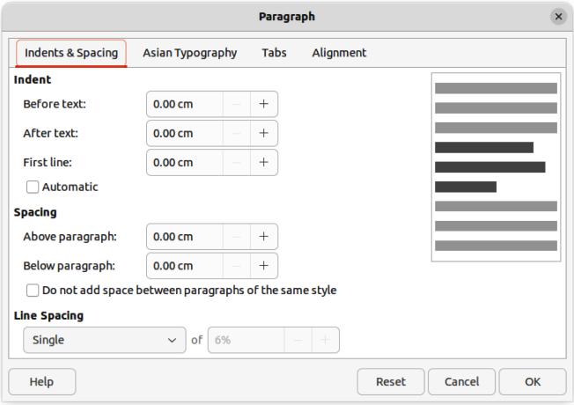
Figure 15: Paragraph dialogIndents & Spacing page

Paragraph dialog
The Paragraph dialog (Figure 15) is used to format paragraphs of text.
- Click anywhere in the paragraph that is to be formatted.
- Use one of the following methods to open the Paragraph dialog.
- Right-click on the selected text and select Paragraph from the context menu.
- Go to Format > Paragraph on the Menu bar.
- Use the various options on the tabbed pages of the Paragraph dialog to format the text.
- Click OK to save the changes and close the Paragraph dialog.
- Click outside the text box or object to deselect the text.
- Note
For information on the various formatting options available for text in the pages of the Paragraph dialog, refer to the Writer Guide.

Paragraph panel in Sidebar
An alternative method of formatting paragraphs is to use the Paragraph panel (Figure 16) in the Properties deck on the Sidebar. The formatting options are limited, but are similar in use to the formatting options in the various pages of the Paragraph dialog. Any formatting applied to a paragraph using the Sidebar is immediate.
- Click anywhere in the paragraph that is to be formatted.
- On the Sidebar, click on Properties to open the Properties deck.
- If necessary, click on the expansion symbol on the left of the Paragraph title bar to open the Paragraph panel.
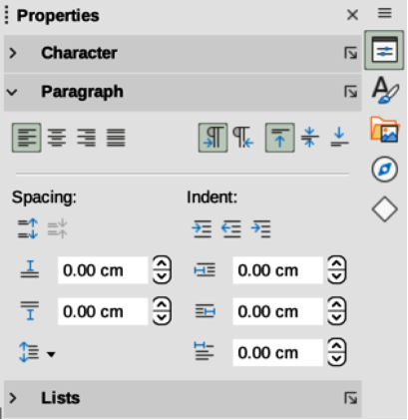
Figure 16: Paragraph panel in Properties deck on Sidebar
- Format the text using the various tools in the Paragraph panel.
- If necessary, click on More Options on the right of the title bar to open the Paragraph dialog to format text.
- Note
For information on the various formatting options available for text in the Paragraph panel on the Sidebar, refer to the Writer Guide.

Character formatting

Direct formatting
Direct or manual character formatting can be applied to individual characters and words. Direct character formatting overrides any formatting that has been applied using text formatting and drawing styles.
- Select the characters for formatting, see “Selecting text” on page 16 for more information.
- Format characters using one of the following methods.
- The various formatting tools on the Text Formatting toolbar. Formatting applied to character(s) is immediate.
- Go to Format on the Menu bar. Selecting a formatting option opens either a context menu or dialog where further formatting options are selected.
- Use the options available in the Character dialog. Clicking OK on the dialog applies the formatting changes.
- Use the options available in the Character panel in the Properties deck on the Sidebar. Formatting applied to character(s) is immediate.
- Click outside the text box or object to deselect the text.
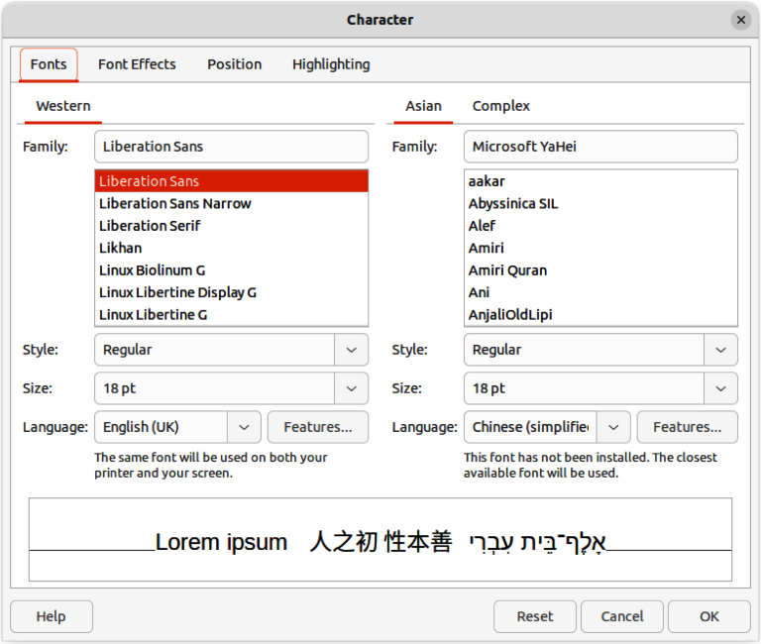
Figure 17: Character dialog — Fonts page

Character dialog
- Select the characters for formatting and open the Character dialog (Figure 22) using one of the following methods:
- Right-click on the characters and select Character from the context menu.
- Go to Format > Character on the Menu bar.
- Use the options on the tabbed pages of the Character dialog to format the selected characters.
- Click OK to apply the formatting changes and close the dialog.
- Click outside the text box or object to deselect the text.
- Note
For information on the various formatting options available for characters in the pages of the Character dialog, refer to the Writer Guide.

Sidebar Character panel
An alternative method of formatting text is to use the Character panel (Figure 18) in the Properties deck on the Sidebar. The formatting options available in the Character panel are limited, but are similar in use to the formatting options available in the various pages of the Character dialog. Most of the options are also available on the Text Formatting toolbar.
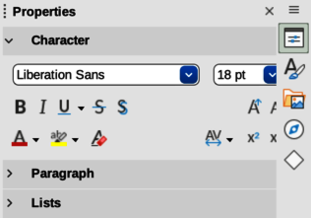
Figure 18: Character panel in Properties deck on Sidebar
- Select a text box or object so that the selection handles on the border are displayed.
- On the Sidebar, click on Properties to open the Properties deck.
- Click on the expansion symbol on the left of the Character title bar to open the Character panel.
- Format the text using the tools in the Character panel.
- If necessary, click on More Options on the right of the title bar to open the Character dialog to format text.
- Note
For information on the various formatting options available for characters in the Character panel on the Sidebar, refer to the Writer Guide.

Unordered or ordered lists
Unordered (bulleted) and ordered (numbered) lists can be created in text boxes and objects. However, when creating lists in objects, please remember that Draw objects are not dynamic and do not automatically expand as a list is created.
- Note
Creating unordered or ordered lists in Draw is similar to LibreOffice Writer. For more information on unordered or ordered lists, see the Writer Guide.

Creating lists
Unordered or ordered lists can be created in text boxes, or Draw objects as follows:
- Select all of the text required for a list.
- Create a list using one of the following methods and default settings for lists:
- Click on Toggle Unordered List, or Toggle Ordered List on the Text Formatting toolbar.
- Click on Toggle Unordered List, or Toggle Ordered List in the Lists panel in the Properties deck on the Sidebar (Figure 19).
- Go to Format > Lists > Unordered List, or Ordered List on the Menu bar.
- To change the format of the list, click on the triangle ▼ on the right of the list icons and select a list style from the options available in the pop-up More Bullets dialog (Figures 20) or More Numbering dialog (Figure 21).
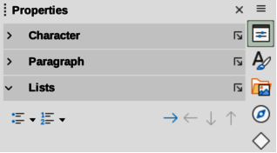
Figure 19: Lists panel in Properties deck on Sidebar
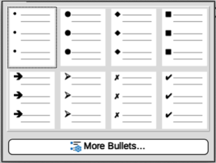
Figure 20: More Bullets dialog
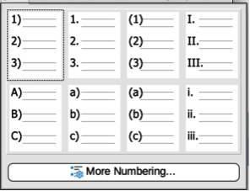
Figure 21: More Numbering dialog

Adjusting list item level and position
Each item in an unordered or ordered list can have its level demoted or promoted within a list, or moved up or down in list order as follows:
- Click on a list item to demote, promote, or move up or down.
- To demote a list item one level at a time, use one of the following methods:
- Use the Tab key.
- Go to Format > Lists > Demote on the Menu bar.
- Use Demote in the Lists panel in the Properties deck on the Sidebar.
- To promote a list item one level at a time, use one of the following methods:
- Use the key combination Shift+Tab.
- Go to Format > Lists > Promote on the Menu bar.
- Use Promote in the Lists panel in the Properties deck on the Sidebar.
- To change the position of a list item in the list order, use one of the following methods:
- Go to Format > Lists > Move Up, or Move Down on the Menu bar.
- Use Move Up, or Move Down in the Lists panel in the Properties deck on the Sidebar.

Bullets and Numbering dialog
Use the Bullets and Numbering dialog (Figure 22) for more control over the format of a list. Select text in a text box or object and open the dialog using one of the following methods:
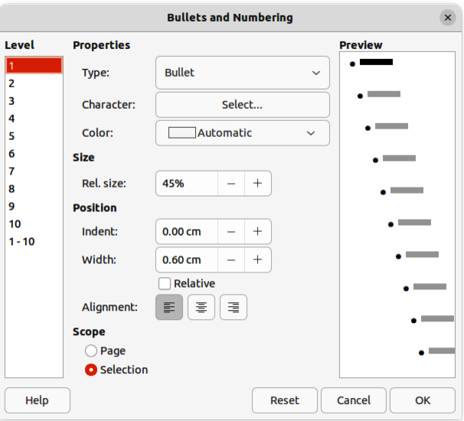
Figure 22: Bullets and Numbering dialog
- Go to Format > Bullets and Numbering on the Menu bar.
- Right-click on the selected text and select Bullets and Numbering from the context menu.
- Click on More Options on the right side of Lists panel title bar in the Properties deck on the Sidebar.
- Click on More Bullets or More Numbering after clicking on the triangle ▼ on the right of Toggle Unordered List, or Toggle Ordered List on the Text Formatting toolbar, or in the Lists panel in the Properties deck on the Sidebar.
- Note
For more information on the options available in the Bullets and Numbering dialog for unordered or ordered lists, see the Writer Guide.

Text columns
Text in a drawing can be formatted into columns inside text boxes and objects. However, columns cannot be used on separate parts of text inside a text box or object. The whole of the text box, or object has to be used for columns.
The type of columns used in Draw are continuous flow columns. This means that when text reaches the bottom of a column it will automatically flow into the next column as text is added. This column type is also known as newspaper columns.

Text boxes
- Click the border of a text box to select it so that the selection handles are displayed indicating that the text box is in edit mode.
- Open the options for text columns using one of the following methods:
- Right-click in the text box and select Text Attributes from the context menu to open the Text dialog, then click on the Text Columns tab to open the Text Columns page (Figure 23),
- Click on Columns in Properties on the Sidebar to open the Columns panel (Figure 24).
- Set the number of columns required in the Number of columns box and the required spacing between the columns in the Spacing box.
- Save the changes and deselect the text box using one of the following methods:
- For the Text dialog, click OK to save the changes and close the dialog, then click outside the text box to deselect it.
- For the Columns panel in the Properties deck on the Sidebar, click outside the text box to deselect it and save the changes.
- Note
Any text inside a text box, or drawing object automatically flows into column format when the changes are saved.
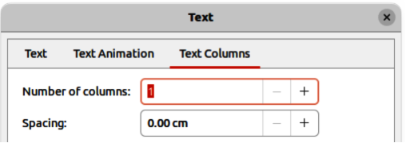
Figure 23: Text dialogText Columns page
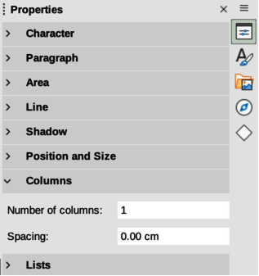
Figure 24: Columns panel in Properties deck on Sidebar

Drawing objects
- Click on an object to select it so that the selection handles are displayed indicating that the object is in edit mode.
- Double-click on the selected object to switch on text edit mode.
- Open the options for text columns using one of the following methods:
- Right-click in the drawing object and select Text Attributes from the context menu to open the Text dialog, the click on the Text Columns tab to open the Text Columns page (Figure 23),
- Click on Columns in Properties on the Sidebar to open the Columns panel (Figure 24).
- Set the number of columns required in the Number of columns box and the required spacing between the columns in the Spacing box.
- Save the changes and deselect the object using one of the following methods:
- For the Text dialog, click OK to save the changes and close the dialog, then click outside the object to deselect it.
- For the Columns panel in the Properties deck on the Sidebar, click outside the object to deselect it and save the changes.
- Double-click again on the object to switch on text edit mode.
- Type in the required text or use copy and paste to enter the required text. Any text entered will be in column format.
- If necessary, format the text to the drawing requirements.
- Click outside the object to deselect it and save the changes.

Text animation
- Note
Text animation is not recommended text in a drawing unless the drawing is going to be displayed as part of a presentation. See the Impress Guide for more information on text animation.

Creating text animation
If necessary, text animation is created as follows:
- Right-click on text in a text box, or drawing object and select Text Attributes from the context menu to open the Text dialog.
- Click on Text Animation to open the Text Animation page in the Text dialog (Figure 25).
- In Effect, select how the text is to appear during the text animation.
- In Direction, select which direction the text will appear during animation.
- In Properties, select Start inside for the text to be visible and inside the drawing object when the animation effect is applied.
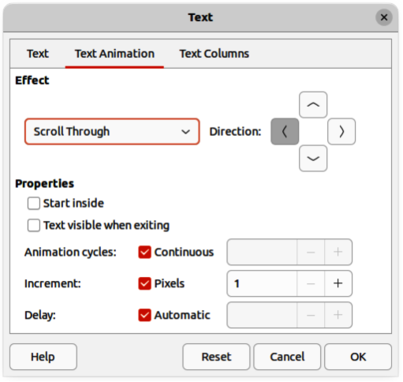
Figure 25: Text dialog — Text Animation page
- In Properties, select Text visible when exiting for the text to remain visible after the animation effect is applied.
- In Animation cycles, select either Continuous, or enter the number of animation cycles for the animated text.
- In Increment, select the increment value in Pixels for scrolling the text.
- In Delay, specify Automatic, or enter the time delay to wait before repeating the animation effect.
- Click OK to save the changes and close the Text dialog.

Text animation options
Effect
Select the animation effect from the drop-down list to apply to the text in the selected drawing object. To remove an animation effect, select No Effect.
Direction
Select a scrolling direction for the animated text.
Properties
Start inside
Text is visible and inside the drawing object when the animation effect is applied.
Text visible when exiting
Text remains visible after the animation effect is applied.
Animation cycles
Set the looping options for the animation effect.
Continuous
Plays the animation effect continuously. To specify the number of times to play the animation effect, deselect this check box, and enter the number of cycles in the Continuous box.
Increment
Specifies the increment value in the Pixels box for scrolling the text.
Delay
Specifies the amount of time before the animation effect is repeated.
Automatic
LibreOffice automatically determines the amount of time before the animation effect is repeated. To manually assign the delay period, unmark this check box, and then enter a time value in the Automatic box.

Text callouts
A text callout is a short line of text connected by a line to highlight, or point out a feature of an illustration or drawing. Two types of text callouts (Figure 26) are available –– Callouts for horizontal text and Vertical Callouts for vertical text. Text callouts in LibreOffice Draw are a legacy from the first versions of LibreOffice and are only available on the Text toolbar.
- Note
Custom shape callouts can also be found by selecting Callout Shapes on the Drawing toolbar, or the Callouts panel in the Shapes deck on the Sidebar. These custom shape callouts have the same purpose as text callouts, but have different options available.
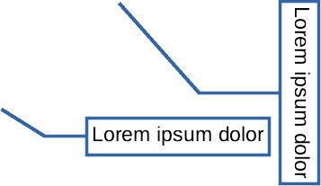
Figure 26: Examples of horizontal and vertical text callouts

Creating text callouts
- Click on Callouts for horizontal text, or Vertical Callouts for vertical text on the Text toolbar (Figure 3 on page 6).
- Click in the drawing and drag the cursor to create the callout.
- Double click in the callout box to enter text mode.
- Type the required text, then click in a blank space in the drawing. The callout box adjusts its size horizontally and/or vertically to fit the text within the callout box.
- Select the callout and click on the selection handle at the end of the connector line, then drag the end of the connector line to the required position.
- With the callout still selected, click on the callout box and drag it to the required position.
- Click in a blank space in the drawing to deselect the text callout and save the changes.

Editing text callouts
- Double click in the callout box to enter text mode and, if required, edit and format the text. See “Formatting text” on page 16 for more information on text formatting.
- Click in a blank space in the drawing to save the changes to the text.
- Select the text callout so that the selection handles are displayed.
- Right click on the selected text callout and select an option from the context menu to change the attributes for position, size, line, and area of the text callout. For more information, see Chapter 3, Working with Objects, and Chapter 4, Changing Object Attributes.
- Click on the selection handle at the end of the connector line and drag it to change the position of the line end or the length of the connector line.
- Select the text callout and open the Position and Size dialog (Figure 27) using one of the following methods:
- Right-click on the selected callout and select Position and Size from the context menu.
- Go to Format > Position and Size on the Menu bar.
- Use the keyboard shortcut F4.
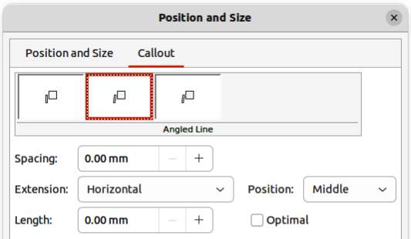
Figure 27: Position and Size dialog — Callout page
- Note
The Callout page in the Position and Size dialog is only available when a text callout has been selected. It is not available for Callout Shapes that are available on the Drawing toolbar, or in the Callouts panel in the Shapes deck on the Sidebar
- Click on the Callout tab to open the formatting options available for text callouts.
- Select the style of text callout from Straight Line, Angled Line, or Angled Connector Line.
- In Spacing, enter the amount of space required between the end of the callout line and the callout box.
- In Extension, select from the drop-down list how the callout line from extends the callout box.
- If From top, or From left has been selected from the Extension drop-down list, enter a distance value in the By: box to create a space between the start point of the connector line and the callout box.
- If Horizontal, or Vertical has been selected from the Extension drop-down list, enter a position setting from the Position drop-down list to set the position of where the connector line is attached to the text callout box.
- In Length, enter the length of the callout line segment that extends from the callout box to the angle point of the connector line.
- Note
The Length option is only available if Angled Connector Line is selected as the callout style and the Optimal check box is not selected.
- In Optimal, select this option to display the angle point in a connector line at an optimal distance from the callout box.
- Click in a blank space in the drawing to deselect the text callout and save the changes.

Text callout options
Callout Styles
Select the required callout style from the options available.
Spacing
Enter the amount of space required between the end of the callout line and the callout box.
Extension
Select where and how the callout line extends from the callout box.
Length
Enter the length of the callout line segment that extends from the callout box to the inflection point of the line.
Optimal
Select this option to display a single line in the optimum position.
- Note
The Length option is only available if Angled connector line is selected as the callout style and Optimal is not selected.

Tables in Draw
Tables are a powerful mechanism to convey structured information quickly when used in a drawing. Tables can be added directly to a drawing eliminating the need to embed a Calc spreadsheet, or a Writer text table. However, in some circumstances, it makes sense to embed a spreadsheet into a drawing, especially when greater functionality is required in the table. The tables provided by Draw do have a limited functionality.

Inserting tables
Tables are placed at the center of a drawing and cannot be placed into objects or shapes. Also, unlike text boxes and other objects, tables cannot be rotated.
- Note
When inserting tables into a drawing, the table is created using the default style with settings already applied. Currently these defaults are hard coded in LibreOffice. The table can be formatted to the drawing requirements after insertion.

Table dialog
- Go to Insert > Table on the Menu bar to open the Insert Table dialog (Figure 28).
- Enter the number of rows and columns required.
- Click OK to insert the table in the center of a drawing and close the dialog.
- Move the table into position by clicking on the border and dragging it to its new position.

Table grid
- Click on Table on the Standard toolbar to open the Table grid (Figure 29).
- Click and drag the cursor until the required number of columns and rows are selected,
- Click again to insert the table into the center of a drawing and close the Table grid.
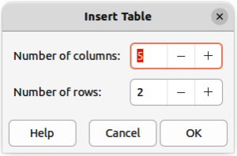
Figure 28: Insert Table dialog
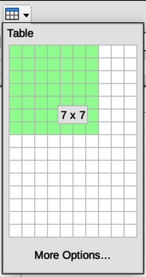
Figure 29: Table grid
- If necessary, click on More Options to open the Insert Table dialog to select the number of rows and columns required.
- Move the table into position by clicking on the border and dragging it to its new position.

Table Design panel
Several predefined table designs are provided in the Table Design panel in the Properties deck on the Sidebar (Figure 30). The Table Design panel is only available when a table is selected.
- Insert a table into a drawing or select a table in a drawing.
- Click on Table Design in the Properties deck on the Sidebar to open the Table Design panel, or click on Table Design on the Table toolbar.
- Select a design for the table and the types of rows and columns from the available options.
The following options for rows and columns are available in the Table Design panel:
Header row
Selected by default. The first row is normally a header row and is displayed with a different background from the rest of the table.
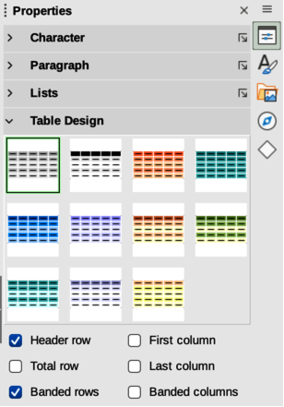
Figure 30: Table Design panel in Properties deck on Sidebar
Total row
When selected, changes the background of the last row to make it stand out from other rows.
Banded rows
Selected by default. Alternate rows have different backgrounds making it easier to read data entered into the rows.
First column
When selected, highlights the first column of the table using a darker background.
Last column
When selected, highlights the last column of the table using a darker background.
Banded columns
When selected, alternate columns are highlighted with dark and light colors.

Table formatting
After inserting a table, it can be formatted using the tools and options available on the Table toolbar, by going to Format > Table on the Menu bar, or using the options available in the Table Properties dialog.

Table toolbar
The Table toolbar (Figure 31) automatically opens when a table is selected providing tools for creating and formatting a table. The default position for the toolbar, when it is first opened, is docked at the bottom of the Workspace.
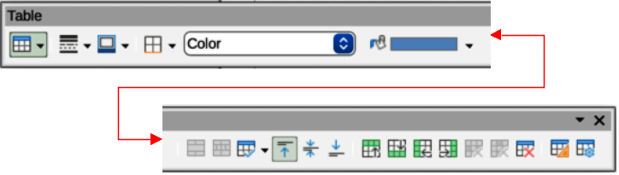
Figure 31: Table toolbar
Table
Inserts a new table in a drawing using the Insert Table dialog or the Table grid. See “Inserting tables” on page 29 for more information on inserting tables.
Border Style
Changes the line style of the borders of selected cells. Click on the triangle ▼ next to Border Style to open a drop-down list and select from a range of predefined styles.
Border Color
Changes the color of the borders of selected cells. Click on the triangle ▼ next to Border Color to open access to the LibreOffice color palettes. Select a color from a range of predefined palettes or create a custom color.
Borders
Selects a predefined border configuration for the selected cells. Click on the triangle ▼ next to Borders to open a drop-down list to select a border configuration.
Area Style/Filling
Select the cells to be filled, then select the type of fill from the drop-down list: None, Color, Gradient, Hatching, Bitmap, Pattern, Use Slide Background.
Fill Color
Select a fill option from the drop-down menu. The fill options change to show the fillings available for each Area Style/Filling type.
Merge Cells
Merges the selected cells into one cell. Note that the contents of the merged cells are also merged. Alternatively, right-click on selected cells and select Merge Cells from the context menu.
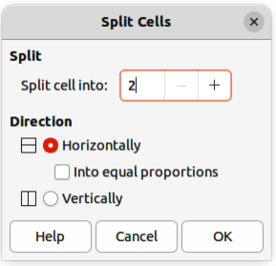
Figure 32: Split Cells dialog
Split Cells
Splits a selected cell into multiple cells either horizontally or vertically. Make sure that the cursor is positioned on the cell, then click on Split Cells to open the Split Cells dialog (Figure 32).
In Split cells into, select the number of cells required when splitting a cell and whether to split the cell Horizontally or Vertically. If necessary, when splitting horizontally, select Into equal proportions to create cells of equal size. The contents of the split cell are kept in the original cell (left or top cell).
Optimize
Evenly distributes the selected rows and columns in a table either horizontally or vertically. Clicking on Optimize opens a pop-up toolbar which contains the following tools:
Minimal Row Height
Determines the minimal row height for selected rows. Minimal row height depends on the font size of the smallest character in the row.
Minimal Column Width
Defines the minimal column width for selected columns. Minimal column width depends on the shortest entry within a column.
Optimal Row Height
Determines the optimal row height for selected rows. Optimal row height depends on the font size of the largest character in the row.
Optimal Column Width
Defines the optimal column width for selected columns. Optimal column width depends on the longest entry within a column.
Distribute Rows Equally
Adjusts the height of the selected rows to match the height of the tallest row in the selection.
Distribute Columns Evenly
Adjusts the width of the selected columns to match the width of the widest column in the selection. The total width of the table cannot exceed the width of the page.
Align Top, Center Vertically, Align Bottom
Sets the vertical alignment of text in selected cells.
Insert Row Above, Insert Row Below
Click in a cell or cells to select rows and use these two tools to insert a row or rows above or below the selected rows. Alternatively, right-click on the selected rows and select Insert > Insert Row Above or Insert Row Below.
Insert Column Before, Insert Column After
Click in a cell or cells to select columns and use these two tools to insert a column or columns before or after the selected columns. Alternatively, right-click on the selected columns and select Insert > Insert Column Before or Insert Column After.
Delete Row, Delete Column, Delete Table
Click in a cell or cells to select rows or columns, then click on a tool to delete the selected rows or columns. To delete the whole table, place the cursor in a cell and select Delete Table. Alternatively, right-click on the selected cells and select Delete > Delete Row, or Delete Column, or Delete Table from the context menu.
Select Table, Select Column, Select Row
Select a table, column, or row if the same attributes are going to be applied to a table, column, or row.
Table Design
Click on this tool and open the Table Design panel in the Properties deck on the Sidebar. See “Table Design panel” on page 30 for more information.
Table Properties
Click on this tool and open the Table Properties dialog. Alternatively, right-click on the table and select Table Properties from the context menu.

Menu bar
Table formatting tools are also available by going to Format > Table on the Menu bar and selecting a formatting option from the submenu that opens.
Minimal Row Height
Determines the minimal row height for selected rows. Minimal row height depends on the font size of the smallest character in the row.
Optimal Row Height
Determines the optimal row height for selected rows. Optimal row height depends on the font size of the largest character in the row.
Distribute Columns Evenly
Adjusts the width of the selected columns to match the width of the widest column in the selection. The total width of the table cannot exceed the width of the page.
Select Row
Selects the row or rows where cells have been selected in the table.
Insert Rows
Inserts rows in the table where cells have been selected in the table.
Delete Row
Deletes rows in the table where cells have been selected in the table.
Minimal Column Width
Defines the minimal column width for selected columns. Minimal column width depends on the shortest entry within a column.
Optimal Column Width
Defines the optimal column width for selected columns. Optimal column width depends on the longest entry within a column.
Distribute Columns Evenly
Adjusts the width of the selected columns to match the width of the widest column in the selection. The total width of the table cannot exceed the width of the page.
Select Column
Selects the column or columns where cells have been selected in the table.
Insert Columns
Inserts columns in the table where cells have been selected in the table.
Delete Column
Deletes columns in the table where cells have been selected in the table.
Merge Cells
Merges the selected cells into one cell. The contents of the merged cells are also merged. Alternatively, right-click on selected cells and select Merge Cells from the context menu.
Split Cells
Splits a selected cell into multiple cells either horizontally or vertically. Make sure that the cursor is positioned on the cell, then click on Split Cells to open the Split Cells dialog.
Delete Table
To delete the whole table, place the cursor in a cell and select Delete Table. Alternatively, right-click on the selected cells and select Delete Table from the context menu.
Select…
Selects the whole table.
Properties…
Opens the Table Properties dialog.

Table Properties dialog
The Table Properties dialog has five tabbed pages that provide formatting options for Font, Font Effects, Borders, Background, and Shadow. Open the Table Properties dialog using one of the following methods:
- Right-click in a table and select Table Properties from the context menu.
- Go to Format > Table > Properties on the Menu bar.
- Click on Table Properties on the Table toolbar.
The formatting options on each dialog page are as follows:
Font (Figure 33)
Select the required Family, Style, Size, and Language for text in the table. A sample of the font selected is displayed in the preview box. See the Writer Guide for more information on fonts.
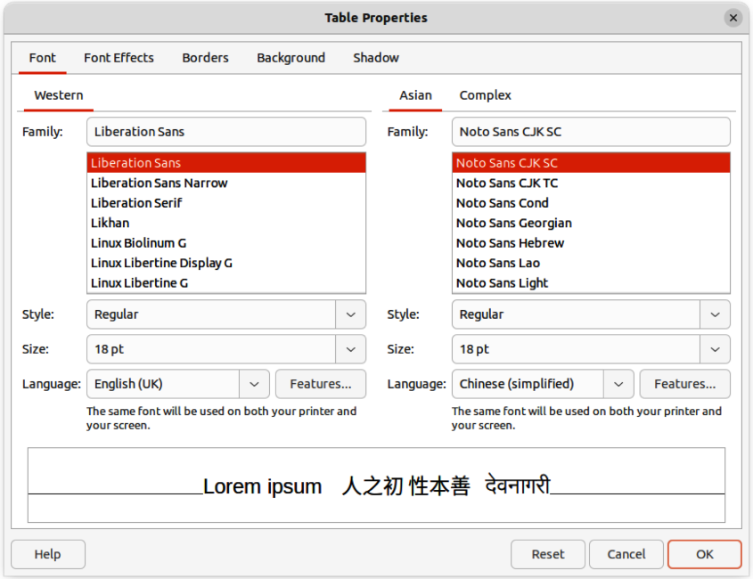
Figure 33: Table Properties dialog — Font page
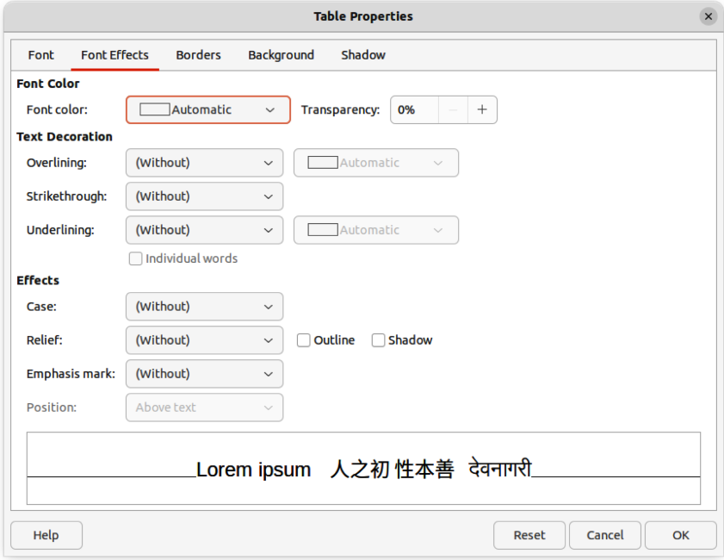
Figure 34: Table Properties dialog — Font Effects page
Font Effects (Figure 34)
Select the required Font Color, Text Decoration, and Effects for the text in the table. A sample of the font effects applied to the text is displayed in the preview box. See the Writer Guide for more information on font effects.
Borders (Figure 35)
Select the required Line Arrangement, Line, and Padding for the table and cell borders. These options are similar to the tools Border Style, Border Color, and Borders on the Table toolbar. See Chapter 4, Changing Object Attributes for more information on the lines used for table and cell borders.
Background (Figure 36)
Select a background as the area fill for the table and/or selected cells. This dialog page provides the same functions as Area Style/Filling tools on the Table toolbar. See Chapter 4, Changing Object Attributes for more information on area style and filling used for table and cell backgrounds.
Shadow (Figure 37)
Adds a shadow to the table. The options adjust the look and position of the shadow. See Chapter 4, Changing Object Attributes for more information on table shadows.
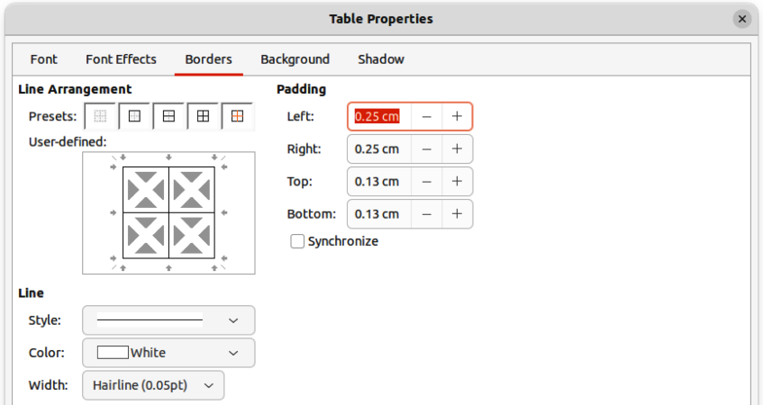
Figure 35: Table Properties dialog — Borders page
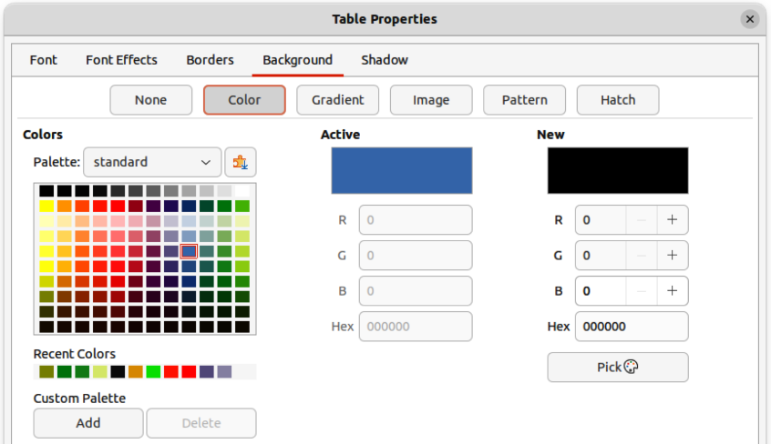
Figure 36: Table Properties dialog — Background page
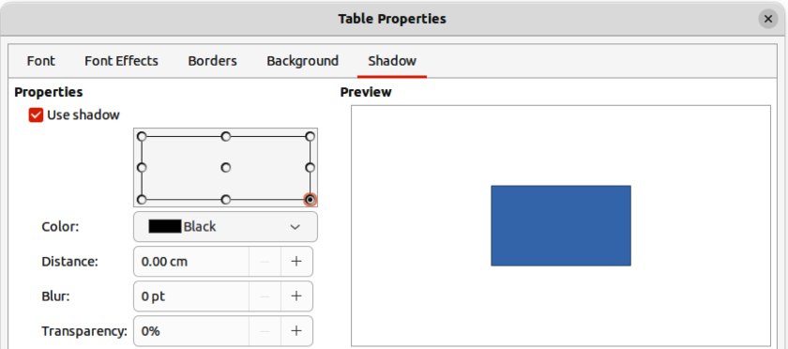
Figure 37: Table Properties dialog — Shadow page

Table position and size
Tables are placed into boxes when created and are treated just like any other object in a drawing. After selecting the table, use one of the following methods to change table position and size. See “Text boxes” on page 6 and Chapter 3, Working with Objects for more information positioning and resizing.
- Click on the table border and drag the table to a new position.
- Click on a selection handle and drag it to change the table size.
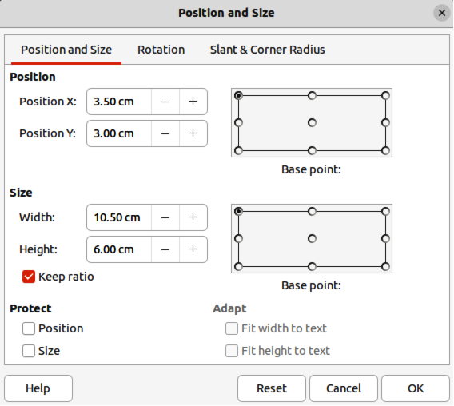
Figure 38: Position and Size dialog
- Open the Position and Size dialog and use the options available on the Position and Size page (Figure 38). The options available in the Rotation, and Slant & Corner Radius pages cannot be used for a table.
After selecting the table, use one of the following methods to open the Position and Size dialog:
- Right-click on the table and select Position and Size from the context menu.
- Go to Format > Position and Size on the Menu bar.
- Use the keyboard shortcut F4.
- Note
When the size of a table box is changed, the table and cell contents also increases or decreases in size to match the box size.

Deleting tables

Whole table
Make sure the table is selected and the selection handles are visible on the table border, then delete the table using one of the following methods:
- Go to Format > Table > Delete Table on the Menu bar.
- Select Delete Table on the Table toolbar.
- Right-click on the table and select Delete > Delete Table from the context menu.

Row or column
Click in a table cell, then delete the table row or column using one of the following methods. Make sure the table selection handles are NOT displayed.
- Go to Format > Table > Delete Row, or Delete Column on the Menu bar
- Select Delete Row, or Delete Column on the Table toolbar.
- Right-click and select Delete > Delete Row, or Delete Column from the context menu.

Cell contents
Delete cell contents in a table as follows:
- Select the cell or cells.
- Press the Delete, or Backspace key on the keyboard.

Using fields
Fields allow for the automatic insertion of text into a drawing. Fields are commonly used when creating templates and drawing masters. For more information on templates and master drawings, see Chapter 11, Advanced Drawing Techniques.

Inserting fields
A text box is created when a field is inserted into the center of a drawing and can be repositioned just like any other text box. See “Text boxes” on page 6 for more information.
- Go to Insert > Field on the Menu bar and select the type of field.
- If necessary, position and resize the field text box.
- If necessary, format the text used for the field information. See “Formatting text” on page 16 for more information.

Field types
Date (fixed)
Inserts the current date into a drawing as a fixed field. The date is not automatically updated. Available date formats depend on the language setting in Tools > Options > Language Settings > Language (macOS LibreOffice > Preferences > Language Settings > Language). Right-click on the date field and select the required date format from the context menu.
Date (variable)
Inserts the current date into a drawing as a variable field. The date is automatically updated each time the file is opened. Available date formats depend on the language setting in Tools > Options > Language Settings > Language (macOS LibreOffice > Preferences > Language Settings > Language). Right-click on the date field and select the required date format from the context menu.
Time (fixed)
Inserts the current time into a drawing as a fixed field. The time is not automatically updated. Available time formats depend on the language setting in Tools > Options > Language Settings > Language (macOS LibreOffice > Preferences > Language Settings > Language). Right-click on the time field and select the required time format from the context menu.
Time (variable)
Inserts the current time into a drawing as a variable field. The time is automatically updated each time the file is opened. Available time formats depend on the language setting in Tools > Options > Language Settings > Language (macOS LibreOffice > Preferences > Language Settings > Language). Right-click on the time field and select the required time format from the context menu.
Author
Inserts the first and last names of the author of the drawing. This information is taken from values entered in the LibreOffice user data. To modify this information go to Tools > Options > LibreOffice > User Data (macOS LibreOffice > Preferences > LibreOffice > User Data).
Page Number
Inserts the page number into the current drawing. Alternatively, go to Insert > Page Number on the Menu bar. If a page number is to be added to every page in the drawing, go to View > Master on the Menu bar and insert the page number field.
Page Title
Inserts the page title. The default name is Page # if the page has not been renamed.
Page Count
Inserts the total number of pages in a drawing.
File Name
Inserts the name of the file used for the drawing. The file name only appears after the file has been saved.

Using hyperlinks
When inserting text that can be used as a hyperlink (for example, a website address or URL), Draw formats it automatically, creating the hyperlink and applying color and underlining. There four types of hyperlinks and each hyperlink type requires a different procedure when inserting a hyperlink.
- Tips
To prevent LibreOffice from automatically turning website addresses, or URLs into hyperlinks, go to Tools > AutoCorrect Options > Options on the Menu bar and deselect URL Recognition.

Internet hyperlink
- Click in the text box at the required position for the hyperlink.
- Go to Insert > Hyperlink on the Menu bar, or use the keyboard shortcut Ctrl+K (macOS ⌘+K) to open the Hyperlink dialog.
- Select Internet to open the Internet page of the Hyperlink dialog (Figure 39).
- In Protocol, select either Web, or FTP.
- In the URL text box, enter the required web address for the hyperlink.
- In the Name text box, enter a name for the hyperlink.
- If necessary, enter the details required for Further Settings. See “Further Settings” on page 44 for more information.
- Click Apply to insert the hyperlink and save the selections. If several hyperlinks are being created, click Apply after inserting each hyperlink.
- Click OK to close the Hyperlink dialog.
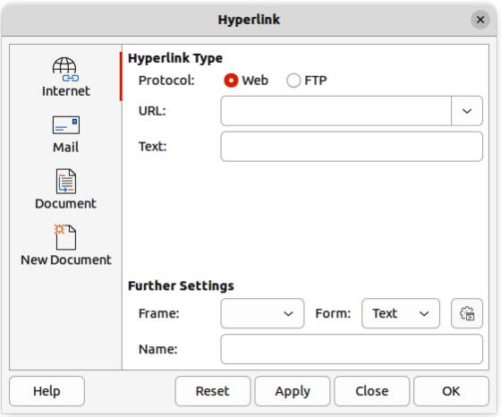
Figure 39: Hyperlink dialog — Internet page
- Tip
To change the color of hyperlinks, go to Tools > Options > LibreOffice > Application Colors, scroll to Unvisited links and/or Visited links, select the checkboxes, then select new colors from the color palettes for the links and click OK. Note this color change changes the color for all hyperlinks across all components of LibreOffice.
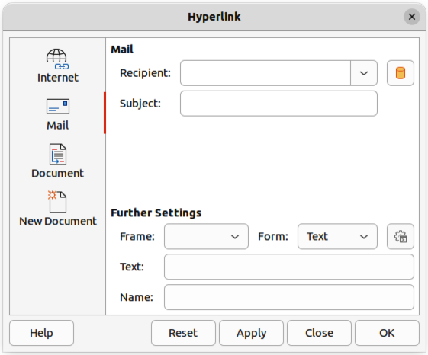
Figure 40: Hyperlink dialog — Mail page

Mail hyperlink
- Click in the text box at the required position for the hyperlink.
- Go to Insert > Hyperlink on the Menu bar, or use the keyboard shortcut Ctrl+K (macOS ⌘+K) to open the Hyperlink dialog.
- Select Mail to open the Mail page of the Hyperlink dialog (Figure 40).
- In Recipient text box, enter the email details of the recipient.
- In the Subject text box, enter a subject title.
- If necessary, click on Data Sources to open a data source browser, then drag the receiver's email data field from the data source browser into the Recipient text box.
- If necessary, enter the details required for Further Settings. See “Further Settings” on page 44 for more information.
- Click Apply to insert the hyperlink and save the selections. If several hyperlinks are being created, click Apply after inserting each hyperlink.
- Click OK to close the Hyperlink dialog.
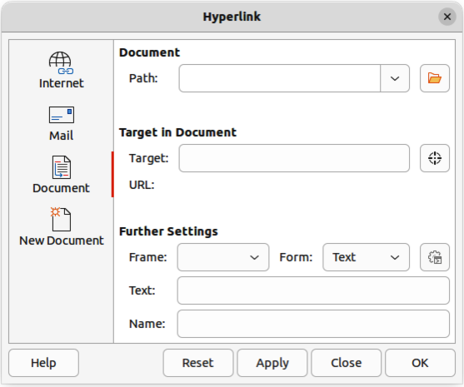
Figure 41: Hyperlink dialog — Document page

Document hyperlink
Creates a hyperlink to another document or to another place in a document, commonly referred to as a bookmark.
- Click in the text box at the required position for the hyperlink.
- Go to Insert > Hyperlink on the Menu bar, or use the keyboard shortcut Ctrl+K (macOS ⌘+K) to open the Hyperlink dialog.
- Select Document to open the Document page of the Hyperlink dialog (Figure 41).
- In the Path text box, enter the file path for the document.
- Alternatively, click on Open File to open a file browser and select the file as a target for the hyperlink.
- Note
Leave Path blank if the link is to a target in the same drawing.
- Optionally, to specify a target in a specific drawing, click on Target in Document to open a dialog to select a target. However, if the name of the target is known, type it into the Target text box.
- If necessary, enter the details required for Further Settings. See “Further Settings” on page 44 for more information.
- Click Apply to insert the hyperlink and save the selections. If several hyperlinks are being created, click Apply after inserting each hyperlink.
- Click OK to close the Hyperlink dialog.
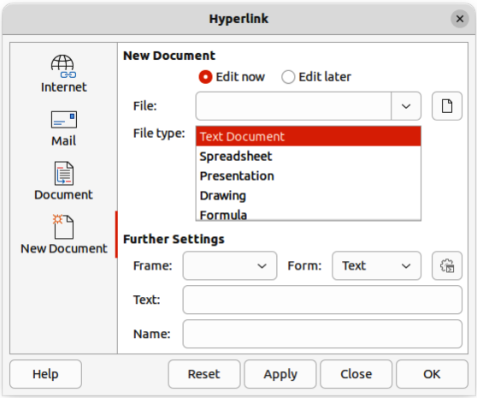
Figure 42: Hyperlink dialog — New Document page

New Document hyperlink
Creates a new document and a hyperlink to the new document.
- Click in the text box at the required position for the hyperlink.
- Go to Insert > Hyperlink on the Menu bar, or use the keyboard shortcut Ctrl+K (macOS ⌘+K) to open the Hyperlink dialog.
- Select New Document to open the New Document page of the Hyperlink dialog (Figure 42).
- In New Document select Edit now to edit the newly created document immediately, or Edit later to only create the hyperlink.
- Select the type of document to create from the File type drop-down list.
- Click on Select path to open a file browser and navigate to the folder where the new document is going to be saved
- Select the folder and click on Open. The selected folder appears in the File text box.
- If necessary, enter the details required for Further Settings. See “Further Settings” on page 44 for more information.
- Click Apply to insert the hyperlink and save the selections. If several hyperlinks are being created, click Apply after inserting each hyperlink.
- Click OK to close the Hyperlink dialog.

Further Settings
The Further Settings section in the Hyperlink dialog is common to all the hyperlink types, although some options are more relevant to specific types of links.
Frame
Enter a name for the frame in the Frame text box that the linked file opens in, or select a predefined frame from the list. If the Frame text box is empty, the linked file opens in the current browser window.
Form
Specifies whether the hyperlink is inserted as text, or as a button.
Text
Specifies the visible text, or button caption for the hyperlink.
Name
Applicable to HTML documents. It specifies the text added as a NAME attribute in the HTML code behind the hyperlink.

Editing text hyperlinks
- Select the hyperlink.
- Right-click on the hyperlink and select Edit Hyperlink from the context menu to open the Hyperlink dialog.
- Make editing changes using the available options.
- Click Apply to insert the hyperlink and save the selections. If several hyperlinks are being created, click Apply after inserting each hyperlink.
- Click OK to save the changes and close the Hyperlink dialog.
- Note
DO NOT click directly on the hyperlink text when editing or formatting hyperlinks. Clicking on the hyperlink text will open the hyperlink.

Formatting hyperlinks
A hyperlink is inserted in the centre of the current slide. To edit the text, the size of a hyperlink text box, or to reposition the hyperlink on the slide:
- Click and drag a selection marquee over the hyperlink text to display a text box border and selection handles.
- Right-click on the selected hyperlink and select the type of formatting required from the options available in the context menu.
- To reposition hyperlink, click and drag on the text border to move the hyperlink on the slide.
- Select Position and Size from the context menu, or use the F4 key to open the Position and Size dialog. Options can be selected to move the hyperlink, or resize the text box.

Image maps
An image map defines areas of the image (called hotspots) associated with a URL (a web address or a file on the computer). Hotspots are the graphic equivalent of text hyperlinks. In Draw, clicking on a hotspot opens the linked page in the appropriate program (for example, default browser for HTML pages; LibreOffice Writer for ODT files; PDF viewer for PDF files).
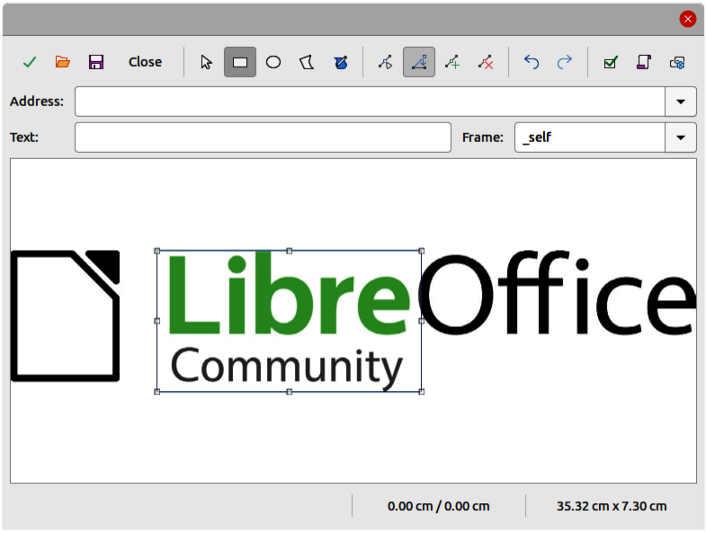
Figure 43: Image Map Editor dialog
Hotspots can be created in various shapes, such as rectangles, ellipses, and polygons, and include several hotspots in the same image. When a hotspot is clicked on, the URL opens in a browser window or frame that has been specified. The text that appears when the cursor hovers over a hotspot can also be specified.

Creating image maps
- Select an image in a drawing to use as a hotspot.
- Go to Tools > ImageMap on the Menu bar to open the Image Map Editor dialog (Figure 43). The main part of the dialog shows the selected image where hotspots will be defined.
- Select the type of hotspot area required from the icons at the top of the Image Map Editor dialog from the options Rectangle, Ellipse, Polygon, or Freeform Polygon.
- Draw the hotspot area onto the selected image.
- Enter the hyperlink address for the hotspot in the Address text box using the address format: file:///<path>/document_name#anchor_name.
- Click on Apply to apply the settings.
- Click on Save to save the image map to a file.
- Click on Close the Image Map Editor dialog.

Image map tools
Apply
Applies the changes.
Open
Loads into the Image Map Editor an existing image map in the MAP-CERN, MAP-NCSA or SIP StarView image map file format.
Save
Saves the image map in the MAP-CERN, MAP-NCSA, or SIP StarView image map file format.
Select
Selects a hotspot in the image map for editing.
Rectangle, Ellipse, Polygon, Freeform Polygon
Draws a hotspot on the selected image in the shape selected.
Edit Points
Change the shape of the selected hotspot by editing the anchor points.
Move Points
Move the individual anchor points of the selected hotspot.
Insert Points
Adds an anchor point at the selected point on the outline of the hotspot.
Delete Points
Deletes a selected anchor point.
Undo
Cancels the previous action.
Redo
Reapplies the previous cancelled action.
Active
Toggles the status of a selected hotspot between active and inactive.
Macro
Assign a macro that runs when the hotspot is clicked on.
Properties
Define the properties of the selected hotspot.
Address
Enter the URL for the file that opens when the selected hotspot is clicked on. The address format to be used: file:///<path>/document_name#anchor_name.
Text
Enter the text that is displayed when the cursor rests on the hotspot . If no text is entered, the Address is displayed.
Frame
Enter the name of the target frame for the hotspot. Standard frame name can be selected from the drop-down list and used instead.
_blank
Opens in a new browser window.
_self
Default selection and opens in the current window.
_top
File opens in the topmost frame in the hierarchy.
_parent
File opens in the parent frame of the current frame. If there is no parent frame, the current frame is used.
Graphic view
Displays the image map so that the hotspots can be selected and edited.
- Note
The value _self for the target frame will work on the vast majority of the occasions. It is not recommended to use the other values, if available, unless absolutely necessary.

Fontwork
Using Fontwork creates graphical text as objects in a drawing. Different settings for Fontwork (line, area, position, size, and more) are available to match the requirements of a drawing.
Fontwork is also available with the Writer, Calc, and Impress modules of LibreOffice, but there are small differences in the way that each LibreOffice module displays Fontwork.

Creating Fontwork
- Go to Insert > Fontwork on the Menu bar to open the Fontwork Gallery dialog (Figure 44).
- Select a Fontwork style from the dialog.
- Double click on the selected Fontwork object, or select OK. This closes the Fontwork Gallery dialog and the selected Fontwork object appears in the center of the drawing.
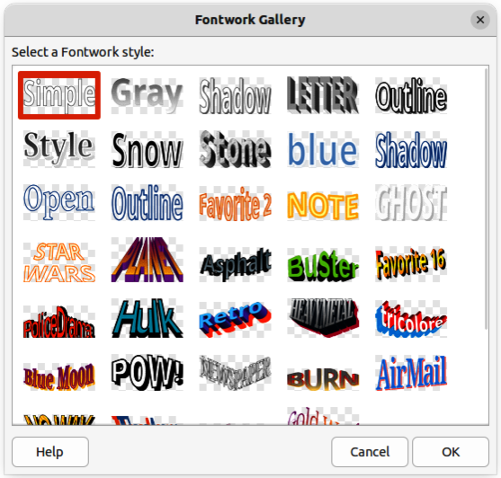
Figure 44: Fontwork Gallery dialog
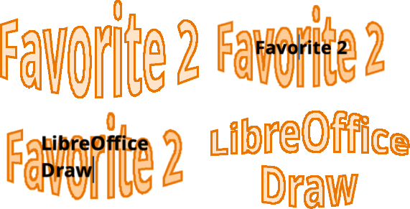
Figure 45: Example of creating Fontwork text
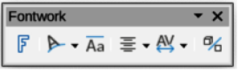
Figure 46: Fontwork toolbar
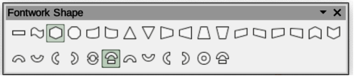
Figure 47: Fontwork Shape sub-toolbar
- Double-click on the Fontwork object to switch on editing mode. The Fontwork text appears in the center of the image in text edit mode, as shown by the example in Figure 45.
- Highlight all of the black text to select, then type in the required text. to replace the highlighted black text.
- Press the Esc key, or click outside the selected area to apply the change and the txt appears as a Fontwork object in the center of the drawing.
- If necessary reposition and resize the Fontwork object to the drawing requirements. See Chapter 3, Working With Objects and Chapter 4, Changing Object Attributes for more information.

Fontwork toolbar
The Fontwork toolbar (Figure 46) becomes visible and active on the workspace when a Fontwork object is selected. If the toolbar is not visible, go to View > Toolbars > Fontwork on the Menu bar. The following tools are available for editing a Fontwork object.
Insert Fontwork Text
Opens the Fontwork Gallery dialog.
Fontwork Shape
Changes the shape of the selected object. Click on Fontwork Shape to open a pop-up toolbar and select a Fontwork shape for the available options. The shapes are shown in the Fontwork Shape floating sub-toolbar (Figure 47).
Fontwork Same Letter Heights
Changes the height of characters in the selected Fontwork object. Toggles between normal height where the characters have different heights to where all characters have the same height.
Fontwork Alignment
Specifies the text alignment within the frame. Options available are Left Align, Center, Right Align, Word Justify, and Stretch Justify.
Fontwork Character Spacing
Selects the spacing between characters and whether kerning pairs should be used. Options available are Very Tight, Tight, Normal, Loose, Very Loose, and Custom. For Custom spacing, input a percentage value: 100% is normal character spacing, less than 100% character spacing is tighter, and more than 100% character spacing is looser.
Toggle Extrusion
Converts the Fontwork object into a 3D shape using extrusion. See Chapter 7, 3D Objects for more information.

Modifying Fontwork
A Fontwork object can be treated like any other object in Draw. It can be resized, rotated, skewed, slanted, flipped, and so on. For more information on modifying a Fontwork object, see Chapter 3, Working With Objects, Chapter 4, Changing Object Attributes, and Chapter 5, Combining Multiple Objects.
Although Fontwork consists of text, only minimal text formatting options can be used with Fontwork text, for example font type, font size, Bold, or Italic.
Some of the Fontwork shapes can be modified. For example, to change the angles of trapezoid or parallelogram basic shapes by moving the dot that is displayed along with the selection handles.

