
Draw Guide 7.4

Appendix B,
Toolbars

Copyright
This document is Copyright © 2023 by the LibreOffice Documentation Team. Contributors are listed below. This document maybe distributed and/or modified under the terms of either the GNU General Public License (https://www.gnu.org/licenses/gpl.html), version 3 or later, or the Creative Commons Attribution License (https://creativecommons.org/licenses/by/4.0/), version 4.0 or later. All trademarks within this guide belong to their legitimate owners.

Contributors
Contributors for this edition:
Peter Schofield

Contributors for previous editions:
Dave Barton
Kees Kriek
Jean Hollis Weber
Peter Schofield

Feedback
Please direct any comments or suggestions about this document to the Documentation Team mailing list: loguides@community.documentfoundation.org.
- Note
Everything sent to a mailing list, including email addresses and any other personal information that is written in the message, is publicly archived and cannot be deleted.

Publication date and software version
Published January 2023. Based on LibreOffice 7.4 Community.
Other versions of LibreOffice may differ in appearance and functionality.

Contents
Copyright 2
Contributors 2
Feedback 2
Publication date and software version 2
Introduction 5
Using toolbars 5
Draw toolbars available 5
Closing toolbars 5
Moving toolbars 5
Docked toolbars 5
Floating toolbars 6
Floating sub-toolbars 6
Docking a floating toolbar 7
Locking toolbars 7
Docked toolbars 7
Locking toolbars and sub-toolbars 7
Editing toolbars 8
Adding tools 8
Deleting tools 8
Customizing toolbars 8
Toolbars 8
3D-Objects 9
3D-Settings 9
Align Objects 9
Comments 10
Distribute Selection 10
Drawing 10
Edit Points 14
Find 15
Fontwork 15
Form Controls 16
Form Design 16
Form Navigation 17
Gluepoints 17
Image 18
Insert 18
Legacy Circles and Ovals 19
Legacy Rectangles 19
Line and Filling 19
Master View 20
Media Playback 20
Options 21
Redaction 21
Standard 21
Standard (Viewing Mode) 22
Table 23
Text Formatting 23
Transformations 24
Zoom 24

Introduction
Draw provides several toolbars to help in creating drawings. Each toolbar has a default set of tools and the option to add additional tools.
- Note
The icons displayed in the Draw toolbars illustrated in this appendix may differ from what is displayed on a computer screen. Toolbar icons depend on the computer operating system being used and how LibreOffice has been set up. For more information on customizing LibreOffice and the toolbars, see the Getting Started Guide.

Using toolbars
To display and make a toolbar active, go to View > Toolbars on the Menu bar. A submenu opens with an alphabetical list of toolbars available for creating drawings in LibreOffice Draw. Click on a toolbar name to display it and make it active. Active toolbars are indicated by highlighting or a check mark next to the name.

Draw toolbars available
3D-Objects
3D-Settings
Align Objects
Comments
Distribute Selection
Drawing
Edit Points
Find
Fontwork
Form Controls
Form Design
Form Navigation
Gluepoints
Image
Insert
Legacy Circles and Ovals
Legacy Rectangles
Line and Filling
Master View
Media Playback
Options
Redaction
Standard
Standard (Viewing Mode)
Table
Text
Text Formatting
Transformations
Zoom
- Note
Some toolbars, although selected in View > Toolbars on the Menu bar, will not display until an object of the correct type is selected in a drawing. For example, the Image toolbar only displays when an image is selected.

Closing toolbars
To close a toolbar, use one of the following methods:
- Go to View > Toolbars on the Menu bar and deselect the toolbar.
- Right-click on a tool on a toolbar and select Close Toolbar from the context menu.
- Click on the X in the right corner of the title bar of a floating toolbar.

Moving toolbars

Docked toolbars
By default, some toolbars are docked into position in the Draw main window. For example, the Standard toolbar is docked at the top of the main window. Docked toolbars can be undocked and moved to a new docked position on the main window or left as a floating toolbar. Before moving a toolbar, the toolbar must be unlocked.
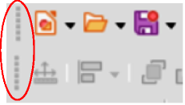
Figure 1: Toolbar handles highlighted
- Move the cursor over the small vertical handle at the left end of the toolbar (highlighted in Figure 1). The cursor changes to a moving cursor for the computer system and setup.
- Click and drag the toolbar to a new location. This can be a new docked position or a floating toolbar. A hashed border appears around the toolbar indicating the toolbar position as it is dragged.
- Release the cursor when the required position is reached.
- Note
If the small vertical bar is not visible at the left end of a docked toolbar, then the toolbar is locked into position. A docked toolbar must be unlocked before it can be moved to a new position in the Draw main window. See “Locking toolbars” on page 7 for more information.

Floating toolbars
To move a floating toolbar, click on its title bar and drag it to a new floating location. Release the cursor when the toolbar is in the required position. A floating toolbar does not have to be positioned on the Draw main window for it to function.

Floating sub-toolbars
Some tools on a toolbar have a triangle ▼ to the right of the tool indicating that more tools are available on a sub-toolbar, for example Basic Shapes on the Drawing toolbar. Sub-toolbars can be turned into floating toolbars and moved into a new position as follows:
- Move the cursor over the horizontal handle at the top of the toolbar (highlighted in Figure 2). The cursor changes to the moving cursor used for the computer system and setup.
- Click and drag the toolbar to a new location to create a floating sub-toolbar.
- Release the cursor when the required position is reached.
- To close the floating sub-toolbar, right-click on the triangle ▼ in the sub-toolbar title bar and select Close Toolbar from the context menu.
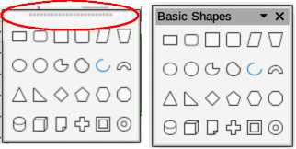
Figure 2: Creating floating sub-toolbar

Docking a floating toolbar
To dock a floating toolbar, use one of the following methods:
- Click on the title bar and drag it to the top, bottom, left side, or right side of the main window. When the toolbar reaches a docking position, a hashed border appears at the docked position. Release the cursor and the toolbar is docked.
- Right-click on the toolbar and select Dock Toolbar from the context menu. The toolbar moves into a docked position. If the position is not suitable, move the toolbar to a new docked position.
- To dock all floating toolbars that are active, right-click on the toolbar and select Dock All Toolbars from the context menu.

Locking toolbars

Docked toolbars
When a toolbar has been docked into position on the Draw main window, the toolbar can also be locked into position preventing the toolbar from becoming a floating toolbar.
- To lock a toolbar into a docked position, right-click in a blank area on the toolbar and select Lock Toolbar Position in the context menu. A check mark appears against this option indicating the toolbar is now locked.
- To unlock a toolbar, right-click in a blank area on the toolbar and click on Lock Toolbar Position in the context menu. The check mark next to this option disappears indicating the toolbar is now unlocked. A small vertical or horizontal bar appears at the left end or top of the toolbar indicating that the toolbar is unlocked. This bar is also is used to move the toolbar.
- Note
Some toolbars cannot be docked or locked into position. This is indicated by the options Dock Toolbar and/or Lock Toolbar Position being grayed out, making the options unavailable.

Locking toolbars and sub-toolbars
To prevent toolbars and sub-toolbars from becoming floating toolbars, all toolbars and sub-toolbars have to be locked as follows:
- Save the drawing that is open in Draw.
- Go to View > Toolbars on the Menu bar and select Lock Toolbars from the context menu.
- Select Restart Now in the Restart LibreOffice dialog that opens to activate the Lock Toolbars option.
- To unlock toolbars and sub-toolbars so they can become floating sub-toolbars, repeat Steps 1 thru 3. The Lock Toolbars option is an on/off switch.
- Note
Using the Lock Toolbars option affects all toolbars and sub-toolbars available in LibreOffice modules.

Editing toolbars
When LibreOffice is installed on a computer, it includes a set of toolbars suitable for each LibreOffice component. Each toolbar has a default set of visible tools. Tools can be added or deleted, and toolbars can be customized.

Adding tools
- Right-click in a blank area on a toolbar, or click on the triangle ▼ on the right of the toolbar title bar.
- Select Visible Buttons from the context menu to display a list of available tools.
- Click on the tool required and the tool appears in the toolbar. The list of available tools closes automatically. A highlight or check mark next to the tool indicates that the tool is already installed on the toolbar.
- Note
When adding tools using Visible Buttons, the tool is added to the toolbar at the same position as the tool appears in the Visible Buttons list. That is, the top tool in Visible Buttons appears at the left end of the toolbar and the bottom tool appears at the right end of the toolbar. Tool positions cannot be changed using Visible Buttons.

Deleting tools
- Right-click in a blank area on a toolbar, or click on the triangle ▼ on the right of the toolbar title bar.
- Select Visible Buttons from the context menu to display a list of available tools.
- Click on the tool no longer required and the tool is removed from the toolbar. The highlight or check mark next to the tool is also removed. The list of available tools closes automatically.

Customizing toolbars
Extra tools and commands that are not available in Visible Buttons can be added to a toolbar using customization (View > Toolbars > Customize on the Menu bar). Customization also allows the creation of new toolbars if a specific set of tools are required for a specific task. For information on customizing toolbars, see the Getting Started Guide.

Toolbars
The available tools listed for each toolbar below are all available for installation on a toolbar when Visible Buttons is opened in the context menu for each toolbar. The tools already installed on a toolbar are indicated in Visible Buttons either by the tool icon being highlighted or by a check mark. This install indication depends on computer setup and computer operating system being used.
On some toolbars, the icons have a triangle ▼ to the right of an icon. Click on this triangle to open further options that are available for use.
Some of the tools in the toolbars also have the option of using a keyboard shortcut instead of clicking on the tool. For a full list of keyboard shortcuts that are available in Draw, see Appendix A, Keyboard Shortcuts.

3D-Objects
The 3D-Objects toolbar (Figure 3) provides tools to create 3D objects in a slide. It is activated by going to View > Toolbars > 3D-Objects on the Menu bar. Alternatively, click on the triangle ▼ next to the 3D-Objects icon displayed on the Drawing toolbar to open a submenu giving access to the available 3D objects.
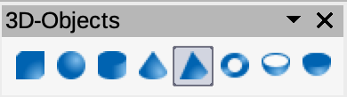
Figure 3: 3D-Objects toolbar
3D-Objects tools numbered position from left to right
- Cube
- Sphere
- Cylinder
- Cone
- Pyramid
- Torus
- Shell
- Half Sphere

3D-Settings
The 3D-Settings toolbar (Figure 4) and its tools only become active when an object has been converted to 3D using the tool Toggle Extrusion and the converted object is then selected.
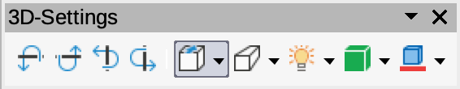
Figure 4: 3D-Settings toolbar
3D-Settings tools numbered position from left to right
- Toggle Extrusion
- Tilt Down
- Tilt Up
- Tilt Left
- Tilt Right
- Depth
- Direction
- Lighting
- Surface
- 3D Color
The following tools on this toolbar have a triangle ▼ on the right of the icon. Click on this triangle to open a drop-down menu giving access to various options as follows:
- Depth –– 3D extrusion depth – 0cm; 1cm; 2.5cm; 5cm; 10cm; Infinity; Custom. The measurement unit depends on the settings in Tools > Options > LibreOffice Draw > General (macOS LibreOffice > Preferences > LibreOffice Draw > General).
- Direction –– 3D extrusion direction and type – Parallel; Perspective.
- Lighting –– lighting direction and lighting level of 3D extrusion – Bright; Normal; Dim.
- Surface –– surface type of 3D extrusion – Wire Frame; Matt; Plastic; Metal.
- 3D Color –– color of 3D extrusion. Select a color from one of the available color palettes.

Align Objects
The Align Objects toolbar (Figure 5) provides tools for aligning several objects in a drawing to improve the visual impact of a drawing.
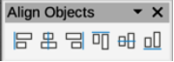
Figure 5: Align Objects toolbar
Align Objects tools numbered position from left to right
- Left
- Centered
- Right
- Top
- Center
- Bottom

Comments
The Comments toolbar (Figure 6) provides tool for adding, deletion, and navigation of comments in a drawing. To use comments, it is recommended to add the name and initials of all users in Tools > Options > LibreOffice > User Data (macOS LibreOffice > Preferences > LibreOffice > User Data) so that comments can be easily identified.
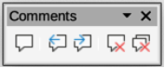
Figure 6: Comments toolbar
Comments tools numbered position from left to right
- Comment
- Previous Comment
- Next Comment
- Delete Comment
- Delete All Comments

Distribute Selection
The Distribute Selection toolbar (Figure 7) provides tools to distribute three or more selected objects evenly along the horizontal axis or vertical axis. Also, the spacing between objects can be evenly distributed.
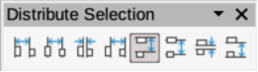
Figure 7: Distribute Selection toolbar
Distribute Selection tools numbered position from left to right
- Horizontally Left
- Horizontally Center
- Horizontally Spacing
- Horizontally Right
- Vertically Top
- Vertically Center
- Vertically Spacing
- Vertically Bottom

Drawing
The Drawing toolbar (Figure 8) provides the majority of the tools normally used to create graphic objects in a drawing. By default, this toolbar is normally docked on the left side of the Workspace.
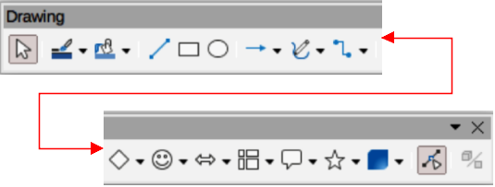
Figure 8: Drawing toolbar
Available Drawing tools numbered position from left to right
- Select
- Zoom & Pan
- Zoom
- Text Box
- Vertical Text
- Insert Fontwork
- Line Color
- Fill Color
- Line
- Rectangle
- Ellipse
- Line Ends with Arrow
- Lines and Arrows
- Curves and Polygons
- Connectors
- Basic Shapes
- Symbol Shapes
- Block Arrows (Arrow Shapes in Visible Buttons))
- Flowchart (Flowchart Shapes in Visible Buttons)
- Callouts (Callout Shapes in Visible Buttons)
- Stars and Banners (Star Shapes in Visible Buttons)
- 3D Objects
- Rotate
- Flip
- Align Objects
- Arrange
- Select at least three objects to distribute (Distribution in visible Buttons)
- Shadow
- Crop Image (Crop in Visible Buttons)
- Filter
- Points (Edit Points in Visible Buttons)
- Show Gluepoints Function (Gluepoints in Visible Buttons)
- To Curve
- To Polygon
- To 3D
- T0 3D Rotation Object
- Toggle Extrusion
- Insert
- Controls
Some tool shapes on the Drawing toolbar change depending on the last tool that had previously been selected and used.
- Click on the triangle ▼ to the right of a tool to open a pop-up toolbar. Select the required shape to add to a drawing.
- To create a sub-toolbar, click and drag at the top of the pop-up toolbar to an empty area on the main window. The sub-toolbars for each object type and the various shapes available are shown in Figures 9 to 18.
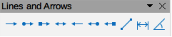
Figure 9: Lines and Arrows sub-toolbar
Lines and Arrows numbered position from left to right
- Line Ends with Arrow
- Line with Circle/Arrow
- Line with Square/Arrow
- Line with Arrows
- Line Starts with Arrow
- Line with Arrow/Circle
- Line with Arrow/Square
- Line
- Dimension Line
- Line (45°)
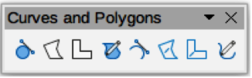
Figure 10: Curves and Polygons sub-toolbar
Curves and Polygons numbered position from left to right
- Curve, Filled
- Polygon, Filled
- Polygon (45°), Filled
- Freeform Line, Filled
- Curve
- Polygon
- Polygon (45°)
- Freeform Line
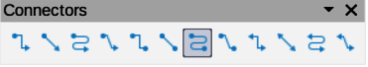
Figure 11: Connectors sub-toolbar
Available Connectors numbered position from left to right
- Connector Ends with Arrow
- Straight Connector Ends with Arrow
- Curved Connector Ends with Arrow
- Line Connector Ends with Arrow
- Connector
- Straight Connector
- Curved Connector
- Line Connector
- Connector with Arrows
- Straight Connector with Arrows
- Curved Connector with Arrows
- Line Connector with Arrows
- Connector Starts with Arrow
- Straight Connector Starts with Arrow
- Curved Connector Starts with Arrow
- Line Connector Starts with Arrow
- Connector Ends with Circle
- Straight Connector Ends with Circle
- Curved Connector Ends with Circle
- Line Connector Ends with Circle
- Connector Starts with Circle
- Straight Connector Starts with Circle
- Curved Connector Starts with Circle
- Line Connector Starts with Circle
- Connector with Circles
- Straight Connector with Circles
- Curved Connector with Circles
- Line Connector with Circles
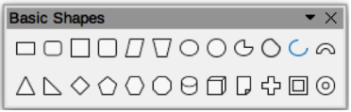
Figure 12: Basic Shapes sub-toolbar
Basic Shapes numbered position from left to right
- Rectangle
- Rectangle, Rounded
- Square
- Square, Rounded
- Parallelogram
- Trapezoid
- Ellipse
- Circle
- Circle Pie
- Circle Segment
- Arc
- Block Arc
- Isosceles Triangle
- Right Triangle
- Diamond
- Regular Pentagon
- Hexagon
- Octagon
- Cylinder
- Cube
- Folded Corner
- Cross
- Frame
- Ring
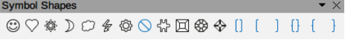
Figure 13: Symbol Shapes sub-toolbar
Symbol Shapes numbered position from left to right
- Smiley Face
- Heart
- Sun
- Moon
- Cloud
- Lightning Bolt
- Flower
- Prohibited
- Puzzle
- Square Bevel
- Octagon Bevel
- Diamond Bevel
- Double Bracket
- Left Bracket
- Right Bracket
- Double Brace
- Left Brace
- Right Brace
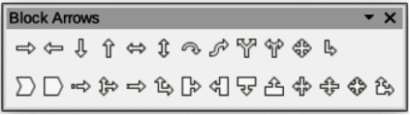
Figure 14: Block Arrows sub-toolbar
Block Arrows numbered position from left to right
- Right Arrow
- Left Arrow
- Down Arrow
- Up Arrow
- Left and Right Arrow
- Up and Down Arrow
- Circular Arrow
- S-shaped Arrow
- Split Arrow
- Right or Left Arrow
- 4-way Arrow
- Corner Right Arrow
- Chevron
- Pentagon
- Striped Right Arrow
- Up, Right and Down Arrow
- Notched Right Arrow
- Up and Right Arrow
- Right Arrow Callout
- Left Arrow Callout
- Down Arrow Callout
- Up Arrow Callout
- Left and Right Arrow Callout
- Up and Down Arrow Callout
- 4-way Arrow Callout
- Up and Right /Arrow Callout
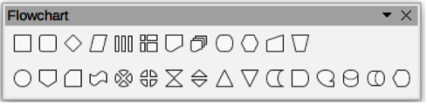
Figure 15: Flowchart sub-toolbar
Flowchart symbols numbered position from left to right
- Flowchart: Process
- Flowchart: Alternate Process
- Flowchart: Decision
- Flowchart: Data
- Flowchart: Predefined Process
- Flowchart: Internal Storage
- Flowchart: Document
- Flowchart: Multidocument
- Flowchart: Terminal
- Flowchart: Preparation
- Flowchart: Manual Input
- Flowchart: Manual Operation
- Flowchart: Connector
- Flowchart: Off-page Connector
- Flowchart: Card
- Flowchart: Punched Tape
- Flowchart: Summing Junction
- Flowchart: Or
- Flowchart: Collate
- Flowchart: Sort
- Flowchart: Extract
- Flowchart: Merge
- Flowchart: Stored Data
- Flowchart: Delay
- Flowchart: Sequential Access
- Flowchart: Magnetic Disc
- Flowchart: Direct Access Storage
- Flowchart: Display
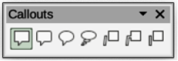
Figure 16: Callouts sub-toolbar
Callouts numbered position from left to right
- Rectangular Callout
- Rounded Rectangular Callout
- Round Callout
- Cloud
- Line Callout 1
- Line Callout 2
- Line Callout 3
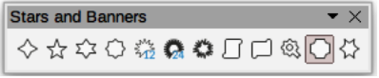
Figure 17: Stars and Banners sub-toolbar
Stars and Banners numbered position from left to right
- 4-Point Star
- 5-Point Star
- 6-Point Star
- 8-Point Star
- 12-Point Star
- 24-Point Star
- Explosion
- Vertical Scroll
- Horizontal Scroll
- Signet
- Doorplate
- 6-Point Star, Concave
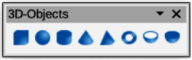
Figure 18: 3D-Objects sub-toolbar
3D-Objects numbered position from left to right
- Cube
- Sphere
- Cylinder
- Cone
- Pyramid
- Torus
- Shall
- Half-Sphere

Edit Points
The Edit Points toolbar (Figure 19) provides tools for editing the points of a curve or an object that has been converted to a curve. The toolbar only becomes active when an object is selected and one of the following methods is used to open the toolbar:
- Click on Edit Points on the Drawing toolbar.
- Use the keyboard shortcut F8.
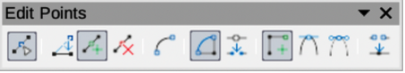
Figure 19: Edit Points toolbar
Edit Points tools numbered position from left to right
- Edit Points
- Move Points
- Insert Points
- Delete Points
- Convert to Curve
- Close Bezier
- Split Curve
- Corner Point
- Smooth Transition
- Symmetric Transition
- Eliminate Points

Find
The Find toolbar (Figure 20) opens by default in the bottom left corner of the Draw main window. This toolbar is normally docked at the bottom left of the Draw main window above the Status Bar. However, it can be undocked and made into a floating toolbar.
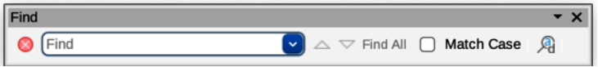
Figure 20: Find toolbar
Find tools numbered position from left to right
- Close Find Bar
- Find Values
- Find Previous
- Find Next
- Find All
- Match Case
- Find and Replace
- [place holder for message]

Fontwork
The Fontwork toolbar (Figure 21) is used to create graphical text objects in a drawing and provide the tools for editing the graphical text object. This toolbar only becomes active when a Fontwork graphical text object in the drawing has been selected.
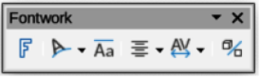
Figure 21: Fontwork toolbar
Fontwork tools numbered position from left to right
- Insert Fontwork Text
- Fontwork Shape
- Fontwork Same Letter Heights
- Fontwork Alignment
- Fontwork Character Spacing
- Toggle Extrusion
Some tools on the Fontwork toolbar have a triangle ▼ to the right of the tool. Click on the triangle to open a pop-up toolbar or drop-down option list.
- Fontwork Shape –– select a shape for the Fontwork graphical text object from available options.
- Fontwork Alignment –– select paragraph alignment from available options.
- Fontwork Character Spacing –– select character spacing from available options.

Form Controls
The Form Controls toolbar (Figure 22) provides the tools required to create an interactive form. This allows controls to be added to a form in a text, drawing, spreadsheet, presentation, or HTML document (for example a button that opens another drawing or document).
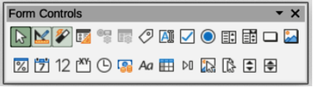
Figure 22: Form Controls toolbar
Form Controls tools numbered position from left to right
- Select
- Design Mode
- Toggle Form Control Wizards
- Form Design
- Control Properties
- Form Properties
- Label
- Text Box
- Check Box
- Option Button
- List Box
- Combo Box
- Push Button
- Image Button
- Formatted Field
- Date Field
- Numerical Field
- Group Box
- Time Field
- Currency Field
- Pattern Field
- Table Control
- Navigation Bar
- Image Control
- File Selection
- Spin Button
- Scrollbar

Form Design
The Form Design toolbar (Figure 23) opens a form in Design Mode so that it can be edited. Controls of the form cannot be activated, or its contents edited, when in Design Mode. However, the position and size of the controls can be changed, other properties edited, and added or deleted controls in Design Mode.
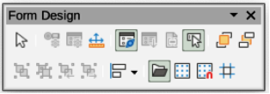
Figure 23: Form Design toolbar
Form Design tools numbered position from left to right
- Select
- Control Properties
- Form Properties
- Position and Size
- Form Navigator
- Activation Order
- Add Field
- Automatic Control Focus
- Bring to Front
- Send to Back
- Group
- Ungroup
- Enter Group
- Exit Group
- Align Objects
- Open in Design Mode
- Display Grid
- Snap to Grid
- Helplines While Moving

Form Navigation
The Form Navigation toolbar (Figure 24) provides tools to edit a database table or control the data view. It is normally displayed at the bottom of a document that contains fields linked to a database. Also, it is only active when forms are connected to a database and an inactivate toolbar is shown in Figure 24.
The Form Navigation toolbar also allows movement within records as well as inserting and deleting records. If data is saved in a form, the changes are transferred to the database. This toolbar also provides tools providing sort, filter, and search functions for data records.
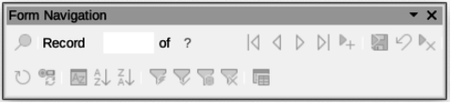
Figure 24: Form Navigation toolbar
Form Navigation tools numbered position from left to right
- Find Record
- Record
- Absolute Record
- Text -> Record
- Total No. of Records
- First Record
- Previous Record
- Next Record
- Last Record
- New Record
- Save Record
- Undo: Data entry
- Delete Record
- Refresh
- Refresh Control
- Sort
- Sort Ascending
- Sort Descending
- AutoFilter
- Apply Filter
- Form-Based Filters
- Reset Filter/Sort
- Data source as Table

Gluepoints
The Gluepoints toolbar (Figure 25) provides tools to insert a gluepoint or modify the properties of a gluepoint. A gluepoint is a point where a connector is attached to an object. By default, LibreOffice automatically places a gluepoint at the center of each side of the bounding rectangle for every object created.
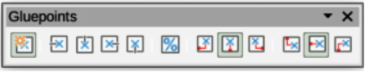
Figure 25: Gluepoints toolbar
Gluepoint tools numbered position from left to right
- Insert Gluepoint
- Exit Direction Left
- Exit Direction Top
- Exit Direction Right
- Exit Direction Bottom
- Gluepoint Relative
- Gluepoint Horizontal Left
- Gluepoint Horizontal Center
- Gluepoint Horizontal Right
- Gluepoint Vertical Top
- Gluepoint Vertical Center
- Gluepoint Vertical Bottom

Image
The Image toolbar (Figure 26) provides tools to edit, modify, align, reposition and resize images. The toolbar only becomes active and available when an image is selected in a drawing. The Image toolbar automatically replaces the Line and Filling toolbar when it becomes active.
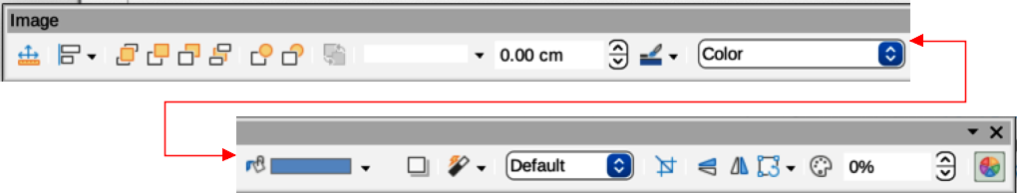
Figure 26: Image toolbar
Available Image tools numbered position from left to right
- Position and Size
- Align Objects
- Left
- Centered
- Right
- Top
- Center
- Bottom
- Arrange
- Bring to Front
- Bring Forward
- Send Backward
- Send to Back
- In Front of Object
- Behind Object
- Reverse
- Line Style
- Line Width
- Line Color
- Area Style/Filling
- Fill Color
- Shadow
- Filter
- Image Mode
- Crop
- Vertically
- Horizontally
- Transformations
- Transparency
- Color
- Line
- Area

Insert
The Insert toolbar (Figure 27) provides tools to insert different types of objects into a drawing.
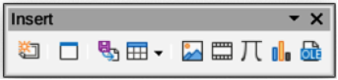
Figure 27: Insert toolbar
Insert tools numbered position from left to right
- New Page
- Floating Frame
- Insert Page from File
- Table
- Image
- Insert Audio or Video (Media in Visible Buttons)
- Formula Object
- Chart
- OLE Object

Legacy Circles and Ovals
The Legacy Circles and Ovals toolbar (Figure 28) provides tools to insert different types of circles and ovals into a drawing.
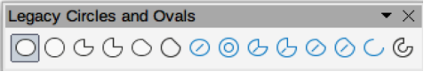
Figure 28: Legacy Circles and Ovals toolbar
Legacy Circles and Ovals tools numbered position from left to right
- Insert Ellipse
- Circle
- Ellipse Pie
- Circle Pie
- Ellipse Segment
- Circle Segment
- Ellipse, Unfilled
- Circle, Unfilled
- Ellipse Pie, Unfilled
- Circle Pie, Unfilled
- Ellipse Segment, Unfilled
- Circle Segment, Unfilled
- Arc
- Circle Arc

Legacy Rectangles
The Legacy Rectangles toolbar (Figure 29) provides tools to insert different types of rectangles and squares into a drawing.
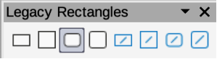
Figure 29: Legacy Rectangles toolbar
Legacy Rectangles tools numbered position from left to right
- Insert Rectangle
- Square
- Rectangle, Rounded
- Rounded Square
- Rectangle, Unfilled
- Square, Unfilled
- Rounded Rectangle, Unfilled
- Rounded Square, Unfilled

Line and Filling
The Line and Filling toolbar (Figure 30) provides tools and drop-down lists for editing lines, arrows, and object borders. The tools available vary depending on the type of object selected for editing.
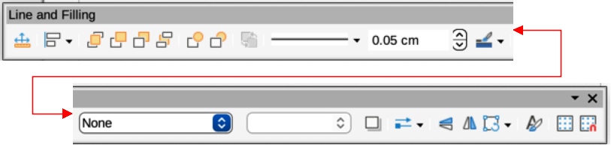
Figure 30: Line and Filling toolbar
Available Line and Filling tools numbered position from left to right
- Position and Size
- Align Objects
- Left
- Centered
- Right
- Top
- Center
- Bottom
- Arrange
- Bring to Front
- Bring Forward
- Send Backward
- Send to Back
- In Front of Object
- Behind Object
- Reverse
- Line Style
- Line Width
- Line Color
- Area Style/Filling
- Fill Color
- Shadow
- Arrow Style
- Vertically
- Horizontally
- Transformations
- Line
- Area
- 3D Effects
- Image Map
- Animation
- Interaction
- Show the Styles Sidebar
- Display Grid
- Helplines While Moving

Master View
The Master View toolbar (Figure 31) provides tools to create a new master page, rename a master page, delete a master page, and close master view. This toolbar is only active when Draw is in master view.
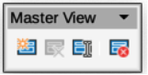
Figure 31: Master View toolbar
Master View tools from numbered position left to right
- New Master
- Rename Master
- Delete Master
- Close Master View

Media Playback
The Media Playback toolbar (Figure 32) provides the standard tools required to insert, view, play, and listen to audio and video files. The toolbar only becomes active when an audio or video file is selected. Draw supports many different media formats depending on the computer operating system being used.
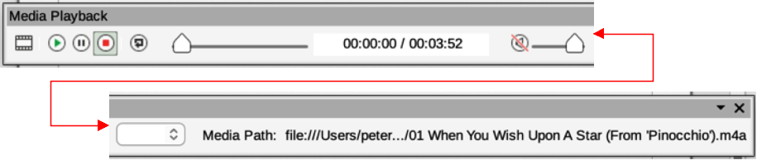
Figure 32: Media Playback toolbar
Media Playback tools numbered position from left to right
- Insert Audio or Video
- Play
- Pause
- Stop
- Repeat
- Position
- Mute
- Volume
- View

Options
The Options toolbar (Figure 33) provides tools for editing various settings for newly created drawings, for example how objects snap to the grid when being moved or resized.
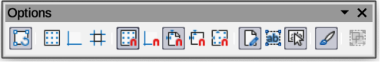
Figure 33: Options toolbar
Options tools numbered position from left to right
- Rotation Mode after Clicking Object
- Display Grid
- Display Snap Guides
- Helplines While Moving
- Snap to Grid
- Snap to Snap Guides
- Snap to Page Margins
- Snap to Object Borders
- Snap to Object Points
- Allow Quick Editing
- Select Text Area Only
- Double-click to edit Text
- Modify Object with Attributes
- Exit All Groups

Redaction
The Redaction toolbar (Figure 34) is used to block portions of a drawing protecting sensitive information and helps enterprises and organizations to comply with regulations on confidentiality or privacy.
When a redacted drawing is exported to a new drawing, any redacted portions are removed from the new drawing and replaced by redaction blocks of pixels. This prevents any attempt to restore or copy the original contents. A redacted drawing is often exported to PDF for publication or sharing.
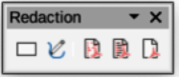
Figure 34: Redaction toolbar
Redaction tools numbered position from left to right
- Rectangle
- Freeform
- Redacted Export (White)
- Redacted Export (Black)
- PDF

Standard
The Standard toolbar (Figure 35) is common to all LibreOffice components and provides the most common tools when creating and editing documents using LibreOffice. The Standard toolbar differs between LibreOffice components to allow for different toolsets used in creating the different types of documents.
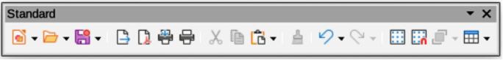
Figure 35: Standard toolbar
Available Standard tools numbered position from left to right
- Load URL
- New
- Templates
- Open
- Open Remote
- Save
- Save As
- Email
- Edit Mode
- Export
- Export Directly as PDF
- Print Directly
- Print
- Cut
- Copy
- Paste
- Clone Formatting (Clone in Visible Buttons)
- Clear
- Undo
- Redo
- Spelling
- Auto Spellcheck
- Display Grid (Grid in Visible Buttons)
- Helplines While Moving
- Zoom & Pan
- Object Zoom
- Zoom
- Table
- Insert Image (Image in Visible Buttons)
- Insert Chart (Chart in Visible Buttons)
- Insert Text Box (Text Box in Visible Buttons)
- Insert Special Characters (Symbol in Visible Buttons)
- Vertical Text
- Insert Fontwork Text
- Insert Hyperlink (Hyperlink in Visible Buttons)
- Transformations
- Flip
- Position and Size
- Align Objects
- Distribution
- Shadow
- Crop
- Filter
- 3D Effects
- Edit Points
- Gluepoints
- Toggle Extrusion
- Show Draw Functions (Draw Functions in Visible Buttons)
- LibreOffice Help
- What’s That
- Go to First Page
- Go to Previous Page
- Go to Next Page
- Go to Last Page
- Move Page to Start
- Move Page Up
- Move Page Down
- Move Page to End

Standard (Viewing Mode)
The Standard (Viewing Mode) toolbar (Figure 36) provides tools to save, edit, and distribute a drawing.
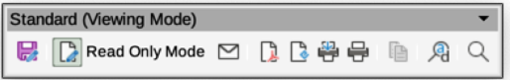
Figure 36: Standard (Viewing Mode) toolbar
Standard (Viewing Mode) tools numbered position from left to right
- Save As
- Toggle Edit Mode (Edit Mode in Visible Buttons)
- Toggle Read Only Mode (Read Only Mode in Visible Buttons)
- Attach to Email (Email in Visible Buttons)
- Export Directly as PDF
- Export as EPUB (EPUB in Visible Buttons)
- Print Directly
- Print
- Copy
- Find and Replace
- Zoom

Table
The Table toolbar (Figure 37) provides tools and options to edit and format a table placed in a drawing. This toolbar only becomes active when a table is selected.
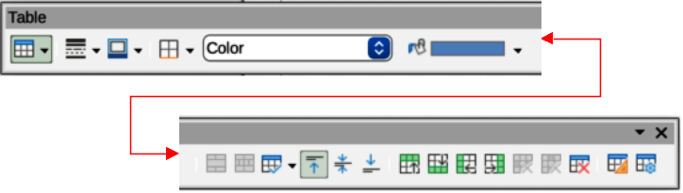Figure 37: Table toolbar
Table tools numbered position from left to right
- Table
- Border Style
- Border Color
- Borders (Shift to overwrite)
- Area Style/Filling
- Fill Color
- Merge Cells
- Split Cells
- Optimize
- Align Top (Top in Visible Buttons)
- Center Vertically (Center in Visible Buttons)
- Align Bottom (Bottom in Visible Buttons)
- Insert Row Above
- Insert Row Below
- Insert Column Before
- Insert Column After
- Delete Row
- Delete Column
- Delete Table
- Select Table
- Select Column
- Select Row
- Table Design
- Table Properties

Text Formatting
The Text Formatting toolbar (Figure 38) provides tools for formatting text and alignment commands. This toolbar becomes active when text in a text box or graphic object has been selected and it automatically replaces the Line and Filling toolbar.
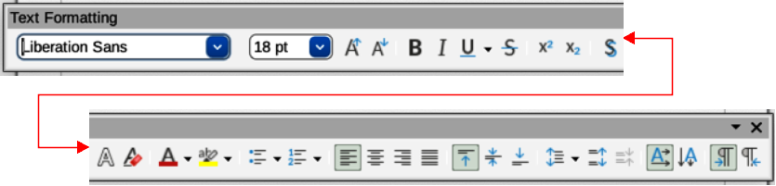
Figure 38: Text Formatting toolbar
Available Text Formatting tools numbered position from left to right
- Font Name
- Font Size
- Increase Font Size (Increase in Visible Buttons)
- Decrease Font Size (Decrease in Visible Buttons)
- Bold
- Italic
- Underline
- Double Underline
- Strikethrough
- Overline
- Superscript
- Subscript
- Toggle Shadow (Shadow in Visible Buttons)
- Apply outline attribute to font. Not all fonts implement this attribute. (Outline Font Effect in Visible Buttons)
- Clear
- lowercase
- UPPERCASE
- Small capitals
- Font Color
- Character Highlighting Color
- Toggle Unordered List (Unordered List in Visible Buttons)
- Toggle Ordered List (Ordered List in Visible Buttons)
- Outline Format
- Align Left (Left in Visible Buttons)
- Align Center (Center in Visible Buttons)
- Align Right (Right in Visible Buttons)
- Justified
- Align Top (Top in Visible Buttons)
- Center Vertically (Center in Visible Buttons)
- Align Bottom (Bottom in Visible Buttons)
- Set Line Spacing (Line Spacing in Visible Buttons)
- Character Spacing
- Increase Paragraph Spacing (Increase in Visible Buttons)
- Decrease Paragraph Spacing (Decrease in Visible Buttons)
- Text direction from left to right
- Text direction from top to bottom
- Left-To-Right
- Right-To-Left
- Select All
- Character
- Paragraph

Transformations
The Transformations toolbar (Figure 39) provides tools to modify the shape, orientation, or fill of selected objects.
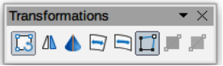
Figure 39: Transformations toolbar
Transformations tools numbered position from left to right
- Rotate
- Flip
- In 3D Rotation Object
- Set in Circle (perspective)
- Set to circle (slant)
- Distort
- Interactive transparency tool (Transparency tool in Visible Buttons)
- Interactive gradient tool (Gradient tool in Visible Buttons)

Zoom
The Zoom toolbar (Figure 40) provides tools to reduce or enlarge the screen display of the current drawing.
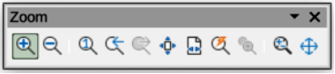
Figure 40: Zoom toolbar
Zoom tools numbered position from left to right
- Zoom In
- Zoom Out
- 100%
- Zoom Previous
- Zoom Next
- Entire Page
- Page Width
- Optimal View (Optimal in Visible Buttons)
- Object Zoom
- Zoom & Pan
- Shift

