
Draw Guide

Chapter 10,
Printing, Exporting and Emailing

Copyright
This document is Copyright © 2021 by the LibreOffice Documentation Team. Contributors are listed below. This document maybe distributed and/or modified under the terms of either the GNU General Public License (https://www.gnu.org/licenses/gpl.html), version 3 or later, or the Creative Commons Attribution License (https://creativecommons.org/licenses/by/4.0/), version 4.0 or later.
All trademarks within this guide belong to their legitimate owners.

Contributors
To This Edition
Peter Schofield | Jean Hollis Weber
To Previous Editions
John A Smith | Jean Hollis Weber | Hazel Russman
Ron Faile Jr. | Peter Schofield | Claire Wood

Feedback
Please direct any comments or suggestions about this document to the Documentation Team’s mailing list: documentation@global.libreoffice.org
- Note
Everything sent to a mailing list, including email addresses and any other personal information that is written in the message, is publicly archived and cannot be deleted.

Publication date and software version
Published July 2021. Based on LibreOffice 7.1 Community. Other versions of LibreOffice may differ in appearance and functionality.

Using LibreOffice on macOS
Some keystrokes and menu items are different on macOS from those used in Windows and Linux. The table below gives some common substitutions for the instructions in this document. For a more detailed list, see the application Help.
Windows or Linux | macOS equivalent | Effect
Tools > Options menu | LibreOffice > Preferences | Access setup options
Right-click | Control+click or right-click depending on computer setup | Open a context menu
Ctrl (Control) | ⌘ (Command) | Used with other keys
F5 | Shift+⌘+F5 | Open the Navigator
F11 | ⌘+T | Open the sidebar Styles deck

Contents
Copyright 2
Contributors 2
Feedback 2
Publication date and software version 2
Using LibreOffice on macOS 2
Printing 4
Quick printing 4
Controlled printing 4
General options 5
LibreOffice Draw options 6
Single sheet printing of multiple pages 7
Selecting pages to print 7
Individual page 7
Range of pages 7
Selection printing 7
Brochure printing 8
Simplex printer 8
Duplex printer 8
Black and white or grayscale printing 9
Printer settings 9
LibreOffice settings 9
Exporting 10
Directly as PDF 10
Controlling PDF content and quality 10
Other formats 11
Web pages 12
Emailing documents 12
Open Document format 12
PDF format 13
Digital signatures 13
Removing personal data 13
Setting security and warning options 13
Removing personal data and drawing information 15
Removing version information 15
Redaction 15
Documents, spreadsheets, or presentations 16
Drawings 16

Printing

Quick printing
To quickly print a document or drawing, click on Print Directly on the Standard toolbar (Figure 1) to send the entire document to the default printer that is defined for the computer.
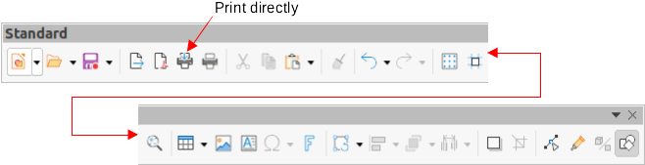Figure 1: Standard toolbar
- Note
The action of Print Directly can be changed by sending a document to the printer defined for the document instead of the default printer defined for the computer. Go to Tools > Options > Load/Save > General and select the option Load printer settings with the document.
- Note
If Print Directly is not visible on the Standard toolbar, right-click in an empty area on the Standard toolbar and select Visible Buttons from the context menu. Select Print Directly from the displayed list of tools and the tool is added to the Standard toolbar.

Controlled printing
For more control over printing, open and use the Print dialog (Figure 2 and 3) using one of the following methods:
- Go to File > Print on the Menu bar.
- Use the keyboard shortcut Ctrl+P.
- Click on Print on the Standard toolbar.
- Note
The options selected in the Print dialog only apply to the printing of the current document that is open in Draw. To specify default print settings for LibreOffice, go to Tools > Options > LibreOffice > Print on the main menu bar to open the Options LibreOffice Print dialog.
- Note
Due to different computer setups and different operating systems, the print dialog that opens on a computer monitor may differ from the dialogs shown in Figure 2 and 3. However, the printing options available for LibreOffice remain the same.
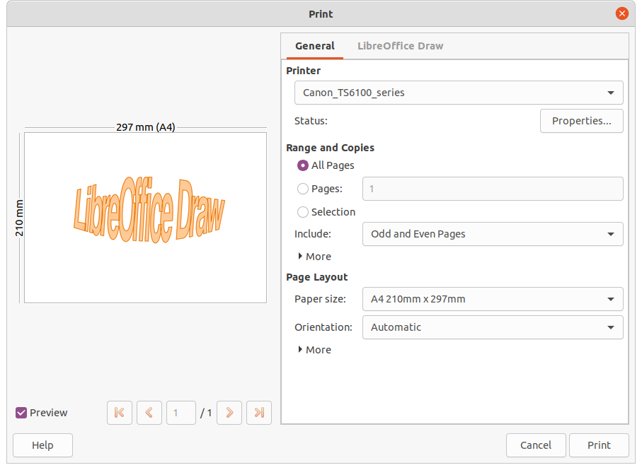Figure 2: Print dialog - General page
- Note
Any print options selected with the Draw Print dialog when printing from Draw will override the default printer settings that have been set using Tools > Options > LibreOffice > Print and Tools > Options > LibreOffice Draw > Print.

General options
The following general options are an example of what may be available on the General page of the Print dialog (Figure 2).
- Printer – select the printer to use from the printers available in the drop-down list.
- Range and Copies – select from the following options:
- All Pages – prints all the pages in the document.
- Pages – select the page number(s) to print. For multiple pages, use the format 1, 3. 7 or 1 – 5, 7, 9 for page number selection.
- Selection – select from the drop-down list Odd and Even pages, Odd pages, or Even pages.
- Paper sides – select from the drop-down list Print on one side (simplex), Print on both sides (duplex long edge binding), or Print on both sides (duplex short edge binding).
- Number of copies – enter number of printed copies required for document.
- Collate – collates multiple printed copies into separate documents.
- Order – select from Create separate print jobs for collated output or Print reverse order.
- Page Layout – select from the following options:
- Paper size – select the paper size to use from drop-down list
- Orientation – select from the drop-down list Automatic, Portrait or Landscape.
- Pages per sheet – select from the drop-down list how many pages are printed on one sheet of paper.
- Order – select from the drop-down list the printing order of multiple pages on one sheet of paper.
- Draw a border around each page – when multiple pages are printed on one sheet of paper, a border is drawn around each page.
- Brochure – prints the document so the pages can be folded into a booklet.

LibreOffice Draw options
The following options are available on the LibreOffice Draw page of the Print dialog (Figure 3) where settings are defined specific to the current document type:
- Contents – prints the Page name and/or Date and time on the drawing.
- Colors – prints the drawing in Original colors, Grayscale, or Black & white.
- Size – print the drawing using one of the following options:
- Original size – prints the drawing using its original size.
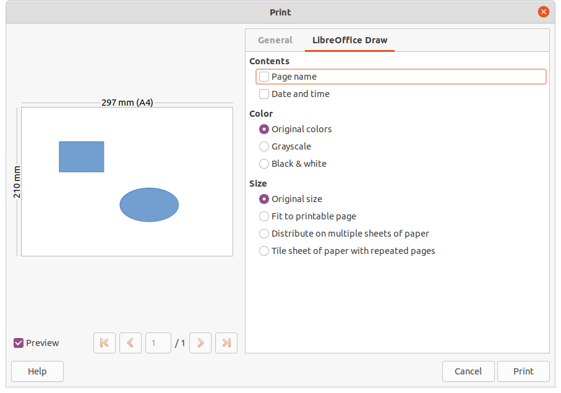Figure 3: Print dialog - LibreOffice Draw page
- Fit to printable page – the drawing size is changed so that it fits on the paper size used for printing.
- Distribute on multiple sheets of paper – used if the drawing is too large for the paper size being used.
- Tile sheet of paper with repeated pages – used to print multiple copies of a drawing on a page.
- Note
The following printing instructions are examples only. Actual method of printing may differ from the examples as this depends on computer operating system, computer setup, and the printer being used.

Single sheet printing of multiple pages
To print multiple pages of a drawing on single sheet of paper:
- Open the Print dialog, see “Controlled printing” on page 4.
- Select the printer to use if more than one printer is connected to the computer.
- In Page Layout, select the number of pages to print per sheet of paper from the Pages per sheet drop-down list. The preview panel on the right shows how the pages will look on a printed sheet of paper.
- In Page Layout, select how the multiple pages are printed on the sheet of paper from the Order drop-down list.
- If necessary, select Draw a border around each page to distinguish each page printed on a sheet of paper.
- Click OK to print the document and close the Print dialog.

Selecting pages to print

Individual page
- Open the Print dialog, see “Controlled printing” on page 4.
- Select the printer to use if more than one printer is connected to the computer.
- In Ranges and Copies, select Pages and enter the page number of the page to print.
- Click OK to print the individual pages and close the Print dialog.

Range of pages
- Open the Print dialog, see “Controlled printing” on page 4.
- Select the printer to use if more than one printer is connected to the computer.
- In Ranges and Copies, select Pages and enter the page numbers of the pages to print using the format, for example, 1,3,7 or 2–5,7,9 for page number selection
- Click OK to print the pages and close the Print dialog.

Selection printing
- Open the Print dialog, see “Controlled printing” on page 4.
- Select the printer to use if more than one printer is connected to the computer.
- In Ranges and Copies, select Selection and then select Odd and Even pages, Even pages, or Odd pages from the drop-down list.
- Click OK to print the pages and close the Print dialog.

Brochure printing
In Writer, Impress, and Draw, a document can be printed as a brochure (also known as booklet printing). The pages are arranged so that when the printed pages are folded in half, the pages are in the correct order to form a brochure or booklet.
- Tip
Plan the document to make it look good when printed as a brochure. Choose appropriate margins, font sizes, and so on as the pages are normally printed at half size on a sheet of paper. Experiment to get the best document format to match the capabilities of the printer being used.

Simplex printer
To print a brochure or booklet on a printer only capable of simplex or single-sided printing:
- Open the Print dialog, see “Controlled printing” on page 4.
- Select the printer to use if more than one printer is connected to the computer.
- In Printer, click Properties to open the properties dialog for the selected printer.
- Make sure the printer is set to the same orientation (portrait or landscape) as specified in the page setup for the document. Usually the orientation does not matter, but it does for brochures.
- Click OK to close the properties dialog and return to the Print dialog.
- In Page Layout, select More, then select the Brochure option.
- In Range and Copies, select Even pages or Odd pages from the Selection drop-down list.
- Click OK to print the even or odd pages.
- Take the printed pages out of the printer and put back into the printer in the correct orientation to print on the blank side. This may require some testing to find out what the correct arrangement is for the selected printer.
- If Even Pages was selected, now select Odd Pages in Range and Copies. If Odd Pages was selected, now select Even Pages in Range and Copies.
- Click OK to finish printing the document as a brochure and close the Print dialog.

Duplex printer
To print a brochure or booklet on a printer that is capable of duplex or double-sided printing:
- Open the Print dialog, see “Controlled printing” on page 4.
- Select the printer to use if more than one printer is connected to the computer.
- In Printer, click Properties to open the properties dialog for the selected printer.
- Make sure the printer is set to the same orientation (portrait or landscape) as specified in the page setup for the document. Usually the orientation does not matter, but it does for brochures.
- Click OK to close the properties dialog and return to the Print dialog.
- In Range and Copies, select More, then select Print on both sides (duplex long edge) from the Paper sides drop-down list. Actual options available for duplex printing depend on the printer model and the computer system being used.
- In Page Layout, Select More, then select the Brochure option.
- In Range and Copies, select the All Pages option.
- Click OK to print the document as a brochure and close the Print dialog..

Black and white or grayscale printing

Printer settings
To print documents in black and white or grayscale on a color printer:
- Open the Print dialog, see “Controlled printing” on page 4..
- Select the printer to use if more than one printer is connected to the computer.
- Click on LibreOffice Draw to open the printing options page for LibreOffice Draw.
- In Color, select Grayscale or Black & white.
- Click OK to print the document and close the Print dialog.
- Note
Some color printers may only allow printing in color regardless of the settings selected. More details can be found in the information that came with the selected printer.
- Tip
Grayscale is the best option for printing any colored text or graphics in a document on a monochrome printer. Colors printed in shades of gray give more detail. When printing color in black and white some of this detail maybe lost.
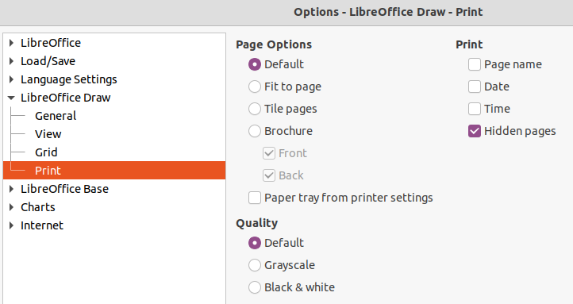Figure 4: Options LibreOffice Draw Print dialog

LibreOffice settings
To change the LibreOffice settings to print all colored text and graphics as grayscale:
- Go to Tools > Options > LibreOffice Draw > Print on the Menu bar to open the Options LibreOffice Draw Print dialog (Figure 4).
- In Quality, select either the option Grayscale or Black & white.
- Click OK to save the change and close the Options LibreOffice Draw Print dialog.
- Print the document using one of the above procedures and the document is printed as grayscale or black and white.

Exporting
LibreOffice can export documents to PDF (Portable Document Format). This industry wide standard of file format is ideal for sending a file for someone else to view using PDF viewing software.

Directly as PDF
To export the entire document using default PDF settings is as follows:
- Click on Export Directly as PDF on the Standard toolbar, or got to File > Export As > Export Directly as PDF on the Menu bar.
- Enter a file name and location for the PDF file and click on Save to export the file as PDF.
- Note
Note that page range, image compression, or other printing options are not available when creating a PDF file using this method.

Controlling PDF content and quality
For more control over the content and quality of the resulting PDF, use the options available in the PDF Options dialog (Figure 5). For more information on available options, see the Getting Started Guide.
- Go to File > Export As > Export as PDF on the Menu bar to open the PDF Options dialog.
- Select the required options available in the General, Initial View, User Interface, Links, Security and Digital Signatures pages.
- Click on Export and a file browser window opens.
- Navigate to the location and enter a file name for the PDF being created.
- Click on Save to export the file as PDF. The file browser window and the PDF Options dialog close.
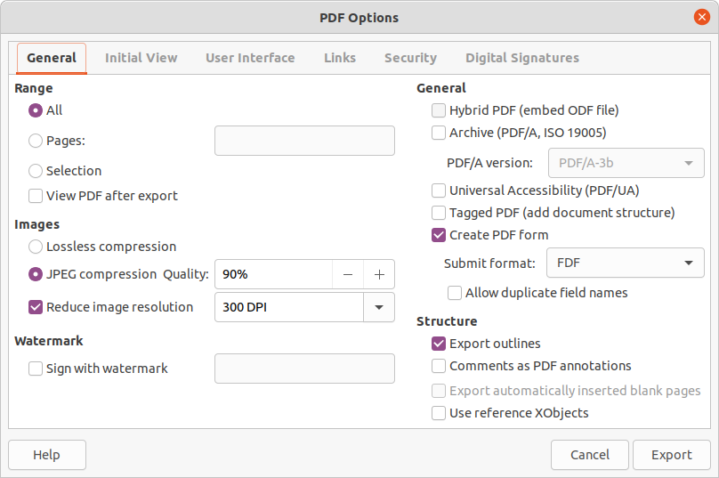Figure 5: PDF Options dialog - General page

Other formats
LibreOffice can export files in various formats, which are listed in the drop-down list of the file browser window. For more information on exporting graphics, see Chapter 6, Editing Pictures.
To export a file in another format:
- Go to File > Export on the Menu bar to open a file browser window.
- Navigate to the directory where the drawing is going to be saved.
- Specify a file name for the exported drawing in the Name text box.
- Select the required file format from the drop-down list.
- Click on Save to save the file and close the file browser window.
- Note
The content of the exported file depends on the elements selected on the drawing. If no elements are selected, the entire drawing is exported.
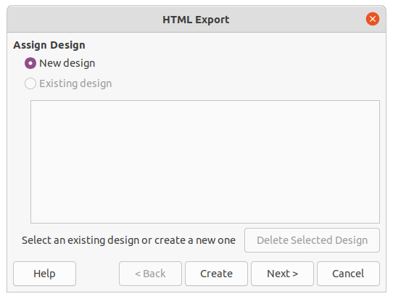Figure 6: HTML Export dialog

Web pages
To export a multi-page Draw document as a series of web pages:
- Go to File > Export on the Menu bar to open a file browser window.
- Select HTML Document as the file format and click on Save to open the HTML Export dialog (Figure 6).
- Create a New Design or select an Existing design and click on Next.
- Follow the prompts to create the web pages and save the drawing as an HTML file. For more information on how to create HTMl file, see the Getting Started Guide.

Emailing documents
LibreOffice provides several ways to send documents quickly and easily as an email attachment in ODF format (LibreOffice default format), or as a PDF. For more information, see the Getting Started Guide.
- Note
Documents can only be sent from the LibreOffice menu if an email profile has been set up.

Open Document format
To email the current document in ODF format:
- Go to File > Send > Email Document on the Menu bar. LibreOffice opens the default email program with the document attached to a new email.
- In the email program, enter the recipient, subject, and message, then send the email.

PDF format
To email the current document as a PDF file:
- Go to File > Send > E-mail as PDF on the Menu bar. LibreOffice creates a PDF using the default PDF settings and then opens the email program with the PDF file attached to a new email.
- In the email program, enter the recipient, subject, and message, then send the email.

Digital signatures
A digital signature is a mathematical scheme for verifying the authenticity of digital versions of drawings or documents.
To sign a drawing digitally, a personal key, also known as a certificate, is required. This personal key is stored on the computer being used as a combination of a private key, which must be kept secret, and a public key. These keys are added to a drawing when a digital signature is applied. A certificate is obtained from a certification authority, which may be a private company or a government institution.
When a digital signature is applied to a drawing, a checksum is computed from the drawing content plus the personal key being used. The checksum and public key are stored together with the drawing.
When the drawing is opened on another computer with a recent version of LibreOffice, the program computes the checksum again and compares it with the stored checksum. If both checksums are the same, the program opens the original, unchanged drawing.
In addition, the program can display the public key information from the certificate. This information can then be compared with the public key that is published on the web site of the certificate authority. Whenever the drawing is changed, this change breaks the digital signature.
For a more detailed description of how to obtain, use and manage a certificate and signature validation, see the Getting Started Guide and “Applying Digital Signatures” in the LibreOffice Help (https://help.libreoffice.org/7.1/en-US/text/shared/guide/digitalsign_send.html?&DbPAR=WRITER&System=UNIX).

Removing personal data
It maybe necessary to remove any personal data, versions, notes, hidden information, or recorded change from drawings before they are sent to other people or PDFs files created from the drawings.

Setting security and warning options
To set the security and warning options for the drawing:
- In Tools > Options > LibreOffice > Security, to open Options LibreOffice Security dialog (Figure 7).
- Click on Options to open the Security Options and Warnings dialog (Figure 8).
- Select the required options to allow LibreOffice to warn when drawings contain certain information and/or automatically remove personal information on saving.
- Click OK to close the Security Options and Warnings dialog and save the option selection.
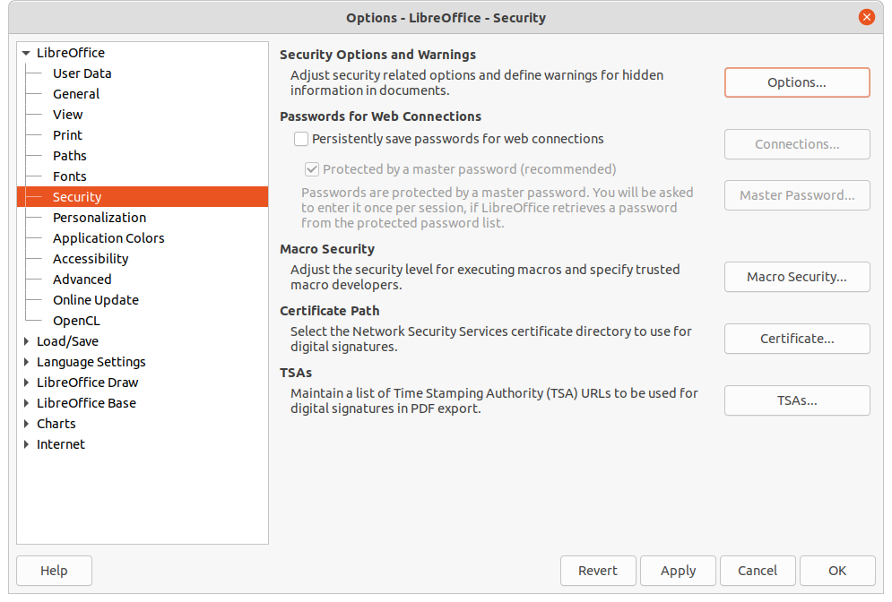Figure 7: Options LibreOffice Security dialog
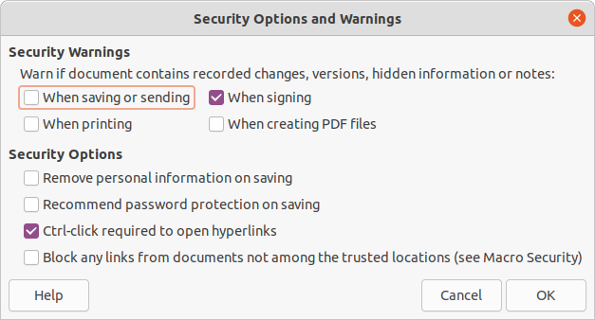Figure 8: Security Options and Warnings dialog
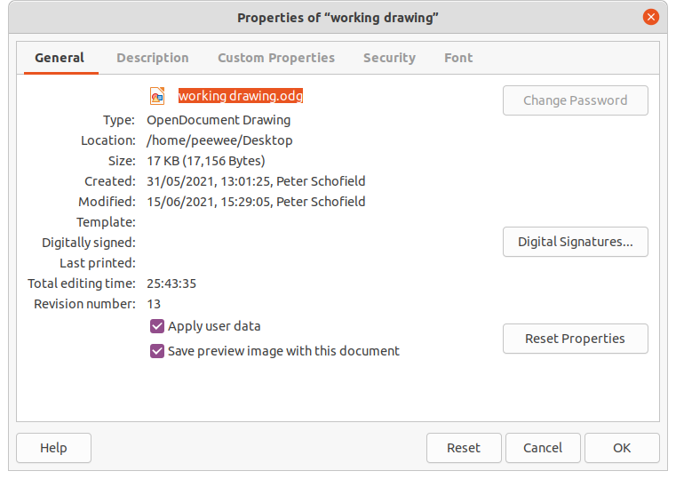Figure 9: Properties dialog

Removing personal data and drawing information
- Go to File > Properties on the Menu bar to open the Properties dialog (Figure 9) for the open drawing.
- In the General page uncheck Apply user data.
- Click on Reset Properties removing any information in the created and modified fields, deleting the modification and printing dates, resetting the editing time to zero, resetting the creation date to the current date and time, and resetting the version number to 1.
- Click OK to save the changes and close the Properties dialog.

Removing version information
To remove version information from a drawing, use one of the following methods:
- Go to File > Versions on the Menu bar to open a dialog for the drawing, then select the versions from the list for deletion and click Delete. The dialog automatically closes.
- Go to File > Save As on the Menu bar and save the drawing with a different name.

Redaction
Documents can be redacted to remove or hide any sensitive information allowing the selective disclosure of information in a document while keeping other parts of the document secret.
When a redacted document is exported to a new document, any redacted portions are removed and replaced by redaction blocks of pixels. This prevents any attempt to restore or copy the original contents. A redacted document is often exported in PDF format for publication or sharing.
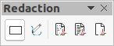Figure 10: Redaction toolbar
Any documents that are redacted in LibreOffice Writer, Calc, or Impress are automatically transferred as a copy to LibreOffice Draw where the redaction is carried out.

Documents, spreadsheets, or presentations
- Open the document to be redacted in LibreOffice Writer, Calc or Impress, then go to Tools > Redact on the Menu bar and the following happens:
- A copy of the document is prepared and transferred to LibreOffice Draw as an untitled file.
- LibreOffice Draw opens with the untitled document document displayed.
- The Redaction toolbar (Figure 10) automatically opens. If the Redaction toolbar is not displayed, go to View > Toolbars on the Menu bar in LibreOffice Draw and select Redaction.
- Go to Tools > Redact on the Menu bar and select either Rectangle or Freeform, or click on Rectangle Redaction or Freeform Redaction in the Redaction toolbar.
- Draw the required shapes to redact the sensitive areas in the document. The redaction shape is gray allowing the sensitive areas in the document to be visible before they are redacted.
- If necessary, click on Export Directly as PDF to make an in-redaction copy of the document as a PDF file. The sensitive information in the redacted areas can then be reviewed that it is correct before redaction is finalized.
- Go to Tools > Redact on the Menu bar and select either Redacted Export (White) or Redacted Export (Black), or click on Redacted Export (White) or Redacted Export (Black) in the Redaction toolbar. This opens a file browser window.
- Navigate to the folder where the redact document is going to be saved and enter a name for the document, then click on Save to create the redacted PDF file.
- The gray redaction shapes are converted to white or black shapes and the document is exported as a PDF.
- There is no selectable text in the PDF file and any redacted content is non-existent.

Drawings
Open a drawing in LibreOffice Draw, then use Steps 2) thru 6) in “Documents, spreadsheets, or presentations” to create a redacted PDF copy of the drawing file.
- Note
When a redacted document is exported as a new PDF file, any redacted portions are removed from the new document and replaced by redaction blocks of pixels. This prevents any attempt to restore or copy the original contents.

