
Draw Guide

Chapter 12,
User Interface Variants

Copyright
This document is Copyright © 2021 by the LibreOffice Documentation Team. Contributors are listed below. This document maybe distributed and/or modified under the terms of either the GNU General Public License (https://www.gnu.org/licenses/gpl.html), version 3 or later, or the Creative Commons Attribution License (https://creativecommons.org/licenses/by/4.0/), version 4.0 or later.
All trademarks within this guide belong to their legitimate owners.

Contributors
To this edition
Peter Schofield | Jean Hollis Weber
To previous editions
First issue of this chapter.

Feedback
Please direct any comments or suggestions about this document to the Documentation Team’s mailing list: documentation@global.libreoffice.org
- Note
Everything sent to a mailing list, including email addresses and any other personal information that is written in the message, is publicly archived and cannot be deleted.

Publication date and software version
Published July 2021. Based on LibreOffice 7.1 Community. Other versions of LibreOffice may differ in appearance and functionality.

Using LibreOffice on macOS
Some keystrokes and menu items are different on macOS from those used in Windows and Linux. The table below gives some common substitutions for the instructions in this document. For a detailed list, see the application Help.
Windows or Linux | macOS equivalent | Effect
Tools > Options | LibreOffice > Preferences | Access setup options
Right-click | Control+click or right-click depending on computer setup | Open a context menu
Ctrl (Control) | ⌘ (Command) | Used with other keys
F11 | ⌘+T | Open the Styles deck in the Sidebar

Contents
Copyright 2
Contributors 2
Feedback 2
Publication date and software version 2
Using LibreOffice on macOS 2
Introduction 4
Selecting user interface 4
Standard Toolbar UI 5
Tabbed UI 5
Fixed tabs 6
File tab 6
Home tab 8
Insert tab 8
Layout tab 9
Review tab 10
View tab 11
Extension tab 12
Tools tab 12
Additional tabs 13
Draw tab 13
Image tab 14
Object tab 15
Table tab 15
Media tab 15
Tabbed Compact UI 16
Groupedbar Compact UI 16
Contextual Single UI 17
Single Toolbar UI & Sidebar UI 17

Introduction
By default, commands and tools used in LibreOffice Draw are grouped in a user interface consisting of cascading menus and toolbars. The functions and use of these cascading menus and toolbars are described in previous chapters of this user guide.
This chapter describes the user interface variants that are available for LibreOffice Draw. A user then has the option to select the user interface that suits their requirements and methods of creating drawings in LibreOffice Draw.
- Note
When changing the user interface, the variant can be applied only to LibreOffice Draw, or applied to all the modules in LibreOffice.

Selecting user interface
To select a user interface variant or switching between the user interface variants:
- Go to View > User Interface on the Menu bar to open the Select Your Preferred User Interface dialog (Figure 1).
- In UI variants, select one of the variants. An example of the selected variant is shown in the Preview box, along with a short description.
- Click on Apply to Draw to apply the variant selection to LibreOffice Draw only, or click on Apply to All to apply the variant to all the LibreOffice modules. The LibreOffice window changes to match the selected variant.
- Click Close to close the dialog.
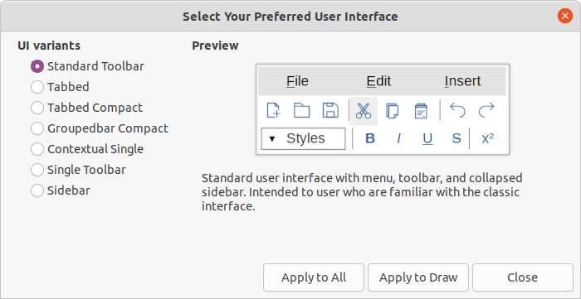Figure 1: Select Your Preferred User Interface dialog
- Note
If the option Enable experimental features has been selected in the Tools > Options > Advanced dialog, several more variants appear in UI variants. Being experimental, these variants are not described in this user guide.
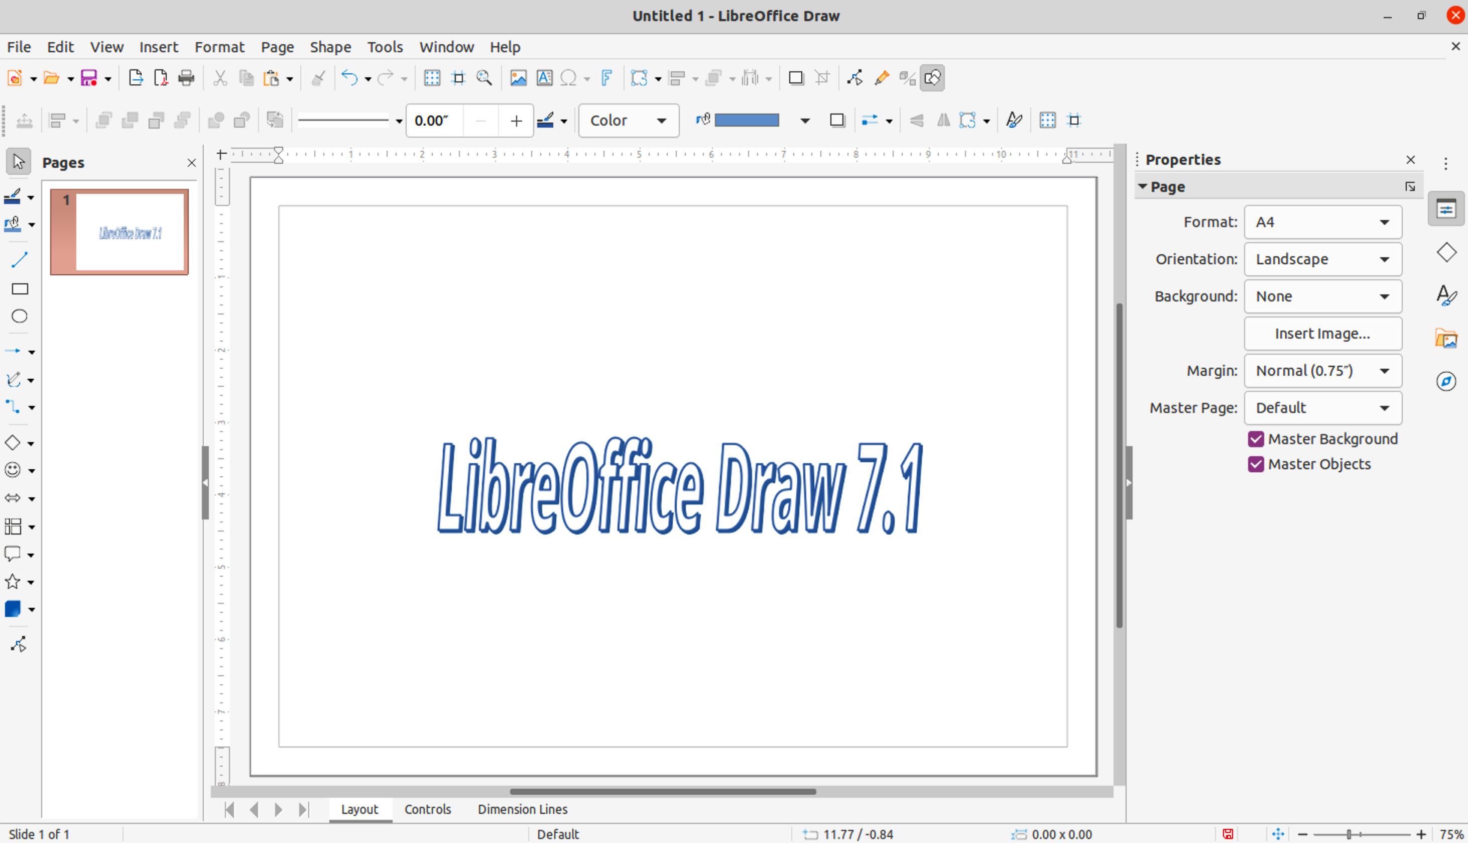Figure 2: Standard Toolbar user interface in LibreOffice Draw
- Note
In all the user interface variants, the Sidebar can be hidden or shown by clicking on the Hide/Show button on the left of the Sidebar,

Standard Toolbar UI
The Standard Toolbar user interface is the default view when LibreOffice is installed and the Workspace opened for the first time. Figure 2 shows an example of the default Workspace view in LibreOffice Draw, which normally consists of the following.
- Menu bar at the top of the Workspace.
- Standard toolbar positioned below the Menu bar.
- Line and Filling toolbar positioned below the Standard toolbar.
- Drawing toolbar positioned vertically on the left of the Workspace.
- Sidebar positioned on the right of the Workspace.
For more information on the Draw Workspace, see Chapter 1, Introducing Draw.

Tabbed UI
The Tabbed user interface provides a familiar interface for users coming from proprietary office suites, for example Microsoft Office. This user interface is divided into tabs, where each tab displays a set of tools grouped by context. The context changes depending on the object selected and the LibreOffice module being used.
It includes a Menu bar, a Tab bar, and tool icons grouped in context that would be normally used in LibreOffice Draw. If the tool icons on a tab page do not fit into the width of the Draw window, a double chevron >> appears at the right end of the row. Click the double chevron >> to display more commands.
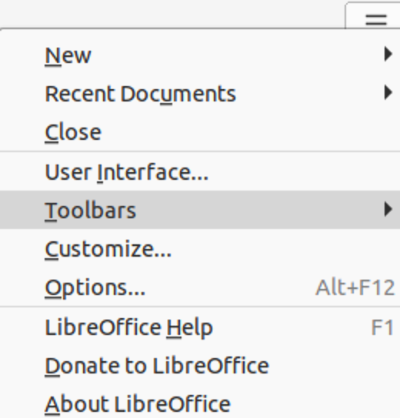Figure 3: Quick menu options
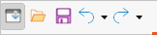Figure 4: Icon bar
On Windows and Linux operating systems, the Menu bar can be hidden or displayed by clicking on Menubar at the left end of the Tab bar.
On the right of the Tab bar, a Quick menu (≡) (Figure 3) is available giving access to some commonly used commands and links. Some of the Quick menu items have submenus, indicated by a small triangle ► on the right. The Quick menu is the same for all tabs.
On the left of the Tab bar, an Icon bar (Figure 4) is available giving access to some commonly used tools – Menu bar; Open (Ctrl+O); Save (Ctrl+S); Undo (Ctrl+Z); Redo (Ctrl+Y).
The Tabbed user interface can be customized using the Notebookbar page of the Customize dialog to show or hide the individual tools on the various tabs. For more information on customization of LibreOffice, see the Getting Started Guide and the Writer Guide.
- Note
When using the Tabbed user interface, the Draw toolbars are removed from view. If it is necessary, toolbars can be opened and used by going to View > Toolbars on the Menu bar or Quick menu > Toolbars.

Fixed tabs
The fixed tabs in the Tabbed user interface for Draw are described on the following pages. The illustrations show the left and right ends of the tabs separately so they are large enough to more easily see the commands.

File tab
The File tab (Figure 5) is a fixed tab providing commands to create new documents; open, save, print, and close documents; manage templates; export to PDF and EPUB; display document properties; add a digital signature; and sign an existing PDF.
The File tab has two menus (Figures 6 and 7): File and Help. The File tab menu contains the same commands as the tools available on the tab. The Help tab menu provides links to a variety of resources.
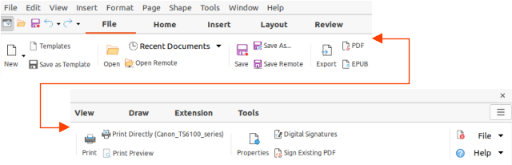Figure 5: Tabbed user interface - File tab
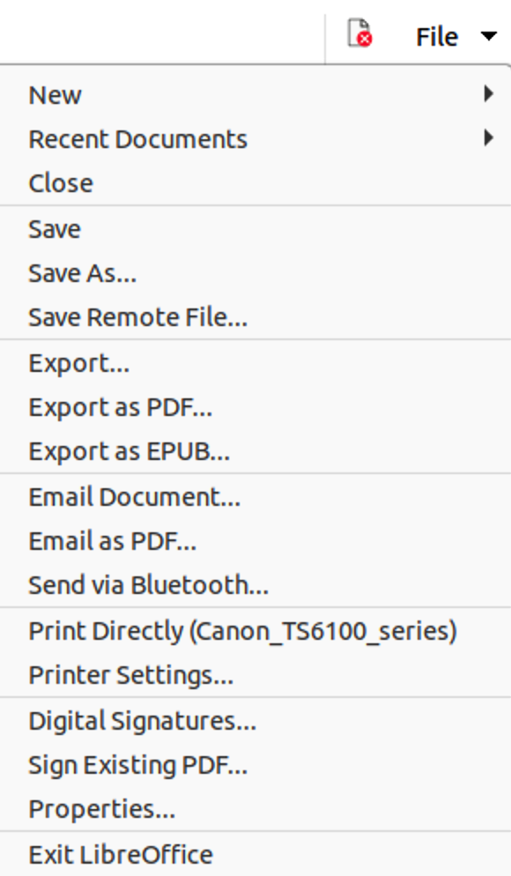Figure 6: File tab menu
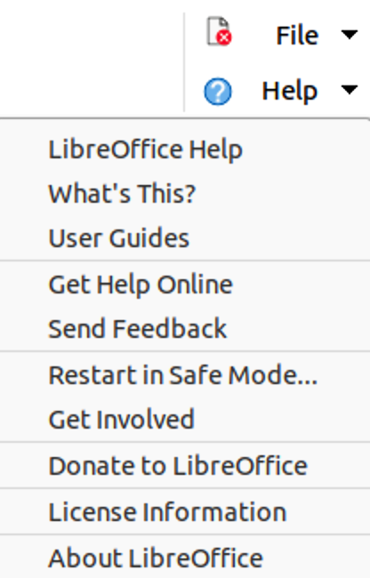Figure 7: Help tab menu

Home tab
The Home tab (Figure 8) is a fixed tab providing commands to cut, copy, paste, and format text; insert common items (for example images, tables, charts); apply, update, and edit drawing styles; and so on. The Home tab menu (Figure 9) at the right end of the Tab bar provides additional commands that are not on the tab.
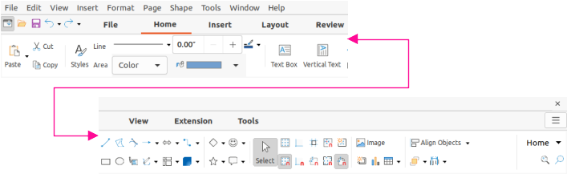Figure 8: Tabbed user interface - Home tab
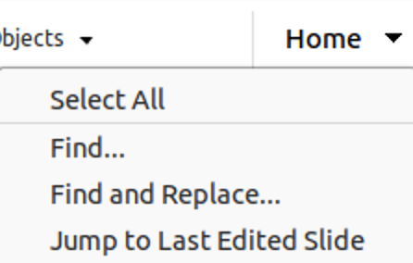Figure 9: Home tab menu

Insert tab
The Insert tab (Figure 10) is a fixed tab providing commands to insert many commonly used items. The Insert tab menu (Figure 11) at the right end of the Tab bar provides some of the same commands.
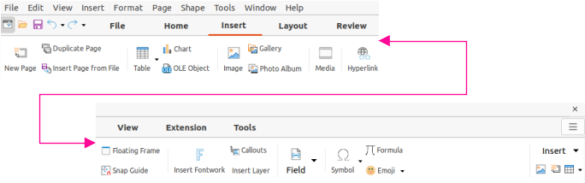Figure 10: Tabbed user interface - Insert tab
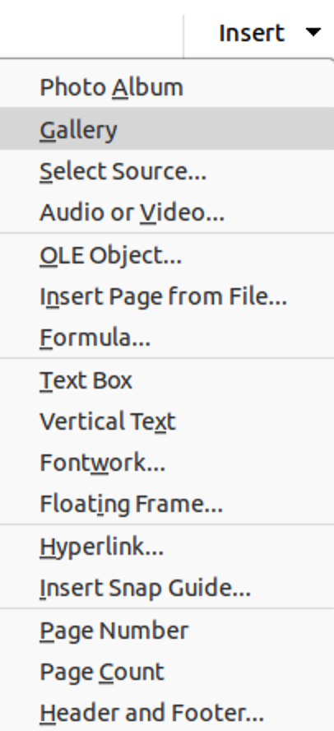Figure 11: Insert tab menu

Layout tab
The Layout tab (Figure 12) is a fixed tab providing commands to create the drawing page layout. The Layout tab menu (Figure 13) provides extra commands to create the drawing page layout.
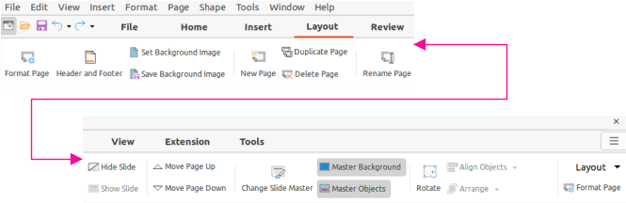Figure 12: Tabbed user interface - Layout tab
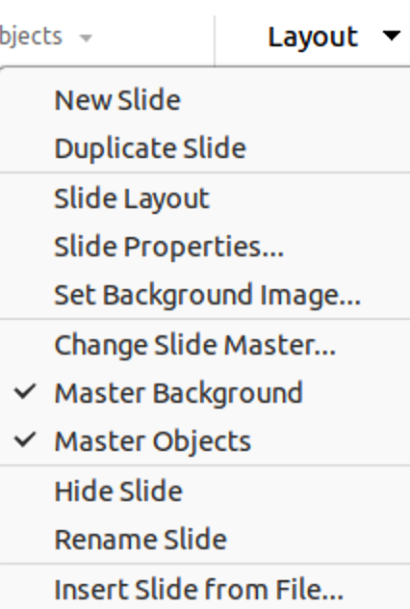Figure 13: Layout tab menu

Review tab
The Review tab (Figure 14) is a fixed tab providing commands for spell checking text; inserting and deleting review comments; and redaction. The Review tab menu (Figure 15) provides additional text editing commands. Some of these commands appear only if Asian or Complex Text Layout are selected in Tools > Options > Language Settings > Languages.
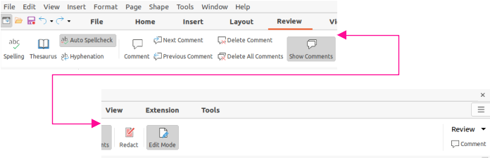Figure 14: Tabbed user interface - Review tab
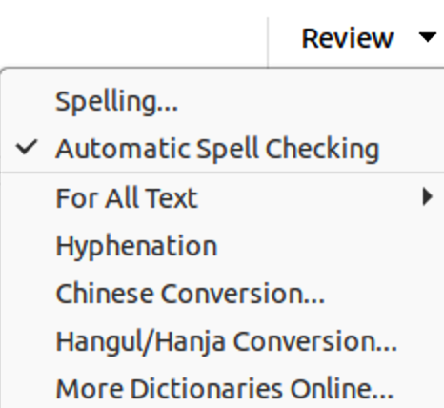Figure 15: Review tab menu

View tab
The View tab (Figure 16) is a fixed tab providing commands for the display of a drawing on screen. The View tab menu (Figure 17) provides additional commands relating to the display on a drawing on screen.
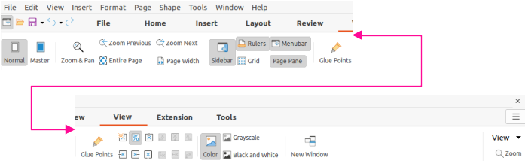Figure 16: Tabbed user interface - View tab
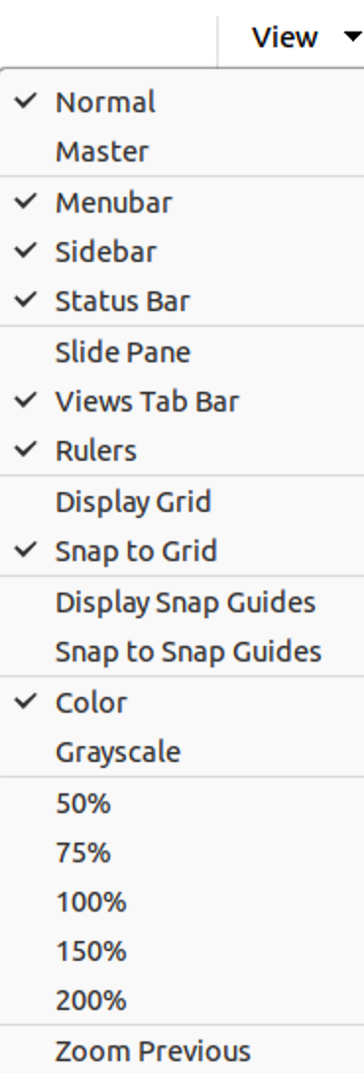Figure 17: View tab menu

Extension tab
The Extension tab (Figure 18) is a fixed tab containing only the command to access the Extension Manager allowing the installation of extensions that are compatible for use in LibreOffice.
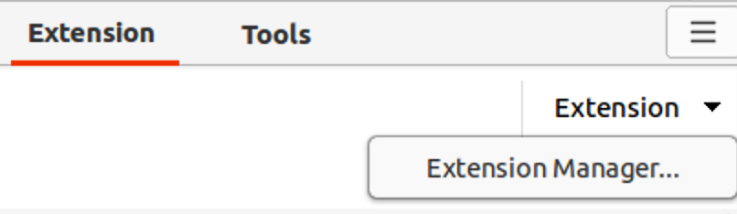Figure 18: Tabbed user interface - Extension tab

Tools tab
The Tools tab (Figure 19) is a fixed tab providing several tools for macros; color replacer; media player; and form creation. The Tools tab menu (Figure 20) provides some of the same commands, plus extra tools for organizing macros and dialogs; image map; data sources; filter settings; extension manager; and options.
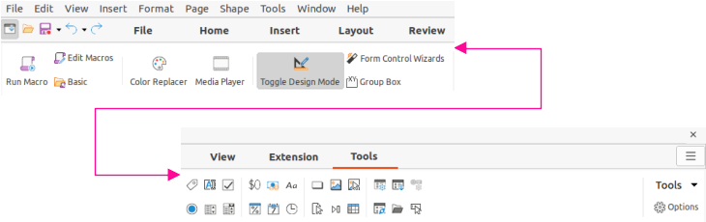Figure 19: Tabbed user interface - Tools tab
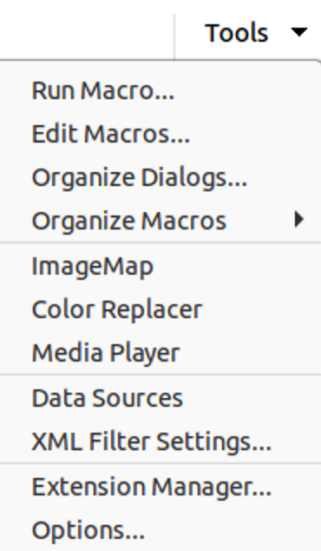Figure 20: Tools tab menu

Additional tabs
Additional tabs appear when an object in Draw is selected and are displayed between the View and Extension tabs. The illustrations show the left and right ends of the tabs separately so they are large enough to more easily see the commands.

Draw tab
The Draw tab (Figure 21) is only available when a draw object is selected in a drawing. It provides commands for editing, transforming, grouping, aligning, and distributing draw objects. The Draw tab menu (Figure 22) provides a similar set of commands for editing, transforming and converting draw objects.
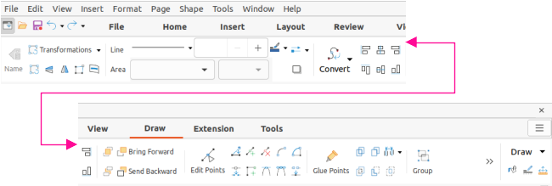Figure 21: Tabbed user Interface - Draw tab
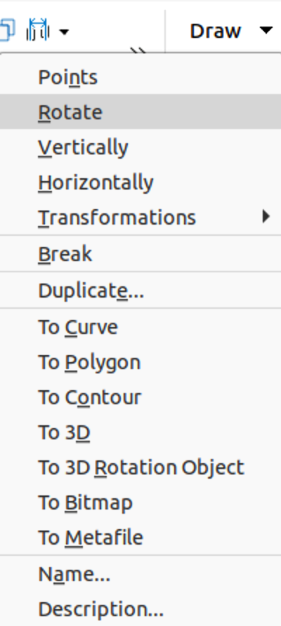Figure 22: Draw tab menu

Image tab
The Image tab (Figure 23) only becomes available when an image is selected in a drawing such as a photograph, Fontwork, OLE object, or QR code. It provides commands for working with these images, including captions, cropping, borders and area styles and colors, anchors, wrapping, positioning, and filtering. The Image tab menu (Figure 24) provides links to dialogs for working with images.
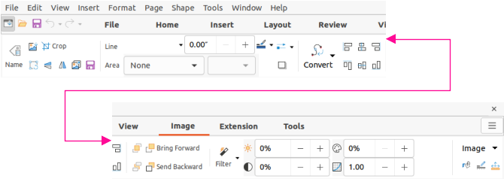Figure 23: Tabbed user interface - Image tab
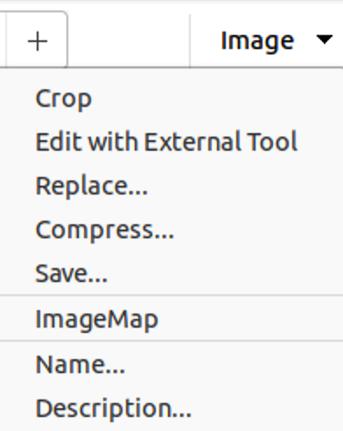Figure 24: Image tab menu
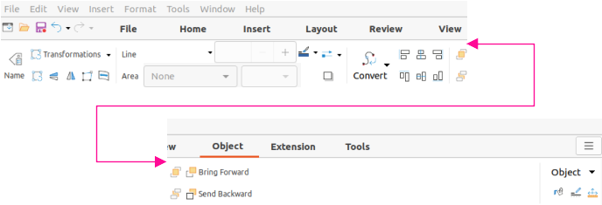Figure 25: Tabbed user interface - Object tab

Object tab
The Object tab (Figure 25) only becomes available when an object, such as a chart, is selected. It provides commands to position, resize, choose colors and borders for the selected object. The Object tab menu (Figure 26) provides extra commands to match the type of object selected.
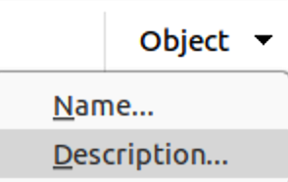Figure 26: Object tab menu

Table tab
The Table tab (Figure 27) only becomes available when a table is selected in a drawing. It provides tools to format a table to the drawing requirements. The Table tab menu (Figure 28) includes extra commands for editing a table.
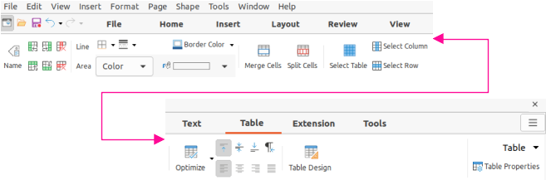Figure 27: Tabbed user interface - Table tab
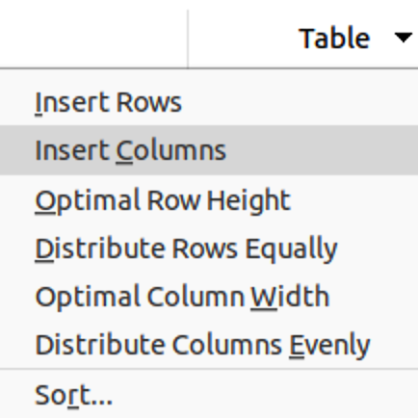Figure 28: Table tab menu

Media tab
The Media tab (Figure 29) only becomes available when a media object is selected in a drawing. It provides commands for positioning and running an audio or video file. The Media tab menu (Figure 30) includes extra commands for editing a media object
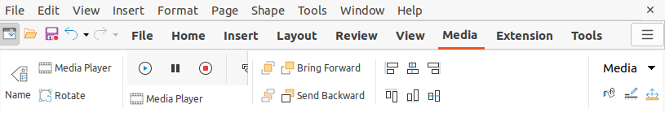Figure 29: Tabbed user interface - Media tab
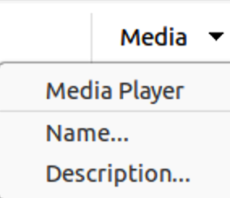Figure 30: Media tab menu

Tabbed Compact UI
The Tabbed Compact user interface has the same tabs as the Tabbed user interface, but the commands on each tab are arranged as a single row of tools. Some of these tools have drop-down menus with extra options. Figure 31 shows an example of the File tab in the Tabbed Compact user interface.
The tab menu on the right of the Tabbed Compact user interface provides the same options as the tab menus in the Tabbed user interface, see “Tabbed UI” on page 5 for more information.
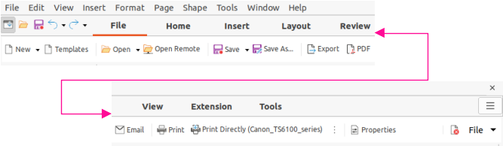Figure 31: Tabbed Compact user interface - File tab

Groupedbar Compact UI
The Groupedbar Compact user interface is divided into groups that contain commands organized as sets of tools and menus. The tools and menus that are available change to suit the type of object that has been selected. Figure 32 shows an example of Groupedbar Compact user interface when a draw object is selected.
Clicking on the double chevron >> displays more tools for editing an object. Figure 33 shows an example of these tools when a draw object is selected.
The Groupedbar menu (Figure 34) on the right-hand end of this interface provides extra commands for working with LibreOffice Draw, including convenient ways to change the user interface and access toolbars.
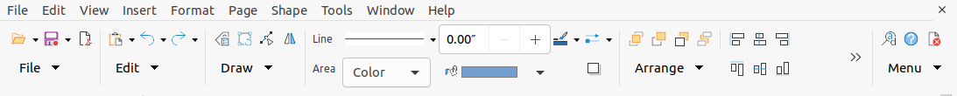Figure 32: Example of Groupedbar Compact user interface with draw object selected
Figure 33: Example of more tools with draw object selected
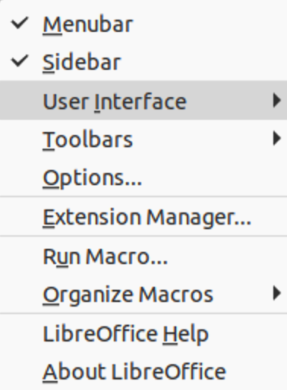Figure 34: Groupedbar menu

Contextual Single UI
The Contextual Single user interface displays a single toolbar to suit the type of object that has been selected. Figure 35 shows an example of Contextual Single user interface when a draw object is selected.
Clicking on the double chevron >> displays more tools for editing an object. Figure 36 shows an example of these tools when a draw object is selected.
Figure 35: Example of Contextual Single user interface with draw object selected
Figure 36: Example of more tools with draw object selected

Single Toolbar UI & Sidebar UI
When selected, the Single Toolbar and Sidebar user interfaces only show the Menu bar with no toolbars. However, toolbars can be added to either of these user interfaces by going to View > Toolbars on the Menu bar and selecting the required toolbar from the options available. For more information on toolbars, see Appendix B, Toolbars in this guide and the Getting Started Guide.

