
Impress Guide 26.2

Appendix B,
Toolbars

Copyright
This document is Copyright © 2026 by the LibreOffice Documentation Team. Contributors are listed below. This document may be distributed and/or modified under the terms of either the GNU General Public License (https://www.gnu.org/licenses/gpl.html), version 3 or later, or the Creative Commons Attribution License (https://creativecommons.org/licenses/by/4.0/), version 4.0 or later. All trademarks within this guide belong to their legitimate owners.

Contributors

To this edition
Peter Schofield

To previous editions
Peter Schofield

Feedback
Please direct any comments or suggestions about this document to the Documentation Team Forum at https://community.documentfoundation.org/c/documentation/loguides/ (registration is required) or send an email to: loguides@community.documentfoundation.org.
- Note
Everything sent to a forum, including email addresses and any other personal information that is written in the message, is publicly archived and cannot be deleted. Emails sent to the forum are moderated.

Publication date and software version
Published April 2026. Based on LibreOffice 26.2 Community.

Contents
Copyright 2
Contributors 2
Feedback 2
Publication date and software version 2
Introduction 5
Using toolbars 5
Displaying toolbars 5
Closing toolbars 5
Moving toolbars 5
Docked toolbars 6
Floating toolbars 6
Floating sub-toolbars 6
Docking toolbars 7
Locking and unlocking toolbars 7
Docked toolbars 7
Locking and unlocking toolbars and sub-toolbars 7
Editing toolbars 8
Adding tools 8
Deleting tools 8
Customizing toolbars 8
Toolbars 8
3D-Objects 9
3D-Settings 9
Align Objects 9
Comments 10
Distribute Selection 10
Drawing 11
Edit Points 12
Find 12
Fontwork 12
Form Controls 13
Form Design 13
Form Navigation 13
Gluepoints 14
Image 14
Insert 15
Legacy Circles and Ovals 15
Legacy Rectangles 15
Line and Filling 15
Master View 16
Media Playback 16
Options 16
Outline 17
Presentation 17
Redaction 17
Slide View 17
Standard 18
Standard (Single Mode) 18
Standard (Viewing Mode) 19
Table 19
Text 19
Text Formatting 20
Transformations 20
TSCP Classification 20
Zoom 21
Sub-toolbars 21
3D-Objects 21
Align Objects 21
Basic Shapes 21
Block Arrows 22
Callouts 22
Color 22
Connectors 23
Curves and Polygons 23
Distribute Selection 24
Flowchart 24
Fontwork Shape 24
Image Filter 25
Lines and Arrows 26
Optimize 26
Position 26
Stars and Banners 26
Symbol Shapes 27

Introduction
In Impress several toolbars are available for creating a presentation. Each toolbar has a default set of tools and an option to add additional tools to a toolbar.
- Notes
The icons displayed on the Impress toolbars illustrated in this appendix may differ from what is displayed on a computer screen. Toolbar icons depend on the computer operating system being used and how LibreOffice has been configured. For more information on customizing LibreOffice and toolbars, see the Getting Started Guide.
Some toolbars when selected do not display until an object of the correct type is selected in a presentation. For example, the Image toolbar only displays when an image, or graphic, using an image file format is selected.

Using toolbars

Displaying toolbars
Two methods of opening toolbars in Impress are used, as follows:
- Go to View > Toolbars on the Menu bar. A submenu opens with an alphabetical list of toolbars available for creating presentations in Impress.
- Click on a toolbar name to display it and make it active. Active toolbars are indicated by highlighting or a check mark next to the toolbar name, depending on computer setup.
- Note
When selecting tools on a toolbar, a sub-toolbar may open providing more tools to edit an object. For example, clicking on Color in the Image toolbar opens the Color sub-toolbar to adjust the color settings of an image.

Closing toolbars
To close a toolbar, use one of the following methods:
- Go to View > Toolbars on the Menu bar and deselect the toolbar.
- Right-click in a blank area on a toolbar and select Close Toolbar from the context menu.
- Click on the X in the right corner of the title bar of a floating toolbar.

Moving toolbars
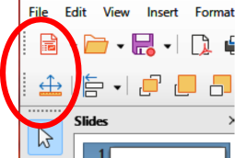
Figure 1: Toolbar moving handles

Docked toolbars
By default, some toolbars are docked into position in the Impress main window. For example, the Standard toolbar is docked at the top of the main window. Docked toolbars can be undocked and moved to a new docked position on the main window, or left as a floating toolbar.
- Move the cursor over the small vertical handle at the left end or top of the toolbar (highlighted in Figure 1). The cursor changes shape to the moving cursor used for the computer system and setup.
- Click and drag the toolbar to a new location. This can be a new docked position, or a floating toolbar. A hashed border appears around the toolbar indicating the toolbar position as it is dragged.
- Release the cursor when the required position is reached.
- Note
If the toolbar moving handles are not visible at the left end or top of a docked toolbar, then the toolbar is locked into position. A docked toolbar must be unlocked before it can be moved to a new position in the Impress main window. See “Locking and unlocking toolbars” on page 7 for more information.

Floating toolbars
- To move a floating toolbar, click on its title bar and drag it to a new floating location.
- Release the toolbar when it is in the required position.
- Note
Floating toolbars does not have to be placed on the Impress main window to function.

Floating sub-toolbars
Some tools on a toolbar have a triangle ▼ to the right of the tool indicating that more tools are available on a sub-toolbar, for example Basic Shapes on the Drawing toolbar. sub-toolbars can be turned into floating sub-toolbars and moved into a new position as follows:
- Move the cursor over the horizontal handle at the top of the sub-toolbar (Figure 2). The cursor changes to the moving cursor used for the computer system and setup.
- Click and drag the sub-toolbar to a new location to create a floating sub-toolbar.
- Release the sub-toolbar when it is in the required position is reached.
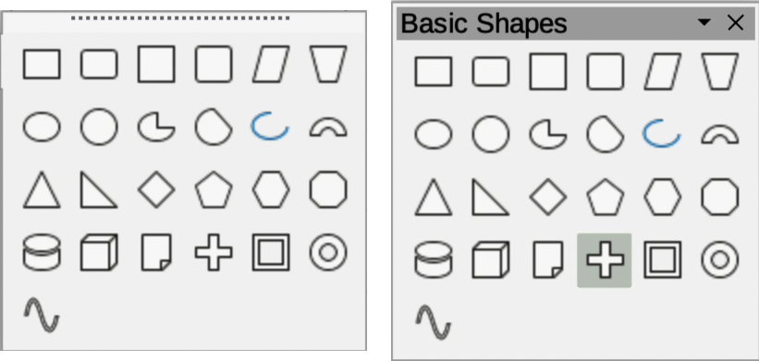
Figure 2: Creating floating toolbars
- To close the floating sub-toolbar use one of the following methods:
- Right-click on the triangle ▼ in the sub-toolbar title bar and select Close Toolbar from the context menu.
- Click on the X at the right end of the sub-toolbar title bar.

Docking toolbars
To dock a floating toolbar, use one of the following methods:
- Click on the title bar and drag it to a docking position on the main window. When a toolbar reaches a docking position, a hashed border appears at the docked position. Release the toolbar and it is docked into position.
- Right-click on the toolbar and select Dock Toolbar from the context menu. The toolbar moves into a docked position. If the position is not suitable, move the toolbar to a new docked position.
- To dock all floating toolbars that are active, right-click on the toolbar and select Dock All Toolbars from the context menu.

Locking and unlocking toolbars

Docked toolbars
When a toolbar has been docked into position on the Impress main window, the toolbar can be locked into position preventing the toolbar from becoming a floating toolbar.
- To lock a toolbar into a docked position, right-click in a blank area on the toolbar and select Lock Toolbar Position from the context menu. A check mark appears against this option indicating the toolbar is now locked. The small vertical or horizontal bar disappears from the top or left end of the toolbar indicating that the toolbar is locked.
- To unlock a toolbar, right-click in a blank area on the toolbar and click on Lock Toolbar Position in the context menu. The check mark next to this option disappears indicating the toolbar is now unlocked. A small vertical or horizontal bar appears at the top or left end of a toolbar indicating that the toolbar is unlocked. This bar is also is used to move a toolbar.
- Notes
Some toolbars cannot be docked or locked into position. This is indicated by the options Dock Toolbar and/or Lock Toolbar Position being grayed out, making the options unavailable.
Using the Lock Toolbars option affects ALL toolbars and sub-toolbars available in all LibreOffice modules.

Locking and unlocking toolbars and sub-toolbars
To prevent toolbars and sub-toolbars from becoming floating toolbars or sub-toolbars, they can be locked. Also, locked toolbars and sub-toolbars can be unlocked using the same method below. The Lock Toolbars option is a lock/unlock switch.
- Save the presentation that is open in Impress, then go to View > Toolbars on the Menu bar and select Lock Toolbars from the submenu.
- Select Restart Now in the Restart LibreOffice dialog that opens to activate the Lock Toolbars option.
- To unlock toolbars or sub-toolbars to create floating toolbars or sub-toolbars, repeat Steps 1 and 2.

Editing toolbars
When LibreOffice is installed on a computer, a set of toolbars suitable for each LibreOffice component is also installed. Each toolbar has a default set of visible tools. Tools can be added or deleted, and toolbars can be customized.

Adding tools
- Right-click in a blank area on a toolbar, or click on the triangle ▼ on the right of the toolbar title bar.
- Select Visible Buttons from the context menu to display a list of available tools.
- Click on the tool required and the tool appears in the toolbar. The list of available tools closes automatically. If there is a highlight or check mark next to the tool, then that tool is already installed on the toolbar.
- Note
When adding tools using Visible Buttons, the tool is added to the toolbar in the same position as the tool appears in the Visible Buttons list. That is, the top tool in the Visible Buttons list appears at the left end or top of the toolbar and the bottom tool appears at the right end or bottom of the toolbar. Tool positions on a toolbar cannot be changed.

Deleting tools
- Right-click in a blank area on a toolbar, or click on the triangle ▼ on the right of the toolbar title bar.
- Select Visible Buttons from the context menu to display a list of available tools.
- Click on the tool no longer required and the tool is removed from the toolbar. The highlight or check mark next to the tool is also removed. The list of available tools closes automatically.

Customizing toolbars
Extra tools and commands that are not available in Visible Buttons can be added to a toolbar using customization. Customization also allows the creation of new toolbars if a specific set of tools are required for a specific task. For information on customizing toolbars, see the Getting Started Guide.

Toolbars
- The number of tools visible on a toolbar depend on the computer setup that is being used to create a presentation.
- The tools displayed on the toolbars in this chapter are EXAMPLES only
- The tools already installed on a toolbar are indicated in Visible Buttons either by the tool icon being highlighted or by a check mark. This install indication depends on computer setup and computer operating system being used.
- On some toolbars, tool icons may have a triangle ▼ to the right of the icon. Click on this triangle to open a list of options, toolbar, or sub-toolbar.
- Some tools also have the option of using a keyboard shortcut instead of clicking on the tool. Keyboard shortcuts are displayed on the right of the tool icon. For a full list of keyboard shortcuts that are available in Impress, see Appendix A, Keyboard Shortcuts.
- The numbered legend for the available tools in a toolbar indicate the position of the tool in a toolbar. For example, (1) indicates that the tool is positioned at the left end or beginning of the toolbar.

3D-Objects
The 3D-Objects toolbar (Figure 3) provides for creating 3D objects in a slide. Go to View > Toolbars > 3D-Objects on the Menu bar. Alternatively, click on the triangle ▼ next to 3D-Objects on the Drawing toolbar to open a sub-toolbar for access to the same 3D tools.
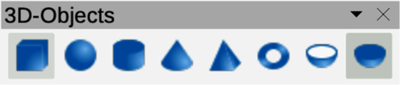
Figure 3: 3D-Objects toolbar
- Cube
- Sphere
- Cylinder
- Cone
- Pyramid
- Torus
- Shell
- Half Sphere

3D-Settings
The 3D-Settings toolbar (Figure 4) and these tools are only active when an object has been converted to 3D using the tool Toggle Extrusion and the converted object is selected.
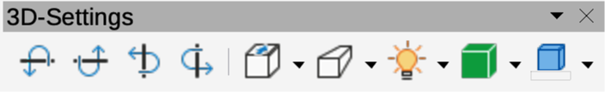
Figure 4: 3D-Settings toolbar
- Toggle Extrusion
- Tilt Down
- Tilt Up
- Tilt Left
- Tilt Right
- Depth
- Direction
- Lighting
- Surface
- 3D Color
For the following tools on the 3D-Settings toolbar click on the triangle ▼ on the right of the icon for access to various options as follows:
Depth
3D extrusion depth — 0cm; 1cm; 2.5cm; 5cm; 10cm; Infinity; Custom. The measurement unit depends on the ruler settings in Tools > Options > LibreOffice Impress > General (macOS LibreOffice > Preferences > LibreOffice Impress > General).
Direction
3D extrusion direction and type — Parallel; Perspective.
Lighting
Lighting direction and lighting level of 3D extrusion — Bright; Normal; Dim.
Surface
Surface type of 3D extrusion — Wire Frame; Matt; Plastic; Metal.
3D Color
Color of 3D extrusion. Select a color from one of the available color palettes.

Align Objects
The Align Objects toolbar (Figure 5) provides tools for aligning several objects in a slide to improve the visual impact of objects on a slide.
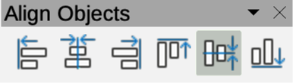
Figure 5: Align Objects toolbar
The tools available on the Align Objects toolbar provide the following options:
Left
Aligns the left edges of selected objects. If only one object is selected in Draw or Impress, the left edge of the object is aligned to the left page margin.
Centered
Horizontally centers selected objects. If only one object is selected in Draw or Impress, the center of the object is aligned to the horizontal center of the page.
Right
Aligns the right edges of selected objects. If only one object is selected in Impress or Draw, the right edge of the object is aligned to the right page margin.
Top
Vertically aligns top edges of the selected objects. If only one object is selected in Draw or Impress, the top edge of the object is aligned to the upper page margin.
Center
Vertically centers selected objects. If only one object is selected in Draw or Impress, the center of the object is aligned to the vertical center of the page.
Bottom
Vertically aligns the bottom edges of selected objects. If only one object is selected in Draw or Impress, the bottom edge of the object is aligned to the lower page margin.

Comments
The Comments toolbar (Figure 7) provides tools for adding, deletion, and navigation of comments in a presentation. When adding comments to a presentation, it is recommended a user to add their name and initials in Tools > Options > LibreOffice > User Data (macOS LibreOffice > Preferences > LibreOffice > User Data).
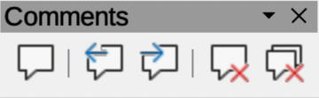
Figure 6: Comments toolbar
- Comment
- Previous Comment
- Next Comment
- Delete Comment
- Delete All Comments

Distribute Selection
The Distribute Selection toolbar (Figure 7) is used to distribute three or more objects evenly along the horizontal or vertical axis. Also, the spacing between objects can be evenly distributed.
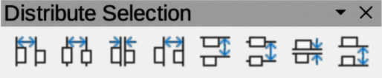
Figure 7: Distribute Selection toolbar
The tools available on the Distribute Selection toolbar provide the following options:
Distribute Horizontally Left
Distributes the selected objects, so that the left edges of the objects are evenly spaced from one another.
Distribute Horizontally Center
Distributes the selected objects, so that the horizontal centers of the objects are evenly spaced from one another.
Distribute Horizontally Spacing
Distributes the selected objects horizontally, so that the objects are evenly spaced from one another.
Distribute Horizontally Right
Distributes the selected objects, so that the right edges of the objects are evenly spaced from one another.
Distribute Vertically Top
Distributes the selected objects, so that the top edges of the objects are evenly spaced from one another.
Distribute Vertically Center
Distributes the selected objects, so that the vertical centers of the objects are evenly spaced from one another.
Distribute Vertically Spacing
Distributes the selected objects vertically, so that the objects are evenly spaced from one another.
Distribute Vertically Bottom
Distributes the selected objects, so that the bottom edges of the objects are evenly spaced from one another.

Drawing
The Drawing toolbar (Figure 8) provides the tools used to create graphic objects on slides in a presentation. By default, this toolbar is docked on the left side of the Workspace.
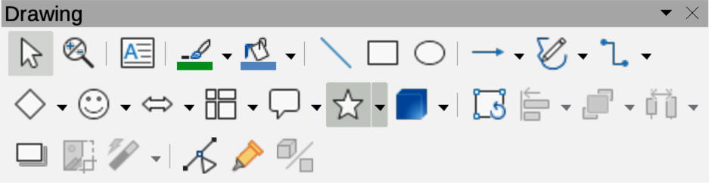
Figure 8: Drawing toolbar
- Select
- Zoom & Pan
- Zoom
- Text Box
- Vertical Text
- Insert Fontwork
- Line Color
- Fill Color
- Line
- Rectangle
- Ellipse
- Line Ends with Arrow
- Lines and Arrows
- Curves and Polygons
- Connectors
- Basic Shapes
- Symbol Shapes
- Block Arrows
- Flowchart
- Callouts
- Stars and Banners
- 3D Objects
- Position and Size
- Rotate
- Flip
- Align Objects
- Arrange
- Select at least three objects to distribute
- Shadow
- Crop Image
- Filter
- Points
- Show Gluepoint Function
- To Curve
- To Polygon
- To 3D
- T0 3D Rotation Object
- Toggle Extrusion
- Insert
- Controls
Some tool shapes on the Drawing toolbar change indicating the tool has been previously used.
- Where available, click on the triangle ▼ to the right of a tool icon to open a pop-up toolbar, then select the required shape to add to a drawing. For more information on sub-toolbars, see “Sub-toolbars” on page 26.
- To create a floating sub-toolbar, click on the handle (Figure 2 on page 6) at the top of the pop-up toolbar and drag to an empty area on the main window.

Edit Points
The Edit Points toolbar (Figure 9) provides tools for editing the points of a curve or polygon, or an object that has been converted to a curve or polygon. The toolbar only becomes active when an object is selected. Click on Edit Points on the Drawing or Standard toolbar, or use the keyboard shortcut F8 to open the toolbar.
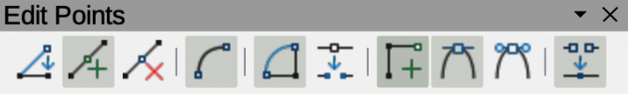
Figure 9: Edit Points toolbar
- Edit Points
- Move Points
- Insert Points
- Delete Points
- Convert to Curve
- Close Bezier
- Split Curve
- Corner Point
- Smooth Transition
- Symmetric Transition
- Eliminate Points

Find
The Find toolbar (Figure 10) opens by default and is docked in the bottom left corner of the Impress main window above the Status bar. This toolbar can be undocked from its default position and made into a floating toolbar.
Figure 10: Find toolbar
- Close Find Bar
- Find Text
- Find Previous
- Find Next
- Find All
- Match Case
- Find and Replace

Fontwork
The Fontwork toolbar (Figure 11) is used to create graphical text objects in a slide and provide the tools for editing a graphical text object. This toolbar only becomes active when a Fontwork graphical text object has been selected on a slide.
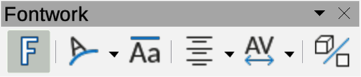
Figure 11: Fontwork toolbar
- Insert Fontwork Text
- Fontwork Shape
- Fontwork Same Letter Heights
- Fontwork Alignment
- Fontwork Character Spacing
- Toggle Extrusion
Some tools on the Fontwork toolbar have a triangle ▼ to the right of the tool. Click on this triangle to open a pop-up toolbar, or drop-down option list.
Fontwork Shape
Select the required shape for a Fontwork graphical text object from the options available.
Fontwork Alignment
Select the paragraph alignment from the options available.
Fontwork Character Spacing
Select the required character spacing from the options available.

Form Controls
The Form Controls toolbar (Figure 12) provides the tools required to create an interactive form. This allows controls to be added to a form in a text, drawing, spreadsheet, presentation, or HTML document. For example, a button that opens another presentation or slide.
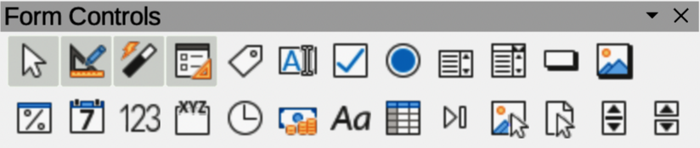
Figure 12: Form Controls toolbar
- Select
- Design Mode
- Toggle Form Control Wizards
- Form Design
- Control Properties
- Form Properties
- Label
- Text Box
- Check Box
- Option Button
- List Box
- Combo Box
- Push Button
- Image Button
- Formatted Field
- Date Field
- Numerical Field
- Group Box
- Time Field
- Currency Field
- Pattern Field
- Table Control
- Navigation Bar
- Image Control
- File Selection
- Spin Button
- Scrollbar

Form Design
The Form Design toolbar (Figure 13) opens a form in Design Mode so that it can be edited. Controls of the form cannot be activated, or its contents edited when in Design Mode. However, the position and size of the controls can be changed, properties edited, and controls added or deleted in Design Mode.
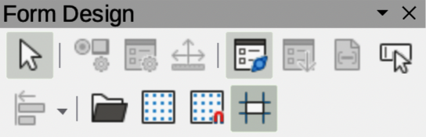
Figure 13: Form Design toolbar
- Select
- Control Properties
- Form Properties
- Position and Size
- Form Navigator
- Activation Order
- Add Field
- Automatic Control Focus
- Bring to Front
- Send to Back
- Group
- Ungroup
- Enter Group
- Exit Group
- Align Objects
- Open in Design Mode
- Display Grid
- Snap to Grid
- Helplines While Moving

Form Navigation
The Form Navigation toolbar (Figure 14) provides tools to edit a database table or control data view. The toolbar is normally displayed at the bottom of a document that contains fields that are linked to a database. The Form Navigation toolbar is only active when any forms created are connected to a database and an inactivate toolbar is shown in Figure 14.
The Form Navigation toolbar allows movement within records as well as inserting and deleting records. If data is saved in a form, the changes are transferred to the database. This toolbar also provides tools providing sort, filter, and search functions for data records.
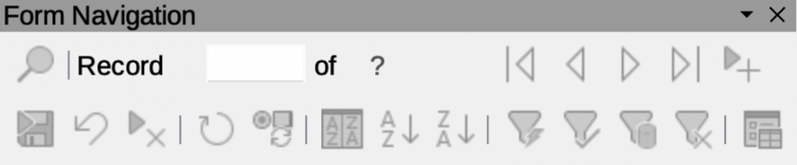
Figure 14: Form Navigation toolbar
- Find Record
- Record
- Absolute Record
- Text -> Record
- Total No. of Records
- First Record
- Previous Record
- Next Record
- Last Record
- New Record
- Save Record
- Undo: Data entry
- Delete Record
- Refresh
- Refresh Control
- Sort
- Sort Ascending
- Sort Descending
- AutoFilter
- Apply Filter
- Form-Based Filters
- Reset Filter/Sort
- Data source as Table

Gluepoints
The Gluepoints toolbar (Figure 15) provides tools to insert a gluepoint or modify the properties of a gluepoint. A gluepoint is where a connector is attached or glued to an object.
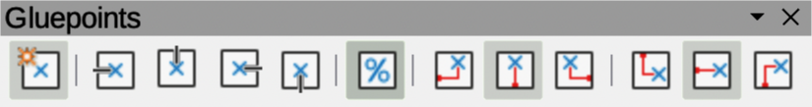
Figure 15: Gluepoints toolbar
- Insert Glue Point
- Exit Direction Left
- Exit Direction Top
- Exit Direction Right
- Exit Direction Bottom
- Glue Point Relative
- Glue Point Horizontal Left
- Glue Point Horizontal Center
- Glue Point Horizontal Right
- Glue Point Vertical Top
- Glue Point Vertical Center
- Glue Point Vertical Bottom

Image
The Image toolbar (Figure 16) provides tools to edit, modify, align, reposition and resize images. The toolbar only becomes active and available when an image is selected in a presentation. The Image toolbar automatically replaces the Line and Filling toolbar when it becomes active.
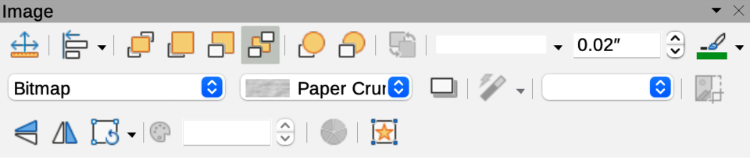
Figure 16: Image toolbar
- Position and Size
- Align Objects
- Left
- Centered
- Right
- Top
- Center
- Bottom
- Arrange
- Bring to Front
- Bring Forward
- Send Backward
- Send to Back
- In Front of Object
- Behind Object
- Reverse
- Line Style
- Line Width
- Line Color
- Area Style/Filling
- Fill Color
- Shadow
- Filter
- Image Mode
- Crop
- Vertically
- Horizontally
- Transformations
- Transparency
- Color
- Line
- Area
- Animation
- Interaction

Insert
The Insert toolbar (Figure 17) provides tools to insert different types of objects into a slide.
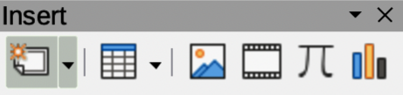
Figure 17: Insert toolbar
- New Page
- Floating Frame
- Insert Page from File
- Table
- Image
- Insert Audio or Video
- Formula Object
- Char
- OLE Object

Legacy Circles and Ovals
The Legacy Circles and Ovals toolbar (Figure 18) provides tools to insert different types of circles and ovals into a drawing.
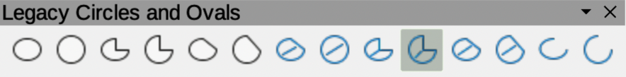
Figure 18: Legacy Circles and Ovals toolbar
- Insert Ellipse
- Circle
- Ellipse Pie
- Circle Pie
- Ellipse Segment
- Circle Segment
- Ellipse, Unfilled
- Circle, Unfilled
- Ellipse Pie, Unfilled
- Circle Pie, Unfilled
- Ellipse Segment, Unfilled
- Circle Segment, Unfilled
- Arc
- Circle Arc

Legacy Rectangles
The Legacy Rectangles toolbar (Figure 19) provides tools to insert different types of rectangles and squares into a slide.
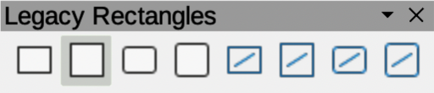Figure 19: Legacy Rectangles toolbar
- Insert Rectangle
- Square
- Rectangle, Rounded
- Rounded Square
- Rectangle, Unfilled
- Square, Unfilled
- Rounded Rectangle, Unfilled
- Rounded Square, Unfilled

Line and Filling
The Line and Filling toolbar (Figure 20) provides tools and drop-down lists for editing lines, arrows, and object borders. Tool availability depends on the type of object selected for editing.
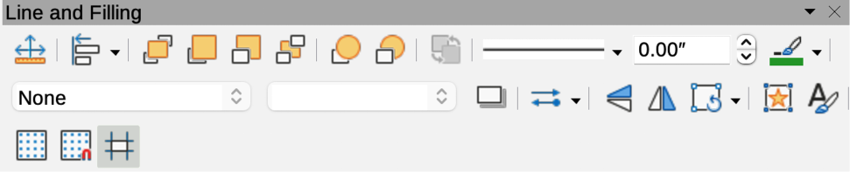
Figure 20: Line and Filling toolbar
- Position and Size
- Align Objects
- Left
- Centered
- Right
- Top
- Center
- Bottom
- Arrange
- Bring to Front
- Bring Forward
- Send Backward
- Send to Back
- In Front of Object
- Behind Object
- Reverse
- Line Style
- Line Width
- Line Color
- Area Style/Filling
- Fill Color
- Shadow
- Arrow Style
- Vertically
- Horizontally
- Transformations
- Line
- Area
- 3D Effects
- Image Map
- Animation
- Interaction
- Show Styles Sidebar
- Display Grid
- Helplines While Moving

Master View
The Master View toolbar (Figure 21) provides tools to create a new master slide, rename a master slide, delete a master slide, and close master view. This toolbar is only active when Impress is in master view.
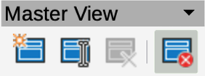
Figure 21: Master View toolbar
- New Master
- Rename Master
- Delete Master
- Close Master View

Media Playback
The Media Playback toolbar (Figure 22) provides the tools required to insert, view, play, and listen to audio and video files. The toolbar only becomes active when an audio or video file is selected. Impress supports many different media formats depending on the computer operating system being used.
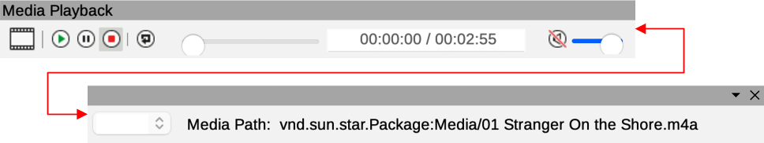
Figure 22: Media Playback toolbar
- Insert Audio or Video
- Play
- Pause
- Stop
- Repeat
- Position
- Mute
- Volume
- View

Options
The Options toolbar (Figure 23) provides tools for editing various settings for newly created presentations, for example how objects snap to the grid when being moved or resized.
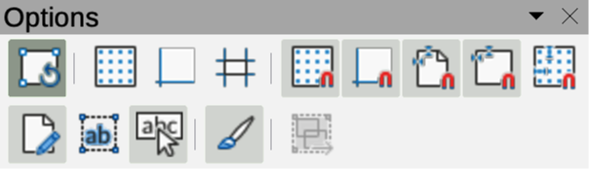
Figure 23: Options toolbar
- Rotation Mode after Clicking Object
- Display Grid
- Display Snap Guides
- Helplines While Moving
- Snap to Grid
- Snap to Snap Guides
- Snap to Page Margins
- Snap to Object Borders
- Snap to Object Points
- Allow Quick Editing
- Select Text Area Only
- Double-click to edit Text
- Modify Object with Attributes
- Exit All Groups

Outline
The Outline toolbar (Figure 24) provides tools for working with outlines.
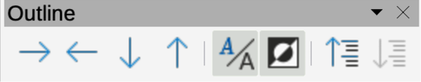
Figure 24: Outline toolbar
- Demote
- Promote
- Move Down
- Move Up
- Show Formatting
- Black & White View
- Show Only First Level
- Show All Levels
- Hide Subpoints
- Show Subpoints

Presentation
The Presentation toolbar (Figure 25) provides tools for working with presentations.
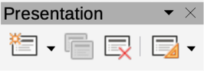
Figure 25: Presentation toolbar
- New Slide
- Duplicate Slide
- Rename Slide
- Delete Slide
- Slide Layout
- Change Slide Master
- Expand Slide
- Go to First Slide
- Go to Previous Slide
- Go to Next Slide
- Go to Last Slide
- Move Slide to Start
- Move Slide Up
- Move Slide Down
- Move Slide to End

Redaction
The Redaction toolbar (Figure 26) is used to block portions of a drawing when protecting sensitive information. Redaction helps enterprises and organizations to comply with regulations on confidentiality or privacy. When a redacted drawing is exported, any redacted portions are removed from the drawing and replaced by redaction blocks of pixels. This prevents any attempt in restoring or copying the original contents. A redacted drawing is often exported as PDF for publication or sharing.
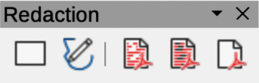
Figure 26: Redaction toolbar
- Rectangle
- Freeform
- Redacted Export (White)
- Redacted Export (Black)
- PDF

Slide View
The Slide View toolbar (Figure 27) opens with the Slide Sorter view and provides tools to rehearse timings of a slide show; hide and show slides, and change the number of slides displayed in Slide Sorter view.
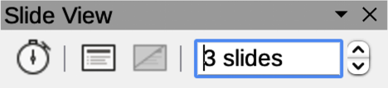
Figure 27: Slide View toolbar
- Rehearse Timings
- Show Slide
- Hide Slide
- Slides per Row

Standard
The Standard toolbar (Figure 28) is common to all LibreOffice modules and provides tools for creating and editing documents using LibreOffice. The Standard toolbar differs between different LibreOffice modules allowing different tool sets used in creating the different types of documents.
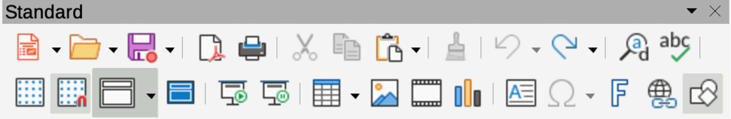
Figure 28: Standard toolbar
- Load URL
- New
- Templates
- Open
- Open Remote
- Save
- Save As
- Email
- Edit Mode
- Export Directly as PDF
- Print Directly
- Print
- Cut
- Copy
- Paste
- Clone Formatting
- Clear
- Undo
- Redo
- Find and Replace
- Spelling
- Auto Spellcheck
- Zoom & Pan
- Zoom
- Display Grid
- Helplines While Moving
- Display Views
- Views Tab Bar
- Format Slide
- Master Slide
- Start from First Slide
- Start from Current Slide
- Table
- Insert Image
- Insert Audio or Video
- Insert Chart
- Text Box
- Insert Special Characters
- Vertical Text
- Insert Fontwork Text
- Insert Hyperlink
- Show LO Draw Functions
- Interaction
- LibreOffice Help
- What’s That

Standard (Single Mode)
The Standard (Single Mode) toolbar (Figure 29) can be used instead of the Standard toolbar if necessary. The Standard (Single Mode) toolbar is normally used when the user interface is switched to single mode. For more information on selecting and using user interface variants, see Chapter 12, User Interface Variants.
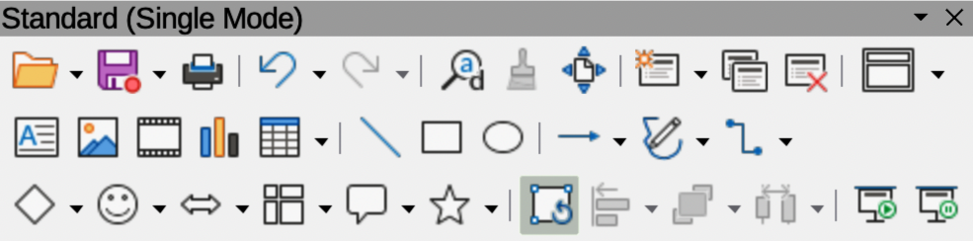
Figure 29: Standard (Single Mode) toolbar
- New
- Open
- Save
- Export Directly as PDF
- Print
- Print Preview
- Undo
- Redo
- Find and Replace
- Clone Formatting
- Spelling
- Entire Page
- New Slide
- Duplicate Slide
- Rename Slide
- Delete Slide
- Slide Layout
- Display Views
- Text Box
- Vertical Text
- Insert Image
- Insert Audio or Video
- Insert Chart
- Table
- Insert Fontwork
- Insert Line
- Rectangle
- Ellipse
- Lines and Arrows
- Curves and Polygons
- Connectors
- Basic Shapes
- Symbol Shapes
- Block Arrows
- Flowchart
- Callouts
- Stars and Banners
- 3D Objects
- Position and Size
- Rotate
- Flip
- Align Objects
- Arrange
- Select at least three objects to distribute
- Group
- Ungroup
- Enter Group
- Exit Group
- Select
- Entire Page
- Zoom & Pan
- Zoom
- Start from First Slide
- Start from Current Slide

Standard (Viewing Mode)
The Standard (Viewing Mode) toolbar (Figure 30) provides tools to save, edit and distribute a document.
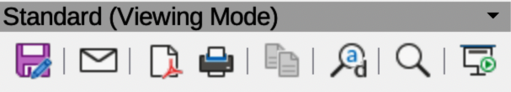
Figure 30: Standard (Viewing Mode) toolbar
- Save As
- Edit Mode
- Read Only Mode
- Attach to Email
- Export Directly as PDF
- EPUB
- Print Directly
- Print
- Copy
- Find and Replace
- Zoom
- Start from First Slide

Table
The Table toolbar (Figure 31) provides tools and options to edit and format a table placed on a slide. This toolbar only becomes active when a table is selected.
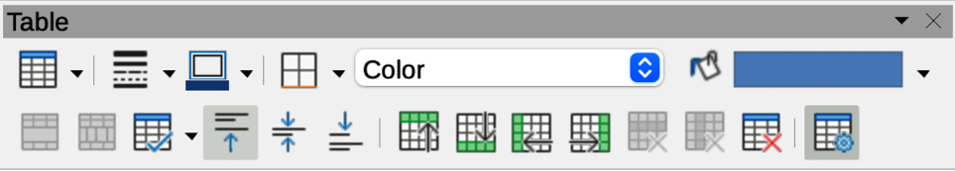
Figure 31: Table toolbar
- Table
- Border Style
- Border Color
- Borders (Shift to overwrite)
- Area Style/Filling
- Fill Color
- Merge Cells
- Split Cells
- Optimize
- Align Top
- Center Vertically
- Align Bottom
- Insert Row Above
- Insert Row Below
- Insert Column Before
- Insert Column After
- Delete Row
- Delete Column
- Delete Table
- Select Table
- Select Column
- Select Row
- Table Design
- Table Properties

Text
The Text toolbar (Figure 32) provides tools to insert text boxes and callouts into a slide.
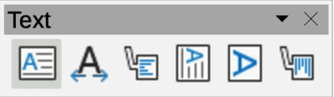
Figure 32: Text toolbar
- Insert Text Box
- Fit Text in Text Box Size
- Callouts
- Insert Vertical Text
- Fit Vertical Text to Frame
- Vertical Callouts

Text Formatting
The Text Formatting toolbar (Figure 33) provides tools for formatting text and alignment commands. This toolbar becomes active when text in a text box or graphic object has been selected and it automatically replaces the Line and Filling toolbar.
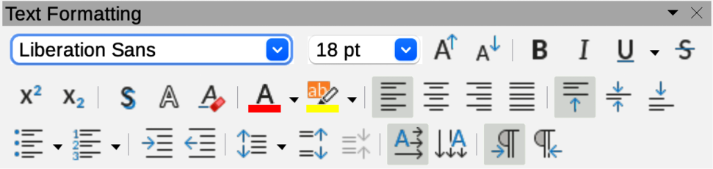
Figure 33: Text Formatting toolbar
- Font Name
- Font Size
- Increase Font Size
- Decrease Font Size
- Bold
- Italic
- Underline
- Double Underline
- Strikethrough
- Overline
- Superscript
- Subscript
- Toggle Shadow
- Apply outline attribute to font
- Clear Direct Formatting
- lowercase
- UPPERCASE
- small capitals
- Font Color
- Character Highlighting Color
- Toggle Unordered List
- Toggle Ordered List
- Outline Format
- Align Left
- Align Center
- Align Right
- Justified
- Align Top
- Center Vertically
- Align Bottom
- Set Line Spacing
- Character Spacing
- Increase Paragraph Spacing
- Decrease Paragraph Spacing
- Text direction from left to right
- Text direction from top to bottom
- Left-To-Right
- Right-To-Left
- Select All
- Character
- Paragraph

Transformations
The Transformations toolbar (Figure 34) provides tools to modify the shape, orientation, or fill of selected objects.
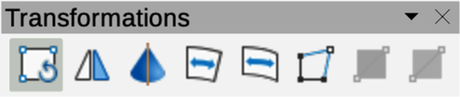
Figure 34: Transformations toolbar
- Rotate
- Flip
- In 3D Rotation Object
- Set in Circle (perspective)
- Set to circle (slant)
- Distort
- Interactive transparency
- Interactive gradient

TSCP Classification
The TSCP Classification toolbar (Figure 35) provides tools to help in selecting the security of a document. LibreOffice adds custom fields in the document properties (File > Properties > Custom Properties on the Menu bar) to store the classification policy as document metadata. TSCP stands for Transglobal Secure Collaboration Participation.
Figure 35: TSCP Classification toolbar
- Apply document classification (Level)
- Manage Document Classification

Zoom
The Zoom toolbar (Figure 36) provides tools to reduce or enlarge the screen display of the current presentation.
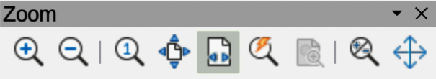
Figure 36: Zoom toolbar
- Zoom In
- Zoom Out
- 100%
- Zoom Previous
- Zoom Next
- Entire Page
- Page Width
- Optimal View
- Object Zoom
- Zoom & Pan
- Shift

Sub-toolbars

3D-Objects
Click on the triangle ▼ to the right of 3D-Objects on the Drawing toolbar to open the 3D-Objects sub-toolbar (Figure 37), then select a 3D object to add to a drawing. The 3D-Objects sub-toolbar is identical to the 3D-Objects toolbar available at View > Toolbars on the Menu bar.
Figure 37: 3D-Objects sub-toolbar
- Cube
- Sphere
- Cylinder
- Cone
- Pyramid
- Torus
- Shell
- Half Sphere

Align Objects
Click on the triangle ▼ to the right of Align Objects on the Drawing toolbar to open the Align Objects sub-toolbar (Figure 38), then select an object alignment from the available options.
Figure 38: Align Objects sub-toolbar
- Left
- Centered
- Right
- Top
- Center
- Bottom

Basic Shapes
Click on the triangle ▼ to the right of Basic Shapes on the Drawing toolbar to open the Basic Shapes sub-toolbar (Figure 39), then select a basic shape to add to a drawing.
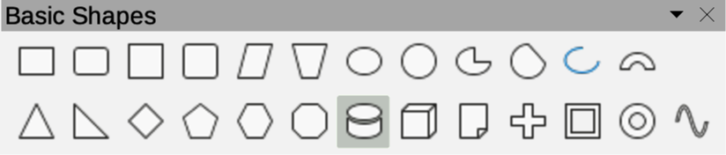
Figure 39: Basic Shapes sub-toolbar
- Rectangle
- Rectangle, Rounded
- Square
- Square, Rounded
- Parallelogram
- Trapezoid
- Ellipse
- Circle
- Circle Pie
- Circle Segment
- Arc
- Block Arc
- Isosceles Triangle
- Right Triangle
- Diamond
- Regular Pentagon
- Hexagon
- Octagon
- Cylinder
- Cube
- Folded Corner
- Cross
- Frame
- Ring

Block Arrows
Click on the triangle ▼ to the right of Block Arrows on the Drawing toolbar to open the Block Arrows sub-toolbar (Figure 40), then select a block arrow to add to a drawing.
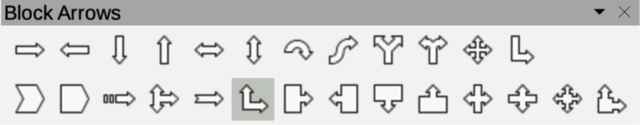
Figure 40: Block Arrows sub-toolbar
- Right Arrow
- Left Arrow
- Down Arrow
- Up Arrow
- Left and Right Arrow
- Up and Down Arrow
- Circular Arrow
- S-shaped Arrow
- Split Arrow
- Right or Left Arrow
- 4-way Arrow
- Corner Right Arrow
- Chevron
- Pentagon
- Striped Right Arrow
- Up, right and Down Arrow
- Notched Right Arrow
- Up and Right Arrow
- Right Arrow Callout
- Left Arrow Callout
- Down Arrow Callout
- Up Arrow Callout
- Left and Right Arrow Callout
- Up and Down Arrow Callout
- 4-way Arrow Callout
- Up and Right Arrow Callout

Callouts
Click on the triangle ▼ to the right of Callouts on the Drawing toolbar to open the Callouts sub-toolbar (Figure 41), then select a callout to add to a drawing.
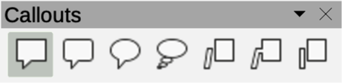
Figure 41: Callouts sub-toolbar
- Rectangular Callout
- Rounded Rectangular Callout
- Round Callout
- Cloud
- Line Callout 1
- Line Callout 2
- Line Callout 3

Color
The Color sub-toolbar (Figure 42) provides tools to edit color properties of a selected object. After selecting an image or graphic to open the Image toolbar, click on Color on the Image toolbar.
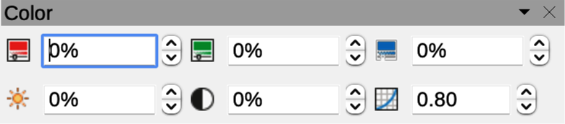
Figure 42: Color sub-toolbar
The tools available on the Color sub-toolbar are as follows:
Red
Specifies the proportion of red RGB color components for the selected graphic object. Values from -100% (no red) to +100% (full red) are possible.
Green
Specifies the proportion of green RGB color components for the selected graphic object. Values from -100% (no green) to +100% (full green) are possible.
Blue
Specifies the proportion of blue RGB color components for the selected graphic. Values from -100% (no blue) to +100% (full blue) are possible.
Brightness
Specifies the brightness for the selected graphic object. Values from -100% (only black) to +100% (only white) are possible.
Contrast
Specifies the contrast for viewing the selected graphic image. Values from -100% (no contrast at all) to +100% (full contrast) are possible.
Gamma
Specifies the gamma value for the view of the selected object, which affects the brightness of the mid-tone values. Values from 0.10 (minimum Gamma) to 10 (maximum Gamma) are possible.

Connectors
Click on the triangle ▼ to the right of Connectors on the Drawing toolbar to open the Connectors sub-toolbar (Figure 43), then select a connector to add to a drawing.
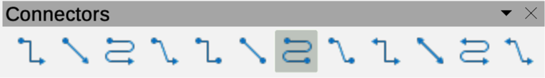
Figure 43: Connectors sub-toolbar
- Connector Ends with Arrow
- Straight Connector Ends with Arrow
- Curved Connector Ends with Arrow
- Line Connector Ends with Arrow
- Connector
- Straight Connector
- Curved Connector
- Line Connector
- Connector Starts with Arrow
- Straight Connector starts with Arrow
- Curved Connector Starts with Arrow
- Line Connector Starts Arrow
- Connector Ends with Circle
- Straight Connector Ends with Circle
- Curved Connector Ends with Circle
- Line Connector Ends with Circle
- Connector Starts with Circle
- Straight Connector starts with Circle
- Curved Connector Starts with Circle
- Line Connector Starts with Circle
- Connector with Circles
- Straight Connector with Circle
- Curved Connector with Circle
- Line Connector with Circle

Curves and Polygons
Click on the triangle ▼ to the right of Curves and Polygons on the Drawing toolbar to open the Curves and Polygons sub-toolbar (Figure 44), then select a curve or polygon to add to a drawing.
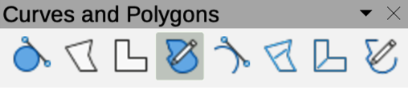
Figure 44: Curves and Polygons sub-toolbar
- Curve, Filled
- Polygon, Filled
- Polygon (45°), Filled
- Freeform Line, Filled
- Curve
- Polygon
- Polygon (45°)
- Freeform Line

Distribute Selection
Click on the triangle ▼ to the right of Select at least three objects to distribute on the Drawing toolbar to open the Distribute Selection sub-toolbar (Figure 45), then select the type of distribution required between the selected objects.
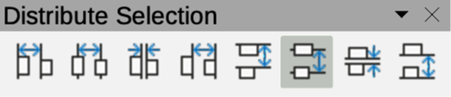
Figure 45: Distribute Selection sub-toolbar
- Distribute Horizontally Left
- Distribute Horizontally Center
- Distribute Horizontally Spacing
- Distribute Horizontally Right
- Distribute Vertically Top
- Distribute Vertically Center
- Distribute Vertically Spacing
- Distribute Vertically Bottom

Flowchart
Click on the triangle ▼ to the right of Flowchart on the Drawing toolbar to open the Flowchart sub-toolbar (Figure 46 ), then select a flowchart shape to add to a drawing.
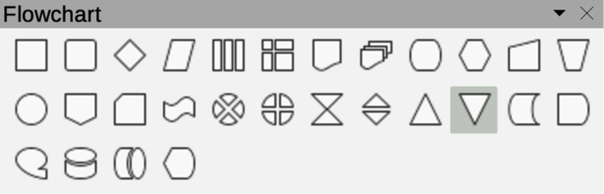
Figure 46: Flowchart sub-toolbar
- Flowchart: Process
- Flowchart: Alternate Process
- Flowchart: Decision
- Flowchart: Data
- Flowchart: Predefined Process
- Flowchart: Internal Storage
- Flowchart: Document
- Flowchart: Multidocument
- Flowchart: Terminator
- Flowchart: Preparation
- Flowchart: Manual Input
- Flowchart: Manual Operation
- Flowchart: Connector
- Flowchart: Off-page Connector
- Flowchart: Card
- Flowchart: Punched Tape
- Flowchart: Summing Junction
- Flowchart: Or
- Flowchart: Collate
- Flowchart: Sort
- Flowchart: Extract
- Flowchart: Merge
- Flowchart: Stored Data
- Flowchart: Delay
- Flowchart: Sequential Access
- Flowchart: Magnetic Disc
- Flowchart: Direct Access Storage
- Flowchart: Display

Fontwork Shape
Clicking on the triangle ▼ to the right of Fontwork Shape on the Fontwork toolbar opens the Fontwork Shape sub-toolbar (Figure 47). Select the required shape to change how a Fontwork text shape appears on a slide.
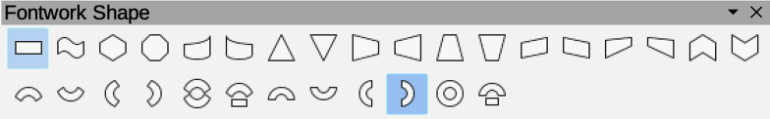
Figure 47: Fontwork Shape sub-toolbar
- Plain Text
- Wave
- Inflate
- Stop
- Curve Up
- Curve Down
- Triangle Up
- Triangle Down
- Fade Right
- Fade Left
- Fade Up
- Fade Down
- Slant Up
- Slant Down
- Fade Up and Right
- Fade Up and Left
- Chevron Up
- Chevron Down
- Arch Up (Curve)
- Arch Down (Curve)
- Arch Left (Curve)
- Arch Right (Curve)
- Circle (Curve)
- Open Circle (Curve)
- Arch Up (Pour)
- Arch Down (Pour)
- Arch Left (Pour)
- Arch Right (Pour)
- Circle (Pour)
- Open Circle (Pour)

Image Filter
Clicking on the triangle ▼ to the right of Filter on the Image toolbar opens the Image Filter sub-toolbar (Figure 48). Select the required filter to change the image display.
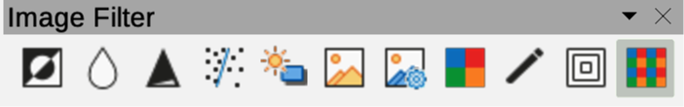
Figure 48: Image Filter sub-toolbar
The image filters available on the Image Filter sub-toolbar are as follows, from left to right:
Invert
Inverts the color values of a color image, or the brightness values of a greyscale image. Apply the filter again to revert the effect.
Smooth
Softens or blurs the image by applying a low pass filter.
Sharpen
Sharpens the image by applying a high pass filter.
Remove Noise
Removes noise by applying a median filter.
Solarization
Opens a dialogue box for defining solarization. Solarization refers to an effect that looks like what can happen when there is too much light during photo development. The colors become partly inverted.
Aging
All pixels are set to their gray values, and then the green and blue color channels are reduced by the amount specified. The red color channel is not changed.
Posterize
Opens a dialogue box to determine the number of poster colors. This effect is based on the reduction of the number of colors. It makes photos look like paintings.
Pop Art
Converts an image to a pop-art format.
Charcoal Sketch
Displays the image as a charcoal sketch. The contours of the image are drawn in black, and the original colors are suppressed.
Relief
Displays a dialogue box for creating reliefs. Selecting the position of the imaginary light source determines the type of shadow created, and how the graphic image looks in relief.
Mosaic
Joins small groups of pixels into rectangular areas of the same color. The larger the individual rectangles are, the fewer details the graphic image has.

Lines and Arrows
Click on the triangle ▼ to the right of Lines and Arrows on the Drawing toolbar to open the Lines and Arrows sub-toolbar (Figure 49), then select a line or arrow to add to a drawing.
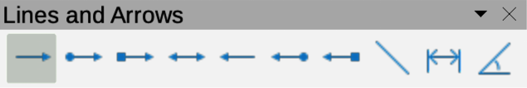
Figure 49: Lines and Arrows sub-toolbar
- Line Ends with Arrow
- Line with Circle/Arrow
- Line with Square/Arrow
- Line with Arrows
- Line Starts with Arrow
- Line with Arrow/Circle
- Line with Arrow/Square
- Insert Line
- Dimension Line
- Line (45°)

Optimize
Click on the triangle ▼ to the right of Optimize on the Table toolbar to open the Optimize sub-toolbar (Figure 50) to evenly distribute selected rows and columns in a table either horizontally or vertically.
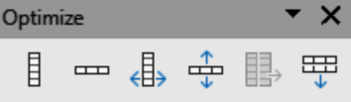
Figure 50: Optimize sub-toolbar
- Minimal Column Width
- Minimal Row Height
- Optimal Column Width
- Optimal Row Height
- Distribute Columns Evenly
- Distribute Rows Evenly

Position
Click on the triangle ▼ to the right of Arrange on the Standard toolbar to open the Position sub-toolbar (Figure 51), then select the position of a selected object in a drawing. These tools are also available on the Drawing toolbar.
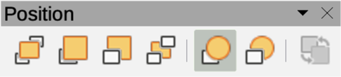
Figure 51: Position sub-toolbar
- Bring to Front
- Bring Forward
- Send Backward
- Send to Back
- In Front of Object
- Behind Object
- Reverse

Stars and Banners
Click on the triangle ▼ to the right of Stars and Banners on the Drawing toolbar to open the Stars and Banners sub-toolbar (Figure 52), then select a star or arrow to add to a drawing.
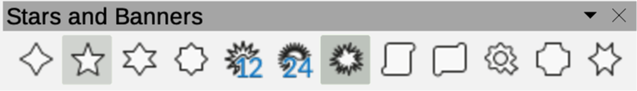
Figure 52: Stars and Banners sub-toolbar
- 4-Point Star
- 5-Point Star
- 6-Point Star
- 8-Point Star
- 12-Point Star
- 24-Point Star
- Explosion
- Vertical Scroll
- Horizontal Scroll
- Signet
- Doorplate
- 6-Point Star, Concave

Symbol Shapes
Click on the triangle ▼ to the right of Symbol Shapes on the Drawing toolbar to open the Symbol Shapes sub-toolbar (Figure 53), then select a symbol shape to add to a drawing.
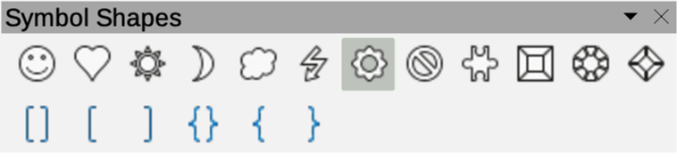
Figure 53: Symbol Shapes sub-toolbar
- Smiley Face
- Heart
- Sun
- Moon
- Cloud
- Lightning Bolt
- Flower
- Prohibited
- Puzzle
- Square Bevel
- Octagon Bevel
- Diamond Bevel
- Double Bracket
- Left Bracket
- Right Bracket
- Double Brace
- Left Brace
- Right Brace

