
LibreOffice Online 6.3 Guide

Preface

Copyright
This document is Copyright © 2019 by the LibreOffice Documentation Team. Contributors are listed below. You may distribute it and/or modify it under the terms of either the GNU General Public License (http://www.gnu.org/licenses/gpl.html), version 3 or later, or the Creative Commons Attribution License (http://creativecommons.org/licenses/by/4.0/), version 4.0 or later.
All trademarks within this guide belong to their legitimate owners.

Contributors
This book, for version 6.3 of LibreOffice Online, was written new as part of the 2019 Google Season of Docs.

To this edition
Aaron Peters

To previous editions

Feedback
Please direct any comments or suggestions about this document to the Documentation Team’s mailing list: documentation@global.libreoffice.org
- Note:
Everything you send to a mailing list, including your email address and any other personal information that is written in the message, is publicly archived and cannot be deleted.

Publication date and software version
Published February 2020. Based on LibreOffice 6.3.
Contents
Copyright 4
Contributors 4
To this edition 4
To previous editions 4
Feedback 4
Publication date and software version 4
Who is this book for? 6
What’s in this book? 6
Where to get more help 6
Help system 6
Other free online support 7
Paid Support and Training 7
What you see may be different 7
Browser-based Controls 7
Icons, Fonts, and Look-and-Feel 7
What are all these things called? 8
Frequently Asked Questions 11
What’s new in LibreOffice Online 6.3? 12

Who is this book for?
LibreOffice is a free and open-source office suite with features comparable to proprietary alternatives. It includes applications for word processing, spreadsheets, presentations, and other functions, and is available to install on your Mac or PC running Windows or Linux. You may also be able to use it on other operating systems either through dedicated viewer applications (such as the one for Android) or through emulation (e.g. the Linux emulation layer in FreeBSD).
LibreOffice Online (hereafter also LOOL) is a web-based office suite compatible with the desktop version of LibreOffice. It offers word processor (Documents), spreadsheet (Spreadsheets), and presentation (Presentations) modules. It also allows you to keep your documents safely in a cloud- or network-based location you control. You can even open one of your LOOL documents in a desktop version of LibreOffice, edit it, and save it back to the remote server.
This book is for users who want any of the benefits a personal cloud affords: increased privacy, lower (free!) costs, or better ability to customize. That said, installing and maintaining LibreOffice Online for yourself is not a “point-and-click” process. You should be comfortable with networking concepts (domain management, hosting services, etc.), the Linux operating system in general, and working from its command-line in order to be able to use LibreOffice Online.

What’s in this book?
This book will help you get LibreOffice installed, introduce it’s browser-based interface, and highlight the major features of its modules.
- Preface (this chapter)
- Introduction to LibreOffice Online
- Installation of LibreOffice Online
- Configuring LibreOffice Online
- Navigating Your LibreOffice Online Files
- Editing, Saving, and Exporting Files in LibreOffice Online Applications
- Using the Documents Module
- Using the Spreadsheets Module
- Using the Presentations Module
- Integrating Other Applications with LibreOffice Online

Where to get more help
There are plenty of resources you can use to get help while using LibreOffice Online. These include not only this guide and others specific to LibreOffice Online, but also the materials created for LibreOffice. The two systems share a great deal of functionality, and answers to one are often just as applicable to the other.

Help system
LibreOffice Online is fairly new, and does not yet have an online Help system like the desktop version. While a Help item exists in the main menu, it contains only two items: Keyboard Shortcuts, and About.
However, if you have the desktop software, many of the functions are similar between the two. You can (and should) check the desktop software’s help system to see if it contains a suggestion that solves your issue.

Other free online support
The LibreOffice project supports its users in many ways, including the following:
- Ask.LibreOffice is a question-and-answer forum where you can post your issue and get a reply from either a member of the project, or one of the other community members.
- The LibreOffice Wiki contains documentation about the software, as well as collaboration areas for groups within the project. If you’re looking for answers to software-related questions, try the Wiki’s Documentation Page as a starting point.
- Mailing lists are a traditional help resource in open source projects, and LibreOffice is no different. There are many people on the LibreOffice mailing lists who will respond to questions.
- In addition to the online help, there is also official documentation available in the form of books and guides—this guide is in fact a member of that group. But you can also find guides on the other modules available in LibreOffice Online (Writer, Calc, and Impress), as well as other components of the LibreOffice suite (e.g. Base, Math, and Draw).
- Finally, if you’re familiar with Internet Chat Relay (IRC), there are LibreOffice channels available on the freenode.net server. You can jump right in and interact with community members from your browser by visiting https://irc.documentfoundation.org/, or you can use some of the tips on the Users/IRC Wiki page to get an IRC client set up.

Paid Support and Training
You can also pay for support through service contracts from a vendor or consulting firm specializing in LibreOffice. For information about certified professional support, see The Document Foundation’s website: https://www.libreoffice.org/get-help/professional-support/

What you see may be different

Browser-based Controls
Unlike LibreOffice, which is a “stand-alone” application, you will be accessing LibreOffice through a browser. As a result, the fine details of how LibreOffice looks and behaves is dependent on the browser, which is in turn dependent on which browsers are available for your operating system.
For a consistent experience using LibreOffice Online, you should use a cross-platform browser like Mozilla Firefox or Google Chrome. The browser controls, such as bookmarks or the start page, will differ between these various browsers. However, the controls you see within LibreOffice Online will remain consistent.

Icons, Fonts, and Look-and-Feel
Desktop operating systems each have their own aesthetics. As a result there may be very slight differences what you see between OSes, or even between browsers on the same OS. These may appear slightly different throughout this text depending on which OS appears in a given screenshot. But these should be mostly confined to elements like the menu or status bar. As with the desktop software, some elements such as fonts, colors, themes, etc., of the browser are also customizable by users, and may appear different in screenshots throughout this book.
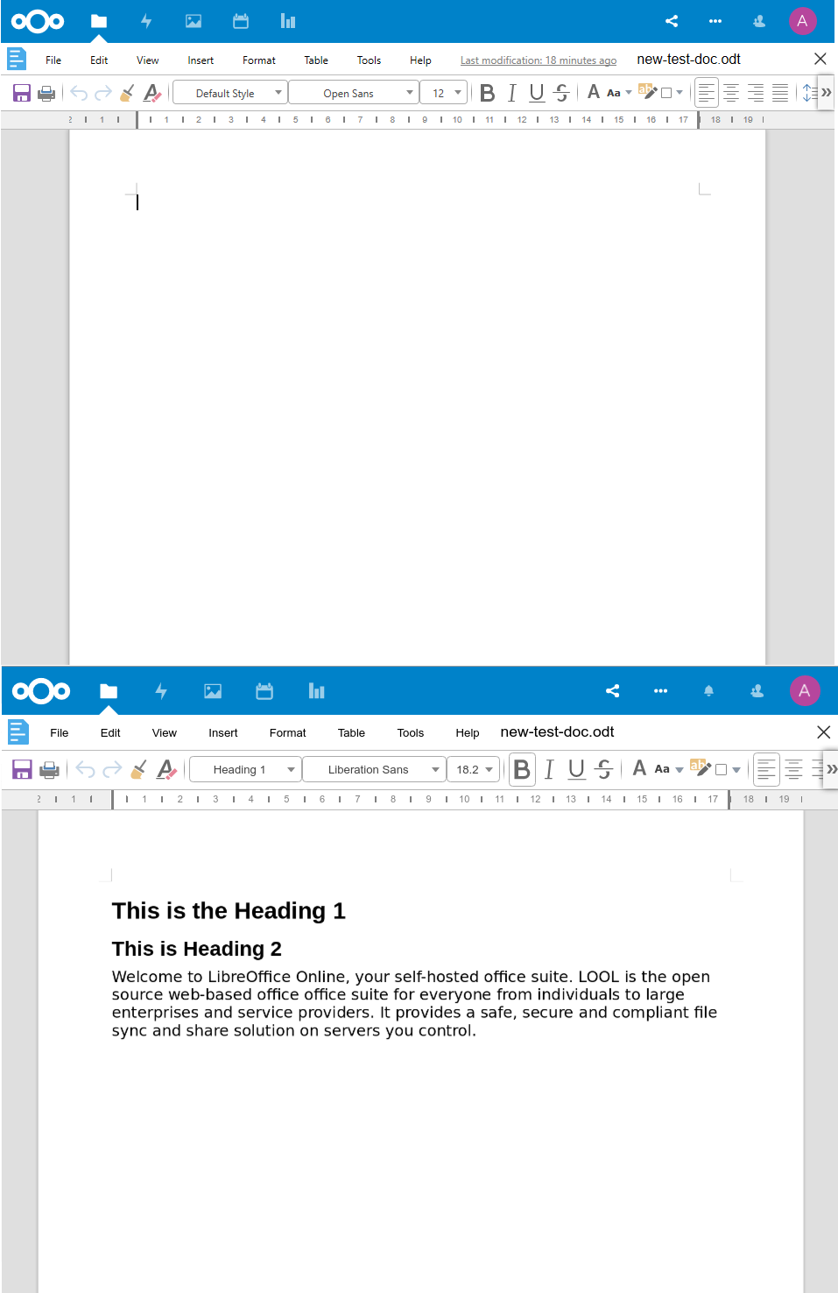Figure 1: LibreOffice Online in Windows/Edge (Top) and Chrome/Linux (Bottom)
What it will not affect is the look and feel of your documents. These should remain consistent regardless of what operating system you’re using, and even whether you’re using LibreOffice Online or the desktop version of LibreOffice.

What are all these things called?
The terms used in LibreOffice Online for most parts of the user interface (the parts of the program you see and use, in contrast to the behind-the-scenes code that actually makes it work) are the same as for most web-based programs.
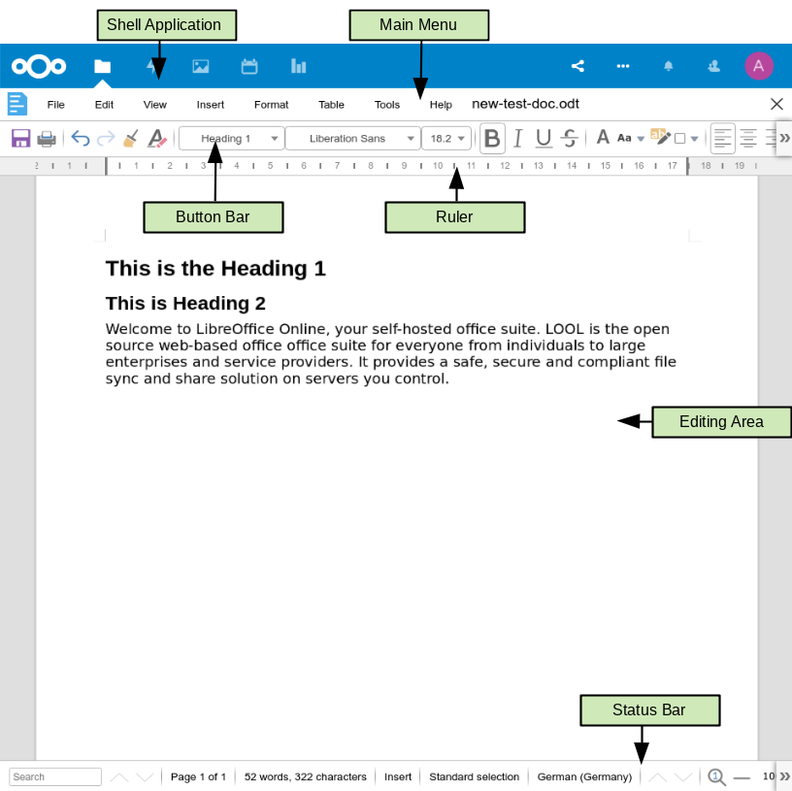Figure 2: The LibreOffice Online UI within a cloud service
Shell Application:
This is the application that “hosts” LibreOffice Online (more information on in the Chapter 2, Introducing LibreOffice Online). In this example, LibreOffice Online is integrated with a popular cloud service, and the top row of controls actually have nothing to do with LOOL at all.
Main Menu:
The main menu of LOOL looks very similar to its desktop counterpart, with main entries such as File, Edit, and Tools.
Button Bar:
Also like desktop versions, the Button Bar contains buttons for common operations like saving the current document, bolding text, or creating a list out of highlighted.
Ruler:
In some modules, beneath the Button Bar is a Ruler showing the width of your document.
Workspace:
Your document takes up most of the screen, and is where you can place the cursor and add content to your documents.
Status Bar:
Finally, the bottom of the application window shows a variety of current, useful information such as Current Page/Total Pages, Word/Character count, and current selected Language.
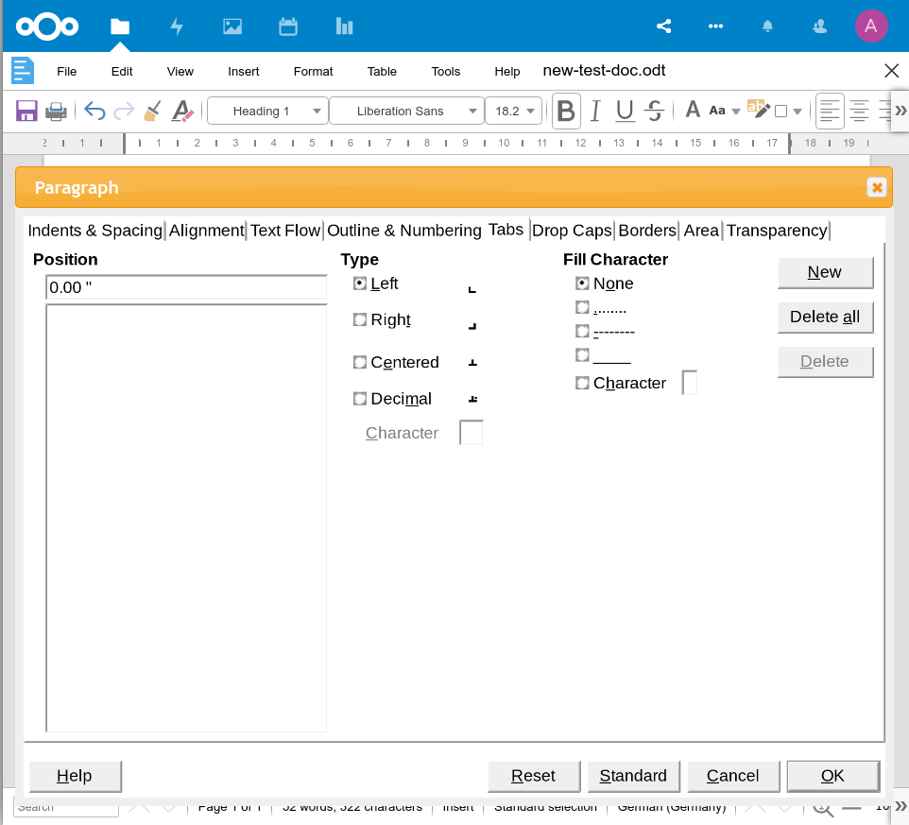Figure 3: The Paragraph Dialog in the Documents Module
You may also see dialogs, which are a window that appears over the main items listed above. Its purpose is to inform you of something, or request input from you, or both. It provides controls to use to specify how to carry out an action. The technical names for common controls are shown in Figure 2. In most cases the technical terms are not used in this book, but it is useful to know them because the Help and other sources of information often use them.

Frequently Asked Questions
May I use LibreOffice Online in my own business?
Yes.
May I distribute LibreOffice Online to anyone?
Yes.
May I sell it, either directly or as part of a subscription service?
Yes.
How many computers may I install it on?
LibreOffice Online is installed on a server, not individual PCs. That said, you may install it on as many servers as you like. However, if you engage the services of a company who installs it for you, they will likely install it on one server.
How can I contribute to LibreOffice?
You can help with the development and user support of LibreOffice in many ways, and you do not need to be a programmer. To start, check out this web page: https://www.libreoffice.org/community/get-involved/
May I distribute the PDF of this book, or print and sell copies?
Yes, as long as you meet the requirements of one of the licenses in the copyright statement at the beginning of this book. You do not have to request special permission. We request that you share with the project some of the profits you make from sales of books, in consideration of all the work we have put into producing them. https://www.libreoffice.org/donate/
What is LibreOffice Online? Is it different than LibreOffice?
LibreOffice Online is an online office suite installed on a server you control. You then access it by pointing your browser to a URL on that server. You will need to make sure that server has all the prerequisite software (more on this in Chapter 2, Installing LibreOffice Online) before you install it, and troubleshoot it if something goes wrong. However, you only need to do so once, after which you can access it via a browser on just about any machine you have, including PCs, Macs, and mobile devices. You need to have a steady connection to a network to use LibreOffice Online.
Do I need to choose between LibreOffice and LibreOffice Online?
Only in terms of what you want to use right now. But the two are created from the same core functionality, and are in fact designed to work together. You can easily create a file in LibreOffice Online, then open it in LibreOffice on your PC to edit it, and finally save the changes back to LOOL.
I don’t see the files on my computer, where are they?
When you create content in LOOL, the files are stored on the server machine, not your local computer. You can freely download them, open them directly on the server machine, or sync them with your local computer using freely-available applications (more on this in Chapter 9, Integrating with LibreOffice Online).

What’s new in LibreOffice Online 6.3?
All new versions of LibreOffice applications come with new features and bug fixes, and LOOL is no exception. Additions to the most recent version of LibreOffice Online can be found on the TDF Wiki.

