
LibreOffice Online 6.3 Guide

Chapter 1
Introducing LibreOffice Online

Copyright
This document is Copyright © 2019 by the LibreOffice Documentation Team. Contributors are listed below. You may distribute it and/or modify it under the terms of either the GNU General Public License (http://www.gnu.org/licenses/gpl.html), version 3 or later, or the Creative Commons Attribution License (http://creativecommons.org/licenses/by/4.0/), version 4.0 or later.
All trademarks within this guide belong to their legitimate owners.

Contributors
This book, for version 6.3 of LibreOffice Online, was written new as part of the 2019 Google Season of Docs.

To this edition
Aaron Peters

Feedback
Please direct any comments or suggestions about this document to the Documentation Team’s mailing list: documentation@global.libreoffice.org
- Note:
Everything you send to a mailing list, including your email address and any other personal information that is written in the message, is publicly archived and cannot be deleted.

Publication date and software version
Published February 2020. Based on LibreOffice 6.3.
Contents
Copyright 2
Contributors 2
To this edition 2
Feedback 2
Publication date and software version 2
Introducing LibreOffice Online 4
What is LibreOffice Online? 4
What does LibreOffice Online include? 4
LibreOffice Online Documents 5
LibreOffice Online Spreadsheets 6
LibreOffice Online Presentations 7

What is LibreOffice Online?
Like many competing productivity suites, the LibreOffice project has created a version of the desktop software that’s available over the Internet. LibreOffice Online is the system that allows users to log into a supported system via a browser and work with their documents. In addition to being open source software, it’s free for both personal and professional use with no license fees. Some advantages include:
Cross-platform:
You can use LibreOffice Online across all your devices running Windows, macOS, or Linux, or any operating system with a supported browser (even mobile devices).
File Compatibility:
Files created in LibreOffice are highly compatible with alternatives such as Microsoft Office, Google Docs, and others.
Multi-User:
You can also invite collaborators to work on your files with you, over the network. You can even edit a file together at the same time!
Multi-lingual:
LibreOffice has support for many languages, with features like spell-checking, thesauri, and complex layout for the locales which require it.
Community-Driven:
A community of users and developers drives the development of LibreOffice, and everyone is encouraged to participate in plotting its future.
Instead of installing LOOL on each of the computers with which you want to use it, you’ll install (or access) it on a server located somewhere else. This could be either on your local (e.g. home) network, or over the Internet.
To use LOOL you’ll visit an address in your browser, which corresponds to a hosting application. LibreOffice Online doesn’t typically exist by itself. Instead, it’s installed alongside another application that will host files. This hosting application will then allow you to open compatible files in LOOL, usually in addition to other options like downloading or deleting them.

What does LibreOffice Online include?
While the goal of LibreOffice Online is to support all the same features as its desktop counterpart. But as a fairly new addition to the LibreOffice family, LOOL currently has the following components:
- Documents, a word processor and counterpart to LibreOffice Writer
- Spreadsheets, a spreadsheet application and counterpart to LibreOffice Calc
- Presentations, a multimedia presentation program and counterpart to LibreOffice Impress

LibreOffice Online Documents
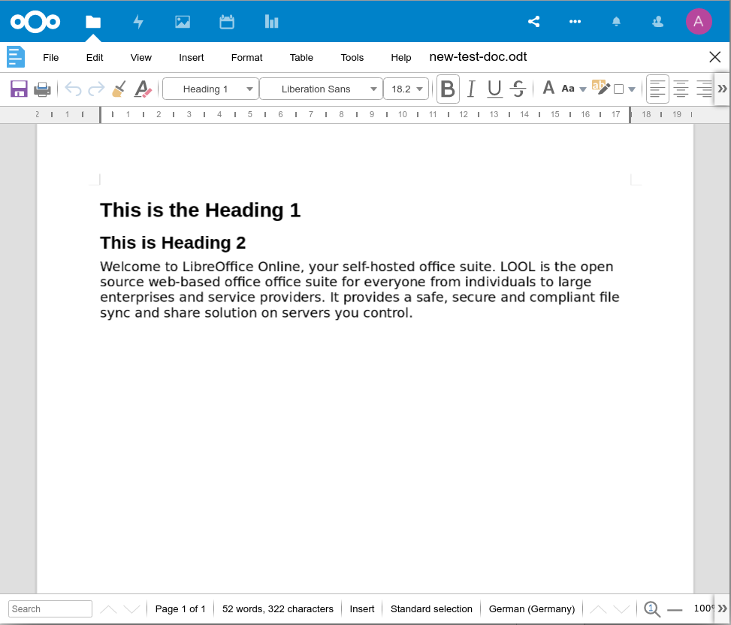Figure 1: LibreOffice Online Documents
LibreOffice Online Documents is an online word processor capable of producing nicely-formatted written papers, reports, or books (among other things). It is a counterpart of LibreOffice Writer, and it creates its files in the same OpenDocument Text (.ODT) format. It can also open and save files in Microsoft Word (.DOCX/.DOC) format.
Some of the features it includes are:
- A selection of Fonts, text color, and text decoration (Bold, Italics, Strikethrough, etc.), and more.
- Styles to allow easy application of all the above formatting options.
- Review tools, including Track Changes.
- Document elements like Headers, Footers, Tables of Contents, and Indices.
- Fields that can be inserted into documents.
- Easy creation of Tables.
- Tools for language like spell checkers, word count, and a thesaurus.

LibreOffice Online Spreadsheets
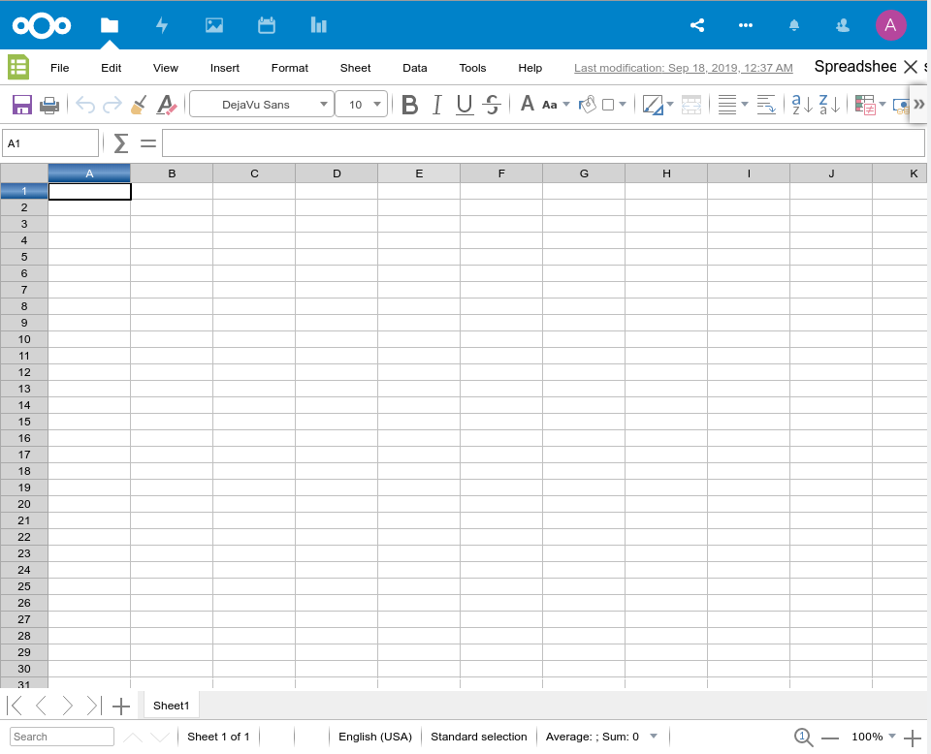
Figure 2: LibreOffice Online Spreadsheets
LOOL Spreadsheets is the online counterpart to LibreOffice Calc, and allows you to collaborate on spreadsheets through your browser. It uses the same “workbook-and-tab” concepts as the desktop version, and shares the same OpenDocument Spreadsheet (.ODS) file format. It can also open and save files in Microsoft Excel (.XLSX/.XLS) format.
A sample of features available in Spreadsheets is as follows:
- Basic arithmetic functions such as addition, subtraction, multiplication, and division.
- Cell formatting including text decoration, cell background/borders, numerical formatting, and conditional formatting.
- Formulas and functions.
- Data tools such as sorting, filtering, grouping, and validation.
- Charts and Graphs that can be inserted into a spreadsheet tab.

LibreOffice Online Presentations
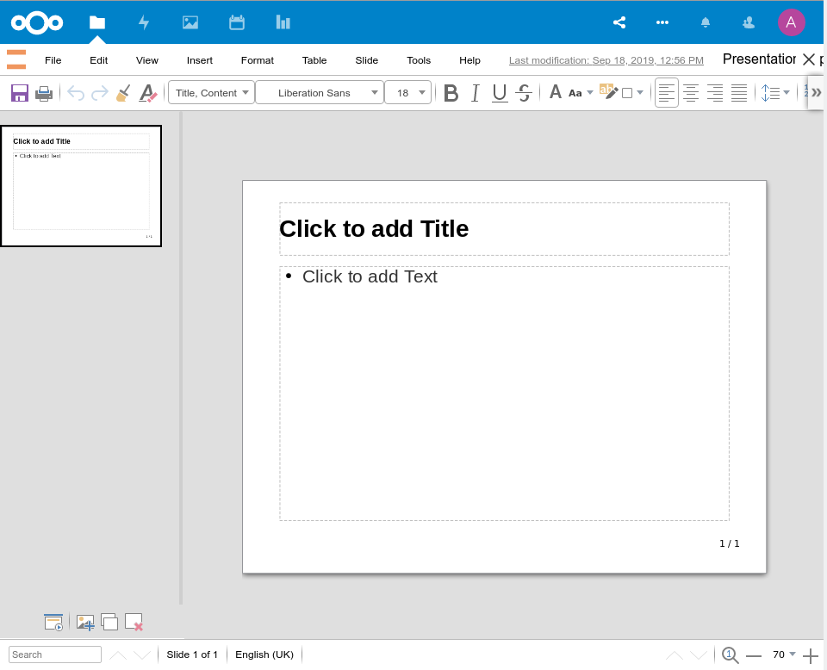
Figure 3: LibreOffice Online Presentations
The Presentations module in LibreOffice Online is the counterpart of LibreOffice Impress, and allows you to create rich, multimedia presentations in OpenDocument Presentation (.ODP) format. It can also open and save files in Microsoft Powerpoint (.PPTX/.PPT) format.
Some of the features supported in this online version include:
- Creating presentation text and graphics.
- Styles for easy decoration of slide elements.
- Adding Shapes, Charts and Tables to presentations.
- Presenting the file in fullscreen mode with animations and transitions.

