
LibreOffice Online 6.3 Guide

Chapter 3
Setting Up to Use LibreOffice Online

Copyright
This document is Copyright © 2019 by the LibreOffice Documentation Team. Contributors are listed below. You may distribute it and/or modify it under the terms of either the GNU General Public License (http://www.gnu.org/licenses/gpl.html), version 3 or later, or the Creative Commons Attribution License (http://creativecommons.org/licenses/by/4.0/), version 4.0 or later.
All trademarks within this guide belong to their legitimate owners.

Contributors
This book, for version 6.3 of LibreOffice Online, was written new as part of the 2019 Google Season of Docs.

To this edition
Aaron Peters

To previous editions

Feedback
Please direct any comments or suggestions about this document to the Documentation Team’s mailing list: documentation@global.libreoffice.org
- Note:
Everything you send to a mailing list, including your email address and any other personal information that is written in the message, is publicly archived and cannot be deleted.

Publication date and software version
Published February 2020. Based on LibreOffice 6.3.
Contents
Copyright 2
Contributors 2
To this edition 2
To previous editions 2
Feedback 2
Publication date and software version 2
Your LibreOffice Online Installation 3
Log Into the cloud service 3
Install the Cloud Service / LibreOffice Online Integration Plugin 4

Your LibreOffice Online Installation
At this point LibreOffice is installed, but it’s not yet connected to your hosting application. We need to set up that hosting application to use LOOL when you take the action of opening a compatible OpenDocument format file for editing.
- Note: Applicability
Note that the following sections will only apply if you’ve installed using the Docker or Linux Package methods. If you’re using the VM appliance, everything should be set up for you already.

Log Into the cloud service
Visit your cloud service installation with a web browser—you can use the IP address of the server where you installed it. If you’re using a cloud service install you already have, you can use your existing username and password.
If you followed the instructions in the last chapter and your cloud service instance is brand new, you’ll need to complete a short setup process. On the first screen you’ll provide the name for your administrative account, and set that account’s password.
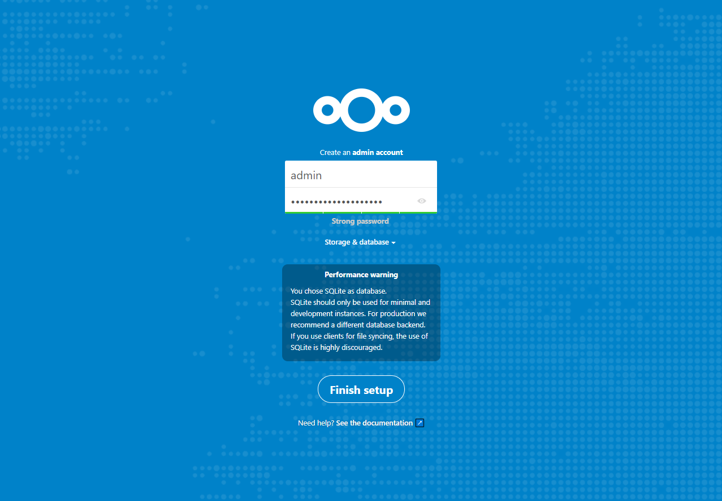Figure 1: the very short setup for cloud service docker installation
Once you’re logged in, you’ll land on Cloud Service Home screen.

Install the Cloud Service / LibreOffice Online Integration Plugin
The next step is to connect your cloud service instance with LibreOffice. First, you’ll need to install the necessary cloud service application, normally using the Market feature of the cloud service, by opening the account menu in the upper-right of the screen, and selecting + Apps. Click on Office & text and search the list for the Collabora Online app. Click the Download & enable button to get it installed.
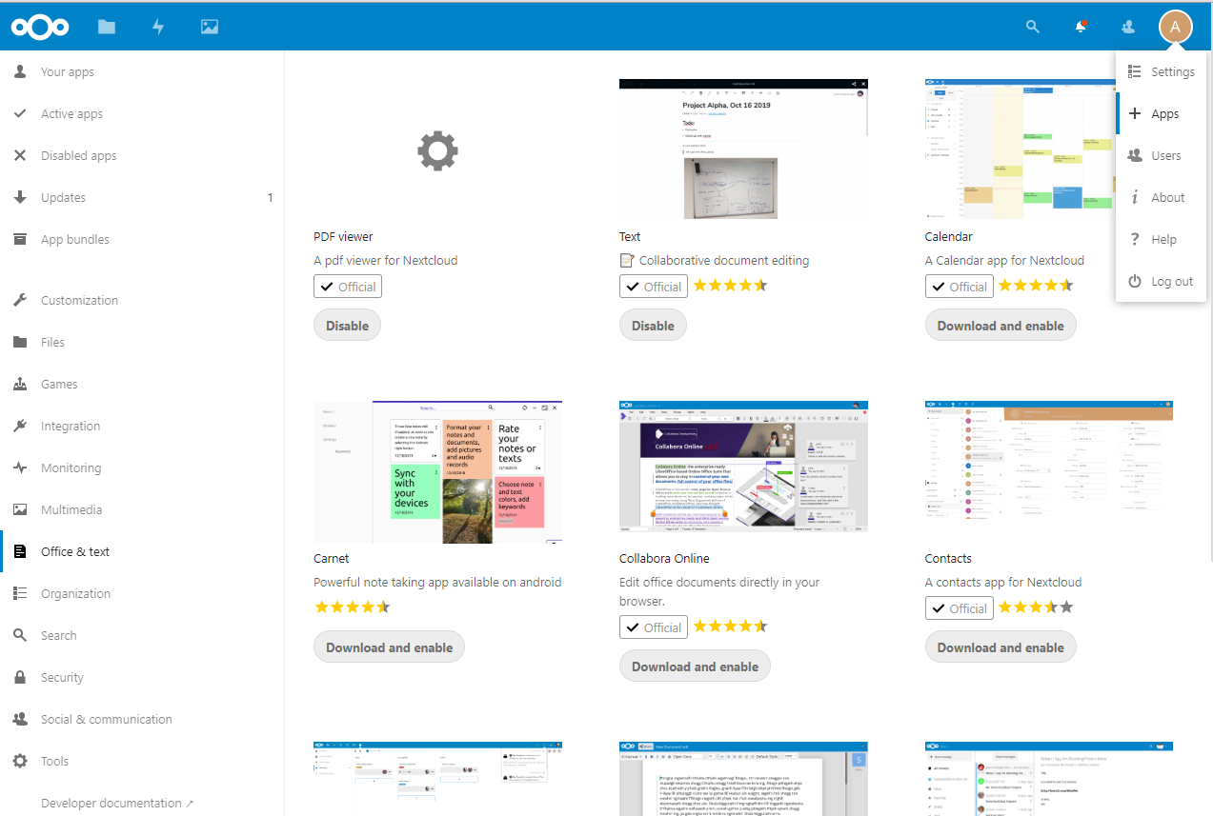
Figure 2: the Collabora Online app in a popular cloud app store
Once it’s installed, you won’t see any immediate change. Click the account menu again, and select Settings. There, you’ll see a new entry for Collabora Online in the Administration section of the Settings screen. Select this, then enter the URL and port for your LibreOffice installation. You can leave the remainder of the settings as they are.
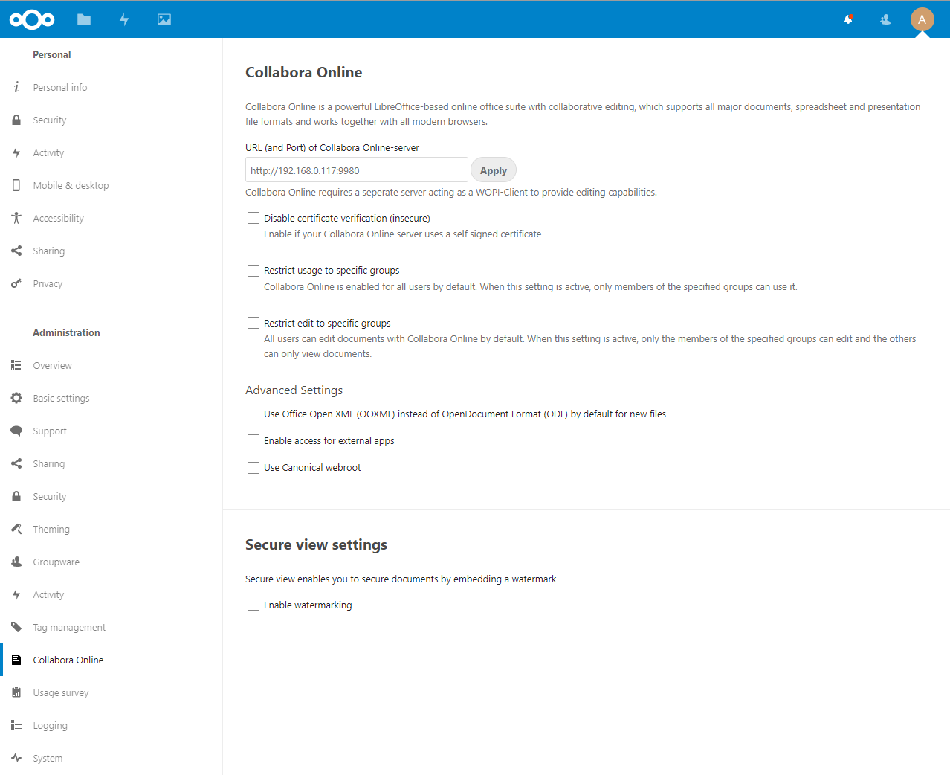
Figure 3: The Collabora Online Settings in the cloud service
Now, go back to the Files app, and select an .ODT file (there should be one in the Documents folder). If the LOOL Documents app doesn’t display your selected file, and/or it displays an error, go back and make sure the value you entered in the Settings screen is correct. hosting
- Tip: Troubleshooting
If you’re sure your LibreOffice Online URL is correct in Settings, and you still can’t connect, there are a couple of other items you should check. Is the LOOL instance actually running? If you installed via Docker, are the two containers on the same network? If your URL contains “https,” are you sure your certificates are valid? There are a few different ways the connection can break down between the two systems. Some savvy Internet searching can likely find a solution to your particular problem.

