
LibreOffice Online 6.3 Guide

Chapter 4
Navigating Your LibreOffice Online Files

Copyright
This document is Copyright © 2019 by the LibreOffice Documentation Team. Contributors are listed below. You may distribute it and/or modify it under the terms of either the GNU General Public License (http://www.gnu.org/licenses/gpl.html), version 3 or later, or the Creative Commons Attribution License (http://creativecommons.org/licenses/by/4.0/), version 4.0 or later.
All trademarks within this guide belong to their legitimate owners.

Contributors
This book, for version 6.3 of LibreOffice Online, was written new as part of the 2019 Google Season of Docs.

To this edition
Aaron Peters

To previous editions

Feedback
Please direct any comments or suggestions about this document to the Documentation Team’s mailing list: documentation@global.libreoffice.org
- Note:
Everything you send to a mailing list, including your email address and any other personal information that is written in the message, is publicly archived and cannot be deleted.

Publication date and software version
Published March 2020. Based on LibreOffice 6.3.
Contents
Copyright 2
Contributors 2
To this edition 2
To previous editions 2
Feedback 2
Publication date and software version 2
LibreOffice Online Files 4
The Files Application in the Cloud Service 4
The Cloud Service Toolbar 4
The Files Sidebar 5
The Files List 6
Managing Your LibreOffice Files in the Cloud 7
Creating a New LOOL File in the Cloud 7
Adding an Existing LOOL File in the Cloud 7
Editing an LOOL File in the Cloud 7
Moving an LOOL File in the Cloud 8
Deleting an LOOL File in the Cloud 8

LibreOffice Online Files
As mentioned in prior chapters, when using LibreOffice Online you won’t go to it “directly,” in the sense of pointing your browser to the LOOL installation. Instead, you’ll interact with a hosting application which will open compatible files in LOOL. In this chapter we’ll look at how you get around in a hosting application or cloud service, Other applications won’t look identical, but the concepts will be very similar.

The Files Application in the Cloud Service
The popular cloud services supports a number of functions including calendar, contacts, and a large selection of add-ons. Its file management is one of the core features, which allows a user to synchronize files and folders among multiple devices.
When logging into most cloud services, you are often sent to the Files screen by default. This screen consists of three main sections: a Toolbar at the top, a Sidebar to the left, and a list of files and folders stored in your account in the cloud server in the center.
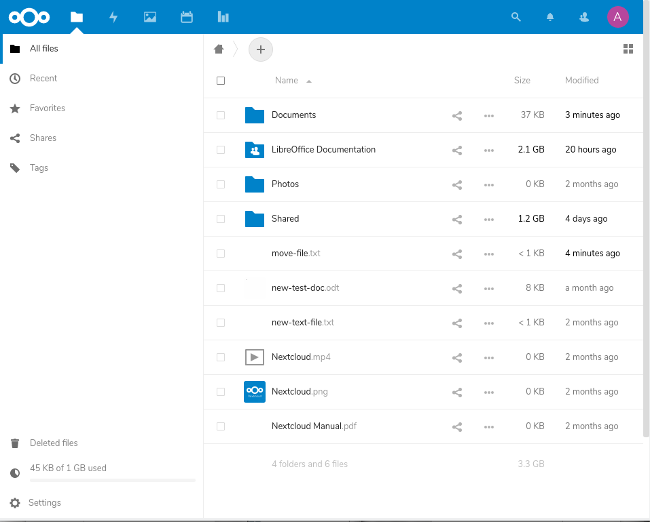Figure 1: example of a cloud service files screen

The Cloud Service Toolbar
Often the top toolbar of the cloud service is common throughout its applications, and allows users to switch between them. The icons on the left represent these applications enabled in the system, which in the above screenshot are as follows:
- Home, which takes the user back to the default screen (in this case, Files).
- Files, which as mentioned shows the files stored in the user’s account.
- Gallery, which presents a browsable view of media files in the user’s account.
- Calendar, for keeping appointments and tasks.
- Polls, where users can set up questionnaires for other users to vote on.
The right side of the Toolbar contains items related to the user’s account, including:
- Notifications, where the system will show alerts.
- Contacts, which allows users to search for or message other members of the cloud instance.
- Account, which is a sub-menu allows users to update their profile and other settings, see system info (i.e. About), get help, or log out.
- Note
The actual list of cloud applications depends on the server installation.

The Files Sidebar
The left-hand Sidebar is, in contrast, specific to the Files application. It contains several items at the top, as follows:
- All files
- Recent
- Favorites
- Shares
- Tags
The bottom entries of the Sidebar include the following:
- Deleted files
- Space Usage
- Settings

The Files List
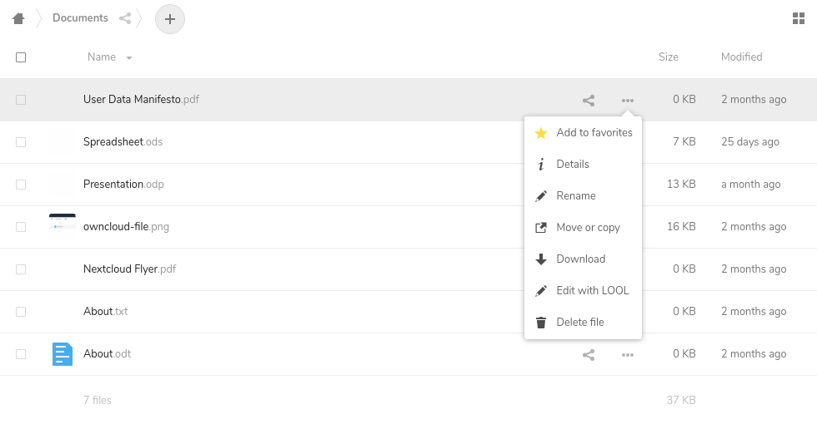Figure 2: cloud files list
The main area of the screen displays a list of files and folders in your account. As you’d expect from working with desktop file managers, clicking on a folder allows you to enter it and view its contents. Your location is shown in the upper-left corner of the pane in “breadcrumb” style, starting with an icon that will return you to your Home (or the root of your account’s file storage).
To the right of the breadcrumbs is a + button. Clicking this will give you the option to create a new file in the current directory. You can switch the view of the files list from the default, a details list, to one that displays thumbnails, by clicking the button at the top-right of the list screen.
The left-most column in the list displays checkboxes which allow you to select multiple files. You’re able to drag-and-drop these to move them around your account. Clicking on a file name will do one of two things:
- If the file’s type has a supported viewer/app in cloud, it will be opened. For example, .PNG files will open in an image previewer, while plain text files open in a pop-up text editor.
- If the file’s type doesn’t have a supported app, the file will begin downloading to your local machine.
Next to the file’s name is a Share button. Clicking on this button will open the file’s Details pane to the Share tab. Here you can share the file with others by entering either the usernames of other users in the hosting application, or email addresses of external people.
The overflow menu to the right of the Sharing button has options to allow you to:
- Add the files to your Favorites list of files.
- View the Details of the file, which will open a Details pane to the containing tabs showing the files Activity (e.g. changes made), any Comments users have made on the file, and the aforementioned Sharing tab.
- Rename the file.
- Move or copy the file.
- Download the file.
- Delete the file.
Finally, the last columns in the list show the Size and Modified date of the file. You can sort the list of files by these two values (along with Name).
- Note: File Navigation in Other Applications
The screens for other supported cloud services application may look different. However, the basic concepts should be similar.

Managing Your LibreOffice Files in the Cloud
With the above in mind, there are five main tasks involved in managing your LOOL files in the cloud service application.

Creating a New LOOL File in the Cloud
To create a brand new LOOL file (either document, spreadsheet, or presentation) in cloud, click the + button at the top of the files list. Then, select your desired file, and provide it a name when prompted.
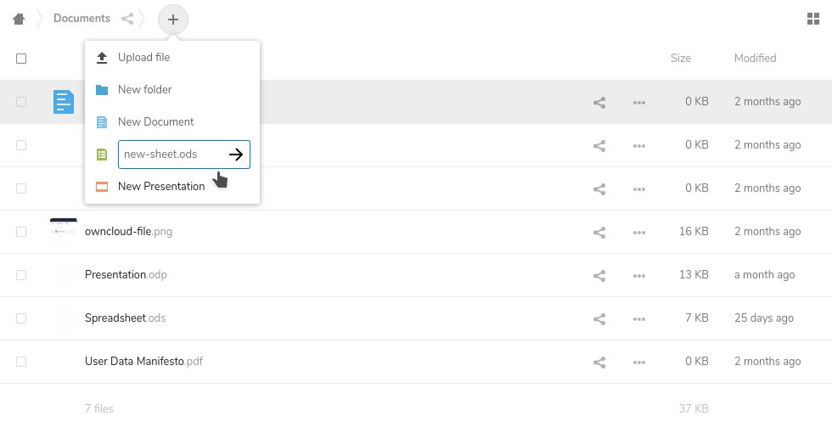
Figure 3: creating a new .ODS File in the cloud

Adding an Existing LOOL File in the Cloud
Click the + button and select Upload file to choose a file from your local computer to send to the cloud. Make sure the one you upload is a supported file type.

Editing an LOOL File in the Cloud
To edit one of your files, simply click it. Provided LOOL in installed correctly, the cloud service will open your desired file in the appropriate LOOL application (Documents, Spreadsheets, or Presentations). See Chapter 5, Editing, Saving, and Exporting Your LibreOffice Online Files for more details on how this operates.

Moving an LOOL File in the Cloud
Drag-and-drop folders and/or files into folders in the list or in the breadcrumbs to move them. If you wish to copy them instead, use the overflow menu’s Move or copy option on your selected item(s), and make sure to click the Copy button in the dialog that appears.
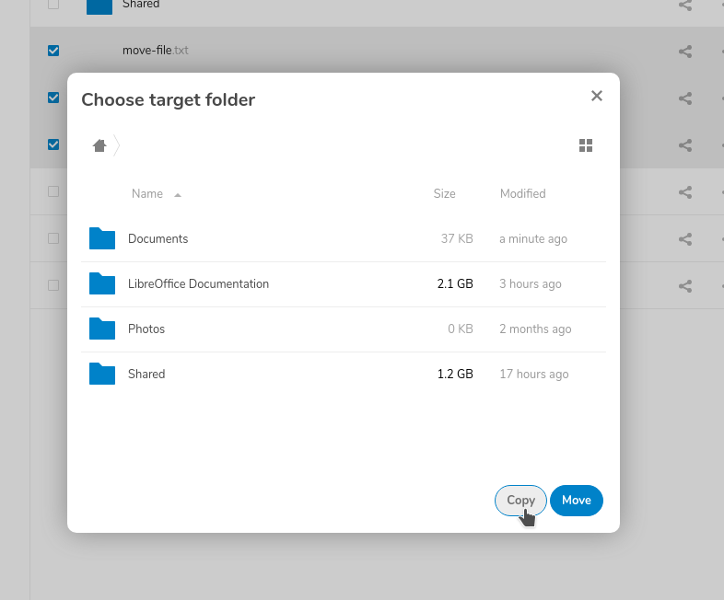Figure 4: moving and copying files in the cloud pops a dialog

Deleting an LOOL File in the Cloud
To remove a file from your list, click the overflow menu, then select the Delete file option it provides. Bear in mind that your deleted files will still be available in the Deleted Files signified by the trash bin in the lower-right corner of the screen.

