
LibreOffice Online 6.3 Guide

Chapter 5
Multi-Editing, Sharing, Exporting and Printing Documents

Copyright
This document is Copyright © 2019 by the LibreOffice Documentation Team. Contributors are listed below. You may distribute it and/or modify it under the terms of either the GNU General Public License (http://www.gnu.org/licenses/gpl.html), version 3 or later, or the Creative Commons Attribution License (http://creativecommons.org/licenses/by/4.0/), version 4.0 or later.
All trademarks within this guide belong to their legitimate owners.

Contributors
This book, for version 6.3 of LibreOffice Online, was written new as part of the 2019 Google Season of Docs.

To this edition
Aaron Peters

To previous editions

Feedback
Please direct any comments or suggestions about this document to the Documentation Team’s mailing list: documentation@global.libreoffice.org
- Note:
Everything you send to a mailing list, including your email address and any other personal information that is written in the message, is publicly archived and cannot be deleted.

Publication date and software version
Published February 2020. Based on LibreOffice 6.3.
Contents
Copyright 2
Contributors 2
To this edition 2
To previous editions 2
Feedback 2
Publication date and software version 2
LibreOffice Online Document Files 4
Sharing Files in LibreOffice Online 4
Multi-User Editing in LibreOffice Online 6
Exporting Your LibreOffice Online Files 7
Printing from LibreOffice Online 8

LibreOffice Online Document Files
Once you open a file from the hosting application, it will open in the appropriate LOOL application. The specifics of editing these files in each application will be presented in more detail in following chapters. However, there are some aspects of working in LibreOffice Online that are the same across the apps.

Sharing Files in LibreOffice Online
When you receive an account in LibreOffice Online, it will include a personal area for your to store your files, i.e. your “home.” But since LOOL is a multi-user application, it’s much more valuable if you can collaborate on the documents you store here. If there’s a file in your account you’d like to work on together with a colleague, you can Share that file and grant that person access to it.
There are two ways to Share a file with a colleague, although all of them have the same affect.
- You can also use the hosting application’s controls for sharing. For example, in the cloud there’s a Share button included in directory listings, as well as one in the hosting application’s top menu when a file is open for editing.
- In addition, when a file is open you can use the application’s File > Share menu item.
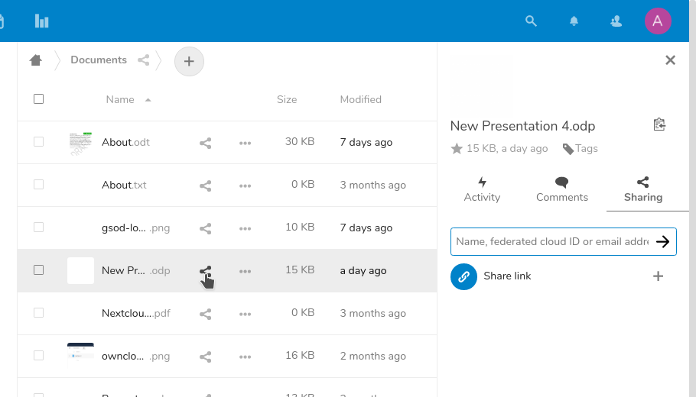Figure 1: selecting the share button in the cloud's files listing
Any of these methods will display the Sharing pane, which will prompt you to enter a name, ID, or email address for the desired user. As you type, LOOL will begin searching the directories to which it has access and display any matching names.
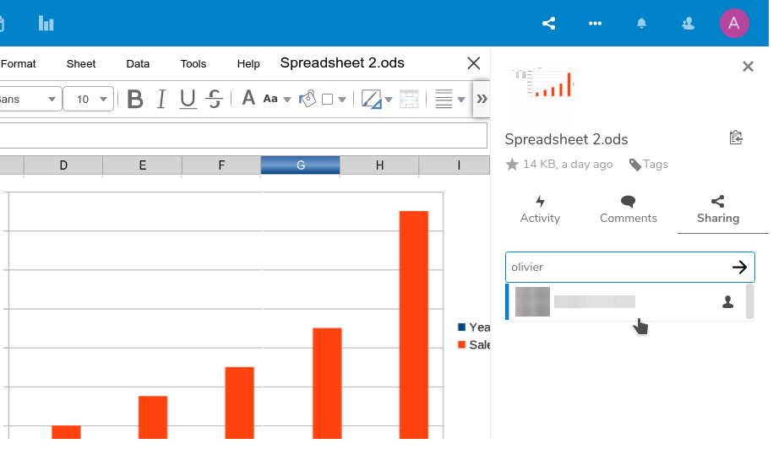Figure 2: Displaying matching users in the Share Tab
Clicking on the user’s name will add him/her to the document. By default, new collaborators are granted the following permissions:
- Can edit
- Can re-share
- Set expiration date
You’ll also have the ability to leave a Note to recipient, or remove the user by selecting Unshare.
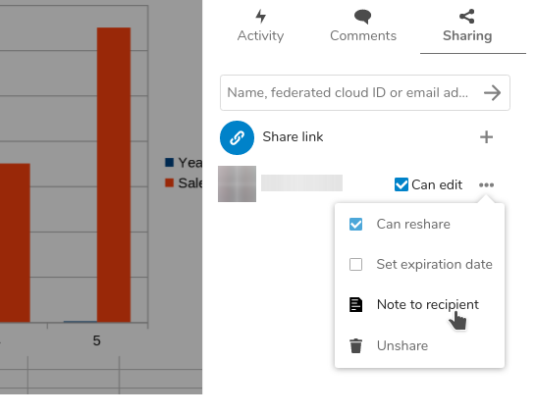Figure 3: User permissions for shared documents

Multi-User Editing in LibreOffice Online
In addition to merely editing files by yourself, LOOL gives you the ability to collaborate with others on files in real time. When you and a colleague open the same file together on different computers, you’re able to edit the file simultaneously. This multi-user editing is unique to LOOL as an online application and isn’t available in the desktop software.
You don’t need to do anything special to start editing files in a multi-user context. When the user B opens the file in question, the user A will notice another cursor appear. If user A hovers over that cursor with their own cursor, the name of user B will appear at the top.

Multi-editing text documents
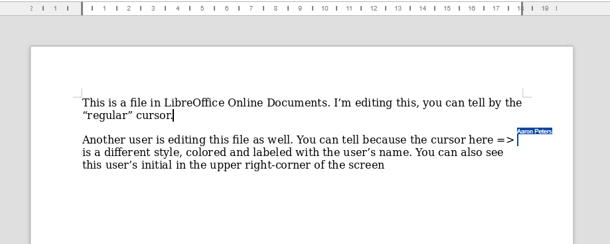
Figure 4: Two users editing the same file in the Documents Module

Multi-editing Spreadsheets
Figure 5: Two users editing the same file in the Spreadsheets Module

Multi-editing presentations
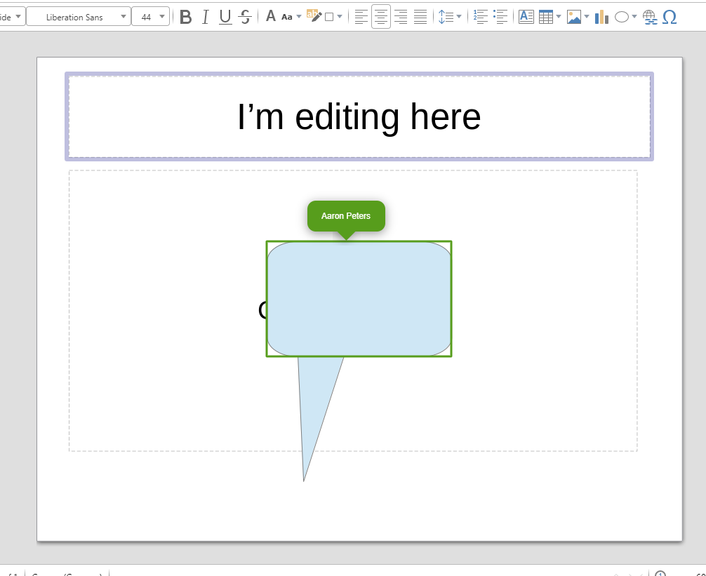Figure 6: Two users editing the same file in the Presentations Module
When in multi-editing mode, there are a few important things to bear in mind.
- Multi-editing only works when all users are using LibreOffice Online. In fact, it’s not advisable for any users to be working on files in the desktop software while users are making changes in LOOL. This is because the content in LibreOffice proper will reflect it’s state when the file was first opened, and it’s possible that LOOL users have made changes since then. Then, when the desktop user saves the file, it may contain outdated content that will be written back to the file along with any other changes made.
- If both users are permitted to edit the file (i.e. no one is restricted to “read-only”), then it’s entirely possible for them to overwrite each other’s changes.
- You’ll need to continue to save the file in the normal way… and one user saving the file will also save the other user’s edits.
But if you’re heedful of these caveats, LOOL provides a very convenient way for a group of collaborators to quickly and easily make changes to documents without the hassle of moving or emailing files back and forth.

Exporting Your LibreOffice Online Files
The File menu in applications also contains the option to export the current file into a variety of formats, dependent on the application:
- You can export files open in the Documents module to .PDF, .ODT, .DOC, .DOCX, or .RTF formats.
- You can export files open in the Spreadsheets module to .PDF, .ODS, .XLS, or .XLSX formats.
- You can export files open in the Presentations module to .PDF, .ODP, .PPT, or .PPTX formats.
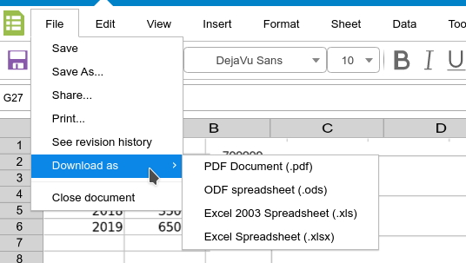Figure 7: Download as options in the Spreadsheets module
- Note: Revising exported files
Note that once you export a file in a particular format, it is separated from its source document in LOOL. You can make revisions to it in other software (including LibreOffice, a competing desktop office suite, or another online application), but these changes will not be reflected in the file in LOOL unless you re-upload it and overwrite the existing file.

Printing from LibreOffice Online
You can print a file from LibreOffice Online using one of two methods:
- You can use LOOL’s built-in printing function, or;
- You can download the file in a suitable format and print it using a desktop application.
If you choose the former, it’s important that you access this function through either the Print button on the main Toolbar, or the File > Print menu item.
- Warning: Using the Browser’s Print Function
If you use the popular Ctrl-p keystroke to print a particular document, it’s possible you’ll actually invoke your browser’s print function. The purpose of this function is to print the entire web page, which as it pertains to LOOL includes not only your document’s content, but also elements like menus and headers. Your Print Preview should tell you whether you’ve accidentally printed this way so you can cancel the operation.

