
LibreOffice Online 6.3 Guide

Chapter 7
The Spreadsheets Module

Copyright
This document is Copyright © 2019 by the LibreOffice Documentation Team. Contributors are listed below. You may distribute it and/or modify it under the terms of either the GNU General Public License (http://www.gnu.org/licenses/gpl.html), version 3 or later, or the Creative Commons Attribution License (http://creativecommons.org/licenses/by/4.0/), version 4.0 or later.
All trademarks within this guide belong to their legitimate owners.

Contributors
This book, for version 6.3 of LibreOffice Online, was written new as part of the 2019 Google Season of Docs.

To this edition
Aaron Peters

To previous editions

Feedback
Please direct any comments or suggestions about this document to the Documentation Team’s mailing list: documentation@global.libreoffice.org
- Note:
Everything you send to a mailing list, including your email address and any other personal information that is written in the message, is publicly archived and cannot be deleted.

Publication date and software version
Published February 2020. Based on LibreOffice 6.3.
Contents
Copyright 2
Contributors 2
To this edition 2
To previous editions 2
Feedback 2
Publication date and software version 2
What is the Spreadsheets Module Used For? 4
The Spreadsheet Module Interface 4
Toolbar 4
Formula Bar 5
Sheet navigation/Sheet Tabs 6
Spreadsheets Status Bar 7
Navigating in the Spreadsheets Module 7
Cell navigation 7
Keyboard navigation 8
Adjusting the View of the Spreadsheet 9
Working with Sheets and Cells 10
Individual cells 10
Sheet tabs 10
Basic Formulas 10
Updating Formula Results 11
Copying/Pasting Formulas 11
Sorting and Filtering Data 12
Sorting Data 12
Formatting Cells 12
Direct Formatting 12
Conditional Formatting 13
Types of conditional formatting 13
Conditional formatting management 13
Functions and Advanced Formulas 14
Page Formatting and Printing 14
Adding Charts and Drawings to Spreadsheets 15
Adding Charts 15
Inserting Graphics 16

What is the Spreadsheets Module Used For?
The Spreadsheets module in LOOL allows you enter data (usually numerical) and then manipulate this data to produce certain results. This includes changing the data in a “What if...” manner and observing the results.
Other features provided by the Spreadsheets module include:
- Functions, which can be used to create formulas to perform complex calculations on data.
- Database functions, to arrange, store, and filter data.
- Dynamic charts; a wide range of 2D and 3D charts.

The Spreadsheet Module Interface
The Spreadsheets window has five main sections: the Toolbar at the top, the Formula Bar just beneath it, the main Workspace grid, the Sheet Tabs beneath the main spreadsheet table, and the Status Bar at the very bottom.

Toolbar
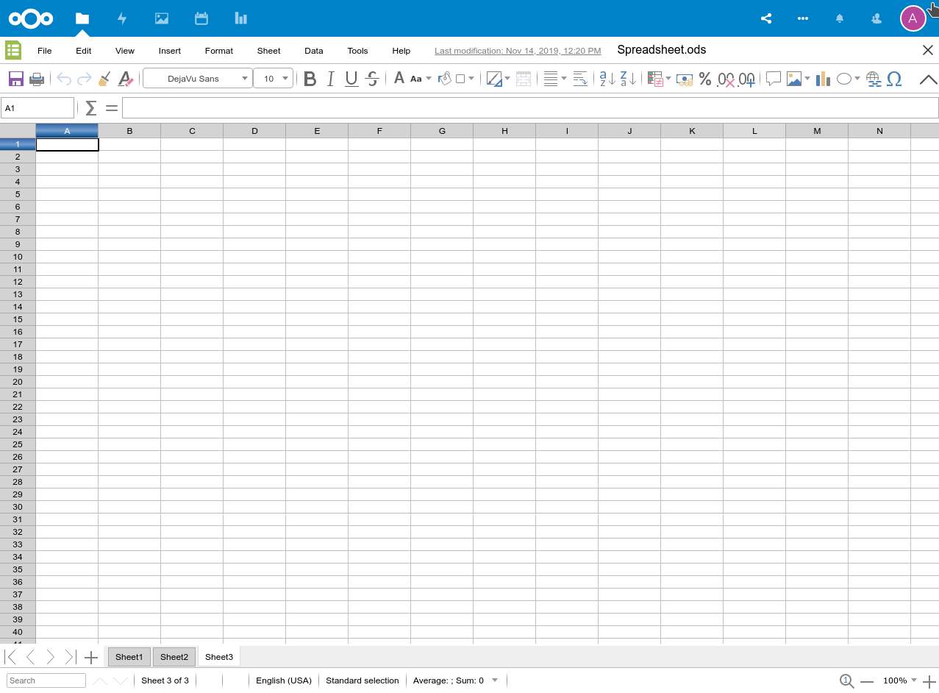Figure 1: the spreadsheets module window
The Spreadsheets Toolbar contains the following entries:
File:
Contains commands that apply to the entire document; for example, Save/Save As, Share, Print, See Revision History, and the Download as sub-menu.
Edit:
Contains commands for editing the document; for example, Undo/Redo, Copy, Paste, Select All, and Find and Replace.
View:
Contains a command to view Spreadsheets in Full Screen.
Insert:
Contains commands for inserting elements into a spreadsheet; for example, Images (Local or within the hosting application), Special Characters, Charts, Comments, Hyperlinks, and Headers and Footers.
Format:
Contains commands for modifying the layout of a spreadsheet; for example, Cell styling, Page styling, and Conditional Formatting (in addition to the option to Clear Direct Formatting).
Sheet:
Contains the most often used commands for handling sheets, such as Insert and Delete Columns, Rows and Page Breaks, in addition to deleting these same items.
Data:
Contains commands for manipulating data in the spreadsheet; for example, Sort, Filters, and Groups and Outlines.
Tools:
Contains various functions to help you check and customize the spreadsheet; for example, Spelling, Language, and Goal Seek.
Help:
Contains a list of the LibreOffice Online Keyboard Shortcuts and information About the application, such as version number.

Formula Bar
The Formula Bar (Figure 2) is located at the top of the sheet in the Calc workspace. The Formula Bar is permanently docked in this position and cannot be used as a floating toolbar. If the Formula Bar is not visible, go to View on the Menu bar and select Formula Bar.
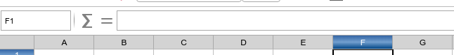Figure 2: the spreadsheets module formula bar
From left to right, the Formula Bar consists of the following:
Name Box:
This gives the current active cell reference using a combination of a letter and number, for example A1. The letter indicates the column and the number indicates the row of the selected cell. If you have selected a range of cells that is also a named range, the name of the range is shown in this box. You can also type a cell reference in the Name Box to jump to the referenced cell. If you type the name of a named range and press the Enter key, the named range is selected and displayed.
Sum:
Clicking on the Sum icon totals the numbers in the cells above the selected cell and then places the total in the selected cell. If there are no numbers above the selected cell, then the cells to the left are totaled. When the Sum icon is used, Calc suggest the range to sum with a colored box, but does not insert the formula. You need to confirm the suggested range by typing Enter, or reject pressing Esc. You can also adjust the range with the mouse by dragging the colored box or its edges to adjust the range.
Function:
Clicking on the Function icon inserts an equals (=) sign into the selected cell and the Input line, allowing a formula to be entered. When in this mode, the Sum button above will change to a Cancel button with red “x” clear the formula entry, and this Function button will change to an Accept button with a check mark to accept it.
Input line:
Displays the contents of the selected cell (data, formula, or function) and allows you to edit the cell contents.
You can also edit the contents of a cell directly in the cell itself by double-clicking on the cell.
- Note
In a spreadsheet the term “function” covers much more than just mathematical functions. See the Calc Guide Chapter 7 Using Formulas and Functions for more information.

Sheet navigation/Sheet Tabs
Each sheet in a spreadsheet is independent of the other sheets, though references can be linked from one sheet to another. There are three ways to navigate between sheets in a spreadsheet:
- Using the keyboard: Use key combinations Ctrl+Page Down to move one sheet to the right and Ctrl+Page Up to move one sheet to the left.
- Using the mouse: Click on one of the sheet tabs at the bottom of the spreadsheet to select that sheet.
- Using the pager buttons: There are four buttons to the left of the Sheet Tabs that can move the tabs into view (Figure 5).
- The left-most button moves you to the first Sheet in the spreadsheet.
- The second button moves you one Sheet back in the spreadsheet.
- The third button moves you one Sheet forward in the spreadsheet.
- The fourth button moves you to the last Sheet forward in the spreadsheet.
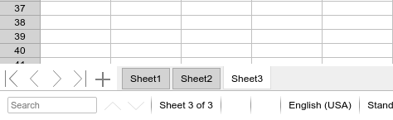Figure 3: the spreadsheet module's sheet tabs
- Note
When you insert a new sheet into a spreadsheet, Spreadsheets automatically uses the next number in the numeric sequence as a name. Depending on which sheet is open when you insert a new sheet, and the insertion method you use, the new sheet may not be in its correct numerical position. It is recommended to rename sheets in a spreadsheet to make them more recognizable.

Spreadsheets Status Bar
Search
The lower-left corner has a search box. Typing a search term will highlight its first occurrence, and provide a count of any additional occurrences.
To jump to a specific page in the document, double-click on this field. The Navigator opens. Click in the Page Number field and type the sequence number of the required page and press Enter.
Sheet location and count
The total number of Sheets, as well as the current active Sheet shown in the Status Bar and kept up to date as you edit.
Selection count
When cells are selected, the column and row counts for the selection will appear here.
Language
Shows the language at the cursor position, or for the selected text, that is used for checking spelling and grammar as well as for hyphenation and thesaurus dictionaries.
Click to open a menu where you can choose another language for the selected text or for the paragraph where the cursor is located. You can also choose None (Do not check spelling) to exclude the text from a spelling check or choose More to open the Character dialog. Any directly formatted language settings can be reset to the default language from this menu.
Selection mode
In the future you’ll click to choose different selection modes here. But these are not yet supported as of the current version of LOOL (6.3).
Zoom
To change the view magnification click on the + and – signs, or right-click on the zoom level percent to pop up a list of magnification values from which to choose. You can reset the zoom level with the left-most button (the magnifying glass).

Navigating in the Spreadsheets Module

Cell navigation
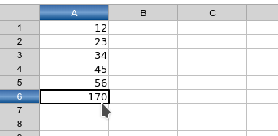
Figure 4: A selected cell in the Spreadsheets Module
When a cell is selected or in focus, the cell borders are emphasized. When a group of cells is selected, the cell area is colored. The color of the cell border emphasis and the color of a group of selected cells depends on the operating system being used and how you have set up LibreOffice.
Using the mouse:
Place the mouse pointer over the cell and click the left mouse button. To move the focus to another cell using the mouse, simply move the mouse pointer to the cell where you want the focus to be and click the left mouse button.
Using a cell reference:
Highlight or delete the existing cell reference in the Name Box on the Formula Bar. Type the new cell reference of the cell you want to move to and press Enter key. Cell references are case-insensitive: for example, typing either a3 or A3 will move the focus to cell A3.
Using the Enter key:
Pressing Enter moves the cell focus down in a column to the next row. Pressing Shift+Enter moves the focus up in a column to the previous row.
Using the Tab key:
Pressing Tab moves the cell focus right in a row to the next column. Pressing Shift+Tab moves the focus to the left in a row to the previous column.
Using the arrow keys:
Pressing￹￹ the arrow keys on the keyboard moves the cell focus in the direction of the arrow pressed.
Using Home, End, Page Up and Page Down
- Home moves the cell focus to the start of a row.
- End moves the cell focus to the last cell on the right in the row in the right-most column that contains data.
- Page Down moves the cell focus down one complete screen display.
- Page Up moves the cell focus up one complete screen display.

Keyboard navigation
To navigate a spreadsheet using the keyboard, pressing a key or a combination of keys. For a key combination, press more than one key at the same time. The table below lists the keys and key combinations you can use for spreadsheet navigation in Calc.
Table 1. Keyboard cell navigation
Keyboard shortcut | Cell navigation
→ | Moves cell focus right one cell.
← | Moves cell focus left one cell.
↑ | Moves cell focus up one cell.
↓ | Moves cell focus down one cell
Ctrl+→ | Moves cell focus to the first column on the right containing data in that row if cell focus is on a blank cell.  Moves cell focus to the last column on the right in the same range of occupied cells in that row if cell focus is on a cell containing data.  Moves cell focus to the last column on the right in the spreadsheet if there are no more cells containing data.
Ctrl+← | Moves cell focus to the last column on the left containing data in that row if cell focus is on a blank cell.  Moves cell focus to the first column on the left in the same range of occupied cells in that row if cell focus is on a cell containing data.  Moves cell focus to the first column in that row if there are no more cells containing data.
Ctrl+↑ | Moves cell focus from a blank cell to the first cell above containing data in the same column.  Moves cell focus to the first row in the same range of occupied cells if cell focus is on a cell containing data.  Moves cell focus from the last cell containing data to the cell in the same column in the first row of the spreadsheet.
Ctrl+↓ | Moves cell focus from a blank cell to the first cell below containing data in the same column.  Moves cell focus to the last row in the same range of occupied cells in that column if cell focus is on a cell containing data.  Moves cell focus from the last cell containing data to the cell in the same column in the last row of the spreadsheet.
Ctrl+Home | Moves cell focus from anywhere on the spreadsheet to Cell A1 on the same sheet.
Ctrl+End | Moves cell focus from anywhere on the spreadsheet to the last cell in the lower right-hand corner of the rectangular area of cells containing data on the same sheet.
Alt+Page Down | Moves cell focus one screen to the right (if possible).
Alt+Page Up | Moves cell focus one screen to the left (if possible).
Ctrl+Page Down | Moves cell focus to the cell on the next sheet to the right in sheet tabs where the focus was there before; if the spreadsheet has more than one sheet.
Ctrl+Page Up | Moves cell focus to the cell on the next sheet to the left in sheet tabs where the focus was there before; if the spreadsheet has more than on sheet.
Tab | Moves cell focus to the next cell on the right.
Shift+Tab | Moves cell focus to the next cell on the left.
Enter | Moves cell focus down one cell (unless changed by user). See the next topic.
Shift+Enter | Moves cell focus up one cell (unless changed by user).

Adjusting the View of the Spreadsheet
There are two primary ways to adjust the view within the Spreadsheets module. The first is to use the The second button moves you one Sheet forward in the spreadsheet. View > Full screen menu option.
The second is to use the Zoom controls at the bottom-right of the application window (the right-side of the Status Bar).
- Application Zoom vs. Browser Zoom
In many applications, the Ctrl-+ and Ctrl-- keystrokes will zoom the application in and out, respectively. However, since LibreOffice Online is a web application, using these keystrokes will adjust the browser’s zoom level, not LOOL’s. While the affect may be similar, it can also cause inconsistent behavior. For a more consistent experience, consider using just the commands described above.

Working with Sheets and Cells

Individual cells
The main section of the workspace in the Spreadsheets Module displays the cells in the form of a grid. Each cell is formed by the intersection of one column and one row in the spreadsheet.
At the top of the columns and the left end of the rows are a series of header boxes containing letters and numbers. The column headers use an alpha character starting at A and go on to the right. The row headers use a numerical character starting at 1 and go down.
These column and row headers form the cell references that appear in the Name Box on the Formula Bar. If the headers are not visible on the spreadsheet, go to View on the Menu bar and select Column & Row Headers.

Sheet tabs
In Calc, you can have more than one sheet in a spreadsheet. At the bottom of the grid of cells in a spreadsheet are Sheet Tabs indicating how many sheets there are in the spreadsheet. Clicking on a tab enables access to each individual sheet and displays that sheet. An active sheet is indicated with a white tab.
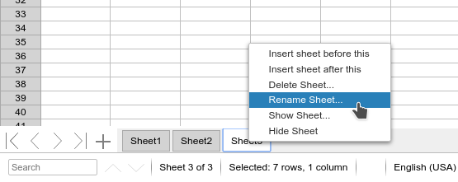Figure 5: sheet tab controls in the spreadsheets module
Right-clicking on the tab gives you a number of options, as follows:
- Insert sheet before this
- Insert sheet after this
- Delete Sheet
- Rename Sheet
- Show Sheet
- Hide Sheet
When selecting Hide Sheet, the tab representing the sheet will disappear. However the sheet, and all the data it contains, still exists. You can select Show Sheet and select the desired sheet to make it appear among the tabs again.

Basic Formulas
In addition to entering data values into cells, you can also enter formulas that perform calculations for you. For example, to add the contents of cells A1 and A2, you’d take the following steps:
- Place the cursor in another cell, e.g. A3.
- In the Formula Bar, type the following: “=A1+A2”
Beginning a cell’s contents with the equals sign signifies it’s a formula. The remainder of content can contain standard mathematical operators, including:
- Addition (+), subtraction (-), multiplication (*), division (/), and exponents (^)
- Nested statements (i.e. calculations within parentheses) with regular order of operations
The values in a basic formula can be a mix of values and cell references. For example, all of the following are valid cell entries:
- =A3+A4+5
- =(C7-2)*4
- =(A14*(4*D12))^2
When you’ve finished entering your formula value into the cell, press Enter, or click into another cell. The formula will be updated with its calculated value (or an error, if there’s something wrong). However, when you click back into the cell, you’ll notice the formula (not the value) displayed in the Formula Bar, where you can adjust it as needed.

Updating Formula Results
When you use cell references within your formulas, you gain the benefit of updating your results automatically when the cell changes. For example:
- Enter the value “12” in cell A1.
- Enter the value “15” in cell A2.
- Enter the formula “=A1+A2” in cell A3. This will give you a result of 27.
- Change the value of A1 to “15.” You’ll see the value in A3 update automatically to “30.”
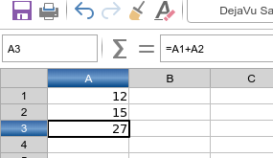Figure 6: the formula bar with cell displaying results

Copying/Pasting Formulas
When copying and pasting direct cell values in Spreadsheets, the value pasted is the same as the value copied. However, formulas get modified to match their destination.
For example, if you copy the three cells you entered above and pasted them into Column B, the formula in cell B3 would be “=B1+B2.” Why is this? The intent of this cell is to add the two values above it. So when you paste it into Column B, Spreadsheets saves you the work of having to change the Column references to “B” in this formula.
This is done relative to the source as well. For example, if you had a formula in Cell C3 that contained “=A1/A2,” then if you copied and pasted it to Cell D3 it would contain “=B1/B2.” As the destination is moving one column over, so too will the source data be taken from one column over as well.

Sorting and Filtering Data
One of the main uses of spreadsheets is to take large quantities of data and put them in order (alphabetical or numerical), or to filter out undesired values.

Sorting Data
Several criteria can be used and a sort applies each criteria consecutively. Sorts are useful when you are searching for a particular item and become even more useful after you have filtered data.
Also, sorting is useful when you add new information to your spreadsheet. When a spreadsheet is long, it is usually easier to add new information at the bottom of the sheet, rather than adding rows in their correct place. After you have added information, you then carry out a sort to update the spreadsheet.

Formatting Cells
There are two different ways of formatting cells in LOOL Spreadsheets. You can either format them directly by applying fonts, background colors, etc. Or, you can make their formatting dependent on their contents.
- Note: Cell Styles in LibreOffice Online
While LOOL itself doesn’t yet support using Cell Styles, the ones contained in .ODS files you upload will remain intact.

Direct Formatting
You can quickly apply styling changes such as the following by using the buttons on the Toolbar
- Font face/size
- Bold/italics/underline/strikethrough text
- Font color
- Background color
- Borders
- Merging cells
- Text alignment
- Text Wrapping
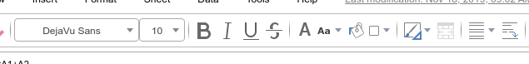
Figure 7: direct formatting buttons on the lool spreadsheets toolbar
You can also select Format > Cells from the Menu. This will display a dialog containing all the relevant options for formatting cells, including not only aesthetic styling but also content:
- Numbers: This tab allows you to format the content of cells, e.g. to format numbers as a percentage or a date and time, or to simply designate everything as plain text.
- Font: Allows you to change the font, size, and language.
- Font Effects: Lets you apply decorations such as over/underlining, strikethrough, outlines, Shadow, and font color.
- Alignment: You can control the horizontal and vertical alignment, orientation, and wrapping properties of text here.
- Borders: Designate borders around and in between cells and set their style, width, color, padding, and shadow on this tab.
- Background: You can set a cell’s background to be a color from the standard palette, or a custom color in RGB format.
- Cell Protection: This tab lets you protect (hide) cells and formulae from display and/or printing.

Conditional Formatting
You can set up cell formats to change depending on conditions that you specify. Conditional formatting is used to highlight data that is outside the specifications that you have set. It is recommended not to overuse conditional formatting as this could reduce the impact of data that falls outside the specifications that you have set.
- Note: Conditional Formatting and Autocalculate
Conditional formatting depends upon the use of styles and the AutoCalculate feature must be enabled. If you are not familiar with styles, see Chapter 4 Using Styles and Templates in the Calc Guide for more information.

Types of conditional formatting
Condition
Condition is the starting point when using conditional formatting. Here you can define what formats to use to highlight any data in your spreadsheet that falls outside the specifications that you have defined.
Color scale
Use Color scale to set the background color of cells depending on the value of the data in a spreadsheet cell. Color scale can only be used when All Cells has been selected for the condition. You can use either two or three colors for your color scale.
Data bars
Data bars provide a graphical representation of data in your spreadsheet. The graphical representation is based on the values of data in a selected range. Click on More Options in the Conditional Formatting dialog to define how your data bars will look. Data bars can only be used when All Cells has been selected for the condition.
Icon sets
Icon sets display an icon next to your data in each selected cell to give a visual representation of where the cell data falls within the defined range that you set. The icons sets available are colored arrows, gray arrows, colored flags, colored signs, symbols, bar ratings and quarters. Icon sets can only be accessed when the Conditional Formatting dialog has been opened and All Cells has been selected for the condition.

Conditional formatting management
You can manage the conditional formatting rules and styles by selecting Formatting > Conditional Formatting > Manage from the Menu. This displays a dialog containing all the rulesets you’ve made, and provides the ability to edit or delete them.

Functions and Advanced Formulas
The simple arithmetic described in the earlier section is only the start of what the Spreadsheets module can do. Much of the power of Spreadsheets is in its Functions, which you can use to build very advanced Formulas.
The basic format of a Function is: FUNCTION(PARAMETER1,PARAMETER2). Here “FUNCTION” is the name of the function, which is usually a short-hand notation for what it does. Within the parentheses are PARAMETERS. Which ones are required, their format, their order, any optional parameters, etc. is specific to the function. A full list of functions supported in LibreOffice Calc can be found in Chapter 17 of the Calc Guide.
- Note: LibreOffice Online Function Support
As LOOL is a newer application than LibreOffice Calc, there may be some functions that are supported in the desktop software that aren’t (yet) supported in the online version.

Page Formatting and Printing
As with cell contents the layout for pages in Spreadsheets doesn’t yet have full support for the same Style mechanisms as LibreOffice proper. However, you can adjust the format of your files in Spreadsheets by using direct formatting.
Selecting the Format > Page option from the Menu will display a dialog with all the relevant options for formatting pages, including:
Organizer:
This shows you the name of the Style in use at the moment. Note, however, that controls related to this style, i.e. Inherit From, Category, and Edit Style aren’t enabled.
Page:
This tab allows you to adjust the Paper Format (size and orientation), Margins on all sides, the printer’s Paper Tray, Page Layout (e.g. left and right pages, or mirrored layout), Page Numbers, and Table Alignment (i.e. how the table of cells is aligned on the page.
Borders:
Designate borders around the outline of the page and set their style, width, color, padding, and shadow on this tab.
Background:
You can set a cell’s background to be a color from the standard palette, or a custom color in RGB format. You can also select an image to serve as the background.
Header:
Set the options for Headers on this page, including whether they appear and where (e.g. left pages, right pages, or both), their margins, spacing, height, and content.
Footer:
As above, but for pages’ footers.
Sheet:
Here you can set options for Page Order (i.e. if a sheet is larger than one printed page will allow, if it prints top to bottom or left to right first), as well as Print options such as displaying column/row headers, comments, charts and other objects, or formulae.
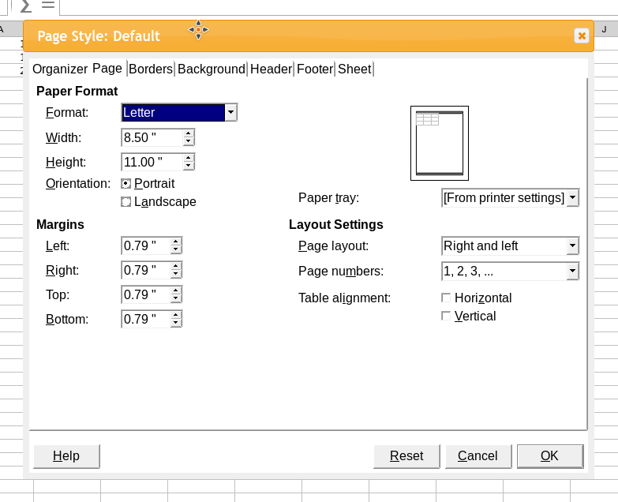Figure 8: the page formatting dialog in spreadsheets

Adding Charts and Drawings to Spreadsheets
You can create engaging charts from the data within Spreadsheets, and in addition you can add graphics and other visual aids.

Adding Charts
Charts are built off data in the Spreadsheet, so the first step in inserting a Chart is selecting that data. If you’re selecting data that has column and row headers, you can include them in the selection. Then, select Insert > Chart from the main Menu. The Chart Wizard will walk you through the following steps of the process:
- Chart Type: You can pick the type of Chart you want on this step, such as Column, Pie, Line, or XY (Scatter).
- Data Range: If you’ve already selected data prior to launching the Wizard, it should be preselected here. Otherwise you’ll be returned to the cell grid where you can select a range, or simply type the range into the Data Range box. You can also indicate whether your selected data has labels, and define the series (i.e. is the main axis of your data the columns or the rows?) here.
- Data Series: Based on your selection above, you can customize each series.
- Chart Elements: Select whether you want auto-generated items like a Title/Subtitle, labels on the X axis/Y axis, grids, and legends here.
- Click Finish to insert your chart.
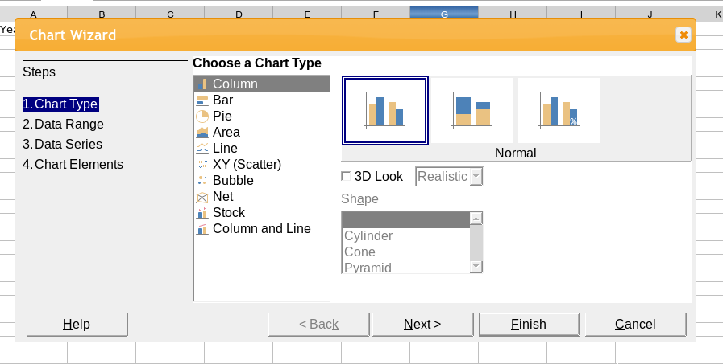Figure 9: the chart wizard in the spreadsheets module

Inserting Graphics
You can insert graphics in a similar way to Charts, and similar to the way described in the Chapter 5, The Documents Module. Select either Insert > Local Image to upload and use an image on your PC, or Insert > Image if the image is already uploaded to the hosting application.
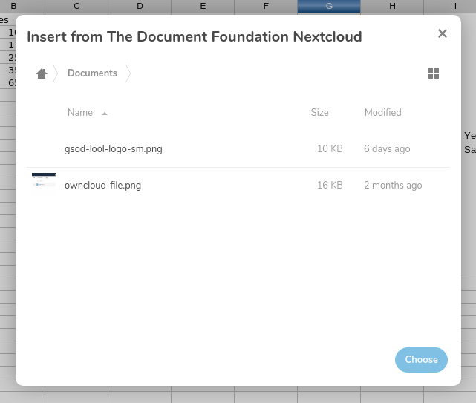Figure 10: inserting an image from the hosting application

