
LibreOffice Online 6.3 Guide

Chapter 9
Integrating LibreOffice Online with Other Applications

Copyright
This document is Copyright © 2019 by the LibreOffice Documentation Team. Contributors are listed below. You may distribute it and/or modify it under the terms of either the GNU General Public License (http://www.gnu.org/licenses/gpl.html), version 3 or later, or the Creative Commons Attribution License (http://creativecommons.org/licenses/by/4.0/), version 4.0 or later.
All trademarks within this guide belong to their legitimate owners.

Contributors
This book, for version 6.3 of LibreOffice Online, was written new as part of the 2019 Google Season of Docs.

To this edition
Aaron Peters

To previous editions

Feedback
Please direct any comments or suggestions about this document to the Documentation Team’s mailing list: documentation@global.libreoffice.org
- Note:
Everything you send to a mailing list, including your email address and any other personal information that is written in the message, is publicly archived and cannot be deleted.

Publication date and software version
Published February 2020. Based on LibreOffice 6.3.
Contents
Copyright 2
Contributors 2
To this edition 2
To previous editions 2
Feedback 2
Publication date and software version 2
Integrating LibreOffice Online with Other Applications 4
Direct LO Access (Remote Open/Remote Save) 4
Configuring a Remote Repository in LibreOffice Desktop 4
Opening/Saving a LOOL Document with LibreOffice 7
WebDAV 8
The Cloud Sync Desktop Applications 9
Installing the Cloud Sync Application 9
Synchronizing Your Files with the Cloud 9
Mobile Applications 10
LibreOffice File Viewer 10
LibreOffice Impress Remote 11
Accessing LOOL in the Mobile Browser 12
Accessing LOOL via WebDAV 12

Integrating LibreOffice Online with Other Applications
LibreOffice Online is designed to provide you a functional office package that’s easy to use through your web browser. However, this isn’t the only way you can interact with your LOOL documents.
The below sections will detail some of the other protocols available to you.
- Warning: Modify Documents Through Multiple Methods
While the below methods provide additional convenience in working with the documents you have stored in LOOL using other tools, some care is required. Some of these will cache or otherwise take the LOOL document’s content “offline,” at least temporarily. If you modify the document using one method without saving it, then modify it using a different method, there is a chance changes will be overwritten. Take care that anyone no one else is editing your documents via WebDAV at the same time you’re editing with LOOL in the browser, for example.

Direct LO Access (Remote Open/Remote Save)
LibreOffice applications have a feature available to set up Remote document repositories, through FTP, WebDAV, and the CMIS open standard services. You can then browse these repositories and open one of the files they contain. We will continue with our use of the cloud as the Remote repository for the below examples.
- Warning: Remote Repositories are the Hosting Applications
When you’re working with Remote repositories, you’re interacting with the hosting application for LibreOffice Online. As described earlier in Chapter 1, Introducing LibreOffice Online, the other applications can use LOOL to display the files they contain, but the files themselves reside in that hosting application. If you’re using an application other than the one described below, the precise way to configure your connection may differ.

Configuring a Remote Repository in LibreOffice Desktop
You can start setting up a Remote repository in LibreOffice by selecting either the Open Remote or Save Remote options from the File menu in LibreOffice.
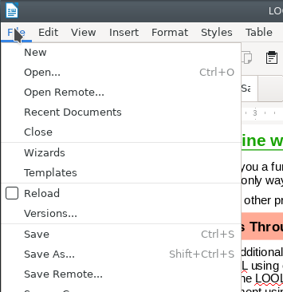Figure 1: open remote and save remote in the LibreOffice Desktop file menu
This will launch the Remote Files dialog. The first time you launch it, the Service drop-down in this dialog will be blank. You can start adding your repositories to LibreOffice by clicking the Add service button, then selecting one of the available options:
- Google Drive
- Alfresco
- IBM FileNet
- IBM Connections Cloud
- Lotus Quickr Domino
- Nuxeo
- OpenDataSpace
- OpenTextELS
- SharePoint
- Other CMIS-compatible systems
- WebDAV
- FTP
- SSH
- Windows File Sharing protocol
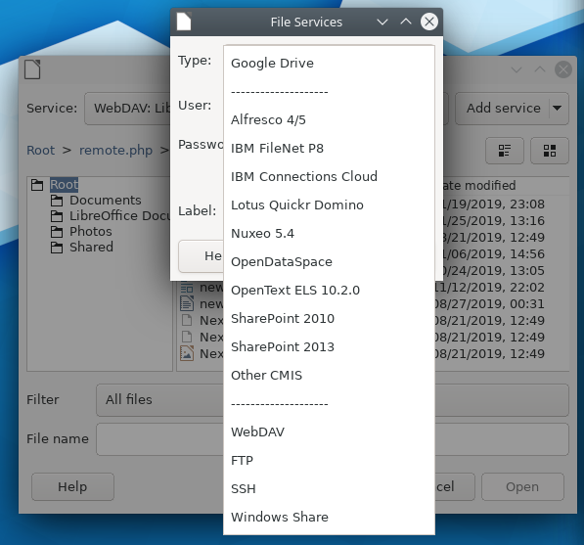Figure 2: File Services options in the Remote Files dialog
You can use use the WebDAV protocol to connect with the cloud. Note that the other services may have different fields to provide or different/additional steps to complete.
- First, enter the hostname of your cloud instance in the Host field. This is typically the URL of the host without any sub-directory information.
- If you'll be connecting to the cloud securely (and you should, unless you're only working inside a private network), mark the Secure connection checkbox. Note: this will change your Port by default to 443.
- You can provide the repository with a name that's easy for you to identify by entering it in the Label field.
- Finally, you'll need to identify the endpoint for your hosting application. For example, with NextCloud or ownCloud it's "www.example.com/remote.php/webdav/." Since you've already provided the hostname, you'll need to enter just the part that comes after that ("/remote.php/webdav/" in this example) into the Root field.
- Click OK to create your repository.
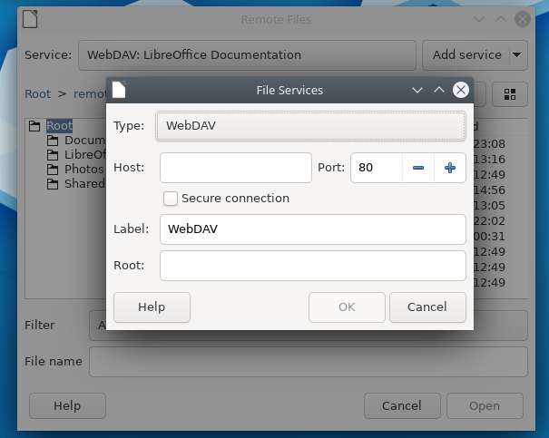Figure 3: Configuring the WebDAV File Service in Remote Files

Opening/Saving a LOOL Document with LibreOffice
Once your repository is created, you can use the File > Open Remote menu item to browse it and select a file to edit. The Remote Files dialog will display a familiar file-and-folders interface when a repository is selected. You can also switch between repositories using the Service drop-down.
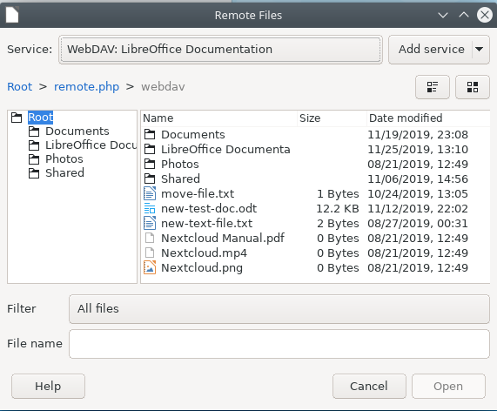Figure 4: The Remote Files Dialog in LibreOffice
If you begin a file in LibreOffice and want to save it in your hosting application, you can use the File > Save Remote in a similar fashion. Note that files you open from a repository will be saved back there as you work by default, unless you use the Save as option from the File menu.

WebDAV
Use an application like your system file manager to access the WebDAV share for the LOOL’s hosting application, and see how to interact with the files there.
In addition to accessing LibreOffice Online files directly, you can set up access to some hosting applications via WebDAV with a file management application.
- Note: File Manager WebDAV Support
You will have to confirm that your preferred file manager includes support for the WebDAV protocol to use the method described in this section. The default file managers for desktop operating systems (Windows, macOS, and Linux with the KDE or GNOME desktop) allow you to set up “servers” or other designations for remote file repositories. Refer to the instructions for your preferred file manager to configure this access.
As is the case when accessing directly from LibreOffice, when you use this method you’re interacting directly with the selected file on the remote server. When you save changes, they are updated immediately and will overwrite the version of the file currently stored in the repository. You should take the same care to avoid conflicts using this method as you do when you use the Remote Files function in LibreOffice.

The Cloud Sync Desktop Applications
You can use the above methods with any hosting applications you happen to select for use with LibreOffice Online. Some of the hosting apps may also have support for unique ways of interacting with files as well, and most cloud services falls into that category. It offers an application that will synchronize files between the server and our local machine. When you make changes to these, the app will push them to the server. Likewise, if changes are detected on the server, the app will copy them down to your local device.

Installing the Cloud Sync Application
You can download the cloud’s application from its website for desktop or mobile OSes and install it in the standard way on your operating system. Installing these applications is outside the scope of this guide, but you can find instructions on the cloud website.

Synchronizing Your Files with the Cloud
Once installed, you can begin syncing files to your local machine by adding a Folder Sync Connection. This is a link between one folder on your local device and your cloud account. Whenever you add, edit, or delete files on one, those changes will be replicated in the other. To add a Folder Sync Connection:
- If you’ve just installed the cloud server, you’ll be prompted to log in to your first server. immediately be prompted to add a connection.
  - If you already have the cloud client installed, you can right-click on the app’s system tray icon and select the Settings option. Then click the Add Folder Sync Connection button.
- Next, you’ll select the files you want to sync, and where you want to store them. You can elect to sync everything in your cloud account, or only specified sub-folders.
- Once you finalize your choices, your local device will begin syncing with the cloud server.
Synchronization means there are copies of the file stored on your device, so you can open and modify them using the LibreOffice desktop suite, or other applications that can read and write OpenDocument Formats. The same caveats that applied to other access methods also apply here as well—take care when modifying files on more than one device using more than one method at the same time.
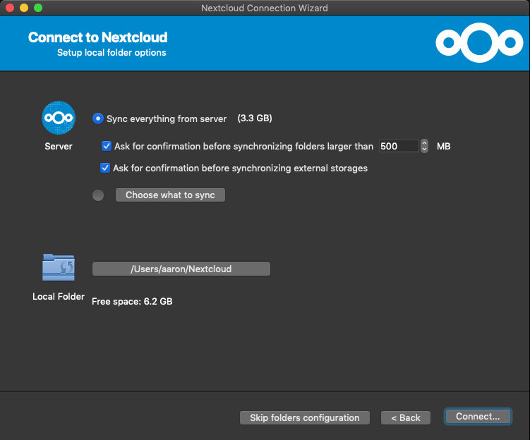Figure 5: configuring a cloud syncing application on macOS

Mobile Applications
Explore different ways users can access LOOL with mobile devices: in mobile browsers, through LibreOffice Viewer, etc.
Of course, chances are you don’t do all your computing on a computer anymore. You can still work with your LibreOffice Online files on a mobile phone, tablet, or other portable device running iOS or Android. However, it will be in a somewhat more limited capacity.

LibreOffice File Viewer
The Document Foundation has made an official LibreOffice Viewer application available in the Google Play store for Android devices. This app will allow you to view OpenDocument Text (.ODT), OpenDocument Spreadsheet (.ODS), and OpenDocument Presentation (.ODP) files on your device.
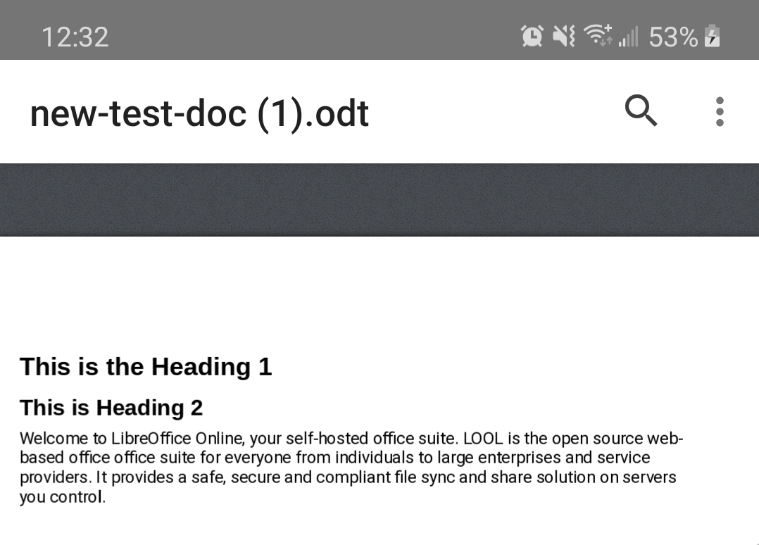Figure 6: The LibreOffice View Application on Android
Note, however, that this is a viewer only. You won’t be able to make any edits using this application.

LibreOffice Impress Remote
Another application developed by TDF is the Impress Remote. This handy app (available for both Android and iOS) is designed to help you during presentations you make with the Impress component of LibreOffice on the desktop. Once you install it and make the connection to your desktop application, you can use Impress Remote to swipe through your slides as well as view any notes you’ve made for yourself on the current page.
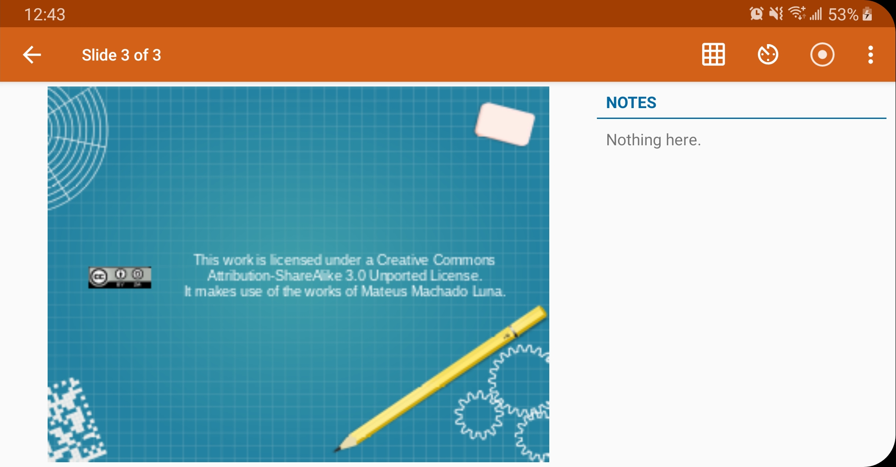Figure 7: The Impress Remote Application on Android

Accessing LOOL in the Mobile Browser
As a web application, you’re entirely able to log into your hosting application using your mobile device’s browser (provided it’s supported) and use the web interface to edit your files. You may find yourself a little limited in terms of screen real estate, but from a functionality perspective everything that works on a PC should also work on a mobile browser.
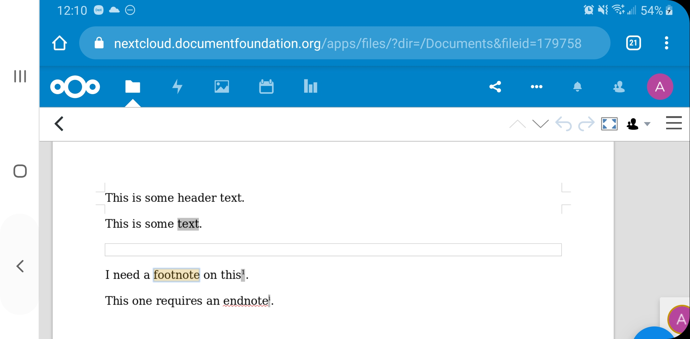
Figure 8: LibreOffice Online in Google Chrome on Android

Accessing LOOL via WebDAV
Finally, there are applications available for both Android and iOS that allow you to browse WebDAV shares. You can use these to interact with your LOOL files in the same way you can with a desktop machine. Setting up these applications is beyond the scope of this guide, but a search in the Apple or Google stores will provide a list of apps that can connect you to a WebDAV server with your mobile device.

