
Getting Started Guide

Chapter 1
Introducing LibreOffice

Copyright
This document is Copyright © 2018 by the LibreOffice Documentation Team. Contributors are listed below. You may distribute it and/or modify it under the terms of either the GNU General Public License (http://www.gnu.org/licenses/gpl.html), version 3 or later, or the Creative Commons Attribution License (http://creativecommons.org/licenses/by/4.0/), version 4.0 or later.
All trademarks within this guide belong to their legitimate owners.

Contributors
This book is adapted and updated from Getting Started with OpenOffice.org 3.3.

To this edition
Paul Figueiredo | Jorge Rodriguez | Amanda Labby
Olivier Hallot | Dave Barton

To previous editions
Thomas Astleitner | Richard Barnes | Agnes Belzunce
Daniel Carrera | Jeremy Cartwright | Laurent Duperval
Ron Faile Jr. | Olivier Hallot | Richard Holt
Ian Laurenson | Alan Madden | Carol Roberts
Iain Roberts | Hazel Russman | Martin Saffron
Gary Schnabl | Peter Schofield | John A Smith
Janet M. Swisher | Jean Hollis Weber | Linda Worthington
Michele Zarri

Feedback
Please direct any comments or suggestions about this document to the Documentation Team’s mailing list: documentation@global.libreoffice.org
- Note
Everything you send to a mailing list, including your email address and any other personal information that is written in the message, is publicly archived and cannot be deleted.

Publication date and software version
Published February 2018. Based on LibreOffice 6.0.

Note for macOS users
Some keystrokes and menu items are different on macOS from those used in Windows and Linux. The table below gives some common substitutions for the instructions in this chapter. For a more detailed list, see the application Help.
Windows or Linux | macOS equivalent | Effect
Tools > Options menu selection | LibreOffice > Preferences | Access setup options
Right-click | Control+click and/or right-click depending on computer setup | Open a context menu
Ctrl (Control) | ⌘ (Command) | Used with other keys
F5 | Shift+⌘+F5 | Open the Navigator
F11 | ⌘+T | Open the Styles and Formatting window
Contents
Copyright 2
Contributors 2
To This Edition 2
To Previous Editions 2
Feedback 2
Publication date and software version 2
Note for macOS users 2
What is LibreOffice? 4
Writer (word processor) 4
Calc (spreadsheet) 4
Impress (presentations) 4
Draw (vector graphics) 4
Base (database) 5
Math (formula editor) 5
Advantages of LibreOffice 5
Minimum requirements 6
How to get the software 6
How to install the software 6
Extensions and add-ons 6
Starting LibreOffice 6
Opening an existing document before starting LibreOffice 7
Quickstarter 8
Activating Quickstarter 8
Using Quickstarter on Linux or Windows 8
Disabling Quickstarter 8
Reactivating Quickstarter 9
Parts of the main window 9
Menu bar 9
Toolbars 9
Displaying or hiding toolbars 10
Sub-menus and tool palettes 10
Moving toolbars 10
Floating toolbars 10
Customizing toolbars 11
Context menus 11
Status bar 12
Sidebar 13
Starting new documents 15
Opening existing documents 15
Saving documents 16
Save command 16
Save As command 17
Password protection 17
Changing the password 18
Saving documents automatically 18
Opening and saving files on remote servers 18
Renaming and deleting files 20
Using the Navigator 20
Undoing and redoing changes 20
Reloading a document 21
Closing a document 21
Closing LibreOffice 21

What is LibreOffice?
LibreOffice is a freely available, fully-featured office productivity suite. Its native file format is Open Document Format (ODF), an open standard format that is being adopted by governments worldwide as a required file format for publishing and accepting documents. LibreOffice can also open and save documents in many other formats, including those used by several versions of Microsoft Office.
LibreOffice includes the following components.

Writer (word processor)
Writer is a feature-rich tool for creating letters, books, reports, newsletters, brochures, and other documents. You can insert graphics and objects from other components into Writer documents. Writer can export files to HTML, XHTML, XML, Adobe Portable Document Format (PDF), and several versions of Microsoft Word files. It also connects to your email client.

Calc (spreadsheet)
Calc has all of the advanced analysis, charting, and decision making features expected from a high-end spreadsheet. It includes over 300 functions for financial, statistical, and mathematical operations, among others. The Scenario Manager provides “what if” analysis. Calc generates 2D and 3D charts, which can be integrated into other LibreOffice documents. You can also open and work with Microsoft Excel workbooks and save them in Excel format. Calc can also export spreadsheets in several formats, including for example Comma Separated Value (CSV), Adobe PDF and HTML formats.

Impress (presentations)
Impress provides all the common multimedia presentation tools, such as special effects, animation, and drawing tools. It is integrated with the advanced graphics capabilities of LibreOffice Draw and Math components. Slideshows can be further enhanced using Fontwork special effects text, as well as sound and video clips. Impress is compatible with Microsoft PowerPoint file format and can also save your work in numerous graphics formats.

Draw (vector graphics)
Draw is a vector drawing tool that can produce everything from simple diagrams or flowcharts to 3D artwork. Its Smart Connectors feature allows you to define your own connection points. You can use Draw to create drawings for use in any of the LibreOffice components, and you can create your own clip art and then add it to the Gallery. Draw can import graphics from many common formats and save them in over 20 formats, including PNG, HTML and PDF.

Base (database)
Base provides tools for day-to-day database work within a simple interface. It can create and edit forms, reports, queries, tables, views, and relations, so that managing a relational database is much the same as in other popular database applications. Base provides many new features, such as the ability to analyze and edit relationships from a diagram view. Base incorporates two relational database engines, HSQLDB and PostgreSQL. It can also use dBASE, Microsoft Access, MySQL, or Oracle, or any ODBC compliant or JDBC compliant database. Base also provides support for a subset of ANSI-92 SQL.

Math (formula editor)
Math is the LibreOffice formula or equation editor. You can use it to create complex equations that include symbols or characters not available in standard font sets. While it is most commonly used to create formulas in other documents, such as Writer and Impress files, Math can also work as a standalone tool. You can save formulas in the standard Mathematical Markup Language (MathML) format for inclusion in web pages and other documents not created by LibreOffice.

Advantages of LibreOffice
Here are some of the advantages of LibreOffice over other office suites:
- No licensing fees. LibreOffice is free for anyone to use and distribute at no cost. Many features that are available as extra cost add-ins in other office suites (like PDF export) are free with LibreOffice. There are no hidden charges now or in the future.
- Open source. You can distribute, copy, and modify the software as much as you wish, in accordance with the LibreOffice Open Source licenses.
- Cross-platform. LibreOffice runs on several hardware architectures and under multiple operating systems, such as Microsoft Windows, Mac OS X and Linux.
- Extensive language support. The LibreOffice user interface, including spelling, hyphenation, and thesaurus dictionaries, is available in over 100 languages and dialects. LibreOffice also provides support for both Complex Text Layout (CTL) and Right to Left (RTL) layout languages (such as Urdu, Hebrew, and Arabic).
- Consistent user interface. All the components have a similar “look and feel,” making them easy to use and master.
- Integration. The components of LibreOffice are well integrated with one another.
- All the components share a common spelling checker and other tools, which are used consistently across the suite. For example, the drawing tools available in Writer are also found in Calc, with similar but enhanced versions in Impress and Draw.
- You do not need to know which application was used to create a particular file. For example, you can open a Draw file from Writer.
- Granularity. Usually, if you change an option, it affects all components. However, LibreOffice options can be set at a component level or even at document level.
- File compatibility. In addition to its native OpenDocument formats, LibreOffice includes support for opening and saving files in many common formats including Microsoft Office, HTML, XML, WordPerfect, Lotus 1-2-3, and PDF.
- No vendor lock-in. LibreOffice uses OpenDocument, an XML (eXtensible Markup Language) file format developed as an industry standard by OASIS (Organization for the Advancement of Structured Information Standards). These files can easily be unzipped and read by any text editor, and their framework is open and published.
- You have a voice. Enhancements, software fixes, and release dates are community-driven. You can join the community and affect the course of the product you use.
You can read more about LibreOffice and The Document Foundation on their websites at http://www.libreoffice.org/ and http://www.documentfoundation.org/.

Minimum requirements
LibreOffice 6.0 requires one of the following operating systems:
- Microsoft Windows: Windows Server 2008, Windows 7, Windows 8/8.1, Windows Server 2012, or Windows 10.
- GNU/Linux Kernel version 2.6.18, glibc2 v2.5 or higher, and gtk v2.10.4 or higher
- Mac OS X 10.8 (Mountain Lion) or higher
Administrator rights are needed for the installation process.
Some LibreOffice features (wizards and the HSQLDB database engine) require that the Java Runtime Environment (JRE) is installed on your computer. Although LibreOffice will work without Java support, some features will not be available.
Java is available at no cost. More information and download links to the appropriate edition for your operating system can be found at: https://java.com/en/download/manual.jsp
- Note
If you want to use LibreOffice features that require Java it is important that the correct 32 bit or 64 bit edition matches the installed version of LibreOffice. See the Advanced Options in Chapter 2 of this guide.
For a more detailed listing of requirements, see the LibreOffice website, http://www.libreoffice.org/get-help/system-requirements/.

How to get the software
Versions of LibreOffice for Windows, Linux, and Mac OS X can be downloaded free from http://www.libreoffice.org/download. You can also download the software by using a Peer-to-Peer client, such as BitTorrent, at the same address.
Linux users will also find LibreOffice included in many of the latest Linux distributions; Ubuntu is just one example.
macOS users can also get two versions of LibreOffice from the App Store: LibreOffice Vanilla (small fee) and LibreOffice-from-Collabora (an enterprise-ready version; small fee).

How to install the software
Information on installing and setting up LibreOffice on the various supported operating systems is given here: http://www.libreoffice.org/get-help/install-howto/.

Extensions and add-ons
Extensions and add-ons are available to enhance LibreOffice. Several extensions are installed with the program and you can get others from the official extensions repository, http://extensions.libreoffice.org/. See Chapter 14, Customizing LibreOffice for more information on installing extensions and add-ons.

Starting LibreOffice
In general, you start LibreOffice the same way you start any other program on your computer.
On computers with Windows or Linux operating systems, a menu entry for LibreOffice and each LibreOffice component appears in the system menu of your computer. On computers operating macOS, only a menu entry for LibreOffice is added to the Applications menu.
Clicking on the LibreOffice menu entry, desktop icon, or tile opens the LibreOffice Start Center (Figure 1) from where you can select the individual components of LibreOffice. You can also select to open an existing file or use a template.

Opening an existing document before starting LibreOffice
You can start LibreOffice by double-clicking the filename of an ODF document on the desktop, or in a file manager such as Windows Explorer or the Mac’s Finder. The appropriate component of LibreOffice will start and the document will be loaded.
You can also open files stored in remote servers running Content Management Interoperability Services (CMIS). CMIS, like OpenDocument Format, is an OASIS standard. When using CMIS servers, the service will ask you for the necessary credentials for file access.
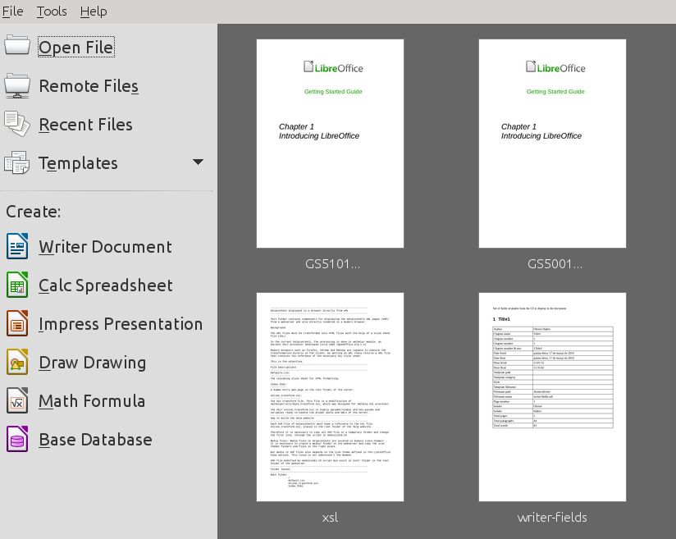Figure 1: LibreOffice Start Center
If you do not have Microsoft Office installed on your computer, or if Microsoft Office is installed but you have associated Microsoft Office file types with LibreOffice, then when you double-click on the following files, they open in LibreOffice:
- A Word file (*.doc or *.docx) opens in Writer.
- An Excel file (*.xls or *.xlsx) opens in Calc.
- A PowerPoint file (*.ppt or *.pptx) opens in Impress.
If you did not associate the file types and Microsoft Office is installed on your computer, then when you double-click on a Microsoft Office file, it opens using the appropriate Microsoft Office component.
For more information on opening files, see “Opening existing documents” on page 17.

Quickstarter
When LibreOffice is installed on computers running Windows or Linux, a Quickstarter feature may also be installed. When Quickstarter is activated, the necessary library files are loaded when the computer system is started, resulting in a shorter startup time for LibreOffice components.
Computers with a macOS do not have a Quickstarter.

Activating Quickstarter
On a computer using Linux or Windows operating systems, the default installation of LibreOffice does not set the Quickstarter to load automatically. To activate it:
- Open LibreOffice.
- Go to Tools > Options > LibreOffice > General on the Menu bar and select Load LibreOffice during system start-up (if using Windows) or select Enable systray Quickstarter (if using Linux).
- Close and restart LibreOffice to have Quickstarter appear.

Using Quickstarter on Linux or Windows
After Quickstarter has been activated, an icon  is installed into the system tray at the bottom of the display. Quickstarter is then available at all times, whether LibreOffice is open or not.
To start a LibreOffice component directly by using Quickstarter:
- Right-click the Quickstarter icon in the system tray to open a pop-up menu (Figure 2).
- Select the LibreOffice component you want to open to create a new document, or select From Template to open the Template Manager, or select Open Document to open an existing document.
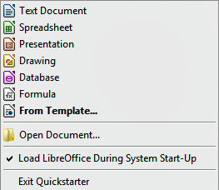Figure 2: Quickstarter menu in Windows

Disabling Quickstarter
To temporarily close Quickstarter on a computer using a Windows operating system, right-click on the Quickstarter icon in the system tray and select Exit Quickstarter in the pop-up menu. However, when the computer is restarted, Quickstarter will be loaded again.
To prevent the Quickstarter from loading during system startup, do one of the following:
- Right-click on the Quickstarter icon and deselect Load LibreOffice during system start-up on the pop-up menu (on Windows) or select Disable systray Quickstarter (on Linux).
- Go to Tools > Options > LibreOffice > General on the Menu bar and deselect Load LibreOffice during system start-up (on Windows) or deselect Enable systray Quickstarter on Linux.

Reactivating Quickstarter
If Quickstarter has been disabled, you can reactivate it by using the instructions given in “Activating Quickstarter” above.

Parts of the main window
The main window is similar for each component of LibreOffice, although some details vary. See the relevant chapters in this guide about Writer, Calc, Draw, and Impress for descriptions of those details.
Common features include the Menu bar, standard toolbar, and formatting toolbar at the top of the window and the status bar at the bottom.

Menu bar
The Menu bar is located across the top of the LibreOffice window, just below the title bar. When you select one of the menus listed below, a sub-menu drops down to show commands. Below is the case for Writer:
- File – contains commands that apply to the entire document such as Open, Save, and Export as PDF.
- Edit – contains commands for editing the document such as Undo, Find & Replace, Cut, Copy, and Paste.
- View – contains commands for controlling the display of the document such as Zoom and Web Layout.
- Insert – contains commands for inserting elements into your document such as Header, Footer, and Image.
- Format – contains commands for formatting the layout of your document.
- Styles – contains commands for quickly applying common styles; for editing, loading, and creating new styles; and for accessing the Styles and Formatting section of the Sidebar.
- Table – contains commands to insert and edit a table in a text document.
- Tools – contains functions such as Spelling and Grammar, AutoCorrect, Customize, and Options.
- Window – contains commands for the display window.
- Help – contains links to the LibreOffice Help file, What’s This?, and information about the program.

Toolbars
LibreOffice has two types of toolbars: docked (fixed in place) and floating. Docked toolbars can be moved to different locations or made to float, and floating toolbars can be docked.
In a default LibreOffice installation, the top docked toolbar, just under the Menu bar, is called the Standard toolbar. It is consistent across the LibreOffice applications.
The second toolbar at the top, in a default LibreOffice installation, is the Formatting bar. It is context-sensitive; that is, it shows the tools relevant to the current position of the cursor or the object selected. For example, when the cursor is on a graphic, the Formatting bar provides tools for formatting graphics; when the cursor is in text, the tools are for formatting text.
In some cases it is convenient to reduce the number of toolbars displayed and get more space for the document. LibreOffice provides a single-toolbar alternative to the default double-toolbar setup. It contains the most-used commands. To activate it, enable View > Toolbars > Standard (Single Mode) and disable View > Toolbars > Standard and View > Toolbars > Formatting.

Displaying or hiding toolbars
To display or hide toolbars, go to View > Toolbars on the Menu bar, then click on the name of a toolbar from the drop-down list. An active toolbar shows a check-mark beside its name. Toolbars created from tool palettes are not listed in the View menu.
To close a toolbar go to View > Toolbars on the Menu bar and deselect the toolbar, or right-click in an empty space between the icons on a toolbar and select Close toolbar from the context menu.

Sub-menus and tool palettes
Toolbar icons with a small triangle to the right will display sub-menus, tool palettes, and alternative methods of selecting items, depending on the icon.
Tool palettes can be made into a floating toolbar. Figure 3 shows an example of a tool palette from the Drawing toolbar made into a floating toolbar. See “Moving toolbars” and “Floating toolbars” below for more information on moving and floating these toolbars created from tool palettes.
Figure 3: Example of tearing off a tool palette

Moving toolbars
Docked toolbars can be undocked and moved to a new docked position or left as a floating toolbar.
- Move the mouse cursor over the toolbar handle, which is the small vertical bar to the left of a docked toolbar and highlighted in Figure 4.
- Hold down the left mouse button and drag the toolbar to the new location. The toolbar can be docked in a new position at the top, sides or bottom of the main window, or left as a floating toolbar.
- Release the mouse button.
To move a floating toolbar, click on its title bar and drag it to a new floating location or dock the toolbar at the top or bottom of the main window.
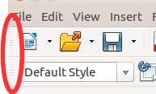Figure 4: Toolbar handles

Floating toolbars
LibreOffice includes several additional toolbars, whose default setting appear as floating toolbars in response to the current position of the cursor or selection. You can dock these toolbars to the top or bottom of the main window, or reposition them on your computer display (see “Moving toolbars” above).
Some of these additional toolbars are context sensitive and will automatically appear depending on the position of the cursor. For example, when the cursor is in a table, a Table toolbar appears, and when the cursor is in a numbered or bullet list, the Bullets and Numbering toolbar appears.

Customizing toolbars
You can customize toolbars in several ways, including choosing which icons are visible and locking the position of a docked toolbar. You can also add icons and create new toolbars, as described in Chapter 14 Customizing LibreOffice. To access the customization options for a toolbar, right-click in an empty space between the icons on a toolbar to open a context menu as follows:
- To show or hide icons defined for the selected toolbar, click Visible Buttons. Visible icons on a toolbar are indicated by an outline around the icon (Figure 5) or by a check mark beside the icon, depending on your operating system. Select or deselect icons to hide or show them on the toolbar.
Figure 5: Selection of visible toolbar icons
- Click Customize Toolbar to open the Customize dialog; See Chapter 14 Customizing LibreOffice for more information.
- Click Dock Toolbar to dock the selected floating toolbar. By default, a toolbar will dock at the top of the workspace. You can reposition the toolbar to a different docked position. See “Moving toolbars” on page 12.
- Click Dock All Toolbars to dock all floating toolbars. By default, toolbars will dock at the top of the workspace. You can reposition the toolbars to different docked positions. See “Moving toolbars” on page 12.
- Click Lock Toolbar Position to lock a docked toolbar into its docked position.
- Click Close Toolbar to close the selected toolbar.

Context menus
Context menus provide quick access to many menu functions. They are opened by right-clicking on a paragraph, graphic, or other object. When a context menu opens, the functions or options available will depend on the object that has been selected. A context menu can be the easiest way to reach a function, especially if you are not sure where the function is located in the menus or toolbars. By default, context menus will display an applicable keyboard shortcut if one has been set. If you wish, you can toggle this visibility off or on in Tools > Options > View > Menu.
Figure 6: Keyboard shortcuts in context menus

Status bar
The status bar is located at the bottom of the workspace. It provides information about the document and convenient ways to change some features quickly. It is similar in Writer, Calc, Impress, and Draw, but each LibreOffice component includes some component-specific items. An example of the Writer status bar is shown in Figure 7.
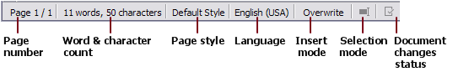Figure 7: Example status bar from Writer
Page, sheet, or slide number and page count
Shows the current page, sheet, or slide number and the total number of pages, sheets, or slides in the document. Click on this field to open the Go to Page dialog. Other uses of this field depend on the LibreOffice component.
Words and characters
Shows the total number of words and characters in the document or in the selection.
Page style or slide design
Shows the current page style or slide design. To edit the current page style or slide design, double-click on this field. To choose a different page style or slide design, right-click on this field and select from the list that pops up.
Language
Shows the current language of the text at the current cursor position.
Insert mode
Shows the type of insert mode the program is in. This field is blank if the program is in Insert mode. Each time the Ins key is pressed, or this field is clicked, the mode toggles between Insert and Overwrite.
Selection mode
Click to choose different selection modes. The icon does not change, but when you hover the mouse pointer over this field, a tooltip indicates which mode is active.
Unsaved changes
The icon shown here is different when changes to the document have not been saved.
Digital signature
If the document has been digitally signed, an icon shows here. You can click the icon to sign the document, or to view the existing certificate.
Object information
Displays information relevant to the position of the cursor or the selected element of the document.
View layout
Select between Single-page view, Multiple-page view, and Book view to change how your document is displayed.
Zoom slider
Drag the Zoom slider, or click on the + and – signs to change the view magnification of your document.
Zoom percentage
Indicates the magnification level of the document. Right-click on the percentage figure to open a list of magnification values from which to choose. Cicking on this percentage figure opens the Zoom & View Layout dialog.

Sidebar
To activate the Sidebar, select View > Sidebar from the Menu bar. The Sidebar (Figure 8) is located on the right side of the edit views of Writer, Calc, Impress, and Draw. It contains one or more panels, based on the current document context. Panels are organized into decks. A tab bar on the right side of the sidebar allows you to switch between different decks.
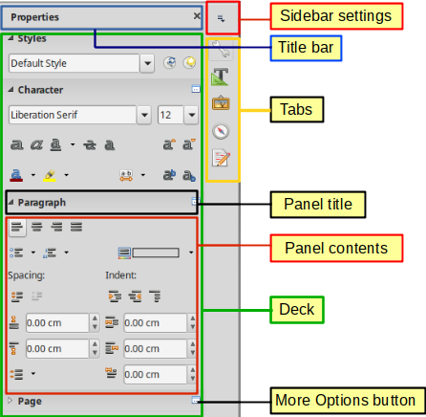Figure 8: Properties panel of Sidebar in Writer
All components contain the Properties, Styles and Formatting, Pages , Gallery, and Navigator decks. Some components have additional decks, such as Master Pages, Custom Animation, and Slide Transition for Impress; Manage Changes for Writer; and Functions for Calc.
A panel is like a combination of a toolbar and a dialog. For example, you can freely mix working in the main edit window to enter text and use the Properties panel in the sidebar to change text attributes.
Tool bars and Sidebar panels share many functions. For example, the buttons for making text bold or italic exist in both the Formatting toolbar and the Properties panel.
For more detail, see the Sidebar explanation in the relevant LibreOffice component’s user guide.
To hide the Sidebar, click on the gray Hide button on the left. Click on the same button to show the Sidebar again.
To undock the Sidebar and make it floating, and to dock a floating Sidebar, use the Sidebar settings drop-down list at the top of the tab bar (see Figure 9). From the same list you can choose which items to show in the Sidebar.
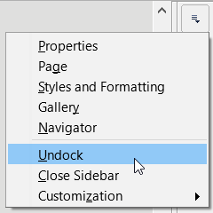Figure 9: Floating (undocking) or docking the Sidebar

Starting new documents
You can start a new, blank document in LibreOffice in several ways.
When LibreOffice is running but no document is open, the Start Center (Figure 1 on page 9) is shown. Click one of the icons to open a new document of that type, or click the Templates icon to start a new document using a template.
You can also start a new document in one of the following ways:
- Use File > New on the Menu bar and select the type of document from the context menu.
- Use the keyboard shortcut Ctrl+N to create a new document. The type of document created depends on which LibreOffice component is open and active. For example, if Calc is open and active, a new spreadsheet is created.
- Use File > Wizards on the Menu bar and select the type of document from the context menu.
- If a document is already open in LibreOffice, click the New icon on the Standard toolbar and a new document of the same type is created in a new window. For example, if Calc is open and active, a new spreadsheet is created. The New icon changes depending on which component of LibreOffice is open.
- If a document is already open in LibreOffice, click on the small triangle to the right of the New icon on the Standard toolbar and select the type of document from the context menu that opens.
- On Windows or Linux, use the Quickstarter feature included with LibreOffice. See “Using Quickstarter on Linux or Windows” on page 9 for more information.
- Note
If all documents are closed without closing the last LibreOffice window, then the Start Center will be displayed.

Opening existing documents
You can also open an existing document in one of the following ways:
- When no document is open, click Open File or Remote files in the Start Center to reach the Open dialog.
- Go to File > Open or File > Open Remote… on the Menu bar to reach the Open dialog.
- Use the keyboard shortcut Ctrl+O to reach the Open dialog.
- If a document is already open, click the Open icon on the Standard toolbar and select from a list of available documents from the Open dialog, or click Open Template… to select a template.
- Click the small triangle to the right of the Open icon and select from a list of recently opened documents.
- When no document is open, double-click on a thumbnail of recently opened documents displayed in the Start Center. You can scroll up or down in the Start Center to locate a recently opened document.
When using the Open dialog, navigate to the folder you want and select the file you want, and then click Open. If a document is already open in LibreOffice, the second document opens in a new window.
In the Open dialog, you can reduce the list of files by selecting the type of file you are looking for. For example, if you choose Text documents as the file type, you will only see documents Writer can open (including .odt, .doc, .txt); if you choose Spreadsheets, you will see .ods, .xls, and other files that Calc opens.
You can also open an existing document that is in a format that LibreOffice recognizes by double-clicking on the file icon on the desktop or in a file manager such as Windows Explorer. LibreOffice has to be associated with file types that are not ODF files for the appropriate LibreOffice component to open.
- Note
When opening files stored in a remote server, you may be asked to enter your user name and password to log in the server.

Saving documents
You can save documents as follows:
- Save command – use if you are keeping the document, its current filename and location.
- Save Remote - use if your document is already stored in a remote server or will be stored in a remote server.
- Save As – use if you want to create a new document, or change the filename and/or file format, or save the file in a different location on your computer.
- Save a copy - use if you want to save a copy of your current document and keep it open for more editing.
- Save All - use to save all the files open in your current session.

Save command
To save a document if you are keeping the document’s current filename and location, do one of the following:
- Use the menu option File > Save
- Use the keyboard shortcut Ctrl+S.
- Click the Save icon on the Standard toolbar.
- Use the menu option File > Save All
- Use the menu option File > Save Remote
- Use the menu option File > Save a Copy (Similar to the Save As command)
Using the Save command will immediately overwrite the last saved version of the file.

Save As command
Figure 10: Example of LibreOffice Save As dialog
If you want to create a new document file, change the filename and/or file format, or save the file in a different location on your computer:
- Use the keyboard shortcut Ctrl+Shift+S.
- Use the menu option File > Save As.
When the Save As dialog (Figure 10) or Save dialog opens, enter the file name, change the file type (if applicable), navigate to a new location (if applicable), and click Save.

Password protection
To restrict who can open and read a document, or open and edit the document, use password protection.
- Using the Save As command command above, select the Save with password option in the Save As dialog or Save dialog.
- Click Save and the Set Password dialog opens (Figure 11).
- In File Encryption Password, enter a password to open the document and then enter the same password as confirmation.
- To restrict who can edit the document, click Options.
- In File Sharing Password, select Open file read-only, enter a password to allow editing, and then enter the same password as confirmation.
- Click OK and the dialog closes. If the passwords match, the document is saved password-protected. If the passwords do not match, you receive an error message.
Figure 11: Set Password dialog
- Caution
LibreOffice uses a very strong encryption mechanism that makes it almost impossible to recover the contents of a document if you lose or forget the password.

Changing the password
When a document is password-protected, you can change the password while the document is open. Go to File > Properties > General on the Menu bar and click the Change Password button. This opens the Set Password dialog where you can enter a new password.

Saving documents automatically
LibreOffice can save files automatically as part of the AutoRecovery feature. Automatic saving, like manual saving, overwrites the last saved state of the file.
To set up automatic file saving:
- Go to Tools > Options > Load/Save > General on the Menu bar.
- Select Save AutoRecovery information every and set the time interval.
- Click OK.

Opening and saving files on remote servers
LibreOffice can open and save files stored on remote servers. Keeping files on remote servers allows you to work with the documents using different computers. For example, you can work on a document in the office during the day and edit it at home for last-minute changes. Storing files on a remote server also backs up documents from computer loss or hard disk failure. Some servers are also able to check-in and check-out files, thus controlling their usage and access.
LibreOffice supports many document servers that use well known network protocols such as FTP, WebDav, Windows share, and SSH. It also supports popular services like Google Drive and Microsoft OneNote, as well as commercial and open source servers that implement the OASIS CMIS standard.
To enable a remote server connection, use one of these methods:
- Click on the Remote Files button in the Start Center
- Select File > Open Remote
- Select File > Save Remote
On the Remote Files dialog (Figure 13), click on the Add Service button in the upper right to open the File Services dialog (Figure 12).
Depending on the type of file service you choose in the Type listbox, different parameters are necessary to fully qualify the connection to the remote server.
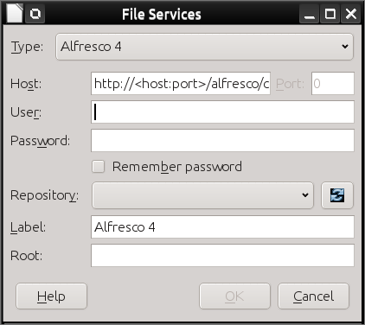Figure 12: Remote server configuration
Once the connection is defined, click OK to connect. The dialog will dim until the connection is established with the server. A dialog asking for the user name and the password may pop up to let you log in the server. Proceed entering your credentials.
The Remote Files dialog (Figure 13) which then appears has many parts. The upper list box contains the list of remote servers you have previously defined. The line below the list box shows the path to access the folder. On the left is the folder structure of the user space in the server. The main pane displays the files in the remote folder. Click the Open or Save button to proceed.
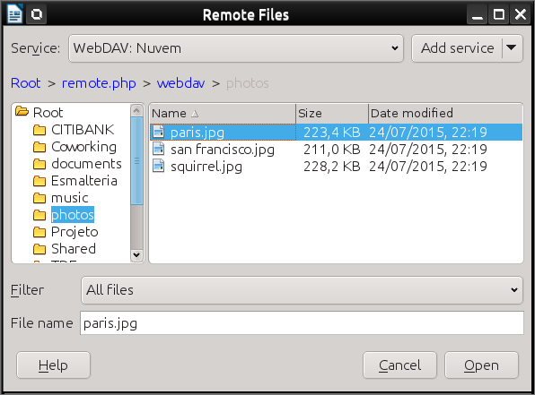Figure 13: Remote Files dialog when connected to a server

Renaming and deleting files
You can rename or delete files within the LibreOffice dialogs, just as you can in a file manager. Select a file and then right click to open a context menu. Select either Delete or Rename, as appropriate. However, you cannot copy or paste files within the dialogs.

Using the Navigator
The LibreOffice Navigator lists objects contained within a document, collected into categories. For example, in Writer it shows Headings, Tables, Text frames, Comments, Graphics, Bookmarks, and other items, as shown in Figure 14. In Calc it shows Sheets, Range Names, Database Ranges, Graphics, Drawing Objects, and other items. In Impress and Draw it shows Slides, Pictures, and other items.
To open the Navigator, click the Navigator icon on the Standard toolbar, or press the F5 key, or go to View > Navigator on the Menu bar,, or click on the Page Number/Count area of the Status Bar, or click the Navigator icon in the Sidebar.
Click the marker (+ or triangle) by any of the categories to display the list of objects in that category.
The Navigator provides several convenient ways to move around a document and find items in it:
- When a category is showing the list of objects in it, double-click on an object to jump directly to that object’s location in the document.
- Objects are much easier to find if you have given them recognizable names when creating them, instead of keeping the default names such as Sheet1, Table1, or Table2. The default names may not correspond to the actual position of the object in the document.
- Navigator also provides the facility to move, promote, demote items within a document.
- Each Navigator in the individual LibreOffice components has a different range of functions. These functions are further explained in the user guide for each LibreOffice component.
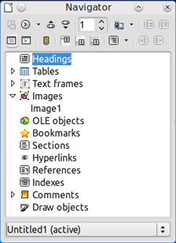Figure 14: Navigator in Writer

Undoing and redoing changes
To undo the most recent unsaved change in a document, use the keyboard shortcut Ctrl+Z, or click the Undo icon on the Standard toolbar, or go to Edit > Undo on the Menu bar. Click the small triangle to the right of the Undo icon to get a list of all the changes that can be undone. You can select multiple changes and undo them at the same time.
After changes have been undone, you can redo changes. To redo a change use the keyboard shortcut Ctrl+Y, or click the Redo icon, or go to Edit > Redo on the Menu bar. As with Undo, click on the triangle to the right of the arrow to get a list of the changes that can be reapplied.
To repeat the last command applied to your document, use the shortcut Ctrl+Shift+Y. This can save several repetitive menu navigation clicks or keyboard shortcuts, especially when the command is taken from a secondary menu.

Reloading a document
You may want to discard all the changes made in an editing session after the last document save. But undoing each change or remembering where the changes took place can be a difficult task. If you are sure you do not want to keep the changes from the last save operation, you can reload your document. A copy of the document that is currently stored in the file system is loaded. The document returns to the state where it was last saved.
To reload a document, go to File > Reload on the menu bar. If you have made changes to a file since the last save, a confirmation dialog will warn you that Reloading will discard your last changes. On reloading your document, the File dialog will not open, because the file is already selected.

Closing a document
If only one document is open and you want to close that document, go to File > Close on the Menu bar or click on the X on the right or left end of the Menu bar. On Windows and Linux, the document closes and the LibreOffice Start Center opens. On macOS, the document closes and only the Menu bar remains at the top of the screen.
If more than one document is open and you want to close one of them, go to File > Close on the Menu bar or click on the X on the title bar of that document’s window. The X may be located on either the right or left end of the title bar.
If the document has not been saved since the last change, a message box is displayed. Choose whether to save or discard your changes.
- Caution
Not saving your document could result in the loss of recently made changes, or worse still, the entire file.

Closing LibreOffice
To close LibreOffice completely, go to File > Exit on the Menu bar in Windows and Linux operating systems. In a Mac operating system, go to LibreOffice > Quit LibreOffice on the Menu bar.
When you close the last document using the X on the title bar of the window, then LibreOffice will close completely. A Mac operating system does not have this function; instead, you need to use to LibreOffice > Quit LibreOffice.
You can also use a keyboard shortcut as follows:
- In Windows and Linux – Ctrl+Q
- In macOS – Command ⌘+Q
If any documents have not been saved since the last change, a message box is displayed. Choose whether to save or discard your changes.

