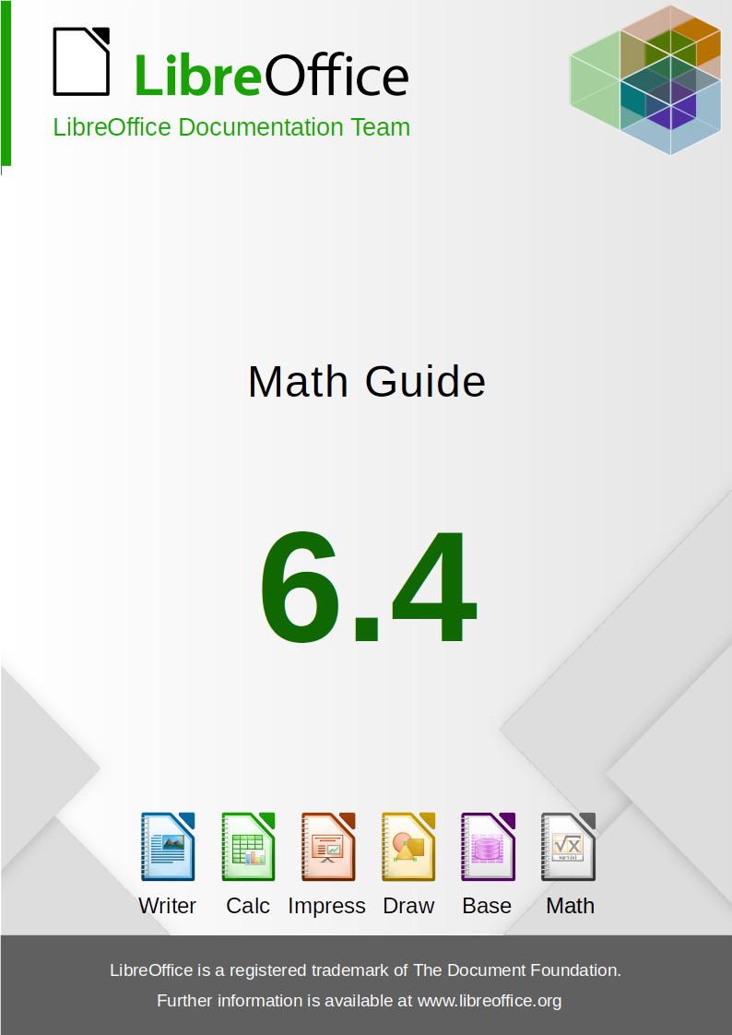

Autorská práva
This document is Copyright © 2012–2020 by the LibreOffice Documentation Team. Přispěvatelé jsou uvedeni níže. Dokument je možné šířit nebo upravovat za podmínek licence GNU General Public License (http://www.gnu.org/licenses/gpl.html) verze 3 nebo novější nebo za podmínek Commons Attribution License (http://creativecommons.org/licenses/by/4.0/) verze 4.0 nebo novější.
Všechny ochranné známky uvedené v této příručce patří jejich vlastníkům.

Přispěvatelé
This book is adapted and updated from Math Guide OpenOffice.org 3.3.

Pro toto vydání
Roman Kuznetsov | Dave Barton | Olivier Hallot

Pro předchozí vydání
Peter Schofield | Hazel Russman | Laurent Balland-Poirier
Jean Hollis Weber | Daniel Carrera | Agnes Belzunce
T. J. Frazier | Peter Kupfer | Ian Laurenson
Janet M. Swisher | Michele Zarri
Additional material has been added from the German Math Handbuch for LibreOffice 3.4 (translated to English by Hazel Russman). Autoři této knihy jsou:
Regina Henschel | Christian Kühl | Florian Reisinger
Gisbert Friege (Dmaths) | Jochen Schiffers
Additional material has been added from the French How-To Math for LibreOffice (translated to English by Laurent Balland-Poirier). Autoři této knihy jsou:
Bernard Siaud | Frédéric Parrenin

Zpětná vazba
Připomínky a náměty k tomuto dokumentu posílejte v angličtině do e-mailové konference dokumentačního týmu na adresu: documentation@global.libreoffice.org.
- Poznámka:
Všechno, co do e-mailové konference pošlete, včetně e-mailové adresy a dalších osobních informací uvedených ve zprávě, bude veřejně viditelné bez možnosti smazání.

Datum vydání a verze programu
Published January 2020. Based on LibreOffice 6.4.
Obsah
Autorská práva 2
Předmluva 5
Pro koho je tato kniha určena? 6
Kde lze získat pomoc 6
Vaše verze může být jiná 7
Using LibreOffice on a macOS 8
Chapter 1 Creating & Editing Formulas 9
Úvod 10
Začínáme 10
Creating formulas 12
Editing formulas 16
Rozvržení vzorců 17
Changing formula appearance 23
Formula library 30
Chapter 2 Formulas in Writer 32
Úvod 33
Automatic formula numbering 33
Anchoring formulas 34
Vertical alignment 35
Object spacing 36
Textový režim 37
Background and borders 37
Quick insertion of formulas 39
Chapter 3 Formulas in Calc, Draw & Impress 40
Úvod 41
Anchoring formulas 41
Formula object properties 41
Formulas in charts 42
Chapter 4 Customization 43
Úvod 44
Chemical formulas 44
Floating dialogs 44
Adding keyboard shortcuts 45
Catalog customization 47
Formula spacing 50
Rozšíření 50
Chapter 5 Exporting & Importing 52
Math ML format 53
Microsoft file formats 53
Appendix A Commands Reference 54
Úvod 55
Unary/binary operator commands 55
Relation commands 56
Set operation commands 58
Funkce 59
Operátory 60
Atributy 63
Závorky 65
Formáty 69
Ostatní 70
Řecké znaky 71
Special characters 73
Reserved words 73


Math Guide

Předmluva

Pro koho je tato kniha určena?
LibreOffice Math is a formula (equation) editor that is an integral part of LibreOffice. Anyone who wants to learn how to insert formulas and equations using Math will find this guide valuable.
If you have never used LibreOffice Math before, or you want an introduction to all of the LibreOffice components, you might like to read the LibreOffice Getting Started Guide first.

Kde lze získat pomoc
This guide, other LibreOffice user guides, the built-in Help system, and user support systems assume that you are familiar with your computer and basic functions such as starting a program, opening and saving files.

Systém nápovědy
LibreOffice comes with an extensive Help system. This is your first line of support for using LibreOffice.
To display the full Help system, press F1 or go to Help > LibreOffice Help on the main menu bar. In addition, you can choose whether to activate Tips, Extended tips, and the Help Agent by going to Tools > Options > LibreOffice > General on the main menu bar.
If Tips are enabled, hover the mouse pointer over any of the icons and a small balloon (tooltip) will pop up giving a brief explanation of the function for that icon. For a more detailed explanation, select Help > What's This? on the main menu bar and hover the pointer over the icon.

Volně dostupná podpora na internetu
Komunita LibreOffice kromě vývoje softwaru poskytuje bezplatnou podporu od dobrovolníků. See Table 1 and this web page: http://www.libreoffice.org/get-help/
Tabulka 1: Bezplatná podpora pro uživatele LibreOffice
Ask LibreOffice | Otázky a odpovědi od komunity uživatelů LibreOffice  http://ask.libreoffice.org/en/questions/
Dokumentace | User guides, how-tos, and other documentation. http://www.libreoffice.org/get-help/documentation/  https://wiki.documentfoundation.org/Documentation/Publications
E-mailové konference | Podpora od komunity poskytovaná sítí zkušených uživatelů  http://cs.libreoffice.org/get-help/mailing-lists/
Časté otázky | Odpovědi na často kladené otázky  http://wiki.documentfoundation.org/Faq
Slovenská a česká podpora | Webová stránka v českém jazyce.  http://global.libreoffice.org/international-sites/  Česká e-mailová konference  https://wiki.documentfoundation.org/Local_Mailing_Lists#Czech_.2F_.C4.8Ce.C5.A1tina
Možnosti zpřístupnění | Informace o dostupných možnostech pro zlepšení přístupnosti http://cs.libreoffice.org/get-help/accessibility/
You can get comprehensive online support from the community through mailing lists and the Ask LibreOffice website, http://ask.libreoffice.org/en/questions/. Kromě toho je dostupných mnoho webových stránek od uživatelů, které nabízejí bezplatné tipy a návody. This forum provides community support for LibreOffice: http://en.libreofficeforum.org/. This site provides support for LibreOffice, among other programs:
http://forum.openoffice.org/en/forum/

Placená podpora a školení
Alternatively, you can pay for support services. Service contracts can be purchased from a vendor or consulting firm specializing in LibreOffice.

Vaše verze může být jiná
LibreOffice lze instalovat a spouštět v operačních systémech Windows, Linux a Mac OS X, přičemž každý z nich má několik verzí a uživatelé si je mohou přizpůsobit (písma, barvy, témata vzhledu, správce oken).

Ilustrace
The illustrations in this guide were taken from the Windows 10 operating system. Proto je možné, že některé prvky v ilustracích nebudou přesně takové, jak je vidíme na svém počítači.
Některá dialogová okna se mohou lišit i kvůli různým nastavením samotného LibreOffice. You can either use dialogs from your computer system or dialogs provided by LibreOffice. To change to using LibreOffice dialogs if settings have been altered:
- Access the general options for LibreOffice as follows:
- On Linux and Windows operating systems, go to Tools > Options > LibreOffice > General on the main menu bar to open the dialog for general options.
- V operačním systému Mac toto okno otevřeme v hlavní nabídce zvolením LibreOffice > Preferences > General.
- Select Use LibreOffice dialogs in Open/Save dialogs to display and use the LibreOffice dialogs for opening and saving files.
- For Linux operating systems only, select Use LibreOffice dialogs in Print Dialogs to display and use the LibreOffice dialogs for printing your documents.
- Kliknutím na OK uložíme nové nastavení a okno zavřeme.
- Poznámka
If you are using a Linux operating system as a virtual machine on a computer running a Windows or Mac operating system, then the LibreOffice option of using Print Dialogs is not available.

Ikony
Ikony, které opravdu uvidíme ve své verzi LibreOffice, se mohou lišit od ikon, které jsou zobrazeny v této příručce. The icons in this guide have been taken from a LibreOffice installation that has been set to display the default set of icons. If you wish, you can change your LibreOffice icons as follows:
- Access the view options for LibreOffice as follows:
- On Linux and Windows operating systems, go to Tools > Options > LibreOffice > View on the main menu bar to open the dialog for view options.
- V operačním systému Mac toto okno otevřeme v hlavní nabídce LibreOffice > Preferences > View.
- In User interface, select from the options available in the Icon Style drop-down list.
- Kliknutím na OK uložíme nové nastavení a okno zavřeme.

Using LibreOffice on a macOS
Některé klávesové zkratky a položky nabídek jsou v systému Mac jiné než v systémech Windows a Linux. V následující tabulce jsou uvedeny nejdůležitější rozdíly, které se týkají informací v této kapitole. Podrobnější seznam se nachází v nápovědě k aplikaci.
Windows nebo Linux | Ekvivalent pro macOS | Význam
Nabídka Nástroje > Možnosti | LibreOffice > Předvolby | Otevře nastavení s možnostmi
Klepnutí pravým tlačítkem | Control+click or right-click depending on computer setup | Otevře se místní nabídka
Ctrl (Control) | ⌘ (Command) | Používá se i s jinými klávesami
F5 | Shift+⌘+F5 | Otevřete Navigátor
F11 | ⌘+T | Otevře postranní lištu Styly a formátování

Math Guide

Chapter 1
Creating & Editing Formulas

Úvod
Math is a formula editor module included with LibreOffice that allows you to create or edit formulas (equations) in a symbolic form, within LibreOffice documents or as stand-alone objects; example formulas are shown below. However, if you want to evaluate numeric values using formulas, then refer to the Calc Guide for more information as Math does not carry out any actual calculation.
nebo
The Formula Editor in Math uses a markup language to represent formulas. This markup language is designed to be easily read wherever possible, for example, a over b produces the fractionwhen used in a formula.

Začínáme
Using the Formula Editor, you can create a formula as a separate document or file for a formula library, or insert formulas directly into a document using LibreOffice Writer, Calc, Impress, or Draw.

Formulas as separate documents or files
To create a formula as a separate document or file, use one of the following methods to open an empty formula document in LibreOffice Math (Figure 1).
- On the main menu bar, go to File > New > Formula.
- On the Standard toolbar, click the triangle to the right of the New icon and select Formula from the context menu.
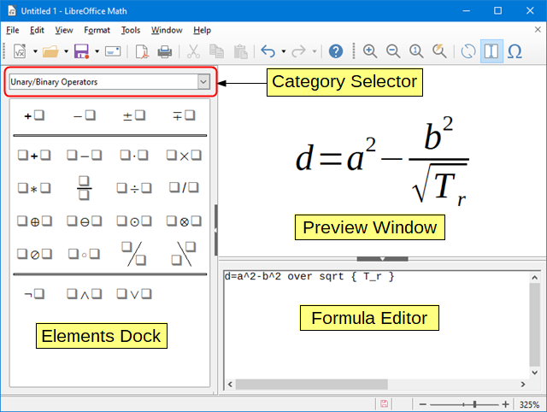Figure 1: An empty formula document in Math
- From the Start Center, click Math Formula.
- From within LibreOffice Math, use the keyboard shortcut Ctrl+N.
As you enter the markup language in the Formula Editor, the formula will appear in the Preview window during and after input of the markup language. The Elements Dock to the left of the Preview window may also appear, if these have been selected in View on the main menu bar. For more information on creating formulas, see “Creating formulas” on Page 12.

Formulas in LibreOffice documents
To insert a formula into a LibreOffice document, open the document in Writer, Calc, Draw, or Impress. The LibreOffice module you are using affects how you position the cursor to insert the formula.
- In Writer, click in the paragraph where you want to insert the formula.
- In Calc, click in the spreadsheet cell where you want to insert the formula.
- In Draw and Impress, the formula is inserted into the center of the drawing or slide.
Then, go to Insert > Object > Formula on the main menu bar to open the Formula Editor. Alternatively, go to Insert > Object > OLE Object on the main menu bar to open the Insert OLE Object dialog, select Create new option and Formula from the sub-menu, then click OK to open the Formula Editor. The Elements Dock to the left of the Preview window and/or the Elements dialog as a floating dialog may also appear, if these have been selected in View on the main menu bar. For more information on creating formulas, see “Creating formulas” on Page 12.
Figure 2 shows an example Writer document with the formula box selected ready for a formula to be entered.
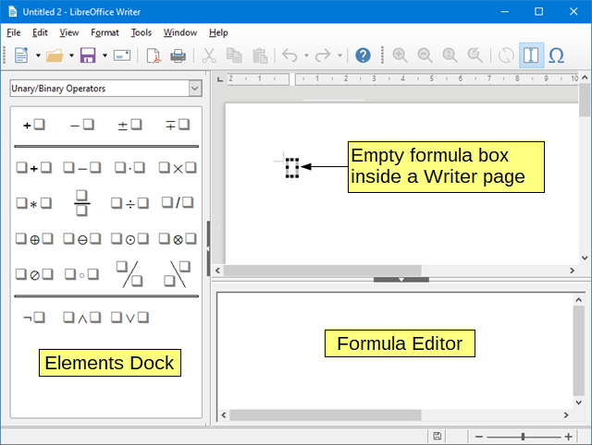Figure 2: Empty formula in a Writer document
When you have completed entering the markup language for your formula, close the Formula Editor by pressing the Esc key or by clicking an area outside the formula in your document. Double-clicking on the formula object in your document will open the Formula Editor again so that you can edit the formula.
Formulas are inserted as OLE objects into documents. You can, as with any OLE object, change how the object is placed within your document. For more information on OLE objects, see Chapter 2 Formulas in Writer, Chapter 3 Formulas in Calc, Draw & Impress and the user guides for Writer, Calc, Draw, and Impress.
If you frequently insert formulas into documents, it is recommended to add the Formula button to the Standard toolbar or create a keyboard shortcut. See Chapter 4 Customization for more information.

Creating formulas
You can insert a formula using one of the following methods:
- In the Elements Dock, select a category from the drop-down list, then a symbol.
- Right-click in the Formula Editor and select a category, then a symbol from the context menu.
- Enter markup language directly in the Formula Editor.
- NOTE
Using the Elements Dock, or the context menus to insert a formula provides a convenient way to learn the markup language used by LibreOffice Math.
- Tip
When using the Elements Dock, it is recommended to have Tips selected in the LibreOffice Options. This will help you identify the categories and symbols you want to use in your formula. Go to Tools > Options on the main menu bar, then select LibreOffice > General in the Options dialog and select Extended Tips in the Help section.

Ukotvené prvky
The Elements Dock can be used when entering your formula data. The Elements Dock also provides an Example category which gives you example formulas to use as a starting point for your formula or equation.
- Go to View on the main menu bar and select Elements Dock to open the Elements Dock (Figure 3).
- Select the category you want to use in your formula from the drop-down list at the top of the Elements Dock.
- Select the symbol you want to use in your formula from the Elements Dock. The symbols that are available change according to the selected category.
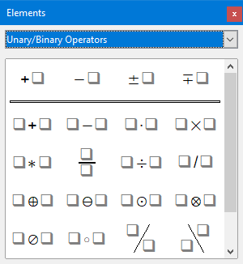
Figure 3: Elements Dock
- NOTE
The Elements Dock can either be a floating dialog, as shown in Figure 3, or positioned to the left of the Formula Editor, as shown in Figure 1 and Figure 2.

Místní nabídka
The Formula Editor also provides a context menu to access categories and symbols when creating your formula. Right-click in the Formula Editor to open the context menu. Select a category and then select the markup example that you want to use from the sub-context menu, an example is shown in Figure 4.
- NOTE
The Elements Dock, or context menu only contain the most common commands that are used in formulas. For some seldom-used commands, you must always enter the command using the markup language. For a complete list of commands, see Appendix A Commands Reference.
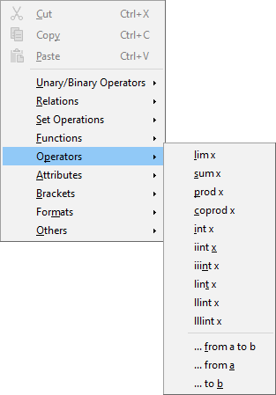Figure 4: Context menu in Formula Editor

Markup language
Markup language is entered directly into the Formula Editor. For example, typing the markup language 5 times 4 into the Formula Editor creates the simple formula . If you are experienced in using markup language, it can be the quickest way to enter a formula. Table 2 shows some examples of using markup language to enter commands. For a full list of commands that can be used in the Formula Editor, see Appendix A Commands Reference.
Table 2: Example commands using markup language
Zobrazení | Příkaz | Zobrazení | Příkaz
 | a = b |  | sqrt {a}
 | a^2 |  | a_n
 | int f(x) dx |  | sum a_n
 | a <= b |  | infinity
 | a times b |  | x cdot y

Řecké znaky

Using markup language
Greek characters are commonly used in formulas, but Greek characters cannot be entered into a formula using the Elements Dock, or the context menu. Use the English names of Greek characters in markup language when entering Greek characters into a formula. See Appendix A Commands Reference for a list of Greek characters that can be entered using markup language.
- For a lowercase Greek character, type a percentage % sign, then type the character name in lowercase using the English name. For example, typing %lambda creates the Greek character λ.
- For an UPPERCASE Greek character, type a percentage % sign, then type the character name in UPPERCASE using the English name. For example, typing %LAMBDA creates the Greek character Λ.
- For an italic Greek character, type a percentage % sign followed by the i character, then the English name of the Greek character in lower or UPPER case. For example, typing %iTHETA creates the italic Greek character Θ.

Symbols dialog
Greek characters can also be entered into a formula using the Symbols dialog.
- Make sure your cursor is in the correct position in the Formula Editor.
- Go to Tools > Symbols on the main menu, click the toolbar Symbols icon to open the Symbols dialog (Figure 5)
- Select Greek from the Symbol set drop-down list. For italic characters, select iGreek from the drop-down list.
- Select the Greek character from the symbol list, then click Insert. When selected, the name of a Greek character is shown below the symbol list.
- Click Close when you have finished entering Greek characters into your formula.
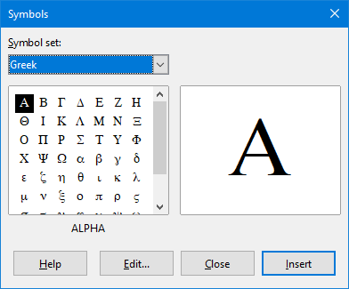Figure 5: Symbols dialog

Formula examples

Example 1
The simple formula can be created using LibreOffice Math as follows:
- Make sure your cursor is flashing in the Formula Editor, then select the category Unary/Binary Operators and symbol Multiplication using one of the following methods:
- In the Elements Dock, select Unary/Binary Operators from the drop-down list and then select the Multiplication icon .
- Right-click in the Formula Editor and select Unary/Binary Operators > a times b from the context menu.
- Using markup language, enter 5 times 4 in the Formula Editor.
- The first three methods place the formula text <?> times <?> in the Formula Editor and the symbol appears in the document.
- Using markup language in the Formula Editor places the formula directly into your document and there is no need to carry out the following steps.
- Select the first placeholder <?> before the word times in the Formula Editor and replace it with the character 5. The formula in your document updates automatically.
- Select the second placeholder <?> after the word times in the Formula Editor and replace it with the character 4. The formula in your document updates automatically.
- Tip
To move forward from one placeholder to the next placeholder in a formula, press the F4 key. To move backward from one placeholder to the previous placeholder in a formula, use the key combination Shift+F4.
- NOTE
If necessary, you can prevent a formula in a document from updating automatically. Go to View on the main menu bar and deselect AutoUpdate display. To then manually update a formula, press F9 key or select View > Update on the main menu bar.

Example 2
You want to enter the formulawhere the value of pi is rounded to 5 decimal places. You know the name of the Greek character (pi), but do not know the markup associated with the Is Similar Or Equal symbol.
- Make sure your cursor is flashing in the Formula Editor.
- Enter %pi in the Formula Editor to enter the Greek character for pi (π).
- Select the category Relations and symbol Is Similar Or Equal using one of the following methods:
- In the Elements Dock, select Relations from the drop-down list and then select the Is Similar Or Equal icon .
- Right-click in the Formula Editor and select Relations > a simeq b from the context menu.
- Delete the first placeholder <?> before the word simeq in the Formula Editor.
- Select the second placeholder <?> after the word simeq in the Formula Editor and replace it with the characters 3.14159. The formulanow appears in your document.

Editing formulas
How you edit a formula and switch into formula editing mode depends on whether the formula is in Math or another LibreOffice module.
- In Math, double-click on a formula element in the formula that appears in the Preview window to select the formula element in the Formula Editor, or directly select a formula element in the Formula Editor.
- In Writer, Calc, Impress, or Draw, double-click on the formula, or right-click on the formula and select Edit form the context menu, to open the Formula Editor and enter editing mode. The cursor is positioned at the start of the formula in the Formula Editor.
- NOTE
If you cannot select a formula element using your cursor, click on the Formula Cursor icon in the Tools toolbar to activate the formula cursor.
- Select the formula element you want to change using one of the following methods:
- Click on the formula element in the preview window, positioning the cursor at the beginning of the formula element in the Formula Editor, then select the formula element in the Formula Editor.
- Double-click on the formula element in the preview window to select the formula element in the Formula Editor.
- Position the cursor in the Formula Editor at the formula element you want to edit, then select that formula element.
- Double-click directly on the formula element in the Formula Editor to select it.
- Make your changes to the formula element you have selected.
- Go to View > Update on the main menu bar, or press the F9 key, or click on the Update icon on the Tools toolbar to update the formula in the preview window or your document.
- In Math, save your changes to the formula after editing.
- In Writer, Calc, Impress, or Draw, click anywhere in your document away from the formula to leave editing mode, then save your document to save your changes to the formula.

Rozvržení vzorců
This section provides some advice on how to layout complex formulas in Math or in your LibreOffice document.

Using braces
LibreOffice Math knows nothing about order of operation within a formula. You must use braces (curly brackets) to state the order of operations that occur within a formula. The following examples show how braces can be used in a formula.
Example 1
2 over x + 1 gives the result
Math has recognized that the 2 before and the x after the over as belonging to the fraction, and has represented them accordingly. If you want x+1 rather than x to be the denominator, you must bracket them together using braces so that both will be placed there.
Inserting braces into 2 over {x + 1} gives the resultwhere x+1 is now the denominator.
Example 2
– 1 over 2 gives the result
Math has recognized the minus sign as a prefix for the 1 and has therefore placed it in the numerator of the fraction. If you wish to show that the whole fraction is negative, with the minus sign in front of the fraction, you must put the fraction in braces to signify to Math that the characters belong together.
Adding braces into the markup language – {1 over 2} gives the resultand the whole fraction is now negative.
Example 3
When braces are used in markup language, they are used to define the layout of the formula and are not displayed or printed. If you want to use braces within a formula, use the commands lbrace and rbrace within the markup language.
x over {–x + 1} gives the result
Replace the braces using the commands lbrace and rbrace in the markup language. Write x over lbrace –x + 1 rbrace and the result is

Brackets (parentheses) and matrices
If you want to use a matrix in a formula, you have to use a matrix command. For example, matrix { a # b ## c # d } gives the resulting matrixin your formula, where rows are separated by two hashes (##) and entries within each row are separated by one hash (#).
Normally, when you use brackets within a matrix, the brackets do not scale as the matrix increases in size. For example, ( matrix { a # b ## c # d } ) gives the result
To overcome this problem of brackets with a matrix, LibreOffice Math provides scalable brackets that grow in size to match the size a matrix. The commands left( and right) have to be used to create scalable brackets within a matrix. For example, left( matrix { a # b ## c # d } right) gives the resultwhere the matrix is now bracketed by scalable brackets.
Scalable brackets can also be used with any element of a formula, such as fraction, square root, and so on.
- Tip
Use the commands left[ and right] to obtain square brackets. A list of all brackets available within Math can be found in Appendix A Commands Reference.
- Tip
If you want all brackets to be scalable, go to Format > Spacing to open the Spacing dialog. Click on Category, select Brackets from the drop-down list and then select the option Scale all brackets.

Unpaired brackets
When using brackets in a formula, Math expects that for every opening bracket there will be a closing one. If you forget to add a closing bracket, Math places an inverted question mark next to where the closing bracket should have been placed. This inverted question mark disappears when all the brackets are paired. However, an unpaired bracket is sometimes necessary and you have the following options.

Non scalable brackets
A backslash \ is placed before a non scalable bracket to indicate that the following character should not be regarded as a bracket, but as a literal character.
For example, the unpaired brackets in the formula [ a; b [ are deliberate, but gives the result. To remove the inverted question marks and create unpaired brackets, backslashes are added. The formula now becomes \ [ a; b \ [ and the resultshows unpaired brackets without the inverted question marks.

Škálovatelné závorky
To create unpaired scalable brackets or braces in a formula, the markup commands left, right, and none are used.
Příklad
You want to create the formulaand in the Formula Editor you enter abs = x lbrace stack {x "for" x >= 0 # -x "for" x < 0. However, this gives the incorrect result. To remove the inverted question marks and create the correct formula, you have to use the markup commands left, right, and none. Change your entry in the Formula Editor to abs x = left lbrace stack {x "for" x >= 0 # -x "for" x < 0} right none and this creates the correct formula.

Recognizing functions
In the basic installation of Math, Math outputs functions in normal characters and variables in italic characters. However, if Math fails to recognize a function, you can tell Math that you have just entered a function. Enter the markup command func before a function forces Math to recognize the following text as a function and uses normal characters.
For a full list of functions within Math, see Appendix A Commands Reference.
Some Math functions have to be followed by a number or a variable. If these are missing, Math places an inverted question mark where the missing number or variable should be. To remove the inverted question mark and correct the formula, you have to enter a number, a variable, or a pair of empty brackets as a placeholder.
- Tip
You can navigate through errors in a formula using the key F3 or the key combination Shift+F3.

Formulas over multiple lines
Suppose you want to create a formula that requires more than one line, for example. Your first reaction would normally be to press the Enter key. However, if you press the Enter key, the markup language in the Formula Editor goes to a new line, but the resulting formula does not have two lines. You must type the macro command newline each time you want to create and display a new line in a formula.
Příklad
x = 3
y = 1
gives the incorrect result
x = 3 newline y = 1 gives the correct result
It is not possible in Math to create multiple line formulas when a line ends with an equals sign and you want to continue the calculation on a new line without completing the term on the right side of the equals sign. If you require a multiple line formula to have an equals sign at the end of a line without a term after the equals sign, then use either empty quotes “” or empty braces {} or the space characters grave ` or tilde ˜.
By default, the alignment of a multiple line formula is center aligned. For more information on alignment using the equals sign, see Chapter 4 Customization.
Spacing between the element in a formula is not set by using space characters in the markup language. If you want to add spaces into your formula, use one of the following options:
- Grave ` to add a small space.
- Tilde ~ for a large space.
- Add space characters between quotes “ ”. These spaces will be considered as text.
Any spaces at the end of a line in the markup language are ignored by default. For more information, see Chapter 4 Customization.

Adding limits to sum/integral commands
The sum and integral commands can take the parameters from and to if you want to set the lower and upper limits respectively. The parameters from and to can be used singly or together as shown by the following examples. For more information on the sum and integral commands, see Appendix A Commands Reference.
Příklady
sum from k = 1 to n a_k gives the result
int from 0 to x f(t) dt gives the result
int_0^x f(t) dt gives the result
int from Re f gives the result
sum to infinity 2^{-n} gives the result

Writing derivatives
When writing derivatives, you have to tell Math that it is a fraction by using the over command. The over command is combined with the character d for a total derivative or the partial command for a partial derivative to achieve the effect of a derivative. Braces {} are used each side of the element to surround the element and make the derivative as shown by the following examples.
Příklady
{df} over {dx} gives the result
{partial f} over {partial y} gives the result
{partial^2 f} over {partial t^2} gives the result
- Poznámka
To write function names with primes, as is normal in school notation, you must first add the symbols to the catalog. See Chapter 4 Customization for more information.

Markup language characters as normal characters
Characters that are used as controls in markup language cannot be entered directly as normal characters. These characters are: %, {, }, &, |, _, ^ and ". For example, you cannot write 2% = 0.02 in markup language and expect the same characters to appear in your formula. To overcome this limitation in markup language, use one of the following methods:
- Use double quotes either side of the character to mark that character as text, for example 2"%"= 0.02 will appear in your formula as. However, this method cannot be used for the double-quote character itself, see “Text in formulas” below.
- Add the character to the Math Catalog, for example the double quote character.
- Use commands, for example lbrace and rbrace give you literal braces.
- Poznámka
The Special Characters dialog used by other LibreOffice modules is not available in Math. If you are going to regularly require special characters in Math, then it is recommended to add the characters to the Math Catalog, see Chapter 4 Customization for more information.

Text in formulas
To include text in a formula, you have to enclose any text in double-quotes, for example x " for " x >= 0 in markup language will create the formula. All characters, except double quotes, can be used in text. However, if you require double quotes in your formula text, then you have to create your text with double quotes in LibreOffice Writer, then copy and paste the text into the Formula Editor as shown in Figure 6.
The font used for text in a formula will be the default font that has been set in the Fonts dialog. For more information on how to change fonts used for in formulas, see “Changing formula appearance” on page 23.
By default, text alignment is left-justified in formulas. For more information on how to change text alignment, see “Adjusting formula alignment” on page 28.
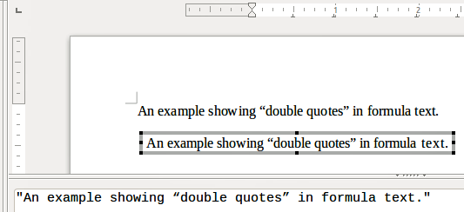Figure 6: Example of double quotes in formula text
Formatting commands are not interpreted within text used in formulas. If you want to use formatting commands within formula text, then you must break up the text using double quotes in the Formula Editor.
Příklad
Enter the following in the Formula Editor:
"In " color blue bold "isosceles" "triangles, the base angles are equal"
creates the following text in a formula

Aligning formulas using equals sign
LibreOffice Math does not have a command for aligning formulas on a particular character. However, you can use a matrix to align formulas on a character and this character is normally the equals sign (=).
Příklad
Creating the matrix:
matrix{ alignr x+y # {}={} # alignl 2 ## alignr x # {}={} # alignl 2-y }
gives the following result where formulas are aligned on the equals sign
- Poznámka
The empty braces each side of the equals sign are necessary because the equals sign is a binary operator and requires an expression on each side. You can use spaces, or ` or ~ characters each side of the equals sign, but braces are recommended as they are easier to see within the markup language.
You can reduce the spacing on each side of the equals sign if you change the inter-column spacing of the matrix. See “Adjusting formula spacing” on page 26 for information on how to adjust adjust formula spacing.

Changing formula appearance

Formula font size

Current formula font size
To change the font size used for a formula already inserted in Math or another LibreOffice module:
- Click in the markup language in the Formula Editor.
- Go to Format > Font size on the main menu bar to open the Font Sizes dialog (Figure 7).
- Select a different font size using the Base size spinner or type a new font size in the Base Size box.
- Click OK to save your changes and close the dialog. An example result when you change font size is shown below.
Příklad
Default font size 12pt:
After font size change to 18pt:
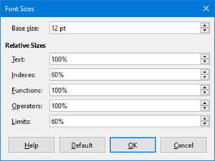Figure 7: Font Sizes dialog

Default formula font size
To change the default font size used for all formulas in Math or another LibreOffice module:
- Before inserting any formulas in your document, go to Format > Font size on the main menu bar to open the Font Sizes dialog (Figure 7).
- Select a different font size using the Base size spinner or type a new font size in the Base Size box.
- Click Default and confirm your changes to the base size font. Any formulas created from this point on will use the new base size font for formulas.
- Click OK to save your changes and close the Font Sizes dialog.
- Poznámka
If you have already inserted formulas into your document and you change the default font size, only formulas inserted after the change in default font size will use the new default settings. You have to individually change the font size of formulas already inserted if you want these formulas to use the same font size as the default settings.
- Tip
There is an extension “Formatting of all Math formulas”. It allows to change font name and font size for all or only for selected formulas in your document. You can download it from the official extension site: https://extensions.libreoffice.org/extensions/formatting-of-all-math-formulas

Font size options
The Font Sizes dialog (Figure 7) specifies the font sizes for your formula. Select a base size and all elements of the formula will be scaled in relation to this base.
- Base size – all elements of a formula are proportionally scaled to the base size. To change the base size, select or type in the desired point (pt) size. You can also use other units of measure or other metrics, which are then automatically converted to points.
- Relative Sizes – in this section, you can determine the relative sizes for each type of element with reference to the base size.
- Text – select the size for text in a formula relative to the base size.
- Indexes – select the relative size for the indexes in a formula in proportion to the base size.
- Functions – select the relative size for names and other function elements in a formula in proportion to the base size.
- Operators – select the relative size of the mathematical operators in a formula in proportion to the base size.
- Limits – select the relative size for the limits in a formula in proportion to the base size.
- Default – clicking this button saves any changes as a default for all new formulas. A confirmation message appears before saving any changes.

Formula fonts

Current formula fonts
To change the fonts used for the current formula in Math or another LibreOffice module:
- Click in the markup language in the Formula Editor.
- Go to Format > Fonts on the main menu bar to open the Fonts dialog (Figure 8).
- Select a new font for each the various options from the drop-down lists.
- If the font you want to use does not appear in the drop-down list, click Modify and select the option from the context menu to open a fonts dialog. Select the font you want to use and click OK to add it to the drop-down list for that option.
- Click OK to save your changes and close the Fonts dialog.
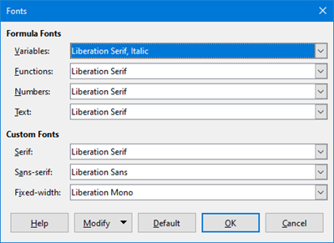Figure 8: Fonts Dialog

Default formula fonts
To change the default fonts used for all formulas in Math or another LibreOffice module:
- Before inserting any formulas in your document, go to Format > Fonts on the main menu bar to open the Fonts dialog (Figure 8).
- Select a new font for each the various options from the drop-down lists.
- If the font you want to use does not appear in the drop-down list, click Modify and select the option from the context menu to open a fonts dialog. Select the font you want to use and click OK to add it to the drop-down list for that option.
- Click Default and confirm your changes to the fonts. Any formulas created from this point on will use the new font for formulas.
- Click OK to save your changes and close the Fonts dialog.
- Poznámka
If you have already inserted formulas into your document and you change the default fonts, only formulas inserted after the change in default fonts will use the new default settings. You have to individually change the font of formulas already inserted if you want these formulas to use the same font as the default settings.

Formula font options
Defines the fonts that can be applied to formula elements.
- Formula Fonts – defines the fonts used for the variables, functions, numbers and inserted text that form the elements of a formula.
- Variables – selects the fonts for the variables in your formula. For example, in the formula x=SIN(y), x and y are variables and will reflect the assigned font.
- Functions – selects the fonts for names and properties of functions. For example, the functions in the formula x=SIN(y) are =SIN( ).
- Numbers – selects the fonts for the numbers in a formula.
- Text – defines the fonts for the text in a formula.
- Custom Fonts – in this section of the Fonts dialog (Figure 8), fonts are defined which format other text components in a formula. The three basic fonts Serif, Sans and Fixed are available. Other fonts can be added to each standard installed basic font using the Modify button. Every font installed on a computer system is available for use.
- Serif – specifies the font to be used for the font serif format. Serifs are the small "guides" that can be seen, for example, at the bottom of a capital A when the Times serif font is used. Using serifs is quite helpful since it guides the eye of a reader in a straight line and can speed up reading.
- Sans – specifies the font to be used for sans font formatting.
- Fixed – specifies the font to be used for fixed font formatting.
- Modify – click one of the options from the context menu to access the Fonts dialog, where the font and attributes can be defined for the respective formula and for custom fonts.
- Default – clicking this button saves any changes as a default for all new formulas. A confirmation message appears before saving any changes.
- Poznámka
When a new font is selected for a formula, the old font remains in the list alongside the new one and can be selected again.
- Poznámka
Variables should be written in italics, so make sure that the Italic option is selected. For the font you want to use. For all other elements, use the basic form of a font. The style can be easily altered in the formula itself by using the commands italic or bold to set these characteristics and nitalic or nbold to unset them.

Adjusting formula spacing
Use the Spacing dialog (Figure 9) to determine the spacing between formula elements. The spacing is specified as a percentage in relation to the defined base size for font sizes.
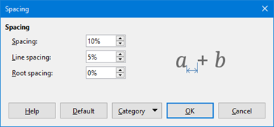Figure 9: Spacing Dialog

Current formula spacing
To change the spacing used for the current formula in Math or another LibreOffice module:
- Click in the markup language in the Formula Editor.
- Go to Format > Spacing on the main menu bar to open the Spacing dialog (Figure 9).
- Click Category and select one of the options from the drop-down list. The options in the Spacing dialog change according to the category selected.
- Enter new values for the spacing category and click OK.
- Check the result in your formula. If not to your satisfaction, repeat the above steps.

Default formula spacing
To change the default spacing used for all formulas in Math or another LibreOffice module:
- Before inserting any formulas in your document, go to Format > Spacing on the main menu bar to open the Spacing dialog (Figure 9).
- Click Category and select one of the options from the drop-down list. The options in the Spacing dialog change according to the category selected.
- Click Default and confirm your changes to the formula spacing. Any formulas created from this point on will use the new spacing for formulas.
- Click OK to save your changes and close the Spacing dialog.
- Poznámka
If you have already inserted formulas into your document and you change the spacing, only formulas inserted after the change in spacing will use the new default settings. You have to individually change the spacing of formulas already inserted if you want these formulas to use the same spacing as the default settings.

Spacing options
Use Category in the Spacing dialog (Figure 9) to determine the formula element for which you would like to specify the spacing. The appearance of the dialog depends on the selected category. A preview window shows you which spacing is modified through the respective boxes.
- Category – pressing this button allows you to select the category for which you would like to change the spacing.
- Spacing – defines the spacing between variables and operators, between lines, and between root signs and radicals.
- Line Spacing – determines the spacing between lines.
- Root Spacing – determines the spacing between the root sign and radicals.
- Indexes – defines the spacing for superscript and subscript indexes.
- Superscript – determines the spacing for superscript indexes.
- Subscript – determines the spacing for subscript indexes.
- Fractions – defines the spacing between the fraction bar and the numerator or denominator.
- Numerator – determines the spacing between the fraction bar and the numerator.
- Denominator – determines the spacing between the fraction bar and the denominator.
- Fraction Bars – defines the excess length and line weight of the fraction bar.
- Excess length – determines the excess length of the fraction line.
- Weight – determines the weight of the fraction line.
- Limits – defines the spacing between the sum symbol and the limit conditions.
- Upper limit – determines the spacing between the sum symbol and the upper limit.
- Lower limit – determines the spacing between the sum symbol and the lower limit.
- Brackets – defines the spacing between brackets and the content.
- Excess size (left/right) – determines the vertical distance between the upper edge of the contents and the upper end of the brackets.
- Spacing – determines the horizontal distance between the contents and the upper end of the brackets.
- Scale all brackets – scales all types of brackets. If you then enter ( a over b) in the Formula Editor, the brackets will surround the whole height of the argument. You normally achieve this effect by entering left ( a over b right ).
- Excess size – adjusts the percentage excess size. At 0% the brackets are set so that they surround the argument at the same height. The higher the entered value is, the larger the vertical gap between the contents of the brackets and the external border of the brackets. The field can only be used in combination with Scale all brackets.
- Matrices – defines the relative spacing for the elements in a matrix.
- Line spacing – determines the spacing between matrix elements in a row.
- Column spacing – determines the spacing between matrix elements in a column.
- Symbols – defines the spacing of symbols in relation to variables
- Primary height – defines the height of the symbols in relation to the baseline.
- Minimum spacing – determines the minimum distance between a symbol and variable.
- Operators – defines the spacing between operators and variables or numbers.
- Excess size – determines the height from the variable to the operator upper edge.
- Spacing – determines the horizontal distance between operators and variables.
- Borders – adds a border to a formula. This option is particularly useful if you want to integrate the formula into a text file in LibreOffice Writer. When making settings, make sure that you do not use 0 as a size as this creates viewing problems for text that surrounds the insertion point.
- Left – the left border is positioned between the formula and background.
- Right – the right border is positioned between the formula and background.
- Top – the top border is positioned between the formula and background.
- Bottom – the bottom border is positioned between the formula and background.
- Preview Field – displays a preview of the current selection.
- Default – saves any changes as default settings for all new formulas. A security response will appear before saving these changes.

Adjusting formula alignment
The alignment settings determine how formula elements located above one another are aligned horizontally relative to each other.
- Poznámka
It is not possible to align formulas on a particular character and formula alignment does not apply to text elements. Text elements are always aligned left.
- Poznámka
Independent of using formula alignment given below, it is possible to align formulas using the commands alignl, alignc and alignr. These commands also work for text elements.

Current formula alignment
To change the alignment used for the current formula in Math or another LibreOffice module:
- Click in the markup language in the Formula Editor.
- Go to Format > Alignment on the main menu bar to open the Alignment dialog (Figure 10).
- Select either Left, Centered, or Right for horizontal alignment.
- Click OK and check the result in your formula. If not to your satisfaction, repeat the above steps.
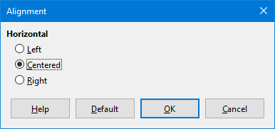Figure 10: Alignment Dialog

Default formula alignment
To change the default alignment used for all formulas in Math or another LibreOffice module:
- Before inserting any formulas in your document, go to Format > Alignment on the main menu bar to open the Alignment dialog (Figure 10).
- Select either Left, Centered, or Right for horizontal alignment.
- Click Default and confirm your changes to the formula alignment. Any formulas created from this point on will use the new alignment for formulas.
- Click OK and check the result in your formula. If not to your satisfaction, repeat the above steps.
- Poznámka
If you have already inserted formulas into your document and you change the formula alignment, only formulas inserted after the change in alignment will use the new default settings. You have to individually change the alignment of formulas already inserted if you want these formulas to use the same alignment as the default settings.

Changing formula color

Character color
Formula color for the characters used in a formula is changed by using the command color in the mark up language. This command only works on the formula element immediately after the color name. For example, entering the markup language color red ABC 5 times 4 gives the result .
To change the color of the whole formula, you have to enclose the whole formula within brackets. For example, entering the markup language color red {ABC 5 times 4} gives the result.
For information on the colors available in Math, see Appendix A Commands Reference.

Barva pozadí
It is not possible to select a background color for formulas in LibreOffice Math. The background color for a formula is by default the same color as the document or frame that the formula has been inserted into. However, in LibreOffice documents, you can use object properties to change the background color for a formula. For more information on using a background color (area fill for objects) with a formula, please refer to the user guides for Writer, Calc, Draw and Impress.

Formula library
If you regularly insert the same formulas into your documents, you can create a formula library using formulas that you have created using the Formula Editor. Individual formulas can be saved as separate files using the ODF format for formulas with the file suffix of .odf, or in MathML format with the file suffix of .mml.
You can use either LibreOffice Math, Writer, Calc, Draw, or Impress to create formulas and build up your formula library.

Using Math
- Create a folder on your computer to contain your formulas and give the folder a memorable name, for example Formula Library.
- In LibreOffice, go to File > New > Formula on the main menu bar, or click on Math Formula in the opening splash screen to open LibreOffice Math and create your formula using the Formula Editor. See “Formulas as separate documents or files” on Page 10 for more information.
- Go to File > Save As on the main main menu bar or use the keyboard shortcut Ctrl+Shift+S to open a Save As dialog.
- Navigate to the folder you have created for your formula library.
- Type in a memorable name for your formula in the File name text box.
- Select from the drop-down list for File type either ODF Formula (.odf) or MathML 1.01 (.mml) as the file type for your formula.
- Click Save to save your formula and close the Save As dialog.

Using Writer, Calc, Draw, or Impress
- Create a folder on your computer to contain your formulas and give the folder a memorable name, for example Formula Library.
- Open a document using Writer, Calc, Draw, or Impress.
- Go to Insert > Object > Formula on the main menu bar to open the Formula Editor and create your formula. See “Formulas in LibreOffice documents” on page 11 for more information.
- Right-click on your formula object and select Save Copy as from the context menu to open a Save As dialog.
- Navigate to the folder you have created for your formula library.
- Type in a memorable name for your formula in the File name text box.
- Select from the drop-down list for File type either ODF Formula (.odf) or MathML 1.01 (.mml) as the file type for your formula.
- Click Save to save your formula and close the Save As dialog.

Using your formula library
You cannot insert a formula from your library into a document by dragging and dropping using the mouse, nor by using Insert > File on the main menu bar. You must insert a formula from your library into your document as an OLE object.
- Open your document in Writer, Calc, Draw, or Impress.
- Go to Insert > Object > OLE Object on the main menu bar to open the Insert OLE Object dialog.
- Select the option Create from file.
- Click Search to open your file browser dialog.
- Navigate to the folder you have created for your formula library.
- Select the formula you want to insert and click Open, or double-click on the formula you want to insert.
- Click OK to insert your formula as an OLE object in your document and close the OLE Object dialog.

Math Guide

Chapter 2
Formulas in Writer

Úvod
When a formula is inserted into a document, LibreOffice Writer inserts the formula into a frame and treats the formula as an OLE object. Double-clicking on an inserted formula will open the Formula Editor in LibreOffice Math allowing you to edit the formula. For more information on creating and editing formulas, please refer to Chapter 1 Creating & Editing Formulas.
This chapter explains what options you can change for each individual formula within your Writer document. Please refer to the chapters on styles in the Writer Guide for information on how to change the default settings for frame styles for OLE objects.

Automatic formula numbering
Automatic numbering of formulas for cross reference purposes can only be carried out in LibreOffice Writer. The easiest way to add numbered formulas in sequence is to use the AutoText entry fn (for 'formula numbered').

Číslování
- Start a new line in your document.
- Type fn and then press the F3 key. A two column table with no borders is inserted into your document with the left column containing a sample formula and the right column containing a reference number, as shown below.
(1)
- Delete the sample formula and insert your formula as an object in the left column. See Chapter 1 Creating & Editing Formulas for more information on inserting formulas.
- Alternatively, you can first insert your formula into the document, then carry out Steps 1 and 2 above replacing the sample formula with your formula.
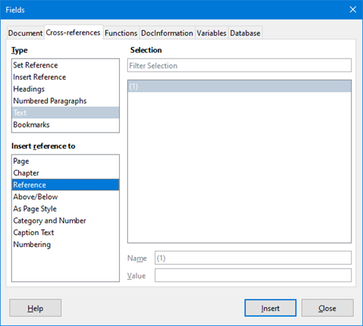Figure 11: Fields Dialog – Cross References Page

Cross referencing
- Click in your document where you want the cross reference to appear.
- Go to Insert > Cross-reference on the menu bar to open the Fields dialog (Figure 11).
- Click on the Cross-references tab, then select Text in the Type section.
- In the Selection section, select the formula number you want to refer to.
- In the Insert reference to section, select Reference and click Insert.
- When you have finished creating cross references, click Close to close the Fields dialog.
- Tip
To insert the cross reference number without parentheses, select Numbering instead of Reference in the Insert reference to section.
- Poznámka
If you want to use square parentheses instead of round ones, or if you want the cross reference number to be separated from the formula by tabs instead of using a table, then refer to the chapter on automatic text in the Writer Guide.

Anchoring formulas
A formula is treated as an object within Writer and its default anchoring is As character within a paragraph when it is inserted into a document. To change the anchoring of a formula object:
- Right-click on the selected formula object and select Anchor from the context menu.
- Select a new anchoring option from the context sub-menu. The anchoring positions available are To page, To paragraph, To character, or As character.
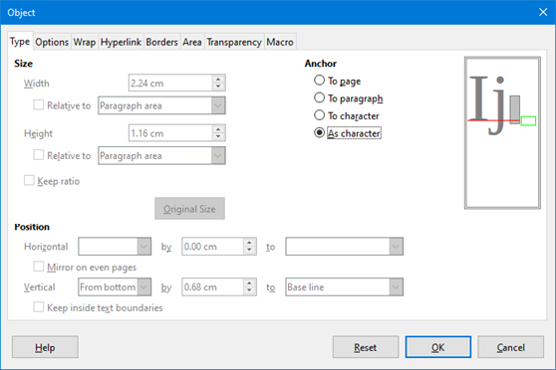Figure 12: Object dialog – Type tab with Anchor options
- Alternatively, right-click on the selected formula object and select Properties from the context menu, or go to Format > Frame and Object > Properties on the main menu bar to open the Object dialog (Figure 12).
- Make sure the Type tab is selected and select a new anchoring position from the Anchor section.
- Click OK to save your changes and close the Object dialog.
- Poznámka
The anchoring options are not available in the Object dialog when you are making changes to the various options available for frame styles. For more information on how to modify frame styles, please refer to the chapters on styles in the Writer Guide.

Vertical alignment
The normal default setting for vertical alignment for formula objects is to use the text base line as a reference. This default setting can be changed by modifying the formula frame style, see the chapters on styles in the Writer Guide for more information.
To change the vertical alignment position of an individual formula object:
- Right-click on the selected formula object and select Properties from the context menu, or go to Format > Frame and Object > Properties to open the Object dialog (Figure 12).
- Make sure the Type tab is selected and select a new alignment position from the drop-down list in the Position section. The vertical alignment options available are Top, Bottom, Center or From bottom.
- If necessary, type in the text box a plus or minus value for vertical alignment. This option is only available if From bottom vertical alignment has been selected.
- Select the type of text alignment from the drop-down list in the Position section. The text alignment options available are Base line, Character and Row.
- Click OK to save your changes and close the Object dialog.
- Poznámka
If the Position section in the Object dialog is greyed out and not available, then go to Tools > Options > LibreOffice Writer > Formatting Aids and uncheck the option Math baseline alignment. Toto nastavení se uloží spolu s dokumentem a vztahuje se na všechny vzorce, které se v něm nacházejí. Any new documents created will also use this setting for Math baseline alignment.

Object spacing
A formula object, when inserted into a Writer document, has spacing each side of the formula object. The default value used for spacing is set within the frame style for formula objects and can be changed by modifying the formula frame style, see the chapters on styles in the Writer Guide for more information.
You can individually adjust the spacing for each formula object within your document as follows:
- Create your formula in your Writer document.
- Right-click on your selected formula object and select Properties from the context menu, or go to Format > Frame and Object > Properties on the main menu bar to open the Object dialog.
- Click on the Wrap tab to open the Wrap page in the Object dialog (Figure 13).
- In the Spacing section, enter the spacing value for Left, Right, Top and Bottom spacing.
- Click OK to save your changes and close the Object dialog.
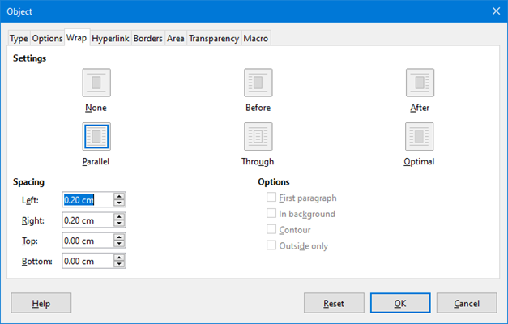Figure 13: Object dialog – Wrap tab

Textový režim
In large formulas placed within a line of text, the formula elements can often be higher than the text height. Therefore, to make large formulas easier to read, it is recommended to always insert large formulas into a separate paragraph of their own so that it is separated from text.
However, if it is necessary to place a large formula within a line of text, double-click on the formula to open the Formula Editor and then go to Format > Text Mode on the main menu bar. The Formula Editor will try to shrink the formula to fit the text height. The numerators and denominators of fractions are shrunk, and the limits of integrals and sums are placed beside the integral/sum sign, as shown in the following example.
Příklad
Vzorec v samostatném odstavci:

and the same formula embedded into a line of text using text mode format:

Background and borders
The default setting for background (area fill) and borders for formula objects is set by the formula frame style. To change this default setting for formula frame style, refer to the chapters on styles in the Writer Guide. However, for individual formulas in your document, you can change the background and borders.
- Poznámka
The size of the frame that a formula is placed in when inserted into a document cannot be changed. The frame size for a formula object depends on the setting of the formula font size, see Chapter 1 Creating & Editing Formulas for more information.

Backgrounds
- In your document, select the formula where you want to change the background.
- Right-click on the formula and select Properties from the context menu, or go to Format > Frame and Object > Properties on the main menu bar to open the object dialog.
- Click on the Area tab and select the type of fill you want to use for your formula from the Fill drop-down list (Figure 14).
- Select the options you want to use for your formula background. The options change depending on the type of fill selected.
- Click OK to save your changes and close the Object dialog.
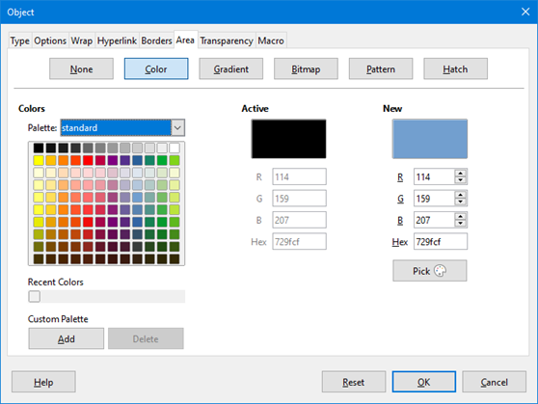Figure 14: Object dialog – Area tab

Borders
- In your document, select the formula where you want to change the borders.
- Right-click on the formula and select Properties from the context menu, or go to Format > Frame and Object > Properties on the main menu bar to open the object dialog.
- Click on the Borders tab and select the options you want to use for your formula borders (Figure 15).
- Click OK to save your changes and close the Object dialog.
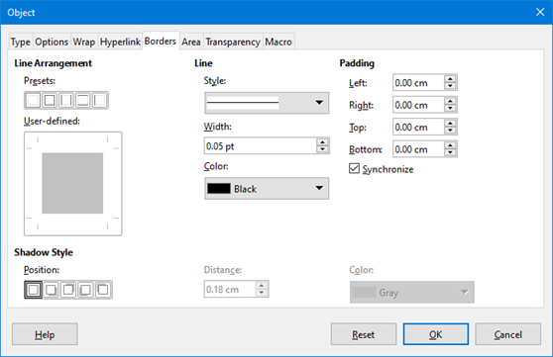Figure 15: Object dialog – Borders tab

Quick insertion of formulas
To quickly insert a formula into your Writer document without opening the Formula Editor and you know the markup language for the formula:
- Enter the formula markup language into your document at the position where you want the formula.
- Select the markup language.
- Go to Insert > Object on the main menu bar and select Formula to create a formula from the selected markup language.

Math Guide

Chapter 3
Formulas in Calc, Draw & Impress

Úvod
In Calc, Draw, and Impress, formulas are inserted as OLE objects without any background (area fill) or borders. See Chapter 1 Creating & Editing Formulas for more information on inserting formulas into a LibreOffice module.
Each formula object is inserted into a spreadsheet, drawing, or slide as follows:
- In Calc, formulas are inserted into a selected cell in a spreadsheet with no style assigned to the formula object.
- In Draw and Impress, formulas are inserted into a central position on your drawing or slide and, by default, are assigned the drawing object style Object with no fill and no line. For more information on how to modify or assign drawing object styles, see the Draw User Guide or the Impress User Guide.

Anchoring formulas

Calc
A formula object can be anchored into your spreadsheet as To Page (default setting), or as To Cell. To change the anchoring type of formulas in a Calc spreadsheet:
- Select the formula object in your spreadsheet.
- Right-click on the formula and select Anchor > To Page or To Cell from the context menu
- Alternatively, go to Format > Anchor on the main menu bar and select To Page or To Cell.

Draw and Impress
When a formula is inserted into a drawing or slide, it is inserted as a floating OLE object and is not anchored to any particular position in a drawing or slide.

Formula object properties
Formula objects in Calc, Draw, and Impress can be modified just like any other object that has been placed in your spreadsheet, drawing, or presentation, with the exception of formula object size and changing the format of any text within a formula. For more information on how to change object properties, see the Calc User Guide, Draw User Guide and Impress User Guide. For more information on formula object size and formatting formula text, see Chapter 1 Creating & Editing Formulas in this guide.
The following points will help you select which dialog to use if you want to change the properties of formula objects.
- For formula backgrounds, use the various options in the tabs of the Area dialog.
- For formula borders, use the various options in the Line dialog. Note that formula borders are separate from cell borders in a Calc spreadsheet.
- To accurately re-position a formula object, use the various options in tabs of the Position and Size dialog.
- In Draw and Impress, you can arrange, align, group, flip, convert, break, combine, and edit points of formula objects.
- You cannot change the text attributes of a formula object. The text used in a formula is set when you create the formula in the Formula Editor.
- Formula object size is set by the formula font size when the formula is created in the Formula Editor. The formula object size is protected in the Position and Size dialog, but this can be deselected if you so wish. However, this is not recommended as resizing a formula object using the Position and Size dialog could lead to distortion of a formula making it difficult to read.

Formulas in charts
A chart in a Calc spreadsheet is itself an OLE object, therefore, you cannot use the Formula Editor to create and insert a formula into a chart.
To insert a formula into a chart, create the formula first using the Formula Editor and copy the formula to the clipboard. You then create your chart in Calc and paste the formula into your chart. The formula is automatically converted into the correct format for insertion into a chart.
If you want to change the formula at a later date, then you must repeat the whole process of creating, copying, and pasting.

Math Guide

Chapter 4
Customization

Úvod
This chapter explains how you can customize LibreOffice Math to suit the way you create formulas for use in LibreOffice documents. Also, refer to the Getting Started Guide for information on how to customize LibreOffice.

Chemical formulas
The primary purpose of Math is to create mathematical formulas, but it can also be used to write chemical formulas. However, in chemical formulas, the chemical symbols are normally written in uppercase using non-italic characters. The following table shows some examples of chemical formulas.
Struktura | Příklad | Markup Language
Molekuly |  | H_2 SO_4
Izotopy |  | U lsub 92 lsup 238
Ióny | or | SO_4^{2-{}} or SO_4^{2"-"}
To create chemical formulas using Math, you have to change the font used for variables to a non-italic font. For more information on how to change fonts in a formula, see Chapter 1 Creating & Editing Formulas.
For reversible reactions in chemical formulas, there is no symbol you can use for a double arrow in Math. If you have a font available with correct symbols for use in chemical formulas, then you can add these symbols to the Catalog. See “Catalog customization” on page 47 for more information on how to add symbols to the Catalog.

Floating dialogs
The Formula Editor and Elements Dock can cover a large part of your document. To help create more space and/or allow you to move either the Formula Editor or Elements Dock out of the way, you turn both of them into floating dialogs.
- Position the cursor on the frame.
- Hold down the Ctrl key and double-click. This turns the Formula Editor into the Commands dialog (Figure 16) and the Elements Dock into the Elements Dock dialog (Figure 17).
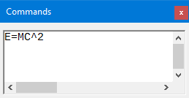Figure 16: Commands dialog
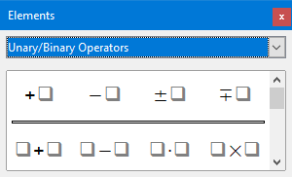Figure 17: Elements dialog
To return the Commands dialog and Elements Dock dialog back to their default positions:
- Position the cursor on the frame of the dialog, NOT the title bar at the top of the of the dialog.
- Hold down the Ctrl key and double-click.

Adding keyboard shortcuts
You can add keyboard shortcuts to LibreOffice to make creating documents much easier and to match your workflow. Below is an example of how to add a keyboard shortcut for inserting a Math formula into a LibreOffice document.
- Poznámka
When selecting new keyboards shortcuts, make sure that you do not select a keyboard shortcut that is already in use by LibreOffice or your computer system. For example, the keyboard combination Shift+Ctrl+F2 in Calc moves the cursor to the input line where you can enter a Calc formula in the selected cell, NOT a Math formula.

Example keyboard shortcut
- Go to Tools > Customize on the main menu bar to open the Customize dialog (Figure 18).
- Click on the Keyboard tab to access the options available for adding keyboard shortcuts.
- Select the level of the new keyboard shortcut.
- Select LibreOffice so that the new keyboard shortcut can be used in all modules of LibreOffice.
- Select Math to use the new keyboard shortcut in Math only.
- In the Category list, select Insert.
- In the Function list, select Import Formula.
- In the Shortcut Keys list, select the key or keyboard combination that you want to use for your new keyboard shortcut.
- Click Modify and your keyboard shortcut will appear in the Keys list.
- If necessary, continue to add keyboard shortcuts using the above steps.
- Click OK to save your keyboard shortcuts and close the Customize dialog.
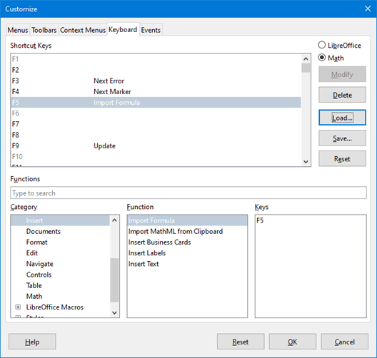Figure 18: Customize dialog – Keyboard tab

Keyboard customize options
The options for customizing keyboard shortcuts are as follows:
- LibreOffice – displays shortcut keys that are common to all LibreOffice modules.
- Math, Writer, Calc, Draw, or Impress – displays the keyboard shortcuts for the open and current LibreOffice module.
- Shortcut Keys – lists the shortcut keys and the associated commands. To assign or modify the shortcut key for the command selected in the Function list, click a shortcut in this list, and then click Modify.
- Functions – type function name in the text field for search it in Function list.
- Function – lists the function categories and the LibreOffice functions that you can assign shortcut keys to.
- Category – lists the available function categories.
- Function – select a function that you want to assign a shortcut key to, select a key combination in the Shortcut Keys list, and then click Modify. If the selected function already has a shortcut key, it is displayed in the Keys list.
- Keys – displays the shortcut keys that are assigned to the selected function.
- Modify – assigns the key combination selected in the Shortcut Keys list to the command selected in the Function list.
- Delete – deletes the selected element or elements without requiring confirmation.
- Load – replaces the shortcut key configuration with one that was previously saved.
- Save – saves the current shortcut key configuration, so that you can load it later.
- Reset – resets modified values back to the default values.

Catalog customization
If you regularly use a symbol that is not available in Math, you can add it to the Symbols dialog (Figure 19) by opening the Edit Symbols dialog (Figure 20).
Using the Edit Symbols dialog you can add symbols to a symbol set, edit symbol sets, or modify symbol notations. You can also define new symbol sets, assign names to symbols, or modify existing symbol sets.

Adding symbols
- Go to Tools > Symbols on the main menu bar or click on the Symbols icon in the Tools toolbar to open the Symbols dialog.
- Click the Edit button to open Edit Symbols dialog.
- Select a font from the Font: drop-down list.
- Select a symbol character that you want to add from the preview box. You may have to scroll down in the preview box to locate the symbol you want to use. The right preview box above the Add button displays the new symbol.
- In the Symbol: box, type a memorable name for the symbol you are adding.
- In the Symbol set: box, select a symbol set from the drop-down list to add your new symbol to, or type a new name to create a new symbol set for your new symbol.
- If required, select a font style from the Style: drop-down list – Standard, Italic, Bold, or Bold Italic.
- Click Add, then click OK to close the Edit Symbols dialog. The new symbol and, if created, new symbol set are now available for use.
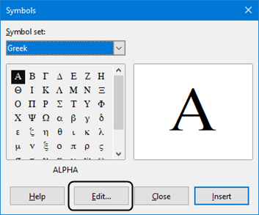Figure 19: Symbol dialog
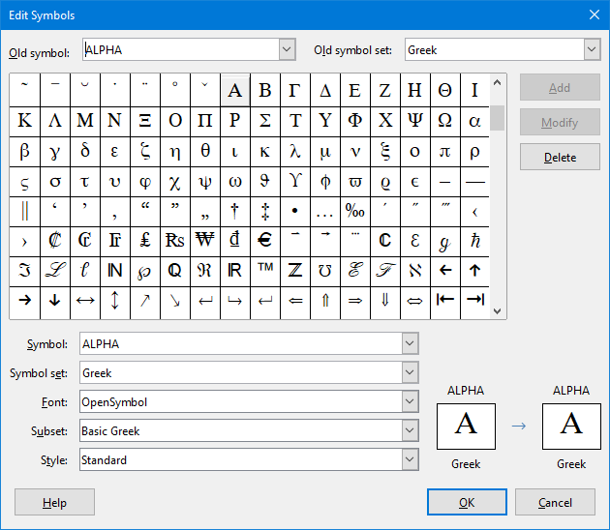Figure 20: The Edit Symbols dialog
- Poznámka
When a new symbol is added to the catalog, you can type a percentage sign (%) followed by the new name into the markup language in the Formula Editor and your new symbol will appear in your formula. Remember that symbol names are case sensitive, for example, %prime is a different symbol to %Prime.
- Poznámka
There are numerous free fonts available that contain several symbols if you cannot find a symbol to use in the fonts already installed on your computer. For example, the STIX font was developed specially for writing mathematical and technical texts. Also, the DejaVu and Lucida fonts have a wide range of symbols that you can use.
- Poznámka
When LibreOffice is installed on a computer, only those user-defined symbols that actually occur in the document are stored with it. Sometimes it is useful to embed all the user-defined symbols, so that when the document is transferred to another computer it can be edited by another person. Go to Tools > Options > LibreOffice Math > Settings, uncheck the option Embed only used symbols (smaller file size).This setting is only available when you are working with LibreOffice Math.

Editing symbols

Modifying symbol names
You can change the name of a symbol as follows:
- Select the symbol name you want to change from the Old symbol: drop-down list. The symbol appears in the left preview pane at the bottom of the Edit Symbols dialog (Figure 20).
- Type a new name for the symbol in the Symbol: text box, or select a new name from the Symbol: drop-down list. The new symbol name appears above the right preview pane at the bottom of the Edit Symbols dialog.
- Click Modify and the symbol name is changed.
- Click OK to close the Edit Symbols dialog.

Moving symbols
You can move a symbol from one symbol set to another as follows:
- In the Old symbol set: drop-down list, select the symbol set where the symbol you want to move is located.
- Select the symbol name you want move from the Old symbol: drop-down list. The symbol appears in the left preview pane at the bottom of the Edit Symbols dialog (Figure 20).
- In the Symbol set: drop-down list, select the symbol set that you want to move the symbol to. The new symbol set name appears below the right preview pane at the bottom of the Edit Symbols dialog.
- Click Modify and the symbol is moved to the new symbol set.
- Click OK to close the Edit Symbols dialog.

Deleting symbols
You can delete a symbol from a symbol set as follows:
- In the Old symbol set: drop-down list, select the symbol set from which you want to delete the symbol.
- Select the symbol name you want delete from the Old symbol: drop-down list. The symbol appears in the left preview pane at the bottom of the Edit Symbols dialog (Figure 20).
- Click Delete and the symbol is deleted from the symbol set without any confirmation.
- Click OK to close the Edit Symbols dialog.
- Poznámka
The only way you can delete a symbol set is by deleting all of the symbols in that set. When you delete the last symbol from a set, the set is also deleted.

Options for editing symbols
- Old symbol – select the name of the current symbol. The symbol, the name of the symbol, and the set that the symbol belongs to are displayed in the left preview pane at the bottom of the Edit Symbols dialog.
- Old symbol set – this list box contains the name of the current symbol set. You can also select a different symbol set using this list box.
- Symbol – lists the names for the symbols in the current symbol set. Select a name from the list or type a name for a newly added symbol.
- Symbol set – this list box contains the names of all existing symbol sets. You can modify a symbol set or create a new one.
- Font – displays the name of the current font and enables you to select a different font.
- Subset – if you selected a non-symbol font in the Font list box, you can select a Unicode subset in which to place your new or edited symbol. When a subset has been selected, all symbols belonging to this subset of the current symbol set are displayed in the Symbol list.
- Style – the current style of font is displayed. You can change the font style by selecting one from the list box.
- Add – click this button to add the symbol shown in the right preview window to the current symbol set. It will be saved under the name displayed in the Symbol list. You must specify a name under Symbol or Symbol set to be able to use the Add button. Names cannot be used more than once.
- Modify – click this button to replace the name of the symbol shown in the left preview window (the old name is displayed in the Old symbol list) with the new name you have entered in the Symbol list.
- Delete – click this button to remove the symbol shown in the left preview window from the current symbol set. There will be confirmation of deletion. Deleting the last remaining symbol of a symbol set also deletes the symbol set.
- Cancel – click this button at any time to close the dialog without saving any of the changes.

Formula spacing
The grave accent (`) inserts an additional small space and the tilde (~) inserts an additional large space into formulas. However, in the basic installation of LibreOffice, these symbols are ignored when they occur at the end of a formula. If you are working with running text in a formula, it may be necessary to include spacing at the end of formulas as well. This customization is only required when you are working with a Math document and is not required when you are inserting a formula into another LibreOffice module.
To add spacing at the end of formula in Math, go to Tools > Options > LibreOffice Math > Settings on the main menu bar and uncheck Ignore ~ and ` at the end of the line in the Miscellaneous Options section.

Rozšíření
If you create formulas frequently in your documents, you can customize LibreOffice by adding extensions that are designed to help you create formulas. Extensions are easily installed using the Extension Manager. For more information on how to install extensions, see the Getting Started Guide.
One extension that is recommended for installation is Dmaths. This extension is designed for use in Writer and adds a mathematical macro package providing five toolbars for creating formulas. For more information on this extension, go to the website http://www.dmaths.org.
Second extension that is recommended for installation is Formatting of All Math Formulas. It allows to format all Math formulas in your Writer, Calc, Draw or Impress document. You'll can change font and font size for all formulas or only for selected formulas. For more information on this extension go to https://extensions.libreoffice.org/extensions/formatting-of-all-math-formulas.

Math Guide

Chapter 5
Exporting & Importing

Math ML format
In addition to exporting documents as PDFs, as described in the Getting Started Guide, LibreOffice offers the possibility of exporting formulas in the MathML format. This allows you or another person to insert formulas into documents that were created in other software, for example, Microsoft Office or an internet browser.
- Poznámka
Some internet browsers do not fully support the MathML format and your formula may not display correctly.
If you are working on a Math document, go to File > Save as on the main menu bar or use the keyboard combination Ctrl+Shift+S to open the Save as dialog. Select MathML from the list of available file formats in File type: to save your formula as MathML.
If you are working in another LibreOffice module, right-click on the formula object and select Save copy as from the context menu to open the Save as dialog. Select MathML from the list of available file formats in File type: to save your formula object as MathML.
In the Math you can import MathML formula also. Use main menu Tools > Import MathML from clipboard for this.

Microsoft file formats
To control how formulas in Microsoft format are imported and exported using LibreOffice, go to Tools > Options > Load/Save > Microsoft Office on the main menu bar and select or deselect the options for MathType to LibreOffice Math or reverse.
- [L]: Load and convert the object
- [S]: Convert and save the object

[L]: Load and convert the object
Select this option if Microsoft OLE objects are to be converted into the specified LibreOffice OLE object when a Microsoft document is opened in LibreOffice. For formulas, any embedded MathType objects must not exceed the MathType 3.1 specifications to be successfully loaded and converted. Information on MathType format can be found on the website http://www.dessci.com/en.
If a document containing OMML formulas has been saved in .docx format and then converted to the older .doc format, then any OMML objects are converted into graphics, which will be displayed in LibreOffice as graphics.

[S]: Convert and save the object
Select this option if LibreOffice OLE objects are to be converted and saved in Microsoft file format. LibreOffice converts any formulas into a format that can be read and modified by Microsoft Equation Editor and MathType.
When this option is not selected, the formula is treated as an OLE object on conversion into a .doc format and remains linked to LibreOffice. A double-click on the object in Microsoft Office will attempt to launch LibreOffice.

Math Guide

Appendix A
Commands Reference

Úvod
This appendix lists all the operators and commands that are available for use in the Formula Editor when you are creating your formulas.
The more common operators and commands can be entered by clicking on the appropriate icon in the Elements Dock. Where there is no icon displayed in the following tables for the Elements Dock, then you have to enter the operator or command into the Formula Editor using markup language.
- Poznámka
In the markup language shown in the following tables, you have to replace the place holder <?> with the value you want to use in your formulas.

Unary/binary operator commands
To access the icons used for entering markup language for unary/binary operator commands into the Formula Editor, select Unary/Binary Operators from the drop-down list at the top of the Elements Dock.
Operation | Markup language | Example formula
Plus | +
Minus | -
Plus/minus | +- or plusminus
Minus/plus | -+ or minusplus
Addition | <?> + <?>
Subtraction | <?> - <?>
Multiplication (Dot) | <?> cdot <?>
Multiplication | <?> times <?>
Multiplication (*) | <?> * <?>
Division (Fraction) | {<?>} over {<?>}
Division | <?> div <?>
Division (Slash) | <?> / <?> or <?> slash <?>
Division (Wideslash) | {<?>} wideslash {<?>}
Division (Counter Wideslash) | <?> widebslash <?>
Concatenate | <?> circ <?>
Boolean NOT | neg <?>
Boolean AND | <?> and <?> or <?> & <?>
Boolean OR | <?> or <?>
Backslash | <?> bslash <?>
Slash in circle | <?> odivide <?>
Small multiply symbol in circle | <?> odot <?>
Subtract symbol in circle | <?> ominus <?>
Add symbol in circle | <?> oplus <?>
Multiply symbol in circle | <?> otimes <?>
User defined binary operator | <?> boper ????? <?>
User defined unary operator | <?> uoper ????? <?>

Relation commands
To access the icons used for entering markup language for relations commands into the Formula Editor, select Relations from the drop-down list at the top of the Elements Dock.
Operation | Markup language | Example formula
Is equal | <?> = <?>
Is not equal | <?> <> <?> or <?> neq <?>
Is less than | <?> < <?> or <?> lt <?>
Is less than or equal to | <?> <= <?>
Is less than or equal to | <?> leslant <?>
Is greater than | <?> > <?> or <?> gt <?>
Is greater than or equal to | <?> >= <?>
Is greater than or equal to | <?> geslant <?>
Is much less than | <?> << <?> or <?> ll <?>
Is much greater than | <?> >> <?> or <?> gg <?>
Is approximately equal | <?> approx <?>
Is similar to | <?> sim <?>
Is similar to or equal | <?> simeq <?>
Is congruent to | <?> equiv <?>
Is proportional to | <?> prop <?>
Is parallel to | <?> parallel <?>
Is orthogonal to | <?> ortho <?>
Divides | <?> divides <?>
Does not divide | <?> ndivides <?>
Toward | <?> toward <?>
Double arrow left | <?> dlarrow <?>
Double arrow left and right | <?> dlrarrow <?>
Double arrow right | <?> drarrow <?>
Precedes | <?> prec <?>
Succeeds | <?> succ <?>
Precedes or equal to | <?> preccurlyeq <?>
Succeeds or equal to | <?> succcurlyeq <?>
Precedes or equivalent to | <?> precsim <?>
Succeeds or equivalent to | <?> succsim <?>
Not precedes | <?> nprec <?>
Not succeeds | <?> nsucc <?>
Definition | <?> def <?>
Corresponding symbol image of | <?> transl <?>
Corresponding symbol original of | <?> transr <?>

Set operation commands
To access the icons used for entering markup language for set operation commands into the Formula Editor, select Set Operations from the drop-down list at the top of the Elements Dock.
Operation | Markup language | Example formula
Is in | <?> in <?>
Is not in | <?> notin <?>
Owns | <?> owns <?> or <?> ni <?>
Intersection | <?> intersection <?>
Union | <?> union <?>
Difference | <?> setminus <?> or  <?> bslash <?>
Quotient set (slash) between characters | <?> slash <?>
Subset | <?> subset <?>
Subset or equal to | <?> subseteq <?>
Superset | <?> supset <?>
Superset or equal to | <?> supseteq <?>
Not subset | <?> nsubset <?>
Not subset or equal to | <?> nsubseteq <?>
Not superset | <?> nsupset <?>
Not superset or equal to | <?> nsupseteq <?>
Empty set | emptyset
Aleph (cardinal numbers) | aleph
Natural numbers set | setN
Integers set | setZ
Set of rational numbers | setQ
Real numbers set | setR
Complex numbers set | setC

Funkce
To access the icons used for entering markup language for function commands into the Formula Editor, select Functions from the drop-down list at the top of the Elements Dock.
Operation | Markup language | Example formula
Absolute value | abs{<?>}
Factorial | fact{<?>}
Square root | sqrt{<?>}
Nth root | nroot{<?>}{<?>}
Power | <?>^{<?>}
Natural exponential function | func e^{<?>}
Natural logarithm | ln(<?>)
Exponential function | exp(<?>)
Logarithm | log(<?>)
Sine | sin(<?>)
Cosine | cos(<?>)
Tangent | tan(<?>)
Cotangent | cot(<?>)
Hyperbolic sine | sinh(<?>)
Hyperbolic cosine | cosh(<?>)
Hyperbolic tangent | tanh(<?>)
Hyperbolic cotangent | coth(<?>)
Inverse sine or arcsine | arcsin(<?>)
Inverse cosine or arccosine | arccos(<?>)
Inverse tangent or arctangent | arctan(<?>)
Inverse cotangent or arccotangent | arccot(<?>)
Inverse or area hyperbolic sine | arsinh(<?>)
Inverse or area hyperbolic cosine | arcosh(<?>)
Inverse or area hyperbolic tangent | artanh(<?>)
Inverse or area hyperbolic cotangent | arcoth(<?>)
Back epsilon | backepsilon
Dolní index | <?> sub <?>

Operátory
To access the icons used for entering markup language for operator commands into the Formula Editor, select Operators from the drop-down list at the top of the Elements Dock.
Operation | Markup language | Example formula
Limes | lim <?>
Limes subscript bottom | lim from{<?>} <?>
Limes superscript top | lim to{<?>} <?>
Limes sup/sub script | lim from{<?>} to{<?>} <?>
Limes inferior | liminf <?>
Limes superior | limsup <?>
Sum | sum <?>
Sum subscript bottom | sum from{<?>} <?>
Sum superscript top | sum to{<?>} <?>
Sum sup/sub script | sum from{<?>} to{<?>} <?>
Product | prod <?>
Product subscript bottom | prod from{<?>} <?>
Product superscript top | prod to{<?>} <?>
Product sup/sub script | prod from{<?>} to{<?>} <?>
Coproduct | coprod <?>
Coproduct subscript bottom | coprod from{<?>} <?>
Coproduct superscript top | coprod to{<?>} <?>
Coproduct sup/sub script | coprod from{<?>} to{<?>} <?>
Integral | int <?>
Integral subscript bottom | int from{<?>} <?>
Integral superscript top | int to{<?>} <?>
Integral sup/sub script | int from{<?>} to{<?>} <?>
Double integral | iint <?>
Double integral subscript bottom | iint from{<?>} <?>
Double integral superscript top | iint to{<?>} <?>
Double integral sup/sub script | iint from{<?>} to{<?>} <?>
Triple integral | iiint <?>
Triple integral subscript bottom | iiint from{<?>} <?>
Triple integral superscript top | iiint to{<?>} <?>
Triple integral sup/sub script | iiint from{<?>} to{<?>}  <?>
Curve integral | lint <?>
Curve integral subscript bottom | lint from{<?>} <?>
Curve integral superscript top | lint to{<?>} <?>
Curve integral sup/sub script | lint from{<?>} to{<?>} <?>
Double curve integral | llint <?>
Double curve integral subscript bottom | llint from{<?>} <?>
Double curve integral superscript top | llint to{<?>} <?>
Double curve integral sup/sub script | llint from{<?>} to{<?>}  <?>
Triple curve integral | lllint <?>
Triple curve integral subscript bottom | lllint from{<?>} <?>
Triple curve integral superscript top | lllint to{<?>} <?>
Triple curve integral sup/sub script | lllint from{<?>} to{<?>} <?>

- Poznámka
For customized operators, use the command oper followed by your custom operator. For example, entering oper OP from 0 to 1 A will give the formula.

Atributy
To access the icons used for entering markup language for attribute commands into the Formula Editor, select Attributes from the drop-down list at the top of the Elements Dock, or click the Attributes icon in the Elements dialog.
Operation | Markup language | Example formula
Acute accent | acute <?>
Grave accent | grave <?>
Breve | breve <?>
Circle | circle <?>
Dot | dot <?>
Double dot | ddot <?>
Triple dot | dddot <?>
Line above | bar <?>
Vector arrow | vec <?>
Harpoon | harpoon <?>
Tilde | tilde <?>
Circumflex | hat <?>
Reverse circumflex | check <?>
Large vector arrow | widevec {<?>}
Large harpoon arrow | wideharpoon <?>
Large tilde | widetilde {<?>}
Large circumflex | widehat {<?>}
Line over | overline {<?>}
Line below | underline {<?>}
Line through | overstrike {<?>}
Transparent (blank placeholder to create space) | phantom {<?>}
Bold font | bold <?>
Not bold font | nbold <?>
Italic font | ital <?> or italic <?>
Not italic font | nitalic <?>
Resize | size <?> {<?>}
Change font | font <?> {<?>}
Color black | color black {<?>}
Color blue | color blue {<?>}
Color green | color green {<?>}
Color red | color red {<?>}
Color cyan | color cyan {<?>}
Color magenta | color magenta {<?>}
Color yellow | color yellow {<?>}
Color gray | color gray {<?>}
Color lime | color lime {<?>}
Color maroon | color maroon {<?>}
Color navy | color navy {<?>}
Color olive | color olive {<?>}
Color purple | color purple {<?>}
Color silver | color silver {<?>}
Color teal | color teal {<?>}

- Poznámka
The font command changes the font type The first placeholder is replaced with the name of the font and the second placeholder is replaced with your formula values or text. The default fonts you can use are Serif, Sans, or Fixed. If you have added custom fonts to Math (see Chapter 1 Creating & Editing Formulas), then you can replace the first placeholder with the custom font name.

Závorky
To access the icons used for entering markup language for bracket commands into the Formula Editor, select Brackets from the drop-down list at the top of the Elements Dock.
Operation | Markup language | Example formula
Group brackets (not displayed in formula) | {<?>}
Round brackets | (<?>)
Left round bracket only | \(<?>
Right round bracket only | <?>\)
Square brackets | [<?>]
Left square bracket only | \[<?>
Right square bracket only | <?>\]
Double square brackets | ldbracket <?> rdbracket
Left double square bracket only | \ldbracket <?>
Right double square bracket only | <?> \rdbracket
Braces | lbrace <?> rbrace
Left brace only | \lbrace <?>
Right brace only | <?> \rbrace
Angle brackets | langle <?> rangle
Left angle bracket only | \langle <?>
Right angle bracket only | <?> \rangle
Operator brackets | langle <?> mline <?> rangle
Ceiling (upper half square brackets) | lceil <?> rceil
Left ceiling only | \lceil <?>
Right ceiling only | <?> \rceil
Floor (lower half square brackets) | lfloor <?> rfloor
Left floor only | \lfloor <?>
Right floor only | <?> \rfloor
Single lines | lline <?> rline
Left single line only | \lline <?>
Right single line only | <?> \rline
Double lines | ldline <?> rdline
Left double line only | \ldline <?>
Right double line only | <?> \rdline
Scalable round brackets | left ( <?> right )
Scalable left round bracket only | left ( <?> right none
Scalable right round bracket only | left none <?> right )
Scalable square brackets | left [ <?> right ]
Scalable left square bracket only | left [ <?> right none
Scalable right square bracket only | left none <?> right ]
Scalable double square brackets | left ldbracket <?> right rdbracket
Scalable left double square bracket only | left ldbracket <?> right none
Scalable right double square bracket only | left none <?> right rdbracket
Scalable braces | left lbrace <?> right rbrace
Scalable left brace only | left lbrace {<?>} right none
Scalable right brace only | left none {<?>} right rbrace
Scalable angle brackets | left langle <?> right rangle
Scalable left angle bracket only | left langle {<?>} right none
Scalable right angle bracket only | left none {<?>} right rangle
Scalable operator brackets | left langle <?> mline <?> right none
Scalable left operator bracket | left langle <?> mline <?> right none
Scalable right operator bracket | left none <?> mline <?> right rangle
Scalable ceiling (upper half square brackets) | left lceil <?> right rceil
Scalable left ceiling | left lceil <?> right none
Scalable right ceiling | left none <?> right rceil
Scalable floor (lower half square brackets) | left lfloor <?> right rfloor
Scalable left floor | left lfloor <?> right none
Scalable right floor | left none <?> right rfloor
Scalable single lines | left lline <?> right rline
Scalable left single line | left lline <?> right none
Scalable right single line | left none <?> right rline
Scalable double lines | left ldline <?> right rdline
Scalable left double line | left ldline <?> right none
Scalable right double line | left none <?> right rdline
Scalable top brace | {<?>} overbrace {<?>}
Scalable bottom brace | {<?>} underbrace {<?>}

Formáty
To access the icons used for entering markup language for format commands into the Formula Editor, select Formats from the drop-down list at the top of the Elements Dock.
Operation | Markup language | Example formula
Power (superscript right) | <?>^{<?>} or <?>sup{<?>} or  <?>rsup{<?>}
Subscript right | <?>_{<?>} or <?>sub{<?>} or  <?>rsub{<?>}
Superscript left | <?>lsup{<?>}
Subscript left | <?>lsub{<?>}
Superscript center | <?>csup{<?>}
Subscript center | <?>csub{<?>}
New line | newline
Small gap | `
Blank or large gap | ~
No space (suppresses space between elements) | nospace {<?>}
Align left | alignl <?>
Align center | alignc <?>
Align right | alignr <?>
Vertical stack (2 elements) | binom{<?>}{<?>}
Vertical stack (more than 2 elements) | stack{<?> # <?> # <?>}
Matrix stack | matrix{<?> # <?> ## <?> # <?>}

- Poznámka
By default, text characters are aligned to the center in a formula. Use the alignl and alignr commands to align text characters in a formula to the left or right when a formula has more than one line. You can also use the align commands in conjunction with the stack commands to align multi-line formulas on a specific formula element, for example, the equals sign (=).

Ostatní
To access the icons used for entering markup language for other commands into the Formula Editor, select Others from the drop-down list at the top of the Elements Dock, or click the Others icon in the Elements dialog.
Operation | Markup language | Example formula
Placeholder | <?>
Infinity | infinity or infty
Partial derivative or set margin | partial
Nabla vector operator | nabla
Existential quantifier, there is at least one | exists
Existential quantifier, there does not exist | notexists
Universal quantifier, for all | forall
H-bar constant | hbar
Lambda bar | lambdabar
Real part of a complex number | re
Imaginary part of a complex number | im
Weierstrass p function | wp
Left arrow | leftarrow
Right arrow | rightarrow
Up arrow | uparrow
Down arrow | downarrow
Výpustky | dotslow
Math axis ellipsis | dotsaxis
Vertical ellipsis | dotsvert
Upward diagonal ellipsis | dotsup or dotsdiag
Downward diagonal ellipsis | dotsdown
Back epsilon | backepsilon

Řecké znaky
Greek characters are normally entered into a formula using the Symbols dialog (see Chapter 1 Creating & Editing Formulas for more information). However, if you know the name of the Greek character, you can type a percentage sign (%) followed by the name of the Greek character into the Formula Editor.
For uppercase Greek characters, type the name using uppercase characters, for example %BETA (see Table 3 for a full list of uppercase Greek characters). For lowercase Greek characters, type the name using lowercase characters, for example %beta (see Table 4 for a full list of lowercase Greek characters)
Italic Greek characters can also be entered into a formula by typing the character i after the percentage sign (%) and before the name of the Greek character, for example, %iPI for uppercase and %ipi for lowercase . See Table 5 for a full list of italic uppercase Greek characters and Table 6 for a full list of italic lowercase Greek characters.
- Poznámka
In localized versions of LibreOffice, the names of Greek characters are also localized. If a document is not localized to the same language, then the names of Greek characters in the following tables may not work correctly. If this happens, you can use the Symbols dialog to select the required Greek character. When selected in the Symbols dialog, the name of the Greek character is displayed at the bottom of the Symbols dialog in the correct language. See Chapter 1 Creating & Editing Formulas for more information on Greek characters and the Symbols dialog.

Table 3: Uppercase Greek characters
%ALPHA |  | %BETA |  | %GAMMA |  | %DELTA
%EPSILON |  | %ZETA |  | %ETA |  | %THETA
%IOTA |  | %KAPPA |  | %LAMBDA |  | %MU
%NU |  | %XI |  | %OMICRON |  | %PI
%RHO |  | %SIGMA |  | %TAU |  | %UPSILON
%PHI |  | %CHI |  | %PSI |  | %OMEGA

Table 4: Lowercase Greek characters
%alpha |  | %beta |  | %gamma |  | %delta
%varepsilon |  | %zeta |  | %eta |  | %theta
%iota |  | %kappa |  | %lambda |  | %mu
%nu |  | %xi |  | %omicron |  | %pi
%rho |  | %varsigma |  | %sigma |  | %tau
%upsilon |  | %varphi |  | %chi |  | %psi
%omega |  | %vartheta |  | %phi |  | %varpi
%varrho |  | %epsilon

Table 5: Uppercase italic Greek characters
%iALPHA |  | %iBETA |  | %iGAMMA |  | %iDELTA
%iEPSILON |  | %iZETA |  | %iETA |  | %iTHETA
%iIOTA |  | %iKAPPA |  | %iLAMBDA |  | %iMU
%iNU |  | %iXI |  | %iOMICRON |  | %iPI
%iRHO |  | %iSIGMA |  | %iTAU |  | %iUPSILON
%iPHI |  | %iCHI |  | %iPSI |  | %iOMEGA

Table 6: Lowercase italic Greek characters
%ialpha |  | %ibeta |  | %igamma |  | %idelta
%ivarepsilon |  | %izeta |  | %ieta |  | %itheta
%iiota |  | %ikappa |  | %ilambda |  | %imu
%inu |  | %ixi |  | %iomicron |  | %ipi
%irho |  | %ivarsigma |  | %isigma |  | %itau
%iupsilon |  | %ivarphi |  | %ichi |  | %ipsi
%iomega |  | %ivartheta |  | %iphi |  | %ivarpi
%ivarrho |  | %iepsilon

Special characters
Special characters are normally entered into a formula using the Symbols dialog (see Chapter 1 Creating & Editing Formulas for more information). However, if you know the name of the special character, you can type a percentage sign (%) followed by the name of the special character into the Formula Editor. Table 7 Shows the full list of special characters that are available in LibreOffice.
- Poznámka
In localized versions of LibreOffice, the names of special characters are also localized. If a document is not localized to the same language, then the names of special characters in the following table may not work correctly. If this happens, you can use the Symbols dialog to select the required special character. When selected in the Symbols dialog, the name of the special character is displayed at the bottom of the Symbols dialog in the correct language. See Chapter 1 Creating & Editing Formulas for more information on special characters and the Symbols dialog.
Table 7: Special characters
%perthousand |  | %tendto |  | %element
%noelement |  | %infinite |  | %angle
%and |  | %or |  | %notequal
%identical |  | %strictlylessthan |  | %strictlygreaterthan

Reserved words
A reserved word is a word that is used by LibreOffice as a command in the Math markup language and it cannot be used as a variable name or entered into a formula as text. However, if you want to use a reserved word as text in a formula then you must place the reserved word between double quotes.
For example, you want to use the word “purple” in a formula, but do not want the formula elements to be changed to the color purple. If you simply type A purple B in the Formula Editor, the resulting formula is, which is incorrect and the error is shown by the upside question mark. To correct this error, type A "purple" B in the Formula Editor using double quotes each side of the word purple and the resulting correct formula is.
The reserved words used in Math are listed in the above tables for commands in markup language.

