
Getting Started Guide

Chapter 2
Setting up LibreOffice
Choosing Options to Suit the Way You Work

Copyright
This document is Copyright © 2010–2016 by the LibreOffice Documentation Team. Contributors are listed below. You may distribute it and/or modify it under the terms of either the GNU General Public License (http://www.gnu.org/licenses/gpl.html), version 3 or later, or the Creative Commons Attribution License (http://creativecommons.org/licenses/by/4.0/), version 4.0 or later.
All trademarks within this guide belong to their legitimate owners.

Contributors
Jean Hollis Weber | Olivier Hallot | Hazel Russman
John A Smith | Martin Saffron | Steve Schwettman
Ron Faile Jr.

Feedback
Please direct any comments or suggestions about this document to the Documentation Team’s mailing list: documentation@global.libreoffice.org
Note: Everything you send to a mailing list, including your email address and any other personal information that is written in the message, is publicly archived and cannot be deleted.

Acknowledgments
This chapter is revised and updated from Chapter 2 of Getting Started with OpenOffice.org 3.x. The contributors to that chapter are:
Jean Hollis Weber | Agnes Belzunce | Daniel Carrera
Peter Hillier-Brook | Stefan A. Keel | Michele Zarri

Publication date and software version
Published 17 May 2016. Based on LibreOffice 5.1.

Note for Mac users
Some keystrokes and menu items are different on a Mac from those used in Windows and Linux. The table below gives some common substitutions for the instructions in this chapter. For a more detailed list, see the application Help.
Windows or Linux | Mac equivalent | Effect
Tools > Options menu selection | LibreOffice > Preferences | Access setup options
Right-click | Control+click and/or right-click depending on computer setup | Open a context menu
Ctrl (Control) | ⌘ (Command) | Used with other keys
F5 | Shift+⌘+F5 | Open the Navigator
F11 | ⌘+T | Open the Styles and Formatting window

Contents
Copyright 2
Contributors 2
Feedback 2
Acknowledgments 2
Publication date and software version 2
Note for Mac users 2
Choosing options for all of LibreOffice 4
User Data options 4
General options 4
Memory options 5
View options 6
Print options 8
Paths options 9
Color options 10
Fonts options 11
Security options 12
Security options and warnings 14
Personalization 15
Application colors 15
Accessibility options 16
Advanced options 17
Basic IDE options 18
Online update options 18
OpenCL options 19
Choosing Load/Save options 20
General 20
VBA Properties 22
Microsoft Office 22
HTML compatibility 22
Choosing language settings 24
Install the required dictionaries 24
Change some locale and language settings 24
Choose spelling options 26
English sentence checking 27
Grammar checking 28
Punctuation 28
Others 28
Other languages sentence checking 29
Choosing Internet options 29
Controlling LibreOffice’s AutoCorrect functions 29

Choosing options for all of LibreOffice
This section covers some of the settings that apply to all the components of LibreOffice. For information on settings not discussed here, see the Help.
Click Tools > Options. The list in the left-hand box of the Options – LibreOffice dialog varies depending on which component of LibreOffice is open. The illustrations in this chapter show the list as it appears when a Writer document is open.
Click the marker (+ or triangle) by LibreOffice on the left-hand side. A list of pages drops down. Selecting an item in the list causes the right-hand side of the dialog to display the relevant page.
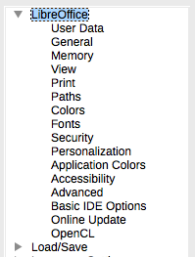
Figure 1: LibreOffice options
- Note
The Reset button, located in the lower right of the full Options dialog, has the same effect on all pages of the dialog. It resets the options to the values that were in place when you opened the dialog.
If you are using a version of LibreOffice other than US English, some field labels may be different from those shown in the illustrations.

User Data options
Because LibreOffice can use the name or initials stored in the LibreOffice – User Data page for several things – including document properties (‘created by’ and ‘last edited by’ information), the name of the author of comments and changes, and the sender address in mailing lists – you will want to ensure that the correct information appears here.
Fill in the form (not shown here), or amend or delete any existing information. If you do not want user data to be part of the document’s properties, clear the box at the bottom.

General options
The options on the LibreOffice – General page are described below Figure 2.
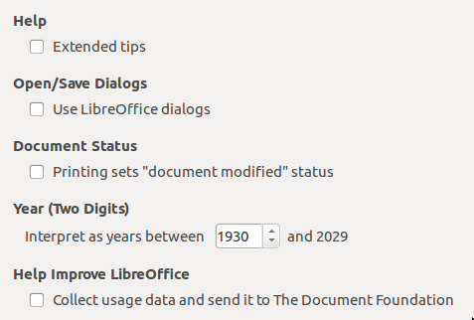
Figure 2: Setting general options for LibreOffice
Help – Extended tips
When Extended tips is active, a brief description of the function of a particular icon or menu command or a field on a dialog appears when you hold the mouse pointer over that item.
Open/Save Dialogs – Use LibreOffice dialogs
To use the standard Open and Save dialogs for your operating system, deselect the Use LibreOffice dialogs option. When this option is selected, the Open and Save dialogs supplied with LibreOffice will be used. See Chapter 1, Introducing LibreOffice, for more about the LibreOffice Open and Save dialogs. This book uses the LibreOffice Open and Save dialogs in illustrations.
Document status – Printing sets “document modified” status
If this option is selected, then the next time you close the document after printing, the print date is recorded in the document properties as a change and you will be prompted to save the document again, even if you did not make any other changes.
Year (two digits)
Specifies how two-digit years are interpreted. For example, if the two-digit year is set to 1930, and you enter a date of 1/1/30 or later into your document, the date is interpreted as 1/1/1930 or later. An “earlier” date is interpreted as being in the following century; that is, 1/1/20 is interpreted as 1/1/2020.
Help Improve LibreOffice – Collect usage data and send it to The Document Foundation
Send usage data to help The Document Foundation improve usability of the software. Data about usage patterns helps with identifying the most frequently used sequences of commands while performing common tasks; the developers can then design a user interface that is easier to use and more productive. The usage data is sent anonymously and carries no document contents, only the commands used.

Memory options
The options on the LibreOffice – Memory page control how LibreOffice uses your computer’s memory and how much memory it requires. Before changing them, you may wish to consider the following points:
- More memory can make LibreOffice faster and more convenient (for example, more undo steps require more memory); but the trade-off is less memory available for other applications and you could run out of memory altogether.
- If your documents contain a lot of objects such as images, or the objects are large, LibreOffice’s performance may improve if you increase the memory for LibreOffice or the memory per object. If you find that objects seem to disappear from a document that contains a lot of them, increase the number of objects in the cache. (The objects are still in the file even if you cannot see them on screen.)
- To load the Quickstarter when you start your computer, select the option near the bottom of the dialog. This makes LibreOffice start faster; the trade-off is LibreOffice uses some memory even when not being used. This option is called Enable systray quickstarter on Linux. It is not available on Mac OS X or on systems where the Quickstarter module has not been installed.
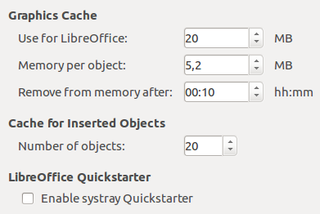
Figure 3: Choosing Memory options for the LibreOffice applications

View options
The options on the LibreOffice – View page affect the way the document window looks and behaves. Some of these options are described below Figure 4. Set them to suit your personal preferences.
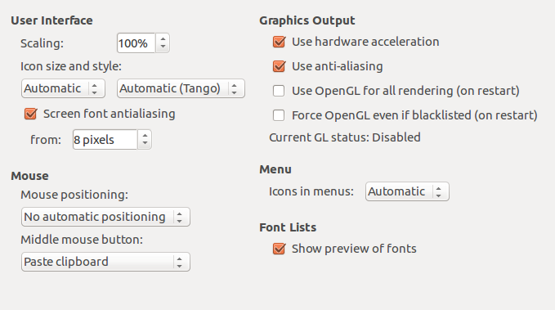
Figure 4: Choosing View options for LibreOffice applications
User Interface – Scaling
If the text in the help files or on the menus of the LibreOffice user interface is too small or too large, you can change it by specifying a scaling factor. Sometimes a change here can have unexpected results, depending on the screen fonts available on your system. However, it does not affect the actual font size of the text in your documents.
User Interface – Icon size and style
The first box specifies the display size of toolbar icons (Automatic, Small, or Large). The Automatic icon size option uses the setting for your operating system. The second box specifies the icon style (theme); here the Automatic option uses an icon set compatible with your operating system and choice of desktop: for example, KDE or Gnome on Linux.
User interface – Screen font anti-aliasing
(Not available in Windows.) Select this option to smooth the screen appearance of text. Enter the smallest font size to apply anti-aliasing.
Mouse positioning
Specifies if and how the mouse pointer will be positioned in newly opened dialogs.
Middle mouse button
Defines the function of the middle mouse button.
- Automatic scrolling – dragging while pressing the middle mouse button shifts the view.
- Paste clipboard – pressing the middle mouse button inserts the contents of the “Selection clipboard” at the cursor position.
The “Selection clipboard” is independent of the normal clipboard that you use by Edit > Copy/Cut/Paste or their respective keyboard shortcuts. Clipboard and “Selection clipboard” can contain different contents at the same time.
Function | Clipboard | Selection clipboard
Copy content | Edit > Copy Ctrl+C | Select text, table, or object.
Paste content | Edit > Paste Ctrl+V pastes at the cursor position. | Clicking the middle mouse button pastes at the mouse pointer position.
Pasting into another document | No effect on the clipboard contents. | The last marked selection is the content of the selection clipboard.
Graphics output – Use hardware acceleration
Directly accesses hardware features of the graphical display adapter to improve the screen display. Not supported on all operating systems and LibreOffice distributions.
Graphics output – Use anti-aliasing
Enables and disables anti-aliasing, which makes the display of most graphical objects look smoother and with fewer artifacts. Not supported on all operating systems and LibreOffice distributions.
- Tip
Press Shift+Ctrl+R to restore or refresh the view of the current document after changing the anti-aliasing settings, to see the effect.
Graphics output – Use OpenGL for all rendering (on restart)
Enables and disables the use of the 3D graphics language OpenGL. Not supported on all operating systems and LibreOffice distributions.
Graphics output – Force OpenGL even if blacklisted (on restart)
Forces the use of OpenGL even if the graphics device is blacklisted. A device is blacklisted when it is buggy or may render graphics with poor quality. Not supported on all operating systems and LibreOffice distributions.
Menu – icons in menus
Causes icons as well as words to be visible in menus.
Font Lists – Show preview of fonts
Causes the font list to look like Figure 5, Left, with the font names shown as an example of the font; with the option deselected, the font list shows only the font names, not their formatting (Figure 5, Right). The fonts you will see listed are those that are installed on your system.
Fonts which are tuned for use with a specific script, such as Arabic, Hebrew, Malayalam, and so on, now show an additional preview of some sample text in the target script.
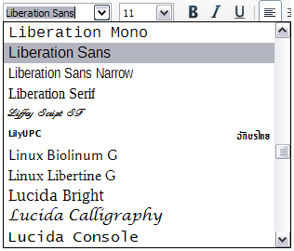 | 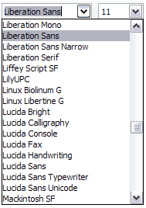
Figure 5: Font list (Left) with preview; (Right) without preview

Print options
On the LibreOffice – Print page, set the print options to suit your default printer and your most common printing method. Most of these options should be self-explanatory.
The option PDF as Standard Print Job Format is not available on Windows. Select this option to change the internal print job format from a Postscript document description to a PDF description. This format has a number of advantages over Postscript. For more information, see http://www.linuxfoundation.org/collaborate/workgroups/openprinting/pdf_as_standard_print_job_format
Deselecting this option reverts to the Postscript document workflow system.
In the Printer warnings section near the bottom of the page, you can choose whether to be warned if the paper size or orientation specified in your document does not match the paper size or orientation available for your printer. Having these warnings turned on can be quite helpful, particularly if you work with documents produced by people in other countries where the standard paper size is different from yours.
- Tip
If your printouts are incorrectly placed on the page or chopped off at the top, bottom, or sides, or the printer is refusing to print, the most likely cause is page size incompatibility.
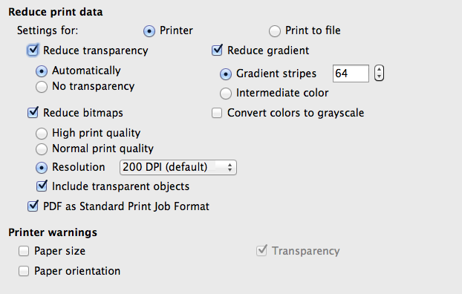
Figure 6: Choosing general printing options to apply to all LibreOffice components

Paths options
On the LibreOffice – Paths page, you can change the location of files associated with, or used by, LibreOffice to suit your working situation. In a Windows system, for example, you might want to store documents by default somewhere other than My Documents.
To make changes, select an item in the list shown in Figure 7 and click Edit. On the Select Path dialog (not shown; may also be titled Edit Paths), add or delete folders as required, and then click OK to return to the Options dialog. Note that some items can have at least two paths listed: one to a shared folder (which might be on a network) and one to a user-specific folder (normally on the user’s personal computer).
- Tip
You can use the entries on the LibreOffice – Paths page to compile a list of files, such as those containing AutoText, that you need to back up or copy to another computer.
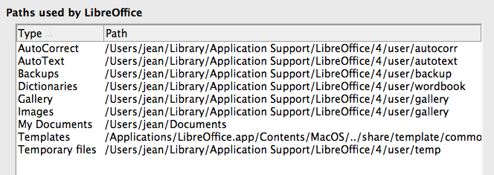
Figure 7: Viewing the paths of files used by LibreOffice

Color options
On the LibreOffice – Colors page, you can specify colors to use in LibreOffice documents. You can select a color from a color table, edit an existing color, and define new colors. These colors are stored in your color palette and are then available in all components of LibreOffice.
To modify a color:
- Select the color to modify from the list or the color table.
- Enter the new values that define the color. You can choose the RGB (Red, Green, Blue) or the CMYK (Cyan, Magenta, Yellow, Black) system to specify your color. The changed color appears in the lower of the two color preview boxes at the top.
- Modify the Name as required.
- Click the Modify button. The newly defined color is now listed in the Color table.
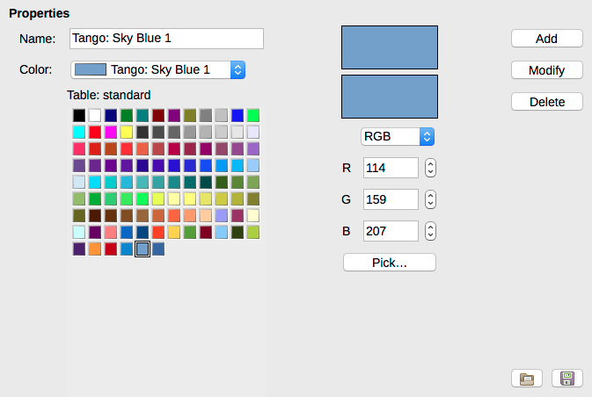
Figure 8: Defining colors to use in color palettes in LibreOffice
Alternatively, click the Pick button to open the Pick a Color dialog, shown in Figure 9. Here you can select a color from the window on the left, or you can enter values on the right using your choice of RGB, CMYK, or HSB (Hue, Saturation and Brightness) values.
The color window on the left is linked directly with the color input fields on the right; as you choose a color in the window, the numbers change accordingly. The color field at the lower left shows the value of the selected color on the left and the currently set value from the color value fields on the right.
Modify the color components as required and click OK to exit the dialog. The newly defined color now appears in the lower of the color preview boxes shown in Figure 8. Type a name for this color in the Name box, then click the Add button. A small box showing the new color is added to the Color table.
Another way to define or alter colors is through the Colors page of the Area dialog, where you can also save and load palettes, a feature that is not possible here. In Calc, draw a temporary draw object and use the context menu of this object to open the Area dialog. If you load a palette in one component of LibreOffice, it is only active in that component; the other components keep their own palettes.
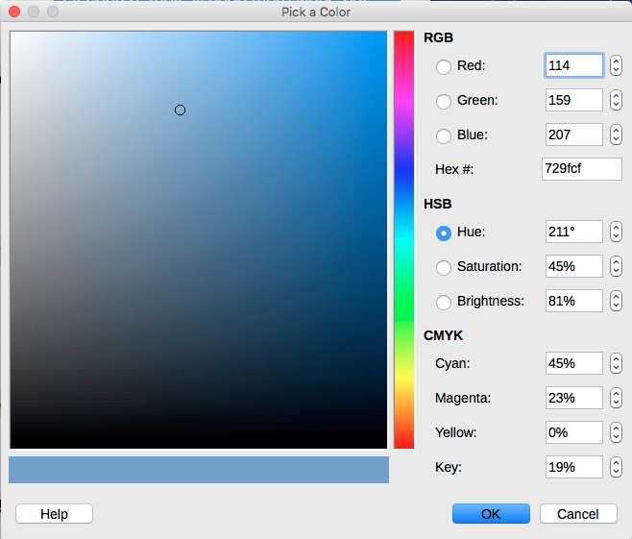
Figure 9: Editing colors

Fonts options
You can define replacements for any fonts that might appear in your documents. If you receive from someone else a document containing fonts that you do not have on your system, LibreOffice will substitute fonts for those it does not find. You might prefer to specify a different font from the one that the program chooses.
- Note
These choices do not affect the default font for your documents. To do that, you need to change the default template for documents, as described in Chapter 3.
On the LibreOffice – Fonts page:
- Select the Apply replacement table option.
- Select or type the name of the font to be replaced in the Font box. (If you do not have this font on your system, it will not appear in the drop-down list in this box, so you need to type it in.)
- In the Replace with box, select a suitable font from the drop-down list of fonts installed on your computer.
- The check mark to the right of the Replace with box turns green. Click on this check mark. A row of information now appears in the larger box below the input boxes. Select Always to replace the font, even if the original font is installed on your system. Select Screen only to replace the screen font only and never replace the font for printing. The results of combining these selections are given in Table 1.
- In the bottom section of the page, you can change the typeface and size of the font used to display source code such as HTML and Basic (in macros).
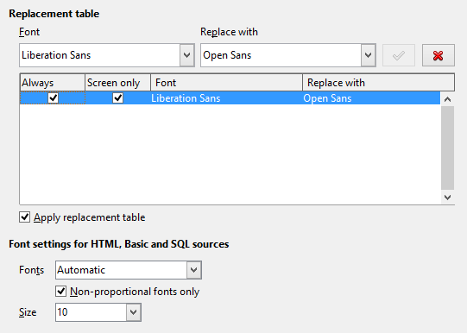
Figure 10: Defining a font to be substituted for another font
Table 1. Font substitution replacement actions
Always checkbox | Screen only checkbox | Replacement action
checked | blank | Font replacement on screen and when printing, whether the font is installed or not.
checked | checked | Font replacement only on screen, whether the font is installed or not.
blank | checked | Font replacement only on screen, but only if font is not available.
blank | blank | Font replacement on screen and when printing, but only if font is not available.

Security options
Use the LibreOffice – Security page to choose security options for saving documents and for opening documents that contain macros.
Security options and warnings
If you record changes, save multiple versions, or include hidden information or notes in your documents, and you do not want some of the recipients to see that information, you can set warnings to remind you to remove it, or you can have LibreOffice remove some of it automatically. Note that (unless removed) much of this information is retained in a file whether the file is in LibreOffice’s default OpenDocument format, or has been saved to other formats, including PDF.
Click the Options button to open a separate dialog with specific choices (Figure 13). See “Security options and warnings” on page 14.
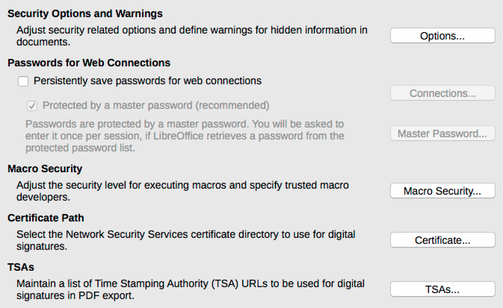
Figure 11: Choosing security options for opening and saving documents
Macro security
Click the Macro Security button to open the Macro Security dialog (not shown here), where you can adjust the security level for executing macros and specify trusted sources.
Certificate Path
Users can digitally sign documents using LibreOffice. A digital signature requires a personal signing certificate. Most operating systems can generate a self-signed certificate. However, a personal certificate issued by an outside agency (after verifying an individual’s identity) has a higher degree of trust associated with it than does a self-signed certificate. LibreOffice does not provide a secure method of storing these certificates, but it can access certificates that have been saved using other programs. Click the Certificate button and select which certificate store to use.
- Note
The Certificate Path option appears only on Linux and Mac systems. On Windows, LibreOffice uses the default Windows location for storing and retrieving certificates.
Passwords for web connections
You can enter a master password to enable easy access to websites that require a user name and password. If you select the Persistently save passwords for web connections option, the Set Master Password dialog opens (Figure 12). LibreOffice will securely store all passwords that you use to access files from web servers. You can retrieve the passwords from the list after you enter the master password.
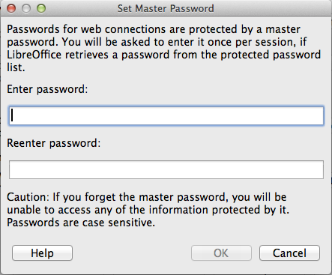
Figure 12: Set Master Password dialog for web connections

Security options and warnings
The following options are on the Security options and warnings dialog (Figure 13).
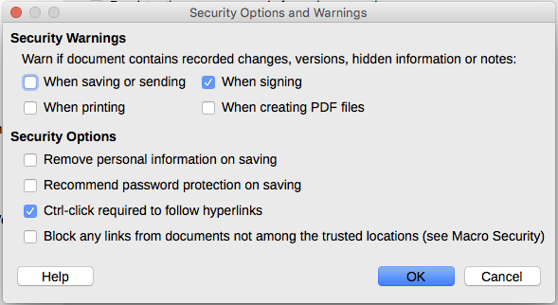
Figure 13: Security options and warnings dialog
Remove personal information on saving
Select this option to always remove user data from the file properties when saving the file. To manually remove personal information from specific documents, deselect this option.
Ctrl-click required to follow hyperlinks
The default behavior in LibreOffice is to Ctrl+click on a hyperlink to open the linked document. Many people find creation and editing of documents easier when accidental clicks on links do not activate the links. To set LibreOffice to activate hyperlinks using an ordinary click, deselect this option.
The other options on this dialog should be self-explanatory.

Personalization
You can customize the overall appearance of LibreOffice with themes designed for Mozilla Firefox.
On the LibreOffice – Personalization page, select Own Theme and then click Select Theme. Another dialog opens. Type a search term, click Search, and wait while theme thumbnails load. Select one and click OK to apply the theme. After a brief pause the appearance of LibreOffice will refresh and reflect the selected theme. An example is shown in Figure 15. For full details about themes, visit the Mozilla website: https://www.https://addons.mozilla.org/en-US/firefox/themes/
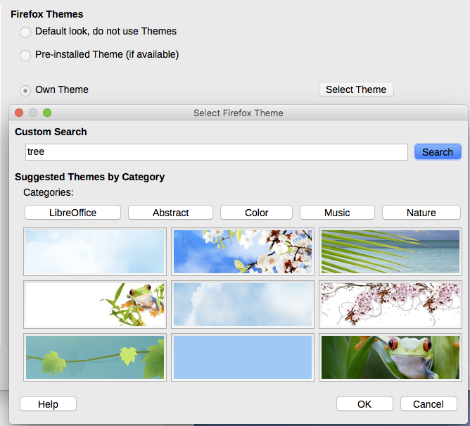
Figure 14: Personalization dialogs
Figure 15: Sample personalized theme

Application colors
Writing, editing, and (especially) page layout are often easier when you can see the page margins (text boundaries), the boundaries of tables and sections (in Writer documents), page breaks in Calc, grid lines in Draw or Writer, and other features. In addition, you might prefer to use colors that are different from LibreOffice’s defaults for such items as comment indicators or field shadings.
On the LibreOffice – Application colors page (Figure 16), you can specify which items are visible and the colors used to display various items.
- To show or hide items such as text boundaries, select or deselect the options next to the names of the items.
- To change the default colors for items, click the down-arrow in the Color Setting column by the name of the item and select a color from the list box. Note that you can change the list of available colors as described in “Color options” on page 10.
- To save your color changes as a color scheme, click Save, type a name in the Scheme box, and then click OK.
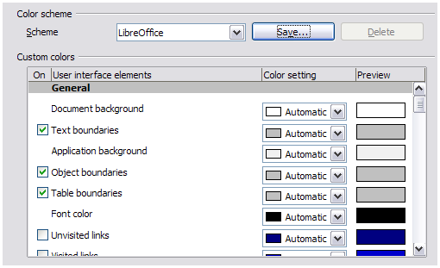
Figure 16: Showing or hiding text, object, and table boundaries

Accessibility options
Accessibility options include whether to allow animated graphics or text, how long help tips remain visible, some options for high contrast display, and a way to change the font for the user interface of the LibreOffice program.
Accessibility support relies on the Java Runtime Environment for communication with assistive technology tools. The Support assistive technology tools option is not shown on all LibreOffice installations. See Assistive Tools in LibreOffice in the Help for other requirements and information.
Select or deselect the options as required.
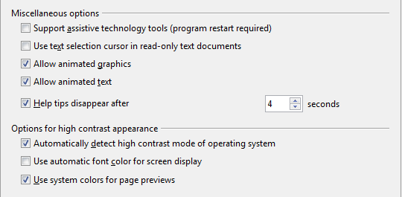
Figure 17: Choosing accessibility options

Advanced options
Java options
If you install or update a Java Runtime Environment (JRE) after you install LibreOffice, or if you have more than one JRE installed on your computer, you can use the LibreOffice – Advanced options page to choose the JRE for LibreOffice to use.
- Note
LibreOffice needs Java to run several wizards (such as in File > Wizards > Letter) and also to run databases with the internal HSQLDB engine.
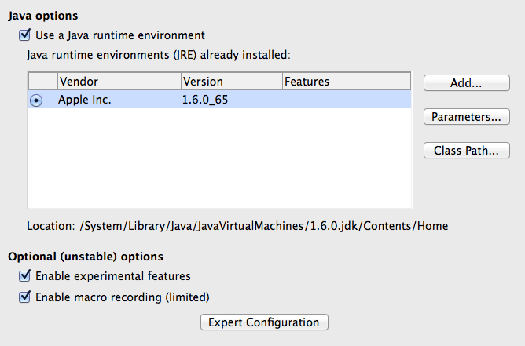
Figure 18: Choosing a Java runtime environment
If you are a system administrator, programmer, or other person who customizes JRE installations, you can use the Parameters and Class Path pages (reached from the Java page) to specify this information.
If you do not see anything listed in the middle of the page, wait a few minutes while LibreOffice searches for JREs on the hard disk.
If LibreOffice finds one or more JREs, it will display them there. You can then select the Use a Java runtime environment option and (if necessary) choose one of the JREs listed.
Optional (unstable) options
Enable experimental features
Selecting this option enables features that are not yet complete or contain known bugs. The list of these features is different version by version.
Enable macro recording (limited)
This option enables macro recording with some limitations. Opening a window, switching between windows, and recording in a different window to that in which the recording began, is not supported. Only actions relating to document contents are recordable, so changes in Options or customizing menus are not supported. For more about macro recording, see Chapter 13, Getting Started with Macros.
Expert Configuration
Most users will have no need to use this. Click the Expert Configuration button to open a new window in which you can fine-tune the LibreOffice installation. The page offers detailed configuration options for many aspects of LibreOffice’s appearance and performance. Double-click on a listed preference to enter a value to configure the preference.
- Caution
The Expert Configuration dialog lets you access, edit, and save configuration preferences that can turn the user profile of LibreOffice unstable, inconsistent, or even unusable.

Basic IDE options
The Basic IDE Options are available after Enable experimental features has been selected on the Advanced page of the Options dialog and the options have been saved. These options are for macro programmers and are not discussed here.
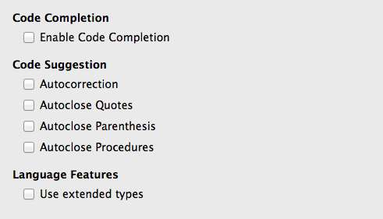
Figure 19: Basic IDE Options dialog

Online update options
On the LibreOffice – Online Update page (Figure 20), you can choose whether and how often to have the program check the LibreOffice website for program updates. If the Check for updates automatically option is selected, an icon appears at the right-hand end of the menu bar when an update is available. Click this icon to open a dialog where you can choose to download the update.
If the Download updates automatically option is selected, the download starts when you click the icon. To change the download destination, click the Change button and select the required folder in the file browser window.
If the Send OS version & simple hardware info option is selected, the information of the computer architecture and operating system will be sent to the server for statistics collection.
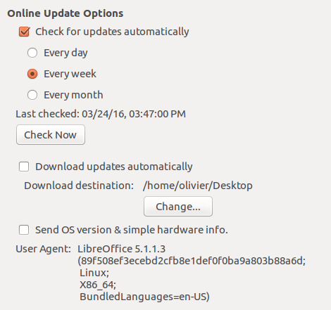
Figure 20: Online update options

OpenCL options
OpenCL (Open Computing Language) is a software architecture used to write programs that run in different processors of the computer, such as the CPU and GPU (graphics processing unit) of the video card. With OpenCL enabled, LibreOffice can benefit from the very fast numerical calculations performed in the GPU, which is especially useful in very large spreadsheets with extensive calculations. The computer video card driver must have support for OpenCL to use this feature.
OpenCL Options - Allow use of Software Interpreter (even when OpenCL is not available)
Mark this box to emulate OpenCL if your computer video card driver does not support OpenCL.
Allow use of OpenCL
Let LibreOffice use the video card GPU to perform numerical calculation with great speed gain. The two boxes below list the OpenCL drivers whitelist and blacklist. Click the Edit, Add... and Delete buttons to modify the lists entries.
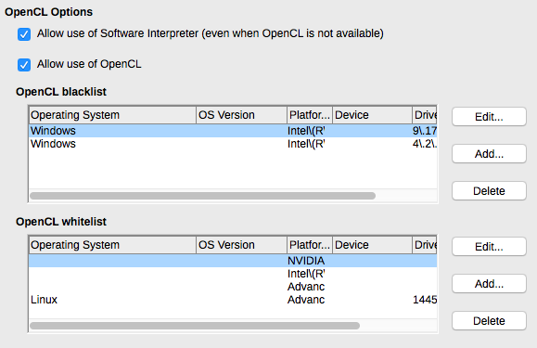
Figure 21: OpenCL options

Choosing Load/Save options
You can set the Load/Save options for loading and saving documents to suit the way you work.
If the Options dialog is not already open, click Tools > Options. Click the expansion symbol (+ or triangle) to the left of Load/Save.

General
Most of the choices on the Load/Save – General page are familiar to users of other office suites. Some items of interest are described below.
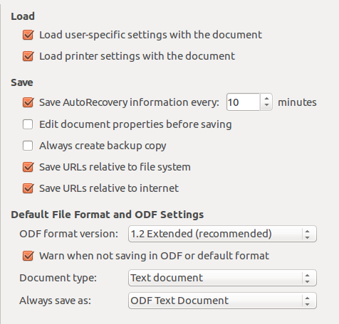
Figure 22: Choosing Load and Save options
Load user-specific settings with the document
A LibreOffice document contains certain settings that are read from the user’s system. When you save a document, these settings are saved with it.
Select this option so that when a document loads, it ignores the stored settings in favor of the settings on your computer.
Even if you do not select this option, some settings are taken from your LibreOffice installation:
- Settings available in File > Print > Options
- Name of Fax
- Spacing options for paragraphs before text tables
- Information about automatic updating for links, field functions and charts
- Information about working with Asian character formats.
The following setting is always loaded with a document, whether or not this option is marked:
- Data source linked to the document and its view.
If you deselect this option, the user’s personal settings do not overrule the settings in the document. For example, your choice (in the options for LibreOffice Writer) of how to update links is affected by the Load user-specific settings option.
Load printer settings with the document
If enabled, the printer settings will be loaded with the document. This can cause a document to be printed on a distant printer (perhaps in an office setting), if you do not change the printer manually in the Print dialog. If disabled, your standard printer will be used to print this document. The current printer settings will be stored with the document whether or not this option is selected.
Save AutoRecovery information every __ Minutes
Choose whether to enable AutoRecovery and how often to save the information used by the AutoRecovery process. AutoRecovery in LibreOffice saves the information needed to restore all open documents in case of a crash. If you have this option set, recovering your document after a system crash will be easier.
Edit document properties before saving
If you select this option, the Document Properties dialog pops up to prompt you to enter relevant information the first time you save a new document (or whenever you use Save As).
Always create backup copy
Saves the previous version of a document as a backup copy whenever you save a document. Every time LibreOffice creates a backup copy, the previous backup copy is replaced. The backup copy gets the extension BAK. Authors whose work may be very lengthy should always consider using this option.
Save URLs relative to file system / internet
Use this option to select the default for relative addressing of URLs in the file system and on the Internet. Relative addressing is only possible if the source document and the referenced document are both on the same drive.
A relative address always starts from the directory in which the current document is located. In contrast, absolute addressing always starts from a root directory. The following table demonstrates the difference in syntax between relative and absolute referencing.
Examples | File system | Internet
relative | ../images/img.jpg | ../images/img.jpg
absolute | file:///c|/work/images/img.jpg | http://myserver.com/work/images/img.jpg
If you choose to save relatively, the references to embedded graphics or other objects in your document will be saved relative to the location in the file system. In this case, it does not matter where the referenced directory structure is recorded. The files will be found regardless of location, as long as the reference remains on the same drive or volume. This is important if you want to make the document available to other computers that may have a completely different directory structure, drive or volume names. It is also recommended to save relatively if you want to create a directory structure on an Internet server.
If you prefer absolute saving, all references to other files will also be defined as absolute, based on the respective drive, volume or root directory. The advantage is that the document containing the references can be moved to other directories or folders, and the references remain valid.
Default file format and ODF settings
ODF format version. LibreOffice by default saves documents in OpenDocument Format (ODF) version 1.2 Extended. While this allows for improved functionality, there may be backwards compatibility issues. When a file saved in ODF 1.2 Extended is opened in an editor that uses earlier versions of ODF (1.0/1.1), some of the advanced features may be lost. Two notable examples are cross-references to headings and the formatting of numbered lists. If you plan to share documents with people who use editors that use older versions of ODF, you may wish to save the document using ODF version 1.0/1.1.
Document type. If you routinely share documents with users of Microsoft Office, you might want to change the Always save as attribute for documents to one of the Microsoft Office formats. Current versions of Microsoft Word can open ODT files, so this may no longer be needed.

VBA Properties
On the VBA Properties page, you can choose whether to keep any macros in Microsoft Office documents that are opened in LibreOffice.
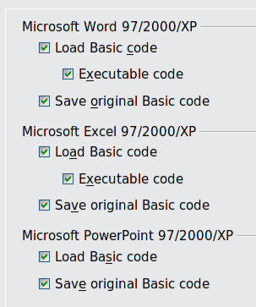
Figure 23: Choosing Load/Save VBA Properties
If you choose Load Basic code, you can edit the macros in LibreOffice. The changed code is saved in an ODF document but is not retained if you save into a Microsoft Office format.
If you choose Save original Basic code, the macros will not work in LibreOffice but are retained unchanged if you save the file into Microsoft Office format.
If you are importing a Microsoft Word or Excel file containing VBA code, you can select the option Executable code. Whereas normally the code is preserved but rendered inactive (if you inspect it with the StarBasic IDE you will notice that it is all commented), with this option the code is ready to be executed.
Save original Basic code takes precedence over Load Basic code. If both options are selected and you edit the disabled code in LibreOffice, the original Microsoft Basic code will be saved when saving in a Microsoft Office format.
To remove any possible macro viruses from the Microsoft Office document, deselect Save original Basic code. The document will be saved without the Microsoft Basic code.

Microsoft Office
On the Load/Save – Microsoft Office page (Figure 24), you can choose what to do when importing and exporting Microsoft Office OLE objects (linked or embedded objects or documents such as spreadsheets or equations).
Select the [L] options to convert Microsoft OLE objects into the corresponding LibreOffice OLE objects when a Microsoft document is loaded into LibreOffice (mnemonic: “L” for “load”).
Select the [S] options to convert LibreOffice OLE objects into the corresponding Microsoft OLE objects when a document is saved in a Microsoft format (mnemonic: “S” for “save”).

HTML compatibility
Choices made on the Load/Save – HTML Compatibility page (Figure 25) affect HTML pages imported into LibreOffice and those exported from LibreOffice. See HTML documents; importing/exporting in the Help for more information.
Font sizes
Use these fields to define the respective font sizes for the HTML <font size=1> to <font size=7> tags, if they are used in the HTML pages. (Many pages no longer use these tags.)
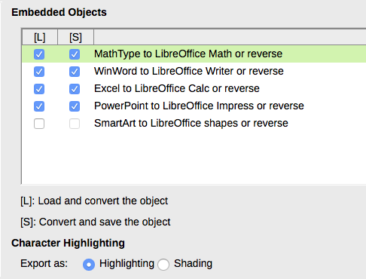
Figure 24: Choosing Load/Save Microsoft Office options
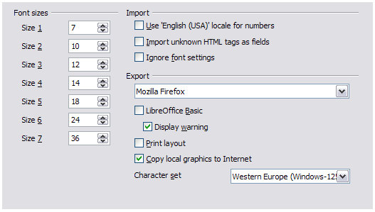
Figure 25. Choosing HTML compatibility options
Import – Use 'English (USA)' locale for numbers
When importing numbers from an HTML page, the decimal and thousands separator characters differ according to the locale of the HTML page. The clipboard, however, contains no information about the locale. If this option is not selected, numbers will be interpreted according to the Locale setting in Tools > Options > Language Settings > Languages (see page 24). If this option is selected, numbers will be interpreted as for the English (USA) locale.
Import – Import unknown HTML tags as fields
Select this option if you want tags that are not recognized by LibreOffice to be imported as fields. For an opening tag, an HTML_ON field will be created with the value of the tag name. For a closing tag, an HTML_OFF will be created. These fields will be converted to tags in the HTML export.
Import – Ignore font settings
Select this option to have LibreOffice ignore all font settings when importing. The fonts that were defined in the HTML Page Style will be used.
Export
To optimize the HTML export, select a browser or HTML standard from the Export box. If LibreOffice Writer is selected, specific LibreOffice Writer instructions are exported.
Export – LibreOffice Basic
Select this option to include LibreOffice Basic macros (scripts) when exporting to HTML format. You must activate this option before you create the LibreOffice Basic macro; otherwise the script will not be inserted. LibreOffice Basic macros must be located in the header of the HTML document. Once you have created the macro in the LibreOffice Basic IDE, it appears in the source text of the HTML document in the header.
If you want the macro to run automatically when the HTML document is opened, choose Tools > Customize > Events. See Chapter 13, Getting Started with Macros, for more information.
Export – Display warning
When the LibreOffice Basic option (see above) is not selected, the Display warning option becomes available. If the Display warning option is selected, then when exporting to HTML a warning is shown that LibreOffice Basic macros will be lost.
Export – Print layout
Select this option to export the print layout of the current document as well. The HTML filter supports CSS2 (Cascading Style Sheets Level 2) for printing documents. These capabilities are only effective if print layout export is activated.
Export – Copy local graphics to Internet
Select this option to automatically upload the embedded pictures to the Internet server when uploading using FTP.
Export – Character set
Select the appropriate character set for the export.

Choosing language settings
To customize the language settings in LibreOffice, you can do any of the following:
- Install the required dictionaries
- Change some locale and language settings
- Choose spelling options

Install the required dictionaries
LibreOffice automatically installs several dictionaries with the program. To add other dictionaries, be sure you are connected to the Internet, and then choose Tools > Language > More Dictionaries Online. LibreOffice will open your default web browser to a page containing links to additional dictionaries that you can install. Follow the prompts to select and install the ones you want.

Change some locale and language settings
You can change some details of the locale and language settings that LibreOffice uses for all documents, or for specific documents.
In the Options dialog, click Language Settings > Languages. The exact list shown depends on the Enhanced language support settings (see Figure 27).
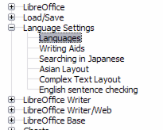Figure 26: LibreOffice language options, without and with Asian and CTL options enabled
On the right-hand side of the Language Settings – Languages page, change the User interface, Locale setting, Default currency, and Default languages for documents as required. In the example, English (USA) has been chosen for all the appropriate settings.
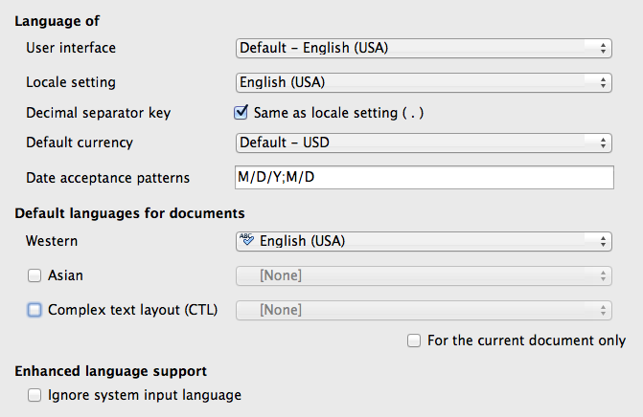
Figure 27: Choosing language options
User interface
The language of the user interface is usually set at the time LibreOffice is installed to match the language of the operating system. If more than one language has been installed for LibreOffice, you can select which language will be used for menus, dialogs, and help files.
Locale setting
The local setting is the basis for many other settings within LibreOffice, for example defaults for numbering, currency, and units of measure. Unless you select something else here, the locale of the operating system will be set as default.
Decimal separator key
If the Decimal separator key option is selected, LibreOffice will use the character defined by the default locale. If this option is not selected, the keyboard driver defines the character used.
Default currency
The Default currency is that used in the country entered as Locale. The default currency determines the proper formatting of fields formatted as currency. If the locale setting is changed, the default currency changes automatically. If the default currency is changed, all dialogs involving currency and all currency icons will be changed in all open documents. Documents that were saved with one currency as the default will open using the new currency defaults.
Date acceptance patterns
Date acceptance patterns define how LibreOffice recognizes input as dates. Locale also defines the default expression of dates. You can define additional date patterns, separated by semicolons, using Y, M, & D for Year, Month, and Day. LibreOffice will always correctly interpret dates entered in ISO 8601 format as Y-M-D and YYYY-MM-DD.
- Caution
Data entered into a Calc spreadsheet or a Writer table must be entered in a format defined by Locale in order to be recognized as dates.
Default languages for documents
Select the languages used for the spelling checker, thesaurus, and hyphenation features of LibreOffice. If these options are only for the current document, select For the current document only.
If necessary, select the options to enable support for Asian languages (Chinese, Japanese, Korean) and support for CTL (complex text layout) languages such as Urdu, Thai, Hebrew, and Arabic. If you choose either of these options, the next time you open this dialog, you will see some extra choices under Language Settings, as shown in Figure 26. These choices (Searching in Japanese, Asian Layout, and Complex Text Layout) are not discussed here.
Enhanced language support – Ignore system input language
Default language settings depend on the Locale setting. The default locale is based on that of the computer’s operating system. A keyboard layout is normally based on the language used by the operating system but can be changed by the user. If this option is not selected, and there is a change in keyboard layout, input from the keyboard will be different from what is expected.

Choose spelling options
To choose the options for checking spelling, click Language Settings > Writing Aids. In the Options section of the page (Figure 28), choose the settings that are useful for you.
Some considerations:
- If you do not want spelling checked while you type, deselect Check spelling as you type. This option can also be deselected using the AutoSpellcheck button on the Standard toolbar.
- If you want grammar to be checked as you type, you must have Check spelling as you type enabled too.
- If you use a custom dictionary that includes words in all upper case and words with numbers (for example, AS/400), select Check uppercase words and Check words with numbers.
- Check special regions includes headers, footers, frames, and tables when checking spelling.
Here you can also check which user-defined (custom) dictionaries are active by default, and add or remove user-installed dictionaries, by clicking the New or Delete buttons. Dictionaries installed by the system cannot be deleted.
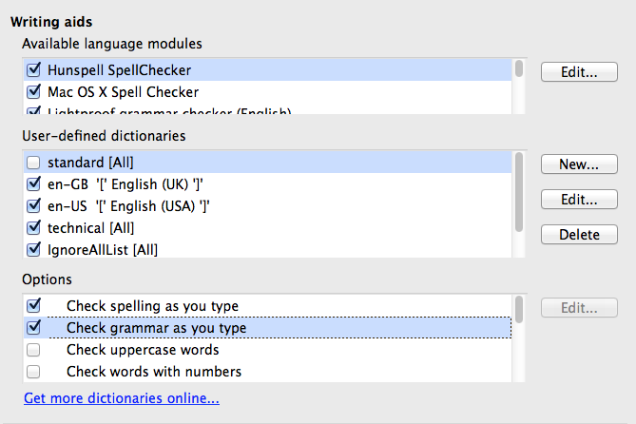
Figure 28: Choosing languages, dictionaries, and options for checking spelling

English sentence checking
On the Language Settings > English sentence checking page, you can choose which items are checked for, reported to you, or converted automatically. This menu is also found in the English dictionaries extension installed by default by LibreOffice. Select Tools > Extension Manager, select the English spelling dictionaries and click the Options button to reveal the menu. Select which of the optional features you wish to check.
After selecting the additional grammar checks, you must restart LibreOffice, or reload the document, for them to take effect.
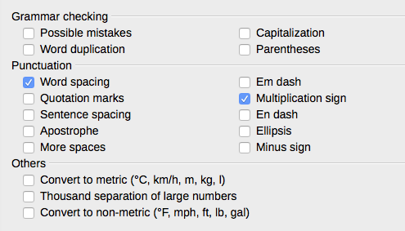
Figure 29: Choosing options for checking sentences in English

Grammar checking
Possible mistakes
Checks for things such as; with it’s, he don’t, this things and so on.
Capitalization
Checks for the capitalization of sentences. The sentence boundary detection depends on abbreviations.
Word duplication
Checks for all word duplication, rather than just the default words ‘and’, ‘or’, ‘for’, and ‘the’.
Parentheses
Checks for pairs of parentheses and quotation marks.

Punctuation
Word spacing
This option is selected by default. It checks for single spaces between words, indicating instances of double or triple spaces, but not of more spaces than that.
Sentence spacing
Checks for a single space between sentences, indicating when one or two extra spaces are found.
More spaces
Checks word and sentence spacing for more than two extra spaces.
Em dash; En dash
These options force a non-spaced em dash to replace a spaced en dash, or force a spaced en dash to replace a non-spaced em dash.
Quotation marks
Checks for correct typographical double quotation marks.
Multiplication sign
This option is selected by default. It replaces an ‘x’ used as a multiplication symbol with the correct typographical symbol.
Apostrophe
Replaces an apostrophe with the correct typographical character.
Ellipsis
Replaces three consecutive periods (full stops) with the correct typographical symbol.
Minus sign
Replaces a hyphen with the correct minus typographical character.

Others
Convert to metric; Convert to non-metric
Converts quantities in a given type of unit to quantities in the other type of unit: metric to imperial or imperial to metric.
Thousands separation of large numbers
Converts a number with five or more significant digits to a common format, that is one which uses the comma as a thousands separator, or to the ISO format which uses a narrow space as a separator.

Other languages sentence checking
LibreOffice can also check sentences in other languages, notably Hungarian, Russian, and Brazilian Portuguese. These checkers are enabled by default if the language is the computer’s default language. The set of rules available for these sentence checkers depends on the language.

Choosing Internet options
The Internet options available depend on your operating system.
Use the Proxy page (if available) to save proxy settings for use with LibreOffice.
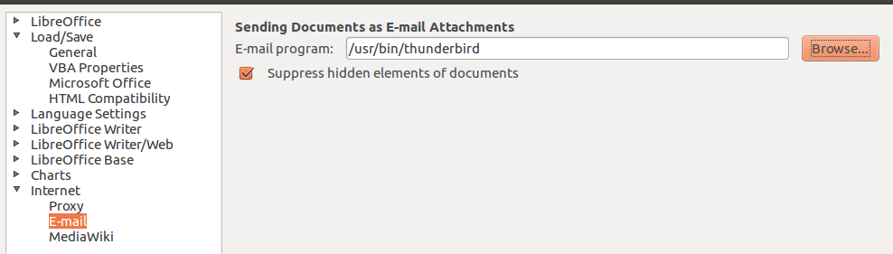
Figure 30: Internet options, showing E-mail page available to Linux users
If you are using a Unix- or Linux-based operating system (including Mac OS X), an additional page of E-mail options is available, where you can specify the e-mail program to use when you send the current document as e-mail. Under Windows the operating system’s default e-mail program is always used.
A MediaWiki publisher is included on Windows and Linux. To enable it, select MediaWiki in the Internet options, then click the Add button to open the dialog shown in Figure 31. Here you can specify the address (URL) and log-in information for a wiki. You can add several wikis to the list.
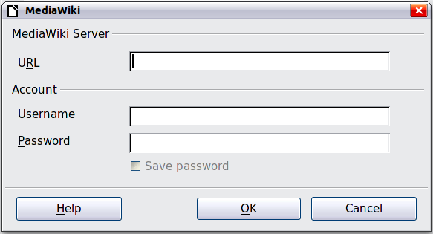
Figure 31: Specifying a MediaWiki server account

Controlling LibreOffice’s AutoCorrect functions
Some people find some or all of the items in LibreOffice’s AutoCorrect function annoying because they change what you type when you do not want it changed. Many people find some of the AutoCorrect functions quite helpful; if you do, then select the relevant options. But if you find unexplained changes appearing in your document, this is a good place to look to find the cause.
To open the AutoCorrect dialog, click Tools > AutoCorrect Options. (You need to have a document open for this menu item to appear.) In Writer, this dialog has five tabs, as shown in Figure 32. In other components of LibreOffice, the dialog has only four tabs. More details are given in the component guides.
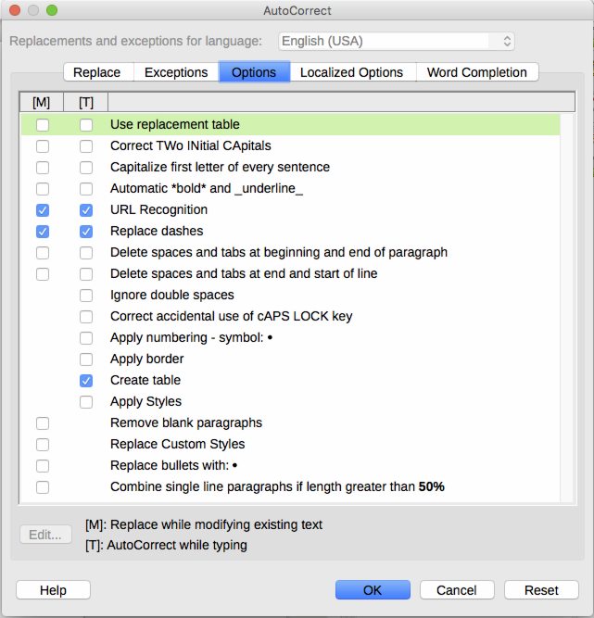
Figure 32: The AutoCorrect dialog in Writer, showing some of the choices on the Options tab

