
Writer 6.4 Guide

Chapter 21
Customizing Writer

Copyright
This document is Copyright © 2020 by the LibreOffice Documentation Team. Contributors are listed below. You may distribute it and/or modify it under the terms of either the GNU General Public License (http://www.gnu.org/licenses/gpl.html), version 3 or later, or the Creative Commons Attribution License (http://creativecommons.org/licenses/by/4.0/), version 4.0 or later.
All trademarks within this guide belong to their legitimate owners.

Contributors

To this edition
Jean Hollis Weber | Kees Kriek

To previous editions
Jean Hollis Weber | Bruce Byfield | Gillian Pollack
Barbara Duprey | John A Smith | Ron Faile Jr.
Rafael Atias

Feedback
Please direct any comments or suggestions about this document to the Documentation Team’s mailing list: documentation@global.libreoffice.org
- Note
Everything you send to a mailing list, including your email address and any other personal information that is written in the message, is publicly archived and cannot be deleted.

Publication date and software version
Published July 2020. Based on LibreOffice 6.4.

Note for macOS users
Some keystrokes and menu items are different on macOS from those used in Windows and Linux. The table below gives some common substitutions for the instructions in this book. For a more detailed list, see the application Help.
Windows or Linux | macOS equivalent | Effect
Tools > Options  menu selection | LibreOffice > Preferences | Access setup options
Right-click | Control+click and/or right-click depending on computer setup | Open a context menu
Ctrl (Control) | ⌘ (Command) | Used with other keys
F11 | ⌘+T | Open the sidebar Styles deck

Contents
Copyright 2
Contributors 2
To this edition 2
To previous editions 2
Feedback 2
Publication date and software version 2
Note for macOS users 2
Introduction 4
Customizing menus 4
Modifying an existing menu 5
Creating a new menu 5
Customizing toolbars 6
Modifying existing toolbars 7
Creating a new toolbar 8
Choosing icons for toolbar commands 8
Customizing the notebook bar 9
Assigning shortcut keys 10
Saving changes to a file 11
Loading a saved keyboard configuration 11
Resetting the shortcut keys 11
Assigning macros to events 11
Adding functionality with extensions 11
Installing extensions 11
Removing and disabling extensions 12
Adding fonts 12
Finding free-licensed fonts 13
Adding custom colors 13

Introduction
This chapter describes some common customizations that you may wish to do, in addition to the options described in Chapter 20, Setting up Writer. You can customize menus, toolbars, and keyboard shortcuts in LibreOffice, add new menus and toolbars, and assign macros to events.
Other customizations are made easy by extensions that you can install from the LibreOffice website or from other providers.
- Note
Customizations to menus and toolbars can be saved in a template. To do so, first save them in a document and then save the document as a template as described in Chapter 10, Working with Templates. If you work on more than one project, you may find that having different menus and toolbars can be useful.

Customizing menus
You can add to and rearrange menus on the Menu bar, add commands to menus, and make other changes. You can also modify context (right-click) menus in a similar way.
To customize a menu, choose Tools > Customize. On the Customize dialog, go to the Menus tab (Figure 1) or the Context Menus tab.
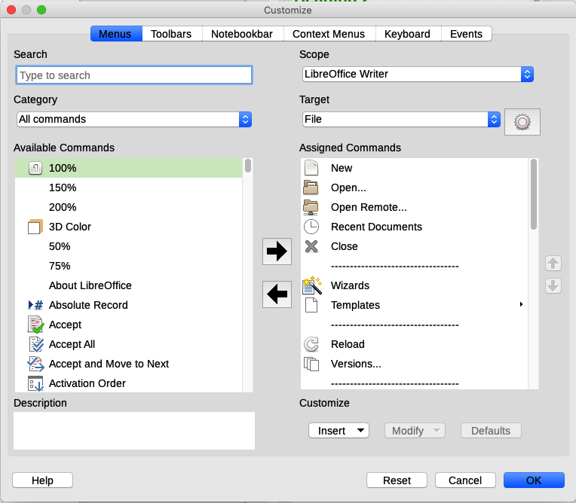Figure 1: The Menus tab of the Customize dialog

Modifying an existing menu
- In the Scope drop-down list in the upper right of the Customize dialog, choose whether to apply the customized menu to all of LibreOffice Writer or only to a specific document.
- In the Target drop-down list, select the menu that you want to customize. The list includes the main menus and submenus. The commands on the selected menu are shown in the Assigned commands list.
- To add a command to the selected menu, click on a command in the Available Commands list and then click the large right arrow. You can narrow the search by using the Search box on the top left or selecting the Category in the drop-down list. Use the up and down arrows on the right-hand side to move the command into the position where you want it in the list.
- To remove a command from the selected menu, click on it in the Assigned Commands list and then click the large left arrow.
- To insert a separator or submenu, select the item directly before where you want the inserted item to appear, and use the commands in the Insert drop-down.
Figure 2: Insert drop-down
- To rename a menu item, select it in the Assigned Commands list and choose Rename from the Modify drop-down.
Figure 3: Modify drop-down
- When you have finished making all your changes, click OK to save them.

Creating a new menu
You might find a “Favorites” menu useful, or a menu collecting tools for a specific project. To create a new menu:
- On the Menus tab of the Customize dialog, click the symbol next to Target and select Add from the drop-down list (Figure 4) to display the New Menu dialog (Figure 5).
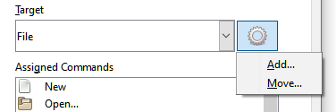Figure 4: Location of command to add a new menu
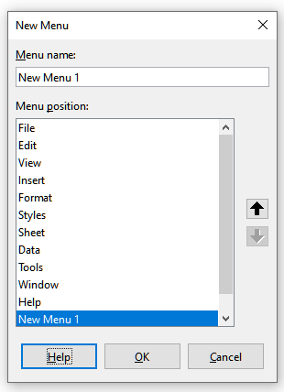Figure 5: Adding a new menu
- Type a name for the new menu in the Menu name box.
- Use the up and down arrow buttons to move the new menu into the required position on the Menu bar.
- Click OK to save and return to the Customize dialog.
The new menu now appears on the list of menus in the Customize dialog. It will appear on the Menu bar itself after you save your customizations.
After creating a new menu, you need to add some commands to it, as described above for modifying a menu.

Customizing toolbars
You can customize toolbars in several ways, including choosing which icons are visible and locking the position of a docked toolbar (as described in Chapter 1, Introducing Writer), and adding or deleting icons (commands) in the list of those available on a toolbar. You can also create new toolbars.
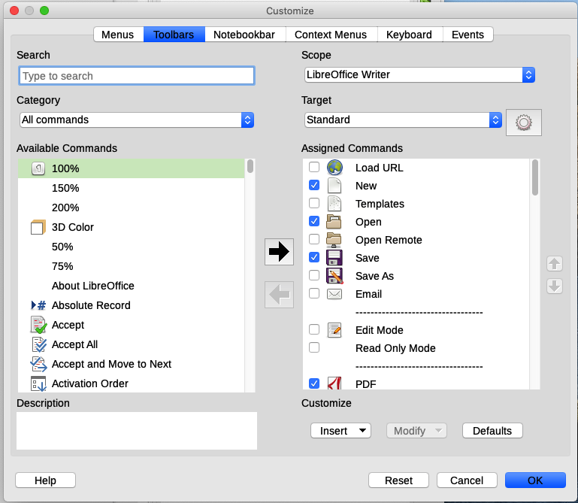Figure 6: The Toolbars tab of the Customize dialog

Modifying existing toolbars
The procedures for creating and modifying a toolbar are similar to those for menus.
- In the Scope drop-down list on the upper right of the Customize dialog, choose whether to save this changed toolbar for Writer or for a selected document.
- In the Target drop-down list, select the toolbar that you want to customize. The current toolbar content is displayed in the Assigned Commands list.
- Select a command in the Available Commands list on the left. You can narrow your search by using the Search box on the top left or choosing a category in the drop-down list just below.
- Click on the large right arrow to add the selected command to the Assigned Commands list for the toolbar (on the right). Use the up and down arrows in the far right to position the command in the toolbar.
- To remove a command from a toolbar, select it in the Assigned Commands list on the right and click the large left arrow.
- To show or hide a command assigned to a toolbar, select or clear the checkbox by its icon in the Assigned Commands list on the right.
- To insert a separator, select the item directly before where you want the separator to appear, and use the command in the Insert drop-down.
- To rename a toolbar item, select it in the Assigned Commands list and choose Rename from the Modify drop-down.
- When you have finished making all your changes, click OK to save them.

Creating a new toolbar
To create a new toolbar:
- Choose Tools > Customize on the Menu bar.
- On the Toolbars tab of the Customize dialog, click the symbol next to Target and select Add from the list, to display the Name dialog (Figure 7).
- On the Name dialog, type the new toolbar's name and choose from the Save In drop-down list where to save this new toolbar: for Writer or for a selected document.
The new toolbar now appears on the list of toolbars in the Customize dialog. After creating a new toolbar, you need to add some commands to it, as described above.
Figure 7: Naming a new toolbar

Choosing icons for toolbar commands
Toolbar buttons usually have icons, not words, on them, but not all of the commands have associated icons. If the command does not have an icon, you can choose an icon for it. To choose an icon, select the command in the list on the right, and click Modify > Change Icon. On the Change Icon dialog (Figure 8), scroll through the available icons, select one, and click OK to assign it to the command.
To use a custom icon, create it in a graphics program and import it into LibreOffice by clicking the Import button on the Change Icon dialog. Custom icons should be 16×16 pixels in size to achieve the best quality and should not contain more than 256 colors.
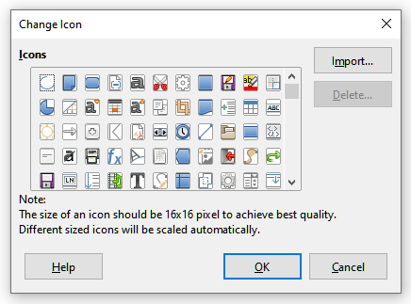Figure 8: Change Icon dialog

Customizing the notebook bar
By default, LibreOffice Writer’s commands are grouped in cascading menus and in toolbars filled with icons. The Notebook bar provides a different way to organize controls and icons, displaying contextual groups of commands and contents. You can find more information about the Notebook bar in the Help system, by searching for “notebook bar” in the index.
One of the available Notebook bar modes is Tabbed – in this mode, the bar is divided into tabs, where each tab displays a set of icons grouped by context. The context can also change depending on the object selected in the document, for example a table or an image.
Checkboxes are provided on the Notebookbar tab of the Customize dialog (Figure 9) to show and hide the individual options on the various tabs that are provided in the Tabbed mode user interface.
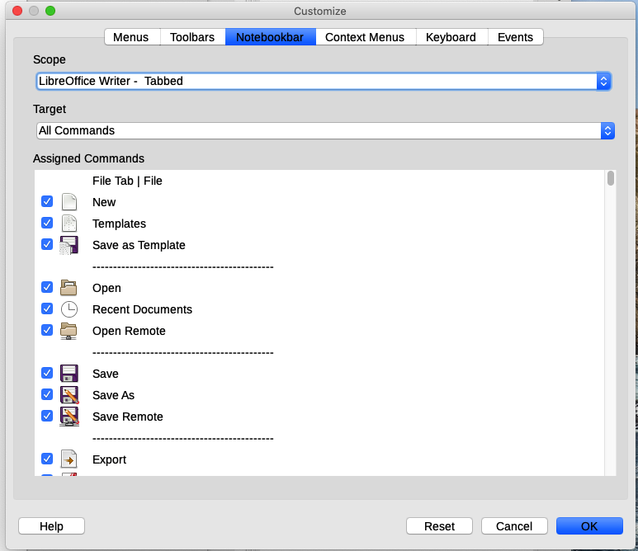Figure 9: The Notebookbar tab of the Customize dialog
Use the Reset button to reset the Tabbed mode of the notebook bar configuration to the default settings.
- Note
LibreOffice 6.4 has three notebook bar modes that can be selected through the View > User Interface menu – Tabbed, Tabbed Compact, and Groupedbar Compact. However, only the first of these can be modified using the Notebookbar tab of the Customize dialog.

Assigning shortcut keys
In addition to using the built-in keyboard shortcuts, you can define others. You can assign shortcuts to standard LibreOffice functions or your own macros and save them for use with Writer or with the entire LibreOffice suite.
To adapt shortcut keys to your needs, use the Keyboard tab of the Customize dialog (Figure 10).
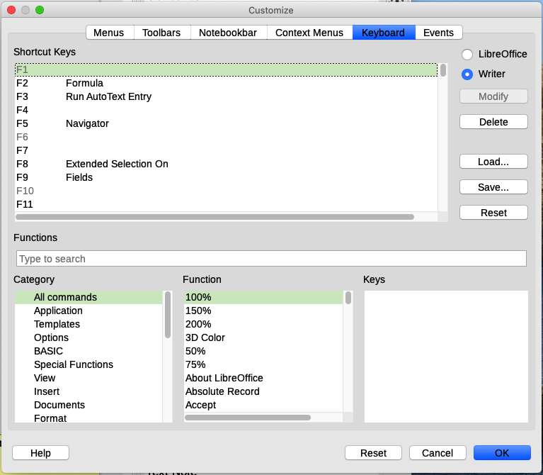Figure 10: Defining keyboard shortcuts for applying styles
- Choose whether to have the shortcut key assignment available in all components of LibreOffice or only in Writer.
- Select the desired shortcut key in the Shortcut Keys list at the top of the page.
- Select the required function from the Category and Function lists.
- Click the Modify button. The selection now appears in the Keys list on the lower right.
- Click OK to accept the change.
Repeat as required.
- Caution
Avoid reassigning your operating system’s predefined shortcut keys.
- Note
Shortcut keys that are grayed-out in the listing on the Customize dialog, such as F1 and F10, are not available for reassignment.

Saving changes to a file
Changes to the shortcut key assignments can be saved in a keyboard configuration file for use at a later time, so you can create and apply different configurations as needed. To save keyboard shortcuts to a file:
- After making keyboard shortcut assignments, click the Save button at the right of the Customize dialog (Figure 10).
- In the Save Keyboard Configuration dialog, type a name for the keyboard configuration file in the File name box, or select an existing file from the list. Browse to the location where you want to save the file. (The file extension is .cfg for Configuration.)
- Click Save. A confirmation dialog appears if you are about to overwrite an existing file, otherwise there will be no feedback and the file will be saved.

Loading a saved keyboard configuration
To load a saved keyboard configuration file and replace your existing configuration, click the Load button on the Customize dialog, and then select the configuration file from the Load Keyboard Configuration dialog.

Resetting the shortcut keys
To reset all of the keyboard shortcuts to their default values, click the Reset button on the Customize dialog. Use this feature with care; no confirmation dialog will be displayed.

Assigning macros to events
In LibreOffice, when something happens, we say that an event occurred. For example, a document is opened, a key is pressed, or the mouse moved. You can associate a macro with an event, so the macro is run when the event occurs. For example, a common use is to assign the “open document” event to run a macro that performs certain setup tasks for the document.
To associate a macro with an event, use the Events tab of the Customize dialog. For more information, see Chapter 13, Getting Started with Macros, in the Getting Started Guide.

Adding functionality with extensions
An extension is a package that can be installed into LibreOffice to add new functionality. Template sets, spelling dictionaries, clipart galleries, macros, and dialog libraries can be packaged as LibreOffice extensions. They can add new top-level menus, submenus or toolbar icons. Extensions may also have their own settings, available from the extension manager.
Several extensions are shipped bundled with LibreOffice and are installed with the program. These can only be removed by changing the installation options. Others can be downloaded from various websites. The official extension repository is located at http://extensions.libreoffice.org/. These extensions are free of charge.
Some extensions from other sources are free of charge; others are available for a fee. Check the descriptions to see what licenses and fees apply to the ones that interest you.
Download the extension to your computer in any folder that you want (usually folder Download).

Installing extensions
To install an extension that is listed in the repository, follow these steps:
- In LibreOffice, select Tools > Extension Manager on the Menu bar.
- In the Extension Manager dialog (Figure 11), click Get more extensions online.
- A browser window opens. Find and select the extension you want to install and click Open.
- Users with administrator or root privileges will see a dialog where they can choose to install extensions "for all users" (shared) or "only for me" (user). Users without those privileges can install, remove, or modify extensions only for their own use.
- The extension begins installing. You may be asked to accept a license agreement.
- When the installation is complete, the extension is listed in the Extension Manager dialog.
To install an extension that is not listed in the repository, download the extension, then continue with step 3 above.
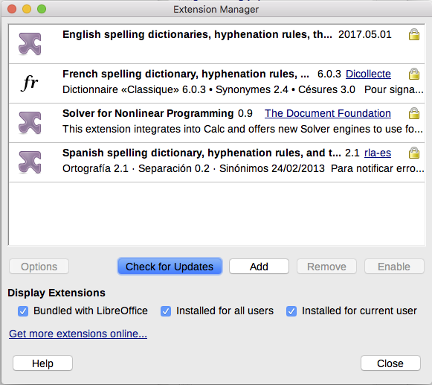Figure 11: Using the Extension Manager

Removing and disabling extensions
To remove (uninstall) an extension that you installed, select the extension in the main window of the Extension Manager dialog and click the Remove button.
To disable an extension without removing (uninstalling) it, select the extension in the main window of the Extension Manager dialog and click the Disable button, which then changes to Enable.

Adding fonts
LibreOffice supports PostScript (.pfb), TrueType (.ttf), and OpenType (.otf) font file formats. Other font formats exist, and may be supported by your operating system, but these formats may be limited in selection and quality.
If you have administration privileges, you can install additional fonts through your operating system; they will then be available for use by LibreOffice and will appear in Writer’s font lists.

Finding free-licensed fonts
In addition to proprietary fonts from sources like Adobe, hundreds of free-licensed fonts are available. You can use, share, and edit free-licensed fonts as you please. Most are available at no cost. Many are clones or near-variations of classic fonts, but some are original fonts.
Many Linux distributions include a few free-licensed fonts in their package repositories. Other places where you can find free-licensed fonts include The League of Moveable Type (https://www.theleagueofmoveabletype.com/) and Open Font Library (http://openfontlibrary.org/).

Adding custom colors
To add custom colors to a color palette, for example to exactly match a corporate color scheme, follow this procedure:
- Insert any drawing object, such as a square, into any document.
- Right-click on the object and choose Area on the context menu.
- Go to the Color tab (Figure 12). Under Colors > Palette, choose which palette you wish to add the new color to. Under New, define the new color using RGB or Hex notation, or click the Pick button to select the color on the Pick a Color dialog (Figure 13).
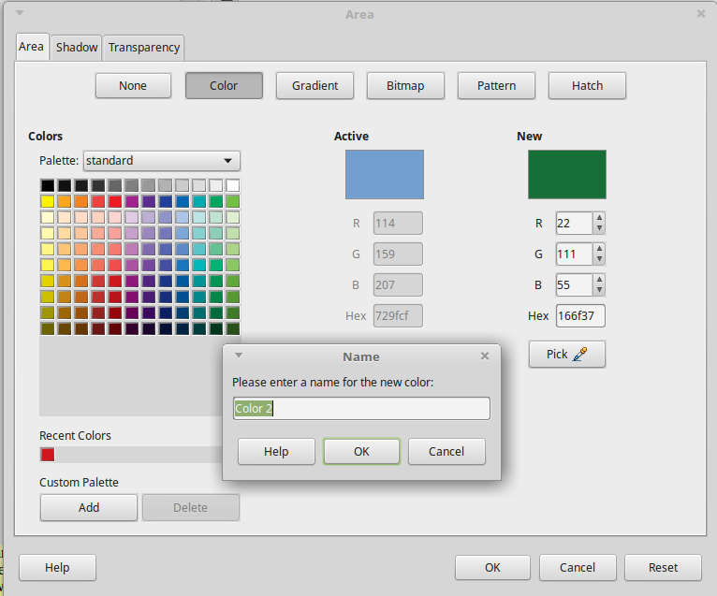Figure 12: Defining a new color
- Click Add in the lower left corner, enter a name for the new color in the pop-up dialog, and click OK to save.
- Delete the drawing object from the document, if it is not needed.
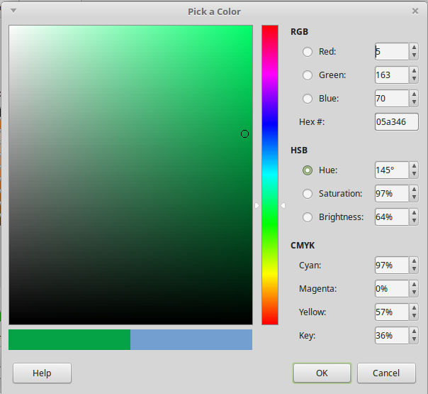Figure 13: Defining a color by picking it from a color chart

