

Chapter 2
Installing LibreOffice Online

Copyright
This document is Copyright © 2019 by the LibreOffice Documentation Team. Contributors are listed below. You may distribute it and/or modify it under the terms of either the GNU General Public License (http://www.gnu.org/licenses/gpl.html), version 3 or later, or the Creative Commons Attribution License (http://creativecommons.org/licenses/by/4.0/), version 4.0 or later.
All trademarks within this guide belong to their legitimate owners.

Contributors
This book, for version 6.3 of LibreOffice Online, was written new as part of the 2019 Google Season of Docs.

To this edition
Aaron Peters

Feedback
Please direct any comments or suggestions about this document to the Documentation Team’s mailing list: documentation@global.libreoffice.org
- Note:
Everything you send to a mailing list, including your email address and any other personal information that is written in the message, is publicly archived and cannot be deleted.

Publication date and software version
Published November 2019. Based on LibreOffice 6.3.
Contents
Copyright 4
Contributors 4
To this edition 4
Feedback 4
Publication date and software version 4
Structure of an LOOL Installation 6
Requirements to Install LibreOffice Online 7
Web Server 7
Hosting Application 7
Selecting a LOOL Version 7
Installing LibreOffice Online through Collabora CODE 8
Installing a Collabora CODE Virtual Machine 8
Installing Collabora CODE with Docker 11
Installing Collabora Code Using Packages 13
Alternative Installations 14

Structure of an LOOL Installation
As mentioned in previous sections, installing LOOL is a bit different from installing LibreOffice proper. With the latter, you install the software to your local machine. Then, when you launch one of the applications, all the processing and display also happens locally.
With LibreOffice Online, you install your application to a server. It will handle functions like the storage of files and the processing of input into formatted text or spreadsheet formulas, which are displayed on your PC through a browser. The process looks like the following:
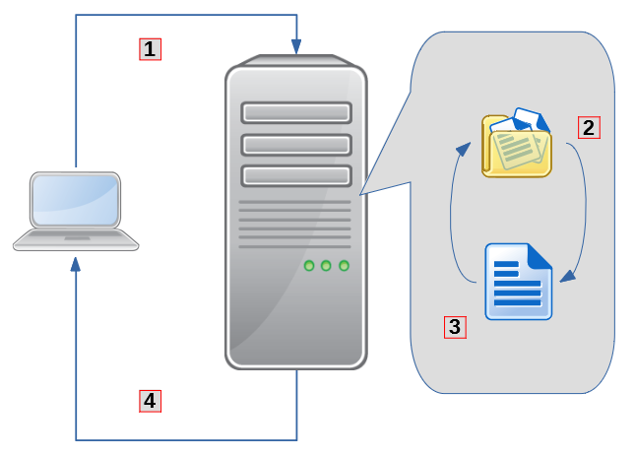Figure 1: Process for Displaying LOOL from a Server
- You contact the server by pointing your browser at a specified URL.
- The URL is for the hosting application, which is responsible for storing your files.
- When you open a supported document type in the hosting application, it will call LOOL via a plugin to display it.
- The results of this are sent back to your PC to display in the browser window.
While you don’t need anything special on your PC to use LibreOffice Online, you’ll need some software on the server where you plan to install it.

Requirements to Install LibreOffice Online

Web Server
As mentioned, LibreOffice Online requires a hosting application that will store your files and display them using LOOL as needed. These host systems are web-based applications, and as such there are three main components they require in order to provide the features LOOL needs:
- A web server, which sends web-based content to browsers
- A database, which is used to store the information in the system (even when it looks like “files” to you)
- A programming language that allows the server to display dynamic information, in this case a full-fledged web application
Fortunately, Linux has these three components in abundance. There’s a selection of different stacks you could use to host LOOL, but of these the LAMP (Linux, Apache, MySQL, PHP) stack is the most common. While installing and configuring a LAMP stack is beyond the scope of this guide, there are plenty of resources available online to get one up and running on your server.
- Confirming an Operational LAMP Stack
Before moving beyond this section, you should be able to visit your server with your web browser and be greeted with some sort of welcome page or message that the web server is running.

Hosting Application
Once your web server is in place, you can install one of the supported hosting applications that will hold the files for LOOL. There are a number of compatible applications, but the two most common are ownCloud and NextCloud. These systems offer a number of functions, including file synchronization, calendaring, contact management, and collaboration.
Again, the detailed instructions to install of one of these systems is outside the scope of this guide. Out of necessity, the below sections may include commands to quickly get a hosting application set up. But check some of the many resources online that will help you to fully administer your system.
- Confirming an Operational ownCloud/NextCloud Instance
Before moving beyond this section, you should be able to visit your server with your browser, see the ownCloud/NextCloud login page, and sign into the application.

Selecting a LOOL Version
Finally, before you start to install LOOL itself, you’ll need to make a decision as to which version you want. LibreOffice Online is an open source, collaborative project, meaning anyone is free to take the code and create a product based on it. As a result, there are a couple of different options you have to install LOOL:
- LibreOffice Project: The Document Foundation itself produces an instance of LOOL you can run using the Docker container system. This is taken directly from the project’s code and could be considered the “upstream” version of LOOL.
- Collabora CODE: Collabora is a commercial enterprise which contributes a great deal to free software in general, and to The Document Foundation and LibreOffice in particular. As the TDF website notes, much of the development of LOOL is done by Collabora, and their Collabora Online Development Edition (CODE) is an excellent choice to get a version of LOOL running on your server. You can install it either as a Docker container, or using native packages on Debian-/Ubuntu-based distributions, CentOS, or openSUSE Leap.
In this guide, we’ll focus on installing and configuring the LibreOffice Project’s Docker container as our version of choice, and use NextCloud as the hosting application.

Installing LibreOffice Online through Docker
Installing the LibreOffice Online application as published by The Document Foundation is easy using the Docker Container they provide. Docker is a system that runs applications for you in containers, which are like little sealed off sections of your computer. This means if there’s something wrong with a Docker application it can’t (normally) affect the rest of your system. It also means that you can’t normally access the contents of these containers through your operating system’s normal tools—at least not without some prior configuration. The purpose of containers is to provide security while also being resource efficient. Getting Docker installed is beyond the scope of this book, but you can find plenty of installation resources on the Docker website to install the Community Edition of Docker Engine.
The actual command to install LOOL from The Document Foundation is easy:
docker pull libreoffice/online
This will download LOOL from the Docker Hub repository and install it for you.
Figure 2: Installing LibreOffice Online from Docker Hub
You’ll need to modify the application’s configuration file (/etc/loolwsd/loolwsd.xml) to include the hosting application’s domain name and the username/password for the administration console. You can then start the container up with the following command, where abcd123 is the name of your Docker container.
docker run abcd123
- Troubleshooting Your Connection
If you find your LibreOffice Online container starts correctly, but you’re not able to open any files (as described later in Chapter 5, Editing, Saving, and Exporting Your LibreOffice Online Files), make sure you’ve entered the right configuration values for your hosting application in the loolwsd.xml file. Additionally, make sure you’re completed the steps described in Chapter 3, Setting Up to Use LibreOffice Online, to make sure that the set-up is complete on the hosting application’s side.

