
Calc Guide

Chapter 5
Using Graphics in Calc

Autorská práva
Tento dokument je duševním vlastnictvím dokumentačního týmu LibreOffice ©2019 . Přispěvatelé jsou uvedeni níže. Dokument je možné šířit nebo upravovat za podmínek licence GNU General Public License (https://www.gnu.org/licenses/gpl.html), verze 3 nebo novější, nebo za podmínek Commons Attribution License (https://creativecommons.org/licenses/by/4.0), verze 4.0 nebo novější.
Všechny ochranné známky uvedené v této příručce patří jejich vlastníkům.

Přispěvatelé
This book is adapted and updated from the LibreOffice 4.1 Calc Guide.

Pro toto vydání
Jean Hollis Weber | Drew Jensen | Kees Kriek

Pro předchozí vydání
Barbara Duprey | Jean Hollis Weber | John A Smith
Peter Schofield | Christian Chenal | Martin Saffron

Zpětná vazba
Připomínky a náměty k tomuto dokumentu posílejte v angličtině do e-mailové konference dokumentačního týmu na adresu: documentation@global.libreoffice.org.
- Poznámka
Všechno, co do e-mailové konference pošlete, včetně e-mailové adresy a dalších osobních informací uvedených ve zprávě, bude veřejně viditelné bez možnosti smazání.

Datum vydání a verze programu
Published December 2019. Based on LibreOffice 6.2.

Používání LibreOffice na systému macOS
Některé klávesové zkratky a položky nabídek jsou v systému macOS jiné než v systémech Windows a Linux.. V následující tabulce jsou uvedeny nejdůležitější rozdíly, které se týkají informací v této knize. Podrobnější seznam se nachází v nápovědě k aplikaci.
Windows nebo Linux | Ekvivalent pro macOS | Význam
Nabídka Nástroje > Možnosti | LibreOffice > Předvolby | Otevře nastavení s možnostmi
Klepnutí pravým tlačítkem | Control+click or right-click depending on computer setup | Otevře se místní nabídka
Ctrl (Control) | ⌘ (Command) | Používá se i s jinými klávesami
F5 | Shift+⌘+F5 | Otevřete Navigátor
F11 | ⌘+T | Open the sidebar Styles panel
Obsah
Autorská práva 2
Přispěvatelé 2
Pro toto vydání 2
Pro předchozí vydání 2
Zpětná vazba 2
Datum vydání a verze programu 2
Používání LibreOffice na systému macOS 2
Úvod 4
Adding graphics (images) to a spreadsheet 4
Vkládání souboru s obrázkem 4
Přetažení 4
Insert Image dialog 4
Linking or embedding an image file 5
Vkládání odkazovaných obrázků 6
Vkládání obrázků ze schránky 6
Vkládání obrázků s použitím skeneru 7
Vkládání obrázků z galerie 7
Modifying images 8
Using the Image toolbar 8
Using the Properties pane in the Sidebar 8
Přidávání textu 9
Positioning, resizing, and arranging images 9
Pomocí myši 9
Using the Position and Size dialog 10
Arranging images 10
Anchoring images 11
Aligning images 11
Grouping and ungrouping images 11
Použití kreslicích nástrojů balíku LibreOffice 12
Nástrojová lišta Kresba 12
Setting the properties of drawing objects 13
Resizing drawing objects 14
Grouping and ungrouping drawing objects 14
Additional tools 14
Použití písmomalby 14
Vytváření objektů písmomalby 15
Úprava objektů písmomalby 15

Úvod
Calc is used to present and analyze data and to make forecasts and predictions. Graphics can turn an average spreadsheet into a more memorable document. Calc can import various vector (line drawing) and raster (bitmap or photo) file formats. The most commonly used graphic formats are GIF, JPG, and PNG. See LibreOffice Help for a full list of the formats that Calc can import.
Graphics in Calc are of three basic types:
- Image files, such as photographs, drawings, and scanned images
- Diagrams created using LibreOffice’s drawing tools
- Charts and graphs created using LibreOffice’s Chart facility; see Chapter 3, Creating Charts and Graphs, for more information
Using graphics in Calc is similar to using graphics in other components of LibreOffice. For more detailed descriptions, please refer to the Getting Started Guide or the Draw Guide.
- Poznámka
In LibreOffice, the terms graphics and images refer to both pictures and drawing objects. Often the word images is used when referring to pictures and other graphics that are not drawing objects.

Adding graphics (images) to a spreadsheet
Graphics or images (sometimes called pictures in LibreOffice), such as corporate logos and photographs, are probably the most common types of graphics added to a spreadsheet. They may be downloaded from the Internet, scanned, created with a graphics program, photographs taken with a digital camera, or clip art in the Gallery.

Inserting an image file
When the image is in a file stored on the computer, you can insert it into a spreadsheet using either of the following methods.

Přetažení
- Otevřeme okno prohlížeče souborů a přemístíme se na obrázek, který chceme vložit.
- Drag the image into the spreadsheet and drop it where you want it to appear. Místo, kde bude obrázek upuštěn, označuje nevýrazná šedá čárka.
Tímto způsob obrázek do dokumentu skutečně vložíme, tj. uložíme v něm jeho kopii. Chceme-li místo místo vložit místo obrázku pouze odkaz, při přetahování obrázku podržíme klávesy Ctrl+Shift.

Insert Image dialog
- Click in the spreadsheet where you want the image to appear.
- Choose Insert > Image from the Menu bar.
- On the Insert Image dialog (Figure 1), navigate to the file to be inserted, and select it.
- At the bottom of the dialog is an Insert as Link option. See page 5 for the use of links.
- Klepneme na Otevřít. The file is inserted into the spreadsheet as a floating image and is anchored to the cell in which the cursor was placed.
Figure 1: Insert Image dialog
- Poznámka
The Insert Image dialog may look different from the one shown in Figure 1, depending on your operating system.

Linking or embedding an image file
Embedding an image into a spreadsheet makes the image a permanent part of the spreadsheet file. Any changes you make to an embedded image will appear only in that spreadsheet; the original image will not be affected.
If you select the Insert as Link option in the Insert Image dialog, LibreOffice creates a link to the file containing the image instead of embedding it. The image is displayed in the document, but when the document is saved, it contains only a reference to the image file, not the image itself. Dokument a obrázek zůstávají dvěma samostatnými soubory a jsou spojeny dohromady až tehdy, když dokument znovu otevřeme.
Odkazování na obrázky má dvě výhody a jednu nevýhodu:
- Advantage – You can modify the image file separately. The modified image will appear when you next open the spreadsheet. To může znamenat velkou výhodu, pokud obrázky (my nebo někdo další jako grafik) aktualizujeme.
- Advantage – Linking can reduce the file size of the spreadsheet when it is saved, because the image file itself is not included. However, file size is usually not a problem on modern computers, and Calc can easily handle large files.
- Disadvantage – If you send the document to someone else, or move it to a different computer, you must also send the image files and keep the same file structure. For example, you might keep image files in a subfolder named Images inside the same folder containing the Calc document. Any recipient of the spreadsheet needs to put the image files in a subfolder with the same name in the same named folder as the spreadsheet.
- Poznámka
When inserting the same image several times in a document, it might appear beneficial to create links. However, this is not necessary, as LibreOffice embeds only one copy of the image file in the document. Deleting one or more of the copies does not affect the other copies of the same file.

Embedding linked images
If you originally linked the images, you can easily embed one or more of them later.
- Open the spreadsheet in Calc.
- Choose Edit > Links to External Files on the Menu bar to open the Edit Links dialog (Figure 2), which shows all the linked files.
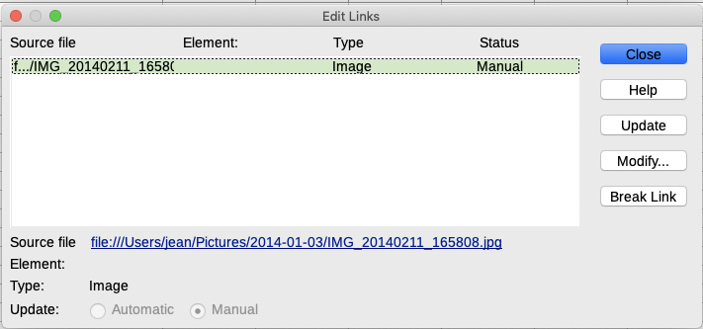Figure 2: Edit Links dialog
- Select the files you want to change from linked to embedded.
- Click Break Link and confirm you want to remove the selected link. The file then becomes embedded into the spreadsheet.
- Poznámka
Going from embedded to linked images is not so easy. You must replace them one at a time, selecting the Insert as Link option when you reinsert each file.

Vkládání obrázků ze schránky
Using the clipboard, you can copy images into a Calc spreadsheet from another LibreOffice document and from other programs. Provedeme to následovně:
- Otevřeme zdrojový a cílový dokument.
- In the source document, right-click on the image to be copied and select Copy from the context menu.
- Přepneme se na cílový dokument. Click to place the cursor in the cell where the image is to be anchored. Right-click and select Paste to insert the image.
- Upozornění
If the application from which the image was copied is closed before the image is pasted into the target, the image stored on the clipboard could be lost.

Vkládání obrázků s použitím skeneru
If a scanner is connected to your computer, LibreOffice can call the scanning application and insert the scanned item into the LibreOffice document as an image. To start this procedure, choose Insert > Media > Scan > Select Source. After selecting the scanner, place the cursor where you want the image to be inserted, and choose Insert > Media > Scan > Request.
Ačkoliv je tento postup rychlý a snadný, pravděpodobně pomocí něj nezískáme kvalitní obrázek o správné velikosti. You may get better results by passing scanned material into a graphics program and cleaning it up there before inserting the resulting image into LibreOffice.

Inserting an image from the Gallery
The Gallery (Figure 3) provides a convenient way to group reusable objects such as images and sounds that you can insert into your documents. The Gallery is available in all components of LibreOffice. You can add your own images as well as using the ones supplied with LibreOffice. For more information, see the Getting Started Guide Chapter 11, Graphics, the Gallery, and Fontwork.
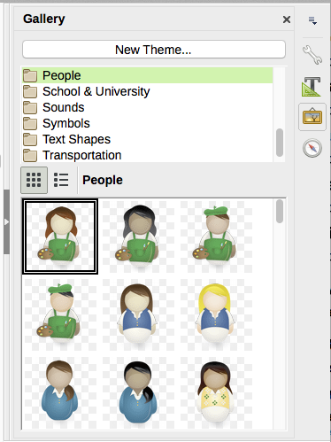Figure 3: The Gallery in the Sidebar
To insert an image from the Gallery:
- Click the Gallery icon in the Sidebar.
- Vybereme motiv vzhledu.
- Jednoduchým klepnutím vybereme objekt.
- Přetáhneme obrázek do dokumentu.
You can also right-click on the object and choose Insert.
- Poznámka
To insert an image as a link, hold down the Shift and Ctrl keys while dragging the object into the document.

Modifying images
When you insert a new image, you may need to modify it to suit the document. Any changes made in Calc do not affect the original image, whether it is an embedded or linked image file.
Calc provides several tools for working with images. These tools are sufficient for most requirements. However, for professional results it is generally better to use LibreOffice Draw or other software designed to modify image files, and then insert the result into Calc.

Using the Image toolbar
When you insert an image or select one already present in the spreadsheet, the Image toolbar replaces the Formatting toolbar. If it does not appear, go to View > Toolbars > Image on the Menu bar. The tools available on the Image toolbar are described below.
- Poznámka
Image properties selections affect only the display and printing of the image. The original image file remains unchanged.
- Anchor – choose between anchoring the image to a cell or to a page. See “Anchoring images” on page 11.
- Align – if two or more images are selected, you can adjust the horizontal and vertical alignment of the images in relation to each other. See “Aligning images” on page 11.
- Six buttons for arrangement (the position of images in the stacking order): Bring to Front, Forward One, Back One, Send to Back, To Background. See “Arranging images” on page 10.
- Line Style, Line Width, Line Color – set the attributes of the border around the image.
- Area Style/Filling – sets the color or other characteristics of the background area that contains the image, not the image itself. To see the background, you must set the transparency of the image to a suitably high value. See the Draw Guide for more information on how to modify areas.
- Shadow – sets the default shadow effect around the image. To adjust the shadow effect, open the Area dialog and choose the Shadow tab.
- Filter – opens the Image Filter toolbar. See the Draw Guide for details on image filters.
- Image Mode – changes the display of the image from color to grayscale, black and white, or a watermark. This setting affects only the display and printing of the image; the original image file remains unchanged.
- Crop – places cropping handles around the image. Drag a handle to crop (hide) the edges of the image.
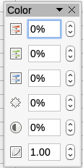
- Flip Horizontally and Flip Vertically – changes the orientation of the image.
- Rotate – places rotation handles around the image.
- Transparency – adjusts the degree of transparency of the picture between 0% (opaque) and 100% (fully transparent).
- Color – opens the Color toolbar to adjust the values of the Red, Green, Blue colors, brightness, contrast and Gamma.

Using the Properties pane in the Sidebar
Some of the settings in the Image toolbar are also available in the Properties pane in the Sidebar when an image is selected. These include the Color, Line, and Transparency settings.

Adding text
You can add text to an image or drawing object. That text will move with the image when the image is repositioned. For more information on adding text to images, see the Draw Guide.
- Double-click on the image. The text cursor flashes in the center of the image. The Text Formatting toolbar automatically opens at the top of the spreadsheet.
Figure 4: Text Formatting toolbar for images
- Type your text and use the tools on the Text Formatting toolbar to format it. Most of the tools are the same as those for formatting text in cells.
- To adjust the position of the text or how it appears in the image, right-click on the image and select Text from the context menu to open the Text dialog (Figure 5).
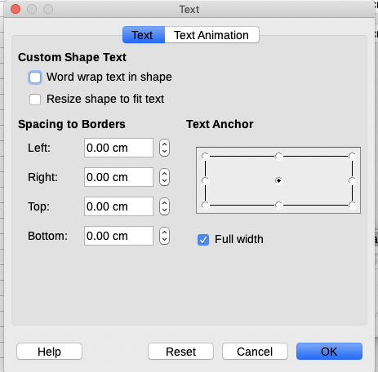Figure 5: Text dialog
- Make any necessary changes and click OK to close the dialog.

Positioning, resizing, and arranging images

Pomocí myši
To move an image to a new position in your spreadsheet, click on the image and drag it to a new position. The image will still be anchored to the cell or page it was originally anchored to.
To resize an image:
- Click on the image to display the selection handles.
- Position the cursor over one of the selection handles. The cursor changes shape, giving a graphical representation of the direction of the resizing. The corner handles resize both the width and the height of the image simultaneously. The top, bottom, left and right handles only resize one dimension at a time.
- Click and drag to resize the image.
- Tip
To retain the original proportions of the image, Shift+click one of the corner handles, then drag.

Using the Position and Size dialog
To accurately position and size an image in your spreadsheet, go to Format > Object > Position and Size on the Menu bar, or right-click on an image and select Position and Size from the context menu.
On the Position and Size tab (Figure 6), you can set these values:
- Position – the location of the selected image on the spreadsheet.
- Position X – the horizontal distance from the base point selected in the grid.
- Position Y – the vertical distance from the base point selected in the grid.
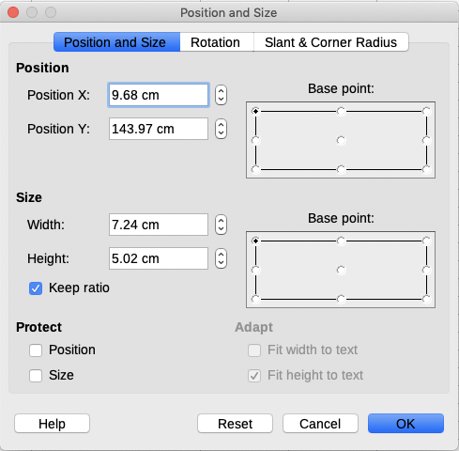Figure 6: Position and Size dialog
- Size – the width and height of the image with respect to the selected base point.
- Protect – To prevent accidental movement or resizing of the image, select the relevant option.
The units of measurement used for X//Y coordinates and the width and height of the image are set by going to Tools > Options > LibreOffice Draw > General.
The default location of the base points for position and size is the upper left corner of the spreadsheet. You can temporarily change this base point to make positioning or dimensioning simpler by clicking on a position corresponding to the location of the base point you want to use. This change in base point is only valid for single use and the base point is reset to the standard position of top left corner when you close the Position and Size dialog.
You can also rotate or slant an image (using the Rotation or Slant & Corner Radius tabs of the Position and Size dialog). See the Draw Guide for details.

Arranging images
Each image that you place in a spreadsheet is successively stacked on the preceding image, whether or not they overlap. Use the arrange commands to change the stacking order of images. You cannot change the stacking order of text.
- Select the image you want to change.
- Go to Format > Arrange on the Menu bar, or right-click on the image and select one of the arrangement options described below.
- Alternatively, click on the Bring to Front icon or the Send to Back icon on the Image toolbar to quickly move the image to the front or rear of the stack.
The arrangement options are as follows:
- Bring to Front – moves the selected image to the top of the stacking order, so that it is in front of other images.
- Forward One – moves the selected image up one level, so that it is closer to top of the stacking order. Not available on the Picture toolbar.
- Back One – moves the selected image down one level, so that it is closer to the bottom of the stacking order. Not available on the Image toolbar.
- Send to Back – moves the selected image to the bottom of the stacking order, so that it is behind the other images.
- To Foreground – moves the selected image in front of text.
- To Background – moves the selected image behind text. To select a background image so that you can modify or replace it, you have to use the Navigator. Other methods of selection, such as clicking or double-clicking, do not work.

Anchoring images
Anchors images so they stay in their position in relation to other items.
- To Page – anchor an image to the page to position it in a specific place. The image does not move when cells are added or deleted; it will always stay in the same position on the page where it is placed.
- To Cell – anchor an image to a cell to ensure that the image always stays with the content it is originally anchored to. If an image is anchored to cell B10, and a new row is inserted above row 10, the image will then be anchored to cell B11.
To anchor an image or change the type of anchor used:
- Go to Format > Anchor > To Page or To Cell on the Menu bar, or right-click on the image and select Anchor > To Page or To Cell from the context menu.
- Alternatively, click on the Change Anchor icon on the Image toolbar and the anchor type will toggle between To Page or To Cell.

Aligning images
When you have more than one image in your spreadsheet, you can align these images to give your spreadsheet a more professional look. The options include three for aligning the images horizontally (left, centered, right) and three for aligning the images vertically (top, center, bottom).
- Select all of the images to be aligned.
- Go to Format > Align on the Menu bar, or right-click on the image and select Align from the context menu, or click on the Alignment icon on the Picture toolbar.
- Select one of the six options available for alignment.

Grouping and ungrouping images
To group several images so that they become a single object in the spreadsheet:
- Select the images you want to group (select one and hold down the Shift key while selecting others).
- Go to Format > Group > Group on the Menu bar, or right-click on the selected images and select Group from the context menu.
To ungroup images:
- Select the image group you want to ungroup.
- Go to Format > Group > Ungroup on the Menu bar, or right-click on the selected images and select Ungroup from the context menu.
To edit an image in a group:
- Select the image group where you want to edit an image within the group.
- Go to Format > Group > Enter Group on the Menu bar, or right-click on the selected images and select Enter Group from the context menu.
- Select the image you want to make changes to and make the changes.
- Go to Format > Group > Exit Group on the Menu bar, or right-click on the selected images and select Exit Group from the context menu.

Using LibreOffice’s drawing tools
Calc, like all other components of LibreOffice, has a range of tools to create drawings such as simple diagrams, using rectangles, circles, lines, text, and other shapes. You can group several drawing objects to make sure they maintain their relative position and proportion if you move or resize them.
You can also use the drawing tools to annotate photographs, screen captures, or other illustrations produced by other programs, but this is not recommended because you cannot include images in a group with drawing objects, so they may not remain aligned in the document. If you need to create complex drawings, it is recommended to use LibreOffice Draw and then insert the drawing into your spreadsheet. For a more detailed explanation, see the Draw Guide.

Drawing toolbar
To begin using the drawing tools, go to View > Toolbars > Drawing to open the Drawing toolbar, which appears in its default position at the bottom of the spreadsheet. You can make this toolbar a floating toolbar and move it to a convenient position.
When the Drawing toolbar opens, it opens with a default set of tools as shown in Figure 7. Hover the mouse pointer over a tool to see a tooltip describing its function. Tools with small arrows to the right side open with palettes of tools. To add tools to the Drawing toolbar, right-click in an empty area on the toolbar and select Visible Buttons from the context menu.
Figure 7: Drawing toolbar
Chceme-li použít kreslicí nástroj:
- Klepneme v dokumentu na místo, ke kterému chceme kresbu ukotvit. V případě potřeby můžeme ukotvení později změnit.
- Choose the tool from the Drawing toolbar (Figure 7). The mouse pointer changes to a drawing-functions pointer and the normal Formatting Toolbar changes to Drawing Object Properties toolbar (Figure 8).
- Move the cross-hair pointer to the place in the document where you want the drawing object to appear and then click and drag to create the object. Uvolníme tlačítko myši. Vybraná kreslicí funkce zůstává aktivní, můžeme proto nakreslit jiný objekt téhož typu.
- Chceme-li vybranou kreslicí funkci zrušit, stiskneme klávesu Esc nebo klepneme na ikonu Vybrat (šipka) na nástrojové liště Kresba.
- You can now change the properties (fill color, line type and weight, anchoring, and others) of the drawing object using the Drawing Object Properties toolbar (Figure 8), the Properties pane in the Sidebar, or the choices reached by right-clicking on the drawing object.

Setting the properties of drawing objects
For more information on the properties of drawing objects, see the Draw Guide.
You can set some default properties for a drawing object before you draw an object. These default properties are applied only to the current spreadsheet and are are not retained when you close the spreadsheet. The properties apply only to drawing objects.
- Click Select on the Drawing toolbar (Figure 7).
- On the Drawing Object Properties toolbar (Figure 8), set the values you want to use for each property. When you select area or line properties, dialogs open where you can set the values used for area or line.
Figure 8: Drawing Object Properties toolbar
- After you draw an object or group it with another object, more properties become active. These appear on the toolbar (Figure 9) and some are shown in the Properties pane of the Sidebar (Figure 10).
Figure 9: Drawing Object Properties toolbar after inserting an object
Figure 10: Drawing Object Properties in Sidebar
You can change the properties of an existing drawing object (fill color, line type and weight, anchoring, and so on) using the Drawing Object Properties toolbar (Figure 8), the Properties pane in the Sidebar, or the context menu when you right-click on the drawing object.

Resizing drawing objects
Select the object and click on one of the selection handles then drag the object to its new size. For a scaled resizing, select one of the corner handles and keep the Shift key pressed while dragging the handle. For more information, see “Positioning, resizing, and arranging images” on page 9.

Grouping and ungrouping drawing objects
For grouping, ungrouping, and editing grouped drawing objects, see “Grouping and ungrouping images” on page 11.

Additional tools
Some additional tools are available when you right-click on an image or drawing object and open the context menu.
Popis
You can add metadata in the form of a title and description to an image. This information is used by accessibility tools (such as screen reader software) and as ALT (alternative text) attributes if you export the document to HTML.
Name
You can add a custom name to be assigned to an image; this will make the image easier to find in the Navigator. Also, assigning names to images helps identify them when teams of people are working on the same multi-page spreadsheet.
Rotate or Flip
You can rotate the image or flip it horizontally or vertically.
Assign Macro
Opens the Assign Macro dialog so you can add programmable functionality to the graphic. Calc has a very good macro functionality. For more information, see Chapter 12, Calc Macros.
Edit Hyperlink
You can define a hyperlink from an image to another location in your spreadsheet, another document, or a web page. Select Edit Hyperlink from the context menu to open the Hyperlink dialog. See Chapter 10, Linking Calc Data, for more information on hyperlinks.
Compress
You can compress images to reduce the file size of the spreadsheet. Select Compress from the context menu to open a dialog where you can set the compression options.
Edit with external tool
You can edit an image with an external tool. The dialog that opens will depend on your computer setup.

Použití písmomalby
With Fontwork, you can create graphical text art objects to make your work more attractive. Máme na výběr z velkého množství různých nastavení těchto textových objektů (čára, oblast, umístění, velikost a další).
Písmomalba je k dispozici v každé součásti balíku LibreOffice, nicméně ve způsobu, jakými ji každá součást zobrazuje, jsou drobné rozdíly.

Vytváření objektů písmomalby
- On the Fontwork toolbar (View > Toolbars > Fontwork) or the Drawing toolbar (View > Toolbars > Drawing), click the Fontwork icon.
- In the Fontwork Gallery (Figure 11), select a Fontwork style, then click OK. The Fontwork object will appear in the document.
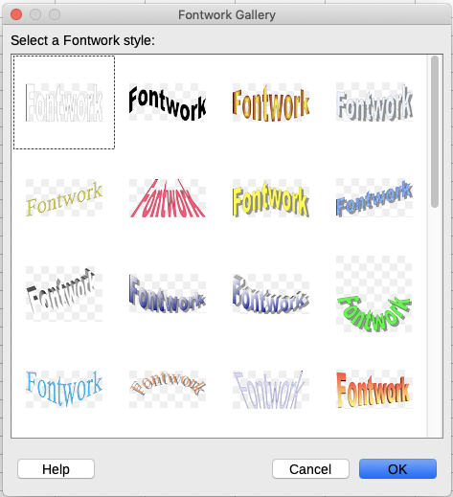Obrázek 11: Galerie písmomalby
- Double-click the object to edit the Fontwork text (see Figure 12). Select the text and type your own text in place of the black Fontwork text that appears over the object.
Obrázek 12: Úprava textu písmomalby
- Klepneme kamkoliv na volné místo nebo stiskneme Esc, čímž změny použijeme.

Úprava objektů písmomalby
Jakmile je objekt písmomalby vytvořen, můžeme upravit některé jeho vlastnosti. To do this, you can use the Fontwork toolbar, the Formatting toolbar, or menu options. For more information, see Chapter 11, Graphics, Gallery, Fontwork, in the Getting Started Guide.

