
LibreOffice Online 6.3 Guide

Chapter 6
The Text Documents Module

Copyright
This document is Copyright © 2019 by the LibreOffice Documentation Team. Contributors are listed below. You may distribute it and/or modify it under the terms of either the GNU General Public License (http://www.gnu.org/licenses/gpl.html), version 3 or later, or the Creative Commons Attribution License (http://creativecommons.org/licenses/by/4.0/), version 4.0 or later.
All trademarks within this guide belong to their legitimate owners.

Contributors
This book, for version 6.3 of LibreOffice Online, was written new as part of the 2019 Google Season of Docs.

To this edition
Aaron Peters

To previous editions

Feedback
Please direct any comments or suggestions about this document to the Documentation Team’s mailing list: documentation@global.libreoffice.org
- Note:
Everything you send to a mailing list, including your email address and any other personal information that is written in the message, is publicly archived and cannot be deleted.

Publication date and software version
Published January 2020. Based on LibreOffice 6.3.
Contents
Copyright 2
Contributors 2
To this edition 2
To previous editions 2
Feedback 2
Publication date and software version 2
What is the Text Documents Module Used For? 5
The Text Documents Module Interface 5
Documents Toolbar 6
Documents Status Bar 7
Adjusting the View of the Document 8
Working with Text 8
Cutting, copying, and moving text 8
Direct Formatting vs. Styles Formatting 9
Styles support in LOOL 10
Direct Formatting 10
Formatting Paragraphs directly 10
Formatting Characters Directly 11
Formatting Bulleted/Numbered Lists Directly 13
Formatting Pages Directly 14
Removing direct formatting 16
Revisiting Styles 16
Applying (Paragraph) Styles 17
Modifying Styles 17
Structuring Your Documentation 18
Inserting Graphics & Other Items 19
Inserting Special Characters 19
Inserting and Styling Tables 20
Inserting Pictures and Graphics 21
Inserting and Controlling Fields 22
Specifying Your Document’s Layout 22
Page Properties 22
Headers and Footers 23
Determining Header and Footer appearance 24
Numbering Pages 24
References 25
Footnotes/Endnotes 25
Hyperlinks 25
Writing Tools 26
Spell Checking & Autocorrect 26
Language Setup 26
Word Count 27
Review & Comments 27
Tracking changed in the document 28

What is the Text Documents Module Used For?
The Text Documents module is an online word processor, which you can use to create all sorts of text-based works. These include letters, reports for school or business, novels, essays, and other works of non-fiction. In fact, this very book was created in part in LibreOffice Online!
In a more technical sense, your hosting application will use the Text Documents module to display supported word processing file formats including the following:
- The OpenDocument Text file formats (including documents, .ODT, and templates, .OTT)
- Microsoft Word file formats (including documents, .DOCX/.DOC, and templates, .DOTX/.DOT)
- Rich Text file format (.RTF)

The Text Documents Module Interface
The main Text Documents Module workspace is shown below. The menus and toolbars are described in Chapter 1, Introducing LibreOffice Online. Some other features of the Text Documents interface are covered in this chapter.
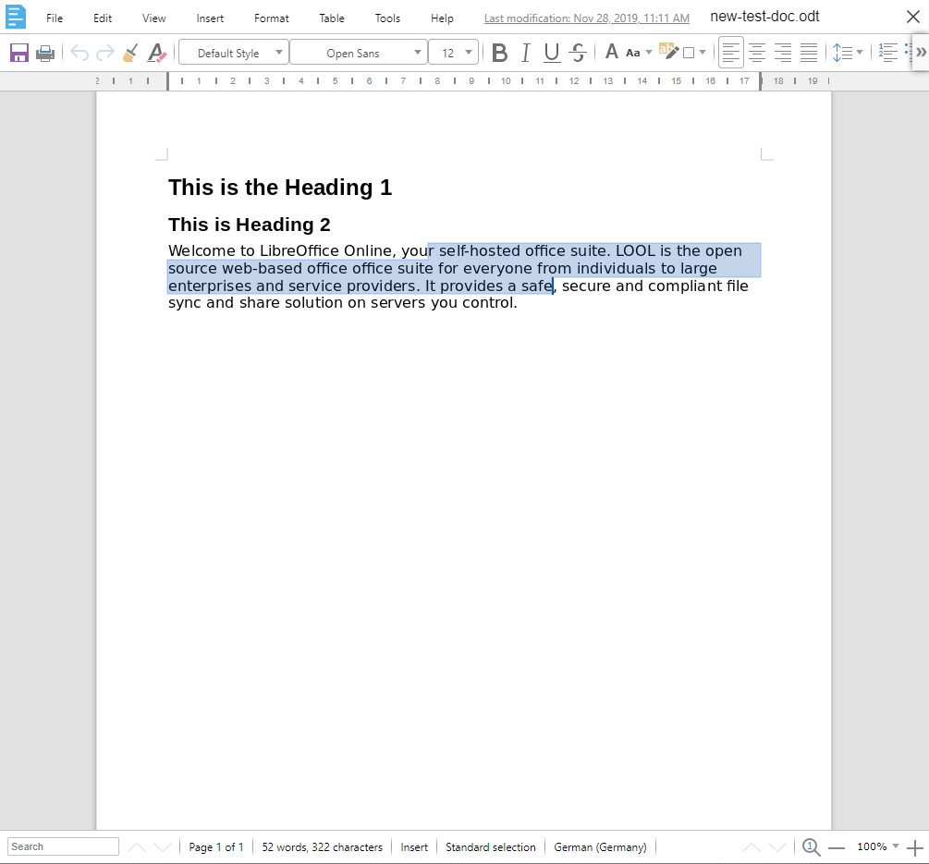Figure 1: The text documents module window
The Documents window has two main sections: the Toolbar at the top, and the Status Bar at the bottom.

Documents Toolbar
The Toolbar appears at the very top of the application window, just under the hosting application’s icons.
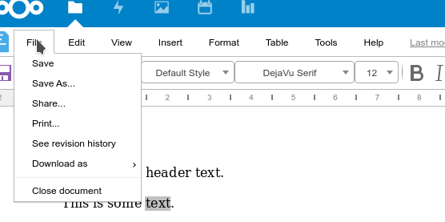Figure 2: The Documents Module Toolbar
The Toolbar contains the following entries:
File:
Contains commands that apply to the entire document; for example, Save, Download As, Print, See Revision History, and Close Document.
Edit:
Contains commands for editing the document; for example, Undo, Copy, Paste, Track Changes, Find and Replace, and Edit Style.
View:
Contains commands for modifying how the Documents user interface looks; for example, Full Screen, Zoom, and Formatting Marks.
Insert:
Contains commands for inserting elements into a document; for example, Image, Special Characters, Charts, Comments, Hyperlinks, Headers and Footers, Fields, Page/Section/Column Breaks, Links, and more.
Format:
Contains commands for modifying the layout of a document; for example, Text and its Orientation, Spacing and Alignment, Lists, Character/Paragraph/Page/Bullets and Numbering styling, Watermarks, and Columns.
Table:
Contains commands to Insert, Delete, or Select Tables/Columns/Rows/Cells, Merge Cells, or adjust a Table’s Properties.
Tools:
Contains various functions to help you check and customize the Document; for example, Spelling, Language settings, and a Word Count function.
Help:
Contains a list of the LibreOffice Online Keyboard Shortcuts and information About the application, such as version number.

Documents Status Bar
The Writer Status Bar provides information about the document and convenient ways to change some document features quickly.
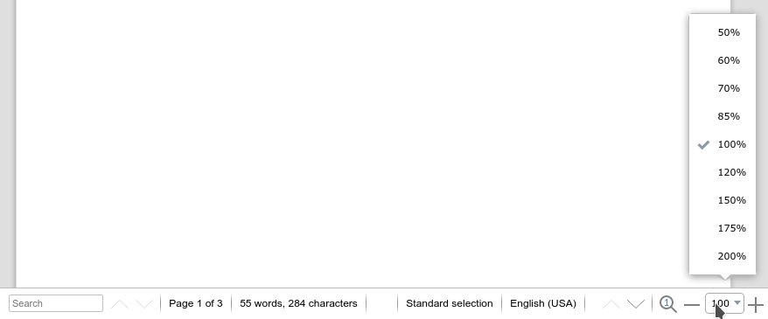Figure 3: The documents module status bar
Search
The lower-left corner has a search box. Typing a search term will highlight its first occurrence, and provide a count of any additional occurrences.
Page number
Shows the current page number, the sequence number of the current page (if different), and the total number of pages in the document. For example, if you restarted page numbering at 1 on the third page, its page number is 1 and its sequence number is 3.
If any bookmarks have been defined in the document, a right-click on this field pops up a list of bookmarks; click on one to go to that location.
To jump to a specific page in the document, double-click on this field. The Navigator opens. Click in the Page Number field and type the sequence number of the required page and press Enter.
Word and character count
The word and character count of the document is shown in the Status Bar, and is kept up to date as you edit. When text is selected, the word and character counts for the selection will appear here.
To display extended statistics such as character counts that exclude spaces, double-click the word count in the Status Bar, or choose Tools > Word Count.
Selection mode
Displays the current selection mode.
Language
Shows the language at the cursor position, or for the selected text, that is used for checking spelling and grammar as well as for hyphenation and thesaurus dictionaries.
Zoom
To change the view magnification, drag the Zoom slider, or click on the + and – signs, or right-click on the zoom level percent to pop up a list of magnification values from which to choose. Zoom interacts with the selected view layout to determine how many pages are visible in the document window.

Adjusting the View of the Document
As mentioned, the Status Bar contains controls to zoom into and out of the document, set the Zoom level to a specific level (e.g. 150%, 200%, etc.), and reset it to its default level. You can also Zoom In, Zoom Out, and Reset zoom from the View menu.
This menu has two additional options, the first of which is Full Screen. While the desktop version of LibreOffice has a similar function, in LOOL this will instead invoke the Full Screen mode of the browser you’re using. In order to return to the normal viewing mode, you should use whichever command your browser requires (for example, in Google Chrome it’s the Esc key).
The other View option in LOOL is Formatting Marks. This will display non-printing characters such as spaces, line returns, and section breaks in your document. Showing Formatting Marks can be useful while troubleshooting layout issues.
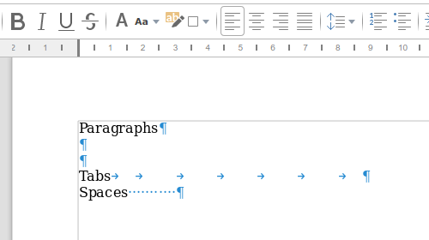Figure 4: Formatting marks for paragraphs, tabs and spaces. Page margins are also displayed.
- Note: No View Controls on the Main Toolbar
Like the desktop version of LibreOffice, LOOL doesn’t include View-related buttons on the Toolbar by default. However, LOOL cannot be customized to include them in the same way LibreOffice can.

Working with Text
The following sections will describe some of LOOL’s basic text editing and formatting features. By and large, tasks you can accomplish in the desktop version of LibreOffice or other comparable programs will function the same way in LOOL. The main difference is that LibreOffice Online supports only a subset of the features of desktop applications.

Cutting, copying, and moving text
Selecting, copying, pasting, or moving text in Writer is similar to working with text in other programs. LibreOffice also has some convenient ways to select items that are not next to each Cutting, copying, and moving text
Cutting and copying text in Documents is similar to cutting and copying text in other applications. You can use the mouse or the keyboard for these operations. You can copy or move text within a document, or between documents, by dragging or by using menu selections, toolbar buttons, or keyboard shortcuts. You can also copy text from other sources such as Web pages and paste it into a Writer document.
To move (drag and drop) selected text using the mouse, drag it to the new location and release it. To copy selected text, hold down the Ctrl key while dragging. To move (cut and paste) selected text, use Ctrl+X to cut the text, insert the cursor at the paste-in point and use Ctrl+V to paste. Alternatively, use the buttons on the Edit menu to Cut, Copy, and Paste text.
- Warning: Pasting from external sources may not retain all formatting
As with many web-based applications, when you paste content that you copied from external sources (whether other applications or even other browser tabs or LOOL documents), not all of your formatting may carry over. While some simple styling such as bolding or italics may show up properly, other more important styling like font may default to LibreOffice Online’s current configuration.
One difference you may notice is the inclusion of handles on either side of the selected content. These help users on mobile devices by long-pressing to select an initial word, then dragging the handles to surround the desired content. You can also use the mouse to click-and-drag handles once you’ve selected some text.
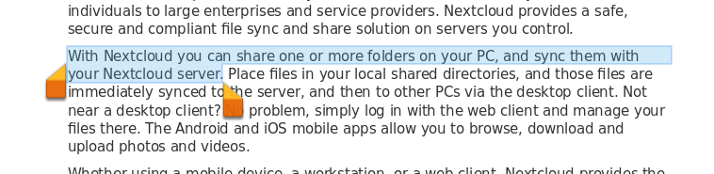Figure 5: Selected text handles in lool documents

Direct Formatting vs. Styles Formatting
There are two basic ways to format text. Understanding these two alternatives is essential for unlocking the power of LibreOffice:
Direct (or Manual) formatting
Applies formatting directly to specific paragraphs, characters, pages, frames, lists, or tables. For example, you can select a word, then click on a button on the Formatting toolbar to format the text as bold or italics.
Styles
Bundles formatting options under one name. For example, a paragraph style defines numerous settings for options such as font type and size, whether paragraphs should be indented, the space between lines, how paragraphs should be aligned on the page, and many others.
LOOL Documents is modeled after LibreOffice’s Writer application, which is designed to be a style-based program. This means that it may work somewhat differently from other word processing programs you are familiar with. It requires some planning but the time spent in planning can save time and frustration over the longer term.
Because styles apply whole groups of formats at the same time, they enable you to easily format a document consistently and to change the formatting of an entire document with minimal effort. In addition, styles are used by LibreOffice for many processes, even if you are not aware of them. For example, Writer relies on heading styles (or other styles you specify) when it compiles a table of contents.

Styles support in LOOL
There are a couple of important gaps between LibreOffice Writer and LOOL Documents with regard to Style management. Firstly, support for paragraph and page styles—there is not yet support for character or list styles—is limited to the existing styles in the document. You cannot create a new paragraph or page style
- To edit a paragraph style: use the menu Edit > Edit styles
- To edit a age style: use menu Format > Page
- Note: Documents’ Styles Functionality is a Subset of Writer’s
While it is still recommended that you use Styles in your LOOL Documents files, it’s important to keep in mind that the Styles capabilities of LOOL Documents are a subset of those available in LibreOffice. You should plan out and implement your styles in LibreOffice prior to uploading and opening your document with LOOL.

Direct Formatting
If you’re looking to get started quickly with simple documents, you can just use Direct Formatting on your text.

Formatting Paragraphs directly
To manually apply many direct formats to paragraphs, use the buttons on the Toolbar or the entries in the Format menu.
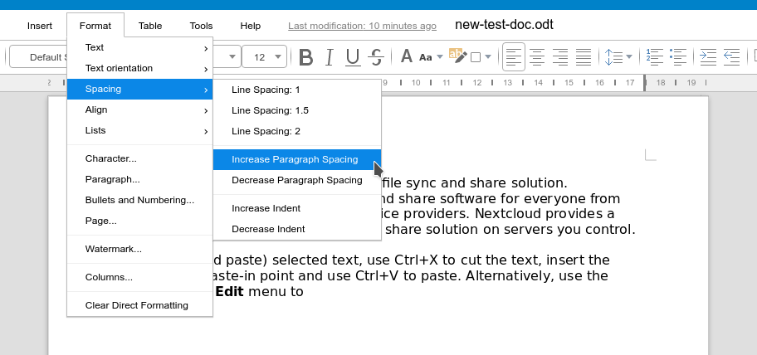Figure 6: Paragraph options in the format > spacing sub-menu
These buttons and formats include:
- Set Paragraph Style (Toolbar drop-down list)
- Bullets On/Off (Toolbar button or Format > Lists)
- Numbering On/Off (Toolbar button or Format > Lists)
- Align Left, Center Horizontally, Align Right, or Justified (Toolbar button or Format > Align)
- Align Top, Center Vertically, Align Bottom (Toolbar button or Format > Align)
- Line Spacing (choose from 1, 1.15, 1.5, 2, or custom spacing (Toolbar button or Format > Spacing)
- Increase Paragraph Spacing, Decrease Paragraph Spacing (Toolbar button or Format > Spacing)
- Increase Indent, Decrease Indent (Toolbar button or Format > Spacing)
The Format menu also contains a Paragraph entry. Selecting this will display a dialog with a large range of formatting options.
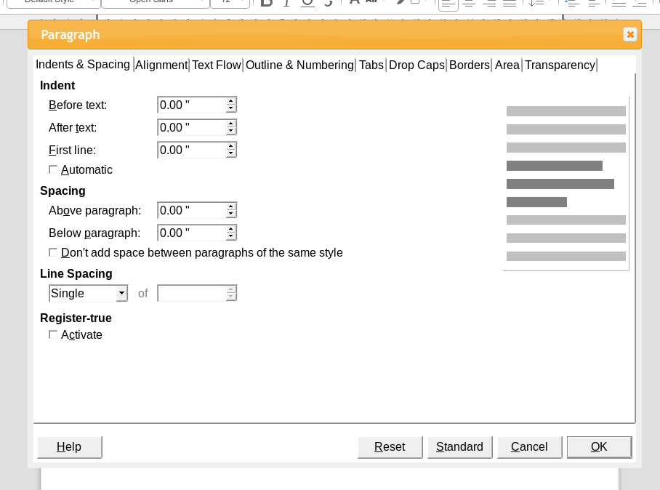Figure 7: LOOL documents' paragraph formatting dialog

Formatting Characters Directly
As with Paragraphs, the text itself can be styled using Toolbar buttons or entries in the Format menu.
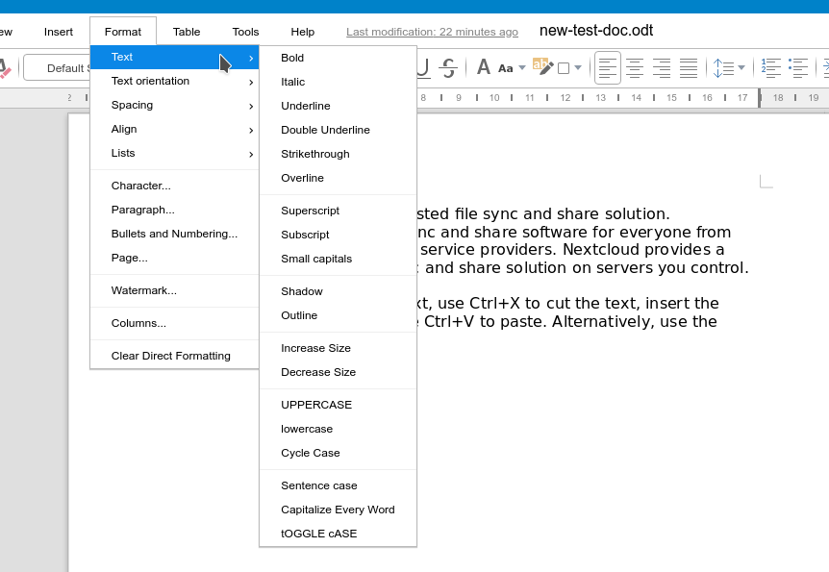Figure 8: Text (Character) Options in the Format > Text Sub-Menu
These buttons and formats include:
- Font Name, Font Size (Toolbar controls, or Increase/Decrease Size in Format > Text)
- Bold, Italic, Underline, Overline, Double Underline, Strikethrough, Outline (Toolbar controls, or Format > Text)
- Superscript, Subscript (Format > Text)
- Uppercase, Lowercase (Format > Text)
- Font Color (Toolbar control)
- Background Color (Toolbar control)
The Format menu also contains a Character entry. Selecting this will display a dialog with a large range of formatting options.
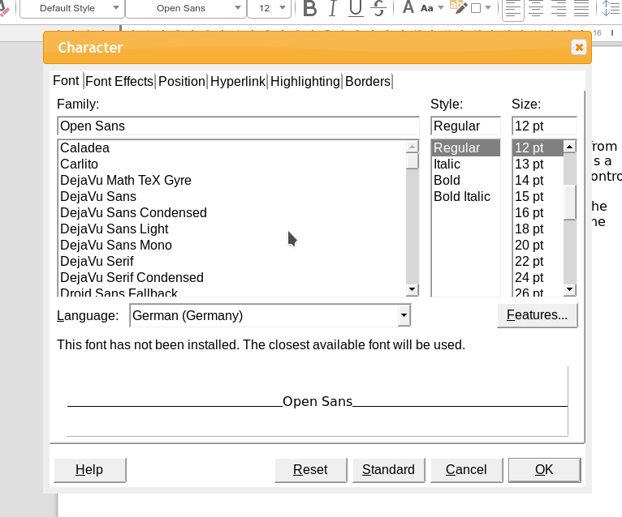Figure 9: LOOL documents' character formatting dialog

Formatting Bulleted/Numbered Lists Directly
Options for formatting Bulleted or Numbers Lists are set in using the Bullets and Numbering entry in the Format menu.
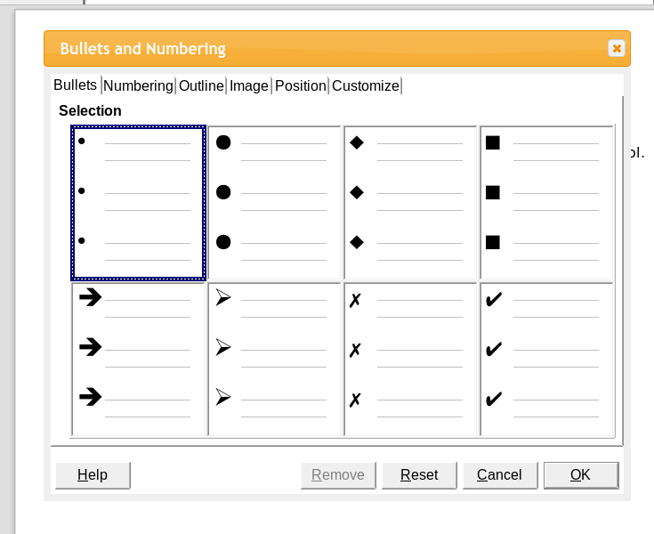Figure 10: LOOL documents' bullets and numbering formatting dialog
This displays a dialog with options, including:
- Setting the symbol used for the Bullets
- Numbering format (e.g. letters, Roman numerals, etc.)
- Outline format (e.g. “1.(a).i,” “1.2.5.3,” etc.)
- Image-based bullets
- Position settings (e.g. Level 1 has a 0.5” indent, Level 2 a 1.0” indent, etc.)
- The ability to completely Customize the current list (such as with text to come before or after the number)

Formatting Pages Directly
Page-related options are available from the Page dialog in the Format menu.
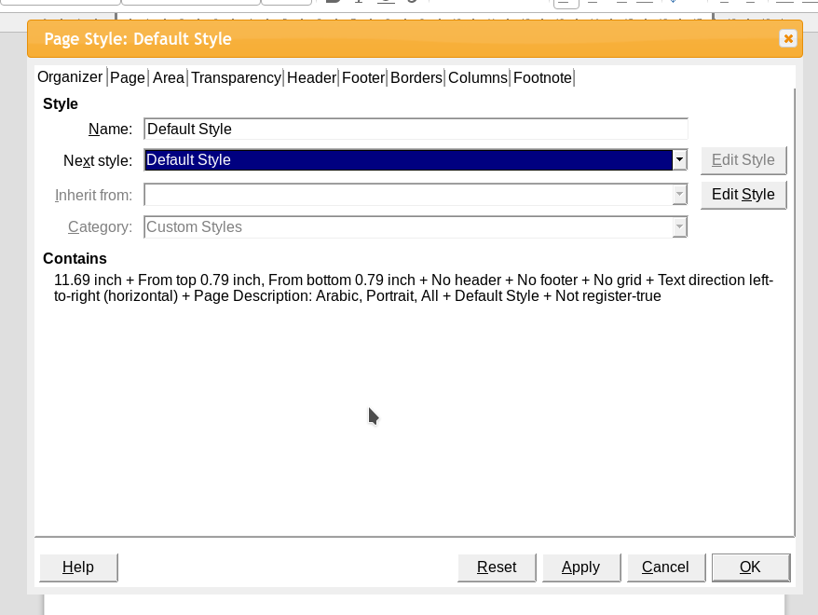Figure 11: LOOL documents' page formatting dialog
The Page Formatting Dialog contains options for:
- Selecting the Page Style from the Organizer
- Setting standard Page options (e.g. size, margins, orientation, etc.)
- Setting Area background, e.g. a color, gradient, or bitmap image
- Setting the Transparency for the Area
- Enabling/disabling the Header and Footer, and setting height, margins, and spacing
- Configuring the Borders for Pages
- Setting the number of Columns (also available from Format > Columns
- Configuring Footnotes, such as position, alignment, and spacing
The Format menu also contains one other Page-related setting, Watermark. This allows you to configure an image to be shown as though imprinted in the page.
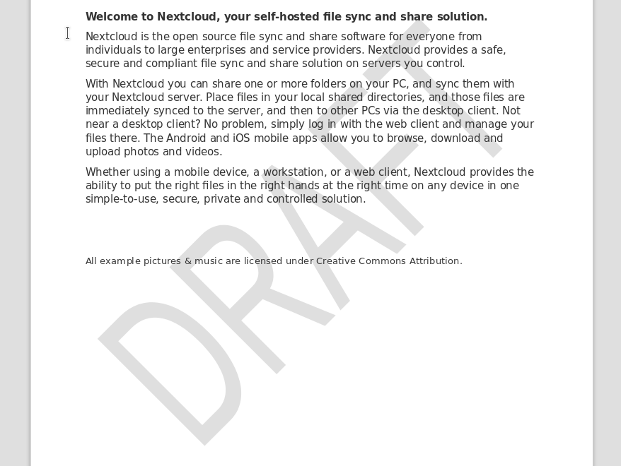Figure 12: Document watermarked with the word "draft"

Removing direct formatting
To remove direct formatting, select the text and choose Format > Clear Direct Formatting from the Menu bar, or Clear Direct Formatting button on the Formatting toolbar, or press Ctrl+M on the keyboard.
- Note
When clearing direct formatting, the text formatting will return to the applied paragraph and character style and not the Default paragraph style or Default character style (unless these styles are actually applied to the text).

Revisiting Styles
In general, Styles in the LibreOffice applications are collections of formatting applied together. Desktop LibreOffice programs have six types of styles: Paragraph, Character, Page, Frame, List, and Table. However, LOOL currently supports only page and paragraph styles, which affects blocks of text between line returns. You can adjust the elements used in the other types of Styles within LOOL Documents where they exist, but you must do so using Direct Formatting.
- Tip: Paragraph Styles Contain Character and List Elements
While you can’t create stand-alone Styles for passages of text (Character Styles) or bulleted/numbered lists (List Styles), you can use Paragraph Styles to apply your desired font, bolding/italics, or outline numbering. But note it will apply to the entire block of text (until the next line return) unless you adjust the formatting directly.

Applying (Paragraph) Styles
You can apply styles to paragraphs using the Styles drop-down selection list at the left end of the Toolbar.
Figure 13: Styles Selection in the Toolbar
- Tip
You can use keyboard shortcuts Ctrl+1 to Ctrl+3 to apply paragraph styles Heading 1 to Heading 3, just like LibreOffice Writer. You can also use Ctrl+0 to return to the default style (usually Text Body).

Modifying Styles
You can adjust the settings for the Style of the current paragraph by selecting the Edit > Edit Style menu item. This will display a multi-tabbed dialog that will be familiar to users of the desktop programs.
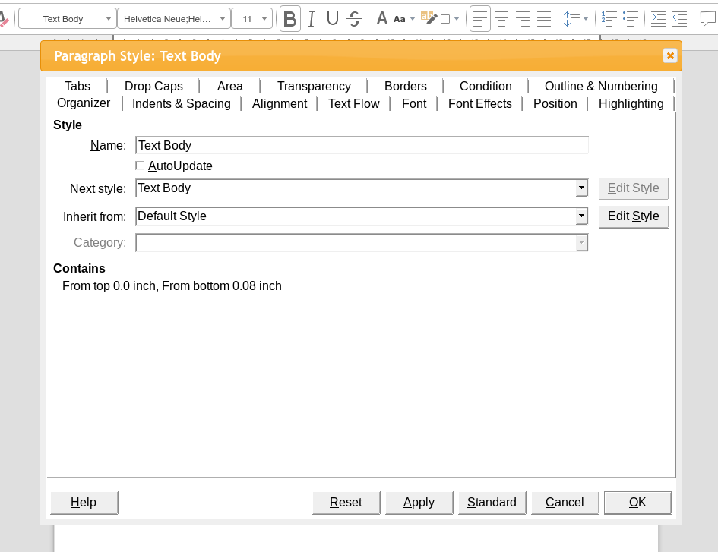Figure 14: Edit style dialog in documents
The options in this dialog are identical to those available in Writer’s dialog. And like Writer, updating a Style here will apply those changes everywhere the Style is used throughout the current document.
- Tip: Some Unavailable Style Options Are Available as Part of a Style
Another reason to favor Styles over Direct Formatting in LOOL Documents is that the former actually provides more options. A number of the options within the tabs in the above screenshot aren’t available from the Main Menu. For example, you cannot configure a Paragraph to Keep with next paragraph anywhere in the Format menu in LOOL, you can set this as part of a Style in the Text Flow tab in the Edit Style dialog.

Structuring Your Documentation
There are several Styles in default LOOL Documents that deserve special attention: Headings. While these are Paragraph Styles in the sense they are applied to blocks of text, they also have some other specific properties.
They will include not only text (e.g. font, color, spacing, etc.) properties, but also Numbering properties. The below screenshot shows the default Heading 1 Style, which includes an increased (130%) font size and bold decoration, as well as a Numbering(Outline) Style. Outline is specified here so sub-headings (i.e. Heading 2 and Heading 3) can be set as children of the top-level Heading 1.
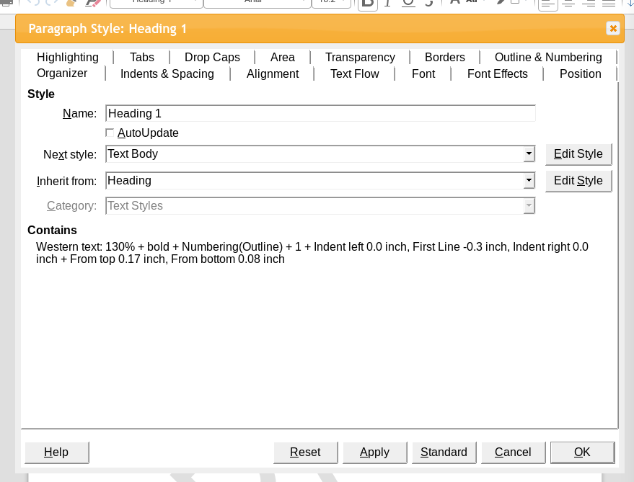Figure 15: The heading 1 style in LOOL documents
Once you’ve applied some Heading Styles to your document, you can very easily generate a Table of Contents. It will follow the structure you created by using first, second, and third level Heading Styles, and will automatically update based on changes you may make.

Inserting Graphics & Other Items
Cover inserting pictures, tables, special characters, shapes, and fields.

Inserting Special Characters
A special character is one not found on a basic English keyboard. For example, © ¾ æ ç Ł ñ ö ø ¢ are all special characters. To insert one or more special characters:
- Place the cursor in the document where you want the characters to appear.
- Click Insert > Special Character or click the Special Character icon in the main toolbar to open the Special Characters dialog.
- Double-click the characters (from any font or mixture of fonts) you wish to insert, in order; they appear in the document as you select them. The selected characters are also added to the Recent Characters list on the lower left of the dialog.
- Tips
To view details of a character, single-click it; it is then shown on the right, along with its numerical codes.
To insert a character and leave the dialog open, double-click the character. To insert a character and close the dialog, click it and then click the Insert button.
Different fonts include different special characters. If you do not find a particular special character you want, try changing the Font selection.

Inserting and Styling Tables
Before you insert a table into a document, it helps to have an idea of the visual result you want to obtain as well as an estimate of the number of rows and columns required. Every parameter can be changed at a later stage; however, thinking ahead can save a large amount of time as changes to fully formatted tables often require a significant effort.
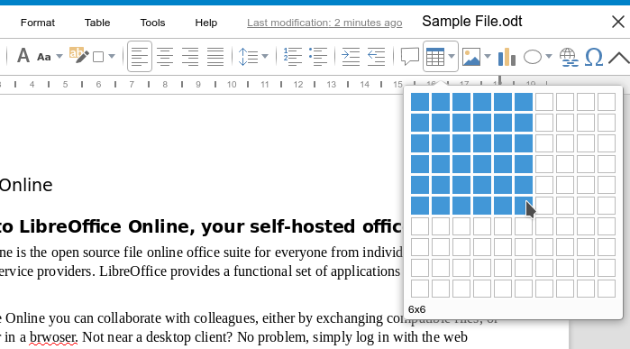Figure 16: The insert table button on the toolbar
To directly insert a table with the default properties, click the Table icon on the Standard toolbar. On the drop-down graphic, choose the size of the table (up to fifteen rows and up to ten columns). To create the table, click the cell that you want to be on the last row of the last column. Holding down the mouse button over the Table icon will also display the graphic.
To use a dialog where you can refine the properties for the table, position the cursor within the table to appear, then choose Table > Properties from the Menu bar to open the dialog.

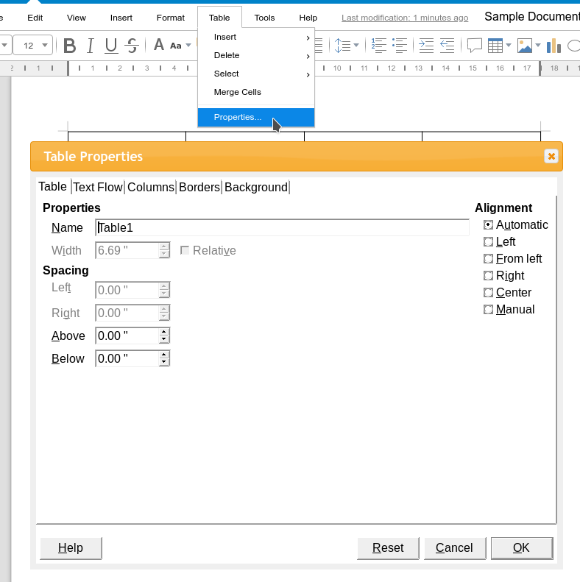Figure 17: The table properties dialog
This dialog contains the following tabs:
- Table: This allows you to change the name and adjust the spacing or alignment of the table overall.
- Text Flow: The Text Flow tab allows you to control options such as whether the table is allowed to break across pages.
- Columns: You can specify the width of columns on this tab.
- Borders: Set the borders as well as their styling (e.g. color) and spacing on this tab.
- Background: A Background can be a color or picture, and can apply to the current cell, row, or entire table.

Inserting Pictures and Graphics
You might create images (also called ‘pictures’ in LOOL) using a graphics program, scan them, or download them from the Internet (make sure you have permission to use them), or use photos taken with a digital camera. LOOL supports raster (bitmap) file formats, the most common of which are GIF, JPG, PNG, and BMP.
You can insert an image into your document in one of two ways:
- To use an image that’s already in the hosting application, use the Insert Local Image option (either the Toolbar, or the Insert > Insert Local Image menu option).
- Alternately, upload it directly from your PC (by using the Insert Image option from the Toolbar, or the Insert > Insert Image menu option)
For best results:
- Create images that have the exact dimensions required for the document, or use an appropriate graphics package to scale photographs and large drawings to the required dimensions. Do not scale images with Writer, even though Writer has tools for doing this, because the results might not be as clear as you would like.
- Do any other required image manipulation (brightness and contrast, color balance, cropping, conversion to grayscale, and so on) in a graphics package, not in Writer, even though Writer has the tools to do a lot of these things too.
- If the document is meant for screen use only, there is no need to use high resolution images of 300 or more dpi (dots per inch). Most computer monitors work at between 72 and 96 dpi; reducing the resolution (and the file size) has no negative impact on what is displayed.
You can also insert charts into your document using the Insert Chart Toolbar button (or the Insert > Chart menu option) or a selection of shapes using the Insert Shapes Toolbar button.

Inserting and Controlling Fields
Fields are data elements you can insert into your document that will get updated automatically. For example, if you insert the Date field, it will automatically display the current date (as opposed to inserting a date like “Nov. 29, 2019” manually, which will not update on a later date.
You can use the Insert > More Fields menu option to insert one of the following elements into your document:
- Page Number (the auto-calculated number of the current page)
- Page Count (the auto-calculated number of total pages in the document)
- Date (the current date)
- Time (the current time)
- Title (the title of the document, as configured in its Properties)
- First Author (the name of the first author listed in the document’s Properties)
- Subject (the subject of the document, as configured in its Properties)

Specifying Your Document’s Layout

Page Properties
Every page in LOOL Documents is based on a page style. Pages styles define basic layout, including page size, margins, headers and footers, borders, backgrounds, etc. Changes to these settings automatically change the page style. This means that, in contrast to paragraph styles, these settings cannot be used to directly format individual pages.
To adjust the style of the current Page, select the Format > Page option from the Menu. This will display the Page Style dialog.
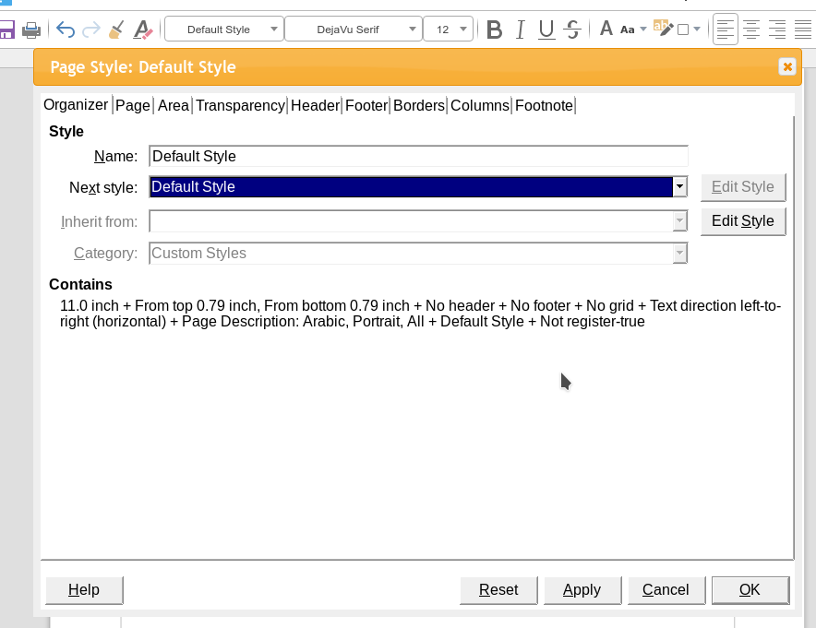Figure 18: The page style dialog in the documents module
As with other styles, Writer comes with a number of page styles. You can modify these styles or create new ones. The Default page style is used when no other page style has been specified.
- Tip
Page layout is usually easier if you show text, object, table, and section boundaries in View > Formatting Marks.

Headers and Footers
You can insert a header in several ways. The easiest is to select one of the options in the Insert > Headers and Footers > Header sub-menu. One of these will be All, meaning all your Page Styles will receive a Header. The other will be the name of the Style of the current Page, and Headers will only appear on Pages using that Style. You can likewise insert a Footer by selecting one of the options in Insert > Headers and Footers > Footer.
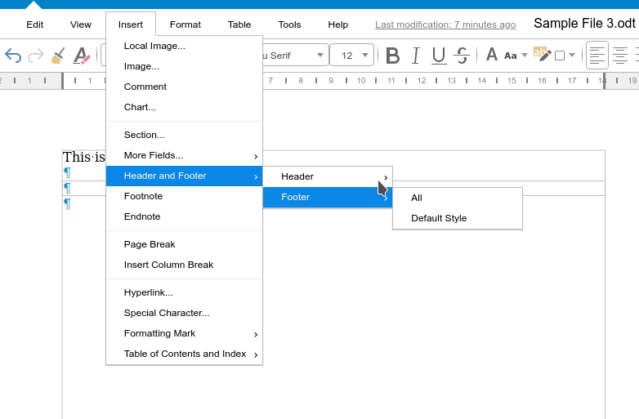Figure 19: The headers and footers sub-menu
After a Header/Footer has been created, you can click inside it to edit its content. You’ll be able to tell you’re in the region when the markers appear at all four corners, as shown in Figure
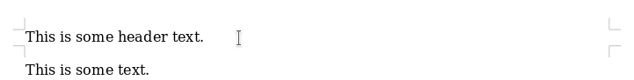Figure 20: Header menu

Determining Header and Footer appearance
To format a Header (use similar settings for a Footer), you can go to the Header or Footer tab in the Format > Page dialog. Both methods take you to the same place.
Here you can specify if Headings on Pages using the Left and Right Page Styles should be the same or different. You can also specify whether the First Page will have no header or a different header than other pages. Finally, in this dialog you can turn the Header on or off, set the margins, and set the spacing between the Header and document text.

Numbering Pages
To display page numbers automatically:
- Insert a header or footer, as described in “Headers and Footers” above.
- Place the cursor in the header or footer where you want the page number to appear and choose Insert > More Fields > Page Number.

References

Footnotes/Endnotes
LibreOffice Online Documents supports both types of citations: Footnotes (which appear at the bottom of the current page) and Endnotes (which appear together at the end of the document). You can insert them by placing the cursor at the end of the passage of text you’d like to cite (or select it), and select Insert > Endnote or Insert > Footnote from the Menu.
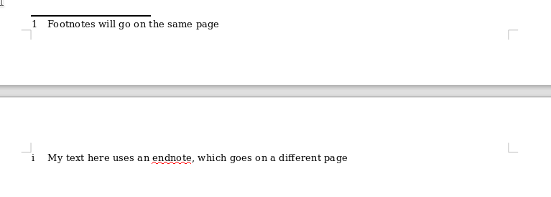Figure 21: Footnotes versus Endnotes

Hyperlinks
The Documents module supports creating Hyperlinks to external resources, such as web pages or email addresses. You can insert a Hyperlink by optionally selecting some existing text, but otherwise placing your cursor where you’d like the link to appear, then pressing Ctrl-k on the keyboard or selecting the Insert > Hyperlink option from the Menu.
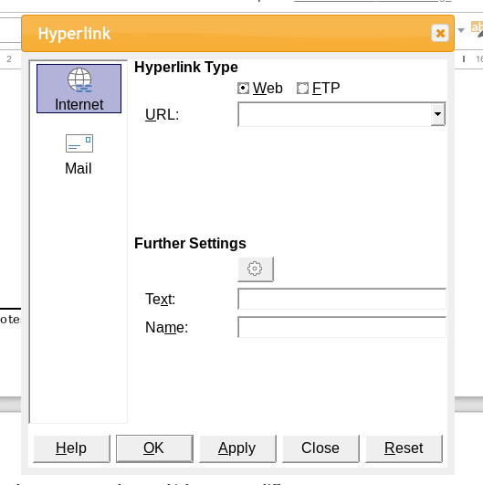Figure 22: The Hyperlink Dialog

Writing Tools

Spell Checking & Autocorrect
LOOL has support for spell-checking, which you can run by selecting the Tools > Spelling option from the main Menu. There is an option to automatically identify misspelled words (Tools > Automatic Spell Checking) as well.
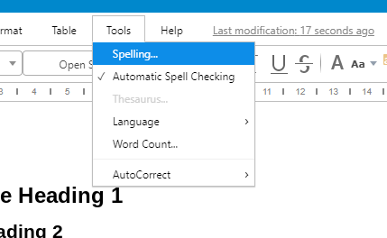Figure 23: Spell Check Options in the Documents Module

Language Setup
Many of the features in the following sections rely on your document’s Language. So be sure you’ve set it correctly. You can change the Language for selected text, the paragraph containing the cursor, or the current document in its entirety using the options in the Tools > Language sub-menu.
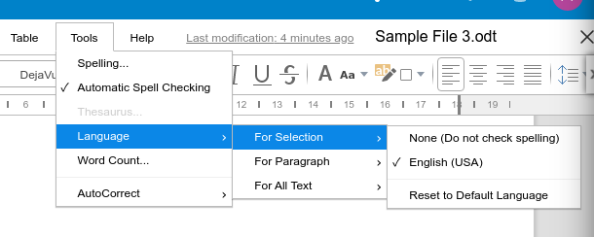Figure 24: Options within the Language Sub-menu
- Tip: Checking the Current Language
You can check the Language in use where the cursor currently resides by looking in the Status Bar at the bottom of the screen, next to the Selection Type.

Word Count
The Documents module will keep track of the number of words in the current file, which you can see by selecting the Tools > Word Count option from the Menu.
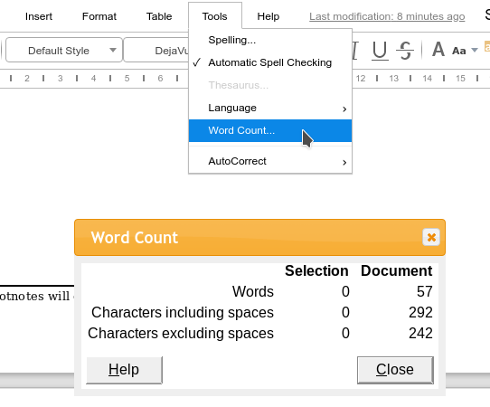Figure 25: The word count menu item and dialog
This total is also available in the Status Bar, to the right of the Page Number.
- Tip: Word Count of Selected Text.
If there is text currently selected, the Word Count Dialog will also display this, while the Status Bar will show the stats for the selection instead of the entire document.

Review & Comments
Authors and reviewers often use Comments to exchange ideas, ask for suggestions, or mark items needing attention.
You can connect a Comment to multiple paragraphs or a single point. To insert a Comment, select the text, or place the cursor in the place the comment refers to. Then either choose Insert > Comment, click the Insert Comment button on the Toolbar, or press Ctrl+Alt+C. The anchor point of the Comment is connected by a line to a box on the right-hand side of the page where you can type the text of the Comment.
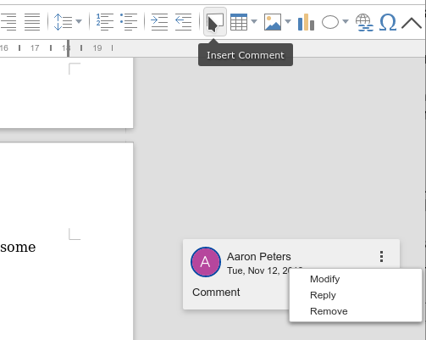Figure 26: The Insert Comment button and Comment overflow menu
You can navigate through the comments using the keyboard. Use Ctrl+Alt+Page Down to move to the next comment and Ctrl+Alt+Page Up to move to the previous comment. For each Comment, you have the option to Modify it, Reply to it, or Remove it from the file by using the overflow menu (the three vertical dots) in its upper-right corner.

Tracking changed in the document
You can use the Document Module’s change marks (often called “redlines” or “revision marks”) to show added or deleted material or changed formatting. Later, you or another person can review and accept or reject each change.
- Note
Not all changes are recorded. For example, changing a tab stop from align left to align right and changes in formulas (equations) or linked graphics are not recorded.
When you send a document to someone else to review or edit, you may want to prepare it first so that the editor or reviewer does not have to remember to turn on the revision marks. After you have protected the document, any subsequent user must enter the correct password in order to turn off protection or accept or reject changes.
- Open the document. Check whether it contains multiple versions by clicking File > Versions. If multiple versions are listed, save the current version as a separate document with a different name and use this new document as the review copy.
- With the review copy open, make sure that change recording is turned on. The Edit > Track Changes > Record menu item has a check mark next to it when recording is turned on.
Now, when you make a change such as removing text, it isn’t deleted immediately. It will be marked with colored text. In addition, a box will appear in the right-hand margin (much like comments) describing what change was made, and by whom.
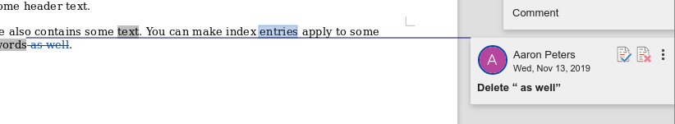Figure 27: A Tracked Change, and its accompanying details
To accept or reject recorded changes, use any of these tools:
- The Previous, Next, Accept All, and Reject All entries in the Edit > Track Changes sub-menu
- Manage Changes dialog (accessible from Edit > Track Changes > Manage)
- The Accept and Reject buttons in the boxes in the right-hand margin
The results of accepting or rejecting a change are as follows:
- Accept: incorporates the alteration into the document and removes the change indication marking.
- Reject: reverts the document to its original state and removes the change indication marking.

