
LibreOffice Online 6.3 Guide

Chapter 8
The Presentations Module

Copyright
This document is Copyright © 2019 by the LibreOffice Documentation Team. Contributors are listed below. You may distribute it and/or modify it under the terms of either the GNU General Public License (http://www.gnu.org/licenses/gpl.html), version 3 or later, or the Creative Commons Attribution License (http://creativecommons.org/licenses/by/4.0/), version 4.0 or later.
All trademarks within this guide belong to their legitimate owners.

Contributors
This book, for version 6.3 of LibreOffice Online, was written new as part of the 2019 Google Season of Docs.

To this edition
Aaron Peters

To previous editions

Feedback
Please direct any comments or suggestions about this document to the Documentation Team’s mailing list: documentation@global.libreoffice.org
- Note:
Everything you send to a mailing list, including your email address and any other personal information that is written in the message, is publicly archived and cannot be deleted.

Publication date and software version
Published January 2020. Based on LibreOffice 6.3.
Contents
Copyright 2
Contributors 2
To this edition 2
To previous editions 2
Feedback 2
Publication date and software version 2
The Presentation Module Interface 4
Toolbar 4
Slides Pane 5
The Presentation Module Status Bar 6
Opening, Saving, and Exporting Files 6
Viewing the Presentation 6
Adding to the Slides in a Presentation 6
Adding Other Objects to a Slide 8

The Presentation Module Interface
The Spreadsheets window has four main sections (Figure 1): the Toolbar at the top, the Slides Pane to the left, the main Workspace, and the Status Bar at the very bottom.

Toolbar
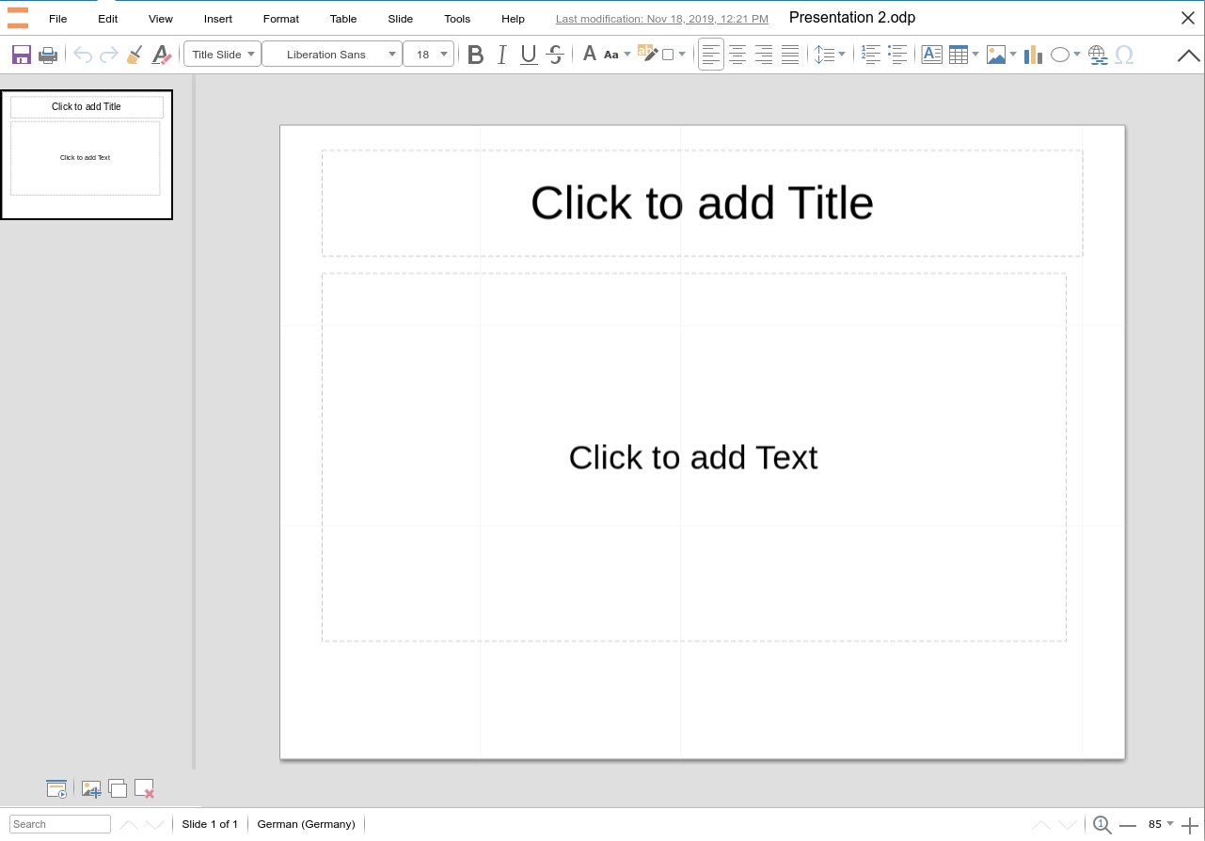Figure 1: The presentations module window
The Presentations toolbar contains the following entries:
File:
Contains commands that apply to the entire presentation; for example, Save/Save As, Share, Print, See Revision History, and the Download as sub-menu.
Edit:
Contains commands for editing the presentation; for example, Undo/Redo, Copy, Paste, Select All, and Find and Replace.
View:
Contains commands for modifying how the Presentations user interface looks; for example, Full Screen, Zoom In/Out, and Reset Zoom.
Insert:
Contains commands for inserting elements into a presentation; for example, Images (Local or within the hosting application), Charts, Comments, Hyperlinks, and Headers and Footers.
Format:
Contains commands for modifying the layout of a presentation; for example, Character/Paragraph/Bullets and Numbering styling, Position and Size of inserted objects, and Line and Area styling.
Table:
Contains commands to Insert or Delete Tables/Columns/Rows/Cells and Merge Cells.
Slide:
Contains the most often used commands for handling slides, such as New Slide, Delete Slide, Duplicate Slide, and putting the application into Fullscreen Presentation mode.
Tools:
Contains various functions to help you check and check the presentation; for example, Spelling, and Language.
Help:
Contains a list of the LibreOffice Online Keyboard Shortcuts and information About the application, such as version number.

Slides Pane
The Slides Pane at the left of the application window provides both navigation among the presentation’s slides as well as the ability to add, remove, and duplicate them. Clicking on a slide to make it active and display it in the main Workspace (it will be bordered in black within the Slides Pane).
You can click the buttons at the bottom of the Slides Pane to:
- Put the application into Fullscreen Presentation mode
- Insert Slide after the current slide
- Duplicate Slide, again the currently-selected one
- Delete Slide
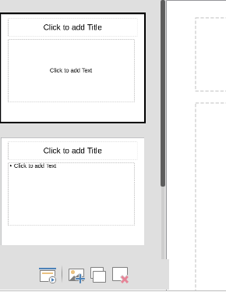Figure 2: The Slide Pane and its controls
- Note: Re-Ordering Slides
LibreOffice Online doesn’t yet support the ability to re-order slides. If you have a presentation and find you need to re-order your slides, you can open it in LibreOffice Impress on a PC, re-order them, then upload it back to LOOL.

The Presentation Module Status Bar
Search
The lower-left corner has a search box. Typing a search term will highlight its first occurrence, and provide a count of any additional occurrences.
To jump to a specific page in the document, double-click on this field. The Navigator opens. Click in the Page Number field and type the sequence number of the required page and press Enter.
Slide location and count
The total number of Slides, as well as the number of the current active Sheet shown in the Status Bar and kept up to date as you edit.
Language
Shows the language at the cursor position, or for the selected text, that is used for checking spelling and grammar as well as for hyphenation and thesaurus dictionaries.
Click to open a menu where you can choose another language for the selected text or for the paragraph where the cursor is located. You can also choose None (Do not check spelling) to exclude the text from a spelling check or choose More to open the Character dialog. Any directly formatted language settings can be reset to the default language from this menu.
Zoom
To change the view magnification click on the + and – signs, or right-click on the zoom level percent to pop up a list of magnification values from which to choose. You can reset the zoom level with the left-most button (the magnifying glass).

Opening, Saving, and Exporting Files
As with the other LOOL modules, files operations are gathered in File menu.

Viewing the Presentation
In addition to the controls in the Status Bar, the entries in the View menu allow you to Zoom In, Zoom Out, and Reset Zoom level. In addition, Presentations offers a Fullscreen Presentation mode.
In this mode, each slide will take up the entire screen; if the slide’s dimensions are such that it doesn’t fit exactly, it will be displayed re-sized and centered. While in Fullscreen Presentation mode, the following will navigate you through the presentation:
- The Space or the Right Arrow keys will move the presentation forward one slide.
- The Left Arrow key will move the presentation back one slide.
- The Esc key will exit Fullscreen Presentation mode.

Adding to the Slides in a Presentation
When adding a new slide to a presentation In LOOL, it will by default contain two layout items:
- A Text Box at the top where you can add a Title
- A Text Box covering the majority of the screen for your content. By default, it will contain a bulleted list with one blank entry.
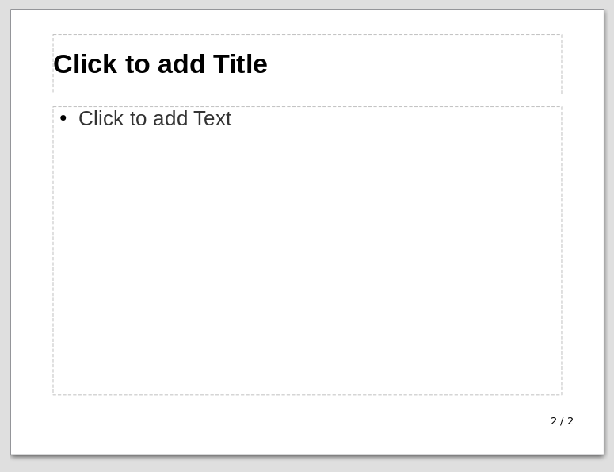Figure 3: The contents of a default new slide
You can select objects within a slide by clicking on them; you’ll know they’re selected when they display handles for resizing and rotation.
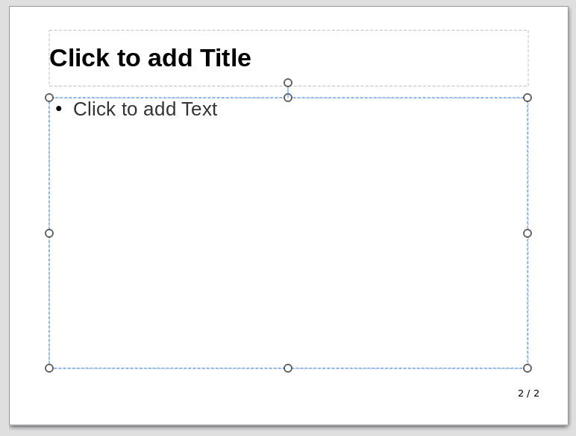Figure 4: The Content Text Box Selected, with resize/rotation handles
You can adjust the width of an object by clicking and dragging one of the handles to the left or right, and the height by moving one of the handles at top or bottom. The handles at the corners will adjust size in both dimensions simultaneously. Pressing the Del key will delete the currently-selected object.
Once an object is selected, pressing the F2 key will put it into editing mode (alternately, you can just begin typing). As you type, the size of the object will grow to accommodate your text. Once you’re finished, click outside the bounds of the object (or press F2 again) to commit the change.

Adding Other Objects to a Slide
The Text Box is one of the basic building blocks of a presentation. But LOOL’s Presentations module supports other items you can use to build your presentation, as follows:
- Graphics
- Charts
- Shapes
Graphics and Charts operate just as they do in the Documents and Spreadsheets Modules. Shapes are a type of built-in graphic commonly used in presentations. You can use the Insert Shape button on the main Toolbar to select from among Shapes in the following categories:
- Basic
- Symbols
- Block Arrows
- Stars
- Callouts
- Flowchart
To insert one of these items, select the Insert Shape button, then select the Shape you want.
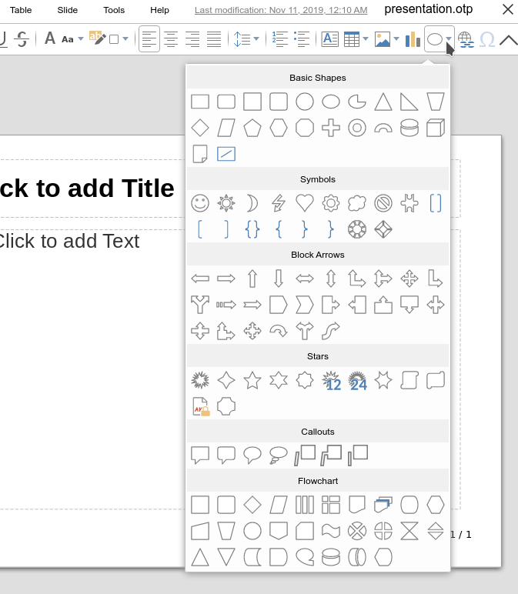Figure 5: Insert Shape Options in Presentations
It will appear on the currently active slide, where you can adjust its properties:
- To move the object, click and drag it with the mouse, or use the Format > Position and Size menu item.
- To change the object’s Area color, Shadow style, and Transparency settings, use the Format > Area menu item.
- To change the color and style of the object’s outline, including width, pattern, arrows, and rounded corners, use the Format > Line menu item.
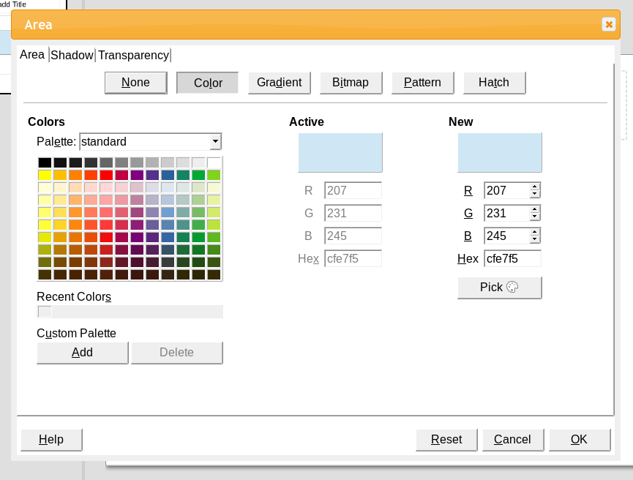Figure 6: The Area Dialog in the Presentations Module

