
Calc Guide

Chapter 6
Printing, Exporting, E-mailing, and Signing

Autorská práva
Tento dokument je duševním vlastnictvím dokumentačního týmu LibreOffice ©2019 . Přispěvatelé jsou uvedeni níže. Dokument je možné šířit nebo upravovat za podmínek licence GNU General Public License (https://www.gnu.org/licenses/gpl.html), verze 3 nebo novější, nebo za podmínek Commons Attribution License (https://creativecommons.org/licenses/by/4.0), verze 4.0 nebo novější.
Všechny ochranné známky uvedené v této příručce patří jejich vlastníkům.

Přispěvatelé
This book is adapted and updated from the OpenOffice.org 3.3 Calc Guide.

Pro toto vydání
Jean Hollis Weber | Kees Kriek

Pro předchozí vydání
Barbara Duprey | Jean Hollis Weber | John A Smith
Peter Schofield | Christian Chenal | Martin Saffron

Zpětná vazba
Připomínky a náměty k tomuto dokumentu posílejte v angličtině do e-mailové konference dokumentačního týmu na adresu: documentation@global.libreoffice.org.
- Poznámka
Všechno, co do e-mailové konference pošlete, včetně e-mailové adresy a dalších osobních informací uvedených ve zprávě, bude veřejně viditelné bez možnosti smazání.

Datum vydání a verze programu
Anglický originál byl vydán v lednu 2020. Based on LibreOffice 6.2.

Používání LibreOffice na systému macOS
Některé klávesové zkratky a položky nabídek jsou v systému macOS jiné než v systémech Windows a Linux.. V následující tabulce jsou uvedeny nejdůležitější rozdíly, které se týkají informací v této knize. Podrobnější seznam se nachází v nápovědě k aplikaci.
Windows nebo Linux | Ekvivalent pro macOS | Význam
Nabídka Nástroje > Možnosti | LibreOffice > Předvolby | Otevře nastavení s možnostmi
Klepnutí pravým tlačítkem | Control+click or right-click depending on computer setup | Otevře se místní nabídka
Ctrl (Control) | ⌘ (Command) | Používá se i s jinými klávesami
F5 | Shift+⌘+F5 | Otevřete Navigátor
F11 | ⌘+T | Open the sidebar Styles panel
Obsah
Autorská práva 2
Přispěvatelé 2
Pro toto vydání 2
Pro předchozí vydání 2
Zpětná vazba 2
Datum vydání a verze programu 2
Používání LibreOffice na systému macOS 2
Tisk 5
Rychlý tisk 5
Ovládání tisku 5
General page 6
LibreOffice Calc page 6
Page Layout page 6
Options page 6
Printing multiple pages on a single piece of paper 7
Selecting what to print 7
Printing in grayscale on a color printer 8
Náhled stran / listů před tiskem 8
Using print ranges 8
Defining and printing a print range 8
Úprava oblasti tisku 9
Viewing print ranges 10
Named print ranges 10
Defining and naming 10
Printing a named range 11
Deleting a named print range 11
Removing print ranges 11
Zopakování tisku řádků a sloupců 12
Using print ranges 12
Using named print ranges 13
Zalomení stránky 13
Inserting page breaks 13
Deleting page breaks 14
Deleting multiple page breaks 14
Printing options for page styles 14
Záhlaví a zápatí 16
Setting headers and footers 16
Header or footer contents 17
Export do PDF 18
Rychlý export do PDF 18
Nastavení obsahu a kvality PDF 18
Karta Obecné v dialogovém okně Možnosti PDF 18
Karta Úvodní zobrazení v dialogovém okně Možnosti PDF 20
Karta Uživatelské rozhraní v dialogovém okně Možnosti PDF 20
Karta Odkazy v dialogovém okně Možnosti PDF 21
Karta Bezpečnost v dialogovém okně Možnosti PDF 22
Digital Signatures page of PDF Options dialog 23
Export do jiných formátů 24
E-mailing spreadsheets 24
Elektronické podepisování dokumentů 24
Applying digital signatures 25
Signing multiple times with same signature 26
Digitally signing macros 27
Odstranění osobních údajů 27

Tisk

Rychlý tisk
To quickly print a spreadsheet, click on the Print Directly icon on the Standard toolbar to send the entire spreadsheet to the default printer that is defined for your computer.
- Poznámka
You can change the action of the Print Directly icon to send a document to the printer defined for the document instead of the default printer for the computer. Go to Tools > Options > Load/Save > General and select the Load printer settings with the document option.
- Tip
If the Print Directly icon is not shown on the toolbar, you can add it. See Chapter 14, Setting Up and Customizing Calc.

Ovládání tisku
For more control over printing, use File > Print or Ctrl+P to open the Print dialog (Figure 1).
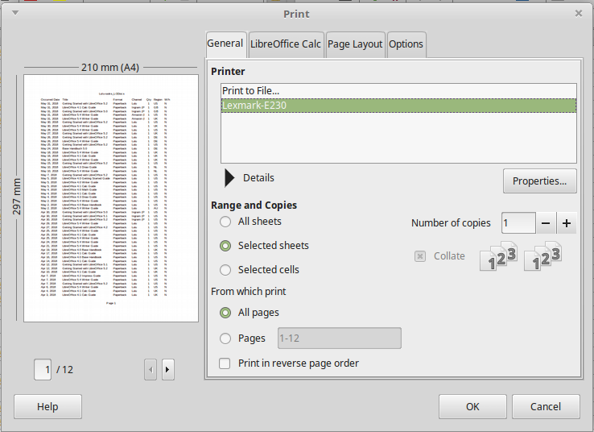Figure 1: Print dialog – General page
- Poznámka
Možnosti vybrané v dialogovém okně Tisk se vztahují pouze na aktuální tisku tohoto dokumentu.
To specify default printing settings for LibreOffice, go to Tools > Options > LibreOffice > Print and Tools > Options > LibreOffice Calc > Print. For details, see Chapter 14, Setting Up and Customizing Calc.
The Print dialog has four tabs where you can choose a range of options, as described in the following sections.
Depending on your computer’s operating system, the layout of these tabs may look different from the illustrations shown in this chapter.

General page
On the General page of the Print dialog (Figure 1), you can choose:
- The printer to use from the list printers available in the Printer section.
- Which sheets and pages to print, the number of copies to print, whether to collate multiple copies, and the page order for printing in the Range and Copies section. (See “Selecting what to print“ on page 7.)
- Printer-specific properties such as paper size, portrait or landscape orientation, duplex printing if available, and which paper tray to use.

LibreOffice Calc page
On the LibreOffice Calc page of the Print dialog (Figure 2), you can select whether to suppress the output of empty pages when you print the spreadsheet.
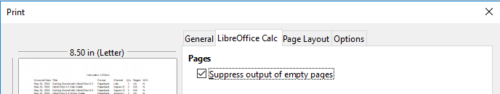Figure 2: Print dialog – LibreOffice Calc page

Page Layout page
On the Page Layout page of the Print dialog (Figure 3), you can select how many pages are printed per sheet of paper, the order in which the pages are printed on a sheet, and whether a border is drawn around each page.
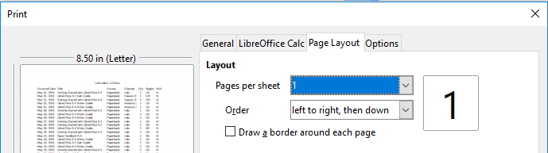Figure 3: Print dialog – Page Layout page

Options page
On the Options page of the Print dialog (Figure 4), you can choose whether to create separate print jobs for collated output, or use only the paper size specified in the printer preferences.
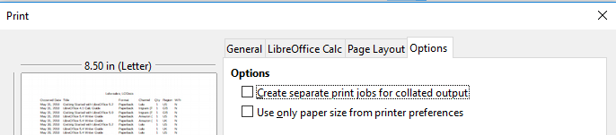Figure 4: Print dialog – Options page

Printing multiple pages on a single piece of paper
To print multiple pages of a spreadsheet on one piece of paper:
- Use File > Print or Ctrl+P to open the Print dialog and then select the Page Layout page (Figure 5).
- In the Layout section, select from the Pages per sheet drop-down list the number of spreadsheet pages to print per sheet of paper. The preview panel on the right shows how the pages will look in the printed document.
- When printing more than two pages per sheet, select the order in which the pages are printed on a sheet from the Order drop-down list.
- To distinguish each page on a sheet, select Draw a border around each page.
- Klepneme na OK.
Figure 5: Printing more than one spreadsheet page per sheet of paper

Selecting what to print
In addition to printing a full spreadsheet document, you can choose single sheets, multiple sheets, and selections of cells for printing.
To print an individual sheet:
- V okně programu Calc kliknutím na záložku vybereme list, který chceme vytisknout.
- V hlavní nabídce zvolíme Soubor > Tisk nebo stiskneme Ctrl+P.
- In the Range and copies section of the Print dialog, choose Selected sheets.
- Click OK.
To print a range of sheets:
- V programu Calc vybereme listy na tisk.
- V hlavní nabídce zvolíme Soubor > Tisk nebo stiskneme Ctrl+P.
- In the Range and copies section of the Print dialog, choose Selected sheets.
- Klepneme na OK.
To print a selection of cells:
- In the spreadsheet, select the cells to print.
- V hlavní nabídce zvolíme Soubor > Tisk nebo stiskneme Ctrl+P.
- In the Ranges and copies section of the Print dialog, choose Selected cells.
- In the sub-section From which print, choose Pages and type 1 in the box.
- Click OK.

Printing in grayscale on a color printer
You may wish to print a spreadsheet in grayscale on a color printer. You can do this in two ways.
- Poznámka
Some color printers may print in color regardless of the settings you choose.
For an individual file, you can change the printer settings to print in black and white or grayscale:
- Choose File > Print, or press Ctrl+P, to open the Print dialog.
- Klikneme na tlačítko Vlastnosti, čímž otevřeme dialogové okno Vlastnosti tiskárny. Dostupné volby se u jednotlivých tiskáren liší, ale i tak bychom měli najít možnosti pro nastavení barev. Více informací o tiskárně najdeme v nápovědě k tiskárně nebo v její uživatelské příručce.
- The choices for color might include black and white or grayscale. Choose grayscale.
- Kliknutím na tlačítko OK nastavení potvrdíme a vrátíme se do okna Tisk.
- Click OK to print the document.
You can change the LibreOffice settings to print all color text and graphics as grayscale:
- Zvolíme Nástroje > Možnosti > LibreOffice > Tisk.
- Select Convert colors to grayscale. Kliknutím na tlačítko OK uložíme změnu.
- Upozornění
This changes the print settings for all components of LibreOffice, not just Calc

Náhled stran / listů před tiskem
Pokud před tiskem chceme zobrazit náhled listů v programu Calc:
- Choose File > Print Preview or click the Toggle Print Preview icon on the Standard toolbar.
The Calc window now displays the Print Preview toolbar instead of the Formatting toolbar.
Figure 6: Print Preview toolbar (Calc)
- To print the document from this view, click the Print icon (on the Standard toolbar) to open the Print dialog.
- Choose the print options and click the OK button.
- Click the Toggle Print Preview icon again to return to the normal spreadsheet view.

Using print ranges
You can define which range of cells on a spreadsheet are to be printed or exported to a PDF. The cells on the sheet that are not part of the defined print range are not printed or exported. Also, any sheets without a defined print range are not printed or exported.

Defining and printing a print range
To set a user-defined print range, which will replace any existing defined print range:
- Select the range of cells that are to be used in the print range.
- Go to Format > Print Ranges > Define on the Menu bar. Automatic page break lines are then displayed on the screen, defining the cells that are included in the print range.
- Click on the Print Directly icon on the Standard toolbar to print the defined print range, or open the Print dialog and click OK to print the defined print range.
- Tip
You can check the print range by using Toggle Print Preview or the Preview pane in the Print dialog. Calc will display only the cells in the print range. See “Viewing print ranges” on page 10.

Úprava oblasti tisku
At any time, you can edit the print range, for example to add or remove cells, or define rows and columns to repeat (such as column or row headings).
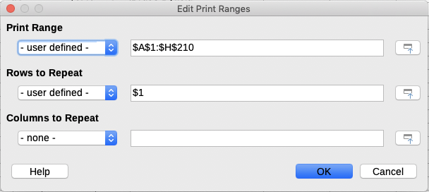Figure 7: Edit Print Ranges dialog
- Go to Format > Print Ranges > Edit on the Menu bar to open the Edit Print Ranges dialog (Figure 7).
- If only a single range is defined, then clicking anywhere in the Print Range box displays the defined print range bounded in blue, as shown in Figure 8.
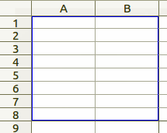Figure 8: Single print range marked by a bounding box
- To add new cells to the defined print ranges, type a comma at the end of the displayed data in the Print range text box as the separator for the print range to be added. Select the cell range using the cursor, or type in the cell references using the same format of the print ranges already defined in the Print range text box. Remember to separate the cell references with a colon.
- To remove a print range, select the print range in the Print range text box and delete it. Make sure the remaining print ranges only have a single comma as a separator and that there is not a comma at the end of the sequence.
- Click OK to save your changes and close the dialog.

Viewing print ranges
After print ranges have been defined, they are formatted with automatic page breaks. To view the page breaks, go to View > Page Break on the Menu bar to open the preview (Figure 9).
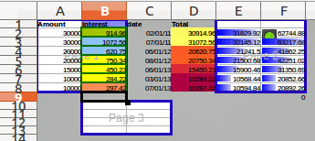Figure 9: Page break preview
The print ranges are outlined by default with a blue border and contain a pale gray page number in the center of each page. The nonprinting area of the spreadsheet normally has a gray background.
To exit Page Break preview, go to View > Normal on the Menu bar.

Named print ranges
In addition to defining a print range for each print job, you can also define a range of cells to be used repeatedly, without having to select a range of cells every time. This is useful if different areas of a large spreadsheet have to be printed for different reports; several named print ranges can be defined to meet this need.
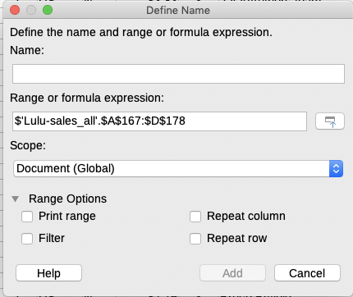Figure 10: Define Names dialog

Defining and naming
- Select the cells you want to define and name as a print range, then go to Sheet > Named Ranges and Expressions > Define on the Menu bar to open the Define Names dialog (Figure 10). The selected cells are displayed in the Range or formula expression box.
Alternatively, open the Define Names dialog, then select the cells you want to define and name. The selected cells are then displayed in the Range or formula expression box.
- Type a name for the range in the Name box. Use only letters, numbers, and underscores in the name; no spaces, hyphens, or other characters are allowed.
- If necessary, you can edit or set the range of selected cells for the print range in the Range or formula expression box. See “Editing a print range” on page 9 for more information.
- Make sure Document (Global) is selected from the Scope drop-down list.
- Select Print range from Range Options to define the settings as a print range.
- Click Add to accept the data and close the dialog.

Printing a named range
To select a named range for printing:
- Go to Format > Print Ranges > Edit on the Menu bar to open the Edit Print Ranges dialog (Figure 11).
- Select the defined and named print range from the Print range drop-down list.
- Click OK to close the dialog.
- Open the Print dialog, which will show only the named range in the Preview. Click OK.
Figure 11: Choosing a named range for printing

Deleting a named print range
To delete a named print range if it is no longer required:
- Go to Sheet > Named Ranges and Expressions > Manage on the Menu bar to open the Manage Names dialog (Figure 12).
- Select the named print range you want to delete and confirm it is a print range by checking the options in Range Options.
- Click Delete and then click OK to close the dialog.

Removing print ranges
It may become necessary to remove a defined print range, for example if the whole sheet needs to be printed later, or you no longer want to print some of the added ranges.
Go to Format > Print Ranges > Clear on the Menu bar to remove all of the defined print ranges in the spreadsheet, except for named print ranges. After the print range is removed, the default page break lines for the selected paper size will appear on the screen.
To remove named print ranges, see “Deleting a named print range” above.
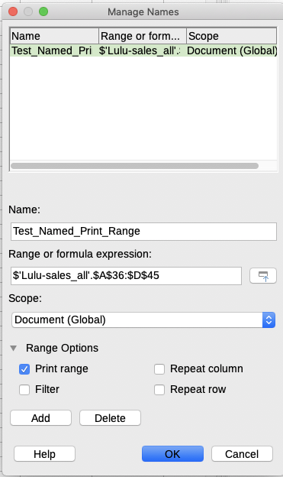Figure 12: Manage Names dialog

Repeat printing of rows or columns
If a spreadsheet is printed on multiple pages, you can define specific rows or columns (for example, headings) to repeat print on each printed page.

Using print ranges
- Go to Format > Print Ranges > Edit to open the Edit Print Ranges dialog (Figure 13).
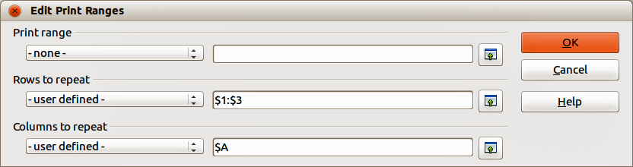Figure 13: Repeat printing of rows and columns
- In the Rows to repeat box, type the references for the rows to be repeat printed. For example, to repeat rows 1, 2 and 3, type $1:$3. This automatically changes Rows to repeat from - none - to - user defined -.
You can also place the cursor in the Rows to repeat box and then, using the mouse, select a cell in each row you want to be repeat printed. It is not necessary to select the whole row.
- In the Columns to repeat box, type the references for the columns to be repeat printed. For example, to repeat column A, type $A. This automatically changes Columns to repeat from - none - to - user defined -.
You can also place the cursor in the Columns to repeat box and then, using the mouse, select a cell in each column you want to be repeat printed.
- Click OK to save your changes and close the dialog.

Using named print ranges
You can also define named print ranges to use for repeat printing of rows or columns as follows:
- Define and name the rows and/or columns you want to repeat print. See “Named print ranges” on page 10 for more information.
- Select Repeat column and/or Repeat row from Range Options to define the columns and/or rows for repeat printing in the Define Names dialog (Figure 10 on page 10).
- Click Add to accept the data and close the dialog.
- Go to Format > Print Ranges > Edit to open the Edit Print Ranges dialog (Figure 13).
- Select the defined and named print ranges from the Rows to repeat and/or Columns to repeat drop-down lists.
- Click OK to save your changes and close the dialog.

Zalomení stránky
While defining a print range can be a powerful tool, you may sometimes need to manually adjust the page breaks to make sure the spreadsheet prints the way you want it to look. You can insert two types of page breaks into a spreadsheet:
- Row break – is a horizontal page break inserted above a selected cell in a row. For example, if the selected cell is H15, then a row break is created between rows 14 and 15.
- Column break – is a vertical page break inserted to the left of the selected cell in a column. For example, if the selected cell is H15, then a column break is created between columns G and H.
When a manual break is inserted, it appears as a blue line or as a bold line between the rows or columns on the display. The actual appearance depends on your computer setup. To see manual break lines more easily on your display, you can change their appearance. Go to Tools > Options > LibreOffice > Application Colors and scroll down to the Spreadsheet section where you can change how page breaks appear.

Inserting page breaks
- Select the cell where you want to insert a manual break in the spreadsheet.
- Go to Sheet > Insert Page Break on the Menu bar.
- Select Row Break to insert a row break above the cell or Column Break to insert a column break to the left of the cell.
Alternatively, go to View > Page Break on the Menu bar, right-click in the spreadsheet and select Row Break or Column Break from the context menu. Remember to go to View > Normal on the Menu bar and return to the standard spreadsheet view.

Deleting page breaks
- Select the cell where you want to delete a manual break from the spreadsheet.
- Go to Sheet > Delete Page Break on the Menu bar.
- Select Row Break to delete a row break from above the cell or Column Break to delete a column break from the left of the cell.

Deleting multiple page breaks
Multiple manual row and column breaks can exist in the same spreadsheet. If you want to remove all breaks from the spreadsheet:
- Go to View > Page Break on the Menu bar.
- Right-click in the spreadsheet and select Delete Page Breaks from the context menu to remove all manual breaks from your spreadsheet.
- Go to View > Normal on the Menu bar to return to the standard spreadsheet view.

Printing options for page styles
When using page styles for your spreadsheets, you can include printing options within the page style; for example, page order, details, scale to be printed, and so on. Using page styles allows you to quickly set up and change the printing options of different sheets within your spreadsheet. See Chapter 4, Using Styles and Templates, for more information about page styles.
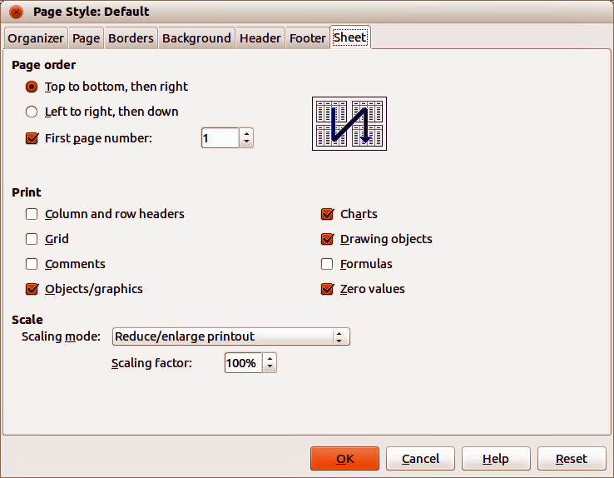Obrázek 14. Page Style dialog – Sheet page
Make sure you have selected the correct sheet within the spreadsheet before setting the print options. Go to Format > Page on the Menu bar to open the Page Style dialog, then click on the Sheet tab (Figure 14) to set the printing options for a page style. The dialog indicates which page style you are about to change.
- Page Order – defines the order in which data in a sheet is numbered and printed when it does not fit on one printed page. A preview of the page order is shown in the graphic on the top right of the dialog in Figure 14.
- Top to bottom, then right – prints vertically from the left column to the bottom of the sheet.
- Left to right, then down – prints horizontally from the top row of the sheet to the right column.
- First page number – select this option if you want the first page to start with a number other than 1. Enter the number of the first page in the box.
- Print – defines which elements of the spreadsheet are to be printed.
- Column and row headers – prints the column and row headers.
- Grid – prints the borders of the individual cells as a grid. For the view on screen, make your selection under LibreOffice > Preferences > LibreOffice Calc > View > Grid lines.
- Comments – prints the comments defined in the spreadsheet. Comments will be printed on a separate page, along with the corresponding cell reference.
- Objects/Images – includes all inserted objects (if printable) and graphics with the printed spreadsheet.
- Charts – prints the charts that have been inserted into your spreadsheet.
- Drawing Objects – includes all drawing objects in the printed spreadsheet.
- Formulas – prints the formulas contained in the cells, instead of the results of any formulas used in the spreadsheet.
- Zero Values – specifies that cells with a zero value are printed with a zero (0) in the cell.
- Scale – defines a page scale for the printed spreadsheet.
- Scaling mode – select a scaling mode from the drop-down list. Appropriate controls for the scaling mode selected will be shown below the drop-down list box.
      - Reduce/enlarge printout – specifies a scaling factor to scale all printed pages. Enter the scaling factor as a percentage in the box.
    - Fit print range(s) to width/height – specifies the maximum number of pages horizontally (width) and vertically (height) on which every sheet with the current Page Style is to be printed.
The print ranges are always scaled proportionally, so the resulting number of pages may be less than specified.
You may clear one of the boxes; then the unspecified dimension will use as many pages as necessary.
If you clear both boxes, the scaling factor will be 100%.
- Width in pages – enter the maximum number of pages to be printed horizontally across.
- Height in pages – enter the maximum number of pages to be printed vertically stacked.
- Fit print range(s) on number of pages – specifies the maximum number of pages to be printed for each sheet that uses the same Page Style. The scale will be reduced as necessary to fit the defined number of pages.
- Number of pages – enter the maximum number of pages to be printed.

Záhlaví a zápatí
Headers and footers are predefined pieces of text that are printed at the top or bottom of a sheet outside of the sheet area. Headers and footers are set the same way and you can have different content on left and right pages that use the same page style.

Setting headers and footers
To turn the headers or footers on in your spreadsheet:
- Select the sheet where you want to turn on the header or footer.
- Go to Format > Page on the Menu bar to open the Page Style dialog and select the Header (or Footer) tab (Figure 15). The Header and Footer pages in the Page Style dialog are identical.
- Zaškrtneme Záhlaví zapnuto nebo Zápatí zapnuto.
- Enter the values for the other options according to your requirements. These options are described below.
- Click OK to save your changes and close the dialog.
Figure 15: Page Style dialog – Header page
- Header on or Footer on – adds a header or footer to the current page style.
- Same content on left and right pages – causes left and right pages to share the same header or footer content. To assign a different header or footer to left and right pages, deselect this option and then click Edit. See “Header or footer contents” on page 17 for more information.
- Left margin – enter the amount of space to leave between the left page margin and the left edge of the header or footer.
- Right margin – enter the amount of space to leave between the right page margin and the right edge of the header or footer.
- Spacing – enter the amount of space to maintain between the bottom edge of the header or footer and the top edge of the spreadsheet.
- Height – enter the height for the header or footer.
- AutoFit height – automatically adjusts the height of the header or footer to fit the content.
- Preview – displays a preview of the current selection.
- More – opens the Border/Background dialog, where you can define the appearance of borders and background colors or images for headers or footers. See Chapter 4, Using Styles and Templates in Calc, for more information.
- Edit – opens the Header or Footer dialog where you can add, edit, or format text that is placed in the header or footer. See “Header or footer contents” below for more information.
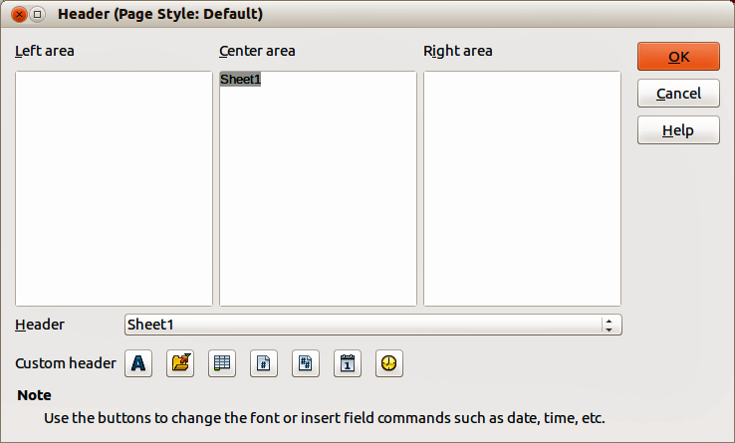Figure 16: Header dialog

Header or footer contents
The headers and footers in a Calc spreadsheet have three columns for text. Each column can either be empty or have different contents from the other columns.
- Select the sheet where you want to turn on the header or footer.
- Open the Page Style dialog (Figure 15), then select Header on or Footer on and the options for the header or footer. See “Setting headers and footers” above.
- Click Edit to open the Header or Footer dialog (Figure 16). If Same content on left and right pages is deselected in the Page Style dialog, the Header or Footer dialog will have tabbed pages where you can set the header or footer contents for right and left pages.
- To enter standard contents into the header or footer, select an option from the Header or Footer drop-down list.
- To enter customized contents into the header or footer, click in one the area boxes and type your text, or click in one of the area boxes and click one of the Custom header or Custom footer icons. These icons are explained below.
- To change the appearance of the text in the header or footer, click the Text Attributes icon to open the Text Attributes dialog, where you can set the font, font effects and font position.
- Click OK to save the changes to text attributes and close the Text Attributes dialog.
- Click OK to save the changes to the contents of the header or footer and close the Header or Footer dialog.
- Click OK to save the changes to your header or footer and close the Page Style dialog.
The options available for a Custom header or Custom footer are as follows:
- Text Attributes – opens a Text Attributes dialog where you can assign formats to new or selected text. The Text Attributes dialog contains tabbed pages for Font, Font Effects, and Position.
- Title – inserts a file name placeholder in the selected area. Click to insert the title. Click and hold to select either Title, File Name or Path/File Name from the context menu that opens. If a title has not be assigned to the spreadsheet, the file name for the spreadsheet will be inserted instead.
- Sheet Name – inserts a placeholder in the selected area for the sheet name of the selected sheet in the spreadsheet.
- Page – inserts a placeholder in the selected area for the page number. This allows continuous page numbering in a spreadsheet.
- Pages – inserts a placeholder in the selected area for the total number of pages in the spreadsheet.
- Date – inserts a placeholder in the selected area for the current date which will be repeated in the header/footer on each page of the spreadsheet.
- Time – inserts a placeholder in the selected area for the current time which will be repeated in the header/footer on each page of the spreadsheet.

Export do PDF
LibreOffice can export documents to PDF (Portable Document Format). This industry-standard file format is ideal for sending a file for someone else to view using Adobe Reader or other PDF viewers.
- Upozornění
A document in PDF format is not protected against contents tampering or editing by default. The PDF document contents can be edited by specialized software tools, including LibreOffice Draw.
- Tip
Unlike Save As, the Export command writes a copy of the current document in a new file with the chosen format, but keeps the current document and format open in your session.

Rychlý export do PDF
Click the Export as PDF icon on the Standard toolbar to export the entire spreadsheet using the PDF settings most recently selected on the PDF Options dialog (see below). You are asked to enter the file name and location for the PDF, but you do not get a chance to choose a page range, image compression, or other options.

Nastavení obsahu a kvality PDF
Pokud chceme vlastnosti exportovaného PDF dokumentu ovlivnit, zvolíme Soubor > Exportovat jako PDF. Tím se otevře dialogové okno Možnosti PDF. This dialog has six pages (General, Initial View, User Interface, Links, Security, and Digital Signatures). Select the appropriate settings, and then click Export. Then enter the location and file name of the PDF to be created, and click Save to export the file.

Karta Obecné v dialogovém okně Možnosti PDF
On the General page (Figure 13), you can choose which pages to include in the PDF, the type of compression to use for images (which affects the quality of images in the PDF), and other options. For more information, see the Getting Started guide or the Help. In most cases, the defaults will be what you need.
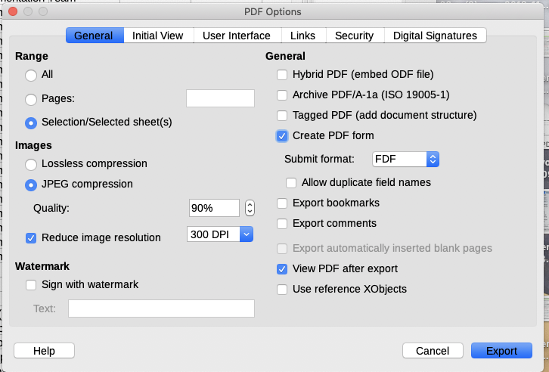Figure 17: PDF Options dialog – General page
Range section
- All: Exports the entire document to PDF.
- Pages: To export a range of pages within a selected sheet, use the format 3-6 (pages 3 to 6). To export single pages, use the format 7;9;11 (pages 7, 9, and 11), or a combination of the two formats.
- Selection/Selected sheet(s): Exports the selected material (a sheet or part of a sheet).
Část Obrázky
- Lossless compression: Images are stored without any loss of quality. Pokud se v souboru nacházejí fotografie, tato možnost může vést k velkým souborům. Recommended for other kinds of images or graphics.
- JPEG compression: Allows for varying degrees of quality. Nastavení 90% je vhodné pro fotografie (malá velikost souboru, nepatrná ztráta kvality).
- Reduce image resolution: Lower DPI (dots per inch) images have lower quality. Higher DPI settings can greatly increase the size of the exported file.
Část Vodoznak
- Sign with Watermark: When this option is selected, a transparent overlay of the text you enter into the Text box will appear on each page of the PDF.
Část Obecné
- Hybrid PDF (embed ODF file): Use this setting to export the document as a PDF file containing two file formats: PDF and ODF. Takový soubor se v PDF prohlížečích otevře stejně jako běžný soubor PDF, v LibreOffice však bude plně upravovatelný.
- Archive PDF/A-1a (ISO 19005-1): PDF/A is an ISO standard for long-term preservation of documents, by embedding all the information necessary for faithful reproduction (such as fonts) while forbidding other elements (including forms, security, and encryption). Zapíší se i PDF značky.
- Tagged PDF: Tagged PDF contains information about the structure of the document’s contents. This can help to display the document on devices with different screens, and when using screen reader software. Mezi značky, které se exportují, patří obsah, hypertextové odkazy a řídicí prvky. Tato volba může významně zvětšit velikost dokumentu.
- Create PDF form – Submit format: Choose the format of submitting forms from within the PDF file.
- Allow duplicate field names – If enabled, the same field name can be used for multiple fields in the generated PDF file. If disabled, field names will be exported using generated unique names.
- Export bookmarks: Generally not used in Calc.
- Export comments: Exports comments as PDF notes. Je možné, že toto není to, co chceme!
- Export automatically inserted blank pages: Not available in Calc.
- View PDF after export: If selected, your default PDF viewer will open and display the newly exported PDF.
- Use reference XObjects: If you don’t know what this means, leave this box unchecked.

Karta Úvodní zobrazení v dialogovém okně Možnosti PDF
On the Initial View page (Figure 18), you can select how the PDF file opens by default in a PDF viewer. The options should be self-explanatory.
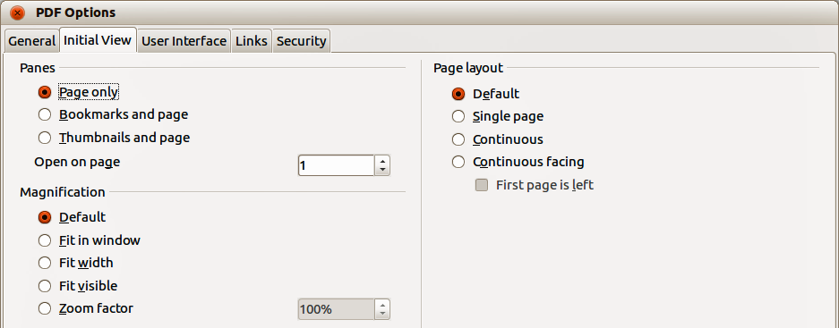Figure 18: PDF Options dialog – Initial View page

Karta Uživatelské rozhraní v dialogovém okně Možnosti PDF
On the User Interface page (Figure 19), you can select options to control how a PDF viewer displays the file. Some of these options are useful when you are creating a PDF to be used as a presentation or a kiosk-type display.
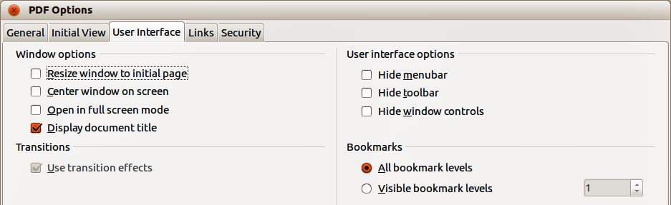Figure 19: PDF Options dialog – User Interface page
Window options
- Resize window to initial page: the PDF reader window displays the whole first page.
- Center window on screen: the PDF is shown in a reader window centered on screen.
- Open in full screen mode: the PDF reader window is in front of all other windows.
- Display document title:– the PDF is shown with the document title in the reader title bar.
Transitions – not used in Calc.
User interface options
- Hide menu bar: hides the reader menu bar when the document is active.
- Hide toolbar: hides the reader toolbar when the document is active.
- Hide window controls: hides the reader controls when the document is active.
Záložky
- All bookmark levels: shows all bookmark levels when the reader opens the PDF.
- Visible bookmark levels: shows bookmark levels down to the selected level when the reader opens the PDF.

Karta Odkazy v dialogovém okně Možnosti PDF
On the Links page (Figure 20) you can select how bookmarks and hyperlinks are exported to PDF.
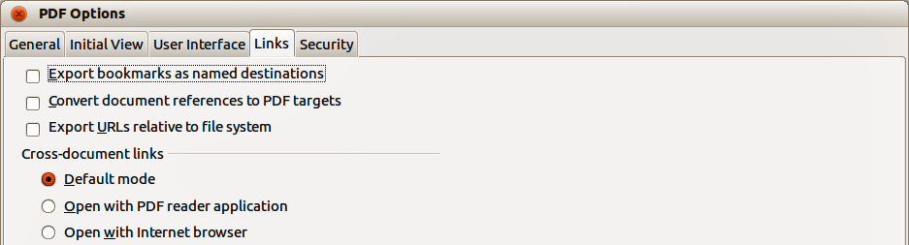Figure 20: PDF Options dialog – Links page
Exportovat záložky jako pojmenované cíle
If you have defined Calc sheet names, this option exports them as “named destinations” to which Web pages and PDF documents can link.
Převést odkazy na dokumenty na odkazy na PDF
If you have defined links to other documents with OpenDocument extensions (such as .odt, .ods, and .odp), this option converts the files’ extensions to .pdf in the exported PDF document.
Export URLs relative to file system
Jestliže jsme definovali v dokumentu relativní odkazy, tato volba exportuje tyto odkazy do PDF souboru. See Relative hyperlinks in the Calc Help for more information.
Odkazy mezi dokumenty
Definuje, jak se v exportovaném dokumentu chovají odkazy po kliknutí. Můžeme si vybrat z těchto alternativ:
- Default mode: The PDF links will be handled as specified in your operating system.
- Open with PDF reader application: Use the same application used to display the PDF document to open linked PDF documents.
- Open with Internet browser: Use the default Internet browser to display linked PDF documents.

Karta Bezpečnost v dialogovém okně Možnosti PDF
Use the Security page (Figure 21) to encrypt and set passwords when you export your spreadsheet and create the PDF file. Setting encryption and passwords also allows you to apply restrictions on printing and if changes or copying can be carried out on the PDF file.
Click the Set passwords button to open the Set Passwords dialog (Figure 22) where you enter the passwords. You can enter a password (Set open password) to open the file and an optional password (Set permission password) to restrict what readers can do with the PDF file.
- Pokud do pole Zadat heslo pro otevírání zadáme heslo, exportovaný soubor můžeme otevřít pouze pomocí tohoto <i1 /> hesla <i2 />. Po otevření souboru není uživatel nijak omezován v tom, co může s dokumentem udělat (například tisk, kopírování, nebo změna).
- With a permission password set, the PDF can be opened by anyone, but its permissions can be restricted. See Figure 21. After you set a password for permissions, the other choices on the Security page become available.
- With both the open password and permission password set, the PDF can only be opened with the correct password, and its permissions can be restricted.
The options on the Security page become available only when passwords have been set.
- Poznámka
Nastavení oprávnění jsou účinné pouze tehdy, pokud je respektuje uživatelův PDF prohlížeč.
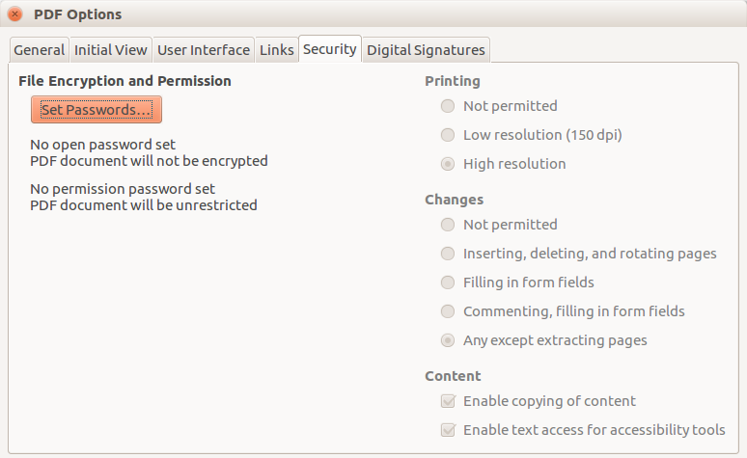Figure 21: PDF Options dialog – Security page
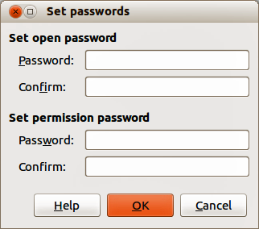Figure 22: Set passwords dialog

Digital Signatures page of PDF Options dialog
This page contains the options related to exporting a digitally signed PDF.
Digital signatures are used to ensure that the PDF was really created by the original author (that is, you), and that the document has not been modified since it was signed.
The signed PDF export uses the keys and X.509 certificates already stored in your default key store location or on a smartcard. The key store to be used can be selected under Tools > Options > LibreOffice > Security > Certificate Path. (Not available on Microsoft Windows systems, where LibreOffice will access the system certificate storage.) When using a smartcard, it must already be configured for use by your key store. This is usually done during installation of the smartcard software. Details about using these features is outside the scope of this chapter.
Figure 23: Digital signature page for PDF
- Use this certificate to digitally sign PDF documents: Click Select to open the Select Certificate dialog, where all certificates found in your selected key store are displayed. If the key store is protected by a password, you are prompted for it. When using a smartcard that is protected by a PIN, you are also prompted for that.
Select the certificate to use for digitally signing the exported PDF, then click OK.
All other fields on the Digital Signatures tab are accessible only after a certificate has been selected.
- Certificate password: Enter the password used for protecting the private key associated with the selected certificate. Usually this is the key store password. If the key store password has already been entered in the Select Certificate dialog, the key store may already be unlocked and not require the password again.
When using a smartcard, enter the PIN here. Some smartcard software will prompt you for the PIN again before signing.
- Location, Contact information, Reason: Optionally enter additional information about the digital signature that will be applied to the PDF. This information will be embedded in the appropriate PDF fields and will be visible to anyone viewing the PDF. Each or all of the three fields may be left blank.
- Time Stamp Authority: Optionally select a Time Stamping Authority (TSA) URL. During the PDF signing process, the TSA will be used to obtain a digitally signed timestamp that is then embedded in the signature. Anyone viewing the PDF can use this timestamp to verify when the document was signed.
The list of TSA URLs that can be selected is maintained under Tools > Options > LibreOffice > Security > TSAs. If no TSA URL is selected (the default), the signature will not be timestamped, but will use the current time from your local computer.

Exporting to other formats
LibreOffice používá pojem „exportovat“ pro některé souborové operace, které provádějí změnu typu souboru. If you want to use another spreadsheet file format (for example, Microsoft Excel), use File > Save As. If you want to create web pages from your spreadsheet, use File > Export.

E-mailing spreadsheets
LibreOffice provides several ways to send documents quickly and easily as an e-mail attachment in OpenDocument format (LibreOffice default format), other spreadsheet formats, or as a PDF file. You can also email a document to several recipients. For more information, see the Getting Started Guide.
To send the spreadsheet as an email:
- Go to File > Send on the Menu bar and select from the following options. LibreOffice opens your default e-mail program with the spreadsheet attached in the selected format.
- Email Document: the spreadsheet is sent in the default ODF format.
- E-mail as OpenDocument Spreadsheet: the spreadsheet is sent in the ODF format.
- E-mail as Microsoft Excel: the spreadsheet is sent in the Excel format.
- E-mail as PDF: The PDF Options dialog opens. Select the parameters to be used for the PDF file. See “Controlling PDF content and quality” on page 18.
- Ve svém e-mailovém programu zadáme příjemce, předmět a text, který chcete přidat, a potom zprávu odešleme.

Elektronické podepisování dokumentů
To sign a document digitally, you need a personal key, also known as a certificate. A personal key is stored on your computer as a combination of a private key, which must be kept secret, and a public key, which you add to your documents when you sign them. Certifikát můžeme získat od certifikační autority, což může být soukromá společnost nebo i instituce státní nebo veřejné správy.
When you apply a digital signature to a document, a checksum is computed from the document’s content plus your personal key. Tento kontrolní součet a váš veřejný klíč se uloží s dokumentem.
When someone later opens the document on any computer with a recent version of LibreOffice, the program will compute the checksum again and compare it with the stored checksum. Pokud jsou oba stejné, program signalizuje, že vidíme původní, nezměněný dokument. In addition, the program can show you the public key information from the certificate. Veřejný klíč můžete porovnat s veřejným klíčem, který je zveřejněn na webu certifikační autority.
Whenever someone changes something in the document, the change breaks the digital signature.
On Windows operating systems, the Windows features for validating a signature are used. On Linux systems, files that are supplied by Mozilla Thunderbird or Firefox are used to validate the signature. For a more detailed description of how to get and manage a certificate, and signature validation, see About Digital Signatures in the LibreOffice Help.

Applying digital signatures
The following procedure is only an example of how to digitally sign a document. The actual procedure depends on how your computer is set up and the computer operating system.
- Open the file that you want to digitally sign.
- Go to File > Digital Signatures > Digital Signatures on the Menu bar.
- If you have set LibreOffice to warn you when the document contains comments (see “Removing personal data” on page 27), you may see a message box asking whether you want to want to continue signing the document.
- If the document contains comments, a warning dialog opens asking if you wish to continue. Click Yes to continue, or click No to exit and take appropriate action to remove the comments and restart this procedure.
- Pokud jsme dokument od poslední změny neuložili, zobrazí se okno s upozorněním. Kliknutím na tlačítko OK uložíme změny. When you have saved the file, the Digital Signatures dialog opens (Figure 24).
- Click Sign Document to open the Select Certificate dialog (Figure 25).
Select the certificate you want to use and click OK to close the Select Certificate dialog.
The certificate used is displayed in the Digital Certificates dialog with an icon next to its name. Tato ikona indikuje stav elektronického podpisu.
- An icon with a red seal () indicates that the document was signed and the certificate was validated.
- An icon with a yellow caution triangle overlaying the red seal () indicates that the document is signed but that the certificate could not be validated.
- An icon with a yellow caution triangle by itself () indicates an invalid digital signature.
- Click Close to close the Digital Signatures dialog and digitally sign your file.
Pokud je dokument podepsán, ve stavovém řádku to indikuje ikona. Poklepáním na ikonu můžeme zobrazit certifikát. K dokumentu lze přidat i více než jeden podpis.
- Poznámka
If you make any changes to the document after digitally signing, the digital signature is removed automatically and you have to repeat the above procedure to digitally sign it again.
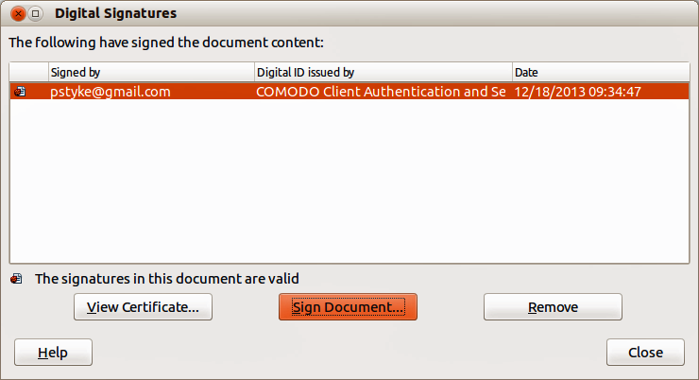Figure 24: Digital Signatures dialog
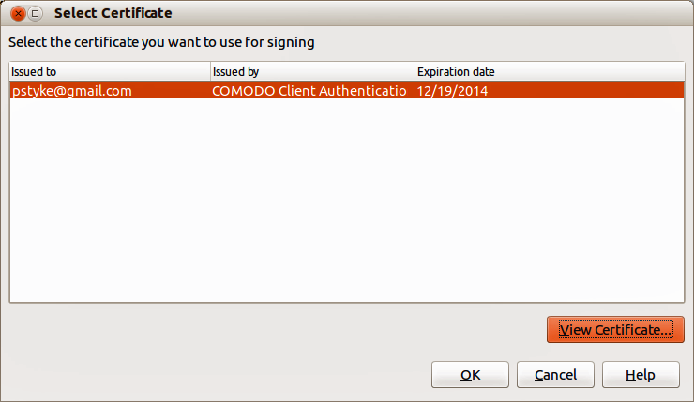Figure 25: Select Certificate dialog

Signing multiple times with same signature
In the past, LibreOffice prohibited creating multiple signatures by the same author on a document, because there was no semantic meaning of signing the same document multiple times. LibreOffice now provides a signature description, so multiple signatures from the same author are now allowed, because each signature can have a different meaning.
When you select File > Digital Signatures > Digital Signatures, the dialog (Figure 24) lists existing signatures together with their description (if they have any).
When you click the Sign Document button, the dialog (Figure 25) for certificate selection now also asks for an optional description.
Changing the value of an existing description invalidates the signature.

Digitally signing macros
Normally, macros are part of a document. If you sign a document, the macros inside the document are signed automatically. If you want to sign only the macros, but not the document, go to Tools > Macros > Digital Signature on the Menu bar and apply the signature as described above.

Odstranění osobních údajů
Možná budete chtít zajistit, aby osobní údaje, verze textu, poznámky, skryté informace nebo zaznamenané změny byly před odesláním jiným lidem nebo před uložením do souboru PDF z dokumentu odstraněny.
- In Tools > Options > LibreOffice > Security > Options, you can set Calc to remind you when files contain certain information and to remove personal information automatically on saving.
- Pokud chceme odstranit osobní a některé další údaje ze souboru, přejdeme na Soubor > Vlastnosti. On the General page, deselect Apply user data and then click Reset Properties. This removes any names in the created and modified fields, deletes the modification and printing dates, and resets the Total editing time to zero, the creation date to the current date and time, and the Revision number to 1.
- To remove version information, either go to File > Versions on the Menu bar, select the versions from the list and click Delete, or go to File > Save As and save the file with a different name.

