
Guia do iniciante 24.8

Appendix B,
Open Source, Open Standards, OpenDocument

Introdução
LibreOffice is a productivity suite that is compatible with other major office suites and available on a variety of platforms. It is open source software and therefore free to download, use, and distribute. If you are new to LibreOffice, this appendix will provide some information regarding its history, its community, and some of its technical specifications.

A short history of LibreOffice
The OpenOffice.org project began when Sun Microsystems released the source code (“blueprints”) for its StarOffice® software to the open source community on 13 October 2000. OpenOffice.org 1.0, the product, was released on 30 April 2002. Major updates to OpenOffice.org included version 2.0 in October 2005 and version 3.0 in October 2008. On 26 January 2010, Oracle Corporation acquired Sun Microsystems.
On 28 September 2010, the community of volunteers who develop and promote OpenOffice.org announced a major change in project structure. After ten years of successful growth with Sun Microsystems as founding and principle sponsor, the project launched an independent foundation called The Document Foundation, to fulfill the promise of independence written in the original charter. This foundation is the cornerstone of a new ecosystem where individuals and organizations can contribute to and benefit from the availability of a truly free office suite.
Unable to acquire the trademarked OpenOffice.org name from Oracle Corporation, The Document Foundation named its product as LibreOffice. Continuing the version numbers from OpenOffice.org, LibreOffice 3.3 was released in January 2011 and version 24.8 was released in August 2024.
In February 2012, The Document Foundation was incorporated in Berlin as a German Stiftung. You can read more about The Document Foundation at: www.documentfoundation.org.
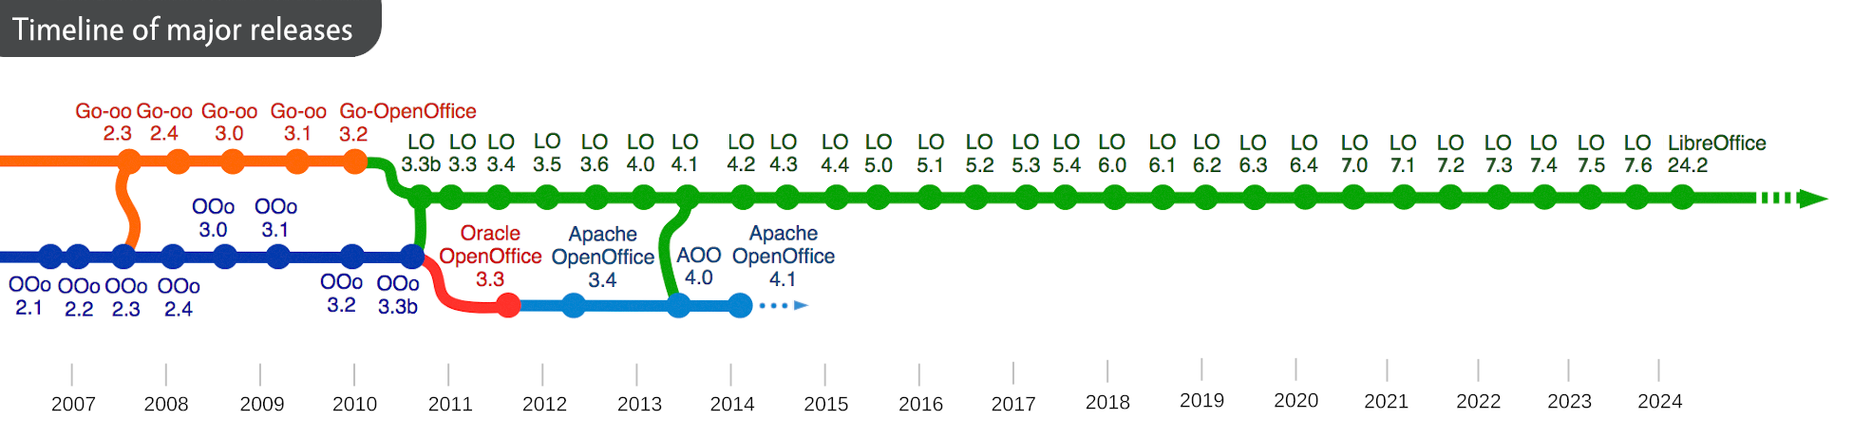
Figure 1: Timeline of major LibreOffice releases
For more detailed history of LibreOffice, visit https://www.libreoffice.org/about-us/libreoffice-timeline/

The LibreOffice community
The Document Foundation’s mission is:
“...to facilitate the evolution of the OpenOffice.org Community into a new open, independent, and meritocratic organizational structure within the next few months. An independent Foundation is a better match to the values of our contributors, users, and supporters, and will enable a more effective, efficient, transparent, and inclusive Community. We will protect past investments by building on the solid achievements of our first decade, encourage wide participation in the Community, and co-ordinate activity across the Community.”
LibreOffice is key in the drive to provide an office suite that is available to anyone, anywhere, for commercial or personal use, with its open source software license, that has been translated into several languages and runs on all major operating systems. New functionality can be added in the form of extensions.

How to participate in LibreOffice Community?
The LibreOffice community invites contributors in all areas, including translators, software developers, graphic artists, technical writers, editors, donors, and end-user support. Whatever you do best, you can make a difference in LibreOffice. The community operates internationally in all time zones and in many languages, linked through the internet at www.libreoffice.org and www.documentfoundation.org.
To guide new users in all possible activities in the LibreOffice project, please visit https://whatcanidoforlibreoffice.org .

Como o LibreOffice é licenciado?
LibreOffice is distributed under both the Mozilla Public License (MPL) 2.0 (www.libreoffice.org/about-us/licenses/) and the GNU Lesser General Public License (LGPL) 3.0+ (www.gnu.org/licenses/lgpl-3.0.en.html).

What is open source?
The four essential rights of open-source software are embodied within the Free Software Foundation family of the GNU General Public License (GPL):
- The right to use the software for any purpose.
- Freedom to redistribute the software for free or for a fee.
- Access to the complete source code of the program (that is, the “blueprints”).
- The right to modify any part of the source, or use portions of it in other programs.
The basic idea behind open source is very simple: when programmers can read, redistribute, and modify the source code for a piece of software, the software evolves. People improve it, people adapt it, people fix bugs.
For more information on Free and Open Source software, visit these websites:
- Open Source Initiative (OSI): www.opensource.org.
- Free Software Foundation (FSF): www.fsf.org.

What are open standards?
An open standard defines a method for accomplishing something that is independent of manufacturer or vendor. In this case, we are discussing open standards which allows competing software programs to freely use the same file formats. HTML, XML, and ODF are examples of open standards documents.
In computing, an open standard meets the following requirements:
- It is well documented with the complete specification publicly available, either free or at a nominal charge.
- It can be freely copied, distributed, and used. The intellectual property of the standard is made irrevocably available on a royalty-free basis.
- It is standardized and maintained in an independent, open forum (also called “standards organization”) using an open process.

What is OpenDocument?
OpenDocument (ODF) is an XML-based file format for office documents (text documents, spreadsheets, drawings, presentations, and more), developed at OASIS (https://www.oasis-open.org/), an independent, international standards group. OpenDocument version 1.2 was adopted by the International Standards Organization and named ISO/IEC 26300:2015 standard. In December 2019, ODF 1.3 was approved as a committee specification.
The OASIS OpenDocument version 1.3 specifications are available in the following links:
- Part 1, Introduction: https://docs.oasis-open.org/office/OpenDocument/v1.3/OpenDocument-v1.3-part1-introduction.html
- Part 2, Packages: https://docs.oasis-open.org/office/OpenDocument/v1.3/OpenDocument-v1.3-part2-packages.html
- Part 3, OpenDocument Schema: https://docs.oasis-open.org/office/OpenDocument/v1.3/OpenDocument-v1.3-part3-schema.html
- Part 4, Recalculated Formula (OpenFormula) Format: https://docs.oasis-open.org/office/OpenDocument/v1.3/OpenDocument-v1.3-part4-formula.html
Unlike other file formats, ODF (ISO/IEC 26300:2015) is an open standard. It is publicly available, royalty-free, and without legal or other restrictions; therefore ODF files are not tied to a specific office suite and anyone can build a program that interprets these files. For this reason ODF is important for government agencies, schools and other companies who prefer not to be too dependent on any software supplier.
LibreOffice 24.8 saves documents in ODF 1.3 Extended by default. LibreOffice can also open and save in earlier versions of the ODF standard, as well as many other file formats, as summarized in this Help page:
https://help.libreoffice.org/latest/en-US/text/shared/guide/convertfilters.html

OpenDocument filename extensions
The most common filename extensions used for OpenDocument documents are summarized in Table 1
Table 1: Filenames extensions for OpenDocument files
‍Document type | ‍Document | ‍Template
Word processing (text documents) | *.odt | ‍*.ott
Spreadsheets | *.ods | ‍*.ots
Presentations | *.odp | ‍*.otp
Databases | *.odb | ‍
Drawings | *.odg | ‍*.otg
Charts | *.odc | ‍
Formulas and equations | *.odf | ‍
‍Master documents (text documents) | *.odm | *.otm

