
Průvodce programem Writer 6.4

Kapitola 15
Obsahy, rejstříky, seznamy použité literatury

Autorská práva
Tento dokument je duševním vlastnictvím dokumentačního týmu LibreOffice Copyright ©2020. Přispěvatelé jsou uvedeni níže. Dokument je možné šířit nebo upravovat za podmínek licence GNU General Public License (http://www.gnu.org/licenses/gpl.html) verze 3 nebo novější nebo za podmínek Commons Attribution License (http://creativecommons.org/licenses/by/4.0/) verze 4.0 nebo novější.
Všechny ochranné známky uvedené v této příručce patří jejich vlastníkům.

Přispěvatelé

Pro toto vydání
Jean Hollis Weber | Felipe Viggiano

Pro předchozí vydání
Jean Hollis Weber | Bruce Byfield | Gillian Pollack
John A. Smith | Ron Faile Jr.

Zpětná vazba
Připomínky a náměty k tomuto dokumentu posílejte v angličtině dokumentačnímu týmu na adresu: documentation@global.libreoffice.org.
- Poznámka
Vše, co do e-mailové konference pošlete, včetně e-mailové adresy a dalších osobních informací uvedených ve zprávě, bude veřejně viditelné bez možnosti smazání.

Datum vydání a verze programu
Publikováno v červenci 2020. Kniha je určena pro LibreOffice 6.4.

Poznámka pro uživatele systému macOS
Některé klávesové zkratky a položky nabídek jsou v systému macOS jiné než v systémech Windows a Linux. V následující tabulce jsou uvedeny nejdůležitější rozdíly, které se týkají informací v této knize. Podrobnější seznam se nachází v nápovědě k aplikaci.
Windows nebo Linux | Ekvivalent pro macOS | Akce
Nástroje > Možnosti…  výběr nabídky | LibreOffice > Předvolby | Otevřou se možnosti nastavení
Klepnutí pravým tlačítkem | Control+klepnutí a/nebo klepnutí pravým tlačítkem myši v závislosti na nastavení počítače | Otevře se místní nabídka
Ctrl (Control) | ⌘ (Command) | Používá se také s dalšími klávesami
F11 | ⌘ + t | Otevře se postranní lišta Styly

Obsah
Autorská práva 2
Přispěvatelé 2
Pro toto vydání 2
Pro předchozí vydání 2
Zpětná vazba 2
Datum vydání a verze programu 2
Poznámka pro uživatele systému macOS 2
Úvod 5
Obsahy 5
Rychlé vytvoření obsahu 5
Vlastní nastavení obsahu 6
Karta Typ 7
Záložka Položky 8
Stránka Styly 10
Stránka Sloupce 11
Stránka Pozadí 11
Úprava obsahu 13
Aktualizace obsahu 14
Smazání obsahu 14
Abecední rejstříky 14
Přidání položek rejstříku 14
Příklad použití indexového klíče 16
Vytvoření konkordance 16
Rychlé vytvoření abecedního rejstříku 17
Nastavení rejstříku 17
Karta Typ 17
Záložka Položky 18
Stránky Styly a Pozadí 20
Stránka Sloupce 20
Udržování rejstříku 21
Zobrazení a úprava existujících položek rejstříku 21
Další typy rejstříků 22
Příklad: vytvoření rejstříku obrázků 22
Seznamy použité literatury 23
Vytvoření bibliografické databáze 24
Filtrování záznamů 25
Změna zdroje dat 26
Přidání záznamů do databáze 26
Uchování položek v databázi 26
Pokročilé: Úpravy seznamu použité literatury 26
Podrobnosti sloupců 26
Podrobnosti polí 27
Adding references (citations) into a document 29
Zadávání odkazů z databáze 29
Zadávání odkazů z dokumentů 29
Úprava odkazu 30
Vytvoření seznamu použité literatury 30
Karta Typ 30
Záložka Položky 31
Karty Styly, Sloupce a Pozadí 32
Úprava stylu odstavce pro seznam použité literatury 32
Updating, editing, and deleting an existing bibliography 34

Úvod
This chapter describes how to create and maintain a table of contents, an index, and a bibliography for a text document using LibreOffice Writer. Other types of index are mentioned briefly. To understand the instructions, you need a basic familiarity with Writer and styles (see Chapters 8 and 9). Some common usage examples are given.

Obsahy
Writer’s table of contents (TOC) feature lets you build an automated TOC from the headings in a document. Whenever changes are made to the text of a heading in the body of the document or the page on which the heading appears, those changes automatically appear in the table of contents when it is updated.
Před začátkem je třeba se ujistit, zda jsou nadpisy vytvořeny konzistentně pomocí stylů. Například můžeme použít styl Nadpis 1 pro názvy kapitol a styly Nadpis 2 a Nadpis 3 pro podnadpisy v kapitole.
Tato část ukazuje, jak:
- Create a table of contents quickly, using the defaults.
- Customize a table of contents.
- Poznámka
You can use any style you want for the different levels to appear in the table of contents; for simplicity, most of this chapter uses the default Heading styles.
You can specify other text in addition to headings to appear in the TOC, as described later in this chapter.

Rychlé vytvoření obsahu
Most of the time you will find the default table of contents to be all you need, although the formatting may be inelegant. To insert a default TOC:
- Create a document, using the following paragraph styles for different heading levels (such as chapter and section headings): Heading 1, Heading 2, and Heading 3. These are what will appear in your TOC. Writer can evaluate up to ten levels of headings.
- Click in the document where you want the TOC to appear.
- Zvolíme Vložit > Obsah a rejstřík > Obsah, rejstřík nebo seznam použité literatury.
- Klepneme na OK. The result will be a typical table of contents with the entries generated as hyperlinks.
- Rady
- If some of your headings do not show up in the table of contents, check that the headings have been tagged with the correct paragraph style. If a whole level of headings does not show up, check the settings in Tools > Chapter Numbering. See “Defining a hierarchy of headings” in Chapter 8, Introduction to Styles, for more information.
- The TOC appears with a gray background. This background is there to remind you that the TOC is a field; the text you see is generated automatically. The background is not printed and does not appear if the document is converted to a PDF. To turn off this gray background, go to Tools > Options > LibreOffice > Application Colors, then scroll down to the Text Document section and deselect Index and table shadings.
This change may leave a gray background showing behind the dots between the headings and the page numbers, because the dots are part of a tab. To turn that shading off, go to Tools > Options > LibreOffice Writer > Formatting Aids and deselect the option for Tabs in the Display formatting section.
- Pokud přidáme nebo odstraníme text (tak, že se nadpisy posunou na jinou stranu), nebo přidáme, smažeme nebo změníme nadpisy, je potřeba obsah aktualizovat. To do this: Right-click anywhere in the TOC and select Update Index from the context menu.
- If you cannot place the cursor in the TOC, choose Tools > Options > LibreOffice Writer > Formatting Aids, and then select Enable cursor in the Protected Areas section.
- Upozornění
If you have Edit > Track Changes > Show enabled when editing a document and you update the TOC, then errors may occur, as the TOC will still include any deleted headings and you may find that deleted text causes page numbering in the TOC to be wrong. To avoid this problem, be sure this option is deselected before updating a TOC.

Vlastní nastavení obsahu
Almost every aspect of the table of contents can be customized to suit the style and requirements of your document. However, with this flexibility also comes some complexity, so it is good to have in mind the desired end result.
Start by clicking in the document where you want the table of contents to appear and choose Insert > Table of Contents and Index > Table of Contents, Index or Bibliography to open the Table of Contents, Index or Bibliography dialog shown in Figure 1.
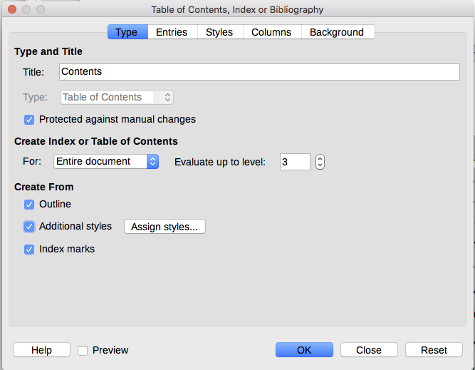Figure 1: Type page of Table of Contents, Index or Bibliography dialog
You can also access this dialog at any time by right-clicking anywhere in an existing table of contents and choosing Edit Index from the context menu.
Dialogové okno Obsah, rejstřík nebo seznam použité literatury má pět karet. Each of them covers a different aspect of the TOC structure and appearance:
- Use the Type page to set the attributes of the TOC.
- Use the Entries and Styles pages to format the entries in the TOC.
- Use the Columns page to put the TOC into more than one column.
- Use the Background page to add color or an image to the background of the TOC.
You can display a preview box, located on the left-hand side of each page, to show as you work how the TOC will look: select the Preview option in the lower left of the dialog. The illustrations in this chapter show the dialog as it appears with the preview box hidden.
- Poznámka
The preview box shows the appearance from settings made on the Type, Entries, and Styles pages. It does not show changes made on the Columns and Background pages.
After making all your changes, click OK to apply them. To revert to the default settings for the Columns and Background pages, select each page in turn and click the Reset button. The settings on the Type, Entries and Styles pages must be reset manually; the Reset button has no effect.

Karta Typ
Use the Type page, pictured in Figure 1, to set the attributes of the TOC.
Changing the title
To give the table of contents a different title, type it in the Title field. Chceme-li název odstranit, pole Název vymažeme.
Setting the type
Be sure the Type is set to Table of Contents. See “Alphabetic indexes” on page 14 and “Other types of indexes” on page 22 for more about creating other types of indexes.
- Upozornění
You can change the type of index only when you first create it. Once you define an index type (for example, a table of contents) you cannot change it.
Protecting against manual changes
By default, to prevent the TOC from being changed accidentally, the Protected against manual changes option is selected; thus, the TOC can only be changed by using the right-click menu or the dialog. If the option is not selected, the TOC can be changed directly on the document page, just like other text. However, any manual changes will be lost when you update the TOC, so they should be avoided.
Choosing the scope of the table of contents
In the For drop-down list in the Create Index or Table of Contents area, you can select whether the TOC will cover all the headings of the document (Entire document) or just the headings of the chapter where it is inserted. Writer identifies a “chapter” as all the headings between two first level outline headings (normally Heading 1).
Changing the number of levels included
Writer uses 10 levels of headings when it builds the table of contents (or the number of levels used in the document, whichever is smaller). To change the number of levels included, enter the required number in the Evaluate up to level box. For example, the TOC in this book includes only the first three heading levels.
Creating a table of contents from an outline
The third section of the Type page determines what Writer should use to create the TOC. The choices (not mutually exclusive) are:
- Outline
- Additional styles
- Index marks
By default Writer uses the outline levels; that is, paragraphs formatted with the paragraph styles associated with outline levels in Tools > Chapter Numbering.
You can change the paragraph styles included in the outline as described in “Using paragraph styles to define a hierarchy of headings” in Chapter 8, Introduction to Styles, and you can include other paragraph styles in the TOC by assigning an outline level to those styles. To do this, modify the paragraph style definition: go to the Outline & Numbering page of the Paragraph Style dialog, and select the required outline level (Figure 2). Click OK to save the change.
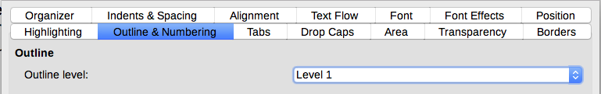Figure 2: Specifying an outline level on Outline & Numbering page for a paragraph style
Creating from additional styles
By selecting the Additional Styles option on the Type page, you can add more paragraph styles to the TOC. This can be useful when you want to include the heading of an annex (appendix) in the TOC. If the Outline option is also selected, the additional styles will be included in the table of contents together with the ones defined in the outline numbering.
Creating from index marks
This selection adds any index entries that you have inserted into the document by using Insert > Table of Contents and Index > Index Entry. Normally you would not use this selection for a table of contents. However, if you do wish to use it, be sure to select Table of Contents from the Index drop-down list at the top of the Insert Index Entry dialog (Figure 8) when you are entering the index entries for use in a TOC, so that Writer can distinguish between them and any index entries intended for inclusion in an alphabetic or other index.

Záložka Položky
Use the Entries page (see Figure 3) to define and format the entries in the TOC. Each outline level can be styled independently from the other levels by adding and deleting elements.
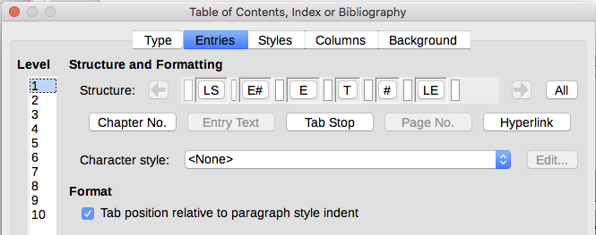Figure 3: Entries page of Table of Contents, Index or Biblioraphydialog
Click a number in the Level column to select the outline level whose elements you want to format. The Structure line contains the elements included in the entries for that level. Elements that can be added to the structure line are displayed just below the structure line, and are grayed out if they cannot be included:
- The LS icon represents the start of a hyperlink.
- The E# icon represents the “chapter number”, which means the heading number value assigned to a heading style in Tools > Chapter Numbering, not just for chapters but also for other levels of headings. See “Setting up heading numbering” in Chapter 8, Introduction to Styles.
- The E icon represents the chapter (or sub-chapter) text: That is the text formatted with the paragraph style used for each level.
- Ikona T představuje zarážku tabulátoru.
- Ikona # představuje číslo stránky.

- The LE icon represents the end of a hyperlink.
- Each white field on the Structure line represents a blank space where you can add custom text or another element.
- Upozornění
In the Chapter Numbering dialog (covered in Chapter 8), if you have included any text in the Before or After boxes in the Separator section for any given level, then that text will be part of the E# field for that level. Take care when building the structure line not to create any unwanted effects in the appearance of the TOC.

Adding elements
To add an element to the Structure line:
- Click in the white field where you want to insert the element.
- Click one of the active buttons just below the Structure line. For example, to add a tab, click the Tab Stop button. An icon representing the new element appears on the Structure line.
- To add custom text, such as the word Chapter, type the text in the white field. Don't forget a trailing space.

Changing elements
To change an element in the Structure line, click the icon representing that element and then click a non-grayed out element in the row of buttons just below the Structure line. For example, to change a chapter number to a tab stop, click the E# icon on the Structure line (it shows then as being pressed) and then click the Tab Stop button in the row of available elements. To cancel before swapping an element, click in one of the white spaces.

Applying changes to all outline levels
If you wish to apply the displayed structure and formatting to all outline levels, click the All button on the right.

Deleting elements
To delete an element from the Structure line, click the button representing that element and then press the Delete key on your keyboard. For example, to delete the default hyperlink setting, click the LS icon and then press the Delete key. Repeat this for the LE icon.

Applying character styles
You might want an element to be a bit different from the rest of the line. For example, you might want the page number to be bold. To apply a character style to an element:
- Be sure you have previously defined a suitable character style.
- On the Structure line, click the button representing the element to which you want to apply a style.
- From the Character Style drop-down list, select the desired style.
To view or edit the attributes of a character style, select the style from the Character Style drop-down list and then click the Edit button.
- Tip
The default character style for hyperlinks (such as those inserted by Insert > Hyperlink) is Internet Link, which by default is underlined and shown in blue.
The default hyperlinks of TOC entries are set to the Index Link character style, which may be different in appearance from the Internet Link style. If you want them to appear the same as internet links, you can select the LS icon on the Structure line and change the character style selection for TOC entries to Internet Link.
You can also change the attributes for Index Link to what you want.

Tab parameters
Click on the Tab stop icon on the Structure line to bring up these controls:
- Fill character: select the tab character you wish to use; the first choice is none (blank).
- Tab stop position: specify the distance to leave between the left page margin and the tab stop. Optionally, select Align right for the tab stop; this selection inactivates the distance.

Tab position relative to paragraph style indent
When this option is selected, entries are indented according to the settings of their individual formats. Where a paragraph style specifies an indent on the left, tab stops are relative to this indent. If this option is not selected, tab stops are relative to the left margin position.

Stránka Styly
Use the Styles page (Figure 4) to change which paragraph style is assigned to display the text of each level in the table of contents. In most cases, the best strategy is to keep the assigned styles but change their settings as needed to make the TOC appear the way you want.
To apply a custom paragraph style to an outline level:
- In the Levels list, select the outline level.
- In the Paragraph Styles list, click on the desired paragraph style.
- Click the < button to apply the selected paragraph style to the selected outline level.
The style assigned to each level appears in square brackets in the Levels list.
To remove paragraph styling from an outline level, select the outline level in the Levels list, and then click the Default button.
To view or edit the attributes of a paragraph style, click the style in the Paragraph Styles list, and then click the Edit button.
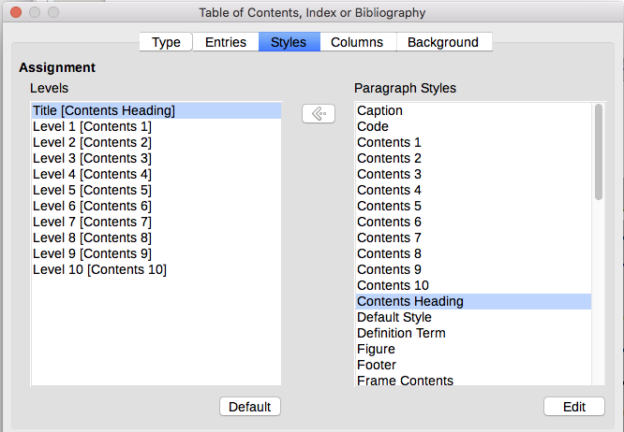Figure 4: Styles page of the Table of Contents, Index or Bibliography dialog
- Poznámka
Changes to a paragraph style will affect any text in the document that is formatted using this style, not just the format of the table of contents.

Stránka Sloupce
Use the Columns page to change the number of columns for the TOC. Multiple columns are more likely to be used in an index than in a TOC, so this page is described in the section on indexes. See Figure 12.

Stránka Pozadí
Use the Background page (Figure 5) to add color or a bitmap (image) to the background of the TOC.

Adding color
To add color to the background of the table of contents, select the Color button from the row of buttons near the top of the dialog, then select a color and click OK.
See “Adding custom colors” in Chapter 21, Customizing Writer, for more about defining and using background colors.
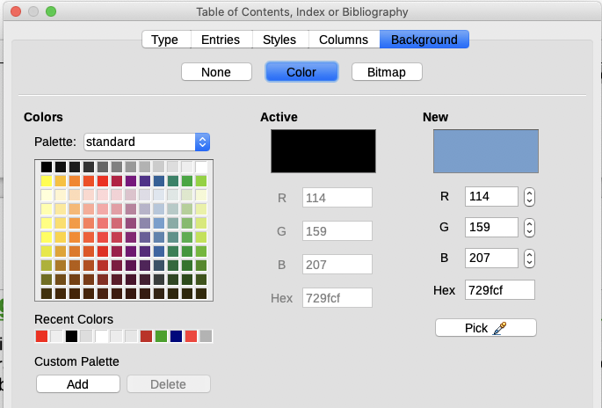Figure 5: Background page, showing Color choices

Adding a bitmap (image)
To add an image to the background of the table of contents:
- From the row of buttons near the top of the dialog, select Bitmap. The Background page now displays the bitmap options, as shown in Figure 6.
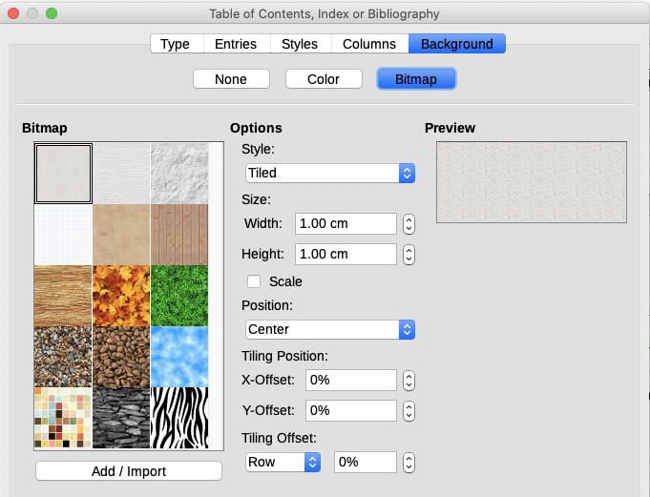Figure 6: Image options on the Background page
- Select from the given bitmaps or click the Add/Import button to select an image from your computer’s file system.
- Under Options, select the type of placement for the image.
- Style – select custom position/size, tiled, or stretched.
- Size – select the required Image aspect ratio or the Scale option.
- Position – select where the image is to be displayed.
- To apply the image, click OK.

Deleting a color or an image
To delete a color or an image from the table background, select None at the top of the dialog.

Úprava obsahu
To edit an existing TOC, right-click anywhere in the TOC and choose Edit Index from the context menu. The Table of Contents, Index or Bibliography dialog (Figure 1 on page 6) opens. You can edit and save the TOC as described in the previous section.
- Tip
If you cannot click in the TOC, it is probably protected. To disable this protection, choose Tools > Options > LibreOffice Writer > Formatting Aids, and then select Enable Cursor in the Protected areas section. If you wish to edit the TOC without enabling the cursor, you can access it from the Navigator as described below.
To access the Table of Contents, Index or Bibliography dialog from the Navigator:
- Open the Navigator (press F5).
- Click the expansion symbol (+ sign or triangle) next to Indexes.
- Right-click on the name of table of contents you want to edit and choose Index > Edit.
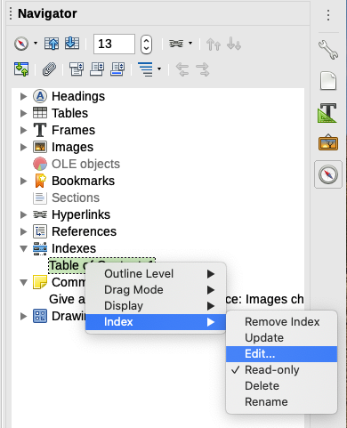Figure 7: Access a TOC from the Navigator

Aktualizace obsahu
Writer does not update the TOC automatically, so after any changes to the headings, you need to update it manually. Right-click anywhere in the TOC; from the context menu, choose Update Index.
You can also update the index from the Navigator: expand Indexes, right-click on the name of table of contents you want to update, and choose Index > Update.

Smazání obsahu
To delete the TOC from a document, right-click anywhere in the TOC and choose Delete Index from the context menu. You can also delete the index from the Navigator by choosing Index > Delete from the menu shown in Figure 7. Writer will not prompt you to confirm the deletion.

Abecední rejstříky
An alphabetical index (referred to as an index) is a list of keywords or phrases used throughout a document that, if listed in order with page numbers, may help the reader find information quickly. Generally an index is found in the back of a book or document.
This section describes how to:
- Add index entries manually.
- Use a concordance file.
- Create an alphabetic index quickly.
- Customize the display of index entries.
- Customize the appearance of the index.
- View and edit existing index entries.

Přidání položek rejstříku
Before you can create an index, you must create some index entries, either manually or by using a concordance (see page 16). To create index entries manually:
- To add a word to the index, place the cursor anywhere in that word. To add multiple words as one entry, select the entire phrase.
- Choose Insert > Table of Contents and Index > Index Entry to display a dialog similar to that shown in Figure 8. When the dialog opens, the selected text appears in the Entry text input box. You can accept the word or phrase shown, or change it to whatever you want.
- Click Insert to create the entry.
- Poznámka
A cursor placed immediately before the first character of a word, or immediately after the last character of a word if it is followed by a space, counts as being in that word.
You can create multiple entries without closing the dialog. For each one:
- Click at the location in the document that you want to index.
- Click again on the dialog.
- Change the entry if needed, and click Insert.
- Repeat steps 1–3 until you have finished with the entries, then click Close.
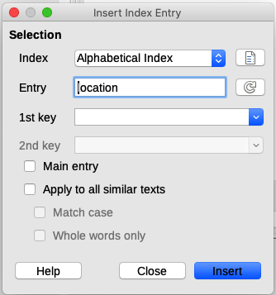Figure 8: Inserting an index entry
Below is a brief explanation of the fields in the Insert Index Entry dialog and how to use them.
Index
The type of index this entry is for. The default is Alphabetical Index, but you can use this field to create extra entries for a table of contents or user-defined indexes or lists of almost anything. Například můžeme vytvořit samostatný rejstřík obsahující pouze vědecké názvy druhů organismů a jiný rejstřík pro jejich české názvy. See “Other types of indexes” on page 22.
Položka
The word or phrase to be added to the selected index. This word or phrase does not need to be in the document itself; you can add synonyms and other terms that you want to appear in the index.
1st key
An index key is an entry that has no associated page number and has several subentries that do have page numbers. Using keys is a useful way of grouping related topics. (See “Example of using an index key” on page 16.)
2nd key
You can have up to a three-level index, where some of the first-level keys have level-2 entries that are also keys (without page numbers). This degree of index complexity is not often necessary.
Main entry
When the same term is indexed on several pages, often one of those pages has more important or detailed information on that topic, so you want it to be the main entry. To make the page number for the main, or most important, entry stand out, select this option and then define the character style for the page number of a main index entry to be bold, for example.
Apply to all similar texts
Select this option to have Writer automatically identify and mark any other word or phrase that matches the current selection. The Match case and Whole words only options become available if this option is selected. Use this option with care, as it may result in many unwanted page numbers (for minor uses of a word) being listed in the index.

Příklad použití indexového klíče
An index key is a primary entry under which subentries are grouped. For example, you might want to create a grouping similar to this:
LibreOffice
Calc, 10
Impress, 15
Writer, 5
In this example, LibreOffice is the 1st key. The subentries (with the page numbers showing) are the indexed entries. To insert an index entry for the topic Writer, on the Insert Index Entry dialog (Figure 8 on page 15), type Writer in the Entry box and LibreOffice in the 1st key box.
- Poznámka
If field shading is active (Tools > Options > LibreOffice > Application Colors > Text Document > Field shadings), when a selected word or phrase has been added to the index, it is shown in the text with a gray background. If the text of an index entry has been changed from the text of the word selected, the index entry is marked by a small gray rectangle at the start of that word.
- Tip
You can also open the Insert Index Entry dialog by clicking the Insert Index Entry icon at the right-hand end of the Insert toolbar, as shown in Figure 9.
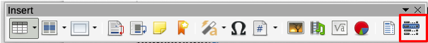Figure 9: Insert Index Entry icon on Insert toolbar

Vytvoření konkordance
Konkordance je soubor prostého textu, který obsahuje seznam slov, která se mají přidat do rejstříku. Na každém řádku je definováno jedno slovo nebo fráze. Každý řádek má přísnou strukturu skládající se ze sedmi polí oddělených středníky:
Hledaný výraz;Alternativní položka;První klíč;Druhý klíč;Rozlišovat velikost;Celá slova
Mezi středníkem a obsahem pole není žádná mezera. Klíčem je nadpis na vyšší úrovni, pod který je umístěn hledaný výraz.
Pokud se rozhodneme, že nebudeme mít alternativní položku, první klíč nebo druhý klíč, necháme tato pole nevyplněná, aby jeden středník okamžitě následoval za druhým.
Poslední dvě pole jsou strukturována poněkud odlišně. Pokud chceme pouze položky, které mají stejná velká nebo malá písmena jako naše položky, zadáme do předposledního pole 1. Podobně zadání 1 do posledního pole nastaví index tak, aby zahrnoval pouze instance, kde je záznam celé slovo a není částí většího slova. Poslední dvě pole můžeme také nechat prázdná, stejně jako u ostatních.
Například zadání:
Papoušek;Ara;Papoušci;;0;0
Vyrobí záznam pro papoušek s
- V seznamu pod papoušek.
- Alternativní seznam pod ara (vědecký název).
- Seznam Papoušci, papoušek.
- Žádný druhý klíč (všimneme si dvou středníků).
- Zahrnutí případů, které začínají malým nebo velkým písmenem (obojí „papoušek“ a „Papoušek“).
- Zahrnutí případů, ve kterých je výrazem celé slovo nebo jeho část.
Zda je vytváření konkordance rychlejší než ruční přidávání položek, je diskutabilní, ale shoda je určitě systematičtější. Nevýhodou konkordance je, že může vytvořit rejstřík obsahující instance běžných slov, která jsou pro vaše účely irelevantní. V mnoha případech může užitečný rejstřík vyžadovat kombinaci ručních záznamů a konkordance.

Rychlé vytvoření abecedního rejstříku
Nyní, když máme nějaké položky rejstříku, můžete jej vytvořit.
I když je možné rejstříky ve Writeru rozsáhle přizpůsobit, většinou stačí provést jen několik voleb.
Rychlé vytvoření rejstříku
- Klepneme do dokumentu na místo, kde chceme přidat rejstřík. Výběrem Vložit > Obsah a rejstřík > Obsah, rejstřík nebo seznam použité literatury otevřeme dialogové okno Obsah, rejstřík nebo seznam použité literatury.
- V poli Typ na kartě Typ (obrázek 10) vybereme Abecední rejstřík.
- V části Možnosti možná budeme chtít zrušit výběr Rozlišovat velikost písmen (aby se velká a malá písmena považovala za stejné slovo) a Sloučit stejné položky s f nebo ff.
- Pokud používáme konkordanci, vybereme Rejstříkový soubor v části Možnosti a poté klepneme na tlačítko Soubor a vyberte soubor, který jsme vytvořili.
- Klepneme na OK. Výsledkem bude typický index.

Nastavení rejstříku
Chceme-li upravit existující rejstřík, klepneme pravým tlačítkem kdekoli v rejstříku a vybereme z místní nabídky Upravit rejstřík.
Dialogové okno Obsah, rejstřík nebo seznam použité literatury má pět karet (obrázek 10). Všechny z nich lze použít k přizpůsobení rejstříku.
- Pro nastavení atributů rejstříku použijeme kartu Typ.
- Pro formátování položek v rejstříku použijeme karty Položky a Styly.
- Pro vložení indexu do více než jednoho sloupce použijeme kartu Sloupce.
- Pro přidání barvy nebo obrázku na pozadí indexu použijeme kartu Pozadí.
Po provedení změn klepnutím na OK uložíme rejstřík, a ten se zobrazí v našem dokumentu.

Karta Typ
Pro nastavení základních atributů rejstříku použijeme kartu Typ (obrázek 10).
Chceme-li dát rejstříku jiný název, upravíme pole Název. Chceme-li název odstranit, pole Název vymažeme.
Ujistíme se, že je typ rejstříku nastaven na Abecední rejstřík.
Chceme-li zabránit neúmyslné změně indexu, zaškrtneme Zamknuto proti ručním změnám. Rejstřík lze poté změnit pouze pomocí nabídky pravého tlačítka nebo v dialogovém okně Obsah, rejstřík nebo seznam použité literatury. Pokud tato možnost není vybrána, lze rejstřík upravovat přímo na stránce dokumentu, stejně jako jiný text. Při aktualizaci však dojde ke ztrátě jakýchkoli ručních změn rejstříku, takže je vhodné se jim vyhnout.
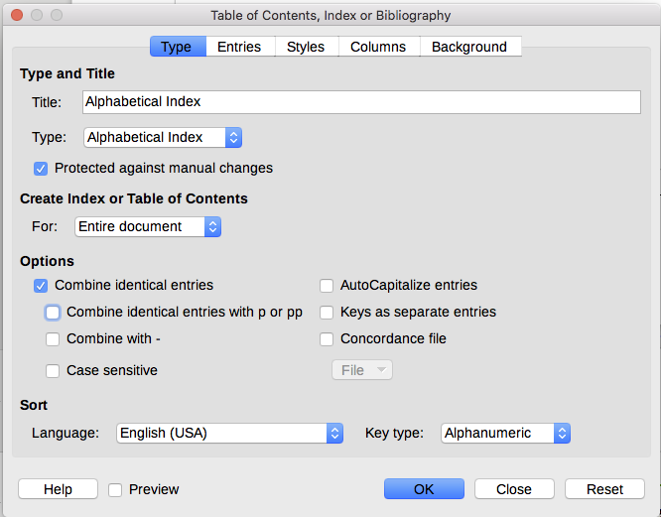Obrázek 10: Karta Typ abecední rejstřík
Z rozbalovacího seznamu v sekci Vytvořit rejstřík nebo obsah zvolíme Celý dokument. Můžeme se také rozhodnout vytvořit rejstřík pouze pro aktuální kapitolu.
Další možnosti určují, jak rejstřík zachází s položkami:
Sloučit stejné položky
Definuje, jak se zachází se stejnými položkami. Normálně se v rejstříku zobrazí každé číslo stránky indexovaného slova nebo fráze; lze je však kombinovat pomocí Sloučit stejné položky s f nebo ff. Chceme-li zobrazit rozsah stránek, vybereme Sloučit do intervalu (což vyprodukuje něco podobného jako 23–31). Pokud chceme různé položky podle toho, jak jsou velká písmena, vybereme Rozlišovat velikost písmen.
Použít velké písmeno
Automaticky nastaví velké písmeno u prvního znaku každé položky bez ohledu na to, jak se zobrazují v samotném dokumentu.
Klíče jako oddělené položky
Tuto volbu vybereme, chceme-li mít vlastní čísla stránek pro klíče.
Rejstříkový soubor
Vybereme soubor, který se má použít. Pro více informací viz strana 16 .
Řadit
Definuje, jak jsou položky při zobrazení seřazeny. Jediná možnost je alfanumericky, ale můžeme určit, která jazyková abeceda bude použita.

Záložka Položky
Pro přesné nastavení, jak a co se bude zobrazovat pro každou z položek použijeme kartu Položky. Karta je podobná obrázku 11.
- Poznámka
Hypertextové odkazy z rejstříku na umístění položek v textu nejsou k dispozici.
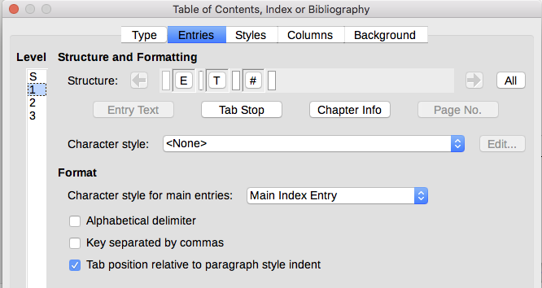Obrázek 11: Karta Položky pro abecední rejstřík
Nejprve ve sloupci Úroveň vyberte úroveň rejstříku, jejíž prvky chceme formátovat. Úroveň „S“ označuje záhlaví jednotlivých písmen, která rozdělují položky rejstříku abecedně, když je v seznamu vybrána možnost Abecední oddělovač v sekci Formát. (Změny budeme moci později použít na všechny úrovně indexu.) V sekci Struktura a formátování, řádek Struktura se zobrazují prvky pro položky na této úrovni. Každé tlačítko na řádku představuje jeden prvek:
- Ikona E představuje vstupní text.
- Ikona T představuje zarážku tabulátoru.
- Ikona # představuje číslo stránky.
- Ikona CI představuje informace o kapitole. Toto není ve výchozím nastavení k dispozici, ale lze je přidat zmáčknutím tlačítka Informace o kapitole.
Každé bílé pole na řádku Struktura představuje prázdné místo. Můžeme přidávat, měnit nebo mazat prvky, jak je popsáno na stránce 9 pro obsah.

Informace o kapitole
Tlačítko Informace o kapitole vloží informace o kapitole, jako je nadpis a číslo kapitoly. Informace, které se mají zobrazit, jsou vybrány ze seznamu Položka kapitoly, který se zobrazí, když po zvolení této možnosti. Tato data jsou určena v dialogovém okně Číslování kapitol (Nástroje > Číslování kapitol).

Aplikace znakových stylů
Každý z prvků na řádku Struktura může mít další formátování. Můžeme například chtít, aby číslo stránky mělo jinou velikost než zbytek textu rejstříku. Chceme-li to provést, použijte znakový styl na jeden z prvků v řádku Struktura, jako pro obsah; viz strana 10.

Formátování položek
Další formátování nastavíme pomocí možností v sekci Formát.
- Abecední oddělovač. Odděluje položky rejstříku do bloků, které začínají stejným prvním písmenem, přičemž se toto písmeno používá jako záhlaví. Například pokud náš index začíná:
apple, 4
author, 10
break, 2
bus, 4
Po výběru této možnosti získáme:
A
apple, 4
author, 10
B
break, 2
bus, 4
- Klíče oddělené čárkami. Uspořádá položky v rejstříku na stejném řádku, ale oddělené čárkami.
- Umístění tabulátoru relativní k odsazení stylu odstavce. Pokud je tato možnost vybrána, jsou položky odsazeny podle nastavení jejich jednotlivých formátů. Pokud se používá styl odstavce s odsazením vlevo, zarážky tabulátoru budou relativní k tomuto odsazení. Pokud není tato možnost vybrána, budou zarážky tabulátoru relativní k poloze levého okraje.

Stránky Styly a Pozadí
kartu Styly použijeme pro změnu stylu odstavce, který je přiřazen k zobrazení textu každé úrovně v rejstříku. Ve většině případů je nejlepší strategií zachovat přiřazené styly, ale můžeme podle potřeby změnit jejich nastavení, aby se rejstřík zobrazoval tak, jak chceme.
Karta Pozadí je stejná jako pro obsah. Podrobné informace na těchto kartách Viz „Karta Styly“ na stránce 10 a „Pozadí stránky“ na stránce 11 .

Stránka Sloupce
Kartu sloupce (obrázek 12) použijeme pro změnu počtu sloupců rejstříku.
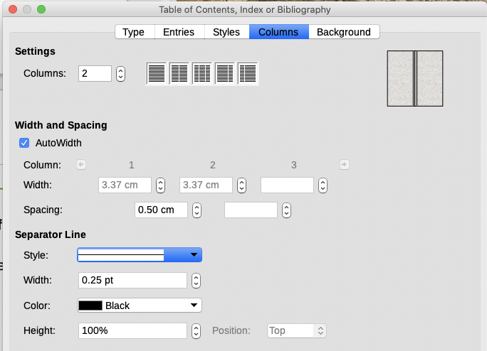Obrázek 12: Karta Sloupce v dialogovém okně Obsah, rejstřík nebo seznam použité literatury

Přidání více sloupců
Zobrazení rejstříku ve více než jednom sloupci:
- Do pole označeného Sloupce zadáme požadovaný počet sloupců nebo vybereme ikonu představující počet sloupců.
- Chceme-li rovnoměrně rozdělit sloupce podle šířky stránky, zaškrtneme Automatická šířka. Pokud není zaškrtnuto, můžeme ručně nastavit každou z následujících možností:
- Šířka každého ze sloupců
- Rozestupy mezi sloupci
- Mezi sloupci můžete zvolit oddělovací čáru:
- Styl: Výchozí hodnota je Žádné nebo vybereme ze tří možností stylu čáry.
- Šířka: Šířka (tloušťka) čáry. Výchozí hodnota je 0,25 bodu.
  - Barva: Vybereme barvu oddělovací čáry.
- Výška: Výška řádku jako procento z celé výšky sloupce. Výchozí hodnota je 100 %
- Pozice: Poloha čáry vzhledem ke sloupcům (nahoře, uprostřed nebo dole), pokud je výška menší než 100 %.

Udržování rejstříku
To modify the appearance of an index, right-click anywhere in the index and choose Edit Index from the context menu. The Table of Contents, Index or Bibliography dialog opens and you can edit and save the index using the five tabs described in the previous section.
To update or delete an index, right-click anywhere in the index and select Update Index or Delete Index.

Viewing and editing existing index entries
Once you have added the initial entries, you can make some amendments. You can view and edit these using the following steps:
- Ensure that field shading is active (View > Field Shadings or Ctrl+F8), so you can locate index entries more easily.
- Place the cursor in the field shading of an existing index entry in the body of the document, right-click, and select Index Entry from the content menu. In the case of a changed-text entry, the field shading is immediately before the word. Placing the cursor immediately before a word marked as a text entry will satisfy both selection criteria.
- A dialog similar to Figure 13 appears. You can move through the various index entries using the forward and back arrow buttons. If there is more than one entry for a single word or phrase, a second row of buttons with a vertical bar at the point of the arrow head is displayed allowing you to scroll through each of these entries.
- Make the necessary modifications or additions to the index entries, and then click OK.
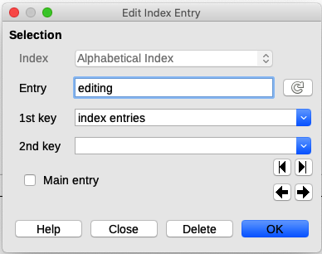Figure 13: Viewing and editing index entries

Další typy rejstříků
An alphabetical index is not the only type of index that you can build with Writer. Other types of indexes supplied with Writer include those for illustrations, tables, and objects, and you can even create a user-defined index. This chapter does not give examples of all the possibilities.
To create other indexes:
- Place the cursor where you want the index created.
- Select Insert > Table of Contents and Index > Table of Contents, Index or Bibliography from the Menu bar.
- On the Table of Contents, Index or Bibliography dialog, in the Type drop-down list, select the index wanted.
- Modify the various pages, which are similar to those discussed in previous sections.
- Click OK when everything has been set.

Příklad: vytvoření rejstříku obrázků
Vytvoření rejstříku (seznamu) obrázků nebo tabulek je snadné, pokud byly titulky k obrázkům vytvořeny pomocí Vložit > Titulek nebo ručně pomocí proměnné číselného rozsahu, jak je popsáno v kapitole 17, Pole.
- V dialogovém okně Obsah, rejstřík seznam použité literatury v rozevíracím seznamu Typ vybereme Tabulka obrázků. Název rejstříku můžete změnit na něco jiného; jako název jsme použili Tabulka obrázků.
- Ujistíme se, že je vybrána položka Popisky v sekci Vytvořit z a vybereme kategorii popisků. Výchozí pro kategorii je Obrázek; v našem příkladu jsme pro popisky použili Obrázek.
- V Zobrazení můžeme vybrat Odkazy (zahrne kategorii, číslo a text popisku), Kategorie a číslo nebo Text titulku. Vybrali jsme Odkazy.
- Ostatní stránky tohoto dialogu jsou podobné těm, které byly popsány pro obsah.
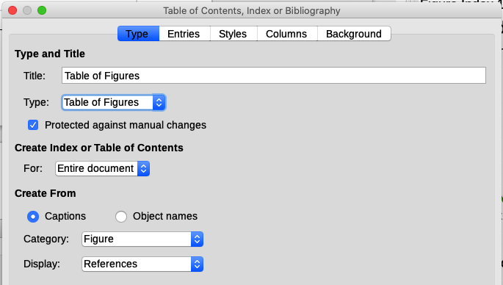Obrázek 14: Vytváření dalších typů indexů
- Klepneme na OK. Výsledek je uveden níže.
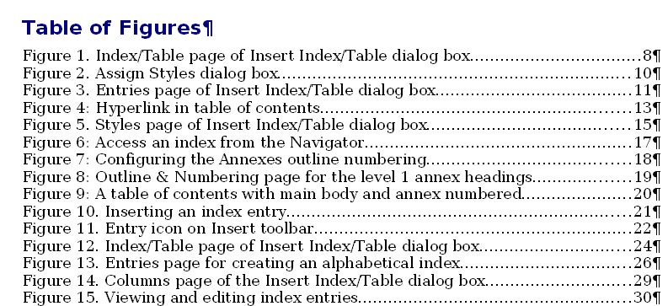Obrázek 15: Výsledná tabulka obrázků

Seznamy použité literatury
Seznam použité literatury je seznam odkazů použitých v dokumentu. Odkazy mohou být uloženy v bibliografické databázi nebo v samotném dokumentu.
Tato část ukazuje, jak:
- Vytvořit bibliografickou databázi; přidávat a udržovat záznamy.
- Přidat do dokumentu odkaz (citaci).
- Formátovat použitou literaturu.
- Aktualizovat a upravit existující seznam použité literatury.
Citace v textu vyžadují položky v různých polích v bibliografické databázi a různé prezentace v textu. Před vytvořením seznamu odkazů určíme, jaký styl citace pro dokument potřebujeme. Pět hlavních stylů je:
- APA (American Psychological Association): Psychologie, vzdělávání a další společenské vědy.
- MLA (Modern Languages Association): Literatura, umění a humanitní vědy.
- Chicago: Historie a konkrétní publikace.
- Turabian: Variace chicagského stylu pro všeobecné použití studenty vysokých škol.
- AMA (American Medical Association): Medicína, zdraví a biologie.
Bibliografická databáze (obrázek 16) je zdrojem citací v textu bez ohledu na to, jaký styl citací používáme.
Všechny citace používají k nastavení formátu citace v dokumentu pole Identifikátor (první vlevo). V tomto sloupci můžeme přidat citaci ve správném tvaru pro styl citace. Před vytvořením jakékoliv citace v dokumentu je třeba zadat všechny potřebné informace, včetně pole Identifikátor. Sloupec Identifikátor v databázové tabulce a pole Krátký název pod tabulkou jsou stejné pole.
- Tip
Writer má pro všechny dokumenty jednu bibliografickou databázi. Protože formátování položek může být zdlouhavé, lze uvažovat o vytvoření šablony s citacemi pro každý typ zdrojového materiálu.

Vytvoření bibliografické databáze
Ačkoli můžeme vytvářet odkazy v samotném dokumentu, vytvoření seznamu použité literatury umožňuje opětovné použití v jiných dokumentech a ušetří spoustu času.
Většinou v této části je použitá databázová tabulka ukázková tabulka dodávaná s programem Writer. Informace o vytvoření nové tabulky v bibliografické databázi najdeme v kapitole 8, Začínáme s Base, v příručce Začínáme s LibreOffice.
Databáze bibliografie musí zahrnovat mnoho různých médií a okolností, a proto obsahuje tolik polí. Zahrnuje také pole, jako je ISBN, která nepoužívá žádný styl citace, ale mohla by nám být užitečná během výzkumu.
- Poznámka
Každá jednotlivá položka v bibliografii potřebuje pouze asi půl tuctu polí vyplněných bez ohledu na to, jaký formát citace používáme. Liší se pole potřebná pro každý typ zdrojového materiálu a pořadí polí v každém stylu citace.
Chceme-li otevřít databázi, vybereme Nástroje > Seznam použité literatury. Otevře se okno Seznam použité literatury, podobné tomu na obrázku 16. V horní části stránky se zobrazují všechny záznamy v rozložení tabulky podobném tabulkovému procesoru. Dolní část stránky zobrazuje všechna pole vybraného záznamu.
- Upozornění
Ukázkové položky v ukázkové databázi pro sloupec Identifikátor a pole Krátký název nemají smysl. Nahradíme je správným formátem pro citační styl, který používáme.
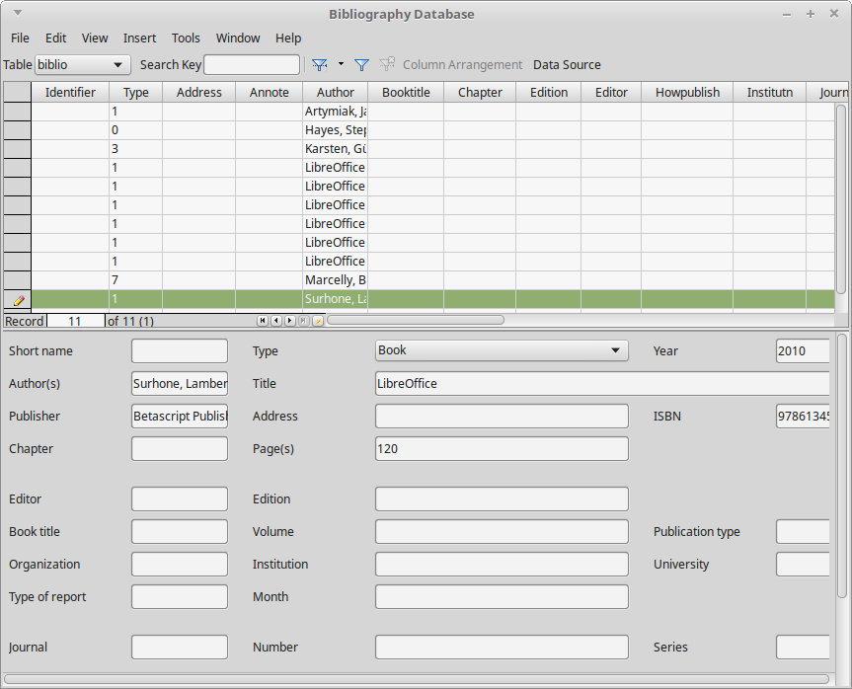Obrázek 16: Hlavní okno Seznamu použité literatury

Filtrování záznamů
Chceme-li nastavit filtr pro konkrétní záznamy v seznamu použité literatury, vybereme z hlavní nabídky Seznamu použité literatury Data > Filtr nebo klepneme na tlačítko Standardní filtr na nástrojové liště v horní části okna. V dialogovém okně Standardní filtr (obrázek 17) vybereme pole, podmínky a hodnoty filtru a klepneme na OK.
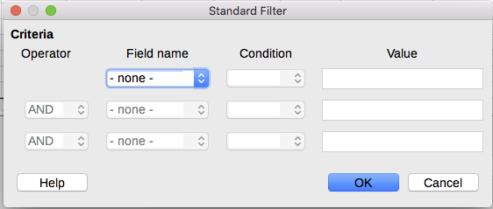Obrázek 17: Nastavení filtru pro seznam použité literatury

Změna zdroje dat
Chceme-li změnit používaný zdroj dat (například pokud máme více než jednu bibliografickou databázi pro různé účely), vybereme v hlavní nabídce Data > Vybrat zdroj dat nebo klepneme na ikonu Zdroj dat na nástrojové liště v horní části okna. Dialogové okno Vybrat zdroj dat uvádí registrované zdroje dat. Vybereme jeden z nich a klepneme na OK.
Chceme-li přidat (zaregistrovat) jiný zdroj dat, podíváme se na pokyny v kapitole 8, Začínáme s Base v příručce Začínáme s LibreOffice.

Přidání záznamů do databáze
Pro přidání záznamů do databáze použijeme dialogové okno Seznam použité literatury ( Nástroje > Seznam použité literatury):
- Záznamy můžeme přidávat přímo do databáze pomocí polí ve spodní části dialogového okna zobrazeného na obrázku 16 na stránce 25.
- Z hlavní nabídky dialogového okna Seznam použité literatury vybereme Data > Záznam nebo klepneme na ikonu +nalevo od vodorovného posuvníku.
- Zadáme název položky do pole Krátké jméno. Podle potřeby vyplníme další pole. Pro pohyb mezi poli používáme klávesu Tab.
V poli Krátký název se doporučuje použít jedinečný název. Toto pole se používá při vkládání položek do dokumentů.
- Chceme-li záznam dokončit, přejdeme na poslední pole a stiskneme znovu klávesu Tab nebo klepneme na libovolnou jinou buňku v tabulce.
Pokud náš dokument vyžaduje citace ve stylu [Autor, datum], použijeme k záznamu informací v požadovaném formátu pole Krátký název.

Uchování položek v databázi
K práci s položkami v databázi použijeme dialogové okno Seznam použité literatury ( Nástroje > Seznam použité literatury). Klepneme na příslušný záznam a upravíme pole podle potřeby.
Upravené položky se automaticky uloží do databáze, když se kurzor přesune mimo záznam.

Pokročilé: Úpravy seznamu použité literatury
Seznam použité literatury můžeme upravit několika způsoby, což je shrnuto níže.
- Poznámka
Další informace o tom, jak používat funkce databáze LibreOffice, najdeme v kapitole 8, Začínáme s Base v příručce Začínáme s LibreOffice.

Podrobnosti sloupců
Chceme-li změnit podrobnosti sloupců v seznamu použité literatury, vybereme z hlavní nabídky Data > Uspořádání sloupců nebo klepneme na ikonu Uspořádání sloupců na nástrojové liště v horní části okna (viz obrázek 16). V dialogovém okně Rozvržení sloupců pro tabulku „biblio“ (obrázek 18) můžeme změnit, která pole jsou přiřazena kterým sloupcům. Například si můžeme vybrat, že chceme, aby se data autora dostala do sloupce Identifikátor, což provedeme změnou cíle v rozevíracím seznamu. Datový sloupec Krátký název se nastaví automaticky na <nic>, protože pro data nemůžeme nastavit duplicitní cíle.
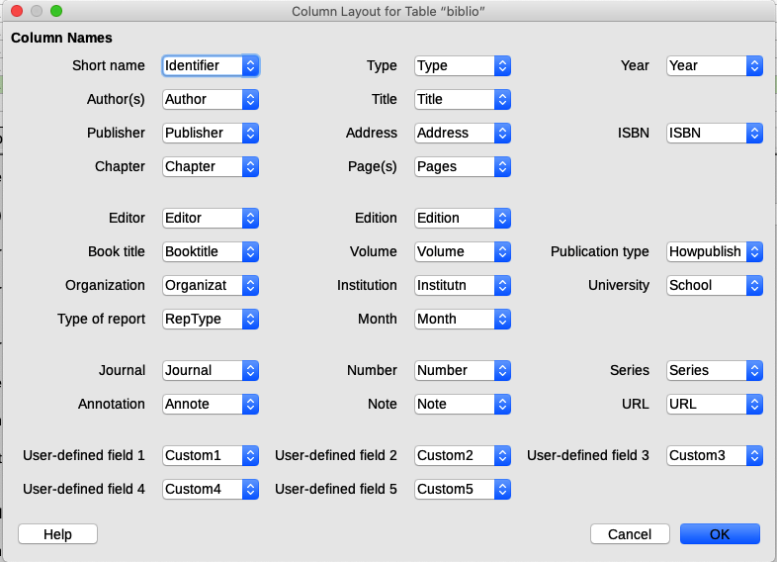Obrázek 18: Změna rozložení sloupců pro Seznam použité literatury

Podrobnosti polí
Změny do seznamu použité literatury (například přejmenovat pole nebo změnit jejich délku) můžeme provést následujícím způsobem:
- V hlavním dokumentu (nikoli v okně Seznam použité literatury) stiskneme Shif + Ctrl + F4 nebo klepnutím na Zobrazit > Zdroje dat otevřeme okno zdroje dat, viz obrázek 19.
- Ujistíme se, že je vybrána databáze Bibliography a je vybrána správná tabulka. Abychom vybrali správnou tabulku, můžeme rozbalit jednotlivé úrovně.
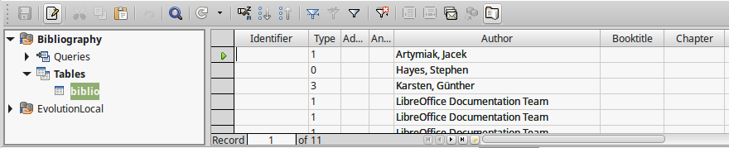Obrázek 19: Pohled na zdroj dat databáze Bibliography
- Pravým tlačítkem klepneme na záznam tabulky (v příkladu biblio) a z místní nabídky vybereme Upravit databázový soubor. Otevře se okno podobné obrázku 20, což je hlavní nabídka pro Base, databázovou komponentu LibreOffice.
- Pokud nejsou vybrány Tabulky (v sekci Databázevlevo), vybereme je.
- Klepneme pravým tlačítkem na název tabulky biblio v sekci Tabulky a výběrem z místní nabídky Upravit zobrazíme okno podobné tomu, které je znázorněno na obrázku 21.
- Nyní můžete vybrat každé z polí. Vyberte text v buňce Název polea podle potřeby změníme záznam. Pro otevření nabídky výběru pro změnu datového typu v této buňce klepneme na buňku Typ pole. V sekci Vlastnosti pole můžeme upravit vlastnosti dat. Pro každé vybrané pole se vpravo od sekce zobrazí popis tohoto pole.
- Po dokončení budeme vyzváni k potvrzení, že chceme změny uložit.
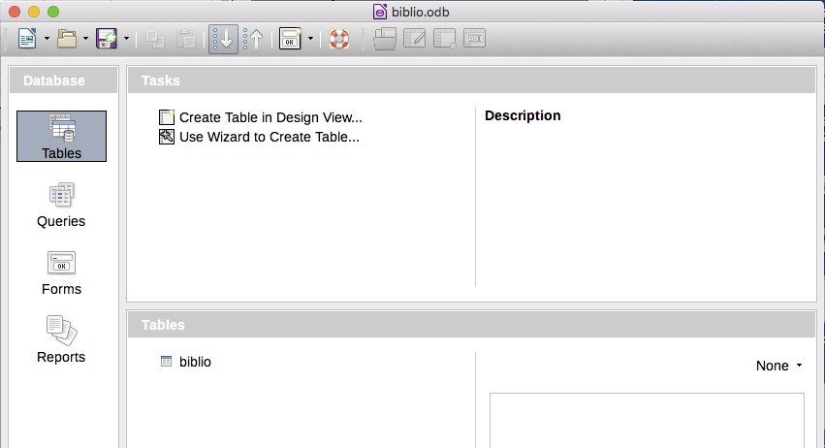Obrázek 20: Hlavní okno pro práci s databázemi
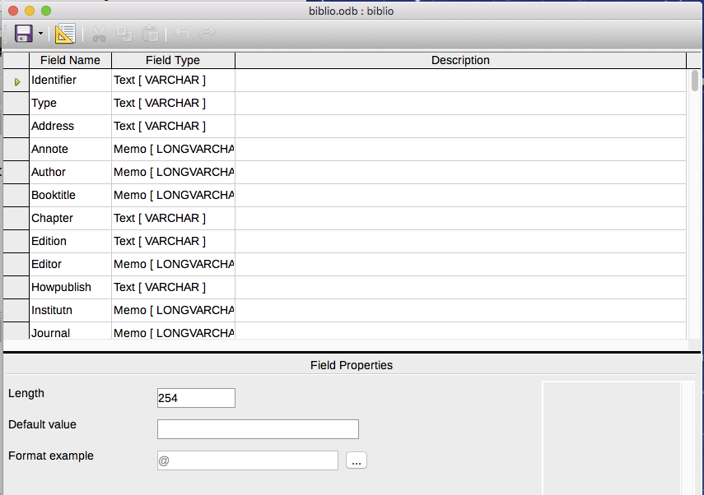Obrázek 21: Okno úpravy vlastností tabulky

Přidávání odkazů (citací) do dokumentu
Writer podporuje dvě metody přidávání odkazů do dokumentu:
- Z databáze Seznam použité literatury, jako je ta zabudovaná do programu Writer.
- Přímo z klávesnice.

Zadávání odkazů z databáze
Postup přidání odkazů z databáze seznamu použité literatury do dokumentu:
- Umístíme kurzor na místo, kde se má odkaz zobrazit.
- V hlavní nabídce vybereme Vložit > Obsah a rejstřík > Položka použité literatury.
- V dialogovém okně Vložit položku použité literatury (obrázek 22) vybereme Seznam použité literatury v horní části dialogu Zdroj použité literatury.
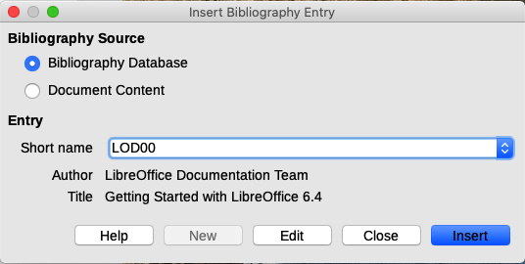Obrázek 22: Vkládání položek použité literatury do dokumentu
- Vybereme odkaz z rozevíracího seznamu Krátký název uprostřed dialogového okna. Autor a název vybrané reference jsou zobrazeny pod polem Krátký název, aby nám pomohly ověřit, zda se jedná o požadovanou referenci.
- Chceme-li vložit odkaz do dokumentu, klepneme na Vložit.
- Dialog můžeme ponechat otevřený a vložit do dokumentu další odkaz; nemusíme jej zavírat a znovu otevírat.
- Po dokončení vkládání všech odkazů klepneme na Zavřít.

Zadávání odkazů z dokumentů
Můžeme si vybrat zadat své bibliografické záznamy přímo do dokumentu, nikoli z externí databáze. Například, když nepracujeme na svém počítači.
Klepneme do dokumentu, kde chceme přidat položku.
- Zvolíme Vložit > Obsah a rejstřík > Položka použité literatury.
- V dialogovém okně Vložit položku použité literatury (obrázek 22) vybereme Obsah dokumentu v horní části dialogu v sekci Zdroj bibliografie.
- Klepnutím na Nový otevřeme dialogové okno Definovat položku použité literatury.
- Vyplníme všechna pole, která jsou relevantní pro položku. Do pole Krátký název zadáme jedinečný název, protože dialog Vložit položku použité literatury používá tuto položku pro citaci.
  - Vybereme možnost z nabídky v seznamu pole Typ. Tlačítko OK se aktivuje.
  - Po vyplnění všech požadovaných polí klepneme na OK.
  - Klepnutím na Vložit přidáme do dokumentu pole Krátký název a potom klepneme na Zavřít.
Chceme-li znovu použít položku v dokumentu, opakujeme výše uvedenou sekvenci a poté vybereme požadovaný název z aktuálního seznamu položek, místo abychom přidali novou položku.

Úprava odkazu
Úprava odkazu:
- Klepneme pravým tlačítkem na položku (kurzor se poté zobrazí vlevo od položky).
- V místní nabídce vybereme Položka použité literatury. Otevře se dialogové okno Upravit položku použité literatury (podobné dialogovému oknu Vložit položku použité literatury).
- Chceme-li rychle upravit pouze Krátký název, klepneme do textového pole, upravíme položku a poté klepneme na Použít.
- Chceme-li upravit více údajů v položce, klepneme na Upravit a otevře se dialogové okno Definovat položku použité literatury.
Provedeme požadované změny a klepneme na OK. Vrátíme se zpět do dialogového okna Upravit záznam položky použité literatury.
- Klepnutím na Použít přijmeme změny a opustíme dialog.
- Poznámka
Ať už je zdroj citace jakýkoli, upravené odkazy jsou uloženy pouze v dokumentu. Pokud je zdrojem bibliografická databáze, zůstává tato databáze nezměněna.

Vytvoření seznamu použité literatury
- Umístíme kurzor na místo, kde chceme vložit položku použité literatury.
- Vybereme Vložit > Obsah a rejstřík > Obsah, rejstřík nebo položky použité literatury a změníme Typ na Seznam použité literatury, aby se zobrazilo dialogové okno podobné oknu zobrazenému na obrázku 23.
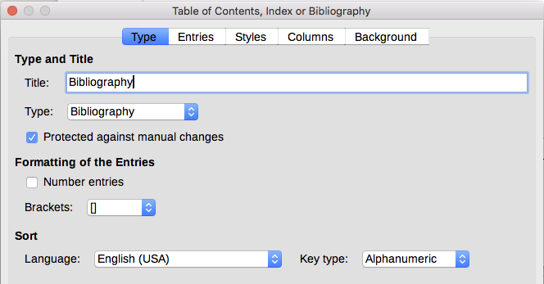Obrázek 23: Vložení položky použité literatury
Dialogové okno Obsah, rejstřík nebo seznam použité literatury má pět karet.

Karta Typ
Writer podporuje dva způsoby zobrazení odkazů (citací) v textu dokumentu:
- Použití textu zaznamenaného v poli Krátký název každé položky použité literatury, například (Smith, 2001), v závislosti na stylu citace.
- Číslováním odkazovaných dokumentů v pořadí, v jakém se vyskytují v textu, například [1].
- Tip
Chceme-li určit, který styl citace se v dokumentu použije, použijeme záložku Typ v dialogovém okně Obsah, rejstřík nebo seznam použité literatury (obrázek 23).
Formátování seznamu použité literatury zahrnuje výběr provedený na dvou místech:
- Dialogovém okně Obsah, rejstřík nebo seznam použité literatury, což je popsáno v této části.
- Styl odstavce Seznam použité literatury 1 (viz strana 32).
Na této stránce jsou vybrána základní nastavení.
- Chceme-li dát seznamu použité literatury název, zadáme jej do pole Nadpis. (Nadpis není vyžadován.)
- Seznam použité literatury můžete chránit před nechtěnou změnou zaškrtnutím pole Zamknuto proti ručním změnám. Pokud je vybrána tato možnost, lze bibliografii změnit pouze pomocí nabídky pravého tlačítka nebo v dialogovém okně Obsah, rejstřík nebo seznam použité literatury. Pokud tato možnost není vybrána, lze seznam použité literatury změnit přímo na stránce dokumentu, stejně jako jiný text, ale jakékoli ruční změny budou při aktualizaci seznamu ztraceny.
- Chceme-li mít položky seznamu použité literatury (citace) očíslované v těle dokumentu (například [1], [2] ...), vybereme Očíslovat položky. Pokud si však přejeme, aby se v poli objevil obsah pole Krátký název (z databáze), zrušíme výběr této možnosti.
- Vybereme typ závorek, které chceme použít pro odkazované položky zobrazené v těle dokumentu.
- Definujte požadované řazení. V současné době je podporováno pouze alfanumerické třídění. Řazení podle pořadí, v jakém se položky objevují v textu, se provádí na záložce Položky.

Záložka Položky
Struktura této stránky (viz obrázek 24) je podobná jako u obsahů a rejstříků.
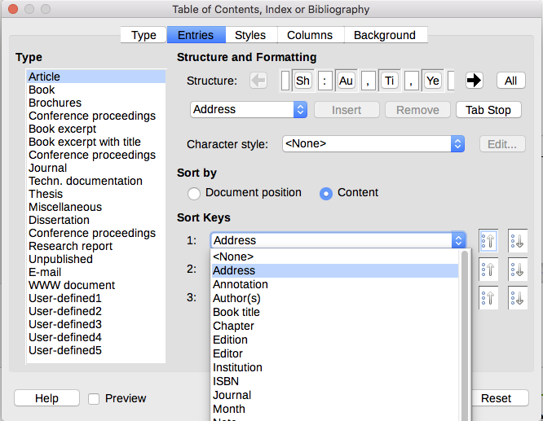Obrázek 24: Stránka záznamů pro seznam použité literatury
Sekce Typ odkazuje na druh zdroje, například periodikum nebo internetovou stránku. Každá položka v seznamu Typ má výchozí formát struktury. Výběrem ze seznamu typů položek můžeme určit, jak se položka zobrazí na základě jejího zdroje, nebo jednoduše můžeme použít stejný formát pro všechny položky klepnutím na tlačítko Vše.
Struktura záznamu vychází z polí dostupných v databázi seznamu použité literatury. Požadovaný styl citace pro náš dokument podle potřeby upravíme v řádku Struktura.
Chceme-li odebrat prvky z řádku Struktura, klepneme na prvek a poté na tlačítko Odstranit.
Chceme-li přidat prvek, klepneme na řádek Struktura, kde má být vložen. Vybereme buď Tabulátor nebo prvek v rozevíracím seznamu vlevo od tlačítka Vložit a potom klepněte na tlačítko Vložit. Prvky v rozevíracím seznamu jsou pole nalezená v seznamu použité literatury.
Všechny prvky na řádku Struktura lze formátovat pomocí výběrového seznamu Znakový styl. Můžeme například definovat styl znaků tak, aby názvy knih a časopisů byly psány kurzívou nebo tučně.
Chceme-li zjistit, jak jsou položky seřazeny, upravíme volby Seřadit podle. Chceme-li seřadit podle pořadí, v jakém se položky objevují v textu, zvolíme Umístění v dokumentu. Ve většině moderních stylů citací budeme chtít Obsah (abecedně sestupně). Pro seskupení podobných odkazů použijeme Klíče pro řazení.

Karty Styly, Sloupce a Pozadí
Pro více informací o těchto záložkách viz „karta Styly” na straně 10, „karta Sloupce” na straně 20 a „karta Pozadí” na straně 11 .

Úprava stylu odstavce pro seznam použité literatury
Styl odstavceSeznam použité literatury 1 můžeme upravit podle našich požadavků. Chceme-li například očíslovat položky v seznamu použité literatury, musíme definovat styl číslování a propojit tento styl číslování se stylem odstavce Seznam použité literatury 1. Provedeme to následovně:
- Na kartě Styly v postranním panelu klepneme na ikonu Styly seznamu. Pravým tlačítkem klepneme na Číslování 123 a vybereme z místní nabídky Nový.
- V dialogovém okně Styl číslování přejdeme na kartu Organizátor a zadáme název tohoto stylu. V našem příkladu jsme jej pojmenovali styl Seznam použité literatury.
- V našem příkladu chceme mít čísla uzavřená v hranatých závorkách. Chceme-li to provést, přejdeme na kartu Přizpůsobit a zadáme [ v poli Vlevo a ] v poli Vpravo, jak je znázorněno na obrázku 25. Odstraníme veškerou další interpunkci, například tečku, která může být v poli Vpravo.
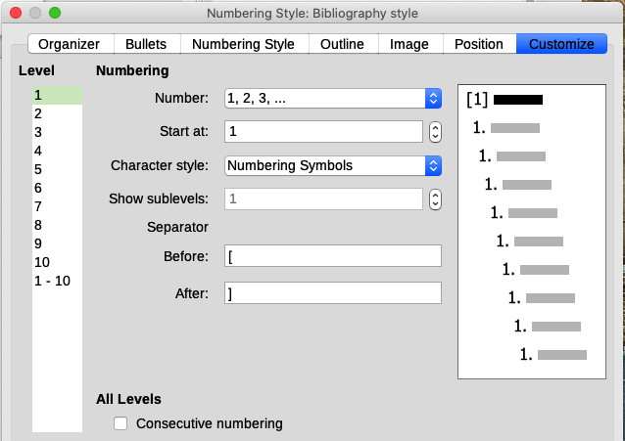Obrázek 25: Určení hranatých závorek před a za číslem v seznamu
- Nyní přejdeme v dialogovém okně Styl číslování na kartu Umístění (obrázek 26). V polích Odsazené na a Krok tabulátoru na určíme, jaké odsazení chceme pro druhý a následující řádky jakékoli položky v seznamu použité literatury našeho dokumentu. Často budeme muset trochu experimentovat, abychom zjistili, jaké je nejlepší nastavení. V našem příkladu jsme vybrali 1 cm.
- Klepnutím na OK uložíme tato nastavení a zavřeme dialogové okno Styl číslování. Vrátíme se na kartu Styly, klepneme na ikonu Styly odstavce, ze seznamu v dolní části tohoto okna vybereme Všechny styly a poté klepneme pravým tlačítkem na Seznam použité literatury 1 a vybereme Upravit.
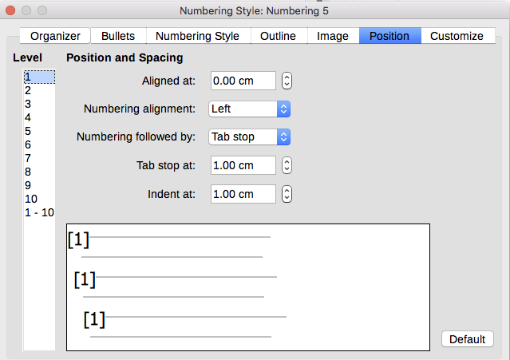Obrázek 26: Nastavení mezer mezi okrajem a textem
- V dialogovém okně Styl odstavce přejdeme na kartu Osnova a číslování a z rozevíracího seznamu vyberte styl Seznam použité literatury. (Viz obrázek 27.) Klepnutím na OK uložíme tuto změnu stylu odstavce Seznam použité literatury 1.
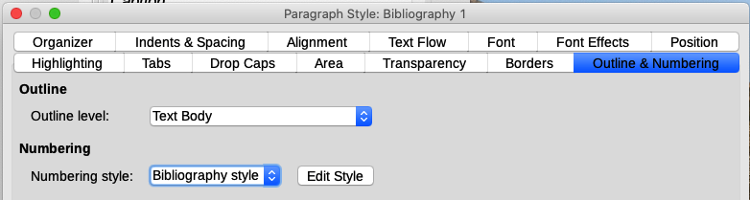Obrázek 27: Použití stylu číslování na styl odstavce
Když nyní vytvoříme seznam použité literatury, bude vypadat podobně jako na obrázku 28 pro knihu po odebrání prvků z řádku struktury (například Krátký název a dvojtečka).
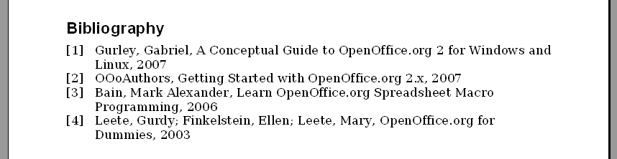Obrázek 28: Výsledek změny nastavení stylu odstavce Seznam použité literatury 1

Aktualizace, úprava a odstranění existujícího seznamu použité literatury
Klepněte pravým tlačítkem kdekoli v seznamu použité literatury. V místní nabídce vybereme:
- Aktualizovat rejstřík pro aktualizaci seznamu použité literatury.
- Upravit rejstřík otevře dialogové okno Obsah, rejstřík nebo seznam použité literatury, takže můžeme seznam použité literatury upravit a uložit.
- Smazat rejstřík odstraní seznam použité literatury bez žádosti o potvrzení.
- Tip
Pokud se nám zdá být funkce Seznamu použité literatury v programu Writer příliš omezená, můžeme zkusit Zotero, což je bezplatný a open source software, který je k dispozici pro MacOS, Windows a Linux. Uvádí se, že dobře spolupracuje s programem Writer (http://www.zotero.org/).

