
Getting Started Guide

Chapter 12
Creating Web Pages
Saving Documents as HTML Files

Copyright
This document is Copyright © 2010–2016 by the LibreOffice Documentation Team. Contributors are listed below. You may distribute it and/or modify it under the terms of either the GNU General Public License (http://www.gnu.org/licenses/gpl.html), version 3 or later, or the Creative Commons Attribution License (http://creativecommons.org/licenses/by/4.0/), version 4.0 or later.
All trademarks within this guide belong to their legitimate owners.

Contributors
Jean Hollis Weber | Peter Schofield | Ron Faile Jr.

Feedback
Please direct any comments or suggestions about this document to the Documentation Team’s mailing list: documentation@global.libreoffice.org
Note: Everything you send to a mailing list, including your email address and any other personal information that is written in the message, is publicly archived and cannot be deleted.

Acknowledgments
This chapter is adapted and updated from Chapter 12 of Getting Started with OpenOffice.org 3.3. The contributors to that chapter are:
Agnes Belzunce | Peter Hillier-Brook | Ian Laurenson
Peter Kupfer | Jean Hollis Weber | Linda Worthington

Publication date and software version
Published 12 February 2016. Based on LibreOffice 5.0.

Note for Mac users
Some keystrokes and menu items are different on a Mac from those used in Windows and Linux. The table below gives some common substitutions for the instructions in this chapter. For a more detailed list, see the application Help.
Windows or Linux | Mac equivalent | Effect
Tools > Options menu selection | LibreOffice > Preferences | Access setup options
Right-click | Control+click or right-click depending on computer setup | Opens a context menu
Ctrl (Control) | ⌘ (Command) | Used with other keys
F5 | Shift+⌘+F5 | Open the Navigator
F11 | ⌘+T | Open the Styles and Formatting window

Contents
Copyright 2
Contributors 2
Feedback 2
Acknowledgments 2
Publication date and software version 2
Note for Mac users 2
Introduction 4
Relative and absolute hyperlinks 4
Creating hyperlinks 5
Using the Navigator 5
Using the Hyperlink dialog 6
Editing hyperlinks 7
Removing hyperlinks 8
Exporting web pages using the Web Wizard 8
Saving and exporting documents as web pages 11
Writer documents 11
Single web page 11
Series of web pages 11
Calc spreadsheets 11
Impress presentations 12
Draw documents 16

Introduction
HTML capabilities in LibreOffice include saving and exporting existing documents in HTML format.
This chapter describes how to do the following in Writer, Calc, Impress, and Draw:
- Create hyperlinks within a document and to other documents such as web pages, PDFs, and other files.
- Save documents as web pages (HTML documents) and create web pages using the Web Wizard included with LibreOffice.
When creating a document that you plan to deliver as a web page, you need to consider the following:
- In an HTML document, hyperlinks are active (clickable), but other cross-references inserted by LibreOffice are not active links.
- An object such as an image is saved as a separate file. However, if that object has been placed in a frame (for example, with an associated caption), it is not saved and does not appear in the HTML document; instead, the name of the frame appears.

Relative and absolute hyperlinks
Hyperlinks stored within a file can be either relative or absolute.
A relative hyperlink says, Here is how to get there starting from where you are now (meaning from the folder in which your current document is saved) while an absolute hyperlink says, Here is how to get there no matter where you start from.
An absolute link will stop working if the target is moved. A relative link will stop working if the start and target locations change relative to each other. For instance, if you have two spreadsheets in the same folder linked to each other and you move the entire folder to a new location, an absolute hyperlink will break but a relative one will not.
To change the way that LibreOffice stores the hyperlinks in your file, select Tools > Options > Load/Save > General and choose if you want URLs saved relatively when referencing the File System, or the Internet, or both.
Calc will always display an absolute hyperlink. Do not be alarmed when it does this even when you have saved a relative hyperlink. This ‘absolute’ target address will be updated if you move the file.
- Note
Make sure that the folder structure on your computer is the same as the file structure on your web server if you save your links as relative to the file system and you are going to upload pages to the Internet.
- Tip
When you rest the mouse pointer on a hyperlink, a help tip displays the absolute reference, because LibreOffice uses absolute path names internally. The complete path and address can only be seen when you view the result of the HTML export (saving the spreadsheet as an HTML file), by loading the HTML file as text, or by opening it with a text editor.

Creating hyperlinks
When you type text (such as a website addresses or URL) that can be used as a hyperlink, and then press the spacebar or the Enter key, LibreOffice automatically creates the hyperlink and applies formatting to the text (usually a color and underlining). If this does not happen, you can enable this feature by going to Tools > AutoCorrect Options > Options on the menu bar and selecting the URL Recognition option.
If you do not want LibreOffice to convert a specific URL to a hyperlink, go to Edit > Undo Insert on the menu bar, or press Ctrl+Z immediately after the formatting has been applied, or place the cursor in the hyperlink, right-click, and select Remove Hyperlink from the context menu.
- Tip
To change the color of hyperlinks, go to Tools > Options > LibreOffice > Appearance, scroll to Unvisited links and/or Visited links, pick the new colors and click OK. Caution: this will change the color for all hyperlinks in all components of LibreOffice; this may not be what you want.
In Writer and Calc (but not Draw or Impress), you can also change the Internet link character style or define and apply new styles to selected links.

Using the Navigator
You can insert hyperlinks using the Navigator and this is an easy way to insert a hyperlink to another part of the same document.
- Open the documents containing the items you want to cross-reference.
- Click on the Navigator icon in the Sidebar.
- Click the triangle to right of the Drag Mode icon and select Insert as Hyperlink (Figure 1). Note that the Drag Mode icon changes shape depending on the type of insert that was previously selected. The default icon for Drag Mode is to show the Hyperlink icon .
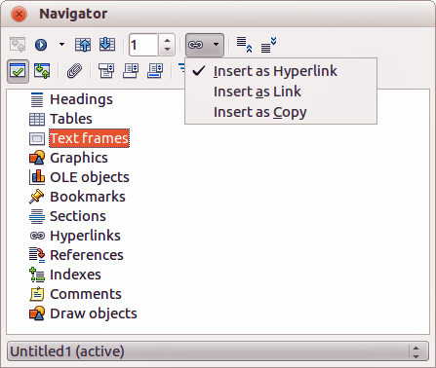
Figure 1: Inserting hyperlink using the Navigator
- Select the document from the drop-down list at the bottom of the Navigator that contains the item that you want to link to.
- In the Navigator list, select the item that you want to insert as a hyperlink.
- Drag the item to where you want to insert the hyperlink in the document. The name of the item is inserted in the document as an active hyperlink.
When using the Navigator to insert a hyperlink to an object such as a graphic, it is recommended to have the hyperlink show a useful name, for example 2009 Sales Graph. You need to give such objects useful names instead of leaving them as the default names, for example Graphics6, or you will have to edit the name of the resulting link using the Hyperlink dialog, as described below.
You can also use the Navigator to insert a hyperlink from one document (the source) to a specific place in another document (the target). Open the Navigator in the target document and drag the item to the position in the source document where you want the hyperlink to appear.

Using the Hyperlink dialog
You can use the Hyperlink dialog to insert a hyperlink and modify all hyperlinks.
- Highlight the existing text you want to use as a link.
- Click the Hyperlink icon on the Standard toolbar or go to Insert > Hyperlink on the menu bar to open the Hyperlink dialog (Figure 2).
- On the left side, select one of the four categories of hyperlink:
- Internet: the hyperlink points to a web address, normally starting with http://.
- Mail & News: the hyperlink opens an email message that is pre-addressed to a particular recipient.
- Document: the hyperlink points to another document or to another place in the current document
- New document: the hyperlink creates a new document.
- The Hyperlink dialog changes depending on the type of hyperlink selected. Enter all necessary details to create the hyperlink.
- Click Apply to create the hyperlink and the Hyperlink dialog remains open allowing you to create another hyperlink.
- Click Close to close the Hyperlink dialog.
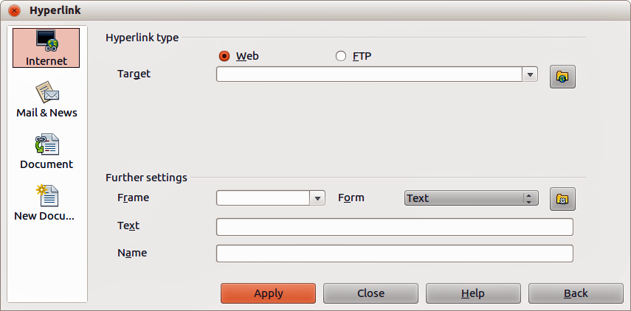
Figure 2. Hyperlink dialog showing details for Internet links
The dialog changes according to the choice made for the hyperlink category in the left panel. A full description of all the choices and their interactions is beyond the scope of this chapter. Here is a summary of the most common choices.
- For an Internet hyperlink, choose the type of hyperlink (Web, FTP, or Telnet), and enter the required web address (URL).
- For a Mail and News hyperlink, specify whether it is a mail or news link, the address of the receiver and, for email, the subject.
- For a Document hyperlink, specify the document path (clicking Open File opens a file browser) or leave this blank if you want to link to a target in the same document. Optionally specify the target in the document (for example a specific slide). Click the Target in Document icon to open the Target in Document dialog where you can select the type of target; or, if you know the name of the target, you can type it into the box.
- For a New Document hyperlink, specify whether to edit the newly created document immediately (Edit now) or just create it (Edit later). Enter the file name and select the type of document to create (text, spreadsheet, and so on). Click the Select Path icon to open a file browser and choose where to store the file.
The Further settings section in the bottom right part of the dialog is common to all the hyperlink categories, although some choices are more relevant to some types of links.
- Frame value determines how the hyperlink will open. This applies to documents that open in a Web browser.
- Form specifies if the link is to be presented as text or as a button. See the Writer Guide Chapter 15 Using Forms in Writer for more information.
- Text specifies the text that will be visible to the user. If you do not enter anything here, LibreOffice uses the full URL or path as the link text. Note that if the link is relative and you move the file, this text will not change, though the target will.
- Name is applicable to HTML documents. It specifies text that will be added as a NAME attribute in the HTML code behind the hyperlink.
- Events : click this icon to open the Assign Macro dialog and select a macro to run when the link is clicked. See Chapter 13 Getting Started with Macros for more information.

Editing hyperlinks
To edit an existing link:
- Click anywhere in the hyperlink text.
- Click the Hyperlink icon on the Standard toolbar or go to Edit > Hyperlink on the menu bar or right-click and select Edit Hyperlink from the context menu. The Hyperlink dialog opens.
- Make your changes and click Apply to save your changes. The Hyperlink dialog remains open allowing you to continue editing hyperlinks. Click Apply after editing each hyperlink.
- When you are finished editing hyperlinks, click Close.
The standard (default) behavior for activating hyperlinks within LibreOffice is to use Ctrl+click. This behavior can be changed in Tools > Options > LibreOffice > Security > Options and deselecting the option Ctrl-click required to follow hyperlinks. If clicking in your links activates them, check that page to see if the option has been deselected.

Removing hyperlinks
You can remove the link from hyperlink text and leave just the text by right-clicking on the link and selecting Remove Hyperlink from the context menu. You may then need to re-apply some formatting to match the text with the rest of your document.
To erase the link text or button from the document completely, select it and press the Backspace or Delete key.

Exporting web pages using the Web Wizard
The Web Wizard in LibreOffice allows you to create several types of standard web pages from all LibreOffice components except Math. Each time you start the Web Wizard in a LibreOffice component, Writer will automatically start before the Web Wizard opens. The Web Wizard is linked to Writer and is normally used in Writer for creating web pages.
- Go to File > Wizards > Web Page on the menu bar to open the Web Wizard dialog.
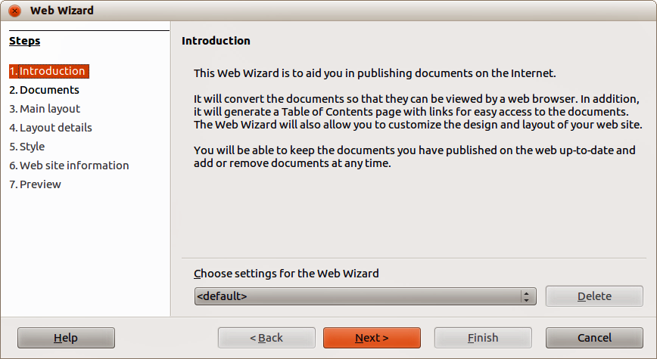
Figure 3: Introduction page of Web Wizard dialog
- On the first page of the Wizard, choose settings and click Next >. If this is your first web page, the only choice is <default>.
- Select or browse to the document you would like to format. The information for Title, Summary and Author is taken from the document properties. If necessary, edit this information (Figure 4).
- Click Next > and select a layout for the web site by clicking on the layout boxes (Figure 5).
- Click Next > to customize the layout and select the information to be listed and screen resolution (Figure 6).
- Click Next > and select a style for the page. Use the drop-down list to choose different styles and color combinations. Browse to select a background image and icon set from the Gallery (Figure 7).
- Click Next > and enter general information for the web site such as Title and HTML Metadata information (Figure 8).
- Click Next > and enter the information of where to publish your new web site (Figure 9).
- Click Finish to save the file and close the Web Wizard.
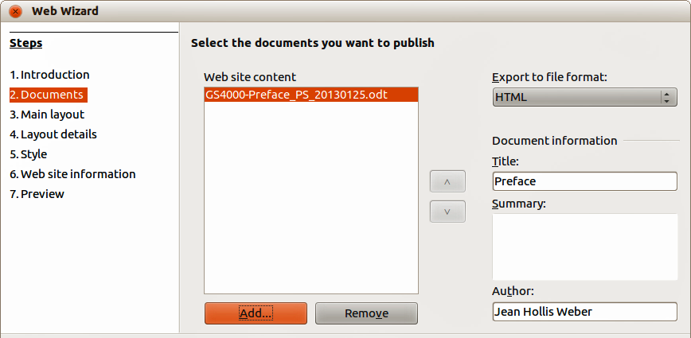
Figure 4: Documents page of Web Wizard dialog
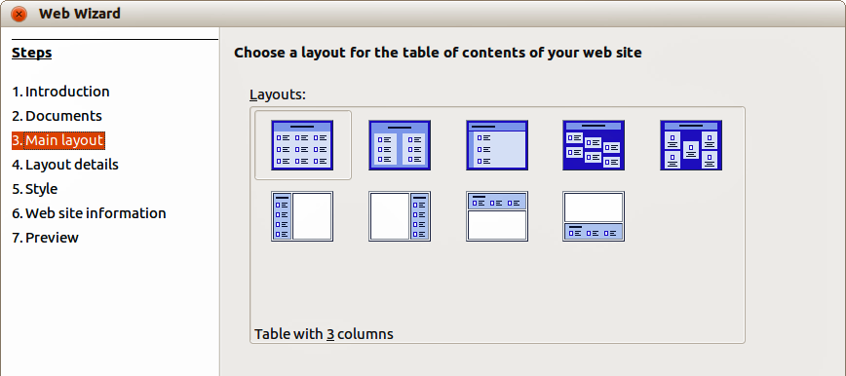
Figure 5: Main layout page of Web Wizard dialog
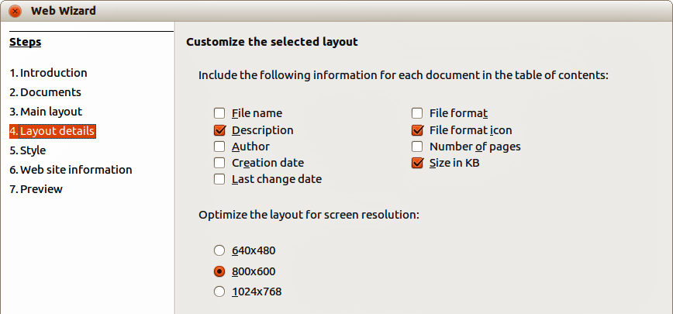
Figure 6: Layout details page of Web Wizard dialog
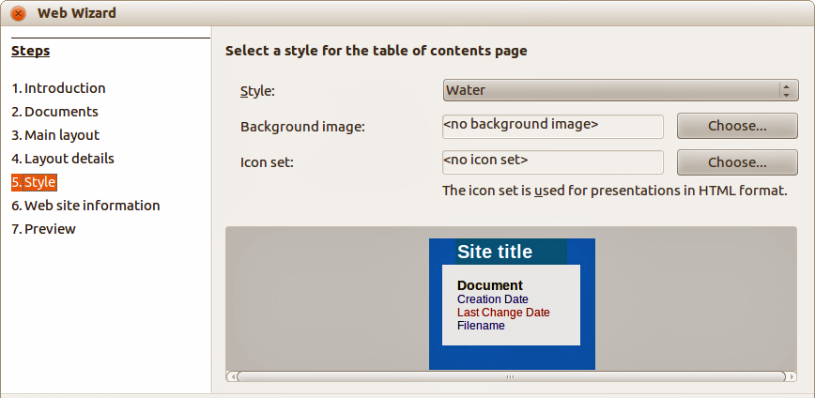
Figure 7: Style page of Web Wizard dialog
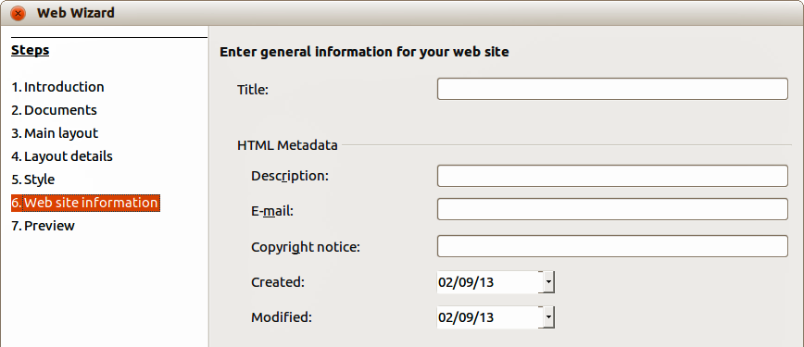
Figure 8: Web site information page of Web Wizard dialog
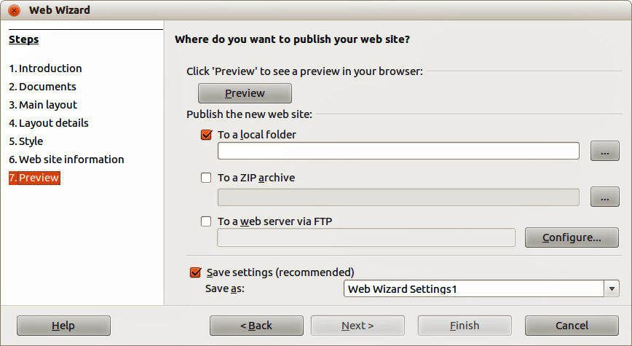
Figure 9: Preview page of Web Wizard dialog

Saving and exporting documents as web pages
The easiest way to create HTML documents in LibreOffice is to start with an existing document. You can get a good idea of how it will appear as a web page by using View > Web Layout. However, web layout view does not show you which features will or will not be saved correctly in HTML format. Refer to “Relative and absolute hyperlinks” on page 4 on what to consider before creating a web page from a document.

Writer documents

Single web page
To save a document as a single web page (HTML format), go to File > Save As on the menu bar and specify HTML Document (Writer) as the file type or File > Export and specify XHTML format as the file type.
- Note
Writer does not replace multiple spaces in the original document with the HTML code for non-breaking spaces. If you want to have extra spaces in your HTML file or web page, you need to insert non-breaking spaces in LibreOffice. To do this, press Ctrl+Spacebar instead of just Spacebar.

Series of web pages
Writer can save a large document as a series of web pages (HTML files) with a table of contents page.
- Decide which headings in the document should start on a new page and make sure all those headings have the same paragraph style (for example, Heading 1).
- Go to File > Send > Create HTML Document on the menu bar to open the Name and Path of the HTML Document dialog (Figure 10).
- Type the file name to save the pages under.
- Specify which style indicates a new page using the Styles drop list at the bottom of the dialog (for example Heading 1).
- Click Save to create the multi-page HTML document. The resulting HTML files conforms to the HTML 4 Transitional.

Calc spreadsheets
Calc can save files as HTML documents by going to File > Save As on the menu bar and select HTML Document (Calc) format as the file type. This is similar to “Single web page” above.
If the file contains more than one sheet and the web pages are created using the Web Wizard (see “Exporting web pages using the Web Wizard” on page 8), the additional sheets will follow one another in the HTML file. Links to each sheet will be placed at the top of the document.
Calc also allows the insertion of links directly into the spreadsheet using the Hyperlink dialog. See “Creating hyperlinks” on page 5 for more information on hyperlinks.
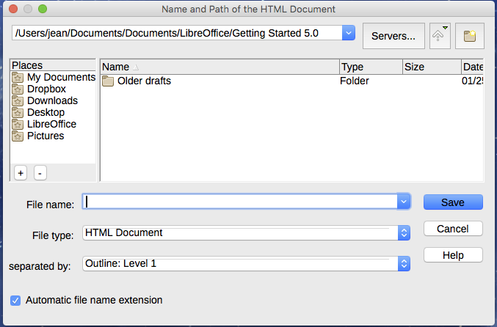
Figure 10. Creating a series of web pages from one document

Impress presentations
- Note
Saving as web pages in HTML format does not retain animation and slide transitions.
Impress presentations cannot be saved in HTML format, but have to be exported as HTML documents. Note that you can click Create at any step in the following procedure. The web pages created will then use the default settings that you have not changed in any way.
- Go to File > Export on the menu bar and specify the file name and location of where to save the web page version of your presentation.
- Select HTML document (Impress) as the file type and click Save to open the HTML Export dialog (Figure 11).
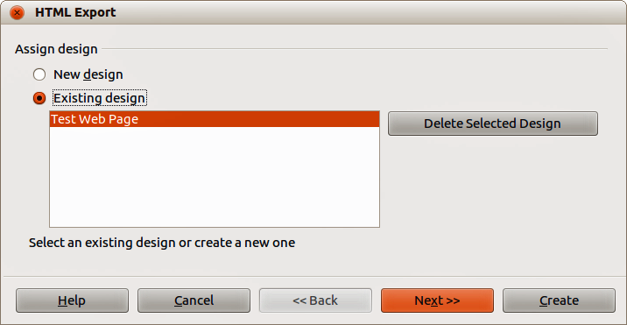
Figure 11: HTML Export dialog - Assign design page
- On the Assign design page you can choose to create a new design and select or delete an existing design. Specify a New design or an Existing design and click Next>>. If you have not previously saved a web page design, the Existing Design choice is not available.
- New design – creates a new design in the next pages of the Wizard.
- Existing design – loads an existing design from the design list to use as a starting point for the steps that follow. The list box displays all existing designs.
- Delete Selected Design deletes the selected design from the design list. If you delete a design, you will only delete the design information. An export file will not be deleted by this action.
- Specify the Publication type for the web pages (Figure 12), then click Next>>. The publication type defines the basic settings for the intended export. The choices are:
- Standard HTML format – creates standard HTML pages from export pages.
- Standard HTML with frames – creates standard HTML pages with frames. The exported page will be placed in the main frame and the frame to the left will display a table of contents in the form of hyperlinks.
- Automatic – creates a default HTML presentation as a kiosk export in which the slides are automatically advanced after a specified amount of time.
- WebCast – in a WebCast export, automatic scripts will be generated with Perl or ASP support. This enables the speaker (for example, a speaker in a telephone conference using a slide show on the Internet) to change the slides in the web browsers used by the audience.
For more information on the options available for this page of the HTML Export dialog, click Help to open the help pages.
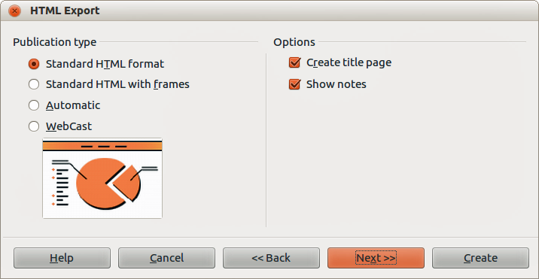
Figure 12: HTML Export dialog – Publication type page
- Specify the options for Save graphics as, Monitor resolution and Effects used for the web pages (Figure 13), then click Next>>. The options for this page of the HTML Export dialog are as follows:
- Save graphics as – determines the image format. You can also define the compression value for the export.
- Monitor resolution – defines the resolution for the target screen. Depending on the selected resolution, the image will be displayed in a reduced size. You can specify a reduction of up to 80% from the original size. When selecting a resolution, consider what the majority of your viewers might be using. If you specify a high resolution, then a viewer with a medium-resolution monitor will have to scroll sideways to see the entire slide, which is probably not desirable.
- Effects – specifies whether sound files defined as an effect for slide transitions are exported and whether any hidden slides are exported.
For more information on the options available for this page of the HTML Export dialog, click Help to open the help pages.
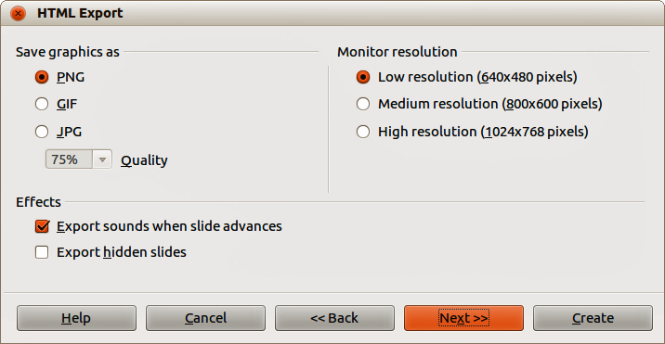
Figure 13: HTML Export dialog – graphics and monitor resolution
- Specify the Information for the title page to be used with the web version of your presentation (Figure 14). The title page normally contains the author's name, an e-mail address and home page, along with any additional information you may want to include. This page is not available if you have selected not to create a title page and either Automatic or WebCast publication type.
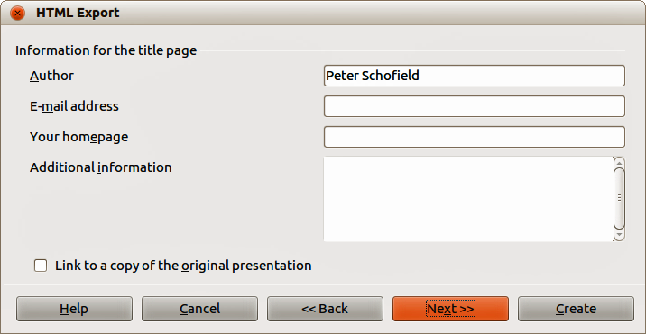
Figure 14: HTML Export dialog – title page information
- Select Link to a copy of the original presentation if you want to create a hyperlink to download a copy of the presentation file and then click Next>>.
- Select button style to be used for the web pages from the designs available (Figure 15) and then click Next>>.
If you do not select a button style, LibreOffice will create a text navigator.
This page is not available if you have selected either Automatic or WebCast publication type.
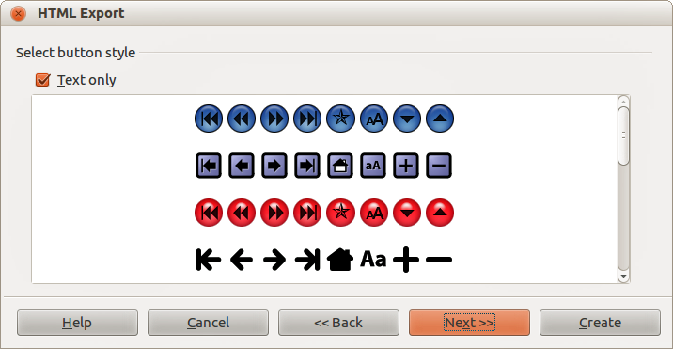
Figure 15: HTML Export dialog – button style page
- Select color scheme to be used for the web pages (Figure 16) such as the color scheme and colors for text and background. This page is not available if you have selected either Automatic or WebCast publication type.
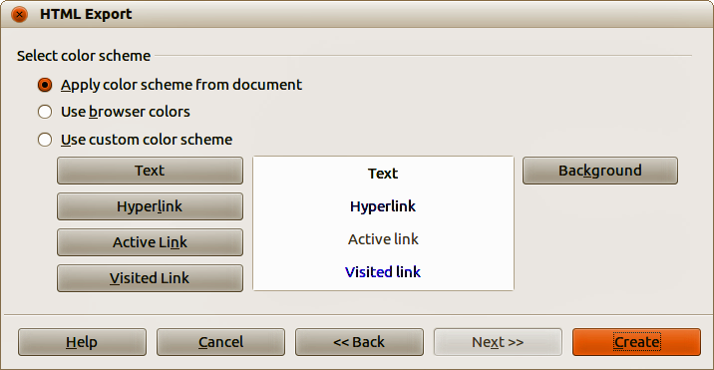
Figure 16: HTML Export dialog – color scheme page
- Click Create.
- If you have created a new design for your web pages, type in a name for your design and click Save.
- Note
Depending on the size of your presentation and the number of graphics it contains, the HTML export function creates several HTML, JPG, and GIF files. For example, if you simply save to your desktop and not in a specific folder, these separate HTML and graphics files will be placed all over your desktop. It is recommended to create a folder to hold all the files created for the web version of your presentation.

Draw documents
Draw documents cannot be saved in HTML format, but have to be exported as HTML documents. Exporting drawings as web pages from Draw is similar to exporting a presentation from Impress. Go to File > Export and select HTML Document (Draw) as the file type, then follow the procedure above for exporting Impress presentations.

