
Getting Started Guide
Chapter 3
Using Styles and Templates
Using consistent formatting in your documents

Copyright
This document is Copyright © 2010–2014 by the LibreOffice Documentation Team. Contributors are listed below. You may distribute or modify it under the terms of either the GNU General Public License (http://www.gnu.org/licenses/gpl.html), version 3 or later, or the Creative Commons Attribution License (http://creativecommons.org/licenses/by/4.0/), version 4.0 or later.
All trademarks within this guide belong to their legitimate owners.

Contributors
John A Smith Jean Hollis Weber Hazel Russman
Martin Saffron Ron Faile Jr. Bruce Byfield

Feedback
Please direct any comments or suggestions about this document to the Documentation Team’s mailing list: documentation@global.libreoffice.org
Note: Everything you send to a mailing list, including your email address and any other personal information that is written in the message, is publicly archived and cannot be deleted.

Acknowledgments
This chapter is adapted and updated from Chapter 3 of Getting Started with OpenOffice.org 3.3. The contributors to that chapter are:
Jean Hollis Weber Michele Zarri Agnes Belzunce
Daniel Carrera Peter Hillier-Brook Peter Kupfer
Gary Schnabl Janet Swisher

Publication date and software version
Published 2 April 2014. Based on LibreOffice 4.2.

Note for Mac users
Some keystrokes and menu items are different on a Mac from those used in Windows and Linux. The table below gives some common substitutions for the instructions in this chapter. For a more detailed list, see the application Help.
Windows or Linux | Mac equivalent | Effect
Tools > Options menu selection | LibreOffice > Preferences | Access setup options
Right-click | Control+click and/or right-click depending on computer system | Opens context menu
Ctrl (Control) | ⌘ (Command) | Used with other keys
F5 | Shift+⌘+F5 | Opens the Navigator
F11 | ⌘+T | Opens Styles and Formatting window

Contents
Copyright 2
Contributors 2
Feedback 2
Acknowledgments 2
Publication date and software version 2
Note for Mac users 2
What is a template? 5
What are styles? 5
Applying styles 6
Using the Styles and Formatting window 6
Using Fill Format Mode 7
Using the Apply Style list 7
Using keyboard shortcuts 8
Modifying styles 8
Changing a style using the Style dialog 9
Updating a style from a selection 9
Using AutoUpdate 9
Updating styles from a document or template 9
Creating new (custom) styles 10
Creating a new style using the Style dialog 10
Creating a new style from a selection 10
Dragging and dropping to create a style 10
Copying styles from a template or document 11
Deleting styles 12
Using a template to create a document 12
Creating a template 13
Creating a template from a document 13
Creating a template using a wizard 13
Editing a template 14
Updating a document from a changed template 15
Adding templates obtained from other sources 15
Installing individual templates 15
Installing collections of templates 16
Setting a default template 16
Setting a template as the default 16
Resetting the default template 16
Associating a document with a different template 17
Organizing templates 17
Creating a template folder 17
Deleting a template folder 18
Moving a template 18
Deleting a template 18
Importing a template 18
Exporting a template 19
Examples of style use 19
Defining a different first page for a document 19
Dividing a document into chapters 19
Changing page orientation within a document 20
Displaying different headers on right and left pages 20
Controlling page breaks automatically 20
Compiling an automatic table of contents 20
Defining a sequence of paragraph styles 20

What is a template?
A template is a model document that you use to create other documents. For example, you can create a template for business reports that has your company’s logo on the first page. New documents created from this template will all have your company’s logo on the first page.
Templates can contain anything that regular documents can contain, such as text, graphics, a set of styles, and user-specific setup information such as measurement units, language, the default printer, and toolbar and menu customization.
All documents in LibreOffice are based on templates. You can create a specific template for any document type (text, spreadsheet, drawing, presentation). If you do not specify a template when you start a new document, then the document is based on the default template for that type of document. If you have not specified a default template, LibreOffice uses the blank template for that type of document that is installed with LibreOffice. See “Setting a default template” on page 17 for more information.

What are styles?
A style is a set of formats that you can apply to selected pages, text, frames, and other elements in your document to quickly change their appearance. Often applying a style means applying a whole group of formats at the same time.
Many people manually format paragraphs, words, tables, page layouts, and other parts of their documents without paying any attention to styles. They are used to writing documents according to physical attributes. For example, you might specify the font family, font size, and any formatting such as bold or italic.
Styles are logical attributes. Using styles means that you stop saying “font size 14pt, Times New Roman, bold, centered”, and you start saying “Title” because you have defined the “Title” style to have those characteristics. In other words, using styles means that you shift the emphasis from what the text (or page, or other element) looks like, to what the text is.
Styles help improve consistency in a document. They also make major formatting changes easy. For example, you may decide to change the indentation of all paragraphs, or change the font of all titles. For a long document, this simple task can require making individual changes in dozens of places. By contrast, when you use styles, you only need to make a single change.
In addition, styles are used by LibreOffice for many processes, even if you are not aware of them. For example, Writer relies on heading styles (or other styles you specify) when it compiles a table of contents. Some common examples of style use are given in “Examples of style use” on page 21.
LibreOffice supports the following types of styles:
- Page styles include margins, headers and footers, borders and backgrounds. In Calc, page styles also include the sequence for printing sheets.
- Paragraph styles control all aspects of a paragraph’s appearance, such as text alignment, tab stops, line spacing, and borders, and can include character formatting.
- Character styles affect selected text within a paragraph, such as the font and size of text, or bold and italic formats.
- Frame styles are used to format graphic and text frames, including text wrap, borders, backgrounds, and columns.
- List styles allow you to select, format, and position numbers or bullets in lists.
- Cell styles include fonts, alignment, borders, background, number formats (for example, currency, date, number), and cell protection.
- Graphics styles in drawings and presentations include line, area, shadowing, transparency, font, connectors, dimensioning, and other attributes.
- Presentation styles include attributes for font, indents, spacing, alignment, and tabs.
Different styles are available in the various components of LibreOffice, as listed in 1.
LibreOffice comes with many predefined styles. You can use the styles as provided, modify them, or create new styles, as described in this chapter.
Table 1. Styles available in LibreOffice components
Style Type | Writer | Calc | Draw | Impress
Page | X | X
Paragraph | X
Character | X
Frame | X
Numbering | X
Cell |  | X
Presentation |  |  | X | X
Graphics | (included in Frame styles) |  | X | X

Applying styles
LibreOffice provides several ways for you to select styles to apply:
- Styles and Formatting window
- Fill Format Mode
- Apply Style List
- Keyboard shortcuts

Using the Styles and Formatting window
The Styles and Formatting window includes the most complete set of tools for styles. To use it for applying styles:
- Select the Styles and Formatting button located at the left-hand end of the Formatting toolbar, or select Format > Styles and Formatting, or press F11 (⌘+T on a Mac) or click the Styles and Formatting tab in the Sidebar (View > Sidebar to open it).
The Styles and Formatting window shows the types of styles available at the current position of the mouse cursor. Figure 1 shows the window for Writer, with Paragraph Styles visible. You can move this window to a convenient position on the screen or dock it to the right edge (hold down the Ctrl key and drag it by the title bar to where you want it docked).
- Select one of the buttons at the top left of the Styles and Formatting window to display a list of styles in a particular category.
- To apply an existing style, position the insertion point in the paragraph, frame, page, or word, and then double-click the name of the style in one of these lists. To apply a character style to more than one word, select the characters first.
Tip | At the bottom of the Styles and Formatting window is a drop-down list. In Figure 1 the window shows Automatic, meaning the list includes only a standard set of styles suggested by LibreOffice. You can choose to show all styles or other groups of styles, for example only custom styles.
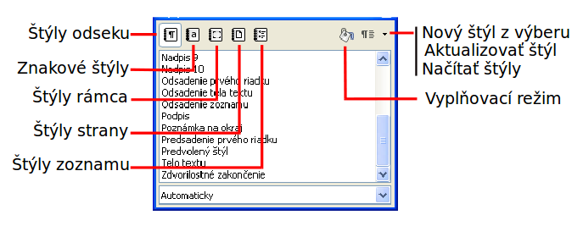
Figure 1: The Styles and Formatting window for Writer, showing paragraph styles

Using Fill Format Mode
Use Fill Format to apply a style to many different areas quickly without having to go back to the Styles and Formatting window and double-click every time. This method is quite useful when you need to format many scattered paragraphs, cells, or other items with the same style:
- Open the Styles and Formatting window and select the style you want to apply.
- Select the Fill Format Mode button.
- To apply a paragraph, page, or frame style, hover the mouse over the paragraph, page, or frame and click. To apply a character style, hold down the mouse button while selecting the characters. Clicking a word applies the character style for that word.
- Repeat step 3 until you have made all the changes for that style.
- To quit Fill Format mode, click the Fill Format Mode button again or press the Esc key.
Caution   | When this mode is active, a right-click anywhere in the document undoes the last Fill Format action. Be careful not to accidentally right-click and undo actions you want to keep.

Using the Apply Style list
After you have used a style at least once in a document, the style name appears on the Apply Style list near the left-hand end of the Formatting toolbar, next to the Styles and Formatting button.
You can open this list and click the style you want, or you can use the up and down arrow keys to move through the list and then press Enter to apply the highlighted style.
Tip | Select More at the bottom of the Apply Style list to open the Styles and Formatting window.
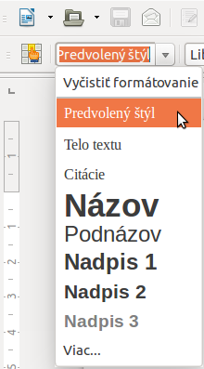
Figure 2: The Apply Style list on the Formatting toolbar

Using keyboard shortcuts
Some keyboard shortcuts for applying styles are predefined. For example, in Writer Ctrl+0 applies the Text body style, Ctrl+1 applies the Heading 1 style, and Ctrl+2 applies the Heading 2 style. You can modify these shortcuts and create your own; see Chapter 14, Customizing LibreOffice, for instructions.
Caution | Manual formatting (also called direct formatting) overrides styles, and you cannot get rid of the manual formatting by applying a style to it.  To remove manual formatting, select the text, right-click, and choose Clear Direct Formatting from the context menu, or use Ctrl+M after selecting the text.

Modifying styles
LibreOffice includes predefined styles, but you can also create custom styles. You can modify both types of styles in several ways:
- Change a style using the Style dialog
- Update a style from a selection
- Use AutoUpdate (paragraph and frame styles only)
- Load or copy styles from another document or template
Note | Any changes you make to a style are effective only in the current document. To change styles in more than one document, you need to change the template or copy the styles into the other documents as described on page 11.

Changing a style using the Style dialog
To change an existing style using the Style dialog, right-click on the required style in the Styles and Formatting window and select Modify from the pop-up menu.
The Style dialog displayed depends on the type of style selected. Each Style dialog has several tabs. See the chapters on styles in the user guides for details.

Updating a style from a selection
To update a style from a selection:
- Open the Styles and Formatting window.
- In the document, select an item that has the format you want to adopt as a style.
- In the Styles and Formatting window, select the style to update, then click on the arrow next to the New Style from Selection icon and click Update Style.
Caution | When updating a paragraph style, make sure that the selected paragraph contains unique properties. If it mixes font sizes or font styles, those mixed properties will remain the same as before.
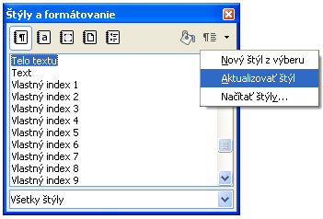
Figure 3: Updating a style from a selection

Using AutoUpdate
AutoUpdate applies to paragraph and frame styles only. If the AutoUpdate option is selected on the Organizer page of the Paragraph Style or Frame Style dialog, applying direct formatting to a paragraph or frame using this style in your document automatically updates the style itself.
Tip | If you are in the habit of manually overriding styles in your document, be sure that AutoUpdate is not enabled.

Updating styles from a document or template
You can update styles by copying or loading them from a template or another document. See “Copying styles from a template or document” on page 12.

Creating new (custom) styles
You may want to add some new styles. You can do this by using either the Styles dialog or the New Style from Selection tool.

Creating a new style using the Style dialog
To create a new style using the Styles dialog, right-click in the Styles and Formatting window and select New from the pop-up menu. If you want your new style to be linked with an existing style, first select that style and then right-click and select New.
If you link styles, then when you change the base style (for example, by changing the font from Times to Helvetica), all the linked styles will change as well. Sometimes this is exactly what you want; other times you do not want the changes to apply to all the linked styles. It pays to plan ahead.
The dialogs and choices are the same for defining new styles and for modifying existing styles. See the chapters on styles in the user guides for details.

Creating a new style from a selection
You can create a new style by copying an existing manual format. This new style applies only to this document; it will not be saved in the template.
- Open the Styles and Formatting window and choose the type of style you want to create.
- In the document, select the item you want to save as a style.
- In the Styles and Formatting window, select on the New Style from Selection icon.
- In the Create Style dialog, type a name for the new style. The list shows the names of existing custom styles of the selected type. Click OK to save the new style.
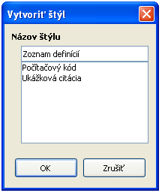
Figure 4: Naming a new style created from a selection

Dragging and dropping to create a style
You can drag and drop a selection into the Styles and Formatting window to create a new style.

Copying styles from a template or document
You can copy styles into a document by loading them from a template or from another document:
- Open the document you want to copy styles into.
- In the Styles and Formatting window, click the arrow next to the New Style from Selection icon, and then select Load Styles (see Figure 3).
- Select the categories of styles to be copied. Select Overwrite if you want the styles being copied to replace any styles of the same names in the document you are copying them into.
- On the Load Styles dialog (Figure 5), find either a template or an ordinary document from which to copy files from. Click the From File button to open a window from which to select the required document.
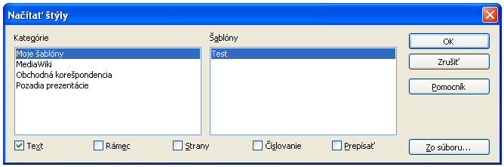
Figure 5: Copying styles from a template into the open document
- Select the types of styles to copy from the checkboxes at the bottom of the dialog.
- Select Overwrite if you want to replace styles in the original document that have the same name as styles in the document from which you are importing styles. If this box is not selected, you will only copy styles whose names are not used in the original document.
- Click OK to copy the styles.
Caution | If your document has a table of contents, and if you have used custom styles for headings, the heading levels associated with outline levels in Tools > Outline Numbering will revert to the defaults of Heading 1, Heading 2, and so on when you load Text styles from a file that does not use the same custom styles. You will need to change these back to your custom heading styles.

Deleting styles
You cannot remove (delete) any of LibreOffice’s predefined styles from a document or template, even if they are not in use.
You can remove any user-defined (custom) styles; but before you do, you should make sure the styles are not in use in the current document. If an unwanted style is in use, you can replace it with a substitute style.
To delete any unwanted styles, in the Styles and Formatting window select each one to be deleted (hold Ctrl while selecting multiple styles), and then right-click on a selected style and select Delete on the context menu.
If the style is not in use, it is deleted immediately without confirmation. If the style is in use, you receive a warning message asking you to confirm deletion.
Caution | If you delete a style that is in use, all objects with that style will return to the default style.

Using a template to create a document
To use a template to create a document:
- From the Menu bar, choose File > New > Templates. The Template Manager dialog opens.
- From the tabs at the top of the dialog, select the category of template you want to use.
- Select the folder that contains the template that you want to use. All the templates contained in that folder are listed on the page (as shown in Figure 6).
- Select the template that you want to use. If you wish to view the template’s properties, click the Properties button above the list of templates. The template’s properties appear in a pop-up window. Click Close to close this pop-up window.
- Select the required template. A new document based on the selected template opens in LibreOffice.
The template the document is based upon is listed in File > Properties > General. The connection between the template and the document remains until the template is modified and, the next time that the document is opened, you choose not to update it to match the template.
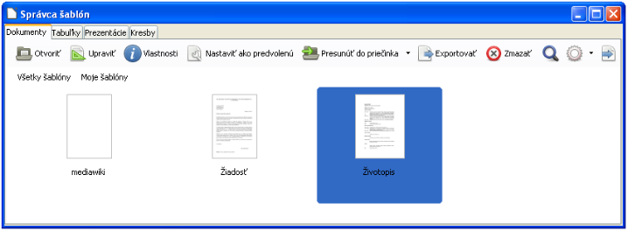
Figure 6: Template Manager dialog, showing a selected template

Creating a template
You can create your own templates in two ways: by saving a document as a template or by or using a wizard.

Creating a template from a document
To create a template from a document and save it to My Templates:
- Open a new or existing document of the type you want to make into a template (text document, spreadsheet, drawing, or presentation).
- Add any content that you want to appear in any document you create from the new template, for example company logo, copyright statement, and so on.
- Create or modify any styles that you want to use in the new template.
- From the Menu bar, choose File > Templates > Save As Template. The Template Manager dialog (Figure 7) opens, displaying the default folders and any user-created folders.
- Select the My Templates folder.
- Select Save.
- In the dialog that opens, type a name for the new template and click Accept.
- Close the Template Manager dialog.
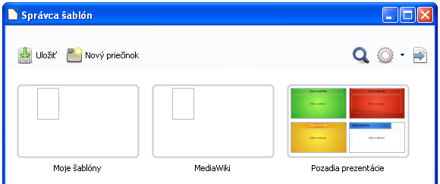
Figure 7: Template Manager dialog, showing default folders
In addition to formatting, any settings that can be added to or modified in a document can be saved within a template. For example, you can also save printer settings, and general behaviors set from Tools > Options, such as Paths and Colors.
Templates can also contain predefined text, saving you from having to type it every time you create a new document. For example, a letter template may contain your name, address, and salutation.
You can also save menu and toolbar customizations in templates; see Chapter 14, Customizing LibreOffice, for more information.

Creating a template using a wizard
You can use wizards to create templates for letters, faxes, agendas, and to create presentations, and Web pages.
For example, the Fax Wizard guides you through the following choices:
- Type of fax (business or personal)
- Document elements like the date, subject line (business fax), salutation, and complementary close
- Options for sender and recipient information (business fax)
- Text to include in the footer (business fax)
To create a template using a wizard:
- From the Menu bar, choose File > Wizards > [type of template required].
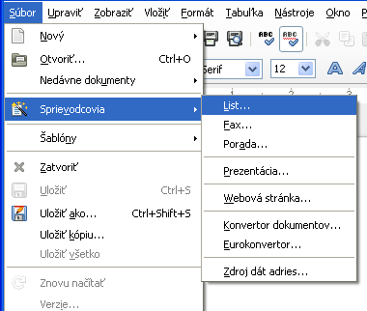
Figure 8: Creating a template using a wizard
- Follow the instructions on the pages of the wizard. This process is slightly different for each type of template, but the format is very similar.
- In the last section of the wizard, you can specify the template name which will show in the Template Manager, and also the name and location for saving the template. The two names can be different but may cause you confusion if you choose two different names. The default location is your user templates directory, but you can choose a different location if you prefer.
- Selecting the Path button to set the file name, and perhaps change the directory, causes the Save As dialog to open. Setting the file name and clicking Save closes the dialog.
- Finally, you can choose whether to create a new document from your template immediately, or manually change the template by clicking Finish. For future documents, you can re-use the template created by the wizard, just as you would use any other template.
You may need to open the Template Manager and click Refresh on the Action menu to have any new templates appear in the listings.

Editing a template
You can edit a template’s styles and content, and then, if you wish, you can reapply the template’s styles to documents that were created from that template. You cannot reapply content.
To edit a template:
- From the Menu bar, choose File > Template> Manage or press Ctrl+Shift+N. The Template Manager dialog opens.
- Navigate to the template that you want to edit. Click once on it to activate the file handling controls (see Figure 6). Click Edit. The template opens in LibreOffice.
- Edit the template just as you would any other document. To save your changes, choose File > Save from the Menu bar.

Updating a document from a changed template
If you make any changes to a template and its styles, the next time you open a document that was created on the template before the changes, a confirmation message is displayed.
To update the document:
- Click Update Styles to apply the changed styles in the template to the document.
- Select Keep Old Styles if you do not want to apply the changed styles in the template to the document. (but see the Caution notice below).
Caution | If you choose Keep Old Styles, the document is no longer connected to the template, even though the template is still listed under File > Properties > General. You can still import styles manually from the template, but to reconnect it to the template, you will have to copy it into an empty document based on the template.

Adding templates obtained from other sources
LibreOffice refers to sources for templates as repositories. A repository can be local (a directory on your computer to which you have downloaded templates) or remote (a URL from which you can download templates).
You can get to the official template repository by using the Get more templates for LibreOffice button at the right-hand end of the Template Manager dialog, as shown in Figure 9, or by entering http://templates.libreoffice.org/template-center in your browser.
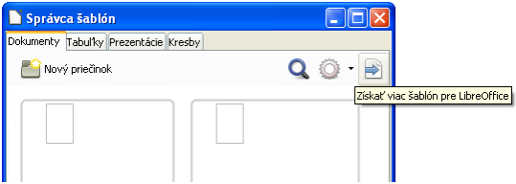
Figure 9: Getting more templates for LibreOffice
If you have enabled experimental features in Tools > Options > Advanced, the Template Manager shows a Repository button that you can use to add other template repositories. As this is an experimental feature, it may not work reliably.
On other websites you may find collections of templates that have been packaged into extension (OXT) files. These are installed a little differently, as described below.

Installing individual templates
To install individual templates:
- Download the template and save it anywhere on your computer.
- Import the template into a template folder by following the instructions in “Importing a template” on page 20.
Tip | You can manually copy new templates into the template folders. The location varies with your computer’s operating system. To learn where the template folders are stored on your computer, go to Tools > Options > LibreOffice > Paths.

Installing collections of templates
The Extension Manager provides an easy way to install collections of templates that have been packaged as extensions. Follow these steps:
- Download the extension package (OXT file) and save it anywhere on your computer.
- In LibreOffice, select Tools > Extension Manager from the Menu bar. In the Extension Manager dialog, click Add to open a file browser window.
- Find and select the package of templates you want to install and click Open. The package begins installing. You may be asked to accept a license agreement.
- When the package installation is complete, restart LibreOffice. The templates are available for use through File > Templates > Manage and File > New > Templates and the extension is listed in the Extension Manager.
See Chapter 14 Customizing LibreOffice for more about the Extension Manager.

Setting a default template
If you create a document by choosing File > New > Text Document (or Spreadsheet, Presentation, or Drawing) from the Menu bar, LibreOffice creates the document from the default template for that type of document. You can, however, change the default whenever you choose.
Note for Microsoft Word users | You may know that Microsoft Word employs a normal.dot or normal.dotx file for its default template and how to regenerate it.  LibreOffice does not have a similar default template file; the “factory defaults” are embedded within the software.

Setting a template as the default
You can set any template displayed in the Template Manager dialog to be the default:
- From the Menu bar, choose File > Templates > Manage.
- In the Template Manager dialog, open the folder containing the template that you want to set as the default, then select the template.
- Click the Set as default button above the list of templates (see Figure 6).
The next time that you create a document by choosing File > New, the document will be created from this template.
Although many important settings can be changed in the Tools > Options dialog (see Chapter 2) for the default template, for example default fonts and page size, more advanced settings (such as page margins) can be changed only by replacing the default template with a new one.

Resetting the default template
To re-enable LibreOffice’s default template for a document type as the default:
- In the Template Manager dialog, click the Action Menu icon on the right
- Point to Reset Default Template on the drop-down menu, and click Text Document (or other template type).
These choices do not appear unless a custom template has been set as the default, as described in the previous section.
The next time that you create a document by choosing File > New, the document will be created from the default template for the document type.
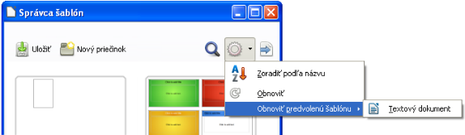
Figure 10: Resetting the default template for text documents

Associating a document with a different template
LibreOffice has no direct method of changing the template that a document uses. However, you can copy the contents of a document into an empty document that uses a different template.
Note | In LibreOffice 3.x, you could use the Template Changer extension to simplify this process. Unfortunately, this extension does not work in LibreOffice 4.x.
For best results, the names of styles should be the same in the existing document and the new template. If they are not, use Edit > Find & Replace to replace old styles with new ones. See Chapter 4, Getting Started with Writer, for more about replacing styles using Find & Replace.
To associate a document with another template:
- Use File > Templates > Manage to open the Template Manager dialog, and select the template you want to use. A new document opens, containing any text or graphics that were in the template. Delete any unwanted text or graphics from this new document.
- Open the document you want to change. Select Edit > Select All or press Ctrl+A.
- Select Edit > Copy, or press Ctrl+C, to copy the contents of the document to the clipboard.
- Click inside the blank document created in step 1. Go to Edit > Paste, or press Ctrl+V, to paste the contents from the old document into the new one.
- Close the old file without saving. Go to File > Save As to save the new file with the name of the file from which content was taken. When asked, confirm that you want to overwrite the old file. You may prefer to save the new file under a new name and preserve the old file under its original name.

Organizing templates
LibreOffice can use only those templates that are in its template folders. You can create new template folders and use them to organize your templates. For example, you might have one template folder for report templates and another for letter templates. You can also import and export templates.
To begin, choose File > Templates > Manage to open the Template Manager dialog.

Creating a template folder
To create a template folder:
- Go to the All Templates section of the Template Manager dialog.
- Click the New folder button (see Figure 11).
- In the pop-up dialog, type a name for the new folder and click Accept.
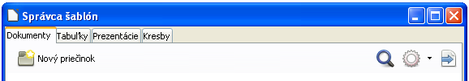
Figure 11: Creating a new folder

Deleting a template folder
You cannot delete template folders supplied with LibreOffice. Nor can you delete any folders created by the Extension Manager unless you first delete the extension that installed them.
However, you can select a folder that you created and click the Delete button. When a message box appears, asking you to confirm the deletion, click Yes.

Moving a template
To move a template from one template folder to another, select it in the Template Manager dialog, and click the Move to folder button above the list of templates (see Figure 12).
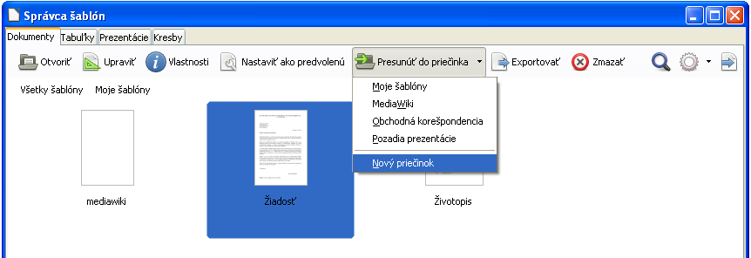
Figure 12: Template file handling icons

Deleting a template
You cannot delete templates supplied with LibreOffice. Nor can you delete any templates created by the Extension Manager except by deleting the extension that installed them.
However, you can delete templates that you have created or imported:
- In the Template Manager dialog, double-click the folder that contains the template you want to delete.
- Select the template to delete.
- Select the Delete button above the list of templates. A message box appears and asks you to confirm the deletion. Click Yes.

Importing a template
Before you can use a template in LibreOffice, it must be in one of the folders listed for the Template path in Tools > Options > LibreOffice >Paths:
- In the Template Manager dialog, select the folder into which you want to import the template.
- Click the Import button above the list of template folders. A standard file browser window opens.
- Find and select the template that you want to import and click Open. The file browser window closes and the template appears in the selected folder.

Exporting a template
To export a template from a template folder to another location:
- In the Template Manager dialog, double-click the folder that contains the template to export.
- Select the template that you want to export.
- Select the Export button above the list of template folders. The Save As window opens.
- Find the folder into which you want to export the template and select Save.

Examples of style use
The following examples of common use of page and paragraph styles are taken from Writer. There are many other ways to use styles; see the guides for the various components for details.

Defining a different first page for a document
Many documents, such as letters and reports, have a first page that is different from the other pages in the document. For example, the first page of a letterhead typically has a different header, or the first page of a report might have no header or footer, while the other pages do. With LibreOffice, you can define the page style for the first page and specify the style for the following pages to be applied automatically.
As an example, we can use the First Page and Default page styles that come with LibreOffice. Figure 13 shows what we want to happen: the first page is to be followed by the default page, and all the following pages are to be in the Default page style. Details are in Chapter 4, Formatting Pages, in the Writer Guide.
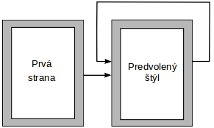
Figure 13: Flow of page styles

Dividing a document into chapters
In a similar way, you can divide a document into chapters. Each chapter might start with the First Page style, with the following pages using the Default page style, as above. At the end of the chapter, insert a manual page break and specify the next page to have the First Page style to start the next chapter, as shown in Figure 14.
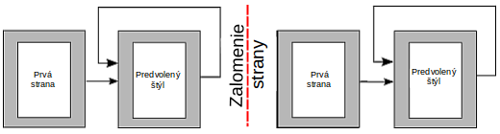
Figure 14: Dividing a document into chapters using page styles

Changing page orientation within a document
A Writer document can contain pages in more than one orientation. A common scenario is to have a landscape page in the middle of a document, whereas the other pages are in a portrait orientation. This setup can also be created with page breaks and page styles.

Displaying different headers on right and left pages
Page styles can be set up to have the facing left and right pages mirrored or only right (first pages of chapters are often defined to be right-page only) or only left. When you insert a header on a page style set up for mirrored pages or right-and-left pages, you can have the contents of the header be the same on all pages or be different on the right and left pages. For example, you can put the page number on the left-hand edge of the left pages and on the right-hand edge of the right pages, put the document title on the right-hand page only, or make other changes.

Controlling page breaks automatically
Writer automatically flows text from one page to the next. If you do not like the default settings, you can change them. For example, you can require a paragraph to start on a new page or column and specify the style of the new page. A typical use is for chapter titles to always start on a new right-hand (odd-numbered) page.

Compiling an automatic table of contents
To compile an automatic table of contents, first apply styles to the headings you want to appear in the contents list, then use Tools > Outline Numbering to tell Writer which styles go with which level in the table of contents. By default, tables of contents use Heading styles, but you can use whatever combination of styles you prefer. See Chapter 4 for more information.

Defining a sequence of paragraph styles
You can set up one paragraph style so that when you press Enter at the end of that paragraph, the following paragraph automatically has the style you wish applied to it. For example, you could define a Heading 1 paragraph to be followed by a Text Body paragraph. A more complex example would be: Title followed by Author followed by Abstract followed by Heading 1 followed by Text Body. By setting up these sequences, you can usually avoid having to apply styles manually.

