
Getting Started Guide
Chapter 5
Getting Started with Calc
Using Spreadsheets in LibreOffice

Copyright
This document is Copyright © 2010–2014 by the LibreOffice Documentation Team. Contributors are listed below. You may distribute or modify it under the terms of either the GNU General Public License (http://www.gnu.org/licenses/gpl.html), version 3 or later, or the Creative Commons Attribution License (http://creativecommons.org/licenses/by/4.0/), version 4.0 or later.
All trademarks within this guide belong to their legitimate owners.

Contributors
Jean Hollis Weber Peter Schofield David Michel
Hazel Russman Ron Faile Jr. Martin Saffron
John A Smith

Feedback
Please direct any comments or suggestions about this document to the Documentation Team’s mailing list: documentation@global.libreoffice.org
Note: Everything you send to a mailing list, including your email address and any other personal information that is written in the message, is publicly archived and cannot be deleted.

Acknowledgments
This chapter is based on Chapter 5 of Getting Started with OpenOffice.org 3.3. The contributors to that chapter are:
Richard Barnes Richard Detwiler John Kane
Peter Kupfer Joe Sellman Jean Hollis Weber
Linda Worthington Michele Zarri

Publication date and software version
Published 9 April 2014. Based on LibreOffice 4.2.

Note for Mac users
Some keystrokes and menu items are different on a Mac from those used in Windows and Linux. The table below gives some common substitutions for the instructions in this chapter. For a more detailed list, see the application Help.
Windows or Linux | Mac equivalent | Effect
Tools > Options menu selection | LibreOffice > Preferences | Access setup options
Right-click | Control+click and/or right-click depending on computer setup | Opens a context menu
Ctrl (Control) | ⌘ (Command) | Used with other keys
F5 | Shift+⌘+F5 | Opens the Navigator
F11 | ⌘+T | Opens the Styles and Formatting window

Contents
Copyright 2
Contributors 2
Feedback 2
Acknowledgments 2
Publication date and software version 2
Note for Mac users 2
What is Calc? 5
Spreadsheets, sheets and cells 5
Calc main window 5
Title bar 5
Menu bar 5
Toolbars 6
Formula bar 7
Spreadsheet layout 7
Opening a CSV file 10
Saving spreadsheets 12
Saving in other spreadsheet formats 12
Navigating within spreadsheets 13
Cell navigation 13
Sheet navigation 14
Keyboard navigation 15
Customizing the Enter key 17
Selecting items in a spreadsheet 17
Selecting cells 17
Selecting columns and rows 18
Selecting sheets 18
Working with columns and rows 19
Inserting columns and rows 19
Deleting columns and rows 20
Working with sheets 20
Inserting new sheets 20
Moving and copying sheets 21
Deleting sheets 22
Renaming sheets 22
Viewing Calc 23
Changing document view 23
Freezing rows and columns 23
Splitting the screen 23
Using the keyboard 25
Numbers 25
Text 26
Date and time 26
Autocorrection options 27
Speeding up data entry 28
Using the Fill tool 29
Using selection lists 31
Sharing content between sheets 31
Validating cell contents 32
Editing data 32
Deleting data 32
Replacing data 33
Editing data 33
Formatting data 33
Multiple lines of text 33
Shrinking text to fit the cell 35
Formatting numbers 35
Formatting a font 35
Formatting cell borders 36
Formatting cell background 36
AutoFormat of cells 36
Using AutoFormat 36
Defining a new AutoFormat 37
Using themes 37
Using conditional formatting 38
Hiding and showing data 38
Hiding data 38
Showing data 39
Sorting records 40
Using formulas and functions 41
Analyzing data 41
Printing 41
Print ranges 41
Printing options 42
Repeat printing of rows or columns 43
Page breaks 43
Headers and footers 44

What is Calc?
Calc is the spreadsheet component of LibreOffice. You can enter data (usually numerical) in a spreadsheet and then manipulate this data to produce certain results.
Alternatively, you can enter data and then use Calc in a ‘What if...’ manner by changing some of the data and observing the results without having to retype the entire spreadsheet or sheet.
Other features provided by Calc include:
- Functions, which can be used to create formulas to perform complex calculations on data.
- Database functions, to arrange, store, and filter data.
- Dynamic charts; a wide range of 2D and 3D charts.
- Macros, for recording and executing repetitive tasks; scripting languages supported include LibreOffice Basic, Python, BeanShell, and JavaScript.
- Ability to open, edit, and save Microsoft Excel spreadsheets.
- Import and export of spreadsheets in multiple formats, including HTML, CSV, PDF, and PostScript.
Note | If you want to use macros written in Microsoft Excel using the VBA macro code in LibreOffice, you must first edit the code in the LibreOffice Basic IDE editor. See Chapter 13 Getting Started with Macros and Calc Guide Chapter 12 Calc Macros.

Spreadsheets, sheets and cells
Calc works with elements called spreadsheets. Spreadsheets consist of a number of individual sheets, each sheet containing cells arranged in rows and columns. A particular cell is identified by its row number and column letter.
Cells hold the individual elements – text, numbers, formulas, and so on – that make up the data to display and manipulate.
Each spreadsheet can have several sheets, and each sheet can have several individual cells. In Calc, each sheet can have a maximum of 1,048,576 rows (65,536 rows in Calc 3.2 and earlier) and a maximum of 1024 columns.

Calc main window
When Calc is started, the main window opens (Figure 1). The parts of this window are described below.

Title bar
The Title bar, located at the top, shows the name of the current spreadsheet. When the spreadsheet is newly created, its name is Untitled X, where X is a number. When you save a spreadsheet for the first time, you are prompted to enter a name of your choice.

Menu bar
The Menu bar is where you select one of the menus and various sub-menus appear giving you more options. You can also customize the Menu bar; see Chapter 14 Customizing LibreOffice for more information.
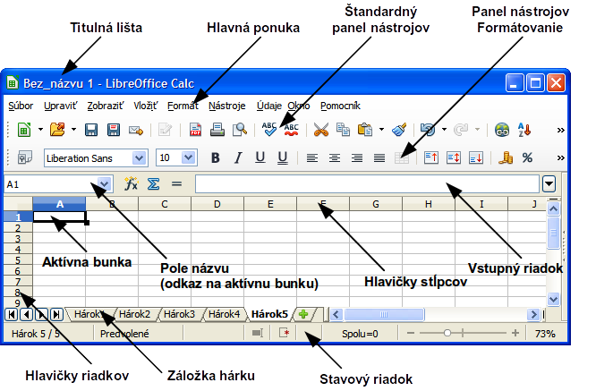
Figure 1: Calc main dialog, without Sidebar
- File – contains commands that apply to the entire document; for example Open, Save, Wizards, Export as PDF, Print, Digital Signatures and so on.
- Edit – contains commands for editing the document; for example Undo, Copy, Changes, Fill, Plug-in and so on.
- View – contains commands for modifying how the Calc user interface looks; for example Toolbars, Column & Row Headers, Full Screen, Zoom and so on.
- Insert – contains commands for inserting elements into a spreadsheet; for example Cells, Rows, Columns, Sheets, Picture and so on.
- Format – contains commands for modifying the layout of a spreadsheet; for example Cells, Page, Styles and Formatting, Alignment and so on.
- Tools – contains various functions to help you check and customize your spreadsheet, for example Spelling, Share Document, Gallery, Macros and so on.
- Data – contains commands for manipulating data in your spreadsheet; for example Define Range, Sort, Consolidate and so on.
- Window – contains commands for the display window; for example New Window, Split and so on.
- Help – contains links to the help system included with the software and other miscellaneous functions; for example Help, License Information, Check for Updates and so on.

Toolbars
The default setting when Calc opens is for the Standard and Formatting toolbars to be docked at the top of the workspace (Figure 1).
Calc toolbars can be either docked and fixed in place, or floating, allowing you to move a toolbar into a more convenient position on your workspace. Docked toolbars can be undocked and moved to different docked position on the workspace, or undocked to become a floating toolbar. Toolbars that are floating when opened can be docked into a fixed position on your workspace.
The default set of icons (sometimes called buttons) on toolbars provide a wide range of common commands and functions. You can also remove or add icons to toolbars, see Chapter 14 Customizing LibreOffice for more information.

Formula bar
The Formula Bar is located at the top of the sheet in the Calc workspace. The Formula Bar is permanently docked in this position and cannot be used as a floating toolbar. If the Formula Bar is not visible, go to View on the Menu bar and select Formula Bar.
Figure 2: Formula bar
Going from left to right and referring to Figure 2, the Formula Bar consists of the following:
- Name Box – gives the cell reference using a combination of a letter and number, for example A1. The letter indicates the column and the number indicates the row of the selected cell.
- Function Wizard – opens a dialog from which you can search through a list of available functions. This can be very useful because it also shows how the functions are formatted.
- Sum – clicking on the Sum icon totals the numbers in the cells above the selected cell and then places the total in the selected cell. If there are no numbers above the selected cell, then the cells to the left are totaled.
- Function – clicking on the Function icon inserts an equals (=) sign into the selected cell and the Input line, allowing a formula to be entered.
- Input line – displays the contents of the selected cell (data, formula, or function) and allows you to edit the cell contents. You can also edit the contents of a cell directly in the cell itself by double-clicking on the cell. When you enter new data into a cell, the Sum and Function icons change to Cancel and Accept icons .
Note | In a spreadsheet the term function covers much more than just mathematical functions. See the Calc Guide Chapter 7 Using Formulas and Functions in for more information.

Spreadsheet layout

Individual cells
The main section of the workspace in Calc displays the cells in the form of a grid. Each cell is formed by the intersection of the columns and rows in the spreadsheet.
At the top of the columns and the left end of the rows are a series of header boxes containing letters and numbers. The column headers use an alpha character starting at A and go on to the right. The row headers use a numerical character starting at 1 and go down.
These column and row headers form the cell references that appear in the Name Box on the Formula Bar (Figure 2). If the headers are not visible on your spreadsheet, go to View on the Menu bar and select Column & Row Headers.

Sheet tabs
In Calc you can have more than one sheet in a spreadsheet. At the bottom of the grid of cells in a spreadsheet are sheet tabs indicating how many sheets there are in your spreadsheet. Clicking on a tab enables access to each individual sheet and displays that sheet. An active sheet is indicated with a white tab (default Calc setup). You can also select multiple sheets by holding down the Ctrl key while you click on the sheet tabs.
To change the default name for a sheet (Sheet1, Sheet2, and so on), right-click on a sheet tab and select Rename Sheet from the context menu. A dialog opens, in which you can type a new name for the sheet. Click OK when finished to close the dialog.
To change the color of a sheet tab, right-click on the tab and select Tab Color from the context menu to open the Tab Color dialog (Figure 3). Select your color and click OK when finished to close the dialog. To add new colors to this color palette, see Chapter 14 Customizing LibreOffice for more information.
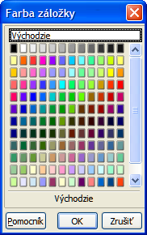
Figure 3: Tab color dialog

Status bar
The Calc status bar (Figure 4) provides information about the spreadsheet as well as quick and convenient ways to change some of its features. Most of the fields are similar to those in other components of LibreOffice; see Chapter 1 Introducing LibreOffice in this guide and the Calc Guide Chapter 1 Introducing Calc for more information.
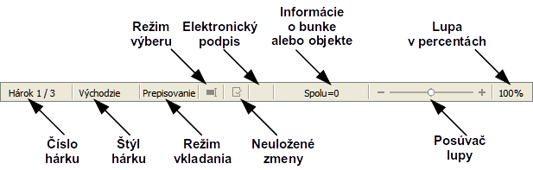
Figure 4: Calc status bar

Sidebar
The Calc Sidebar (View > Sidebar) is located on the right side of the window. It is a mixture of toolbar and dialog and consists of five decks: Properties, Styles and Formatting, Gallery, Navigator, and Functions. Each deck has a corresponding icon on the Tab panel to the right of the sidebar, allowing you to switch between them.
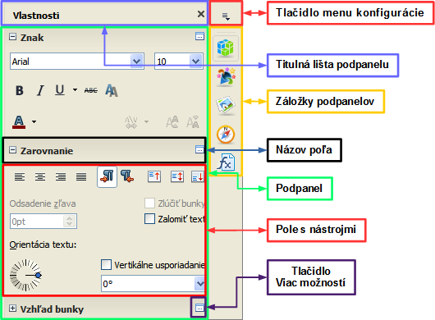
Figure 5: Calc Sidebar with Properties open
The decks are described below.
- Properties: This deck includes four content panels.
- Character: Provides controls for formatting the text, such as font family, size, and color. Some controls, such as superscript, only become active when the text cursor is active in the Input line of the Formula bar or the cell.
- Alignment: Provides controls to align the text in various ways, including horizontal and vertical alignment, wrapping, indenting, merging, text orientation, and vertical stacking.
- Cell Appearance: Provides controls to set the appearance options, including cell background color, cell border formats including line color and style, and grid lines.
- Number Format: Provides a way to quickly change the format of numbers including decimals, currency, dates, or numeric text. Numerical and label field controls for Forms are also available.
Each of these panels has a More Options button, which opens a dialog that gives a greater number of options. These dialogs lock the document for editing until they are closed.
- Styles and Formatting: This deck contains a single panel, which is the same as that opened by selecting the Styles and Formatting button (F11) from the Text Formatting toolbar.
- Gallery: This deck contain a single panel, which is the same as that opened by selecting Gallery from the Standard toolbar or Tools > Gallery from the Menu bar.
- Navigator: This deck contains a single panel, which is essentially the same as the Navigator window opened by clicking the Navigator button on the Standard toolbar or selecting View > Navigator (F5) from the Menu bar. Only the Contents button is absent in the Sidebar’s Navigator panel.
- Functions: This deck contains a single panel, which is the same as the window opened by selecting Insert > Function List from the Menu bar.
To the right side of the title bar of each open deck is a Close button (X), which closes the deck to leave only the Tab bar open. Clicking on any Tab button reopens the deck.
The Sidebar can be hidden, or revealed if already hidden, by clicking on the edge Hide/Show button. You can adjust the deck width by dragging on the left edge of the sidebar.

Opening a CSV file
Comma-separated-values (CSV) files are spreadsheet files in a text format where cell contents are separated by a character, for example a comma or semi-colon. Each line in a CSV text file represents a row in a spreadsheet. Text is entered between quotation marks; numbers are entered without quotation marks.
To open a CSV file in Calc:
- Choose File > Open on the Menu bar and locate the CSV file that you want to open.
- Select the file and click Open. By default, a CSV file has the extension .csv. However, some CSV files may have a .txt extension.
- The Text Import dialog (Figure 6) opens allowing you to select the various options available when importing a CSV file into a Calc spreadsheet.
- Click OK to open and import the file.
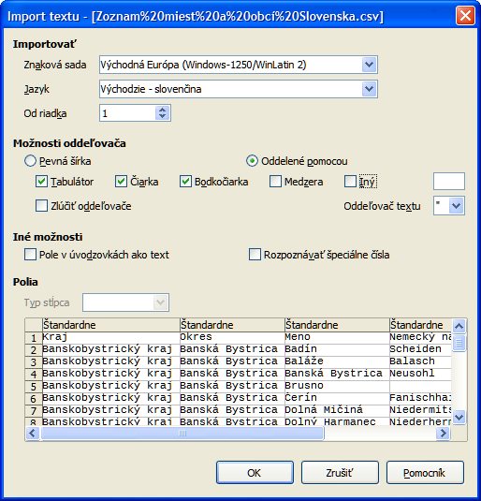
Figure 6: Text Import dialog
The various options for importing CSV files into a Calc spreadsheet are as follows:
- Import
- Character Set – specifies the character set to be used in the imported file.
- Language – determines how the number strings are imported.
If Language is set to Default for CSV import, Calc will use the globally set language. If Language is set to a specific language, that language will be used when importing numbers.
- From Row – specifies the row where you want to start the import. The rows are visible in the preview window at the bottom of the dialog.
- Separator Options – specifies whether your data uses separators or fixed widths as delimiters.
- Fixed width – separates fixed-width data (equal number of characters) into columns. Click on the ruler in the preview window to set the width.
- Separated by – select the separator used in your data to delimit the data into columns. When you select Other, you specify the character used to separate data into columns. This custom separator must also be contained in your data.
- Merge delimiters – combines consecutive delimiters and removes blank data fields.
- Text delimiter – select a character to delimit text data.
- Other options
- Quoted fields as text – when this option is enabled, fields or cells whose values are quoted in their entirety (the first and last characters of the value equal the text delimiter) are imported as text.
- Detect special numbers – when this option is enabled, Calc will automatically detect all number formats, including special number formats such as dates, time, and scientific notation.
The selected language also influences how such special numbers are detected, since different languages and regions many have different conventions for such special numbers.
When this option is disabled, Calc will detect and convert only decimal numbers. The rest, including numbers formatted in scientific notation, will be imported as text. A decimal number string can have digits 0-9, thousands separators, and a decimal separator. Thousands separators and decimal separators may vary with the selected language and region.
- Fields – shows how your data will look when it is separated into columns.
- Column type – select a column in the preview window and select the data type to be applied the imported data.
- Standard – Calc determines the type of data.
- Text – imported data are treated as text.
- US English – numbers formatted in US English are searched for and included regardless of the system language. A number format is not applied. If there are no US English entries, the Standard format is applied.
- Hide – the data in the column are not imported.

Saving spreadsheets
To save a spreadsheet, see Chapter 1 Introducing LibreOffice for more details on how to save files manually or automatically. Calc can also save spreadsheets in a range of formats and also export spreadsheets to PDF, HTML and XHTML file formats, see the Calc Guide Chapter 6 Printing, Exporting, and E-mailing for more information.

Saving in other spreadsheet formats
If you need to exchange files with users who are unable to receive spreadsheet files in Open Document Format (ODF) (*.ods), which Calc uses as default format, you can save a spreadsheet in an another format.
- Save your spreadsheet in Calc spreadsheet file format (*.ods).
- Select File > Save As on the Menu bar to open the Save As dialog (Figure 7).
- In File name, if you wish, enter a new file name for the spreadsheet.
- In File type drop-down menu, select the type of spreadsheet format you want to use.
- If Automatic file name extension is selected, the correct file extension for the spreadsheet format you have selected will be added to the file name.
- Click Save.
- Each time you click Save, the Confirm File Format dialog opens (Figure 8). Click Use [xxx] Format to continue saving in your selected spreadsheet format or click Use ODF Format to save the spreadsheet in Calc ODS format.
- If you select Text CSV format (*.csv) for your spreadsheet, the Export Text File dialog (Figure 9) opens allowing you to select the character set, field delimiter, text delimiter and so on to be used for your CSV file.
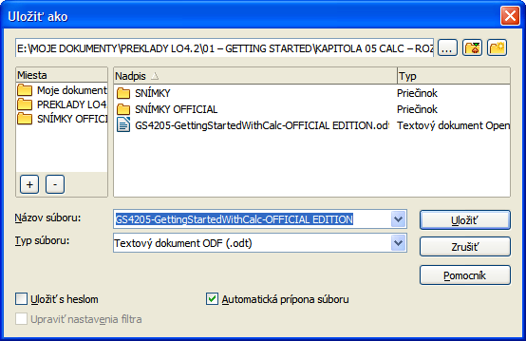
Figure 7: Save As dialog
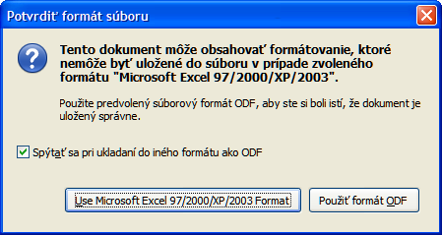
Figure 8: Confirm File Format dialog
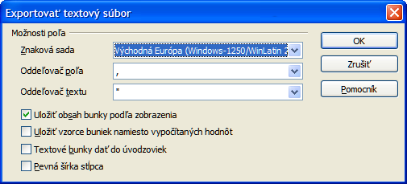
Figure 9: Export Text File dialog for CSV files
Tip | To have Calc save documents by default in a file format other than the default ODF format, go to Tools > Options > Load/Save > General. In Default file format and ODF settings > Document type, select Spreadsheet, then in Always save as, select your preferred file format.

Navigating within spreadsheets
Calc provides many ways to navigate within a spreadsheet from cell to cell and sheet to sheet. You can generally use the method you prefer.

Cell navigation
When a cell is selected or in focus, the cell borders are emphasized. When a group of cells is selected, the cell area is colored. The color of the cell border emphasis and the color of a group of selected cells depends on the operating system being used and how you have set up LibreOffice.
- Using the mouse – place the mouse pointer over the cell and click the left mouse button. To move the focus to another cell using the mouse, simply move the mouse pointer to the cell where you want the focus to be and click the left mouse button.
- Using a cell reference – highlight or delete the existing cell reference in the Name Box on the Formula Bar (Figure 2 on page 8). Type the new cell reference of the cell you want to move to and press Enter key. Cell references are case-insensitive: for example, typing either a3 or A3 will move the focus to cell A3.
- Using the Navigator – click on the Navigator icon on the Standard toolbar or press the F5 key to open the Navigator dialog (Figure 10) or click the Navigator Tab button in the open Sidebar. Type the cell reference into the Column and Row fields and press the Enter key.
- Using the Enter key – pressing Enter moves the cell focus down in a column to the next row. Pressing Shift+Enter moves the focus up in a column to the next row.
- Using the Tab key – pressing Tab moves the cell focus right in a row to the next column. Pressing Shift+Tab moves the focus to the left in a row to the next column.
- Using the arrow keys – pressing the arrow keys on the keyboard moves the cell focus in the direction of the arrow pressed.
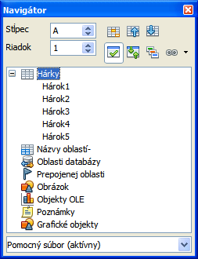
Figure 10: Navigator dialog in Calc
- Using Home, End, Page Up and Page Down
- Home moves the cell focus to the start of a row.
- End moves the cell focus to the last cell on the right in the row that contains data.
- Page Down moves the cell focus down one complete screen display.
- Page Up moves the cell focus up one complete screen display.

Sheet navigation
Each sheet in a spreadsheet is independent of the other sheets in a spreadsheet, though references can be linked from one sheet to another sheet. There are three ways to navigate between different sheets in a spreadsheet.
- Using the Navigator – when the Navigator is open (Figure 10), double-clicking on any of the listed sheets selects the sheet.
- Using the keyboard – using key combinations Ctrl+Page Down moves one sheet to the right and Ctrl+Page Up moves one sheet to the left.
- Using the mouse – clicking on one of the sheet tabs at the bottom of the spreadsheet selects that sheet.
If your spreadsheet contains a lot of sheets, then some of the sheet tabs may be hidden behind the horizontal scroll bar at the bottom of the screen. If this is the case:
- Using the four buttons to the left of the sheet tabs can move the tabs into view (Figure 11).
- Dragging the scroll bar edge to the right may reveal all the tabs.
- Right-clicking on any of the arrows opens a context menu where you can select a sheet (see Figure 12).
Note | When you insert a new sheet into your spreadsheet, Calc automatically uses the next number in the numeric sequence as a name. Depending on which sheet is open when you insert a new sheet, and the method you use to insert a new sheet, the new sheet may not be in numerical order. It is recommended to rename sheets in your spreadsheet to make them more recognizable.
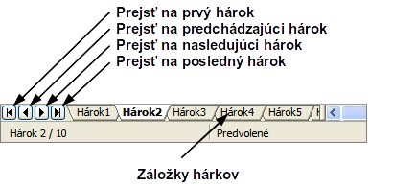
Figure 11: Navigating sheet tabs
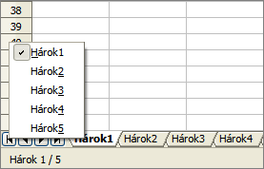
Figure 12: Right-click any arrow button

Keyboard navigation
Pressing a key or a combination of keys allows you to navigate a spreadsheet using the keyboard. A key combination is where you press more than one key together, for example Ctrl+Home key combination to move to cell A1. 1 lists the keys and key combinations you can use for spreadsheet navigation in Calc.
Table 1. Keyboard cell navigation
Keyboard shortcut | Cell navigation
→ | Moves cell focus right one cell
← | Moves cell focus left one cell
↑ | Moves cell focus up one cell
↓ | Moves cell focus down one cell
Ctrl+→ | Moves cell focus to the first column on the right containing data in that row if cell focus is on a blank cell.  Moves cell focus to the last column on the right in the same range of occupied cells in that row if cell focus is on a cell containing data.  Moves cell focus to the last column on the right in the spreadsheet if there are no more cells containing data.
Ctrl+← | Moves cell focus to the last column on the left containing data in that row if cell focus is on a blank cell.  Moves cell focus to the first column on the left in the same range of occupied cells in that row if cell focus is on a cell containing data.  Moves cell focus to the first column in that row if there are no more cells containing data.
Ctrl+↑ | Moves cell focus from a blank cell to the first cell above containing data in the same column.  Moves cell focus to the first row in the same range of occupied cells if cell focus is on a cell containing data.  Moves cell focus from the last cell containing data to the cell in the same column in the last row of the spreadsheet.
Ctrl+↓ | Moves cell focus from a blank cell to the first cell below containing data in the same column.  Moves cell focus to the last row in the same range of occupied cells in that column if cell focus is on a cell containing data.  Moves cell focus from the last cell containing data to the cell in the same column in the last row of the spreadsheet.
Ctrl+Home | Moves cell focus from anywhere on the spreadsheet to Cell A1 on the same sheet.
Ctrl+End | Moves cell focus from anywhere on the spreadsheet to the last cell in the lower right-hand corner of the rectangular area of cells containing data on the same sheet.
Alt+Page Down | Moves cell focus one screen to the right (if possible).
Alt+Page Up | Moves cell focus one screen to the left (if possible).
Ctrl+Page Down | Moves cell focus to the same cell on the next sheet to the right in sheet tabs if the spreadsheet has more than on sheet.
Ctrl+Page Up | Moves cell focus to the same cell on the next sheet to the left in sheet tabs if the spreadsheet has more than on sheet.
Tab | Moves cell focus to the next cell on the right
Shift+Tab | Moves cell focus to the next cell on the left
Enter | Down one cell (unless changed by user)
Shift+Enter | Up one cell (unless changed by user)

Customizing the Enter key
You can customize the direction in which the Enter key moves the cell focus by going to Tools > Options > LibreOffice Calc > General. Select the direction cell focus moves from the drop-down list. Depending on the file being used or the type of data being entered, setting a different direction can be useful. The Enter key can also be used to switch into and out of editing mode. Use the first two options under Input settings in Figure 13 to change the Enter key settings.
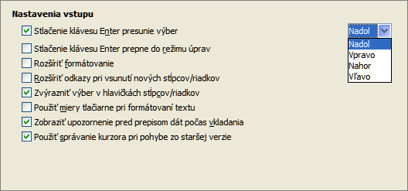
Figure 13: Customizing the Enter key

Selecting items in a spreadsheet

Selecting cells

Single cell
Left-click in the cell. You can verify your selection by looking in the Name Box on the Formula Bar (Figure 2 on page 8).

Range of contiguous cells
A range of cells can be selected using the keyboard or the mouse.
To select a range of cells by dragging the mouse cursor:
- Click in a cell.
- Press and hold down the left mouse button.
- Move the mouse around the screen.
- Once the desired block of cells is highlighted, release the left mouse button.
To select a range of cells without dragging the mouse:
- Click in the cell which is to be one corner of the range of cells.
- Move the mouse to the opposite corner of the range of cells.
- Hold down the Shift key and click.
Tip | You can also select a contiguous range of cells by first clicking in the Selection mode field on the Status Bar (Figure 4 on page 10) and selecting Extending selection before clicking in the opposite corner of the range of cells. Make sure to change back to Standard selection or you may find yourself extending a cell selection unintentionally.
To select a range of cells without using the mouse:
- Select the cell that will be one of the corners in the range of cells.
- While holding down the Shift key, use the cursor arrows to select the rest of the range.
Tip | You can also directly select a range of cells using the Name Box. Click into the Name Box on the Formula Bar (Figure 2 on page 8). To select a range of cells, enter the cell reference for the upper left-hand cell, followed by a colon (:), and then the lower right-hand cell reference. For example, to select the range that would go from A3 to C6, you would enter A3:C6.

Range of non-contiguous cells
- Select the cell or range of cells using one of the methods above.
- Move the mouse pointer to the start of the next range or single cell.
- Hold down the Ctrl key and click or click-and-drag to select another range of cells to add to the first range.
- Repeat as necessary.

Selecting columns and rows

Single column or row
To select a single column, click on the column header (Figure 1 on page 7).
To select a single row, click on the row header.

Multiple columns or rows
To select multiple columns or rows that are contiguous:
- Click on the first column or row in the group.
- Hold down the Shift key.
- Click the last column or row in the group.
To select multiple columns or rows that are not contiguous:
- Click on the first column or row in the group.
- Hold down the Ctrl key.
- Click on all of the subsequent columns or rows while holding down the Ctrl key.

Entire sheet
To select the entire sheet, click on the small box between the column headers and the row headers (Figure 14), or use the key combination Ctrl+A to select the entire sheet, or go to Edit on the Menu bar and select Select All.
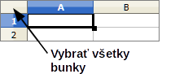
Figure 14: Select All box

Selecting sheets
You can select either one or multiple sheets in Calc. It can be advantageous to select multiple sheets, especially when you want to make changes to many sheets at once.

Single sheet
Click on the sheet tab for the sheet you want to select. The tab for the selected sheet becomes white (default Calc setup).

Multiple contiguous sheets
To select multiple contiguous sheets:
- Click on the sheet tab for the first desired sheet.
- Move the mouse pointer over the sheet tab for the last desired sheet.
- Hold down the Shift key and click on the sheet tab.
- All tabs between these two selections will turn white (default Calc setup). Any actions that you perform will now affect all highlighted sheets.

Multiple non-contiguous sheets
To select multiple non-contiguous sheets:
- Click on the sheet tab for the first desired sheet.
- Move the mouse pointer over the sheet tab for the second desired sheet.
- Hold down the Ctrl key and click on the sheet tab.
- Repeat as necessary.
- The selected tabs will turn white (default Calc setup). Any actions that you perform will now affect all highlighted sheets.

All sheets
Right-click a sheet tab and choose Select All Sheets from the context menu.

Working with columns and rows

Inserting columns and rows
Note | When you insert a column, it is inserted to the left of the highlighted column. When you insert a row, it is inserted above the highlighted row.  When you insert columns or rows, the cells take the formatting of the corresponding cells in the next column to left or the row above.

Single column or row
Using the Insert menu:
- Select a cell, column, or row where you want the new column or row inserted.
- Go to Insert on the Menu bar and select either Insert > Columns or Insert > Rows.
Using the mouse:
- Select a column or row where you want the new column or row inserted.
- Right-click the column or row header.
- Select Insert Columns or Insert Rows from the context menu.

Multiple columns or rows
Multiple columns or rows can be inserted at once rather than inserting them one at a time.
- Select the columns or rows, see “Multiple columns or rows” on page 20 for more information.
- Proceed as for inserting a single column or row above.

Deleting columns and rows

Single column or row
To delete a single column or row:
- Select a cell in the column or row you want to delete.
- Go to Edit on the Menu bar and select Delete Cells or right-click and select Delete from the context menu.
- Select the option you require from the Delete Cells dialog (Figure 15).
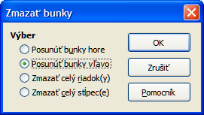
Figure 15: Delete Cells dialog
Alternatively:
- Click in the column or header to select the column or row.
- Go to Edit on the Menu bar and select Delete Cells or right-click and select Delete Columns or Delete Rows from the context menu.

Multiple columns or rows
To delete multiple columns or rows:
- Select the columns or rows, see “Multiple columns or rows” on page 20 for more information.
- Go to Edit on the Menu bar and select Delete Cells or right-click and select Delete Columns or Delete Rows from the context menu.

Working with sheets

Inserting new sheets
Click on the Add Sheet icon . This inserts a new sheet after the last sheet in the spreadsheet without opening the Insert Sheet dialog. The following methods open the Insert Sheet dialog (Figure 16) where you can position the new sheet, create more than one sheet, name the new sheet, or select a sheet from a file.
- Select the sheet where you want to insert a new sheet, then go to Insert > Sheet on the Menu bar.
- Right-click on the sheet tab where you want to insert a new sheet and select Insert Sheet from the context menu.
- Click in the empty space at the end of the sheet tabs.
- Right-click in the empty space at the end of the sheet tabs and select Insert Sheet from the context menu.
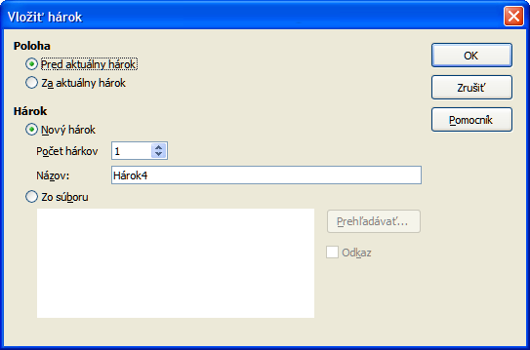
Figure 16: Insert Sheet dialog

Moving and copying sheets
You can move or copy sheets within the same spreadsheet by dragging and dropping or using the Move/Copy Sheet dialog. To move or copy a sheet into a different spreadsheet, you have to use the Move/Copy Sheet dialog.

Dragging and dropping
To move a sheet to a different position within the same spreadsheet, click and hold on the sheet tab and drag it to its new position before releasing the mouse button.
To copy a sheet within the same spreadsheet, hold down the Ctrl key (Option key on Mac) then click on the sheet tab and drag it to its new position before releasing the mouse button. The mouse pointer may change to include a plus sign depending on the setup of your operating system.

Using a dialog
Use the Move/Copy Sheet dialog (Figure 17) to specify exactly whether you want the sheet in the same or a different spreadsheet, its position within the spreadsheet, the sheet name when you move or copy the sheet.
- In the current document, right-click on the sheet tab you wish to move or copy and select Move/Copy Sheet from the context menu or go to Edit > Sheet > Move/Copy on the Menu bar.
- Select Move to move the sheet or Copy to copy the sheet.
- Select the spreadsheet where you want the sheet to be placed from the drop-down list in To document. This can be the same spreadsheet, another spreadsheet already open, or you can create a new spreadsheet.
- Select the position in Insert before where you want to place the sheet.
- Type a name in the New name text box if you want to rename the sheet when it is moved or copied. If you do not enter a name, Calc creates a default name (Sheet 1, Sheet 2, and so on).
- Click OK to confirm the move or copy and close the dialog.
Caution   | When you move or copy to another spreadsheet or a new spreadsheet, a conflict may occur with formulas linked to other sheets in the previous location.
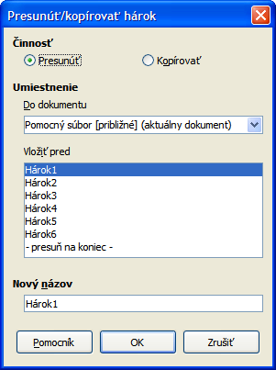
Figure 17: Move/Copy Sheet dialog

Deleting sheets
To delete a single sheet, right-click on the sheet tab you want to delete and select Delete Sheet from the context menu, or go to Edit > Sheet > Delete from on the Menu bar. Click Yes to confirm the deletion.
To delete multiple sheets, select the sheets (see “Selecting sheets” on page 20), then right-click one of the sheet tabs and select Delete Sheet from the context menu, or go to Edit > Sheet > Delete from on the Menu bar. Click Yes to confirm the deletion.

Renaming sheets
By default, the name for each new sheet added is SheetX, where X is the number of the next sheet to be added. While this works for a small spreadsheet with only a few sheets, it can become difficult to identify sheets when a spreadsheet contains many sheets.
You can rename a sheet using one of the following methods:
- Enter the name in the Name text box when you create the sheet using the Insert Sheet dialog (Figure 16 on page 23).
- Right-click on a sheet tab and select Rename Sheet from the context menu to replace the existing name with a different one.
- Double-click on a sheet tab to open the Rename Sheet dialog.
Note | Sheet names must start with either a letter or a number; other characters including spaces are not allowed. Apart from the first character of the sheet name, permitted characters are letters, numbers, spaces, and the underscore character. Attempting to rename a sheet with an invalid name will produce an error message.

Viewing Calc

Changing document view
Use the zoom function to show more or fewer cells in the window when you are working on a spreadsheet. For more about zoom, see Chapter 1 Introducing LibreOffice in this guide.

Freezing rows and columns
Freezing locks a number of rows at the top of a spreadsheet or a number of columns on the left of a spreadsheet or both rows and columns. Then, when moving around within a sheet, the cells in frozen rows and columns always remain in view.
Figure 18 shows some frozen rows and columns. The heavier horizontal line between rows 3 and 23 and the heavier vertical line between columns F and Q indicate that rows 1 to 3 and columns A to F are frozen. The rows between 3 and 23 and the columns between F and Q have been scrolled off the page.
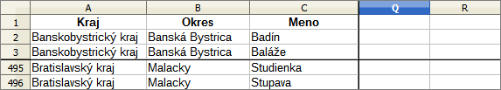
Figure 18: Frozen rows and columns

Freezing rows or columns
- Click on the row header below the rows where you want the freeze, or click on the column header to the right of the columns where you want the freeze.
- Go to Window on the Menu bar and select Freeze. A heavier line appears between the rows or columns indicating where the freeze has been placed.

Freezing rows and columns
- Click into the cell that is immediately below the rows you want frozen and immediately to the right of the columns you want frozen.
- Go to Window on the Menu bar and select Freeze. A heavier line appears between the rows or columns indicating where the freeze has been placed.

Unfreezing
To unfreeze rows or columns, go to Window on the Menu bar and uncheck Freeze. The heavier lines indicating freezing will disappear.

Splitting the screen
Another way to change the view is by splitting the screen your spreadsheet is displayed in (also known as splitting the window). The screen can be split horizontally, vertically, or both giving you up to four portions of the spreadsheet in view at any one time. An example of splitting the screen is shown in Figure 19 where a split is indicated by additional window borders within the sheet.
Why would you want to do this? For example, consider a large spreadsheet in which one cell contains a number that is used by three formulas in other cells. Using the split-screen technique, you can position the cell containing the number in one section and each of the cells with formulas in the other sections. You can then change the number in one cell and watch how it affects each of the formulas.
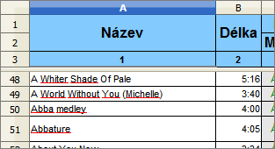
Figure 19: Split screen example

Splitting horizontally or vertically
- Click on the row header below the rows where you want to split the screen horizontally or click on the column header to the right of the columns where you want to split the screen vertically.
- Go to Window on the Menu bar and select Split. Window borders appear between the rows or columns indicating where the split has been placed, as shown in Figure 20.
- Alternatively
- For a horizontal split, drag the new horizontal window border beneath the row where you want the horizontal split positioned.
- For a vertical split, drag the new vertical window border across to the right of the column where you want the vertical split positioned.

Splitting horizontally and vertically
- Click in the cell that is immediately below the rows where you want to split the screen horizontally and immediately to the right of the columns where you want to split the screen vertically.
- Go to Window on the Menu bar and select Split. A heavy black line appears between the rows or columns indicating where the split has been placed.
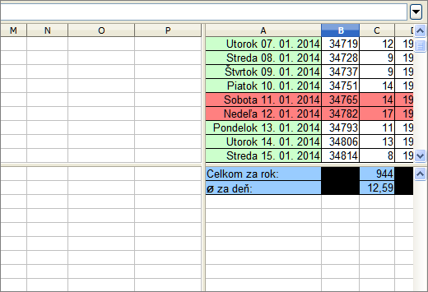
Figure 20: Split screen window borders

Removing split views
To remove a split view, do one of the following:
- Drag the split window borders back to their places at the ends of the scroll bars.
- Go to Window on the Menu bar and uncheck Split.

Using the keyboard
Most data entry in Calc can be accomplished using the keyboard.

Numbers
Click in the cell and type in a number using the number keys on either the main keyboard or numeric keypad. By default, numbers are right aligned in a cell.

Minus numbers
To enter a negative number, either type a minus (–) sign in front of the number or enclose the number in parentheses (), for example (1234). The result for both methods of entry will be the same, for example -1234.

Leading zeroes
To retain a minimum number of integer characters in a cell when entering numbers in order to retain the number format, for example 1234 and 0012, leading zeros have to be added using one of the following methods:
Method 1
- With the cell selected, right-click on the cell, select Format Cells from the context menu or go to Format > Cells on the Menu bar or use the keyboard shortcut Ctrl+1 to open the Format Cells dialog (Figure 21).
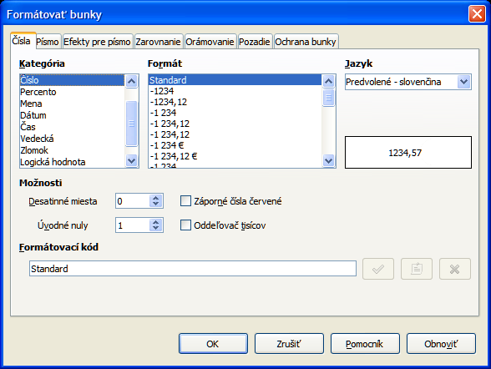
Figure 21: Format Cells dialog – Numbers page
- Make sure the Numbers tab is selected then select Number in the Category list.
- In Options > Leading Zeros, enter the minimum number of characters required. For example, for four characters, enter 4. Any number less than four characters will have leading zeros added, for example 12 becomes 0012.
- Click OK. The number entered retains its number format and any formula used in the spreadsheet will treat the entry as a number in formula functions.
Method 2
- Select the cell.
- Open the Sidebar (View > Sidebar) and click the Open Panel (+) icon on the Number Format panel to open it.
- Select Number in the Category list box.
- Set the Leading zeroes value box to 4. Formatting is applied immediately.
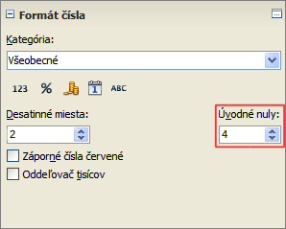
Figure 22: Set Leading zeroes
If a number is entered with leading zeroes, for example 01481, without first setting the Leading zeros parameter, then by default Calc will automatically drop the leading 0. To preserve leading zeros in a number:
- Type an apostrophe (') before the number, for example '01481.
- Move the cell focus to another cell. The apostrophe is automatically removed, the leading zeros are retained and the number is converted to text left aligned.

Numbers as text
Numbers can also be entered as text using one of the following methods.
Method 1
- With the cell selected, right-click on the cell and select Format Cells from the context menu or go to Format > Cells on the Menu bar or use the keyboard shortcut Ctrl+1 to open the Format Cells dialog (Figure 21).
- Make sure the Numbers page is selected, then select Text from the Category list.
- Click OK and the number, when entered, is converted to text and, by default, left aligned.
Method 2
- Select the cell.
- Open the Sidebar (View > Sidebar) and click the Open Panel (+) icon on the Number Format panel.
- Select Text in the Category list box. Formatting is applied to the cell immediately.
- Click back on the cell. Enter the number and move focus from the cell to have the data formatted.
Note | Any numbers that have been formatted as text in a spreadsheet will be treated as a zero by any formulas used in the spreadsheet. Formula functions will ignore text entries.

Text
Click in the cell and type the text. By default, text is left-aligned in a cell.

Date and time
Select the cell and type the date or time.
You can separate the date elements with a slash (/) or a hyphen (–) or use text, for example 10 Oct 2012. The date format automatically changes to the selected format used by Calc.
When entering a time, separate time elements with colons, for example 10:43:45. The time format automatically changes to the selected format used by Calc.
To change the date or time format used by Calc, use one of the following methods.
Method 1
- With the cell selected, right-click on the cell and select Format Cells from the context menu, or go to Format > Cells on the Menu bar, or use the keyboard shortcut Ctrl+1, to open the Format Cells dialog (Figure 21).
- Make sure the Numbers page is selected, then select Date or Time from the Category list.
- Select the date or time format you want to use from the Format list.
- Click OK.
Method 2
- Select the cell.
- Open the Sidebar (View > Sidebar) and click the Open Panel (+) icon on the Number Format panel.
- Select Date in the Category list box, or click the Date icon below the list box.
- Click the More Options button in the panel title bar to open the Format Cells dialog.
- Select the date or time format you want to use from the Format list.
- Click OK.
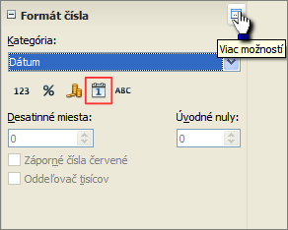
Figure 23: Select Date and More Options

Autocorrection options
Calc automatically applies many changes during data input using autocorrection, unless you have deactivated any autocorrect changes. You can also undo any autocorrection changes by using the keyboard shortcut Ctrl+Z or manually by going back to the change and replacing the autocorrection with what you want to actually see.
To change the autocorrect options, go to Tools > AutoCorrect Options on the Menu bar to open the AutoCorrect dialog (Figure 24).

Replace
Edits the replacement table for automatically correcting or replacing words or abbreviations in your document.

Exceptions
Specify the abbreviations or letter combinations that you do not want LibreOffice to correct automatically.
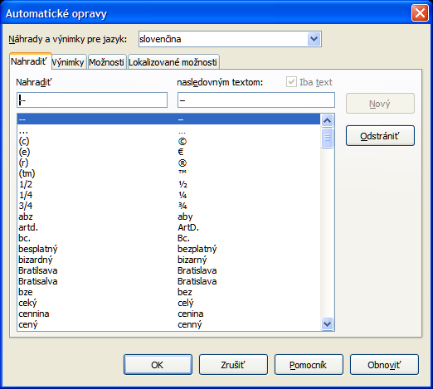
Figure 24: AutoCorrect dialog

Options
Select the options for automatically correcting errors as you type and then click OK.

Localized options
Specify the AutoCorrect options for quotation marks and for options that are specific to the language of the text.

Reset
Resets modified values back to the LibreOffice default values.

Deactivating automatic changes
Some AutoCorrect settings are applied when you press the spacebar after you enter data. To turn off or on Calc AutoCorrect, go to Tools > Cell Contents on the Menu bar and deselect or select AutoInput.

Speeding up data entry
Entering data into a spreadsheet can be very labor-intensive, but Calc provides several tools for removing some of the drudgery from input.
The most basic ability is to drop and drag the contents of one cell to another with a mouse. Many people also find AutoInput helpful. Calc also includes several other tools for automating input, especially of repetitive material. They include the fill tool, selection lists, and the ability to input information into multiple sheets of the same document.

Using the Fill tool
The Calc Fill tool is used to duplicate existing content or create a series in a range of cells in your spreadsheet (Figure 25).
- Select the cell containing the contents you want to copy or start the series from.
- Drag the mouse in any direction or hold down the Shift key and click in the last cell you want to fill.
- Go to Edit > Fill on the Menu bar and select the direction in which you want to copy or create data (Up, Down, Left or Right) or Series from the context menu.
Alternatively, you can use a shortcut to fill cells.
- Select the cell containing the contents you want to copy or start the series from.
- Move the cursor over the small square in the bottom right corner of the selected cell. The cursor will change shape.
- Click and drag in the direction you want the cells to be filled. If the original cell contained text, then the text will automatically be copied. If the original cell contained a number, a series will be created.
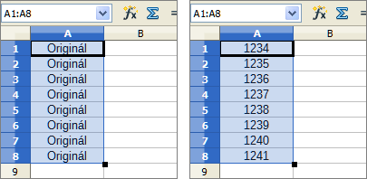
Figure 25: Using the Fill tool

Using a fill series
When you select a series fill from Edit > Fill > Series, the Fill Series dialog (Figure 26) opens. Here you can select the type of series you want.
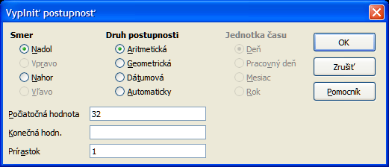
Figure 26: Fill Series dialog
- Direction – determines the direction of series creation.
- Down – creates a downward series in the selected cell range for the column using the defined increment to the end value.
- Right – creates a series running from left to right within the selected cell range using the defined increment to the end value.
- Up – creates an upward series in the cell range of the column using the defined increment to the end value.
- Left – creates a series running from right to left in the selected cell range using the defined increment to the end value.
- Series Type – defines the series type.
- Linear – creates a linear number series using the defined increment and end value.
- Growth – creates a growth series using the defined increment and end value.
- Date – creates a date series using the defined increment and end date.
- AutoFill – forms a series directly in the sheet. The AutoFill function takes account of customized lists. For example, by entering January in the first cell, the series is completed using the list defined in LibreOffice > Tools > Options > LibreOffice Calc > Sort Lists. AutoFill tries to complete a value series by using a defined pattern. For example, a numerical series using 1,3,5 is automatically completed with 7,9,11,13; a date and time series using 01.01.99 and 15.01.99, an interval of fourteen days is used.
- Unit of Time – in this area you specify the desired unit of time. This area is only active if the Date option has been chosen in the Series type area.
- Day – use the Date series type and this option to create a series using seven days.
- Weekday – use the Date series type and this option to create a series of five day sets.
- Month – use the Date series type and this option to form a series from the names or abbreviations of the months.
- Year – use the Date series type and this option to create a series of years.
- Start Value – determines the start value for the series. Use numbers, dates or times.
- End Value – determines the end value for the series. Use numbers, dates or times.
- Increment – determines the value by which the series of the selected type increases by each step. Entries can only be made if the linear, growth or date series types have been selected.
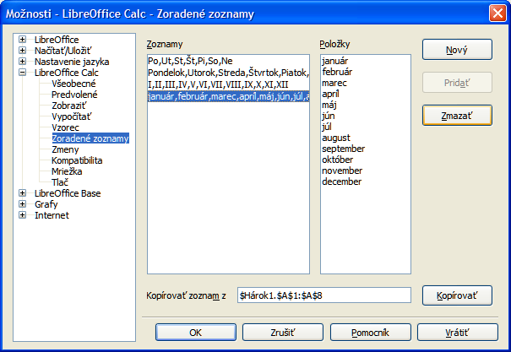Figure 27: Sort Lists dialog

Defining a fill series
To define your own fill series:
- Go to Tools > Options > LibreOffice Calc > Sort Lists to open the Sort Lists dialog (Figure 27). This dialog shows the previously-defined series in the Lists box on the left and the contents of the highlighted list in the Entries box.
- Click New and the Entries box is cleared.
- Type the series for the new list in the Entries box (one entry per line).
- Click Add and the new list will now appear in the Lists box.
- Click OK to save the new list.

Using selection lists
Selection lists are available only for text and are limited to using only text that has already been entered in the same column.
- Select a blank cell in a column that contains cells with text entries.
- Right-click and select Selection Lists from the context menu. A drop-down list appears listing any cell in the same column that either has at least one text character or whose format is defined as text.
- Click on the text entry you require and it is entered into the selected cell.

Sharing content between sheets
You might want to enter the same information in the same cell on multiple sheets, for example to set up standard listings for a group of individuals or organizations. Instead of entering the list on each sheet individually, you can enter the information in several sheets at the same time.
- Go to Edit > Sheet > Select on the Menu bar to open the Select Sheets dialog.
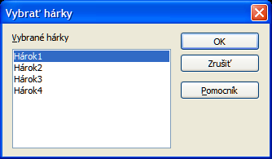
Figure 28: Select Sheets dialog
- Select the individual sheets where you want the information to be repeated. Use the Shift and Ctrl (Options on Mac) keys to select multiple sheets.
- Click OK to select the sheets and the sheet tabs will change color.
- Enter the information in the cells on the first sheet where you want it to appear and it will be repeated in all the selected sheets.
Note | This technique automatically overwrites, without any warning, any information that is already in the cells on the selected sheets. Make sure you deselect the additional sheets when you are finished entering information that is going to be repeated before continuing to enter data into your spreadsheet.

Validating cell contents
When creating spreadsheets for other people to use, validating cell contents ensures that they enter data that is valid and appropriate for the cell. You can also use validation in your own work as a guide to entering data that is either complex or rarely used.
Fill series and selection lists can handle some types of data, but are limited to predefined information. To validate new data entered by a user, select a cell and go to Data > Validity on the Menu bar to define the type of contents that can be entered in that cell. For example, a cell may require a date or a whole number with no alphabetic characters or decimal points, or a cell may not be left empty.
Depending on how validation is set up, validation can also define the range of contents that can be entered, provide help messages explaining the content rules set up for the cell and what users should do when they enter invalid content. You can also set the cell to refuse invalid content, accept it with a warning, or start a macro when an error is entered. See the Calc Guide Chapter 2 Entering, Editing and Formatting Data for more information on validating cell contents.

Editing data

Deleting data

Deleting data only
Data can be deleted from a cell without deleting any of the cell formatting. Click in the cell to select it and then press the Delete key.

Deleting data and formatting
Data and cell formatting can be deleted from a cell at the same time.
- Click in the cell to select it.
- Press the Backspace key, or right-click in the cell and select Delete Contents from the context menu, or go to Edit > Delete Contents) on the Menu bar to open the Delete Contents dialog (Figure 29). Here you can delete the different aspects of the data in the cell or to delete everything in the cell.
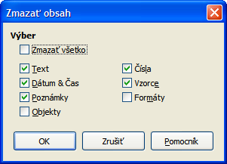
Figure 29: Delete Contents dialog

Replacing data
To completely replace data in a cell and insert new data, select the cell and type in the new data. The new data will replace the data already contained in the cell but will retain the original formatting used in the cell.
Alternatively, click in the Input Line on the Formula Bar (Figure 2 on page 8), then double-click on the data to highlight it completely and type the new data.

Editing data
Sometimes it is necessary to edit the contents of cell without removing all of the data from the cell. For example, changing the phrase “Sales in Qtr. 2” to “Sales rose in Qtr” can be done as follows.

Using the keyboard
- Click in the cell to select it.
- Press the F2 key and the cursor is placed at the end of the cell.
- Use the keyboard arrow keys to reposition the cursor where you want to start entering the new data in the cell.
- When you have finished, press the Enter key and your editing changes are saved.

Using the mouse
- Double-click on the cell to select it and place the cursor in the cell for editing.
- Move the cursor to the Input Line on the Formula Bar (Figure 2 on page 8) and click at the position where you want to start entering the new data in the cell.
When you have finished, click away from the cell to deselect it and your editing changes are saved.

Formatting data
Note | All the settings discussed in this section can also be set as a part of the cell style. See the Calc Guide Chapter 4 Using Styles and Templates in Calc for more information.

Multiple lines of text
Multiple lines of text can be entered into a single cell using automatic wrapping or manual line breaks. Each method is useful for different situations.

Automatic wrapping
To automatically wrap multiple lines of text in a cell, use one of the following methods.
Method 1
- Right-click on the cell and select Format Cells from the context menu, or go to Format > Cells on the Menu bar, or press Ctrl+1, to open the Format Cells dialog.
- Click on the Alignment tab (Figure 30).
- Under Properties, select Wrap text automatically and click OK.
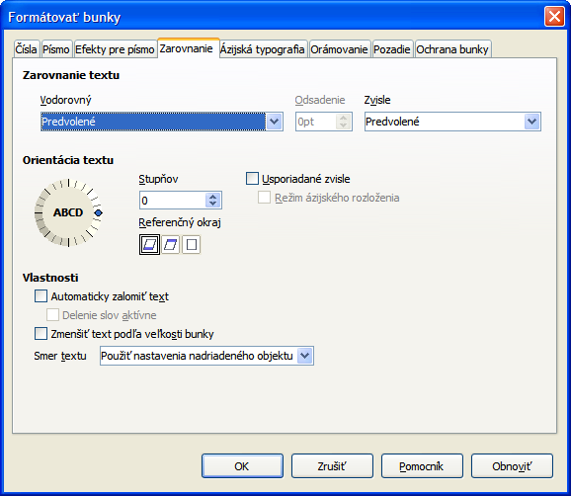
Figure 30: Format Cells dialog – Alignment page
Method 2
- Select the cell.
- Open the Sidebar (View > Sidebar) and click the Open Panel (+) icon on the Alignment panel.
- Select the Wrap text option to apply the formatting immediately.
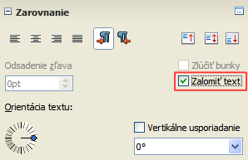
Figure 31: Wrap text formatting

Manual line breaks
To insert a manual line break while typing in a cell, press Ctrl+Enter. This method does not work with the cursor in the input line. When editing text, double-click the cell, then reposition the cursor to where you want the line break.
When a manual line break is entered, the cell width does not change and your text may still overlap the end of the cell. You have to change the cell width manually or reposition your line break so that your text does not overlap the end of the cell.

Shrinking text to fit the cell
The font size of the data in a cell can automatically adjust to fit inside cell borders. To do this, select the Shrink to fit cell size option under Properties in the Format Cells dialog (Figure 30) on the Alignment page. This dialog is also available by clicking the More Options button in the Character title bar of the Properties deck on the opened Sidebar.

Formatting numbers
Several different number formats can be applied to cells by using icons on the Formatting toolbar (highlighted in Figure 32). Select the cell, then click the relevant icon to change the number format.
Figure 32: Number icons on Formatting toolbar
For more control or to select other number formats, use the Numbers page of the Format Cells dialog (Figure 21 on page 28):
- Apply any of the data types in the Category list to the data.
- Control the number of decimal places and leading zeros in Options.
- Enter a custom format code.
- The Language setting controls the local settings for the different formats such as the date format and currency symbol.
Some number formats are available from the Sidebar’s Number Format panel in the Properties deck. Click the More Options button to open the Format Cells dialog described above.
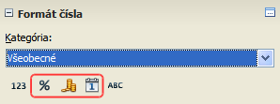
Figure 33: Number format icons in the Number Format panel on the Sidebar

Formatting a font
To quickly select a font and format it for use in a cell:
- Select the cell.
- Click the small triangle on the right of the Font Name box on the Formatting toolbar (highlighted in Figure 34) and select a font from the drop-down list.
- Click on the small triangle on the right of the Font Size on the Formatting toolbar and select a font size from the drop down list.
Figure 34: Font Name and Size on Formatting toolbar
- To change the character format, click on the Bold (B), Italic (I), or Underline (U) icons.
- To change the paragraph alignment of the font, click on one of the four alignment icons (Left, Center, Right, Justified) .
- To change the font color, click the arrow next to the Font Color icon to display the color palette, then select the desired color.
The Properties deck of the Sidebar has two panels, Character and Alignment, which between them contain all the formatting controls from the Formatting toolbar.
To specify the language used in the cell, open the Font page on the Format Cells dialog. You can also select the More Options button on either of the Sidebar panels to open the Format Cells dialog. Changing language in a cell allows different languages to be used within the same document.
Use the Font Effects tab on the Format Cells dialog to set other font characteristics. See the Calc Guide Chapter 4 Using Styles and Templates in Calc for more information.

Formatting cell borders
To format the borders of a cell or a group of selected cells, click on the Borders icon on the Formatting toolbar, and select one of the border options displayed in the palette.
To format the line style and line color for the borders of a cell, click the small arrows next to the Line Style and Line Color (Border Color) icons on the Formatting toolbar. A line style palette and a border color palette respectively are displayed.
The Cell Appearance panel of the Properties deck in the Sidebar contains Cell border, Line style and Line color controls.
For more control, including the spacing between cell borders and any data in the cell, use the Borders page of the Format Cells dialog (Figure 21 on page 28), where you can also define a shadow style. Clicking the More Options button on the Cell Appearance title bar, or clicking More in the panel’s line style drop-down list, opens the Format Cells dialog at the Borders page.
See the Calc Guide Chapter 4 Using Styles and Templates in Calc for more information.
Note | Cell border properties apply only to the selected cells and can only be changed if you are editing those cells. For example, if cell C3 has a top border, that border can only be removed by selecting C3. It cannot be removed in C2 despite also appearing to be the bottom border for cell C2.

Formatting cell background
To format the background color for a cell or a group of cells, click the small arrow next to the Background Color icon on the Formatting toolbar. A color palette, similar to the Font Color palette, is displayed. You can also use the Background tab of the Format Cells dialog (Figure 21 on page 28). The Cell Appearance panel of the Properties deck in the Sidebar contains a Cell background control with a color palette. See the Calc Guide Chapter 4 Using Styles and Templates in Calc for more information.

AutoFormat of cells

Using AutoFormat
You can use Calc’s AutoFormat feature to format a group of cells quickly and easily.
- Select the cells in at least three columns and rows, including column and row headers, that you want to format.
- Go to Format > AutoFormat on the Menu bar to open the AutoFormat dialog (Figure 35).
- Select the type of format and format color from the list.
- If necessary, click More to open Formatting if Formatting is not visible.
- Select the formatting properties to be included in the AutoFormat function.
- Click OK.
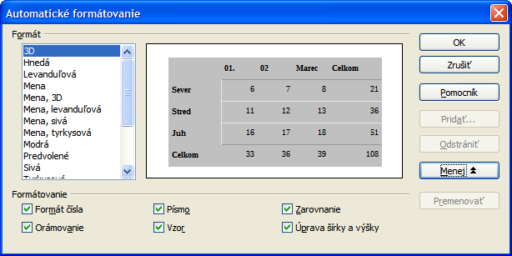
Figure 35: AutoFormat dialog

Defining a new AutoFormat
You can define a new AutoFormat so that it becomes available for use in all spreadsheets.
- Format the data type, font, font size, cell borders, cell background and so on for a group of cells.
- Go to Edit > Select All on the Menu bar to select the whole spreadsheet.
- Go to Format > AutoFormat to open the AutoFormat dialog and the Add button is now active.
- Click Add.
- In the Name box of the Add AutoFormat dialog that opens, type a meaningful name for the new format.
- Click OK to save. The new AutoFormat is now available in the Format list in the AutoFormat dialog.

Using themes
Calc comes with a predefined set of formatting themes that you can apply to spreadsheets. It is not possible to add themes to Calc and they cannot be modified. However, you can modify their styles after you apply them to a spreadsheet and the modified styles are only available for use for that spreadsheet when you save the spreadsheet.
To apply a theme to a spreadsheet:
- Click the Choose Themes icon in the Tools toolbar. If this toolbar is not visible, go to View > Toolbars on the Menu bar and select Tools, and the Theme Selection dialog (Figure 36) opens. This dialog lists the available themes for the whole spreadsheet.
- Select the theme that you want to apply. As soon as you select a theme, the theme styles are applied to the spreadsheet and are immediately visible.
- Click OK.
- If you wish, you can now open the Styles and Formatting window to modify specific styles. These modifications do not modify the theme; they only change the appearance of the style in the specific spreadsheet you are creating.
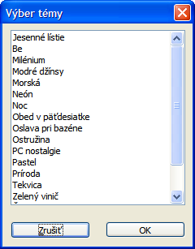
Figure 36: Theme Selection dialog

Using conditional formatting
You can set up cell formats to change depending on conditions that you specify. For example, in a table of numbers, you can show all the values above the average in green and all those below the average in red.
Conditional formatting depends upon the use of styles and the AutoCalculate feature must be enabled. Go to Tools > Cell Contents > AutoCalculate on the Menu bar to enable this feature. See the Calc Guide Chapter 2 Entering, Editing, and Formatting Data for more information.

Hiding and showing data
In Calc you can hide elements so that they are neither visible on a computer display nor printed when a spreadsheet is printed. However, hidden elements can still be selected for copying if you select the elements around them. For example, if column B is hidden, it is copied when you select columns A and C.

Hiding data
To hide sheets, rows, and columns:
- Select the sheet, row or column you want to hide.
- Go to Format on the Menu bar and select Sheet, Row or Column.
- Select Hide from the menu and the sheet, row or column can no longer viewed or printed.
- Alternatively, right-click on the sheet tab, row header or column header and select Hide from the context menu.
To hide and protect data in selected cells:
- Select the cells you want to hide.
- Go to Format > Cells on the Menu bar, or right-click and select Format Cells from the context menu, or use the keyboard shortcut Ctrl+1 to open the Format Cells dialog.
- Click the Cell Protection tab (Figure 37) and select an option to hide the cells.
- Click OK.
- Go to Tools > Protect Document and select Sheet from the menu options. The Protect Sheet dialog dialog will open (Figure 38).
- Select Protect this sheet and the contents of protected cells.
- Create a password and then confirm the password.
- Select or deselect the user selection options for cells.
- Click OK.
For more information on how to hide and show data, including how to use outline groups and filtering, see the Calc Guide Chapter 2 Entering, Editing, and Formatting Data.
Note | When data in cells are hidden, it is only the data contained in the cells that are hidden and the protected cells cannot be modified. The blank cells remain visible in the spreadsheet.
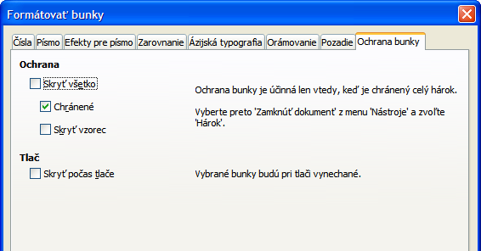
Figure 37: Cell Protection page in Format Cells dialog
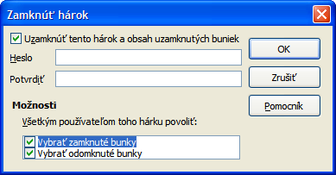
Figure 38: Protect Sheet dialog

Showing data
To show hidden sheets, rows, and columns:
- Select the sheets, rows or columns each side of the hidden sheet, row or column.
- Go to Format on the Menu bar and select Sheet, Row or Column.
- Select Show from the menu and the sheet, row or column will be displayed and can be printed.
- Alternatively, right-click on the sheet tabs, row headers or column headers and select Show from the context menu.
To show hidden data in cells:
- Go to Tools > Protect Document and select Sheet from the menu options.
- Enter the password to unprotect the sheet and click OK.
- Go to Format > Cells on the Menu bar, or right-click and select Format Cells from the context menu, or use the keyboard shortcut Ctrl+1 to open the Format Cells dialog.
- Click the Cell Protection tab (Figure 37) and deselect the hide options for the cells.
- Click OK.

Sorting records
Sorting within Calc arranges the cells in a sheet using the sort criteria that you specify. Several criteria can be used and a sort applies each criteria consecutively. Sorts are useful when you are searching for a particular item and become even more useful after you have filtered data.
Also, sorting is useful when you add new information to your spreadsheet. When a spreadsheet is long, it is usually easier to add new information at the bottom of the sheet, rather than adding rows in their correct place. After you have added information, you then carry out a sort to update the spreadsheet.
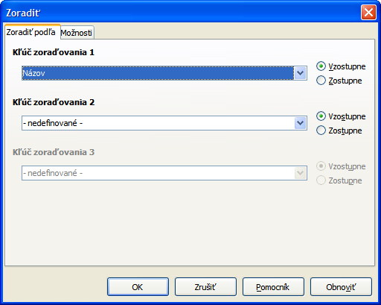
Figure 39: Sort Criteria dialog
To sort cells in your spreadsheet:
- Select the cells to be sorted.
- Go to Data > Sort on the Menu bar to open the Sort dialog (Figure 39).
- Select the sort criteria from the drop down lists. The selected lists are populated from the selected cells.
- Select either ascending order (A-Z, 1-9) or descending order (Z-A, 9-1).
- Click OK and the sort is carried out on your spreadsheet.
For more information on how to sort records and the sorting options available, see the Calc Guide Chapter 2 Entering, Editing, and Formatting Data.

Using formulas and functions
You may need more than numbers and text on your spreadsheet. Often the contents of one cell depend on the contents of other cells. Formulas are equations that use numbers and variables to produce a result. Variables are placed in cells to hold data required equations.
A function is a predefined calculation entered in a cell to help you analyze or manipulate data. All you have to do is enter the arguments and the calculation is automatically made for you. Functions help you create the formulas required to get the results that you are looking for.
See the Calc Guide, Chapter 7 Using Formulas and Functions for more information.

Analyzing data
Calc includes several tools to help you analyze the information in your spreadsheets, ranging from features for copying and reusing data, to creating subtotals automatically, to varying information to help you find the answers you need. These tools are divided between the Tools and Data menus.
One of the most useful of these tools is the PivotTable, which is used for combining, comparing, and analyzing large amounts of data easily. Using the PivotTable, you can view different summaries of the source data, display the details of areas of interest, and create reports, whether you are a beginner, an intermediate or advanced user.
See the Calc Guide Chapter 8 Using Pivot Tables and Chapter 9 Data Analysis for more information on pivot tables and other tools available in Calc to analyze your data.

Printing
Printing from Calc is much the same as printing from other LibreOffice components (see Chapter 10 Printing, Exporting, and Emailing in this guide). However, some details for printing in Calc are different, especially regarding preparation for printing.

Print ranges
Print ranges have several uses, including printing only a specific part of the data or printing selected rows or columns on every page. For more information about using print ranges, see the Calc Guide Chapter 6 Printing, Exporting, and E-mailing.

Defining a print range
To define a new print range or modify an existing print range:
- Select the range of cells to be included in the print range.
- Go to Format > Print Ranges > Define on the Menu bar. Page break lines are displayed on screen.
- To check the print range, go to File > Page Preview on the Menu bar or click on the Page Preview icon . LibreOffice will display the cells in the print range.

Adding to a print range
After defining a print range, you can add more cells to it by creating another print range. This allows multiple, separate areas of the same sheet to be printed while not printing the whole sheet.
- After defining a print range, select an extra range of cells for adding to the print range.
- Go to Format > Print Ranges > Add on the Menu bar to add the extra cells to the print range. The page break lines are no longer displayed on the screen.
- To check the print ranges, go to File > Page Preview on the Menu bar or click on the Page Preview icon . LibreOffice will display the print ranges as separate pages.
Note | The additional print range will print as a separate page, even if both ranges are on the same sheet.

Removing a print range
It may become necessary to remove a defined print range, for example, if the whole sheet needs to be printed later.
To remove all the defined print ranges, go to Format > Print Ranges > Remove on the Menu bar. After the print ranges have been removed, the default page break lines will appear on the screen.

Editing a print range
At any time, you can directly edit the print range, for example to remove or resize part of the print range. Go to Format > Print Ranges > Edit on the Menu bar to open the Edit Print Ranges dialog where you can define the print range.

Printing options
To select the printing options for page order, details, and scale to be used when printing a spreadsheet:
- Go to Format > Page on the Menu bar to open the Page Style dialog (Figure 40).
- Select the Sheet tab and make your selections from the available options.
- Click OK.
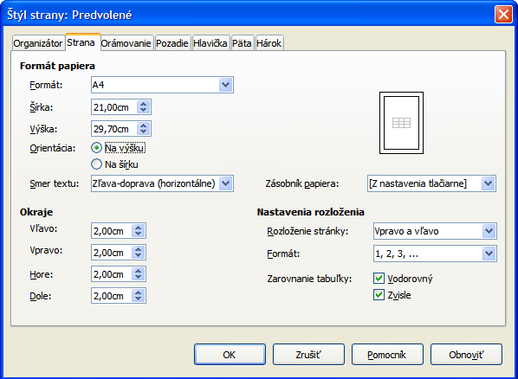
Figure 40: Page Style dialog

Repeat printing of rows or columns
If a sheet is printed on multiple pages, you can set up certain rows or columns to repeat on each printed page. For example, if the top two rows of the sheet as well as column A need to be printed on all pages, do the following:
- Go to Format > Print Ranges > Edit on the Menu bar to open the Edit Print Ranges dialog (Figure 41).
- Type the row identifiers in the Rows to repeat box. For example, to repeat rows 1 and 2, type $1:$2. This automatically changes Rows to repeat from, - none - to - user defined -.
- Type the column identifiers in the Columns to repeat box. For example, to repeat column A, type $A. In the Columns to repeat list, - none - changes to - user defined -.
- Click OK.
For more information on editing print ranges, see the Calc Guide, Chapter 6 Printing, Exporting, and E-mailing.
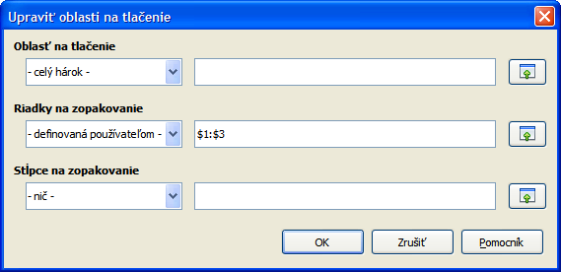Figure 41: Edit Print Ranges dialog

Page breaks
While defining a print range can be a powerful tool, it may sometimes be necessary to manually adjust the Calc printout manually using a manual or page break. A page break helps to ensure that your data prints properly according to your page size and page orientation. You can insert a horizontal page break above or a vertical page break to the left of the active cell.
For more information on manual breaks, see the Calc Guide Chapter 6 Printing, Exporting, and E-mailing.

Inserting a break
To insert a page break:
- Navigate to the cell where the page break will begin.
- Go to Insert > Page Break on the Menu bar.
- Select Row Break to create a page break above the selected cell.
- Select Column Break to create a page break to the left of the selected cell.

Deleting a page break
To remove a page break:
- Navigate to a cell that is next to the break you want to remove.
- Go to Edit > Delete Page Break on the Menu bar.
- Select Row Break or Column Break depending on your need and break is removed.
For more information on printing options, see the Calc Guide Chapter 6 Printing, Exporting, and E-mailing.
Note | Multiple manual row and column breaks can exist on the same page. When you want to remove them, you have to remove each break individually.

Headers and footers
Headers and footers are predefined pieces of text that are printed at the top or bottom of a printed page when a spreadsheet is printed. Headers and footers are set and defined using the same method. For more information on setting and defining headers and footers, see the Calc Guide Chapter 6 Printing, Exporting, and E-mailing.
Headers and footers are also assigned to a page style. You can define more than one page style for a spreadsheet and assign different page styles to different sheets within a spreadsheet. For more information on page styles, see the Calc Guide Chapter 4 Using Styles and Templates.

Setting a header or footer
To set a header or footer:
- Navigate to the sheet that you want to set the header or footer for.
- Go to Format > Page on the Menu bar to open the Page Style dialog (Figure 42).
- On the Page Style dialog, select Header or Footer tab.
- Select the Header on or Footer on option.
- Select Same content left/right option if you want the same header or footer to appear on all the printed pages.
- Set the margins, spacing, and height for the header or footer. You can also select AutoFit height box to automatically adjust the height of the header or footer.
- To change the appearance of the header or footer, click on More to open the borders and background dialog.
- To set the contents, for example page number, date and so on, that appears in the header or footer, click on Edit to open the style dialog.
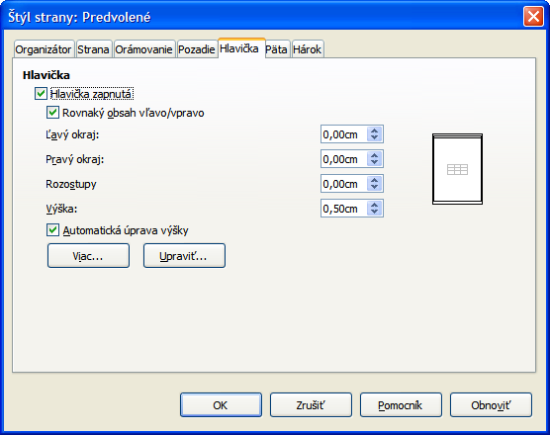
Figure 42: Header page of Page Style dialog

