
Getting Started Guide
Chapter 7
Getting Started with Draw
Vector Drawing in LibreOffice

Copyright
This document is Copyright © 2010–2014 by the LibreOffice Documentation Team. Contributors are listed below. You may distribute it and/or modify it under the terms of either the GNU General Public License (http://www.gnu.org/licenses/gpl.html), version 3 or later, or the Creative Commons Attribution License (http://creativecommons.org/licenses/by/4.0/), version 4.0 or later.
All trademarks within this guide belong to their legitimate owners.

Contributors
Ron Faile Jr. Jean Hollis Weber Peter Schofield

Feedback
Please direct any comments or suggestions about this document to the Documentation Team’s mailing list: documentation@global.libreoffice.org
Note: Everything you send to a mailing list, including your email address and any other personal information that is written in the message, is publicly archived and cannot be deleted.

Acknowledgments
This chapter is based on the Chapter 7 of Getting Started with OpenOffice.org 3.3. The contributors to that chapter are:
Agnes Belzunce Chris Bonde Daniel Carrera
Regina Henschel Michel Pinquier Iain Roberts
Gary Schnabl Joe Sellman Jim Taylor
Alex Thurgood Jean Hollis Weber Linda Worthington
Michele Zarri

Publication date and software version
Published 24 March 2014. Based on LibreOffice 4.2.

Note for Mac users
Some keystrokes and menu items are different on a Mac from those used in Windows and Linux. The table below gives some common substitutions for the instructions in this chapter. For a more detailed list, see the application Help.
Windows or Linux | Mac equivalent | Effect
Tools > Options menu selection | LibreOffice > Preferences | Access setup options
Right-click | Control+click or right-click depending on computer system | Opens a context menu
Ctrl (Control) | ⌘ (Command) | Used with other keys
F5 | Shift+⌘+F5 | Opens the Navigator
F11 | ⌘+T | Opens the Styles and Formatting window

Contents
Copyright 2
Contributors 2
Feedback 2
Acknowledgments 2
Publication date and software version 2
Note for Mac users 2
What is Draw? 6
Draw main window 6
Workspace 6
Page pane 7
Sidebar 7
Rulers 8
Status bar 9
Toolbars 9
Standard toolbar 9
Drawing toolbar 10
Line and Filling toolbar 10
Text Formatting toolbar 10
Options toolbar 10
Choosing and defining colors 11
Drawing basic shapes 12
Drawing a straight line 12
Drawing an arrow 14
Choosing line endings 14
Drawing rectangles or squares 14
Drawing circles or ellipses 15
Drawing curves or polygons 15
Curves 16
Polygons 16
Polygons 45° 16
Freeform lines 16
Adding text 16
Glue points and connectors 17
Glue points 17
Connectors 18
Drawing geometric shapes 19
Basic shapes 20
Symbol shapes 20
Block arrows 20
Flowcharts 20
Callouts 21
Stars and banners 21
Selecting objects 21
Direct selection 21
Selection by framing 21
Selecting hidden objects 21
Arranging objects 22
Moving and adjusting object size 22
Moving objects 23
Adjusting object size 23
Rotating and slanting an object 24
Rotating an object 24
Slanting an object 25
Editing objects 25
Line and Filling toolbar 26
Text Formatting toolbar 26
Sidebar Properties 27
Context menu 27
Formatting lines and borders 27
Arrows, arrowheads and line endings 28
Formatting area fill 28
Using styles 29
Positioning objects 29
Snap function 29
Snap to grid 29
Displaying the grid 29
Configuring the grid 30
Help lines 30
Applying special effects 30
Flipping objects 31
Mirror copies 31
Distorting an object 31
Dynamic transparency gradients 32
Duplication 32
Cross-fading 33
Combining multiple objects 33
Grouping 34
Temporary grouping 34
Permanent grouping 34
Ungrouping 34
Combining objects 34
Arranging, aligning and distributing objects 35
Inserting and editing pictures 35
Working with 3D objects 35
Exporting graphics 35
Inserting comments in a drawing 36

What is Draw?
LibreOffice Draw is a vector graphics drawing program, although it can also perform some operations on raster graphics (pixels). Using Draw, you can quickly create a wide variety of graphical images.
Vector graphics store and display an image as simple geometric elements such as lines, circles, and polygons rather than a collections of pixels (points on the screen). Vector graphics allow for easier storage and scaling of the image.
Draw is fully integrated into the LibreOffice suite, and this simplifies exchanging graphics with all components of the suite. For example, if you create an image in Draw, reusing it in a Writer document is as simple as copying and pasting the image. You can also work with drawings directly from within Writer or Impress, using a subset of the functions and tools from Draw.
The functionality of LibreOffice Draw is extensive and, even though it was not designed to rival high-end graphics applications, it possesses more functionality than the drawing tools that are generally integrated with most office productivity suites.
A few examples of the drawing functions are: layer management, magnetic grid-point system, dimensions and measurement display, connectors for making organization charts, 3D functions that enable small three-dimensional drawings to be created (with texture and lighting effects), drawing and page-style integration, and Bézier curves.
This chapter introduces some features of Draw and does not attempt to cover all of the Draw features. See the Draw Guide and the application help for more information.

Draw main window
The main components of the Draw main window are shown in Figure 1 and are as follows:
- Main menu bar
- Standard toolbar
- Line and Filling toolbar
- Page pane
- Workspace
- Status bar
- Drawing toolbar
- Sidebar

Workspace
The large area in the center of the window (Workspace) is where you create your drawings and this drawing area can be surrounded with toolbars and information areas. The number and position of the visible tools vary with the task in hand and user preferences, therefore your setup may look different from Figure 1.
In LibreOffice Draw, the maximum size of a drawing is 300 cm by 300 cm.

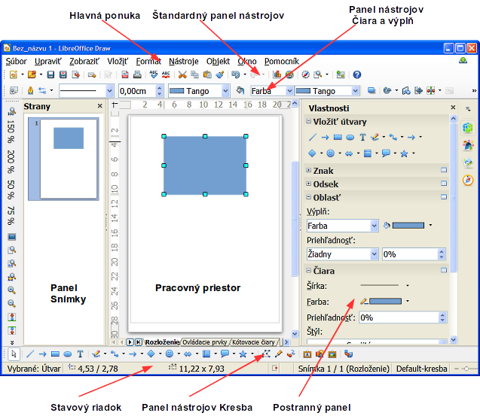Figure 1: LibreOffice Draw workspace

Page pane
You can split drawings in Draw over several pages. Multi-page drawings are used mainly for presentations. The Pages pane gives an overview of the pages that you create in your drawing. If the Pages pane is not visible, go to View on the main menu bar and select Page Pane from the context menu. To make changes to the page order, just drag and drop one or more pages.

Sidebar
The Sidebar has four main sections. To expand a section you want to use, click on its icon or click on the small triangle at the top of the icons and select a section from the drop down list. Only one section at a time can be open. If the Sidebar is not visible, go to View on the main menu bar and select Sidebar from the context menu.
Properties
Opens sub-sections for object properties that you can change to suit your requirements. The sub-sections are Insert Shapes, Character, Paragraph, Area, Line and Position and Size.
Styles and Formatting
Here you can edit and apply image styles to objects within your drawing. When you edit a style, the changes are automatically applied to all of the elements formatted with this image style in your drawing.
Gallery
Opens the Drawing gallery where you can insert an object into your drawing either as a copy or as a link. A copy of an object is independent of the original object. Changes to the original object have no effect on the copy. A link remains dependent on the original object. Changes to the original object are also reflected in the link.
Navigator
Opens the Drawing navigator, in which you can quickly move between pages in your drawing or select an object on the drawing. It is recommended to give pages and objects in your drawing meaningful names so that you can easily identify them when using the Navigator.

Rulers
You should see rulers (bars with numbers) on the upper and left-hand sides of the workspace. If they are not visible, you can enable them by selecting View > Ruler in the main menu bar. The rulers show the size of a selected object on the page using double lines (highlighted in Figure 2). When no object is selected, they show the location of the mouse pointer, which helps to position drawing objects more accurately.
You can also use the rulers to manage object handles and guide lines, making it easier to position objects.
The page margins in the drawing area are also represented on the rulers. You can change the margins directly on the rulers by dragging them with the mouse. The margin area is indicated by the grayed out area on the rulers as shown in Figure 2.
To change the measurement units of the rulers, which can be defined independently, right-click on a ruler and select the measurement units from the drop down list, as illustrated for the horizontal ruler in Figure 3.
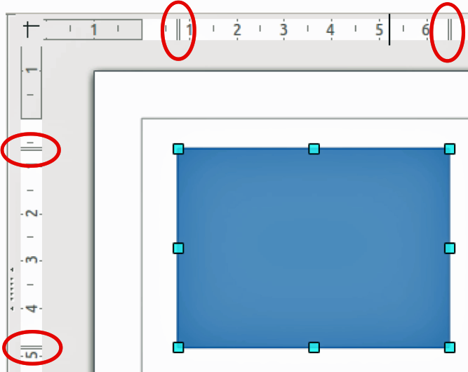
Figure 2: Rulers showing size of a selected object
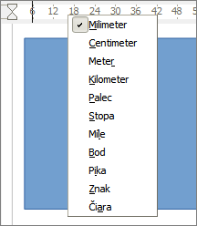
Figure 3: Ruler units

Status bar
The Status bar is located at the bottom of the screen in all LibreOffice components; it includes several Draw-specific fields. For details on the contents and use of these fields, see Chapter 1 Introducing LibreOffice in this guide and in the Draw Guide Chapter 1 Introducing Draw.
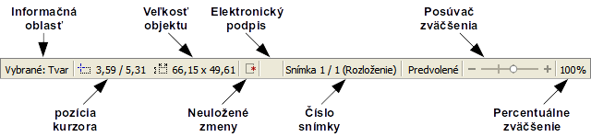
Figure 4: Draw status bar
Note | The sizes are given in the current measurement unit and are not to be confused with the ruler units. The measurement unit on the Status bar is defined in Tools > Options > LibreOffice Draw > General, where you can also change the scale of the page.

Toolbars
To display or hide the various Draw toolbars, go to View > Toolbars on the main menu bar. On the menu that appears, select which toolbars you want to display. For more about working with toolbars, see Chapter 1 Introducing LibreOffice in this guide.
The tools available in the Draw toolbars are explained in the following sections. The appearance of the toolbar icons may vary depending on your operating system and the selection of icon size and style in Tools > Options > LibreOffice > View.

Standard toolbar
The Standard toolbar is the same for all LibreOffice components and is not described in detail in this chapter.
Figure 5: Standard toolbar

Drawing toolbar
The Drawing toolbar is the most important toolbar in Draw. It contains all the necessary functions for drawing various geometric and freehand shapes and for organizing them on the page.
Figure 6: Drawing toolbar

Line and Filling toolbar
The Line and Filling toolbar lets you modify the main properties of a drawing object. The icons and pull-down lists vary, according to the type of object selected. For example, to change the style of a line, click on the up and down arrows for Line Style and select the required style.
Figure 7: Line and Filling toolbar

Text Formatting toolbar
If the selected object is text, the Line and Filling toolbar changes to the Text Formatting toolbar, which is similar to the Formatting toolbar in Writer. For more information, see Chapter 4 Getting Started with Writer in this guide.
Figure 8: Text Formatting toolbar

Options toolbar
Use the Options toolbar to activate or deactivate various drawing aids. The Options toolbar is not one of the toolbars displayed by default. To display the Options toolbar, select View > Toolbars > Options.
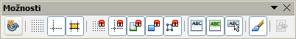
Figure 9: Options toolbar
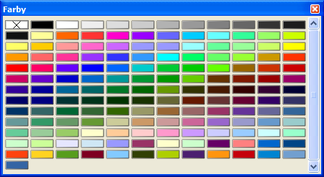
Figure 10: Colors dialog

Choosing and defining colors
To display the Colors dialog (Figure 10), select View > Toolbars > Color Bar to display the current color palette. This dialog lets you rapidly choose the color of the various objects (lines, areas, and 3D effects). The first box in the panel corresponds to none (no color).
You can access several specialized color palettes in Draw, as well as change individual colors to your own taste. This is done using the Area dialog by selecting Format > Area on the main menu bar or clicking the Area icon on the Line and Filling toolbar, then selecting the Colors tab (Figure 11).
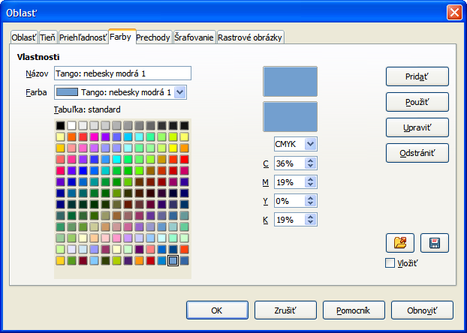
Figure 11: Area dialog – Colors page
To load another palette, click on the Load Color List icon . The file selector dialog asks you to choose one of the standard LibreOffice palettes (files with the file extension *.soc). For example, web.soc is a color palette that is adapted to creating drawings for placing in web pages. These colors will display correctly on workstations with screens capable of at least 256 colors.
The color selection box also lets you individually change any color by modifying the numerical values in the fields provided to the right of the color palette. You can use the color schemes known as CMYK (Cyan, Magenta, Yellow, Black) or RGB (Red, Green, Blue).
Click on the Edit button to open the Color dialog, where you can set individual colors. See “Color options” in Chapter 2 Setting Up LibreOffice in this guide.
For a more detailed description of color palettes and their options, see the Draw Guide Chapter 10 Advanced Draw Techniques.

Drawing basic shapes
Draw provides a wide range of shapes, located in palettes accessed from the Drawing toolbar (Figure 6) and a full list of these various tools is shown in Figure 12. The icons or buttons that are already installed on the Drawing toolbar are highlighted in Figure 12.
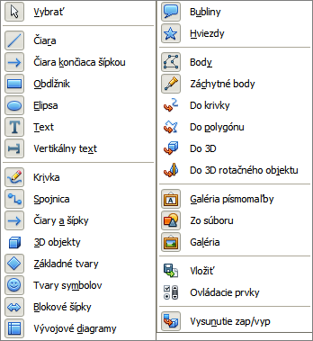
Figure 12: Tools available for Drawing toolbar
This section describes only a few of the basic shapes, including text, which are treated as objects in Draw. See the Draw Guide for a complete description of the shapes available.
Please note that some of the icons on the Drawing toolbar will change according to the shape that has been selected from the choice available. Icons with tool palettes available are indicated by a small triangle to the right of the icon.
Note | When you draw a basic shape or select one for editing, the Info field at the left side in the status bar changes to reflect the present action: for example Line created, Text frame xxyy selected, and so on.

Drawing a straight line
Click on the Line icon and place the cursor at the point where you want to start the line (Figure 13). Drag the mouse while keeping the mouse button pressed. Release the mouse button at the point where you want to end the line. A selection handle appears at each end of the line, showing that this object is the currently selected object. The selection handle at the starting point of the line is slightly larger than the other selection handle.
Keep the Shift key pressed while you draw a line to restrict the drawing angle of the line to a multiple of 45 degrees (0, 45, 90, 135, and so on).
Note | This is the default behavior of the Shift key. However, if the option When creating or moving objects in the Snap position section of Tools > Options > LibreOffice Draw > Grid has been selected, the action of the Shift key is the opposite. Lines will automatically be drawn at a multiple of 45 degrees unless the Shift key is pressed.
Keep the Ctrl key pressed while drawing a line to enable the end of the line to snap to the nearest grid point.
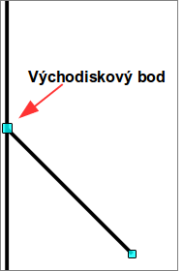
Figure 13: Drawing a straight line
Note | This is the default behavior of the Ctrl key. However, if the Snap to Grid option on the View > Grid menu has been selected, the Ctrl key deactivates the snap to grid activity.
Hold down the Alt key while drawing a line to cause the line to extend outwards symmetrically in both directions from the start point. This lets you draw lines by starting from the middle of the line.
When a line is drawn, it uses default attributes. To change any of these attributes, select a line by clicking on it, then right-click and select Line from the context menu or got to Format > Line on the main menu bar to open the Line dialog (Figure 14). Alternatively, click on the Properties icon on the Sidebar and open the Line sub-section. Line style, line width, and line color can also be changed using the controls in the Line and Filling toolbar at the top of the workspace.
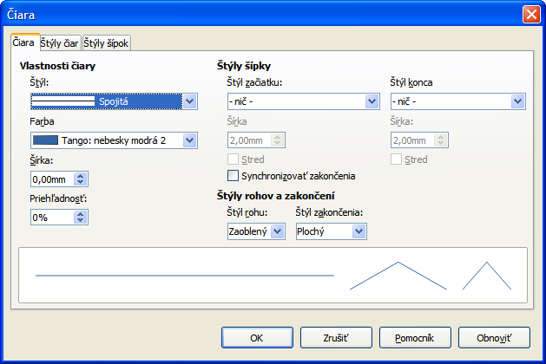
Figure 14: Line dialog

Drawing an arrow
Arrows are drawn like lines. In fact Draw classifies arrows as a subgroup of lines: lines with arrowheads. The information field on the status bar shows them only as lines. Click on the Line Ends with Arrow icon on the Drawing toolbar or the Insert Shapes sub-section in Sidebar Properties to draw an arrow. The arrow head is drawn at the end point of the arrow when you release the mouse button.

Choosing line endings
Several types of line endings (arrows, circles, squares, and others) are available in Draw. Click on the small triangle to the right of the Lines and Arrows icon on the Drawing toolbar or the Insert Shapes sub-section in Sidebar Properties to open a tool palette containing tools for drawing lines and arrows. Alternatively, go to View > Toolbars > Arrows to open the Arrows toolbar as a floating toolbar (Figure 15). The icon for the tool used most recently will be shown on the Drawing toolbar or the Insert Shapes sub-section in Sidebar Properties to make it easier to use the same tool again.
After drawing the line, you can change the arrow style by clicking on the Arrowheads icon in the Line and Filling toolbar and select the arrow start and end options.
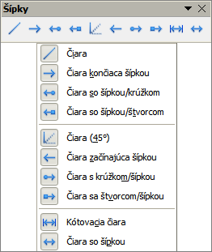
Figure 15: Arrows toolbar and available tools

Drawing rectangles or squares
Drawing a rectangle is similar to drawing a straight line. Click on the Rectangle icon in the Drawing toolbar or the Insert Shapes sub-section in Sidebar Properties. As you draw the rectangle with the mouse cursor, the rectangle appears with the bottom right corner of the rectangle attached to the cursor.
Squares are rectangles with all sides of equal length. To draw a square, click on the Rectangle icon and hold down the Shift key whilst you draw a square.
Note | If the option When creating or moving objects has been selected in Tools > Options > LibreOffice Draw > General, the action of the Shift key is reversed. When the Rectangle tool is selected, a square is drawn. To draw a rectangle, you have to press the Shift key when drawing. This Shift key reversal also applies when drawing ellipses and circles.
To draw a rectangle or square from its center rather than the bottom right corner, position your cursor on the drawing, press the mouse button and then hold down the Alt key while dragging with the cursor. The rectangle or square uses the start point (where you first clicked the mouse button) as the center.

Drawing circles or ellipses
To draw an ellipse (also called an oval), click on the Ellipse icon on the Drawing toolbar or the Insert Shapes sub-section in Sidebar Properties. A circle is an ellipse with both axes the same length. To draw a circle, click on the Ellipse icon and hold down the Shift key whilst you draw a circle.
To draw an ellipse or circle from its center, position your cursor on the drawing, press the mouse button and then hold down the Alt key while dragging with the cursor. The ellipse or circle uses the start point (where you first clicked the mouse button) as the center.
Note | If you first press and hold down the Ctrl key and then click on one of the icons for Line, Rectangle, Ellipse, or Text, a standard sized object is drawn automatically in the work area; the size, shape, and color are all standard values. These attributes can be changed later, if desired. See the Draw Guide for more information.

Drawing curves or polygons
To draw a curve or polygon click the Curve icon on the Drawing toolbar or the Insert Shapes sub-section in Sidebar Properties. Click on the triangle to the right of the icon to open the tool palette containing tools that are available for drawing curves and polygons (Figure 16). The icon for the tool used most recently will be shown on the Drawing toolbar to make it easier to use the same tool again.
If you move the mouse cursor over one of the icons, a tooltip pops up with a description of the function.
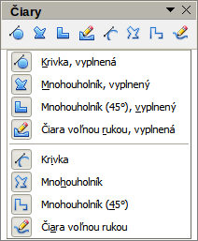
Figure 16: Curves (Lines) toolbar and available tools
Note | Hovering the mouse pointer over this icon gives a tooltip of Curve. If you open the floating toolbar, the title is Lines, as shown in Figure 16.  Holding down the Shift key when drawing lines with the Curve or Polygon tools will restrict the angles between the lines to 45 or 90 degrees.

Curves
Click and hold the left mouse button to create the starting point of your curve, then, while holding down the left mouse button, drag from the starting point to draw a line. Release the left mouse button and continue to drag the cursor to bend the line into a curve. Click to set the end point of the curve and fix the line on the page. To continue with your line, drag the mouse cursor to draw a straight line. Each mouse click sets a corner point and allows you to continue drawing another straight line from the corner point. A double click ends the drawing of your line.
A filled curve automatically joins the last point to the first point to close off the figure and fills it with the current standard fill color. A curve without filling will not be closed at the end of the drawing.

Polygons
Click and draw the first line from the start point with the left mouse button held down. As soon as you release the mouse button, a line between the first and second points is drawn. Move the cursor to draw the next line. Each mouse click sets a corner point and allows you to draw another line. A double-click ends the drawing.
A filled polygon automatically joins the last point to the first point to close off the figure and fills it with the current standard fill color. A polygon without filling will not be closed at the end of the drawing.

Polygons 45°
Like ordinary polygons, these are formed from lines, but the angles between lines are restricted to 45 or 90 degrees.

Freeform lines
Using the freeform line tools is similar to drawing with a pencil on paper. Press and hold the left mouse button and drag the cursor to the line shape you require. It is not necessary to end the drawing with a double-click, just release the mouse button and the drawing is completed.
If Freeform Line Filled is selected, the end point is joined automatically to the start point and the object is filled with the appropriate color.

Adding text
To activate the text tool, click on the Text icon for horizontal text or the Vertical Text icon for vertical script. If the Vertical Text icon is not visible, check that the option Enabled for Asian languages has been selected in Tools > Options > Language Settings > Languages. The Text Formatting toolbar appears (Figure 8 on page 11) when the Text icon is selected; from this toolbar you can select font type, font size, and other text properties before you start typing your text.
Note | The Vertical Text icon is only available on the Drawing toolbar.
After activating the Text command, click at the location where you want to position the text. A small text frame appears, containing only the cursor. This frame can be moved like any other object. A text frame is also dynamic and grows as you enter text.
Observe the information field in the status bar: it shows that you are editing text and also provides details about the current cursor location using paragraph, row, and column numbers (Figure 17).
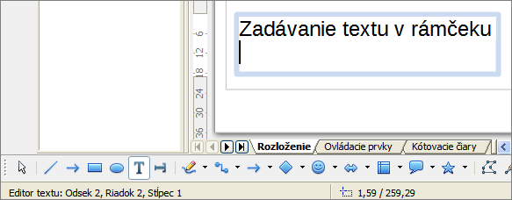
Figure 17: Text information on the Status Bar
You can insert a line break with the Shift+Enter key combination or start a new paragraph with the Enter key. The insertion of line breaks or new paragraphs does not terminate text editing or deselect the text frame. When you have finished typing text, click outside the text frame to cancel adding or editing text.
If you want to edit text, double-click on the text to open the Text Formatting toolbar and highlight the text to start editing.
Text properties can also be changed during text input, with any changes taking effect from the cursor position onwards. To change the properties for all of the text in the text frame, you have to highlight all text in the text frame.
You can create Image styles that you can reuse for other text frames. Select Format > Styles and Formatting or press F11 to open the Styles and Formatting dialog, or click on the Styles and Formatting icon on the Sidebar. Image styles affect all of the text within a text frame. To only format parts of the text, use direct formatting with the Text Formatting toolbar or the Character and Paragraph sub-sections in Sidebar Properties.
Text frames can also have fill colors, shadows, and other attributes, just like any other Draw object. You can rotate the frame and write the text at any angle. These options are available by right-clicking on the text frame itself.
If you double-click on a graphic object, or press F2 or click on the Text icon when an object is selected, you can add text to the graphic object. This text then becomes part of the graphic object.
A graphic object is not dynamic and does not behave like a text frame. To keep text within the borders of the object, you have to use paragraphs, line breaks, or smaller text size, increase the object size, or combine all four methods.
For more information about text, see the Draw Guide Chapter 2 Drawing Basic Shapes and Chapter 9 Adding and Formatting Text.

Glue points and connectors

Glue points
All Draw objects have glue points, which are not normally displayed. Glue points become visible when the Connectors icon is selected on the Drawing toolbar or the Insert Shapes sub-section in Sidebar Properties. Most objects have four glue points (Figure 18). You can add more glue points and customize glue points, using the Glue Points toolbar (Figure 19). Go to View > Toolbars > Glue Points on to open the toolbar.
Glue points are not the same as the selection handles of an object. The handles are for moving or changing the shape of an object. Glue points are used to fix or glue a connector to an object so that when the object moves, the connector stays fixed to the object. For a more detailed description on the use of glue points, see the Draw Guide Chapter 3 Working with Objects and Object Points and Chapter 8 Connections, Flowcharts and Organization Charts.
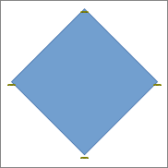
Figure 18: Glue points

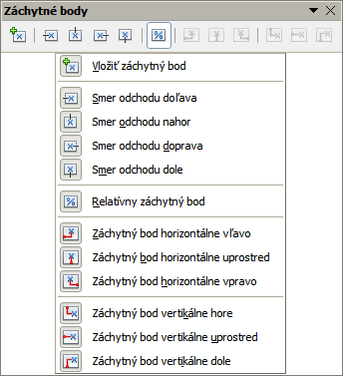Figure 19: Glue Points toolbar and available tools

Connectors
Connectors are lines or arrows whose ends automatically snap to a glue point of an object. Connectors are especially useful in drawing organization charts, flow diagrams, and mind-maps. When objects are moved or reordered, the connectors remain attached to a glue point. Figure 20 shows an example of two objects and a connector.
Draw offers a range of different connectors and connector functions. On the Drawing toolbar or the Insert Shapes sub-section in Sidebar Properties, click on the triangle next to the Connector icon to open the Connectors toolbar (Figure 21). For a more detailed description of the use of connectors, see the Draw Guide Chapter 8 Connections, Flowcharts and Organization Charts.
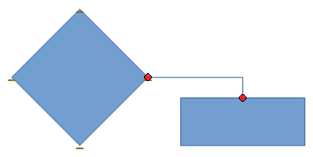
Figure 20: A connector between two objects
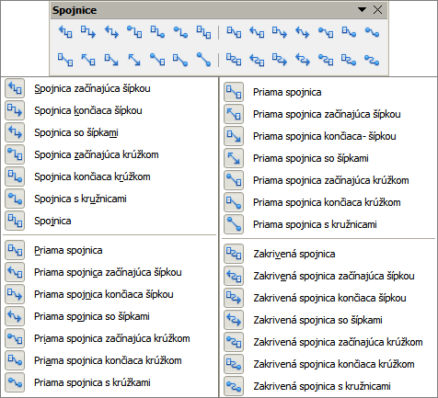
Figure 21: Connectors toolbar and available tools

Drawing geometric shapes
The icons for drawing geometric shapes are located on the Drawing toolbar and each geometric shape is explained in the following sections. Clicking on the triangle to the right of the icon on the Drawing toolbar or the Insert Shapes sub-section in Sidebar Properties opens a floating toolbar giving access to the tools for that geometric shape.
Tip | The use of these tools for geometric shapes is similar to the tool used for drawing rectangles and squares. For more information, see “Drawing basic shapes” on page 14 and the Draw Guide Chapter 2 Drawing Basic Shapes.
Note | The icons for geometric shapes displayed on the Drawing toolbar will change shape according to the last tool selected and used to draw an object.

Basic shapes
Click on the triangle to the right of the Basic Shapes icon to open the Basic Shapes toolbar for drawing basic shapes. This toolbar also includes a rectangle tool identical to the one already displayed on the Drawing toolbar, or the Insert Shapes sub-section in Sidebar Properties.
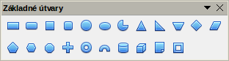
Figure 22: Basic Shapes toolbar

Symbol shapes
Click on the triangle to the right of the Symbol Shapes icon to open the Symbol Shapes toolbar for drawing symbols.
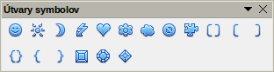
Figure 23: Symbol Shapes toolbar

Block arrows
Click on the triangle to the right of the Block Arrows icon to open the Block Arrows toolbar for drawing block arrows.
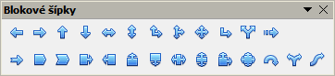
Figure 24: Block Arrows toolbar

Flowcharts
Click on the triangle to the right of the Flowcharts icon to open the Flowchart toolbar for symbols used in drawing flowcharts. The creation of flowcharts, organization charts, and similar planning tools are further described in the Draw Guide Chapter 8 Connections, Flowcharts and Organization Charts.
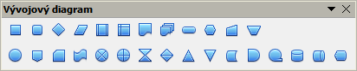
Figure 25: Flowcharts toolbar

Callouts
Click on the triangle to the right of the Callouts icon to open the Callouts toolbar for drawing callouts.
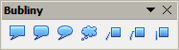
Figure 26: Callouts toolbar

Stars and banners
Click on the triangle to the right of the Stars icon to open the Stars and Banners toolbar for drawing stars and banners.
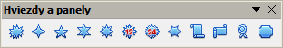
Figure 27: Stars and Banners toolbar
Note | You can add text to all these geometric shapes. For more information, see the Draw Guide Chapter 2 Drawing Basic Shapes and Chapter 10 Advanced Draw Techniques.

Selecting objects

Direct selection
The easiest way to select an object is to click directly on it. For objects that are not filled, click on the object outline to select it. One click selects; a second click deselects. To select or deselect more than one object, hold the shift button down while clicking.

Selection by framing
You can also select several objects at once by dragging the mouse cursor around the objects. This cursor dragging draws a rectangle around the objects and only objects that lie entirely within the rectangle will be selected.
To select multiple objects by framing, the Select icon on the Drawing toolbar must be active.

Selecting hidden objects
Even if objects are located behind others and not visible, they can still be selected. Hold down the Alt key and click on the object at the front of where the hidden object is located, then click again to select the hidden object. If there are several hidden objects, keep holding down the Alt key and clicking until you reach the object you want. To cycle through the objects in reverse order, hold down the Alt+Shift keys and click.
When you click on the selected object, its outline will appear briefly through the objects covering it.
Note | Using the Alt key method works on computers using a Windows or Mac operating systems. On a computer using a Linux operating system the Tab key method, described below, has to be used.
To select an object that is covered by another object using the keyboard, use the Tab key to cycle through the objects, stopping at the object you want to select. To cycle through the objects in reverse order, press Shift+Tab. This is a very quick way to reach an object, but it may not be practical if there a large number of objects in a drawing.

Arranging objects
In a complex drawing, several objects may be stacked on top of one another. To rearrange the stacking order by moving an object forward or backward, select an object, click Modify > Arrange on the main menu bar and select Bring Forward or Send Backward. Alternatively, right-click the object, select Arrange from the context menu, then Bring Forward or Send Backward.
The arrange options are also available by clicking on the small triangle to the right of the Arrange icon on the Line and Filling toolbar. This opens the Position toolbar giving access to the various arrangement options (Figure 28).
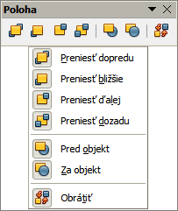
Figure 28: Position toolbar and available tools

Moving and adjusting object size
When moving an object or changing its size, check the left-hand area of the status bar at the bottom of the Draw window (Figure 29). The area on the left of the Status bar, from left to right, shows what object is selected, its position on the drawing in X/Y coordinates and dimensions of the object. The units of measurement are those selected in Tools > Options > LibreOffice Draw > General.
For more information on moving and adjusting object size, see the Draw Guide Chapter 3 Working with Objects and Object Points.
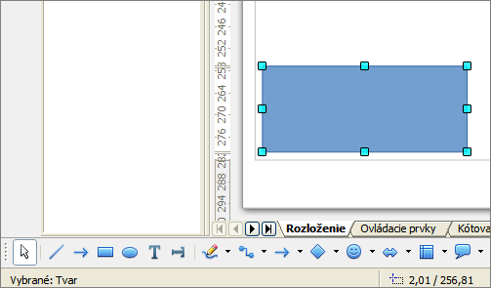
Figure 29: Left end of status bar when moving or adjusting an object

Moving objects
To move an object (or a group of objects), select it and then click within the object borders and hold down the left mouse button while dragging the mouse. During movement, the ghost image of the object appears to help with repositioning (Figure 30). To locate the object at its new location, release the mouse button.
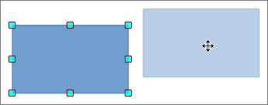
Figure 30: Moving an object

Adjusting object size
To change the size of a selected object (or a group of selected objects), move the mouse cursor to one of the selection handles. The mouse cursor will change shape to indicate the direction of movement for that selection handle. As you change the size of the object, a ghosted outline of the object appears (Figure 31). When you have reached the desired size of the object, release the mouse button.
The results depend on which selection handle you use. To resize an object along one axis, use a side handle. To resize along both axes, use a corner handle.
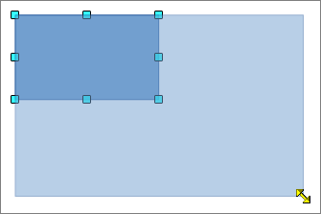
Figure 31: Adjusting object size
Note | If you press the Shift key while resizing an object, the change in size will be carried out symmetrically with respect to the two axes so that the aspect ratio of the object remains the same. This Shift key behavior works on all selection handles.  This is the default behavior of the Shift key. However, if When creating or moving objects has been selected in Tools > Options > LibreOffice Draw > Grid, the action of the Shift key is reversed: that is the aspect ratio will be preserved unless the Shift key is pressed.

Rotating and slanting an object
For more information on rotating and slanting an object, see the Draw Guide Chapter 3 Working with Objects and Object Points.

Rotating an object
To rotate an object (or a group of objects), select the object, then go to rotation mode using one of the following methods:
- Click on the Rotate icon on the Line and Filling toolbar.
- Go to View > Toolbars > Mode and select the Rotate icon .
The selection handles will change shape and color (Figure 32). Also a center of rotation point will appear in the center of the object. As you move the mouse cursor over the handles the cursor changes shape. The corner handles are for rotating an object and the top, bottom and side handles are to slant an object.
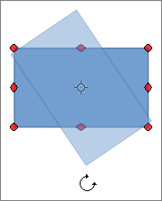
Figure 32: Rotating an object
Move the mouse cursor to one of the corner handles and it normally changes to an arc with an arrow at each end. Click and hold the mouse button, then start to move the cursor to rotate the object. A ghost image of the object being rotated appears and the current angle of rotation is shown in the status bar.
Note | Rotation works differently for 3D objects because rotation occurs in global axes and not in a single axis. See the Draw Guide Chapter 7 Working with 3D Objects for more information.
The rotation point is normally located at the center of an object. To change the position of the rotation point, click on the object with the mouse cursor and drag the object until the rotation point is at the desired position. This rotation point can even be outside of the object.
Note | If you press the Shift key while rotating an object, rotation will be restricted to 15° of movement.  This is the default behavior of the Shift key. However, if When creating or moving objects has been selected in Tools > Options > LibreOffice Draw > Grid, the action of the Shift key is reversed: that is rotation will be restricted to 15° of movement unless the Shift key is pressed.

Slanting an object
To slant an object, use the handles located at the midpoints on the top, bottom and sides of a selected object. The mouse cursor changes when it hovers over one of these midpoint handles. The axis used for slanting an object is the object edge directly opposite the midpoint handle being used to slant the object. This axis stays fixed in location while the other sides of the object move in relation to it as you drag the mouse cursor.
Click and hold the mouse button, then start to move the cursor to shear the object. A ghost image of the object being slanted appears (Figure 33) and the current angle of slanting is shown in the status bar.
Note | If you press the Shift key while slanting an object, slanting will be restricted to 15° of movement. This is the default behavior of the Shift key. However, if When creating or moving objects has been selected in Tools > Options > LibreOffice Draw > Grid, the action of the Shift key is reversed: that is slanting will be restricted to 15° of movement unless the Shift key is pressed.
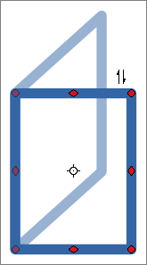
Figure 33: Slanting an object

Editing objects
To edit an object or change its attributes, such as color or border width, and so on, the Line and Filling toolbar, the Text Formatting toolbar, the Sidebar Properties section, or a context menu can be used. More information on editing objects and changing attributes can be found in the Draw Guide Chapter 4 Changing Object Attributes.
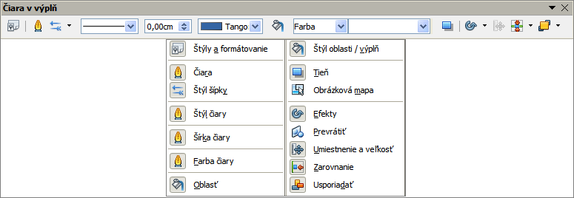
Figure 34: Line and Filling toolbar and its available tools

Line and Filling toolbar
By default, the Line and Filling toolbar in Draw is placed at the top of the workspace. However, if the Line and Filling toolbar is not displayed, go to View > Toolbars > Line and Filling on the main menu bar to open the toolbar (Figure 34). The most common object attributes can be edited using this toolbar. You can also open the Line dialog by clicking on the Line icon and the Area dialog by clicking on the Area icon for access to more formatting options.

Text Formatting toolbar
When you select text, the Line and Filling toolbar automatically changes to show the Text Formatting toolbar (Figure 35). You can also open the Text Formatting toolbar by selecting View > Toolbars > Text Formatting on the main menu bar. The tools on this toolbar will not become active until text has been selected.
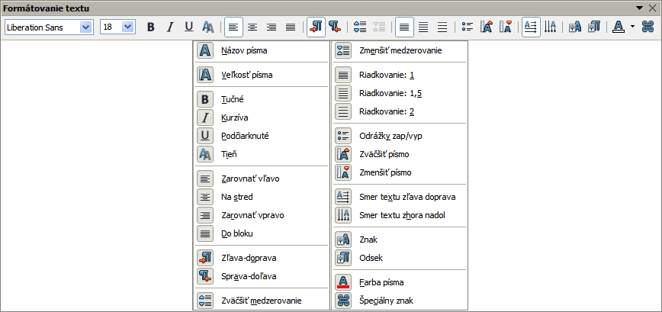
Figure 35: Text Formatting toolbar and its available tools
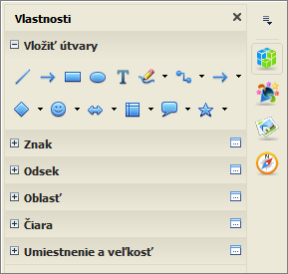
Figure 36: Sub-sections in Sidebar Properties

Sidebar Properties
When you select an object in your drawing, the sub-sections in Sidebar Properties become active (Figure 36). This allows you to change the properties or options of an object without having to open a dialog or use any of the available tools on the various toolbars provided by Draw. To expand a sub-section, click on the plus (+) sign next to the sub-section title.

Context menu
When an object is selected and you right-click on the object, a context menu (Figure 37) opens that applies to the selected object. This context menu provides access to the options available and allows you to change object attributes without having to open a dialog. Menu entries with a small arrow on the right-hand side contain a submenu.
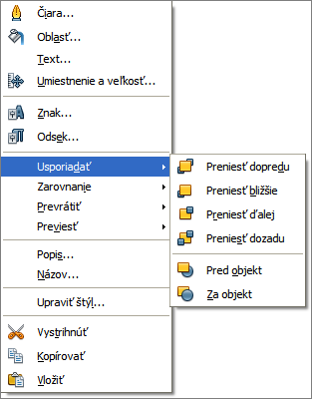
Figure 37: Example of a context menu

Formatting lines and borders
In LibreOffice the term line indicates both a freestanding segment (line), outer edge of a shape (border), or an arrow. In most cases the properties of the line you can modify are its style (solid, dashed, invisible, and so on), its width and its color.
Select the line you need to format and then use the controls on the Line and Filling toolbar to change the most common options (highlighted in Figure 38).
Figure 38: Common line properties (style, color, width)
If you need to fine tune the appearance of a line, choose Format > Line from the main menu bar, or right-click on the line and select Line from the context menu, or select the Line icon from the Line and Filling toolbar. All of these methods open the Line dialog (Figure 15 on page 17), where you can set line properties. This dialog consists of three pages: Line, Line Styles, and Arrow Styles. Alternatively, use the Line sub-section in Sidebar Properties to change the appearance of a line.

Arrows, arrowheads and line endings
Arrows, arrowheads and other line endings are usually referred to as arrows and can be treated the same as lines when editing and changing attributes. Select a line and click on the Arrow Style icon from the Line and Filling toolbar to open the Arrowheads menu (Figure 39).
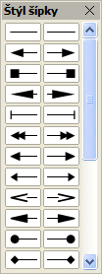
Figure 39: Arrowheads menu
Several types of arrowheads are available. Each end of a line can have a different arrowhead or no arrowhead). Arrowheads are only applicable to lines and they have no effect on the border of an object.

Formatting area fill
The term area fill refers to the inside of an object, which can be a uniform color, gradient, hatching pattern, or bitmap (Figure 40). An area fill can be made partly or wholly transparent. In most cases, you will choose one of the standard fill options, which are all available from the Line and Filling toolbar, or the Area sub-section in Sidebar Properties.. You can also define your own area fills. For more information on formatting area fill, see the Draw Guide Chapter 4 Changing Object Attributes.
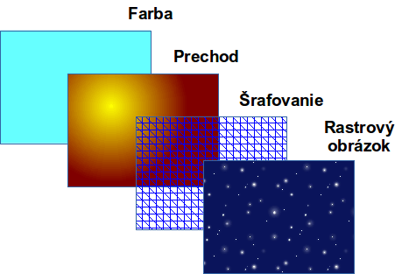
Figure 40: Different types of area fill

Using styles
Suppose that you want to apply the same area fill, line thickness, and border to a set of objects. This repetitive process can be greatly simplified by the use of styles. Styles allow you to define a formatting template (a style) and then to apply that style to multiple objects. For more information on styles, see Chapter 3 Using Styles and Templates in this guide, the Writer Guide Chapter 6 Introduction to Styles and the Draw Guide Chapter 4 Changing Object Attributes.

Positioning objects

Snap function
In Draw, objects can be accurately and consistently positioned using the snap function. Grid points, snap points and lines, object frames, individual points on objects, or page edges can all be used with the snap function.
Snap function is easier to work with at the high zoom values that are practical for your display. Two different snap functions can be used at the same time; for example snapping to a guide line and to the page edge. It is recommended, however, to activate only the functions that you really need.
For more detailed information about the snap function, see the Draw Guide Chapter 3 Working with Objects and Object Points and Chapter 10 Advanced Draw Techniques.

Snap to grid
Snap to grid allows you to position an object to a grid point (Figure 41). Go to View > Grid > Snap to Grid on the main menu bar or click on the Snap to Grid icon on the Options toolbar to turn on or off the snap to grid function. If the Options toolbar is not displayed, go to View > Toolbars > Options on the main menu bar.
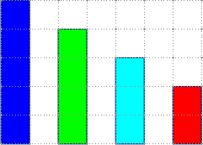
Figure 41: Positioning with snap to grid

Displaying the grid
To display the grid in Draw or to switch off the grid, go to View > Grid > Display Grid on the main menu bar or click on the Display Grid icon on the Options toolbar.

Configuring the grid
The resolution, snap and snap position of the grid points can be configured. Go to Tools > Options > LibreOffice Draw > Grid on the main menu bar to open the options dialog for the grid (Figure 42).
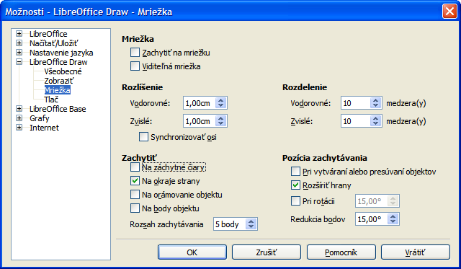
Figure 42: Configuring the grid
- Vertical and horizontal spacing of the dots in the grid. You can also change the unit of measurement used in the general Draw options by going to Tools > Options > LibreOffice Draw > General.
- The resolution is the size of the squares or rectangles in the grid. If the resolution is 1 cm horizontal and 2 cm vertical, the grid consists of rectangles 2 cm high and 1 cm wide.
- Subdivisions are additional points that appear along the sides of each rectangle or square in the grid. Objects snap to subdivisions as well as to the corners of the grid.
- The pixel size of the snap area defines how close you need to bring an object to a snap point or line before it will snap to it.
- The default color of the grid is light gray. To change the color of the grid points, go to Tools > Options > LibreOffice > Appearance on the main menu bar.

Help lines
Draw has help lines to easily allow you to position an object using the rulers at the top and left side of the workspace. To turn on or off the help lines, go to Tools > Options > LibreOffice Draw > View on the main menu bar and select Snap Lines when moving option or go to the Options toolbar and click on the Helplines While Moving icon .

Applying special effects
With Draw, you can apply many special effects to objects and groups of objects. This section is an introduction to some of these effects. For more information on special effects, see the Draw Guide Chapter 4 Changing Object Attributes.
To access the tools used for special effects, go to View > Toolbars > Mode (Figure 43). Rotate and Flip can also be accessed by going to Modify on the main menu bar or by right-clicking on the object and using the context menu.
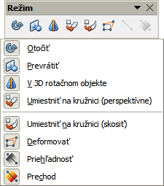
Figure 43: Mode toolbar and its available tools

Flipping objects
The quickest and easiest method to flip an object horizontally or vertically is as follows:
- Click on a graphic object and the selection handles will show.
- Right-click and select Flip > Vertically or Horizontally, or got to Modify > Flip > Vertically or Horizontally on the main menu bar and the selected object will be flipped to face the other direction.
However, the Flip tool on the Mode or Drawing toolbar can be used to give you greater control over the flipping process. Using the Flip tool allows you to change the position and angle that the object flips over and this is described in the Draw Guide Chapter 4 Changing Object Attributes.

Mirror copies
At the moment no mirror command exists in Draw. However, mirroring an object can be emulated by using the Flip tool, as described in the Draw Guide Chapter 4 Changing Object Attributes.

Distorting an object
Three tools on the Mode toolbar let you drag the corners and edges of an object to distort the image.
- Distort tool distorts an object in perspective.
- Set to Circle (slant) creates a pseudo three-dimensional effect.
- Set in Circle (perspective) creates a pseudo three-dimensional effect.
In all three cases you are initially asked if you want to transform the object to a curve. This is a necessary first step, so click Yes. Then you can move the object handles to produce the desired effect. See the Draw Guide Chapter 4 Changing Object Attributes for more information on how to distort an object.

Dynamic transparency gradients
You can control transparency gradients in the same manner as color gradients. Both types of gradient can be used together. With a transparency gradient, the direction and degree of object fill color changes from opaque to transparent. In a regular gradient, the fill changes from one color to another, but the degree of transparency remains the same.
The Transparency and Gradient tools on the Mode toolbar dynamically control transparency and color gradients. See the Draw Guide Chapter 4 Changing Object Attributes for more information on how to create transparencies and gradients in an object.

Duplication
Duplication makes copies of an object while applying a set of changes such as color or rotation to the duplicates that are created.
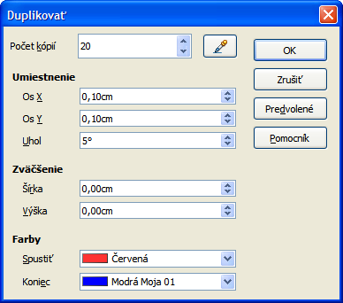
Figure 44: Duplicate dialog
- Click on an object or group of objects and go to Edit > Duplicate on the main menu bar or use the keyboard shortcut Shift+F3 to open the Duplicate dialog (Figure 44).
- Select the required options chosen from the options available. For example, when the options in the dialog are applied to a rectangle, they produce the result shown in Figure 45.
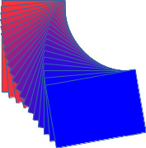
Figure 45: Duplication result

Cross-fading
Cross-fading transforms one object shape to another object shape and only works when two objects are selected.
- Select two differently shaped objects.
- Go to Edit > Cross-fading on the main menu bar to open the Cross-fading dialog (Figure 46).
- Select Increments to determine the number of shapes between the two objects.
- Select Cross-fading attributes to apply a gradual change of line and fill properties between the two objects.
- Select Same orientation to apply a smooth transition between the two objects.
- Click on OK and the result is a new group of objects with the first object selected as the start object and the second object selected as the end object. For example, when the options in the dialog are applied to a rectangle and a triangle, the cross fade produces the result shown in Figure 47.
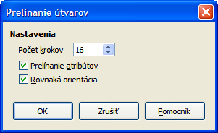
Figure 46: Cross-fading dialog
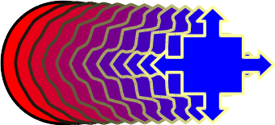
Figure 47: Cross-fading result

Combining multiple objects
Using Draw, you can group or combine objects together allowing you to treat multiple objects as one unit, or to merge objects to form a new shape. For more information, see the Draw Guide Chapter 5 Combining Multiple Objects.
Grouping of objects is similar to putting objects into a container. You can move the objects as a group and apply global changes to the objects within the group. A group can always be undone and the objects that make up the group can always be manipulated separately. The objects within a group also retain their own individual properties.
Combining objects is a permanent merging of objects that creates a new object. The original objects are no longer available as individual entities and cannot be edited as individual objects. Any editing of a combined object affects all the objects that were used when combination was carried out.

Grouping

Temporary grouping
A temporary grouping is when several objects are selected using the Select icon on the Drawing toolbar or using the mouse to drag a rectangle around the objects (also known as a marquee). Any changes to object parameters you carry out are applied to all of the objects within the temporary group. For example, you can rotate a temporary group of objects in its entirety.
To cancel a temporary grouping of objects simply click outside of the selection handles displayed around the objects.

Permanent grouping
A permanent grouping of objects is created after you have selected your objects and then going to Modify > Group on the main menu bar, or right clicking on the selection and select Group from the context menu, or using the keyboard shortcut Ctrl+Shift+G. When you deselect your selection the objects remain grouped together.
When objects are permanently grouped, any editing operations carried out on that group are applied to all members of the group. If you click on one member of the group, the whole group is selected.
You can edit an individual member of a group without ungrouping or breaking the group. Select the group and go to Modify > Enter Group, or right click and select Enter Group from the context menu, or use the keyboard shortcut F3, or double click on the group.
When you have finished editing an individual member of a group, go to Modify > Exit Group, or right click and select Exit Group from the context menu, or use the keyboard shortcut Shift+F3.

Ungrouping
To ungroup or break apart a group of objects, select the group then go to Modify > Ungroup on the main menu bar, or right click and select Ungroup from the context menu or use the keyboard shortcut Ctrl+Alt+Shift+G.

Combining objects
Combining objects is a permanent merging of objects that creates a new object. The original objects are no longer available as individual entities and cannot be edited as individual objects. Any editing of a combined object affects all the objects that were used when combination was carried out.
Select several objects, then go to Modify > Combine on the main menu bar, or right click on the objects and select Combine from the context menu, or use the keyboard shortcut Ctrl+Shift+K.
After you have selected your objects, the Merge, Subtract, and Intersect functions also become available so that you can create a new object from your selected objects. See the Draw Guide Chapter 5 Combining Multiple Objects for more information on these functions.

Arranging, aligning and distributing objects
In Draw you can arrange, align and distribute selected objects in relation to each other:
- Arrange the position of an object by moving it either forward or backward in relation to the order of objects.
- Align objects with respect to each other using Left, Centered, or Right for horizontal alignment and Top, Center or Bottom for vertical alignment.
- Distribute objects so that the space between each of the objects is the same.
See the Draw Guide Chapter 5 Combining Multiple Objects for more information on arranging and aligning objects in relation to each other.

Inserting and editing pictures
Draw contains a number of functions for editing pictures or raster graphics (bitmaps); for example, photos and scanned images. This includes the import and export of graphics, and the conversion of one graphic format to another graphic format.
Draw includes a large range of graphic filters so that it can read and display several graphic file formats. It also includes several tools for working with raster graphics, but does not have the same functionality as specialized graphic programs like Gimp or Adobe Photoshop. See the Draw Guide Chapter 6 Editing Pictures for more information.
You can add pictures from several sources:
- Directly from a scanner (Insert > Picture > Scan)
- Images created by another program, including photographs from a digital camera (Insert > Picture > From File)
- The Draw Gallery; see Chapter 11 Graphics, the Gallery, and Fontwork in this guide for more information.

Working with 3D objects
Although Draw does not match the functionality of the leading drawing or picture editing programs, it is capable of producing and editing very good 3D drawings.
Draw offers two types of 3D objects: 3D bodies and 3D shapes. Depending on which type you choose, there are different methods of editing of a 3D object (rotation, illumination, perspective, and so on) with 3D shapes being simpler to set up and edit than 3D bodies. However, 3D bodies currently allow for more customization.
See the Draw Guide Chapter 7 Working with 3D Objects for more information.

Exporting graphics
Draw saves graphics and images in the open source format *.odg. To save a graphic or the entire file in another format, use File > Export and select a format from the list displayed. The graphic formats that Draw can export and save to are listed in Appendix B Open Source, Open Standards, OpenDocument in this guide.
You can also export Draw files to HTML, XHTML, PDF, or Flash. PDF export for modules of LibreOffice is described in Chapter 10 Printing, Exporting, and E-mailing of this guide.
HTML export uses a conversion wizard that creates as many web pages as there are pages in your Draw document. You can optionally choose to display pages in frames with a navigator and set an index page. For more information, see Chapter 12 Creating Web Pages in this guide.

Inserting comments in a drawing
You can insert comments into your drawing and this a similar process used in Writer and Calc.
- Go to Insert > Comment on the menu bar. A small box containing your initials appears in the upper left-hand corner of your drawing with a larger text box beside it (Figure 48). Draw automatically adds your name and the date at the bottom of this text box.
- Type or paste your comment into the text box. You can apply basic formatting to parts of the text by selecting it, right-clicking, and choosing from the context menu. From this menu, you can also delete the current comment, all the comments from the same author, or all the comments in the document.
- You can move the small comment markers to anywhere you wish on the drawing. Typically you might place it on or near an object you refer to in the comment.
- To show or hide the comment markers, go to View > Comments on the main menu bar.
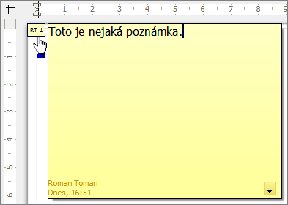
Figure 48: Inserting comments
- Go to Tools > Options > User Data to enter the name you want to appear in the Author field of the comment.
- If more than one person edits the document, each author is automatically allocated a different background color.

