
Getting Started Guide
Chapter 8
Getting Started with Base
Creating an embedded flat database

Copyright
This document is Copyright © 2014 by the LibreOffice Documentation Team. Contributors are listed below. You may distribute or modify it under the terms of either the GNU General Public License (http://www.gnu.org/licenses/gpl.html), version 3 or later, or the Creative Commons Attribution License (http://creativecommons.org/licenses/by/4.0/), version 4.0 or later.
All trademarks within this guide belong to their legitimate owners.

Contributors
Dan Lewis
Reizinger Zoltán
Hazel Russman
John Viestenz
Jean Hollis Weber

Feedback
Please direct any comments or suggestions about this document to the Documentation Team’s mailing list: documentation@global.libreoffice.org
Note: Everything you send to a mailing list, including your email address and any other personal information that is written in the message, is publicly archived and cannot be deleted.

Publication date and software version
Published 10 Augustl 2014. Based on LibreOffice 4.2.

Note for Mac users
Some keystrokes and menu items are different on a Mac from those used in Windows and Linux. The table below gives some common substitutions for the instructions in this chapter. For a more detailed list, see the application Help.
Windows or Linux | Mac equivalent | Effect
Tools > Options menu selection | LibreOffice > Preferences | Access setup options
Right-click | Control+click and/or right-click depending on computer system | Opens a context menu
Ctrl (Control) | ⌘ (Command) | Used with other keys
F5 | Shift+⌘+F5 | Open the Navigator
F11 | ⌘+T | Open the Styles and Formatting window

Contents
Copyright 2
Contributors 2
Feedback 2
Publication date and software version 2
Note for Mac users 2
Introduction 5
Database components 6
Types of database 6
Planning your database 6
Creating a new Base file 7
Opening an existing database 9
Using the database wizard to open an existing database 9
Main database window and its parts 9
Database section 10
Tasks section 10
List section 10
Database objects 11
Tables: use wizard to create tables 11
Step 1: Select fields for your table 11
Practice exercise: Create the HouseholdInventory table 12
Step 2: Set types and formats 13
Selected fields list 13
Field information 14
Practice exercise 15
Step 3: Set primary key 16
Practice exercise 17
Step 4: Create table 18
Practice exercise 18
Enter or remove data using the Table Data View dialog 18
Enter data into a table 19
Modify data in a cell of a table 20
Delete data from a table 21
Forms: using the Forms Wizard 21
Create a simple form using the Form Wizard 21
Enter or remove data using forms 24
Enter or remove data from individual controls 25
Practice exercise 27
Deleting records in a form 28
Queries: using the Query Wizard 28
Plan the query 29
Create the detailed query 30
Step 1: Field selection 31
Step 2: Sorting order 31
Step 3: Search conditions 32
Step 4: Detailed or Summary 32
Steps 5 and 6: Group by and Grouping conditions 33
Step 7: Aliases 33
Step 8: Overview 33
Reports: use wizard to create reports 35
Step 1: Select the table and its field for the report 36
Step 2: Labeling fields 37
Step 3: Grouping 37
Step 4: Sort options 37
Step 5: Choose layout. 38
Step 6: Create report. 39
Mixing Base with the rest of LibreOffice 40
Writer 40
Calc 40
Impress 41
Using Base with other data sources 41

Introduction
Base is the database component of LibreOffice. A data source, or database, is a collection of information organized so that it can easily be accessed, managed, and updated. For example, a list of names and addresses is a data source that could be used for producing a mail merge letter. A shop stock list could be a data source managed through LibreOffice.
If you have information that you would like to organize, Base will help you do this. You could use a spreadsheet to organize information, but maintaining a spreadsheet with Calc can often be more complex and time consuming than using a database with Base.
This chapter is for the person who has not used Base before or who wants to review the basics of creating and using a database. This chapter covers the wizards needed to create the database parts and the principles that the wizards use. It also provides references to more information in the Base Handbook (https://wiki.documentfoundation.org/Documentation/Publications).
The Base Handbook and the Base Guide (being written) are for people who understand some of the basics of how Base works and want a more in-depth discussion.
Note | To use Base, you need a Java Runtime Environment (JRE). Please go to Tools > Options > LibreOffice > Advanced to choose a JRE from those installed on your computer.  If no JRE is already installed, you will need to download and install one. For Windows, you need to get Java from www.java.com. For Linux, you can download it from the same website or you can use openjdk-7-jre, available from the repository of your Linux version. Mac OS X users can install a JRE from Apple Inc.
With Base, you create a Database document file. This file contains the data and all of the structures you create to obtain information from the data. Because everything is included in one file, it is known as an embedded database.
Base can also be used to connect to other databases. In this case, Base creates a file to make the connection. These are not embedded databases since they exist outside the Base file. They are front end database documents. See the Base Handbook and Base Guide for more information.

Note | By following the text of this chapter you will create a database with a table, form, two types of queries and a report. You will also fill the database with data. For your convenience and also as a reference we have created database files corresponding to various activities. The files can be downloaded together with the text of this chapter from https://wiki.documentfoundation.org/Documentation/Publications/. Later in the text you will find information regarding the appropriate files.

Database components
Consider an address book. Usually, the data in an address book can be divided into groups based upon the relationships between the data. For example, all the first names are put into one group. Other groups can include last names, spouse names, addresses, phone numbers, birthdays, and so on. You probably need to identify phone numbers based on their use (home, work, mobile). If you were keeping this information in a spreadsheet, you would use one column for each one of these groups. In a database, this column is called a field.
Other relationships that exist between data can be used to further define the structure of that data. In an address book, one value in each of these groups describes a specific individual. This divides the data into a table.
Each column contains data with the same properties. Each row contains data that describes a specific entity or individual. The structure of rows and columns is called a table.
Three tools are available to help you to work with your data to get the information you need. We use queries to obtain the information. You can think of queries as way to ask questions in Base and receive the answers. If we want to give the information to someone else, we will give them a report that is based upon a query we created. A report can be created from a table as well. The third tool is view which allows you to display and interactively analyze selected data.
So, a database consists of one or several tables whose columns are called fields and whose rows are called records. We use the table structure to ask questions and to receive answers using queries. When providing others with information obtained from a query, we create a report. These, then, are the components a database consists of: tables with their fields and records, queries, and reports. When a new database is created, they have to also be created to make the database's data useful.
This chapter discusses the use of wizards for creating these objects. The example database will be a household inventory.

Types of database
The two types of database are known as flat and relational. Base can create and work with both types. This chapter discusses flat databases. Relational databases are covered in detail in the Base Handbook.
A flat database contains one or more tables, each containing one or more fields. Each table is completely independent of all the other tables in the database. For example, you might have an address database with several tables in it. One might contain your family’s contacts, another your business contacts, and another your spouse’s family contacts.
A relational database contains one or more tables with one or more relationships defined between those tables; each relationship is defined by a pair of fields. One field of each pair belongs to one table and the second field belongs to the same or a different table. Where relationships exist between fields in the same or different tables, a flat database could still be used, but it provides no mechanism for defining the relationship. Instead the same data must be entered in both fields, making data entry errors more likely. A well designed relational database requires the data to be entered only once, reducing possible errors.

Planning your database
Before creating a database, you should take some time planning what you want it to do and why. The better your plan, the better the results you will get from using the database.
You need to have an idea of what you want to do with the data that you have. This includes how you will divide the data into columns, the fields, and into rows, the records. This determines what the table will be. What information do you want to get from the data? This determines what the queries will be. What information do you want to have in a report? So, take some time to think through what you want first before ever creating a database.
The Table Wizard (see discussion beginning on page 10) contains a list of suggested tables: some for business purposes, and some for personal purposes. The wizard also contains a list of fields for each of the suggested tables. Each of the fields also has been given the properties it needs.
As a result, the wizard does most of your planning for you. However, you do need to make some decisions, for example whether to use all of the suggested fields. Will you want to use additional fields that the wizard did not include? What properties should these fields have?
Therefore, you need to understand what you are doing as you do it. You need to practice creating the objects of a database before creating them in your database. Learn how to apply the principles first on an example.

Creating a new Base file
After you have planned your database, create a new Base file. To do this, open the Database Wizard using one of the following methods:
- Choose File > New > Database from the main menu bar.
- Click the arrow by the New icon on the Standard toolbar and select Database from the drop-down menu.
- Click the New Database icon on the splash screen if it appears when LibreOffice opens.
Step 1 of the Database Wizard (Figure 1) has three parts. Use the top part to create a new database. The middle and bottom parts are used to open an existing database. (These two parts are briefly discussed in “Using Base with other data sources” on page 43.)
Creating a database using the wizard requires two steps.
- On the Select database page (Figure 1):
  - Under the question What do you want to do?, choose Create a new database (it is selected by default).
  - Click the Next >> button at the bottom of the wizard.
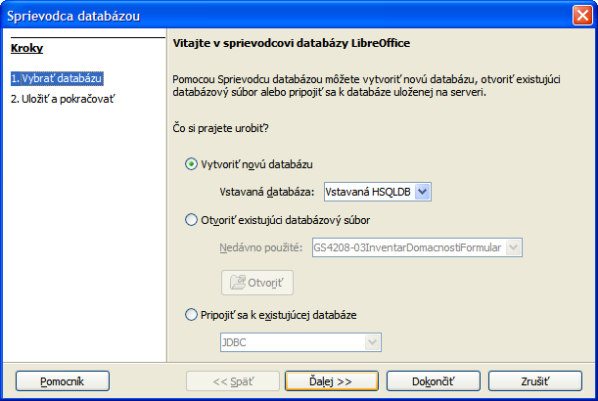
Figure 1: Creating a new database using the Database Wizard
- On the Save and proceed page (Figure 2):
  - Choose Register the database for me (the default setting). You should register a database in order to access it from Writer or Calc. A list of registered databases can be found in Tools > Options > LibreOffice Base > Databases.
  - Choose what you want to do after the database file is saved. In this example, we choose Open the database for editing.
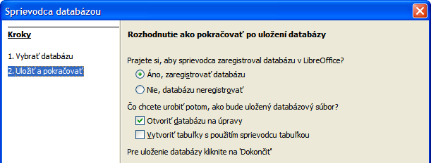Figure 2: Registering and opening the database file
Note | If you want to create a table with the wizard immediately after creating a new database, select Create tables using the table wizard in addition to Open the database for editing. If you do this, the main database window opens with the Table Wizard opening in front of it.  We will discuss the main database window before the Table Wizard, so in our example the second choice is not checked.
- Click the Finish button at the bottom of the wizard. A standard Save as window opens. Name and save the database.
You have created and saved a new database file that has opened the main database window. If you wish, you can close it now and reopen it later.

Opening an existing database
You can reopen your new database in several ways. In any file browser, you can browse to where you saved the database and double-click it. Or you can right-click it and select LibreOffice to open it. You can also use the database wizard to open it, as described below.

Using the database wizard to open an existing database
Below the Open an existing database option on the first page of the Database Wizard is a drop-down list of the databases you have recently used. After creating your first database, its name will appear as the default value for this list. Once you create or open another database, other names will appear in this list.
To open an exiting database:
- Open the database wizard like you did when you created your database.
- Click the Open an existing database option button.
  - From the Recently used drop-down list, select the name of the database.
  - Or, Click the Open button, browse to the location of the database, and select it.
- Click the Finish button.
The third section of page 1 of the database wizard is used to connect to databases that have been created by other programs than Base. This includes text databases, spreadsheets, MySQL, PostgreSQL, Oracle, and Access among the more well known ones. These databases and how to connect to them using Base are discussed in Chapters 2 and 8 of the Base Guide.

Main database window and its parts
Everything you do with a database begins with the main database window (Figure 3). When performing some tasks, you will have to come back to this window to complete the task. So, become well acquainted with it.
Once you have created a new database and saved it, this window opens. Opening a database file will also open it.
The main database window contains three sections: Database, Tasks, and List. However, you will not see List as the heading of a section as you do for Database and Tasks. Instead, its heading depends upon which icon is selected in the Database section.
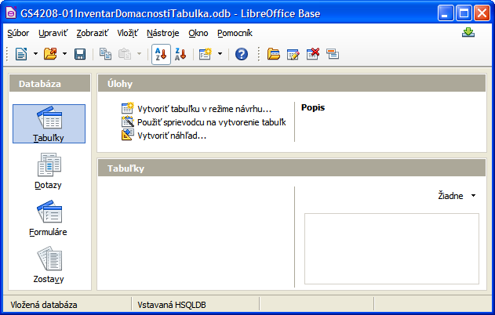Figure 3: Main Database window

Database section
This section is the column of icons on the left side of the window. There is an icon for each part of the database. Your first step after opening a database is to select what part of the database you will work in. The selection you make here changes what appears in the other sections, as explained below.

Tasks section
This section contains a list of tasks that can be done related to the icon selected in the Database section. When the Tables icon is selected in the Database section, three tasks appear in this section. Two of them help you create a table, and one helps you create a view. When the Queries icon is selected, three tasks appear to help you create a query. When the Forms icon is selected, two tasks appear to help you create a form. When the Reports icon is selected, two tasks appear to help you create a report.
The right side of the Tasks section has the heading Description. This area gives you information about each of the tasks. Click any one of the tasks to see its description.
Note | In this chapter, we are using only the wizards to create the tables, queries, forms, and reports. The Base Guide discusses the rest of the tasks, their principles, and an example of their uses.

List section
This section contains a list of the objects whose icon is selected in the Database section. Click the Tables, Queries, Forms, or Report icon, and this section contains a list of the tables, queries, forms, or reports respectively. The title for this section is the name of the icon selected.
A variety of things can be done with any member of the visible list by right-clicking the item and selecting an action that appears in the context menu. The standard actions are Copy, Delete, Rename, Edit, and Open. The context menu includes additional choices that depend upon the type of list.
To the right of the list is a small window labeled Document view, giving you more information about the specific document (table, query, form, or report) you have selected. The view is controlled by a drop-down list containing three options: None, Document Information, and Document.
When Tables or Queries is selected in the Database section, only two choices are available: None or Document. When Forms or Reports are selected, all three choices are available. Selecting None leaves the Document view window blank.
Select Document information for a form to see who last modified the form and when it was modified. If it has not been modified, there is no information.
Select Document and a member of the list, and you will see a snapshot of what you selected. In most cases, you see only the top left portion because of size limitations. For a table or query, you will see only the first few columns and rows along with any data. For a form, you will see the top left portion of it. (If the form is small, you will see all of it.)
Tip | Document view does not work for reports. You will see all three choices in the drop-down list, but you will not see anything when you make a selection.

Tables: use wizard to create tables
To open the table wizard, begin in the main database window. Click the Tables icon in the Database section on the left. This places three tasks in the Tasks section. Click this task: Use Wizard to Create Table. The wizard opens to its first page (Figure 4).
The table wizard uses several steps to create a table. Each step is located on a separate page. Within each step are smaller steps to do. The major steps are:
- Select fields.
- Set types and formats.
- Set primary key.
- Create table.
Tip | File GS4208-01HouseholdInventoryTable.odb, distributed along with this chapter, contains the table Household Inventory created according to instructions given in this section. File GS4208-02HouseholdInventoryTableFilled.odb contains the same table filled with sample data provided by tables 4 and 5 on page 27.

Step 1: Select fields for your table
Category has two choices that determines the type of tables that you can use: Business, and Personal. Sample tables is a drop-down list of tables based upon the table's purpose. Select a table from this list, and its fields appear in the Available fields list.
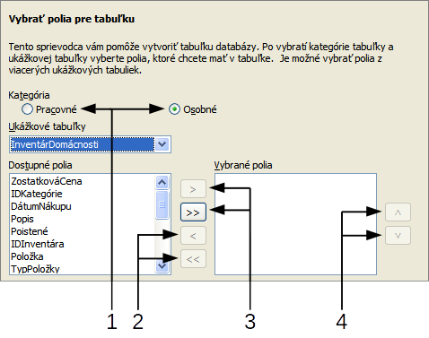
1 | Category labeled option buttons | 3 | Move selected fields from left to right
2 | Move selected fields from right to left | 4 | Change the order of the listed fields
Figure 4: Step 1 of Table Wizard: Select fields
Here are the smaller steps required on this page. These will be applied to selecting HouseholdInventory as the table and the fields in it in the example following these steps.
- Select the category: Business or Personal. This determines what is listed in the Sample tables drop-down list.
- Open the Sample tables drop-down list by clicking the down arrow.
- Select the table you want to use.
- Move the fields you want to use in your database to the Selected fields list.
- To move all the fields at one time, click the double right arrow.
- To move one or more fields, highlight the fields and then click the single right arrow.
- To remove one or more fields from the Selected fields list, highlight the fields and click the left single arrow. To remove them all, click the left double arrow.
- Change the order of the fields.
- Click the field which you want to move up or down in the list of fields.
- Click the up arrow to move the field higher, or click the down arrow to move it lower.
- Click Next to go to Page 2.

Practice exercise: Create the HouseholdInventory table
Begin in the Database file window by clicking the Table icon. From the Task section, click Use Wizard to Create Table to open the Table Wizard.
The wizard contains many suggested tables that you can use. Some of them are for business purposes and some are for personal purposes. The first thing to do is some research for the names of the sample tables. This requires you to click either the Business option button and search through the sample table names or click the Personal option button and search through its Sample table names.
If you looked through the sample table names, you discovered that category of the Household Inventory table is Personal. The available fields list appears when you select Personal as the category and HouseholdInventory from the Sample table drop-down list. So, make these selections now.
Sixteen fields are available for this table. You can select all or only a few of them, depending upon the information needed for your database.
Choosing what fields to use is part of the planning of the database. If you think that any of the fields should not be apart of the database, do not select them for your table.
What if there is a field that you want to be part of the table, but it does not exist? You can create one in step 2 of the wizard. You can also select a similar field in step 1 and change its type and format in step 2.
For example: you want to include the names of the rooms that contain furniture. One of the 16 fields is RoomID. You can select this field in this step. Then in page 2, change the name of the field from RoomID to Room. Also change the field type and format.
For this exercise, use these fields: AppraisedValue, DatePurchased, Description, Insured, Item, Manufacturer, ModelNumber, Notes, PlacePurchased, PurchasePrice, RoomID, SerialNumber, and InventoryID.
Move these fields from the Available fields to the Selected fields. You can click a single field or Control+click multiple fields to highlight them. Then click the single right arrow. If you accidentally move a field that should not be moved, click the field and then click the single left arrow.
Now comes another part of the planning. Think about the order that you want to use when entering the data into your table. The fields are listed now in alphabetical order. Is that what you want? Chances are that the answer is no. Then what order do you want? One possible order is shown in Figure 5. This order will be used in the exercises for the rest of the steps of this wizard.
To complete this part of the practice exercise, click the Next > button. The exercise continues on page 14.

Step 2: Set types and formats
On this page you can choose among the supplied fields, create new fields and set their type and format, and rename fields. It has two parts: the list of selected fields, and field information. The first part contains the same list as you created in page 1 including the order you gave them. When you select one of the fields in this list, the field's information appears in the second part (Figure 5).

Selected fields list
There are a couple of things that you can do with the Selected fields list (Figure 5). It has a pair of arrows at the bottom right. You can reorder the fields in this list just as you did on page 1.
It also has a plus (+) button and minus (-) button. Use these to create a new field or delete an existing field.
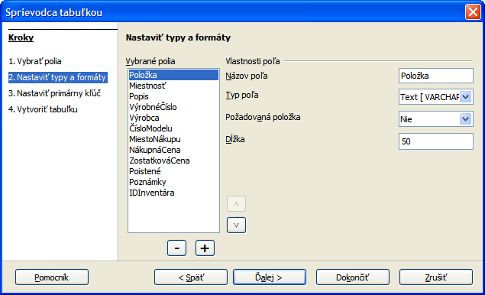
Figure 5: Ordered selected fields list with field information items

Field information
All the fields have at least four items as field information. The actual number of items depends upon the field type. When the field type is Integer, there are five items.
Most of the field types used in Base are similar to those used in other database programs. However, different programs are likely to have some field types that are not available in Base. For example, MEDIUMINT, is used in the MySQL database. Its Length is less than INTEGER and larger than SMALLINT which Base uses.
Tip | Whether you are new to creating databases or new to using Base to create them, you will be selecting the field information for all of your fields. For this reason, those used in Base are discussed in Appendix I of the Base Guide, Field Information for Base.
The Field name permits you to change the spelling of the field's name. The Field type determines the main characteristic of the field such as text, numbers, dates, times, timestamps, Boolean (for example, yes/no, true/false, or male/female), and very large fields including images.
Use Entry required for any field that must always have a value by selecting Yes.
Caution   | If you have a field that requires an entry, you will get an error message if you do not enter a value.
The Length property determines the size of the entry that can be used for a field. Length of some field types is fixed and cannot be changed, length of other types is variable. For example, the number of digits for the INTEGER numbers is set to 10 and cannot be modified, while the length of various text field types can be adjusted. You might need to change the field type if you need a larger length than your chosen field type will permit.
Text field types include CHAR, VARCHAR, VARCHAR_IGNORECASE, and MEMO. CHAR stores entries in a user selectable fixed length. For example, the selected length is 10 and the values entered were cat, mouse, leather, and something. These would be stored as cat0000000, mouse00000, leather000, and something0. The zeros are added to make the length of each one 10. When this field is later read, the zeros are ignored.
VARCHAR is character field with variable length. Only the actual characters entered are stored up to the length selected. If it also has a selected length of 10, the above examples are stored as cat, mouse, leather, and something. So less storage is needed when using VARCHAR instead of CHAR. This is especially useful when a field's values vary considerable in length. The suggested length of 50 can be used for VARCHAR as long as the longest entry is less than or equal to 50.
Use these steps to set the fields and their properties for your table:
- To verify or modify the Field information for the selected fields,
  - Click the field name in the Selected field list.
  - Compare the field information to what you want the field to have.
  - Change any of it if necessary.
  - Repeat steps 1a-c for the rest of the fields.
- To create a new field:
  - Click the plus (+) button. (See Figure 5.)
  - Change Field name to the field name you want.
  - Modify any of the other Field information to what you need.
  - Repeat steps 2a-c for additional fields to be created.
- To delete an unneeded field:
  - Click the field you want to delete.
  - Click the minus (-) button.
  - Repeat steps 3a-b to delete any additional fields.

Practice exercise
The field, RoomID, needs to change its name, field type, and length. Two of the fields, AppraisedValue and PurchasePrice, require a change in the number of decimal places. Finally, the field InventoryID Auto value and field Item Required value should be changed from No to Yes.
All changes are accomplished in the same manner: click the field in the Selected Fields list, and then change the part of the field information that needs it. After making the changes a particular field needs, use the Tab key to proceed to the next field or click one of the other fields. This saves the values to memory.
First select the field RoomID. Change the Field name to Room. Now move to Field type. Click its drop-down list to open it. Now select Text[VARCHAR] and change the Length to 50 unless you have a room with a name longer than 50 characters. Select the field AppraisedValue. Change Decimal places from 0 to 2. Now we can store values in dollars and cents. Change Decimal places for PurchasePrice the same way. Finally set the Required value for the field Item from No to Yes.
To complete this part of the practice exercise, click the Next > button. The exercise continues on page 16.
Note | When using the table wizard to create a table, very seldom will you need to make any changes in the field information since the suggested values are usually the ones you need. However, check the Decimal places value for currency fields as the wizard suggests using 0.

Step 3: Set primary key
First of all, what is a primary key, and what is its purpose? It consists of one or more fields that have a special characteristic: no two values of the primary key in the table are the same. Its purpose is to identify the rows of a table.
For beginners, any primary key used should be a single field. It is even better if this field has the field type, Integer, and has Auto value set to Yes. When you create your primary key this way, Base will assign values to the field beginning at 0. Each new value for this field will be an Integer that is one greater than the previous one. This guarantees this field will contain distinct values.
Primary keys containing more than one field require more vigilance to make sure no two rows have the same values for these fields. Consider the table below. No two rows are identical even though Field1 has duplicate values as does Field2. However, together there are no duplications of the combination.
Table 1: Example of values for a two-field primary key
Field1 | Field2
1 | 0
0 | 1
0 | 0
1 | 1
Caution | When a table is created without a primary key, you will not be able to enter any data into the table. You will first have to learn how to use the Table Design dialog before you can correct this error. (See Chapter 3 of the Base Guide.) So when using the table wizard always have this checked on Page 3: Create a primary key.
There are three choices on this page of the table wizard once you have made sure that Create primary key has been selected. This should be the default setting, but make sure anyway. The choices are Automatically add a primary key, Use an existing field as a primary key, and Define primary key as a combination of several fields.
The first option adds an additional field, ID, as the table's primary key. Its field type is Integer. However, Auto value is set to No. This means you would have to manually enter each value for the field, ID, unless you check the “Automatic value” field.
The second option selection has been selected in Figure 6. The field name has been selected from the drop-down list of field names. The Auto value checkbox has been checked to have Base select the values for this field automatically.
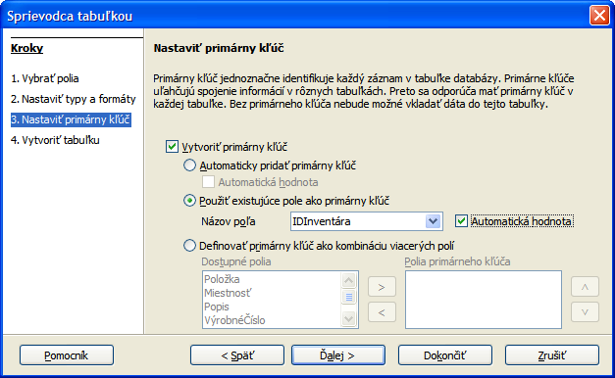
Figure 6: Table Wizard Step 3
The third option allows you to select two or more fields to use for the primary key. If you select this, you can select the fields from the Available fields list and move them to the Primary key field list using the right arrow in the middle. You can even change the order in the Primary key field list using the up or down arrow.
If you want to experiment with a multiple field primary key, select the Personal Category and the Addresses sample table. Select FirstName, LastName, and any other fields you want. Then in this page, select the third option. Move FirstName and LastName from Available fields to Primary key fields. When you added data to this table make sure that you do not use the same first name last name combination more than once.

Practice exercise
Select InventoryID to be the primary key for the table and give it the Auto value property. To complete this part of the practice exercise, click the Next > button. The exercise continues on page 17.

Step 4: Create table
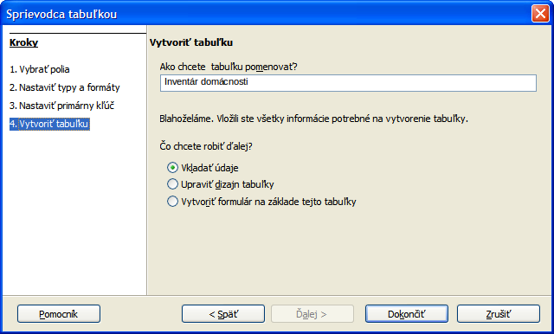
Figure 7: Table Wizard Step 4
Tip | A common naming practice has been to make two or more words into one word for the name of a field or database. (Each word is capitalized when joining them.) HouseholdInventory and InventoryID are two examples. You may use spaces in names used in a database if you want.
Use this page to name the table you are creating. You can use the name suggested, modify it, or give it a name of your choice. Then you have three options regarding what to do next: Insert data immediately, Modify the table design, or Create a form based on this table. After making any modification in the table name and selecting your option, close the table wizard.
When the first option is selected and the table wizard is closed, the Table Data View dialog opens. At this point you can add information in this table. (See Figure 8.)
When the second option is selected and the table wizard is closed, the Table Design dialog opens. With this you can modify the fields of the table.
With the third option and the Table Wizard closed, the Form Wizard opens. With this you can create a form for the Household Inventory table. (See Forms section on page 20.)

Practice exercise
Modify the name of the table to Household Inventory. Then select the first option, Insert data immediately. Click Finish to close the Table Wizard. The Table Data View dialog (Figure 8) opens.

Enter or remove data using the Table Data View dialog
Data can be entered into a table using this dialog or the form based upon this table. Instructions are give here about how to enter data using this dialog; later instructions will be given for how to insert, modify, or remove data in a form at the end of the Forms section on page 20.
To insert or remove data using the Table Data View dialog, it has to be opened. This can be done while creating the table by selecting Insert data immediately in the last step of creation. Also, you can always open any table at any time from the Main Database window by the following steps:
- Click the Tables icon in the Database section.
- Right-click the name of the table in the list of tables.
- Select Open from the context menu. The Table Data View dialog opens.
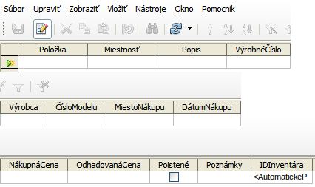
Figure 8: Table Data View dialog (the table is divided into three snapshots because of the width of the table)

Enter data into a table
When the table is first created, it contains no data as shown in Figure 8. Before entering data into the cells, you may need some reminders about the rows and columns of a table. All the data contained in a given row apply to a given item. All the data contained in a given column belong to the field whose name appears as the heading of that column.
When the Table Data View dialog is opened, a cursor appears in the first cell of the row. It is ready for you to enter data into that cell. Once you have entered data into a cell, you can move the cursor into the other cells by pressing the Enter or Tab keys, any arrow key or by clicking a cell by the mouse so that data can be entered there as well. Finally, when the cursor is in the last column of a row, pressing the Enter, Tab or right arrow key moves the cursor to the first column of the next row.
To save the entered data choose File > Save current record in the main menu of the Table Data View dialog or press Ctrl+S. To close the dialog choose File > Close in the main menu of the dialog or click the X button in its title bar. Confirm saving it in the dialog which opens if necessary. In both cases the changed data is saved in the actual .odb file.
Entering data into an empty table: (The cursor is located in the first column of the first row.)
- The first row:
  - Type the data into the first cell.
  - Move the cursor to the next cell.
  - Repeat steps a) and b) until the cursor is in the last cell of the row.
  - Type the data into the last cell.
  - Move the cursor to the first cell of the second row.
- Additional rows:
Repeat steps a) – e) in 1).
- Close the table data view dialog, saving it if necessary.
Entering data into any empty cell of a table is very similar to the above steps.
- Use the mouse to move the cursor to the empty cell.
- Type the data into it.
- Move the cursor to another cell.
- Close the table data view dialog, saving it if necessary.
Practical exercise
Enter this data into the Household Inventory table using the Table Data View dialog:
Table 2: Sample data (first 6 fields)
Item | Room | Description | SerialNumber | Manufacturer | ModelNumber
Keyboard | Den |  | 14268941235 | Casio | CTK-720
HP Pavillion | Computer | computer w/printer | KQ946AA#ABA | Hewlett Packard | A6503f
Piano | Living | Upright | STE112211 | Steinway | 2002STE4556
Table | Dining | round | WW2113 | Woodworks, Inc. | WW126
Microwave | Kitchen | 900W | SHR4568de222 | Sharp | SHR54678KL
Table 3: Sample data (last 7 fields)
Place Purchased | Date Purchased | Purchase Price | Appraised Value | Insured | Notes | InventoryID
Target | 05/16/08 | 90 | 75 | TRUE |  | 0
Best Buy | 09/04/11 | 1097 | 999 | TRUE |  | 1
Classical Instruments | 08/12/02 | 5895 | 6000 | TRUE |  | 2
Sonny's Furniture | 10/19/67 | 825 | 125 | TRUE | 6 chairs | 3
Service Deluxe | 08/30/11 | 145.99 | 130 | TRUE |  | 4

Modify data in a cell of a table
Modifying data requires five steps:
- Open the table.
- Click the cell containing the data.
- Change the data as you would in any text box.
- Close the table data view dialog, saving it if necessary.

Delete data from a table
Deleting data involves one of two things: either deleting the data from a single cell or deleting the data from all the cells of a row. Deleting data from a single cell is done the same way as modifying the data of a single cell (described in the previous section). In step 3, you delete the data that you no longer want.
Deleting all the data in a table's row requires the following steps:
- Open the table.
- Right click the gray box to the left of the row whose data you want to delete and select Delete Row from the context menu. A dialog appears labeled Do you want to delete the selected data?
- Click OK if that is the row of data you want to delete. Click NO if it is not.
- Save the table, and then close it.
Caution | Be very careful when deleting a row of data. It is permanent and undo is not possible.

Forms: using the Forms Wizard
If we had to enter all of our data directly into our table, it would be more time consuming than it needs to be. Creating a form based upon the table we created will allow us to enter our data in a more meaningful way. When we look at a table, we see many rows of data simultaneously. The form allows us to see only one row (one record) at a time.
Tip | In this section we assume that you have created the table Household Inventory according to instructions given in the section Practice exercise: Create the HouseholdInventory table on page 12. You can find the table in file GS4208-02HouseholdInventoryTableFilled.odb, distributed along with this chapter.  File GS4208-03HouseholdInventoryForm.odb contains the Household Inventory form created according to instructions given in this section. File GS4208-04HouseholdInventoryFormFilled.odb contains the same form filled with sample data provided by tables 2 and 3 on page 19.

Create a simple form using the Form Wizard
The wizard guides us through some fairly easy steps for creating a form based on the table we have already created. The wizard creates a layout of controls (the table's fields and their labels) based upon the choices we make while using it.
Once the form is created, it can be edited. Because of the additional complexity that editing involves, editing of forms is discussed in Chapter 3 of the Base Guide.
Here are two ways to open the wizard for create a form:
- Click the Table icon in the Database section of the main database window.
  - Right-click the table you want to use. (Right click the Household Inventory table.)
  - Select Form Wizard from the context menu.
- OR, click the Forms icon in the Database section of the main window, then in the Task section, click Use Wizard to create form.
Step 1: Field selection (Figure 9)
- Select the table, Household Inventory, in the Tables and queries drop-down list.
  - If you right-clicked the Household Inventory table and selected Form Wizard from the context menu, Table: Household Inventory will already be selected. OR
  - If you had earlier clicked Use Wizard to create form, select Table: Household Inventory.
- Choose fields from the Household Inventory table to be used in the form.
- If you want to use all of the fields, click the right double arrow to move all the fields listed under Available fields to the Fields in the form list.
- If you only want to move part of the fields, click the field you want to move and click the right arrow to move this field.
- Repeat for the rest of the fields to be moved.
- Click Next.
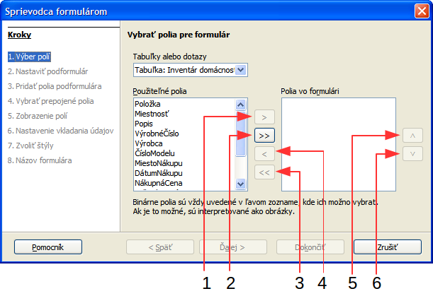
1 | Move selected field to the right | 4 | Move selected field to the left
2 | Move all fields to the right | 5 | Move selected field higher in list
3 | Move all fields to the left | 6 | Move selected field lower in list
Figure 9: Page 1 of the Form Wizard
Tip | Notice that the drop-down list we used to select the Household Inventory table is labeled, Tables or queries. This is because a form can be created from a query just as it can be from a table.
Step 2: Set up a subform.
- Subforms are used mostly in the case two or more tables. We will not use them.
- Click Next.
Step 3, Add Subform fields, and 4, Get joined fields.
Both of these pages only apply when using subforms. In our case they are grayed out.
Step 5: Arrange the controls on your form.

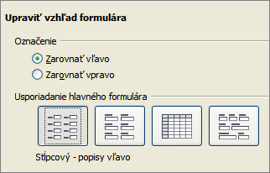
Figure 10: Arranging the controls of the form
In a form we create a control for each data item, which consists of a label and field. The label contains the name of the control, and the Field contains the data entered into the form.
You have four choices in arranging your controls as shown in the figure from left to right: Columnar – Label left, Columnar – Label on top, As Data Sheet, and In Blocks – Labels Above. Each choice gives a slightly different layout.
Both of the columnar layouts create the controls in columns beginning with the first control at the upper left and continuing down the left side. If additional columns are needed, they are filled in from top to bottom and then columns from left to right. The first control is the top control in the left column. The last control is the bottom control in the column on the right.
The Data Sheet arrangement looks like a spreadsheet with the labels across the top. This is probably best used for a subform rather than for the main form. It is your choice.
The In Blocks – Labels Above arrangement places the controls in rows from left to right. When one row is filled, the next control is placed at the left end of the row below. So, the first control is at the left end of the top row, and the last control is at the right end of the bottom row.
We will use Columnar – Labels Left for the Household Inventory form.
- Arrangement of the main form: click the graphic on the left. (See Figure 10 for the correct appearance of the window.
- Label placement: Select how you want the labels to be aligned: left or right.
- Accept the Default value of Align left, or click the bottom option button to select Align right.
- Arrangement of the subform: we are using only one table in this form, so this is grayed out.
- Click Next.
Step 6: Select the data entry mode.
- The default choice match our needs. Click Next.
Tip | I strongly advise that you look at the data entry choices available, thinking about how each of these choices might meet your future needs. For instructions on the purpose of each of these choices, see Chapter 3 of the Base Guide.
Step 7: Apply the style of your form.
- Apply styles: page color:
  - Chose one of the listed colors.
- Field border:
  - Experiment with the three choices. Use the mouse to move the Form window around so that you can see each of the three choices in the form which is displayed in the background window.
- Click Next.
Step 8: Set the name of the form.
- The suggested name for the form is the same as the table that was used to create the form: Household Inventory. Use the suggested name this time, but remember that you can choose the name you want to use. You can rename the form if you like.
- How do you want to precede after creating the form?
  - If you want to add data immediately after creating the form, use Work with the form. Select this choice for this example.
- Click Finish.
  - Since we chose Work with the form above, the Household Inventory form opens in the input mode, as in Figure 11.
  - If you had chosen Modify the form, the Household Inventory form would have opened in edit mode. Modifying a form is discussed in Chapter 4 of the Base Handbook.

Enter or remove data using forms
The data for any of the fields in a given record can be entered, removed, or changed at the same time. There are some similarities and differences between manipulating data by using the Table Data View dialog (page 18) and a form. This discussion involves two parts: working with individual controls, and removing an entire record from the database. The latter is similar to deleting an entire row from a table with the same possible consequences.
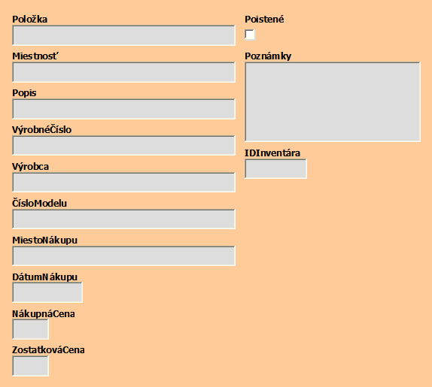
Figure 11: Newly created Household Inventory form

Enter or remove data from individual controls
The form contains a control for each of the fields in the table. Each control contains a label which identifies the field from the table and a box which contains data from the field. When the cursor is in a box, data can be typed into it.
Before entering or removing data from individual controls, you need to acquaint yourself with both the newly created form and the left side of the Form Navigation toolbar, shown in Figure 12. (The rest of the tools on it are discussed in Chapter 4, Forms, in the Base Handbook.)
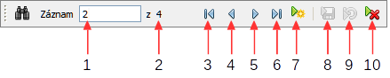
1 | Record number | 6 | Last record
2 | Total records | 7 | New record
3 | First record | 8 | Save record
4 | Previous record | 9 | Undo: data entry
5 | Next record | 10 | Delete record
Figure 12: Form Navigation toolbar
- Record number: The form numbers the rows of the underlying table from the top row to the bottom row. The record number shown is the number of the row that appears on the form.
- Total records: This shows the total number of records of the underlying table.
- First record: Click this arrow to go to the first record. The record number becomes 1 or whatever is the smallest number. If the present record is the first record, this arrow is grayed out and not useable.
- Previous record: Click this arrow to go to the previous record. The record number becomes one less than what it had been. If the present record is the first record, this arrow is grayed out and not useable.
- Next record: Click this arrow to go to the next record. The record number will be one larger than what it has been. If the present record is the last one, no data will appear in this record with one exception: the form contains the table's primary key, and its field property, AutoValue, is set to Yes. Only then will the primary key show AutoValue.
- Last record: Click this arrow to go to the last record. The record number becomes the largest one. If the present record is the last record, this arrow is grayed out and can not be used.
- New record: Click this icon if you want to create a new record becoming the last record. The record number becomes one larger than the previous largest one. No data appears in the controls of this record except for a primary key control whose field property for AutoValue is Yes.
- Save record: Click this icon to save data that has been typed into one or more controls to the table.
- Undo data entry: If you have made some entries but have not saved them, you can click this icon to remove all the entries you have made in the present record since the last time the record was saved.
- Delete record: Click this icon if you want to delete the data from all of the controls in the present record. This will remove data that you just entered as well as the data that had been saved earlier.
Caution | Be very careful when clicking the Delete record icon. This is equivalent to deleting a row from a table. Only do this if you are absolutely sure that you will no longer need the data that you are deleting.
Tip | Using the listed tools saves the entered or modified data typed into the currently active record:  - First record  - Previous record  - Next record  - Last record  - New record  - Save record
Caution | When records are saved, they are written to the underlying table. However, this is done in the computer's memory (RAM). To write the data to the Base file (.odb), you have to close the form dialog by choosing File > Close from the form's main menu or by clicking the X button in the form's title bar.
Entering data in a new record requires the following steps.
- Click the New record icon to create a new record.
- Select the first control by clicking a mouse and type the data.
- To move to another control:
  - Use the Tab or Enter key to move to the next control.
  - Use the Shift+Tab key or Shift+Enter key to move to the previous control.
  - Click on any field by mouse
- Type the data into the control to where you have moved.
- Repeat steps 1-4 to enter the data into the record.
- After typing data into the last control of the record, use the Tab or Enter key to save the data and create another new record.
Removing or modifying data from an individual control:
- Go to the record that contains the data to be deleted or modified using the first, previous, next, or last record arrow.
- Click the field that contains the data you want to change.
- Delete or modify the data.
- Save the record.

Practice exercise
- Create five more records in the form using the data in Tables 4 and 5 below.
- Modify the following records with the data given:
  - Change the appraised value for the piano from 6000 to 5700.
  - Delete the Description for the WiFi. (802.11g is not needed.)
Table 4: Data for first six controls
Item | Room | Description | SerialNumber | Manufacturer | Model Number
Dishwasher | Kitchen | built-in | GE4581839315 | General Electric | GE456ee781
Refrigerator | Kitchen | side by side | HP4865818634 | Hot Point | SBS44588F1990
Stove | Kitchen | counter top w/built-in oven | 456789123258 | Whirlpool | WP5748we84
TV | Den | 19" Digital ready | MOT123456789 | Motorola | MOT57dde85815
WiFi modem | Computer | 802.11g compatible | CGNC1H111980 | Linksys | WRT54GS V7
Table 5: Data for last seven controls
Place Purchased | Date Purchased | Purchase Price | Appraised Value | Insured | Notes | Inventory ID
Lowes | 04/20/99 | 450.95 | 250 | TRUE | 5 cycles | 5
Brothers Appliances | 12/16/90 | 1599.99 | 528 | TRUE |  | 6
Sears | 12/30/99 | 899 | 452 | TRUE | oven built-in | 7
Sanders TV & Repair | 03/31/09 | 249.99 | 143 | TRUE |  | 8
Webster's Computers | 04/22/04 | 35.99 | 20 | TRUE | 4-RJ45 | 9

Deleting records in a form
Once the specific record to be deleted is located it can be deleted by clicking the Delete record icon in the Form Navigation toolbar and then the Yes button in the dialog which opens.
Practice exercise:
Delete the record for the WiFi modem. While you are at it, add a new record for the WiFi modem.

Queries: using the Query Wizard
The query is used to obtain information from the database and present it in a useful way. We can create a query by using the Query Wizard for simple queries using a single table or using the Query Design dialog which is designed for the more complex queries using multiple tables. The Query Design dialog is discussed in Chapter 5, Queries, of the Base Handbook.
Tip | In this section we assume that you have either followed the instructions given in the previous sections or that you have opened the file 04HouseholdInventoryFormFilled.odb, distributed along with this chapter.  File GS4208-05HouseholdInventoryQuery.odb contains the Household Inventory and Household Inventory Summary queries created according to instructions given in this section.
Query
A query is a search of the database to locate specific types of information.
Some of this information may be what has been entered. We may want to know the appraised value of the items in the Living Room. This produces a detailed query whose output is a detailed list. A query can also manipulate the data to obtain desirable information. For example: Based upon the appraised values of the individual items, what is the total appraised value of the entire inventory? This summary query produces a single cell containing the total appraised value of the inventory.
Detailed query
A query that produces a detailed list as its output. The data in this list are part of the data contained in the database. The list consists of one or more rows.
Summary query
A query that manipulates database data to produce its output. Unless the summary query is group, its output will contain only one row and each column will contain manipulated data.

Plan the query
As when creating a table, some thinking needs to be done about the purposes of the query before creating it. Questions based on them should be asked, questions based upon the eight steps that the wizard uses. It is best to ask the questions before using the wizard. Then you have the answers you need to make your selections in each of the steps.
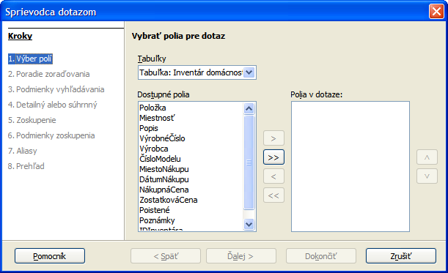
Figure 13: Query wizard Step 1
Questions of step 1. Field Selection:
- What table or query contains the fields the query needs?
- What fields are needed?
Questions of step 2. Sorting order:
- What fields will you use to sort the query output?
- Will the sorting for a give field be ascending or descending?
Questions of step 3. Search conditions:
- What fields need to have conditions added to them?
- What are the specific conditions?
Questions of step 4. Detailed or Summary:
- Do you want the output to be a detailed list or a summary of selected database data?
- Ak výstupom má byť súhrnný dotaz, ktoré polia a ktoré agregačné funkcie použijeme pre výpočty?
Questions of step 5. Grouped by:
- (No selections are available for this step. Instead the selection in Step 2 is used.)
Questions of step 6. Grouping conditions:
- (No selections available for this step. Instead the selection in Step 3 is used.)
- Do ktorých polí bude potrebné pridať podmienky?
Questions of step 7. Aliases:
- What fields should have their names modified?
- What should the modifications be?
Questions of step 8. Overview:
- In the Overview window, what does not match what you wanted?
- What should the name of the query be? (Base suggests a name.)
- Do you want to display or modify the query? (The latter is discussed in Chapter 5, Queries, in the Base Handbook.)
The importance of these questions should become clearer when you create two sample queries using the Household Inventory database (detailed and summary). First we will explain what needs to be done for each of these eight steps.

Create the detailed query
To do this, we begin with the main database window open.
- Click the Queries icon in the Database section.
- In the Task section, click Use Wizard to Create Query. The wizard opens.
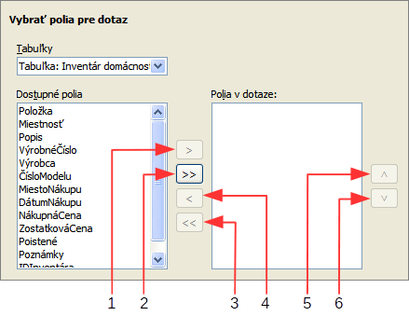
1 | Move selected field to the right | 4 | Move all fields to the left
2 | Move all fields to the right | 5 | Move selected field up
3 | Move selected field to the left | 6 | Move selected field down
Figure 14: Selection of fields in a query

Step 1: Field selection
- Click Tables: Select the table or query to be used from the Table list. (Select the Household Inventory table.)
- Select the fields to be used from the Inventory table. (Select the fields AppraisedValue, DatePurchased, Item and PurchasePrice):
  - Click one that is in the Available fields list.
  - Click the right arrow to move it to the Fields in the Query list.
  - Kroky a) až b) opakujeme, až kým všetky požadované polia nepresunieme do zoznamu Polia v dotaze.
- Change the order of the fields in the Fields in the Query. (Rearrange the order of fields to Item, then AppraisedValue, then PurchasePrice, then DatePurchased):
  - Click the name of the field you want to move.
  - Use the up arrow to move it higher in the list, or the down arrow to move it lower.
- Click Next.

Step 2: Sorting order
Select the field to be used for sorting the information you want.
- Open the Sort by drop-down menu by clicking the box labeled Undefined.
- Click the field's name in this drop-down list to select it.
- Select Ascending or Descending as the order of the sorting.
- Click Next.
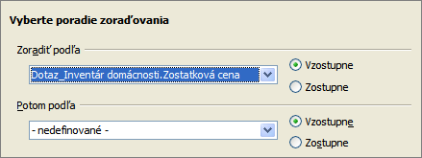
Figure 15: Sorting order selection

Step 3: Search conditions
Define the search conditions that will be applied to the query data.
- Select the field in the Fields drop-down list in the top row.
- Select the first condition from the Condition drop-down list.
- Enter the value in Value.
- If additional conditions should be defined, follow steps 1–3 in the succeeding rows of Fields, Condition, and Value.
- If you have selected multiple conditions,
  - If you want all of the data to match all conditions in your query output, select the Match all of the following option button.
  - If you want any individual datum (singular of data) to match any of the selected search conditions, select Match any of the following option button.
- Click Next.
Two examples of a query with multiple search conditions: the last name must be Smith and the city must be Selma; and the last name can be Smith or Jones.
For the first example, you need two rows. Select Last Name in Fields; for Condition, select is equal to; and enter Smith in Value. For the second row, enter City in Fields; for Condition, select is equal to; and enter Selma in Value. When this query is run, the only rows in the output will be those containing Smith in the Last Name field and Selma in the City field.
For the second example, you also need two rows. Select Last Name in Fields; for Condition, select is equal to; and enter Smith in Value. For the second row, select Last Name in Fields; for Condition, select is equal to; and enter Jones in Value. With this query, the only rows in the output will be those containing either Smith or Jones in the Last Name field.
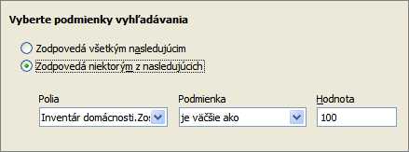
Figure 16: Selecting the search conditions

Step 4: Detailed or Summary
This is where you define whether the query is detailed or summary.
- Keep the predefined value (detailed)
- Click Next.
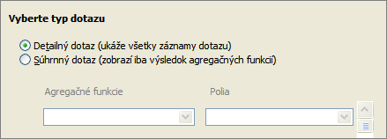

Steps 5 and 6: Group by and Grouping conditions
Grouping is only used with summary queries and therefore these are grayed out now.
- Click Next.

Step 7: Aliases
An alias is similar to a nickname. For example, the name of suggested fields in the table wizard are often two or more words that have been combined into one word. At this point you may wish to create aliases that have these names divided into their original words or changed to something more meaningful.
- Click Next.

Step 8: Overview
Figure 17 shows the overview of a query. It contains three parts: naming the query, what will be done next after the query is created, and an overview of the selections made using the wizard.
You should enter what you want to call the query in the Name of the query text box. The suggested name combines Query with the name of the table used in the query using an underline.
Do not use the name of the table as the name of the query as well; doing so will cause an error message. Because tables and queries can be used when creating queries, forms, and reports, a name for a table or query can be used only one time to prevent selecting the wrong one if duplicate names are allowed.
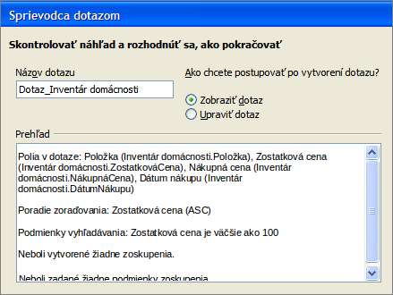Figure 17: Overview of a query
You have two choices after closing the query wizard: display the query results, or modify the query. The first choice runs the query to give you an output. The second choice opens the Query Design dialog. Because the second choice leads to something that is beyond the discussion of this chapter, do not change the default setting (Display Query).
Like the naming of the query, the overview list is rather important. It contains three pieces of information that we need to verify matches what we originally wanted in the query.
There are four fields in the query, all from the Household Inventory table: Item, AppraisedValue, PurchasePrice, and DatePurchased. These have been given the aliases Item, Appraised Value, Purchase Price, and Date Purchased respectively.
Verification: Household Inventory is the correct table, the listed fields are the correct fields, and the alias are also correct.
The field, Appraised Value, is the field that will be used for sorting, and the direction of the sort is ascending (from the least value to the greatest). (The alias, Appraised Value, is used in place of the field name, AppraisedValue.)
Verification: This is the correct field, and the sorting is in the correct direction.
The search condition applies only to Appraised Value and it restricts its values to $50 or more. Any items worth less than or equal to $50 will not be shown when the query is run.
Verification: This is the correct field, and the search condition is also correct.
Verification: Since none of the fields are manipulated, we have a detailed query. This is correct.
When you click the Finish button, the query wizard closes and the Query_Household Inventory-Inventory-LibreOffice Base: Table Data View dialog opens with the output for the query. (See Figure 18.) All of the items have an appraised value greater than $50. The WiFi modem is not part of the output because its appraised value is less than $50. If an item in the inventory had an appraised value of $50, it would not be in the output either.

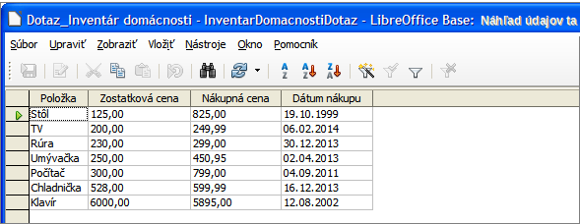
Figure 18: The Table Data View for this query

Create the summary query
For this example query, what you want to know is this: What is the total purchase price and appraised value for the contents of each room in our inventory?
This requires sorting the values for these two fields by room. Then the SUM function is applied to the values of these two fields for each group.

Step 1: Field Selection
- The table will be Household Inventory.
- Select these fields from it: PurchasePrice, AppraisedValue, and Room.
- Click Next.

Step 2: Sort Order
- Select the field, Room, as the one to sort by.
- Select Ascending as the direction of the sort.
- Click Next.

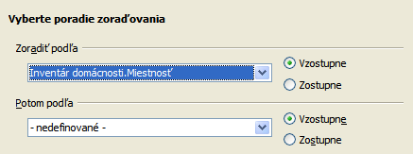

Step 3: Search Condition
In this case we want to process all data. Therefore, we do not specify any conditions. The Match all of the following (Default) is appropriate.
- Click Next.

Step 4: Detailed or Summary
- Select the Summary query (Shows only results of aggregate functions.)
- Aggregate functions
  - Click the arrows at the right end of its drop-down list.
  - From this list, select get the sum of.
  - From the Fields dropdown list, select Household Inventory.PurchasePrice
  - Click the plus (+) button to reveal a second row of drop-down lists.
  - From the Aggregate functions drop-down list, select get the sum of.
  - From the Fields dropdown list, select Household Inventory.AppraisedValue.
- Click Next.

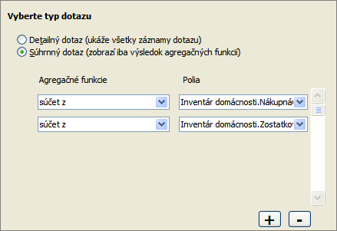

Steps 5 and 6
These are not used by the wizard in our case and therefore are inactive.

Step 7: Aliases
  - Change PurchasePrice to Total Purchase Price.
  - Change AppraisedValue to Total Appraised Value.
  - Click Next.
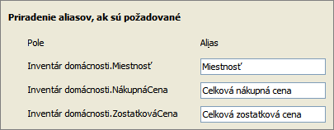

Step 8: Overview
- Name the query Household Inventory Summary.
- Display the query after closing the query (Default selection).
- Check the Overview:
  - The table used is Household Inventory. (Correct)
  - The fields used are Room, PurchasePrice, and AppraisedValue. (Correct)
  - The Sorting order is Room. (Correct)
  - No Searching conditions were given. (Correct)
  - Zoskupené podľa poľa Miestnosť (správne).
  - Neboli zadané podmienky zoskupenia (správne).
To close the wizard and display the query in a Table Data View dialog, click Finish.
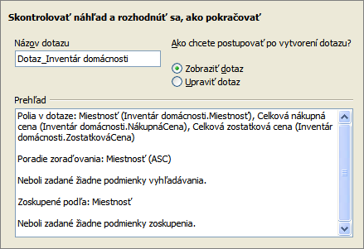
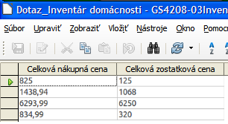

Note | The Table Data View dialog shown in the picture above does not display the Room column. In order to display it, one has to open context menu of the Household Inventory Summary query and select the Edit item. The Query design dialog opens. There, check the unchecked field in the Visible row in the Room column and save. Next time the query is opened by selecting the Open item in its context menu, all three columns will be displayed.

Reports: use wizard to create reports
Reports present information found in the database in a useful way. In this respect they are similar to queries. Reports are generated from the database’s tables or queries. They can contain all of the fields of the table or query or just a selected group of fields. Since the data that concerns us is contained in a query, we will use that.
Tip | In this section we assume that you have either followed the instructions given in the previous sections or that you have opened the file 04HouseholdInventoryQuery.odb, distributed along with this chapter.  File GS4208-06HouseholdInventoryReport.odb contains the Report_Household Inventory query created according to instructions given in this section.
Reports can be static or dynamic. Static reports contain the data from the selected fields at the time the report was created. Dynamic reports can be updated to show the latest data. If you are sure that data for your report does not change with time, creating a static report is a good choice. A report of your inventory’s total appraised value for the year 2008 is an example of a static report. But a similar report for your insurance agent for updating your policy needs to be a dynamic report. This report needs to contain any purchases made since the last report was made. When you purchase or replace an item, this report can tell you whether you even need to contact your agent or not.
The report that we will create, is based upon Query_Household Inventory.
To start the wizard:
- In the main database window, click the Report icon in the Database section.
- In the Task section, click Use Wizard to Create Report. (The Report Wizard opens with the Report Builder opening in the background.)
Tip | As you go through the steps of the Report Wizard, use the mouse to move it so that you can see what effects your selections in the wizard have on the Report Builder.
Under Tables or queries, a drop-down list contains the tables and queries you have created.
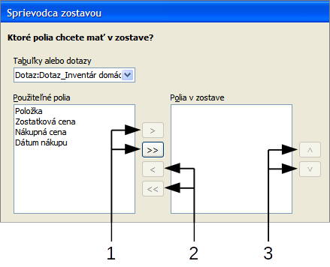
1 | Move available fields to the right | 3 | Change order of report fields
2 | Move report fields to the left
Figure 19: Report Wizard field selection

Step 1: Select the table and its field for the report
- Select Query_Household Inventory from the Tables or queries drop-down list (see Figure 19).
- Move the list of Available fields to the list of Fields in report using the double right arrow button.
- If you want to change the order of the fields in the Fields in report list, click the field you want to move up or down in this list. Click one of the arrows (#3 in figure 19) to move the field up or down to where you want it.
The fields in your report should match the ones in the figure below.

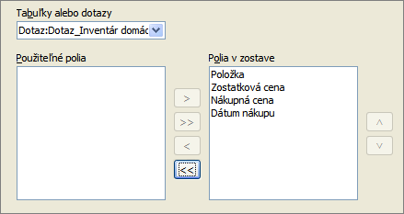
Step 2: Labeling fields
Here you can give aliases to one or more fields. The report suggests using the name of the fields of the query.
- Review the suggested labels for the fields. Change them if you think your name is better.
- Remember to use the vertical scrollbar if all of the fields are not visible, and then review the rest of the suggested labels.
We added aliases for these fields in the query earlier: AppraisedValue, DatePurchased, and PurchasePrice. So, the report will use the aliases of the query instead: Appraised Value, Date Purchased, and Purchase Price respectively.
- Click Next.

Step 3: Grouping
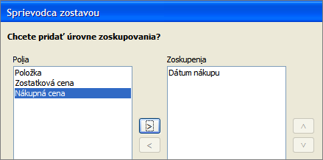
- Click Date Purchased in the Fields list.
- Click the right arrow button to move it to the Groupings list. Make sure your lists match those in the figure above.

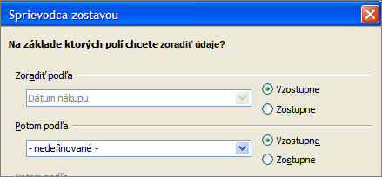
Step 4: Sort options
By selecting how the report should group the data, we have already selected the field, Date Purchased, as the first sort option. We want the field’s sorting order to be ascending. No more fields will be used in the sorting.
- If you want to sort by more fields of the report, do so now.
  - Click the drop-down list below Then by to open the list.
  - Select the field you want to use to sort the report by. This sorting will be in addition to the sorting by the Date Purchased field.
- Click Next.

Step 5: Choose layout.
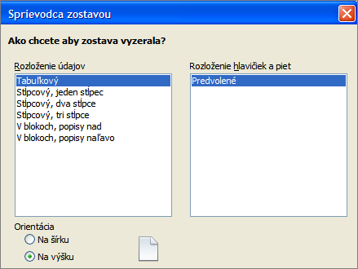
Page orientation can be either Landscape or Portrait. Which one you use depends upon the number of fields contained in the report. For a large number of fields in the report, use the Landscape orientation. For a smaller number of fields, Portrait will probably be the best selection.
To see each of the data layout choices, move the Report Wizard so you can see the layout in the Report Builder. Then select the layouts one at a time while observing what happens in the Report Builder.
- Select the Layout of data that meets your needs. For this example, select Columnar, three columns.
- Select the Orientation for your report. For this example, select Portrait.
- Click Next.
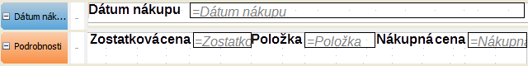
Figure 20: Report Builder layout for the selections above

Step 6: Create report.
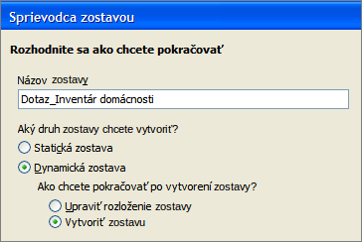
Name the report. The suggestion given is Query_Household Inventory. This is the same name as the query we used to create this report. Change Query_Household Inventory to Report_Household Inventory.
You can create two types of report: static or dynamic. A static report is a Writer document which can be modified like any text document, but any changes in the data in the underlying query will not change the report. A dynamic report is much more flexible. Changes in the data of the database will change the report the next time the report is run.
The final selection involves what should happen next. Selecting Modify report layout will open the Report Builder so that the report can be edited. This is beyond the scope of this chapter. (See Chapter 6 for how to use the Report Builder.) So, use the Default choice, Create report now.
Click Finish.
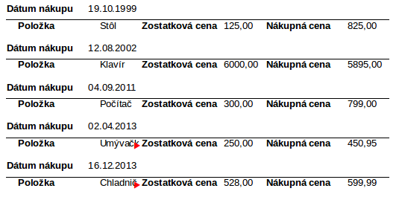
Figure 21: Top portion of the report

Note | Figure 21 shows that sometimes the report created by the wizard needs to be edited by the Report Builder, which can be opened in the last step of the wizard or by selecting Edit in the context menu of the report. In this example the layout did not allow enough room for the words Microwave and Refrigerator, and the space allowed for the field label Item is wider than it needs to be. The date format might be changed as well, and this might require a change in the length of this field. The fields containing currency amounts should be modified to the currency being used in the Inventory database.  The next time the Report is run (by selecting Open in its context menu), the data will have the changed format. In a static report, you would have to change format for each place the modified field appears in the report.

Mixing Base with the rest of LibreOffice
Base can be used alone or be used with other components of LibreOffice. Your choice depends on what you want to do with the information in the database.
This section mentions a few ways in which Base can be used with the other components of LibreOffice. Chapter 7, Linking to Databases, in the Base Handbook, as well as the individual guides for the other components of LibreOffice, contain instructions how to do this.

Writer
One very common database is the address book. Base will connect to several of them. Using Writer with Base, you can print envelopes using the postal addresses in the address book and you can send an email to several people in the address book at one time. This process is called mail merge. It is explained in Chapter 11, Mail Merge, of the Writer Guide.
To include in a Writer document data that exists in one of our databases. we could look up the data and type it into the document, but we might make a mistake in typing. By using Base with Writer, we can place a field linked to the desired data in the document. Doing it this way guarantees the data shown in the document will be as accurate as the data in the corresponding database.
Using Writer, tables in text documents can be copied into a table in a database. A new table can be created in the database including the data in the text document table. Or, a new table can be created in the database without any data. Or, if the data in the table is arranged properly, this data can be added to an existing table of a database. This is discussed in Chapter 7 of the Base handbook.

Calc
Base and Calc work together well. Using F4 or View Data Sources in Calc opens the Data window. Data and column names can be copied from the data source to the spreadsheet that is open in Calc. Data can also be copied from the spreadsheet to the data source. These methods are discussed in the Calc Guide.
Once the data has been copied from the data source to the spreadsheet, you can apply all of the available Calc functions to the data, including creating charts from the data.
There are different ways to use the data in a spreadsheet as a data source. One way is to create a Base file to connect to the spreadsheet. A second way is to save the spreadsheet using the .dbf file format. This is the file format used by dBase. Base will open this file format. This is discussed in Chapter 7 of the Base Guide.

Impress
Base and Impress are not directly used together, but they can be used together in an indirect way. Calc spreadsheets can be inserted into slides. So when you want to use data from a database in a slide, you first copy the data into a spreadsheet and then insert this spreadsheet into the slide. This is discussed in Chapter 7, Inserting Spreadsheets, Charts, and Other Objects, in the Impress Guide.

Using Base with other data sources
Base can be used with a variety of data sources, including Oracle, Groupwise, Evolution (LDAP and Local), KDE Address Book, Thunderbird/Icedove Address Book, Spreadsheet, dBASE, Text, MySQL, and Postgresql. Also included are the data sources which Base can access using JDBC (java database connectivity or ODBC (open database connectivity).
You can connect Base directly to some of these data sources (text files and spreadsheets) by making only a few selections in the Base Wizard. Chapter 7 of the Base Handbook contains instructions for how to work with these data sources.
Base requires a special driver to connect to some data sources. PostgreSQL, MySQL, JDBC, and Oracle JDBC are examples of these data sources. Chapter 7 of the Base Handbook discusses how to connect to these database sources as well as how to work with them.

