
Getting Started Guide
Chapter 10
Printing, Exporting, and E-mailing

Copyright
This document is Copyright © 2010–2014 by the LibreOffice Documentation Team. Contributors are listed below. You may distribute or modify it under the terms of either the GNU General Public License (http://www.gnu.org/licenses/gpl.html), version 3 or later, or the Creative Commons Attribution License (http://creativecommons.org/licenses/by/4.0/), version 4.0 or later.
All trademarks within this guide belong to their legitimate owners.

Contributors
John A Smith Jean Hollis Weber Hazel Russman
Ron Faile Jr.

Feedback
Please direct any comments or suggestions about this document to the Documentation Team’s mailing list: documentation@global.libreoffice.org
Note: Everything you send to a mailing list, including your email address and any other personal information that is written in the message, is publicly archived and cannot be deleted.

Acknowledgments
This chapter is based on Chapter 10 of Getting Started with OpenOffice.org 3.3. The contributors to that chapter are:
Jean Hollis Weber Agnes Belzunce Michael Kotsarinis
Peter Kupfer Robert Scott Janet M. Swisher
Joe Sellman

Publication date and software version
Published 3 April 2014. Based on LibreOffice 4.2.

Note for Mac users
Some keystrokes and menu items are different on a Mac from those used in Windows and Linux. The table below gives some common substitutions for the instructions in this chapter. For a more detailed list, see the application Help.
Windows or Linux | Mac equivalent | Effect
Tools > Options menu selection | LibreOffice > Preferences | Access setup options
Right-click | Control+click and/or right-click depending on computer setup | Opens a context menu
Ctrl (Control) | ⌘ (Command) | Used with other keys
F5 | Shift+⌘+F5 | Opens the Navigator
F11 | ⌘+T | Opens the Styles and Formatting window

Contents
Copyright 2
Contributors 2
Feedback 2
Acknowledgments 2
Publication date and software version 2
Note for Mac users 2
Quick printing 4
Controlling printing 4
Selecting general printing options 5
Printing multiple pages on a single sheet of paper 6
Selecting pages/sheets/slides to print 7
Writer 7
Calc 8
Impress and Draw 9
Printing handouts, notes, or outlines in Impress 9
Printing a brochure 10
Printing envelopes, labels, business cards 11
Printing in black and white (on a color printer) 11
Previewing pages/sheets before printing 12
Writer 12
Calc 12
Exporting to PDF 12
Quick export to PDF 13
Controlling PDF content and quality 13
General page of PDF Options dialog 13
Initial View page of PDF Options dialog 15
User Interface page of PDF Options dialog 15
Links page of PDF Options dialog 16
Security page of PDF Options dialog 17
Exporting to other formats 18
E-mailing documents 18
E-mailing a document to several recipients 19
Digital signing of documents 21
Removing personal data 22

Quick printing
Click the Print File Directly icon () to send the entire document to the default printer defined for your computer.
Note | You can change the action of the Print File Directly icon to send the document to the printer defined for the document instead of the default printer for the computer. Go to Tools > Options > Load/Save > General and select the Load printer settings with the document option.

Controlling printing
For more control over printing, use the Print dialog (File > Print or Ctrl+P).
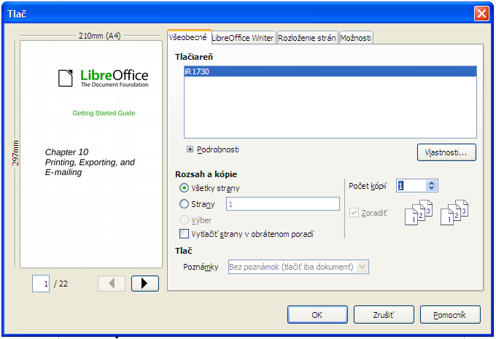
Figure 1: The Print dialog
Note | The options selected on the Print dialog apply to this printing of this document only.  To specify default printing settings for LibreOffice, go to Tools > Options > LibreOffice – Print and Tools > Options > LibreOffice Writer – Print. See Chapter 2, Setting Up LibreOffice, for more details.
The Print dialog has four pages, from which you can choose a range of options, as described in the following sections.
The different components of LibreOffice have different available print settings, as summarized in Table 1.
Table 1: Print options in LibreOffice components
Feature | Writer | Calc | Impress | Draw
Select pages/sheets/slides to print | Yes | Yes | Yes | Yes
Print multiple pages/sheets/slides on one page | Yes | Yes | Yes | Yes
Print a brochure | Yes | No | Yes | Yes
Print envelopes | Yes | No | No | No
Print labels or business cards | Yes | No | No | No
Preview pages/sheets before printing | Yes | Yes | No | No

Selecting general printing options
On the General tab of the Print dialog, you can choose:
- The printer (from the printers available)
- Which pages to print, the number of copies to print, and whether to collate multiple copies (Range and copies section)
- Whether to print any comments that are in the document, and where to print the comments.
Some selections may not be available all the time. For example, if the document contains no comments, the Print – Comments drop-down list does not work.
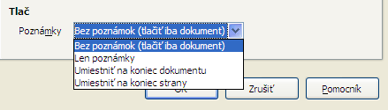
Figure 2: Choosing whether and where to print comments
Select the Properties button to display the selected printer's properties dialog where you can choose portrait or landscape orientation, which paper tray to use, and the paper size to print on.
On the Options tab of the Print dialog (Figure 3), the last item, Use only paper tray from printer preference, is not available in Calc.
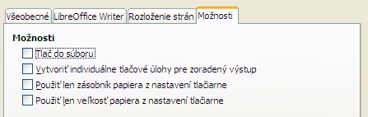
Figure 3: General print options

Printing multiple pages on a single sheet of paper
You can print multiple pages of a document on one sheet of paper. To do this:
- In the Print dialog, select the Page Layout tab (Figure 4).
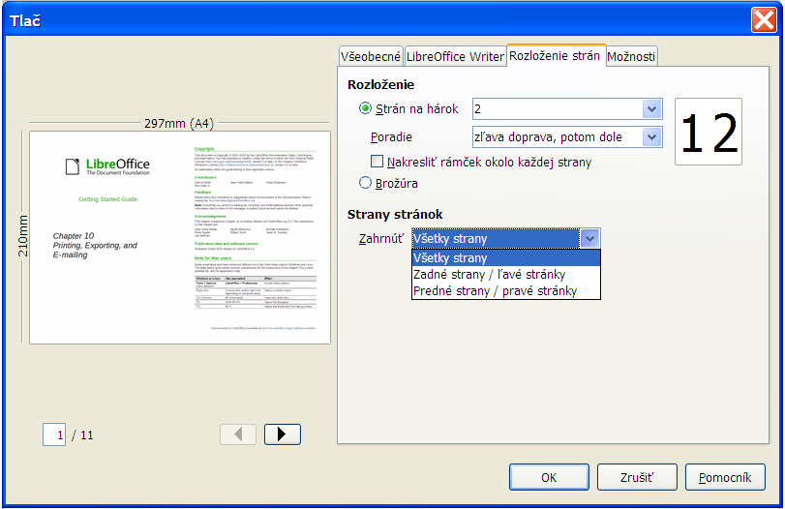
Figure 4: Printing multiple page per sheet of paper
- In the Layout section, select from the drop-down list the number of pages to print per sheet. The preview panel on the left of the Print dialog shows how the printed document will look.
When printing more than 2 pages per sheet, you can choose the order in which they are printing across and down the paper.
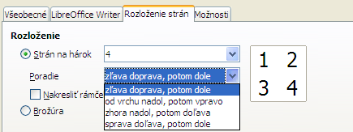
- In the Page sides section, select whether to print all pages or only some pages. Click the OK button.
Tip | In Writer, to print two pages per sheet in “facing pages” (book layout) style, print from Print Preview instead. See page 12.

Selecting pages/sheets/slides to print
In addition to printing a full document, you can choose to print individual pages/sheets/slides, ranges of pages/sheets/slides, or a selection of a document. The details vary slightly in Writer, Calc, Draw and Impress, as described in this section.

Writer
Printing an individual page:
- Choose File > Print from the Menu bar, or press Ctrl+P.
- On the Print dialog, select the page to print.
  - In the Ranges and copies section of the General page, select the Pages option. The text input box displays the current page number.
  - Enter the page number of the page you want to print. The preview box changes to show the selected page.
- Click the OK button.
Printing a range of pages:
- Choose File > Print from the Menu bar, or press Ctrl+P.
- On the Print dialog, select the range of pages to print.
  - In the Ranges and copies section of the General page, select the Pages option.
  - Enter the sequence numbers of the pages to print (for example, 1–4 or 1,3,7,11).
- Click the OK button.
Printing a selection of text:
- In the document, select the material (text and graphics) to print.
- Choose File > Print from the Menu bar, or press Ctrl+P.
- The Ranges and copies section of the Print dialog now includes a Selection option and the preview box shows the selected material. See Figure 5.
- Click the OK button.
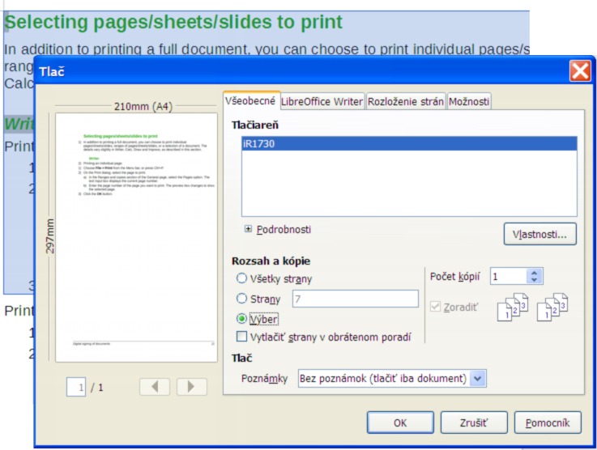
Figure 5: Printing a selection of text

Calc
You can choose single sheets, multiple sheets, and selections of cells for printing.
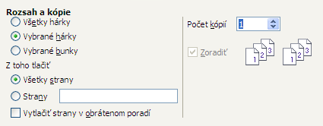
Figure 6: Choosing what to print in Calc
Printing an individual sheet:
- In the spreadsheet, click on the sheet tab to select the sheet you want to print.
- Choose File > Print from the Menu bar, or press Ctrl+P.
- In the Ranges and copies section of the Print dialog, choose the Selected sheets option.
- Click the OK button.
Printing a range of sheets:
- In the spreadsheet, select the sheets to print.
  - Select the first sheet.
  - Hold down the Control key.
  - Click on the additional sheet tabs.
  - Release the Control key when all required sheets are selected.
- Choose File > Print from the Menu bar, or press Ctrl+P.
- In the Ranges and copies section of the Print dialog, choose the Selected sheets option.
- Click the OK button.
Printing a selection of cells:
- In the document, select the section of cells to print.
- Choose File > Print from the Menu bar, or press Ctrl+P.
- In the Ranges and copies section of the Print dialog, select the Selected cells option.
- Click the OK button.
Caution   | After printing, be sure to deselect the extra sheets. If you keep them selected, the next time you enter data on one sheet, you enter data on all the selected sheets. This might not be what you want.

Impress and Draw
You can choose individual slides, ranges of slides, or selections of slides for printing.
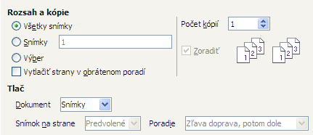
Figure 7: Choosing what to print in Impress and Draw
Printing an individual slide:
- Choose File > Print from the Menu bar, or press Ctrl+P.
- Select the slide to print.
  - In the Ranges and copies section of the Print dialog, select the Slides option.
  - Enter the number of the slide to print.
- Click the OK button.
Printing a range of slides:
- Choose File > Print from the Menu bar, or press Ctrl+P.
- Select the slides to print.
  - In the Ranges and copies section of the Print dialog, select the Slides option.
  - Enter the number of the slides to print (for example 1-4 or 1,3,7,11).
- Click the OK button.
Printing a selection from a slide, or a selection from multiple slides:
- In the document, select the section of the slide to print.
- Choose File > Print from the Menu bar, or press Ctrl+P.
- Select the Selection option in the Ranges and copies section of the Print dialog.
- Click the OK button.

Printing handouts, notes, or outlines in Impress
Handouts prints the slides in reduced size on the page, from one to nine slides per page. The slides can be printed horizontally (landscape orientation) or vertically (portrait orientation) on the page.
Notes prints a single slide per page with any notes entered for that slide in Notes View.
Outline prints the title and headings of each slide in outline format.
To print handouts, notes, or outlines:
- Choose File > Print from the Menu bar, or press Ctrl+P.
- In the Print section of the Print dialog, select the required option.
- For Handouts, you can then choose how many slides to print per page, and the order in which they are printed.
- Click the OK button.
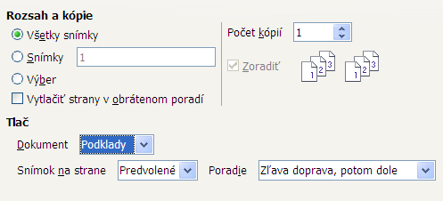

Printing a brochure
In Writer, Impress, and Draw, you can print a document with two pages on each side of a sheet of paper, arranged so that when the printed pages are folded in half, the pages are in the correct order to form a booklet or brochure.
Tip | Plan your document so it will look good when printed half size; choose appropriate margins, font sizes, and so on. You may need to experiment.
To print a brochure on a single-sided printer:
- Choose File > Print, or press Ctrl+P.
- In the Print dialog, click Properties.
- Check the printer is set to the same orientation (portrait or landscape) as specified in the page setup for your document. Usually the orientation does not matter, but it does for brochures. Click OK to return to the Print dialog.
- Select the Page layout tab in the Print dialog.
- Select the Brochure option.
- In the Page sides section, select Back sides / left pages option from the Include drop-down list.
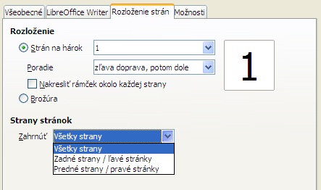
Figure 8: Selecting which pages to print
- Click the OK button.
- Take the printed pages out of the printer, turn the pages over, and put them back into the printer in the correct orientation to print on the blank side. You may need to experiment a bit to find out what the correct arrangement is for your printer.
- On the Print dialog, in the Page sides section, select Front sides / right pages option from the Include drop down box.
- Click the OK button.
Tip | If your printer can print double-sided automatically, choose All pages.

Printing envelopes, labels, business cards
Printing envelopes, labels, or business cards using Writer involves two steps: setup and printing.
For details of how to set these up, see Chapter 11, Using Mail Merge, in the Writer Guide. To print:
- Choose File > Print from the Menu bar, or press Ctrl+P.
- On the Print dialog, under Range and copies, choose Pages and type 1 in the box. Click the OK button.

Printing in black and white (on a color printer)
You may wish to print documents in black and white on a color printer. Several choices are available. Please note that some color printers may print in color regardless of the settings you choose.
Change the printer settings to print in black and white or grayscale:
- Choose File > Print, or press Ctrl+P, to open the Print dialog.
- Click Properties to open the Properties dialog for the printer. The available choices vary from one printer to another, but you should find options for the Color settings. See your printer’s help or user manual for more information.
- The choices for color might include black and white or grayscale. Choose the required setting.
- Click OK to confirm your choice and return to the Print dialog,
- Click the OK button to print the document.
Tip | Grayscale is best if you have any graphics in the document.
Change the LibreOffice settings to print all color text and graphics as grayscale:
- Choose Tools > Options > LibreOffice > Print.
- Select the Convert colors to grayscale option. Click OK to save the change.
- Open the Print dialog (File > Print), or press Ctrl+P.
- Click the OK button to print the document.
Change the LibreOffice Writer (or Calc, Impress, Draw) settings to print all color text as black, and all graphics as grayscale:
- Choose Tools > Options > LibreOffice Writer > Print.
- Under Contents, select the Print text in black option. Click OK to save the change.
- Open the Print dialog (File > Print), or press Ctrl+P.
- Click the OK button to print the document.

Previewing pages/sheets before printing
You can use the previewing options in Writer and Calc to view the document as it will be printed. Different viewing options are available.

Writer
The normal page view in Writer shows you what each page will look like when printed and you can edit the pages in that view. If you are designing a document to be printed double-sided, you may want to see what facing pages look like. Writer provides two ways to do this:
- View Layout (editable view): use the Facing Pages (Book Preview) button on the status bar.
- Page Preview (read-only view).
To use Page Preview:
- Choose File > Page Preview, click the Page Preview button () on the Standard toolbar or press Ctrl+Shift+O.
Writer now displays the Page Preview toolbar instead of the Formatting toolbar.
Figure 9: Page Preview toolbar (Writer)
- Select the required preview icon: Two Pages (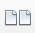), Multiple Pages (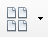) or Book Preview ().
- To print the document from this view, click the Print document icon (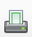) to open the Print dialog. Choose the print options and click the OK button.

Calc
To preview the sheets in Calc before printing:
- Choose File > Page Preview.
The Calc window now displays the Page Preview toolbar instead of the Formatting toolbar.
Figure 10: Page Preview toolbar (Calc)
- To print the document from this view, click the Print document icon () to open the Print dialog.
- Choose the print options and click the Print button.

Exporting to PDF
LibreOffice can export documents to PDF (Portable Document Format). This industry-standard file format is ideal for sending the file to someone else to view using Adobe Reader or other PDF viewers.
The process and dialogs are the same for Writer, Calc, Impress, and Draw, with a few minor differences mentioned in this section.

Quick export to PDF
Click the Export Directly as PDF icon (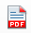) to export the entire document using the PDF settings you most recently selected on the PDF Options dialog (see below). You are asked to enter the file name and location for the PDF file, but you do not get a chance to choose a page range, the image compression, or other options.

Controlling PDF content and quality
For more control over the content and quality of the resulting PDF, use File > Export as PDF. The PDF Options dialog opens. This dialog has five pages (General, Initial View, User Interface, Links, and Security). Select the appropriate settings, and then click Export. Then you are asked to enter the location and file name of the PDF to be created, and click Save to export the file.
Note | Another choice is to use File > Export. This opens the Export dialog. Select the PDF file format, file name and location and click Export. This then opens the PDF Options dialog, as described above. Click Export when all the selections have been made.

General page of PDF Options dialog
On the General page, you can choose which pages to include in the PDF, the type of compression to use for images (which affects the quality of images in the PDF), and other options.
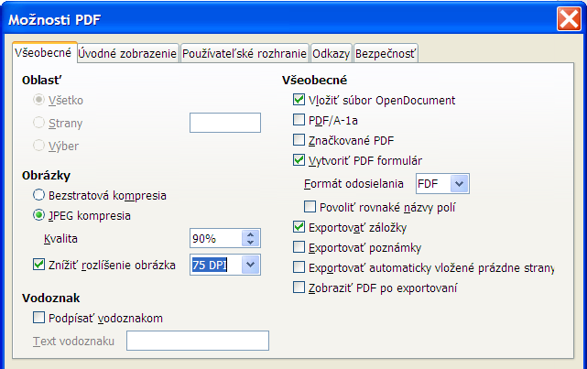
Figure 11: General page of PDF Options dialog
Range section
- All: Exports the entire document to PDF.
- Pages: To export a range of pages, use the format 3-6 (pages 3 to 6). To export single pages, use the format 7;9;11 (pages 7, 9 and 11). You can also export a combination of page ranges and single pages, by using a format like 3-6;8;10;12.
- Selection: Exports all the selected material.
Images section
- Lossless compression: Images are stored without any loss of quality. Tends to make large files when used with photographs. Recommended for other kinds of images or graphics.
- JPEG compression: Allows for varying degrees of quality. A setting of 90% works well with photographs (small file size, little perceptible loss of quality).
- Reduce image resolution: Lower DPI (dots per inch) images have lower quality. For viewing on a computer screen, generally a resolution of 72dpi (for Windows) or 96dpi (GNU/Linux) is sufficient, while for printing it is generally preferable to use at least 300 or 600dpi, depending on the capability of the printer. Higher DPI settings greatly increase the size of the exported file.
Note | EPS (Encapsulated PostScript) images with embedded previews are exported only as previews. EPS images without embedded previews are exported as empty placeholders.
Watermark section
- Sign with Watermark: When this option is selected, a transparent overlay of the text you enter into the Watermark Text box will appear on each page of the PDF.
General section
- Embed OpenDocument file: Use this setting to export the document as a PDF file containing two file formats: PDF and ODF. In PDF viewers it behaves like a normal PDF file, and it remains fully editable in LibreOffice.
- PDF/A-1a: PDF/A is an ISO standard for long-term preservation of documents, by embedding all the information necessary for faithful reproduction (such as fonts) while forbidding other elements (including forms, security, and encryption). PDF tags are written. If you select PDF/A-1a, the forbidden elements are grayed-out (not available).
- Tagged PDF: Tagged PDF contains information about the structure of the document’s contents. This can help to display the document on devices with different screens, and when using screen reader software. Some tags that are exported are table of contents, hyperlinks, and controls. This option can increase file sizes significantly.
- Create PDF form – Submit format: Choose the format of submitting forms from within the PDF file. This setting overrides the control’s URL property that you set in the document. There is only one common setting valid for the whole PDF document: PDF (sends the whole document), FDF (sends the control contents), HTML, and XML. Most often you will choose the PDF format.
- Export bookmarks: Exports headings in Writer documents, and page or slide names in Impress and Draw documents, as “bookmarks” (a table of contents list displayed by most PDF viewers, including Adobe Reader).
- Export comments: Exports comments as PDF notes. You may not want this!
- Export automatically inserted blank pages: If selected, automatically inserted blank pages are exported to the PDF. This is best if you are printing the PDF double-sided. For example, books usually have chapters set to always start on an odd-numbered (right-hand) page. When the previous chapter ends on an odd page, LibreOffice inserts a blank page between the two odd pages. This option controls whether to export that blank page.
Earlier versions of LibreOffice had the option:
- Embed standard fonts: Normally the 14 standard PostScript fonts were not embedded in a PDF file, because PDF readers already contained these fonts. However, you could choose to embed these fonts in all PDF documents created by LibreOffice to enhance display accuracy in PDF viewers. The PostScript fonts are now embedded by default.

Initial View page of PDF Options dialog
On the Initial View page (Figure 12), you can choose how the PDF opens by default in a PDF viewer. The selections should be self-explanatory.
If you have Complex Text Layout enabled (in Tools > Options > Language settings > Languages), an additional selection is available under Continuous facing: First page is left (normally, the first page is on the right when using the Continuous facing option).
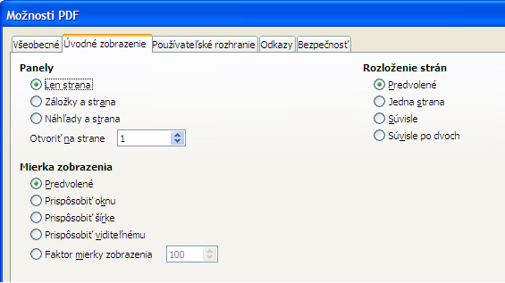
Figure 12: Initial View page of PDF Options dialog

User Interface page of PDF Options dialog
On the User Interface page, you can choose more settings to control how a PDF viewer displays the file. Some of these choices are particularly useful when you are creating a PDF to be used as a presentation or a kiosk-type display.
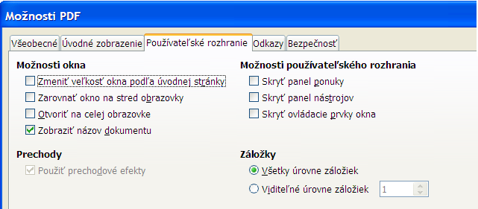
Figure 13: User Interface page of the PDF Options dialog
Window options section
- Resize window to initial page. Causes the PDF viewer window to resize to fit the first page of the PDF.
- Center window on screen. Causes the PDF viewer window to be centered on the computer screen.
- Open in full screen mode. Causes the PDF viewer to open full-screen instead of in a smaller window.
- Display document title. Causes the PDF viewer to display the document’s title in the title bar.
User interface options section
- Hide menubar. Causes the PDF viewer to hide the menu bar.
- Hide toolbar. Causes the PDF viewer to hide the toolbar.
- Hide window controls. Causes the PDF viewer to hide other window controls.
Transitions
In Impress, displays slide transition effects as their respective PDF effects.
Bookmarks
Select how many heading levels are displayed as bookmarks, if Export bookmarks is selected on the General page.

Links page of PDF Options dialog
On the Links page, you can choose how links are exported to PDF.
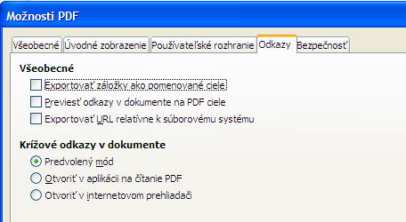
Figure 14: Links page of PDF Options dialog
Export bookmarks as named destinations
If you have defined Writer bookmarks, Impress or Draw slide names, or Calc sheet names, this option exports them as “named destinations” to which Web pages and PDF documents can link.
Convert document references to PDF targets
If you have defined links to other documents with OpenDocument extensions (such as .odt, .ods, and .odp), this option converts the files' extensions to .pdf in the exported PDF document.
Export URLs relative to file system
If you have defined relative links in a document, this option exports those links to the PDF.
Cross-document links
Defines the behavior of links clicked in PDF files. Select one among the following alternatives:
- Default mode: The PDF links will be handled as specified in your operating system.
- Open with PDF reader application: Use the same application used to display the PDF document to open linked PDF documents.
- Open with Internet browser: Use the default Internet browser to display linked PDF documents.

Security page of PDF Options dialog
PDF export includes options to encrypt the PDF (so it cannot be opened without a password) and apply some digital rights management (DRM) features.
- With an open password set, the PDF can only be opened with the password. Once opened, there are no restrictions on what the user can do with the document (for example, print, copy, or change it).
- With a permissions password set, the PDF can be opened by anyone, but its permissions can be restricted. See Figure 15. After you set a password for permissions, the other choices on the Security page become available.
- With both the open password and permission password set, the PDF can only be opened with the correct password, and its permissions can be restricted.
Note | Permissions settings are effective only if the user’s PDF viewer respects the settings.
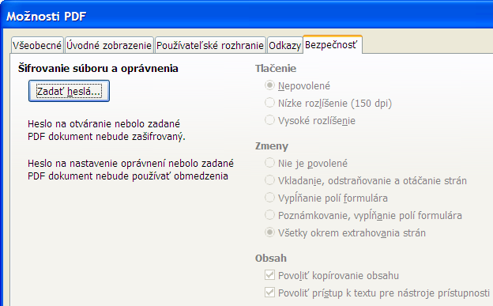
Figure 15: Security page of PDF Options dialog
Figure 16 shows the pop-up dialog displayed when you click the Set open password button on the Security page of the PDF Options dialog.
Once you have set all the options you require, click on Export to open the Export dialog, where you can set the file name and the save location.
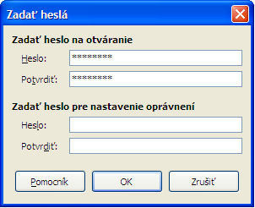
Figure 16: Setting a password to encrypt a PDF

Exporting to other formats
LibreOffice uses the term “export” for some file operations involving a change of file type. If you cannot find what you want under File > Save As, look under File > Export as well.
LibreOffice can export files to XHTML. In addition, Draw and Impress can export to Adobe Flash (SWF) and a range of image formats.
To export to one of these formats, choose File > Export. On the Export dialog, specify a file name for the exported document, then select the required format in the File format list and click the Export button.

E-mailing documents
LibreOffice provides several ways to send documents quickly and easily as e-mail attachments in one of three formats: OpenDocument (LibreOffice’s default format), Microsoft Office formats, or PDF.
Note | Documents can only be sent from the LibreOffice menu if a mail profile has been set up in Tools > Options > LibreOffice Writer > Mail Merge E-mail.
To send the current document in OpenDocument format:
- Choose File > Send > Document as E-mail. LibreOffice opens your default e-mail program. The document is attached.
- In your e-mail program, enter the recipient, subject, and any text you want to add, then send the e-mail.
File > Send > E-mail as OpenDocument (Text, Spreadsheet, or Presentation) has the same effect.
If you choose E-mail as Microsoft [Word, Excel, or PowerPoint], LibreOffice first creates a file in one of those formats and then opens your e-mail program with the file attached.
Similarly, if you choose E-mail as PDF, LibreOffice first creates a PDF using your default PDF settings (as when using the Export Directly as PDF toolbar button) and then opens your email program with the PDF file attached.

E-mailing a document to several recipients
To e-mail a document to several recipients, you can use the features in your e-mail program or you can use LibreOffice’s mail merge facilities to extract email addresses from an address book.
You can use LibreOffice’s mail merge to send e-mail in two ways:
- Use the Mail Merge Wizard to create the document and send it. See Chapter 11, Using Mail Merge, in the Writer Guide for details.
- Create the document in Writer without using the Wizard, then use the Wizard to send it. This method is described here.
To use the Mail Merge Wizard to send a previously-created Writer document:
- Click Tools > Mail Merge Wizard. On the first page of the wizard, select Use the current document and click Next.
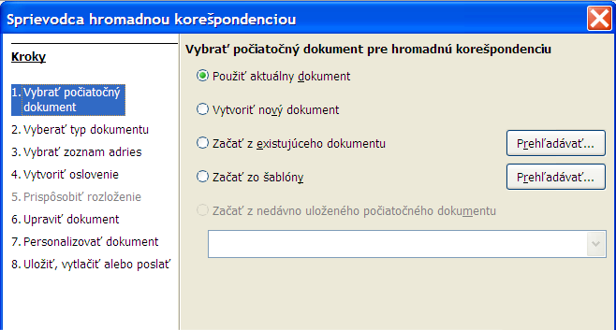
Figure 17: Select starting document
- On the second page, select E-mail message and click Next.
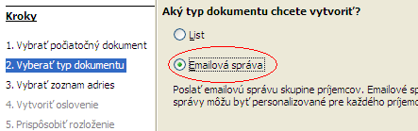
Figure 18: Select document type
- On the third page, click the Select Address List button. Select the required address list (even if only one is shown) and then click OK. (If the address list you need is not shown here, you can click Add to find it and add it to the list.)

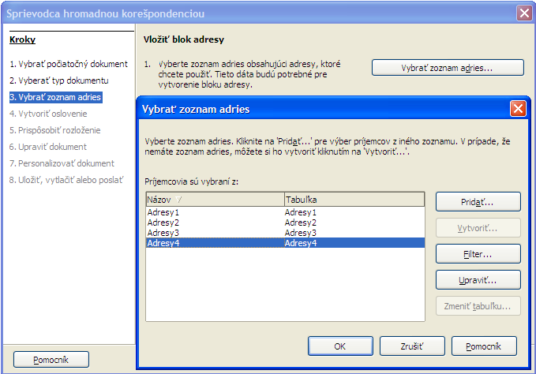Figure 19: Selecting an address list
- Back on the Select address list page, click Next. On the Create salutation page, deselect This document should contain a salutation.
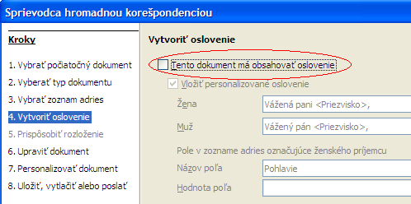
Figure 20: Deselecting a salutation
- In the left-hand list, click 8. Save, print or send. LibreOffice displays a “Creating documents” message and then displays the Save, print or send page of the Wizard.
- Select Send merged document as E-Mail. The lower part of the page changes to show e-mail settings choices. See Figure 21.
- Type a subject for your email and click Send documents. LibreOffice sends the e-mails.
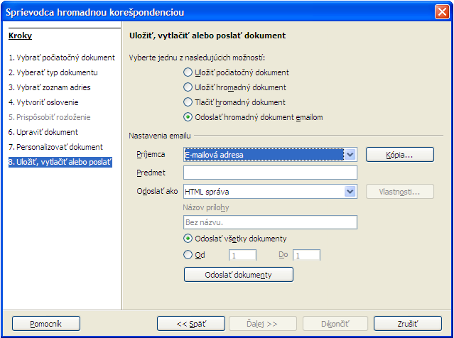
Figure 21: Sending a document as an email message

Digital signing of documents
To sign a document digitally, you need a personal key, also known as a certificate. A personal key is stored on your computer as a combination of a private key, which must be kept secret, and a public key, which you add to your documents when you sign them. You can get a certificate from a certification authority, which may be a private company or a governmental institution.
When you apply a digital signature to a document, a kind of checksum is computed from the document’s content plus your personal key. The checksum and your public key are stored together with the document.
When someone later opens the document on any computer with a recent version of LibreOffice, the program will compute the checksum again and compare it with the stored checksum. If both are the same, the program will signal that you see the original, unchanged document. In addition, the program can show you the public key information from the certificate. You can compare the public key with the public key that is published on the web site of the certificate authority. Whenever someone changes something in the document, this change breaks the digital signature.
On Windows operating systems, the Windows features of validating a signature are used. On Solaris and Linux systems, files that are supplied by Thunderbird, Mozilla or Firefox are used. For a more detailed description of how to get and manage a certificate, and signature validation, see “About Digital Signatures” in the LibreOffice Help.
To sign a document:
- Choose File > Digital Signatures.
- If you have not saved the document since the last change, a message box appears. Click Yes to save the file.
- The Digital Signatures dialog opens. Click Sign Document to add a public key to the document.
- In the Select Certificate dialog, select your certificate and click OK to return to the Digital Signatures dialog.
- The certificate used is displayed in the dialog with an icon next to its name.
This icon indicates the status of the digital signature.
- An icon with a red seal () indicates that the document was signed and the certificate was validated.
- An icon with a yellow caution triangle overlaying the red seal () indicates that the document is signed but that the certificate could not be validated.
- An icon of a yellow caution triangle () indicates an invalid digital signature.
- Click Close to apply the digital signature.
A signed document shows an icon in the status bar. You can double-click the icon to view the certificate. More than one signature can be added to a document.

Removing personal data
You may wish to ensure that personal data, versions, notes, hidden information, or recorded changes are removed from files before you send them to other people or create PDFs from them.
In Tools > Options > LibreOffice > Security > Options, you can set LibreOffice to remind (warn) you when files contain certain information and remove personal information automatically on saving.
To remove personal and some other data from a file, go to File > Properties. On the General tab, uncheck Apply user data and then click the Reset button. This removes any names in the created and modified fields, deletes the modification and printing dates, and resets the editing time to zero, the creation date to the current date and time, and the version number to 1.
To remove version information, either (a) go to File > Versions, select the versions from the list and click Delete; or (b) use File > Save As and save the file with a different name.

