
Getting Started Guide
Chapter 11
Graphics, the Gallery, and Fontwork

Copyright
This document is Copyright © 2010–2014 by the LibreOffice Documentation Team. Contributors are listed below. You may distribute or modify it under the terms of either the GNU General Public License (http://www.gnu.org/licenses/gpl.html), version 3 or later, or the Creative Commons Attribution License (http://creativecommons.org/licenses/by/4.0/), version 4.0 or later.
All trademarks within this guide belong to their legitimate owners.

Contributors
Jean Hollis Weber Hazel Russman John A Smith
Ron Faile Jr. Martin Saffron

Feedback
Please direct any comments or suggestions about this document to the Documentation Team’s mailing list: documentation@global.libreoffice.org
Note: Everything you send to a mailing list, including your email address and any other personal information that is written in the message, is publicly archived and cannot be deleted.

Acknowledgments
This chapter is adapted and updated from Chapter 11 of Getting Started with OpenOffice.org. The contributors to that chapter are:
Agnes Belzunce Daniel Carrera Peter Hillier-Brook
Peter Kupfer Iain Roberts Jean Hollis Weber
Linda Worthington Michele Zarri

Publication date and software version
Published 17 June 2014. Based on LibreOffice 4.2.

Note for Mac users
Some keystrokes and menu items are different on a Mac from those used in Windows and Linux. The table below gives some common substitutions for the instructions in this chapter. For a more detailed list, see the application Help.
Windows or Linux | Mac equivalent | Effect
Tools > Options menu selection | LibreOffice > Preferences | Access setup options
Right-click | Control+click and/or right-click depending on computer system | Opens a context menu
Ctrl (Control) | ⌘ (Command) | Used with other keys
F5 | Shift+⌘+F5 | Opens the Navigator
F11 | ⌘+T | Opens the Styles and Formatting window

Contents
Copyright 2
Contributors 2
Feedback 2
Acknowledgments 2
Publication date and software version 2
Note for Mac users 2
Introduction 4
Adding images to a document 4
Inserting an image file 4
Drag and drop 4
Insert Image dialog 4
Linking an image file 5
Embedding linked images 6
Inserting an image from the clipboard 6
Inserting an image using a scanner 7
Inserting an image from the Gallery 7
Inserting an image as a background 7
Modifying and positioning graphics 7
Managing the LibreOffice Gallery 8
Adding objects to the Gallery 9
Deleting images from the Gallery 10
Adding a new theme to the Gallery 10
Deleting a theme from the Gallery 10
Location of the Gallery and the objects in it 10
Creating an image map 11
Using LibreOffice’s drawing tools 12
Creating drawing objects 13
Set or change properties for drawing objects 13
Resizing a drawing object 14
Grouping drawing objects 14
Using Fontwork 15
The Fontwork toolbars 15
Creating a Fontwork object 15
Editing a Fontwork object 16
Using the Fontwork toolbar 16
Using the Formatting toolbar 17
Using menu options 19
Using the 3D-Settings toolbar 19
Moving and resizing Fontwork objects 19

Introduction
You can add graphic and image files, including photos, drawings, scanned images, and others, to LibreOffice documents. LibreOffice can import various vector (line drawing) and raster (bitmap) file formats. The most commonly used graphic formats are GIF, JPG, PNG, and BMP. See Appendix B for a full list of the graphic formats LibreOffice can import.
Graphics in LibreOffice are of three basic types:
- Image files, such as photos, drawings, and scanned images
- Diagrams created using LibreOffice’s drawing tools
- Charts created using LibreOffice’s Chart component
This chapter covers images and diagrams.
More detailed descriptions on working with drawing tools can be found in the Draw Guide and Impress Guide. Instructions on how to create charts are given in the Calc Guide.

Adding images to a document
Images can be added to a document in several ways: by inserting an image file, directly from a graphics program or a scanner, from a file stored on your computer, or by copying and pasting from a source being viewed on your computer.

Inserting an image file
When the image is in a file stored on the computer, you can insert it into an LibreOffice document using either of the following methods.

Drag and drop
- Open a file browser window and locate the image you want to insert.
- Drag the image into the LibreOffice document and drop it where you want it to appear. A faint vertical line marks where the image will be dropped.
This method embeds (saves a copy of) the image file in the document. To link the file instead of embedding it, hold down the Ctrl+Shift keys while dragging the image.

Insert Image dialog
- Click in the LibreOffice document where you want the image to appear.
- Choose Insert > Image > From File from the menu bar.
- On the Insert Image dialog, navigate to the file to be inserted, and select it.
At the bottom of the dialog (Figure 1) are two options, Preview and Link. Select Preview to view a thumbnail of the selected image in the preview pane on the right, so that you can verify that you have the correct file. See page 5 for the use of Link.
- Click Open.
Note | If you choose the Link option, a message box appears when you click Open. The message states that the picture will not be stored with the document, but only referenced as a link, and asks if you want to embed the graphic instead. Choose Keep Link if you want the link, or Embed Graphic if you do not. To prevent this message from appearing again, deselect the box by Ask when linking a graphic at the bottom of the message.
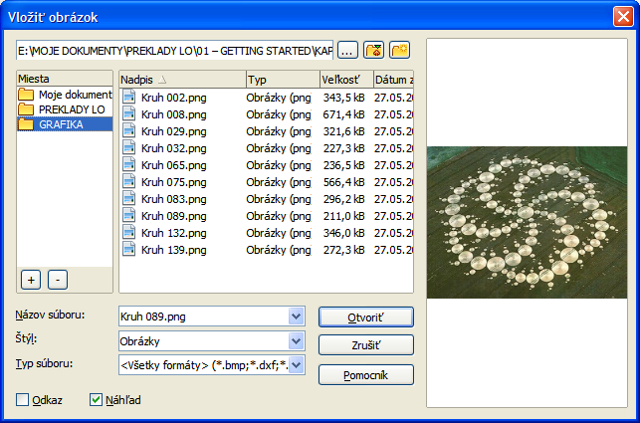
Figure 1: Insert Image dialog

Linking an image file
If the Link option in the Insert picture dialog is selected, LibreOffice creates a link to the file containing the image instead of saving a copy of the image in the document. The result is that the image is displayed in the document, but when the document is saved, it contains only a reference to the image file—not the image itself. The document and the image remain as two separate files, and they are merged together only when you open the document again.
Linking an image has two advantages and one disadvantage:
- Advantage – Linking can reduce the size of the document when it is saved, because the image file itself is not included. File size is usually not a problem on a modern computer with a reasonable amount of memory, unless the document includes many large graphics files; LibreOffice can handle quite large files.
- Advantage – You can modify the image file separately without changing the document because the link to the file remains valid, and the modified image will appear when you next open the document. This can be a big advantage if you (or someone else, perhaps a graphic artist) is updating images.
- Disadvantage – If you send the document to someone else, or move it to a different computer, you must also send the image files, or the receiver will not be able to see the linked images. You need to keep track of the location of the images and make sure the recipient knows where to put them on another machine, so that the document can find them. For example, you might keep images in a subfolder named Images (under the folder containing the document); the recipient of the file needs to put the images in a subfolder with the same name and in the same place relative to the document.
Note | When inserting the same image several times in the document, it would appear beneficial to link rather than embed; however, this is not necessary as LibreOffice embeds only one copy of the image file in the document.

Embedding linked images
If you originally linked the images, you can easily embed one or more of them later if you wish. To do so:
- Open the document in LibreOffice and choose Edit > Links.
- The Edit Links dialog (Figure 2) shows all the linked files. In the Source file list, select the files you want to change from linked to embedded.
- Click the Break Link button.
- Save the document.
Note | Going the other way, from embedded to linked, is not so easy—you must delete and reinsert the images, one at a time, selecting the Link option when you do so.
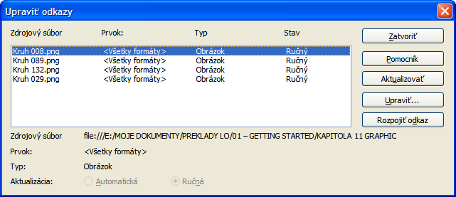
Figure 2: The Edit Links dialog

Inserting an image from the clipboard
Using the clipboard, you can copy images into a LibreOffice document from another LibreOffice document and from other programs. To do this:
- Open both the source document and the target document.
- In the source document, select the image to be copied.
- Click once on the selected image and press Ctrl+C to copy the image to the clipboard.
- Switch to the target document.
- Click to place the cursor where the graphic is to be inserted.
- Press Ctrl+V to insert the image.
Caution   | If the application from which the graphic was copied is closed before the graphic is pasted into the target, the image stored on the clipboard could be lost.

Inserting an image using a scanner
If a scanner is connected to your computer, LibreOffice can call the scanning application and inserted the scanned item into the LibreOffice document as an image. To start this procedure, place the cursor where you want the graphic to be inserted and choose Insert > Image > Scan > Select Source.
Although this practice is quick and easy, it is unlikely to result in a high-quality image of the correct size. You may get better results by scanned material into a graphics program and cleaning it up there before inserting the resulting image into LibreOffice.

Inserting an image from the Gallery
The Gallery provides a convenient way to group reusable objects such as graphics and sounds that you can insert into your documents. The Gallery is available in all components of LibreOffice. See “Managing the LibreOffice Gallery“ on page 8. You can copy or link an object from the Gallery into a document.
To insert an object:
- Choose Tools > Gallery or click the Gallery icon on the Standard toolbar (in Writer and Calc) or the Drawing toolbar (in Impress, Writer, and Draw). The Gallery is also accessible in the Sidebar (View > Sidebar and click the Gallery tab).
- Select a theme.
- Select an object with a single click.
- Drag and drop the image into the document. (See Figure 3.)
You can also right-click on the object and choose Insert > Copy.
This then causes the Frame toolbar to replace the Formatting toolbar and opens the Picture toolbar, docked to the Status bar.
To insert an object as a link:
- Choose Tools > Gallery and select a theme.
- Select an object with a single click, then while pressing the Shift and Ctrl keys, drag and drop the object into the document.

Inserting an image as a background
To insert an image as the background to a page or paragraph:
- Choose Tools > Gallery and select a theme.
- Select an object with a single click, right-click on the object, and choose Insert > Background > Page or > Paragraph.

Modifying and positioning graphics
LibreOffice provides many tools for resizing, modifying, filtering, and positioning graphics; wrapping text around graphics; and using graphics as backgrounds and watermarks. These tools are described in relevant chapters of the other guides. Some sophisticated adjustments of the graphics are best done in an image manipulation program and the results brought into LibreOffice, rather than using LibreOffice’s built-in tools.
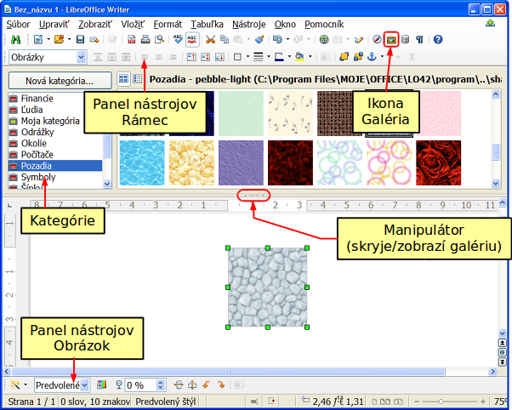
Figure 3: Copying a graphic object from the Gallery into a document (the Hide/Show button for the Gallery is indicated by the ellipse)

Managing the LibreOffice Gallery
Graphics in the Gallery are grouped by themes, such as Bullets, Rulers, and Backgrounds. You can create other groups or themes and add your own pictures or find extensions containing more graphics.
The Gallery list box lists the available themes. Click on a theme to see its contents displayed in the Gallery window.
You can display the Gallery in Icon View (Figure 4) or Detailed View, and you can hide or show the Gallery by clicking on the Hide button (similar to the Hide button for the Navigator and the Styles and Formatting windows when they are docked).
By default, the Gallery is docked above the workspace unless opened in the Sidebar when it is opened in a vertical orientation to the right of the work space. To expand the Gallery, position the pointer over the line that divides it from the top (or the left if the Sidebar Gallery) of the workspace. When the pointer changes to parallel lines with arrows, click and drag downward. The workspace resizes in response.
As with other docked windows, you can “float” the Gallery by moving the mouse pointer over an edge of the Gallery window, holding down the Ctrl key, and double-clicking. Drag the floating window to any of the edges of the LibreOffice window to dock the Gallery again.
Note | In a default installation, only the My themes theme is customizable, although new themes can be added as explained in “Adding a new theme to the Gallery” on page 10. The locked themes are easily recognizable by right-clicking on them; the only available option in the context menu is Properties. In some installations, or when you are running LibreOffice as an Administrator, all themes are customizable.
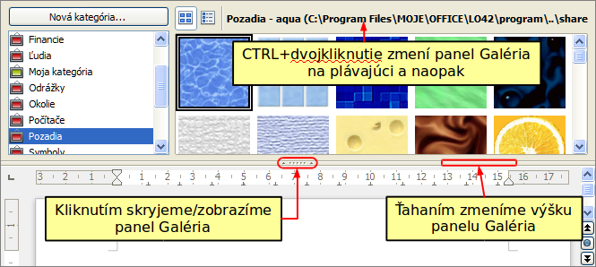
Figure 4: Icon view of one theme in the Gallery accessed from a toolbar

Adding objects to the Gallery
You may wish to add to the Gallery any images that you use frequently, for example, a company logo. You can then very easily insert these graphics into a document later.
Method 1 (selecting a file)
- Right-click on the desired theme and select Properties from the context menu.
- In the theme’s Properties dialog, click the Files tab.
On the Files tab, you can either:
- Click the Find Files button.
- The Select path dialog (not shown) opens. You can enter the path for the file’s directory in the Path text box, or you can navigate to locate the file’s directory.
- Click the Select button to start the search. A list of graphic files is then displayed in the Properties dialog. You can use the File type drop-down list to limit the files displayed.
- To add all of the files shown in the list, click Add All. Otherwise, select the files to add and then click Add (hold down either the Shift key or the Ctrl key while clicking on the files).
Or, to add a single file:
- Click the Add button to open the Gallery dialog.
- Use the navigation controls to locate the image to add to the theme. Select it and then click Open to add it to the theme.
- Click the OK button of the Properties dialog to close it.
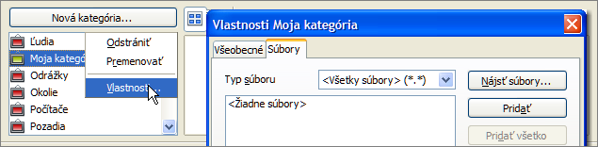
Figure 5: Gallery Properties dialog
Method 2 (drag and drop)
You can drag and drop an image into the Gallery from a document.
- Open the document containing an image you want to add to the Gallery, and display the Gallery theme to which you want to add it.
- Position the mouse pointer above the image, without clicking.
- If the mouse pointer changes to a hand symbol, the image refers to a hyperlink. In this case, press the Alt key while you click the image, to select it without activating the link. If the mouse pointer does not change to a hand symbol, you can simply click the image to select it.
- Once the image is selected, evident from the colored selection handles around it, release the mouse button. Click again on the image, keeping the mouse button pressed for more than two seconds. Without releasing the mouse button, drag the image into the Gallery.
- Release the mouse button.

Deleting images from the Gallery
To delete an image from a theme:
- Right-click on the name of the image file or its thumbnail in the Gallery.
- Click Delete in the context menu. A message appears, asking if you want to delete this object. Click Yes.
Note | Deleting the name of a file from the list in the Gallery does not delete the file from the hard disk or other location. This includes the drag-drop folder in the Gallery.

Adding a new theme to the Gallery
To add a new theme to the Gallery:
- Click the New Theme button above the list of themes (Figure 4).
- In the Properties of New Theme dialog, click the General tab and type a name for the new theme.
- Click the Files tab and add images to the theme, as described earlier.

Deleting a theme from the Gallery
To delete a theme from the Gallery:
- Go to Tools > Gallery.
- Select from the list of themes the theme you wish to delete.
- Right-click on the theme, then click Delete on the context menu.

Location of the Gallery and the objects in it
Graphics and other objects shown in the Gallery can be located anywhere on your computer’s hard disk, on a network drive, or other removable media. Listings in the Gallery show the location of each object. When you add graphics to the Gallery using method 1, the files are not moved or copied; only the location of each new object is added as a reference. When files are added using drag and drop, they are copied into a folder (dragdrop) in the Gallery, and allocated a file name.
Figure 6 shows in Detailed View, two files in the My Theme in the Gallery, one is contained in the dragdrop folder, and the other is a reference path to its actual location.

Figure 6: Theme showing files inserted with drag-and-drop and by reference
In a workgroup, you may have access to a shared Gallery (where you cannot change the contents unless authorized to do so) and a user Gallery, where you can add, change, or delete objects.
The location of the user Gallery is specified in Tools > Options > LibreOffice > Paths. You can change this location, and you can copy your gallery files (SDV) to other computers.
Gallery contents provided with LibreOffice are stored in a different location. You cannot change this location.

Creating an image map
An image map defines areas of an image (called hotspots) with hyperlinks to web addresses, other files on the computer, or parts of the same document. Hotspots are the graphic equivalent of text hyperlinks (described in Chapter 12). Clicking on a hotspot causes LibreOffice to open the linked page in the appropriate program (for example, the default browser for an HTML page; LibreOffice Calc for an ODS file; a PDF viewer for a PDF file). You can create hotspots of various shapes and include several hotspots in the same image.
To use the image map editor:
- In your LibreOffice document, click on the picture in which you want to create the hotspots.
- Choose Edit > ImageMap from the menu bar. The ImageMap Editor (Figure 7) opens.
- Use the tools and fields in the dialog (described below) to define the hotspots and links necessary.
- Click the Apply icon to apply the settings.
- When done, click the Save icon to save the image map to a file, then click the X in the upper right corner to close the dialog.
The main part of the dialog shows the image on which the hotspots are defined. A hotspot is identified by a line indicating its shape.
The toolbar at the top of the dialog contains the following tools:
- Apply button: click this button to apply the changes.
- Load, Save, and Select icons.
- Tools for drawing a hotspot shape: these tools work in exactly the same way as the corresponding tools in the Drawing toolbar.
- Edit, Move, Insert, Delete Points: advanced editing tools to manipulate the shape of a polygon hotspot. Choose the Edit Points tool to activate the other tools.
- Active icon: toggles the status of a selected hotspot between active and inactive.
- Macro: associates a macro with the hotspot instead of just associating a hyperlink.
- Properties: sets the hyperlink properties and adds the Name attribute to the hyperlink.
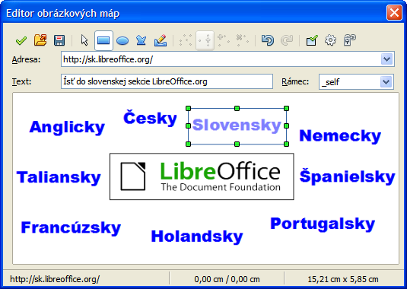
Figure 7: The dialog to create or edit an image map
Below the toolbar, specify for the selected hotspot:
- Address: the address pointed to by the hyperlink. You can also point to an anchor in a document; to do this, write the address in this format: file:///<path>/document_name#anchor_name
- Text: type the text that you want to be displayed when the mouse pointer is moved over the hotspot.
- Frame: where the target of the hyperlink will open: pick among _blank (opens in a new browser window), _self (opens in the active browser window), _top or _parent.
Tip | The value _self for the target frame will usually work just fine. It is therefore not recommended to use the other choices unless absolutely necessary.

Using LibreOffice’s drawing tools
You can use LibreOffice’s drawing tools to create graphics such as simple diagrams using rectangles, circles, lines, text, and other predefined shapes. You can also group several drawing objects to make sure they maintain their relative position and proportion.
You can place the drawing objects directly on a page in your document, or you can insert them into a frame.
You can also use the drawing tools to annotate photographs, screen captures, or other illustrations produced by other programs, but this is not recommended because:
- You cannot include images in a group with drawing objects, so they may not remain aligned in your document.
- If you convert a document to another format, such as HTML, the drawing objects and the graphics will not remain associated; they are saved separately.
In general, if you need to create complex drawings, it is recommended to use LibreOffice Draw, which includes many more features such as layers, styles, and so on.

Creating drawing objects
To begin using the drawing tools, display the Drawing toolbar (Figure 8) by clicking View > Toolbars > Drawing.
If you are planning to use the drawing tools repeatedly, you can tear off this toolbar and move it to a convenient place on the window.
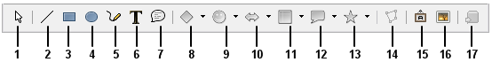
1 | Select | 5 | Freeform Line | 9 | Symbol Shapes | 13 | Stars
2 | Line | 6 | Text | 10 | Block arrows | 14 | Points
3 | Rectangle | 7 | Callouts | 11 | Flowcharts | 15 | Fontwork Gallery
4 | Ellipse | 8 | Basic Shapes | 12 | Callouts | 16 | From File
 |  |  |  |  |  | 17 | Extrusion On/Off
Figure 8: The Drawing toolbar
To use a drawing tool:
- Click in the document where you want the drawing to be anchored. You can change the anchor later, if necessary.
- Choose the tool from the Drawing toolbar (Figure 8). The mouse pointer changes to a drawing-functions pointer similar to this one for a rectangle shape .
- Move the cross-hair pointer to the place in the document where you want the graphic to appear and then click and drag to create the drawing object. Release the mouse button. The selected drawing function remains active, so that you can draw another object of the same type.
- To cancel the selected drawing function, press the Esc key or click on the Select icon (the arrow) on the Drawing toolbar.
- You can now change the properties (fill color, line type and weight, anchoring, and others) of the drawing object using either the Drawing Object Properties toolbar (Figure 9) or the choices and dialogs reached by right-clicking on the drawing object.

Set or change properties for drawing objects
To set the properties for a drawing object before you draw it:
- On the Drawing toolbar (Figure 8), click the Select tool.
- On the Drawing Object Properties toolbar (Figure 9), click on the icon for each property and select the value you want for that property.
- For more control, or to define new attributes, you can click on the Area or Line icons on the toolbar to display detailed dialogs.
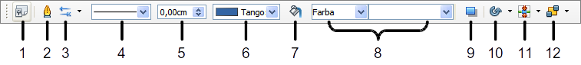
1 | Styles and Formatting | 4 | Line Style | 7 | Area | 10 | Effects
2 | Line | 5 | Line Width | 8 | Area Style / Filling | 11 | Alignment
3 | Arrow Style | 6 | Line Color | 9 | Shadow | 12 | Arrange
Figure 9: Drawing Object Properties toolbar
The default you set applies to the current document and session. It is not retained when you close the document or close Writer, and it does not apply to any other document you open. The defaults apply to all the drawing objects except text objects.
To change the properties for an existing drawing object:
- Select the object.
- Continue as described above.
You can also specify the position and size, rotation, and slant and corner radius properties of the drawing object:
- Right-click on the drawing object and then choose Position and Size from the context menu. The Position and Size dialog is displayed.
- Choose any properties, as required.

Resizing a drawing object
An object is resized in a similar way to an image. Select the object, click on one of the eight handles around it and drag it to its new position. For a scaled resizing, select one of the corner handles and keep the Shift key pressed while dragging the handle to its new position.
For more sophisticated control of the size of the object, choose Format > Object > Position and Size from the Menu bar. Use the Position and Size dialog to set the width and height independently. If the Keep ratio option is selected, then the two dimensions change so that the proportion is maintained, allowing for a scaled resizing.

Grouping drawing objects
To group drawing objects:
- Select one object, then hold down the Shift key and select the others you want to include in the group. The bounding box expands to include all the selected objects.
- With the objects selected, hover the mouse pointer over one of the objects and choose Format > Group > Group from the Menu bar or right-click and choose Group > Group from the pop-up menu.
Note | You cannot include an embedded or linked graphic in a group with drawing objects.

Using Fontwork
With Fontwork you can create graphical text art objects to make your work more attractive. There are many different settings for text art objects (line, area, position, size, and more), so you have a large choice.
Fontwork is available with each component of LibreOffice, but you will notice small differences in the way that each component displays it.

The Fontwork toolbars
You can use two different toolbars for creating and editing a Fontwork object.
Choose either View > Toolbars > Fontwork or View > Toolbars > Drawing.
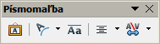
Figure 10: The floating Fontwork toolbar
If you click on an existing Fontwork object, the Formatting toolbar changes to display the Fontwork options as shown in Figure 14. The contents of this toolbar vary depending on the LibreOffice component with which it is being used.

Creating a Fontwork object
- On the chosen toolbar, click the Fontwork Gallery icon .
- In the Fontwork Gallery (Figure 11), select a Fontwork style, then click OK. The Fontwork object will appear in your document. Notice the colored squares around the edge (indicating that the object is selected) and the yellow dot; these are discussed in “Moving and resizing Fontwork objects” on page 20.
- Double-click the object to edit the Fontwork text (see Figure 12). Select the text and type your own text in place of the black Fontwork text that appears over the object.
- Click anywhere in a free space or press Esc to apply your changes.

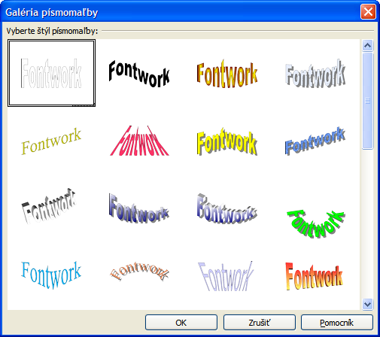
Figure 11: The Fontwork Gallery

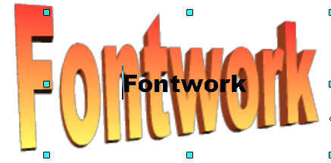Figure 12: Editing Fontwork text

Editing a Fontwork object
Now that the Fontwork object is created, you can edit some of its attributes. To do this, you can use the Fontwork toolbar, the Formatting toolbar, or menu options as described in this section. If the selected Fontwork object is a 3-D object, you can also use the 3D-Settings toolbar.

Using the Fontwork toolbar
Make sure that the Fontwork toolbar, shown in Figure 10, is visible. If you do not see it, go to View > Toolbars > Fontwork. Click on the different icons to edit Fontwork objects.
 | Fontwork Shape: Edits the shape of the selected object. You can choose from a palette of shapes. | 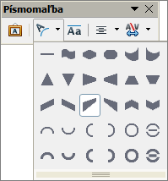
Fontwork Same Letter Heights: Changes the height of characters in the object. Toggles between normal height (some characters taller than others, for example capital letters, d, h, l and others) and all letters the same height.

Figure 13: Left: normal letters; right: same letter heights
 | Fontwork Alignment: Changes the alignment of characters. Choices are left align, center, right align, word justify, and stretch justify. The effects of the text alignment can only be seen if the text spans over two or more lines. In the stretch justify mode, all the lines are filled completely. | 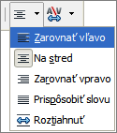
 | Fontwork Character Spacing: Changes the character spacing and kerning in the object. Select from the choices in the drop-down list. | 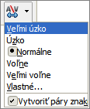

Using the Formatting toolbar
Now let us go further and customize the Fontwork object with several more attributes.
Click on the Fontwork object. The Formatting toolbar changes to show the options for editing the object. (The toolbar shown in Figure 14 appears when you use Fontwork in Writer.)
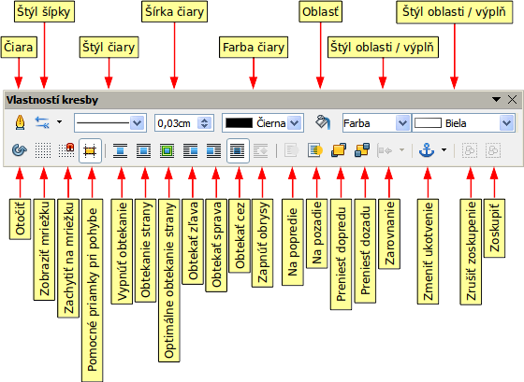
Figure 14: Formatting toolbar for a Fontwork object in Writer
This figure shows the toolbar floating. In its default, docked position it is one of the toolbars located below the menu bar. The example toolbar has also been customized to show all of the available options; by default only a subset of these options is shown.
The Formatting toolbar provides a large choice of options for customizing your object. These choices are the same as the ones for other drawing objects. For more information, see the Draw Guide.
Line options
Line icon: Opens a dialog with three tabs: Line, Line Styles, Arrow Styles. Use the Line tab to edit the most common properties of the line around the selected Fontwork object, by choosing from previously-defined attributes including line style, line color, and arrow styles. Use the Lines Styles and Arrow Styles tabs to edit the properties of line and arrow styles, and define new styles.
Arrow Style icon: Choose from the different arrow styles.
Line Style box: Choose from the available line styles.
Line Width box: Set the width of the line.
Line Color box: Select the color of the line.
Area options
Area icon: Opens a dialog with seven tabs: Area, Shadow, Transparency, Colors, Gradients, Hatching, Bitmaps.
- Area tab: Choose from the predefined list a color, bitmap, gradient or hatching pattern to fill the selected object.
- Shadow tab: Set the shadow properties of the selected object.
- Transparency tab: Set the transparency properties of the selected object.
- Colors tab: Modify the available colors or add new ones to appear on the Area tab.
- Gradients tab: Modify the available gradients or add new ones to appear on the Area tab.
- Hatching tab: Modify the available hatching patterns or add new ones to appear on the Area tab.
- Bitmaps tab: Create simple bitmap patterns and import bitmaps, to make them available on the Area tab.
Area Style / Filling boxes: Select the type of the fill of the selected object. For more detailed settings, use the Area icon.
Positioning options
Rotate icon: Rotate the selected object manually using the mouse to drag the object.
To Foreground icon: Move the selected object in front of the text.
To Background icon: Move the selected object behind the text.
Alignment icon: Modify the alignment of the selected objects.
Bring to front icon: Move the selected object in front of the others.
Send to back icon: Move the selected object behind the others.
Change Anchor icon: Choose between anchoring options:
- To Page—The object keeps the same position in relation to the page margins. It does not move as you add or delete text.
- To Paragraph—The object is associated with a paragraph and moves with the paragraph. It may be placed in the margin or another location.
- To Character—The object is associated with a character but is not in the text sequence. It moves with the paragraph but may be placed in the margin or another location. This method resembles anchoring to a paragraph.
- As Character—The object is placed in the document like any character and moves with the paragraph as you add or delete text before the object.
Ungroup icon: Ungroup a selection of grouped objects, so that they can be managed individually.
Group icon: Group the selected objects, so you can manage them as a single object.

Using menu options
You can use some the choices on the Format menu to anchor, align, arrange and group selected Fontwork objects, wrap text around them, and flip them horizontally and vertically.
You can also right-click on a Fontwork object and choose many of the same options from the pop-up menu. The pop-up menu also provides quick access to the Line, Area, Text, and Position and Size dialogs. The Text dialog offers only a few options for Fontwork objects and is not discussed here. On the Position and Size dialog, you can enter precise values concerning size and position. For more information on all of these menu options, see the Draw Guide.

Using the 3D-Settings toolbar
If the selected Fontwork object is a 3-D object, you can also use the options on the 3D-Settings toolbar. You can also change a 2-D Fontwork object into a 3-D object (or change a 3-D object into a 2-D object) by clicking the Extrusion On/Off icon on the 3D-Settings toolbar. For more information, see the Draw Guide.
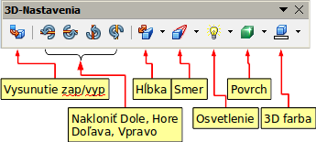
Figure 15: 3D-Settings toolbars

Moving and resizing Fontwork objects
When you select a Fontwork object, eight colored squares (known as handles) appear around the edge of the object, as shown below. You can drag these handles to resize the object.
A yellow dot also appears on the object. This dot may be along an edge of the object, or it may be somewhere else; in the example on the right. If you hover the pointer over this yellow dot, the pointer turns into a hand symbol. You can drag the dot in different directions to distort the object.  Hovering the pointer over other parts of the object turns the pointer into the usual symbol for dragging the object to another part of the page.  For precise control of the location and size of the object, use the Position and Size dialog. | 