
Impress Guide

Chapter 11
Setting Up and Customizing Impress

Copyright
This document is Copyright © 2021 by the LibreOffice Documentation Team. Contributors are listed below. You may distribute it and/or modify it under the terms of either the GNU General Public License (http://www.gnu.org/licenses/gpl.html), version 3 or later, or the Creative Commons Attribution License (http://creativecommons.org/licenses/by/4.0/), version 4.0 or later.
All trademarks within this guide belong to their legitimate owners.

Contributors
To this edition.
Peter Schofield | Olivier Hallot
To previous editions.
Michele Zarri | T. Elliot Turner | Jean Hollis Weber
Peter Schofield

Feedback
Please direct any comments or suggestions about this document to the Documentation Team’s mailing list: documentation@global.libreoffice.org
- Note
Everything sent to a mailing list, including your email address and any other personal information that is written in the message, is publicly archived and cannot be deleted.

Publication date and software version
Published February 2021. Based on LibreOffice 7.0.

Using LibreOffice on macOS
Some keystrokes and menu items are different on macOS from those used in Windows and Linux. The table below gives some common substitutions for the instructions in this document. For a detailed list, see the application Help.
Windows or Linux | macOS equivalent | Effect
Tools > Options  menu selection | LibreOffice > Preferences | Access setup options
Right-click | Control+click or right-click depending on computer setup | Open a context menu
Ctrl (Control) | ⌘ (Command) | Used with other keys
F11 | ⌘+T | Open the Styles deck in the Sidebar

Contents
Copyright 2
Contributors 2
Feedback 2
Publication date and software version 2
Using LibreOffice on macOS 2
Introduction 4
LibreOffice options 4
User Data options 4
Print options 5
View options 6
Application Color options 7
Impress options 8
General options 8
View options 9
Grid options 10
Print options 12
Customizing user interface 12
Adding extensions 13

Introduction
This chapter covers some of the settings in LibreOffice that apply when using Impress, but may also apply to all the other modules in LibreOffice. The illustrations in this chapter have been taken from LibreOffice Impress. For more information on setting up and customizing all the modules in LibreOffice, see the Getting Started Guide.

LibreOffice options
- Note
Revert has the same effect on all pages in the Options LibreOffice dialog. It resets the options to the values that were in place when you opened LibreOffice.

User Data options
Impress uses the first and last name stored in User Data for document properties, optional author field used in slides, and the name associated with any comments that have been made.
- Go to Tools > Options on the main menu bar to open the Options LibreOffice dialog (Figure 1). The list on the left-hand side varies depending on which component of LibreOffice is open.
- Click the expansion marker ▼ by LibreOffice on the left-hand side and select User Data to open the user data options page for LibreOffice. Enter or amend details that you would like to use for document properties.
- Click OK to save the changes and close the Options LibreOffice dialog.
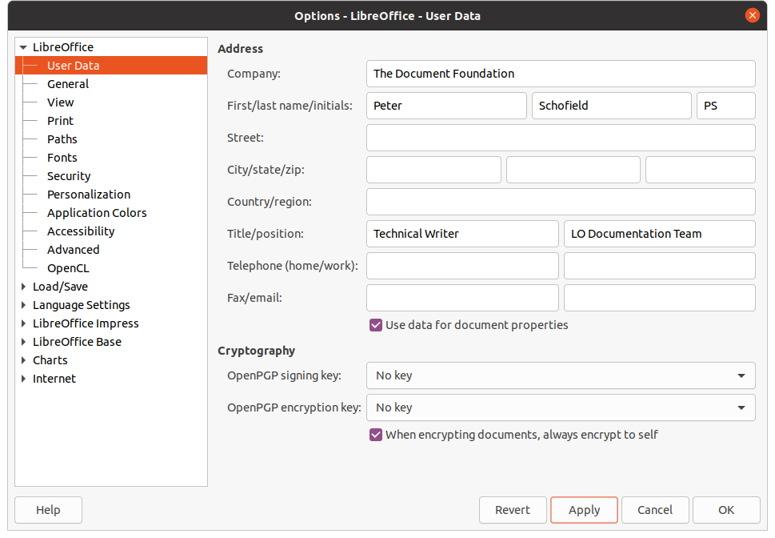Figure 1: Options LibreOffice dialog - User Data page
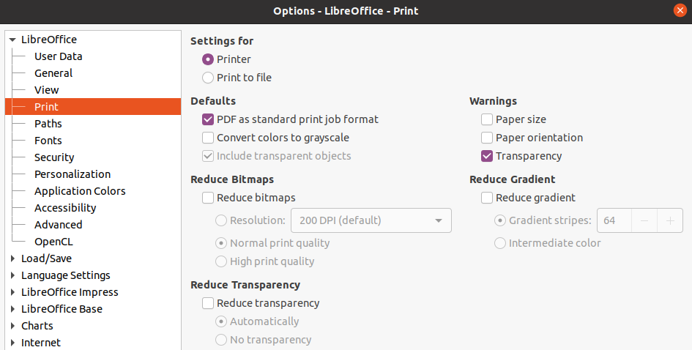Figure 2: Options LibreOffice dialog - Print page

Print options
Print options can be selected and changed using the Print page of the Options LibreOffice dialog (Figure 2) or during the printing process. See Chapter 10, Saving Slide Shows, Printing, E-mailing, and Exporting for more information about the printing of slide shows.
- Go to Tools > Options on the main menu bar to open the Options LibreOffice dialog.
- Click the expansion marker ▼ by LibreOffice on the left-hand side to open a list of subsections and select Print to open the printing options page for LibreOffice (Figure 2).
- Select the print settings that suit your printer and you most common printing method.
- Click OK to save the changes and close the Options LibreOffice dialog.
The amount of data sent to the printer can be reduced. This increases the print speed because the print files are smaller. It also makes it easier for printers with a smaller memory to print. However, reducing print data can result in slightly lower print quality.
- Settings for – specifies whether the print settings apply to the printer or to a file.
- Printer – define options for reducing data while printing directly to a printer.
- Print to file – define options for reducing data while printing to a file.
- Defaults
- Convert colors to grayscale – specifies that all colors are printed only as grayscale.
- Include transparent objects – when selected, any reduction in print quality also applies to the transparent areas of objects.
- Reduce bitmaps – specifies that bitmaps are printed with reduced quality. The resolution can only be reduced and not increased.
- Resolution – specifies the maximum print quality in dpi.
- Normal print quality – corresponds to a resolution of 200dpi.
- High print quality – corresponds to a resolution of 300dpi.
- Reduce transparency – if selected, any transparent objects will be printed as normal, depending on the selection for the two options.
- Automatically – specifies that any transparencies are only printed if the transparent areas covers less than a quarter of the entire page.
- No transparency – when selected, transparencies are not printed.
- Note
Transparency cannot be sent directly to a printer. The document areas where transparencies are to be visible must therefore always be calculated as bitmaps and sent to the printer. Depending on the size of the bitmaps and the print resolution, a large amount of data may result.
- Warnings – defines which warnings appear before any printing starts.
- Paper size – select this option if a certain paper size is required for printing a document. If the paper size required is not available in the current printer, a warning is displayed.
- Paper orientation – select this option if a specific page orientation is required for a document. If the format is not available, a warning is displayed.
- Transparency – select this option if a warning is required when transparencies are contained in the document. A dialog appears allowing selection if the transparency is to be printed.
- Reduce gradient – if selected, gradients are printed with reduced quality.
- Gradient stripes – specifies the maximum number of gradient stripes for printing.
- Intermediate color – specifies that gradients are only printed in a single intermediate color.

View options
View options (Figure 3) control how the user interface for LibreOffice appears when creating slide shows. For more information on customizing the user interface, see the Getting Started Guide.
- Icon style – specifies the icon style for icons in toolbars and dialogs.
- icon size – sets the icon size to Automatic, Small, Large or Extra Large.
- Toolbar – specifies the display size of toolbar icons.
- Notebook bar – specifies the display size of notebook bar icons.
- Sidebar – specifies the display size of sidebar icons.
- Visibility - select from Automatic, Hide or Show. Automatic displays icons according to system settings and themes.
- Shortcuts – displays keyboard shortcuts next to the corresponding menu items.
- Mouse – defines how the mouse cursor is positioned and the action of the middle button, if used.
- Positioning – specifies if and how the mouse cursor is positioned in newly opened dialogs.
- Middle button – defines the function of the middle mouse button. Automatic scrolling dragging while pressing the middle mouse button shifts the view. Paste clipboard pressing the middle mouse button inserts the contents of the clipboard.
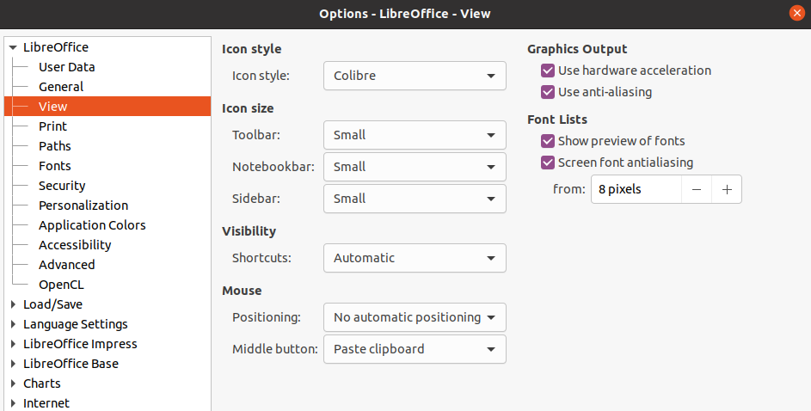Figure 3: Options LibreOffice dialog - View page
- Graphics Output – defines how graphics are displayed.
- Use hardware acceleration – directly accesses hardware features of the graphical display adapter to improve the screen display. The support for hardware acceleration is not available for all operating systems and platform distributions of LibreOffice.
- Use anti-aliasing – when supported, you can enable and disable anti-aliasing of graphics. With anti-aliasing enabled, the display of most graphical objects looks smoother and with less artifacts.
- Font Lists – defines how the fonts are displayed.
- Show preview of fonts – displays how a selected font will appear on the user interface.
- Screen font aliasing – when selected, the display of fonts looks smoother and with less artifacts.

Application Color options
Application colors specify which color is used to display various elements of the user interface in LibreOffice. The only option specific to Impress is the color of the grid points. Scroll down in the page until you find Drawing/Presentation.
- Go to Tools > Options on the main menu bar to open the Options LibreOffice dialog.
- Click the expansion marker ▼ by LibreOffice on the left-hand side to open a list of subsections and select Application Colors to open the color options page for the colors used in LibreOffice (Figure 4).
- Scroll down the Custom Colors list until you reach the option for Drawing/Presentation.
- Select from the list of color palettes a color to use for the Grid.
- Click OK to save the changes and close the Options LibreOffice dialog.
- Note
If you wish to save your color changes as a color scheme, click Save and type a name in the Save scheme dialog, then click OK.
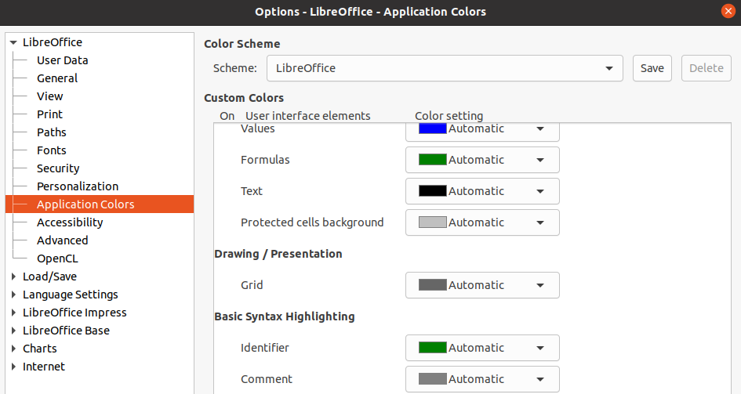Figure 4: Options LibreOffice dialog - Application Colors page
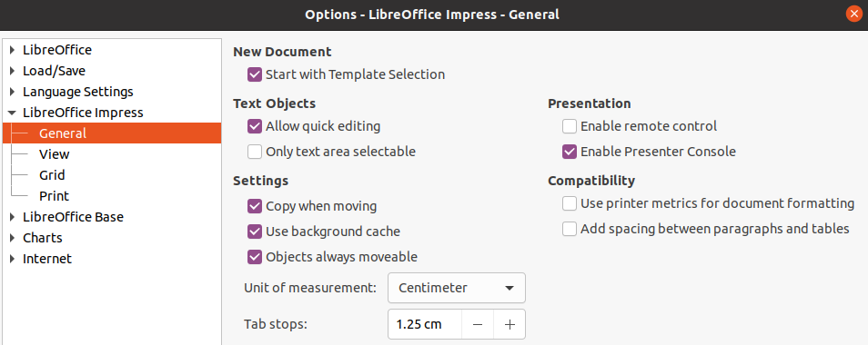Figure 5: Options LibreOffice Impress dialog - General page

Impress options
In the Options LibreOffice dialog, click the expansion marker ▼ to the left of LibreOffice Impress on the left-hand side to open a list of subsections available for Impress (Figure 5).

General options
Select LibreOffice Impress > General (Figure 5) to specify the general options for slide shows.
- New document
- Start with Template Selection – if selected, the Select a Template dialog opens when creating a new presentation.
- Text objects
- Allow quick editing – if selected, you can edit text immediately after clicking a text object. If deselected, you must double-click to edit text. You can also activate this mode by clicking on Allow Quick Editing in the Options toolbar (Figure 6).
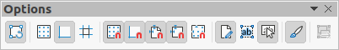Figure 6: Options toolbar
- Only text area selectable – specifies whether to select a text frame by clicking the text. In the area of the text frame that is not filled with text, an object behind the text frame can be selected. You can also activate this mode by clicking on Select Text Area Only in the Options toolbar (Figure 6).
- Settings
- Copy when moving – if selected, a copy is created when you move an object while holding down the Ctrl key. The same applies for rotating and resizing an object. The original object will remain in its current position and size.
- Use background cache – specifies whether to use the cache for displaying objects on the master slide. This speeds up the display. Deselect this option if you want to display changing contents on the master slide.
- Objects always moveable – when selected, it allows you to move an object with Rotate enabled. If this option is not selected, Rotate can only be used to rotate an object.
- Unit of measurement – determines the unit of measurement used in Impress.
- Tab stops – defines the spacing between tab stops.
- Presentation
- Enable Presenter Console – when selected, opens the Presenter Console for presentations when using multiple displays.
- Compatibility – these settings are valid for the current presentation only.
- Use printer metrics for document formatting – specifies that printer metrics are applied for printing and also for formatting the display on the screen. If this option is not selected, a printer independent layout will be used for screen display and printing. If you set this option for the current document and then save the document, for example, in an older binary format, this option will not be saved. If you later open the file from the older format, this option will be set by default.
- Add spacing between paragraphs and tables – specifies that Impress calculates the paragraph spacing. Similar to Microsoft PowerPoint which adds the bottom spacing of a paragraph to the top spacing of the next paragraph to calculate the total spacing between both paragraphs. Impress utilizes only the larger of the two spacings.

View options
Select LibreOffice Impress > View (Figure 7) to specify the Display options for the available display modes.
- Rulers visible – specifies whether to display the rulers at the top and to the left of the work area.
- Helplines when moving – specifies whether to display guides when moving an object. Impress creates dotted guides that extend beyond the box containing the selected object and which cover the entire Workspace, helping you position the object. You can also activate this mode by clicking on Helplines While Moving in the Options toolbar.
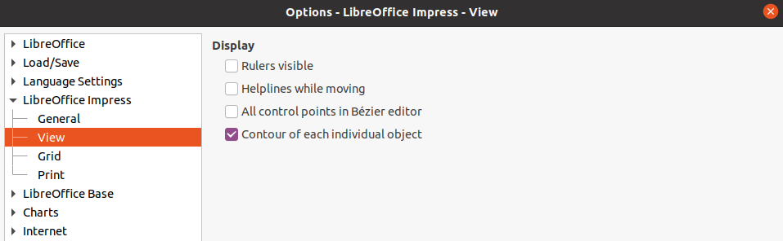Figure 7: Options LibreOffice dialog - View page
- All control points in Bézier editor – displays the control points of all Bézier points if you have previously selected a Bézier curve. If this option is not selected, only the control points of the selected Bézier points will be visible.
- Contour of each individual object – Impress displays the contour line of each individual object when moving this object. This option enables you to see if single objects conflict with other objects in the target position. If you do not select this option, Impress displays only a square contour that includes all selected objects.

Grid options
Select LibreOffice Impress > Grid (Figure 8) to specify the grid settings for Impress. Using a grid helps you determine the exact position of your objects. You can also set this grid to line up with the snap grid.
- Grid
- Snap to grid – activates the snap function. If this option is selected and you want to move or create individual objects without snapping to the grid, press the Shift key to deactivate Snap to grid whilst moving the individual object. You can also activate this mode by clicking on Snap to Grid on the Options toolbar.
- Visible grid – displays grid points on the screen. These points will not display or print as part of a presentation.
- Resolution
- Horizontal – defines the measurement unit for the spacing between grid points on the X-axis.
- Vertical – defines the measurement unit for the spacing between grid points the Y-axis.
- Synchronize axes – when selected, the measurement and spacing settings for X and Y axes are synchronized for Resolution and Subdivision.
- Subdivision
- Horizontal – specify the number of intermediate spaces between grid points on the X-axis.
- Vertical – specify the number of intermediate spaces between grid points on the Y-axis.
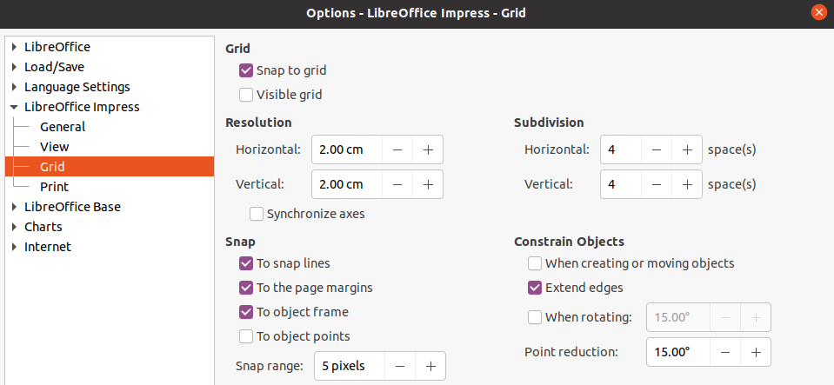Figure 8: Options LibreOffice Impress dialog - Grid page
- Snap
- To snap lines – snaps the edge of an object being dragged to the nearest snap line when you release the mouse. You can also activate this mode by clicking on Snap to Snap Lines on the Options toolbar.
- To the page margins – specifies whether to align the contour of the graphic object to the nearest page margin. The cursor or a contour line of the graphics object must be in the snap range. You can also activate this mode by clicking on Snap to Page Margins on the Options toolbar.
- To object frame – specifies whether to align the contour of the graphic object to the border of the nearest graphic object. The cursor or a contour line of the graphics object must be in the snap range. You can also activate this mode by clicking on Snap to Object Border on the Options toolbar.
- To object points – specifies whether to align the contour of the graphic object to the points of the nearest graphic object. This only applies if the cursor or a contour line of the graphics object is in the snap range. You can also activate this mode by clicking on Snap to Object Points on the Options toolbar.
- Snap range – defines the snap distance between the mouse pointer and the object contour. If the cursor is nearer than the distance specified, the cursor snaps to a snap point.
- Constrain Objects
- When creating or moving objects – specifies that graphic objects are restricted vertically, horizontally or diagonally (45°) when creating or moving them. You can temporarily deactivate this setting by pressing the Shift key.
- Extend edges – specifies that a square is created based on the longer side of a rectangle when the Shift key is pressed before you release the mouse button. This also applies to an ellipse where a circle will be created based on the longest diameter of the ellipse. When this option is NOT selected, a square or a circle will be created based on the shorter side or diameter.
- When rotating – specifies that graphic objects can only be rotated within the rotation angle that you selected. If you want to rotate an object outside the defined angle, press the Shift key when rotating. Release the key when the desired rotation angle is reached.
- Point reduction – defines the angle for point reduction. When working with polygons, you might find it useful to reduce their editing points.
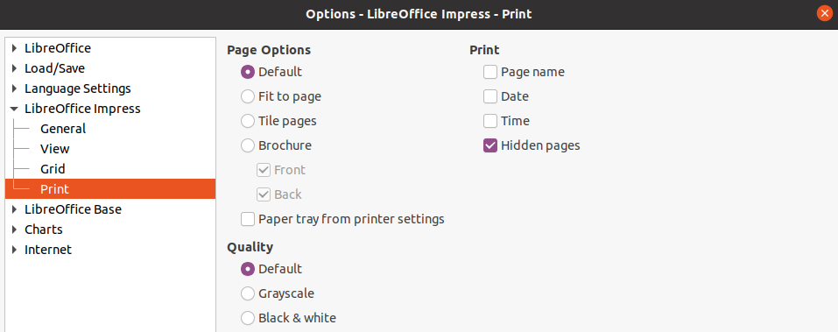Figure 9: Options LibreOffice Impress dialog - Print page

Print options
Select LibreOffice Impress > Print (Figure 9) to specify print settings for a presentation. See Chapter 10 Saving Slide Shows, Printing, E-mailing, and Exporting for more information about printing and the options available.
- Page Options
- Default – pages are printed at the default setting for printing.
- Fit to page – a slide is resized to fit the printed page, while maintaining the relative positions of the objects on the slide.
- Tile pages – specifies that pages are printed in tiled format. If the pages or slides are smaller than the paper, several pages or slides will be printed on one page of paper.
- Brochure – elect this option to print the document in brochure format. Select Front to print from the front to the back of a brochure. Select Back to print from the back to the front of a brochure.
- Paper tray from printer settings – when selected, the paper tray used is defined in the printer setup.
- Print
- Page name – when selected, the page name is printed.
- Date – when selected, the current date is printed.
- Time – when selected, the current time is printed.
- Hidden pages – when selected, any hidden pages in the slide show are printed.
- Quality
- Default – when selected, the slides are printed in color.
- Grayscale – when selected, the slides are printed as grayscale.
- Black & white – when selected, the slides are printed in black and white.

Customizing user interface
Impress menus, toolbars, and keyboard shortcuts can be customized by adding, deleting, or modifying items in the menus, toolbars, and keyboard shortcuts that are used when you create slides and slide shows. For more information on customizing the user interface, see the Getting Started Guide.

Adding extensions
An extension is a package that can be installed into LibreOffice Impress to add a new function.
Although individual extensions can be found in different places, the official LibreOffice extension repository is at http://extensions.libreoffice.org/. Some extensions are free of charge; others are available for a fee. Check the descriptions to see what licenses and fees apply to the ones that interest you. For more information on extensions, see the Getting Started Guide.

