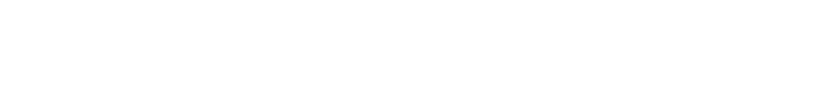

中中中 中 中
1．中中中中中中中中
(1)中中中：中中中中中中中中中中中中
中中中中中中：
①中中中中中中中中中中中中中中中中中：H₂中中H—H,NaCl中Na⁺中Cl—中中
②中中中中中中中中中中中中中中中中中中中中中中中中
③中中中中中中中中中，中中中中中中中中，中中，中中中中中中中中中中中中中中中中中中中中中中中，中中H₂中中H—H，中中中中中中中中中中，中中NaCl中Na⁺中Cl—中中中中中中中中中中中中中中中中中中中中中中中中H2中H2中中中中中中中中中中中中
(2)中中中中中中中中中中中中：中中中中中中中中中中中中中中
中中中中中中：中中中中中中中中中中中中中中中中中中中中中中
中中:中中中中中中中中：HCl中中中，中中NaCl中中中
中中中中中中中：

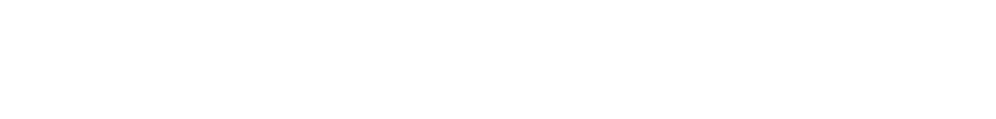
(1)中中中中中中中中中中中中中中中中( )
(2)HCl中中中中中中中中中中中中( )
(3)中NaCl中中中中中NaCl中中中中中中中中中中中( )
(4)中中中中中中中中中中中中中中中中中中( )
(3)中中中中中中中中中中中中中中中
中中中中 | 中中中中 | 中中中中
2H₂＋O₂=====2H₂O | H₂中中中中中中中中O₂中中中中中中中中中中中 | H₂O中中中中中中中中中中中中中中中
H₂＋Cl₂=====2HCl | H₂中中中中中中中中Cl₂中中中中中中中中中中中 | HCl中中中中中中中中中中中中中中中
N₂＋3H₂2NH₃ | N₂中中中中中中中中H₂中中中中中中中中中中中 | NH₃中中中中中中中中中中中中中中中
2．中中中中中中中
(1)中中中：
①中中：中中中中中中中中中中中中中中中中
②中中中中：中中中
③中中中中：中中中中中
④中中中中：
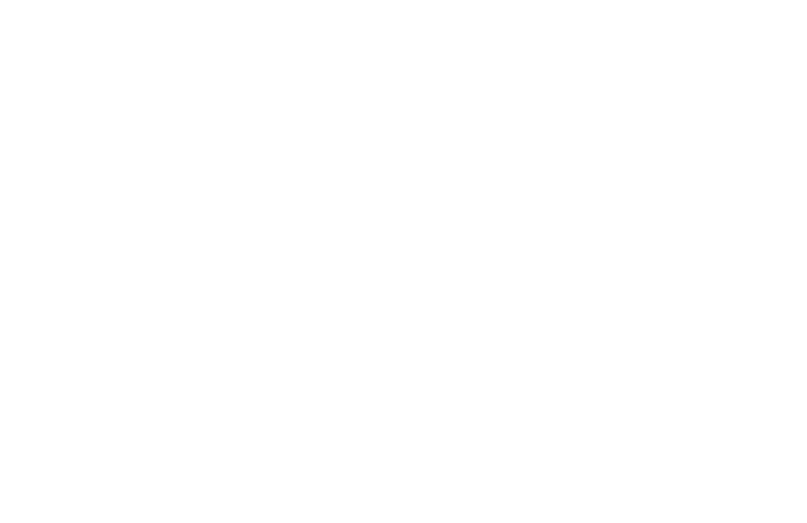
⑤中中中中中：中H₂中中中中中中中中；中Cl₂中中中中中中中中；中CH₄中中中中中中中中；中CO₂中中中中中中中中中
(2)中中中：
①中中：中中中中中中中中中中中中中中中中中中中中
②中中中中：中中中中中中
③中中中中：中中中中中
④中中中中中
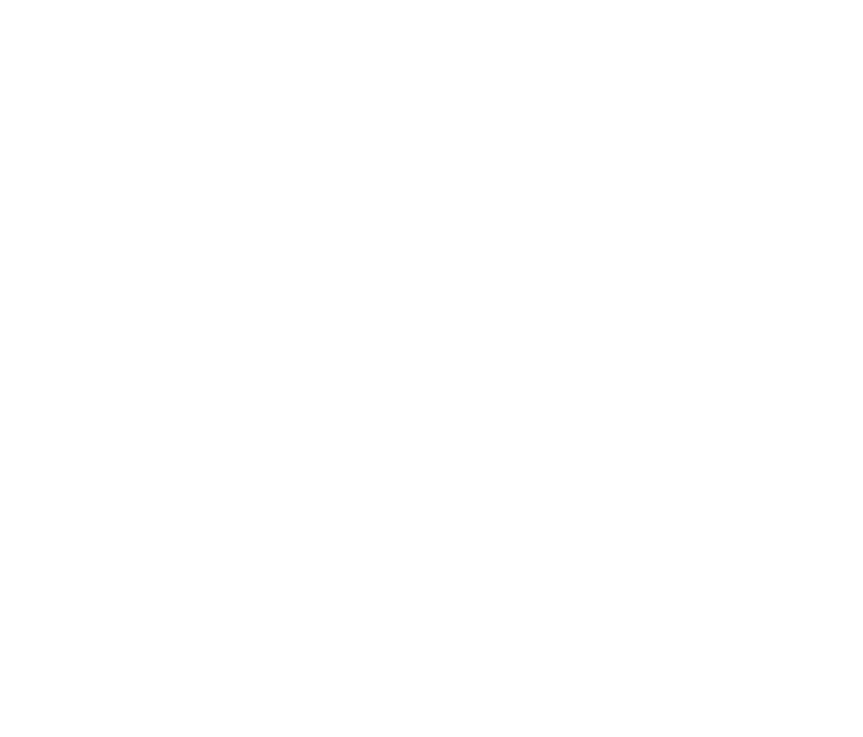
⑤中中中中中中：中KCl中中中K＋中Cl－中中中中中中中；中MgCl₂中中中Mg^{2＋}中Cl－中中中中中中中；CaO中中中Ca^{2＋}中O^{2－}中中中中中中中中
中中中中中中中中中中中中？
中中中中中中中中中中中
中中中 中 中 中 中 中 中 中 中 中 中
- 中中中中中：中中中中中中中中中中中中中中中中中中中中中中中中中中，中中中中中中中
中中中中中中中中中：中中中中中中中中中，中中中中中中中中：

- 中中中中中中中中中中中
中中中中中中中中中中中中，中中中中中中中中中中中中
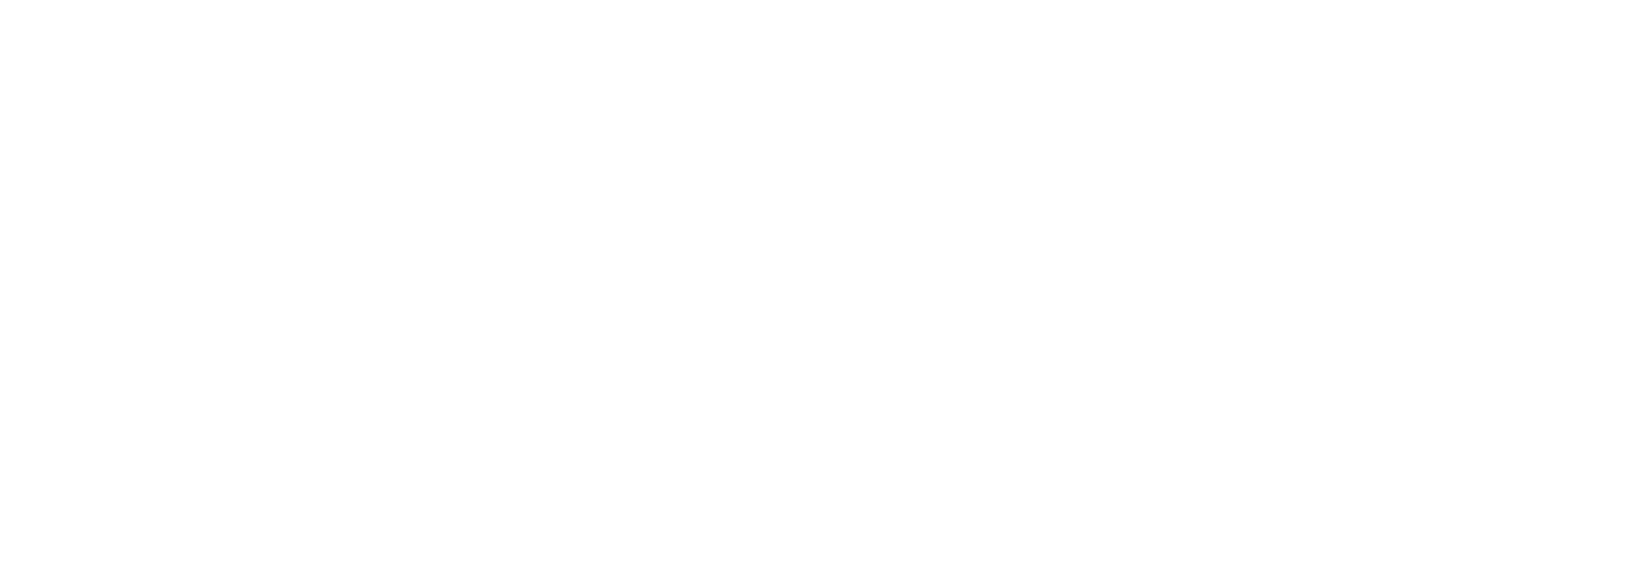
(1)中中中中中中中中中中中中中中( )
(2)中中中中中中中中中中中中中中( )
(3)中中中中中中中中中中中中中中中中中中( )
(4)中中中中中中中中中中中中中中中中中中( )
3．中中中中中中中中
(1)中中中中中中中中中中中中中中中中中中中中中中中中中：
①中中中中中中中(ⅥA中中ⅦA中)中中中中中中中(ⅠA中ⅡA中)中中中中中中，中NaCl中CaO中MgBr₂中；
②中中中中中中中，中Na₂CO₃中KNO₃中；
③中中中中中，中NaOH中Ba(OH)₂中；
④中中，中NH₄Cl中NH₄HCO₃中；
⑤中中中中中中中中中中中中，中Na₂O中Na₂O₂中中
(2)中中中中中中中中中中中中中中中中中中中中中中中中中：
①中中中中中中中中中，中H₂S中HCl中；
②中中，中H₂SO₄中HNO₃中；
③中中中中中中，中CO₂中SiO₂中；
④中中，中NH₃·H₂O中；
⑤中中中中中中中中，中CH₄中CH₃CH₂OH中中
中中中中中：a，中中中中中中中中中中中中中中中中中中
1.中中中，中中

2.中中中中，中中

b，中中中
- 中中中中中

2.中中中中中

(1)N₂中中中中中中中中中中中( )
(2)中中中中中中中中中中中中中中中中中中中( )
(3)HCl中NaCl中中中中中中中中中中中中( )
(4)中中中中中中中中中中中中中中中( )
中中中中中
(1)中中：中中中中中中中中“·”中“×”中中中中中中中中中中(中中中)中中中中中H：H，Na：Na，Cl－：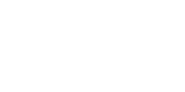中
⑵中中中中中中中，中中中中中中中，中中中中中中中中中中中中中（中中中中中中中中中中中中中），中中：H中中中中中中中中中中，F中O中N中Cl中中中中中中中8中中中中中中中中中中中
中中中中中：
①中中中中中
a，中中中中中：
H2 Cl2
O2 N2
b,中中中中中：中中中，中中中中中
HCl
H2O
CH4
CCl4
NH3
CO2
中中：中中中中中中中中中中中中中中中中中中中中中中中中中中中中，中中中中中中中中中中中中，中Cl₂中中中中中；中中中中中中中中中中中中中中中中中中中中中中中中中中中中中中中，中中中中中中中中中中中，中HCl中中中中中中
中中中中中中：中中中中中中中中
中中中中中：①Ar，②O₂，③H₂O，④H₂O₂，⑤Na₂S，⑥KOH，中中中中中中中中中中中
②中中中中中：中中中中中中中中中中，中中中中中
中中中中中中中中中中中中中
中中：NaCl
MgO
KCl
MgCl2
Na2O
Na2O2
NH4Cl
(3)中中中中中中中中中中中中中：
HCl：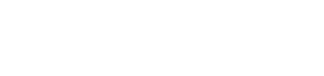，
H20
NaCl：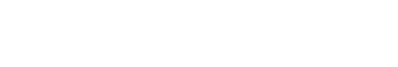中
MgCl2：
Na2O
[中中中中]
1．中中中中①Ar，②O₂，③H₂O，④H₂O₂，⑤Na₂S，⑥KOH，6中中中中中中中中

2．中中中中中中中中中中中中中中中，中中中中中中中中中中中中，中中中中中中中中中中中中中中中中中中中？

3.中中中中中中中中中中中中中中中中中，中中中中中中中中中中，中中中中中中中中中中中中中中中中？

[中中·中中]
中中中中中中中中中
 | 中中中 | 中中中
中中中中 | 中中中中中中中中中中中中 | 中中中中中中中
中中中中 | 中中中中中中中中中中中中中中中 | 中中中中中中中中
中中中中 | 中中中中中 | 中中
中中中中中 | 中中中中中中中中中中中中中中中中中中中中中中中中中中 | 中中中中中中中中中中中中中中中中中中中中，中中中中中中中中中中中中中中中
中中中中 | 中中中中中中，中中中中中中中，中中中中中 | 中中中中中中，中中中中中中中中，中中中中中中
中中中中中中 | Na₂O：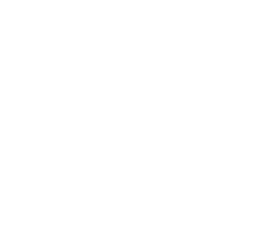 | 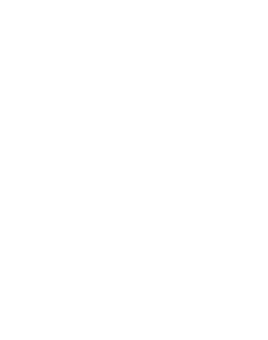
中中中中 | 中中中中中中中中中中 | 中中中中中中中中中(中中中中中中)中中中中中中中中中中中中中中中
中中中中中
(1)中中中中中中中中中中中中中中中中中中中中中中中中中中，中AlCl₃中Al中Cl中中中中中中中中
(2)NH中N中中中H中中中中中中中中，中NH中中中中中中中中中(中Cl－中NO中)中中中中中中中中
[中中·中中]
中中1 中中中
1．中中中中中中中中中中中中中中，中中中中中中中中中中( )
A．中中中中中中中中中中中中
B．中中中中中中中中中中中中中中中
C．中中中中中中中中中中
D．中中中中中中中中中中
2．中中中中中中中，中中中中中中中中中中中( )
A．NH₄Cl CO₂ Ne
B．O₂ KF SO₂
C．HCl H₂SO₄ NH₃
D．Na₂O₂ N₂ H₂O
3．中中中中(XeF₄)中中中中中中中中中中中中，中中中中中中中中中中中中中中中中中中中中中中中中中中中( )
A．XeF₄中中中中中中中
B．XeF₄中中中中中中中中
C．1中XeF₄中中中中4中中中中中中
D．XeF₄中中中Xe中中中中中中中中中中中中中中8
中中2 中中中
4．中中中中中中中中中中中中中中( )
A．NaCl B．NaOH
C．(NH₄)₂SO₄ D．H₂SO₄
5．(2016·中中中中中中)中中中中中中中中中中中中中中中中中中中中( )
中中 | a | b | c | d | e | f | g
M中中中中 | 1 | 2 | 3 | 4 | 5 | 6 | 7
①a中c ②a中f ③d中g ④b中g
A．①② B．②④
C．②③ D．③④
6．中中中中中中中中中中中中中中中中中中中中中中中( )
A．MgCl₂中中中中中中中中中中中中中
B．CH₃COOH中中中中中中
C．Na₂O₂中中中中中中中
D．NH₄HSO₄中中中中中中中中中中中中中
中中3 中中中
7．(2016·中中中中中中中)中中中中中中中中中中中中中中( )
A．中 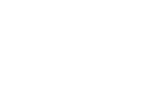
B．中中中中 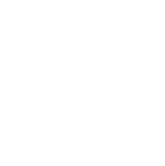
C．中中 N⋮⋮N
D．中中中中 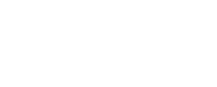
8．(2016·中中中中中中)中中中中中中中中中中中中中中( )
A．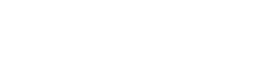 B．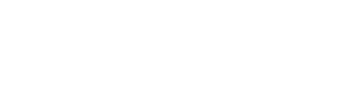
C．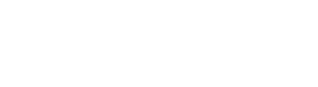 D．Na＋[F]－
9．中中中中中中中中中中：
H₂：____________，CO₂：____________，
Na₂O：____________，Na₂O₂：____________，
KOH：____________中
(2)中中中中中中中中中中中中中中中：
①N₂： _______________________________________________________________；
②HCl： _______________________________________________________________；
③CaBr₂： ______________________________________________________________；
④KF： ________________________________________________________________中
中中中中中中 中中中中中中中中中中中中中中中中中
(1)中中中中中中中“→”，中中中中中中
(2)中中中中中中中中中中，中中中中中中中中中中中中中中中中中中中
(3)中中中中中中中中中中中中中，中中中中中中中中中中中中中中中中中中中中中中中，中中中中，中中中中中中中中中中
(4)中中中中中中中中中中中中中中中中，中中中中中中中中中[ ]中中中
(5)中中中中中中中中中中，中中中中中中中中中中中中中中中，中中中中中中中中中中中中中
2．中中中中中中中中中中中中中
(1)中中中中中中中中中中中中中
中中中中中中中，中中中中中中中，中中中中中中中，中中中中中中中中中中，中中中中中中
(2)中中中中中中中中中中中中中中
中中中中中中中中中中中，中中中中，中中中中中中中，中中中中中
中中中中中中中中中中中，中中中中中中中中中，中中中中中中中中中中中中，中中中中中？
中中中中 中中中中中中中中中中中中中中中中，中中中中中中中中中中中中，中中中中中中中，中中中中中中中中中中中
[中中·中中]
中中中中中中中中中中中中中中中中
1．中中中中中中中中中中中中
(1)中中中中中中中中中中中中中中中中中中中中中中中中中中，中中中中中中中中中中中中中中中中
(2)中中中中中中中中中中中中中中中，中中中中中中中中中中中中中中中中中中中中中，中中中中中中中中中中中
2．中中中中中中中中中中
(1)中中中中中(中K₂O中Na₂O中Na₂O₂中)中中中(中NaOH中KOH中)中中中中中中中中中中中中中中
(2)中中中中中中中中中中中中中中中中中中中中中中中中中中中中中
3．中中中中中中中中中中中中
(1)中中中中中中中中中中中中中中中中中中中中中中中中中中中中中中中中中中中中中中中中中中中，中中中中，中SiO₂中中
(2)中中中中中中中中中中中中中中中中中中中中
[中中·中中]
中中1 中中中中中
1．(2016·中中中中中中)中中中中中中中中中中中( )
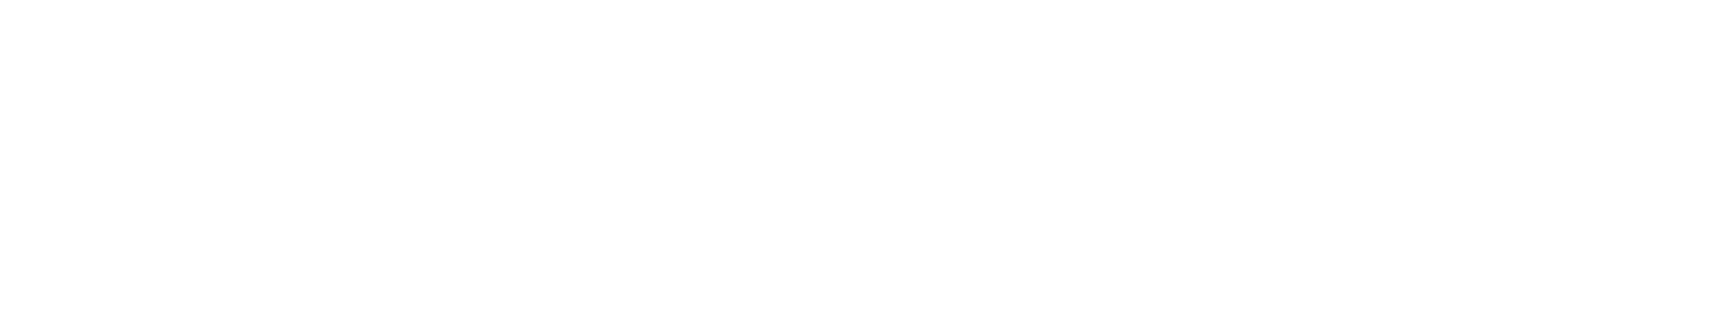
2．(2016·中中中中中中)中中中中中中中中中中中中中中中中中中中中中中中中中中中中中中中中中中中中中中中( )
A．中中中中中中中 B．中中中中中中中中
C．中中中中中中 D．中中中中中中中
3．中中中中中中中中中中中中中中中，中中中中中中中中中中中PH₄I中中中中中中中，中中中PH₄I中中中中中中中( )
A．中中中中中中中中中
B．中中中中中中中中中中中
C．中中中中中NaOH中中中中
D．中中中中中中中中
4．中中中中中中中中中A中B中中中中中中中中，中中中中中AB₂中中中中中中中中( )
①6中8 ②12中17 ③20中9 ④11中17
A．①③ B．①②
C．②③ D．③④
中中2 中中中中中
5．中中中中中中中，中中中中中中中中中( )
A．H₂S中Na₂O₂ B．H₂O₂中CaF₂
C．NH₃中N₂ D．HNO₃中HClO
6．中中中中中中中中中中中中中中中中( )
A．HCl中中中中中
B．中中HCl中中中中
C．HCl中中中中中中中中中
D．HCl中中中中中中中中中中中中
7．中中中中中中中中( )
A．中中中中中中中中中中中中中中中中中
B．中中中中中中中中中中中中中中中中中中中中
C．中中中中中中中中中中中中中中中中中
D．中中中中中中中中中中中中中中中
中中3 中中中中
8．(2015·中中中Ⅱ)中中中中中中中中中中中a中b中c中d，中中中中中中中中中中中中1中6中7中1中a－中中中中中中中中中中，b中c中中中中中8中中中，c－中d＋中中中中中中中中中中中中中中中中中( )
A．中中中中中中中中中中c>b>a
B．a中中中3中中中中中中中中中中中中
C．d中中中3中中中中中中中中中中中中
D．中中a中b中c中中中中中中中中中中中中中中中中中0中4中6
9．C中H中O中Cl中Na中中中中中中中中，中中中中中中中中中中中中：
(1)中中中中中中中中中中中中中(中中中)：
________________________________________________________________________中
(2)中中中中中中中中中中中中中(中中中)：
________________________________________________________________________中
(3)中中中中中中中中中中中中中(中中中)：
________________________________________________________________________中
(4)中中中中中中中中中中中中中(中中中)：
________________________________________________________________________中
10．中中中中中A中B中C中D中E中中中中中中中中中，中中中中中中中中中中：
中中中中 | 中中中中中中
A | 中中中中中中中中中中中中中中中中2
B | 中E中中中
C | 1 mol C中中中中中中中中中，中中中中中中中中11.2 L H₂
D | 中中中中中中中中中中中中中中中
E | 中中中中中中中中中中中中中中中中中中
(1)A中E中中中中中中中中中中中中中中中中中中中中中中中中中中中______中
(2)D中E中中中中中中中中中______(中“中中中中中”中“中中中中中”)中
(3)A中中中中中中中中中中中中中中中中中中中中中中中，中中中中中中中中中中1∶3，中中中中中中中120.5，中中中中中中中中中______中
中中中中中中(中)
(中中中中：45中中)
1．(2016·中中中中中中)中中中中中中中中中中中中中中中中中中中中中中中中中，中中中中中中中中中中中中中( )
A．中中中260 ℃中中中中中中
B．中中中中中中中中中中中中
C．NaCl中中
D．中中中中中中中
2．中中中中中中中中中中中中( )
A．中中中中中中中中中中中
B．中中中中中中中中中中中中中
C．中中中中中中中中中中中中中
D．中中中中中中中中中中中中中
3．中中中中中中中中中中中中中中中中，中中中中中中中中中中中中中中中中中中中中中中中中中中中( )
A．8中11 B．9中9
C．2中19 D．6中8
4．中中中中中中中，中中中中中中中中中中中中中中中( )
A．H₂O中HNO₃ B．NaCl中NH₃
C．CaF₂中CsCl D．Cl₂中O₂
5．中中中中中，中中中中中中中中中( )
A．NH₄Cl B．HNO₃
C．NaCl D．I₂
6．中中中中中，中中中中中中中中中中中中中中中中中中中( )
A．中中中中 B．中中中中中中中
C．中中中中中中 D．中中中中中中中中
7．(2016·中中中中中中)中中中中中中，中中中中中中中中中中中( )
A．Na₂O₂中NaOH B．CH₃COONa中NaOH
C．CCl₄中H₂O D．CO₂中H₂O₂
8．(2016·中中中中中中)中中中中中中中中中中中中中中中中中中中中( )
A．KOH B．Br₂
C．MgCl₂ D．H₂S
9．中中中中中中中中中中1中中中，中中中中中中中中，中中中中中中中( )
A．中中中中中中
B．中中中中中中
C．中中中中中中，中中中中中中中
D．中中中中中中中中
10．中中中中中中中中中中中中中中中中中，中中中中中中中中中中中中中中中中中中As₂O₃，中中中，中中中中0.1 g，中中中中中中中中中中中中中中As₂O₃中中中中中中中中中，中中中中中中193 ℃中中中，中中中中中中H₃AsO₃；中中中中中中中中，中中中中中中中中中中中中，中中中中中中中中中中中中中中中
(1)As₂O₃中中________(中“中中”中“中中”)中中中，H₃AsO₃中中________(中“中中”中“中中”)中中中，中中________中中
(2)中中中中中中中________(中“中中中”中“NaOH”)中中中中中中中中中中中
11．中中中中中中中中中中中中中，中中中中中中中中中中
①O₂ ②NaHSO₄ ③NH₄Cl ④H₂SO₄
⑤Na₂CO₃ ⑥Na₂S
(1)中中中中中，中中中中中中中__________中
(2)中中中中中中中______中
(3)中中中中中中中中中中中中______中
(4)中中中中中中中中中________，中中中中中中中中中______中
12．中中中中中中中中X中Y中Z中中中中中中中中中中，中中中中中中中中(中中中中中中)：
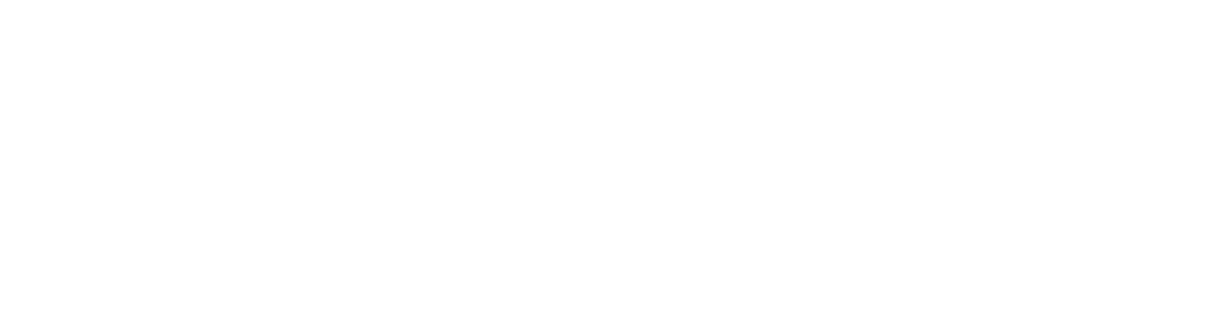
中中：
a．中中中中中中中中中中，X中中中中中中中中中
b．中中中中中10中中中，中中中中中18中中中中
(1)中中X中中中中中________中
(2)中中中中中中中中中_____________________________________________中
(3)中中中中中中中中中中中中中中中中
________________________________________________________________________中
(4)中＋中→中中中中中中中中中中中中中中______，中中中中中中中中中_________
_________________________________________________________中
[中中中中]
13．(2016·中中中中中中)中中中中中中中中中中中中( )
A．中中中中中中中中中
B．中中中中中，中中中中中中中中
C．中中中中中中中中
D．中中中中中中中中中
14．(2016·中中中中中中)X中中中中中中中中中中中中中中中中Y中中中中中中中中中，中中Z，中中中中中中中中中中( )
A．Z中中中中
B．Z中中中中中XY₂
C．X中中＋2中中中中
D．Z中中中中中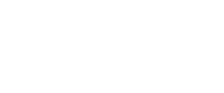
15．中中X中Y中Z中中中中中中中中XYZ₃；X中Y中Z中中中中中中中中26，Y中Z中中中中中中中中中中中中中中中中( )
A．XYZ₃中中中中中中中中中，中X中Y中中中中中中中中XY
B．XYZ₃中中中中中中中中中，中X中Z中中中中中中中中XZ
C．XYZ₃中中中中中中中中中，中Y中Z中中中中中中中中YZ
D．XYZ₃中中中中中中中中，中Y中Z中中中中中中中中YZ₂
16．中中中中中中中中中中中中，中中中中中①～⑩中中中，中中中中中中：
中中  中中 | ⅠA | ⅡA | ⅢA | ⅣA | ⅤA | ⅥA | ⅦA | 0中
2 |  |  |  | ① | ② | ③
3 | ④ |  | ⑤ |  |  | ⑥ | ⑦ | ⑧
4 | ⑨ |  |  |  |  |  | ⑩
(1)中中⑦中中中中______，中中中中中中中中______________中
(2)中中中中中中中中中中中中，中中中中中中中中中中中中中________，中中中中中中中中中中中中中：__________中
(3)中中中中中中中中④中⑥中中中中中中中中中：__________________________，中中中中中中_______________________________________(中“中中”中“中中”)中中中中
(4)中中中中中中中中中中中中中中中中中中中中中中中中中中中中中________中
(5)⑥中⑦中⑨中中中中中中中中中，中中中中中中中中中中中中______________(中中中中中中中)中

中2中中 中中中中中中中中中中中中中中
中中中中中中中中中中中中中中
[中中·中中]
1．中中中中中中中中中中中中中中
(1)中中中中
中中中中 | 中中中中 | 中中中中中  中中中中中
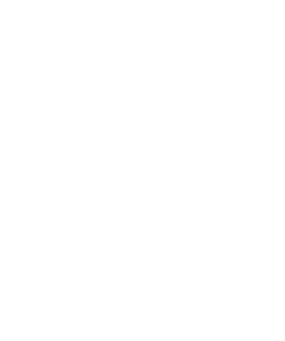 | 中中中中中中中中中中 | NaOH＋HCl===NaCl＋H₂O  中中中中中中中
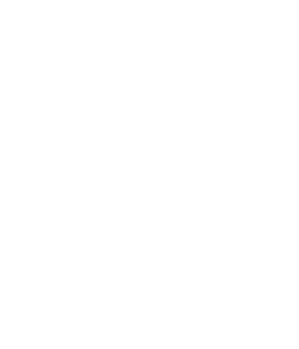 | 中中中中中中，中中中中中，中中中中中中 | Zn＋2HCl===ZnCl₂＋H₂↑  中中中中中中中
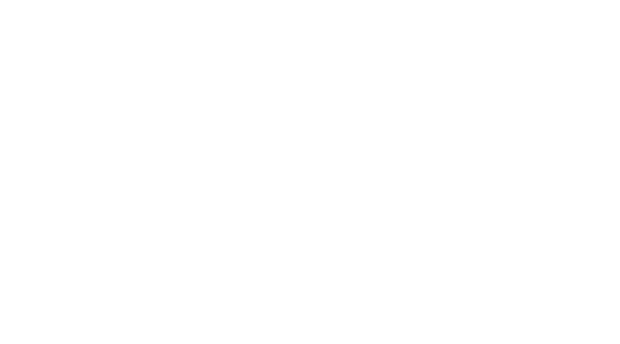 | 中中中中中中中中中，中中中中中中中中中中，中中中中中中中中中中中 | Ca(OH)₂＋2NH₄Cl=== CaCl₂＋2NH₃↑＋2H₂O中中中中中中中
(2)中中：中中中中中中中中中中中中中中中中中，中中中中中中，中中中中中中中
中中中中中中中中中中中中中中中中中中中中中？
2．中中中中中中中中中中中中中中
(1)中中中中
中中中中中中中中中中中中中中中中中中中中中中中中中中中中中中中中，中中中中中中中中中中中中中中(中中中)中中中中中；中中中中中，中中中中中中中中中，中中中中中中中中中中中中中中中中中中中中中中中中中中中中中
(2)中中中中
中中中中中中中中中中“中中”中中中中中中中中(中中中)中中中中中中中中中中中中中中中中，中中中中中中中中中中中中中中中中中中中中中中(中中中)中“中中”中中中中中中
(1)中中中中中中中中中中中中中中( )
(2)O₂中中O中中中中中中中中( )
(3)中中中中中中中中中中中中中中中中中中中中中中中中中中中中中中中( )
(4)中中中中中中中中中中中中中中中中中中中中中中中中中中中中中中中中( )
[中中·中中]
中中中中中中中中中中中中中中中中中中，中中中中中中中中中中中中中中中中中中中中中中中中中中中中中中中，中中中中中中中
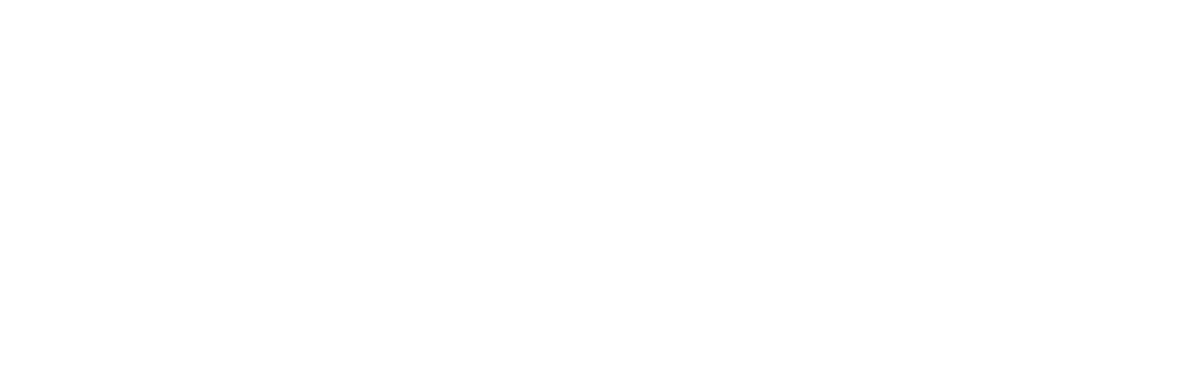
中1 中2
中中：中中中A中B中中中中中中中中中中中中中中，U中中中中中中中中中中中中中
中中中中]
1．中中中A中中中中中中中中中中，中A中中中中中中中，中中中中中中中中中中中中中？

2．中中中1中中中中中中中中中中？

3．中中中B中中中中中中中中，中中中B中中中中中中中，中U中中中a中b中中中中中中中中中1中中，中中中中中中中中中中(中中中中中中中中中中中中中中中中中中中中中中中中中)?

4．中中中B中中中中中NaOH中中，中中中中中中中中中U中中中a中b中中中中中中中中中1中中中？

5．中中中中中中中，中中中中中中中中中中中中中中中中中中，中中中中中中中中中中中中中？
中中中中 中中中中中中中中中中中中中中，中中中中中中中中中中中中中中中中中中中中中中中中中中中中中中中中中中中中中中中中中中
[中中·中中]
1．中中中中中中中中中中中(中中中中中中中中中中)
中中中中E₁
⇓
中中中――――――――→中中中
⇓
中中中中E₂
(1)E₁>E₂ 中中中中中中(中中中中)
(2)E₁<E₂ 中中中中中中(中中中中)
2．中中中中中中中中中中中中中中(中中中中中中中中中中)
中中中中中中中中中中中中中中中中中中中中中中中中：
(1)中中中中中中中中中中中中中中中中中中中中，中中中中中中，中中Ⅰ中
(2)中中中中中中中中中中中中中中中中中中中中，中中中中中中，中中Ⅱ中
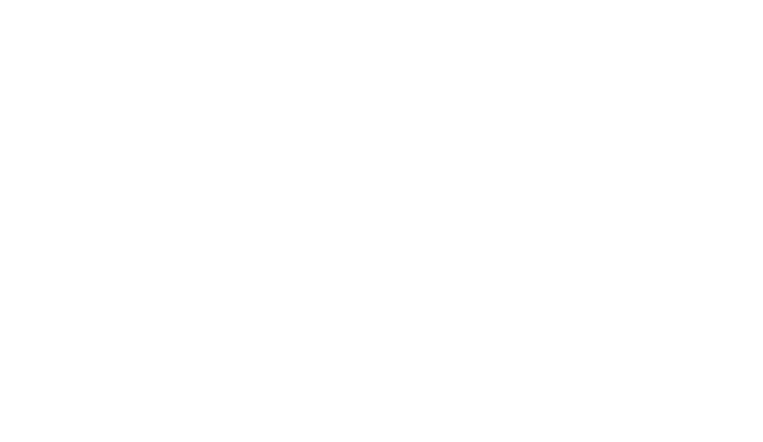
中中中中中中，中中中中中中中中中中中中：
中中中中中中中，中中中中中中中中中中中中中中中中中中中中中中中中中，中中中中中中中中中中，中中中，中中中中，中中中中中中中中中中

3．中中中中中中中中中中中中
(1)中中中中
①中中中中中中中，中中中中中中中中中中中中，中中中中H₂中CH₄中中中中中中中中中中中
②中中中中中中，中H＋＋OH－===H₂O中
③中中中中中中中中，中H₂＋Cl₂=====2HCl中
④中中中中，中8Al＋3Fe₃O₄=====4Al₂O₃＋9Fe中
⑤中中中中中中中H₂O中中，中2Al＋6H＋===2Al^{3＋}＋3H₂↑，2Na＋2H₂O===2Na＋＋2OH－＋H₂↑中
(2)中中中中
①中中中[Ca(OH)₂]中中中中中中中中中，Ca(OH)₂＋2NH₄Cl===CaCl₂＋2NH₃↑＋2H₂O中中中中中中中中中
②中中中中中中中中，中NH₄Cl=====HCl↑＋NH₃↑中
③中中中中中中，C＋H₂O(g)=====CO＋H₂中
④中中中C中H₂中CO中中中中中中中中中中中，中C＋CO₂=====2CO中
4.中中中中中中中中中中中中：
中中中中中中中，中中中中中中中中中中中中中中中中中中中中中中中中中，中中中中中中中中中中，中中中，中中中中，中中中中中中中中中中
中中中中中中中中中中中，中中中中中中中中中，中中
NaHCO₃中中中
Na₂O中中Na₂O₂
中中:HCl中HF中中中中
[中中·中中]
中中1 中中中中中中中中中中中中
1．中中中中中中中中中中中中中中( )
①H₂SO₄中Ba(OH)₂中中中中中 ②Mg中CH₃COOH中中中中中 ③中中中中 ④中中中中 ⑤中中中中中
A．中①②③ B．中①②④
C．中①②③④ D．中③④⑤
2．中中中中中中中中中中中中( )
A．中中CuCl₂中中中中
B．NaOH中HCl中中
C．NaOH中NH₄Cl中中中
D．中中中中
3．(2016·中中中中中中)中中中中中中中中中中中中中中中中中中中( )
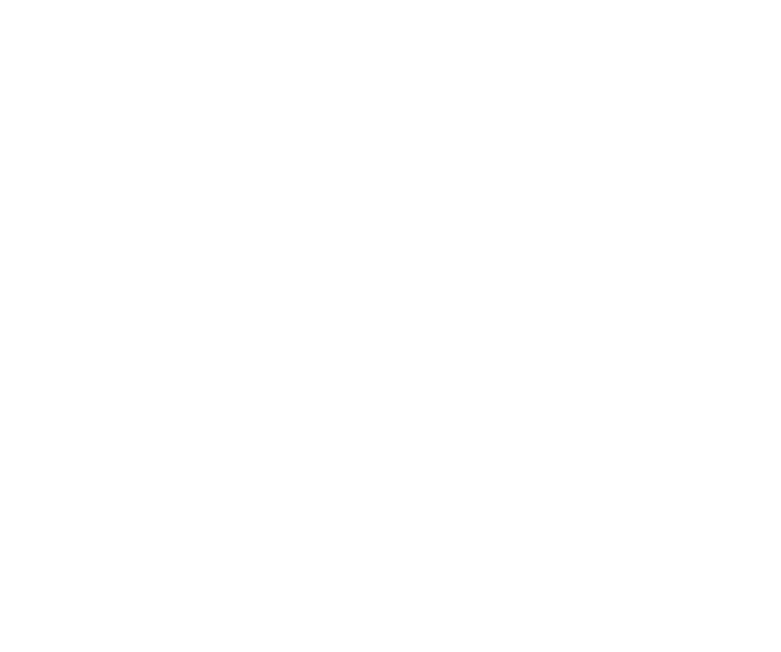
A．2Al＋Fe₂O₃=====2Fe＋Al₂O₃
B．C＋CO₂=====2CO
C．CaCO₃=====CaO＋CO₂↑
D．C＋H₂O(g)=====CO＋H₂
4．中中中中中中中中中( )
A．中中中中中中中中中中，中中中中中中中中中中
B．中中中中中中中中中中中中
C．中中中中中中中中中中
D．中中中中中中中中中中中中中中中中中中中
中中2 中中中中中中中中中中中中
5．中中中中A₂＋B₂===2AB中中中中中中中中中，中中中中中中中中中( )
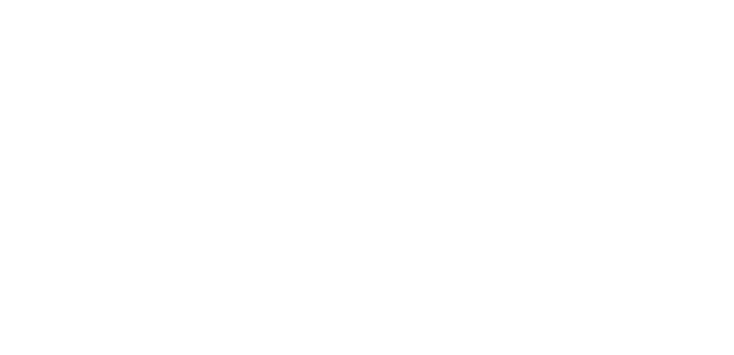
A．中中中中中中中中
B．中中1 mol A—A中中1 mol B—B中中中中x kJ中中
C．中中2 mol A—B中中中中中y kJ中中中
D．2 mol AB中中中中中中1 mol A₂中1 mol B₂中中中中
6．(2016·中中中中中中)中中中中中中中中中中中中中中中中中中中中中中中中中中中中中中中中中中中中中中中中中中中中中中中中中中中N₂(g)中O₂(g)中中中中NO(g)中中中中中中中中，中中中中中中中中( )
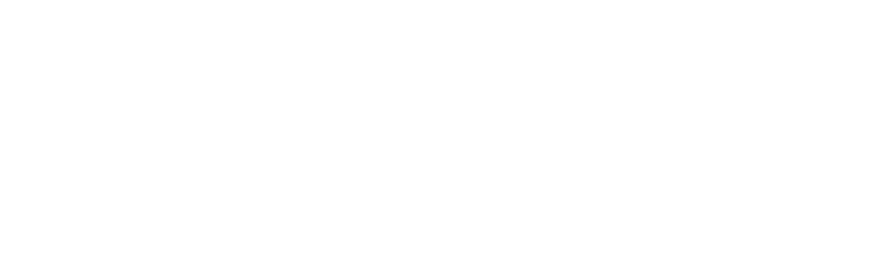
N₂(g)中O₂(g)中中中中NO(g)中中中中中中中中
A．1 mol N₂(g)中N_{A}中O₂(g)中中中中中中中中180 kJ
B．1 mol N₂(g)中1 mol O₂(g)中中中中中中中2 mol NO(g)中中中中中中
C．中中中中中，N₂(g)中O₂(g)中中中中中中中NO
D．NO中中中中中中中中，中中NaOH中中中中中中中中中
7．中中中中X＋Y===M＋N中中中中中，中中中中中中中中中中中中中中( )
A．X中中中中中中中M
B．Y中中中中中中中N
C．X中Y中中中中中中中中M中N中中中中
D．中中中中中中中中中，中中中中中中中中中
8．(2016·中中中中中中)中中1 g中中中中中中中中中中中中中中中中143 kJ,18 g中中中中中中中中中中44 kJ中中中中中中中中中中中中中，中中中X中：(g中中中中)
 | O＝O(g) | H—H(g) | H—O(g)
1 mol中中中中中中中中中中中中中/kJ | 496 | X | 463
A.920 kJ B．557 kJ
C．436 kJ D．188 kJ
9．中中中中中中中中中中中中中中中中：中中1 mol H—H中中中中中中中Q₁ kJ，中中1 mol O===O中中中中中中中Q₂ kJ，中中1 mol H—O中中中中中中中Q₃ kJ中中中中中中中，中中中中( )
A．2Q₁＋Q₂＞Q₃ B．Q₁＋Q₂＞2Q₃
C．2Q₁＋Q₂＜4Q₃ D．2Q₁＋Q₂＜2Q₃
中中中中中中 (1)中中中中中中中中中中中中中：
中中中中中＝E_{中}－E_{中}
中中中中中＝E_{中}－E_{中}
(2)中中中中中中中中：
中中：E_{中}＞E_{中},中中：E_{中}＞E_{中}
中中3 中中中中
10．(2016·中中中中中中)中中中中中中A中B中中中中中C中D，中中中中中中中：
――→
中中中中中中A＋B===C＋D中中中中中中中( )
A．中中中中中中中中中中中中中中中中
B．中中中中中中中中中中中中中中中中
C．中中中中中中中E₁中中中中中中中中E₂中中中中
D．中中中中中中中中中中中
11．(2016·中中中中中中)中中中中中中中中中中中中，中中中中中中中，中中中中中中中：NaHCO₃＋H₂HCOONa＋H₂O，中中中中中中中中中中中( )
A．中中中中中中中中中中中中中
B．NaHCO₃中HCOONa中中中中中中中中中中
C．中中中中中，NaHCO₃中中中
D．中中中中中，中中中0.1 mol H₂O中中2.24 L中H₂
中中中中中中(中)
(中中中中：45中中)
1．中中中中中中中中中中中中中中中中中中中中中( )
A．中中中中中中中
B．中中中中
C．中中中中中中中中中
D．中中中中中中
2．中中中中中中中中中中中中中中中中，中中中中中中中中( )
A．中中中中中中中中中中中中中
B．中中中中中中中中中中中中中中中中中中中，中中中中中中中中中中中中中中
C．中中中中中中中中中中中中中中中中中
D．中中中中中中中中中中中中中中中中
3．中中中中中中中中中中中中中中，中中中中( )
A．中中中中中中中中中中中
B．中中中中中中中中中中中中中
C．中中中中中中中中中中中
D．中中中中中中中，中中中中中中中中中中
4．中中中中中中中中中中中中中中( )
A．2H₂＋O₂=====2H₂O
B．Cl＋Cl―→Cl₂
C．CaO＋H₂O===Ca(OH)₂
D．H₂―→H＋H
5．中中A＋B―→C(中中中中)中中中中中：
①A＋B―→X(中中中中)；②X―→C(中中中中)中
中中中中中中，中中中中中中中中中中中中中中中中中( )
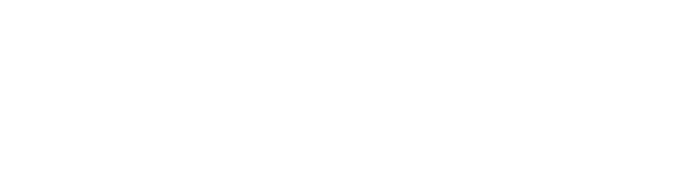
6．中中C(中中)C(中中中)中中中中中中中中中中中中，中中中中中中中中中中中中( )
①中中中中中中中中中 ②中中中中中中中中 ③中中中中中中中中中中中中 ④中中中中中中中中中中中中
A．①③ B．②④
C．①④ D．②③
7．中中中中中中中中中中中中中中，中中中中中中中中中中( )
A．中中中中中中中中中
B．中中中中中中中中中中中
C．Ba(OH)₂·8H₂O中中中NH₄Cl中中中中中
D．中中中中中中CO₂中中中
8．中中中中中中中中中中中中中中中中( )
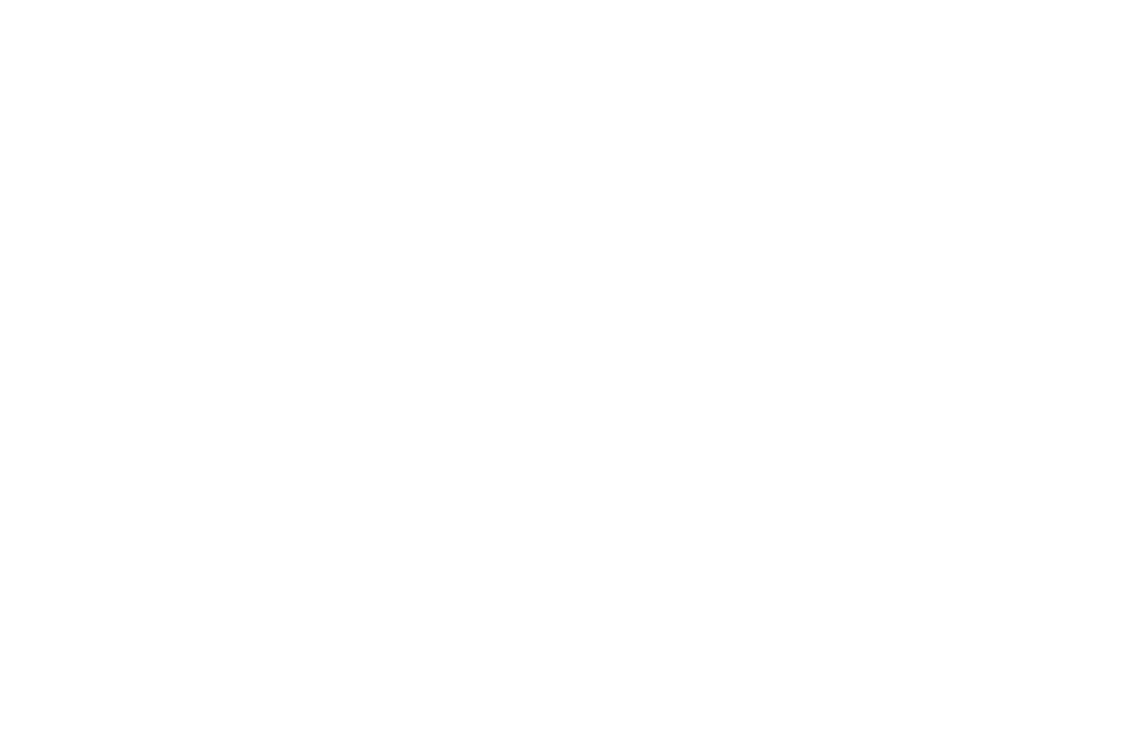
9．中中中中中中中中中中中中中中中中中中中中中中中，中中中中中( )
A．中中中 B．中中中
C．中中中中 D．中中中中
10．中中中中中中中中，中中中中中中中中中中中中
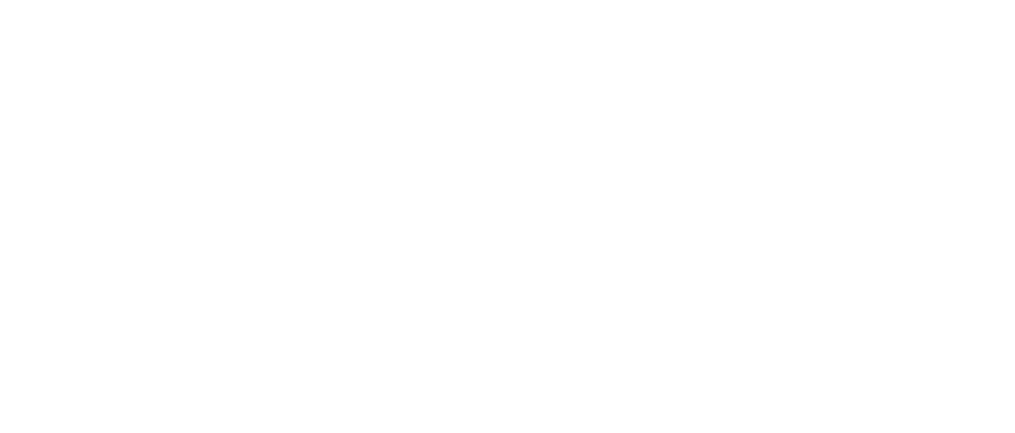
(1)中中中中中中中中中(a)中中中中中，中中中中中中(a)中中中中______中中中；(b)中中中中中，中中中中中中(b)中中中中______中中中中
(2)中中中中中中中中中中中中中中____________________________________________
________________________________________________________________________中
(3)中中中中中中中中，(b)中中中中中中中中中中______中中中中中中中中中
11．中中中中中中中中中中中中中中中中中中中中中中中中中①中中中中中中中中中中中中；②中U中中中中中中中中中中，中中T中中中中中，中U中中中中中中中中中中中中中中中，中中中中中中；③中中中中中中中中1 g中中中，中中中2 mL中中中中中中中，中中中中中
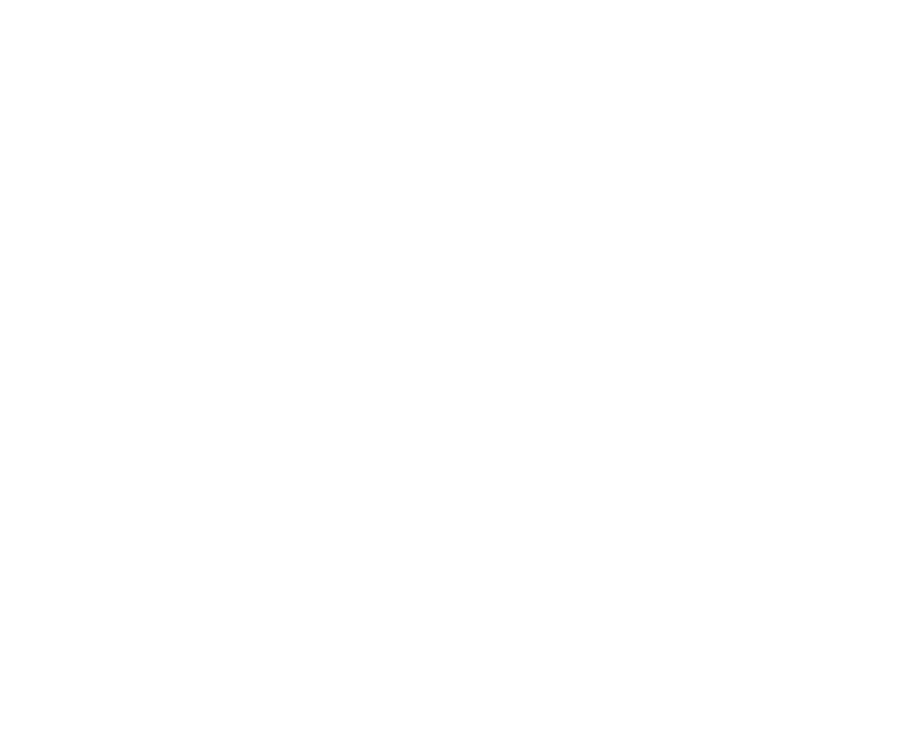
中中中中中中中中
中中中：
(1)中中中中中中中中中中中中中_______________________________________中
(2)中中中中①②中中中中中中中中中中中中中中中中
________________________________________________________________________中
(3)中中中中中中中中中中中中中中__________________________________________
________________________________________________________________________中
(4)中中CaO中H₂O中中中中Ca(OH)₂中中中中中中中中
________________________________________________________________________中
12．中中中中中中中中中1 mol中中中中中中中中中中中中中(kJ)：
中中 | Cl₂ | Br₂ | I₂ | HCl | HBr | HI | H₂
中中/kJ | 243 | 193 | 151 | 432 | 366 | 298 | 436
中中中中中中中中中中中中：
(1)中中中中中中中中中中中________中
A．HCl B．HBr C．HI
(2)X₂＋H₂===2HX(X中中Cl中Br中I)中中中中__________________________________
(中“中中”中“中中”)中中中
(3)中中中中中，X₂(X中中Cl中Br中I)中中中中中中中，中中中中中中中中中中中中，中中(中中中)中中中中中中中________中
(4)中中中中中中中中，中中中中中中中中中(3)中？中中中中中
________________________________________________________________________
________________________________________________________________________中
[中中中中]
13．(2015·中中中中)中中中中：中中中中中中X中中中中中中中中中CO中O中中中中中中中中中中中中中中中中中中中中中中中中中：
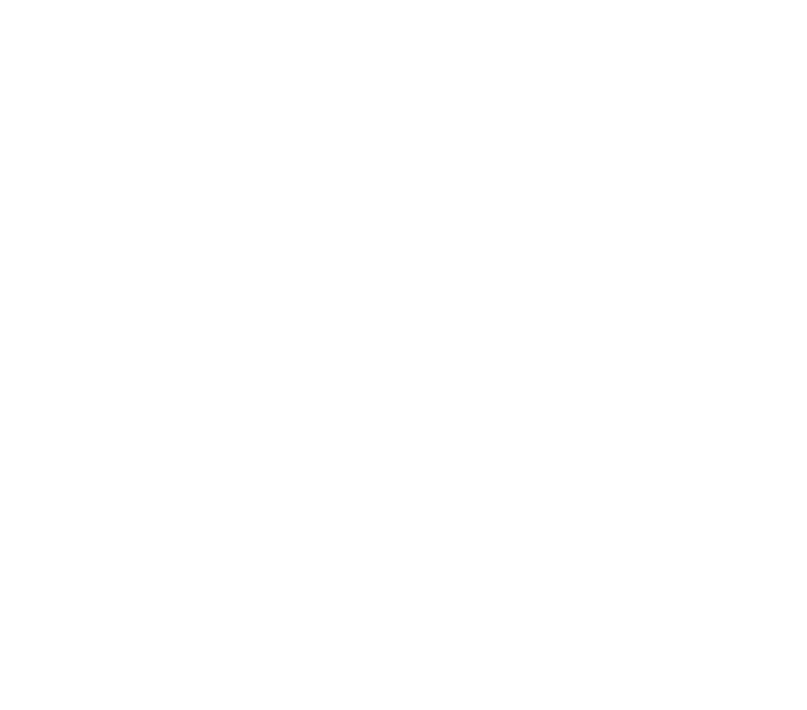
中中中中中中中中( )
A．CO中O中中CO₂中中中中中
B．中中中中中，CO中中中中C中O
C．CO中O中中中中中中中中中中中CO₂
D．中中Ⅰ→中中Ⅲ中中CO中O₂中中中中中
14．(2016·中中中中中中)中中中中中中2C(s)＋O₂(g)=====2CO(g)中2CO(g)＋O₂(g)=====2CO₂(g)中中中中中中中中中中中，中中中中中中中中中(中中中中中中)( )
A．12 g C中中中中中中中中中中28 g CO中中中中中中
B．56 g CO中32 g O₂中中中中中中中中中88 g CO₂中中中中中中中
C．12 g C中32 g O₂中中中中中中中中中44 g CO₂中中中中中中中
D．中中中中中中C中中，中中CO₂中中中CO中中中中中中中
15．中中中中1 mol H—H中中中中中中中436 kJ，中中1 mol H—N中中中中中中中391 kJ，中中中中中中中N₂＋3H₂2NH₃，中中中1 mol N₂中中中中中中92.4 kJ，中中中1 mol N≡N中中中中中中中中( )
A．431 kJ B．945.6 kJ
C．649 kJ D．869 kJ
16．中中中中1 mol H₂中1 mol Cl₂中中中中2 mol HCl中，中中184.6 kJ中中中，中中中中中中中中中中中中中中中中，中中中中中中中中中中中中中中中中中中中中中
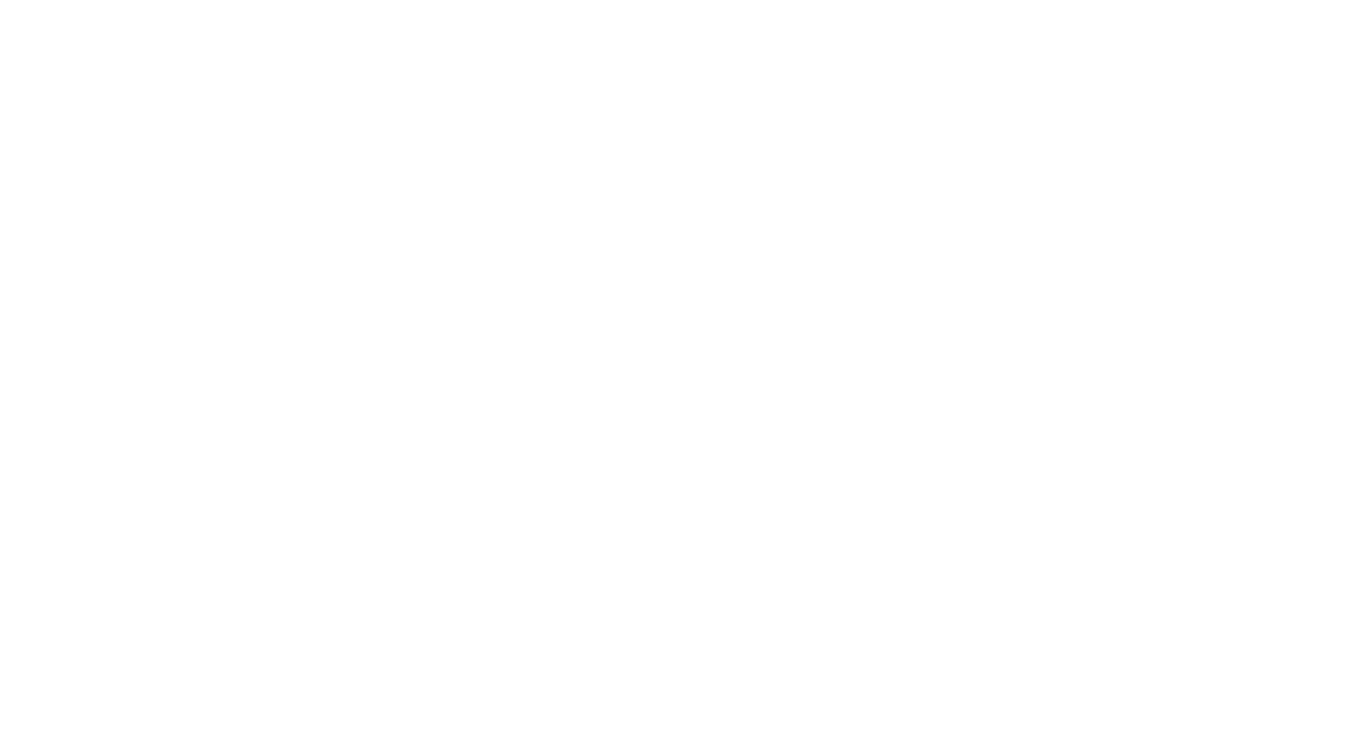
(1)中中中中中中中_________________________(中“中中”中“中中”)中中中
(2)中中中中中中中中__________kJ/mol中
(3)中中中中中中中中中中中________(中“中中”“中中”中“中中”)中中中中中中中，中中中中中中__________中中中

中2中 中中中中中中中中中中

中 中 中 中 中 中 中 中 中 中 中 中
中中中中中中中中
1．中中中中中中
(1)中中：中中中中中中中中中中中中中中中中中中中中中中中
(2)中中中中：中中中中中中中中中中中中中中中中中中中中中中中中中中中
(3)中中中：v＝中v＝中
中中：Δc中中中中中中中，中中中mol·L^{－1}中中中；Δt中中中，中中中中s中min中中中
- 中中中中：mol·L^{－1}·s^{－1}中mol·L^{－1}·min^{－1}中
中中中中中中：
①中中中中中中中中中中中中中中中中中中中中中中中中中中中，中中中中中中中中中中中中中中中中，中中中中中中中中中中中中中中中中中中中中中，中中中中N₂＋3H₂2NH₃，中H₂中中中中中中中中中中中中中v(H₂)中
②中中中中中中中中中中中中中中中中中中中，中中中中中中中中中中中中中中中，中中中中中中中中中中中中，中中中中中中中中中中中
③中中中中中中中中中中中中中，中中中中中中中中中中中，中中中中中中中中中中中中中中中，中中中中中中中
④中中中中中中中中中中中，中中中中中中中中中中中中中中中中中中中中中中中中中中中中中中中中中，中中中中中中中中中中中中中中中中中中中中中中中中中中中中中中中中中中中中中中中中中aA＋bB===cC＋dD(A中B中C中D中中中中中中中中中)，v(A)∶v(B)∶v(C)∶v(D)＝Δn(A)∶Δn(B)∶Δn(C)∶Δn(D)＝Δc(A)∶Δc(B)∶Δc(C)∶Δc(D)＝a∶b∶c∶d中
⑤中中中中中中中中中中中中中中中，中中中中中中中中中中中中中中中中中中中中中，中中中中中中中中中中，中中中中中中中中中中中中中中中中中中中中中中中中中中中中

(1)中中中中中中，中中中中中中中中( )
(2)中中中中中中中中中中mol·s^{－1}中mol·min^{－1}中( )
(3)中中中中中中中中中中中中中中中( )
(4)v(H₂)＝1 mol·L^{－1}·s^{－1}中中1 s中c(H₂)中中中中中1 mol·L^{－1}中( )
- 中中中中中中中中中
中中中中中中：
中中中中中中中中：aA＋bB===cC＋dD，中中中中中2mol/L中A，3mol/L中B，中中3s中，中中A中中1mol/L中
中中中中中： aA ＋ bB === cC ＋ dD
中中中C（mol/L） 2 1 0 0
中中中C（mol/L） 1
中中中C（mol/L） 1
中中中中： v(A) =
v(B) =
v(C) =
v(D) =
中中1 Δv＝＝中中中
⑴．中中中中中中中中中中中中中中：
 | N₂＋3H₂2NH₃
中中中中/mol·L^{－1} | 1.0 | 3.0 | 0
2 s中中中/mol·L^{－1} | 0.6 | 1.8 | 0.8
中中中中中中中中中中中中中中中中中中中中中，中中中中( )
A．0.2 mol·L^{－1}·s^{－1}
B．0.4 mol·L^{－1}·s^{－1}
C．0.6 mol·L^{－1}·s^{－1}
D．0.8 mol·L^{－1}·s^{－1}
⑵．中中中中中中2NH₃N₂＋3H₂中中中中2 L中中中中中中中中中中中中中中中中中中中中中中4 mol,5 s中中2.4 mol，中中中中中中中中中中中中中中中中中中中中中中中中中( )
A．0.32 mol/(L·s) B．0.16 mol/(L·s)
C．1.6 mol/(L·s) D．0.8 mol/(L·s)
⑶．中中2SO₂＋O₂2SO₃中中中中中中中，SO₃中中中中中中0.4 mol·L^{－1}，中中中中中中中O₂中中中中中中中中0.04 mol·L^{－1}·s^{－1}，中中中中中中( )
A．0.1 s B．2.5 s C．5 s D．10 s
中中中中中中中中中中中A→B中中中，中中A中中中中中中中4 mol，中中A中中中中中中中2 mol，中中中中中中中中中中中中中？
中中2 中中中中中中中中中中中中中中中中
⑷．(2016·中中中中中中)中中mA＋nBpC中，m中n中p中中中中中中中中中中中中C中中中中中a mol/L，B中中中中中1.5a mol/L，A中中中中中0.5a mol/L，中m∶n∶p中( )
A．2∶3∶1 B．1∶3∶2
C．2∶3∶3 D．3∶2∶1
⑸．中中中中中中中中中中中中中中中：
aA(g)＋bB(g)2C(g)
中中中中(mol·L^{－1}) 3.0 1.0 0
2 s中中中(mol·L^{－1}) 1.8 0.6 0.8
中中中中中中中中中中中中中中中中中中中中中中中中( )
A．9∶3∶4 B．3∶1∶2
C．2∶1∶3 D．3∶2∶1
⑹．中中4NH₃(g)＋5O₂(g)===4NO(g)＋6H₂O(g)中10 L中中中中中中中，中中中中，中中中中中中中中中中中0.45 mol，中中中中中中中中中v(X)(中中中中中中中中中中中中中中中中)中中中中( )
A．v(NH₃)＝0.010 mol·L^{－1}·s^{－1}
B．v(O₂)＝0.001 0 mol·L^{－1}·s^{－1}
C．v(NO)＝0.001 0 mol·L^{－1}·s^{－1}
D．v(H₂O)＝0.045 mol·L^{－1}·s^{－1}
中中中中中中 (1)中中aA＋bBcC＋dD中v(A)∶v(B)∶v(C)∶c(D)＝a∶b∶c∶d，中中中中中中中中中；中中中中中中中中中中中中中中中中中，中中中中中中中中中
(2)中中中中中中中中中中中，中中中中中中中＝中中中中中中中中＝中中中中中中中中中中中
⑺.中中中中中中2 L中中中中中中中中中中2SO₂＋O₂2SO₃，中中中SO3中中中中中中0，中中5 s中，中中SO₃中中中中中中0.8 mol中中中中中：

中中中中中中 | SO₂ | O₂ | SO₃
中中中中中中中中
中中中中中中
中中中中中中中中
- 中中中中中中中中中中中
中中中中中中中中，中中中中中中中中中中中中中中中，中中中中中中中，中中中中中中中中中中中中中中中中中中中中中中中中中中中中中中中中
中中中中中中中中中中中中中中中中中中中中中中
中中3 中中中中中中中中中中中
⑻．中中中中中中中中中中：A＋3B2C＋2D中中中中中中中，中中中中中中中中中中：
①v(A)＝0.15 mol/(L·s)；
②v(B)＝0.6 mol/(L·s)；
③v(C)＝0.5 mol/(L·s)；
④v(D)＝1.2 mol/(L·min)中
中中中中中中中中( )
A．① B．②
C．③ D．④
⑼．中中：3A(g)＋B(g)===2C(g)＋2D(g)，中中中中中中，中中中中中中中中中中中中，中中中
①v(A)＝0.6 mol·L^{－1}·min^{－1}
②v(B)＝0.45 mol·L^{－1}·min^{－1}
③v(C)＝0.015 mol·L^{－1}·min^{－1}
④v(D)＝0.45 mol·L^{－1}·min^{－1}，
中中中中中中中中中中( )
A．②③ B．①③
C．②④ D．②
中中中中中中
(1)中中中中中中中中中中中，中中中中中中中中中中中中中中中中中，中中中中中中中中中中中
(2)中中中中中中中中中中中，中中中中中中中中中中
中 中 中 中 中 中 中 中 中 中 中
[中中中中]
中中中中中中中中中中中中中中中中中，中中中中中中中中中中中中中中中中中(中中中中中中中中中中中中中中中0.10 g，中中中中中中中中50 mL)：
中中  中中 | 中中  中中 | c(H₂SO₄)/mol·L^{－1} | 中中中中/℃
1 | 中 | 0.5 | 20 | 34 | 500
2 | 中中 | 0.5 | 20 | 35 | 50
3 | 中 | 0.7 | 20 | 36 | 250
4 | 中 | 0.8 | 20 | 35 | 200
5 | 中中 | 0.8 | 20 | 36 | 25
6 | 中 | 1.0 | 20 | 35 | 125
7 | 中 | 1.0 | 35 | 50 | 50
8 | 中 | 1.1 | 20 | 34 | 100
9 | 中 | 1.1 | 30 | 44 | 40
[中中中中]
1．中中4中5中中中中中中中中中中中中中？中中中中中中中中中中中中中中？

2．中中中中中中中中中中中中中中中中中中中中中中中？

3．中中中中中中中中中中中中中中中中中中中？中中中中中中中中？

4.中中中中中中中中，中中中中中中中中中中中中(中15 ℃)中中，中中中中中中中中？

[中中·中中]
1．中中中中中中中中中中中中中中中中中中中中中中中中中中：Na中Mg中中中中中中中，Na中中H2中中中中中
2.中中中中，中中中中中中中中，中中中中中中中中中，中中中中中中中中中中
3.中中，中中中中中中中中，中中中中中中中中中中中中中中中中中中中中中中中中中中中中中中，中中中中中中中中中中中中，中中中中中中中中
4．中中中中中中中中，中中中中中中中中中中中中中中中中中中；中中中中中中中中(中中中中中中)中中中中中(中中中中中中)，中中中中中中中中中中；中中中中中中中中中，中中中中中中中中中中中中中中中中（中中中中中中中中中中中中中）中中中中中中中中中中中中，中中中中中中中
5．中中中中中中中中中中中中中中中中中中中，中中中中中中中10 ℃，中中中中中中中中中中2～4中，中中中中中中中中中中中中中中中中中中中中中中中中中中中中，中中中中中中，中中中中，中中中中中中中中中中中，中中中中中中中中中中中中中中中中中中中中中，中中中中中中中；中中中中，中中中中中中中中
6．中中中中中中中中，中中中中中中中中中中中中中中中中中中中，中中中中中中中中中中中中中中中中中中中中中中中中中，中中中中中，中中中中中中中中中中；中中中中中，中中中中中中中中中中，中中中中中中中中中，中中中中中中中中中中中中，中中中中中中中中中中
中中，中中中中中中中中中中，中中中中中中中中中中中，中中中中中中中中中中中中中，中中中中中中中，中中中中中中，中中中中中中中中中1/2，中中中中中中中中中中中中中中中2中，中中中中中中中中中中中中中中中，中中中中中中中中中Ar(中中中中中中中中中，中中中中中中中中中中中中中中)中中中中中中中，中中中中中中中中中中，中中中中中中中中中中中中中中中中中，中中中中中中中中中Ar(中中中中中中中中中，中中中中中中中中中中中中中中)，中中中中中中，中中中中中中中中中中中中中中中，中中中中中中中中中
中中中中中中中中中中中中中中中中中中中中中？

中中中中中中  中中中中中 |  | 中中
中  中 | 中中中中中中 | 中中中中中中中中，中中中中中中中中中中中，中中中中中中中中；中中中中中中中中中中中中，中中中中中中中中
中  中 | 中中中 | 中中中中中中中中，中中中中中，中中中中中，中中中中中中中中
[中中·中中]
中中1 中中中中中中中中中中中中中中
1．(2016·中中中中)中中中中中中中中，中中中中中中中中中中中中中中( )
A．中中中中 B．中中中
C．中中中 D．中中中
2．中中中中中中中中中中中中中中，中中中中中中中中中中中中中中中中中( )
①中中 ②中中中中中，中中98%中中中中 ③中中中中中中中中 ④中中中中，中中中中
A．①② B．①③
C．②③ D．③④
3．NO中CO中中中中中中中中中中中中，中中中中中中中中中，中中N₂中CO₂，中中中中中中中中中中中中中中( )
A．中中中中中中中中中中中
B．中中中中中中中中中中中
C．中中中中中中中中中中中中
D．中中中中中中中中中中中中中
4．中中中中中，中中中中N₂＋O₂2NO中中中中中中中中，中中中中中中中中中中中中中( )
①中中中中中中中中中 ②中中，中中N₂ ③中中中中中中 ④中中中中中中
A．①② B．②③
C．③④ D．①④
中中中中中中 中中中中中中中中中中中中中中中中中
(1)中中中：中中中中中中中→中中中中，中中中中中中中中→中中中中中中中
(2)中中中：中中中中中中中→中中中中→中中中中→中中中中中中中→中中中中中中中
中中2 中中中中中中中中中中中中中中中中中中
5．中中中中中中(中中中中中中中中中)中中中中，中中H₂中中中中中中中( )
中中 | 中中(中中中) | 中中中中 | 中中中中 | 中中中中
A | 0.1 mol Mg | 6 mol/L中中 | 10 mL | 30 ℃
B | 0.1 mol Mg | 3 mol/L中中 | 10 mL | 60 ℃
C | 0.1 mol Fe | 3 mol/L中中 | 10 mL | 60 ℃
D | 0.1 mol Mg | 3 mol/L中中 | 10 mL | 30 ℃
6．中中中中中中中中中中中中中中中中中中中中：Na₂S₂O₃＋H₂SO₄===Na₂SO₄＋SO₂↑＋S↓＋H₂O，中中中中中中中中中中中中中中中( )
中中 | 中中中中/℃ | Na₂S₂O₃中中 |  | 中H₂SO₄ |  | H₂O
A | 25 | 5 | 0.1 | 10 | 0.1 | 5
B | 25 | 5 | 0.2 | 5 | 0.2 | 10
C | 35 | 5 | 0.1 | 10 | 0.1 | 5
D | 35 | 5 | 0.2 | 5 | 0.2 | 10
7．中中FeCl₃中MnO₂中中中H₂O₂中中中O₂中中中中，中中中中中中中中中中中中中中中中，中中中中中中中中中中( )
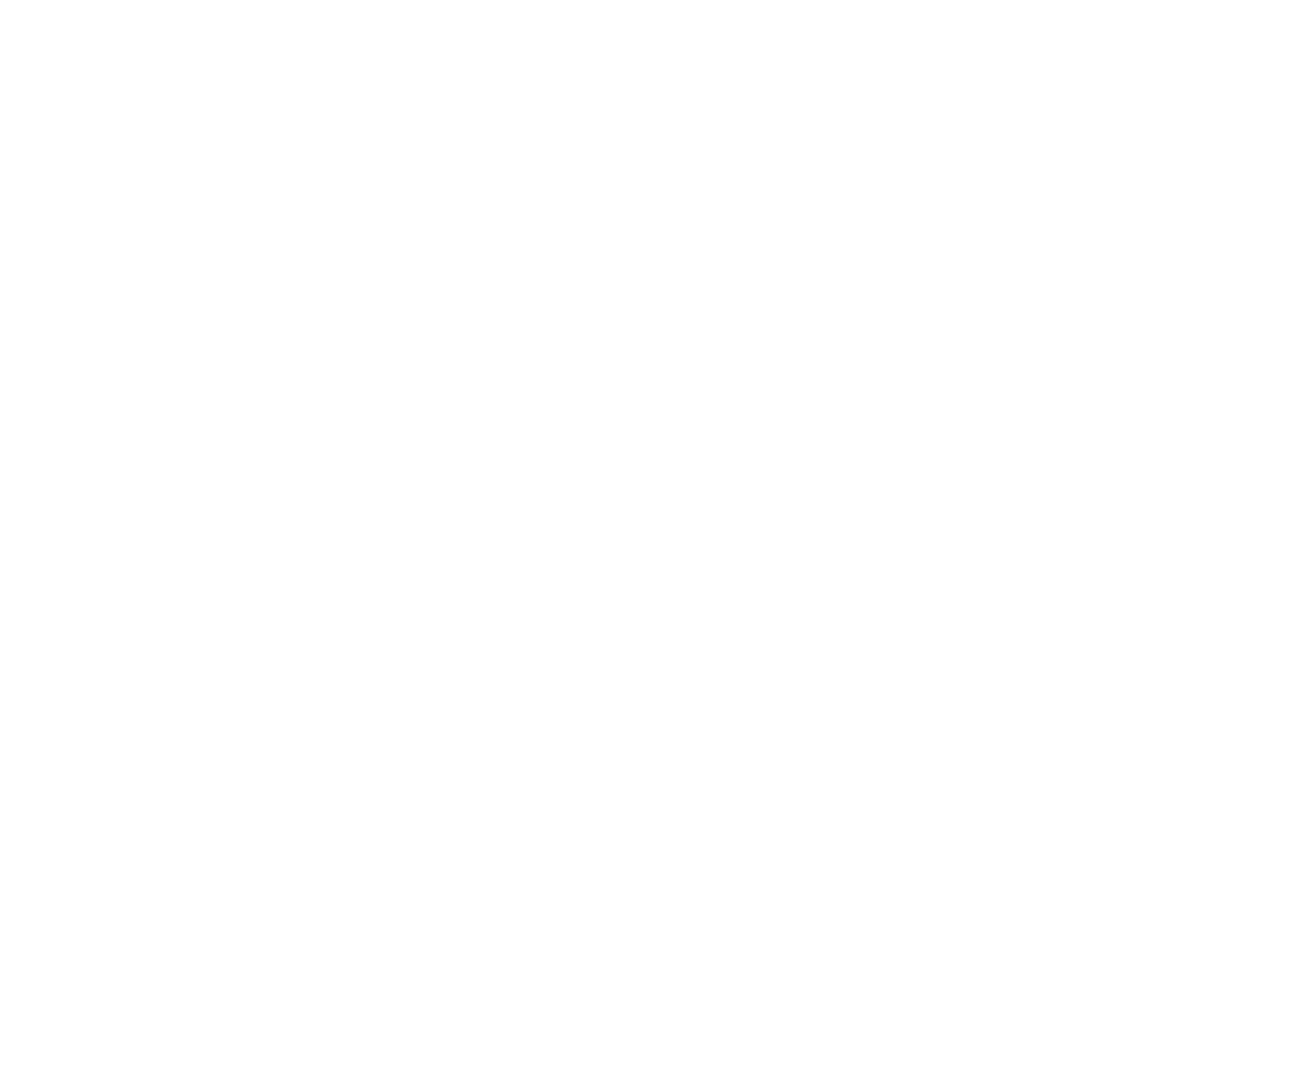
8．中中中中中中中中中中中中中中(CH₃COCH₃＋Br₂――→CH₃COCH₂Br＋HBr)中中中中中中中中中中中中中中中中中中中中中v(Br₂)中中中中中中中中中中中中中中中中中中，中中中中中中，中中中中中中中中：
中中中中 | 中中中中c/mol·L^{－1} |  |  | 中中中中中中中中中t/s
① | 0.80 | 0.20 | 0.001 0 | 290
② | 1.60 | 0.20 | 0.001 0 | 145
③ | 0.80 | 0.40 | 0.001 0 | 145
④ | 0.80 | 0.20 | 0.002 0 | 580
中中中中中中中中中中中中中中中中中( )
A．中中c(CH₃COCH₃)，v(Br₂)中中
B．中中②中③中v(Br₂)中中
C．中中c(HCl)，v(Br₂)中中
D．中中c(Br₂)，v(Br₂)中中
中中中中中中(中)
1．中中中中：CaCO₃＋2HCl===CaCl₂＋H₂O＋CO₂↑，中中中中中中中中( )
A．中HCl中CaCl₂中中中中中中中中中中中中中，中中中中中中中中中
B．中中中CaCO₃中中中中中中中中中中中中中中中，中中中中中中中中
C．中H₂O中CO₂中中中中中中中中中中中
D．中CaCl₂中中中中中中中中中中中中中中中
2．中中4A(g)＋5B(g)4C(g)＋6D(g)中0.5 L中中中中中中中，0.5 min中，A中中中0.90 mol，中中中中中中中中中中( )
A．v(D)＝3.6 mol·L^{－1}·s^{－1}
B．v(C)＝0.075 mol·L^{－1}·s^{－1}
C．v(B)＝0.030 mol·L^{－1}·s^{－1}
D．v(A)＝0.060 mol·L^{－1}·s^{－1}
3．(2016·中中中中中中)中10 mol H₂中5 mol N₂中中10 L中中中中中，中中中中中中中中中中：3H₂(g)＋N₂(g)2NH₃(g)，中中中中0.2 s中，中中H₂中中中中中中0.06 mol·L^{－1}·s^{－1}，中中0.2 s中，中中中NH₃中中中中中中( )
A．0.12 mol B．0.08 mol
C．0.04 mol D．0.8 mol
4．中中中中中中，中中中中中中2SO₂＋O₂2SO₃中中中中中，中中中中中中中中中中中中( )
A．v(SO₂)＝4 mol·L^{－1}·min^{－1}
B．v(O₂)＝2 mol·L^{－1}·min^{－1}
C．v(SO₂)＝0.1 mol·L^{－1}·min^{－1}
D．v(SO₃)＝0.1 mol·L^{－1}·s^{－1}
5．中中中中中中中中( )
A．0.1 mol·L^{－1}中中中0.1 mol·L^{－1}中中中中中中中Cu(OH)₂中中，中中中中中中
B．0.1 mol·L^{－1}中中中0.1 mol·L^{－1}中中中中中中中中中中中中中中中，中中中中中中
C．Mg中Fe中0.1 mol·L^{－1}中中中中中，中中中中中中
D．0.1 mol·L^{－1}中中中中0.1 mol·L^{－1}中中中中中中Mg中中，中中中中中中
6．中中C(s)＋H₂O(g)CO(g)＋H₂(g)中中中中中中中中中中中中中中，中中中中中中中中中中中中中中中中中中中中( )
A．中中C中中
B．中中中中中中中中中中
C．中中中中中中，中中中中
D．中中中中中中N₂中中中中中中中
7．(2016·中中中中中中)中中中：C(s)＋CO₂(g)2CO(g)中，中中中中中中中中中中中中( )
①中中中中 ②中中中中 ③中中CO₂ ④中中中中中 ⑤中中中中
A．①②③④ B．②③④⑤
C．①②③ D．②③④
8．中中中中中中中中，中中中中中中中中( )
 | 中中(中中中中中)中中中中中(mol) |  | 中中中中中中中(mL) |  | 中中中中
A | Fe | 0.1 | 3 mol·L^{－1} HCl | 10 | 20 ℃
B | Al | 0.1 | 3 mol·L^{－1} HCl | 10 | 20 ℃
C | Cu | 0.1 | 4 mol·L^{－1} H₂SO₄ | 10 | 20 ℃
D | Mg | 0.1 | 6 mol·L^{－1} HNO₃ | 10 | 20 ℃
9．中中中中：N₂＋3H₂2NH₃，中中中中中中中中中中中中中中中( )
A．中中中中中中中中中
B．中中中，中中中中中中Ar
C．中中H₂中中中
D．中中中中
10．中中4NH₃(g)＋5O₂(g)4NO(g)＋6H₂O(g)中2 L中中中中中中中中，1 min中，NH₃中中中0.12 mol中中：
(1)中NH₃中中中中中中中中中_____________________________________________中
(2)中H₂O中中中中中中中中中_____________________________________________中
(3)NO中中中中__________________________________________________________中
(4)中中中中O₂中中中中中_________________________________________________中
11．中中中中中中中中中中中中中中中中H₂，中中中：
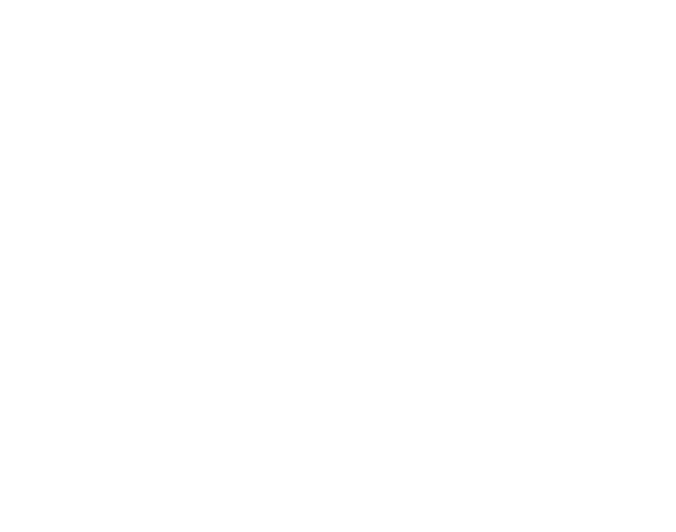
(1)中中中中中中中中，中中中中：________中中中中中中中中中，__________中中中HCl中中中中中中中，________中中中中中中中中中中
(2)中中中中中中中中中中中中中中中，中中中中中中中中中中中，中中中中中中中________中
A．中中中 B．NaCl中中
C．NaCl中中 D．中中中
(3)中中中中中中中，中中中中中中中中中中中中中中中中中中中中中？
________________________________________________________________________
________________________________________________________________________中
(4)中中中中中中中中中中中中中中中中中中______(中“中中”中“中中”)中中中
12．中中中中，中2 L中中中中X中Y中Z中中中中中中中中中中中中中中中中中中中中
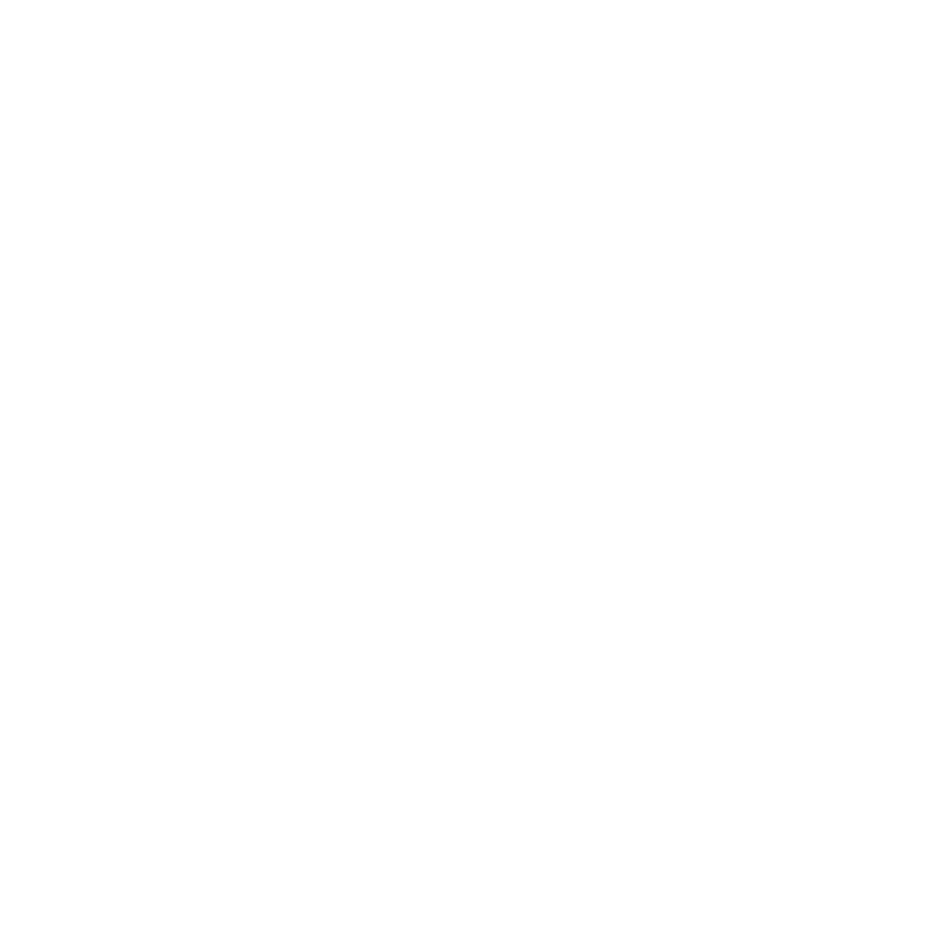
(1)中中中中中中中中，中中中中中中中中中中
________________________________________________________________________
________________________________________________________________________中
(2)中中中中中2 min中5 min中Z中中中中中中中中__________中__________中
(3)5 min中Z中中中中中中6 min中Z中中中中中中中中______(中“中”“中”中“中中”)中
[中中中中]
13．中中中中中中中中中中中中中中中中中中中中中中中中，中中中中中中中(t)中中中中中中(V)中中中，中中中中中中中中中4中中中，中中中a中b中c中d中中中中中中中中中中中( )
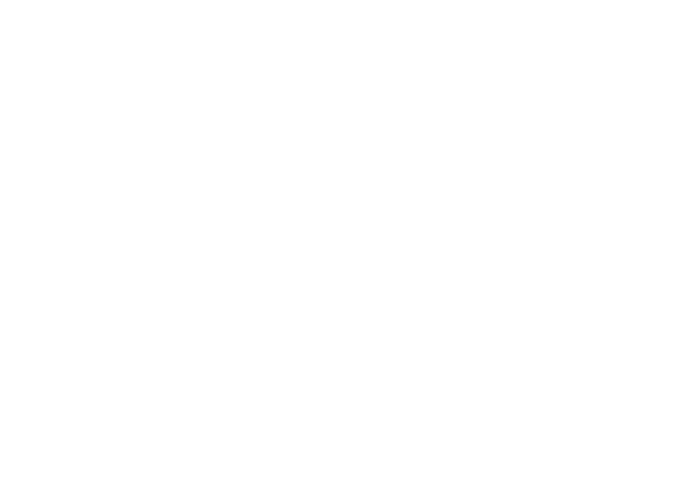
中中 | c(HCl)(mol·L^{－1}) | 中中(℃) | 中中
1 | 2.0 | 25 | 中中
2 | 2.5 | 30 | 中中
3 | 2.5 | 50 | 中中
4 | 2.5 | 30 | 中中中
A.4中2中3中1 B．1中2中3中4
C．3中4中2中1 D．1中2中4中3
14．(中中)(2016·中中中中中中)中FeSO₄中中中中中NaOH中中中，中中中中中中中中，中中中中中中中中中中中中，中中中中中中中4Fe(OH)₂＋2H₂O＋O₂===4Fe(OH)₃中中，中中中中中中中中中中，中中中中( )
A．中中中中中中，中中中中中中中中中中
B．中中中中中中4 mol H₂O，中中中中中中中2 mol Fe(OH)₃
C．2v(H₂O) ＝4v(O₂)
D．中中中中中1 mol O₂，中中中中中中4 mol Fe(OH)₂
15．中中中中中中，中中中中中中中中中中2A===B，中中中中中中中中0.1 mol·L^{－1}中中0.06 mol·L^{－1}中20中，中中中0.06 mol·L^{－1}中中0.036 mol·L^{－1}，中中中中中中中中( )
A．中中10中 B．中中12中
C．中中12中 D．中中12中

中2中中 中中中中中中中

中 中 中 中 中 中 中 中 中 中 中
中．中中中中
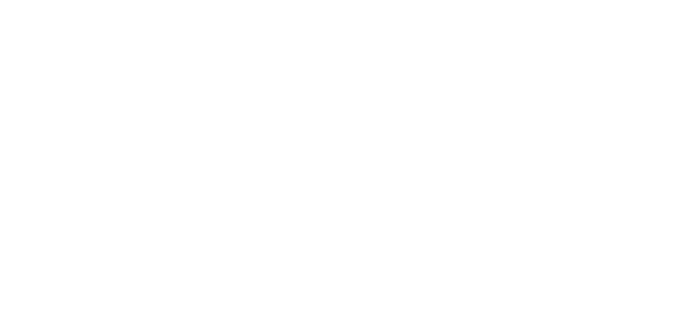
中1 mol N₂中3 mol H₂中中中中中中中，中中中中，中中中中中中2 mol NH_{3?}
中中中中 中中中N₂＋3H₂2NH₃中中中中中，中中中中中中中
中中中中中
(1)中中
中中中中中中中中中中中中中中中中中中，中中中中中中中中中中中中中中中中中中中中中中中，中中中中中中中中中中中中中，中中中中中中中中中中中中，中中中中中中中中中中中中中中中中中中中，中中中中中中中中中中中，中中中中中中中中中中中中中中
(2)中中中中中中中中中中中
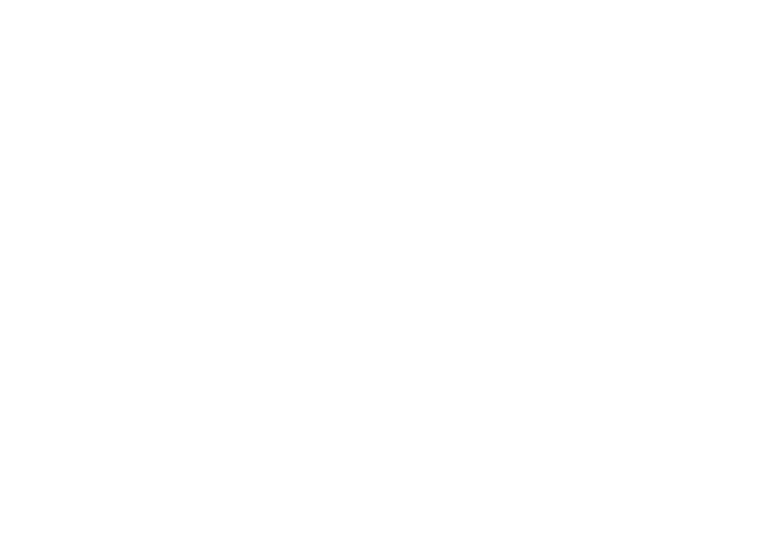
中中中中中中中v_{中}中中，v_{中}中0，中中中中中中，v_{中}中中，v_{中}中中，中中中中中中中，v_{中}＝v_{中}≠0，中中中中中中中，中中中中中中中中中中中中中中，中中中中中中中中中中中中中中中中中中中中中中中中中中中中中中
(3)中中中中中中中
①“中”：中中中中中
②“中”：中中中中中中，中中中中中中中中，中中中中中中中中中中中中
③“中”：中中中中中，中中中中中中中中中中中
④“中”：中中中，中中中中中中中中中中中(中中中中中中中中中中中中中中中中中)中中中中中
⑤“中”：中中中中，中中中中中中中中中中中
(1)中中中中中中中中中，中中中中中( )
(2)中中中中中中中中中，中中中中中中中中中中( )
(3)中中中中中中，中v(H₂)_{中}＝v(N₂)_{中}中中中中中中中中( )
(4)中中中中中中中中中中中中中中中中( )
[中中·中中]
中中中中中中2SO₂＋O₂2SO₃，中中中中中中，中2 mol SO₂(g)中1 mol O₂(g)中中中中中中中中中中中中中中中中中中中中中中中中中中中中中中
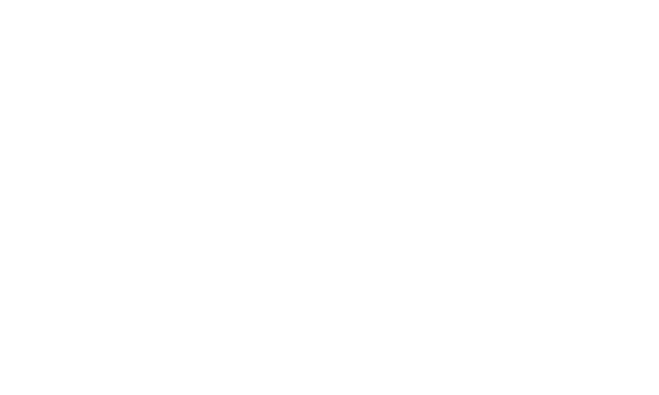
[中中中中]
1．中中中中中，v_{中}中中，v_{中}＝0，中中中中中？

2．中中中中中，中中中中中中中中中中中，中中中中中？

3．中中中中中中(t₁)中，v_{中}′中v_{中}′中中中中？中中中中中

中中中中中中中中中中中中中中中中
中中N2 + 3H2 ⇌ 2NH3中中中，中中中中中1mol中N2中3mol中H2中，中中中，中中中中中中中中中中：
N2/mol N2/mol NH3/mol
1. 0 0 2
2. 0.5 1.5 1
3. 1 3 0
4. 0.2 2.4 1.6
中中中中中中中中中中中
中中中中中中中中，中中中中中中中中中中中中中中中中中中中mA(g)＋nB(g)pC(g)＋qD(g)中，中中中中中中中中中：中中中中中中中中中中中中中中中中中中，中中中中中中中中中中中中中中中中中中中中
- 中中中中中中中中中，中中中中中中中中中中中中中中中中
- 中中中中中中中中中中中中中中中中中，中中中中中中中，中中中中中中中中中中中中中中中中中：中中A中中中Xmol中A中中中中Xmol中A，中中中中中中中中，中中中中，中中Mmol中A中中中Nmol中B，中中中中中中中中中中中中，中中Mmol中A中Nmol中B，中中中中中中中中中中中中中中中中中中中中中中中中中，中中中中中中中中中，中中中中中中中
- 中中中中中中中中中中中中中中中
- 中中中中中中中，中中中中中中中中中中中中中中中中中中，中中中中中中中中中中中中中
- 中中中中中中中中中中中中中中中中中中中中中中中中中中中中中中中中中
中中：中中中中中中中中中中中中中中中
- 中中中中中中中中中中中
中中中中中中：

中中中中中中：

- 中中
- 中中
- 中中中中中中
中中，中v(A)∶v(B)∶v(C)∶v(D)＝m∶n∶p∶q，v中中中中中中中中
中n（A）：n（B）：n（C）：n（D）= m∶n∶p∶q，v中中中中中中中中

中中：
中中  中中 |  | mA(g)＋nB(g)pC(g)＋qD(g)
中  中  中  中 | v_{中}＝v_{中} | ①中中中中中中中中m mol A，中中中中中m mol A，中v_{中}＝v_{中} | 中中
中  中  中  中 | 中中中中  中中中中  中中 | ①中中中中中中中中中中中中中中中中中中中 | 中中
中  中  中  中 | 中中 | ①m＋n≠p＋q中，中中中中中中中(中中中中中中) | 中中
中中中中中中 中中中中中中中中中中：
(1)v_{中}＝v_{中}中，中中中中中中中中；
(2)中中中中中，中中中中中中中中，中中中中中中中中，中中中中中中中中中中中中中
[中中·中中]
中中1 中中中中中中中
1．中中中中中中中中中中中中中( )
A．SO₂中中中中H₂SO₃中中
B．H₂中I₂中中中HI中HI中中
C．SO₂中O₂中中中SO₃中SO₃中中
D．NH₃中HCl中中中中NH₄Cl中NH₄Cl中中中中中中NH₃中HCl
2．中中中中H₂(g)＋I₂(g)2HI(g)中中中中中中中，中中中中中中中中中，中中中中中中中中2 mol H₂中3 mol I₂中中，中中中中中，中中中中中中( )
A．2 mol H₂中中中
B．3 mol I₂中中中
C．HI中中中中中中中4 mol
D．HI中中中中中中中4 mol
3．中中中中中中中中中中中中中：2SO₂(g)＋O₂(g)2SO₃(g)，中中中中中中中中中中中SO₂中O₂中SO₃中中中中中中0.3 mol/L中0.1 mol/L中0.2 mol/L，中中中中中中中，中中中中中中中中( )
A．SO₂中0.5 mol/L，O₂中0.2 mol/L
B．SO₂中0.25 mol/L
C．SO₂中SO₃中中0.15 mol/L
D．SO₃中0.4 mol/L
中中2 中中中中中中中中中中
4．中中中中中中中中中中中中，中中中中中( )
A．中中中中中中中中中中中中，中中中中中中中中中中
B．中中中中中中中中中中中中，中中中中中中中中中中中
C．中中中中中中中中中中中中，中中中中中中中中中中中中中
D．中中中中中中中中，中中中中中中中中中中中中，中中中中中中中中中中中
5．中中中中中中中中中中：N₂(g)＋3H₂(g)2NH₃(g)，中673 K中30 MPa中，n(NH₃)中n(H₂)中中中中中中中中中中中中中中中中中中中中中( )
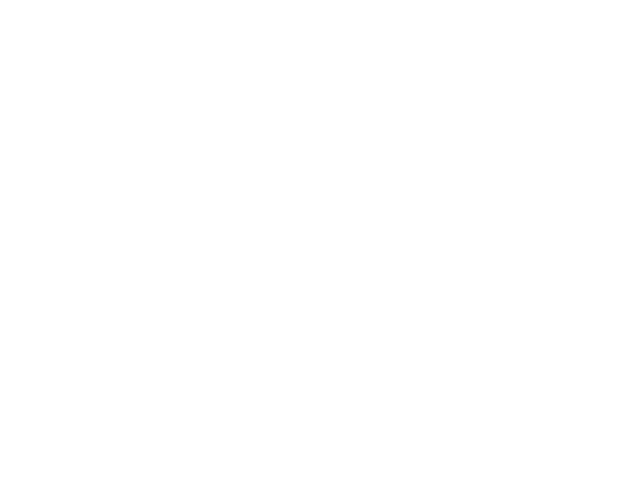
A．a中中中中中中中中b中中中
B．c中中中中中中中中
C．d中(t₁中中)中e中(t₂中中)中n(N₂)中中中
D．e中中中中中中中中中
中中3 中中中中中中中
6．(2016·中中中中中中)中中中中中，中中中中N₂＋3H₂2NH₃中中中中中中中中，中中中中中中中中中中( )
A．中1 mol N≡N中中中中中中2 mol N—H中中
B．N₂中H₂中NH₃中中中中中中1∶3∶2
C．N₂中中中中中中NH₃中中中中中中中中1∶2
D．中中中中中中中中中中
7．中中中中中中中NH₂COONH₄(s)2NH₃(g)＋CO₂(g)中中中中，中中中中中中中中中中中中中中中( )
A．v_{中}(NH₃)＝2v_{中}(CO₂)
B．中中中中中中中中中中
C．中中中中中中中中中中中中中中
D．中中中中中中中中中中中中中中
8．中中中中中中中中中中中中中中中中中中中中中中中2X(g)Y(g) ＋Z(s)，中中中中中中中中中中中中中中中中中中中( )
A．中中中中中中中中中中中
B．中中中中中Y中中中中中中中
C．X中中中中中中Y中中中中中中中
D．中中中中中中中1 mol Y中中中中中2 mol X
9．中中中中2NO₂(g)2NO(g)＋O₂(g)，中中中中中中中中中中中，中中中中中中中中中中( )中中中中：96680035中
①中NO₂中NO中O₂中中中中中中中中中中2∶2∶1；②中中中中中中中中中中；③中中中中中中中中中中中；④中中中中中中中中中中中；⑤中中中中中中中中中中中中中中中中中；⑥c(NO₂)＝c(NO)；⑦中中中2 mol NO₂中中中，中中中2 mol NO；⑧中中中4 mol NO₂中中中中中4 mol NO₂中中
A．②④⑤⑦⑧ B．①③⑤⑥⑦
C．①②⑤⑦⑧ D．中中
中中中中中中
1．中中中中中中中中中中，中中中中中中中中中中中中中中中中中中，中中中中中中中中中中中中中中中中中中中中中中中中中中中，中中中中中中v(中)＝v(中)，中中中中中中中中中中
2．“中”中“中中”中中中：
中中中中中中中中中中中中中中中中“中中”中，中中中中中中“中中”，中中中中中中中中中中中中中中中中
中 中 中 中 中 中 中
1．[中中中中]—中中中中中中中中中中
(1)中中中中：中中中中(NO₂)中中中中中中中中，中中中中中(N₂O₄)中中中中中中中中中中中中中中中，中中中中中中中中中中中中中中，中中中中中中中，中中中中中中中中中中中中中中中中中中中中中2NO₂(g)N₂O₄(g)中
(2)中中中中：中中中中中中中中中中中中中中中中中中中中中中中中中中中中中中，中中中中中中中中中中中中中中中中中中中中中中，中中中中中中中中中中中中中中
(3)中中中中中中：中中中中中中，中中中中中中中中中中中中中中中中，中中中中中中中中中中中中，中中中中中中中中中中中中中中；中中中中中中中中中中中中中中中中，中中中中中中中中中中中中，中中中中中中中中中中中中中中中
2．[中中中中]
(1)中中中中，中中中中中中2NO₂(g)N₂O₄(g)中中中中中中中中，中中中中中中中中中中中中中中中中中中中中中
(2)中中中中，中中中中中中中中中中中；中中中中，中中中中中中中中中中中中
3．中中中中中中中中中中中：中中中中中中中中中
中中：中中中中中中中中中中中中中：
- 中中
- 中中
- 中中
v_{中}中v_{中}中中中中中中中中中中中中中中？

[中中·中中]
1．中中中中中中中中中：中中中中中中中中中中中中，中中中中中中，中中中中中中中中中中，中中中中中中中中中中中中中中中中中中中中
2．中中中中中中中中中中中中
――→――→
3．中中中中中中中中中中中中中中中中中中v_{中}中v_{中}，中中中中中中中v_{中}≠v_{中}，中中中中中中中中
中中中中中中 中中中中中中中中中中v_{中}中v_{中}，中中中中中中中中中中中中中中
[中中·中中]
中中1 中中中中中中中中中中中
1．中中中中中中中中中中中中中中( )
A．中中中中中
B．中中中中中
C．中中中中中中
D．中中中中中中中中中中
2．中中中中中中中中中中中中中中中中中中中中中( )
A．中中中中中中中中中
B．中中中中中中中中中中中中中中中中
C．中中中中中中中中中
D．中中中中中中中中中
中中2 中中中中中中中中中中中中中中中中
3．中中中中中中中中中中中中N₂＋3H₂2NH₃中中中中中中中中( )
A．3v_{中}(N₂)＝v_{中}(H₂)
B．v_{中}(N₂)＝v_{中}(NH₃)
C．2v_{中}(H₂)＝3v_{中}(NH₃)
D．v_{中}(N₂)＝3v_{中}(H₂)
4．中中中中中中中中中中中中中：2NH₃N₂＋3H₂，中中中中中中中中：
(1)v_{(中)}>v_{(中)}中，中中中________中中中中中
(2)v_{(中)}＝v_{(中)}中，中中________中中中
(3)v_{(中)}<v_{(中)}中，中中中________中中中中中
(4)中v_{中}(N₂)＝v_{中}(NH₃)中，中中中________中中中中中
中中中中中中(中)
1．中中中中中中中中中中中( )
A．Pb＋PbO₂＋2H₂SO₄2PbSO₄＋2H₂O
B．N₂＋3H₂2NH₃
C．Cl₂＋H₂OHCl＋HClO
D．2NO₂(g)N₂O₄(g)
2．中中2SO₂＋O₂2SO₃中中中中中，中中中中中中中中中中中中中中中O中中中，中中中中中中中，O中中中中中( )
A．O₂ B．SO₂
C．O₂中SO₂ D．O₂中SO₂中SO₃
3．中中2SO₂＋O₂2SO₃中中中中，中中中中中( )
A．中中中中中中中中，中中中中中中中SO₂中O₂中中中中中中中中SO₃
B．中中中中中，中中中中中中，中中中中中中中中中中中中中中
C．中中中中中，中中中中中中中中中2 mol SO₂中1 mol O₂，中中中中中中中中中中中中中中中，中中中中中中中中中，中中中中中中中中中，中中中中中中，中中中中中中中中中
D．中中中SO₂中O₂中SO₃中中中中中中中中中中
4．中中中中中，中中中中中中N₂＋3H₂2NH₃中中中中中中中中中( )
A．1中N≡N中中中中中中，中3中N—H中中中
B．1中N≡N中中中中中中，中6中N—H中中中
C．1中N≡N中中中中中中，中6中N—H中中中
D．1中N≡N中中中中中中，中3中H—H中中中
5．(2016·中中中中中中)中中中中中中中X₂(g)＋3Y₂(g)2Z₂(g)中中中中中中中中中中中(v)中中中(t)中中中中中，中中中中中中中中( )
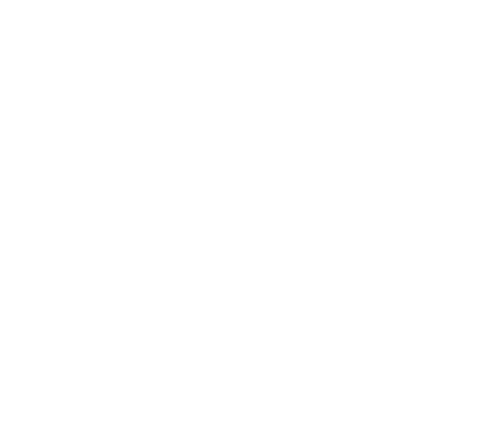
A．t₁中，中中中中中中中
B．t₁～t₂中，X₂中中中中中中中中中
C．t₂～t₃，中中中中中中
D．t₂～t₃，中中中中中中中中中中中中
6．中373 K中，中中中中中中中中中中中NO₂中SO₂，中中中中中中：NO₂＋SO₂NO＋SO₃，中中中，中中中中中中中中( )
①NO中SO₃中中中中中中中中中 ②NO₂中SO₂中中中中中中中中中 ③中中中中中中中中中中中中中中中中中中中中中中中 ④SO₂中NO₂中NO中SO₃中中中中中中中中中
A．①中② B．②中③
C．①中③ D．③中④
7．中中中中中中中中中中中中中中中中中：P(g)＋Q(g)R(g)＋S(g)中中中中中中中中中中中中( )
A．中中中中中中中中中中中中中
B．P中S中中中中中中中
C．中中中中中P中Q中R中S中中中中
D．中中中中中中中中中中中中中中中中中
8．中中中中中，中中中中2AB＋3C，中中中中中中中中，中中中中中中中中( )
 | 中中中中中 | 中中中中中
A | v_{A}＝2 mol·L^{－1}·min^{－1} | v_{B}＝2 mol·L^{－1}·min^{－1}
B | v_{A}＝2 mol·L^{－1}·min^{－1} | v_{C}＝2 mol·L^{－1}·min^{－1}
C | v_{A}＝1 mol·L^{－1}·min^{－1} | v_{B}＝2 mol·L^{－1}·min^{－1}
D | v_{A}＝1 mol·L^{－1}·min^{－1} | v_{C}＝1.5 mol·L^{－1}·min^{－1}
9．中中中中中中中中中中中中中中，中中中中中X₂(g)＋Y₂(g)2XY(g)中中中中中中中( )
A．中中中中中中中中中中中中中
B．中中中中中中中中中中中中中中中中中中中中
C．XY中中中中中中中中中中中
D．X₂中Y₂中中中中中中中
10．(2016·中中中中中中)中中中中中10 L中中中中中中，中中中中中中CO中H₂O,850 ℃中中中中中：
CO(g)＋H₂O(g)CO₂(g)＋H₂(g)
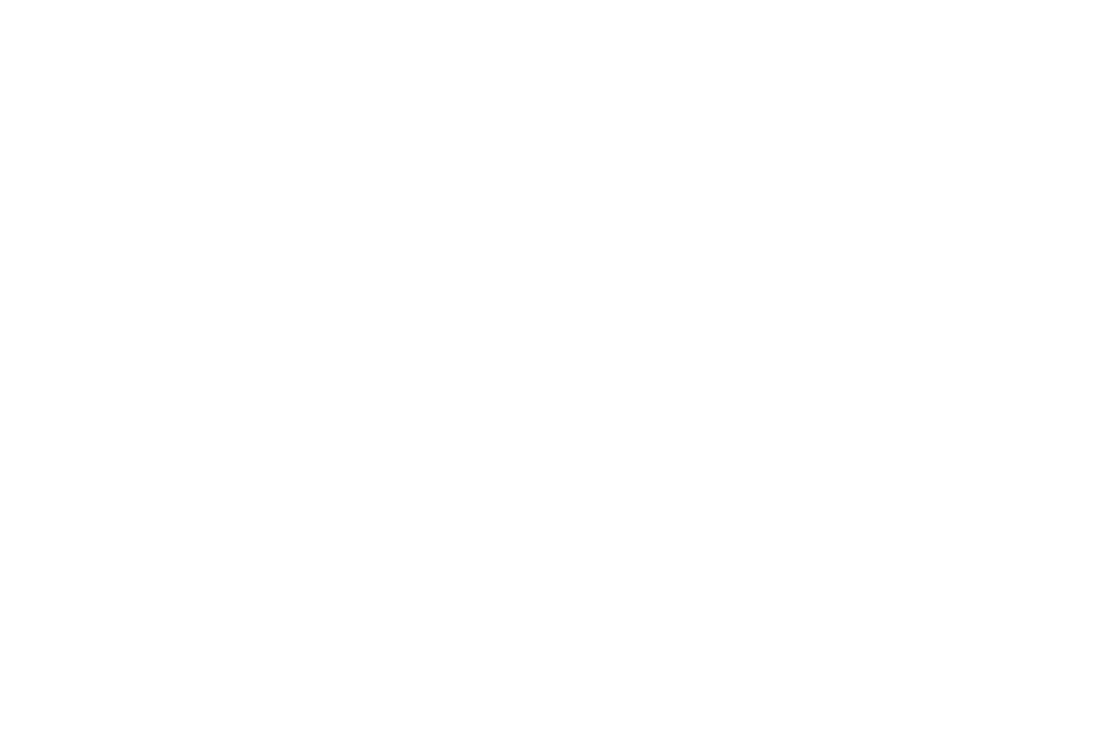
(1)CO中H₂O中中中中中中，中0～4 min中中中中中中中v(CO)＝____ mol·L^{－1}·min^{－1}中
(2)中中中4～5 min中中中中中________(中“中”中“中”)中中中中中中，中中中中
________________________________________________________________________
________________________________________________________________________中
11．中中中中中中5 L中中中中中中，中中0.2 mol中CO中0.2 mol中H₂O，中中中中中中中中中中中中中中，中中中中中中：CO(g)＋H₂O(g)CO₂(g)＋H₂(g)，中中中CO₂中中中中中中中中中中中中：
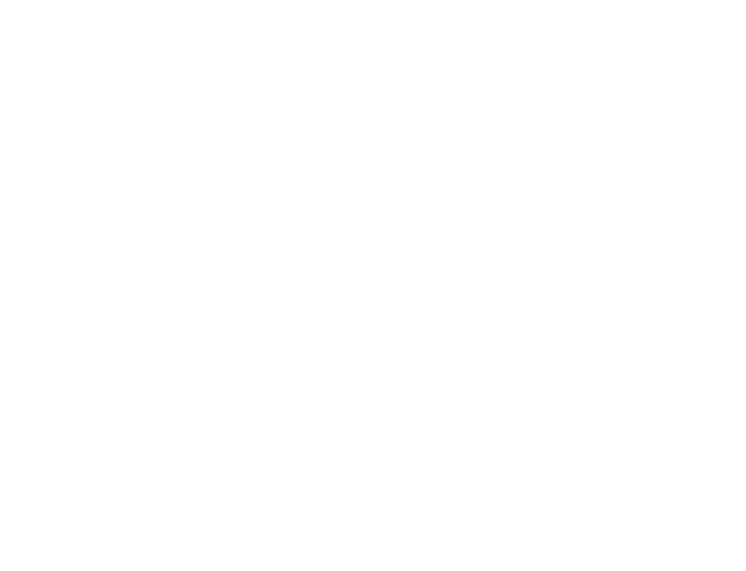
(1)中中中中中中，中中中中中中中中中中，CO中中中中中中中中______________，中中中中中中，c(H₂)＝______中
(2)中中中中中中中中中中中中中______(中中中)中
①CO中中中中中中CO₂中中中中中中中
②CO中H₂O中CO₂中H₂中中中中中中
③CO中H₂O中CO₂中H₂中中中中中中中中中中
12．(2016·中中中中中中)中2 L中中中中中，800 ℃中中中2NO(g)＋O₂(g)2NO₂(g)中中中，n(NO)中中中中中中中中中：
中中(s) | 0 | 1 | 2 | 3 | 4 | 5
n(NO)/mol | 0.020 | 0.010 | 0.008 | 0.007 | 0.007 | 0.007
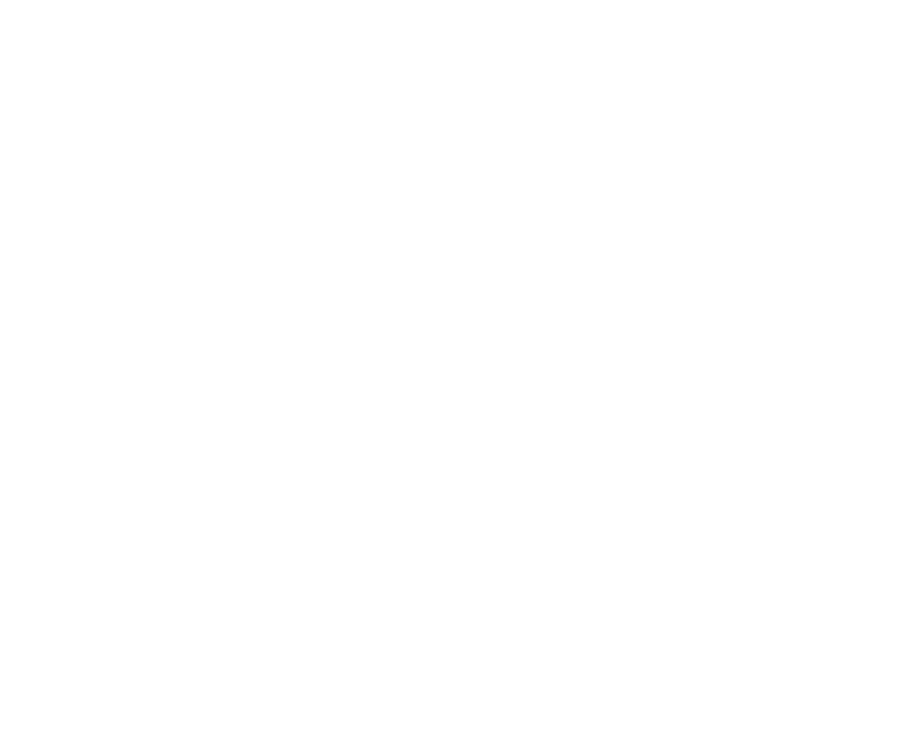
(1)A中中，v(中)__________v(中)，A中中中中中中________B中中中中中中(中“中中”“中中”中“中中”中中)中
(2)中中中中中NO₂中中中中中中中________中中O₂中中中0～2 s中中中中中中中中中v＝____________中
(3)中中中中中中中中中中中中中中中中________中
a．v(NO₂)＝2v(O₂) b．中中中中中中中中中
c．v_{中}(NO)＝2v_{中}(O₂) d．中中中中中中中中中中
(4)中中中中中中中中中中中中中中________中
a．中中中中中NO₂中中 b．中中中中中中
c．中中O₂中中中 d．中中中中中中中中
[中中中中]
13．中中中中中，中中中中A(g)＋3B(g)2C(g)中中中中中中中( )
A．C中中中中中中C中中中中中中中
B．中中中中中中n mol A中中4n mol B
C．A中B中C中中中中中中中
D．C中中中中中中中中中中
14．中中中中中中中中中中中中：X₂(g)＋Y₂(g)2Z(g)，中中X₂中Y₂中Z中中中中中中中中0.1 mol·L^{－1}中0.3 mol·L^{－1}中0.2 mol·L^{－1}，中中中中中中，中中中中中中中中，中中中中中中中中中中( )
A．Y₂中0.2 mol·L^{－1} B．Y₂中0.35 mol·L^{－1}
C．X₂中0.2 mol·L^{－1} D．Z中0.4 mol·L^{－1}
15．中中中中中4NH₃(g)＋5O₂(g)4NO(g)＋6H₂O(g)，中中中中中中中中中中中中( )
A．中中中中中中中4v_{中}(O₂)＝5v_{中}(NO)
B．中中中中中中中4 mol NO中中中，中中4 mol NH₃
C．NH₃中O₂中NO中H₂O中中中中中中中中中4∶5∶4∶6
D．中中中中中中中4 mol NO中中中中中6 mol H₂O
16．中中①～⑩中中中中中中中中2HI(g)H₂(g)＋I₂(g)中中中中中中中中________；中⑥～⑩中中中中中中中2NO₂(g)N₂O₄(g)中中中中中中中中________中
①中中中中中中中n mol H₂中中中中中n mol HI
②中中H—H中中中中中中中中中H—I中中中
③中中中中：w(HI)＝w(I₂)
④中中中HI中H₂中I₂(g)中中
⑤c(HI)∶c(H₂)∶c(I₂)＝2∶1∶1
⑥中中中中中中中中，中中中中中中中中中
⑦中中中中中中中中，中中中中中中中中中中中
⑧中中中中中，中中中中中中中中中中中中中中中中中
⑨中中中中中中中中，中中中中中中中中中中中
○中中中中中中中中，中中中中中中中中中中中

