What is LibreOffice?
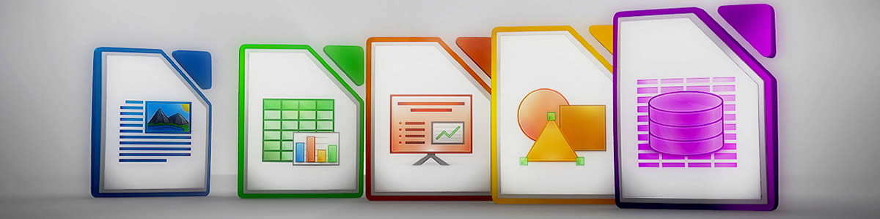

Do more – easily, quickly
LibreOffice is a powerful office suite; its clean interface and powerful tools let you unleash your creativity and grow your productivity. LibreOffice embeds several applications that make it the most powerful Free & Open Source Office suite on the market: Writer, the word processor, Calc, the spreadsheet application, Impress, the presentation engine, Draw, our drawing and flowcharting application, Base, our database and database frontend, and Math for editing mathematics.

Finally, documents that look good
Your documents will look professional and clean, regardless of their purpose: a letter, a master thesis, a brochure, financial reports, marketing presentations, technical drawings and diagrams.

Use documents of all kinds
LibreOffice is compatible with many document formats such as Microsoft® Word, Excel, PowerPoint and Publisher. But LibreOffice goes further by enabling you to use a modern open standard, the OpenDocument Format (ODF).

Free as in Freedom, now and forever
LibreOffice is Free and Open Source Software. Its development is open to new talent and new ideas. Our software is tested and used daily by a large and devoted user community; you, too, can get involved and influence its future development.

Table
A | B | C | D | E |  | F
I
II
III
IV

DrawShapes
Text in Shape

Textframe
He heard quiet steps behind him. That didn't bode well. Who could be following him this late at night and in this deadbeat part of town? And at this particular moment, just after he pulled off the big time and was making off with the greenbacks. Was there another crook who'd had the same idea, and was now watching him and waiting for a chance to grab the fruit of his labor? Or did the steps behind him mean that one of many law officers in town was on to him and just waiting to pounce and snap those cuffs on his wrists?

3DShape

Textbox

The quick brown Fox Jumps over the lazy Dog

Fontwork
NOTE

Chart

