Heading OL 1

Heading OL 2
More text here.

Figure 1
Table 1

Heading OL 3
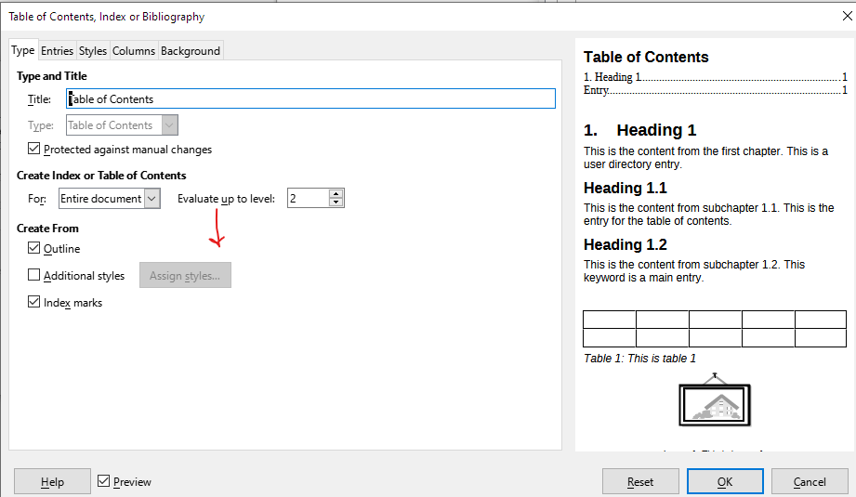
Test
Table 2

User-Defined Index
Frame1 1
SecondTable 1
Image1 1
FirstTable 1

