Setting up LibreOffice
Choosing Options to Suit the Way You Work

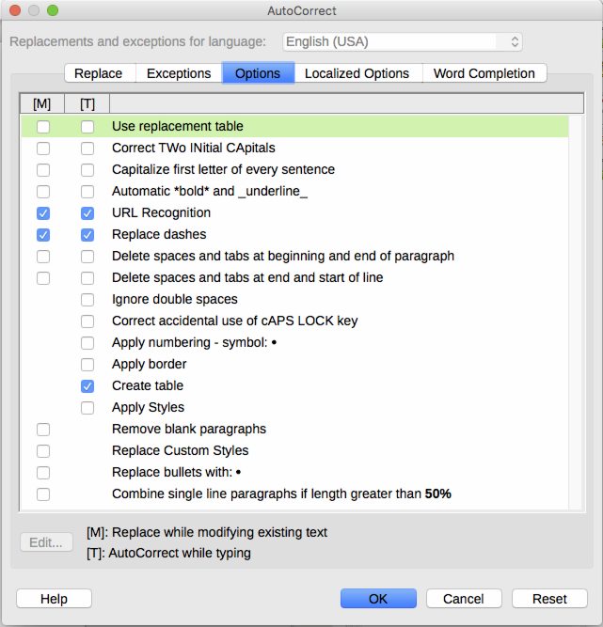
Figure 1: The AutoCorrect dialog in Writer, showing some of the choices on the Options tab

