
AB
Calc Guide
Chapter 2
Entering, Editing, and Formatting Data

Copyright
This document is Copyright © 2005–2013 by its contributors as listed below. You may distribute it and/or modify it under the terms of either the GNU General Public License (http://www.gnu.org/licenses/gpl.html), version 3 or later, or the Creative Commons Attribution License (http://creativecommons.org/licenses/by/3.0/), version 3.0 or later.
All trademarks within this guide belong to their legitimate owners.

Contributors
Barbara Duprey Christian Chenal Jean Hollis Weber
Shelagh Manton John A Smith Peter Schofield

Feedback
Please direct any comments or suggestions about this document to: documentation@global.libreoffice.org

Acknowledgments
This chapter is adapted and updated from Chapter 2 of the OpenOffice.org 3.3 Calc Guide. The contributors to that chapter are:
Peter Kupfer Andy Brown Stephen Buck
Iain Roberts Hazel Russman Barbara M. Tobias
Jean Hollis Weber Jared Kobos

Publication date and software version
Published 8 August 2013. Based on LibreOffice 4.1.

Note for Mac users
Some keystrokes and menu items are different on a Mac from those used in Windows and Linux. The table below gives some common substitutions for the instructions in this chapter. For a more detailed list, see the application Help.
Windows or Linux | Mac equivalent | Effect
Tools > Options menu selection | LibreOffice > Preferences | Access setup options
Right-click | Control+click or right-click depending on computer setup | Opens a context menu
Ctrl (Control) | ⌘ (Command) | Used with other keys
F5 | Shift+⌘+F5 | Opens the Navigator
F11 | ⌘+T | Opens the Styles and Formatting window

Contents
Copyright 2
Contributors 2
Feedback 2
Acknowledgments 2
Publication date and software version 2
Note for Mac users 2
Introduction 4
Using the keyboard 4
Numbers 4
Negative numbers 4
Leading zeroes 4
Numbers as text 5
Text 5
Date and time 5
Special characters 6
Autocorrection options 6
Replacing 7
Find & Replace options 7

Introduction
You can enter data into Calc in several ways: using the keyboard, dragging and dropping using the mouse, the Fill tool, and selection lists. Calc also provides the ability to enter information into multiple sheets of the same spreadsheet at the same time. After entering data, you can format and display it in various ways.

Using the keyboard
Most data entry in Calc can be accomplished using the keyboard.

Numbers
Click in the cell and type the number using the number keys on either the main keyboard or the numeric keypad.

Negative numbers
To enter a negative number, either type a minus (–) sign in front of the number or enclose the number in parentheses (), for example (1234). The result for both methods of entry will be the same, for example -1234.

Leading zeroes
To retain a minimum number of characters in a cell when entering numbers and retain the number format, for example 1234 and 0012, leading zeroes have to be added as follows:
- With the cell selected, right-click on the cell and select Format Cells from the context menu, or go to Format > Cells on the menu bar, or use the keyboard shortcut Ctrl+1 to open the Format Cells dialog (Figure 1).
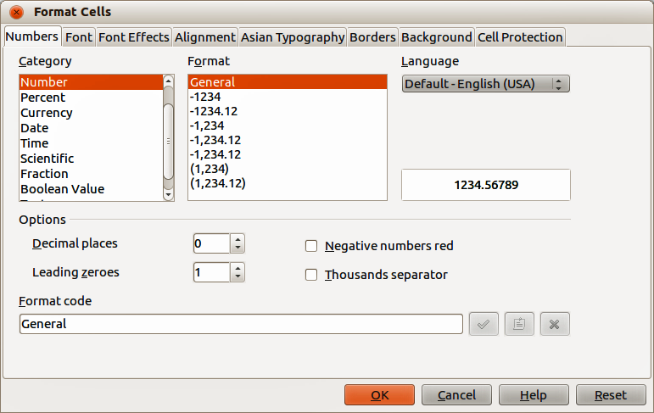
Figure 1: Format Cells dialog – Numbers page
- Make sure the Numbers page is selected, then select Number in the Category list.
- In Options > Leading Zeroes, enter the minimum number of characters required. For example, for four characters, enter 4. Any number less than four characters will have leading zeroes added, for example 12 becomes 0012.
- Click OK. The number entered retains its number format and any formula used in the spreadsheet will treat the entry as a number in formula functions.
If a number is entered with leading zeroes, for example 01481, by default Calc will automatically drop the leading 0. To preserve leading zeroes in a number:
- Type an apostrophe (') before the number, for example '01481.
- Move the cell focus to another cell. The apostrophe is automatically removed, the leading zeroes are retained and the number is converted to left-aligned text.

Numbers as text
Numbers can also be converted to text as follows:
- With the cell selected, right-click on the cell and select Format Cells from the context menu, or go to Format > Cells on the menu bar, or use the keyboard shortcut Ctrl+1 to open the Format Cells dialog (Figure 1).
- Make sure the Numbers page is selected, then select Text from the Category list.
- Click OK. The number is converted to text and, by default, is left-aligned. You can change the formatting and alignment of any text numbers just as you would with normal text.
Note | Any numbers that have been formatted as text in a spreadsheet will be treated as a zero by any formulas used in the spreadsheet. Formula functions will ignore text entries.

Text
Click in a cell and type the text. The text is left-aligned by default. Cells can contain several lines of text. If you want to use paragraphs, press Ctrl+Enter to create another paragraph.
On the Formula Bar, you can extend the Input Line if you are entering several lines of text. Click on the Extend Formula Bar icon located on the right of the Formula Bar and the Input Line becomes multi-line, as shown in Figure 2. Click the Extend Formula Bar icon again to return to a single input line.
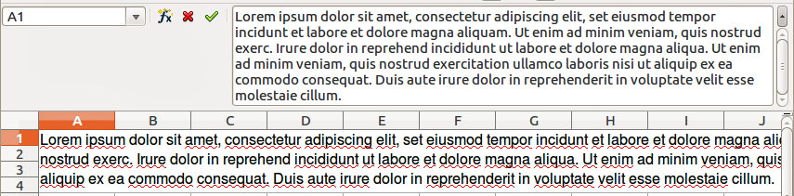
Figure 2: Extended input line on Formula Bar

Date and time
Select the cell and type the date or time. You can separate the date elements with a slash (/) or a hyphen (–) or use text, for example 10 Oct 2012. The date format automatically changes to the selected format used by Calc.
When you enter a time, separate time elements with colons, for example 10:43:45. The time format automatically changes to the selected format used by Calc.
To change the date or time format used by Calc:
- With the cell selected, right-click on the cell select Format Cells from the context menu or go to Format > Cells on the menu bar or use the keyboard shortcut Ctrl+1 to open the Format Cells dialog (Figure 1).
- Make sure the Numbers page is selected, then select Date or Time from the Category list.
- Select the date or time format you want to use from the Format list.
- Click OK to save the changes and close the dialog.

Special characters
A special character is a character not normally found on a standard keyboard, for example, © ¾ æ ç ñ ö ø ¢. To insert a special character:
- Place the cursor in the cell where you want the character to appear.
- Go to Insert > Special Character… on the menu bar to open the Special Characters dialog (Figure 3).
- Select in order the special characters you want to insert into the cell. The special characters selected will appear at the bottom left of the Special Characters dialog. The last character selected is shown on the right of the Special Characters dialog along with its numerical code.
- Click OK to close the dialog and the special characters are inserted into the selected cell.
Note | Different fonts include different special characters. If you do not find a particular special character you want, try changing the Font and Subset selection.
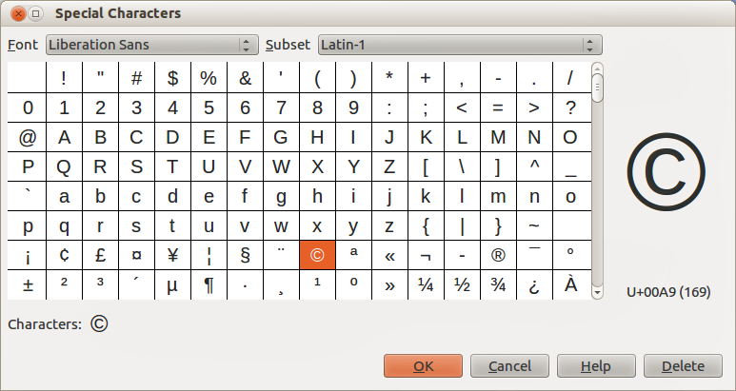
Figure 3: Special Characters dialog

Autocorrection options
Calc automatically applies many changes during data input using autocorrection, unless you have deactivated any autocorrect changes. You can also undo any autocorrection changes by using the keyboard shortcut Ctrl+Z or manually by going back to the change and replacing the autocorrection with what you want to actually see.
- Find & Replace on the menu bar, or use the keyboard shortcut Ctrl+H, or select the Find & Replace icon on the Find toolbar to open the Find & Replace dialog (Error: Reference source not found).
- Enter or select the search criteria in the Search for box.
- If necessary, click on Other Options so that you can increase the number of search filters that you can apply to your search.
- Click Find to locate the first instance of the search criteria you entered.
- Click Find again to locate the next instance of your search criteria.
- Click Find All to locate all instances of your search criteria. The instances of your search criteria will be highlighted in the spreadsheet.

Replacing
- Go to Edit > Find & Replace on the menu bar, or use the keyboard shortcut Ctrl+H, or select the Find & Replace icon on the Find toolbar to open the Find & Replace dialog (Error: Reference source not found).
- Enter or select the search criteria in the Search for box.
- Enter or select the replace criteria in the Replace with box.
- If necessary, click on Other Options so that you can increase the number of search filters that you can apply to your find and replace.
- Click Replace to locate and replace the first instance of the search criteria you entered with your replacement criteria.
- Click Replace again to locate and replace the next instance of the search criteria you entered with your replacement criteria.
- Click Replace All to locate and replace all instances of the search criteria you entered with your replacement criteria.
Note | Use Replace All with caution; otherwise, you may end up with some highly embarrassing mistakes. A mistake with Replace All might require a manual, word-by-word search to fix, if it is not discovered in time to undo it.

Find & Replace options
The options available to refine your find and replace are as follows:
- Search for – enter the text that you want to search for, or select a previous search from the list.
- Replace with – enter the replacement text, or select a recent replacement text or style from the list.
- Match case – distinguishes between uppercase and lowercase characters.
- Entire Cells – searches for whole words or cells that are identical to the search text.
- Current selection only – searches only the selected text or cells.
- Backwards – search starts at the current cursor position and goes backwards to the beginning of the file.
- Regular expressions – select to use wildcards in your search. See LibreOffice Help for more information on the use of regular expressions.
- Similarity Search – find terms that are similar to the Search for text. Select this checkbox, and then click the ... button to define the similarity options.
- Search for Styles – searches for text formatted with the style that you specify. Select this option and then select a style from the Search for list. To specify a replacement style, select a style from the Replace with list.
- Match character width – distinguishes between half-width and full-width character forms; only available if Asian languages are enabled.
- Sounds like (Japanese) – specify the search options for similar notation used in Japanese text. Select this option, and then click the ... button to specify the search options. This option is only available if Asian languages are enabled.
- Search in – select either Formulas, Values, or Notes to search for the characters that you specify in values, in the results of formulas, or in notes.
- Search direction – determines the order for searching the cells.
- Search in all sheets – searches through all of the sheets in the current spreadsheet file.

