Hi.

I noticed that when inserting a formula on a writer document in LO 4.4.0.3 on Win 8.0, the frame is blocked for resizing, this behavior doesn’t happen in LO 4.3.5.2 on Win 8.0.

Steps to reproduce:

Create a new Writer file

insert a formula with Insert Object Formula
when finished try to resize the frame
it is blocked.

This behavior was not present in writer 4.3.5.2.
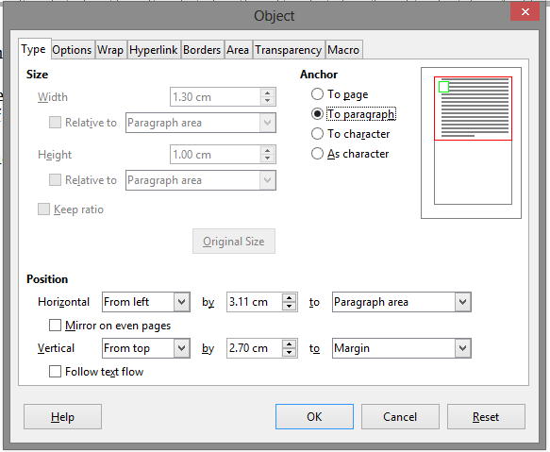
if you access the frame properties with right click or in the menu bar of the object, the size options are grayed and inaccessible. Even if you change the anchor position to paragraph or page.

This will be correct if in the options tab of the object properties was activated the protect size option.
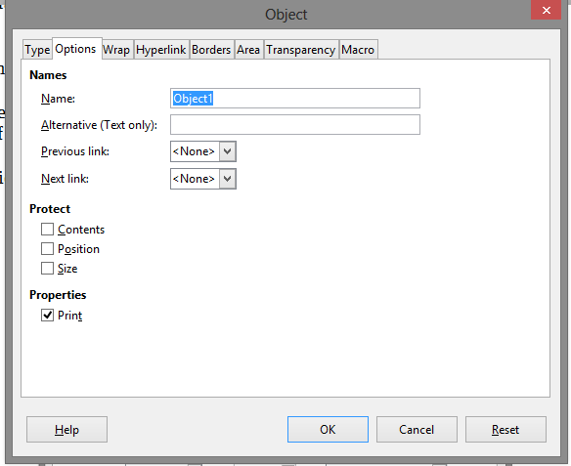

I see bug 88145 resolved invalid with some of the same problems.

Testing win LO 4.3.5.2 in parallel installation works as expected.

