Runtime error traceback on create new project – no session - project created but invisible

Create new project, supplying only the project name (no templates or customers have yet been created).

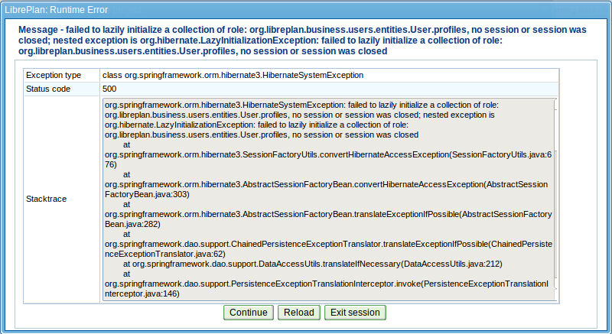
Continue. The project appears to be created (you cannot create another one with the same name) but it does not appear in the projects list for that user (it is visible when you log in as admin).

When creating a project as admin the problem does not occur. The problematic user had just “Create projects” role:

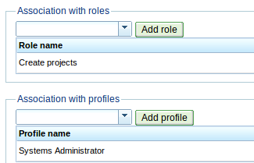

Related to this, clicking in the projects list area produced this:

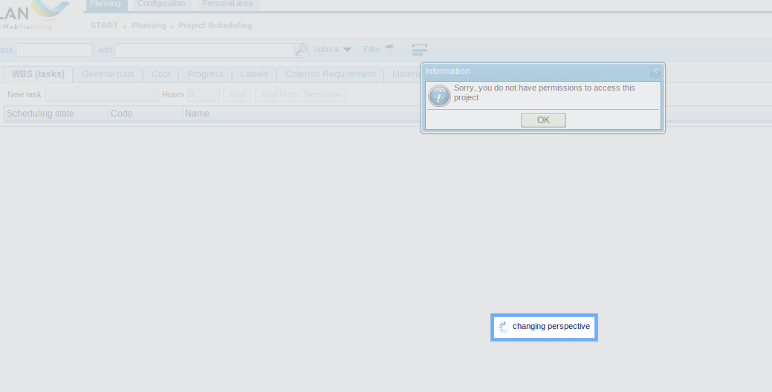
where it got stuck (left it for several minutes, no change).

Ubuntu 12.10 (GNU/Linux 3.5.0-34-generic i686)
LibrePlan v1.4.0 installed using the ppa
Chromium Version 25.0.1364.160 Ubuntu 12.10 (25.0.1364.160-0ubuntu0.12.10.1)

