Introduction

This document describes the mapping of the user interface to backend methods.

Pages

1. **Authorization page.**

**Description**: The first page when the web application loads. There is an option for authorization in the application only through one of the TON wallets.

**Mockup**:

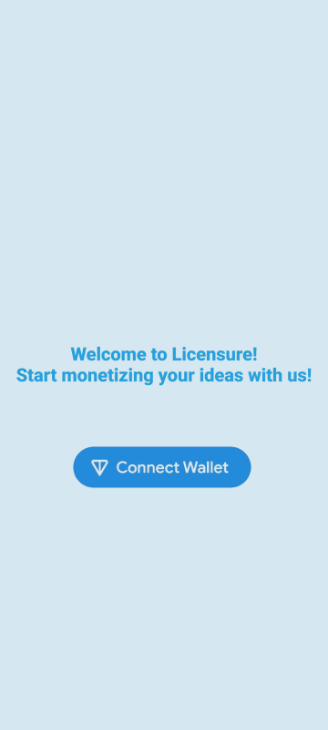

**Implementation**: Button “Connect Wallet” works through the “**@tonconnect/ui-react**” library. To add this button, you must use the **<TonConnectButton>** component. In addition, the React application must be “wrapped” in the **<TonConnectUIProvider>** component.

After authorization via TON wallet, need to automatically create a user account in the system.

To create a user in the system must use the following backend endpoint “**Create User**”:

**POST /api/createUser  
Host:** <https://licensure.tech> **Headers:  
 1. Content-Type: application/json  
 2. Authorization: Bearer {Token Value}  
Body:**{

"wallet_address": {TON Wallet Address}

}

**Response Example**:

**OK** – 201 CREATED:

{

"nickname": "HappyKitten5407",

"user_id": 6,

"wallet_address": {TON Wallet Address}

}

**User already exist** – 500 INTERNAL SERVER ERROR:

{

"error": "User with this wallet address already exists"

}

**Empty Body** – 400 BAD REQUEST.

**Empty Parameter** – 400 BAD REQUEST:

{

"error": "Wallet address are required"

}

Each registered user has two unique parameters in addition to the wallet address:

**user_id** – The user's sequence number in the system, auto-incrementing.

**nickname** – Unique nickname of the user in the system, which can be used to display instead of the wallet address.

1. **P2P Market page.**

**Description**: After authorization and user creation, the system should display a P2P marketplace page where the user can view all offers and purchase a license.

**Mockup**:

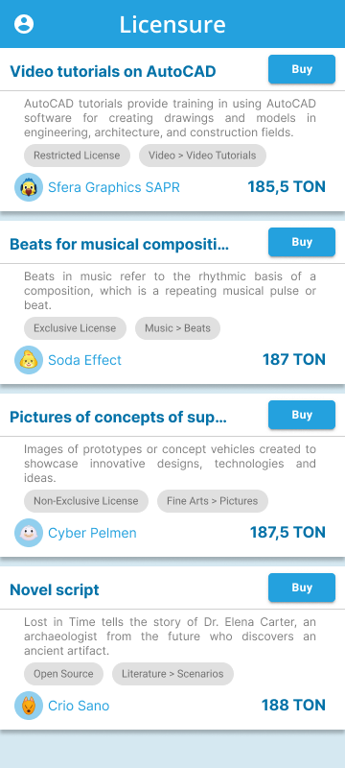

**Implementation**: To retrieve data about all licenses, you must use the smart contract method, which accesses the TON blockchain network and returns all licenses that the smart contract stores:

import { useAsyncInitialize } from './useAsyncInitialize';

import { useTonClient } from './useTonClient';

import { Main } from '../../wrappers/Main';

import { Address, OpenedContract } from 'ton-core';

const {client} = useTonClient();

const mainContract = useAsyncInitialize(async() => {

if (!client) return;

const contract = Main.fromAddress(Address.parse('{Address of contract in blockchain}'));

return client.open(contract) as OpenedContract<Main>;

}, [client]);

Now you can refer to different contract **GET** methods:

mainContract?.getArrayOfLicenses()

**Response Example**:

{

'$$type': 'LicenseArray',

map: Dictionary {

_key: {

bits: 257,

serialize: [Function: serialize],

parse: [Function: parse]

},

_value: { serialize: [Function: serialize], parse: [Function: parse] },

_map: Map(1) {

'b:52386475024439176110681937689299597561070022963244119515134366198178265804108' => [Object]

}

},

length: 1n

}

This object contains three main child objects:

**'$$type'** – The type of message you sent to the blockchain network.

**map** – A dictionary that contains all the licenses that are stored in the smart contract.

**length** – Total number of licenses in the dictionary.

In order to get all the necessary license parameters, it is needed to refer to the _map.Map(n) {} attribute in map object:

Map(1) {

'b:9302427541248522615927265473332735202783708273626430849222715083863515990000' => {

'$$type': 'License',

licenseId: 9302427541248522615927265473332735202783708273626430849222715083863515990000n,

sellerAddress: EQBGhqLAZseEqRXz4ByFPTGV7SVMlI4hrbs-Sps_Xzx01x8G,

buyerAddress: EQAAAAAAAAAAAAAAAAAAAAAAAAAAAAAAAAAAAAAAAAAAAM9c,

createdAt: 1715385981n,

contentName: 'Videos with dogs',

contentDescription: 'super!!!',

contentUrls: '1 - https://docs.tact-lang.org/cookbook/data-structures',

licenseType: 'Restricted license',

contentCategory: 'Video',

contentSubcategory: 'Internet video',

price: 50n,

currency: 'TON',

allRestrictions: 'Duration: 1 year; Purpose: Training neural networks, Marketing; Modification: No',

additionalTerms: '',

status: 'Pending'

}

}

You need to parse this array with licenses and display them as cards on the P2P marketplace. Only display licenses that have **status: 'Pending'**, which means they are still waiting to be purchased.

You can use the **'Get User**' method to get nicknames of license sellers:

**GET /api/getUser  
Host:** <https://licensure.tech> **Headers:  
 1. Authorization: Bearer {Token Value}  
Query Params:** 1. user_id: Integer

2. wallet_address: String

3. nickname: String

Exactly one parameter (user_id, wallet_address, or nickname) is required.

**Response Example**:

**OK** – 200 OK:

{

"created_at": "2024-05-08 05:19:03",

"nickname": "HappyPuppy0186",

"user_id": 9,

"wallet_address": "4a15s1a651d6a5s1s6s5d122112"

}

**Empty Parameter** – 400 BAD REQUEST:

{

"error": "Exactly one parameter (user_id, wallet_address, or nickname) is required"

}

When you click on the **“Buy” button**, two actions should occur:

1. Transfer of the specified amount in the price parameter for the license purchase from the buyer's wallet to the seller's wallet, which is specified in the sellerAddress parameter.

2. Сhanging the buyerAddress parameter and changing the license status in the smart contract to mark the license as purchased.

1:

const body = beginCell()

.storeUint(0, 32)

.storeStringTail(comment)

.endCell();

const myTransaction: SendTransactionRequest = {

validUntil: Math.floor(Date.now() / 1000) + 360,

messages: [

{

address: destination,

amount: toNano(amount).toString(),

payload: body.toBoc().toString('base64')

}

]

};

tonConnectUI.sendTransaction(myTransaction);

2:

const { sender } = useTonConnect();

await sender.send(

{

value: toNano('0.05')

},

{

$$type: 'LicenseBuy',

licenseId: licenseId,

buyerAddress: address(sender.address)

}

)

This message to the smart contract will be paid by the user-buyer through his TON wallet, if the transaction did not complete successfully, this message must be repeated, otherwise the license will not be marked as purchased in the smart contract.